Mount Nansen Habitat Classification
PREPARED FOR:
Assessment & Abandoned Mines
Yukon Government
Box 2703, K-419
Whitehorse, YT Y1A 2C6
PREPARED BY:
EDI ENVIRONMENTAL DYNAMICS INC.
3-478 Range Road
Whitehorse, YT Y1A 3A2
867.393.4882

With
John Meikle
& Simon Lapointe
EDI Contact:
Michael Setterington, R.P.Bio.
EDI PROJECT NO.:
PROJECT # 11-Y-0324
March 7, 2012
This page is intentionally blank.

EXECUTIVE SUMMARY
EDI Environmental Dynamics Inc. was retained by Assessment and Abandoned Mines to develop and ground trught a habitat mapping classification for the Mount Nansen site. Additionally they were to develop habitat ratings for key wildlife species at the site. The project area is 45 km west of Carmacks, Yukon Territory. The habitat classes were based on a Predictive Ecosystem Model (PEM) developed specifically for the site, but within the developing standards currently being created within the Yukon. This project began with gathering existing digital data to be used as spatial inputs and creating derivative products from spatial data, such as aspect, slope and topographic position models. At the same time, a Broad Ecosystem Classification was developed. Fieldwork in early September 2011 resulted in 295 quick plots designed to refine the classification, test spatial inputs and facilitate modeling, along with site and aerial photographs. Results of this project are a delineation of three Bioclimate zones: Alpine, Subalpine and Boreal High; and ten ecosystem types, each with one to five phases. This report begins with a brief overview of the ecological context in support of the ecosystem classification and mapping. A more comprehensive treatment of the area is found in Mount Nansen: Existing Environmental Conditions, by EDI (2010). The next section describes the methodology followed in generating the predictive ecosystem map (PEM), and is followed by a description of the Broad Ecosystem Units. The final section uses the PEM and other inputs to describe wildlife habitat suitability for moose, caribou and grizzly bear.

AUTHORSHIP
This report was prepared by the EDI Environmental Dynamics Inc. in association with John Meikle and Simon Lapointe.

John Meikle, BA, MCS Primary author, field surveys, photographer
Simon Lapointe, MURP, MCIP GIS modeling
Jane Bachman Terrain analysis
Matt Power, AScT Field surveys, GIS analyses and figure preparation
Meghan Marjanovic, BSc Report editing
Vashti Etzel Data entry
Danny Skookum Field surveys
Mike Setterington, R.P.Bio. Senior review
This page is intentionally blank.

TABLE OF CONTENTS
1 Introduction 1
2 Ecological Context 2
2.1 Natural History Influencing Ecosystems 2
2.1.1 Climate 2
2.1.2 Geology 2
2.1.3 Surficial Geology & Soils 5
2.1.4 Permafrost 7
2.1.5 Fire History 7
2.1.6 Vegetation 11
2.2 Bioclimate Zones 12
3 Predictive Ecosystem Mapping Methods 15
3.1 Classification 15
3.2 Modeling 15
4 Nansen Ecosystem Units 19
4.1 Alpine Ecosystems 23
4.2 Mid- to High- Elevation Ecosystems 27
4.3 Wet Ecosystems 38
4.4 Water 47
4.5 Disturbances 48
5 Wildlife habitat suitability 49
5.1 Moose 49
5.1.1 Key Habitat Requirements 49
5.2 Caribou 51
5.2.1 Key Habitat Requirements 51
5.3 Grizzly bear 53
6 Uses and Limitations 65
6.1 Data Accuracy 66
7 Conclusion 67
8 REFERENCES 68
8.1 Literature Cited 68
8.2 SPATIAL DATA 70

LIST OF TABLES
Table 1. Description of Bioclimate Zones for the project area (based on ELC Framework). 12
Table 2. Input class definitions 18
Table 3. Outline of broad ecosystem classifications for the Mount Nansen project area. 19
Table 4. Description and rating of moose habitats that occur within the Mount Nansen project area. 50
Table 5. Availability of moose habitat within the Mount Nansen project area by season. Units are in square kilometres (km²). 50
Table 6. Description and rating of woodland caribou habitats that occur within the Mount Nansen RSA. 52
Table 7. Availability of woodland caribou habitat within the Mount Nansen project area by season. Units are in square kilometres (km²). 52
Table 8. Description and suitability of grizzly bear habitats that occur within the Mount Nansen project area. 53
Table 9. Availability of grizzly bear foraging and denning habitat within the Mount Nansen project area by season. Units are in square kilometres (km²). 53

LIST OF FIGURES
Figure 1. Mount Nansen site overview. 3
Figure 2. Generalized toposequence from the Nisling River in the south to Nansen and Victoria peaks in the north. 5
Figure 3. Fire history within the Mount Nansen project area. 9
Figure 4. Bioclimate Zones within the Mount Nansen project area. 13
Figure 5. A generalized edatopic grid provides an outline of the broad ecosystem classes present at the Mount Nansen project area. 16
Figure 6. Overview of the Mount Nansen Ecosystem Units. 21
Figure 7. Moose spring/calving habitat classification, Mount Nansen study area. 55
Figure 8. Moose summer habitat classification, Mount Nansen study area. 56
Figure 9. Moose rut/early winter habitat classification, Mount Nansen study area. 57
Figure 10. Moose late winter habitat classification, Mount Nansen study area. 58
Figure 11. Caribou spring/calving habitat classification, Mount Nansen study area. 59
Figure 12. Caribou summer habitat classification, Mount Nansen study area. 60
Figure 13. Caribou rut/early winter habitat classification, Mount Nansen study area. 61
Figure 14. Caribou late winter habitat classification, Mount Nansen study area. 62
Figure 15. Grizzly Bear denning habitat classification, Mount Nansen study area. 63
Figure 16. Grizzly Bear foraging habitat classification, Mount Nansen study area. 64

List of photos
Photo 1. The central portion of the project area is dominated by colluviated granodiorite from the Dawson Range Batholith. 2
Photo 2. One of the few signs of recent glacial influence is the alluvial sediment on which the airstrip is built, likely deposited in a proglacial lake. 6
Photo 3. Permafrost occurs at all elevations in the project area and has a strong influence on ecosystem distribution. 7
Photo 4. A large fire grazed the southern edge of the project area in 1996, (left photo). The rest of the area appears to have escaped burns, evidenced by the lack of fire scarred stumps and numerous snags (right). 11
Photo 5. Aspect has a major influence on ecosystem distribution, as seen in upper Victoria Creek above. Amphi-beringian plants are expected in the project area, such as White Gentian (inset). 11

This page is intentionally blank.

Introduction
A key component of understanding the wildlife habitat potential of the Mount Nansen site is the ecological context in which those habitats exist. Predictions of habitat potential require observations of wildlife species utilization of undisturbed habitat to be applied to habitat maps of the area in question. Currently the Mount Nansen area is described in a high-level manner through 1:1,000,000 scale ecoregional mapping. This sets the site in a Yukon-wide ecological context. Larger scale mapping is required to answer questions of habitat potential of specific species at the site itself and in the immediate vicinity. This project applies a broad ecosystem classification to the Mount Nansen area. The classification is mapped through a predictive modeling process.
The Government of Yukon is in the process of developing protocols for ecosystem mapping at various scales, to meet a range of management needs. Yukon has contributed to the National Ecological Framework, which was reported in Ecoregions of the Yukon Territory (Smith et al. 2004). Considerable work has been undertaken to develop ecosystem mapping at larger scales. In particular, regional-scale predictive ecosystem maps (PEM) have been developed for the North Yukon and Peel Watershed (Meikle and Waterreus, 2008), in support of regional land use planning. These products are intended for use at a nominal scale of 1:250,000. In 2005, the Watson Lake map sheet, 105A/2, was mapped following an approach similar to the British Columbia Terrestrial Ecosystem Mapping (TEM) format (Lipovsky and McKenna, 2005). This 1:50,000 scale product required two years of contract and staff time, and cost in the range of $200,000. This resolution is appropriate for applications such as timber harvest planning. The ecosystem classification and mapping developed for the Mount Nansen area is considered intermediate in terms of accuracy, cost per unit area and accuracy, compared to these regional predictive and large-scale TEM products. Ecosystem mapping at map scales of 1:100.000 and smaller have been used as a framework for territorial and national-level reporting on ecological stewardship.
This project began with gathering existing digital data to be used as spatial inputs and creating derivative products from spatial data, such as aspect, slope and topographic position models. At the same time, a Broad Ecosystem Classification was developed. Fieldwork in early September 2011 resulted in 295 quick assessment plots designed to refine the classification, test spatial inputs and facilitate modeling, along with site and aerial photographs. Ecosystem modeling took place in the later fall of 2011.
Results of this project are a delineation of three Bioclimate zones: Alpine, Subalpine and Boreal High; and ten ecosystem types, each with one to five phases. This report begins with a brief overview of the ecological context in support of the ecosystem classification and mapping. A more comprehensive treatment of the area is found in Mount Nansen: Existing Environmental Conditions, by EDI (2010). The next section describes the methodology followed in generating the predictive ecosystem map (PEM), and is followed by a description of the Broad Ecosystem Units. The final section uses the PEM and other inputs to describe wildlife habitat suitability for select species.

Ecological Context
The project area is 45 km west of Carmacks, Yukon Territory. It is centred on the Mount Nansen site and is comprised of Victoria and Nansen watersheds, tributaries of the Nisling River. It lies within the Klondike Plateau Ecoregion (Smith et al. 2004; Figure 1). This overview focuses on the abiotic and biotic parameters that give rise to the broad ecosystem units that are mapped and described later in this report.

Natural History Influencing Ecosystems

Climate
The project area is within the rain shadow of the St. Elias Mountains, which lie to the southwest of the project area. Annual precipitation for the Klondike Plateau Ecoregion ranges from 300 to 500mm (Smith et al. 2004). Regional temperatures reflect the continental character of the region, with cold dry winters and July mean temperatures in the range of 10 to 15°C, with highs occasionally reaching 30°C. These dry and cool subarctic continental conditions influence the moisture available to ecosystems today, through precipitation, low levels of evapotranspiration, and the development of permafrost. These conditions also contributed to the lack of snow accumulation during previous cordilleran glacial events resulting in this area being within the southeastern extent of non-glaciated Beringia.

Geology
The project area lies between the Tintina and Shakwak trenches in the southeast corner of the Klondike Plateau physiographic region, part of the Yukon-Tanana Terrane. Rocks in this terrane were both accreted onto North America and intruded subsequently. Around and to the south of the mine site and east of Victoria Creek, the surface expression of rocks has schists and gneisses. Granodiorite dominates the mid-portion of the project area in a northwesterly trend from Back Creek (Victoria Creek watershed) towards the Klaza River valley (Photo 1). Volcanics, such as andesite, tuffs, and tuff breccias are exposed in the northeast, including Mount Nansen, into the central portion of the project area of Discovery and Dolly creeks. The Victoria Mountain area is comprised of syenite, a resistant intrusive. (Hart and Langdon, 1997). | 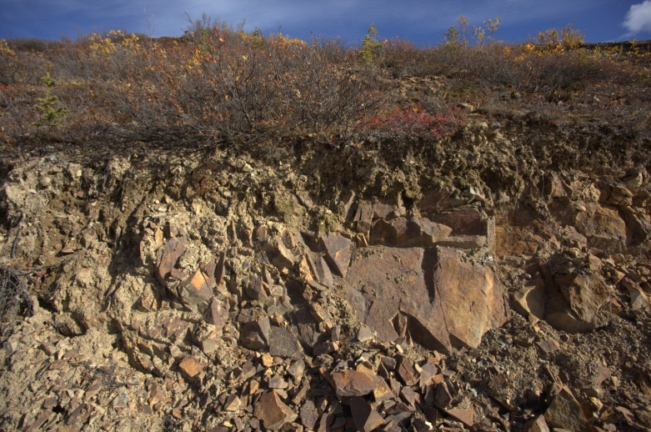  - The central portion of the project area is dominated by colluviated granodiorite from the Dawson Range Batholith.

- Mount Nansen site overview.

Surficial Geology & Soils
The absence of recent glaciation has a formative effect on contemporary ecosystems. Surficial geology and soils are described in Mount Nansen: Existing Environmental Conditions (EDI 2010). The following observations are provided to help understand the distribution of ecosystems within the project area. The generalized occurrence of parent materials through the project area is illustrated in Figure 2. The majority of the area is characterized by colluvium and weathered bedrock. Small areas of exposed rock are found in the alpine. In addition, the alluvial material found toward the Nisling River valley appears to have been deposited during the Reid glacial event (Photo 2). The result is an area bisected by lower Victoria Creek of deep glaciofluvial material. This sediment was eroded in a glacial outwash event through the Nisling Valley, which created steep sloping valley sides that support grasslands and wetlands in the valley bottom now occupied by an underfit stream.
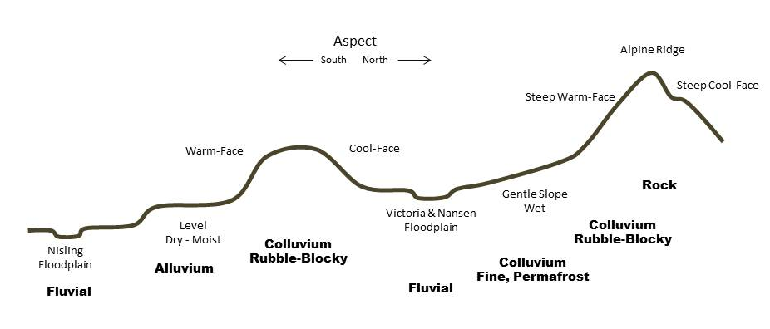
- Generalized toposequence from the Nisling River in the south to Nansen and Victoria peaks in the north.
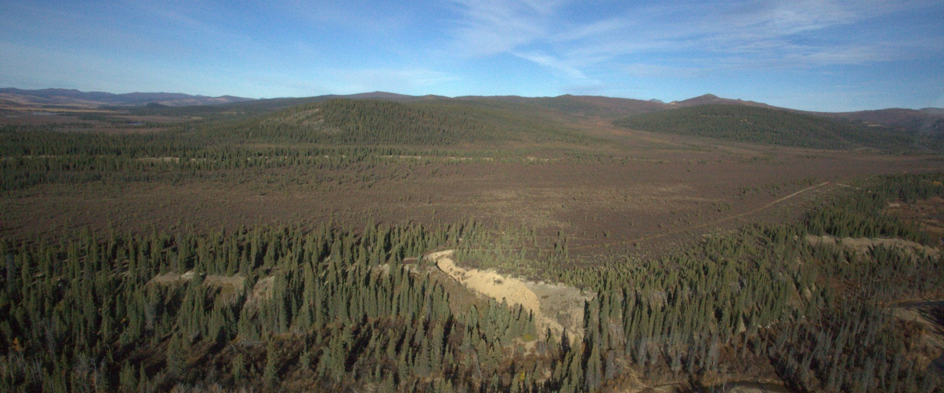
- One of the few signs of recent glacial influence is the alluvial sediment on which the airstrip is built, likely deposited in a proglacial lake.

Eolian deposits have been observed throughout the project area. These deposits are from McConnell, and possibly Reid glacial events, rather than being ongoing, as is the case in the Ruby Ranges to the southeast where loess contributes nutrients to the system. Also owing to the absence of recent glaciation, fluvial deposits are restricted to the valleys, where they are mined for placer gold.
The shallow soils in the upland areas have formed over bedrock and colluvium, rather than over till as in much of glaciated Yukon and are thought to be slightly acidic. Where permafrost is absent, the soils are well drained. Eutric Brunisols are common on drier sites, with cryosols dominating terrain affected by near-surface permafrost.

Permafrost
The project area is located in the discontinuous permafrost zone. Permafrost underlies most surfaces, with the exception of steep warm aspects (Photo 3). In the alpine, level to gently sloping areas have periglacial features such as felsenmeer fields and sorted circles, grading to stripes where slope increases. These areas host moist to wet ecosystems from rich herb communities to tussock tundra.  At mid to high elevations, the long weathering process on bedrock has produced gentle colluviated slopes. Near surface permafrost results in saturated soils that support tussock herb communities, and hummocky shrub and sparse black spruce communities.  Vegetative insulation, including a deep layer of moss on portions of the glaciofluvial terrace, north of the Nisling River and west of Victoria Creek, appears to have enabled the development of near surface permafrost. In these areas, standing water and saturated soils were observed in the late summer, indicating bog wetland conditions.  In the Nisling Valley, ice-wedge patterned ground, suggestive of ice-wedge polygons and runnel drainage on alluvial fans, indicate the presence of permafrost.  There is no detailed permafrost mapping for the project area. Near surface permafrost restricts permeability, resulting in moister conditions than the ecosystem model accounts for on the basis of slope, aspect and materials. Large scale permafrost mapping would increase the predictive capability of the model. | 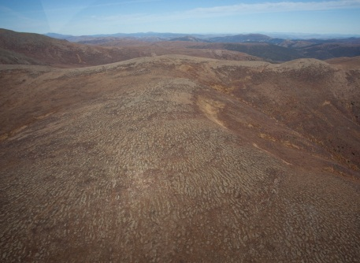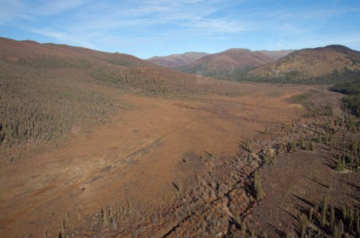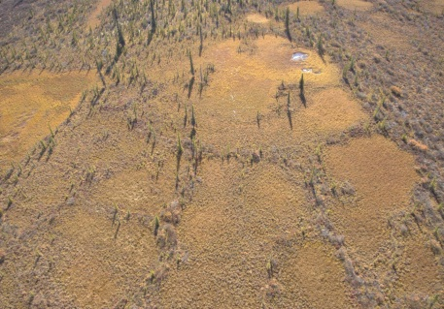  - Permafrost occurs at all elevations in the project area and has a strong influence on ecosystem distribution.

Fire History
The major disturbance agent in boreal Yukon is fire. It appears that the project area has not been subject to burns for at least the age of the trees (Figure 3, Photo 4). The small portion of the project area that burned in the 1996 fire in the Nisling Valley was sparsely treed, with a dry shrub birch/lichen understory. This understory community remains intact. A fire in 2009 burned near the southwest edge of the project area.

- Fire history within the Mount Nansen project area.

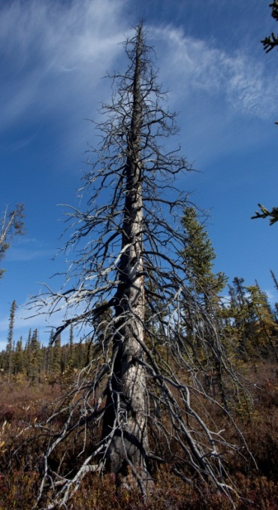
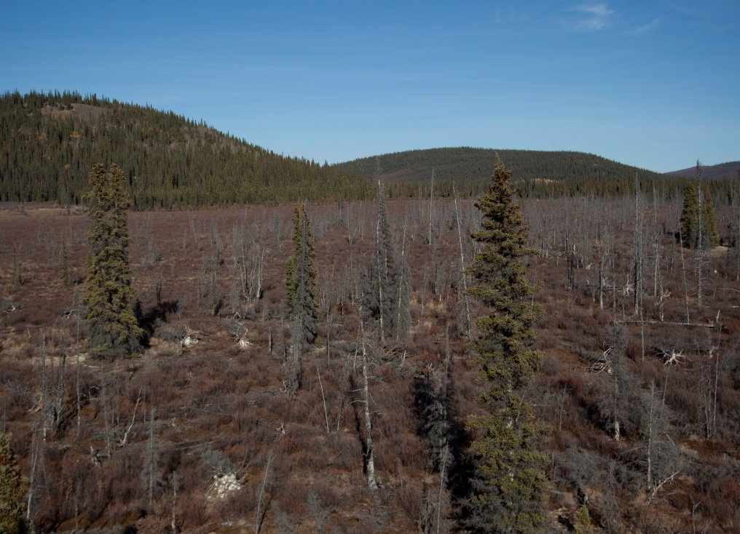
- A large fire grazed the southern edge of the project area in 1996, (left photo). The rest of the area appears to have escaped burns, evidenced by the lack of fire scarred stumps and numerous snags (right).

Vegetation
As mentioned above, permafrost has a strong influence on ecosystem distribution. This is particularly pronounced in east-west valleys in the subalpine and boreal Bioclimate Zones where permafrost on north-facing slopes results in moist, shrub dominated ecosystems, while warm aspects are better drained and dry, supporting aspect grasslands through to dry, treed ecosystems (Photo 5). Aspect is a controlling influence in the alpine too, with dry herb and shrub dominated warm aspects and rock and moist herb communities on cool aspects.  The project area lies just east of an area of high endemism for vascular plants. The Kluane-Ruby Range area, along with the Ogilvie-Wernecke Mountains and two arctic regions host numerous plants whose distribution is related to Beringia. During the September 2011 field program, one amphi-beringian plant, white gentian (Gentiana algida), was observed in the alpine, south of Victoria Mountain. It is anticipated that others also occur. | 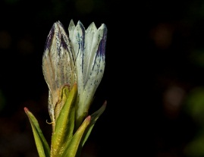  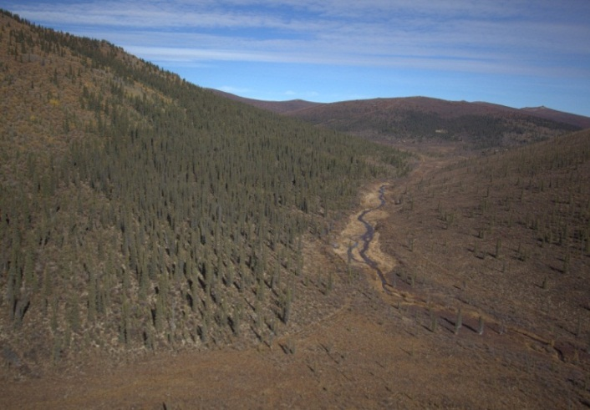  - Aspect has a major influence on ecosystem distribution, as seen in upper Victoria Creek above. Amphi-beringian plants are expected in the project area, such as White Gentian (inset).

Bioclimate Zones
The emerging ecosystem classification framework in Yukon, The Yukon Ecosystem and Landscape Classification (ELC) Framework, (Flynn and Francis 2011), concurs with frameworks from elsewhere in Canada, that climate is a central concept in ecosystem classification and mapping. Yukon has chosen to represent regional climates in the ELC framework through Bioclimate Zonation. In this approach, sites that have ecosystems that are not influenced by local conditions, such as steep slopes, cold air drainage, moisture collection on valley bottoms, and/or recent disturbance are described as typical or ‘reference’ sites. Mature plant associations on these sites are used as indicators of regional climate. Bioclimate Zones described for the project area include Alpine (ALP), Subalpine (SUB) and Boreal High (BOH) (Table 1, Figure 4).

- Description of Bioclimate Zones for the project area (based on ELC Framework).
Bioclimate Zone | Project Area % | Description
Alpine (ALP) | 13.4 | High elevations associated with mountainous conditions throughout Yukon. Dwarf shrubs, herb/cryptograms and low-growing and scattered krummholtz trees are the predominant vegetation condition. In very high elevation areas, bare rock, colluvium or ice/snow may be the dominant conditions.
Subalpine (SUB) | 61.0 | Sparsely forested areas at moderate to higher elevations on steep slopes above the BOH (or Boreal Low, BOL). Subalpine areas form a transitional zone between forested Boreal and the higher elevation non-forested (ALP). Open-canopy conifer forests (tree cover < 20%) and tall-shrub communities are characteristic vegetation conditions. Subalpine fir (Abies lasiocarpa) is the predominant tree species. Winters are long and cold, while summers are short, cool and moist.
Boreal High (BOH) | 25.6 | Middle to upper elevations of forested areas in all mountain valley and plateau ecoregions of southern and central Yukon. Found above the BOL in large valleys. Characterized by steep slopes in southern mountainous ecoregions and gentle rolling plateaus in the central ecoregions. Summers are brief, cool and moist, with long cold winters. Forests are dominated by white spruce (Picea glauca), lodgepole pine (Pinus contorta), and subalpine fir (A. lasiocarpa).

- Bioclimate Zones within the Mount Nansen project area.

Predictive Ecosystem Mapping Methods
In August 2011 this project began with gathering existing digital data to be used as spatial inputs and creating derivative products from spatial data, such as aspect, slope and topographic position models. At the same time, a Broad Ecosystem Classification was developed. Fieldwork took place from September 9 to 13, 2011. It resulted in 295 quick assessment plots. Plot forms used were designed to assist in refining the classification, test each of the spatial inputs, such as major vegetation type, and to facilitate modeling. Since the project intended to use broad ecosystem classes, detailed ecological plots were not conducted. Rather, the intent of the field program was to maximize the number of data points throughout the project area in support of the modeling effort. A field form was developed that included the model input classes, along with location data and photographs. Site and aerial photographs accompanied each site. Ecosystem modeling took place in the later fall of 2011.

Classification
The approach taken to classification for this project is to describe ecosystems that are mapable at sub-regional (1:50,000) to regional (1:100,000 to 1:250,000) map scales. These broad ecosystem classes are considered appropriate for use in land use planning, and, in this case, sub-regional wildlife habitat assessments and environmental assessments. This approach is described in more detail in the draft ELC Framework (Flynn and Francis 2011). The broad ecosystems were intended to both capture a discrete range of ecological conditions, while at the same time lend themselves to being mapped through a modeling process.
The broad ecosystems described and mapped for the Mount Nansen area were organized according to available moisture, from dry to moist, and nutrients, from poor to rich, on a generalized edatopic grid (Figure 5). Two types are included in the classification that stand outside of the grid. First is open water which is comprised of lakes and large streams that in the CanVec database are described as ‘double line’ streams. Most of the open water in the project area is found in the Nisling Valley. Second are disturbed sites. No large, recent natural disturbances, such as slope failures, were observed in the project area. There is considerable mining activity in the project area, including the Mount Nansen site and associated exploration area, placer operations in the valleys and trenching in the uplands. While mining disturbance to naturally occurring ecosystems is part of the classification, there is no interpretation available that permits its inclusion in the map. These classes are described in more detail in Section 4.0.

Modeling
The Mount Nansen predictive ecosystem model involves a series of conditional statements utilizing four primary model inputs: slope, aspect, Earth Observation for Sustainable Development (EOSD), and curvature. The results from the conditional statements were then reviewed by the Project Ecologist and subsequent manipulations were applied in order to arrive at the final ecosystem classes.
The spatial datasets that were directly used as inputs to the model include (Table 2):
- EOSD Land Cover Classification - SAFORAH;
- CanVec Base Data - streams/wetland/waterbody; NRCAN
- Digital Elevation Model (DEM); GeoBase
- Yukon Forest Cover Inventory (FCI); Yukon Government, EMR, Forest Resources

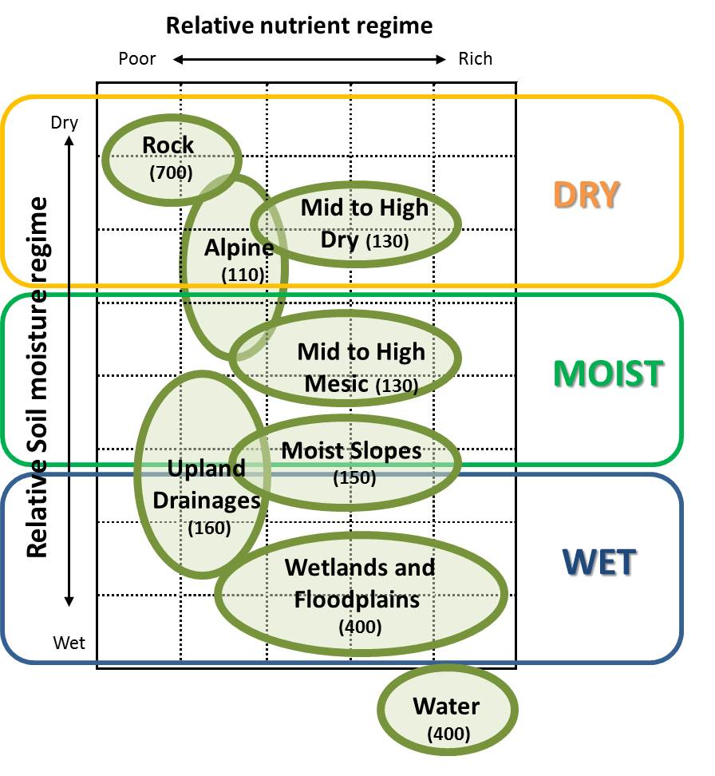
- A generalized edatopic grid provides an outline of the broad ecosystem classes present at the Mount Nansen project area.

CanVec is the newest topographic base data available. It provides the best representation of the landscape for the project area. CanVec is currently the best representation of the landscape in Yukon. It is built using several sources including the National Topographic Database (NTDB), Geobase and updates using satellite imagery. A quick visual assessment of CanVec and NTDB was done to verify the extent of association between both layers with the EOSD. Neither dataset line up perfectly with the EOSD. However, generally speaking, CanVec surpasses NTDB and does a better job at representing water bodies in the study area. A qualitative assessment using orthophotos demonstrated acceptable landscape representation.
The EOSD was modified prior to use for modeling. The modification involved filling gaps (terrain shadow and cloud). Currently, the EOSD data is the only land cover product that covers the entire project area. The EOSD for this area has terrain shadow and cloud cover. Most terrain shadow and cloud cover were filled using expert knowledge for the area based on field visits and oblique aerial photos. In the absence of more detailed terrain mapping, the FCI provided the most useful starting point for delineating riparian areas. FCI polygons were selected and merged into adjacent polygons. Riparian areas were classified based on the vegetation using the EOSD. This process involved several iterations before extracting all riparian classes as best as possible.
The alpine mask is based on the FCI Land Position A – Alpine. The Alpine class was carefully examined and it was felt that this product would be sufficient. The Upland Drainage mask was generated using a Topographic Index model TPI). A TPI is an automated way to classify the landscape into slope position and landform category. Wetlands captured by CanVec were used as the sole source of wetland information in the project area. More detailed wetland mapping was not available at the time.
The Mount Nansen modeling approach involved applying a series of mask and linking conditional statements specific to five ecosystem units. The final steps involved reclassifying the results of the conditional statements in ecosystem classes. The modeling approach followed the subsequent steps:
- Derive slope classes from DEM;
- Derive aspect classes from DEM;
- Derive bioclimate from DEM, EOSD, and FCI;
- Derive a curvature model from DEM;
- Generate mutually exclusive masks:
  - Riparian mask;
  - Wetland mask;
  - Upland drainage mask; and
  - Alpine mask;
- Apply series of conditional statements; and
- Reclassify results to ecosystem classes.

- Input class definitions
Bioclimate | Re-class |  | Aspect | Re-class
BOL (-450) | 1 |  | Warm (135-285) | 2
BOH (450-1100) | 2 |  | Cold (285-135) | 3
SUB (1100-1500) | 3
ALP (1500+) | 4 |  | Curvature | Re-class
 |  |  | 1 | Concave
Slope Class (%) | Re-class |  | 2 | Convex
0-3 | 1 (plain) |  | 3 | Flat
3-15 | 2 (gentle) |  | 4 | >5 degree slope
15-26 | 3 (moderate)
26-35 | 4 (steep) |  | EOSD | Description
35-45 | 5 (very steep) |  | 0 | No Data
45-55 | 6 (extremely steep) |  | 11 | Cloud
 |  |  | 12 | Shadow
Forest Cover Inventory | Description |  | 20 | Water
SW | White Spruce |  | 31 | Snow/Ice
P | Pine |  | 32 | Rock/Rubble
SB | Black Spruce |  | 33 | Exposed/Barren Land
F | Fir |  | 40 | Bryoids
A | Aspen |  | 50 | Shrubland
B | Balsam Poplar |  | 51 | Shrub Tall
W | White Birch |  | 52 | Shrub Low
 |  |  | 81 | Wetland-Treed
TPI | Re-class |  | 82 | Wetland-shrub
Upland drainage | 1 |  | 83 | Wetland-herb
Valley | 2 |  | 100 | Herbs
Gentle slope | 3 |  | 211 | Coniferous-dense
Plain | 4 |  | 212 | Coniferous-open
Steep lower slope | 5 |  | 213 | Coniferous-sparse
Open slope | 6 |  | 221 | Broadleaf-dense
Mid-slope | 7 |  | 222 | Broadleaf-open
Upper slope | 8 |  | 231 | Mixewood-dense
Ridge | 9 |  | 232 | Mixewood-open
 |  |  | 233 | Mixewood-sparse

Nansen Ecosystem Units
Based on application of the methods described above, the ecosystem units were classified into Alpine, Mid to High elevation, Wet, and Disturbance-related ecosystems (Table 3). An overview of the Mount Nansen area by ecosystem unit is provided in Figure 6. Descriptions of the units and subunits are described in the following sections.
- Outline of broad ecosystem classifications for the Mount Nansen project area.
Ecosystem ID | Ecosystem Unit | Bioclimate Zones | General Elevation (masl) | Moisture Regime
Alpine Ecosystems
700 | High elevation rock | BOH/SUB/ALP | 450 - 1500+ | Dry
111 | High elevation ridges - herb | SUB/ALP | 1100 - 1500+ | Dry
112 | High elevation ridges - shrub
Mid to High Elevation Ecoysystems
131 | Mid to high elevation - herb | BOH/SUB | 450 - 1500 | Dry
132 | Mid to high elevation - shrub
133 | Mid to high elevation - deciduous
134 | Mid to high elevation - mixedwood
135 | Mid to high elevation - coniferous
141 | Mid to high elevation - herb | BOH/SUB | 450 - 1500 | Mesic
142 | Mid to high elevation - shrub
145 | Mid to high elevation - coniferous
151 | Mid to high elevation - herb | BOH/SUB | 450 - 1500 | Moist
152 | Mid to high elevation - shrub
155 | Mid to high elevation - coniferous
Wet Ecosystems
161 | Mid to high elevation upland drainage - herb | BOH/SUB/ALP | 450 - 1500+ | Wet
162 | Mid to high elevation upland drainage - shrub
165 | Mid to high elevation upland drainage - coniferous
311 | Wetlands - herb | BOH/SUB | 450 - 1500 | Wet
312 | Wetlands - Shrub
371 | Wetland Floodplain, gravel bar - herb
372 | Wetland Floodplain - shrub
383 | Wetland Floodplain - deciduous
395 | Wetland Floodplain - coniferous
401 | Water - lake/rivers | - | - | -
Anthropogenic
503 | Disturbance | - | - | -

- Overview of the Mount Nansen Ecosystem Units.

Alpine Ecosystems

Topographic Profile
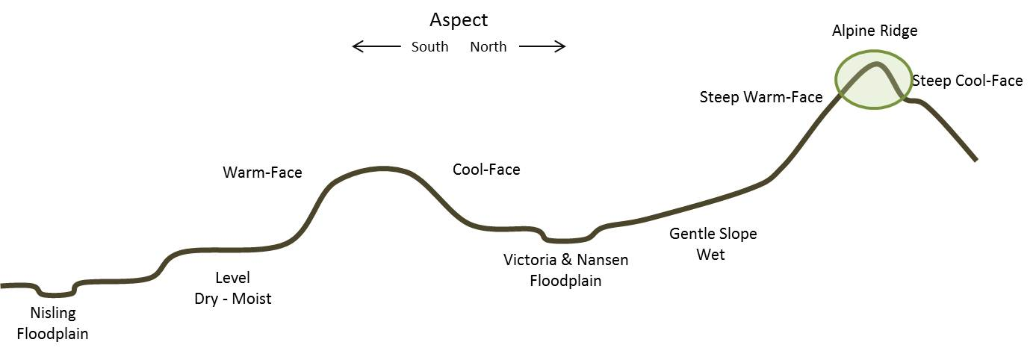
Edatopic Position
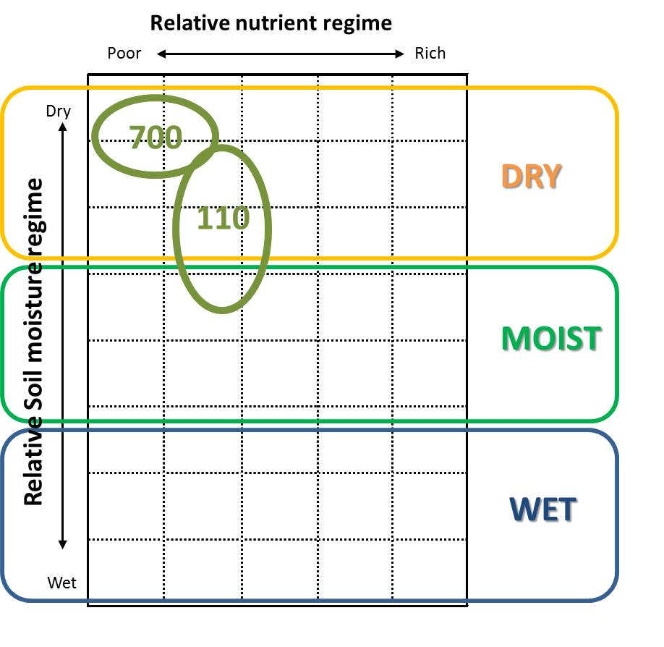 | 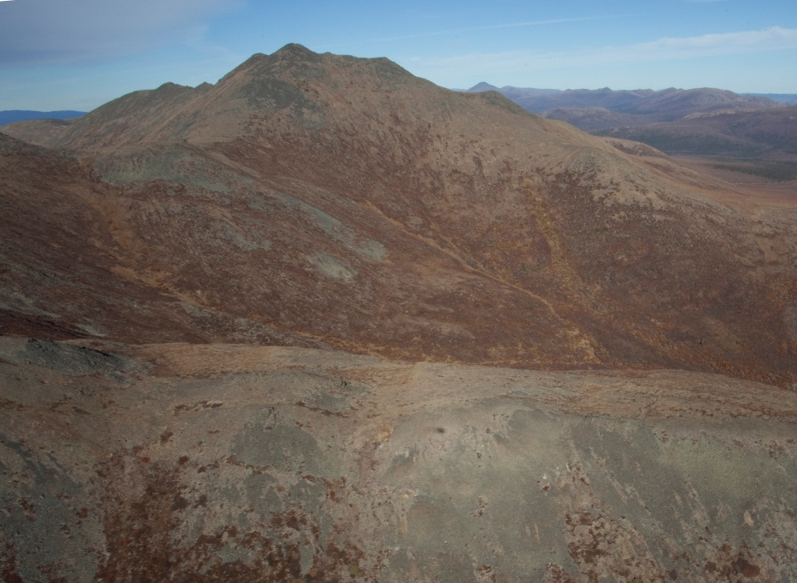
Description
The alpine ecosystems within the project area are limited to the northeast and northwest, centred on Victoria and Nansen (photo above) peaks respectively. A smaller area occurs in the central portion of the project area at the headwaters of Back, Discovery and Webber creeks. The Nansen and central area alpine are underlain by andesite, which weathers to rounded peaks and ridges, with well drained colluvium and slightly acidic soils. The syenite of Victoria Mountain is more resistant to weathering, producing the highest and steepest alpine in the project area. Gentle ridges and extensive shallow slopes to the east of Victoria Mountain are comprised of granodiorite. This area includes large areas of moist to wet alpine with periglacial features such as solifluction lobes and sorted circles

High Elevation Rock (BOH, SUB, ALP)
Rock (700)
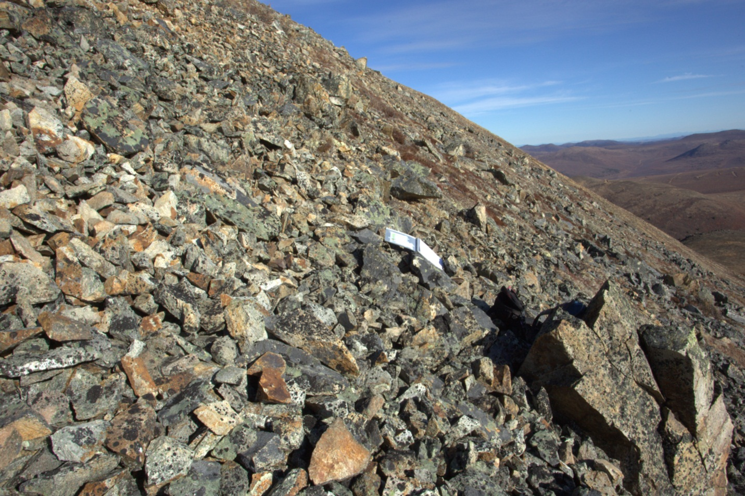
Description
Exposed rock in the project area is limited to the Alpine Bioclimate Zone around Victoria and Nansen peaks. In both cases, the rock is in the form of bedrock weathered to rubbly to blocky colluvium. Except on steep slopes, the exposed colluvium is covered by varying amounts of lichen and is partially infilled by mosses and mats of alpine forbs, such as Saxifraga tricuspidata, and ground shrubs, particularly Empetrum nigrum.
Information Table
BEU Group: Dry Ecosystems; BEU Type: Rock (700); BEU Phase: Rock (700)
Bioclimate Zones: BOH, SUB, ALP | Slope Conditions: crest
Soil Conditions: Regosols | Aspect Conditions: crest
Total Project Area: 0.6% | Seral Position: stable
Portion of Bioclimate Zone: BOH 0.1%; SUB 0.1%; ALP 4.5 %

High Elevation Ridges (SUB, ALP)
Ridge – Herb (111)
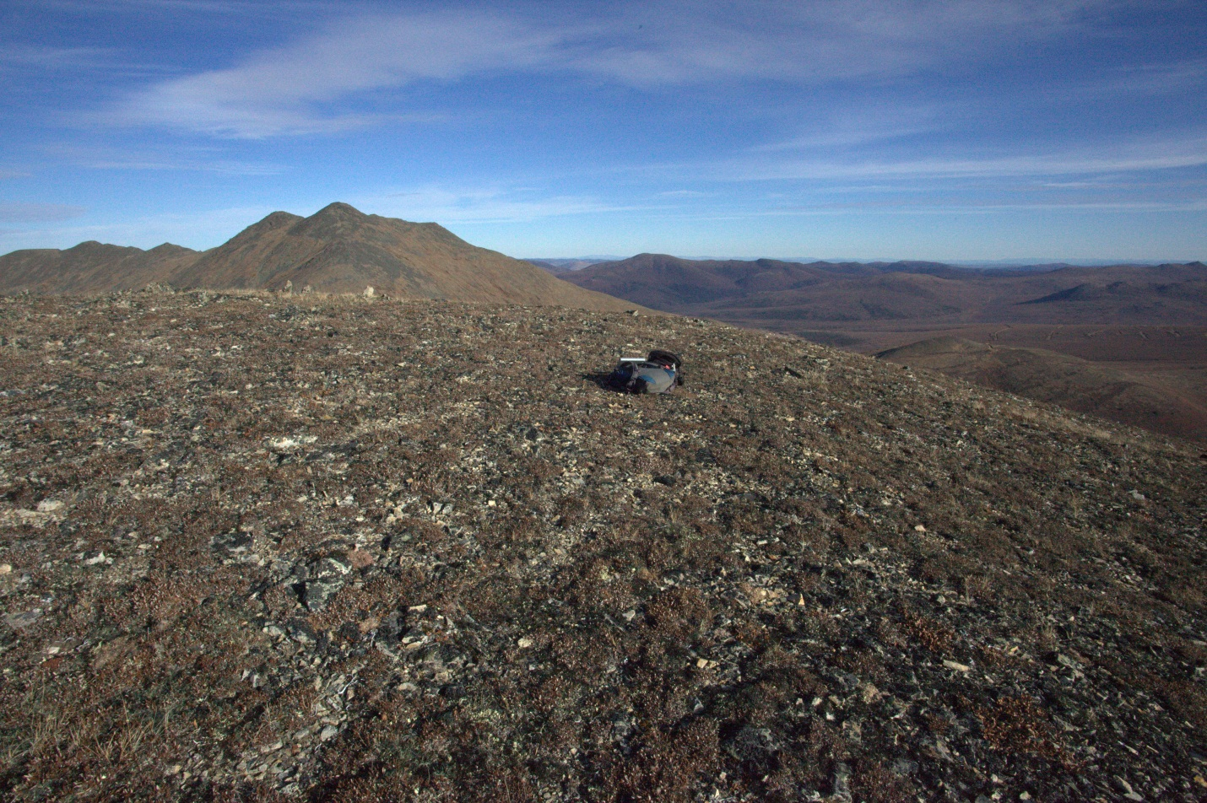
Description
This unit is the most extensive of the alpine ecosystems, covering over half of the alpine and 7.8 percent of the project area. Sites are very dry to submesic with limited soil development. Dry sites can be dominated by Dryas spp. and lichens, and may also include ground shrubs including Empetrum nigrum, Arctostaphylos uva-ursi, A. rubra, Salix sp, and prostrate Betula glandulosa. Cool aspects support wetter conditions where Cassiope tetragona-lichen associations dominate, with forbs such as Polygonum bistorta and Saussurea angustifolia. In the northeast of the project area, level to gentle slopes affected by near-surface permafrost are moist, with tussock tundra vegetation.
Information Table
BEU Group: Dry Ecosystems; BEU Type: Ridge (110); BEU Phase: Herb (111)
Bioclimate Zones: SUB, ALP | Slope Conditions: crest
Soil Conditions: Regosols & Cryosols | Aspect Conditions: crest
Total Project Area: 7.8% | Seral Position: stable
Portion of Bioclimate Zone: SUB 0.3%; ALP 56.5%

High Elevation Ridges (SUB, ALP)
Ridge – Shrub (112)
Description
This unit comprises one quarter of the ALP Zone. It is dominated by dry to mesic Betula glandulosa-lichen associations, with inclusion of Ledum decumbens, Empetrum nigrens, and pockets of Salix sp. This unit grades into Dry Shrub (132) and Mesic Shrub (142) in the SUB Zone.
Information Table
BEU Group: Dry Ecosystems; BEU Type: Ridge (110); BEU Phase: Shrub (112)
Bioclimate Zones: SUB, ALP | Slope Conditions: crest
Soil Conditions: Regosols & Cryosols | Aspect Conditions: crest
Total Project Area: 3.4% | Seral Position: stable
Portion of Bioclimate Zone: SUB 0.3%; ALP 24.3%

Mid- to High- Elevation Ecosystems

Topographic Profile
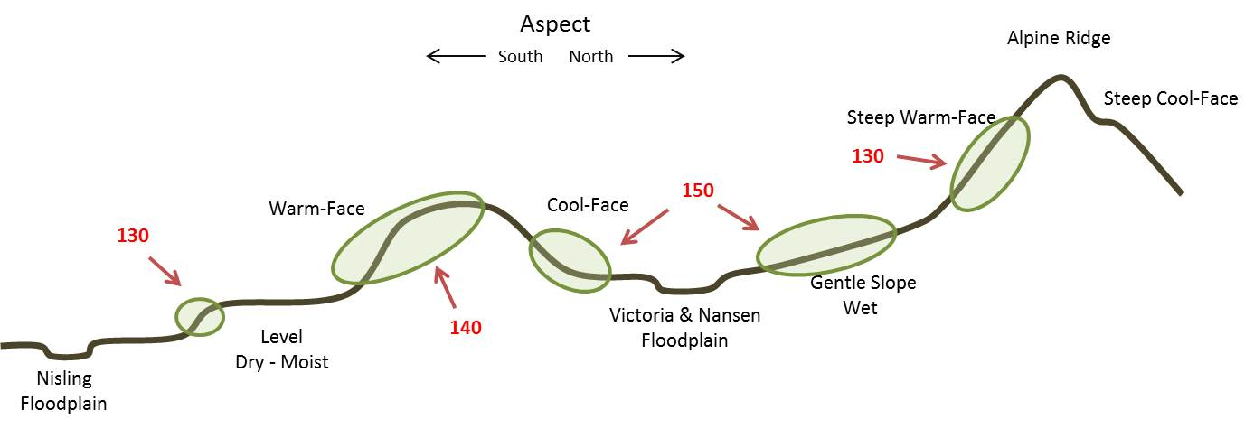
Edatopic Position
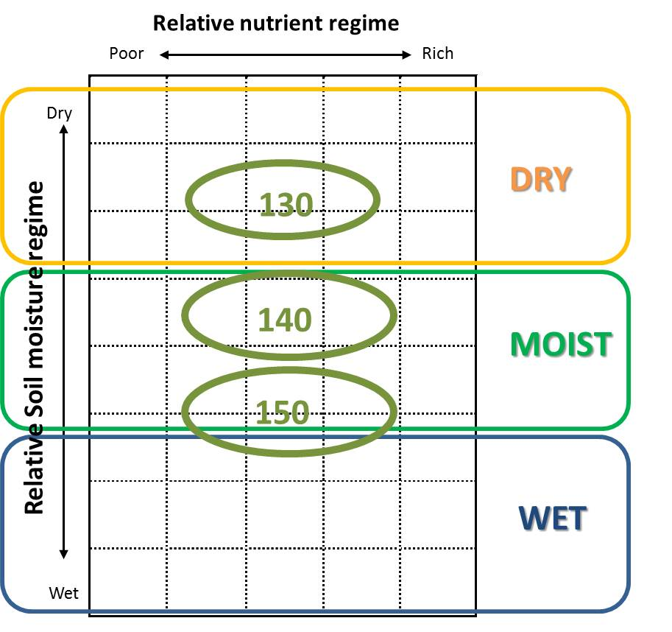 | 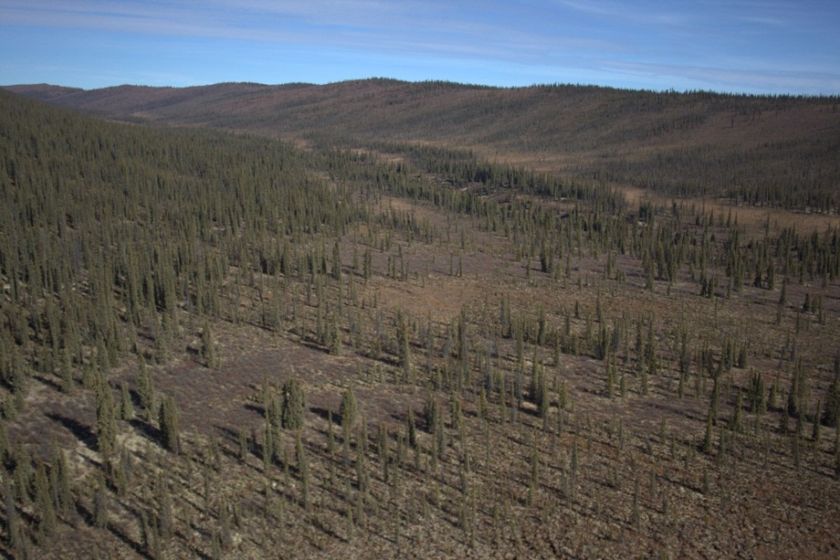
Description
Mid to High Elevation Dry (130) occurs throughout the project area on ridges and moderate to steep warm-aspect slopes. Permafrost is either absent or the active layer is sufficiently deep to enable good surface drainage. This type generally occurs on colluvium and accounts for over one third of the project area.
Mid to High Elevation Mesic (140) is also found through the project area, though it tends to be on gentle to steep cool-aspect slopes. Macro terrain can be mounded to hummocky, with near surface permafrost. This type accounts for one quarter of the project area, with the shrub phase (142) being most extensive.
Mid to High Elevation Moist (150) in the Mount Nansen area refers to the ecosystems that form on the smooth ancient surfaces that have formed at the toes of mountains, adjacent to the two main north south valleys. The material is fine- weathered colluvium that is well insulated by vegetation, enabling the development of near-surface permafrost. Moisture from above flows across the surface, with a minimum of runnelling or channel development.
Middle to High Elevation – Dry (BOH, SUB)
Herb 131
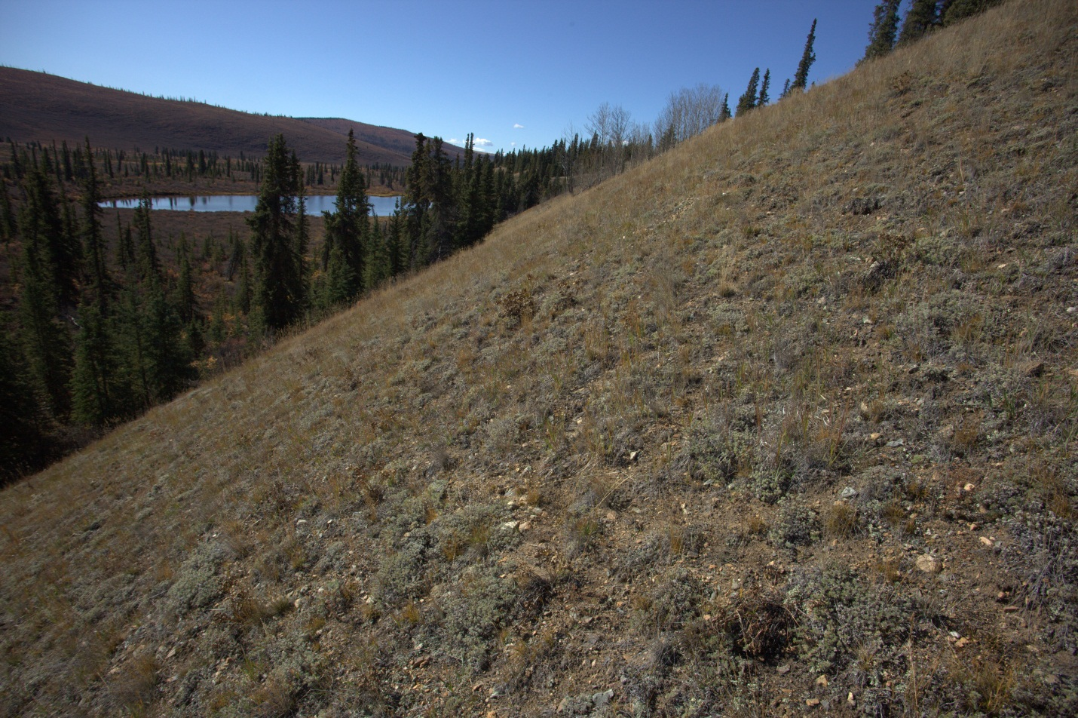
Description
This ecosystem is found on the bluffs along the north side of the Nisling Valley (above) as a grassland community on exposed glaciofluvial material. Grasses and Artemesia sp. dominate steep open areas. On shallower slopes, ground- shrub mats develop, mostly Arctostaphylos uva-ursi with gradual infill by Populus tremuloides. At higher elevations in the BOH Zone, this unit is found on south facing slopes and dry ridges. It is most extensive in the SUB Zone where it grades into ALP herb (111) at high elevations.
Information Table
BEU Group: Dry Ecosystems; BEU Type: Steep Warm Slopes (130); BEU Phase: Herb (131)
Bioclimate Zones: BOH, SUB |  | Slope Conditions: ridge and steep warm slope
Soil Conditions: Brunisols |  | Aspect Conditions: warm
Total Project Area: 6.9% |  | Seral Position: stable
Portion of Bioclimate Zone: BOH 5.2%; SUB 9.8%

Middle to High Elevation – Dry (BOH, SUB)
Shrub (132)
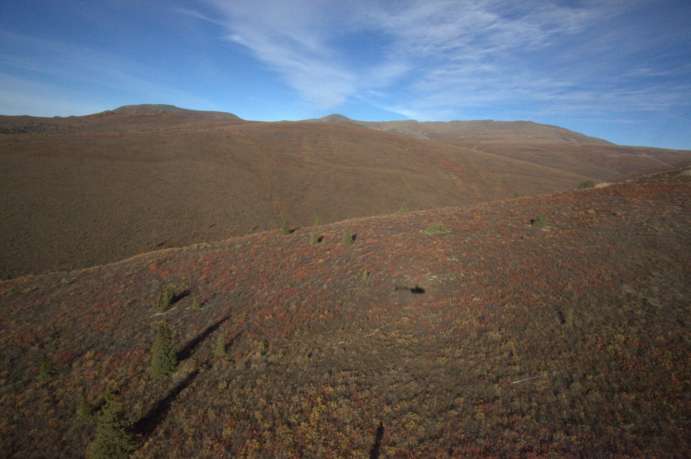
Description
This is the most common ecosystem unit, covering over 20 percent of the project area. Together with moister shrub ecosystems, shrub covers one half of the project area. Dry shrub (132) is found mostly on colluvium with warm aspects. The ecosystem is dominated by Betula glandulosa, with a varying component of sparse Salix pulchra and other Salix. sp. Understory shrubs include Vaccinium uliginosum and Empetrum nigrum. It is considered to be serally stable in this region. It is also found on the driest portion of the glaciolfluvial habitat, where open Picea glauca forests are encroaching.
Information Table
BEU Group: Dry Ecosystems; BEU Type: Steep Warm Slopes (130); BEU Phase: Shrub (132)
Bioclimate Zones: BOH, SUB | Slope Conditions: ridge and steep warm slope
Soil Conditions: Brunisols | Aspect Conditions: warm
Total Project Area: 21.7% | Seral Position: stable
Portion of Bioclimate Zone: BOH 16.2%; SUB 29.2%
Middle to High Elevation – Dry (BOH, SUB)
Deciduous (133) & Mixedwood (134)
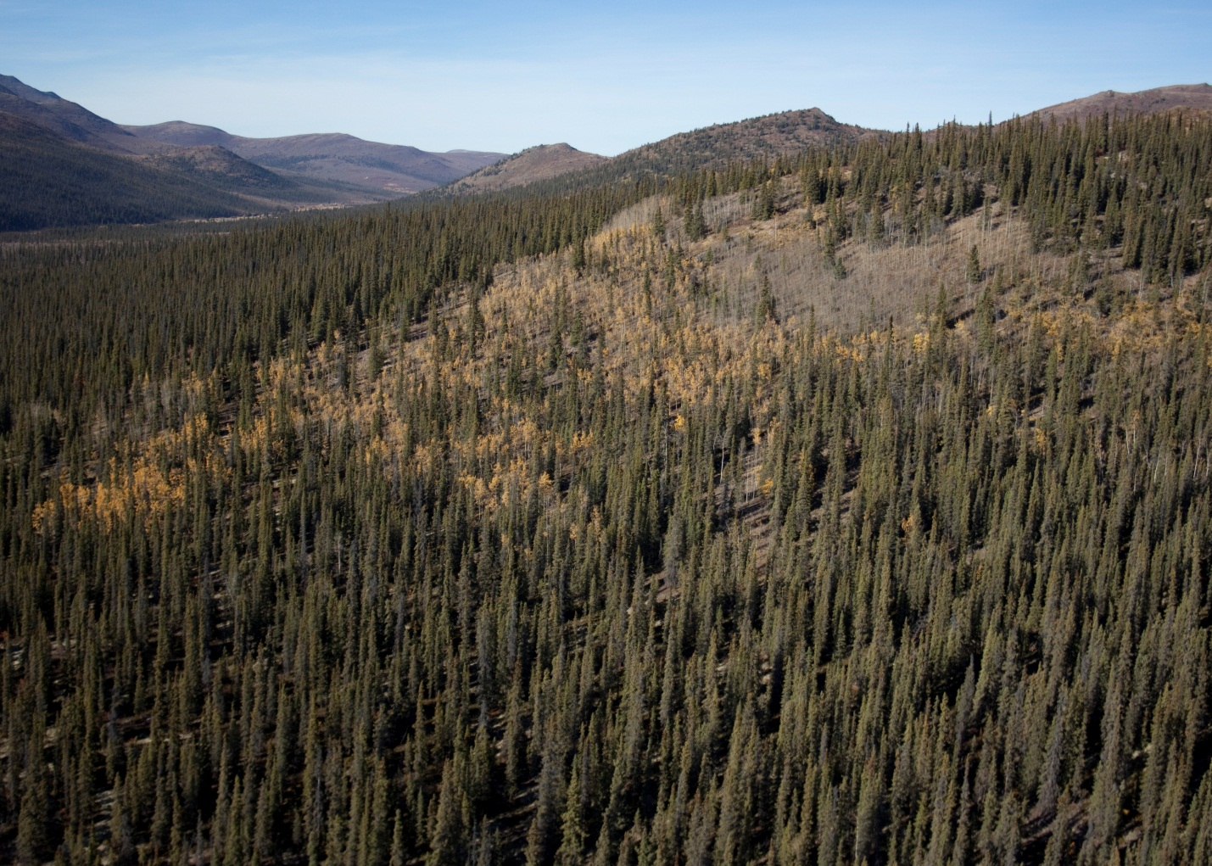
Description
Unlike boreal areas with recent burns, the deciduous component within the project area is uncommon and is limited to Populus tremuloides on dry, steep, south-facing slopes. It is considered to be relatively stable, though may fill in with Picea glauca over time.
Information Table
BEU Group: Dry Ecosystems; BEU Type: Steep Warm Slopes (130); BEU Phase: Deciduous (133) & Mixedwood (134)
Bioclimate Zones: BOH, SUB | Slope Conditions: ridge and steep warm slope
Soil Conditions: Brunisols | Aspect Conditions: warm
Total Project Area: 0.4% | Seral Position: stable
Portion of Bioclimate Zone: BOH 1.5%; SUB 0.1%

Middle to High Elevation – Dry (BOH, SUB)
Coniferous (135)
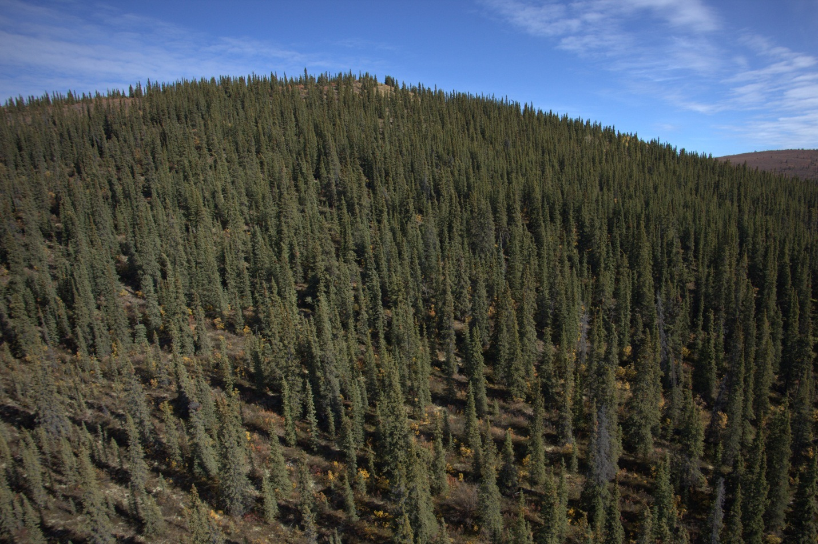
Description
Forested ecosystems account for less than 13 percent of the project area, with dry coniferous forests (135) accounting for 6%. These forests occur primarily in the BOH Zone on dry crests and south-facing slopes over colluvium. Understory shrubs include sparse Salix sp., Rosa acicularis, and Arctostaphylos uva-ursi, with forbs such as Geocaulon lividum and over 50 percent lichen cover. Snags and fallen trees are common. Pinus contorta was not observed in the project area.
Information Table
BEU Group: Dry Ecosystems; BEU Type: Steep Warm Slopes (130); BEU Phase: Coniferous (135)
Bioclimate Zones: BOH, SUB | Slope Conditions: ridge and steep warm slope
Soil Conditions: Brunisols | Aspect Conditions: warm
Total Project Area: 6.1% | Seral Position: stable
Portion of Bioclimate Zone: BOH 13.5%; SUB 4.4%

Middle to High Elevation – Mesic (BOH, SUB)
Herb (141)
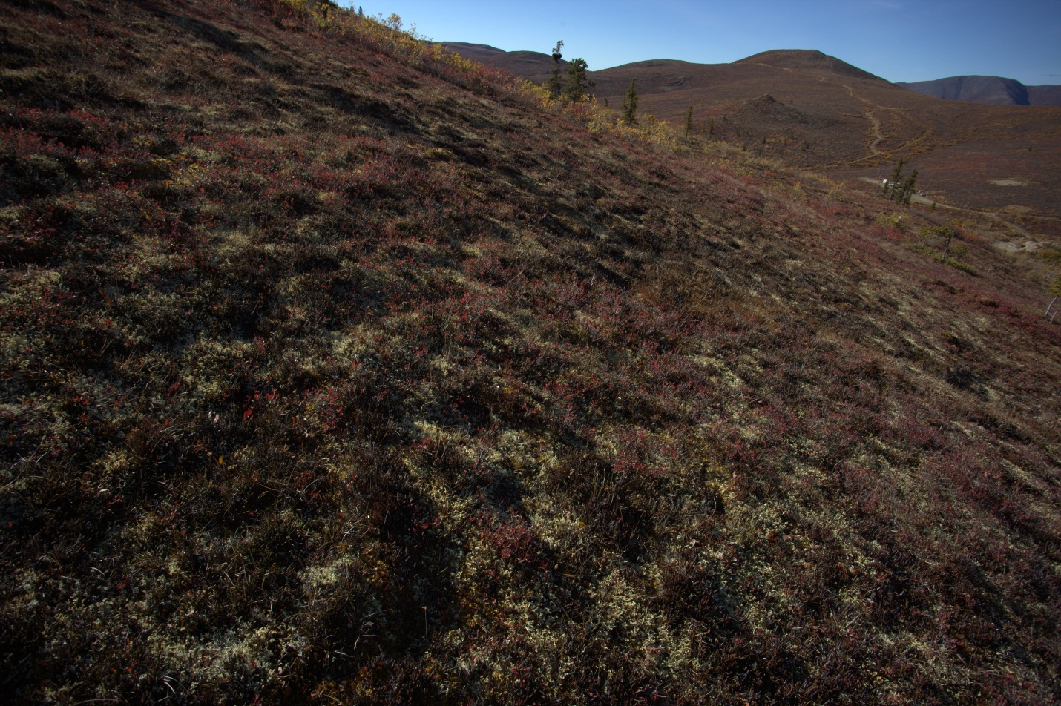
Description
This ecosystem is common in the SUB Zone, where it grades into moist alpine herb (111) at the upper elevations, and at lower elevations in the SUB and throughout the BOH Zone on cool aspects. It is dominated by moss and lichen, with low shrubs such as Cassiope tetragona, Betula glandulosa, and Salix reticulata, along with moisture tolerant herbs and grasses.
Information Table
BEU Group: Moist Ecosystems; BEU Type: Steep North Slope (140); BEU Phase: Herb (141)
Bioclimate Zones: BOH, SUB | Slope Conditions: gentle to steep
Soil Conditions: Brunisols or Cryosols | Aspect Conditions: cool
Total Project Area: 5.2% | Seral Position: stable
Portion of Bioclimate Zone: BOH 1.9%; SUB 8.1%

Middle to High Elevation – Mesic (BOH, SUB)
Shrub (142)
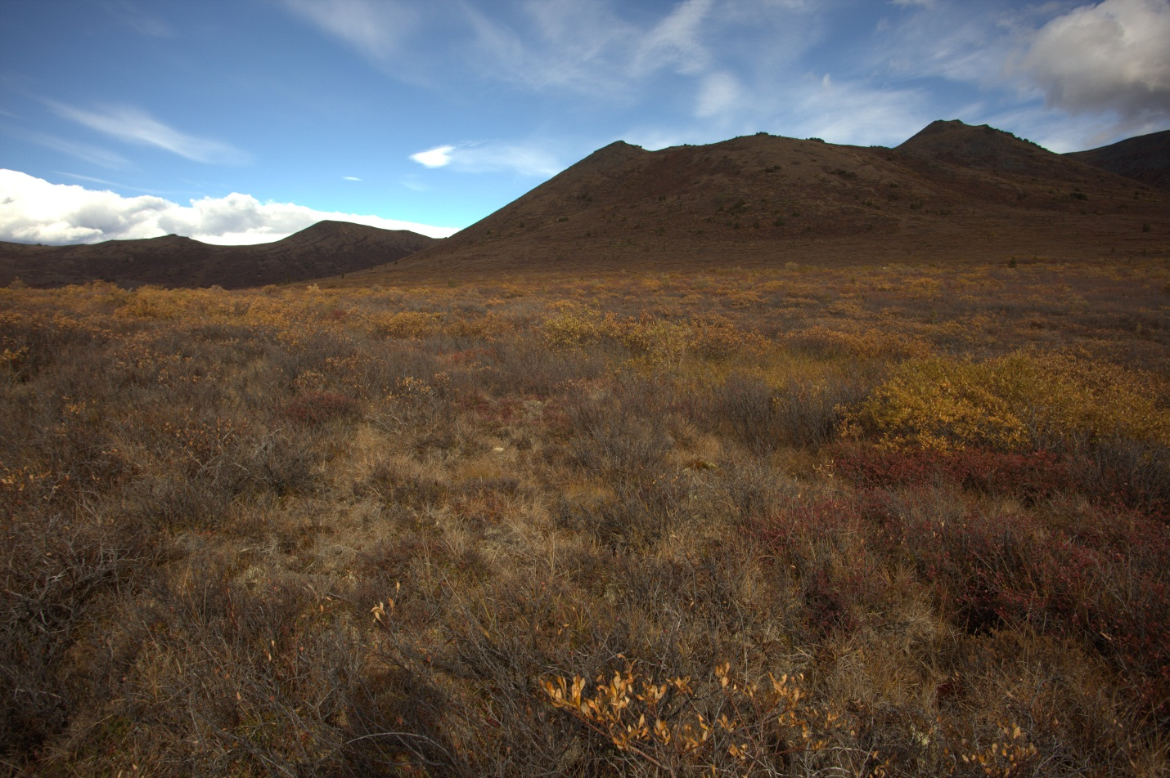
Description
After dry shrub (141), this is the most common ecosystem unit, covering 16% of the project area. It occurs mostly on colluvium on level to gently sloping, cool aspects. Betula glandulosa is the most dominant shrub, while Salix sp. are more dominant than in drier shrub sites. Low shrubs include Ledum sp., Vaccinium uliginosum, and Empetrum nigrum. Grasses are well developed at the drier end, while feather moss-lichen dominate ground cover on moister sites.
Information Table
BEU Group: Moist Ecosystems; BEU Type: Steep North Slope (140); BEU Phase: Shrub (142)
Bioclimate Zones: BOH, SUB | Slope Conditions: gentle to steep
Soil Conditions: Brunisols or Cryosols | Aspect Conditions: cool
Total Project Area: 16.5% | Seral Position: stable
Portion of Bioclimate Zone: BOH 7.0%; SUB 24.6%

Middle to High Elevation – Mesic (BOH, SUB)
Coniferous (145)
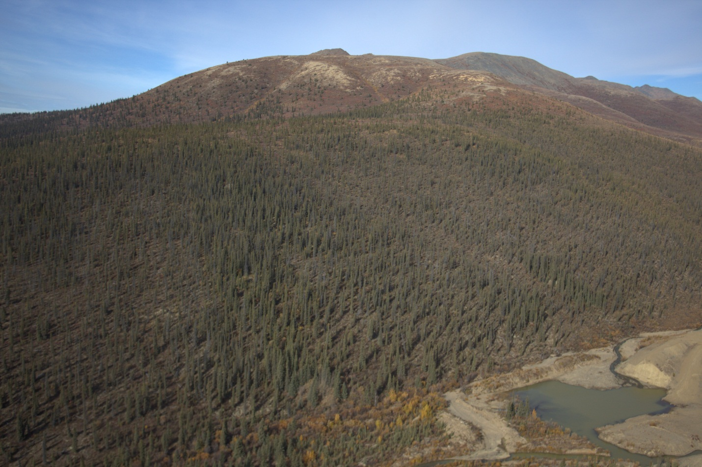
Description
These sparse to open forests are distinguished from dry coniferous ecosystems (135) mostly by aspect, with this ecosystem unit occurring on cool, gentle to modest slopes. These moist forests occur mostly within the BOH Zone. They appear to be permafrost affected. Understory shrubs are dominated by Betula glandulosa, and ground cover is largely feathermoss-lichen. Mesic forests were observed on level glaciofluvial sites where permafrost is limiting surface drainage, and on aeolian material over colluvium on gentle slopes. Abies lasiocarpa was not observed in the project area.
Information Table
BEU Group: Moist Ecosystems; BEU Type: Steep North Slope (140); BEU Phase: Coniferous (145)
Bioclimate Zones: BOH, SUB | Slope Conditions: gentle to steep
Soil Conditions: Brunisols or Cryosols | Aspect Conditions: cool
Total Project Area: 3.1% | Seral Position: stable
Portion of Bioclimate Zone: BOH 4.0%; SUB 3.4%

Middle to High Elevation – Moist (BOH, SUB)
Herb (151)
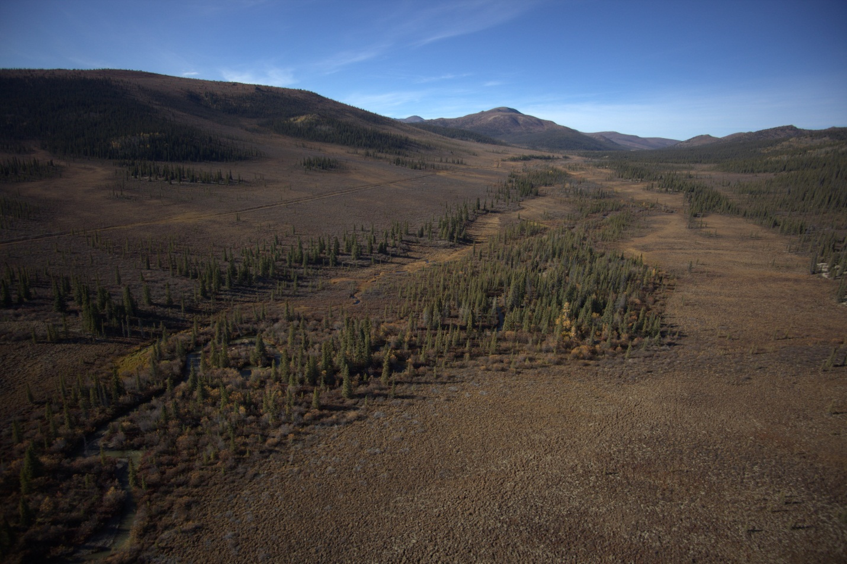
Description
This unit occurs on gentle colluvial slopes of less than 10 degrees that are affected by permafrost. The wettest sites support tussock tundra type herb communities (light areas on slopes beyond stream, above). These ecosystems are concentrated in the BOH Zone, but extend into the SUB Zone. Similar herb communities also occur at lower elevations on level, alluvial plains adjacent to Nansen (foreground) and Victoria creeks.
Information Table
BEU Group: Moist Ecosystems; BEU Type: Gentle Slope- Periglacial (150); BEU Phase: Herb (151)
Bioclimate Zones: BOH, SUB | Slope Conditions: gentle to steep
Soil Conditions: Cryosols | Aspect Conditions: neutral to cool
Total Project Area: 4.6% | Seral Position: stable
Portion of Bioclimate Zone: BOH 7.0%; SUB 4.9%

Middle to High Elevation – Moist (BOH, SUB)
Shrub (152)
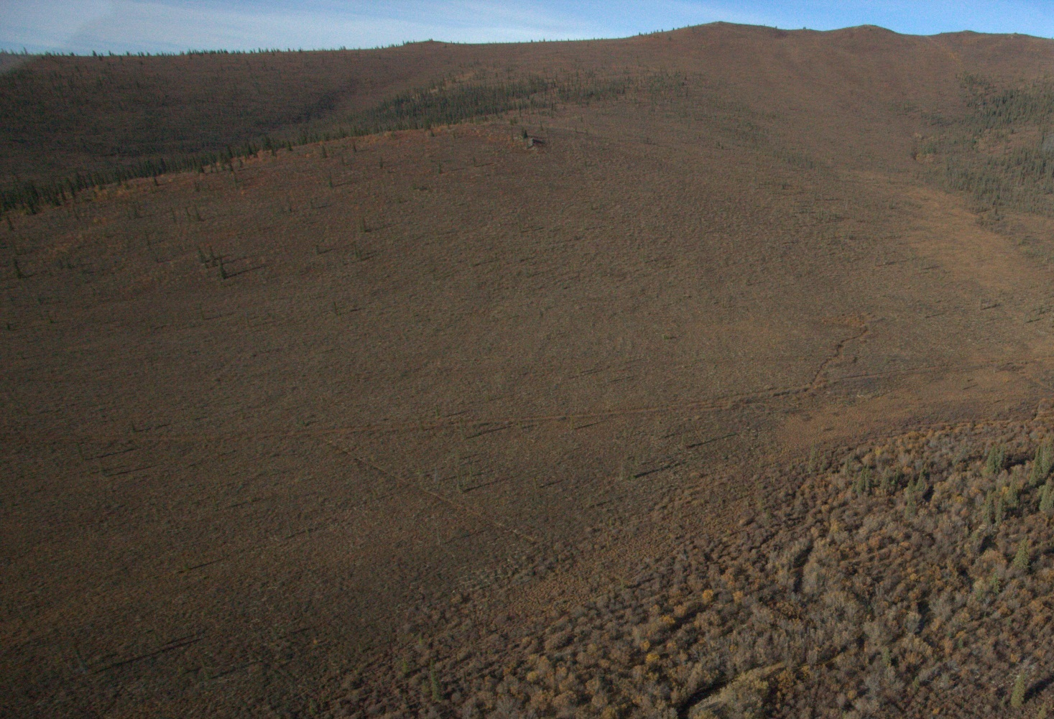
Description
Conditions are similar to moist herb (151), but are slightly drier, allowing for shrub growth. The dominant shrub is Betula glandulosa, with Ledum sp, Salix sp., Vaccinium uliginosum and V. vitis-idaea. Forbs include moisture tolerant species such as Petasites frigidus, Rubus chamaemorus and Pyrola sp., along with sedge, rush and grass species. Ground cover includes moss and lichen in depressions and drier lichens, such as Cladina rangiferina on hummocks. These shrub communities are stable.
Information Table
BEU Group: Moist Ecosystems; BEU Type: Gentle Slope- Periglacial (150); BEU Phase: Shrub (152)
Bioclimate Zones: BOH, SUB | Slope Conditions: gentle slope
Soil Conditions: Cryosols | Aspect Conditions: neutral to cool
Total Project Area: 8.1% | Seral Position: stable
Distribution by Bioclimate Zone: BOH 13.6%; SUB 7.7%

Middle to High Elevation – Moist (BOH, SUB)
Coniferous (155)
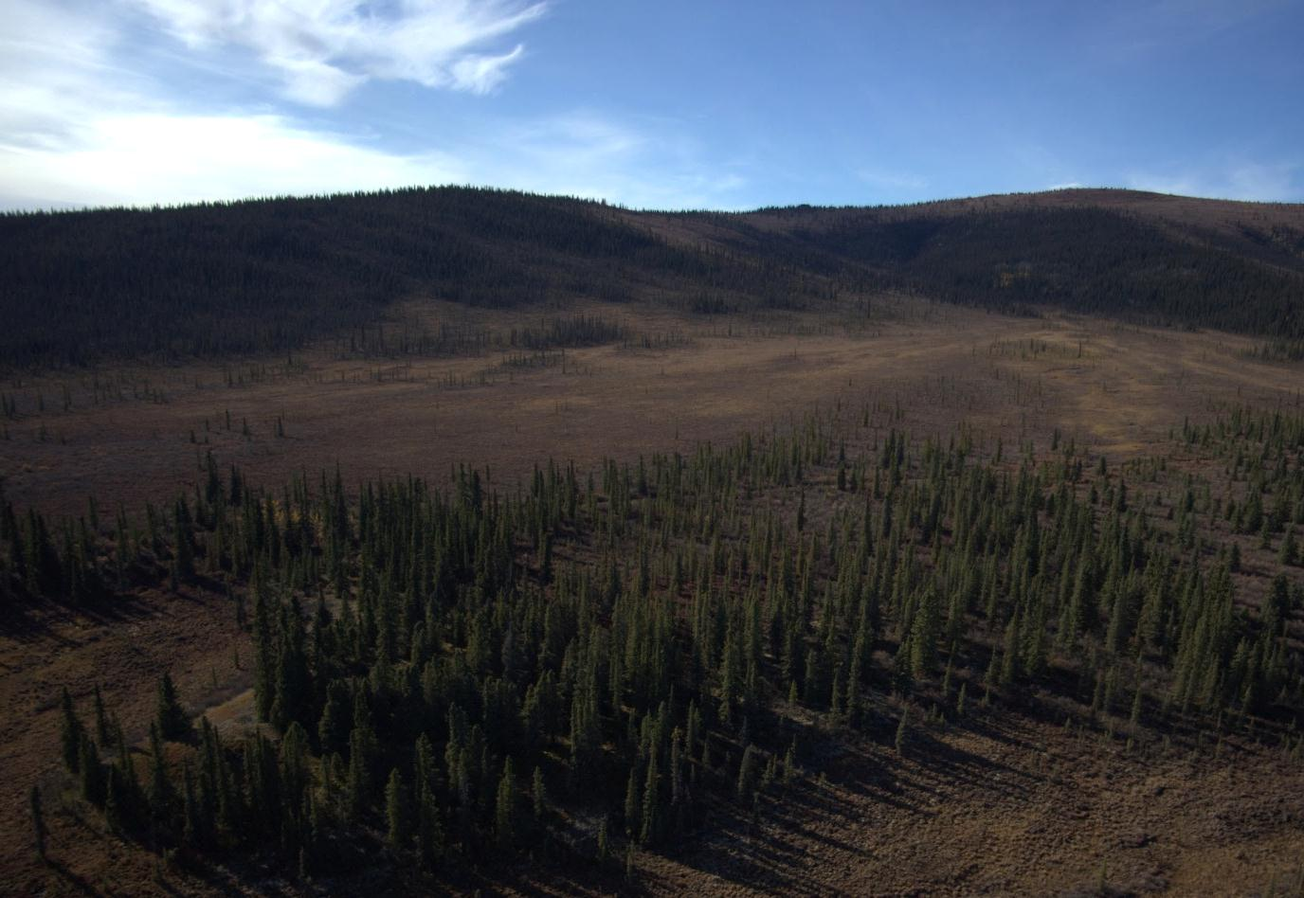
Description
While still moist, this ecosystem occupies the driest of the gentle cool, permafrost affected sites. Shrub sites (152) grade into sparse Picea glauca (possibly some P. mariana) forests. The shrub and forb components are thought to be similar to 152.
Information Table
BEU Group: Moist Ecosystems; BEU Type: Gentle Slope- Periglacial (150); BEU Phase: Coniferous (155)
Bioclimate Zones: BOH, SUB | Slope Conditions: gentle slope
Soil Conditions: Cryosols | Aspect Conditions: neutral to cool
Total Project Area: 1.4% | Seral Position: stable
Portion of Bioclimate Zone: BOH 3.9%; SUB 0.6%

Wet Ecosystems

Topographic Profile
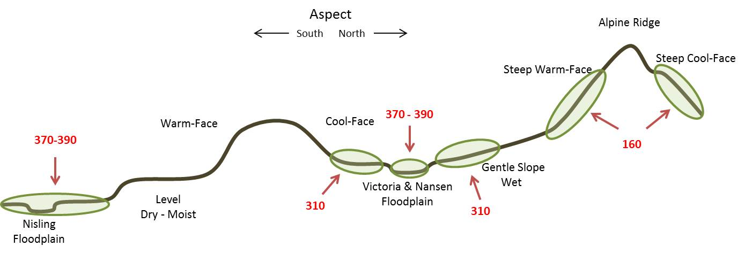
Edatopic Position
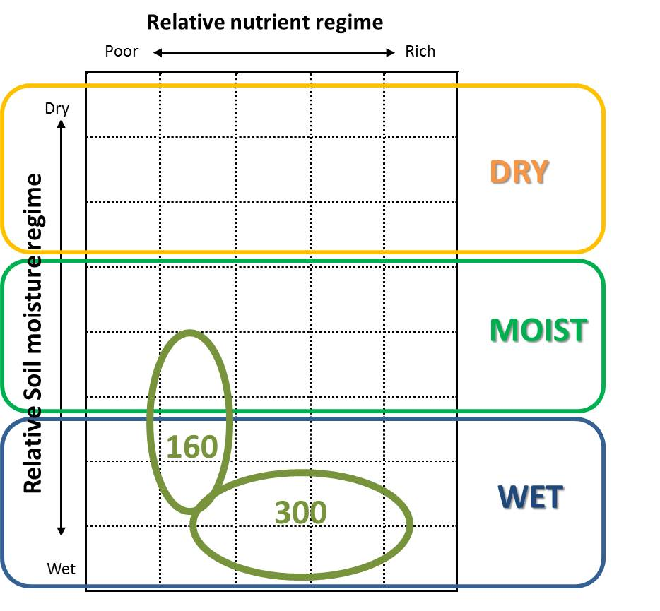 | 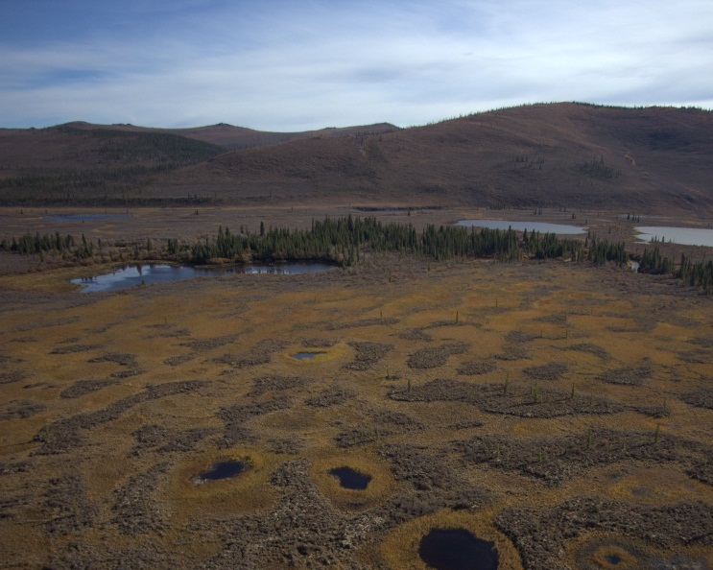
Description
High Elevation Drainages (160) are common in the upper BOH through to the ALP zones. In this unglaciated landscape, small ephemeral streams occupy the V-shaped catchments between adjacent mountain slopes, supporting more vigorous vegetation growth. These sites are wettest in spring. The largest sites remain wet to moist throughout the summer, while smaller or steeper catchments may become dry. This type covers six percent of the project area.
Wetlands (310), defined as areas where soils are saturated year-round, in a manner influencing soil development and vegetation associations, occur throughout the project area. Small wet sites occur throughout the project area, including the alpine that are too small to map. The larger wetland complexes are concentrated in the BOH Zone, and are defined here by the lead vegetation expression as being herb (311), shrub (312) or treed (315) wetlands. This type covers only two percent of the project area.
Floodplains (370/380/390) are wetlands found in association with active stream channels. They are in a seral progression from young gravel bars and herb marshes (371) to shrub marshes (372), to mid-seral deciduous (382) and mixedwood (384) forests on frequently flooded terraces, through to mature white spruce forests (395) on elevated benches. This type also covers six percent of the project area.
Middle to High Elevation Upland Drainages (BOH, SUB, ALP)
Herb (161)
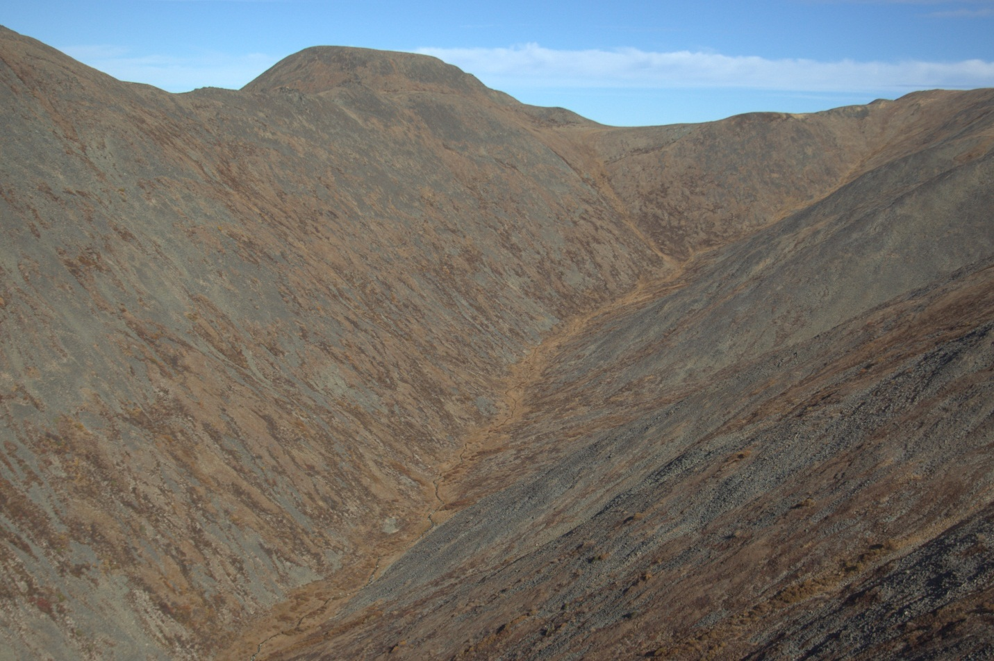
Description
Small catchments in the SUB and ALP zones are wetter, have shallower slopes, and support more rigorous vegetation growth than the adjacent slopes. At the higher elevations these tend to be dominated by grasses and moisture tolerant forbs.
Information Table
BEU Group: Wet Ecosystems; BEU Type: Drainage (160); BEU Phase: Herb (161)
Bioclimate Zones: BOH, SUB, ALP |  | Slope Conditions: gentle to steep
Soil Conditions: fine to boulder Regosols or Cryosols |  | Aspect Conditions: all
Total Project Area: 1.6% |  | Seral Position: stable
Portion of Bioclimate Zone: BOH 0.4%; SUB 1.2%; ALP 5.5%
Middle to High Elevation Upland Drainages (BOH, SUB, ALP)
Shrub (162)
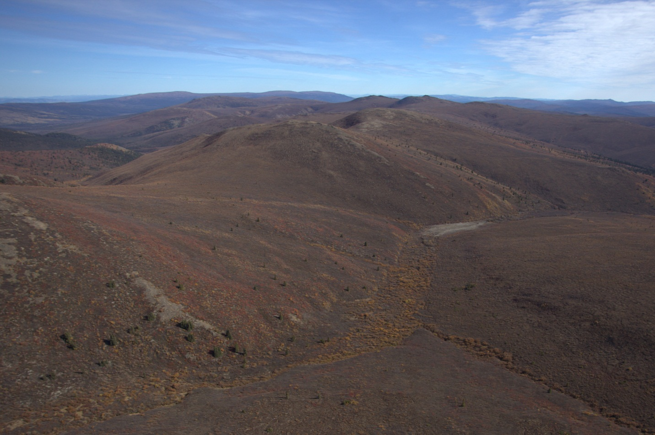
Description
In the ALP Zone, catchments support Salix sp. led ecosystems that occur well into drier herb (111) or bare rock (700) dominated terrain. Within the SUB Zone, tall Salix sp. occupy the catchments, while Betula glandulosa dominates on the surrounding slopes. Understory shrubs include Salix sp., Betula glandulosa, and Potentilla fruticosa. Ground cover is comprised of moss and leaf litter, supporting herbs such as Rumex arcticus, Epilobium angustifolium, and Delphinium glaucum. In the BOH Zone this unit grades into riparian shrub (372). In the BOH zone this unit grades into riparian shrub (372) and conifer (165).
Information Table
BEU Group: Wet Ecosystems; BEU Type: Drainage (160); BEU Phase: Shrub (162), Conifer (165)
Bioclimate Zones: BOH, SUB, ALP |  | Slope Conditions: gentle to moderate
Soil Conditions: Regosols |  | Aspect Conditions: all
Total Project Area: 4.3% |  | Seral Position: stable
Portion of Bioclimate Zone: BOH 1.4%; SUB 5.6%; ALP 3.9%

Wetlands (BOH, SUB)
Wetland – Herb (311)
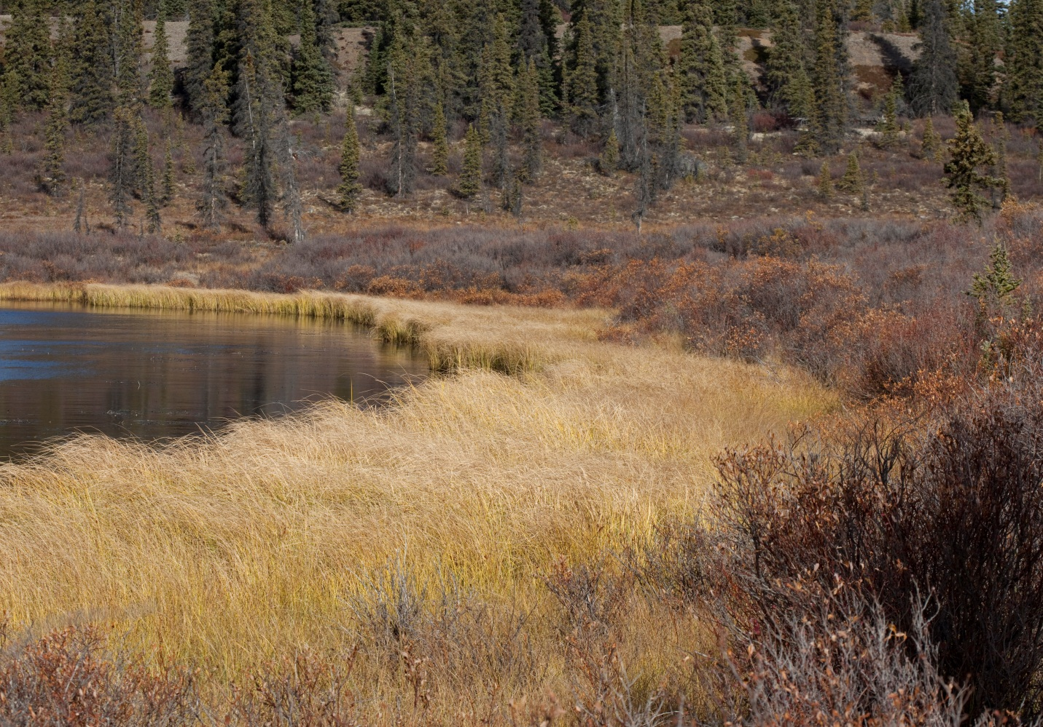
Description
This ecosystem includes shore fens and sloping to level bogs that grade into moist herb (151). It is closely related to the floodplain herb wetland (371).
Information Table
BEU Group: Wet Ecosystems; BEU Type: Wetlands (310); BEU Phase: Wetland – Herb (311)
Bioclimate Zones: BOH, SUB | Slope Conditions: level
Soil Conditions: Organic | Aspect Conditions: none
Total Project Area: 0.6% | Seral Position: stable
Portion of Bioclimate Zone: BOH 1.8%; SUB 0.2%

Wetlands (BOH, SUB)
Wetland – Shrub (312)
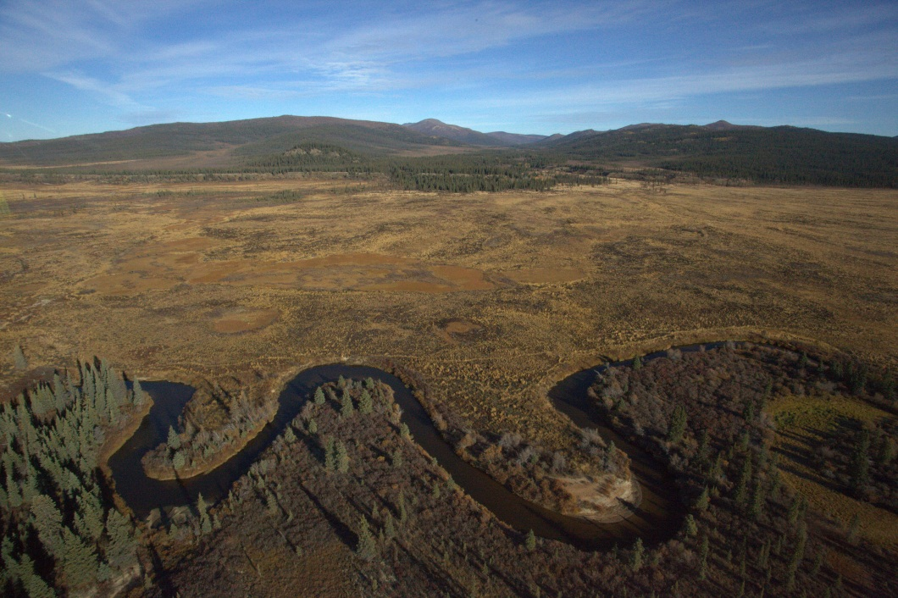
Description
This ecosystem is closely related to Moist Shrub (153). These shrub wetlands occur on shallow slopes, less than 5% to level ground, and are mostly over permafrost affected colluvium.
Information Table
BEU Group: Wet Ecosystems; BEU Type: Wetlands (310); BEU Phase: Wetland - Shrub (312)
Bioclimate Zones: BOH, SUB | Slope Conditions: level
Soil Conditions: Organics, Cryosols | Aspect Conditions: none
Total Project Area: 1.5% | Seral Position: stable
Portion of Bioclimate Zone: BOH 5.1%; SUB 0.3%

Wetlands (BOH, SUB)
Floodplain – Gravel Bar – Herb (371)
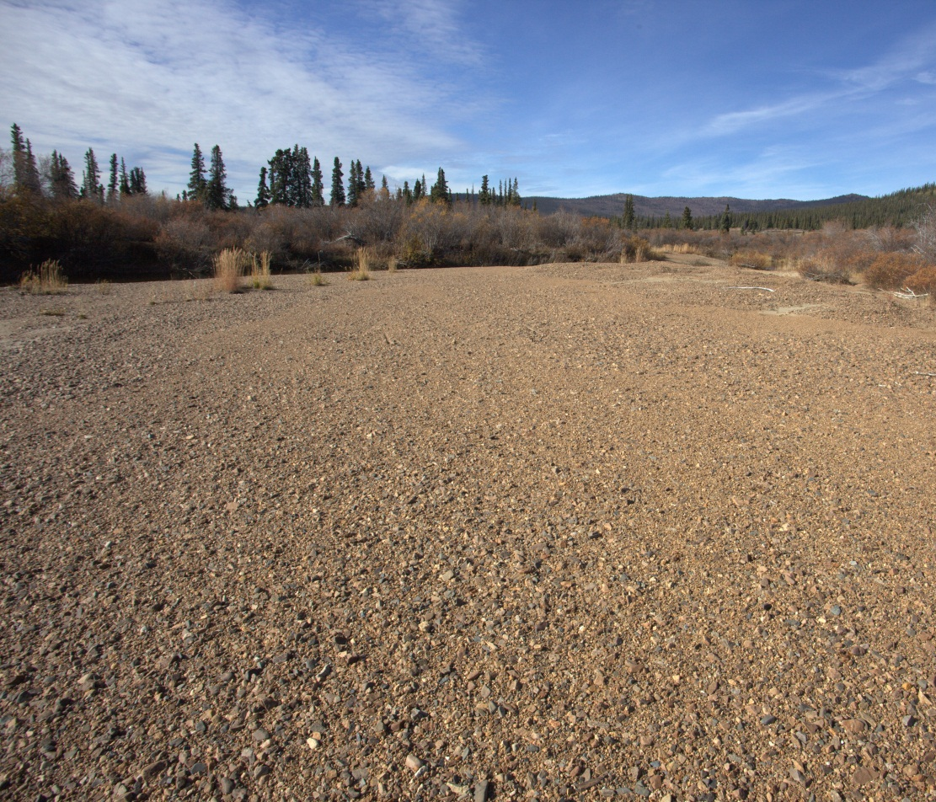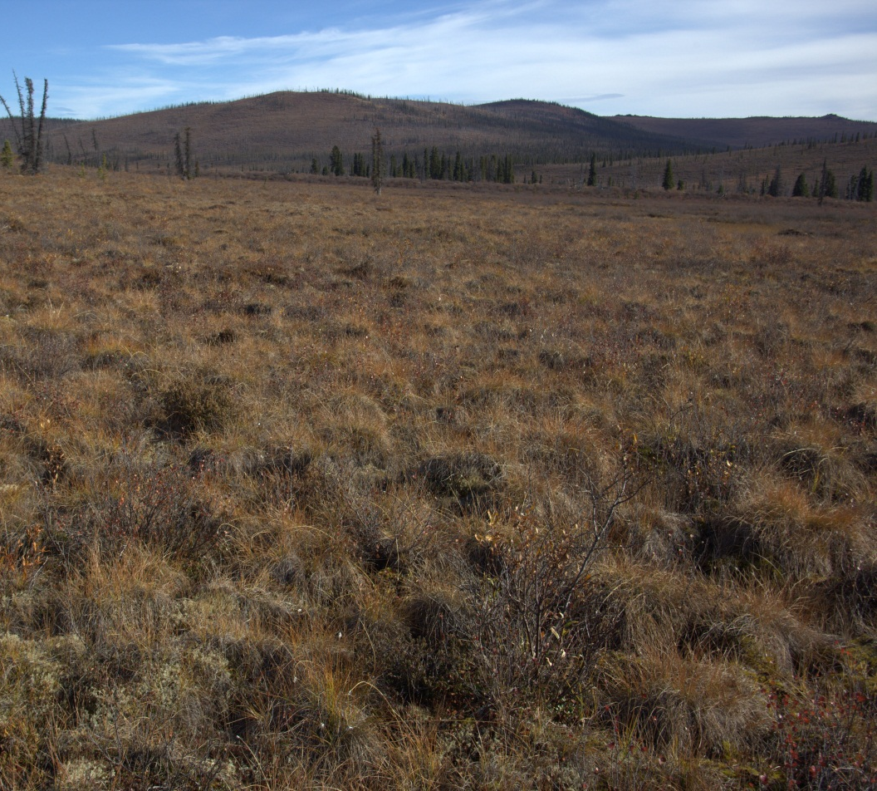
Description
Gravel Bars are restricted to the Nisling River channel, where flooding and ice scouring occurs annually, (left photo above). All of the herb wetlands within the floodplain are mapped as 371. Most however are slightly perched above the seasonally flooded zone and are herb fens and bogs, as shown above in the Victoria Creek floodplain (right photo above).
Information Table
BEU Group: Wet Ecosystems; BEU Type: Floodplains (370/380/390); BEU Phase: Gravel Bar – Herb (371)
Bioclimate Zones: SUB,BOH | Slope Conditions: level
Soil Conditions: Regosols | Aspect Conditions: none
Total Project Area: 1.7% | Seral Position: early seral
Portion of Bioclimate Zone: BOH 4.2%; SUB 1.1%

Wetlands (BOH, SUB)
Floodplain – Shrub (372)
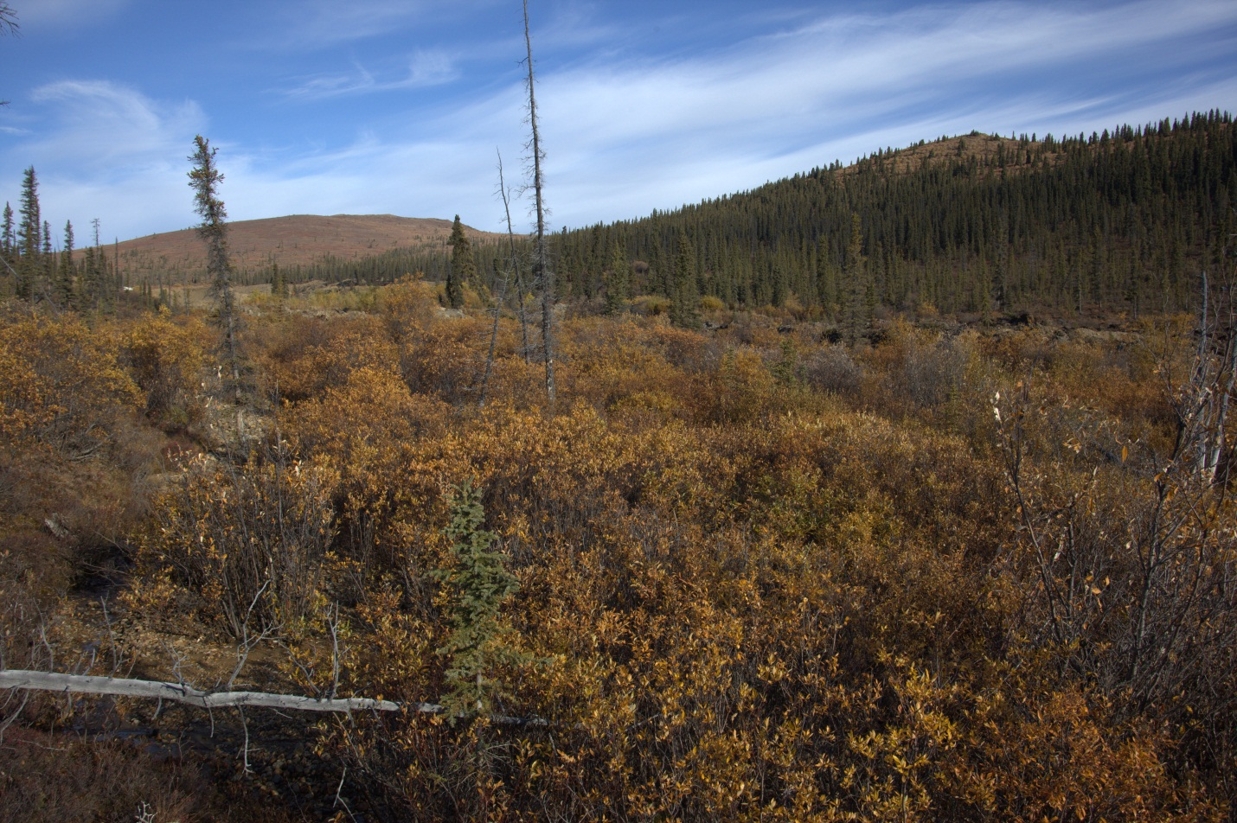
Description
This shrub-marsh ecosystem occurs on the floodplains of Nansen and Victoria creeks, and adjacent to the Nisling River channel. It is dominated by Salix sp. with grasses, Hedysarum alpinum, Epilobium angustifolium and a mix of exposed gravel and leaf litter. A portion of this unit has been removed by placer operations. In the Nisling Valley away from the active channel, shrub wetlands include shrub fens.
Information Table
BEU Group: Wet Ecosystems; BEU Type: Floodplains (370/380/390);BEU Phase: Shrub (372)
Bioclimate Zones: BOH, SUB | Slope Conditions: level
Soil Conditions: Regosols | Aspect Conditions: none
Total Project Area: 3.0% | Seral Position: early successional
Portion of Bioclimate Zone: BOH 10.0%; SUB 0.7%

Wetlands (BOH, SUB)
Floodplain – Deciduous (383)
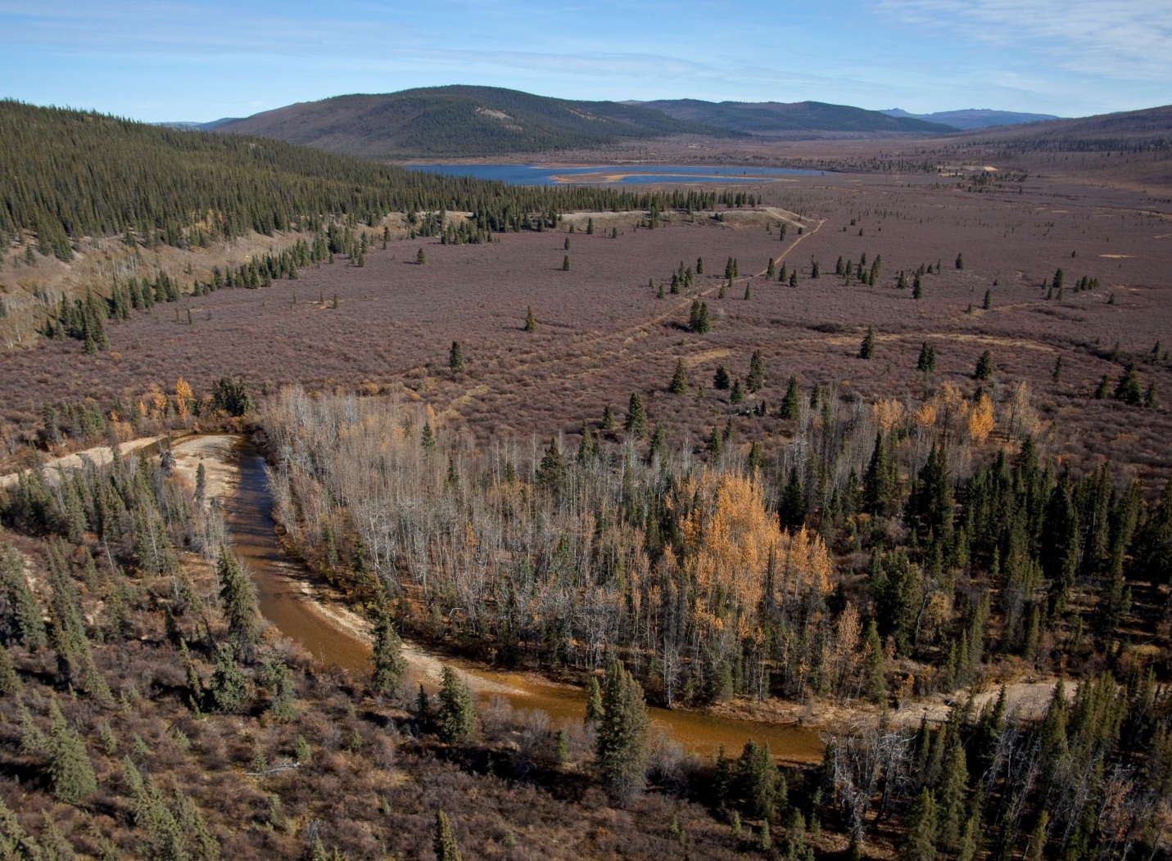
Description
This ecosystem occurs in only one or two patches along the Nisling River, and Victoria Creek as it enters the Nisling Valley (above). Like the coniferous floodplain (395) it occupies elevated gravel benches adjacent to active channels that are free of near-surface permafrost and are well drained. Flooding is moderate to infrequent. Populus balsamifera is the dominant deciduous species, with Picea glauca co-dominating mixedwood sites. The understory shrubs are dominated by Salix sp.
Information Table
BEU Group: Wet Ecosystems; BEU Type: Floodplains (370/380/390); BEU Phase: Deciduous (383)
Bioclimate Zones: BOH | Slope Conditions: level
Soil Conditions: Regosols | Aspect Conditions: none
Total Project Area: 0.01% | Seral Position: mid to late successional
Distribution by Bioclimate Zone: BOH 0.02%

Wetlands (BOH, SUB)
Floodplain - Coniferous (395)
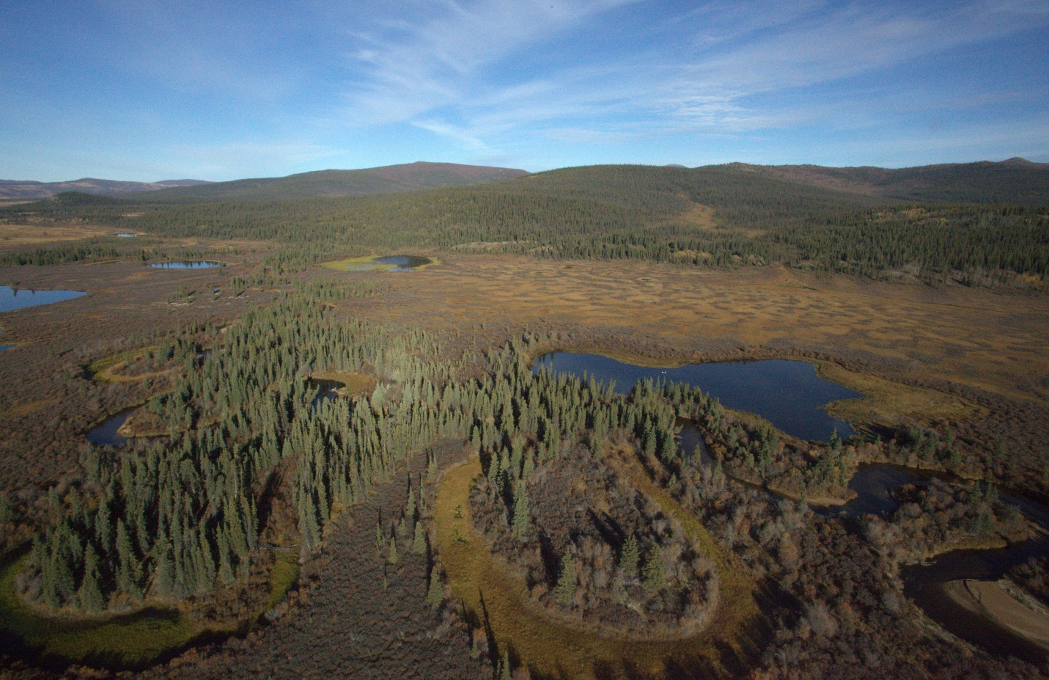
Description
Floodplains were mapped for the Nisling, Nansen and Victoria valleys. This unit includes all coniferous forests within the floodplain. It occupies elevated gravel benches adjacent to active channels that are free of near-surface permafrost and are well drained. Flooding is infrequent. Picea glauca dominates and reaches greater heights here than in, what are presumed to be, similar aged upland forests. These forests are relatively open, with understory shrubs a mix of Betula glandulosa and Salix sp.
Information Table
BEU Group: Wet Ecosystems; BEU Type: Floodplains (370/380/390);BEU Phase: Coniferous (395)
Bioclimate Zones: BOH, SUB | Slope Conditions: level
Soil Conditions: Regosols | Aspect Conditions: none
Total Project Area: 0.8% | Seral Position: stable
Portion of Bioclimate Zone: BOH 2.9%; SUB 0.1%

Water
Water
Water (401)
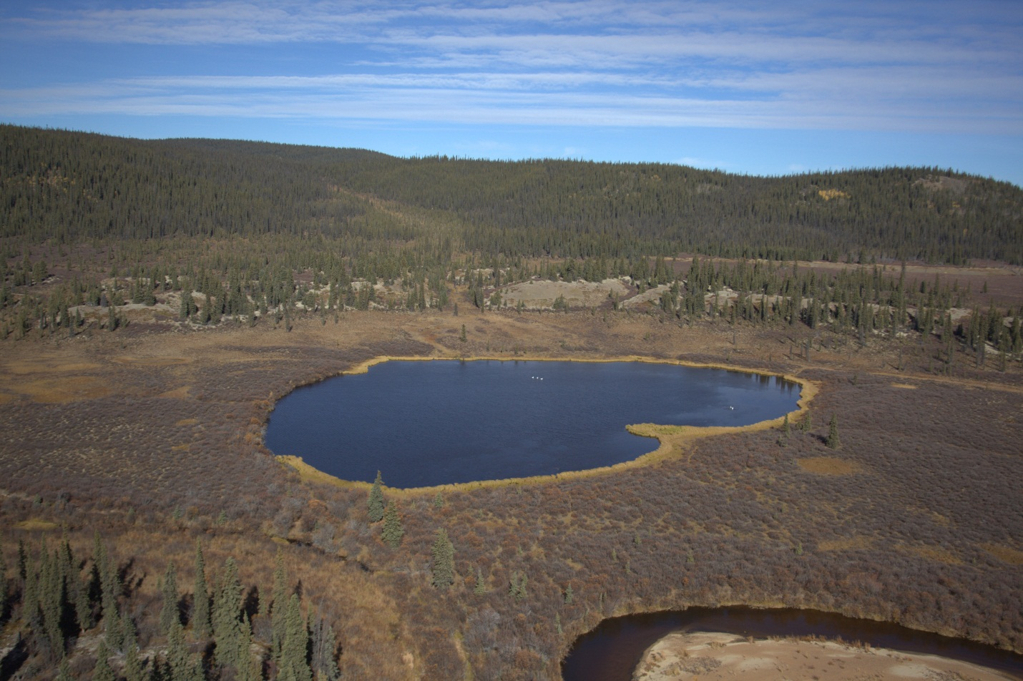
Description
Large lakes do not occur in the project area. In areas west and north of recent glacial limits, the lack of valley scouring and till deposits results in few lakes relative to glaciated part of the Yukon. In these areas, lakes are largely limited to riparian terraces. This unit includes shallow-water wetlands, with emergent vegetation such as Nuphar polysepalum and Potamogeton sp. This unit also includes flowing water for rivers mapped as double lined streams.
Information Table
BEU Group: Aquatic; BEU Type: Open Water (400); BEU Phase: Water (401)
Bioclimate Zones: BOH, SUB | Slope Conditions: none
Soil Conditions: n/a | Aspect Conditions: none
Total Project Area: 0.1% | Seral Position: n/a
Portion of Bioclimate Zone: BOH 0.3%; SUB trace.

Disturbances
Disturbance
Mines (503)
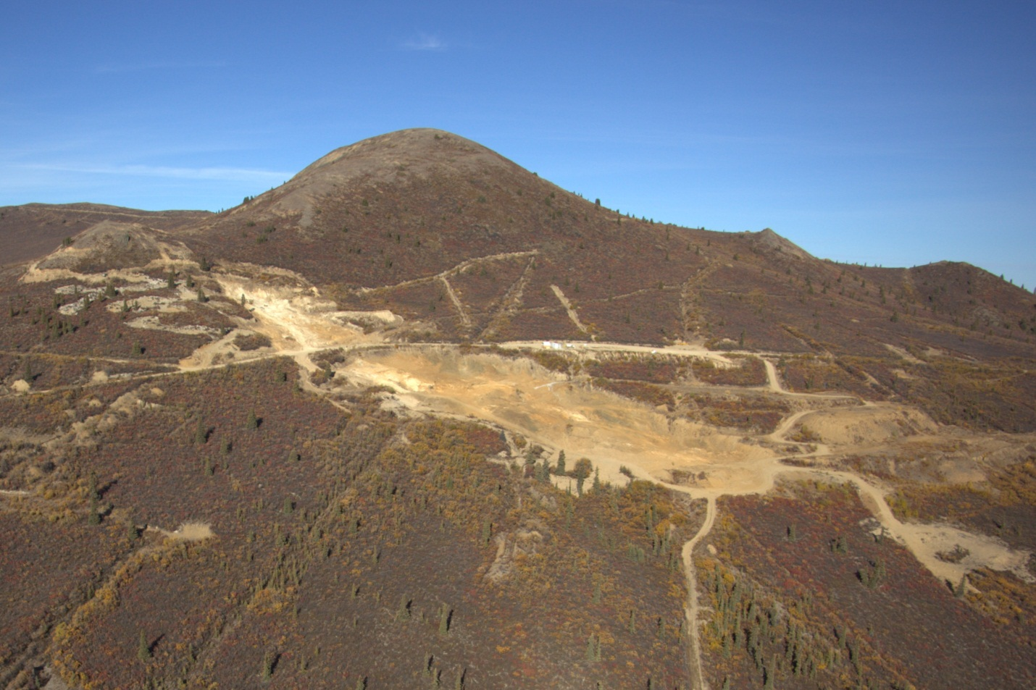
Description
The mining footprint includes the Mount Nansen abandoned mine site, advanced exploration areas, such as the ‘Flex’ area below the Dickson Stock (above), trenching, placer workings, the airstrip and access roads.
Information Table
BEU Group: Disturbance; BEU Type: Anthropogenic (500);BEU Phase: Mines (503)
Bioclimate Zones: All | Slope Conditions: variable
Soil Conditions: All | Aspect Conditions: variable
Total Project Area: Data unavailable | Seral Position: n/a
Distribution by Bioclimate Zone: Data unavailable

Wildlife habitat suitability
A habitat suitability index (HSI) for the project area was developed using the developed Predictive Ecosystem Map for moose, woodland caribou, and grizzly bear. The HSI is developed by reviewing habitat selection described in both published and unpublished literature relevant to Yukon wildlife, and assigning relative values to each of the broad ecosystem units identified within the project area. Upon review of relevant literature sources, moose and caribou habitat use was separated into four distinct seasons: calving/spring, summer, rutting/early winter, and late winter; grizzly bear habitat was separated into foraging and denning habitats. Characteristics of habitat were defined for each season and related to broad ecosystem units. Units were grouped into categories that contain similar habitat features that moose, caribou, and grizzly bear select. Moose and caribou habitats were rated using a four class ordinal scale based on the habitat units predicted value to the species, while the grizzly bear habitats were rated using only two categories. The number of categories for bears is reduced because bear habitat selection is highly variable among regions and years; therefore, we categorize grizzly bear habitats into suitable and unsuitable foraging and denning habitat (Clarke et al. 2011).

Moose
Moose in the Yukon are distributed throughout the territory, with high densities in the southern Yukon, especially in subalpine areas. Environment Yukon estimates the current Yukon-wide population to be between 65,000 to 70,000 individuals (Environment Yukon 2010a). Due to their large size, moose require a considerable amount of energy to maintain daily activity. Moose are often associated with dense shrub habitats that provided abundant browse, such as willows in riparian and sub-alpine areas, or recently burned areas. Generally, moose select for habitats that provide either abundant browse or cover from predators.

Key Habitat Requirements
Habitat use in late winter is largely determined by snow depth and browse availability. During winters with high snow depth, moose tend to use mature coniferous forests at lower elevations (SLWCC 2010, Doerr 1983, Hundertmark et al. 1990, Dussault et al. 2005). In addition, forests in proximity to areas with abundant browse, such as river valleys or forest edges, are preferred in late winter, suggesting that habitat heterogeneity also plays a key role in winter habitat use (SLWCC 2010, Dussault et al. 2005). During shallow snow winters, moose will use more open habitats, such as disturbed or clear-cut forests, or mixed coniferous-hardwood forests (Hundertmark et al. 1990). Low elevation habitats that contain suitable shrubs are rated as high during the late-winter season (Table 4).
Spring habitat use is primarily influenced by calving activity and the need to avoid predation by grizzly bears and wolves (Larsen et al. 1989), while providing sufficient browse to satisfy energy needs. Typically, moose will use lower elevation areas with dense cover or secluded habitats such as islands, peninsulas, or wetlands (SLWCC 2010). However, they also use riparian habitats since they provide forage availability, cover, and proximity to water, allowing for escape from predators. Moose are generally not limited by availability of calving/spring habitats. Low elevation forest and riparian habitats are rated as moderate during the calving/spring season, but no habitats are rated as high (Table 4).
Summer habitat use is partially influenced by the need for thermal relief, resulting in the use of cooler areas such as shaded forests, snow patches, rivers, creeks, lakes, and ponds (SLWCCS 2010). Moose are also attracted to sodium-rich food sources in the summer, including aquatic plants and natural mineral licks (Fraser et al. 1982, SLWCC 2010). Water associated ecosystems, such as ponds, wetlands, or floodplains are typical summer habitats due to the abundance of fresh browse vegetation and the opportunity to cool down in warm summer temperatures. Water associated habitats and water are rated as high and moderate, respectively, during the summer season (Table 4).
During the rut, bull moose may not eat for a number of days or weeks while they search and compete for breeding opportunities. Cow moose are also observed in a variety of habitat during the rut. After the rut and into early winter, moose use higher elevation areas near the treeline in subalpine areas, or recently burned forest patches. They are often observed aggregated in small groups. Water associated habitats and higher elevation shrub habitats are rated as moderate during the rut (Table 4).
The RSA contains small amounts of high quality habitat during all seasons (Table 5). Most of the RSA is rated at low quality habitat during late winter, spring/calving, and summer seasons. The project area provides some moderate rut/early winter habitat, mostly associated with alpine and sub-alpine shrub.

- Description and rating of moose habitats that occur within the Mount Nansen project area.
Habitat Description | Broad Ecosystem Unit | Spring/ Calving (1 Apr –15 Jun) | Summer (15 Jun – 15 Sept) | Rut/Early winter  (15 Sept – 31 Jan) | Late-winter (31 Jan – 31 Mar) | Area (km²)
High elevation - sparse vegetation | 111, 161, 700 | N | N | N | N | 19.7
Alpine and sub-alpine shrub | 112, 132, 142, 152, 162 | L | L | M | L | 104.0
Alpine and sub-alpine herb | 131, 141, 151 | L | L | L | L | 32.4
Forest habitat | 134, 135, 145, 155, 165 | M | L | L | M | 21.4
Water associated habitat | 311, 312, 371, 372, 383, 395 | M | H | M | H | 16.2
Open Water | 401 | L | M | N | N | 0.1
Mine disturbance | 503 | L | L | L | L
Total |  |  |  |  |  | 193.7

- Availability of moose habitat within the Mount Nansen project area by season. Units are in square kilometres (km²).
Suitability | Spring/ Calving (1 Apr –15 Jun) | Summer  (15 Jun – 15 Sept) | Rut/Early winter  (15 Sept – 31 Jan) | Late-winter  (31 Jan – 31 Mar)
High | 0 | 16.179 | 0 | 16.18
Moderate | 37.58 | 0.066 | 120.2 | 21.40
Low | 136.46 | 157.79 | 53.8 | 136.39
Nil | 19.68 | 19.68 | 19.7 | 19.74

Caribou
The Mount Nansen project area overlaps with the Klaza Caribou Herd range and the northern most extent of the Aishihik Caribou Herd range. Both herds have been previously intensively studied by Environment Yukon. The Klaza Caribou Herd was studied during the late 1980s in order to collect baseline data that would inform the proposed Casino Mine project. The Aishihik caribou herd has been intensively studied and managed during the 1990s with the objectives of understanding the wolf-caribou dynamics, and increasing the herd’s size.
The most important season for woodland caribou is late-winter when their diets are more limited to lichens and the availability of forage is reduced because of snow cover (Florkiewicz et al. 2004). Other seasons are important for mating, calving, and energy intake during growing; however, habitat availability is not as limited during these seasons compared to the winter season.

Key Habitat Requirements
Terrestrial lichens are the most important and consumed winter forage for caribou that occupy the region (Farnell et al. 1991, Hayes et al. 2003, Collins et al. 2011). Lichens constituted 78% and 70% of Klaza and Aishihik caribou winter diets, respectively (Farnell et al. 1991, Hayes et al. 2003). Horsetails made up 12% of Klaza caribou winter diet, and the remainder included graminoids and shrubs (Farnell et al. 1991). Lichen occurs at highest density and abundance in old growth. There is strong evidence (from nearby southeastern Alaska) that caribou avoid winter range that has been burnt within the last 60 years (Joly et al. 2003; Collins et al 2011, Environment Canada 2011).
In winter, snow depth can be an important factor influencing habitat selection — deep snow limits caribou ability to crater to terrestrial lichens. Within the Klaza range snow depths are shallow enough that it likely does not significantly influence caribou habitat selection (Farnell et al. 1991). Open and sparse spruce stands are the most used cover types of the Klaza caribou herd (Farnell et al. 1991). Forest fires remove lichen from ground cover and limit caribou use of an area for at least 60 years post fire (Collins et al. 2011); consequently, mature forests are the primary source of caribou late-winter food. All lichen producing broad ecosystem units are rated as high. Water associated ecosystems that could contain other suitable forage are rated as moderate. High elevation and non-lichen producing subalpine ecosystems are rated as low (Table 6).
Woodland caribou are widely dispersed in alpine and subalpine habitats during their calving period. Their dispersed distribution is hypothesized to be a strategy used to minimize predator detection, and increase calf survival. All high elevation habitats are rated as high. Sub-alpine habitats are rated as moderate. Low elevation habitats are rated as low (Table 6).
Caribou select high elevation habitats for insect relief and predator avoidance during summer. Caribou are often seen bedded on high elevation snow patches that last late into the summer for thermoregulation. All high elevation habitats are rated as high. Sub-alpine habitats are rated as moderate. Low elevation habitats are rated as low (Table 6).
Yukon’s woodland caribou rut (i.e., when male caribou spar with one another for mating privileges) in open alpine and sub-alpine, and flat mountain tops. Bulls travel between groups of cow caribou to breed. While caribou are frequently observed in high elevation habitats during the rut, habitat selection is likely not as much a factor during this season. Bulls select habitat based on the presence of females. Cows are selecting similar habitat that are used during the summer until environmental condition make the area less suitable. Alpine and sub-alpine habitats are rated as moderate and lower elevation habitats are rated as low (Table 6).
The project area contains a considerable amount of high quality late-winter habitat (44%) and abundant moderate habitat during the spring/calving, summer and rutting/early winter season (Table 5). The project area provides suitable habitat for spring/calving, summer and rutting/early winter season because of the abundance of sub-alpine habitats.

- Description and rating of woodland caribou habitats that occur within the Mount Nansen RSA.
Habitat description | Broad  Ecosystem  Unit | Spring/  Calving  (1 Apr –15 Jun) | Summer  (15 Jun – 15 Sept) | Rut/  Early winter  (15 Sept – 31 Jan) | Late-winter  (31 Jan –  31 Mar) | Area
High elevation - sparse vegetation | 111, 161, 700 | H | H | M | L | 19.7
Lichen producing alpine and sub-alpine ecosystems | 112, 141, 142, 152 | M | M | M | H | 65.2
Lichen producing forest ecosystems | 135, 145, 155 | L | L | L | H | 20.4
Non-forested sub-alpine ecosystems | 131, 132, 151, 162 | M | M | M | L | 71.2
Sub-alpine forested ecosystems | 134, 165 | L | L | L | L | 1.0
Water associated ecosystems | 311, 312, 371, 372, 383, 395 | L | L | L | M | 16.2
Open Water | 401 | N | N | N | N | 0.1
Mine disturbance | 503 | N | N | N | N
Total |  |  |  |  |  | 193.7

- Availability of woodland caribou habitat within the Mount Nansen project area by season. Units are in square kilometres (km²).
Suitability | Spring/ Calving (1 Apr –15 Jun) | Summer  (15 Jun – 15 Sept) | Rut/Early winter  (15 Sept – 31 Jan) | Late-winter  (31 Jan – 31 Mar)
H | 19.68 | 19.68 | 0 | 85.57
M | 136.39 | 136.39 | 156.1 | 16.18
L | 37.582 | 37.58 | 37.6 | 91.91
N | 0.07 | 0.07 | 0.1 | 0.07

Grizzly bear
Grizzly bears are described as opportunistic omnivores (Ross, 2002), primarily feeding on vegetation but opportunistically prey upon animals. Their diets and behaviour are dependent on the habitat in which they live and are highly variable. In Yukon, grizzly bears are the primary predator of moose calves each spring before fresh vegetation and berries are available (Larsen et al. 1989). Other spring vegetation includes roots, the previous year’s berries, and other old vegetation. Once new vegetation is available grizzly bears forage switches primarily to grasses then berries (Environment Yukon 2010b).
Denning areas are generally in alpine and sub-alpine habitats that have deeper soils and vegetation that keeps den roofs from calving in. Denning habitats tend to be 20–40° slopes, and are most likely to be found on south facing slopes (Pearson 1975). Permafrost and soil moisture reduce the suitability of denning sites. Most habitats within the RSA are ranked as suitable foraging habitat, and dry elevation habitat is ranked as suitable denning habitat (Table 8 and Table 9).

- Description and suitability of grizzly bear habitats that occur within the Mount Nansen project area.
Habitat description | Broad Ecosystem Unit | Denning (01 Oct – 01 Apr) | Foraging (01 Apr – 01 Oct) | Area (km²)
High elevation rock | 700 | No | No | 1.2
Dry alpine and sub-alpine shrub and herb | 111, 112, 131, 132, 141, 142 | Yes | Yes | 120.0
Wet alpine and sub-alpine shrub and herb | 151, 152, 161, 162 | No | Yes | 34.9
Forested ecosystems | 134, 135 145, 155, 165 | No | Yes | 21.4
Water associated ecosystems | 311, 312, 371, 372, 383, 395 | No | Yes | 16.2
Open Water | 401 | No | No | 0.1
Mine disturbance | 503 | No | No
Total |  |  |  | 193.7

- Availability of grizzly bear foraging and denning habitat within the Mount Nansen project area by season. Units are in square kilometres (km²).
Suitability | Denning  (01 Oct – 01 Apr) | Foraging  (01 Apr – 01 Oct)
Yes | 120.01 | 192.5
No | 72.46 | 1.3

- Moose spring/calving habitat classification, Mount Nansen study area.

- Moose summer habitat classification, Mount Nansen study area.

- Moose rut/early winter habitat classification, Mount Nansen study area.

- Moose late winter habitat classification, Mount Nansen study area.

- Caribou spring/calving habitat classification, Mount Nansen study area.

- Caribou summer habitat classification, Mount Nansen study area.

- Caribou rut/early winter habitat classification, Mount Nansen study area.

- Caribou late winter habitat classification, Mount Nansen study area.

- Grizzly Bear denning habitat classification, Mount Nansen study area.

- Grizzly Bear foraging habitat classification, Mount Nansen study area.

Uses and Limitations
- The active floodplains can be mapped from airphotos to distinguish riparian marsh ecosystems from wetlands in or adjacent to the floodplain that are not seasonally flooded by the contemporary stream. This is a minor issue along Nansen and Victoria creeks, but is a significant issue in the Nisling Valley. The valley is a meltwater channel, now occupied by an underfit stream that does not influence the entire floodplain.
- Anthropogenic disturbance, mining (503) is not reflected in the map output. Detailed mapping of anthropogenic disturbance was not possible within the study area based on available imagery. Slopes were observed within the study area where trenching had a downslope influence on moisture availability resulting in tall willow dominated sites that were previously shrub birch (142).
- The landcover classification data from EOSD appears to recognize the signature for shrub in sparse forests that were more than 10% treed. The result is an underestimation of the sparse forest cover in favour of shrub ecosystems.
- Trumpeter Swans were observed on a number of the small lakes in the Nisling Valley. This, and other observations of one of the lakes, suggests that the open water (401) unit may be more appropriately described as a shallow-water wetland. The lack of a mapped wetland layer likely results in the extent of herb and shrub wetlands being underestimated.
- Ecosystem maps require spatial inputs at resolutions or map scales appropriate to the end use. Some of the inputs are very large scale, such as the 25 m² EOSD grid. Others are intended for regional applications, such as the Yukon Forest Cover Inventory (FCI). It is recommended that this product be used at map scales of 1:50,000 to 1:100,000. Larger scale applications require georeferenced airphotos or GeoEye coverage that allows for an interpreter to generate a vector-based framework that could then be attributed using some of the inputs generated for this project.
- The assignment of HSI ratings are based on the PEM, literature and professional opinion. This approach is appropriate for evaluating large regional areas, where wildlife habitat use studies are not available, and in situations where populations are depleted due to effects other than habitat alteration. HSI can be used as a decision support tool, and are strengthened when used in tandem with wildlife habitat use data based on field observations (e.g., collar data, aerial survey observations).

Data Accuracy
Accuracy is difficult to assess. Based on experience of the senior authors, it is becoming evident that the EOSD (the only landcover available in Yukon), can be less than 50% accurate at the pixel level. Accuracy can be improved significantly by aggregating pixels and / or classes (in a way appropriate for a habitat assessment); or by going to a vector based assessment (significant cost increase requiring regional-scale high resolution imagery). Modified forest inventory polygons were used for the riparian zonation; but the forest coverage is too coarse for most of the habitats in the rest of the project area. At the size and scale of the project area, a vector-based terrain map would improve accuracy considerably. Aggregating pixels and/or classes as was done for the Habitat assessment was considered to have improved accuracy for the intended purpose.

Conclusion
This project describes ten broad ecosystem types in a total of 26 phases for the project area surrounding the Mount Nansen site. These broad ecosystem units are mapped using a predictive ecosystem mapping methodology. The broad ecosystems were used as a primary input to developing habitat suitability predictions for moose, woodland caribou and grizzly bear. This work was done in support of conducting an environmental assessment for the Mount Nansen site and surrounding area. It was done as well with a view to using and advancing the emerging frameworks being developed by the Yukon Government for ecosystem classification and mapping and for habitat assessment.

REFERENCES
  - Literature Cited
Canadian Forest Service. 2005. EOSD Land Cover Classification v 1.0. Canadian Forest Service, Pacific Forestry Centre, Victoria, British Columbia.
Clarke, H., M. O'Donoghue, J. Ryder, O. Barker, V. Loewen, H. Cooke, D. Reid, S. Skinner, J. Meikle, and S. Lapointe. 2011. Yukon standards and guidelines for knowledge-based habitat suitability modeling. Yukon Department of Environment, Draft Report. 11 pp.
Collins, W. B., B. W. Dale, L. G. Adams, D. E. Mcelwain, and K. Joly. 2011. Fire, grazing history, lichen abundance, and winter distribution of caribou in Alaska’s taiga. The Journal of Wildlife Management 75:369–377. doi: 10.1002/jwmg.39.
Dussault, C., J-P. Ouellet, R. Courtois, J. Huot, L. Breton, and H. Jolicoeur. 2005. Linking moose habitat selection to limiting factors. Ecography 28: 619–628.
EDI Environmental Dynamics Inc. 2010. Mount Nansen: Existing Environmental Conditions. Prepared for Assessment and Abandoned Mines Branch. Yukon Government.
Environment Canada. 2011. Management Plan for the Northern Mountain Population of Woodland Caribou (Rangifer tarandus caribou) in Canada [Proposed]. Species at Risk Act Management Plan Series. Environment Canada, Ottawa. vii + 80 pp.
Environment Yukon. 2010a. Wildlife and Biodiversity: Moose. http://www.env.gov.yk.ca/wildlifebiodiversity/mammals/moose.php. Accessed 21 December 2011.Yukon, Indian and Northern Affairs Canada, p.129-138.
Environment Yukon. 2010b. Wildlife and Biodiversity: Grizzly bears. http://www.env.gov.yk.ca/wildlifebiodiversity/mammals/grizzly.php. Accessed 21 December 2011.Yukon, Indian and Northern Affairs Canada, p.129-138.
Farnell, R., R. Sumanik, J. McDonald, and B. Gilroy. 1991. The distribution, movements, demography, and habitat characteristics of the Klaza Caribou Herd in relation to the Casino Trail development, Yukon Territory. Pages 1-75. Yukon Department of Renewable Resources, Whitehorse, Yukon.
Florkiewicz, R., N. Flynn, N. MacLean, S. R. Francis, J. Adamczewski, and V. Loewen. 2004. Little Rancheria caribou in the Yukon: evaluation of winter habitat quality. Yukon Fish and Wildlife Branch Report TR-03-03. 62 pp.
Flynn, N. and S.R.Francis. 2011. The Yukon Ecosystem and Landscape Classification (ELC) Framework: Overview and Concepts. Interim Draft for Review. Yukon Department of Environment. Whitehorse, Yukon.
Fraser, D., B. K. Thompson, and D. Arthur. 1982. Aquatic feeding by moose: seasonal variation in relation to plant chemical composition and use of mineral licks. Canadian Journal of Zoology 60: 3121–3126.
Hart, C.J.R. and M. Langdon. 1997. Geology and mineral deposits of the Mount Nansen camp, Yukon. In:Yukon Exploration and Geology 1997, Exploration and Geological Services Division, Doerr, J.G. 1983. Home range size, movements and habitat use in two moose, Alces alces, populations in southeastern Alaska. Canadian Field-Naturalist 97: 79–88.
Hayes, R. D., R. Farnell, R. M. P. Ward, J. Carey, M. Dehn, G. W. Kuzyk, A. M. Baer, C. L. Gardner, and M. O’Donoghue. 2003. Experimental reduction of wolves in the Yukon: Ungulate responses and management implications. Wildlife Monographs: 1–35.
Hundertmark, K.J., W.L. Eberhardt, and R.E. Ball. 1990. Winter habitat use by moose in southeastern Alaska: implications for forest management. Alces 26: 108–114.
Joly, K. B. Dale, W.B. Collins, and L.G. Adams. 2003. Winter habitat use by female caribou in relation to wildlife fires in interior Alaska. Canadian Journal of Zoology 81:1192–1201.
Larsen, D.G., D.A. Gauthier, R.L. Markel, R.SD. Hayes. 1989. Limiting factors on moose population growth in the southwest Yukon: Final Report. Moose population research and management studies. Yukon Territorial Government, Department of Renewable Resources.
Lipovsky, P.S. and K. McKenna. 2005. Local-scale biophysical mapping for integrated resource management, Watson Lake area (NTS 105A/2), Yukon. Yukon Geological Survey, Energy, Mines and Resources, Yukon Government, Open File 2005-6.
Meikle, J.C. and M.B. Waterreus. 2008. Ecosystems of the Peel Watershed: A Predictive Approach to Regional Ecosystem Mapping. Yukon Fish and Wildlife Branch Report TR-08-01. 66 pp.
Pearson, M. 1975. The northern interior grizzly bear Ursus arctos L. Canadian Wildlife Service Report 86pp.
Ross. P.I. 2002. Update COSEWIC status report on the grizzly bear Ursus arctos in Canada, in COSEWIC assessment and update status report on the Grizzly Bear Ursus arctos in Canada. Committee on the Status of Endangered Wildlife in Canada. Ottawa. 91 pp.
Smith, C.A.S., J.C. Meikle, and C.F. Roots (editors). 2004. Ecoregions of the Yukon Territory: Biophysical properties of Yukon landscapes. Agriculture and Agri-Food Canada, PARC Technical Bulletin No.04-01, Summerland, British Columbia. 313 pp.
Southern Lakes Wildlife Coordinating Committee Secretariat, Yukon Department of Environment. 2010. Moose status for the Southern Lakes area: A summary prepared for the Southern Lakes Wildlife Coordinating Committee. Yukon Fish and Wildlife Branch Report TR-10-xx, Whitehorse, Yukon.
  - SPATIAL DATA
1:50,000 CanVec topographic data from Government of Canada, Natural Resources Canada, Earth Sciences Sector, Centre for Topographic Information. Geogratis website (http://geogratis.cgdi.gc.ca).
1:50,000 Digital Elevation Model from Geobase (http://www.geobase.ca/geobase/en/find.do?produit=cded)
25 Metre Land Cover (EOSD) from Canadian Forest Services (http://www4.saforah.org/eosdlcp/nts_prov.html)
1:20,000 TRIM positional files from the Land and Resource Data Warehouse (http://lrdw.ca). Copyright belongs to Her Majesty the Queen in Right of the Province of British Columbia.
1:50,000 Yukon Forest Cover from Energy Mines and Resources, Forest Resources.

Disclaimer:
Maps presented in this document are a geographical representation of known features. Although the data collected and presented herein has been obtained with the utmost attention to quality, this document is not an official land survey and should not be considered for spatial calculation. EDI Environmental Dynamics Inc. does not accept any liability for errors, omissions or inaccuracies in the data.

