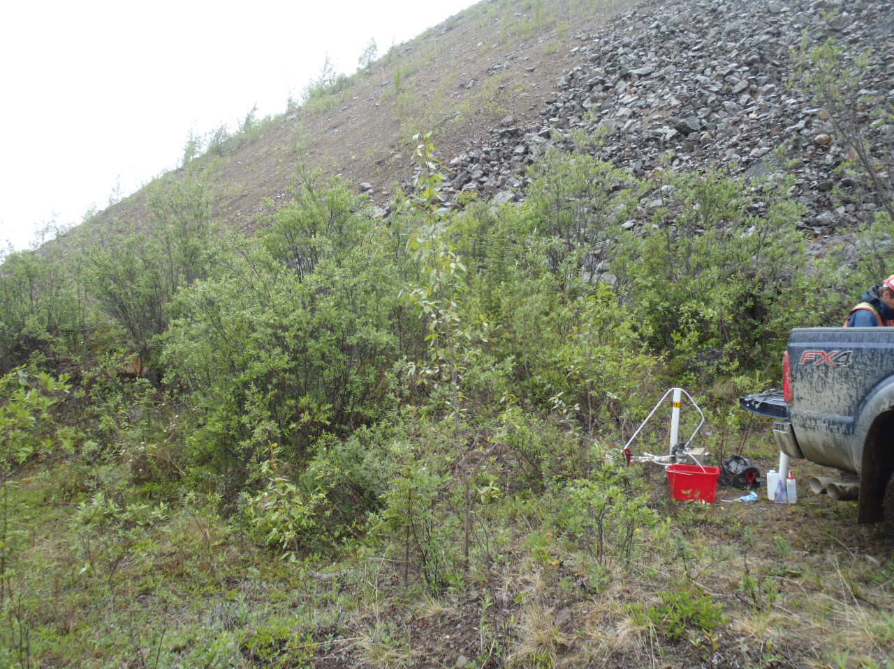
Photo 1: View of well BH13B. Photo taken on June 11, 2015.
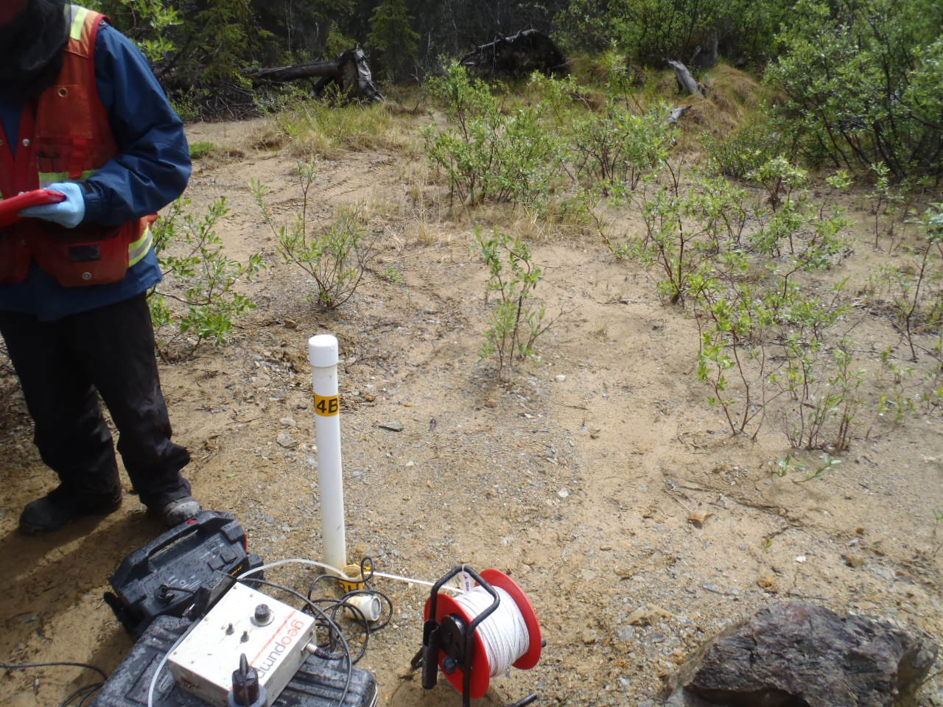
Photo 2: View of wells BH14A and BH14B. Photo taken on June 11, 2015.
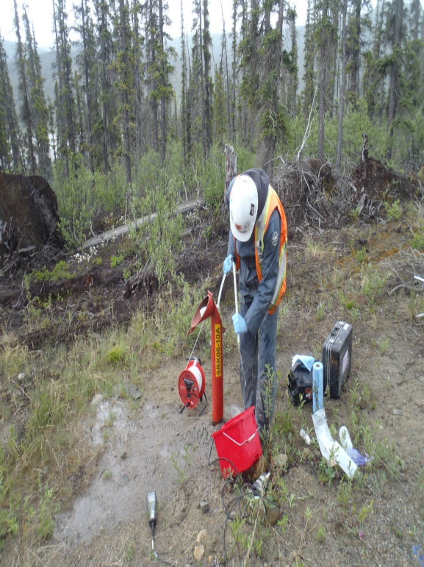
Photo 3: View of well SRK08-10A. Photo taken on June 11, 2015.
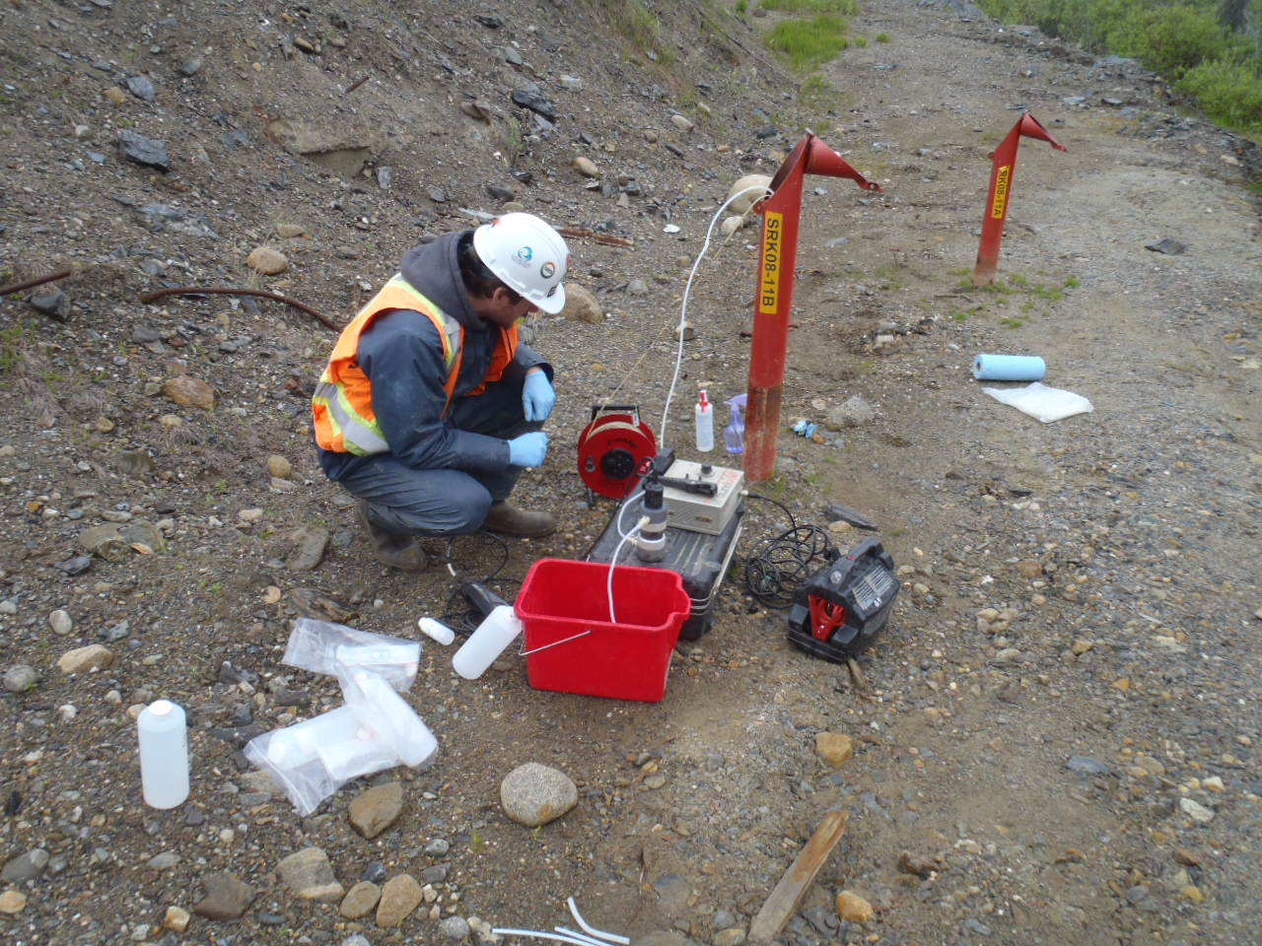
Photo 4: View of wells SRK08-11A and SRK08-11B. Photo taken on June 11, 2015.
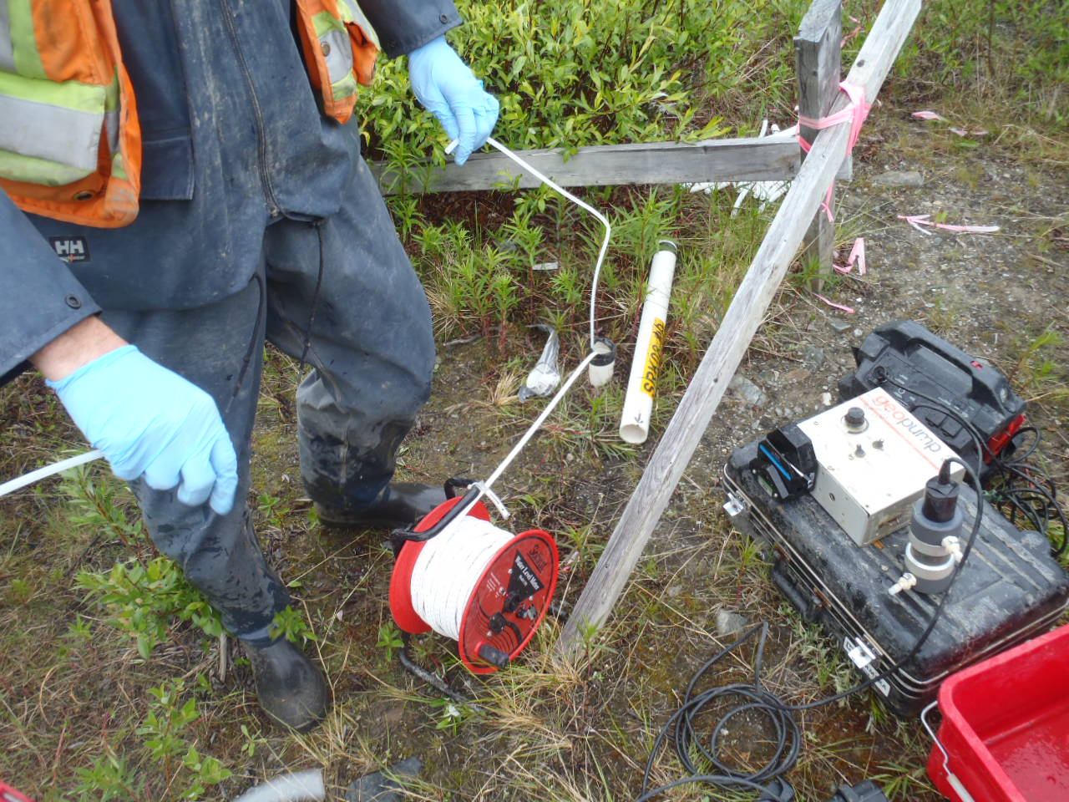
Photo 5: View of well SRK08-P9. Stick-up broken upon arrival. Photo taken on June 11, 2015.
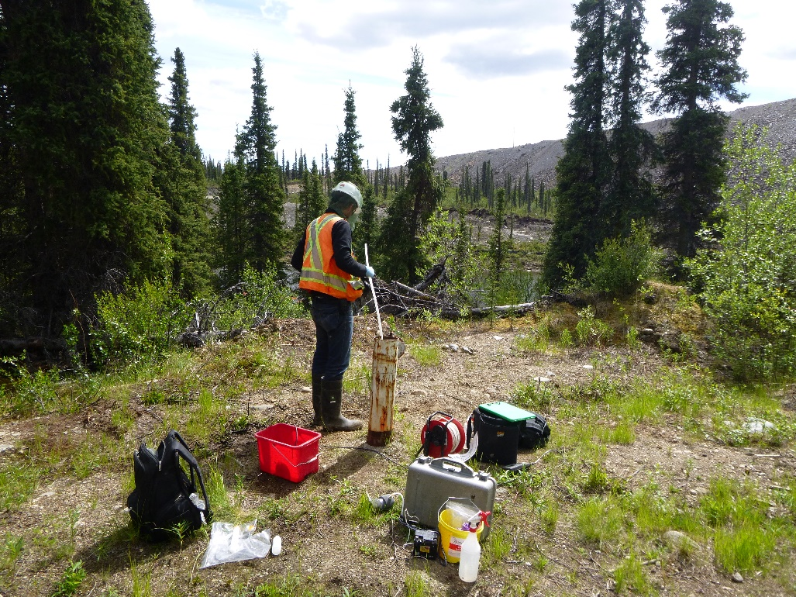
Photo 6: View of well P96-6, Photo taken on June 14, 2015.
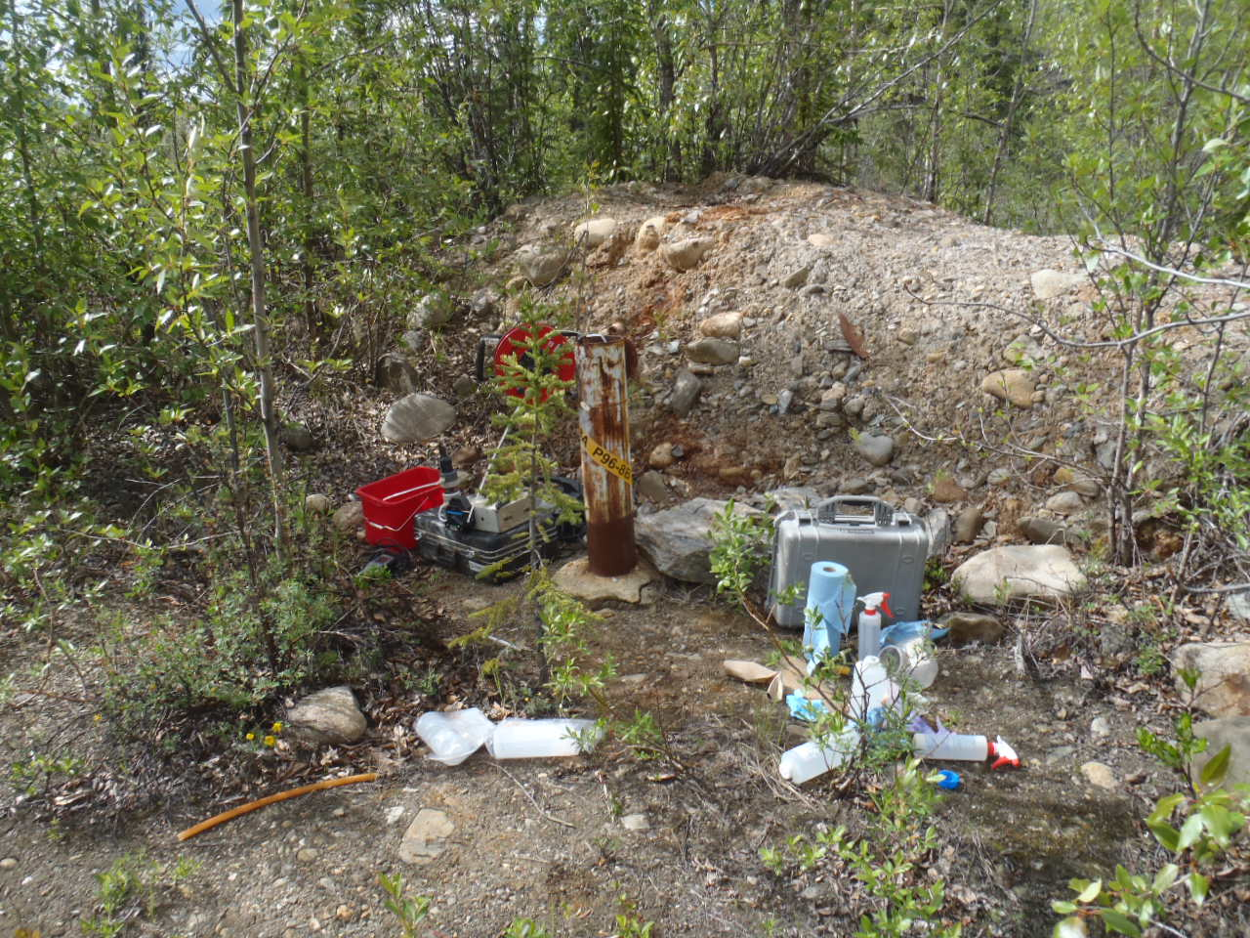
Photo 7: View of wells P96-8A and P96-8B. Photo taken on June 10, 2015.
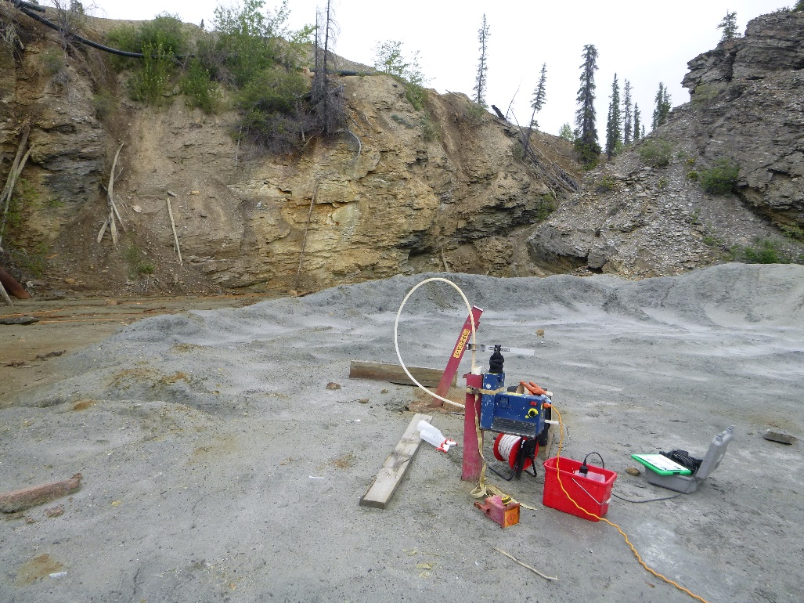
Photo 8: View of well P09-ETA-2. Photo taken on June 11, 2015.
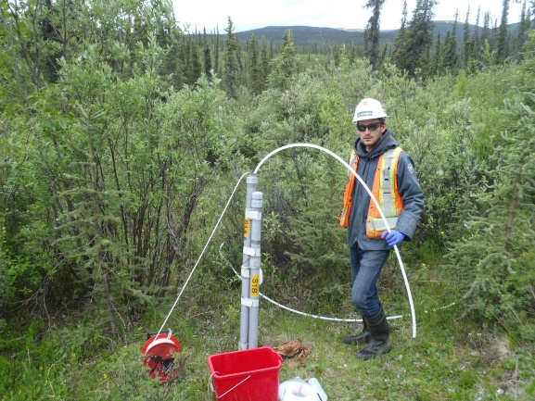
Photo 9: View of wells S1A and S1B. Photo taken on June 13, 2015.
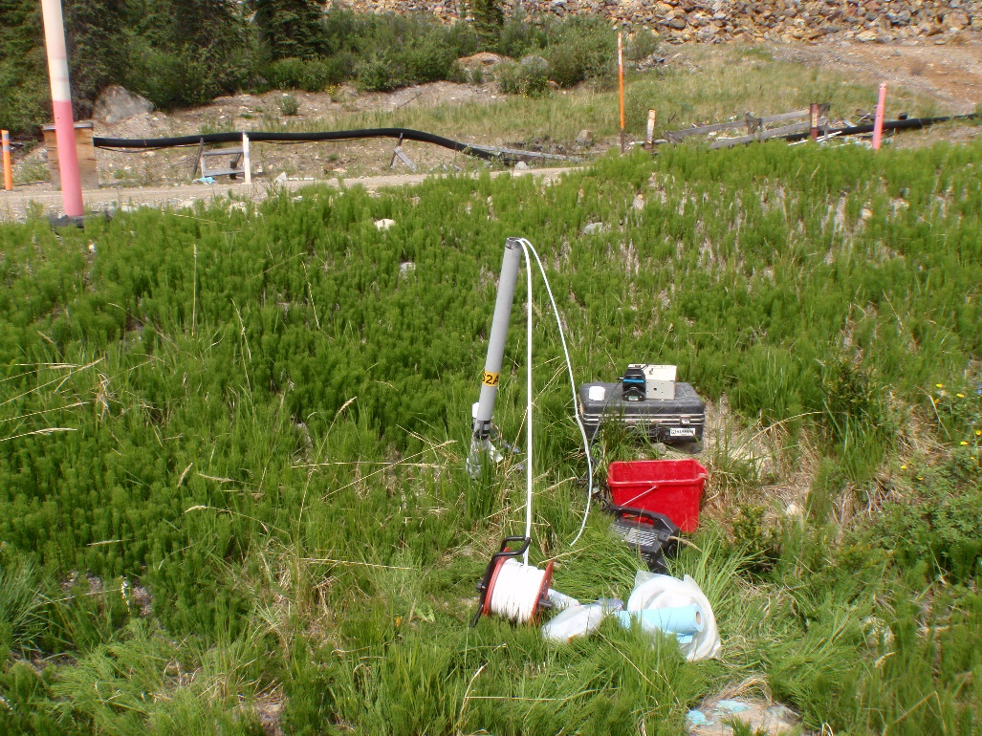
Photo 10: View of well S2A and S2B. Photo taken on June 14, 2015.
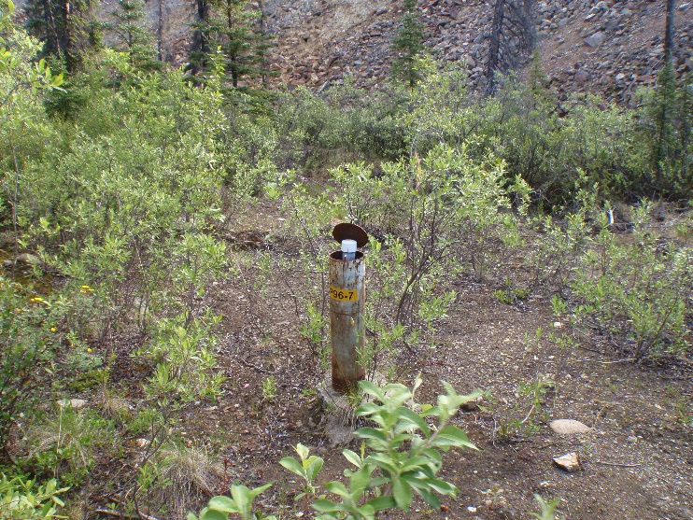
Photo 11: View of well P96-7. Photo taken on June 14, 2015.
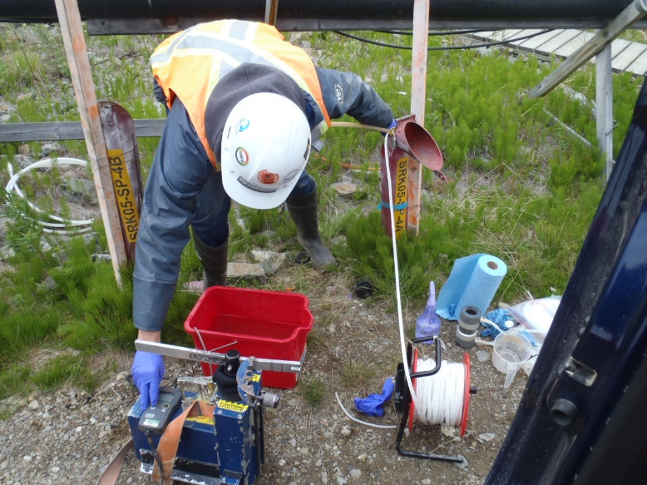
Photo 12: View of well SRK05-SP-4A. Photo taken on June 13, 2015.

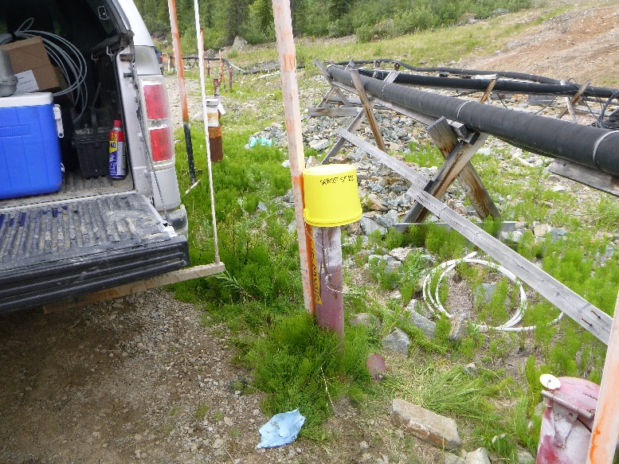
Photo 13: View of well SRK05-SP-4B. Photo taken on June 14, 2015.
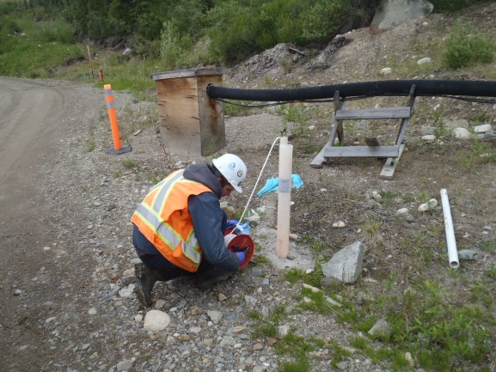
Photo 14: View of well SRK05-SP-5. Photo taken on June 13, 2015.

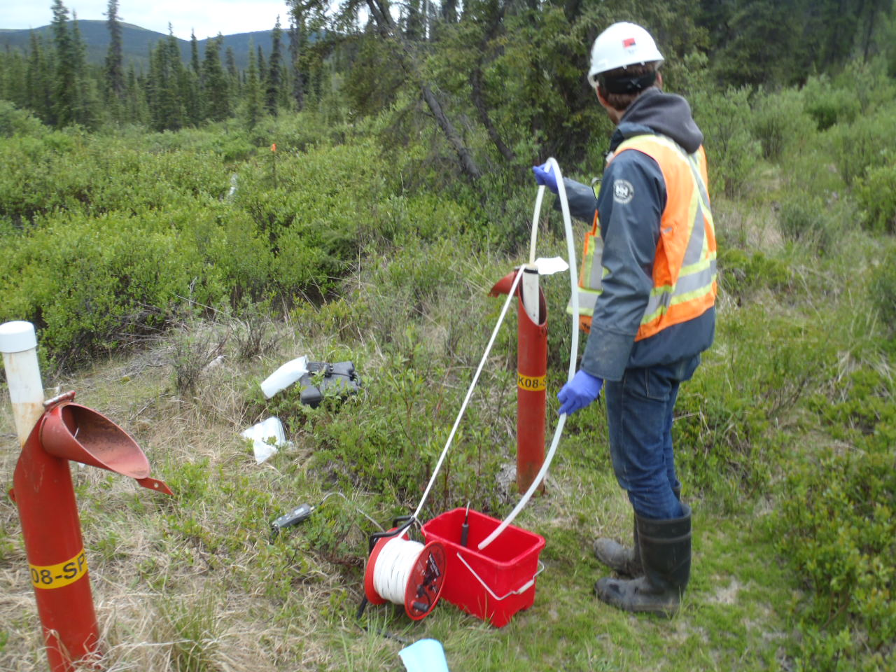
Photo 15: View of wells SRK08-7A and SRK08-7B. Photo taken on June 13, 2015.
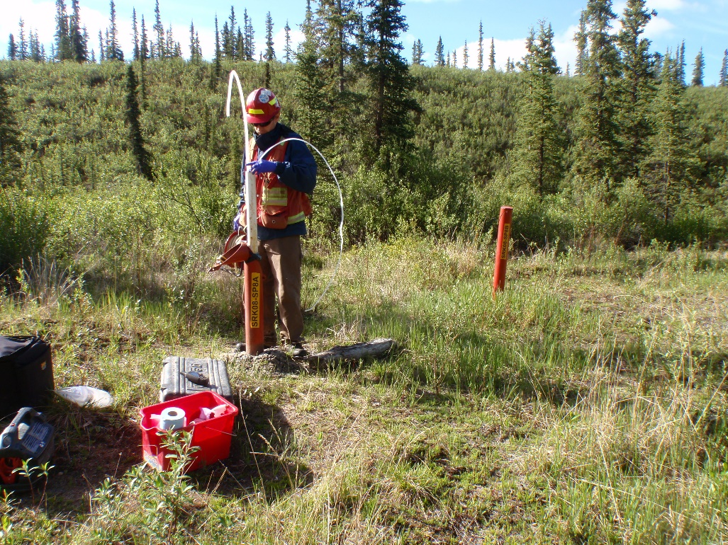
Photo 16: View of wells SRK08-SP8A and SRK08-SP8B. Photo taken on June 14, 2015.

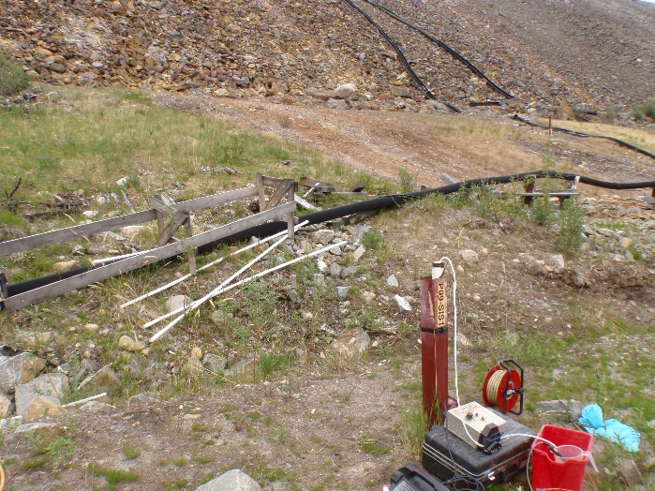
Photo 17: View of well P09-SIS1. Photo taken on June 14, 2015.
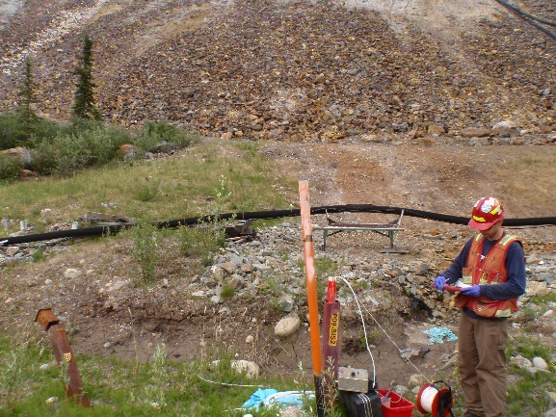
Photo 18: View of well P09-SIS2. Photo taken on June 14, 2015.

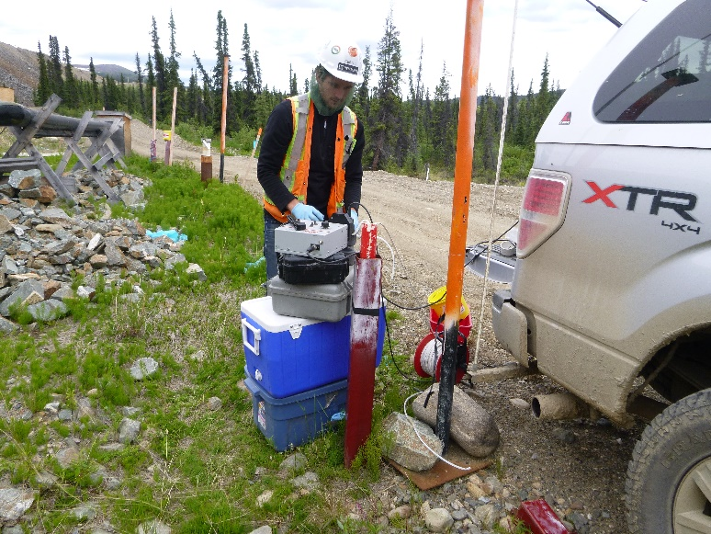
Photo 19: View of well P09-SIS3. Photo taken on June 14, 2015.
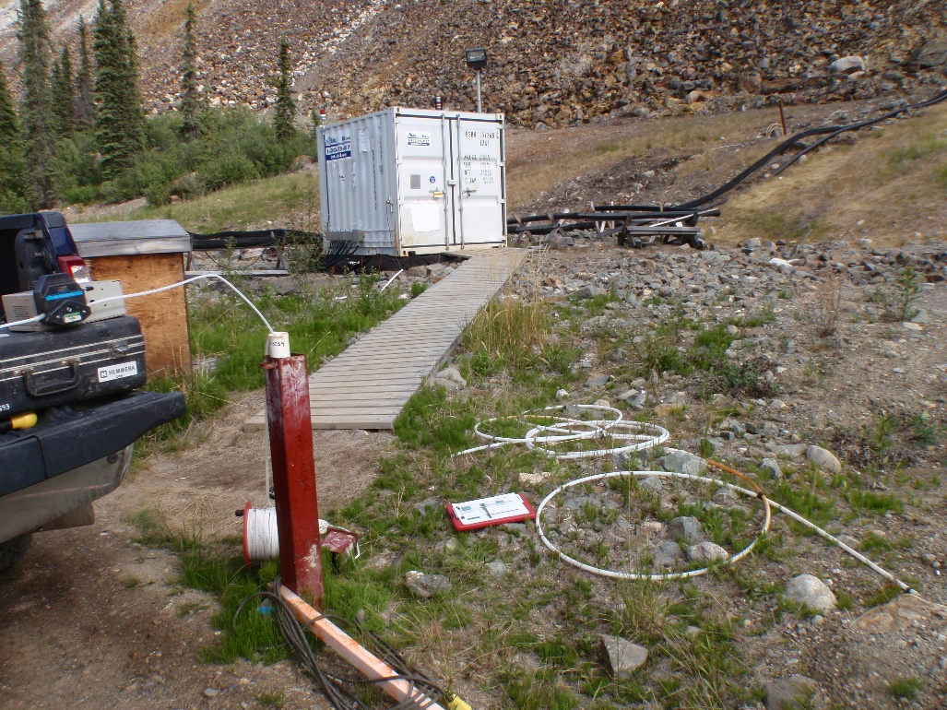
Photo 20: View of well P09-SIS4. Photo taken on June 15, 2015.

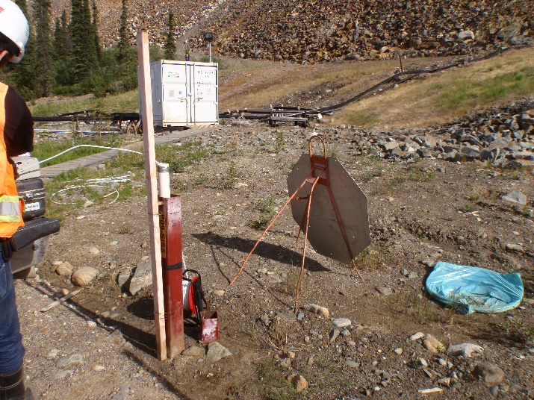
Photo 21: View of well P09-SIS5. Photo taken on June 15, 2015.
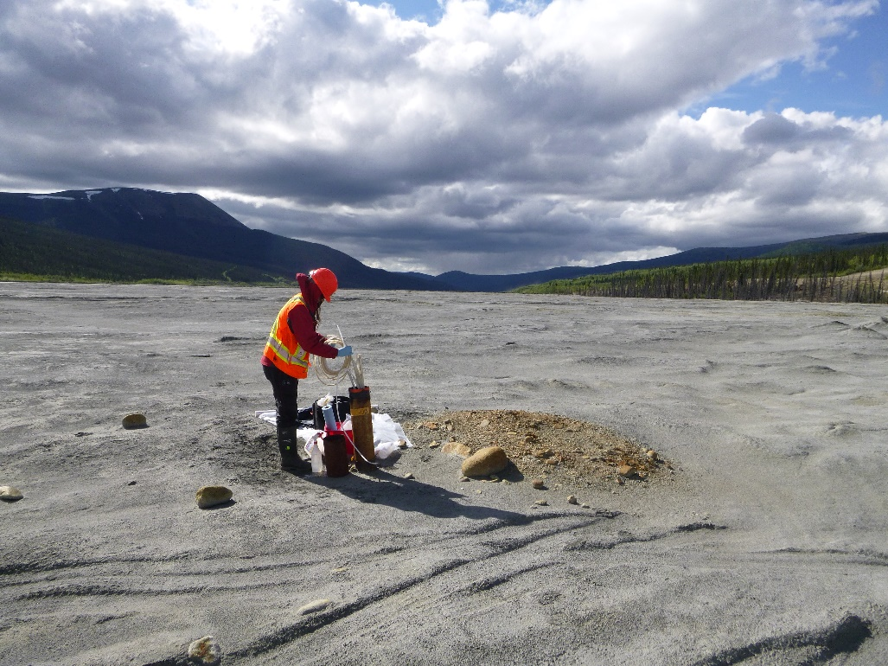
Photo 22: View of CMT wells P03-06-1, P03-06-2, P03-06-6 and P03-06-7. Photo taken on June 11, 2015.

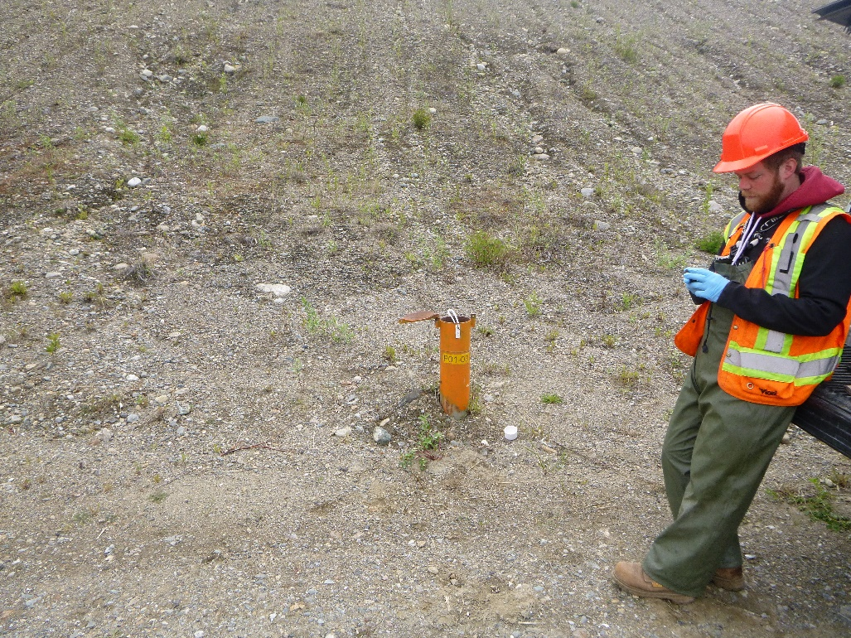
Photo 23: View of well P01-03. Photo taken on June 10, 2015.
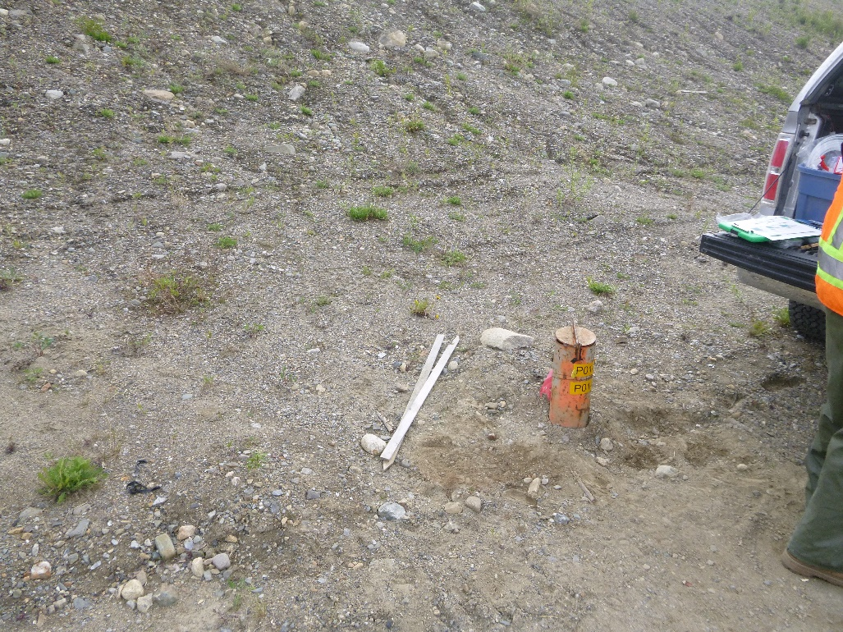
Photo 24: View of wells P01-04A and P01-04B. Photo taken on June 10, 2015.

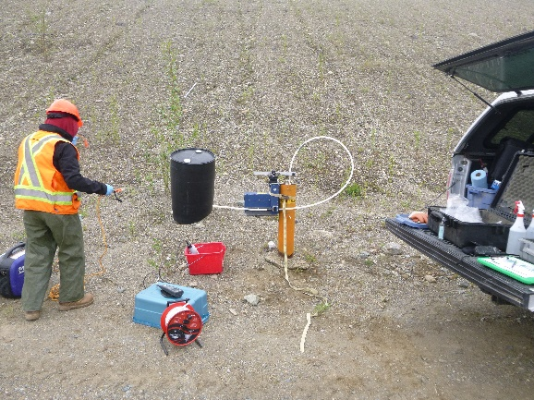
Photo 25: View of well X24-96D. Photo taken on June 10, 2015.
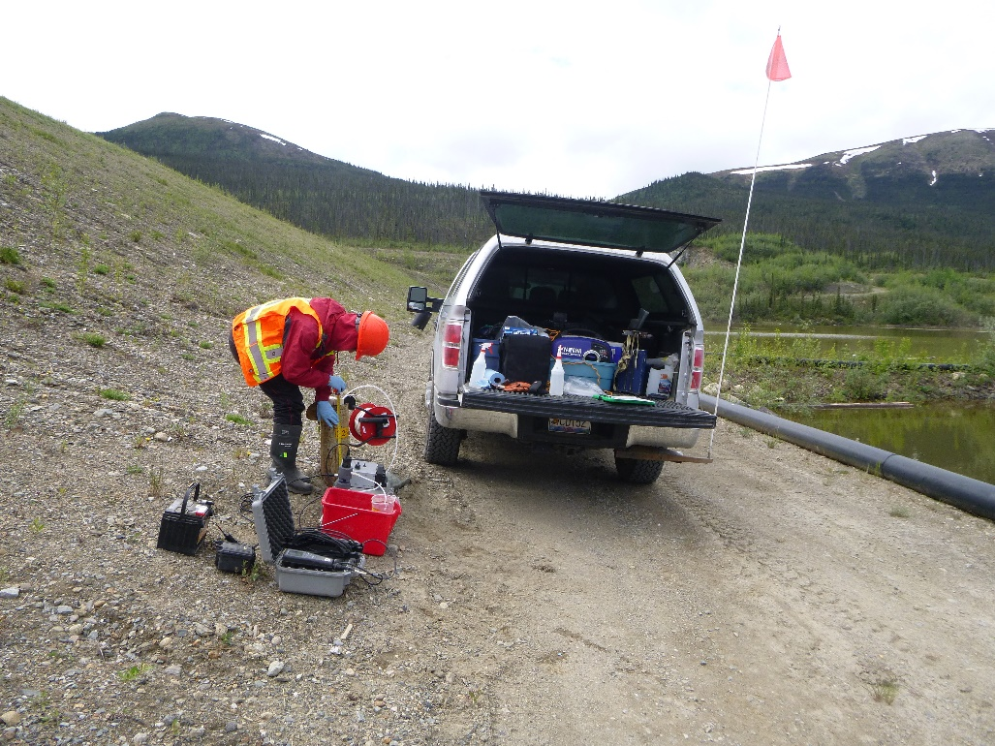
Photo 26: View of wells X25-96A and X25-96B. Photo taken on June 10, 2015.

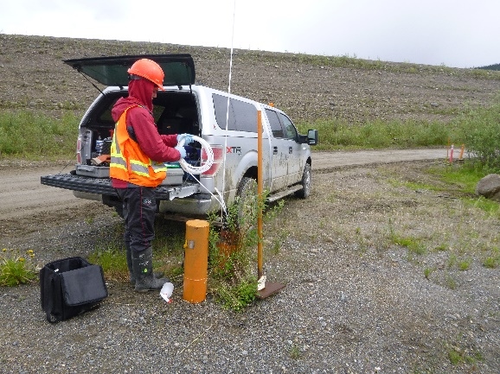
Photo 27: View of CMT wells P05-01-03 and P05-01-05. Photo taken on June 10, 2015.
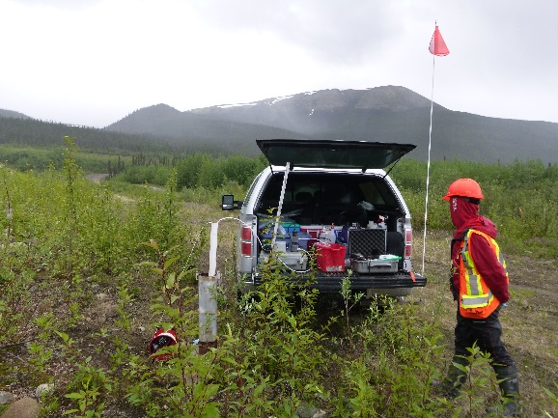
Photo 28: View of well P01-11. Photo taken on June 11, 2015.

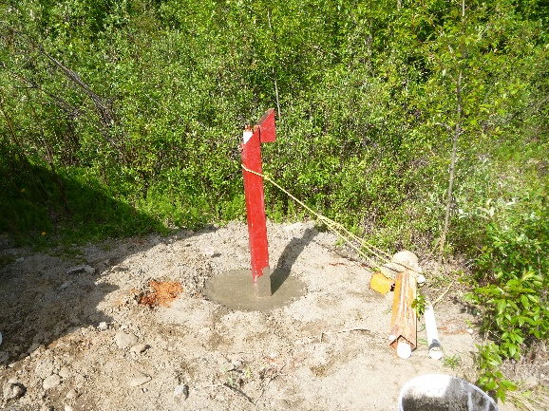
Photo 29: View of well P09-C2. Photo taken on June 11, 2015.
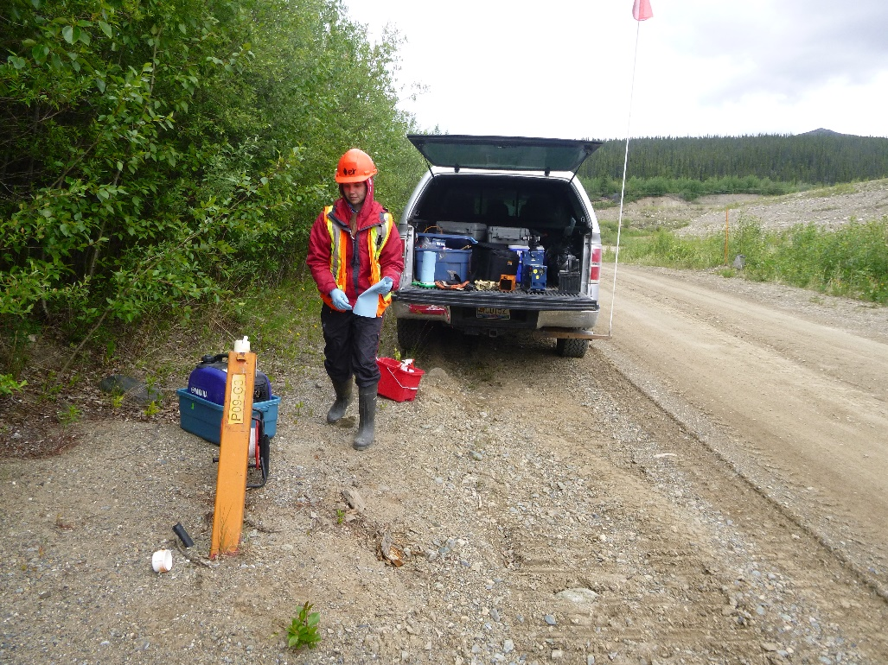
Photo 30: View of well P09-C3. Photo taken on June 10, 2015.

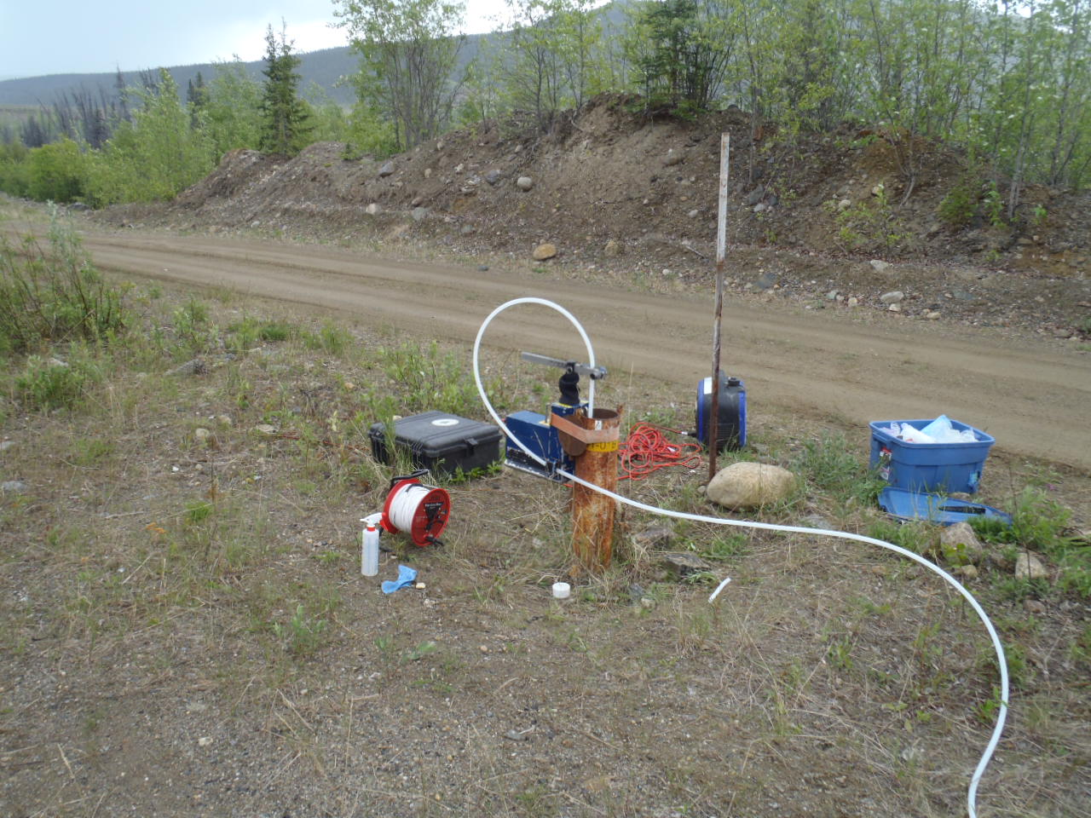
Photo 31: View of wells P01-01A and P01-01B. Photo taken on June 11, 2015.
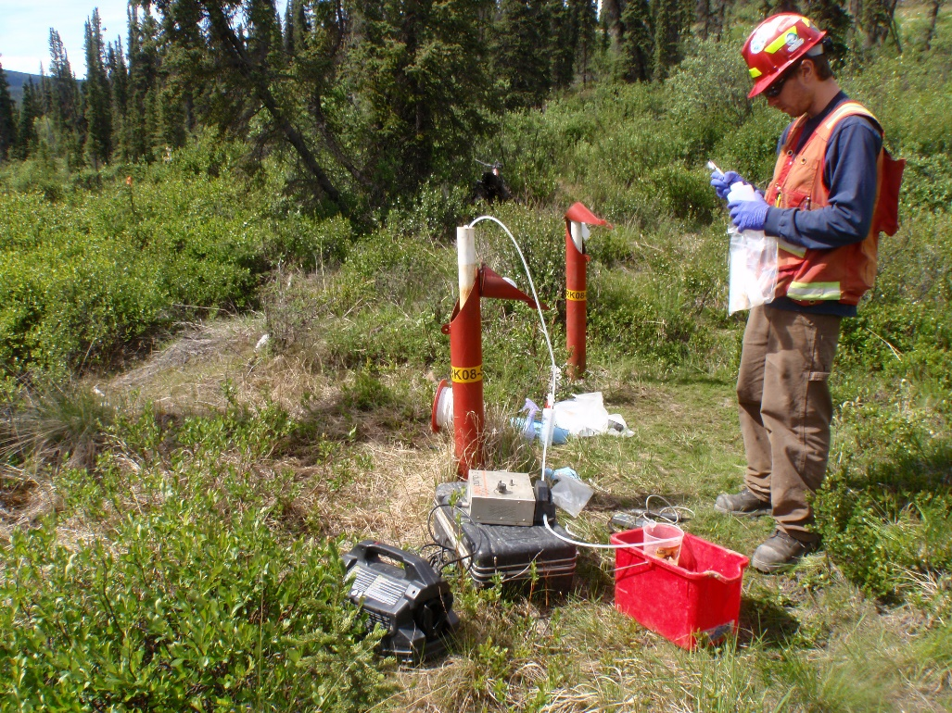
Photo 32: Views of Wells SRK08-SP7A and SRK08-SP7B. Photo taken June 13, 2015.

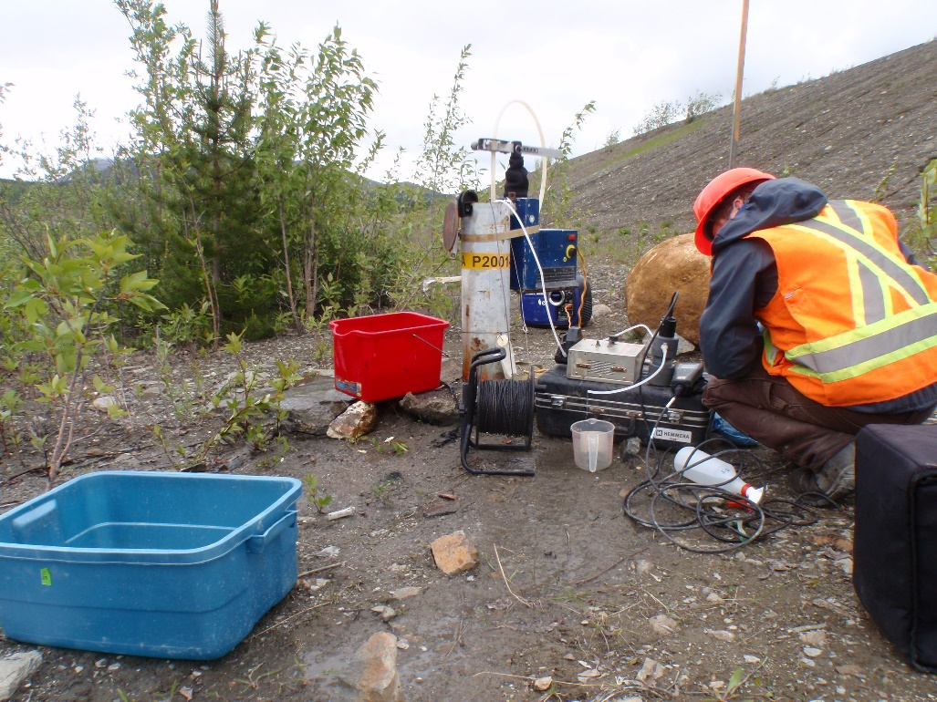
Photo 33: View of wells P2001-02A and P2001-02B. Photo taken on June 14, 2015.
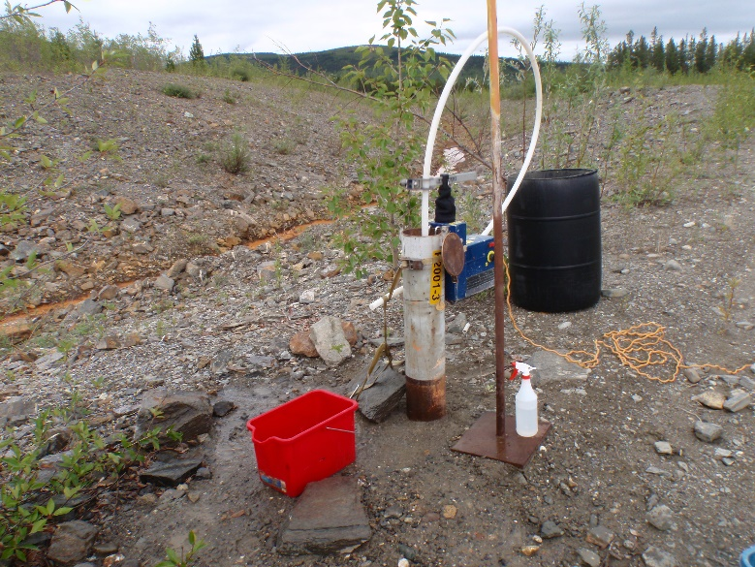
Photo 34: View of well P2001-3. Photo taken on June 14, 2015.

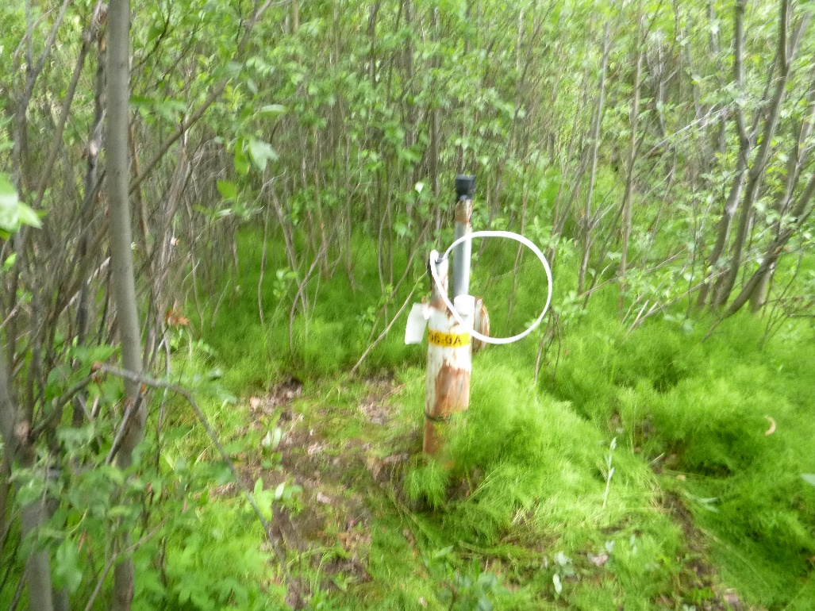
Photo 35: View of well P96-9A. Photo taken on June 12, 2015.
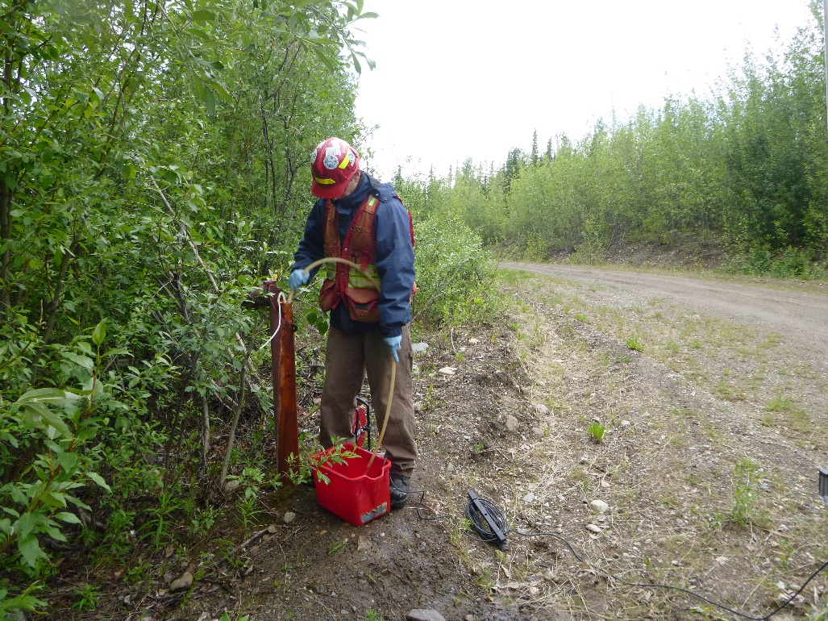
Photo 36: View of well BH05-9B-R (P96-9BR). Photo taken on June 12, 2015.

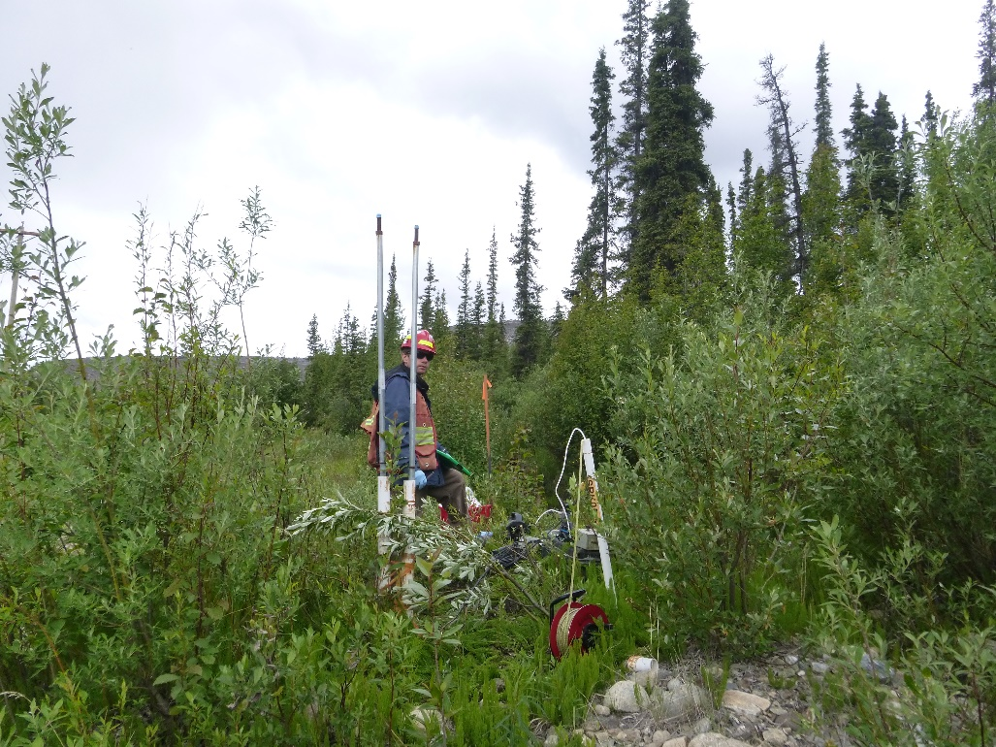
Photo 37: View of well SRK05-5C. Photo taken on June 12, 2015.
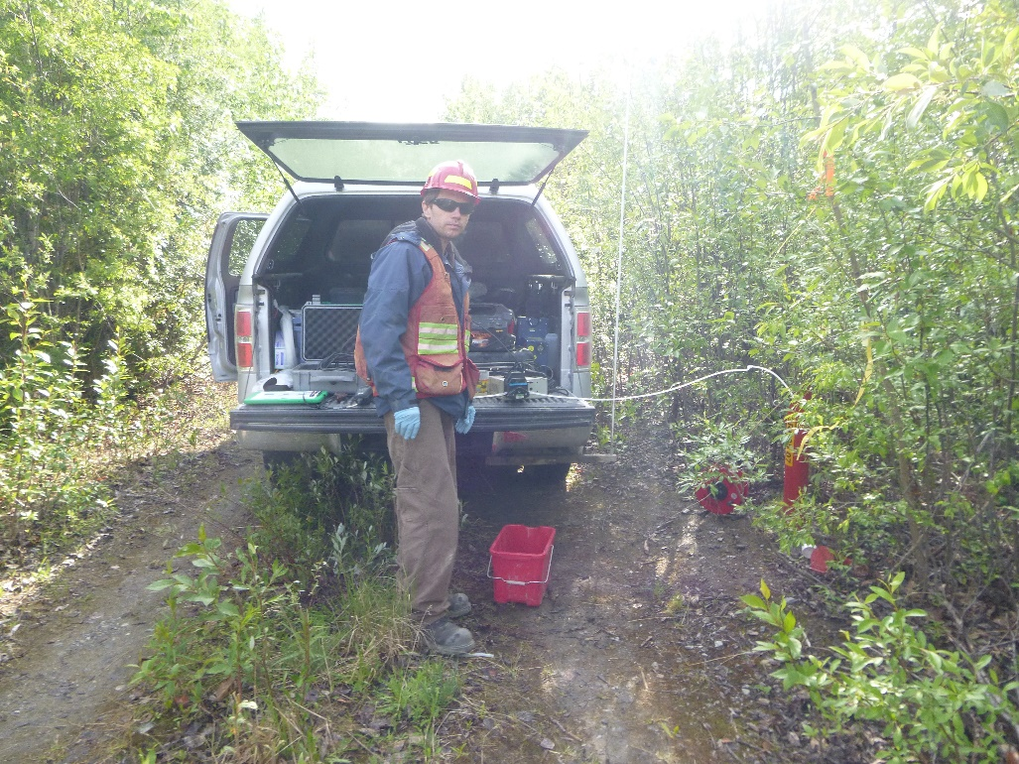
Photo 38: View of well SRK05-7. Photo taken on June 12, 2015.

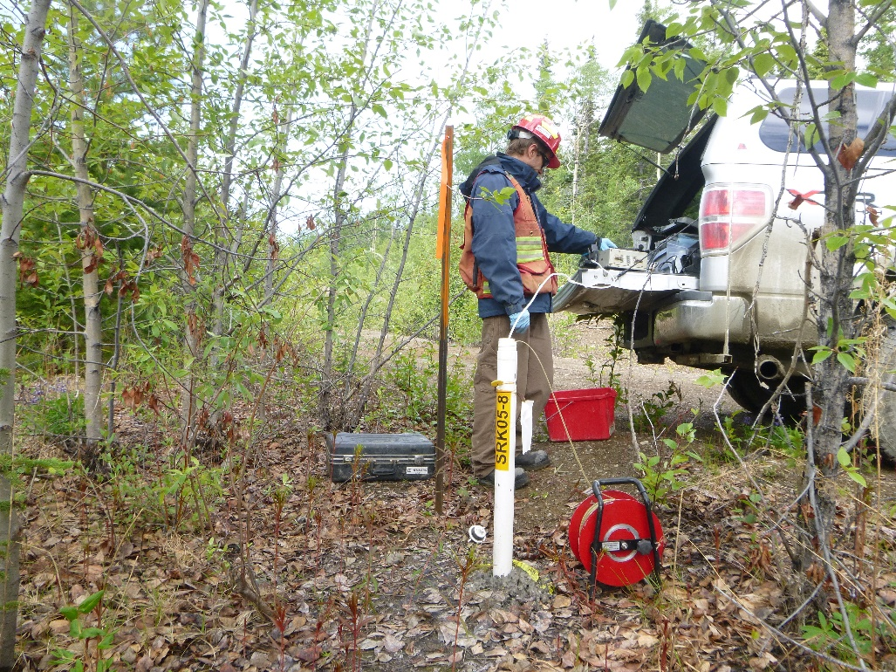
Photo 39: View of well SRK05-08. Photo taken on June 12, 2015.
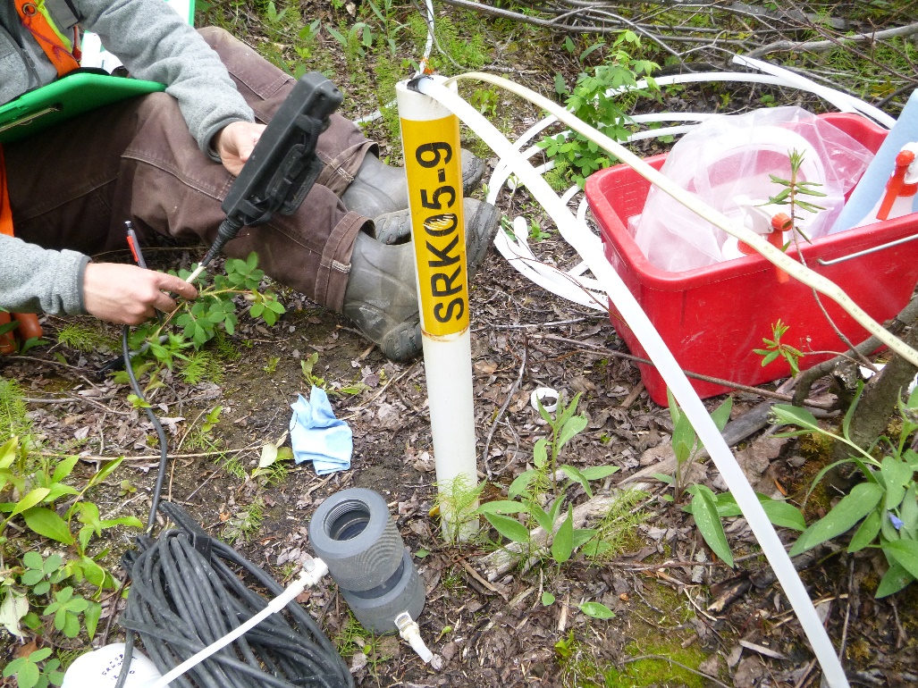
Photo 40: View of well SRK05-9. Lots of old tubing found at site upon arrival. Photo taken on June 12, 20145.

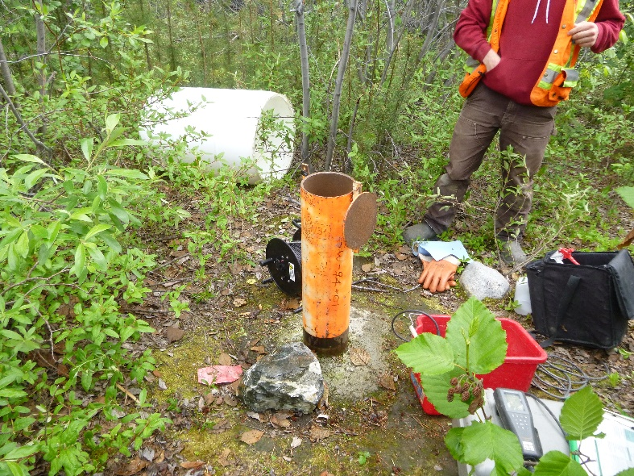
Photo 41: View of well V34. Photo taken on June 13, 2015.
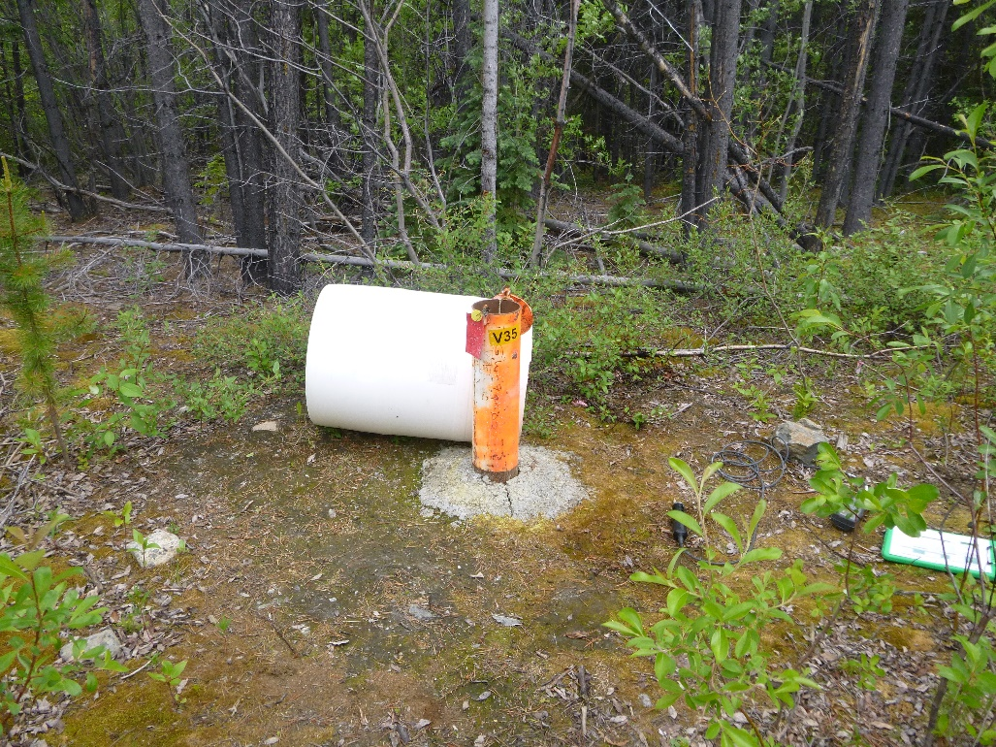
Photo 42: View of well V35. Photo taken on June 13, 2015.

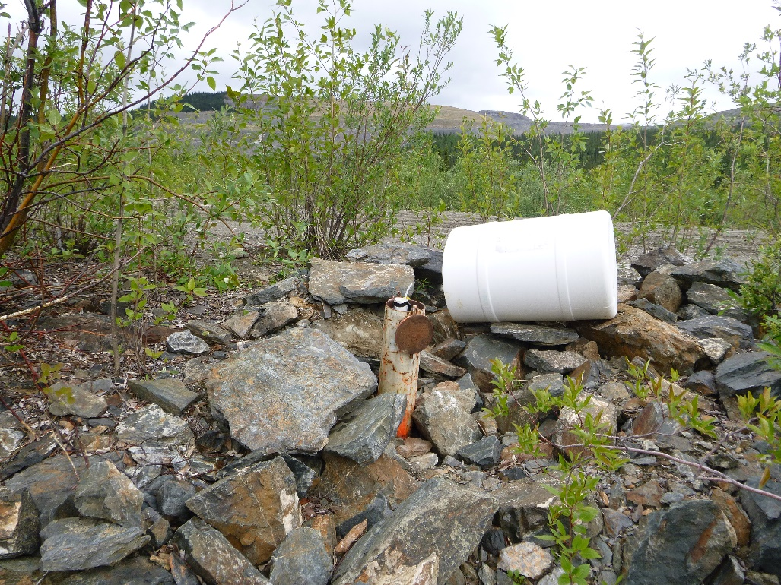
Photo 43: View of well V36. Photo taken on June 13, 2015.
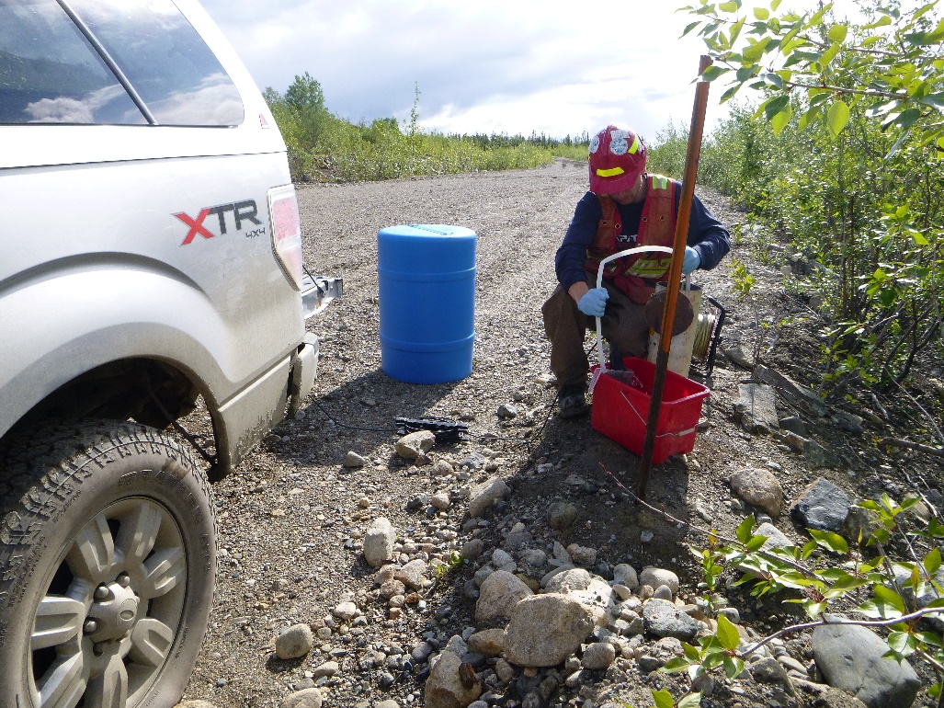
Photo 44: View of well V37. Photo taken on June 12, 2015.

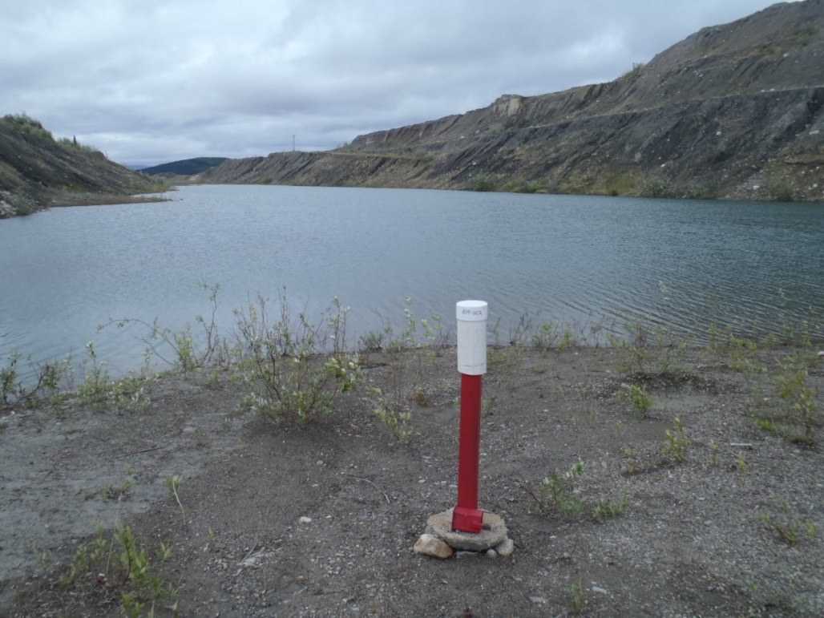
Photo 45: View of wells P09-GS1A. Photo taken on June 13, 2015.
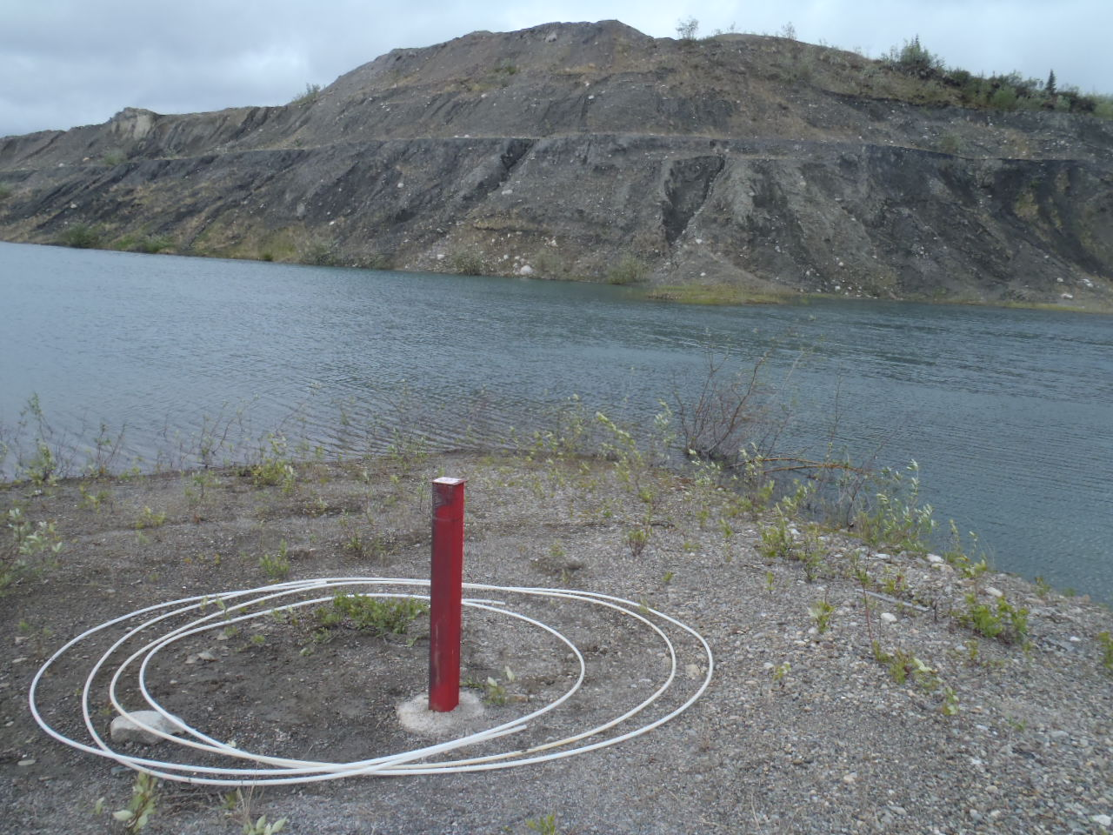
Photo 46: View of wells P09-GS1B. Photo taken on June 13, 2015.

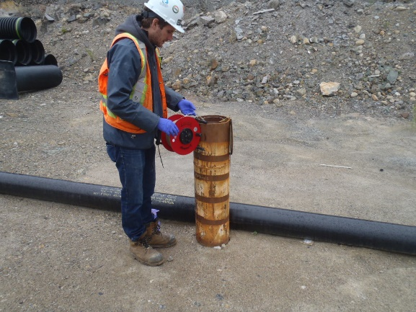
Photo 47: View of well PW14-06. Photo taken on June 10, 2015.
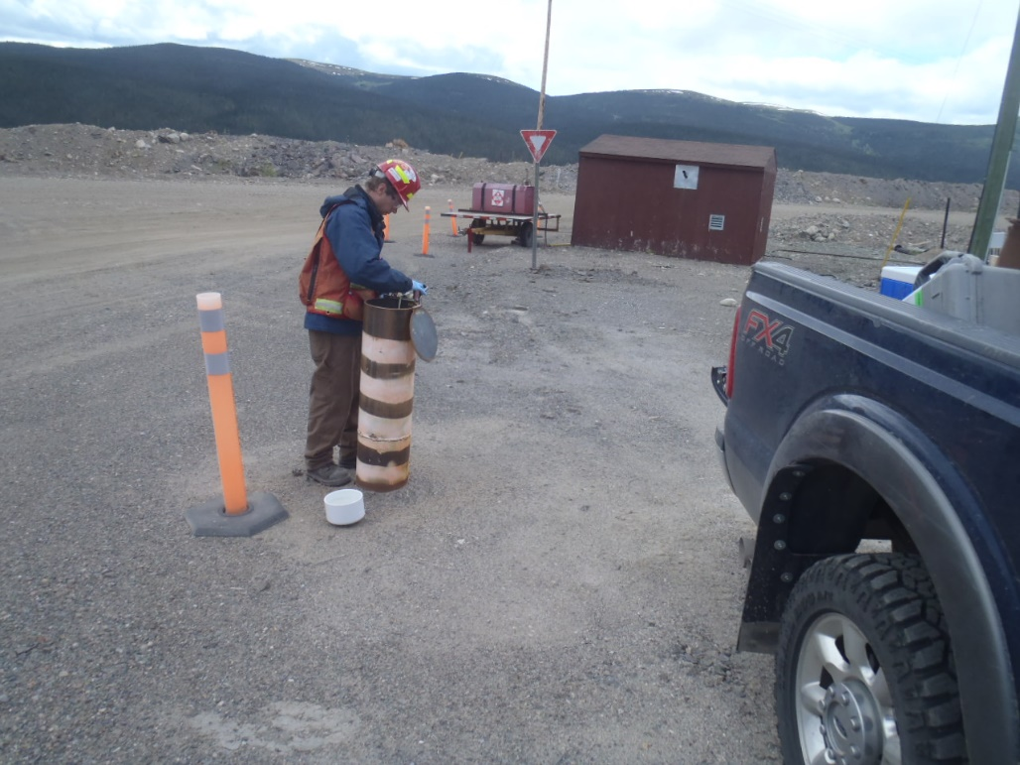
Photo 48: View of well MW14-03. Photo taken on June 18, 2015.

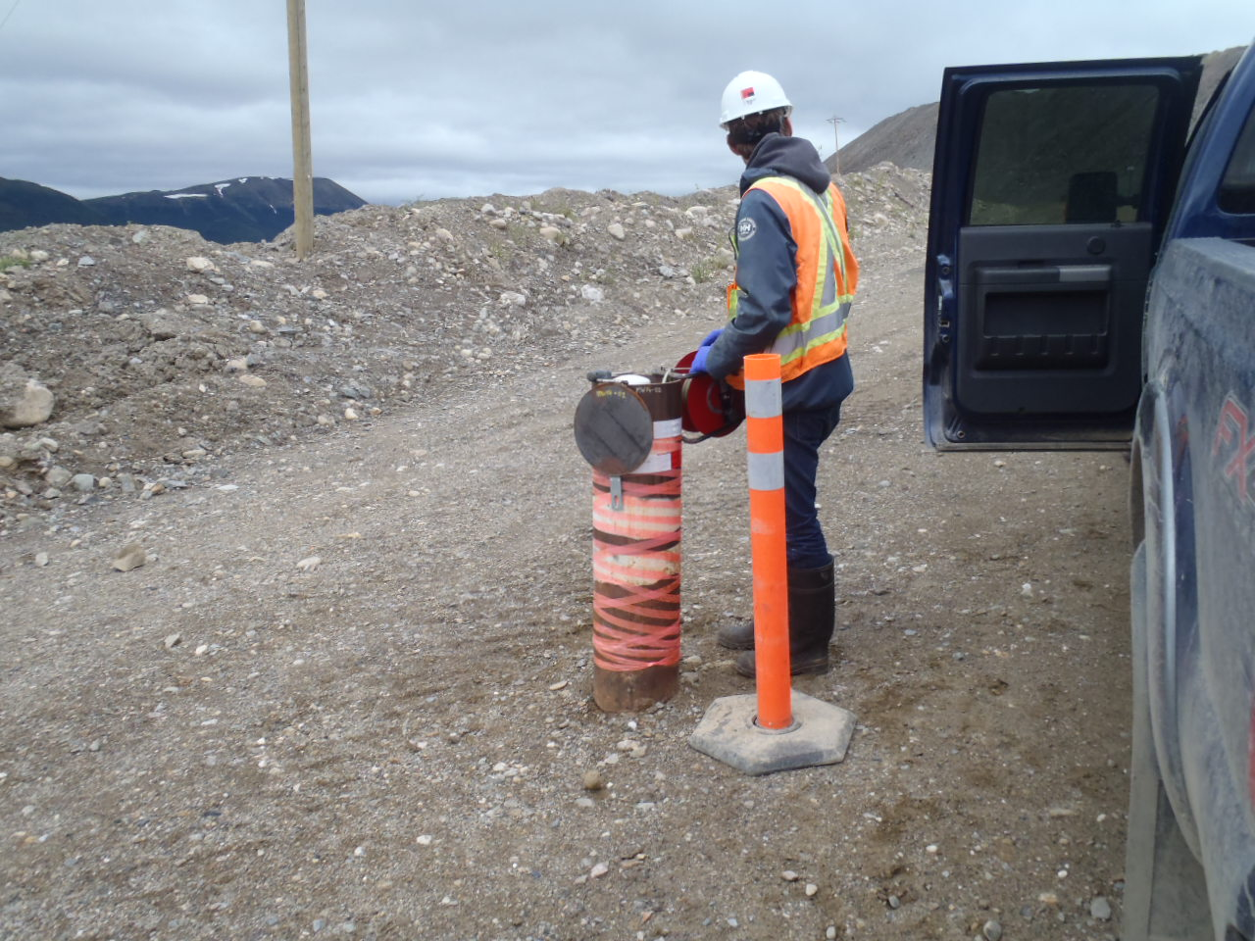
Photo 49: View of well MW14-02D. Photo taken on June 17, 2015.
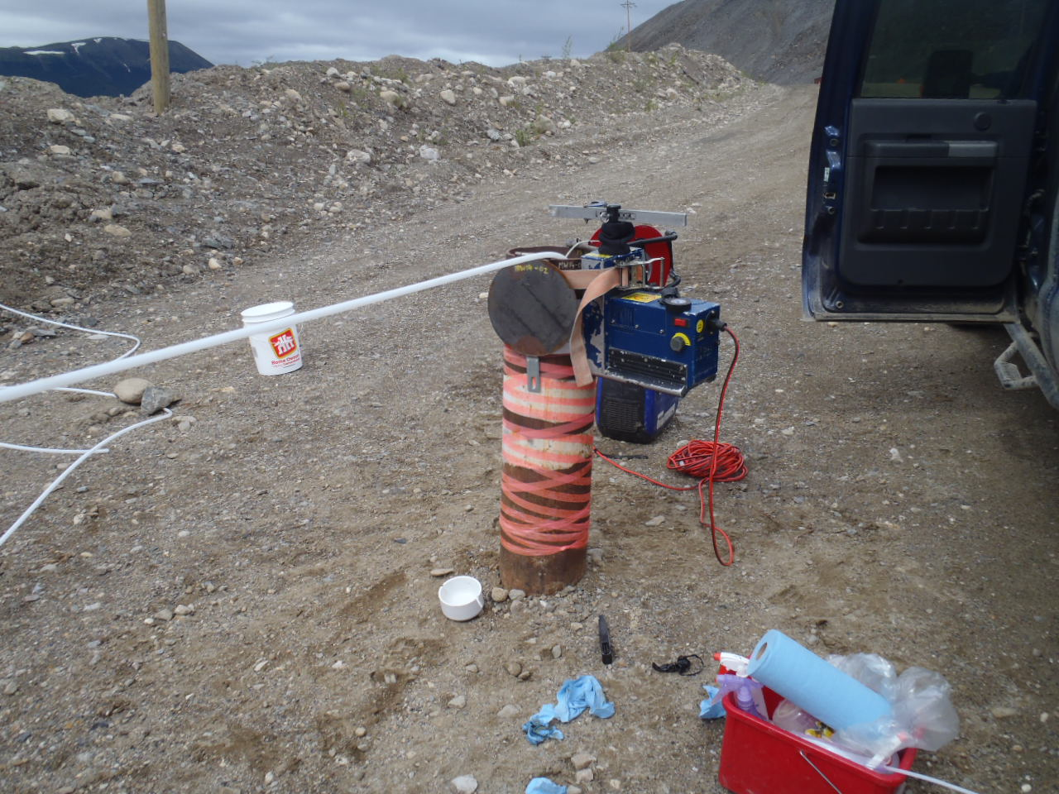
Photo 50: View of well MW14-02S. Photo taken on June 17, 2015.

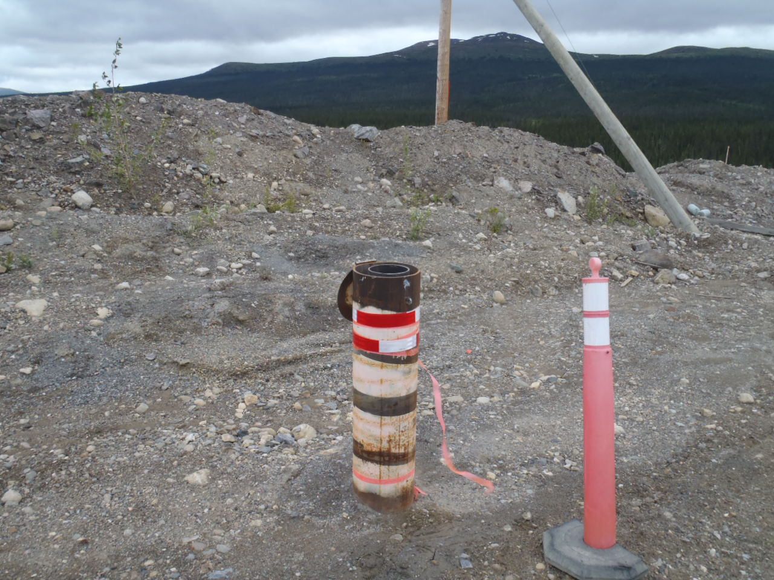
Photo 51: View of well PW14-01. Photo taken on June 17, 2015.
Photo 52: View of well MW14-02S. Photo taken on June 17, 2015.

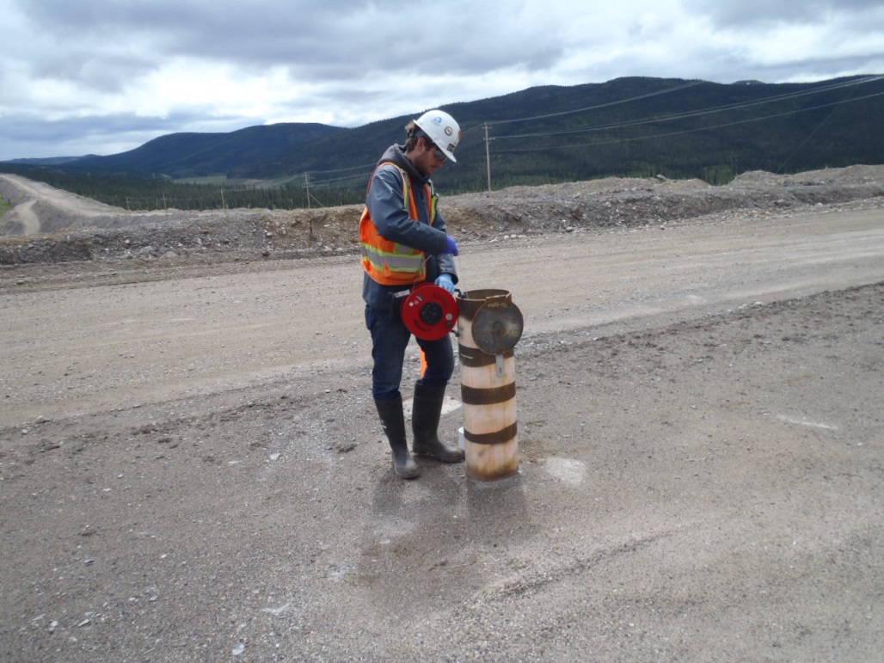
Photo 53: View of well MW14-05. Photo taken on June 18, 2015.
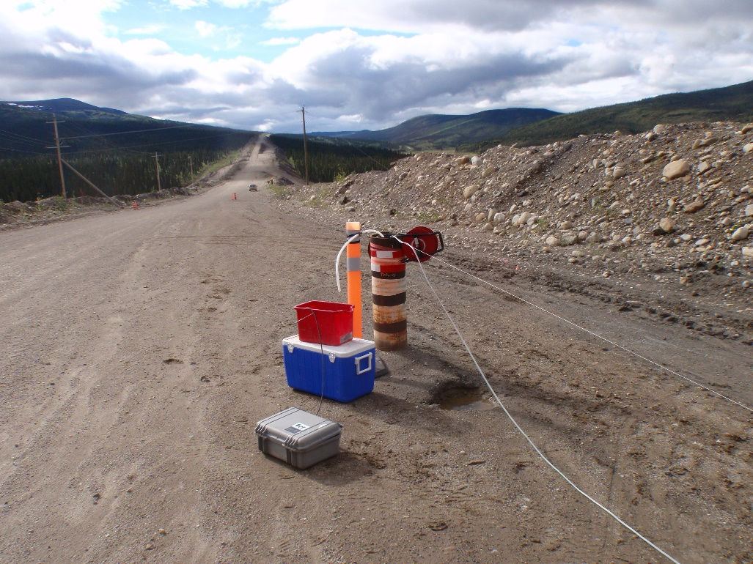
Photo 54: View of well PW14-07 taken on June 19, 2015

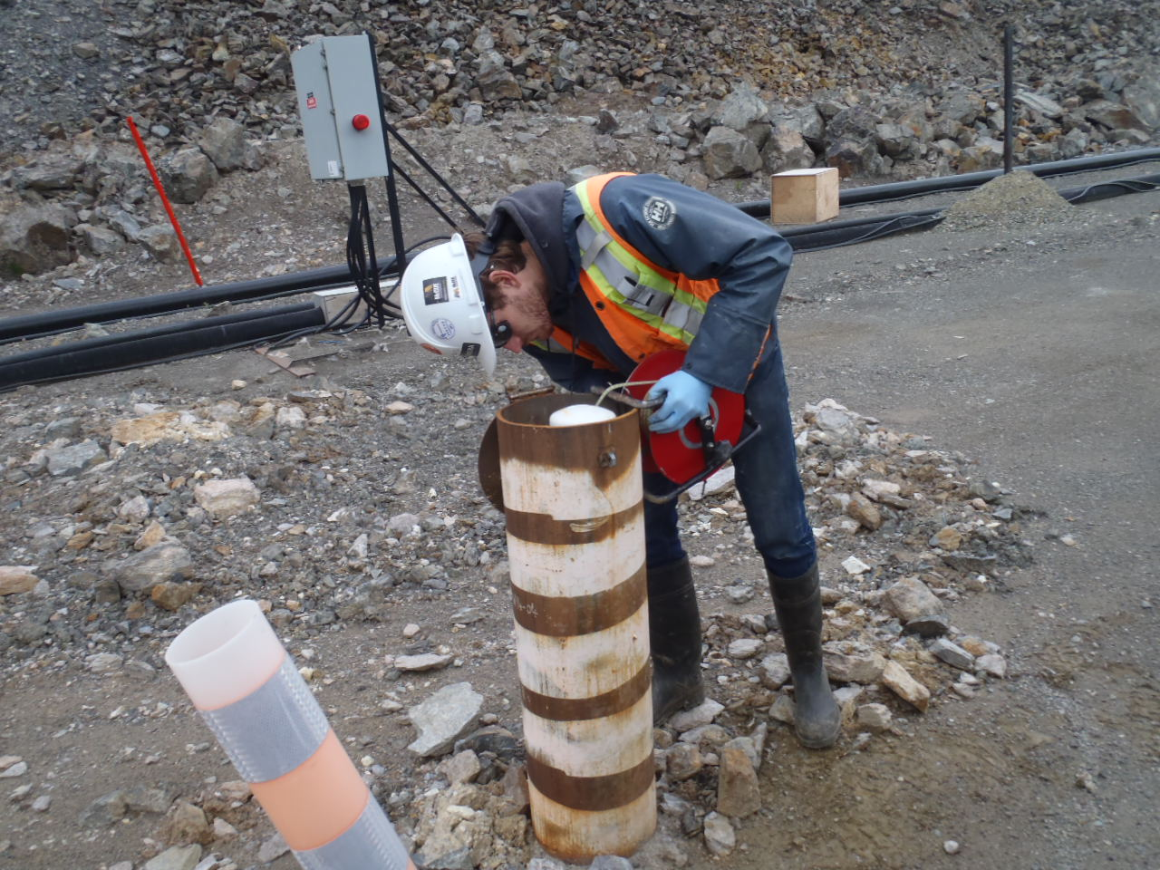
Photo 55: View of well MW14-04D and MW14-04S. Photo taken on June 18, 2015.

