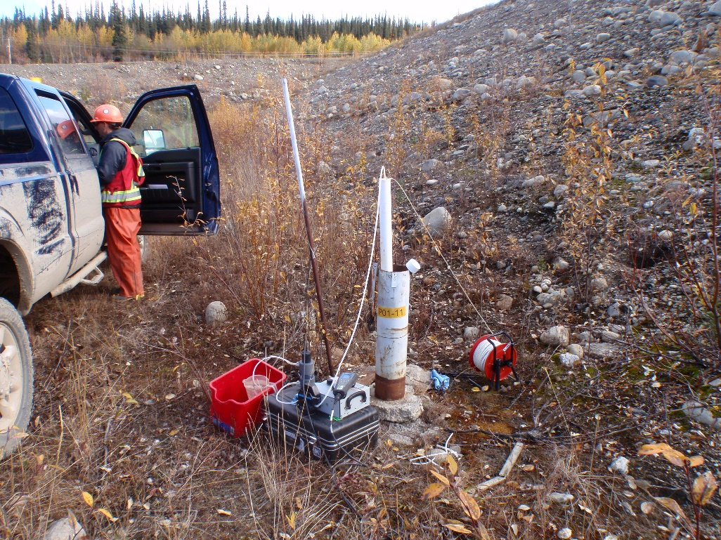
Photo 1: View of well P01-11. Photo taken on September 13th, 2015.
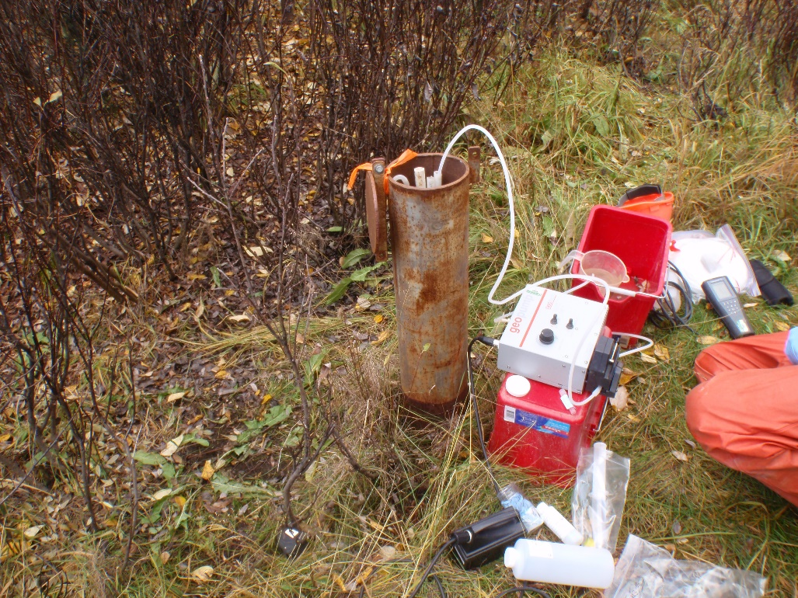
Photo 2: View of wells P03-09-6 and P03-09-9. Photo taken on September 13th, 2015.
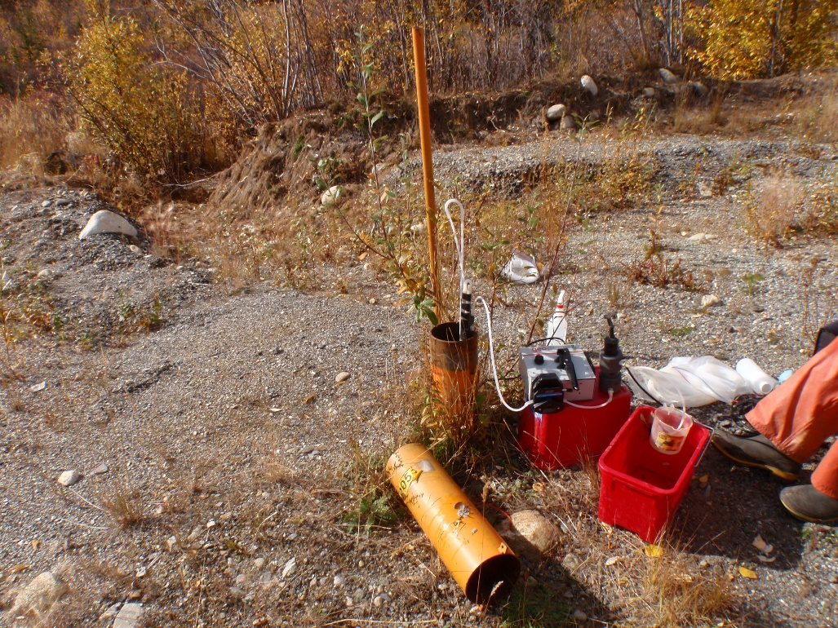
Photo 3: View of well P05-01. Photo taken on September 13th, 2015.
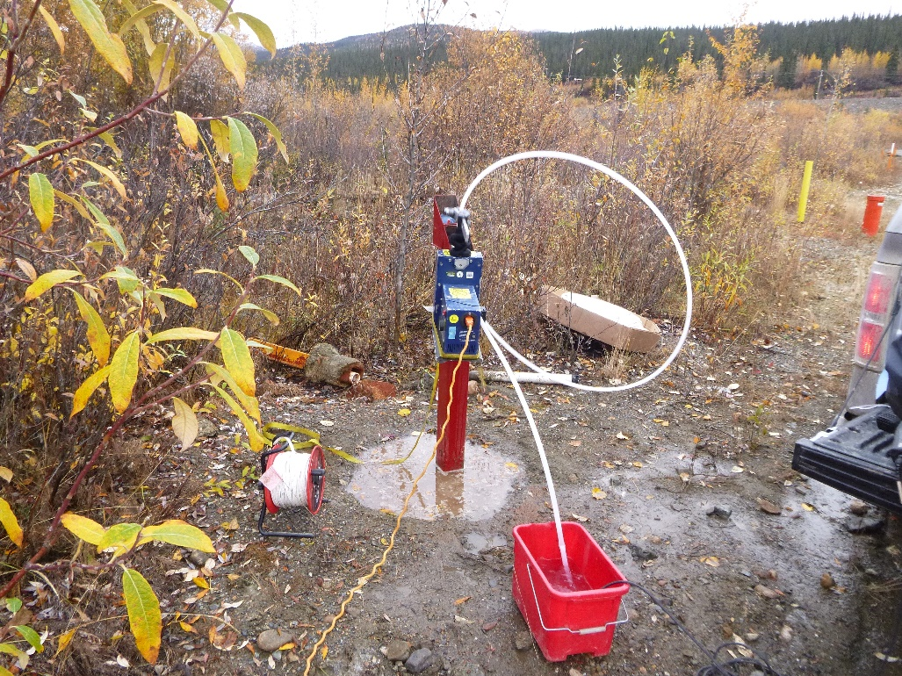
Photo 4: View of well P09-C2. Photo taken on September 14th, 2015.
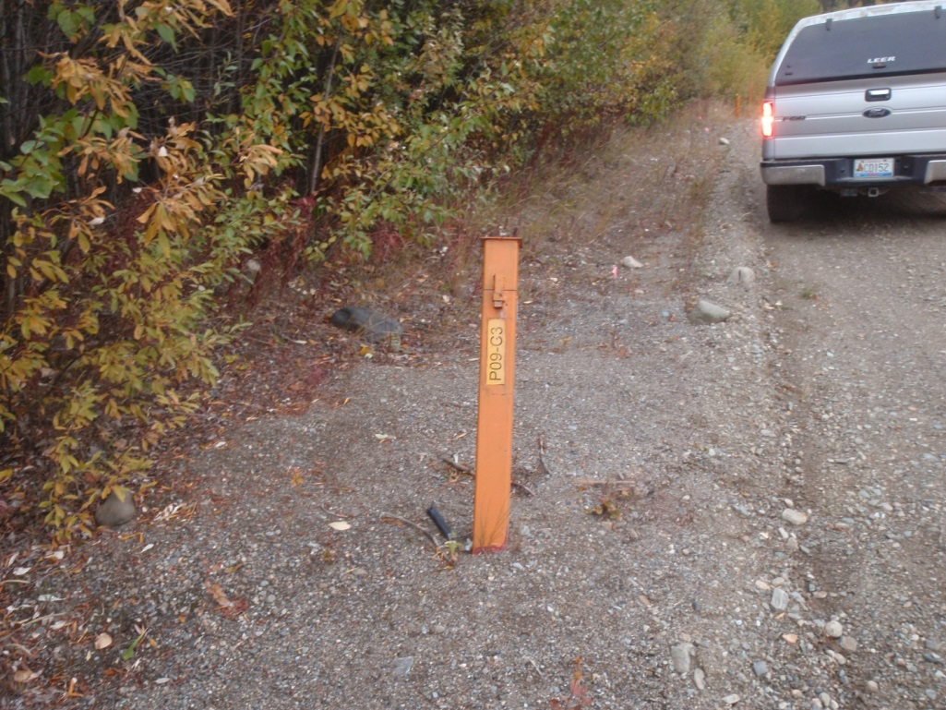
Photo 5: View of well P09-C3. Photo taken on September 14th, 2015.
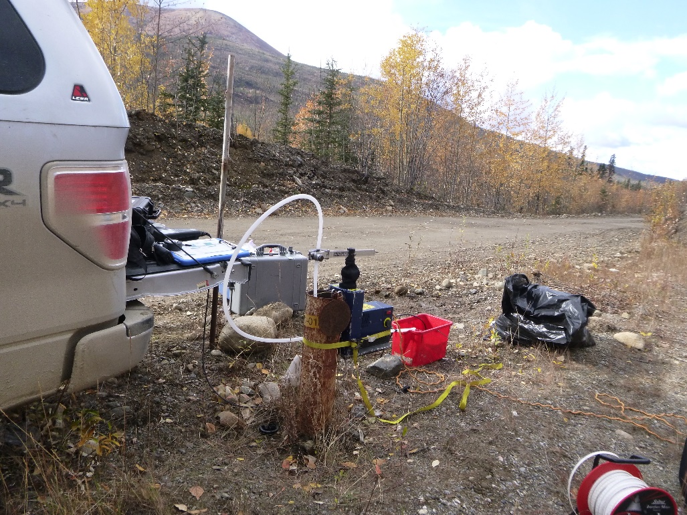
Photo 6: View of wells P01-01A and P01-01B. Photo taken on September 13th, 2015.
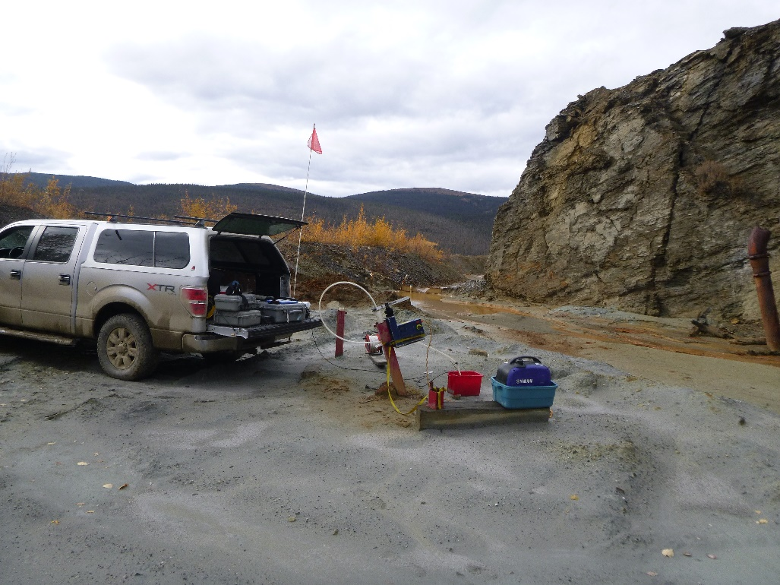
Photo 7: View of wells P09-ETA-1 and P09-ETA-2. Photo taken on September 14th, 2015.
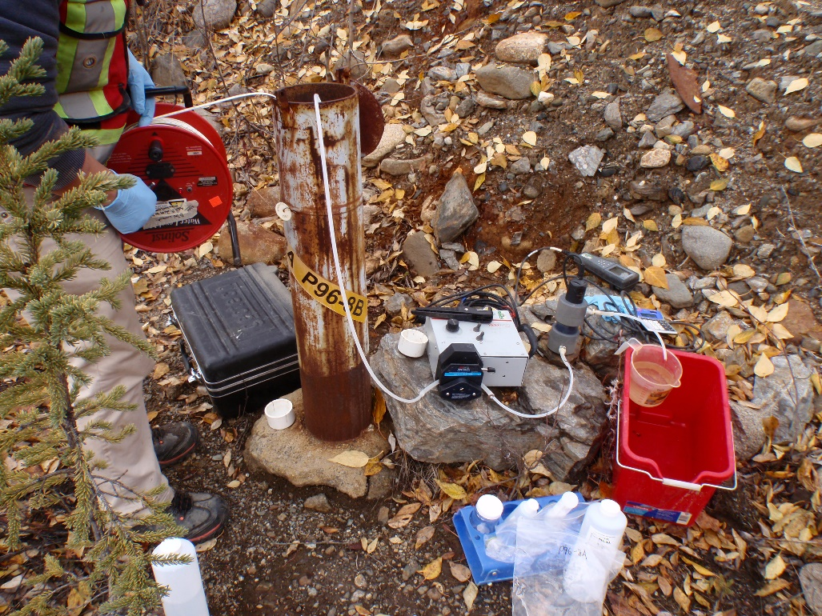
Photo 8: View of wells P96-8A and P96-8B. Photo taken on September 14th, 2015.
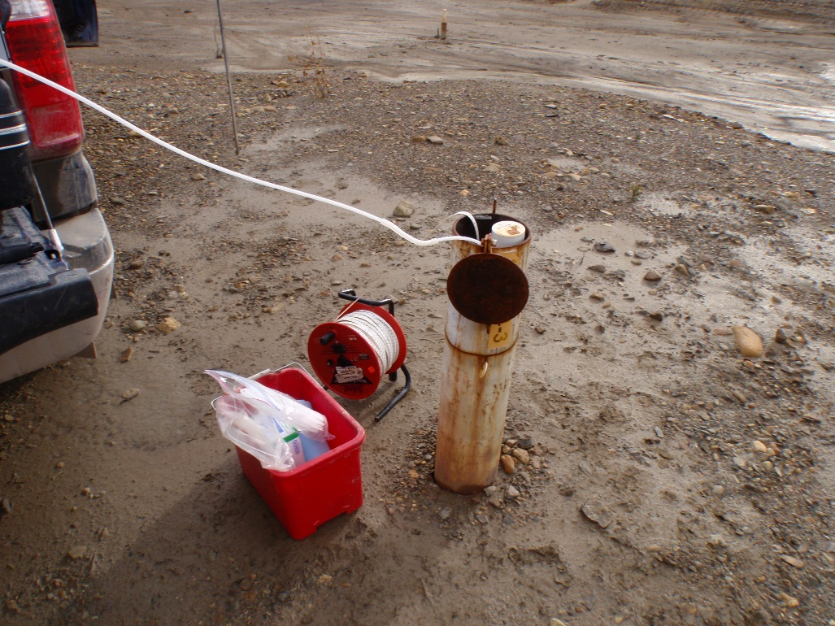
Photo 9: View of well SRK04-3A. Photo taken on September 14th, 2015.
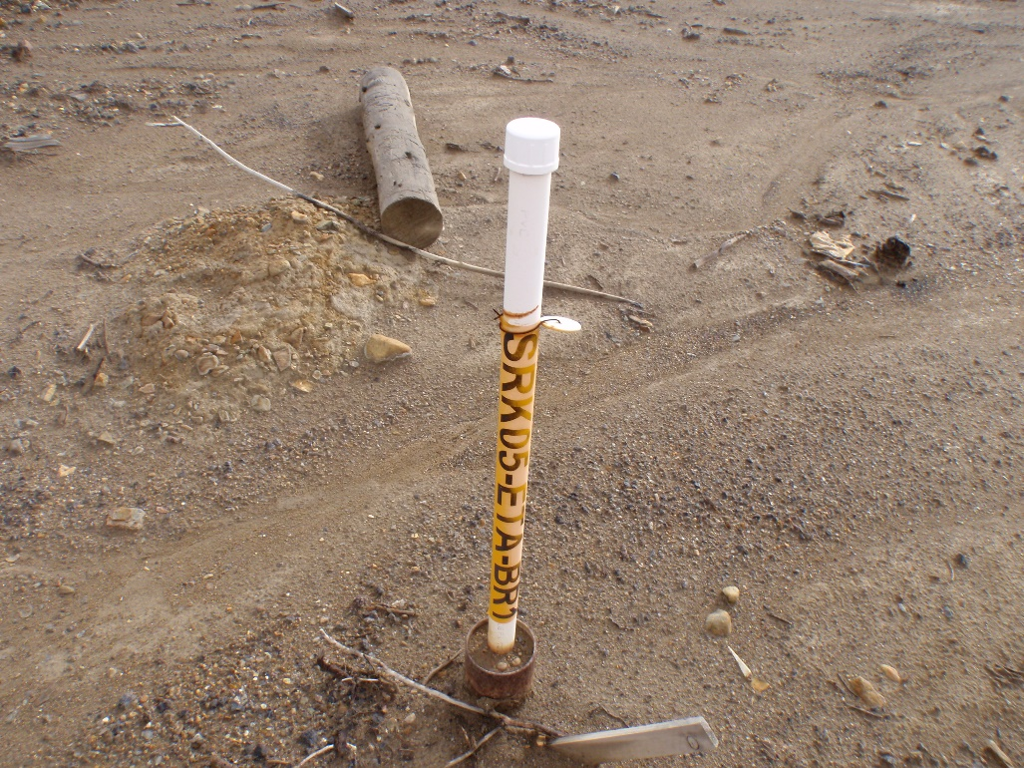
Photo 10: View of well SRK05-ETA-BR1. Photo taken on September 14th, 2015.
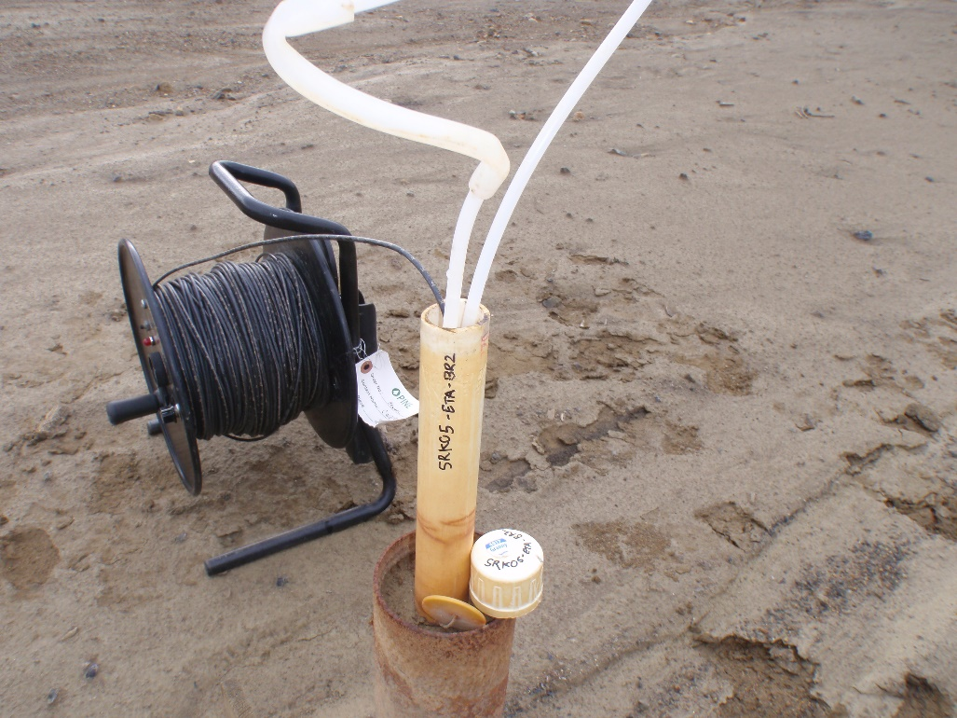
Photo 11: View of well SRK05-ETA-BR2. Photo taken on September 14th, 2015.
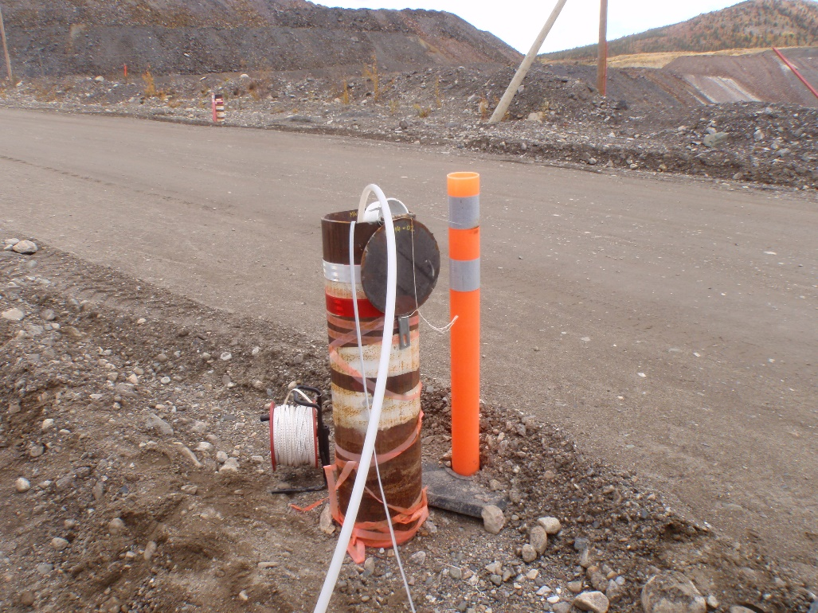
Photo 12: View of wells MW14-02S and MW14-02D. Photo taken on September 10th, 2015.

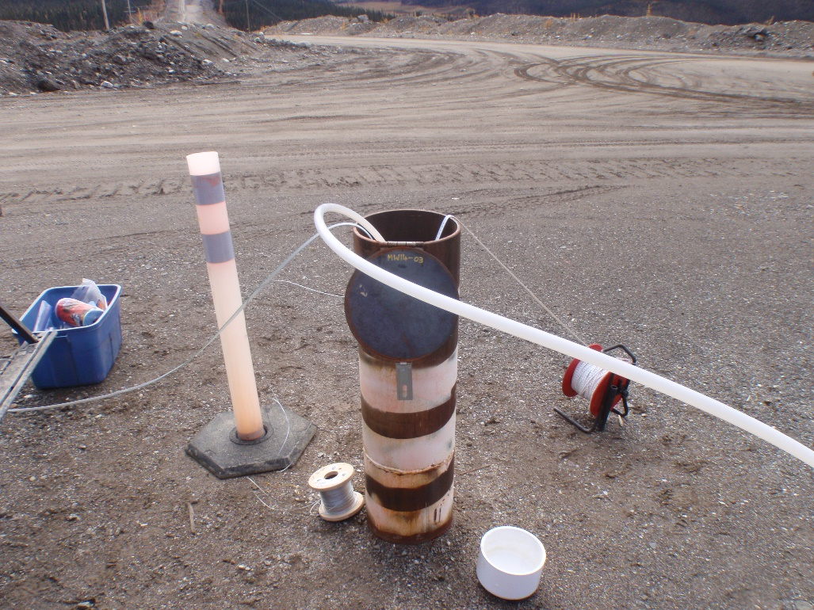
Photo 13: View of well MW14-03. Photo taken on September 10th, 2015.
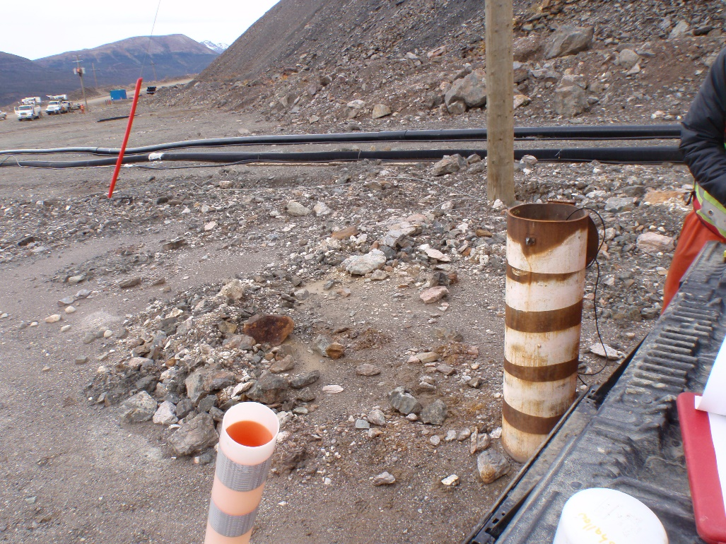
Photo 14: View of wells MW14-04S and MW14-04D. Photo taken on September 12th, 2015.

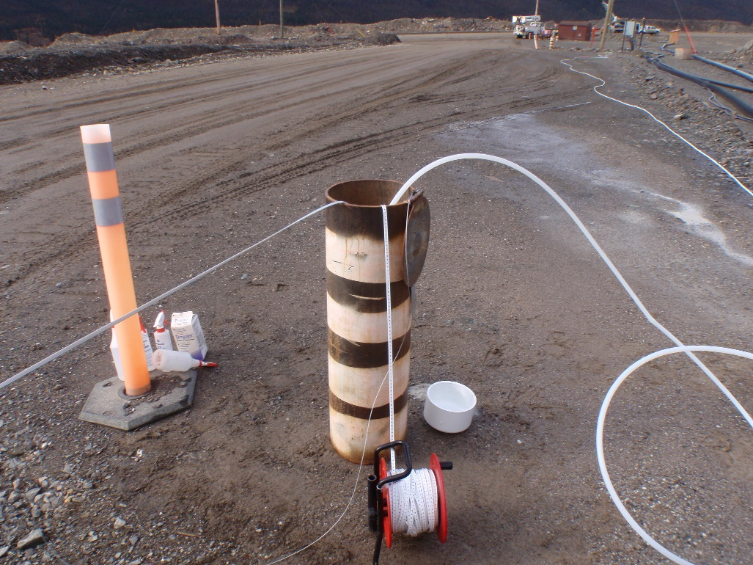
Photo 15: View of well MW14-05. Photo taken on September 10th, 2015.
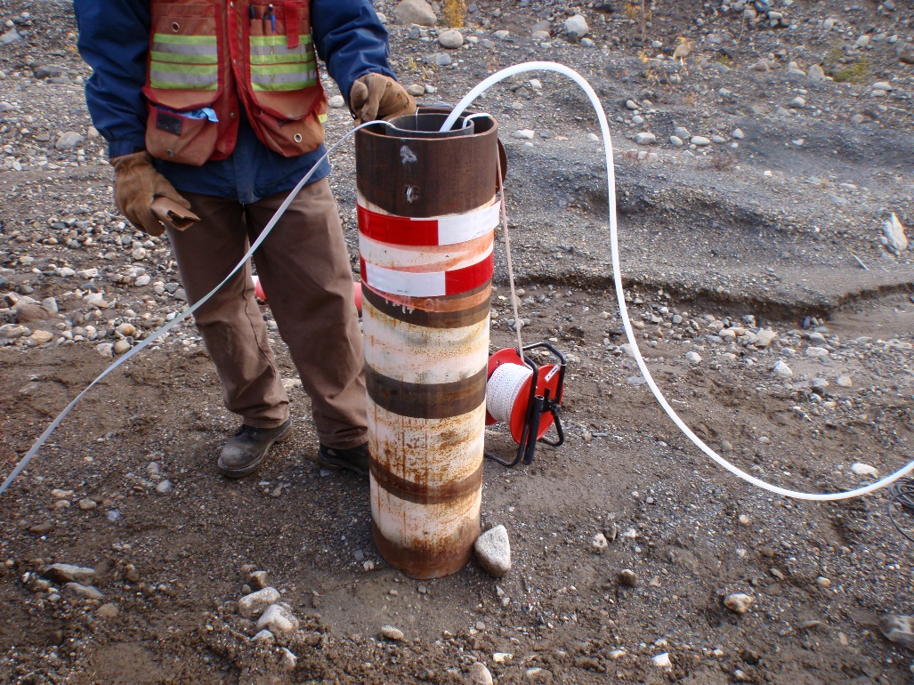
Photo 16: View of well PW14-01. Photo taken on September 11th, 2015.

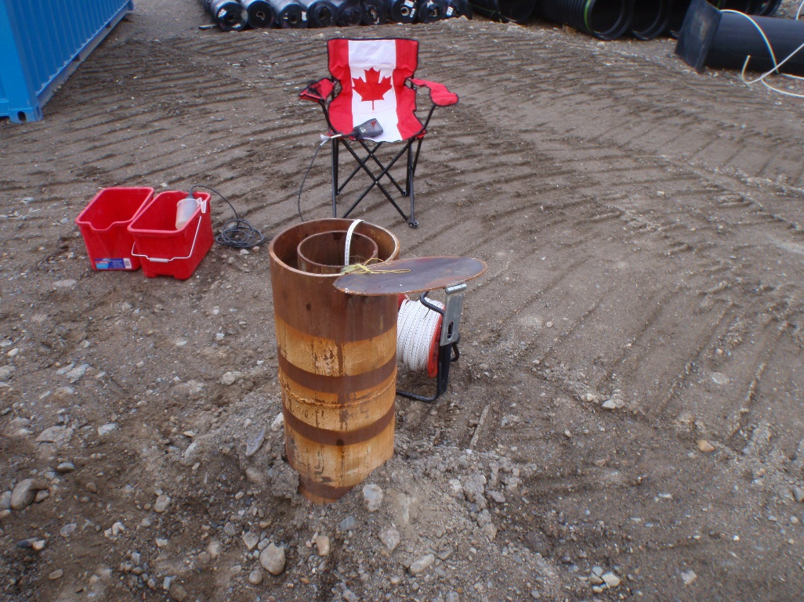
Photo 17: View of well PW14-06. Photo taken on September 12th, 2015.
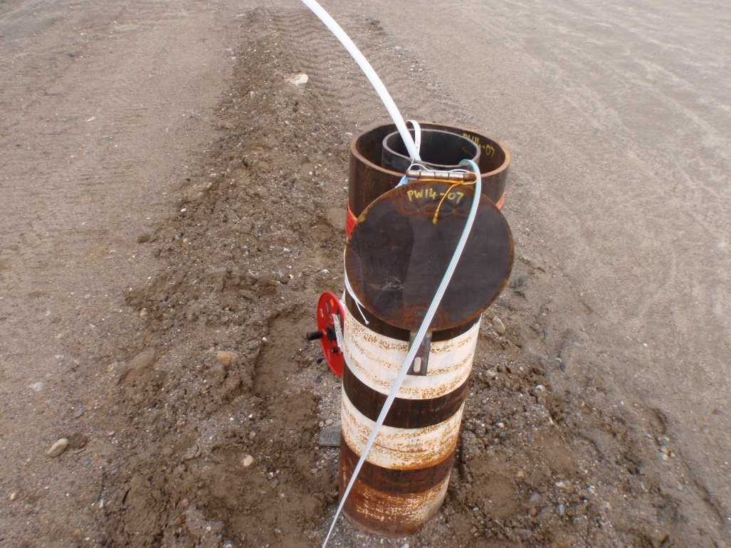
Photo 18: View of well PW14-07. Photo taken on September 12th, 2015.

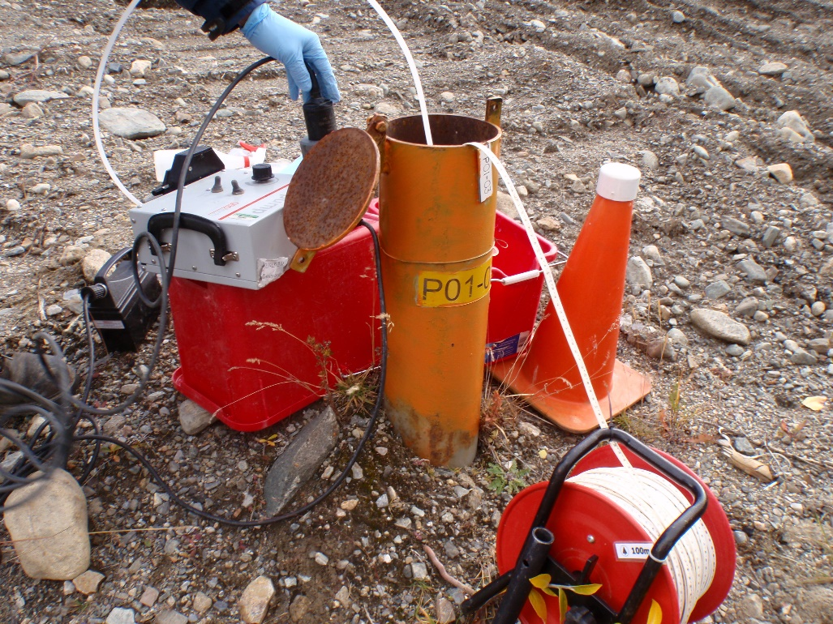
Photo 19: View of well P01-03. Photo taken on September 13th, 2015.
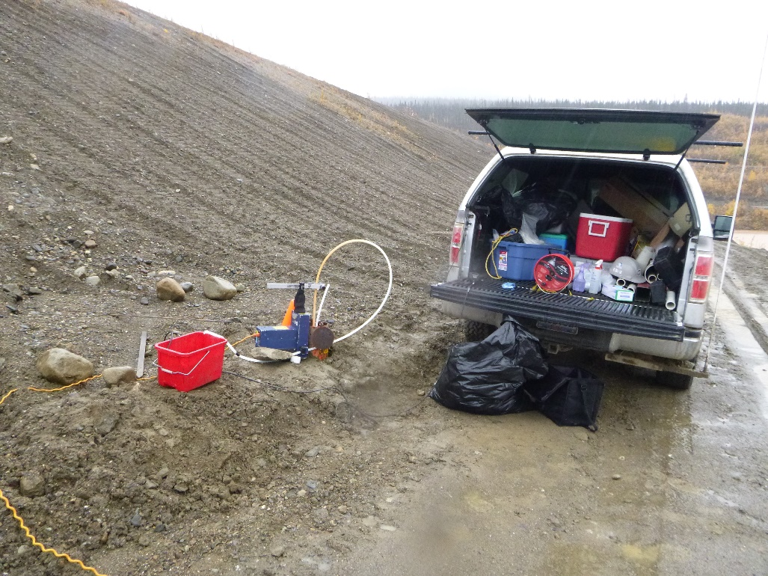
Photo 20: View of wells P01-04A and P01-04B. Photo taken on September 13th, 2015.

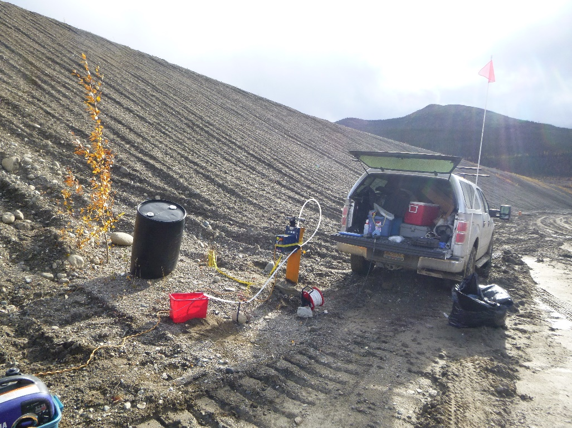
Photo 21: View of well X24-96D. Photo taken on September 13th, 2015.
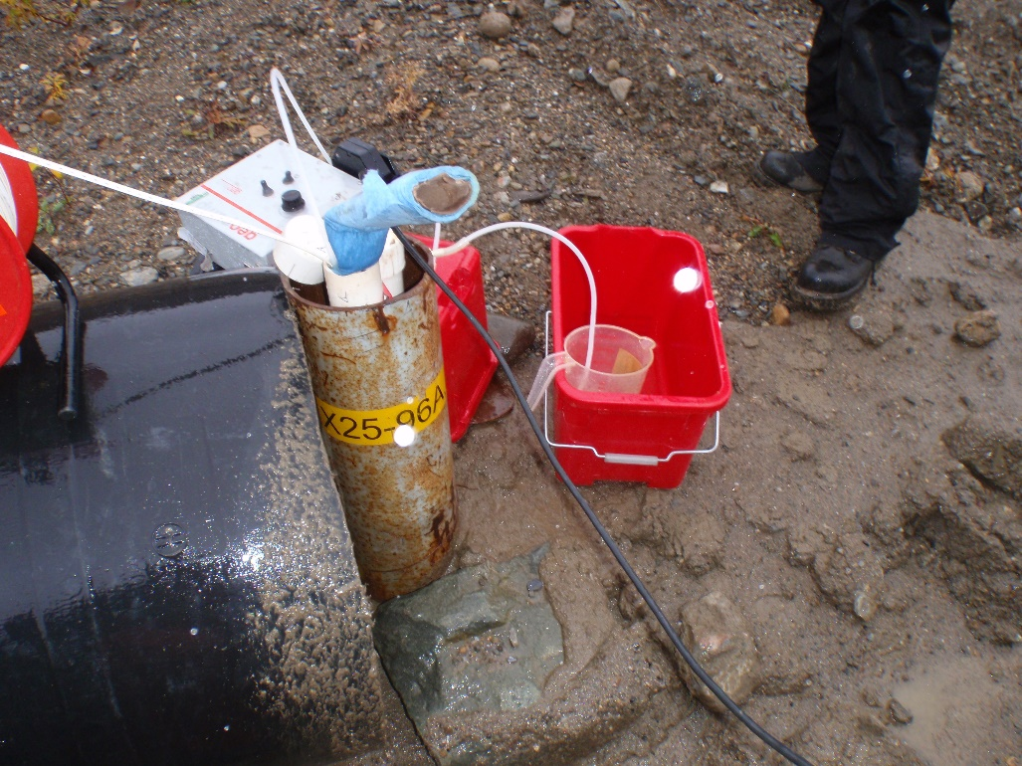
Photo 22: View of wells X25-96A and X25-96B. Photo taken on September 13th, 2015.

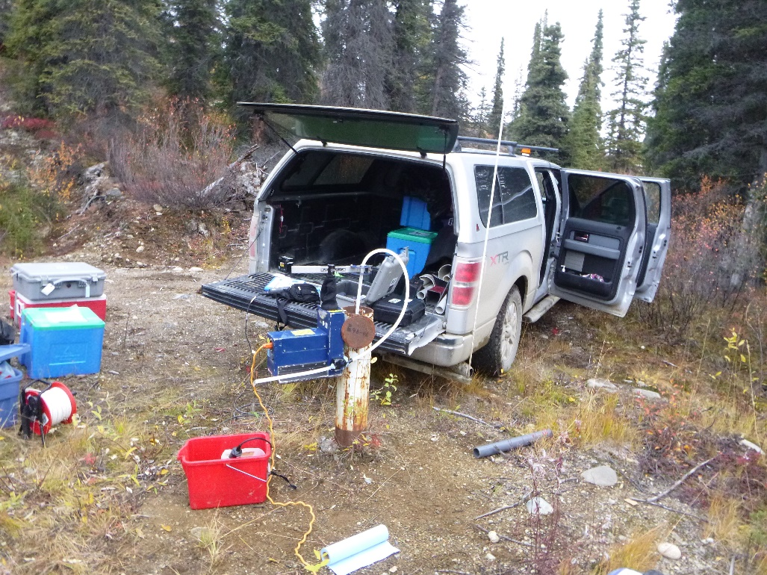
Photo 23: View of well P96-6. Photo taken on September 12th, 2015.
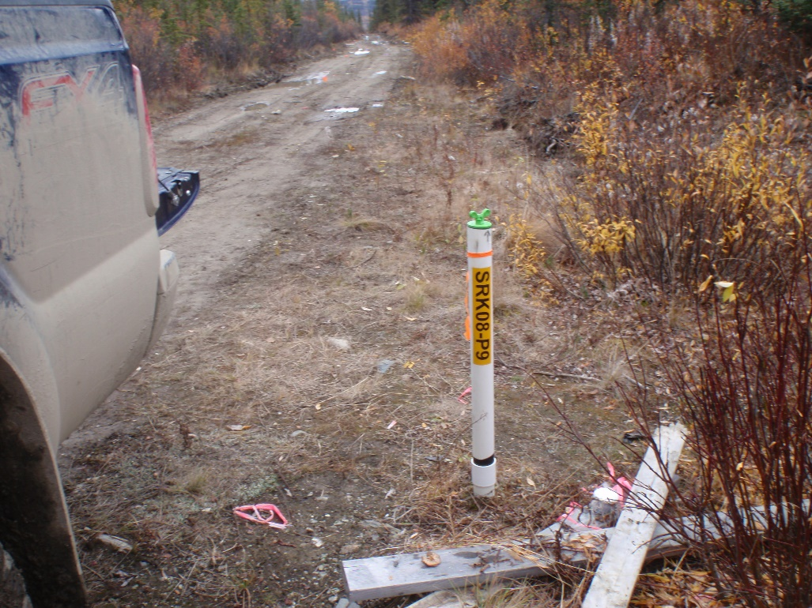
Photo 24: View of well SRK08-P9. Photo taken on September 14th, 2015.

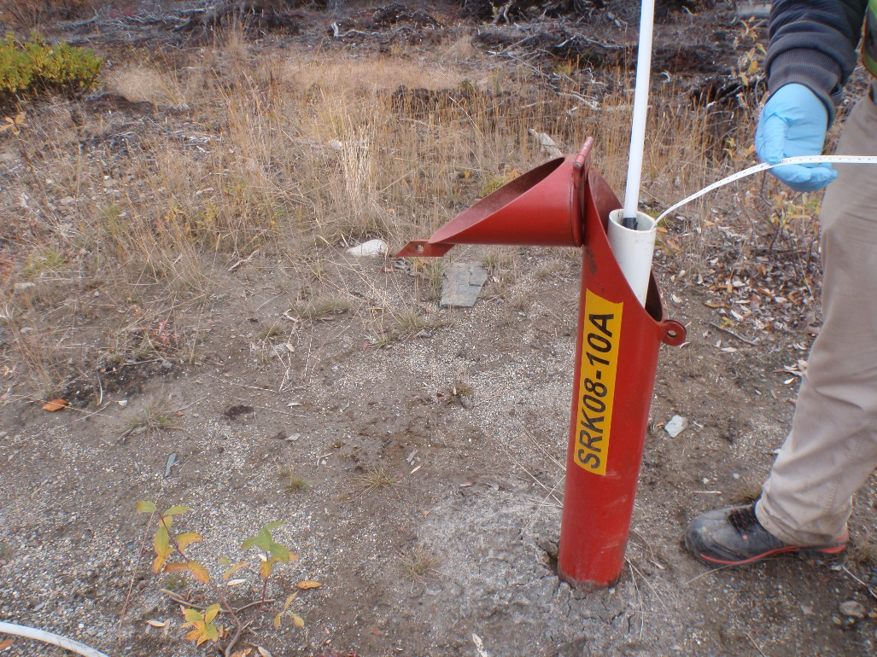
Photo 25: View of well SRK08-10A. Photo taken on September 14th, 2015.
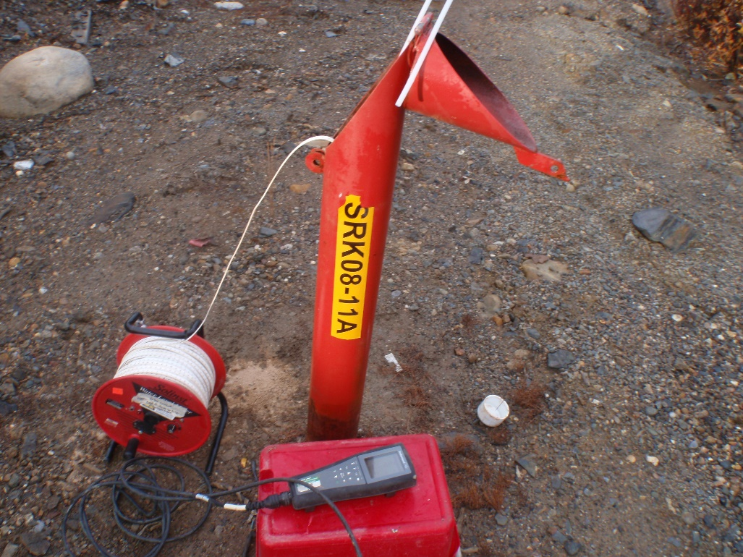
Photo 26: View of well SRK08-11A. Photo taken on September 14th, 2015.

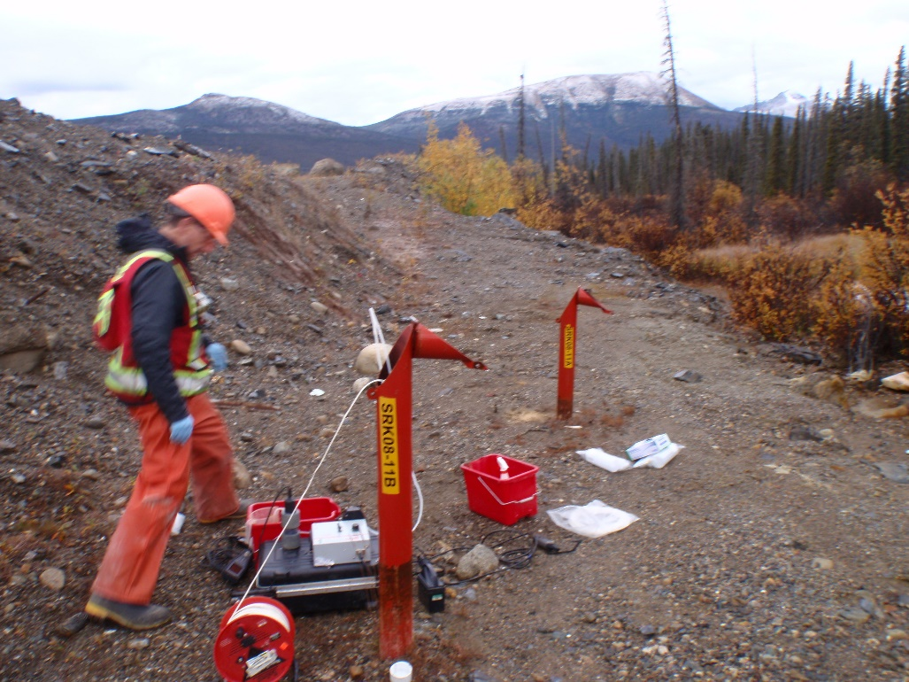
Photo 27: View of well SRK08-11B. Photo taken on September 14th, 2015.
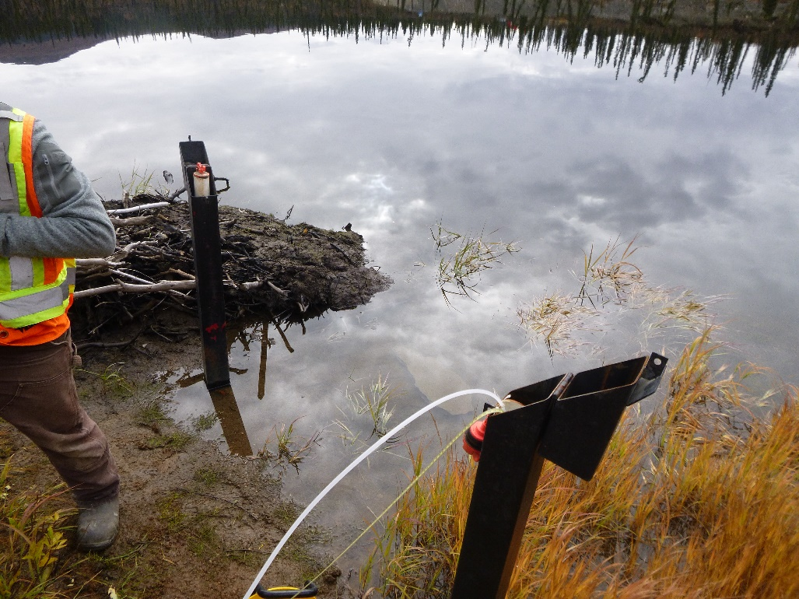
Photo 28: View of wells MW14-12D and MW14-12S. Photo taken on September 12th, 2015.

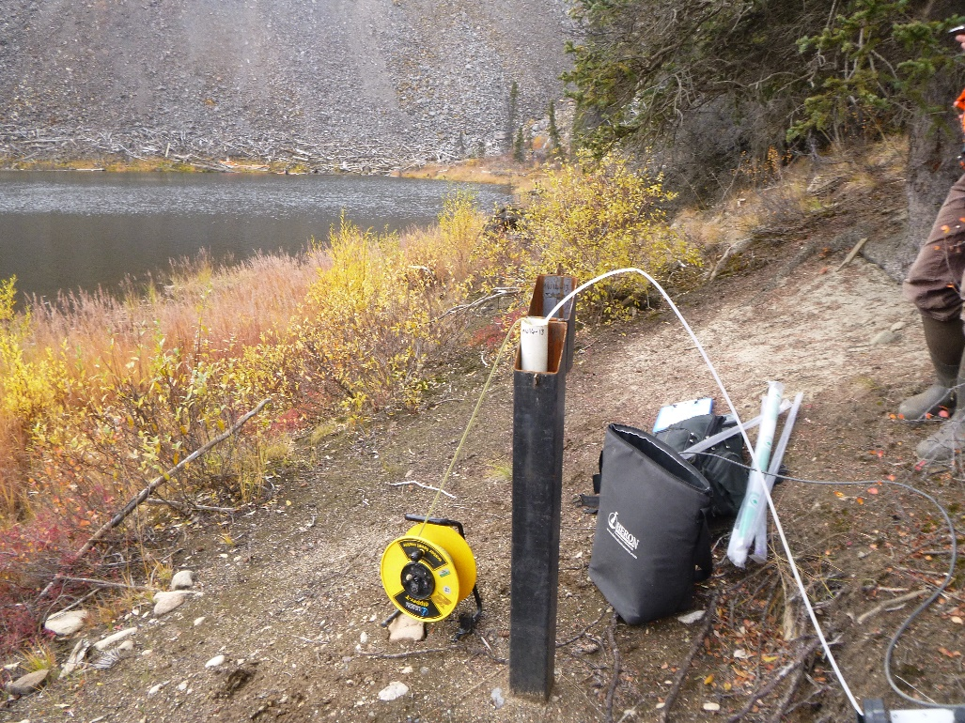
Photo 29: View of well MW14-13. Photo taken on September 12th, 2015.
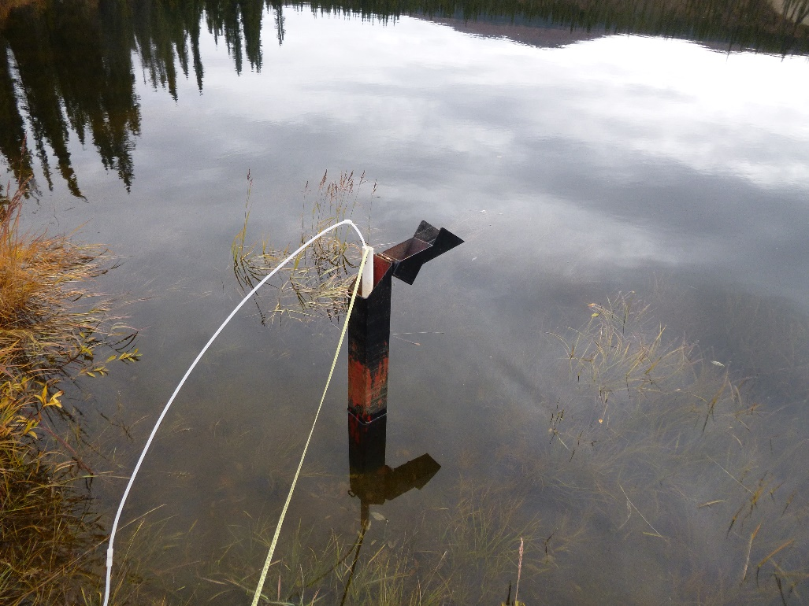
Photo 30: Views of Well MW14-14. Photo taken September 12th, 2015.

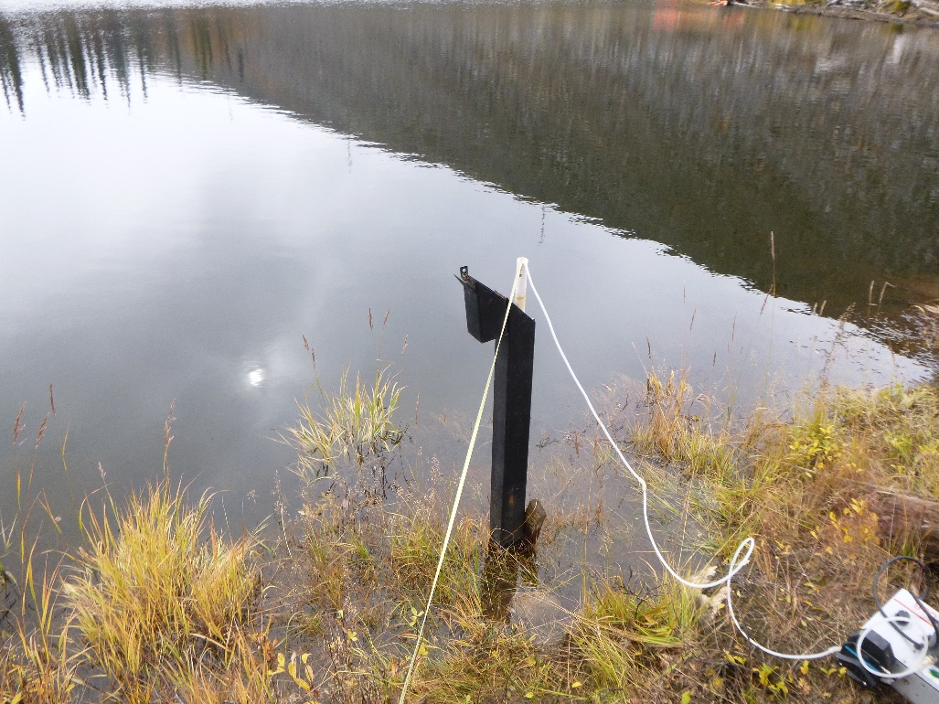
Photo 31: View of well MW14-15. Photo taken on September 12th, 2015.
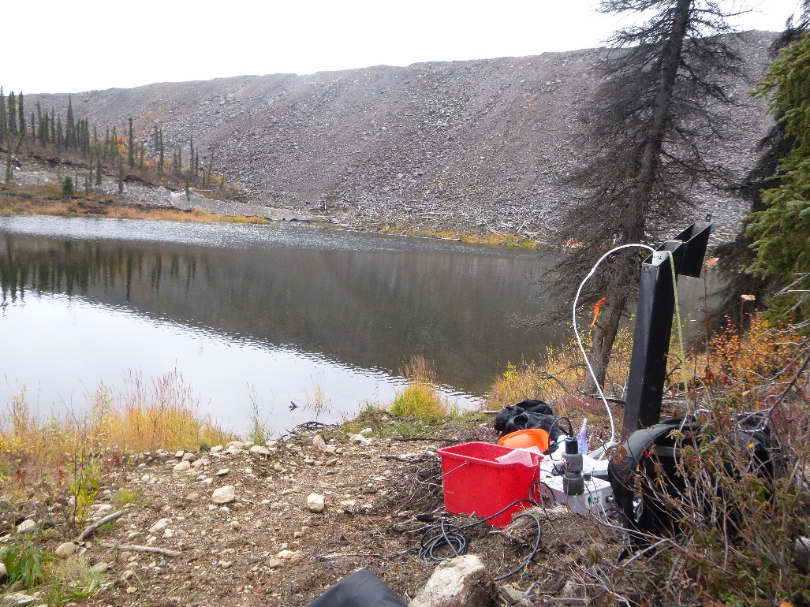
Photo 32: View of well MW14-16. Photo taken on September 12th, 2015.

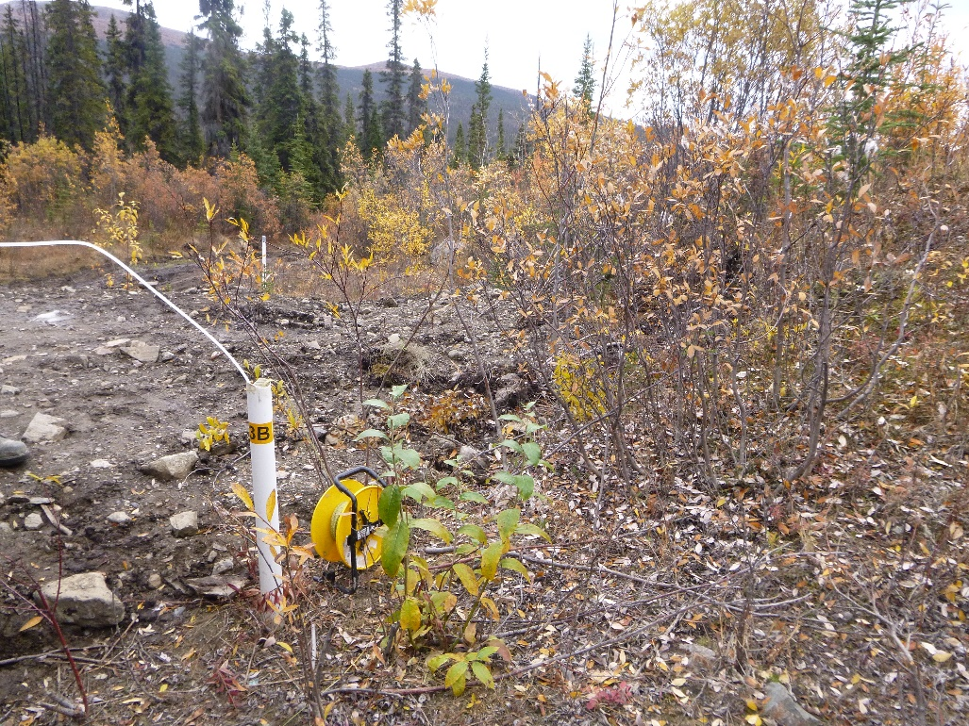
Photo 33: View of well BH13B. Photo taken on September 14th, 2015.
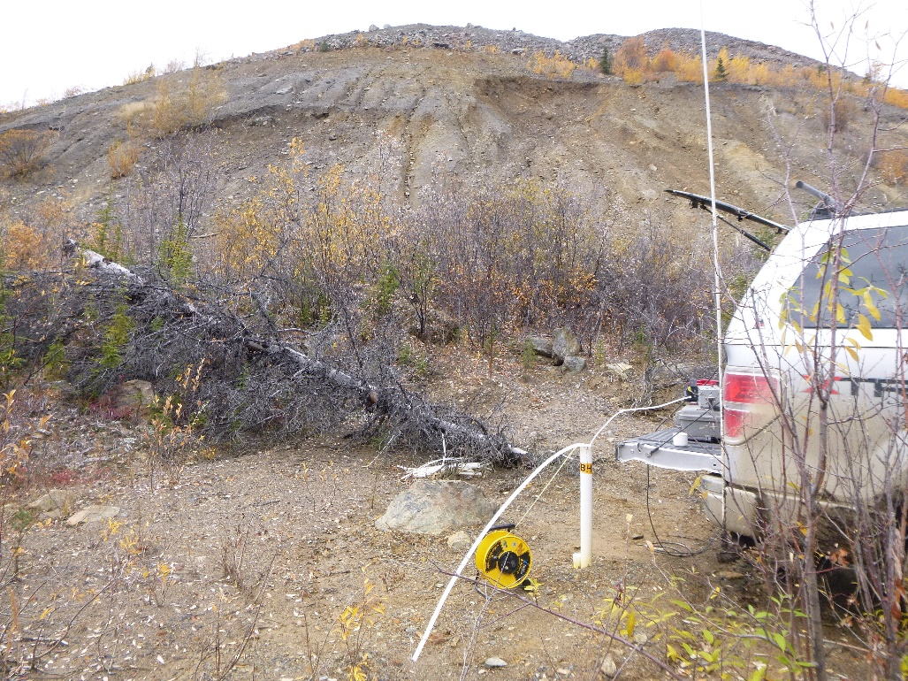
Photo 34: View of wells BH14A and BH14B. Photo taken on September 14th, 2015.

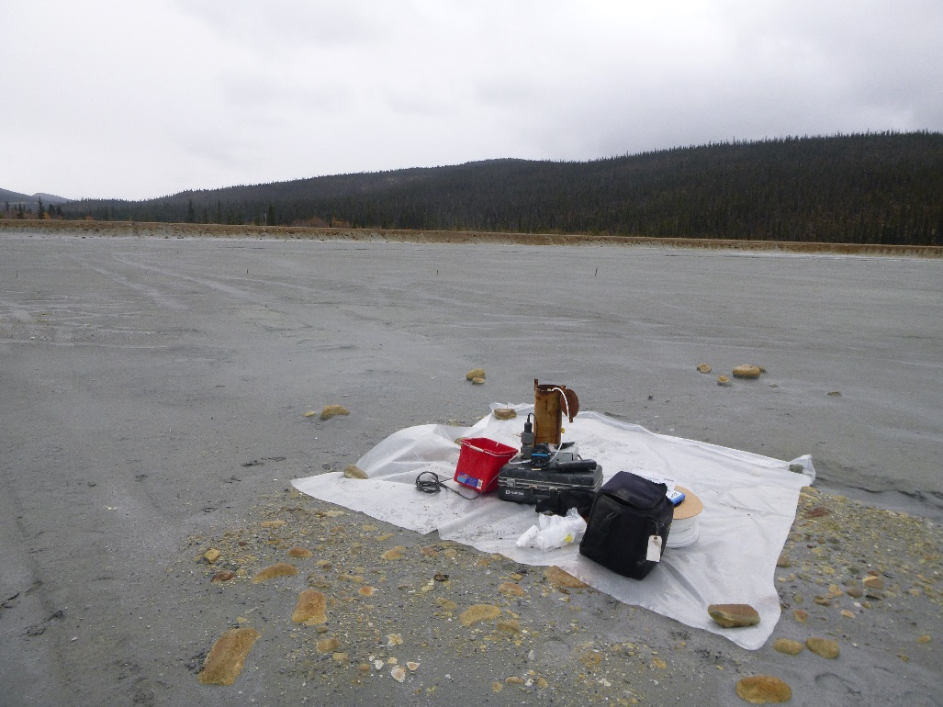
Photo 35: View of wells P03-01-2 and P03-01-8. Photo taken on September 16th, 2015.
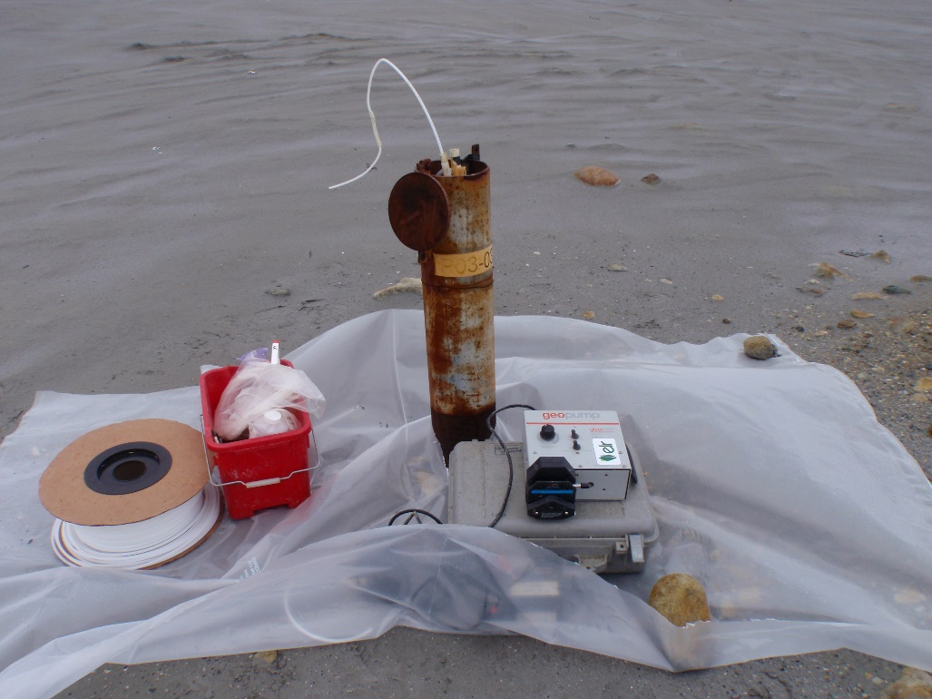
Photo 36: View of well P03-03. Photo taken on September 15th, 2015.

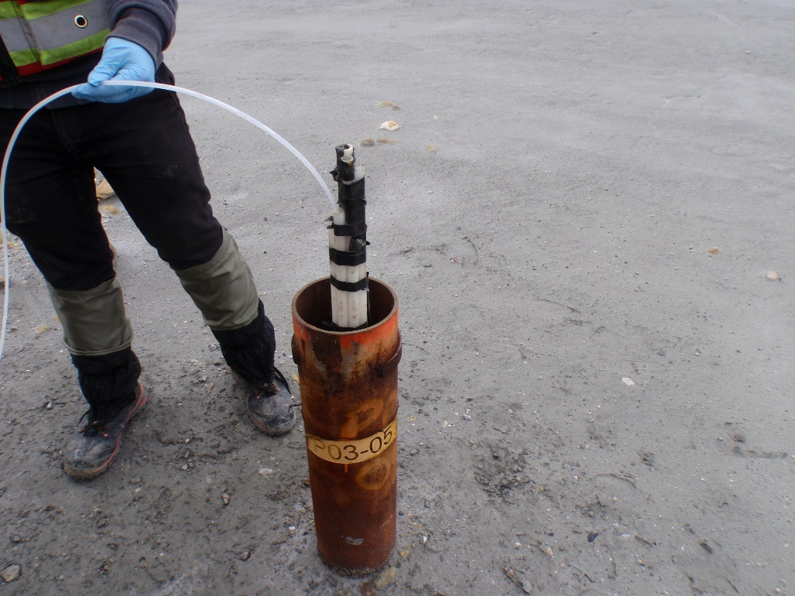
Photo 37: View of well P03-05-4. Photo taken on September 15th, 2015.
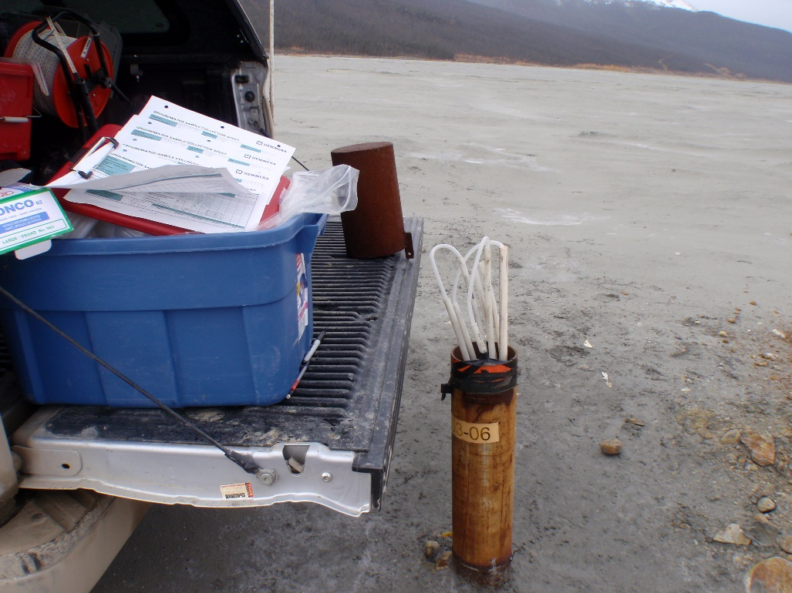
Photo 38: View of well P03-06. Photo taken on September 15th, 2015.

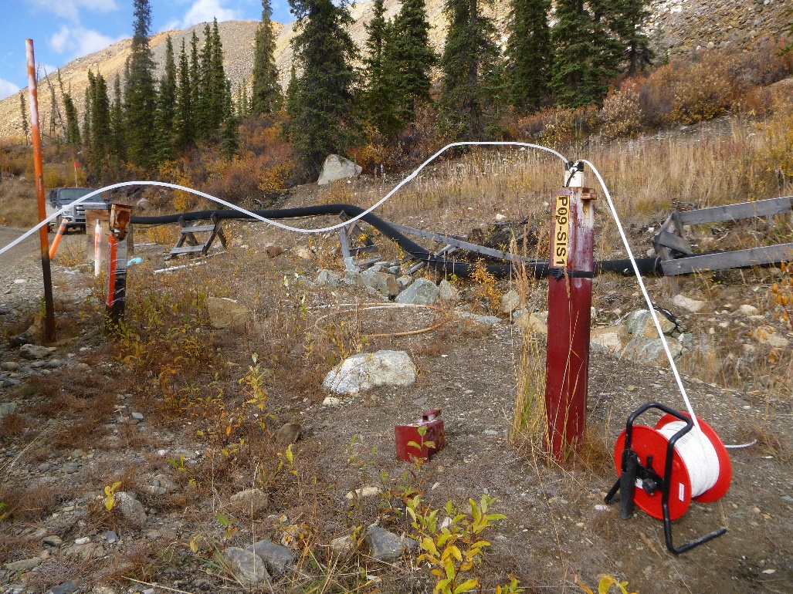
Photo 39: View of well P09-SIS1. Photo taken on September 11th, 2015.
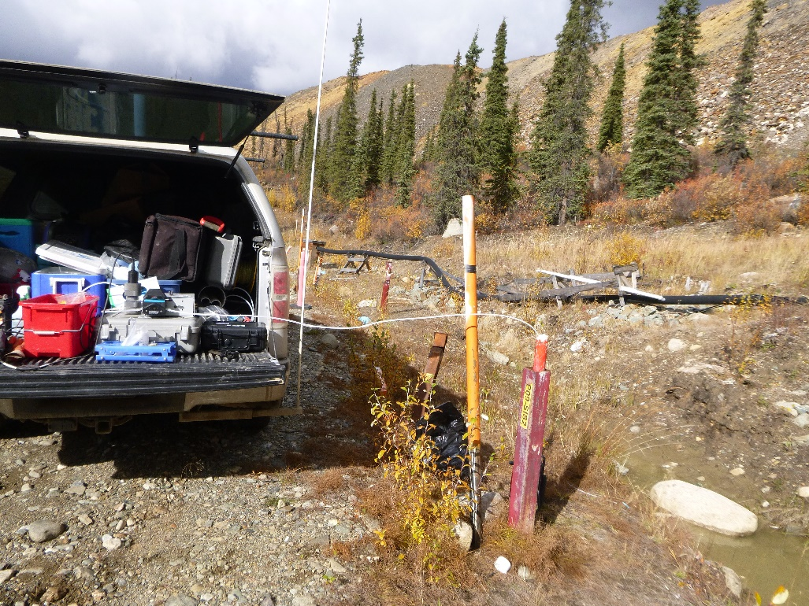
Photo 40: View of well P09-SIS2. Photo taken on September 11th, 2015.

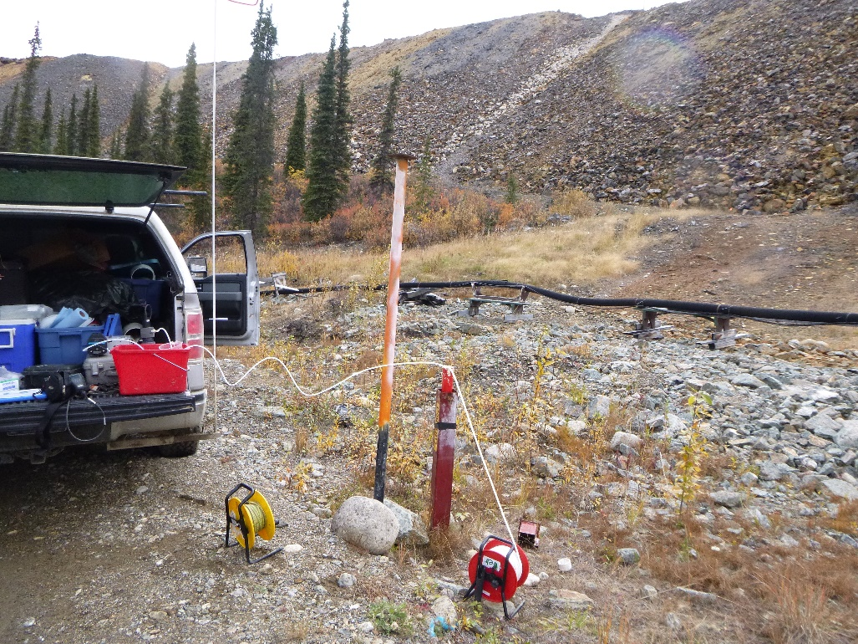
Photo 41: View of well P09-SIS3. Photo taken on September 11th, 2015.
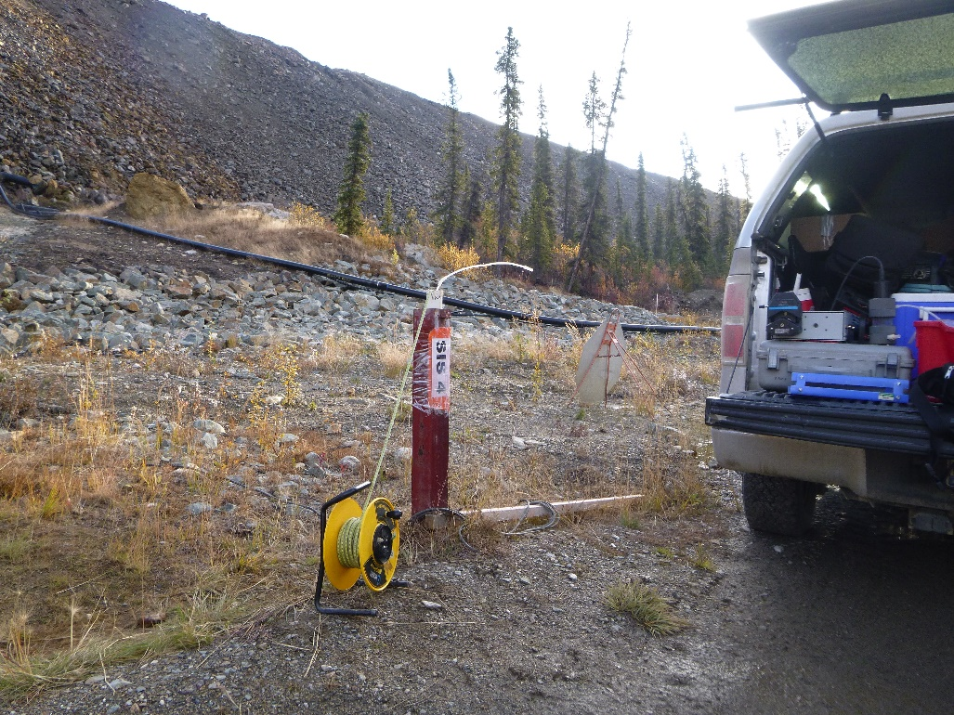
Photo 42: View of well P09-SIS4. Photo taken on September 11th, 2015.

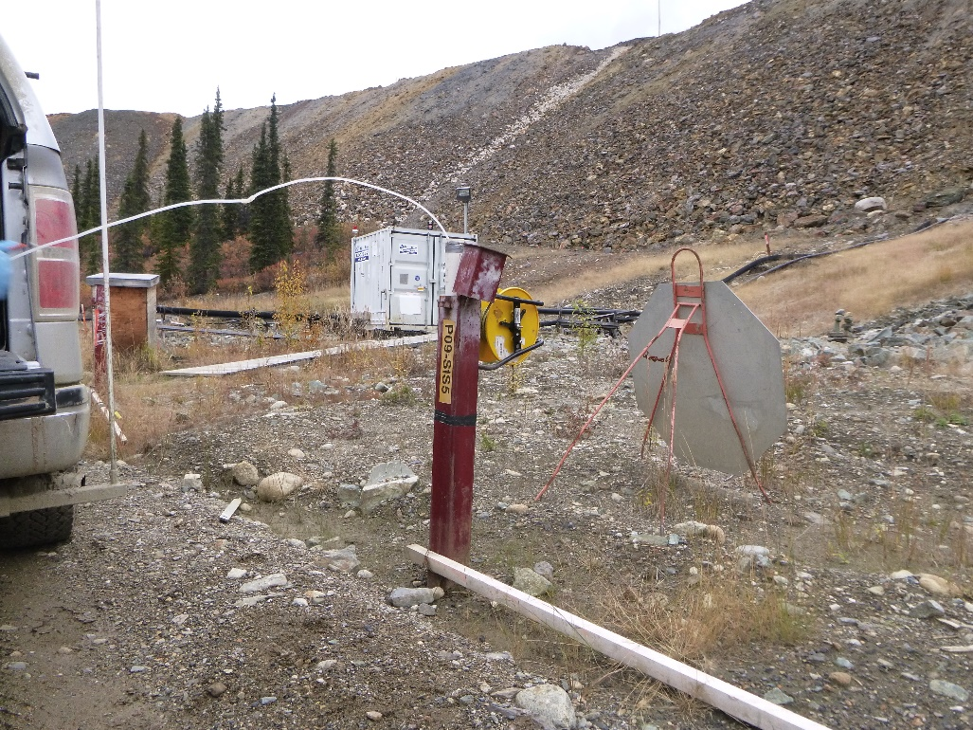
Photo 43: View of well P09-SIS5. Photo taken on September 10th, 2015.
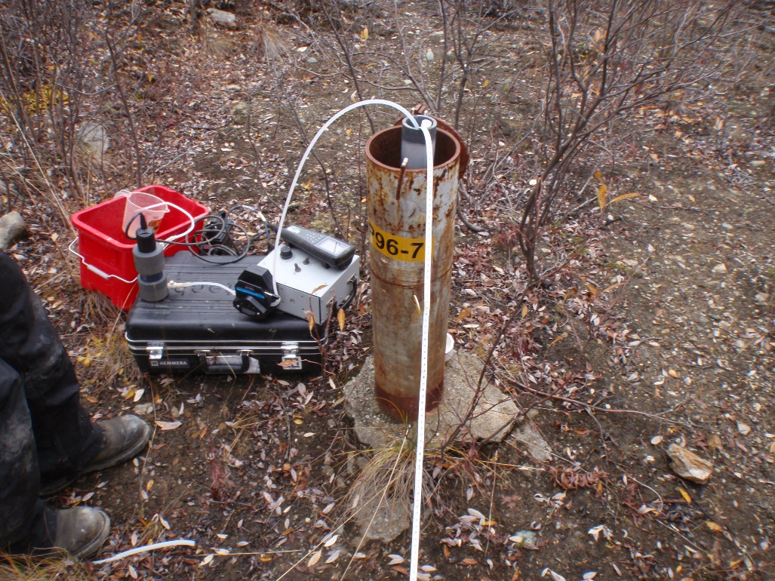
Photo 44: View of well P96-7. Photo taken on September 11th, 2015.

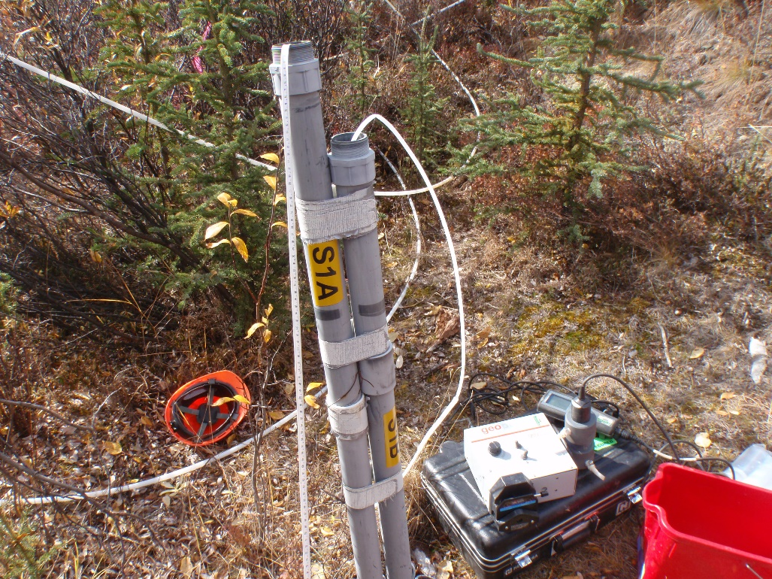
Photo 45: View of well S1A and S1B. Photo taken on September 11th, 2015.
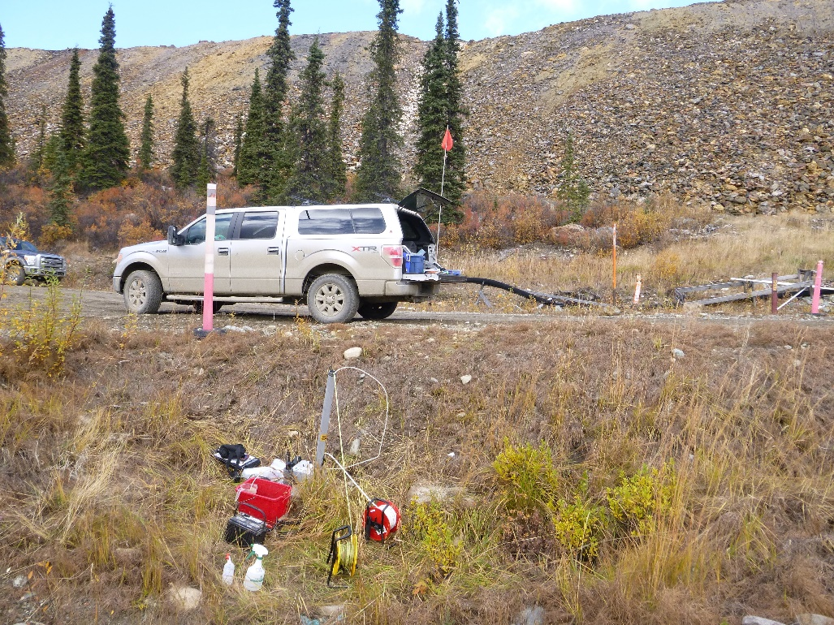
Photo 46: View of wells S2A and S2B. Photo taken on September 11th, 2015.

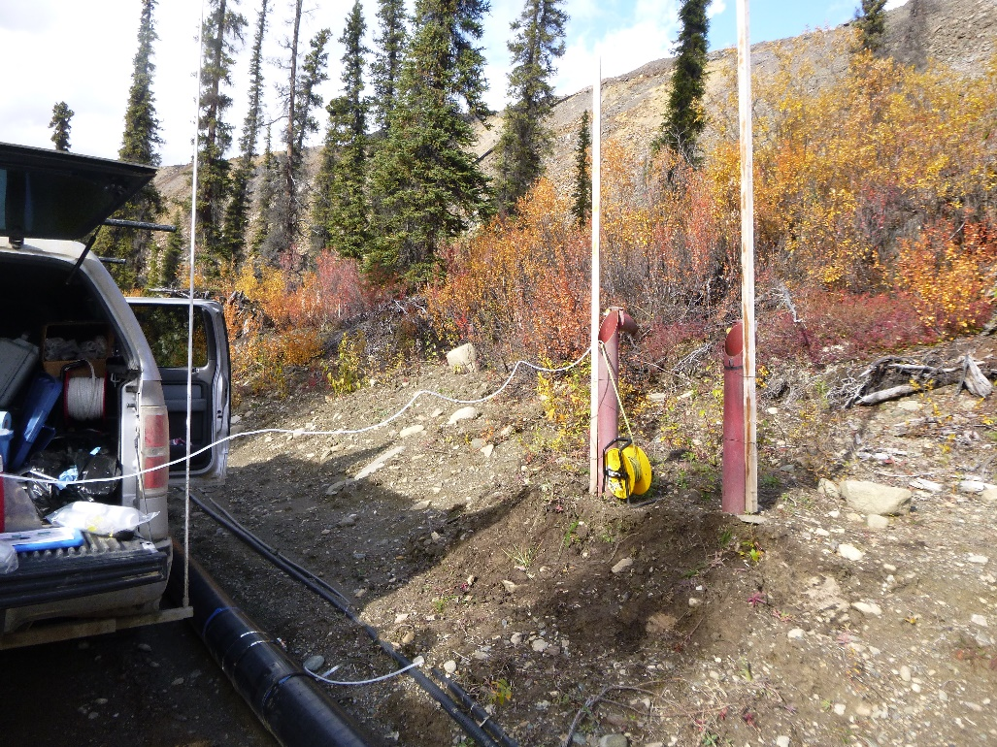
Photo 47: View of wells SRK05-SP-1A and SRK05-SP-1B. Photo taken on September 10th, 2015.
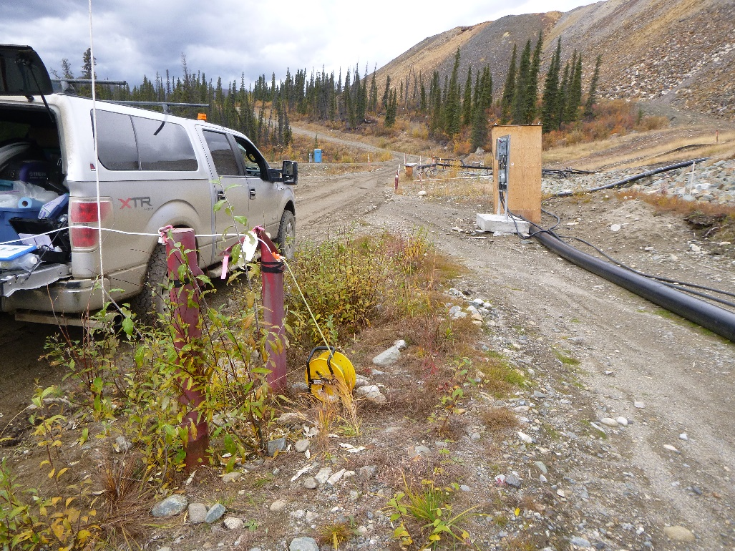
Photo 48: View of wells SRK05-SP-3A and SRK05-SP-3B. Photo taken on September 10th, 2015.

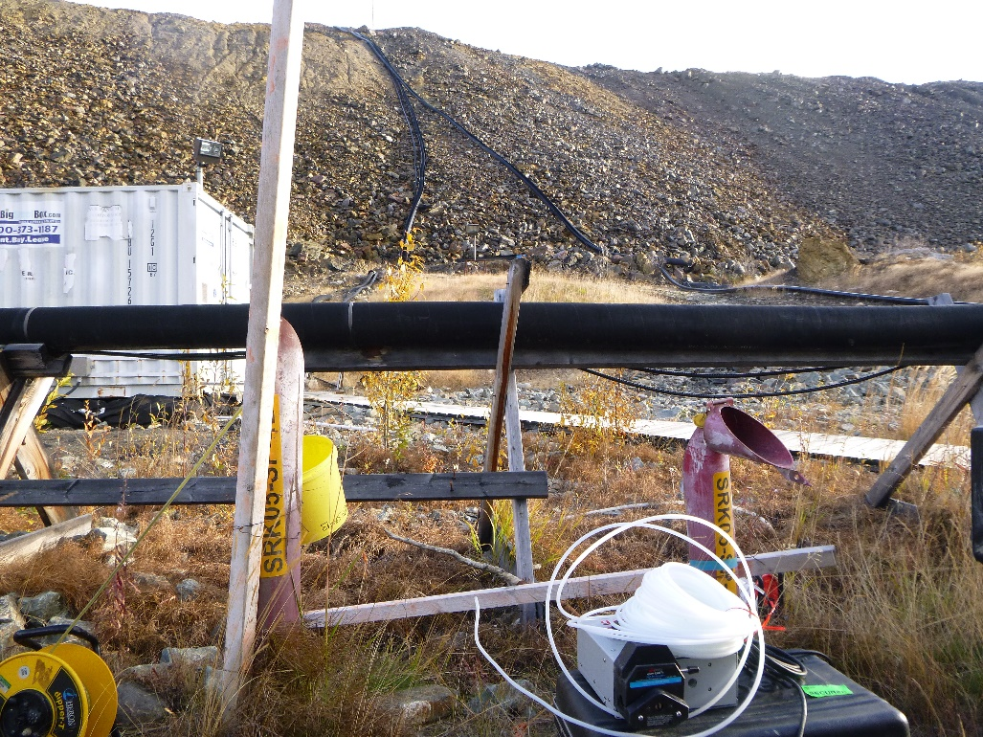
Photo 49: View of well SRK05-SP-4A and SRK05-SP-4B. Photo taken on September 11th, 2015.
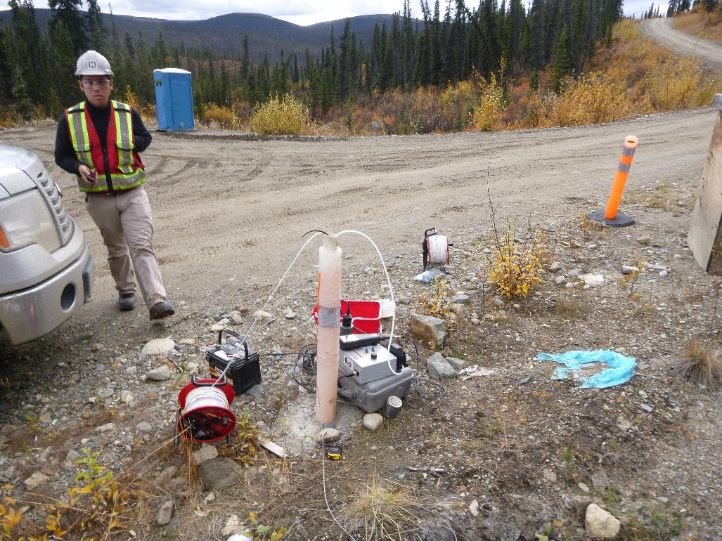
Photo 50: View of well SRK05-SP-5. Photo taken on September 11th, 2015.

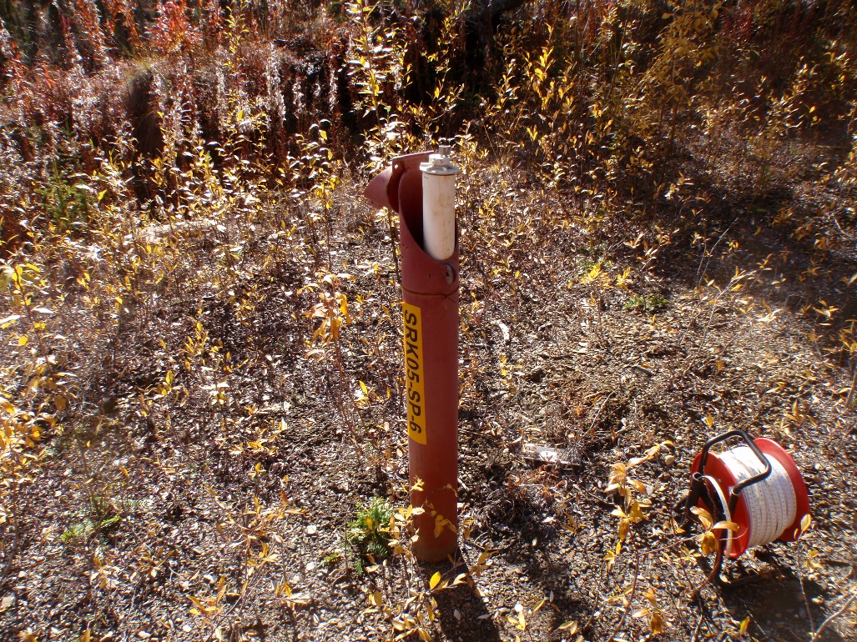
Photo 51: View of well SRK05-SP-6. Photo taken on September 11th, 2015.
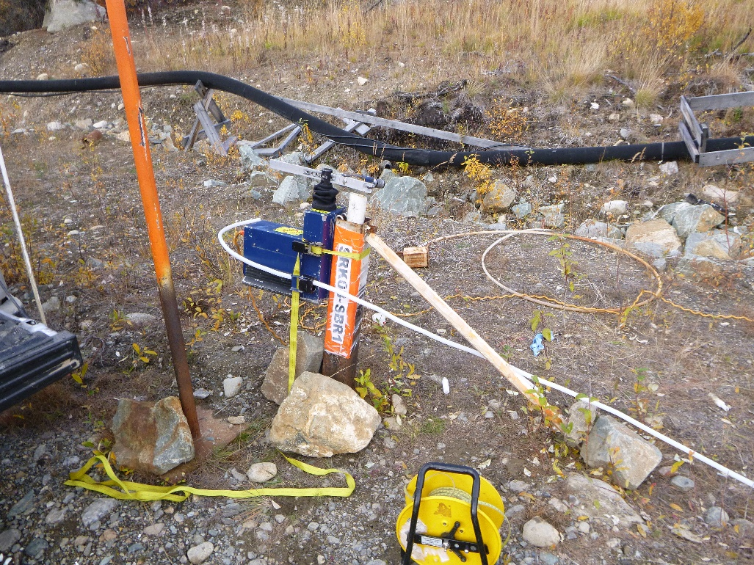
Photo 52: View of well SRK08-SBR1. Photo taken on September 11th, 2015.

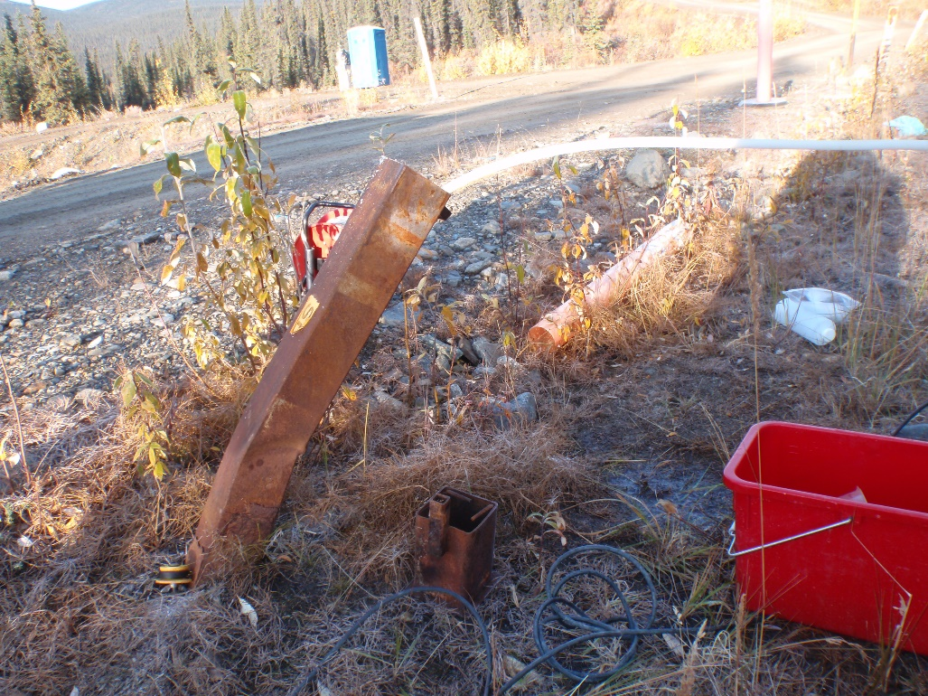
Photo 53: View of well SRK08-SBR2. Photo taken on September 12th, 2015.
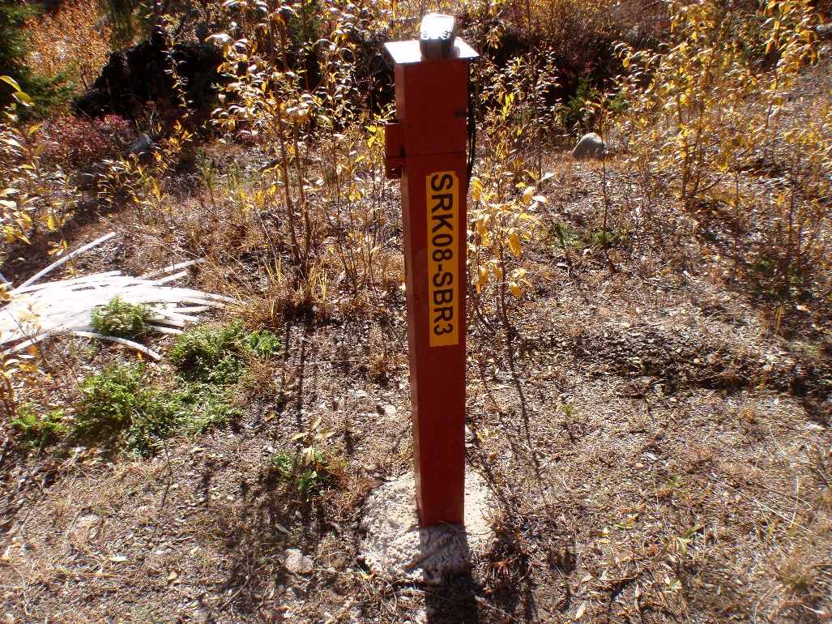
Photo 54: View of well SRK08-SBR3. Photo taken on September 11th, 2015.

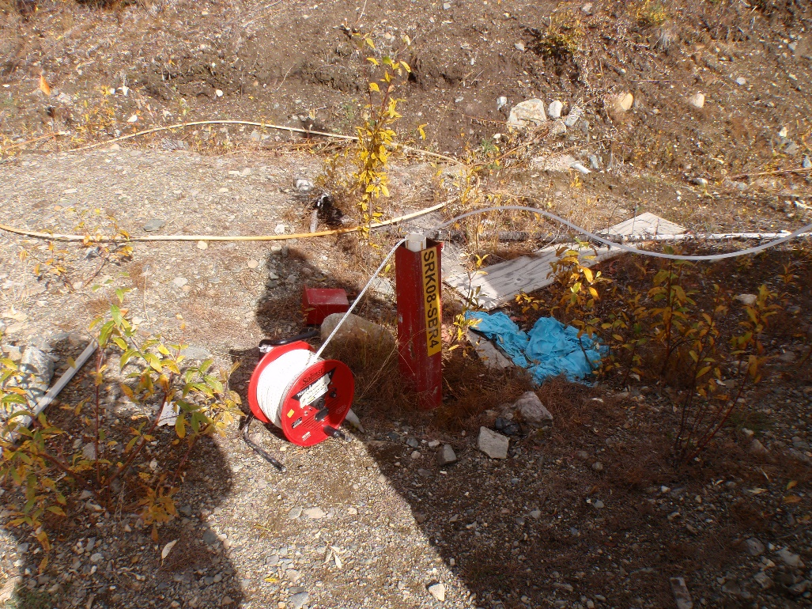
Photo 55: View of well SRK08-SBR4. Photo taken on September 11th, 2015.
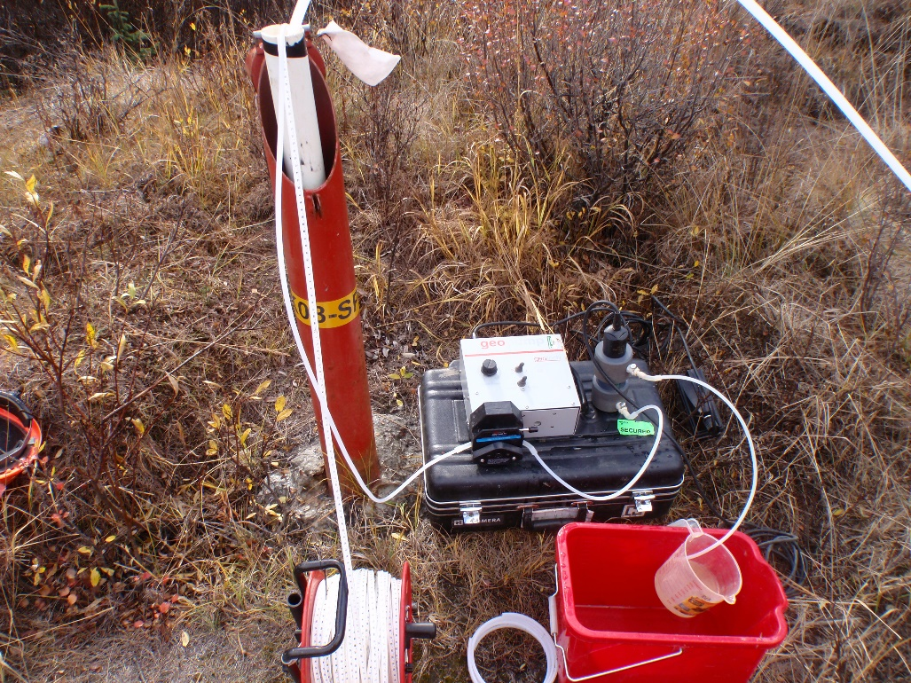
Photo 56: View of well SRK08-SP-7A. Photo taken on September 11th, 2015.
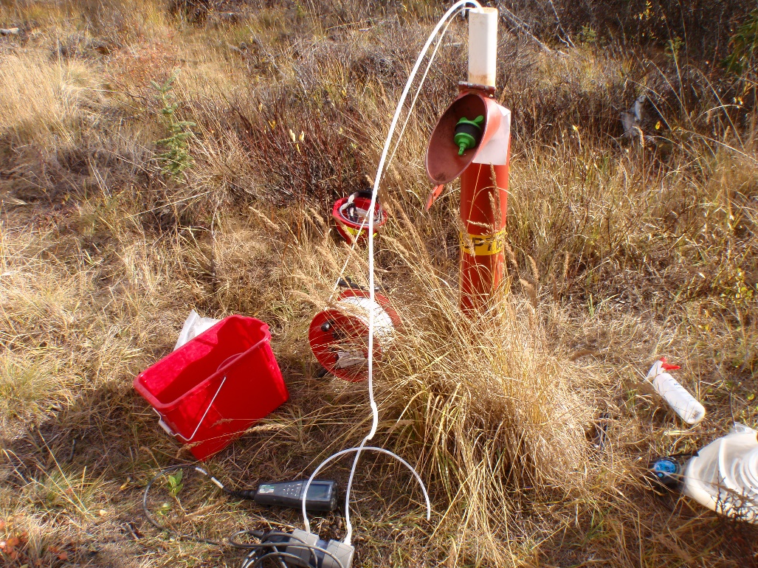
Photo 57: View of well SRK08-SP-7B. Photo taken on September 11th, 2015.
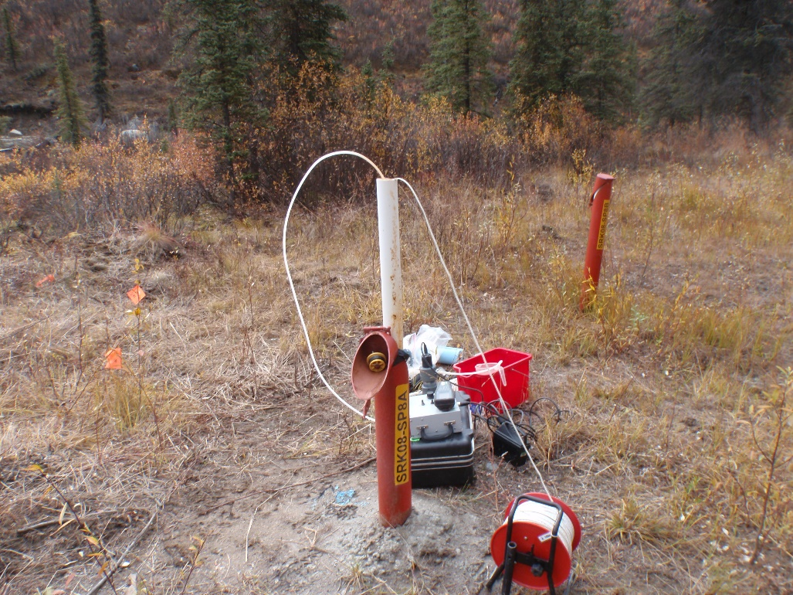
Photo 58: View of well SRK08-SP-8A. Photo taken on September 11th, 2015.
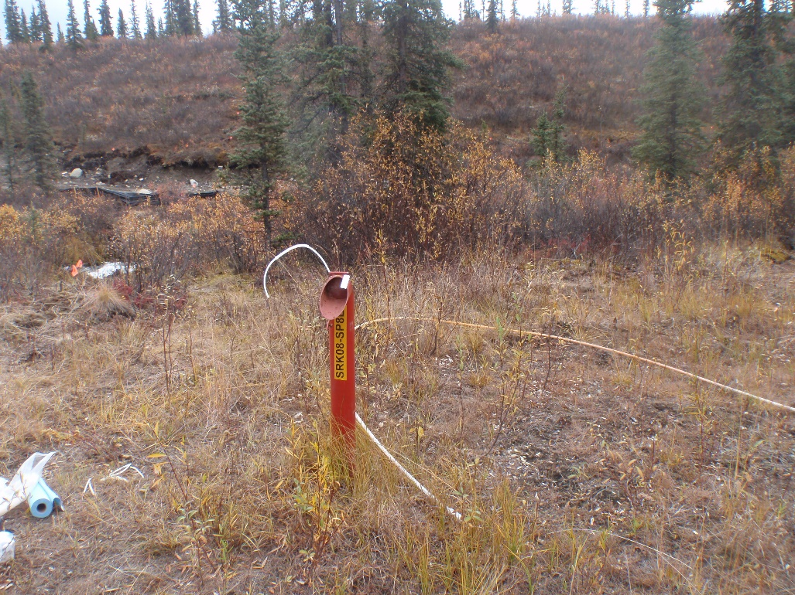
Photo 59: View of well SRK08-SP-8B. Photo taken on September 11th, 2015.
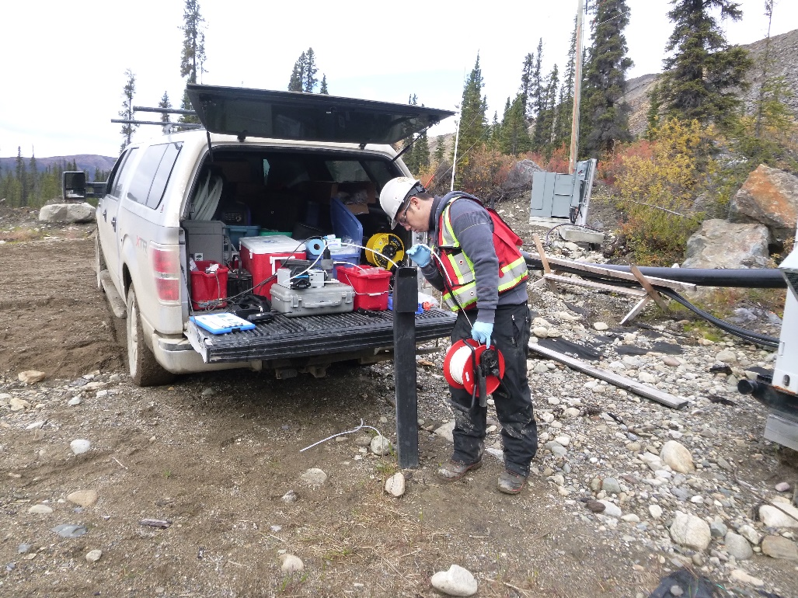
Photo 60: View of well MW14-08. Photo taken on September 10th, 2015.

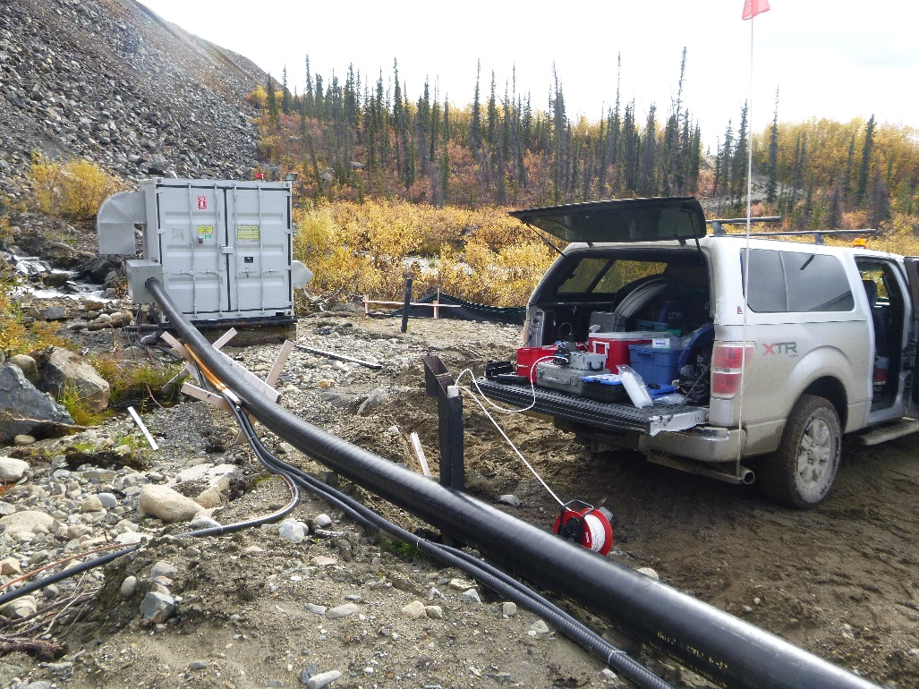
Photo 61: View of well MW14-09. Photo taken on September 10th, 2015.
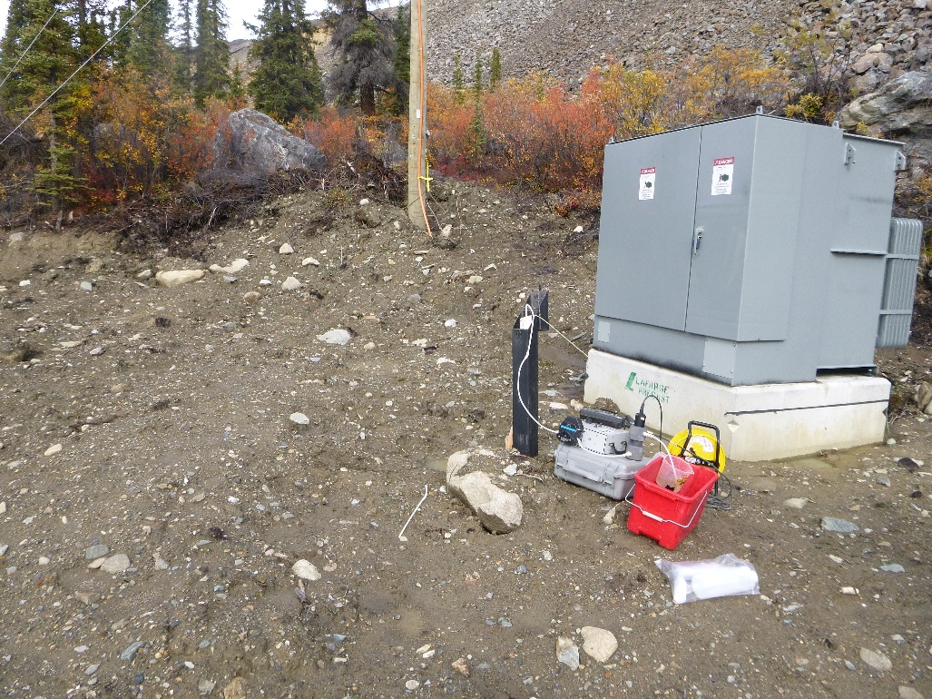
Photo 62: View of well MW14-10. Photo taken on September 10th, 2015.

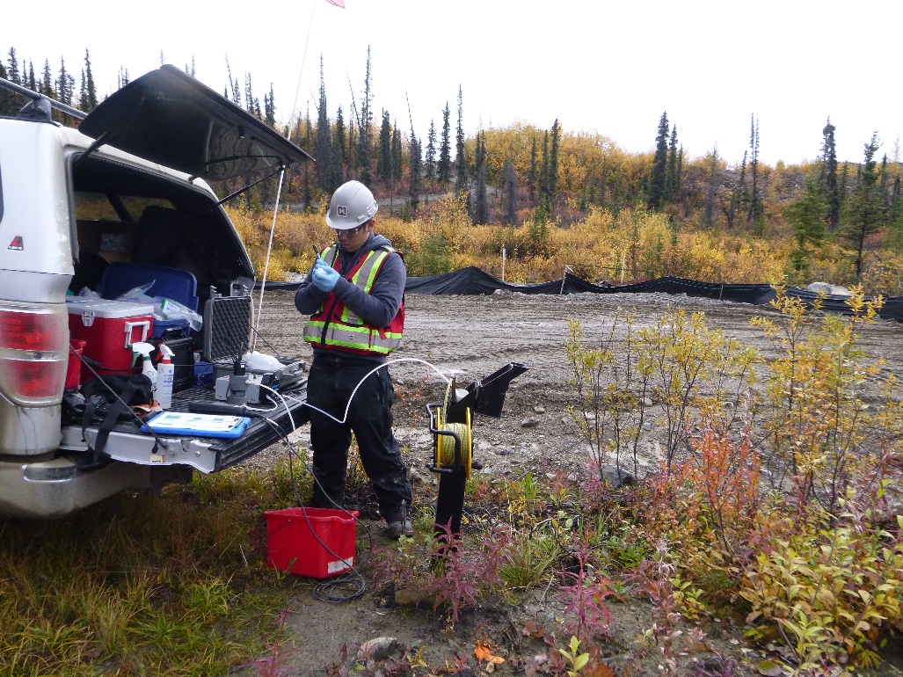
Photo 63: View of well MW14-11. Photo taken on September 10th, 2015.
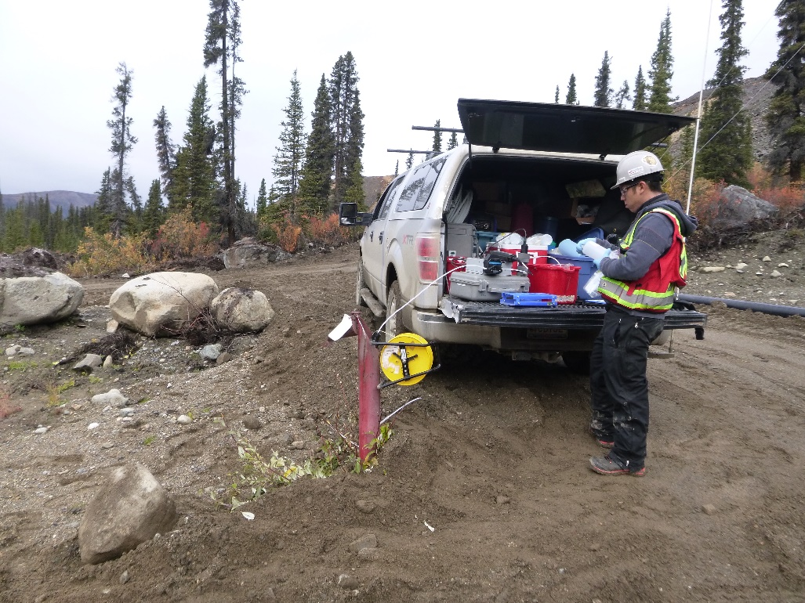
Photo 64: View of well SRK05-SP-2. Photo taken on September 10th, 2015.

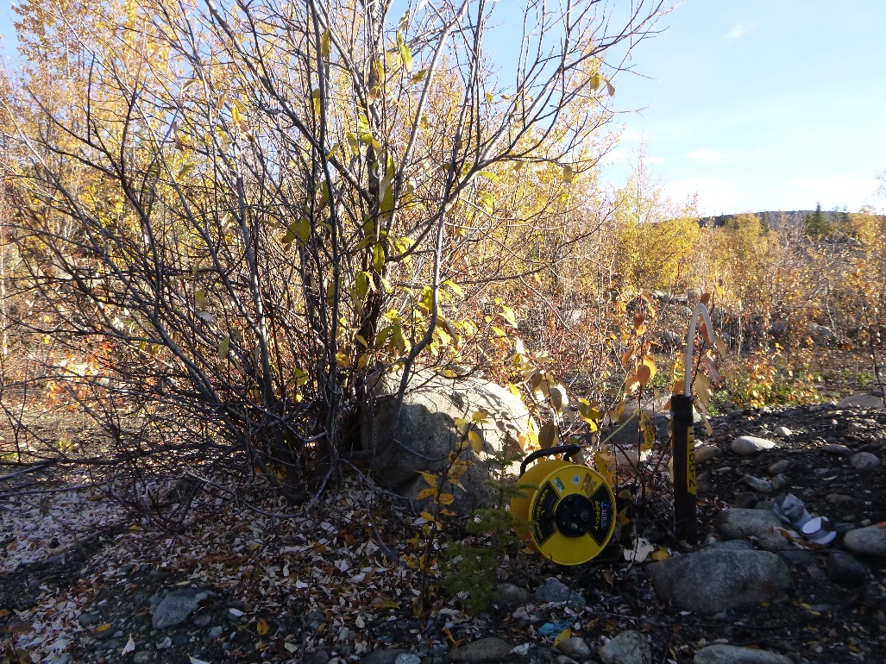
Photo 65: View of well TH86-2. Photo taken on September 13th, 2015.
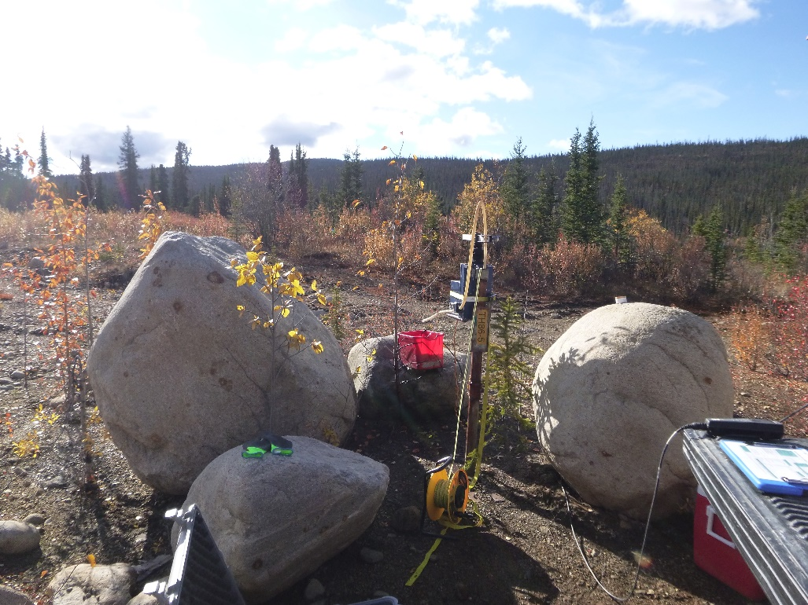
Photo 66: View of well TH86-5. Photo taken on September 13th, 2015.

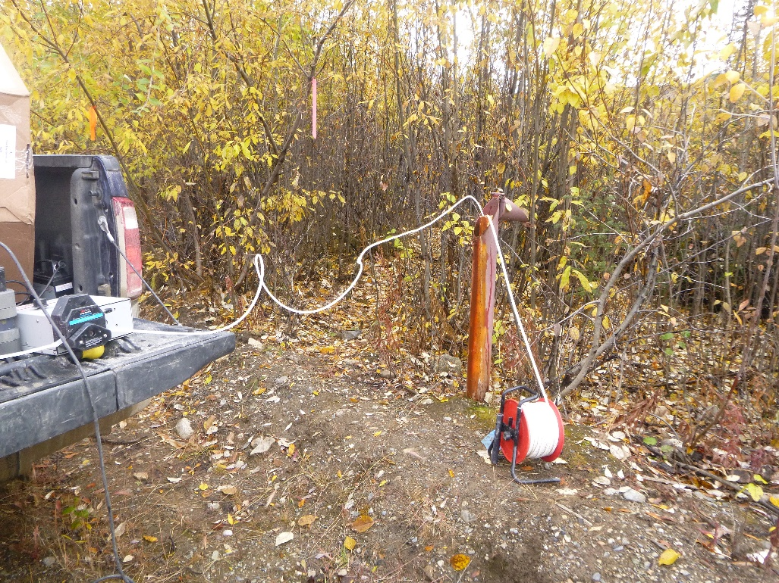
Photo 67: View of well BH05-9B-R. Photo taken on September 15th, 2015.
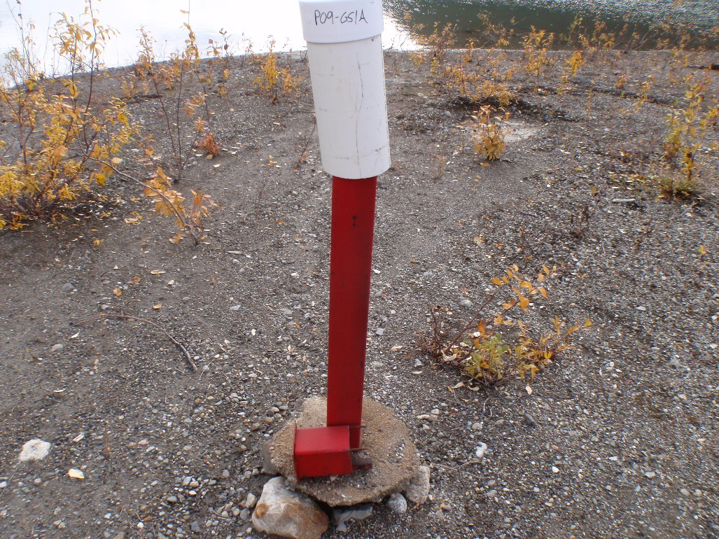
Photo 68: View of well P09-GS1A. Photo taken on September 15th, 2015.

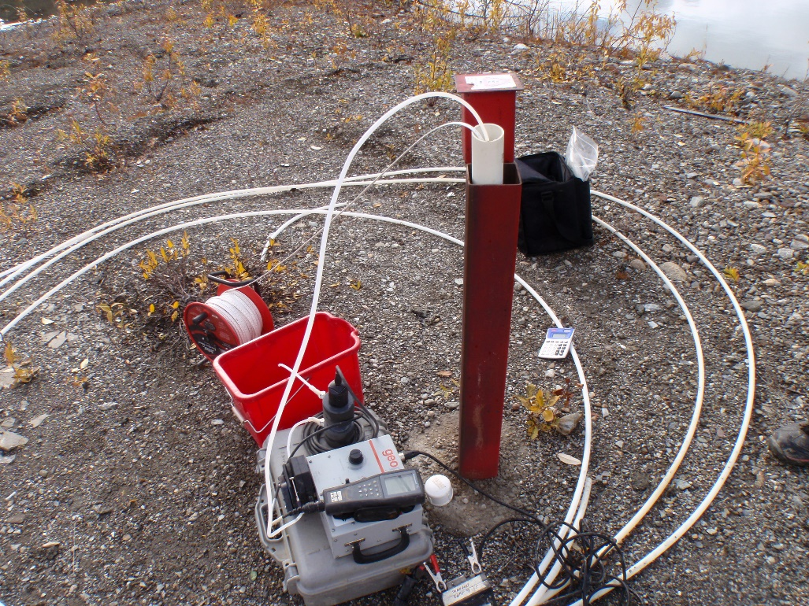
Photo 69: View of well P09-GS1B. Photo taken on September 15th, 2015.
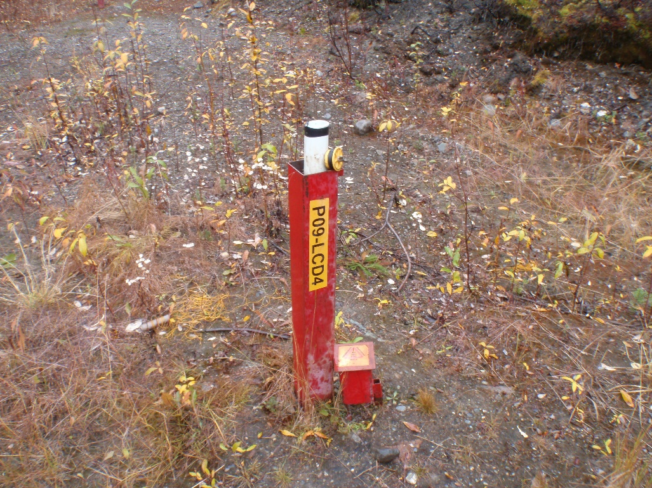
Photo 70: View of well P09-LCD4. Photo taken on September 14th, 2015.

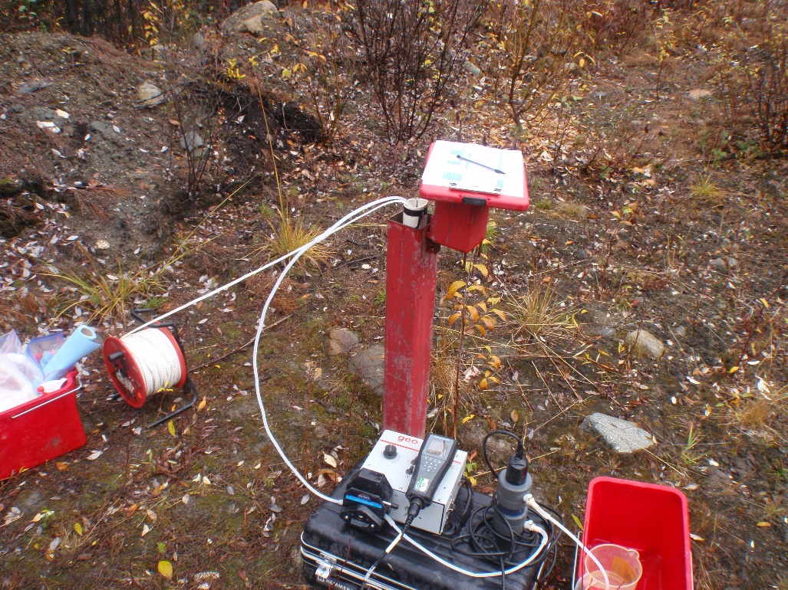
Photo 71: View of well P09-LCD1. Photo taken on September 14th, 2015.
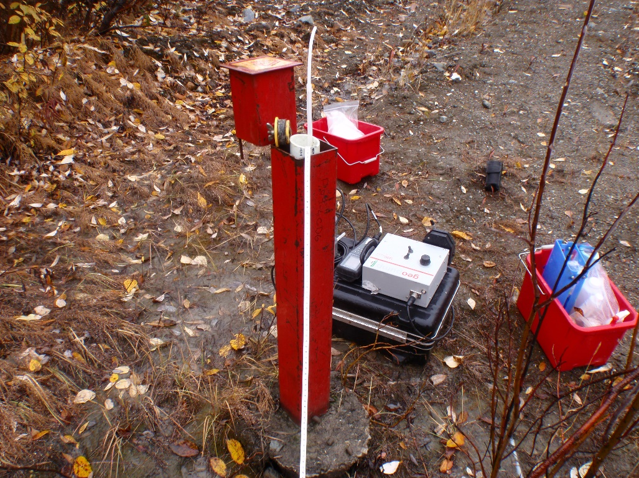
Photo 72: View of well P09-LCD6. Photo taken on September 14th, 2015.
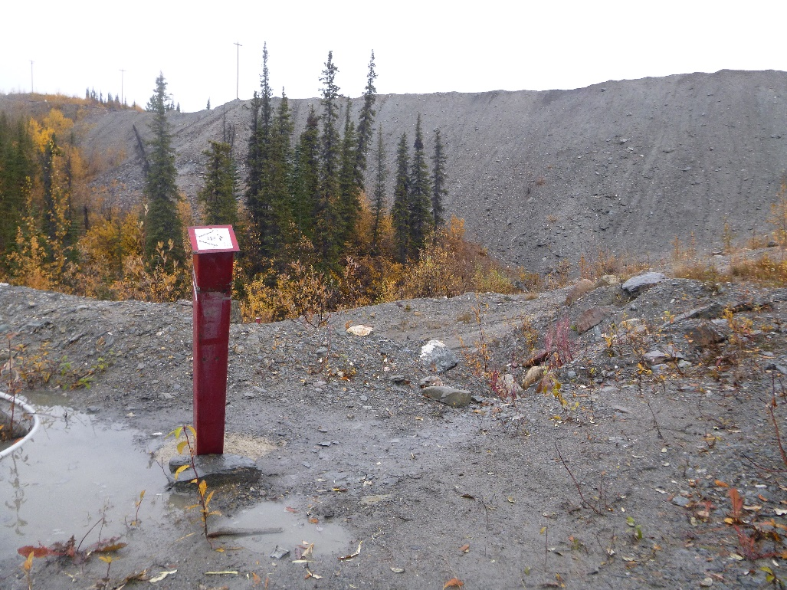
Photo 73: View of well P09-VC1. Photo taken on September 16th, 2015.
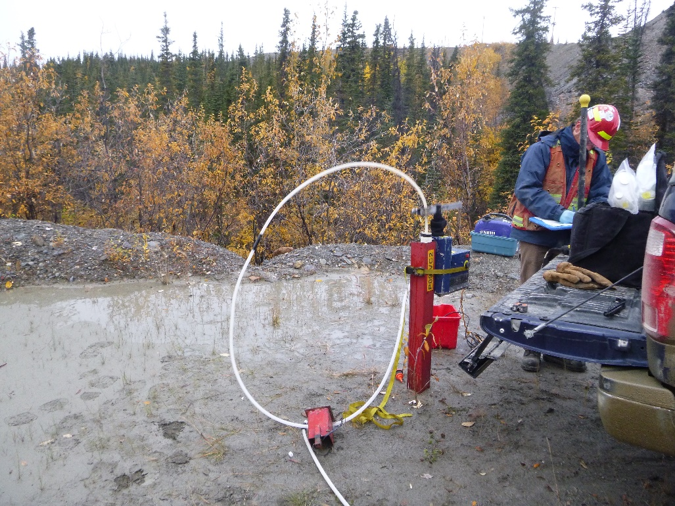
Photo 74: View of well P09-VC2. Photo taken on September 16th, 2015.

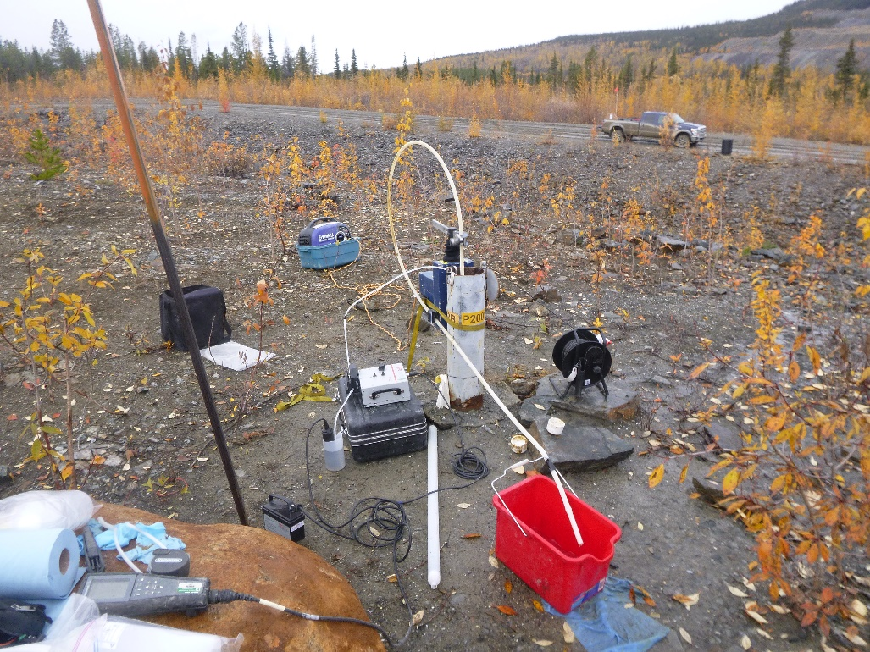
Photo 75: View of wells P2001-02A and P2001-02B. Photo taken on September 16th, 2015.
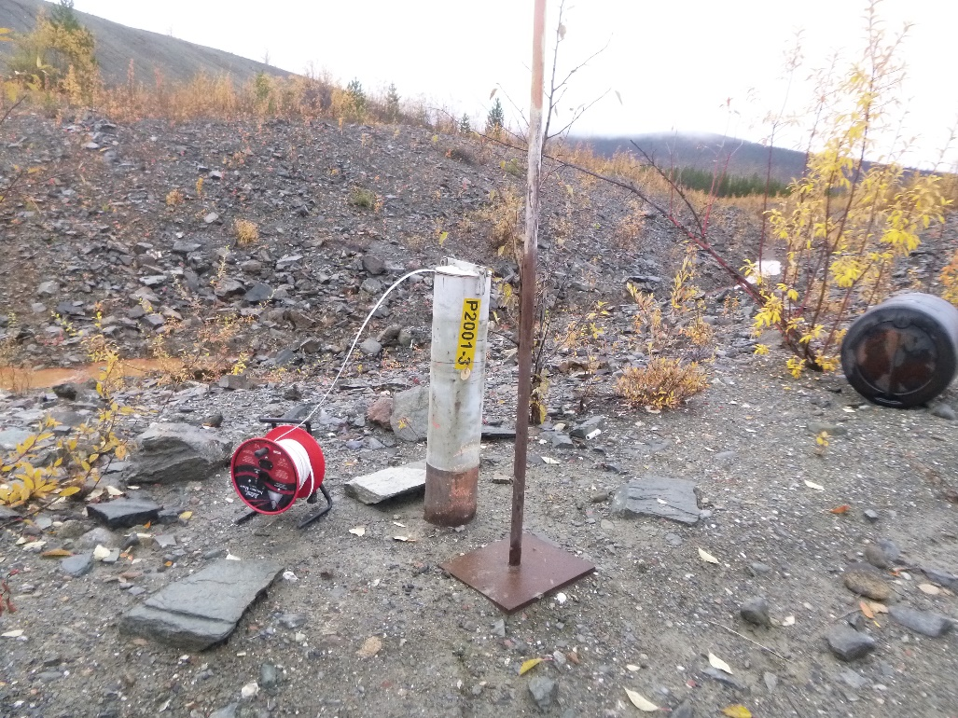
Photo 76: View of well P2001-3. Photo taken on September 15th, 2015.

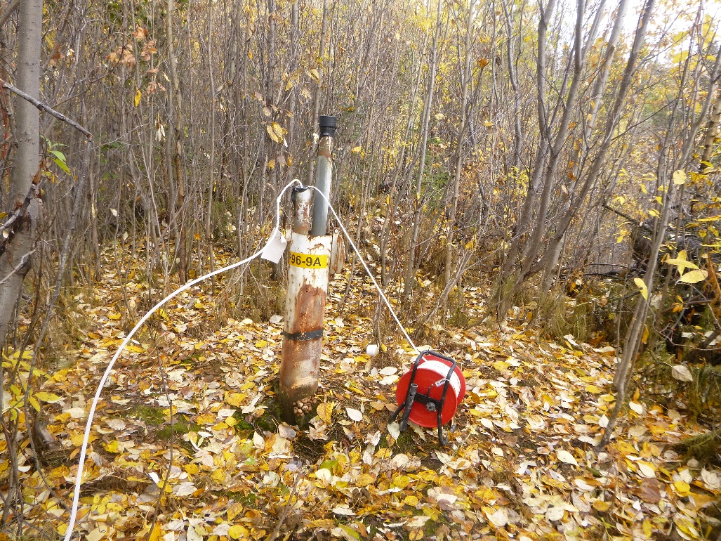
Photo 77: View of well P96-9A. Photo taken on September 15th, 2015.
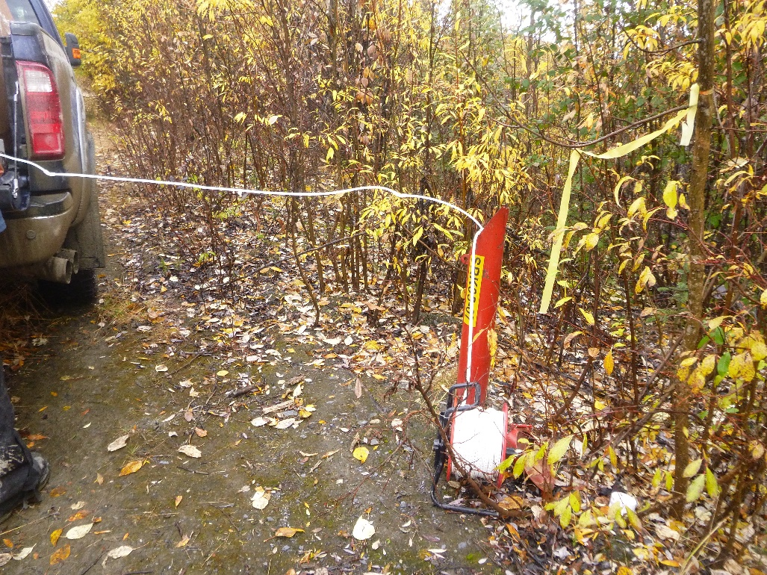
Photo 78: View of well SRK05-07. Photo taken on September 15th, 2015.

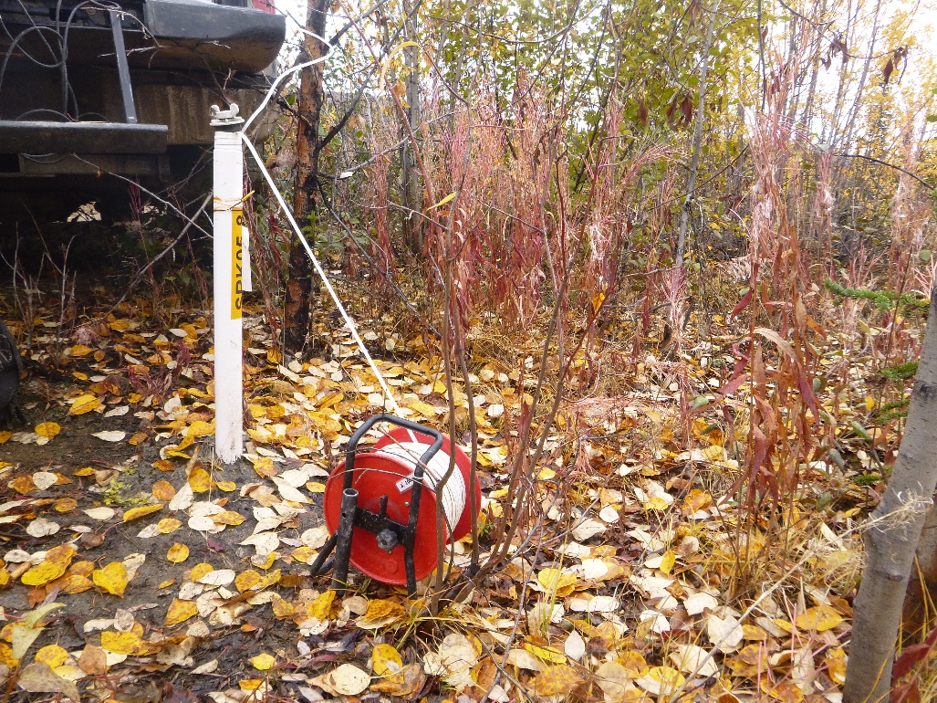
Photo 79: View of well SRK05-08. Photo taken on September 15th, 2015.
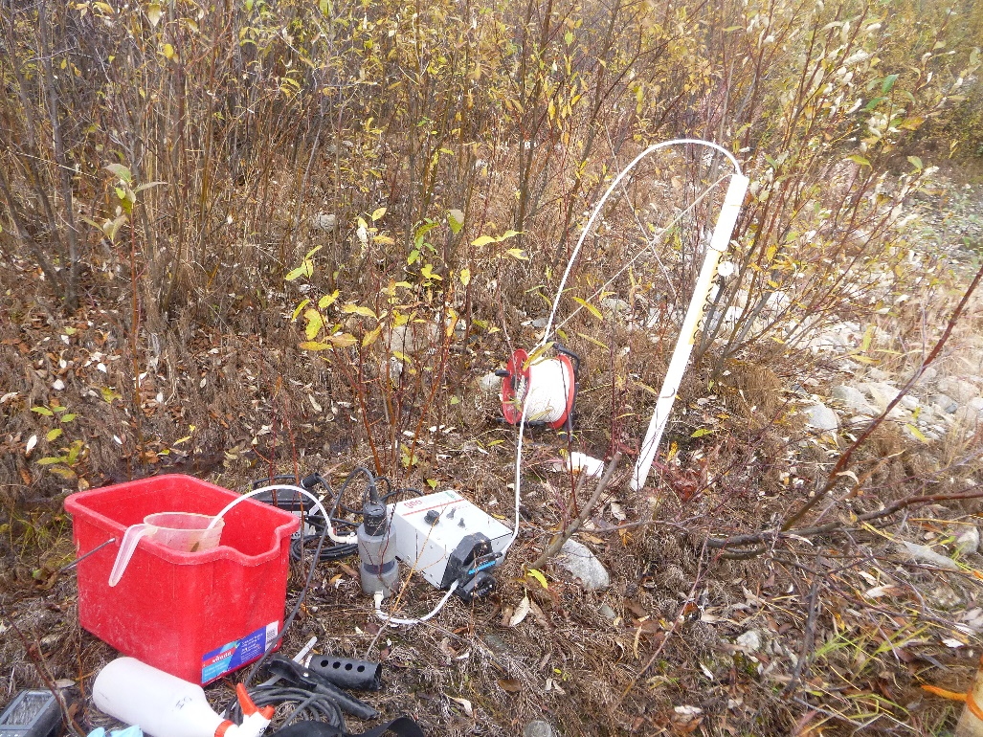
Photo 80: View of well SRK05-5C. Photo taken on September 15th, 2015.

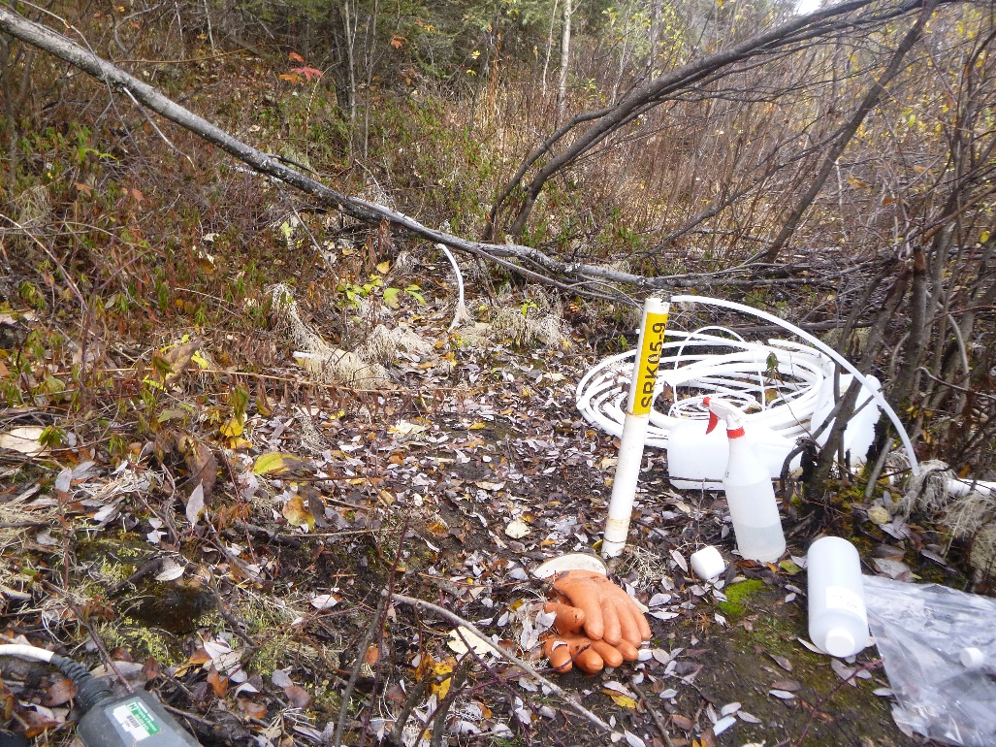
Photo 81: View of well SRK05-09. Photo taken on September 15th, 2015.
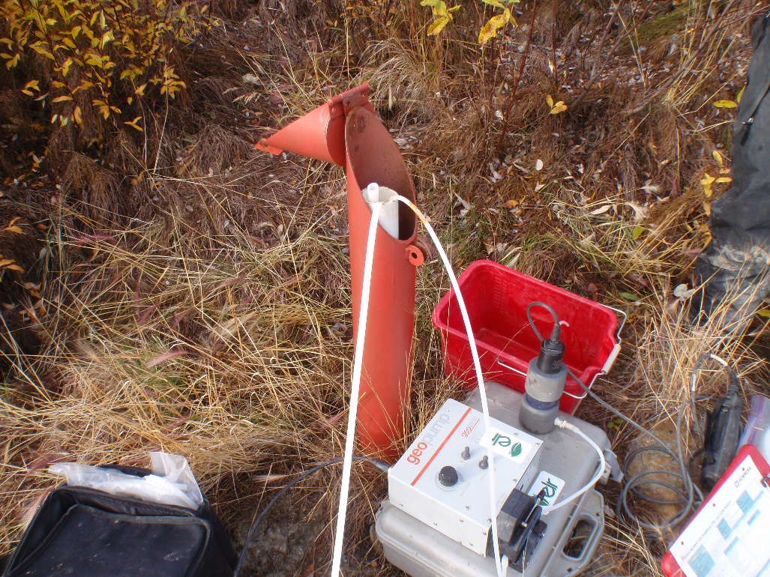
Photo 82: View of well SRK08-P14. Photo taken on September 15th, 2015.

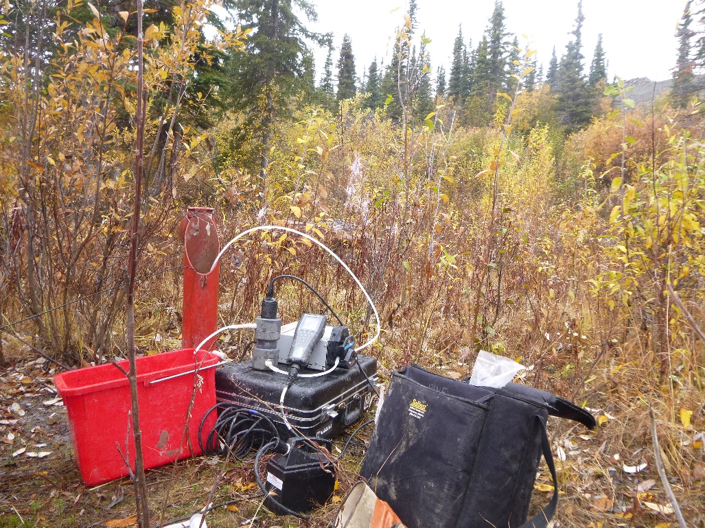
Photo 83: View of well SRK08-P15. Photo taken on September 16th, 2015.
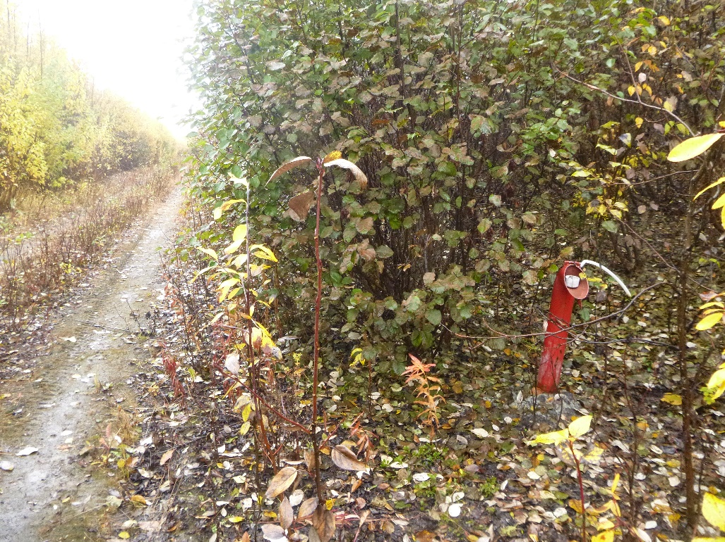
Photo 84: View of well SRK08-P16. Photo taken on September 15th, 2015.

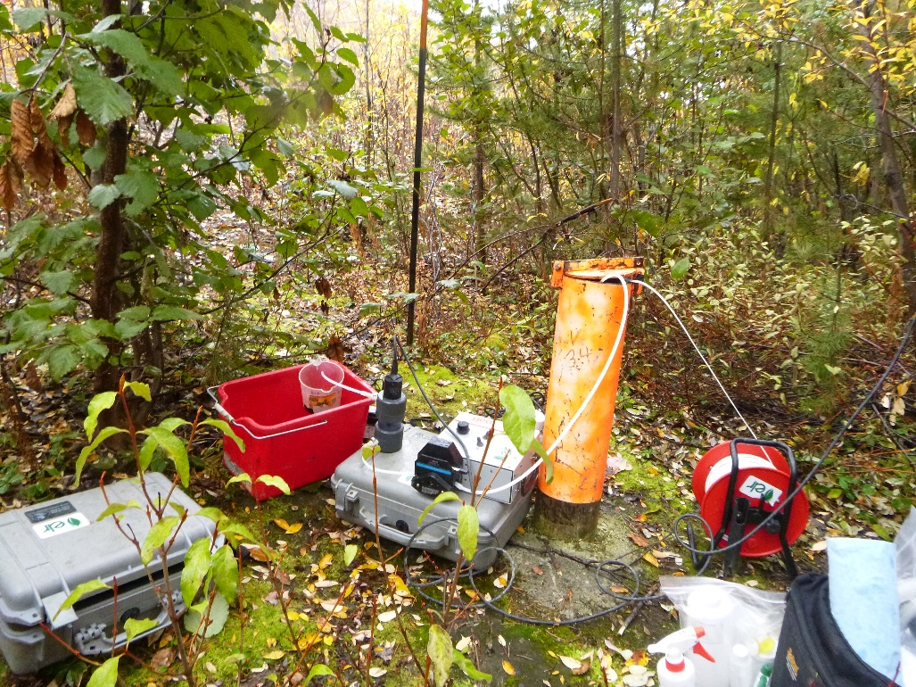
Photo 85: View of well V34. Photo taken on September 15th, 2015.
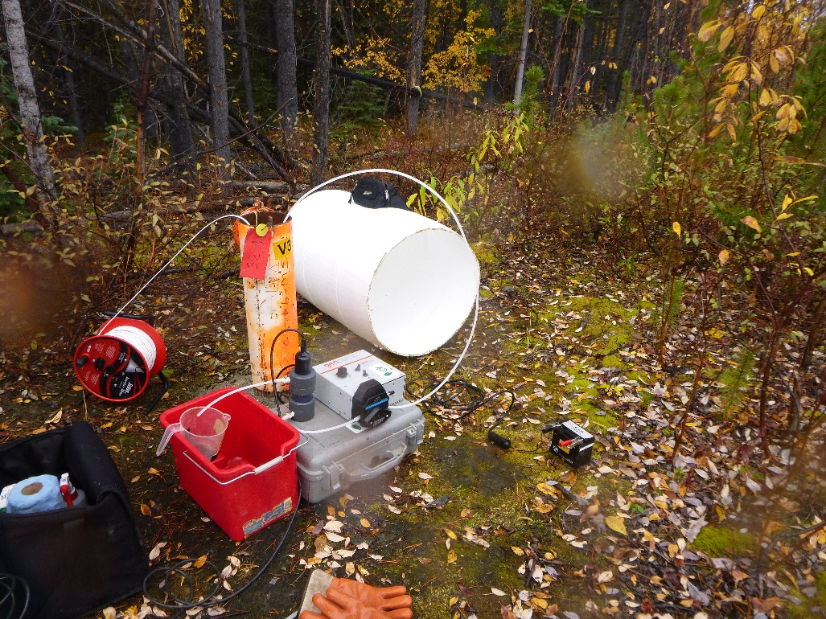
Photo 86: View of well V35. Photo taken on September 15th, 2015.

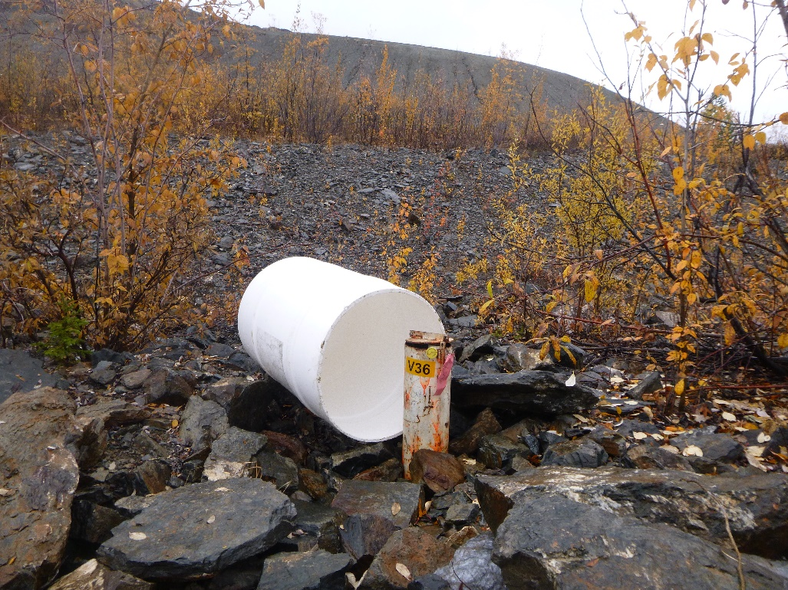
Photo 87: View of well V36. Photo taken on September 15th, 2015.
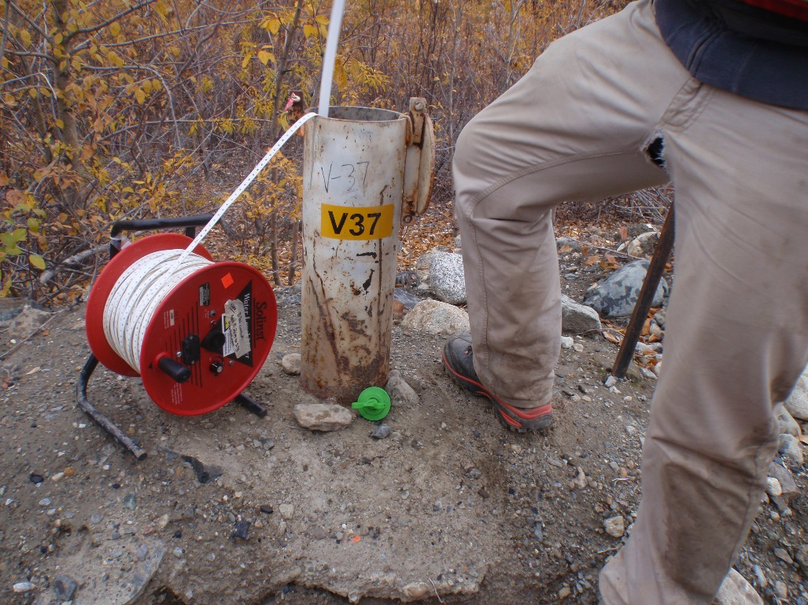
Photo 88: View of well V37. Photo taken on September 15th, 2015.

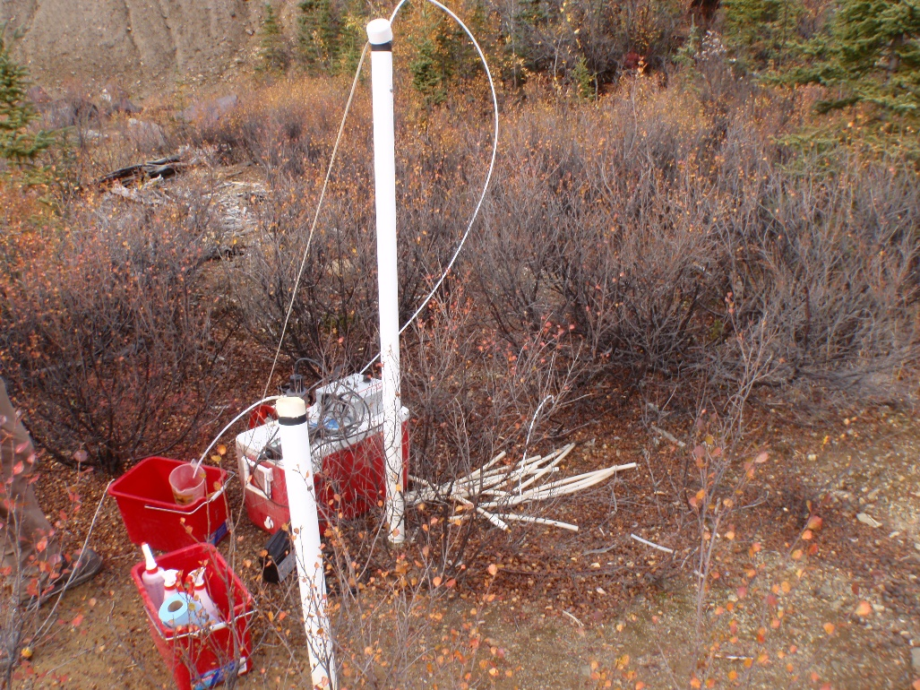
Photo 89: View of wells BH10A and BH10B. Photo taken on September 13th, 2015.
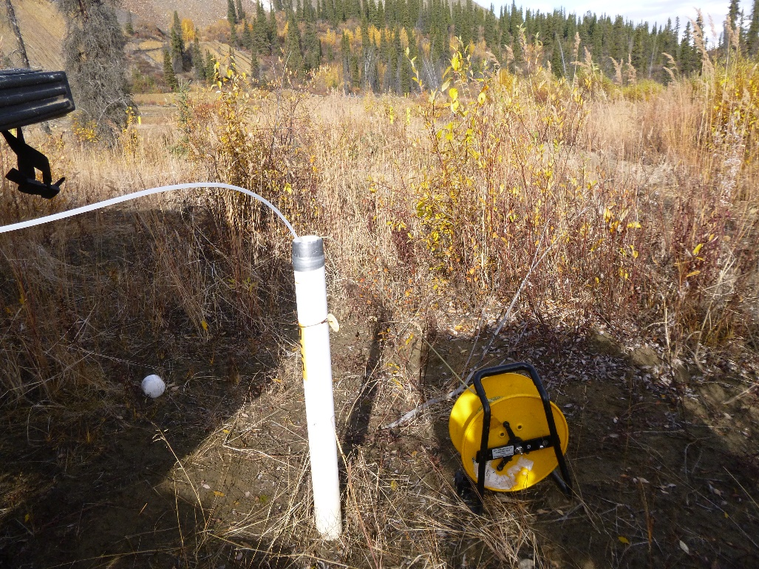
Photo 90: View of well BH5. Photo taken on September 12th, 2015.

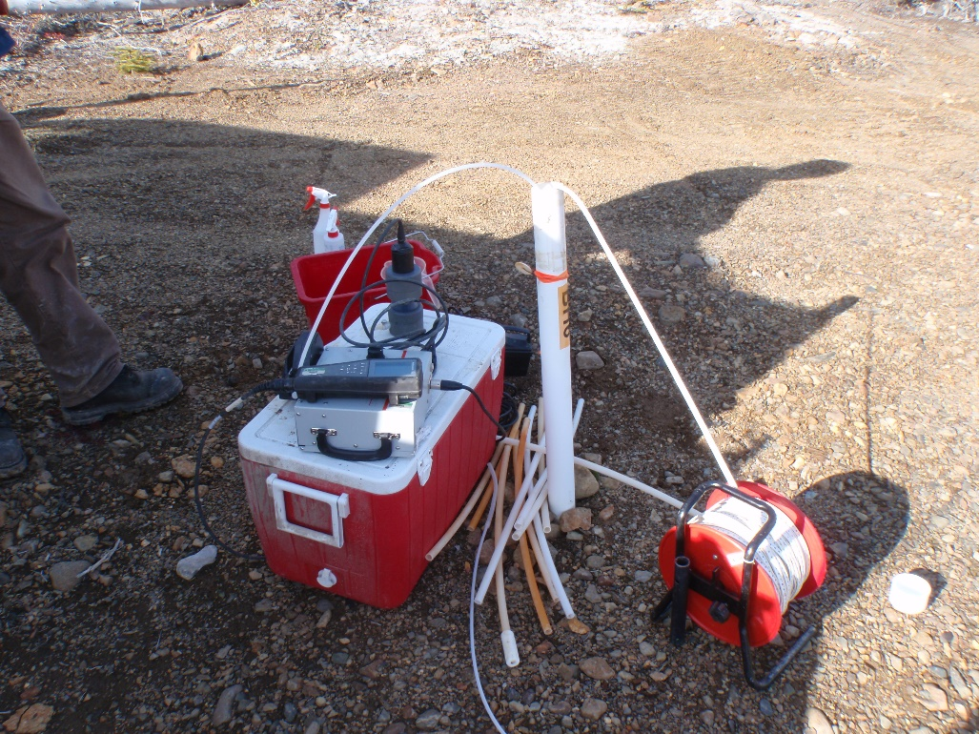
Photo 91: View of well BH6. Photo taken on September 15th, 2015.
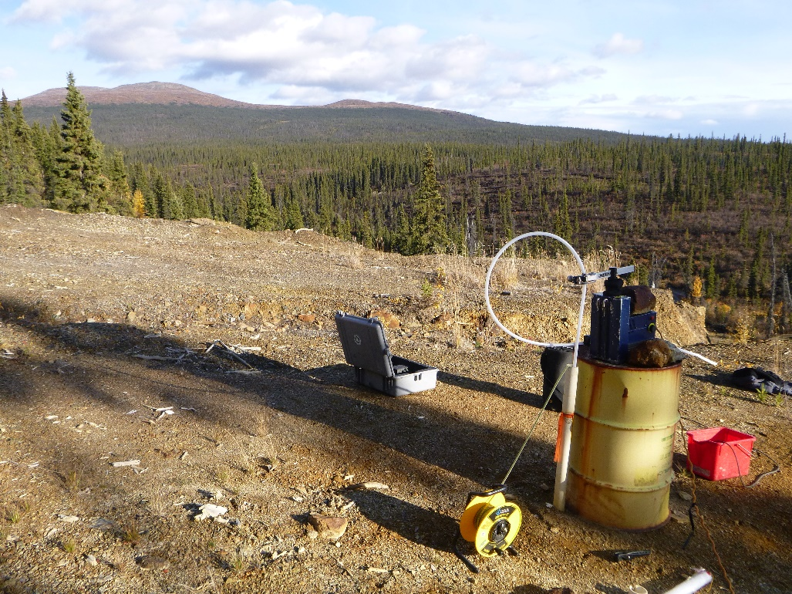
Photo 92: View of well BH8. Photo taken on September 12th, 2015.

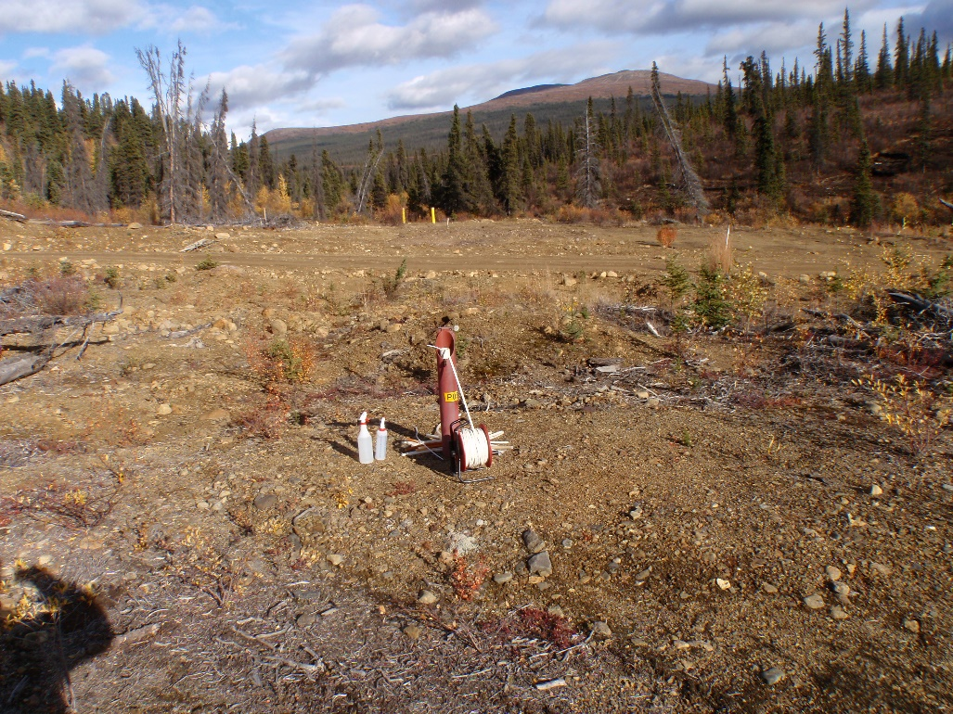
Photo 93: View of well P05-04. Photo taken on September 12th, 2015.
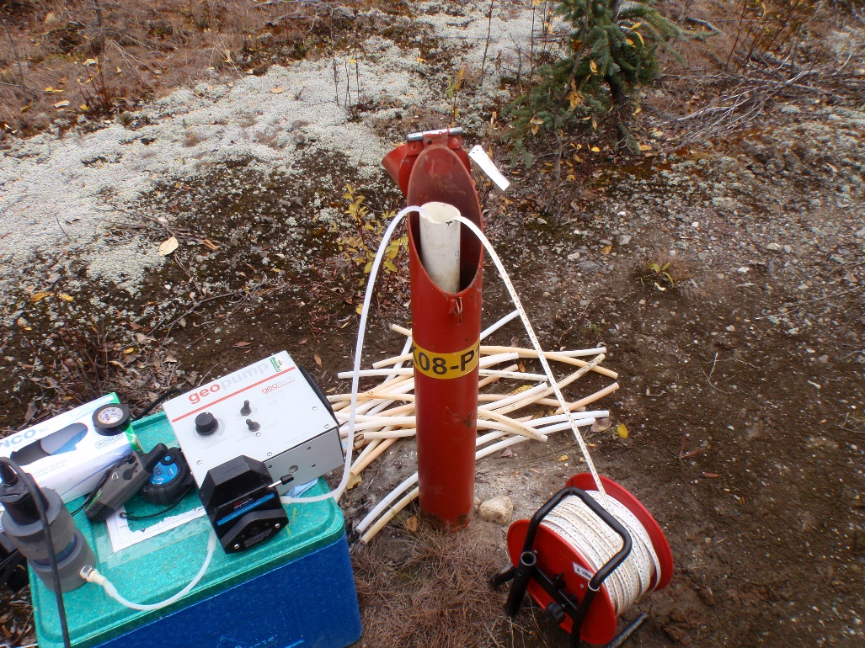
Photo 94: View of well SRK08-P12A. Photo taken on September 12th, 2015.

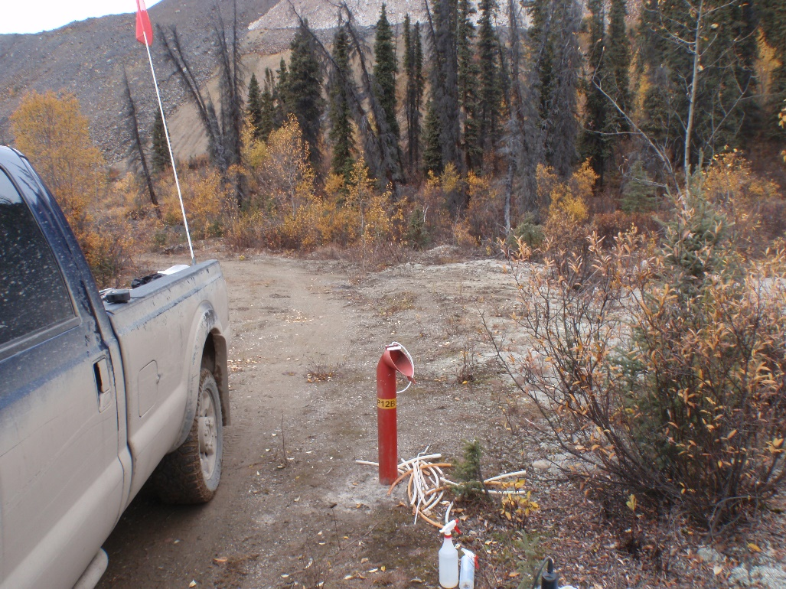
Photo 95: View of well SRK08-P12B. Photo taken on September 12th, 2015.
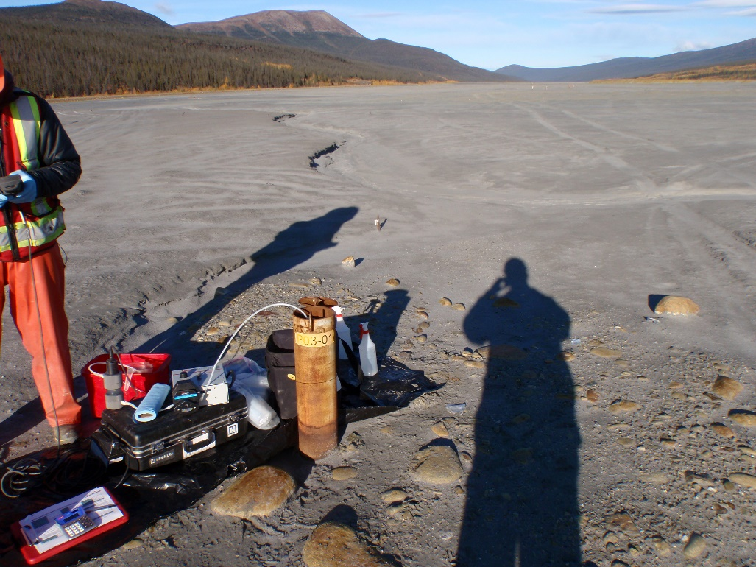
Photo 96: View of well P03-01-8. Photo taken on September 12th, 2015.

Photo 97: View of well P09-LCD6. Photo taken on September 15th, 2015.
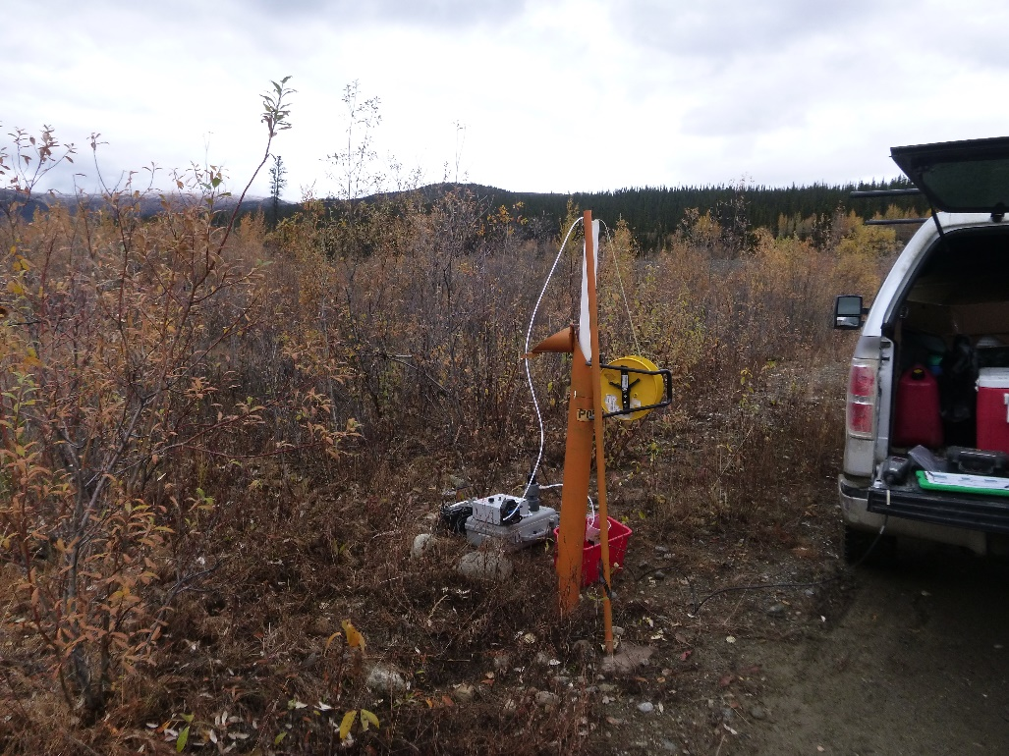
Photo 98: View of well P05-02. Photo taken on September 13th, 2015.

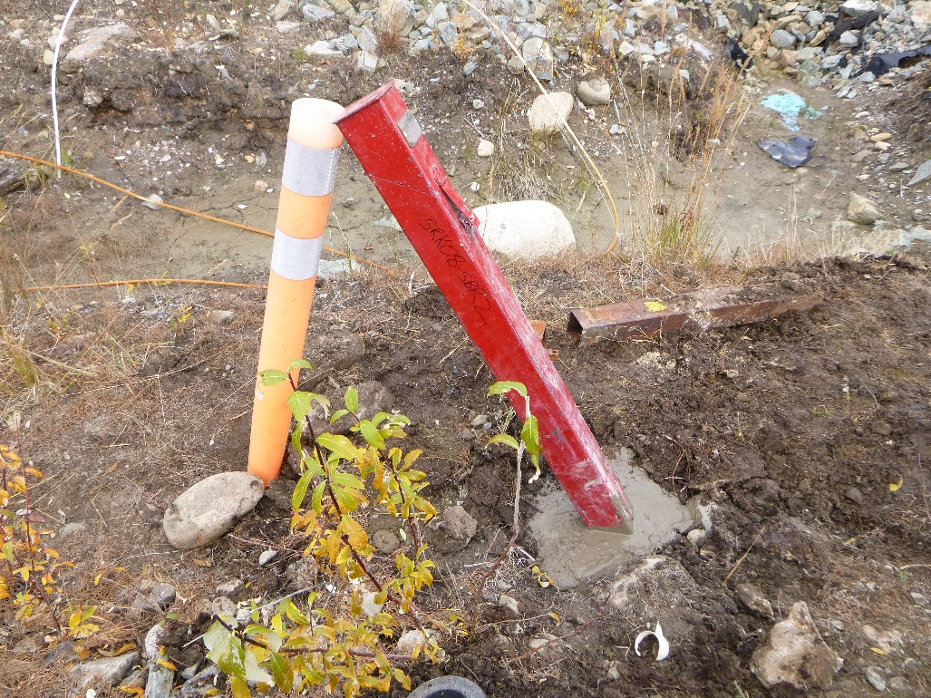
Photo 99: View of well SRK08-SBR2. Photo taken following well repairs on September 14th, 2015.

