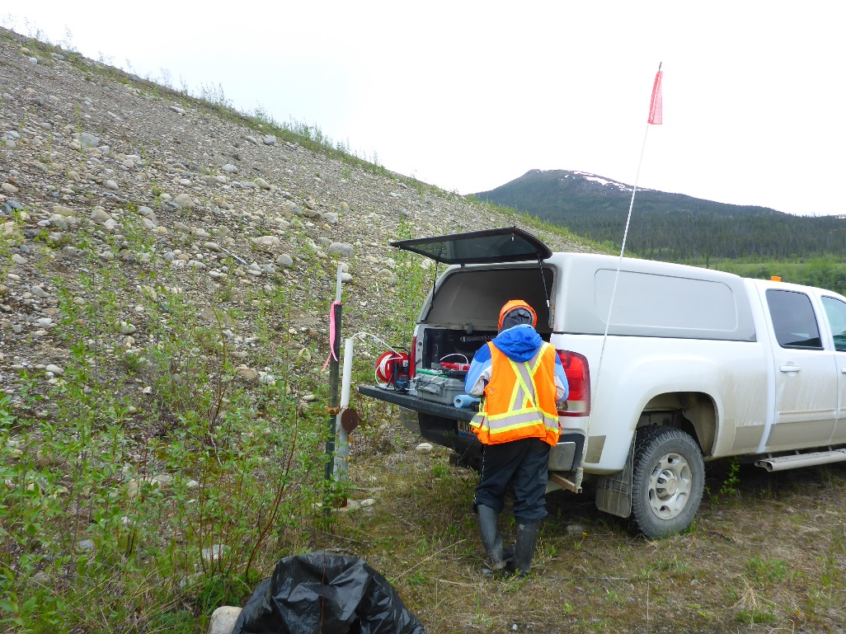
Photo 1: View of well P01-11. Photo taken on June 2nd, 2016.
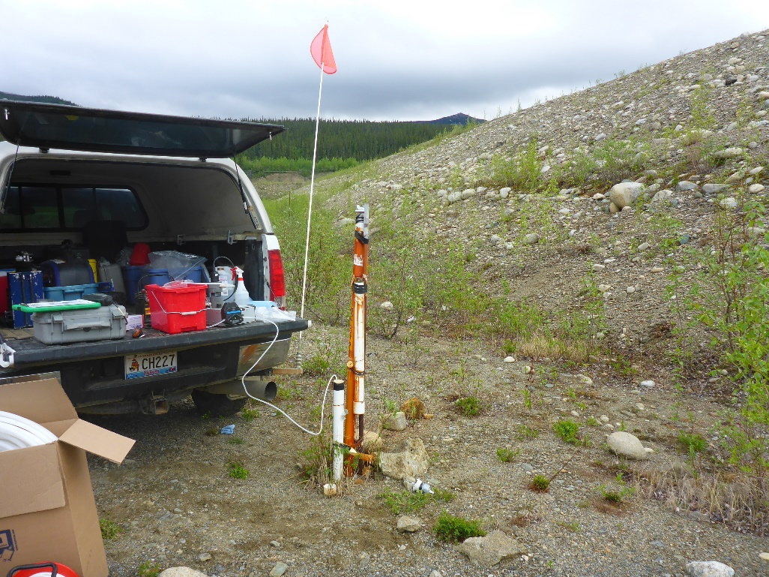
Photo 2: View of wells P01-02A and P01-02B. Photo taken on June 2nd, 2016.
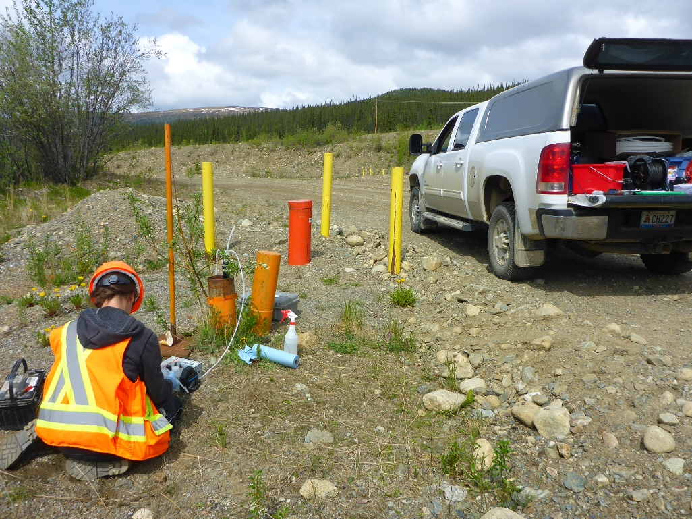
Photo 3: View of wells P05-01-02 and P05-01-04. Photo taken on June 2nd, 2016.
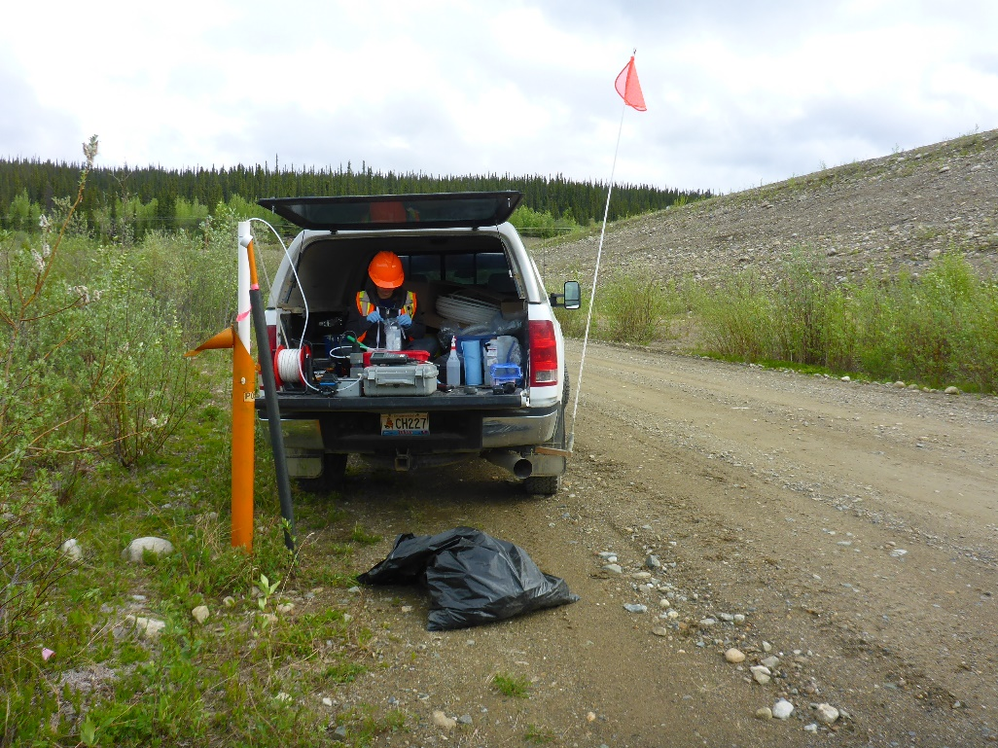
Photo 4: View of well P05-02. Photo taken on June 2nd, 2016.
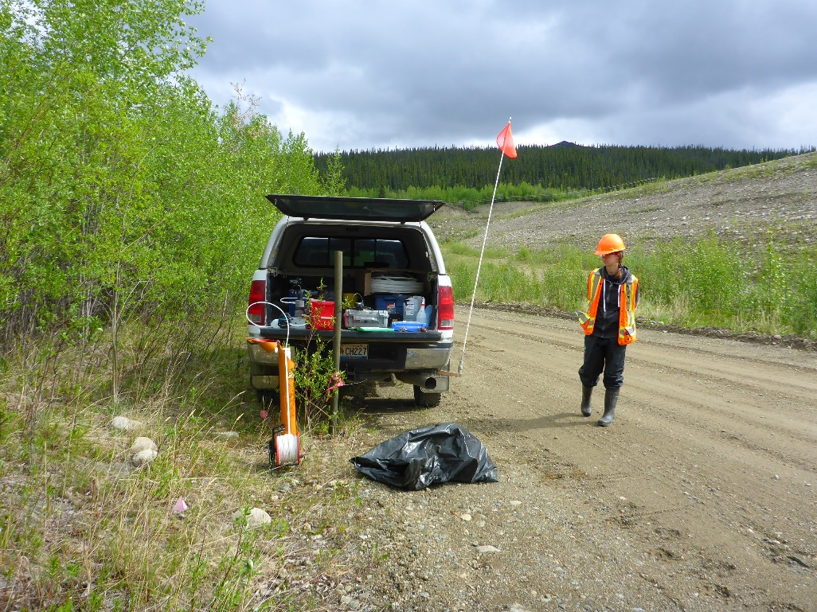
Photo 5: View of well P05-03. Photo taken on June 2nd, 2016.
Photo 6: View of wells P01-01A and P01-01B. Photo taken on June 2nd, 2016.
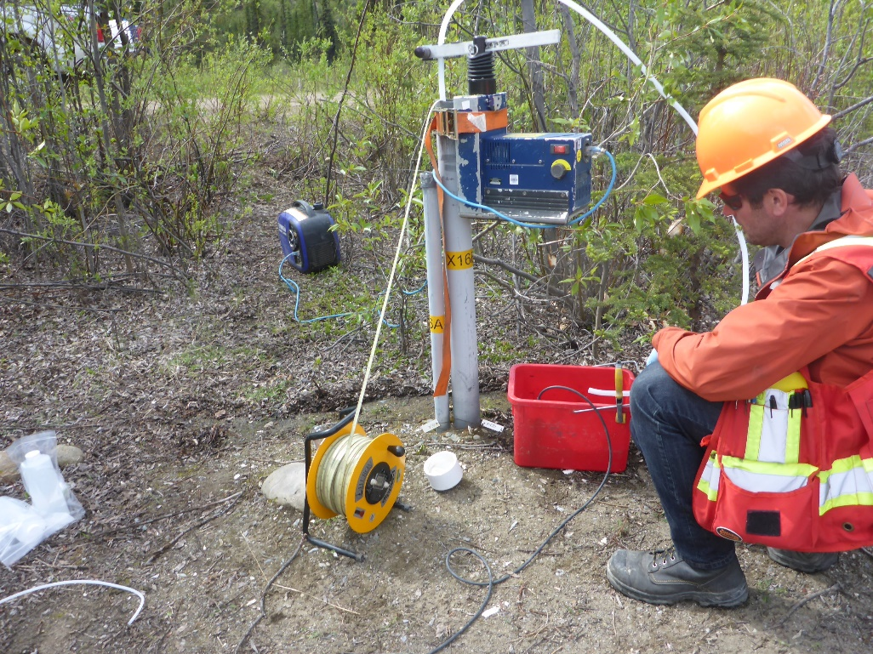
Photo 7: View of wells X16A and X16B. Photo taken on June 2nd, 2016.
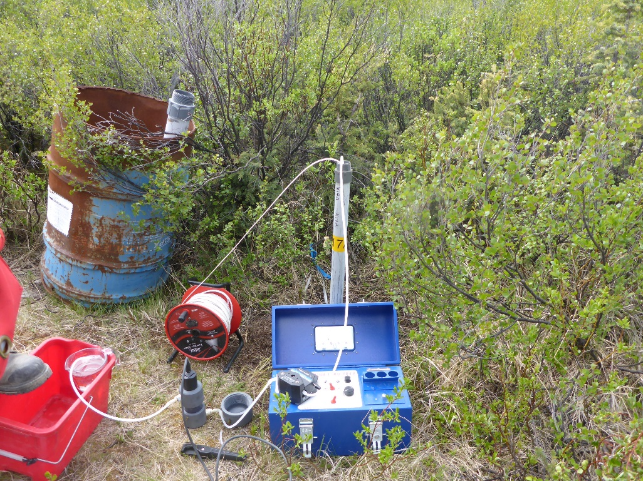
Photo 8: View of well X17A. Photo taken on June 3rd, 2016.
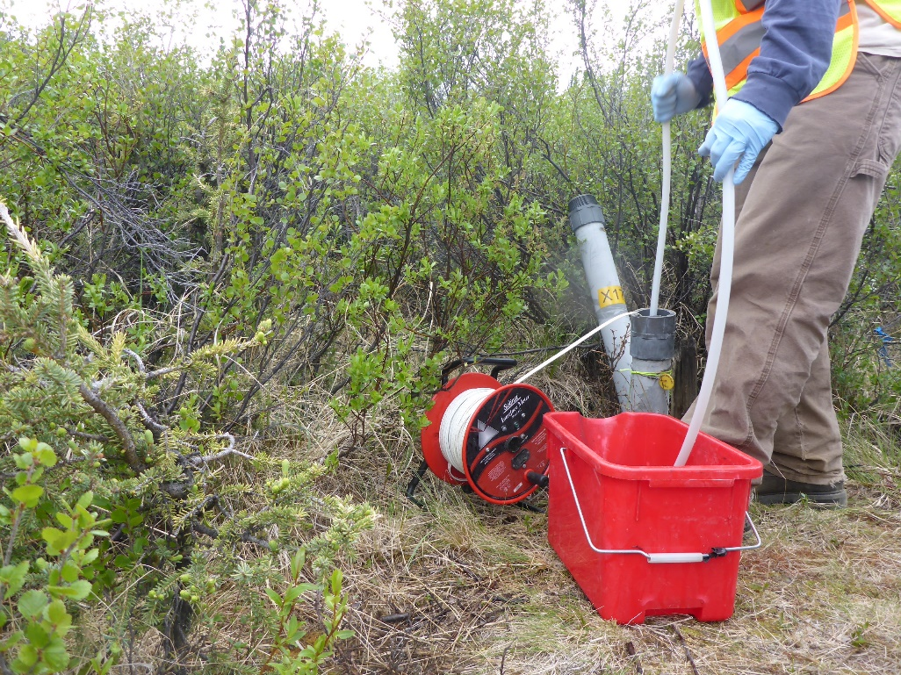
Photo 9: View of well X17B. Photo taken on June 3rd, 2016.
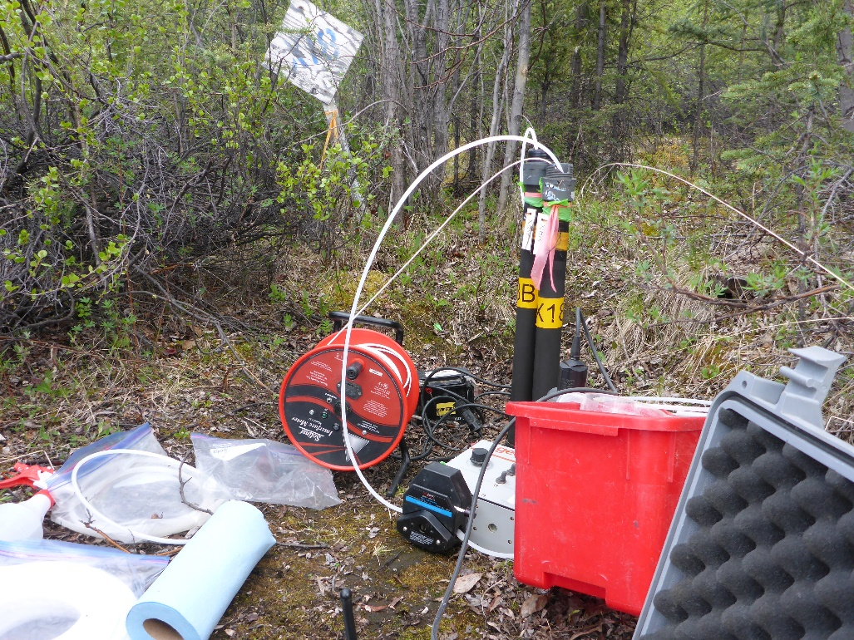
Photo 10: View of wells X18A and X18B. Photo taken on June 2nd, 2016.
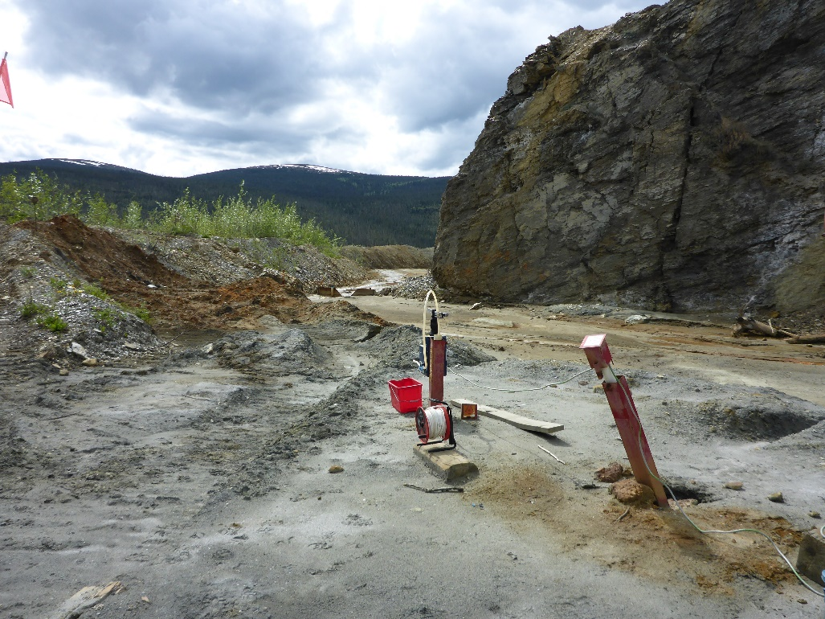
Photo 11: View of well P09-ETA-2. Photo taken on June 3rd, 2016.
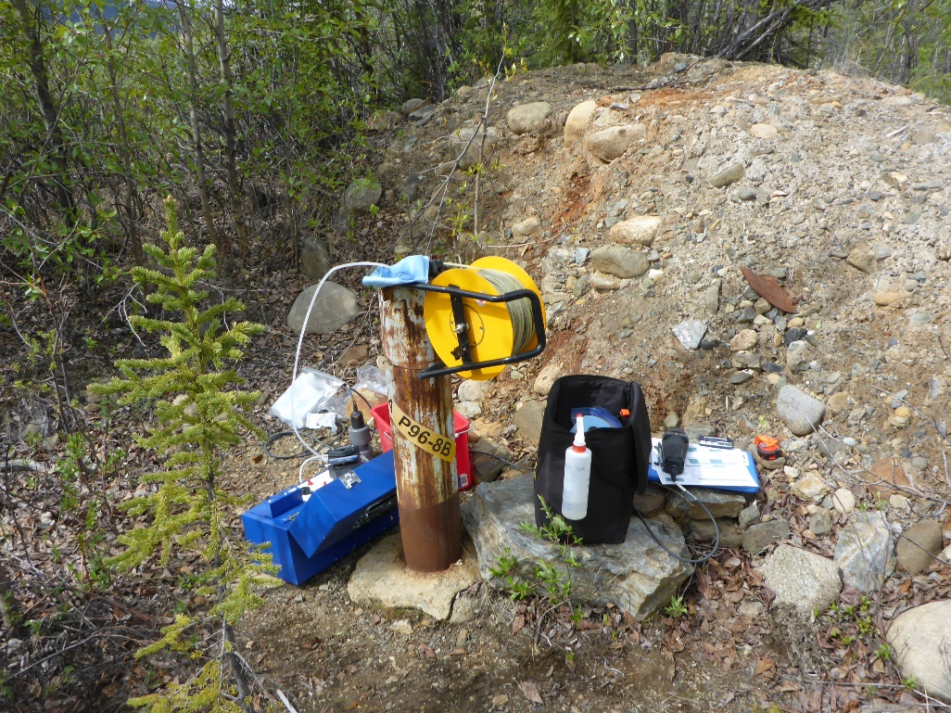
Photo 12: View of wells P96-8A and P96-8B. Photo taken on June 3rd, 2016.

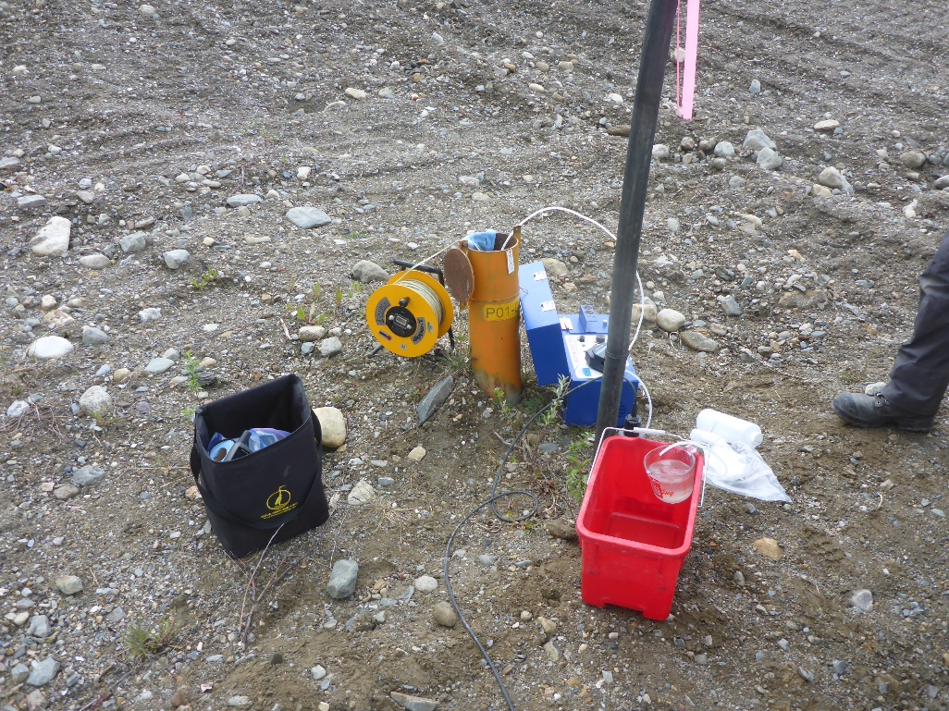
Photo 13: View of well P01-03. Photo taken on June 2nd, 2016.
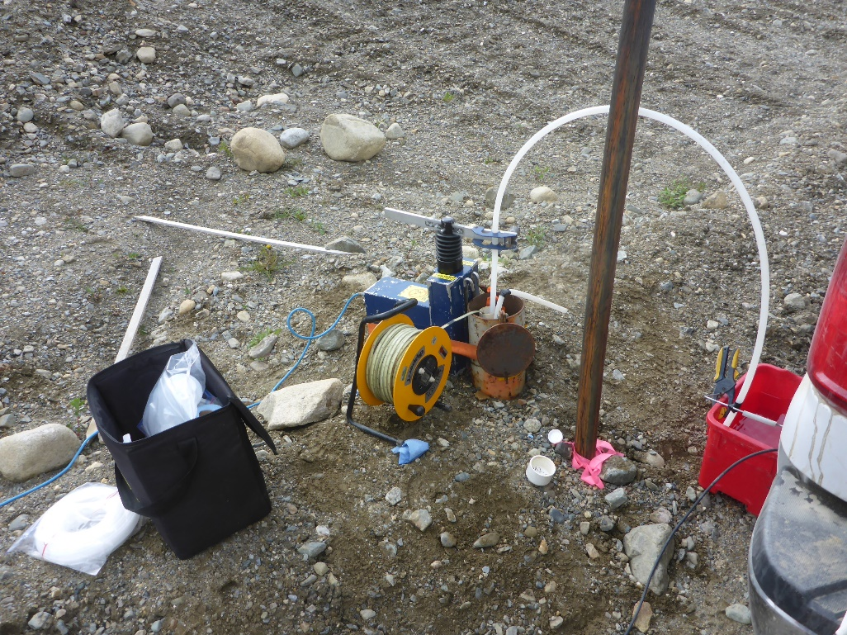
Photo 14: View of well P01-04A and P01-04B. Photo taken on June 2nd, 2016.

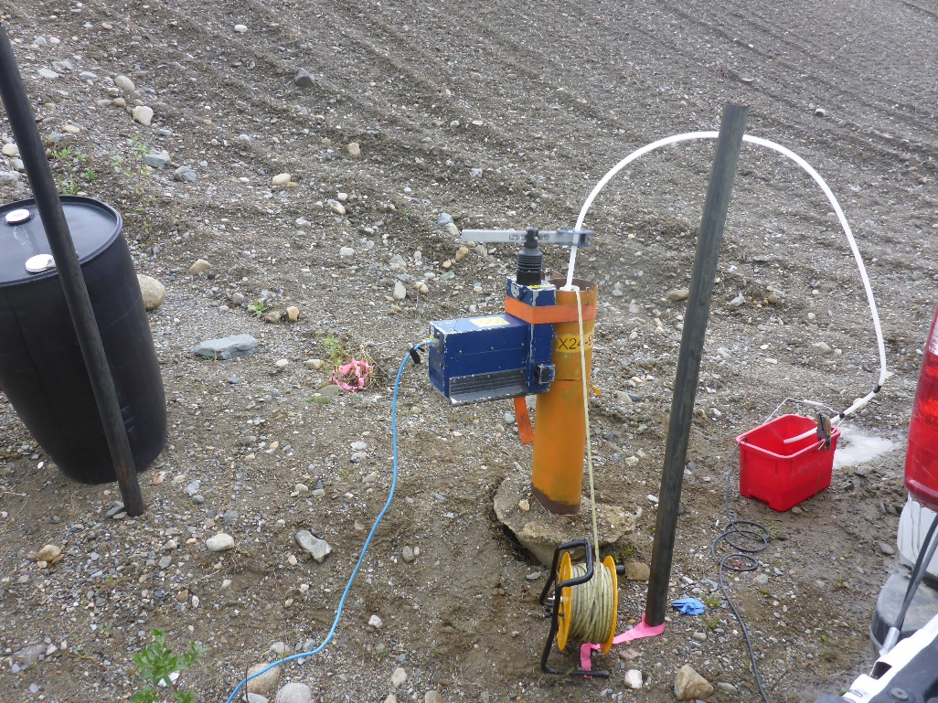
Photo 15: View of well X24-96D. Photo taken on June 2nd, 2016.
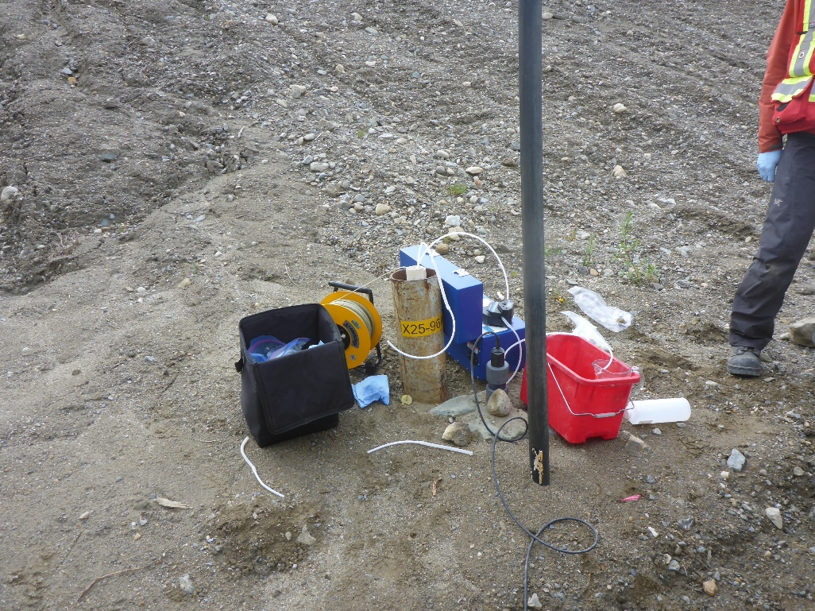
Photo 16: View of wells X25-96A and X25-96B. Photo taken on June 2nd, 2016.

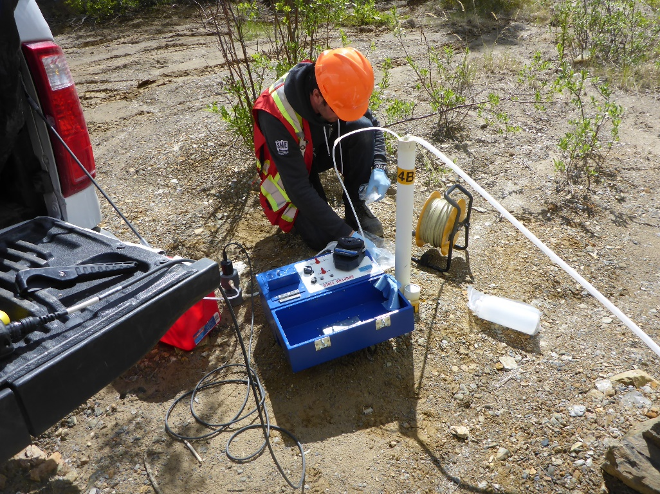
Photo 17: View of wells BH14A and BH 14B. Photo taken on June 3rd, 2016.
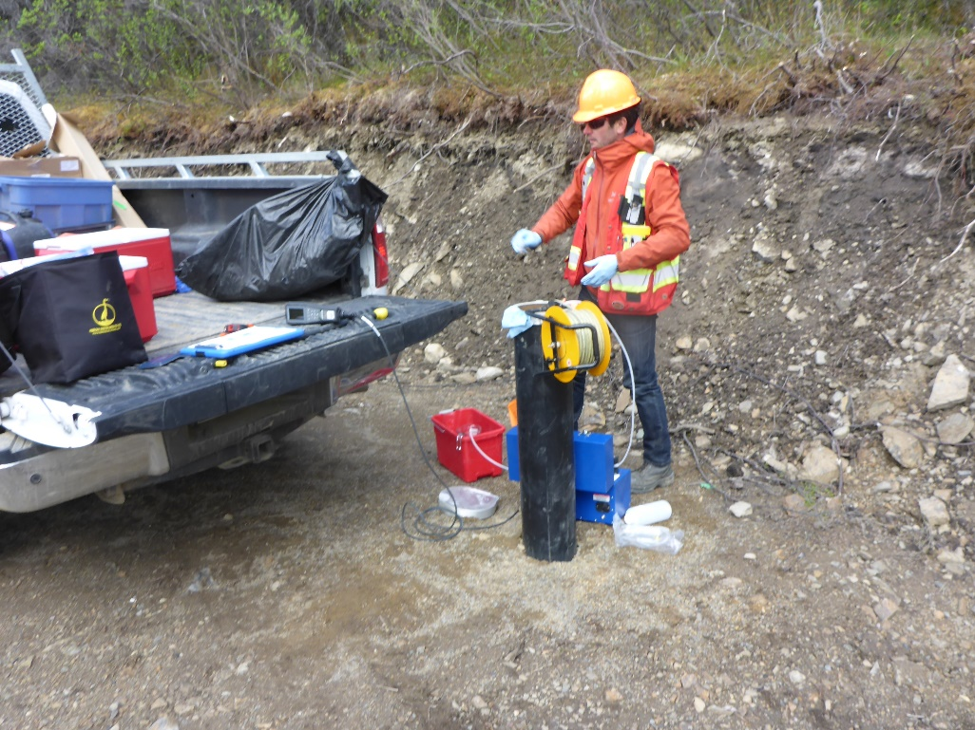
Photo 18: View of well CH15-107-MW029. Photo taken on June 3rd, 2016.

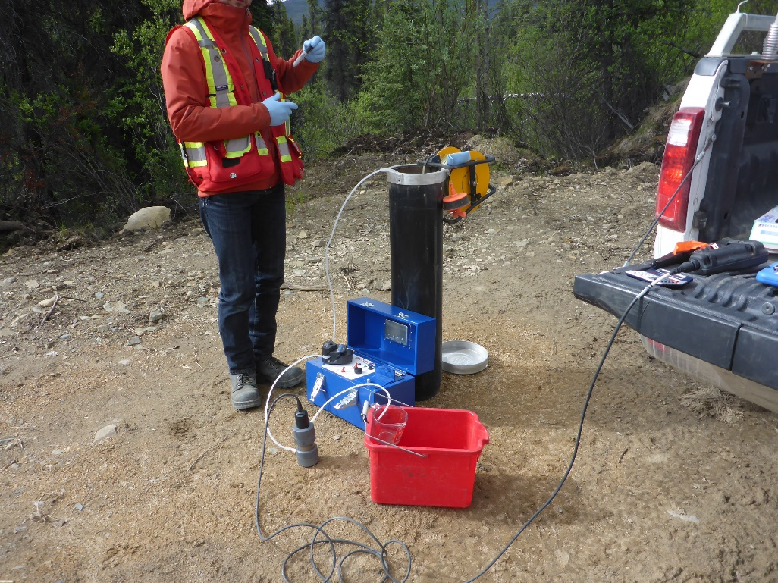
Photo 19: View of well CH15-107-MW030. Photo taken on June 3rd, 2016.
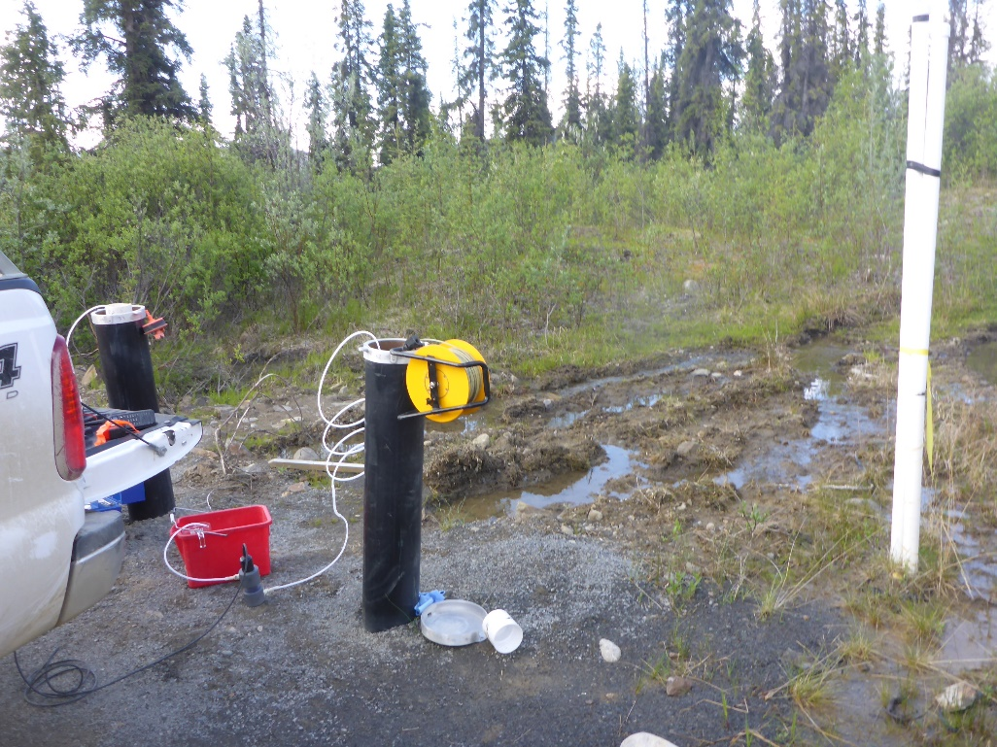
Photo 20: View of well CH15-107-032. Photo taken on June 3rd, 2016.

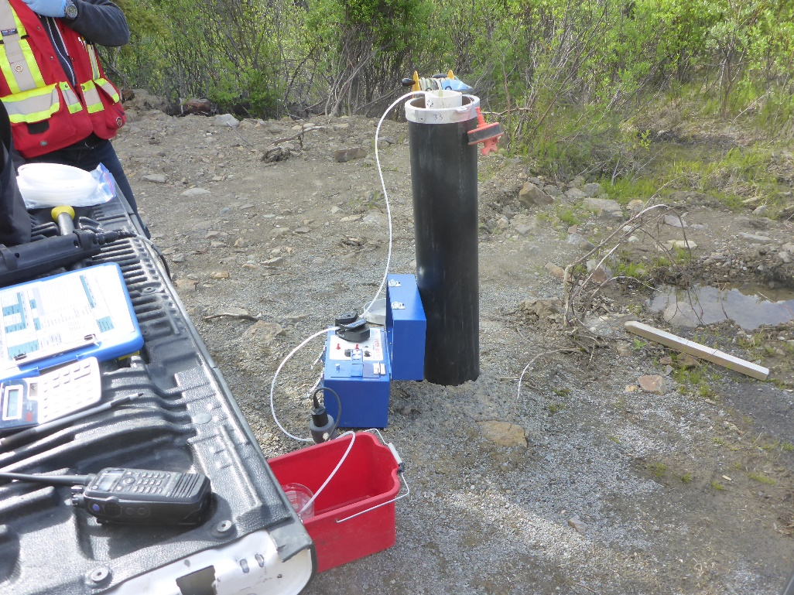
Photo 21: View of well CH15-107-MW033. Photo taken on June 3rd, 2016.
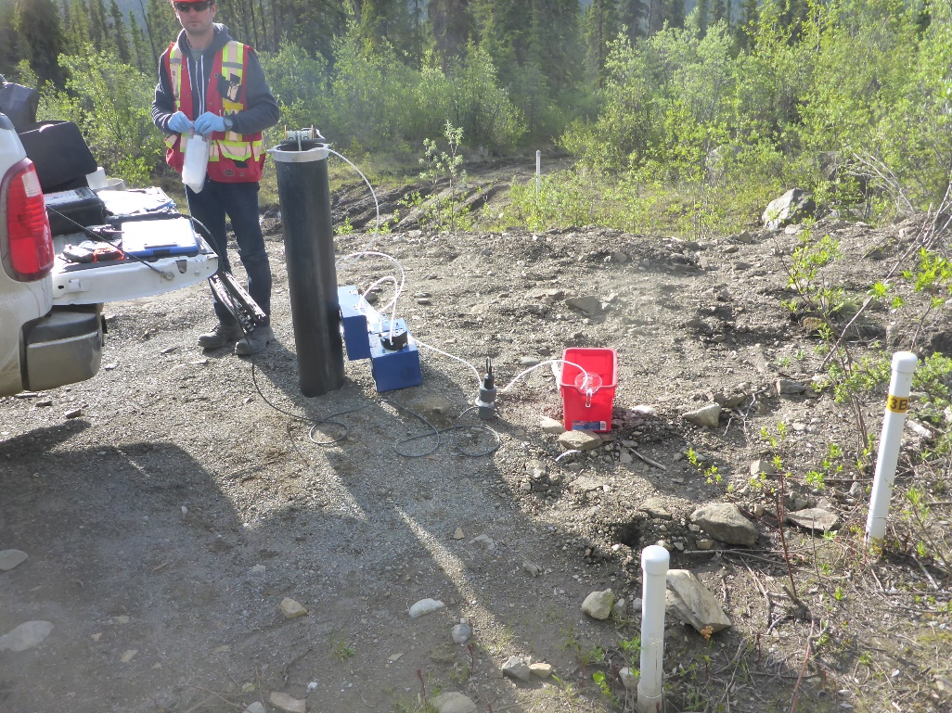
Photo 22: View of well CH15-107-MW034. Photo taken on June 3rd, 2016.

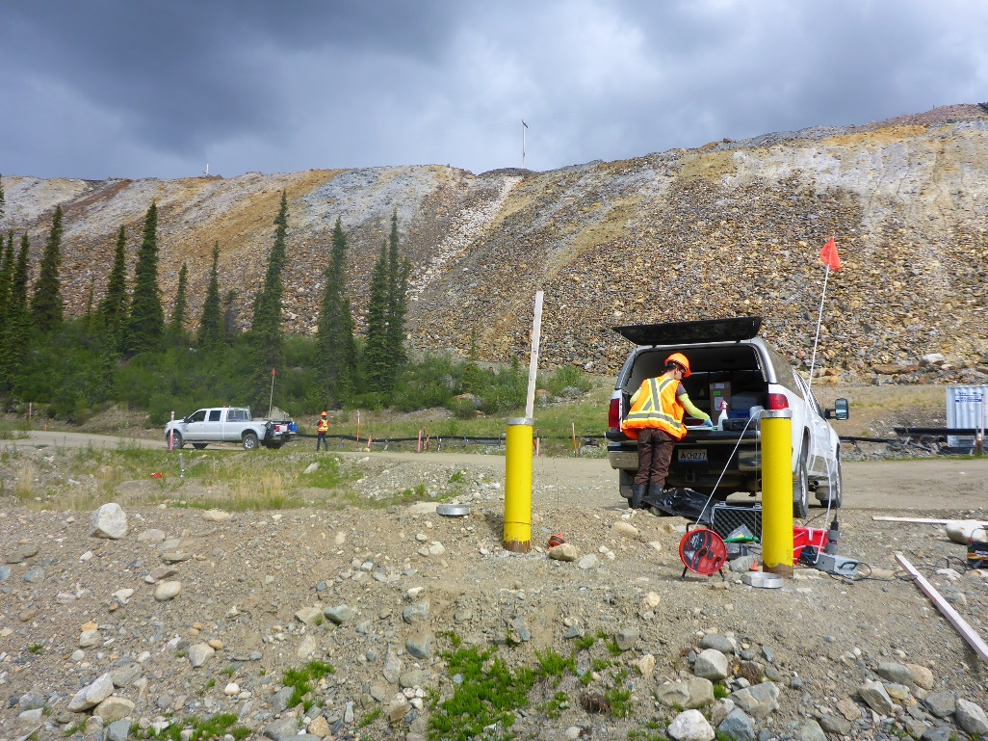
Photo 23: View of wells CH14-107-MW007A and CH14-107-MW007B. Photo taken on June 1st, 2016.
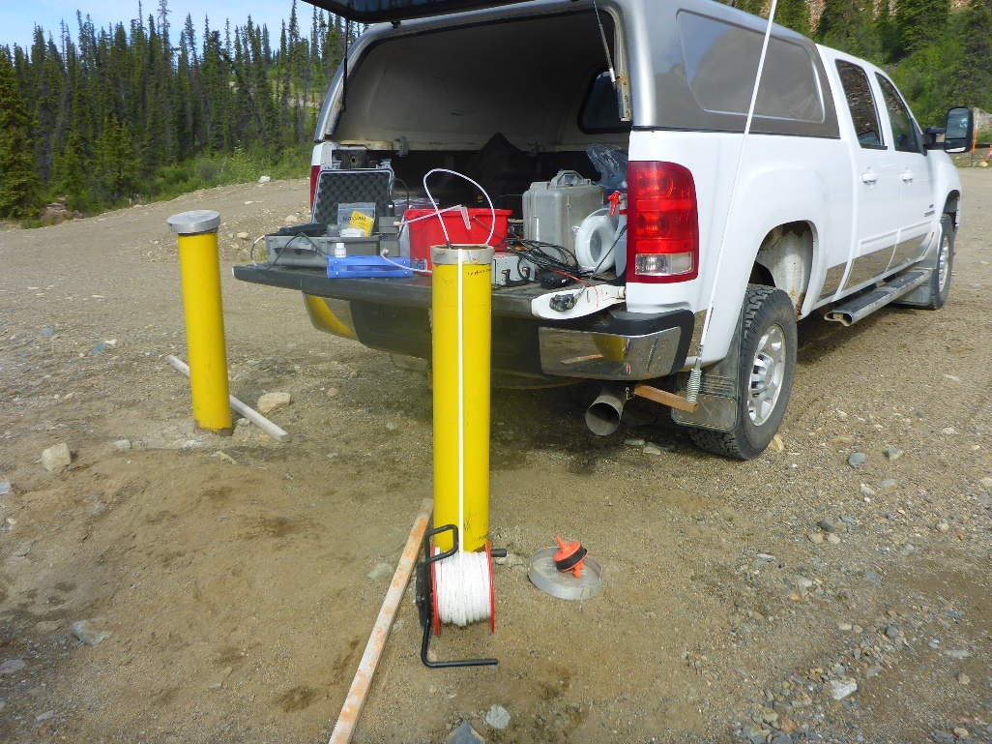
Photo 24: View of well CH14-107-MW009. Photo taken on June 1st, 2016.

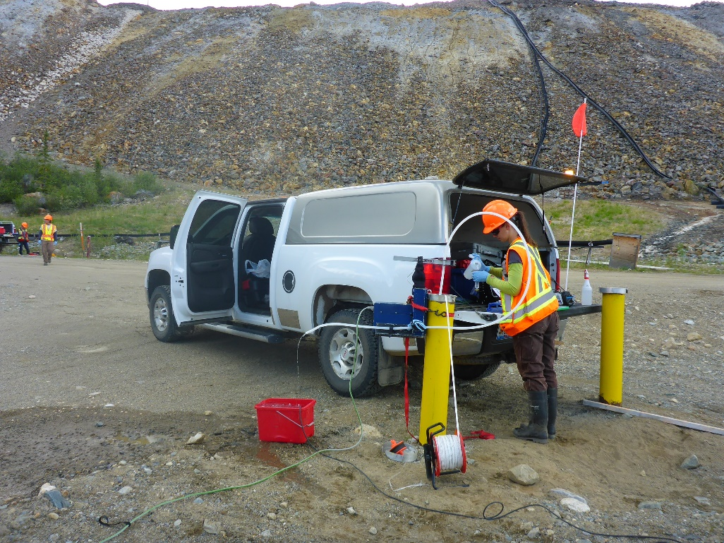
Photo 25: View of well CH14-107-MW010. Photo taken on June 1st, 2016.
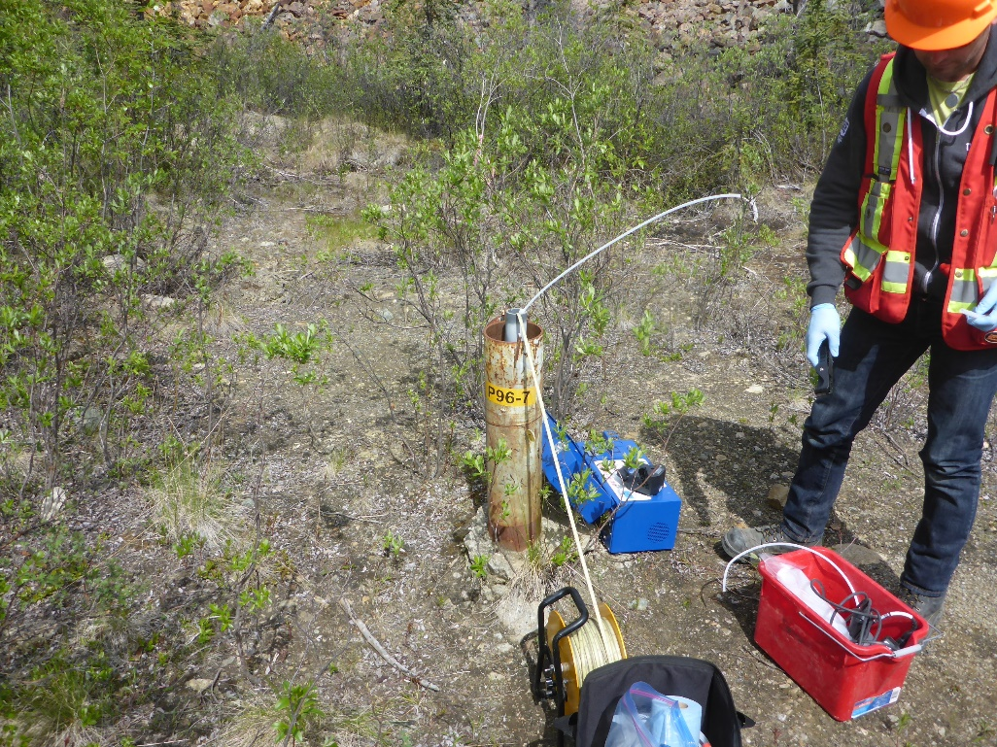
Photo 26: View of well P96-7. Photo taken on June 1st, 2016.

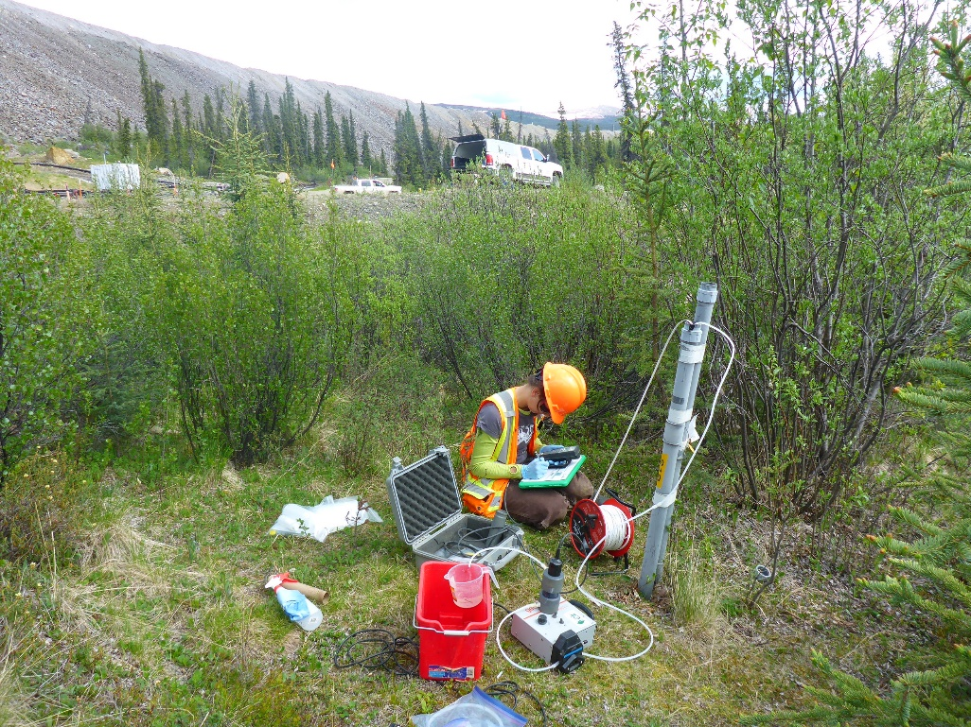
Photo 27: View of wells S1A and S1B. Photo taken on June 1st, 2016.
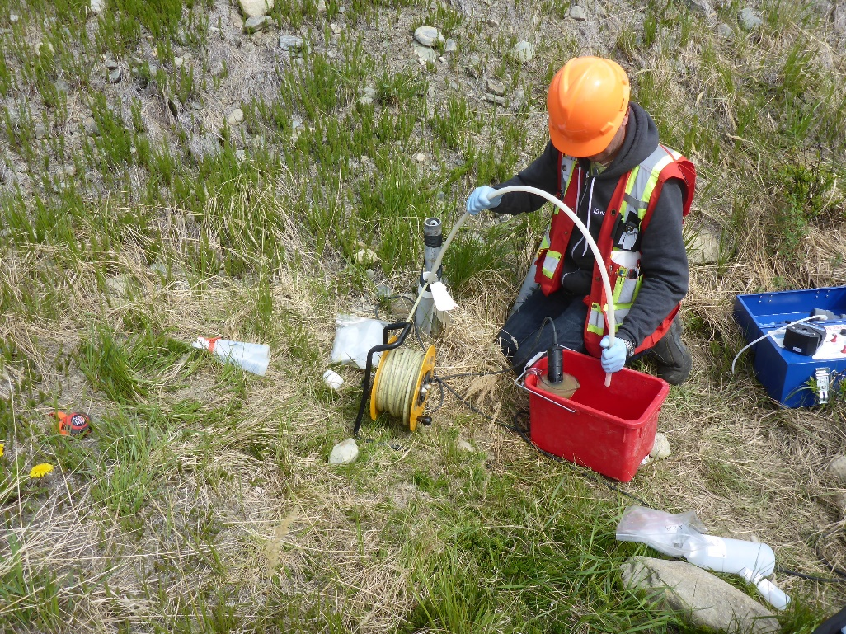
Photo 28: View of wells S2A and S2B. Phot taken on June 1st, 2016.

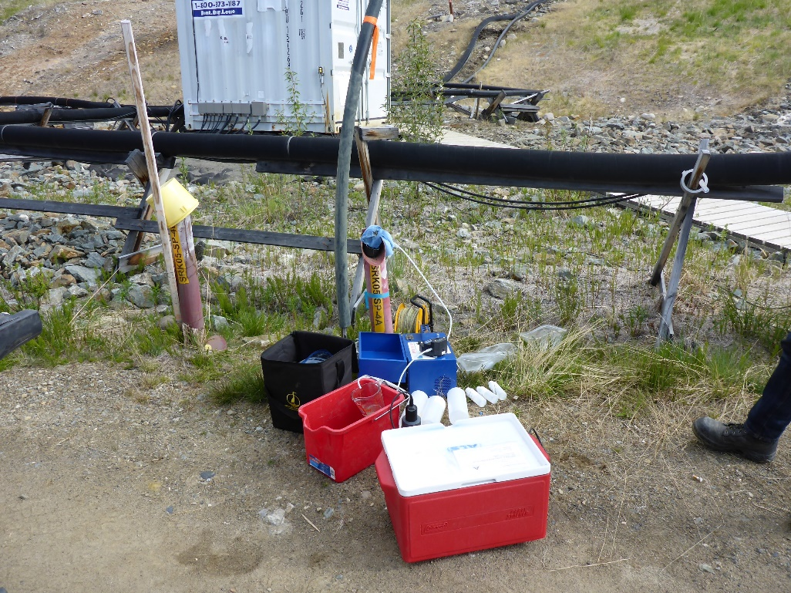
Photo 29: View of well SRK05-SP-4A. Photo taken on June 1st, 2016.
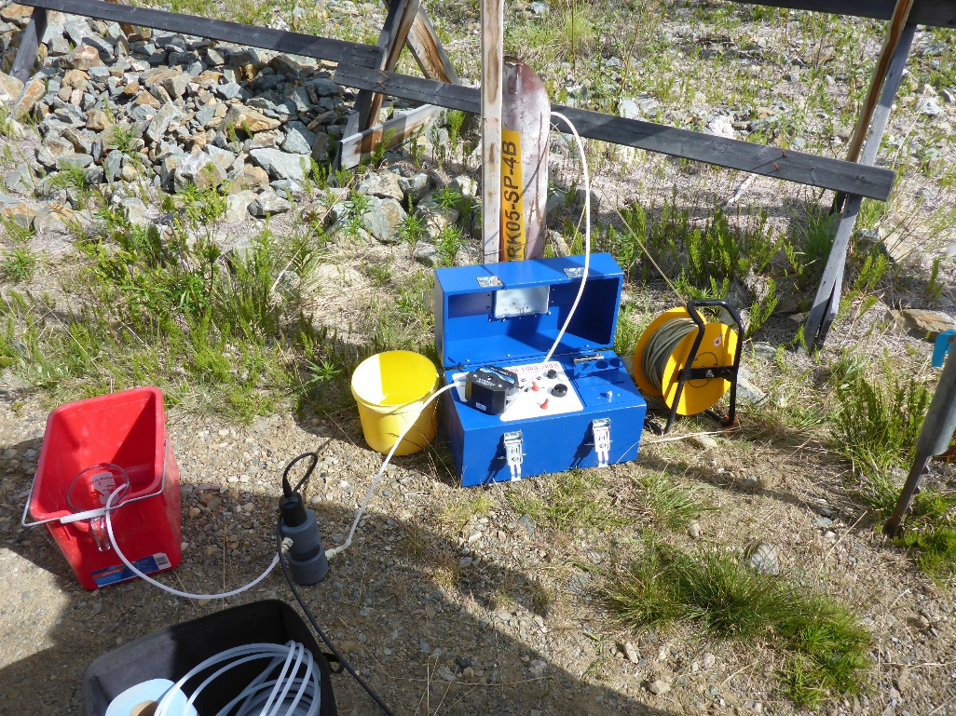
Photo 30: Views of well SRK05-SP-4B. Photo taken on June 1st, 2016.

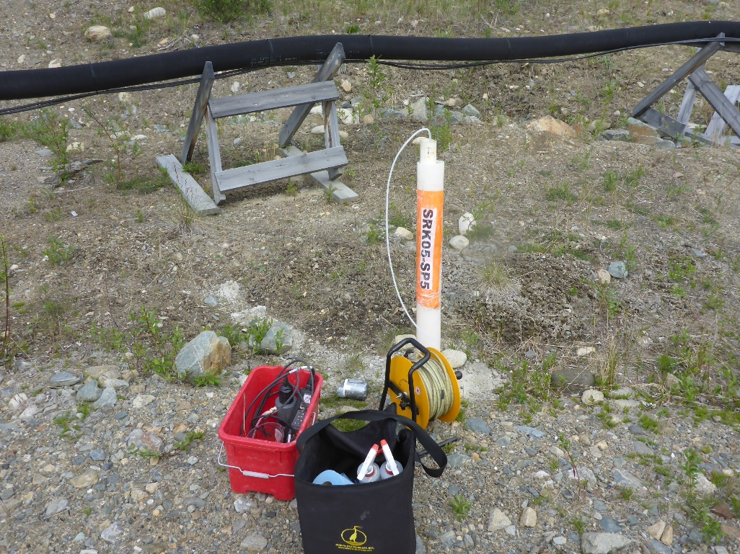
Photo 31: View of well SRK05-SP-5. Photo taken on June 1st, 2016.
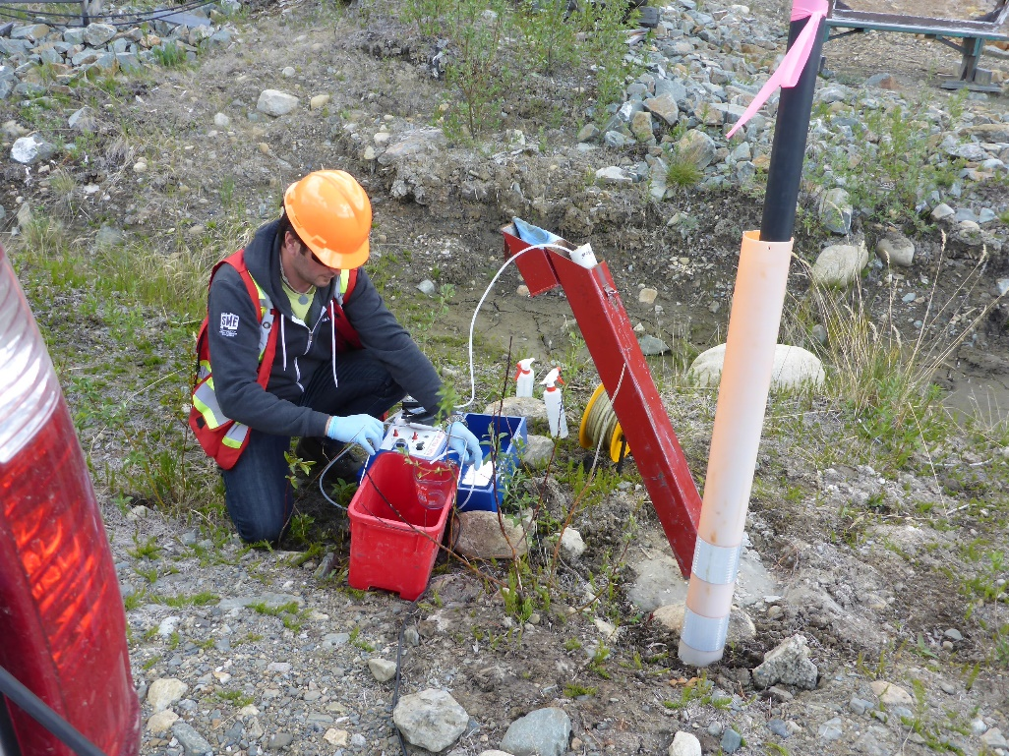
Photo 32: View of well SRK08-SBR2. Photo taken on June 1st, 2016.

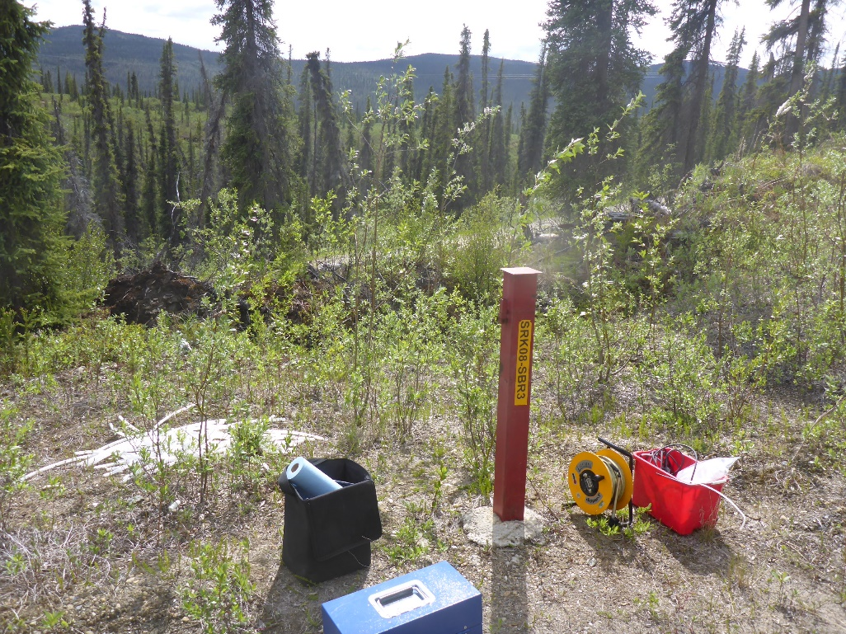
Photo 33: View of well SRK08-SBR3. Photo taken on June 1st, 2016.
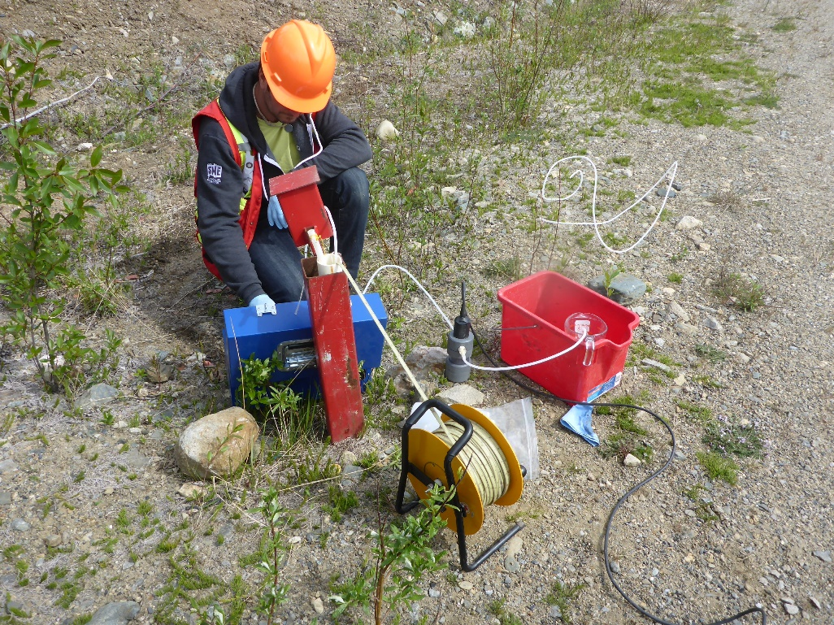
Photo 34: View of well SRK08-SBR4. Photo taken on June 1st, 2016.

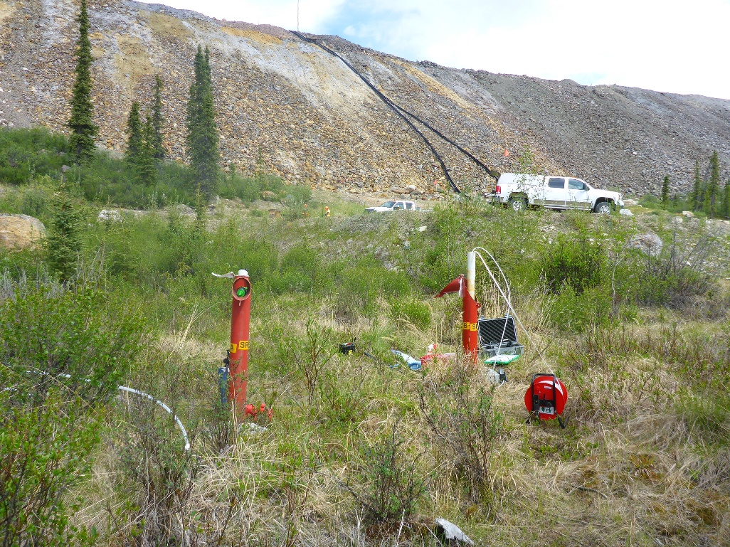
Photo 35: View of wells SRK08-SP-7A and SRK08-SP-7B. Photo taken on June 1st, 2016.
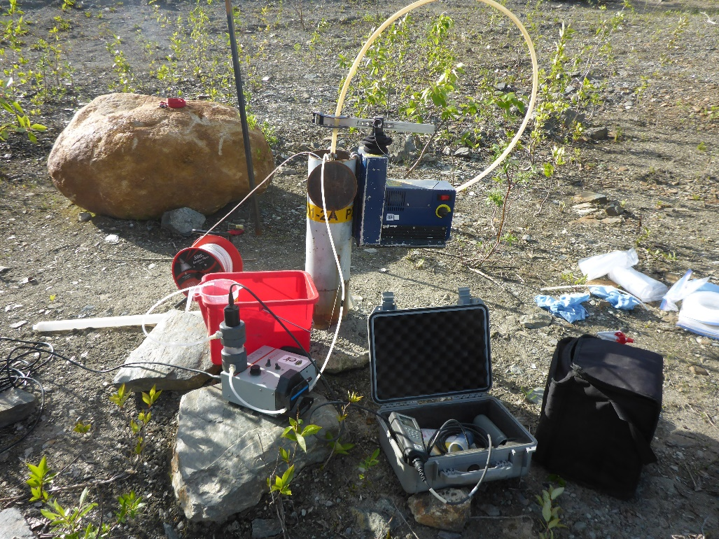
Photo 36: View of well P2001-02A and P2001-02B. Photos taken on June 3rd, 2016.

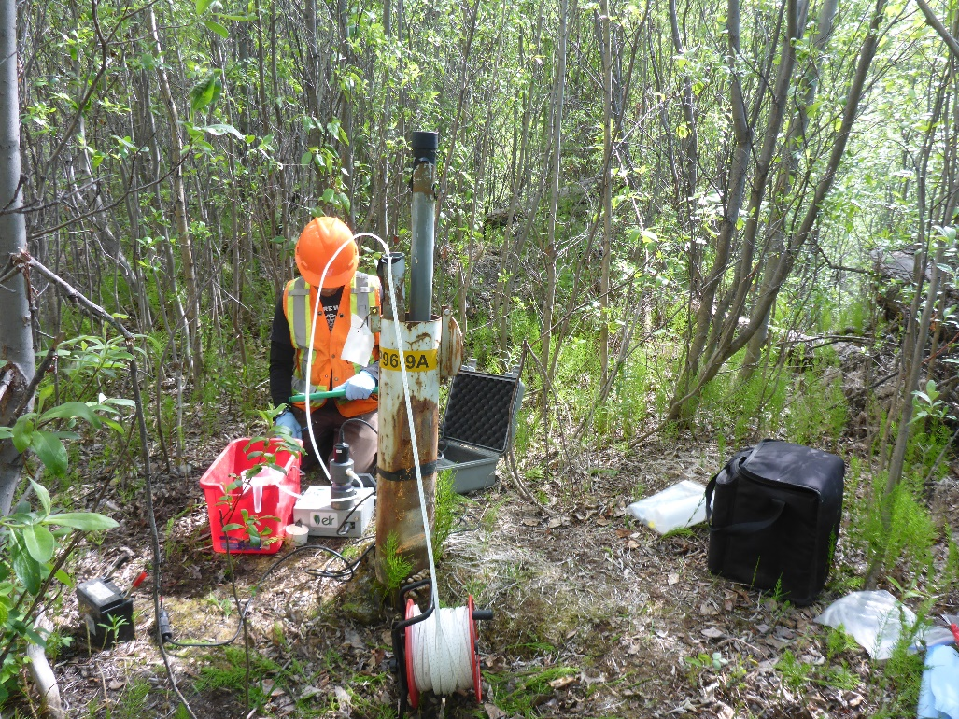
Photo 37: View of well P96-9A. Photo taken on June 3rd, 2016.
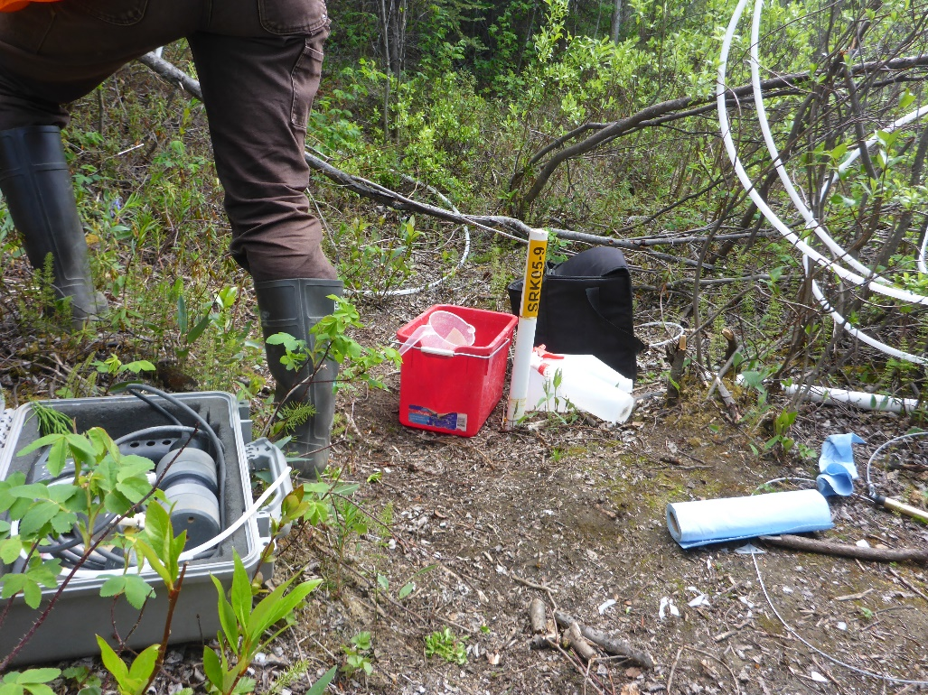
Photo 38: View of well SRK05-9. Photo taken on June 3rd, 2016.

