Water Treatment Plant – Plant Siting Cost Benefit Analysis
Faro Mine Remediation Project
PREPARED FOR: | Government of Yukon
PREPARED BY: | CH2M Canada Limited
DATE: | August 26, 2016
PROJECT NUMBER: | 660403

Purpose
The purpose of this technical memorandum is to evaluate two siting options for the replacement water treatment plant (WTP): the Mill Area and the Gravel Pit (also known as the horse corral). These locations are presented on Figure 1 and are the areas described in Faro WTP Design Definition – Plant Siting, Faro Mine Remediation Project (CH2M, November 2012b).
The assessment also includes a comparative estimate of both the Mill Area and Gravel Pit WTP site pumping power costs under two scenarios. The first, seasonal WTP pumping, involves seasonal (April 15 to Oct 15) water treatment at the water treatment plant for all water sources. The second, year-round WTP pumping, involves year-round water treatment at the WTP for select water sources. Pumping power costs were expected to vary between the Mill Area and Gravel Pit sites, in part because of differences in site elevation and distances from the water source. Therefore, although the costs presented in this technical memo are not inclusive of all project costs, they provide value for comparison purposes.

Background
As part of the Government of Yukon (YG) long-term water management strategy at the Faro Mine Complex (FMC), the construction, commissioning, and implementation of a replacement WTP was deemed necessary. Under Task Authorization 013, CH2M HILL Canada Limited (CH2M) prepared a replacement WTP 90 percent design to treat a variety of water sources. Sources of water to be treated onsite included the Faro Pit, Emergency Tailings Area (ETA), Intermediate Dam (ID) Pond, and seepage collected by the Cross Valley Dam (CVD) Seepage Interception System (SIS).
Based on these sources of water, assumed flows, and other factors, a plant siting memorandum was prepared, recommending the plant site location be at the Mill Area (CH2M, November 2012b). That document compared the following three potential sites for construction of the new replacement WTP:
- Eastern end of the Rose Creek Tailings Area (BXL Site)
- Southwest of the existing mill (Mill Area)
- Gravel borrow pit downstream from the CVD (Gravel Pit site)
The Mill Area was recommended as the preferred alternative based on its comparative ranking against the other sites. The recommendation considered many factors, including suitability for the treatment process, ease and speed of construction, access and usability for site-wide care and maintenance, construction cost, and annual operating cost including the long-term cost of pumping water to the plant location. The assessment also considered sufficient area for the placement of the plant, laydown areas for construction, and floodplain risk.
Since completion of the initial siting evaluation, better understanding of the sources of water requiring future collection and treatment suggests an increase in both the annual volume of water expected to be treated, and in particular, the annual volume to be collected and pumped from the CVD SIS, as well as the addition of new sources not known at the time of the previous siting evaluation. Given the potentially significantly higher annual pumping cost to the Mill Area, YG requested the siting evaluation be updated to re-compare the Mill Area site and the Gravel Pit site, which is located downgradient of the CVD SIS and which would have the lowest pumping requirements for all site water sources requiring treatment. The proposed locations are depicted in Figure 1.
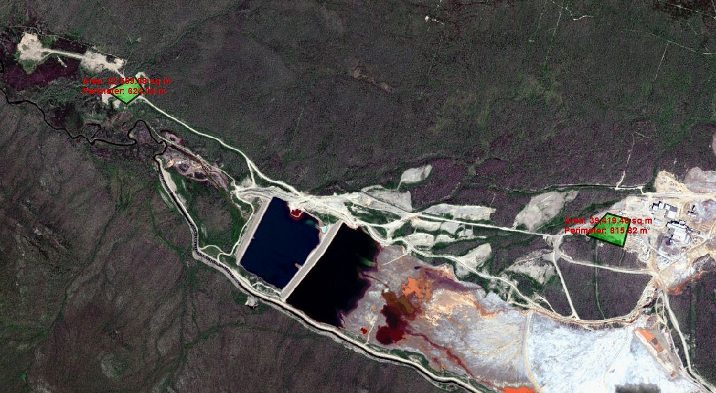
Figure 1. Water Treatment Plant Site Locations
Faro Mine Remediation Project

Description of Candidate Sites

Mill Area
The Mill Area site (Figure 2) is located to the southwest of the existing Mill Building. The site, as shown, covers approximately 39 hectares (ha). There is adequate space for the initial plant construction, with space to double the plant capacity. There is adequate space for temporary construction staging purposes, as well. The approximate elevation of the site is 1,140 metres (m) above mean sea level (amsl).
The Mill Building was a central hub of activity during the mine’s operation and was converted to a temporary lime treatment facility. As such, this site has developed infrastructure, including pipelines, roads, electrical substation, communications, and parking facilities that can be reused or adapted. The construction of a WTP at this site requires the least level of infrastructure development, compared to other sites.
The proposed location is sufficiently removed from the existing buildings, so that locating a WTP at the proposed site will not pose a significant barrier to subsequent decommissioning activities that will be required for future mine closure activities.
This site provides the topographical relief necessary to implement gravity flow through the plant profile (including a lower bench for the filters) without an undue level of site regrading. It would be expected to provide the fastest and most economical implementation of a new WTP. A number of the existing shop, administration, and support building facilities can be reused for the new WTP, thereby achieving cost savings.
The site is also suitable as a long‐term operations centre, within the overall site remediation strategy, with parking areas for the fleet of trucks and machines necessary for ongoing maintenance of the closed FMC. Security gates can be provided to direct vehicular traffic towards this location as the initial entry point to the FMC. Of all the potential sites, the Mill Area also has the largest available space for future expansion.
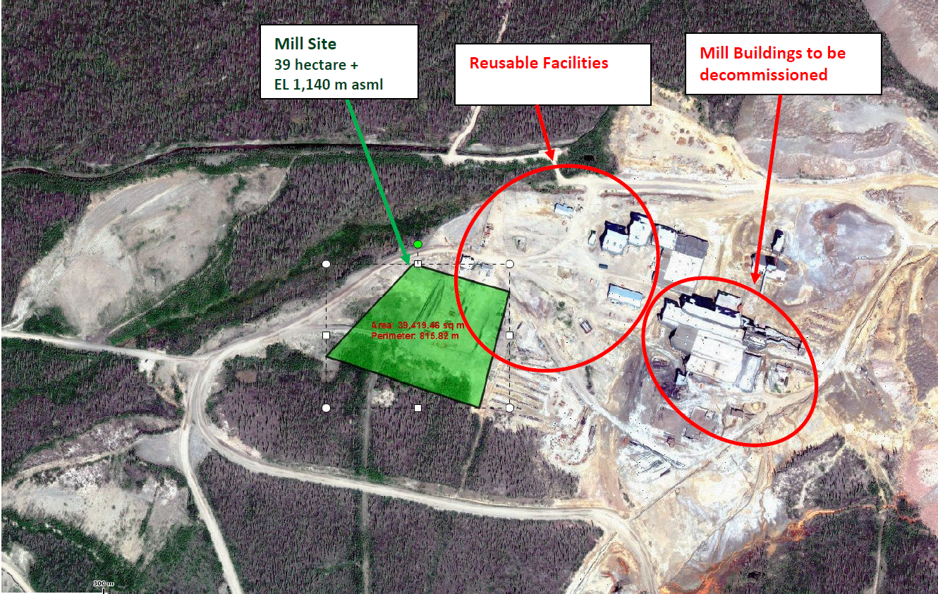
Figure 2. Mill Area Location
Faro Mine Remediation Project

Gravel Pit
The Gravel Pit site (Figure 3) (also known as the horse corrals) is the first (highest elevation) of a series of three benches (used as gravel pits), located downgradient of the CVD. The site is at an approximate elevation of 1,028 m amsl and has approximately 15 ha of available space. The available space is adequate for current needs and has provision for doubling the WTP capacity in the future (6 ha), but is constrained for construction‐related space. This site is limited for further expansion without considerable grade changes.
This site is more remote than the Mill Area. It requires the highest investment in infrastructure development to support the new WTP, including influent and sludge piping, electrical power, communications, administrative facilities, water, and sewage.
While a detailed investigation was not performed, this site may also have a flood risk because of its low elevation. Visually, it appears to be some distance above the apparent high water mark of Rose Creek bottom, but there is also a smaller creek that runs by the site to the north.
This site is being evaluated because it represents the scenario for the lowest influent pumping lift and pumping energy from the ID Pond, the future North Fork Rose Creek (NFRC) Seepage Collection Pond, future CVD SIS, and potential pumping needs from the CVD Pond. This evaluation provides insight into the economic value of pumping energy savings over a long period of evaluation. Based on location, the small creek could be an effective clean water source for lime slaking.
This site has been identified in the Faro Mine Complex Final Closure and Remediation Plan Project Description – Draft 4 (SRK, March 2010a) as a borrow area (for cap and cover activities). Clean granular fill is a relatively scarce resource. The construction of a WTP at this location would necessitate replacement of this borrow site, although considerable material could be removed and stockpiled during plant construction.
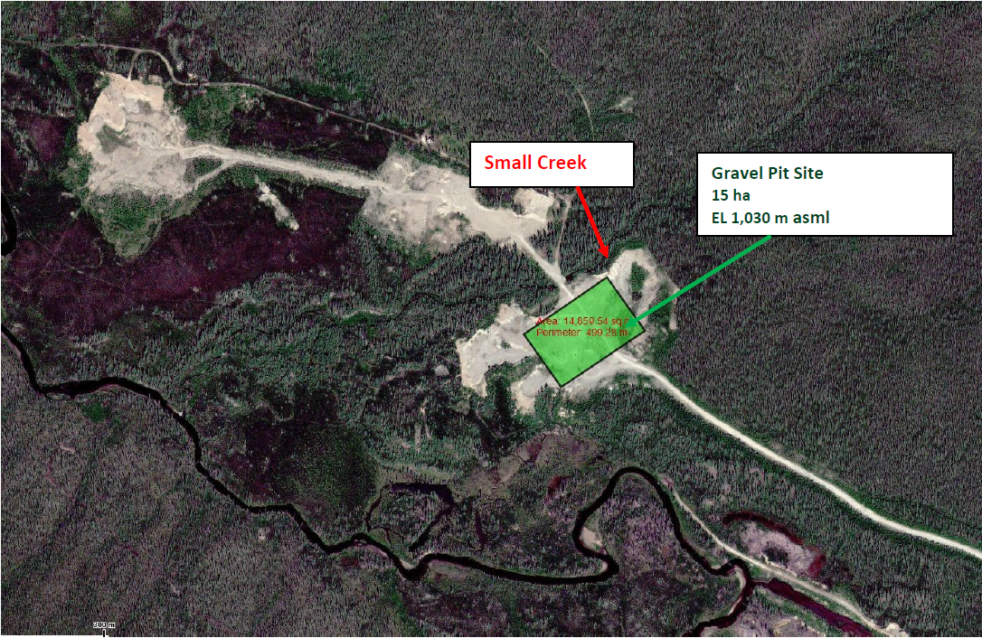
Figure 3. Gravel Pit site Location
Faro Mine Remediation Project

Water Treatment Plant Influent Sources
For purposes of this assessment, the following five water sources would be treated at the WTP, as described in Table 1: the CVD SIS, CVD Pond, ID Pond, NFRC Seepage Collection Pond, and the ETA. The locations of each of the sources of water assessed, along with flow paths to the Mill Area and the Gravel Pit sites, are shown on Figure 4 and Figure 5, respectively (dark blue path). A sixth source of water treated would come from water that recharges or drains into Faro Pit from its catchment. Once that water is pumped over the wall of the Faro Pit, gravity flow would take the water to either the Mill Area or the Gravel Pit sites; the cost to pump this sixth source of water from the Faro Pit would be the same for both sites and has been omitted from the cost benefit analysis assessment. However, water that is pumped into Faro Pit for temporary storage would need to be pumped back out (light blue path, Figure 4 and Figure 5), incurring an additional cost. The cost of pumping this water back out was considered in this assessment as it effects seasonal versus year-round treatment differently.
For pumping to the WTP, flow rates would vary if treatment were conducted seasonally or year-round. The differences in pumping cost for seasonal or year-round treatment scenarios was assessed using the information summarized in the following bullets and in Table 1:
- Seasonal WTP pumping – All water sources would be pumped to the WTP for treatment from April 15 to October 15 (6 months). For the remainder of the year, the CVD SIS, ID Pond, and ETA water sources would be pumped to Faro Pit. It was assumed that water would be stored within the NFRC Seepage Collection Pond and the CVD Pond over the winter, requiring no pumping during the winter.
- Year-round WTP pumping - The CVD SIS, ID Pond, and ETA water sources would be pumped to the WTP for year-round treatment; the NFRC Seepage Collection Pond and CVD Pond would only be pumped for treatment from April 15 to October 15.
Table 1. WTP Influent Sources
Faro Mine Remediation Project
Source | Elevation (m amsl) | Annual Assumed Water Volume Treated (m³) | Flow Rate during pumping season (m³/s) | Assumed Future Treatment Demand (seasonal or year-round) | Basis
CVD SIS | 1,014 | 5,570,958 | 0.177  year-round pumping to WTP | Once in operation, required to operate year-round to maintain groundwater capture. | Future water source.  Flow is groundwater collected in the Rose Creek alluvial aquifer with the operating flow rate predicted by the groundwater flow model for the site.
CVD Pond | 1,027.5 | 1,345,557 | 0.085  6 month pumping to WTP | Pumped from April 15 to October 15 each year. | Expected to require treatment due to contaminated seepage and need to maintain emergency storage capacity.  Year-round emergency storage capacity achieved by pumping for 6 months per year. Dedicated working volume used for winter storage.
ID Pond | 1,044 | 1,530,000 | 0.049  year-round pumping to WTP | Pumped year round to align to current water management plan discussions. | Current water source.  Assumed pumped year-round to prevent formation of a pond on the tailings cover.
NFRC Seepage Collection Pond | 1,075 | 615,302 | 0.039  6 month pumping to WTP | Pumped from April 15 to October 15 each year. | Future water source.  Operating level maintained by achieving the flow rate for a period of 6 months each year. Water assumed to be drawn down in the NFRC Seepage Collection Pond and allowed to fill over winter months for subsequent drainage.
ETA | 1,090 | 82,799 | 0.003  year-round pumping to WTP | Year round pumping assumed to prevent water from reporting to tailings area. | Current water source.
Water Seasonally Stored in Faro Pit | Faro Pit Lake = 1,141  Pit Rim High Point = 1,180 | 3,591,879 | 0.228  6 month pumping | Pumped from April 15 to October 15 each year. | Total of water pumped into Faro Pit for CVD SIS, ID pond, and ETA for the 6-month period the WTP does not operate
Notes:
Elevation = mean elevation used for calculating pumping costs
m³ = cubic metre
m³/s = cubic metre per second

Water Conveyance
The current sources of water to be treated by the WTP include the Faro Pit, the ETA, and the ID Pond. Future sources of water to be treated include the NFRC Seepage Collection Pond, the CVD SIS, and potentially the CVD Pond. The total annual volume of water requiring treatment from these sources at the replacement WTP before the installation of waste rock and tailings covers is 9.14 million m³. The flow rates and pumping requirements for the Mill Area and Gravel Pit sites were estimated under seasonal and year-round water treatment scenarios. For the seasonal scenario it was assumed that 3 water sources, the CVD SIS, ID Pond, and ETA, would be pumped to the WTP from April 15 to October 15 and then pumped to Faro Pit for the remainder of the year. In the year-round scenario, these same three water sources would be pumped to the WTP for treatment year-round. For both scenarios, the NFRC Seepage Collection Pond and CVD Pond would be pumped to the WTP from April 15 to October 15, and then accumulated within their impoundments over the winter months.
For seasonal pumping to the WTP for all 5 water sources, treating this volume of water would result in a flow rate of 0.580 metre per second (m/s) (9,190 gallons per minute [gpm]) to the WTP from April 15 to October 15. It should, however, be cautioned that these treatment volumes and flow rates do not include the extra water needing treatment from Faro Pit, only the volume of water sent to Faro Pit from CVD SIS, ID Pond, and ETA over the winter months that would then require treatment over the summer months. For year-round pumping to the WTP for the CVD SIS, ID Pond, and ETA, treating this volume of water would result in a treatment rate of 0.228 m/s (3,610 gpm) from October 15 to April 15, and then a treatment rate of 0.352 m/s (5,580 gpm) from April 15 to October 15 (because of the addition of the NFRC Seepage Collection Pond and CVD Pond for summer treatment). Again, these treatment rates do not include water that recharges (originates from) Faro Pit.
Once waste rock and tailings covers are installed, the volume of water requiring treatment from the ID Pond and the CVD Pond is expected to decrease somewhat. However, for the purpose of this evaluation, no decrease has been assumed. Other sources of water on the FMC that go untreated are assumed to meet the discharge limits for the site and do not require treatment before passing through the FMC.

Cross Valley Dam Seepage Interception System
A future installation includes the CVD SIS water collected downstream of the CVD that would be either seasonally conveyed to the WTP (April 15 to October 15) and up to the Faro Pit the remaining 6 months of the year or conveyed to the WTP year-round for treatment. For the purposes of this assessment, it is assumed that the pipeline from the CVD SIS would be independent from other pipelines. However, future optimizations may involve a combined pipeline with CVD Pond or ID Pond water, or both. For the combination of pipelines and water sources, assessment of backpressures and geochemical considerations would be needed.

Cross Valley Dam Pond
This assessment includes the possibility of treating water from the CVD Pond for 6 months of the year. For the purposes of this assessment, it is assumed that the pipeline from the CVD SIS would be independent from other pipelines. However, as with the CVD SIS, future optimizations may involve a combined pipeline with CVD Pond or ID Pond. For the combination of pipelines and water sources, assessment of backpressures and geochemical considerations would be needed.

Intermediate Dam Pond
For purposes of this assessment, and similar to the CVD SIS pumping scenarios, the water from the ID Pond would be conveyed to the WTP seasonally for 6 months and up to the Faro Pit for the remaining 6 months of the year. Alternately, the water could be treated year-round at the WTP. The assumption is that a pond would not be allowed to accumulate on the tailings cover. As with the previous paragraphs, for the purposes of this assessment it is assumed that the pipeline from the ID Pond would be independent from other pipelines. However, future optimizations may involve a combined pipeline with CVD Pond, ID Pond, or both, depending on assessment of backpressures and geochemical considerations.

North Fork Rose Creek Seepage Collection Pond
Part of the overall site water management strategy is to contain the seeps that emerge from the waste dumps along the NFRC with the NFRC Seepage Collection Pond. Water could be pumped either year-round or seasonally to either WTP location. For this assessment, it is assumed that water conveyed to the WTP from the NFRC Seepage Collection Pond would be conveyed independently of ETA water, but along the same route. However, future optimizations may involve a combined pipeline with other sources depending on backpressures and geochemical compatibility. Figures 4 and 5 show the assumed pipeline routing. During design, an evaluation should be performed to determine if the pipeline could be located across the tailings area near the sludge ponds to reduce pumping head.

Emergency Tailings Area
Without collection, water from the ETA flows to the RCTA. Under the procedures for a replacement WTP and for purposes of this assessment, the ETA water is assumed to be either seasonally treated or treated year-round. In the seasonal treatment scenario, for the 6 months the WTP is offline, the water would be conveyed up to the Faro Pit. For this assessment, water conveyed to the WTP from the ETA is conveyed independently of NFRC Seepage Collection Pond, but along the same route. However, future optimizations may involve a combined pipeline as for the other pipelines.

Faro Pit
The Faro Pit is the main storage location for water on the site, currently contains water from a variety of sources, and will continue to be a storage solution as part of the long-term water management plan and strategy. For purposes of this assessment, it is assumed that water that drains into Faro Pit from its catchment would be pumped over the Faro Pit ramp high point and then drain by gravity to either the Mill Area or the Gravel Pit site. As a result, pumping costs from Faro Pit to the WTP would be identical for both sites for the catchment area water. However, additional pumping costs would be incurred to pump water originating in the CVD SIS, ID Pond, and ETA back out of Faro Pit if those three water sources are pumped to Faro Pit during the winter for the seasonal scenario described previously. It is assumed that the pipeline conveying water from the pump station to the Faro Pit ramp high point would follow the ramp similar to the existing pipeline (light blue path, Figure 4 and Figure 5).
The Hazen-Williams equation was used to calculate pump power requirements associated with the total dynamic head (TDH). Static head was based on the highest required vertical lift. Friction losses were calculated for the length of pipeline to the high point, assuming gravity flow after. The friction loss calculations also assumed individual pipelines from each water source to the WTP site; therefore, back pressure effects, precipitate formations, and other factors associated with combining pipelines were not considered and would require consideration for the pipeline routing indicated in Figures 4 and 5. Pipeline sizes were selected for a specific flow velocity range that would reduce the risk of solids settling. It should be cautioned that pressure specifications for some of the selected pipelines do not necessarily meet calculated needs, but could meet needs with design optimization such as adding booster stations and pipes in series.

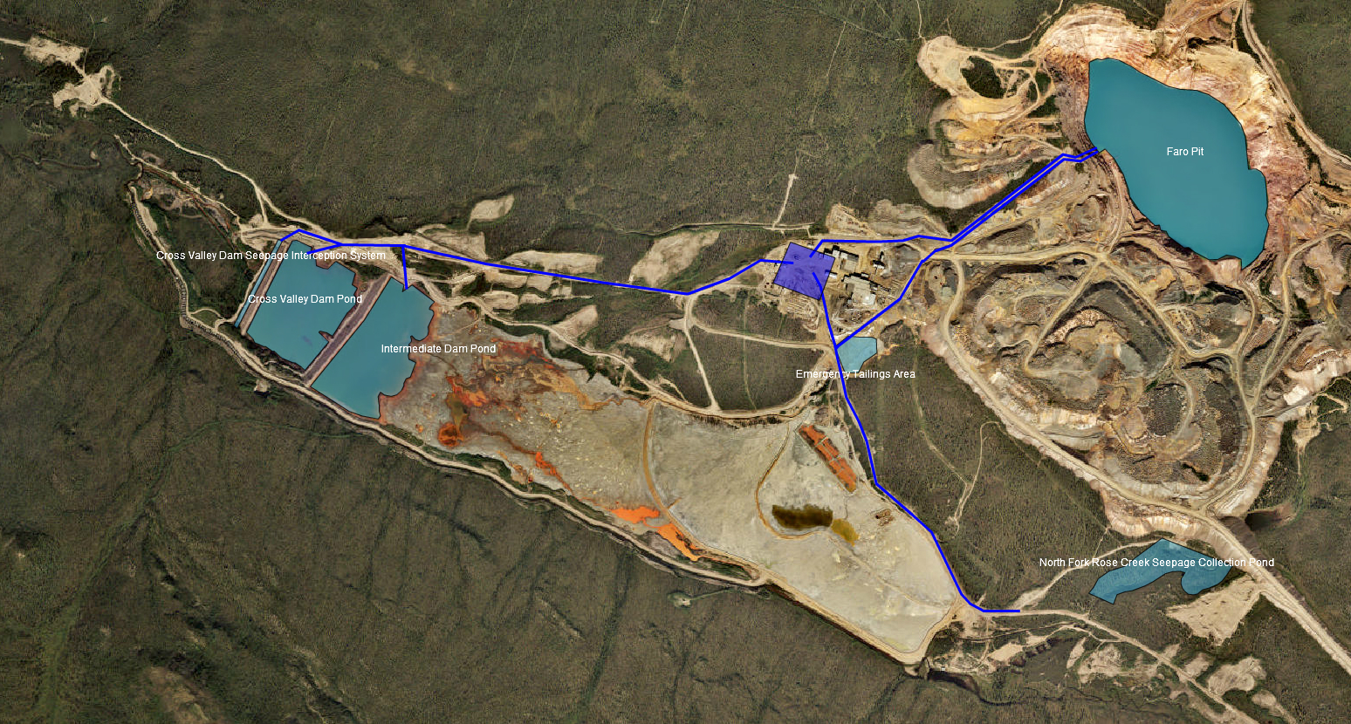
Figure 4. Mill Area Water Conveyance
Faro Mine Remediation Project

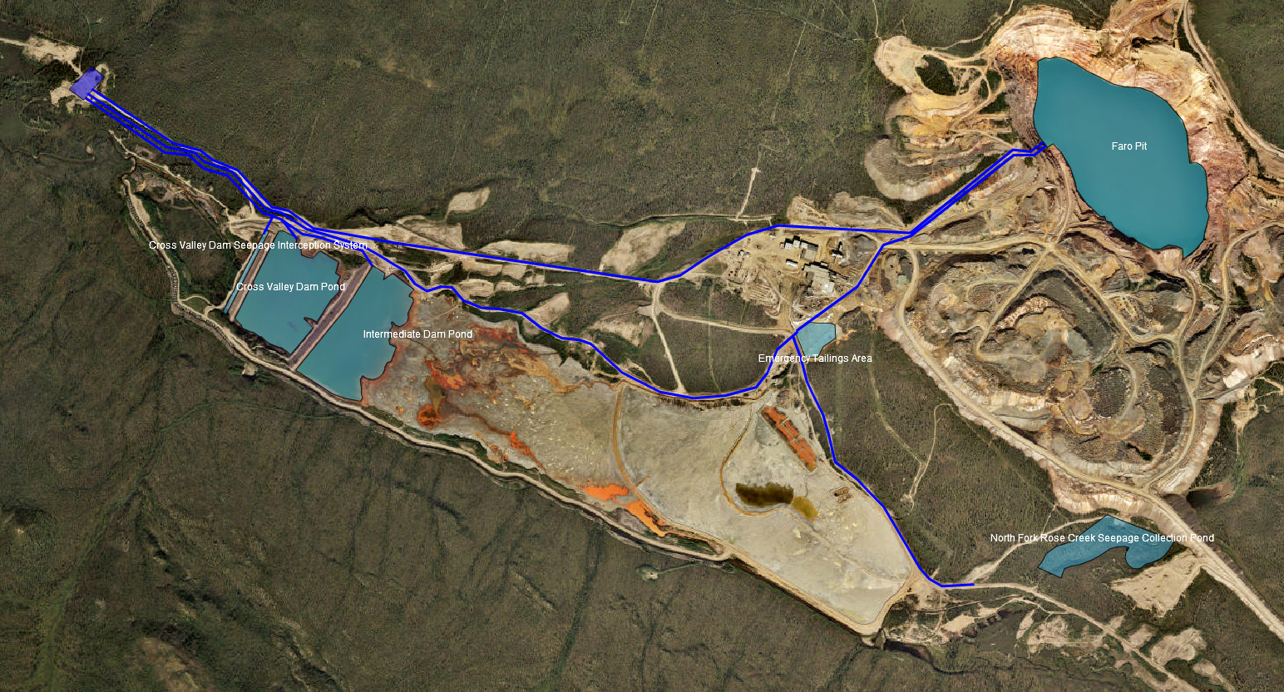
Figure 5. Gravel Pit Water Conveyance
Faro Mine Remediation Project

The pipeline routes, total lengths, and pipeline length, size, and TDH used to calculate pumping power requirements are shown in Table 2 and Table 3 for the Mill Area and Gravel Pit WTP sites, respectively.
Table 2. Mill Area – Water Conveyance
Faro Mine Remediation Project
Water Source | Total Pipeline Length Along Route  (Figure 4) | Pipeline Size and Length Used for Hazen-Williams | Calculated Total Dynamic Head (TDH)
CVD Pond | 2,430 m of pipe to WTP alongside CVD SIS and ID Pond pipes | 2,430 m of 14-inch DR 9 (200 psi) | 133.7 m (to WTP)
NFRC Seepage Collection Pond | 2,520 m of pipe to WTP alongside ETA pipe | 2,520 m of 10-inch DR 9 (200 psi) | 83.6 m (to WTP)
CVD SIS | 2,570 m of pipe to WTP alongside CVD Pond and ID Pond pipes  4,170 m of pipe to Faro Pit alongside ID Pond pipe for seasonal treatment scenario | 2,570 m of 18-inch DR 9 (200 psi)  4040 m of 18-inch DR 9 (200 psi) to Faro Pit for seasonal treatment scenario | 151.5 m (to WTP)  252.8 m (to Faro Pit)
ID Pond | 2,170 m of pipe to WTP alongside CVD Pond and CVD SIS pipes  3,770 m of pipe to Faro Pit alongside CVD SIS pipe for seasonal treatment scenario | 2,170 m of 10-inch DR 9 (200 psi)  3,640 m of 10-inch DR 9 (200 psi) to Faro Pit for seasonal treatment scenario | 120.0 m (to WTP)  223.0 m (to Faro Pit)
ETA | 690 m of pipe to WTP alongside NFRC Seepage Collection Pond pipe  1,600 m of pipe to Faro Pit for seasonal treatment scenario | 690 m of 2-inch DR 9 (200 psi)  1,470 m of 2-inch DR 9 (200 psi) to Faro Pit for seasonal treatment scenario | 103.2 m (to WTP)  248.6 m (to Faro Pit)
Water Seasonally Stored in Faro Pit | 580 m of pipe from Pit lake pump station to pit ramp high point for seasonal treatment scenario. | 580 m of 20-inch DR 17 (125 psi)  (Note: Assumes use of a dedicated pipe. A larger pipe may be used for overall pit dewatering.) | 42.1 m (to pit ramp high point)
Note:
DR =dimension ratio
psi = pounds per square inch

Table 3. Gravel Pit site – Water Conveyance
Faro Mine Remediation Project
Water Source | Total Pipeline Length along Route  (Figure 5) |  | Pipeline Size and Length Used for Hazen-Williams | Calculated Total Dynamic Head (TDH)
CVD Pond | 1320 m of pipe to WTP alongside CVD SIS and ID Pond pipes |  | 410 m of 14-inch DR 9 (200 psi) | 19.9 m (to WTP)
NFRC Seepage Collection Pond | 6330 m of pipe to WTP alongside ETA pipe |  | 2100 m of 10-inch DR 9 (200 psi) | 50.0 m (to WTP)
CVD SIS | 1250 m of pipe to WTP alongside CVD Pond and ID Pond pipes  4340 m of pipe to Faro Pit alongside ID Pond pipe for seasonal treatment scenario |  | 340 m of 18-inch DR 9 (200 psi)  4040 m of 20-inch DR 9 (200 psi) to Faro Pit for seasonal treatment scenario | 33.5 m (to WTP)  236.9 m (to Faro Pit)
ID Pond | 1740 m of pipe to WTP alongside CVD Pond and CVD SIS pipes  3770 m of pipe to Faro Pit alongside CVD SIS pipe for seasonal treatment scenario |  | 50 m of 10-inch DR 9 (200 psi)  3640 m of 10-inch DR 9 (200 psi) to Faro Pit for seasonal treatment scenario | 5.0 m (to WTP)  223.0 m (to Faro Pit)
ETA | 4530 m of pipe to WTP alongside NFRC Seepage Collection Pond pipe  1600 m of pipe to Faro Pit for seasonal treatment scenario |  | 300 m of 2-inch DR 9 (200 psi)  1470 m of 2-inch DR 9 (200 psi) to Faro Pit for seasonal treatment scenario | 42.9 m (to WTP)  249.8 m (to Faro Pit)
Water Seasonally Stored in Faro Pit | 580 m of pipe from Pit lake pump station to pit ramp high point for seasonal treatment scenario. | 580 m of 20-inch DR 17 (125 psi)  (Note: Assumes use of a dedicated pipe. A larger pipe may be used for overall pit dewatering.) |  | 42.1 m (to pit ramp high point)

Technical Evaluation of Alternative Sites
The primary basis of evaluation was to compare the estimated extra pumping costs associated with the Mill Area site to the expected additional infrastructure costs required for the Gravel Pit site.
The secondary basis of evaluation was to assess other technical merits of each site. This was done by updating the previous technical merit evaluation (CH2M, November 2012b). CH2M ranked each of the sites on a number of technical requirements, necessary to meet the short‐ and long‐term goals of the project. Rankings were assigned on a scale of 1 to 5, with 5 being highest. A total score was tallied for each site. The highest score represents the more favorable of the two sites. Table 4 summarizes the technical rankings of each site.

Technical Criteria
The following characteristics are desirable for the WTP location:
- Generally flat area, of sufficient size to accommodate the main process building and equipment, as well as potential expansion of the WTP or construction of a parallel WTP in the future
- Additional flat space nearby to use as a laydown area, base materials stockpile, and for other purposes during construction
- Sufficient topographical relief adjacent to the selected area to locate the filter system at a lower elevation and allow gravity flow from the thickener to the filters, and from the filters to the plant discharge pipeline
- Adequate distance from the Mill Building and other contaminated materials to avoid interference with demolition and remediation activities
- Good road access
- Convenient location for access to existing pipelines (e.g., influent lines from Faro Pit, ID Pond, and ETA and effluent line to CVD Pond and Rose Creek), electrical power, potable water, sewer system (e.g., septic tank and drain field), and other utilities, as appropriate
- Satisfactory subsurface conditions for foundations, which would not require an undue amount of work in solid rock
- Effectiveness of location as long‐term operational base of the closed Faro Mine
- Low risk of site flooding and other detrimental weather‐related impacts

Technical Evaluation
Table 4 summarizes the technical rankings of each site.
Table 4. Summary of Technical Ranking of Two WTP Sites
Faro Mine Remediation Project
Technical Factor | Mill Area | Gravel Pit site
Available for long-term expansion | 5 | 3
Space for construction staging purposes | 5 | 3
Topographical relief for gravity feed to filters | 5 | 3
Adequate distance from existing areas that require demolition or remediation | 4 | 4
Road and parking infrastructure | 5 | 2
Convenient location for new pipelines and tie-in to existing pipelines | 5 | 1
Access for electrical power | 5 | 1
Access for potable water and sewer | 3 | 5
Communications access | 5 | 1
Low risk of flood | 5 | 3
Long-term effectiveness as operational base | 4 | 1
Total Score | 51 | 27

Cost Evaluation

Additional Infrastructure Costs
For purposes of this assessment, it is assumed that all water sources described in this memo are available for treatment at the time the water treatment plant is commissioned. It is presumed that this timeline is at some point into the future, at the end of the useful or required life of the Interim Water Treatment System.
If the Gravel Pit site were to be chosen for the WTP, there would be additional infrastructure costs relative to the Mill Area. According to Faro WTP Design Definition – Plant Siting, Faro Mine Remediation Project (CH2M, November 2012b), these costs have been estimated to be within the range of $4 million to $6 million and include the following:
- A detailed site investigation and site preparation
- Additional influent pipelines from the Mill Area to Gravel Pit site
- Additional sludge pipe from the Gravel Pit site to the Mill Area
- An upgrade to road services and parking (approximately 3.65 kilometers [km] of road from the Mill Area to the Gravel Pit site)
- Construction and installation of electrical power and communications lines (approximately 3.65 km to nearest utilities at Mill Area)
- Construction of a security gate, because of the current uncontrolled access to this location more remote location of the Gravel Pit site
- Installation of a septic field
- Construction of an administrative area at the Gravel Pit site

Pumping Costs
The pumping costs for the two sites were analyzed and compared in the following two separate scenarios of treatment frequency:
- Seasonal WTP operation for 6 months of the year (April 15 to October 15)
- Year-round WTP operation

Pumping Cost Assumptions
The pumping cost analysis was prepared based on establishing assumptions related to the annual pumping rates, TDH calculations, and electricity costs. The following assumptions were made:
- Combined pump and motor efficiency of 75 percent
- Minor losses (fittings, valves, etc.) used a K value of 4
- Friction losses used a C factor of 130
- The replacement WTP comes online when the CVD SIS becomes operational, at which time the NFRC Seepage Collection Pond system is already operational
- TDH used to calculate electricity costs for pumping accounted for the highest elevation along the pipeline length as well as friction and minor losses
- Tables 2 and 3 list TDH values used in energy cost calculations
- Assumed electricity cost of $0.23/kilowatt-hour
- Costs were only for water to be treated from the 5 water sources and did not include the cost to pump sludge to Faro Pit

Seasonal Operation Pumping Costs
Seasonal operation of the WTP would likely vary each year, depending on breakup of the ice, freshet, and the onset of freezing conditions each fall. For purposes of this long-term assessment, a typical pumping and treatment season is assumed to be 6 months annually, from April 15 to October 15 of each year.
As mentioned in the water conveyance section, there are three water sources that are expected to be pumped year-round for treatment or storage: the CVD SIS, ID Pond, and ETA. When not being treated at the WTP under a seasonal (April 15 to Oct 15) WTP operating scenario, the water would be pumped up to Faro Pit over the winter for future seasonal treatment. The CVD pond may need to be pumped year-round depending on emergency storage requirements. However, for this analysis it was assumed that the CVD pond would be pumped seasonally using a portion of the pond for over-winter storage.
Table 5 provides a summary of the calculated costs for a seasonally operated WTP, where all 5 water sources would be pumped to the WTP during the warmer summer months (April 15 to October 15). For the winter months the CVD SIS, ID Pond, and ETA would be pumped to Faro Pit for over-winter storage.
Table 5. Seasonal Pumping Costs by Water Source
Faro Mine Remediation Project
Water Source | Seasonal Mill Area Pumping Costsª | Seasonal Gravel Pit site Pumping Costsª
CVD Pond | $124,000 | $24,000
NFRC Seepage Collection Pond | $35,000 | $27,000
CVD SIS | $967,000 | $834,000
ID Pond | $227,000 | $167,000
ETA | $10,000 | $9,000
Pump Seasonally Stored Water Back Out of Faro Pit^{b} | $126,000 | $126,000
Total | $1,489,000 | $1,188,000
Notes:
ªCosts rounded to nearest $1,000
^{b}Consists of CVD SIS, ID Pond, and ETA water stored for 6 months in Faro Pit

Year-round Operation Pumping Costs
The year-round operation of the WTP includes treatment of water 12 months of the year from the CVD SIS, ID Pond, and ETA. Two water sources, the CVD Pond and NFRC Seepage Collection Pond, would be treated 6 months (April 15 to Oct 15) of the year and left to accumulate water for the remainder of the year. Tables 6 provides a summary of the year-round pumping cost.
Table 6. Year-round Pumping Costs by Water Source
Faro Mine Remediation Project
Water Source | Annual Mill Area Pumping Costs | Annual Gravel Pit site Pumping Costs
CVD Pond | $161,000 | $24,000
NFRC Seepage Collection Pond | $35,000 | $27,000
CVD SIS | $905,000 | $83,000
ID Pond | $82,000 | $3,000
ETA | $3,000 | $2,000
Total | $1,186,000 | $139,000

Pumping Cost Net Present Value Evaluation
The net present value (NPV) was calculated using annual estimated pumping costs over a 10- to 100-year period. The federal interest rate schedule (Government of Canada, 2016) was used to select semi-annual interest rates, which were converted to an effective annual rate and used to estimate variable rates for the first 25 years that the WTP is online. After the first 25 years, a fixed rate of 4.04 percent annually was considered until year 100. The NPVs for both the Mill Site and the Gravel Pit site under the two different scenarios can be found in Table 7 for 10, 15, 25, 50, and 100 years from the point when the WTP is online, which was considered time zero for the NPV calculations.
Table 7. NPV of Pumping Costs
Faro Mine Remediation Project
Evaluation Period (years) | Annual Mill Area WTP NPV |  | Annual Gravel Pit site WTP NPV
 | Seasonal  ($ million) | Year-Round  ($ million) | Seasonal  ($ million) | Year-Round  ($ million)
10 | $13.3 | $10.6 | $10.6 | $1.2
15 | $17.7 | $14.1 | $14.1 | $1.7
25 | $23.2 | $18.5 | $18.5 | $2.2
50 | $31.8 | $25.3 | $25.3 | $3.0
100 | $36.2 | $28.8 | $28.8 | $3.4

As shown in Table 7, the NPV of pumping costs associated with the year-round scenario at the Gravel Pit site is lower than both the seasonal and year-round scenarios at the Mill Site and the seasonal scenario at the Gravel Pit site. The year-round Gravel Pit WTP scenario is approximately 12 percent of the cost of the year-round Mill Area WTP scenario, which amounts to an estimated cost savings of $16.3 million for a 25-year period and $25.4 million over a 100-year operating period. The cost savings are expected to be substantially higher than the additional infrastructure requirements for siting the WTP at the Gravel Pit site (estimated at $4 to $6 million).
The seasonal pumping scenarios at both the Mill Area site and the Gravel Pit site are more costly than the year-round scenarios because of (1) the increased TDH up to Faro Pit for 6 months of the year and (2) the need to pump the stored water back out of the pit. The additional costs associated with constructing year-round versus seasonal pipelines have not been assessed, but are expected to be significantly less than the savings obtained from year-round pumping.

Future Design Considerations
Costs were developed for comparative purposes only. Additional considerations and optimizations that are required for pump and pipeline sizing during design, include the following:
- Collection of more information pertaining to the water and sludge streams (e.g., chemistry, density, particle size distribution of solids) to determine pump type and sizing requirements
- Investigation of pump brands and types that would be optimal for high TDHs and the application
- Investigation of the need for booster stations or pumps in series to overcome TDH and to lower the pressure
- Consideration of local suppliers for pumps and pipelines, if available, to facilitate acquisition of spare parts and service support
- Optimization of pipeline routing and sizing
- Pipeline free-draining and insulation requirements
- Consideration of start-up and shut-down efficiencies, pressures, minimum and maximum expected flowrates, surge propagation, optimization of velocities to prevent settling, and cleanout
- Consideration of a back-up system for water storage during WTP down-time

Gravel Pit site Operating Costs
Operating the Gravel Pit site as the WTP will involve additional infrastructure and construction costs compared to the Mill Area site. Further, there would be additional costs to operate a WTP at the Gravel Pit site compared to the Mill Area site, including items such as road maintenance, snow clearing, and powerline maintenance.
These additional operating costs are considered to be somewhat incidental to the entire annual operating budget for the FMC, and are expected to be much less than the estimated annual pumping savings. These additional operating costs will be somewhat offset by the lower operating costs associated with the simpler site-wide conveyance system which makes better use of gravity. Therefore, no specific estimates have been prepared for these operating costs in this evaluation.

Conclusion and Recommendation
The Gravel Pit Site allows better use of gravity flow than the Mill Area site, especially if year-round treatment is conducted. If seasonal treatment is conducted, the resulting power savings associated with the Gravel Pit site are less significant, and may not be sufficient to appreciably offset the higher additional construction cost for that location.
The primary large difference in pumping costs between the two sites, in comparison to the previous Cost-Benefit Analysis (CH2M, November 2012b), is the increased flow expected from the CVD SIS, the new water source coming from the NFRC Seepage Collection Pond, and the potential requirement to treat water from the CVD Pond. These water sources have elevations resulting in a significantly higher TDH to the Mill Area site than to the Gravel Pit Site. The largest difference in cost stems from the CVD SIS, which is anticipated to require the movement of about 5.6 million m³ of water annually.
There are technical and physical limitations (area for construction and within the potential flood plain, among others) to the Gravel Pit Site compared to the Mill Area site. The Mill Area provides the most technically suitable location for the WTP, with the lowest cost infrastructure, largest site size for future expansion, the safest location against flood risk, and a good centralized location for long-term operation. However, the significantly lower pumping costs associated with the Gravel Pit Site are expected to readily offset the likely lower initial capital cost of the Mill Area Site if treatment is conducted year-round.
It is recommended that the Gravel Pit site be considered for the location of the Permanent WTP, and that this cost-benefit analysis be revisited in the future when more is known of long-term water sources requiring collection and treatment. A flood plain assessment is also recommended for the Gravel Pit site before moving forward with additional investigation and assessment of its location as a viable location for the WTP.

References
CH2M HILL Canada Limited (CH2M). November 2012b. Faro WTP Design Definition – Plant Siting, Faro Mine Remediation Project. Technical memorandum No. 3. Final. Prepared for Government of Yukon. November 23.
Government of Canada. 2016. Consolidated Revenue Fund Monthly Lending Rates for Periods of One Year and Over. Department of Finance Canada, Government of Canada. Retrieved from http://www.fin.gc.ca/admin/len/crf-tid-eng.asp?cm=1
SRK Consulting Engineers and Scientists (SRK). March 2010a. Faro Mine Complex Closure and Remediation Plan. Project Description – Draft 4A. Prepared for: Yukon Government. March.

