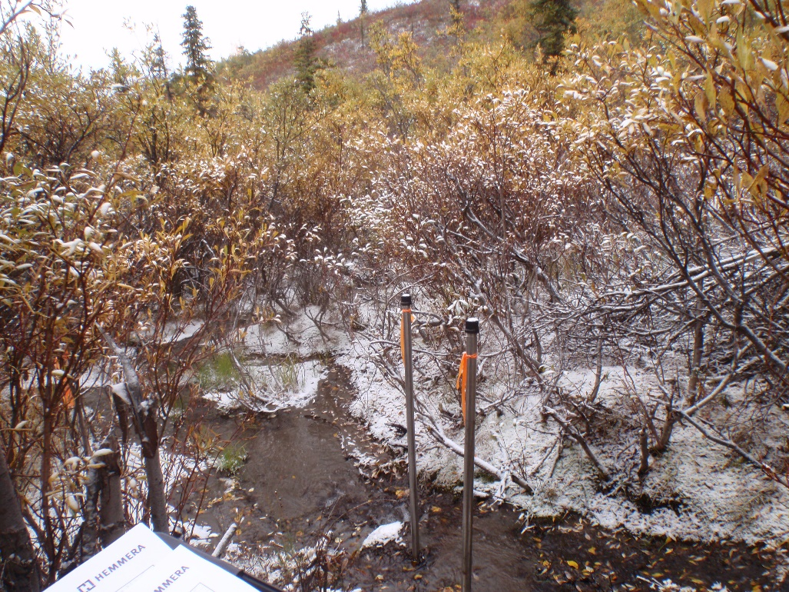
Photo 1: View of drive point wells GSI-DC-01A and GSI-DC-01B. Photo taken on August 31, 2015.
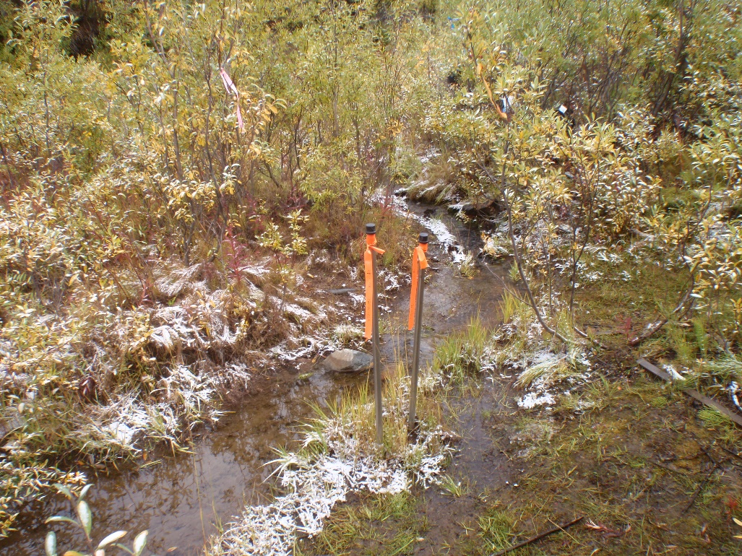
Photo 2: View of drive point wells GSI-DC-02A and GSI-DC-02B. Photo taken on August 31, 2015.
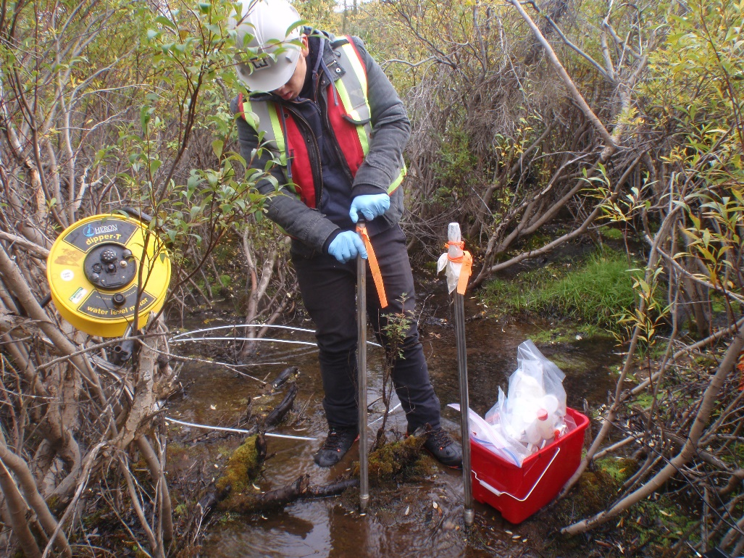
Photo 3: View of drive point wells GSI-DC-03A and GSI-DC-03B. Photo taken on August 31, 2015.
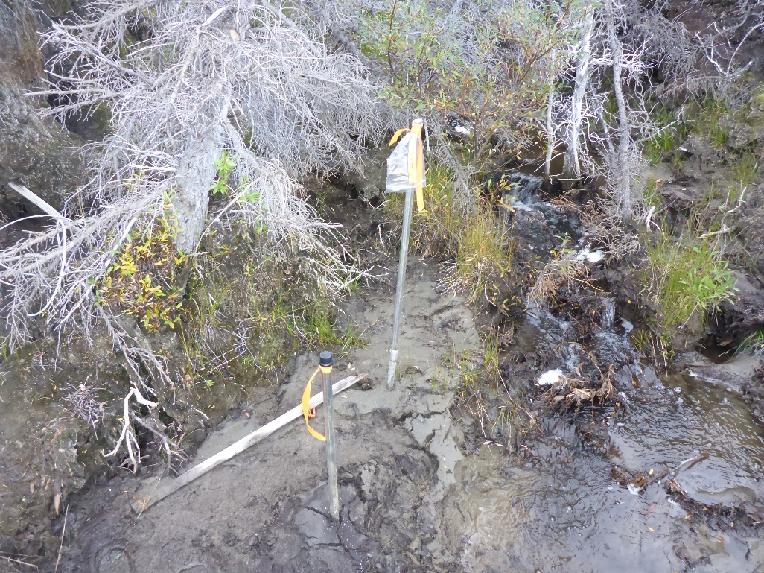
Photo 4: View of drive point wells GSI-DC-05A and GSI-DC-05B. Photo taken on September 1, 2015.
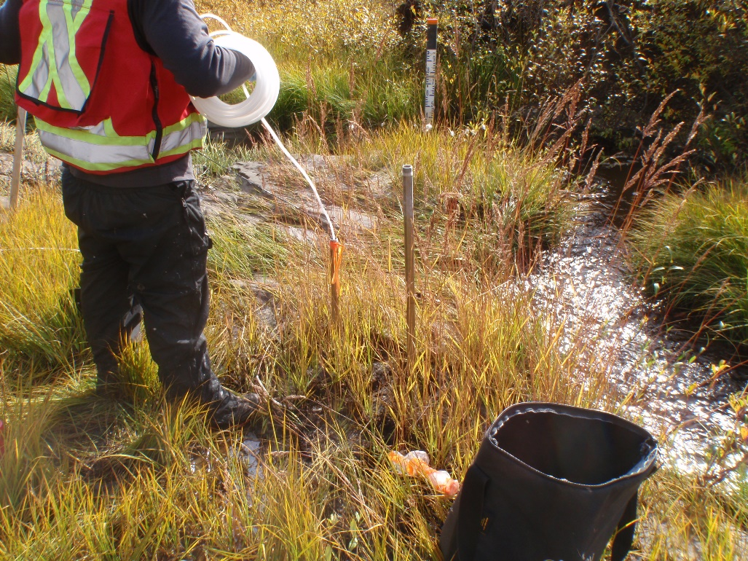
Photo 5: View of drive point wells GSI-DC-06A and GSI-DC-06B. Photo taken on September 3, 2015.
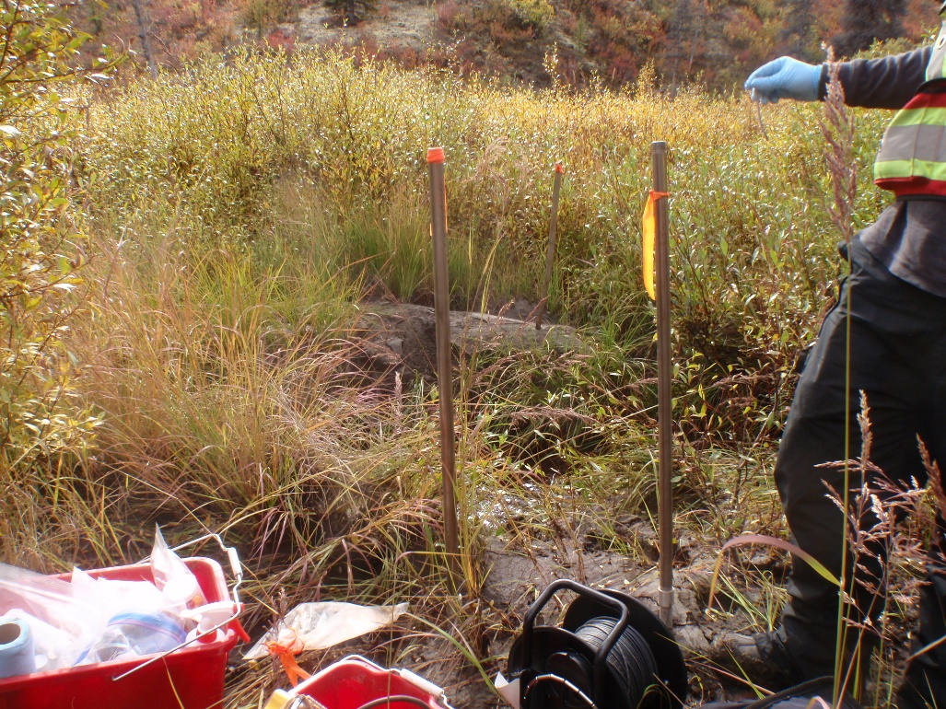
Photo 6: View of drive point wells GSI-DC-07A and GSI-DC-07B. Photo taken on September 3, 2015.
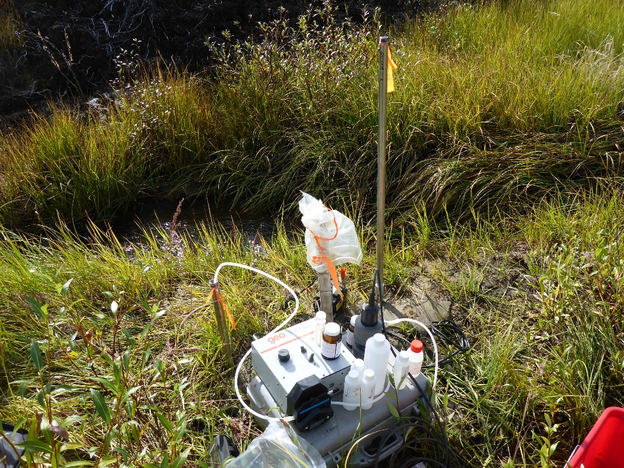
Photo 7: View of drive point wells GSI-DC-08A and GSI-DC-08B. Photo taken on September 3, 2015.
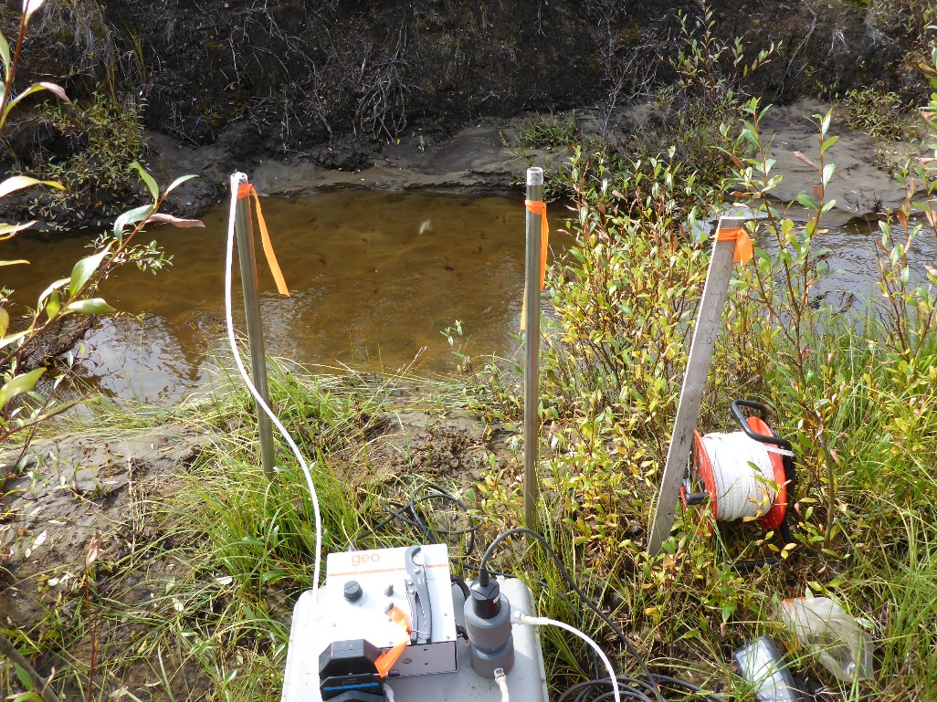
Photo 8: View of drive point wells GSI-DC-09A and GSI-DC-09B. Photo taken on September 3, 2015.
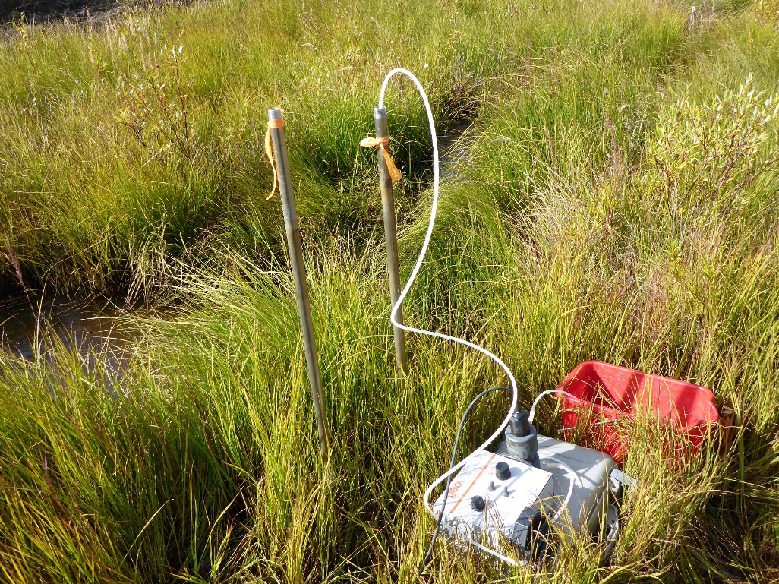
Photo 9: View of drive point wells GSI-DC-10A and GSI-DC-10B. Photo taken on September 3, 2015.
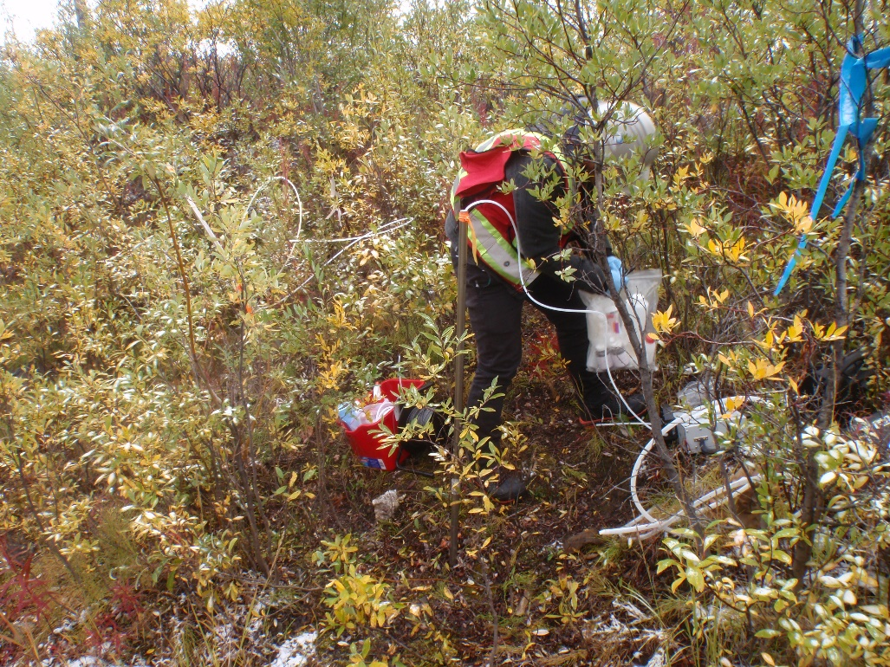
Photo 10: View of drive point well GSI-HA-01A. Photo taken on August 31, 2015.
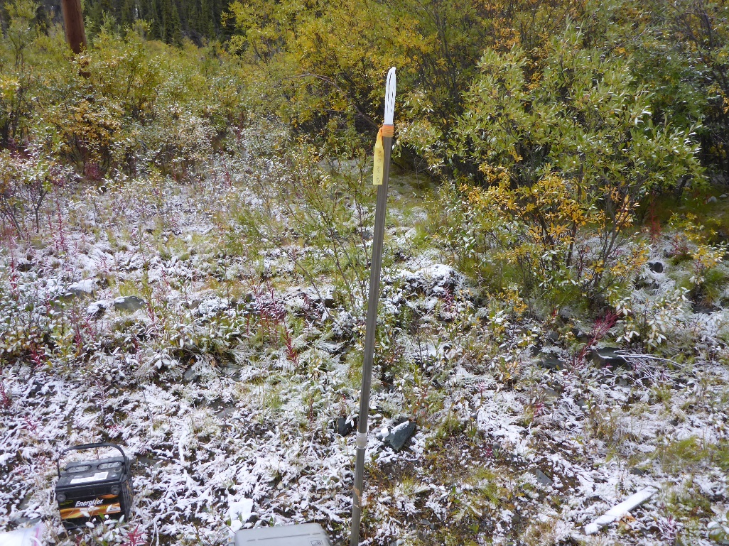
Photo 11: View of drive point well GSI-HA-02A. Photo taken on August 31, 2015.
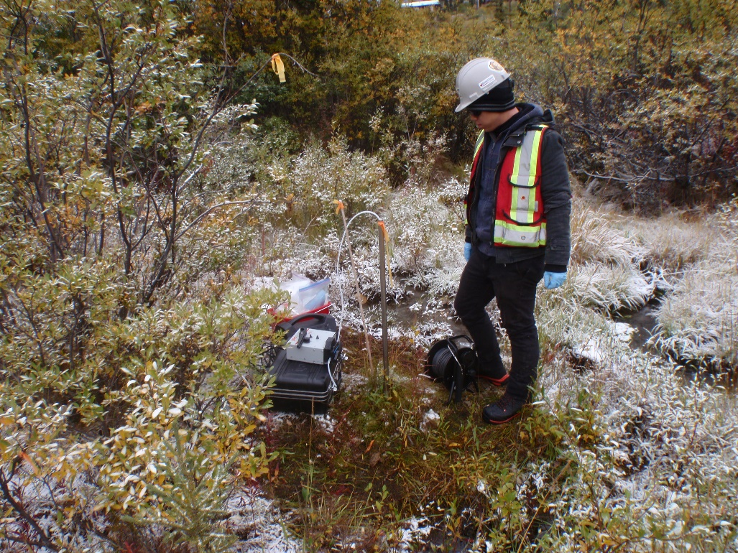
Photo 12: View of drive point well GSI-HA-03A. Photo taken on August 31, 2015.

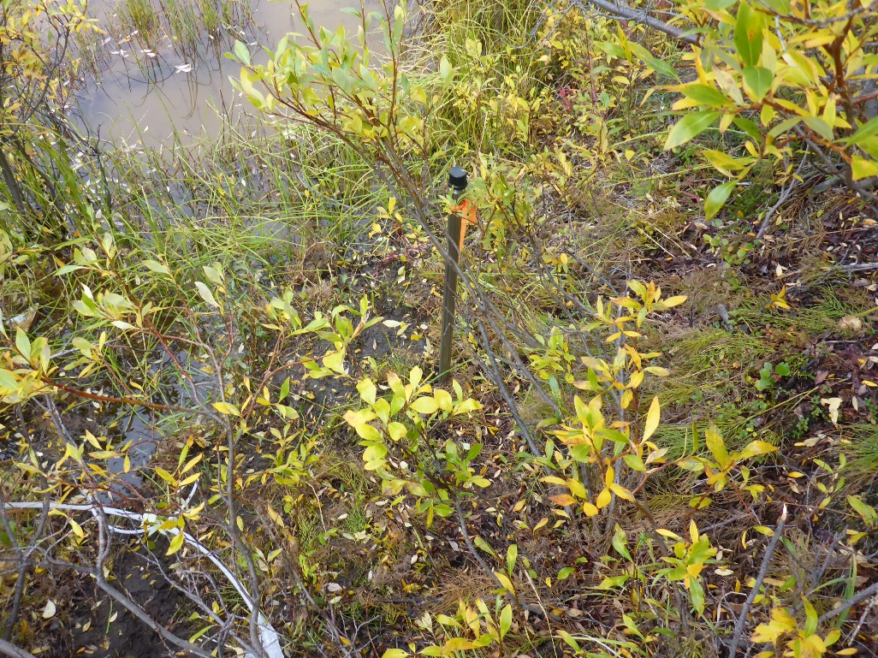
Photo 13: View of drive point well GSI-HA-04A. Photo taken on August 31, 2015.
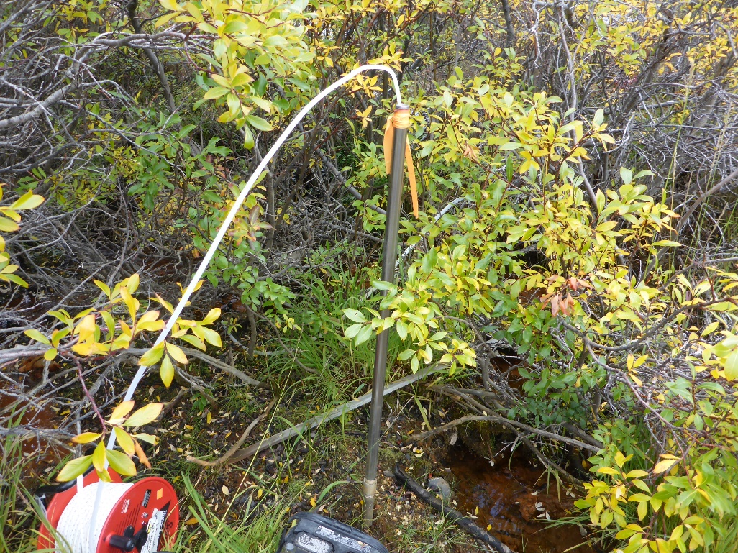
Photo 14: View of drive point well GSI-HA-05A. Photo taken on August 31, 2015.
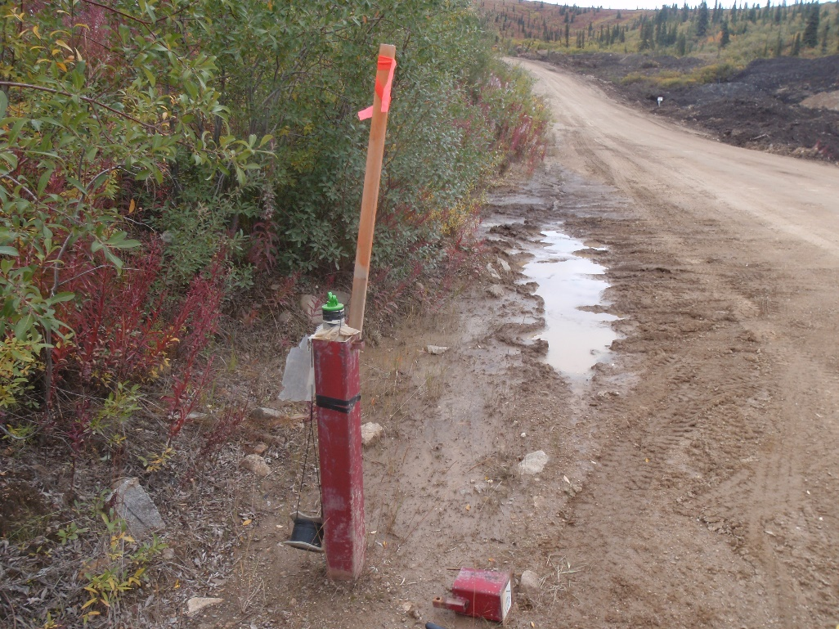

Photo 15: View of well MW09-15. Photo taken on September 2, 2015.
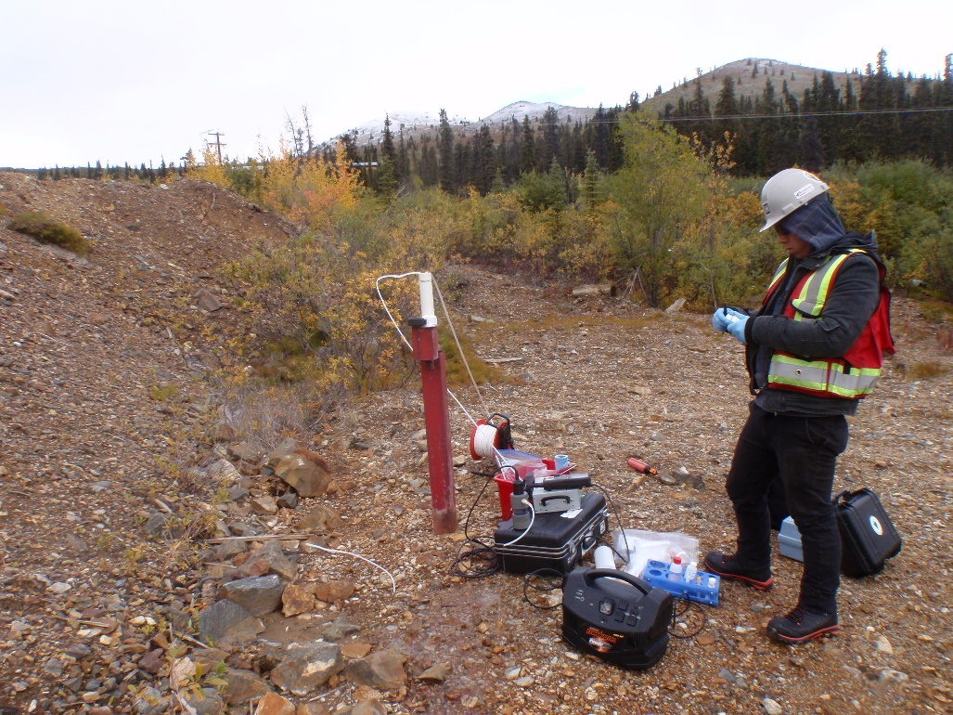
Photo 16: View of well MW09-16. Photo taken on August 31, 2015.
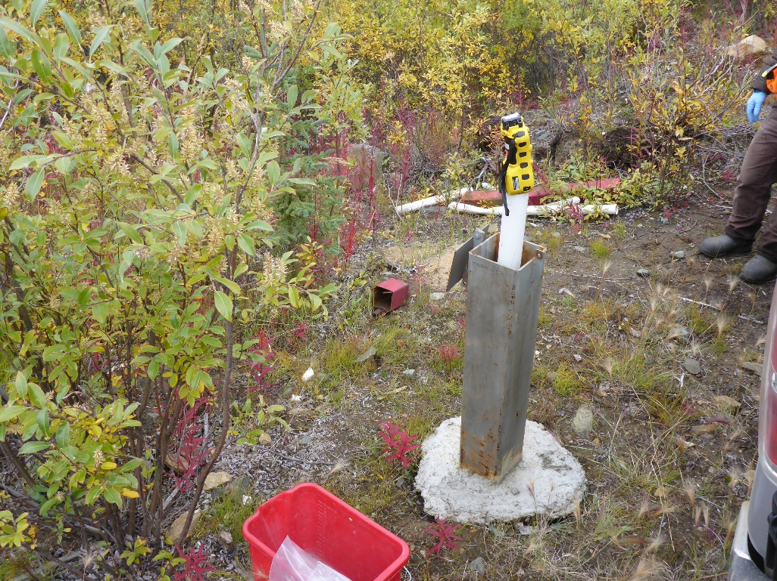
Photo 17: View of well MW09-17. Photo taken on August 31, 2015.
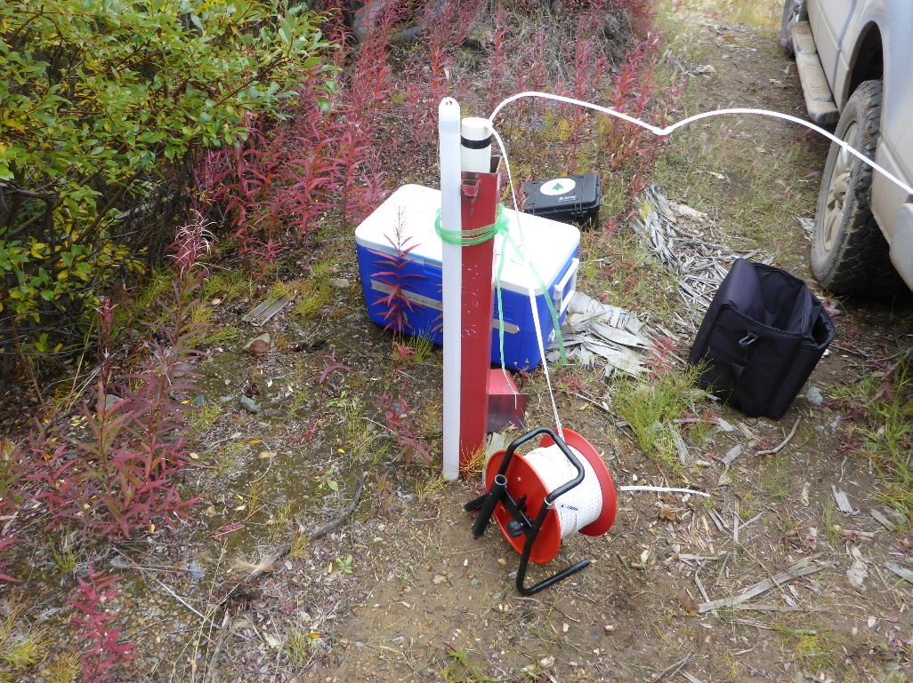
Photo 18: View of well MW09-18. Photo taken on August 31, 2015.
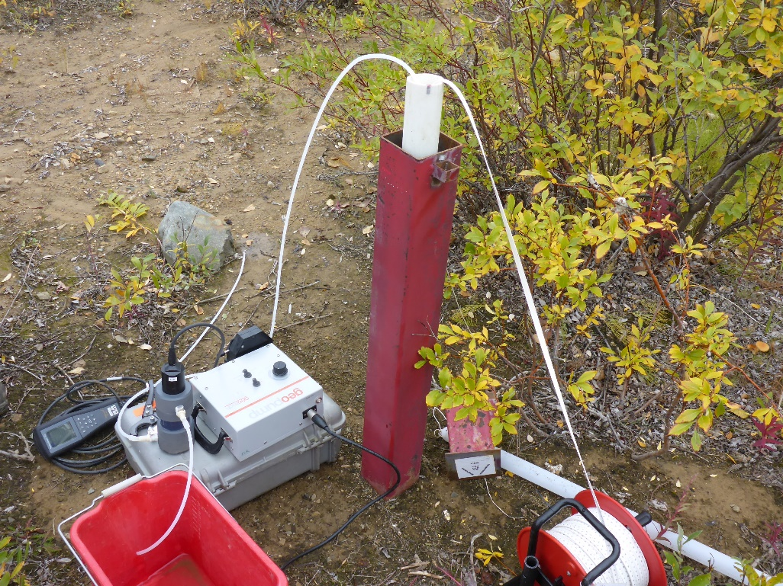
Photo 19: View of well MW09-19. Photo taken on August 31, 2015.
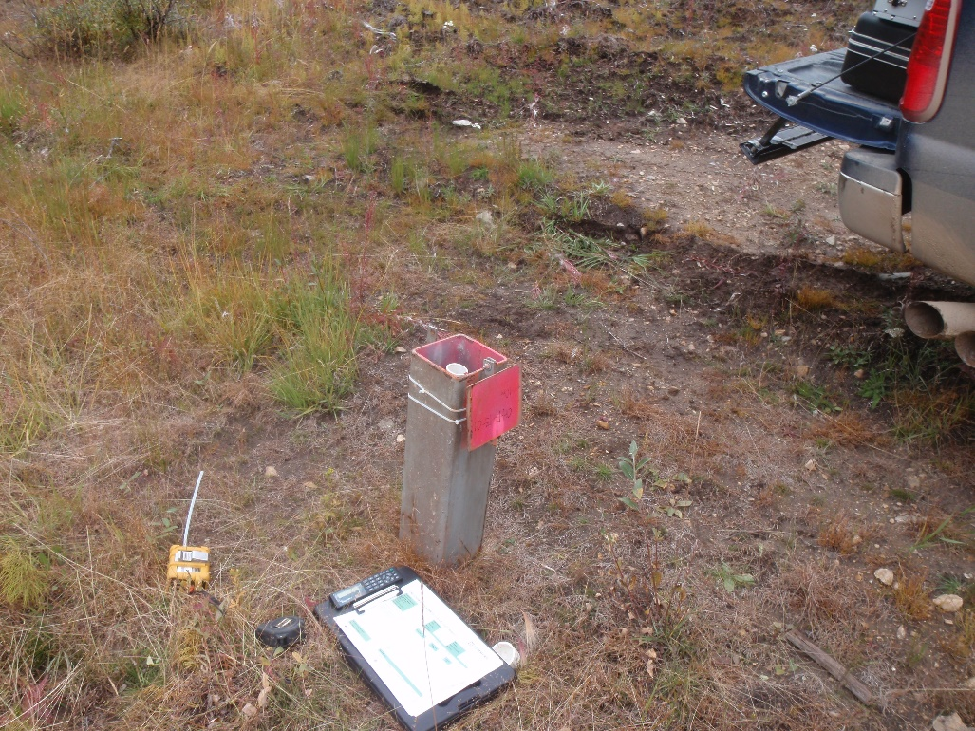
Photo 20: View of well CH-P-13-01/10. Photo taken on August 31, 2015.
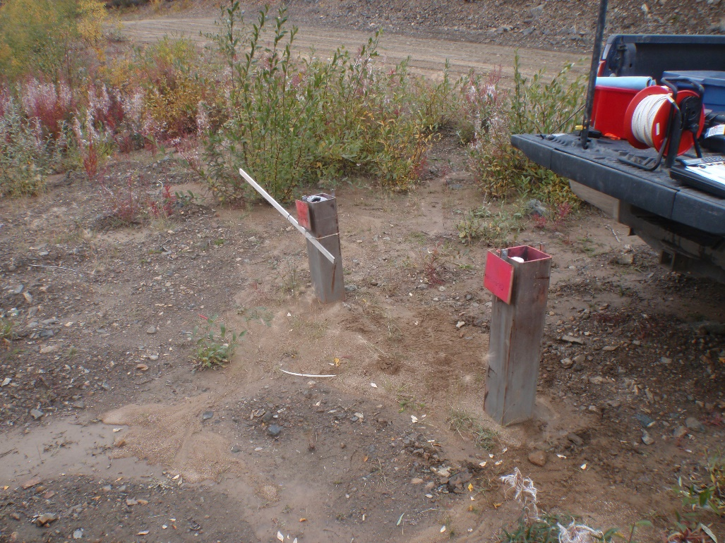
Photo 21: View of wells CH-P-13-03/50 and CH-P-13-03/10. Photo taken on August 31, 2015.
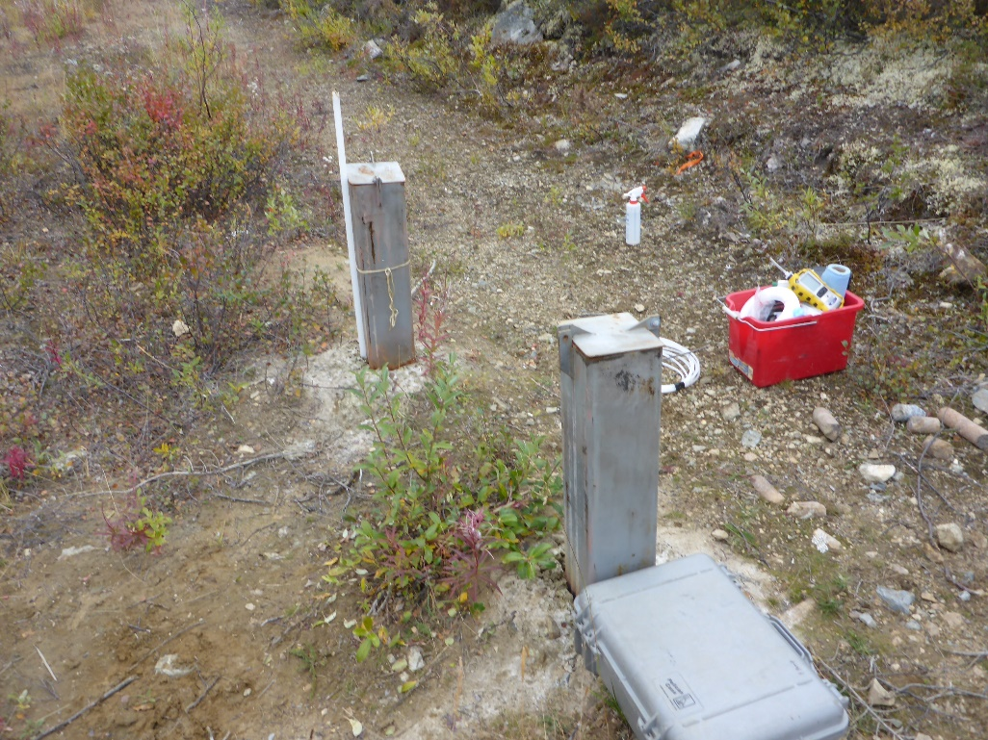
Photo 22: View of wells CH-P-13-04/10 and CH-P-13-04/35. Photo taken on September 2, 2015.

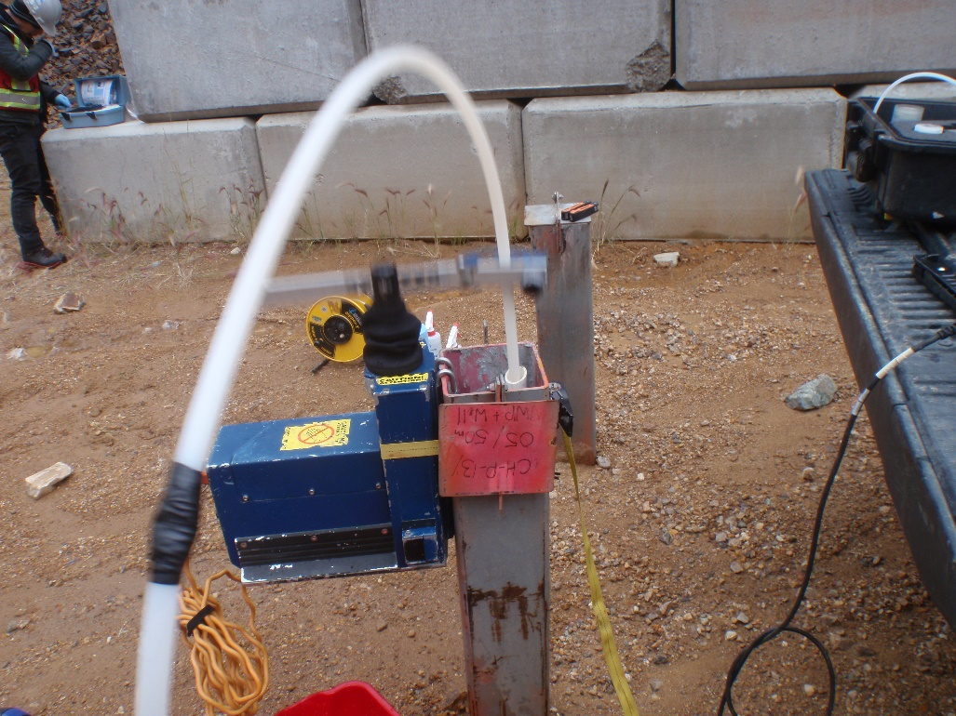
Photo 23: View of well CH-P-13-05/50. Photo taken on September 1, 2015.
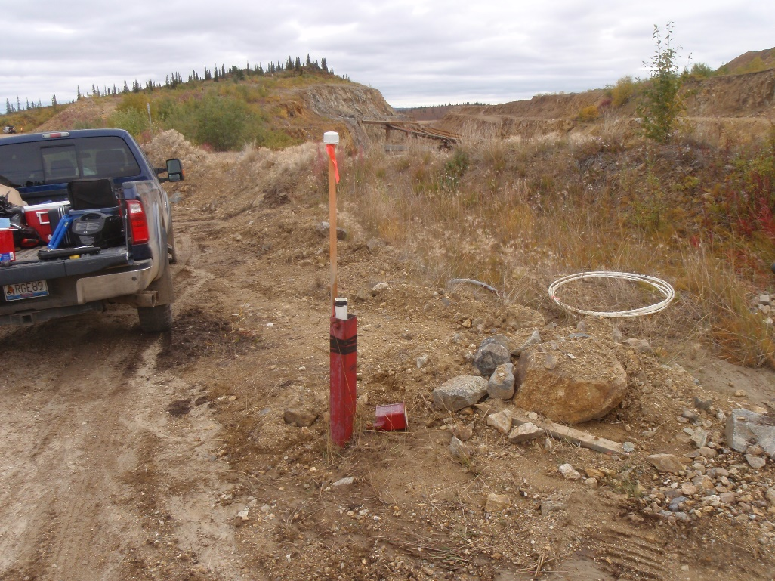
Photo 24: View of well GLL07-01. Photo taken on September 2, 2015.
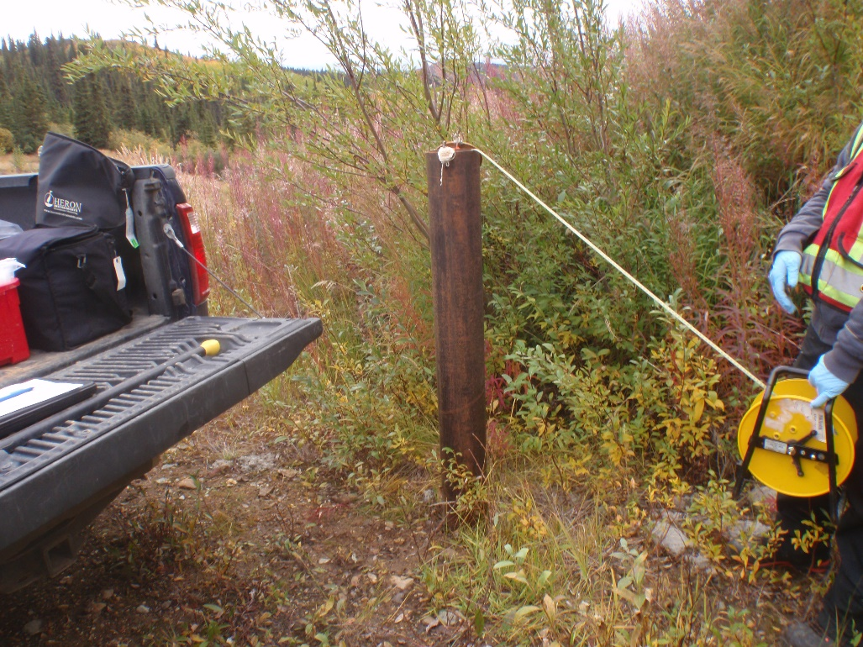
Photo 25: View of well GLL07-02. Photo taken on September 3, 2015.
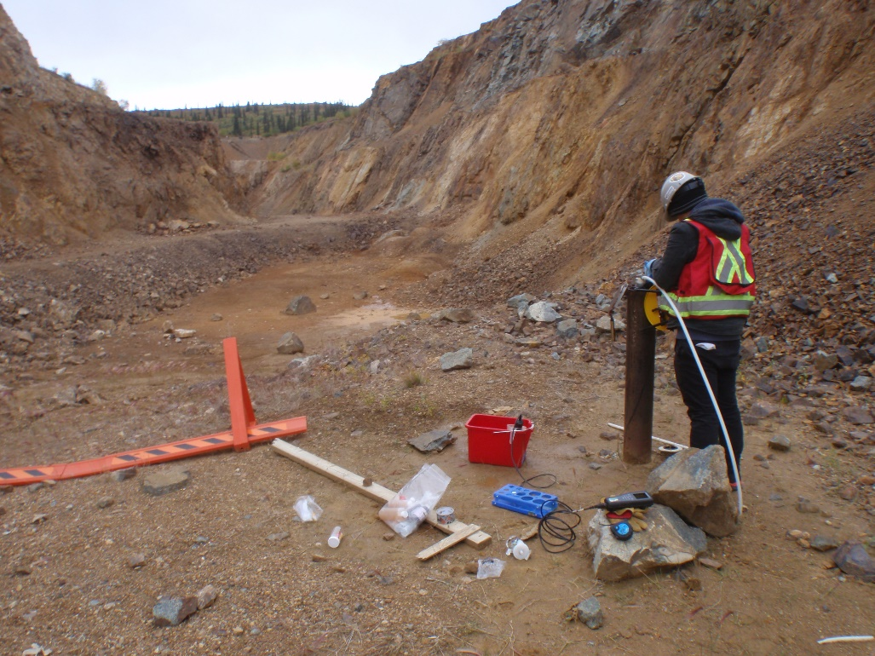
Photo 26: View of well GLL07-03. Photo taken on September 1, 2015.
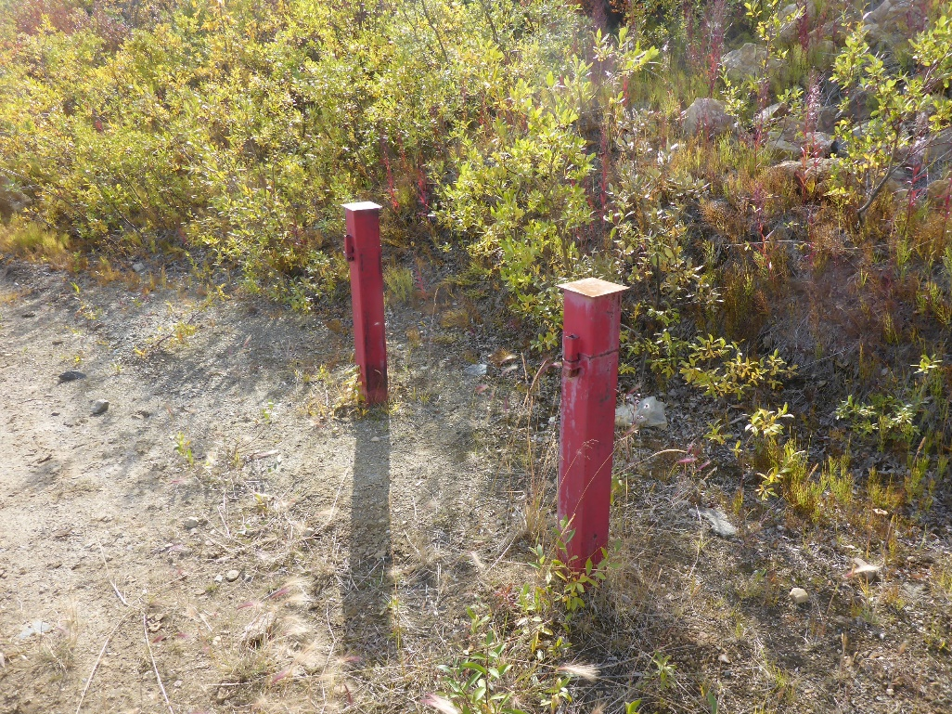
Photo 27: View of well MW09-13. Photo taken on September 2, 2015.
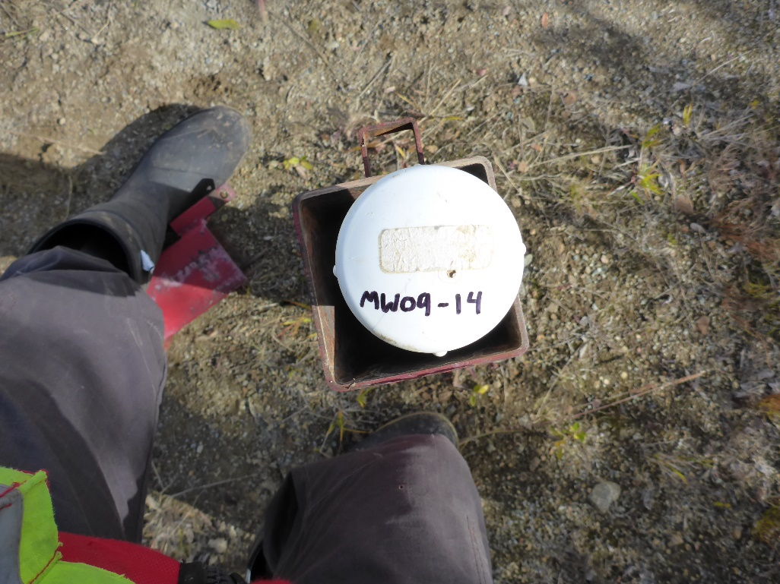
Photo 28: View of well MW09-14. Photo taken on September 2, 2015.
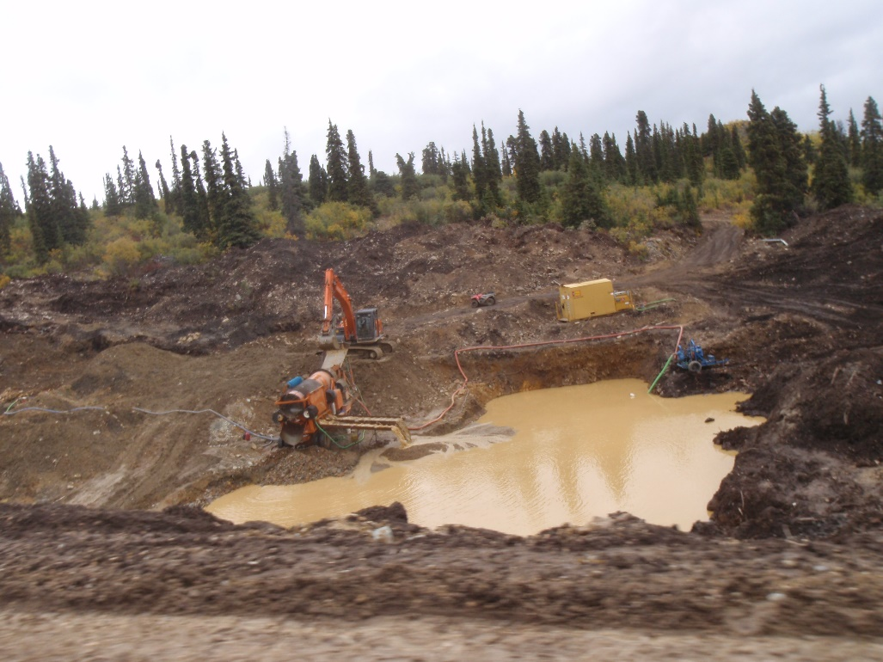
Photo 29: View of well placer mining activity on Pony Creek (previous location of GSI-PC-02A and GSI-PC-02B). Photo taken on September 2, 2015.
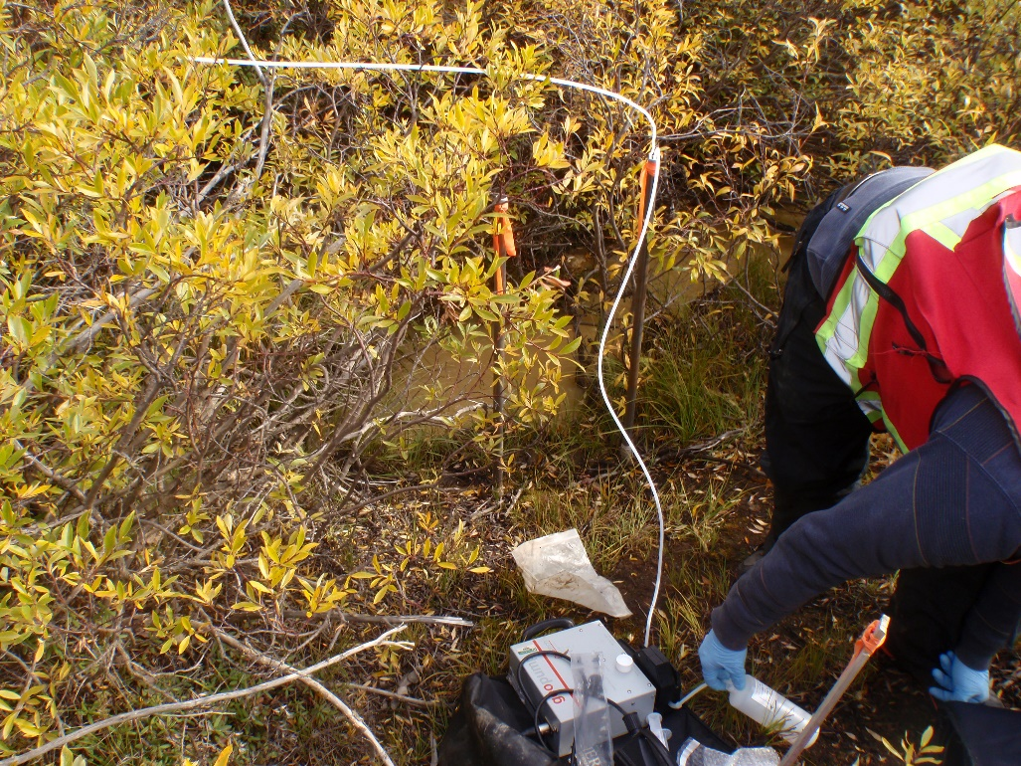
Photo 30: General location of well GSI-PC-03A and GSI-PC-03B. Photo taken on September 3, 2015.
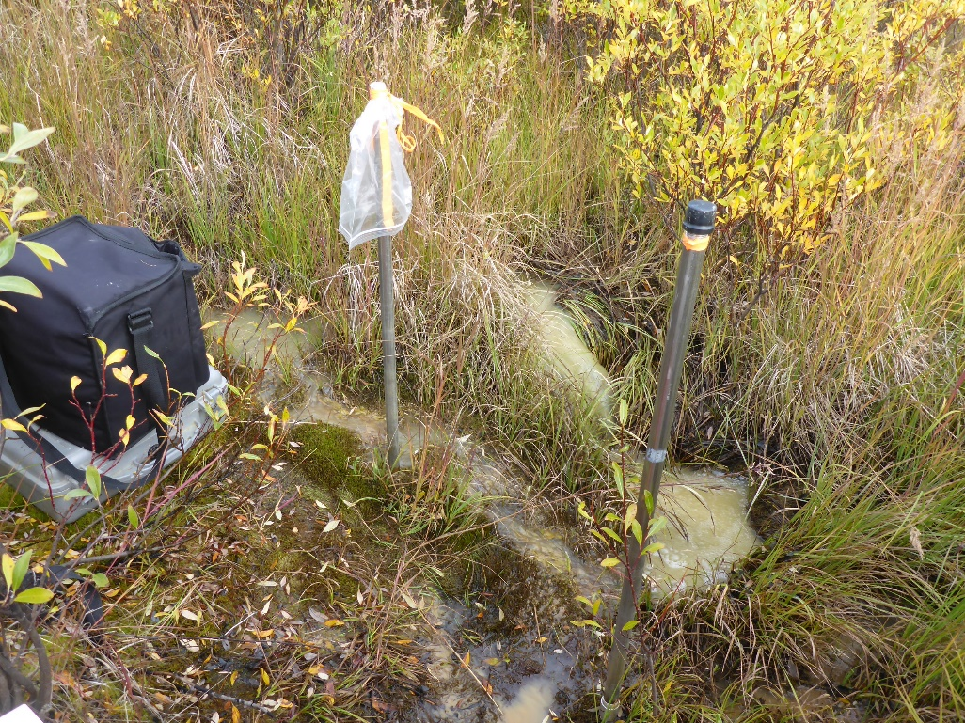
Photo 31: View of wells GSI-PC-04A and GSI-PC-04B. Photo taken on September 3, 2015.
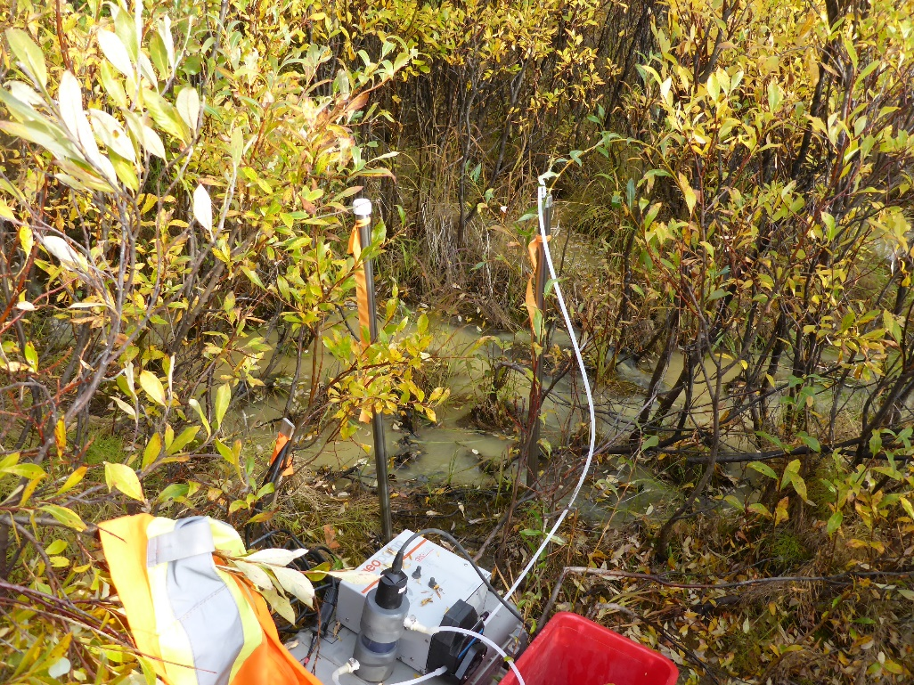
Photo 32: View of wells GSI-PC-05A and GSI-PC-05B. Photo taken on September 3, 2015.
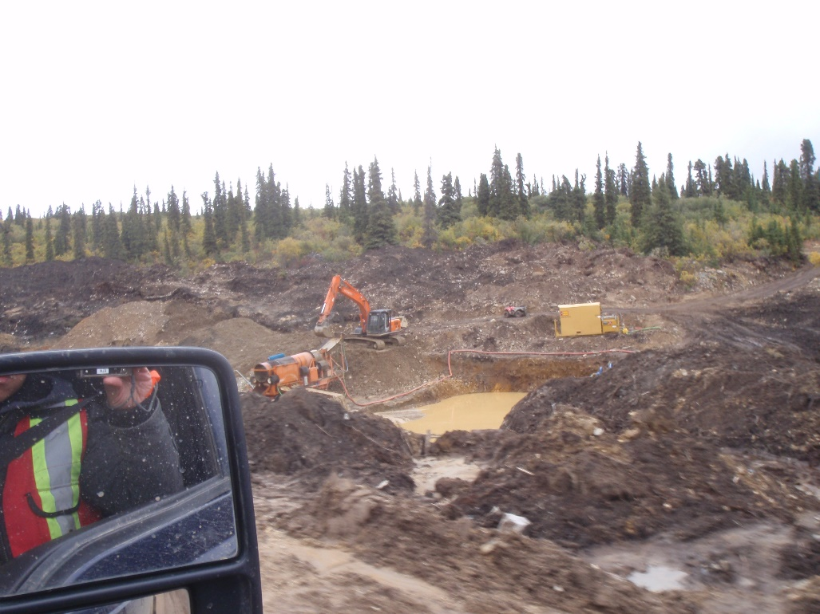
Photo 33: View of placer mining operations on Pony Creek (previous location of well MP09-02). Photo taken on September 2, 2015.
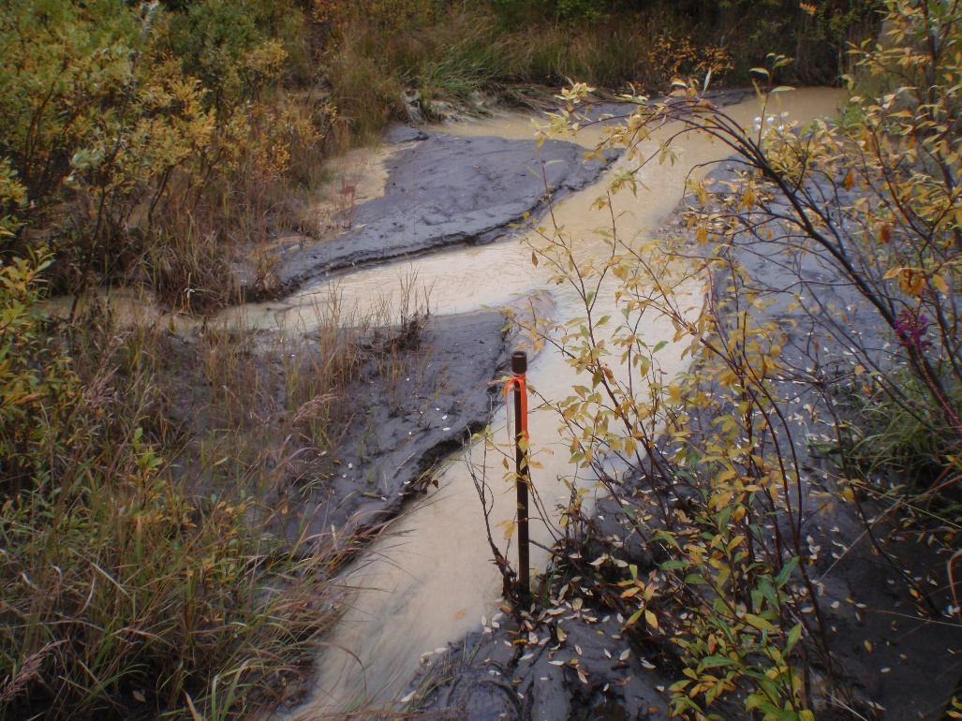
Photo 34: View of well MP09-03. Photo taken on September 3, 2015.

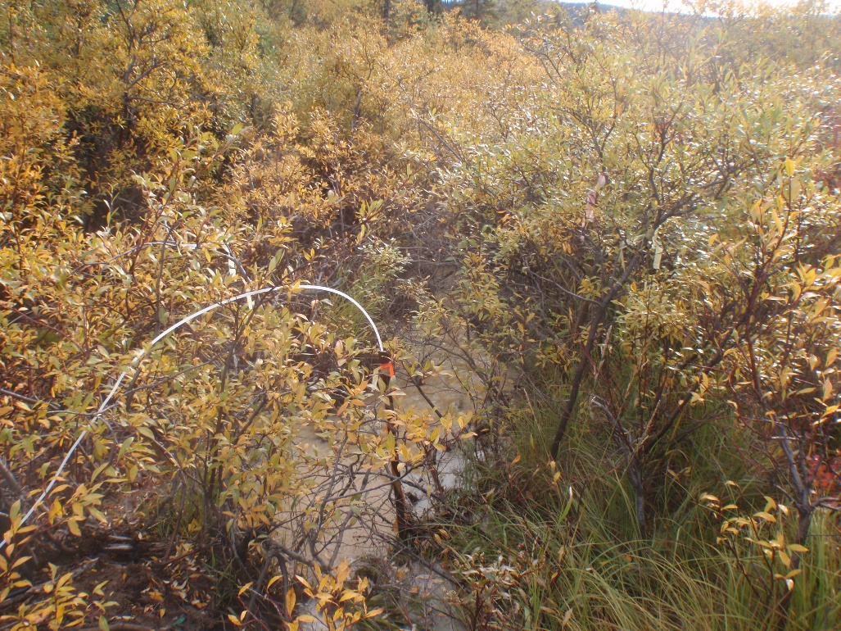
Photo 35: View of well MP09-08. Photo taken on September 3, 2015.
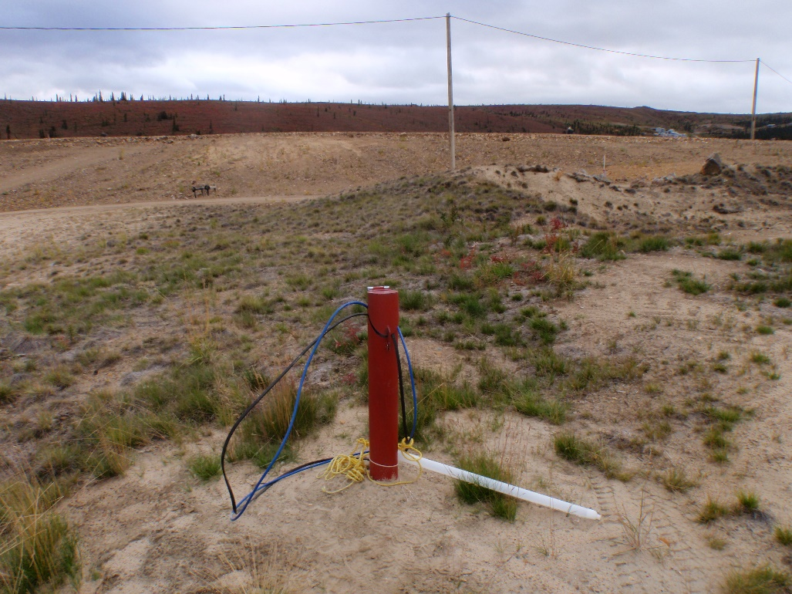
Photo 36: View of well W14103083BH01. Photo taken on September 2, 2015.
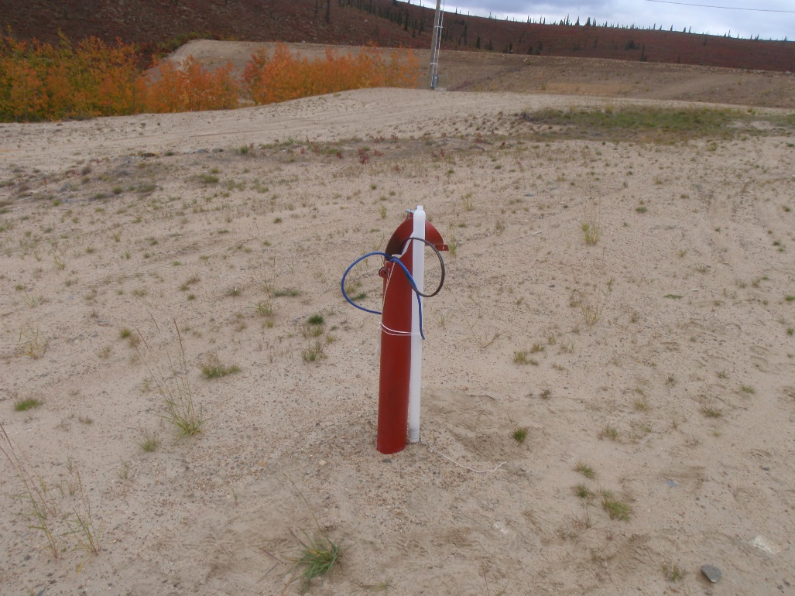

Photo 37: View of well W14103083BH02. Photo taken on September 2, 2015.
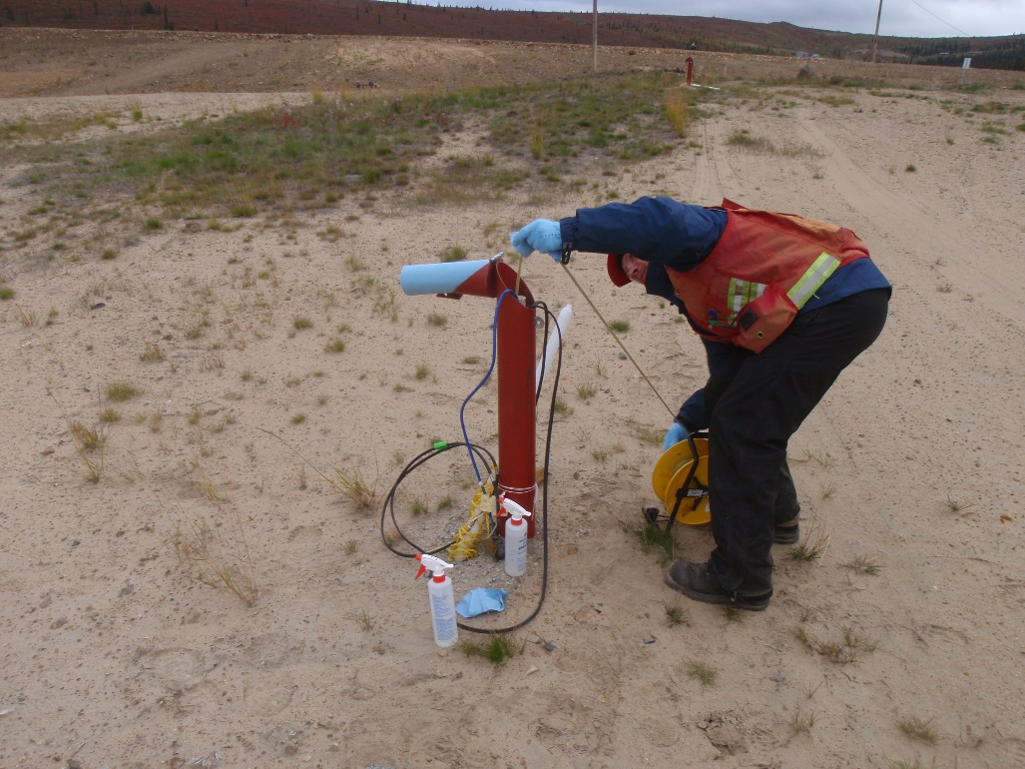
Photo 38: View of well W14103083BH04. Photo taken on September 2, 2015.
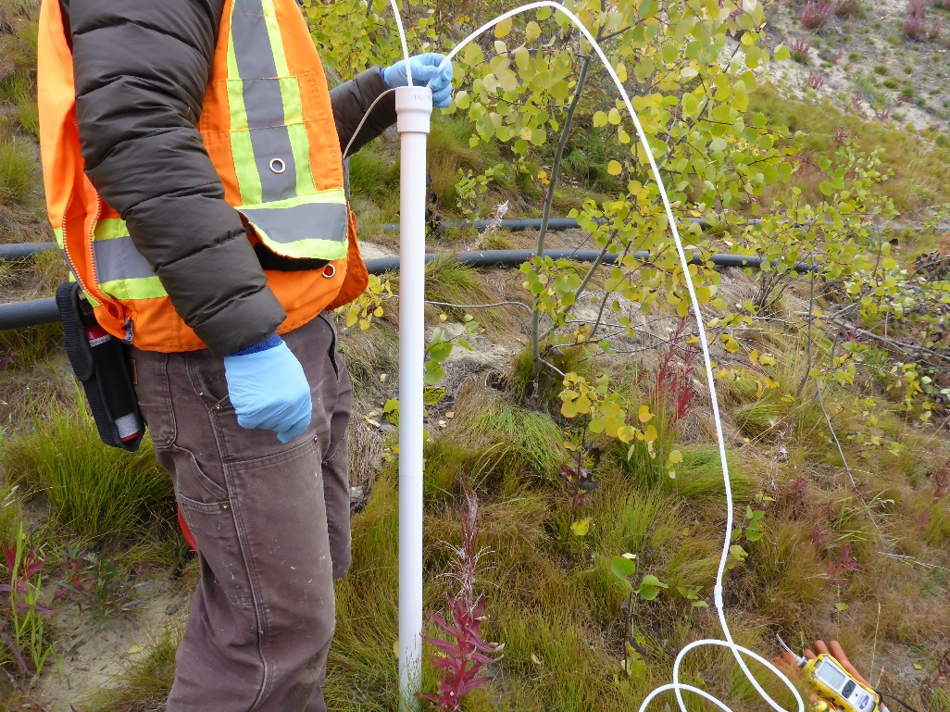
Photo 39: View of well MP09-04. Photo taken on September 1, 2015.
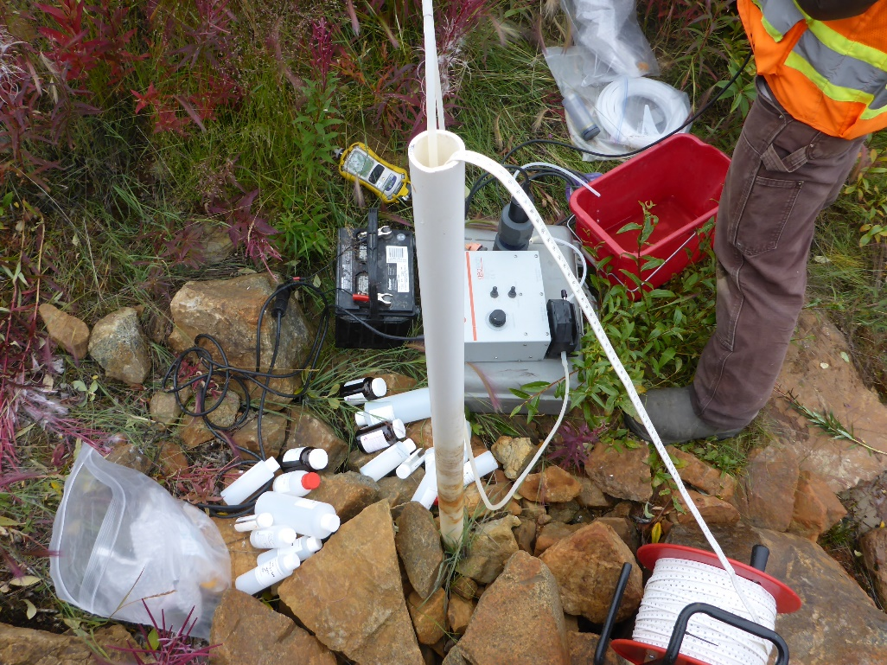
Photo 40: View of well MP09-05. Photo taken on September 1, 2015.
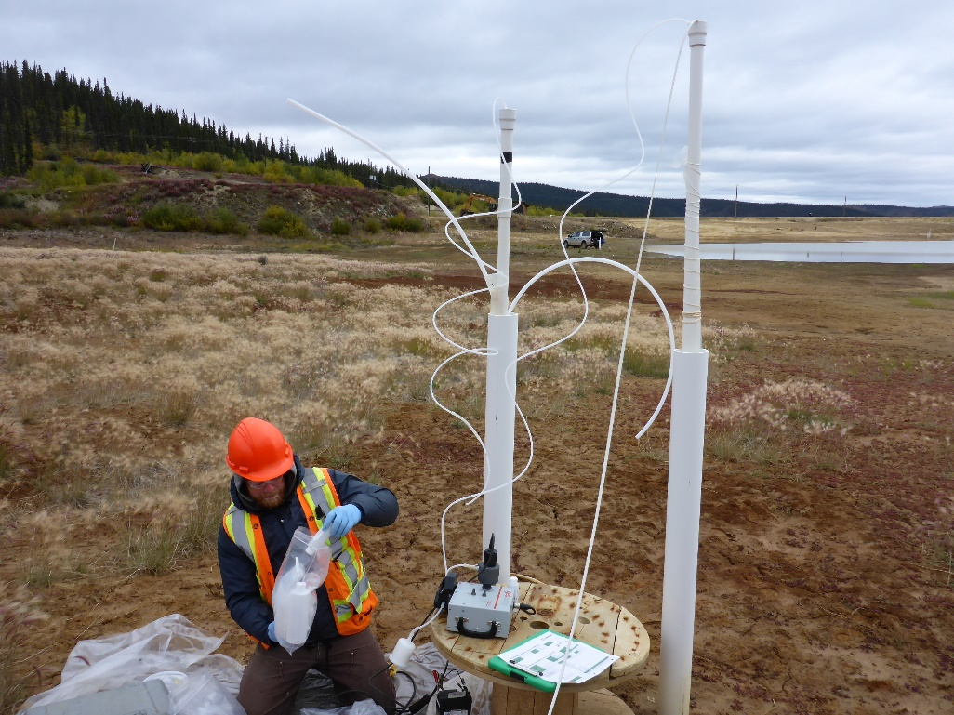
Photo 41: View of wells MP09-09 and MP09-10. Photo taken on September 2, 2015.
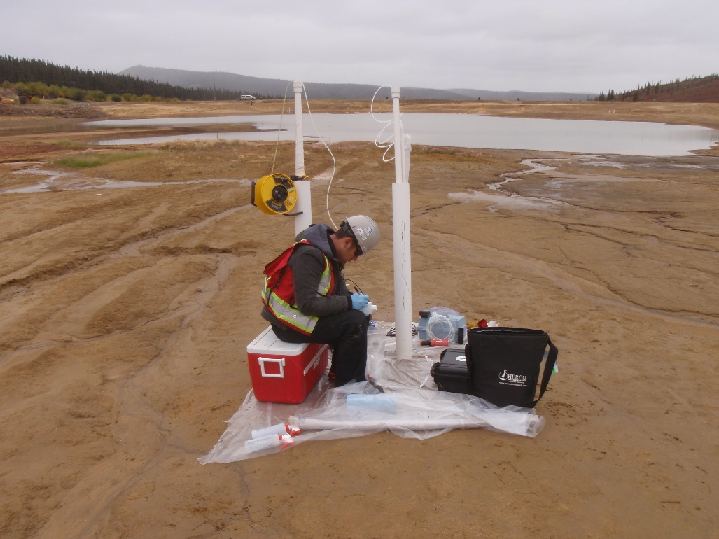
Photo 42: View of wells MP09-11 and MP09-12. Photo taken on September 2, 2015.
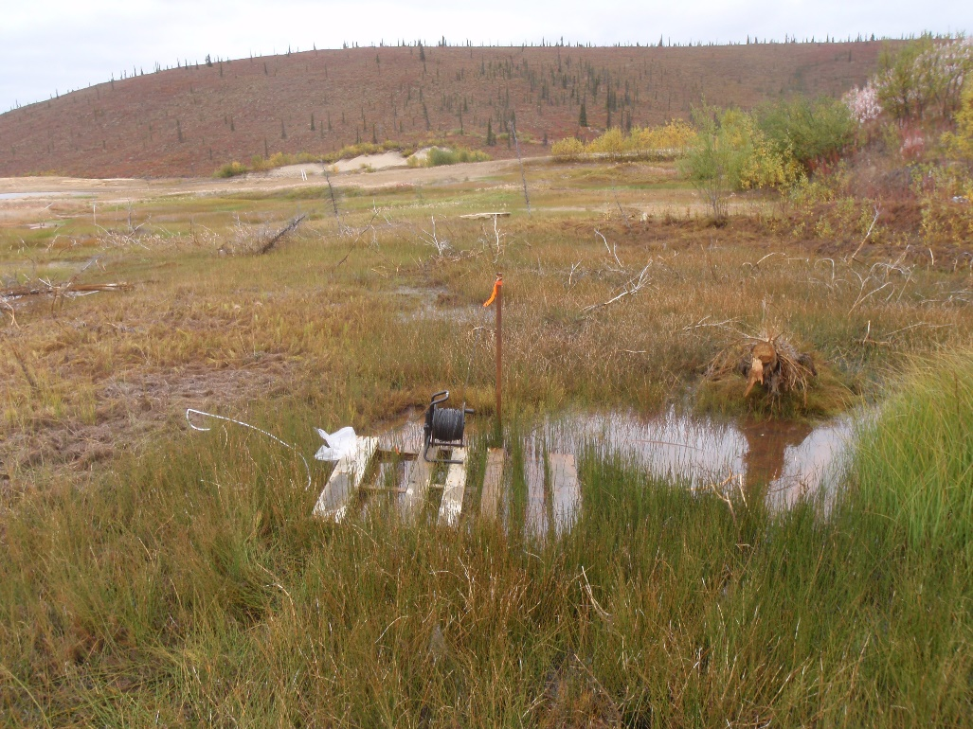
Photo 43: View of well MP09-14. Photo taken on September 2, 2015.
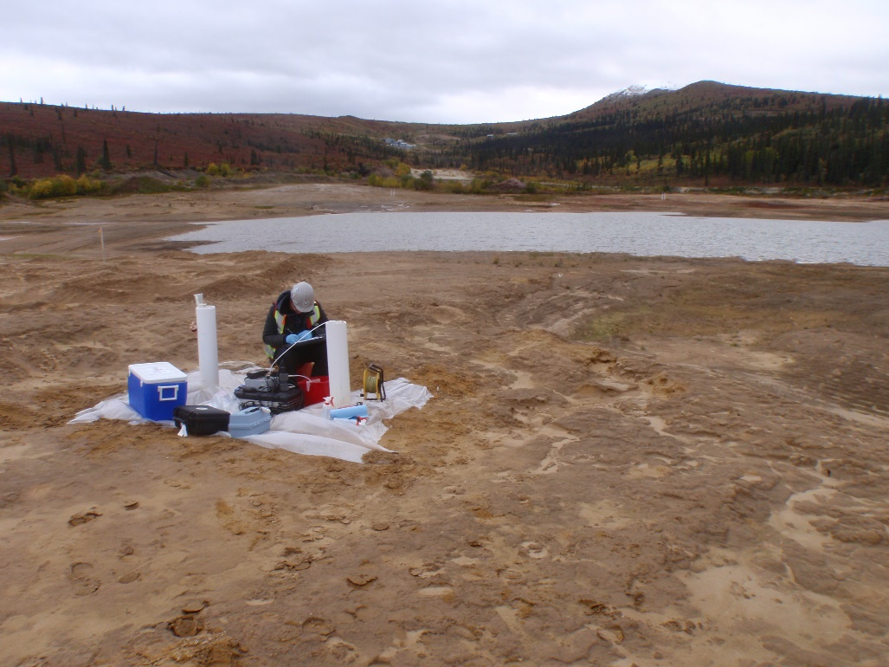
Photo 44: View of wells MW09-01 and MW09-02. Photo taken on September 1, 2015.
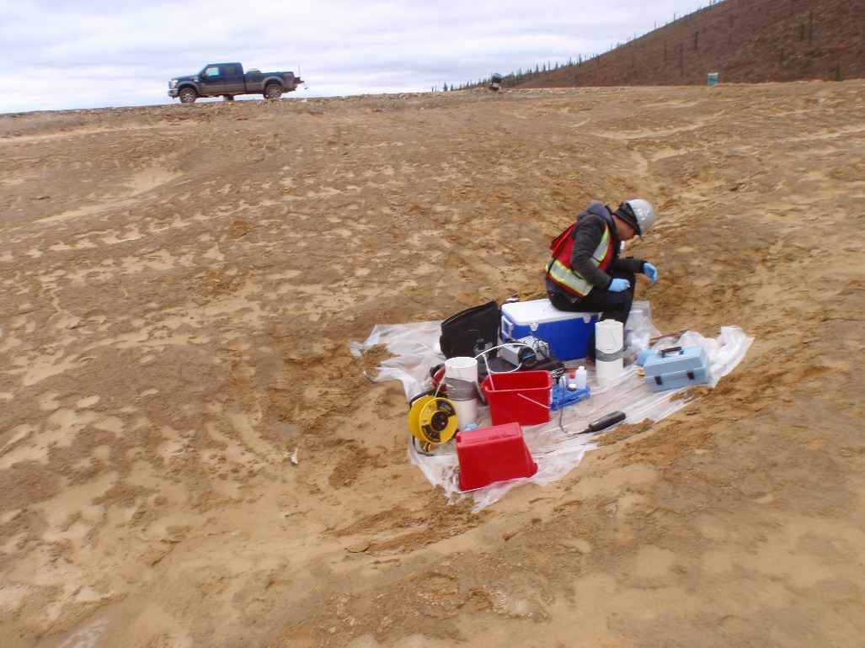
Photo 45: View of wells MW09-03 and MW09-04. Photo taken on September 1, 2015.
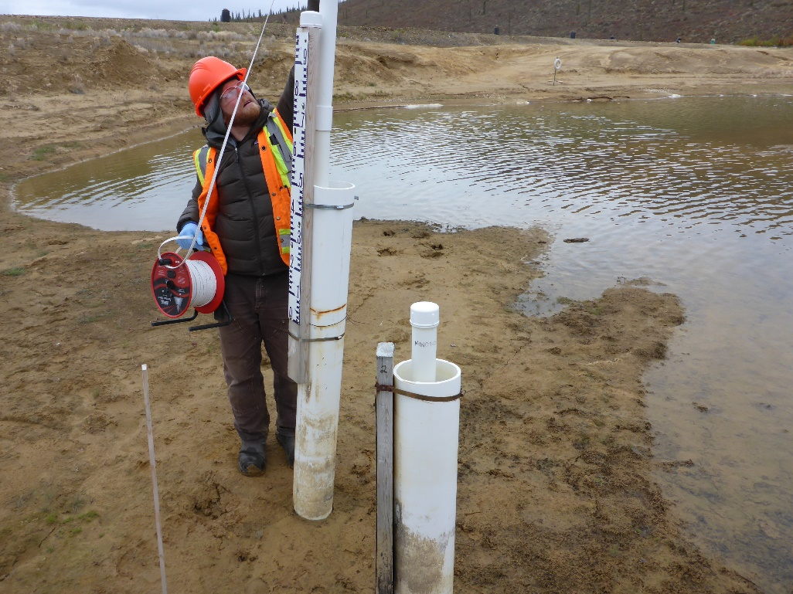
Photo 46: View of wells MW09-05 and MW09-06. Photo taken on September 2, 2015.

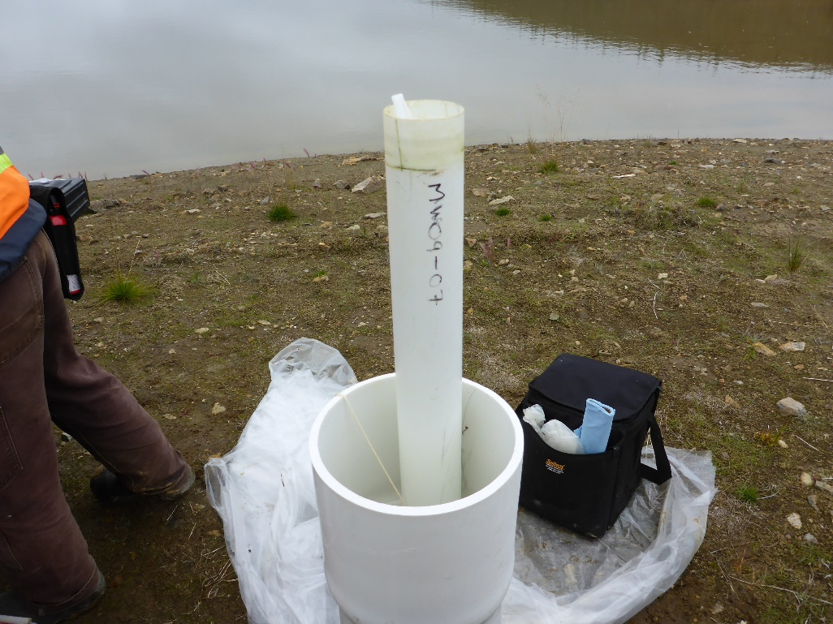
Photo 47: View of well MW09-07. Photo taken on September 2, 2015.
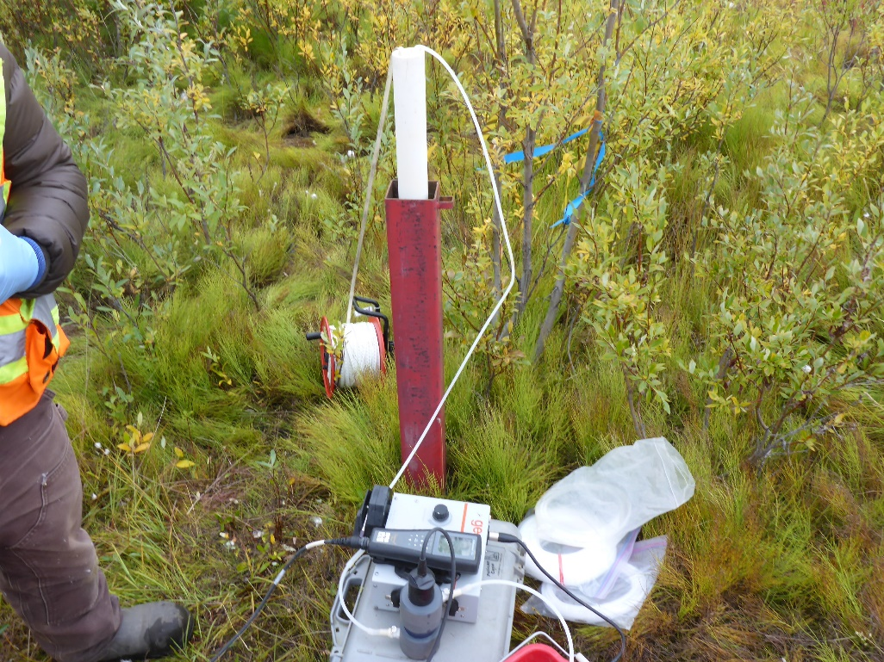
Photo 48: View of well MW09-08. Photo taken on September 1, 2015.
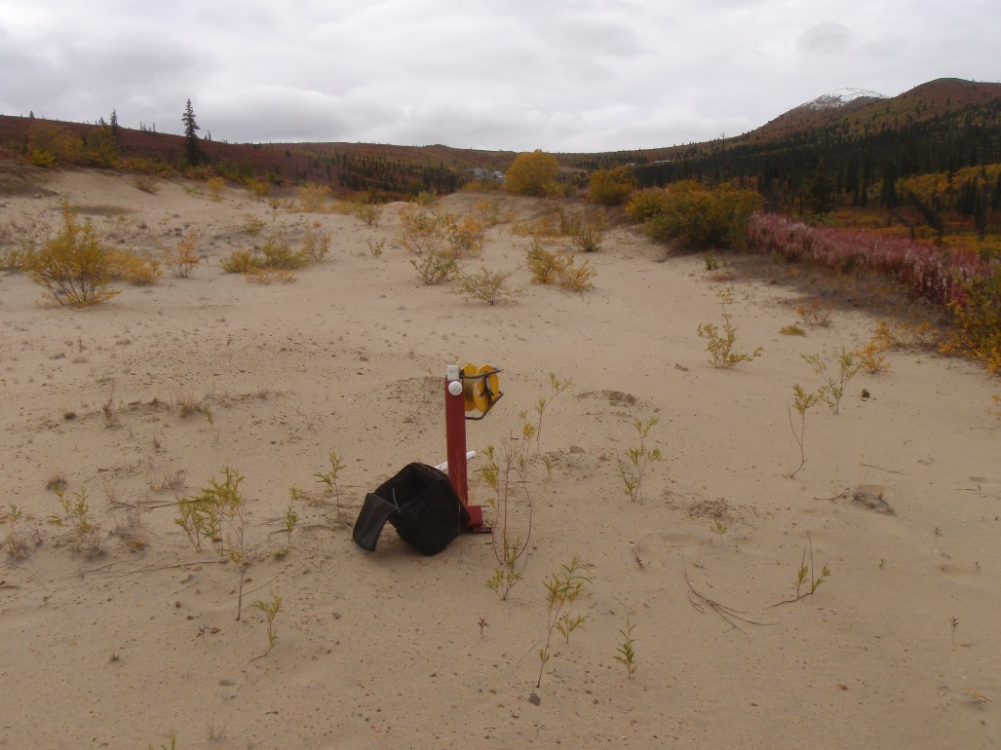
Photo 49: View of well MW09-11. Photo taken on September 2, 2015.
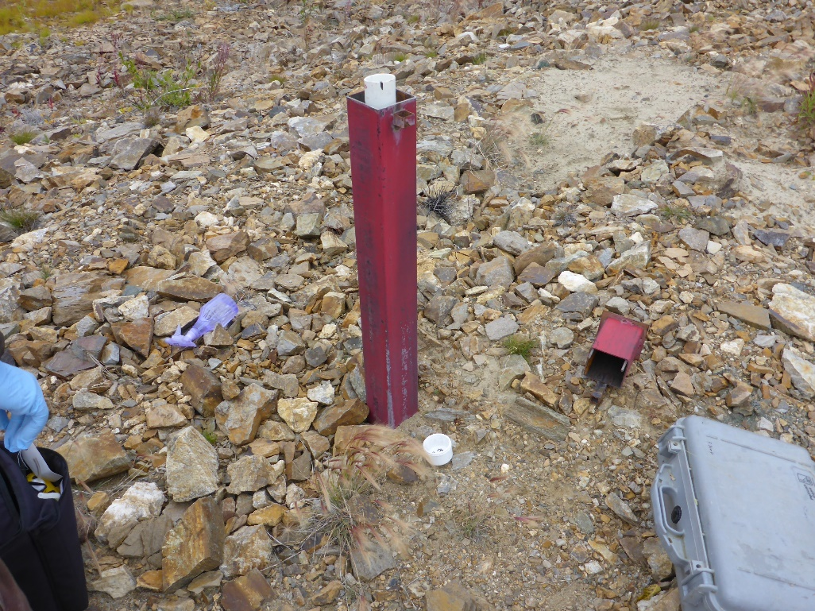
Photo 50: View of well MW09-20. Photo taken on September 1, 2015.
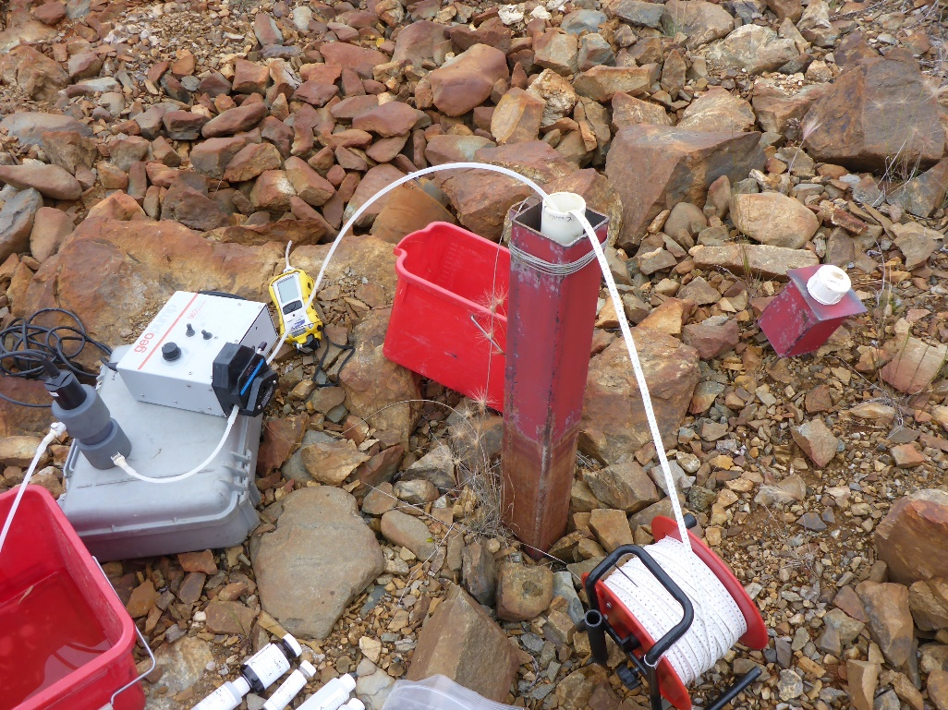
Photo 51: View of well MW09-21. Photo taken on September 1, 2015.
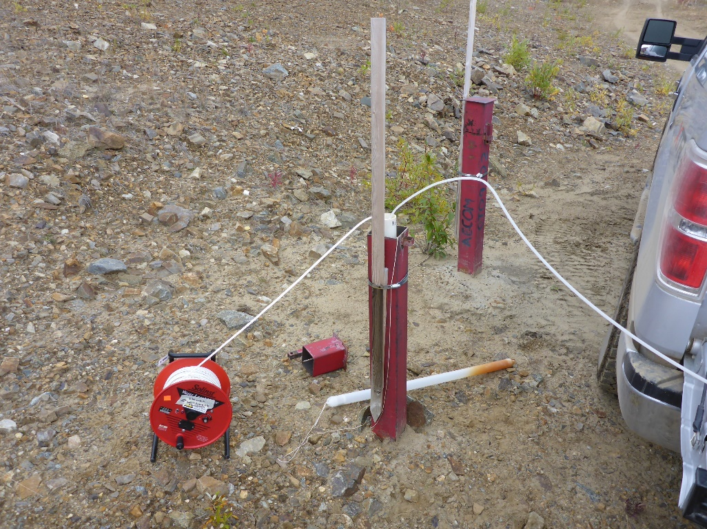
Photo 52: View of well MW09-22. Photo taken on September 1, 2015.
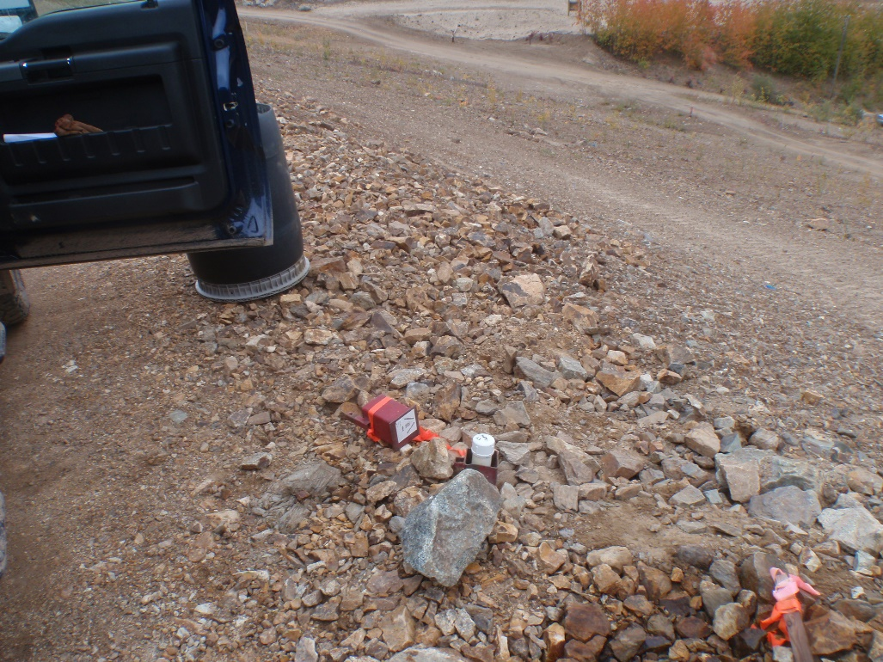
Photo 53: View of well MW09-23. Photo taken on September 1, 2015.

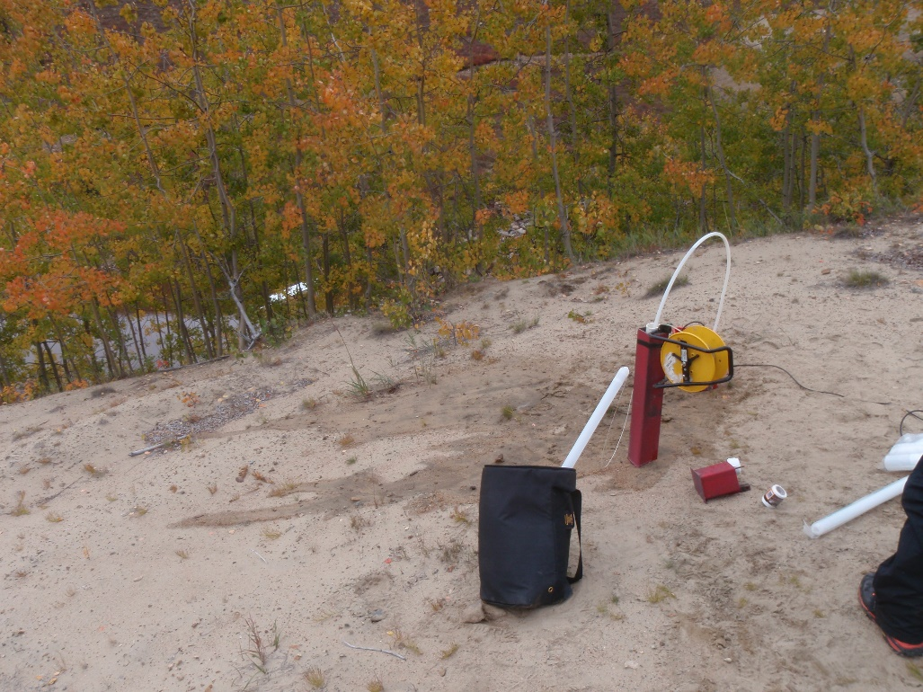
Photo 54: View of well MW09-24. Photo taken on September 2, 2015.

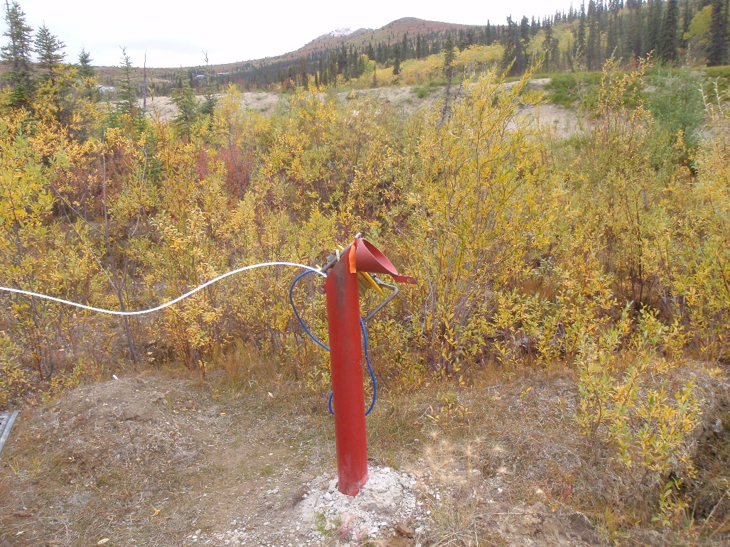
Photo 55: View of well W14103083BH03. Photo taken on September 2, 2015.
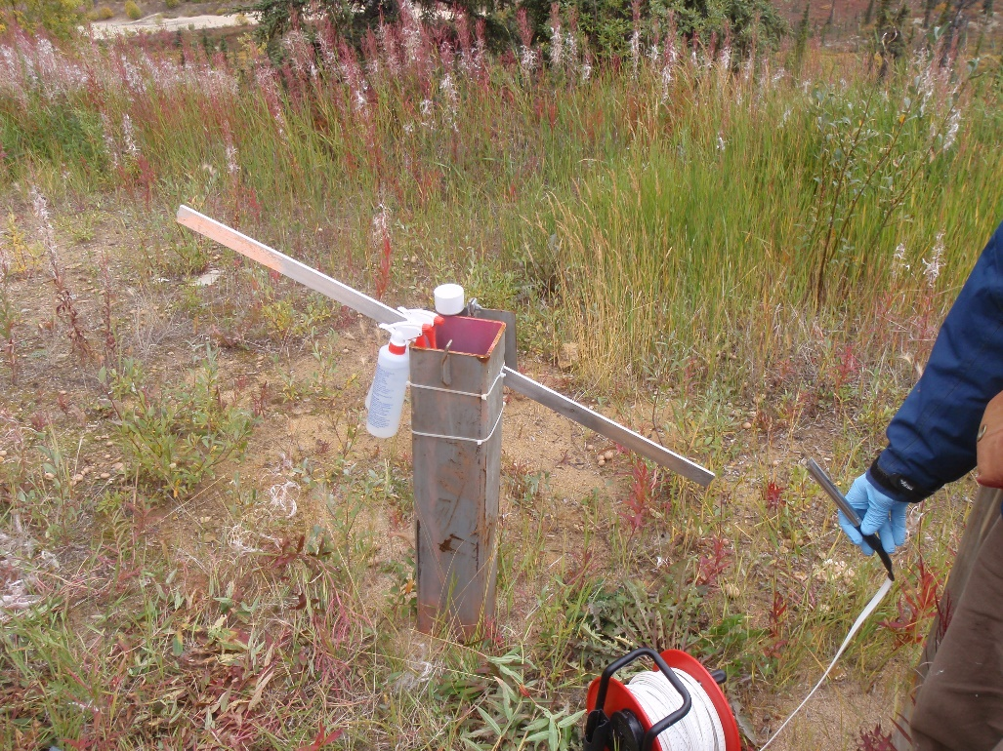
Photo 56: View of well CH-P-13-02/10. Photo taken on August 31, 2015.

