Field Memorandum

From: | Dan Piccininni, EIT (AMEC) |  | ref: VM00605E
To: | file
Date: | November 18, 2013
Subject: | General Observations Regarding Geohazard and Borrow Material– Mount Nansen, YT Rev 1

During the 2013 field program at Mount Nansen, an effort was made to observe the geohazard potential around the site, as well as the potential for various borrow material sources around the site. This memo provides a summary of the observations that were made. The reconnaissance was a relatively informal exercise. Relevant pictures were taken, with accompanying notes, as well as slope angle or other measurements, where they were warranted.

In general, the Mount Nansen site consists of moderately to steeply sloped, hilly terrain, with several creeks cutting through the property. There appears to be shallow permafrost in some areas, particularly on north facing slopes, although there was no extensive test pitting to validate presence or absence of permafrost on a site wide scale. Vegetation on the site is similarly also affected by the slope aspect. Mosses and low lying shrubs are located on north slopes, whereas evergreen and aspen trees grow on south facing slopes. The creek valleys often contain dense willow growth. This is generally illustrated in Photos 1 and 2 below.

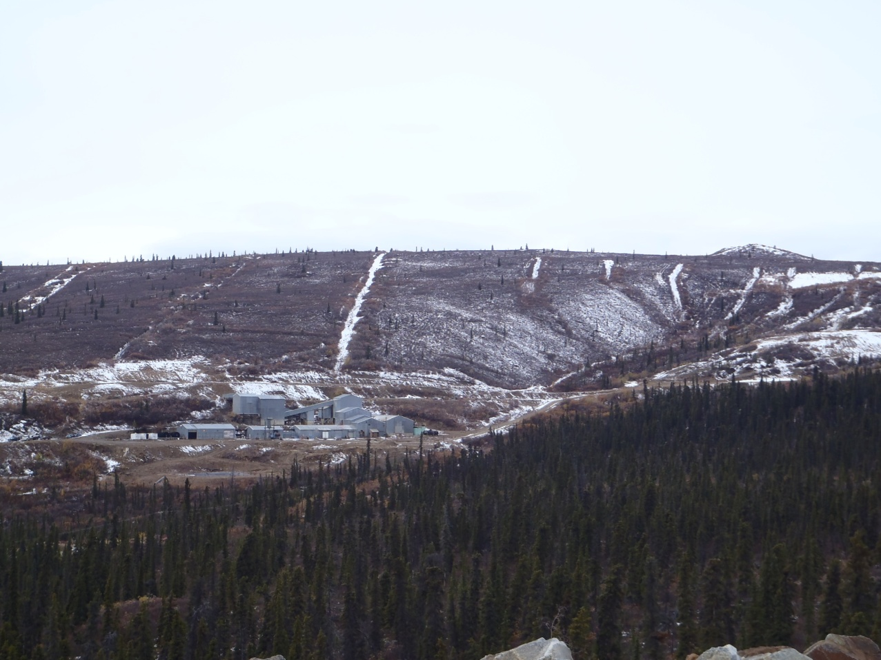
Photo 1: Mill Site and Camp Area, with exploration trenches highlighted by the snow
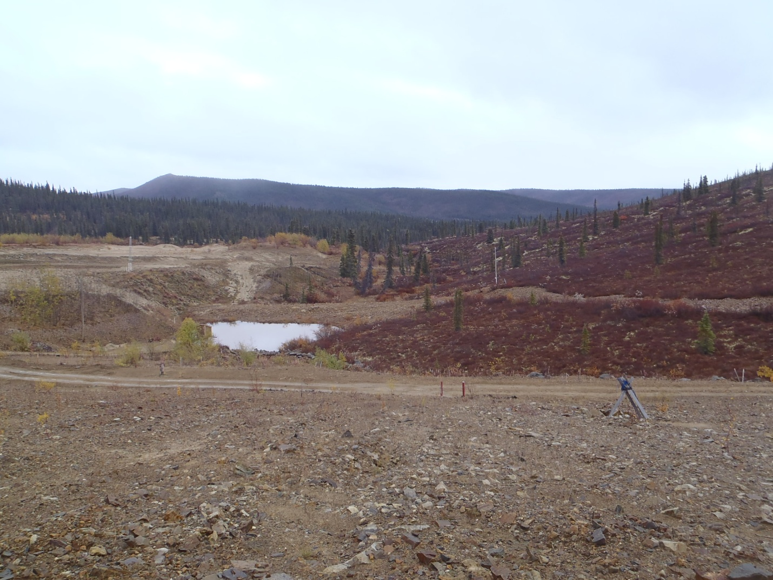
Photo 2: Looking East from the Tailings Dam. Thinly Vegetated North facing slope on the right,
thickly treed south facing slope on the left.

Observations Related to Geohazards

The specific hazard potential on site that was considered was avalanche hazard, solifluction, and general slope failure, especially on road cuts.

Avalanche hazard
Avalanche hazards around site appeared to be minimal. Slopes are generally not big enough or steep enough for snow to build up enough to be a significant hazard. Informal observations from Jeff Moore, with AAM, also indicate that any bare slopes around the site generally get wind scoured before avalanche hazards can build up. The one area that could potentially have an avalanche slide hazard is the slope immediately above the pony creek adit. This is a fairly steep slope with a northeast aspect and thin vegetation cover, and is generally on the leeward side of the dominant wind direction. This combination could cause a cornice or wind slab to build up for a minor avalanche hazard.

Solifluction
Solifluction is the slow downslope movement of waterlogged soil over underlying frozen soil. It is generally triggered by freeze thaw action and slides occur along a permafrost surface which acts as impermeable layer and a slide surface. Some of the permafrost slopes around the Mount Nansen Site could be susceptible to solifluction. The north facing slope immediately downstream of the tailings dam and diversion channel (see Photo 3) and the slope southwest of the mill (Photo 1) and the camp are north facing and likely to have reasonably shallow permafrost. They are also slightly steeper than other slopes in the area (approximately 35°). These two areas appear to be the most likely areas for solifluction processes.

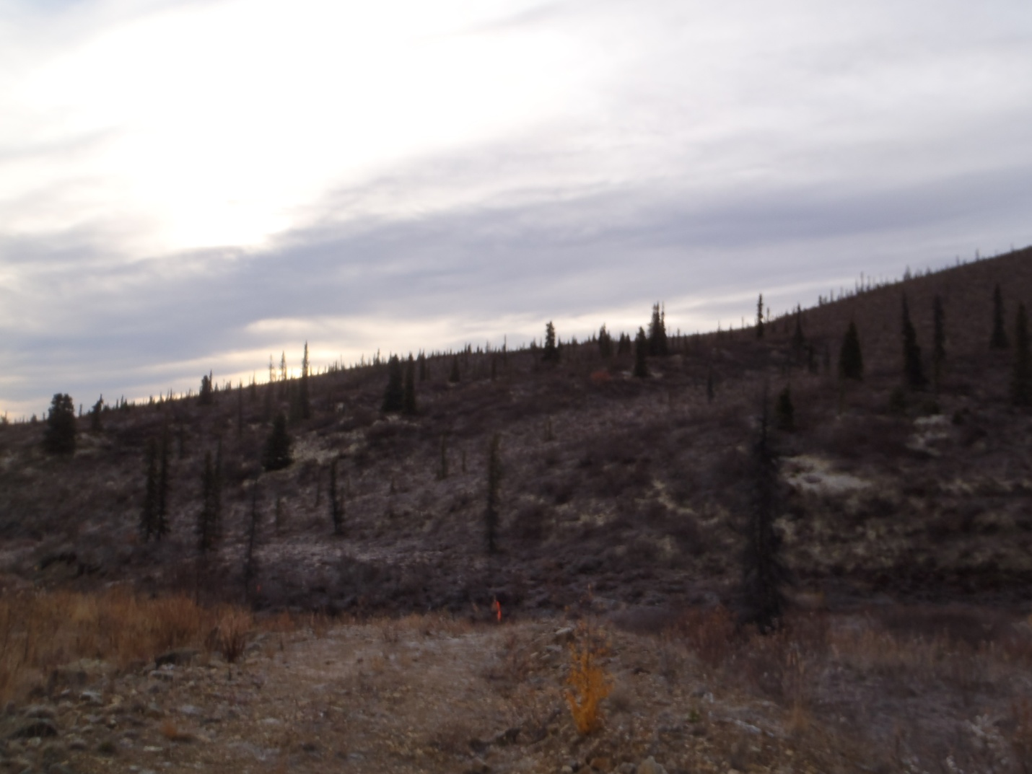
Photo 3: potential site for solifluction, downstream of the seepage pond, above dome creek

Slope instability

No obvious headscarps were observed and the topography and geologic conditions do not appear to indicate the potential for a large landslide.

Some small debris flows appear to be present on various slopes around the site (see example in Photos 4 and 6). Some of these appear to be washout from the large exploration trenches that have been dug around the site.

On some of the cut slopes on the site roads, it was observed that slope erosion has caused the exposed cut soil to slough away from and undercut the organic and root mat. These road cuts are typically at an angle of 35° - 45°. There is not very much vegetation covering to stabilize or prevent erosion of the exposed slopes (see Photo 5). Most of these cuts are not very tall, generally ranging from 1 to 2 m tall. It is possible that on a large enough cut, a heavy rain event could cause a road washout, or any large trees to be undercut enough that they fall across the road.

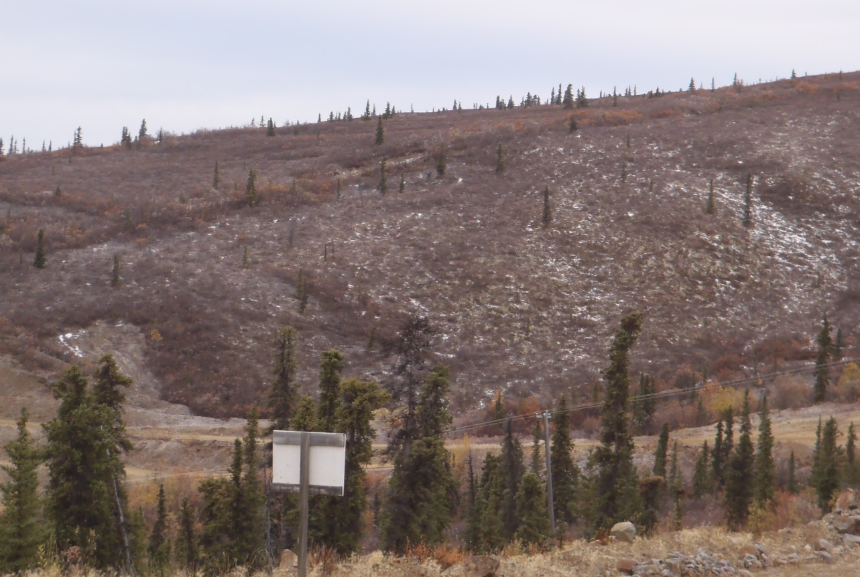
Photo 4: Slope south of the mill, small potential debris flow feature on left

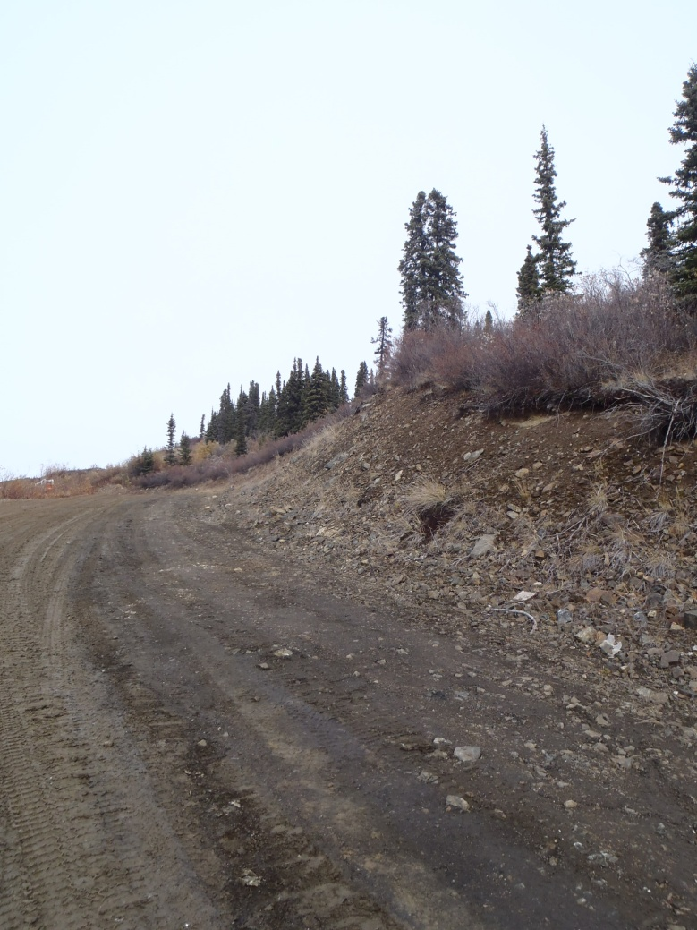
Photo 5: Road cut with erosion potential
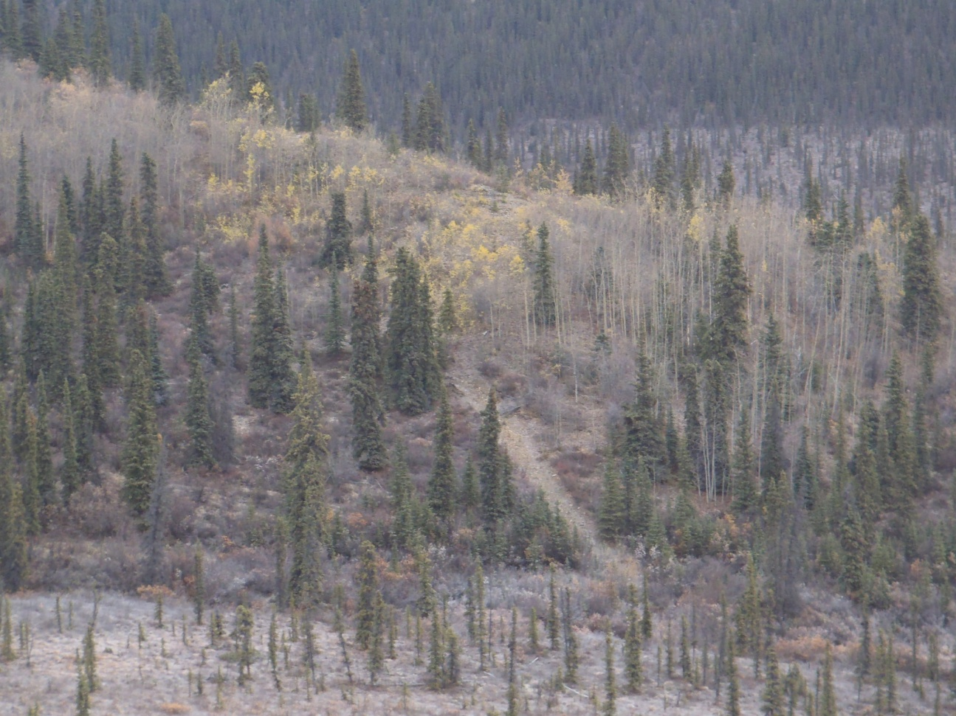
Photo 6: Steep Slope with potential debris flow North of Pony Creek

Observations Related to Borrow

The potential for fine grained borrow on site has already been assessed as very unlikely. The sand borrow areas have been investigated through a test pit program and has been documented as part of dam construction. The observations made with regards to on site borrow as part of this reconnaissance focused on the potential for competent rock material. An effort was made to identify potential rip rap sources, and gravel sources on site, as summarized below. In order to completely assess the quantity and quality of borrow material on site it would be necessary to know the expected application of the material, especially regarding the required gradation. Depending on the borrow requirements that are developed a more detailed and targeted reconnaissance including sampling and laboratory testing may be warranted.

Rip Rap

A source of competent, durable rip rap was not overly evident around the site, however, there were multiple areas around the tailings dam where some rip rap had been stockpiled. There are several small bedrock outcrops around the site, particularly near drill hole CH-P-13-02, but these appear to consist of weak, weathered bedrock with closely spaced fractures. The majority of the rock in the waste rock pile near the pit was weathered, easily broken rock that would not likely have the suitable durability for rip rap use. Some waste rock was fresh, granitic rock that would be suitable for rip rap, depending on the size and volume required. However there was not a significant amount of this material and it was mixed in with the rest of the waste rock. This granitic rock presumably originated from the pit and some of the drilling around the pit (particularly CH-P-13-04) did encountered competent rock. Although the exposed pit slopes show weathered, fractured rock a detailed review of historic information may indicate specific zones of more competent rock that could be a source of rip rap. There is some competent rip rap near the tailings area (see Photo 7) and just north of the dam. Some of the rip rap is part of the diversion and some is stockpiled for emergency repair. This is the best quality rip rap that was observed on site, and includes large, fresh, granitic boulders. This material was reportedly sourced from the spillway slopes, previously stockpiled material and the waste rock area near the open pit (EBA 2003).

Gravel Borrow

Very few gravel resources were evident on site; with the exception of the 2 borrow areas existing near the tailings storage facility (termed the “shale borrow areas”), see Photo 8. Each of these sites is currently approximately 50 m x 30 m x 7 m tall. These borrow sites would continue to be a good source of angular granular material, depending on the utilization. It is likely that similar areas could be developed on site. Like the majority of the rock evident on site, this gravel appears to be susceptible to weathering, and may not be suitable for applications that require long term durability. It appears to be the source of the erosion protection surface on the tailings dam.

The sediment present in Pony Creek is quite coarse, and the soil visible in road cuts appears to be a potentially good gravel source (see Photo 9). The thickness of such soil is likely limited however and there would be issues to consider with any borrow operations in creek areas.

There is another existing borrow area at Victoria Creek, off of the property; however, snow conditions did not allow for an accurate evaluation of the soil conditions present here.

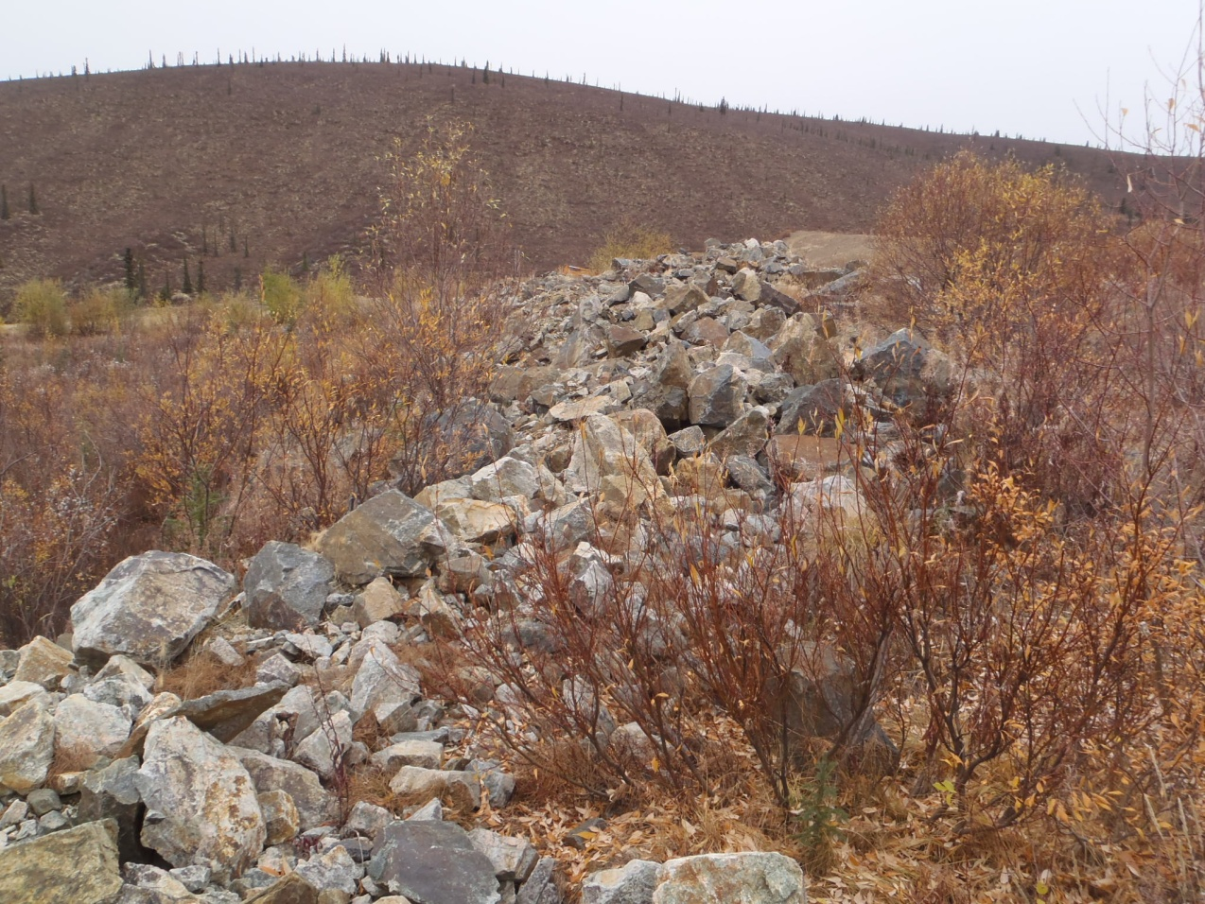
Photo 7: Rip Rap stockpiled near tailings dam and diversion channel
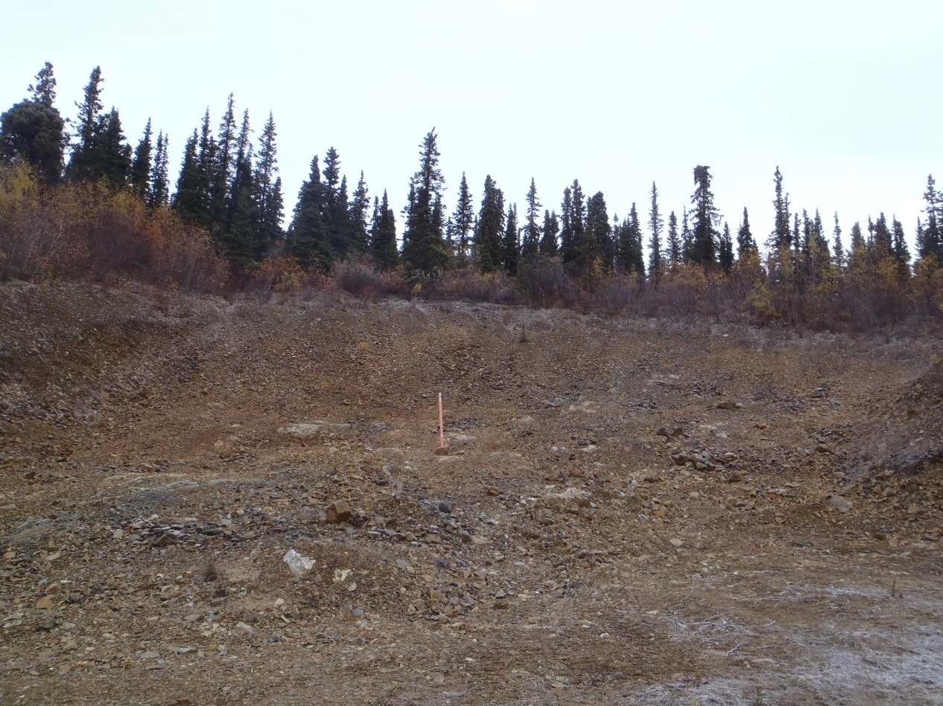
Photo 8: One of the two shale/gravel borrow pits near the tailings facility

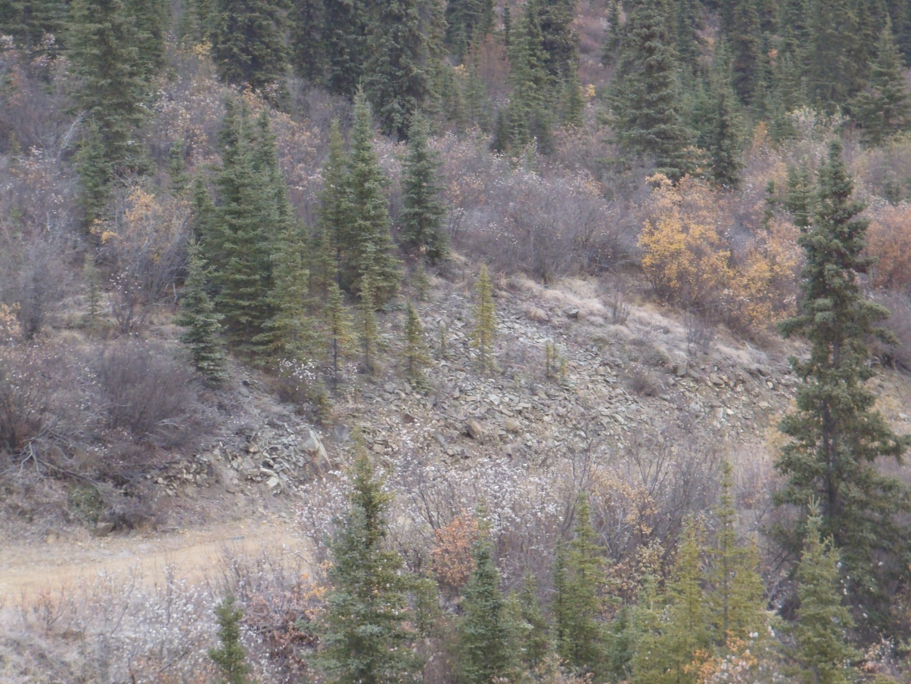
Photo 9: Gravelly soil in road cut at head of Pony Creek

EBA. 2003, “Construction Report Mount Nansen Seepage Control Dyke and Spillway Upgrading”, Report submitted to Department of Indian Affairs and Northern Development, Report number 0201-00-14618, March 2003.

