Field Memo
To |  | Renata Wood
From |  | Shane Magnusson |  | Reviewed By: | Renata Wood
Tel |  | 604-294-3811 |  | AMEC File No. | VM00605
e-mail |  |  |  | cc
Date |  | 06 March 2014
 | Subject |  | Mount Nansen Remediation Project  Summary of Geotechnical Field Observations – Tailings Facility Area, Rev 1

Introduction
AMEC in conjunction with Associated Engineering is currently undertaking a site investigation program at the Mount Nansen Site. Several disciplines are working on characterizing the site conditions in support of designing a remediation plan. This memo was originally written on September 16, 2013 to summarize the geotechnical observations made at the tailings facility during the test pitting and sonic drilling programs. It has been re-issued as Rev 1 to address comments raised by AAM. It has not been updated to incorporate new information available since the memo was originally written. The memo was written in the field with the intent of presenting high level general impressions and observations regarding excavation, trafficability and general understanding of geotechnical conditions. It was not indented to be a complete geotechnical characterization. Detailed discussions of material properties will be included in the site characterization report.

Work Completed To Date
AMEC mobilized to site on September 3, 2013 to carry out the field investigation program. At the time of writing on September 16, 2013, the following components have been completed at the site as shown in Figure 1.
- 3 test pits in the shale borrow area
- 3 test pits in the sand borrow area, to the east of the Tailings Facility
- 3 test pits in the tailings dam
- 7 test pits on the tailings surface
- 4 sonic boreholes on the tailings surface
- 1 sonic borehole through the tailings dam

Test pits were completed with a CAT 324 D excavator provided by Boreal Engineering.

Sonic boreholes were completed with a small tracked sonic rig provided by Dark Side Drilling.

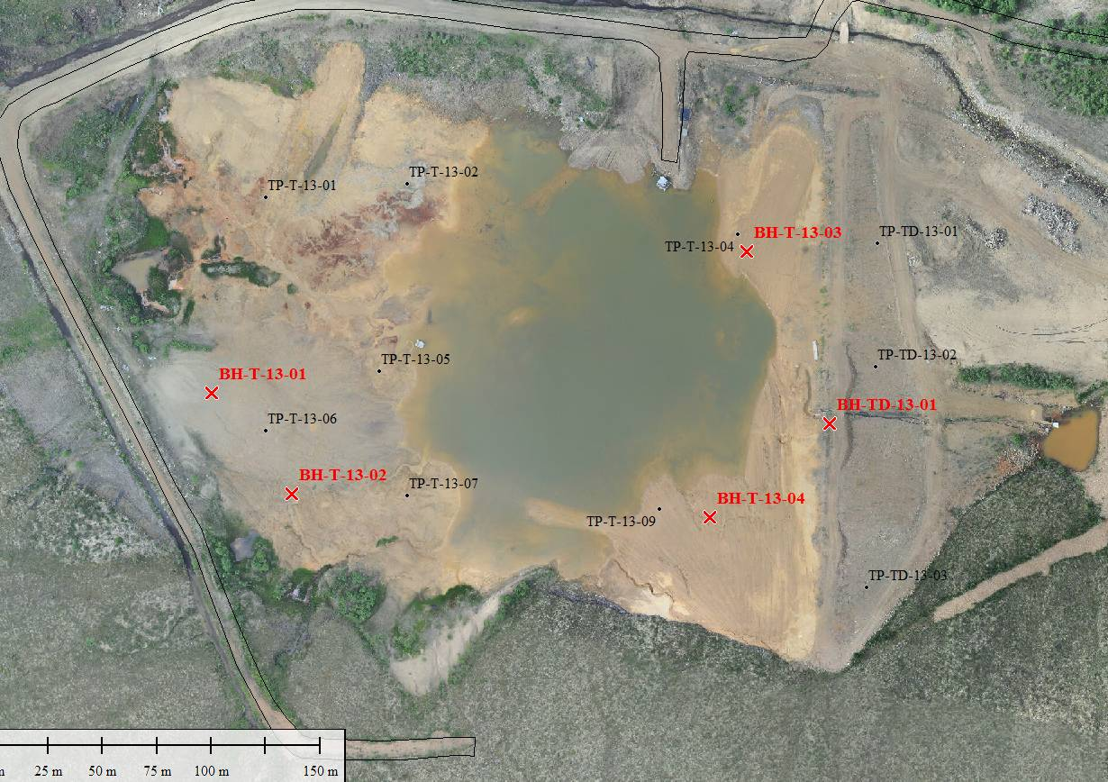
Figure 1: General layout of approximate test locations – note imagery is from 2012.

Tailings Area - excavation conditions
Seven test pits were completed on the tailings beaches to assess the behaviour of the tailings when excavated. In addition the material was sampled and characterized with regards to geotechnical properties. That information is presented and discussed. Observations made during test pit excavation are summarized below. Also some test pits were left open overnight to provide some indication of long term stand-up behaviour. It should also be noted that these conditions are likely reflective of relatively good behaviour because test pits could only be completed where the excavator could traffic (see discussion in Section 4.0)
- TP-T-13-04 and 09 were located on the tailings beach on the east side of the pond and the tailings performed in a similar manner.
  - The test pits were generally damp and dry in the top portion until the water table or original ground/organics were reached (approximately 3-4 m depth).
  - The dry material sloughed in a lot until a round test pit formed. Tension cracks formed at the pit rim and the edges of the pit sloughed in vertical slabs approximately 6” to 12” thick.
  - The pit walls were generally vertical in the top meter or two, then it sloped approximately 2H:1V into the base of the pit.
  - Test pits were completed to about 4 m depth, and the excavation was about
6-8 m wide and round at surface.
    - Left open overnight, the pits enlarged another 1 m in diameter.
  - No water was seeping / observed into the test pits during excavation even though the tailings pond level was above the bottom of the hole.
    - Left open overnight, the pits filled with water.
    - TP-T-13-04 had water at 2.3 m depth 1 day after excavation, with a wet zone at 2.0 m depth
      - The tailings pond was about 10 m away, and 1.2 m below the rim of the pit
    - TP-T-13-09 had water at 1.6 m depth 1 day after excavation, with a wet zone at 1.3 m depth.
      - The tailings pond was 7-10 m away, and 0.7 m below the rim of the pit.

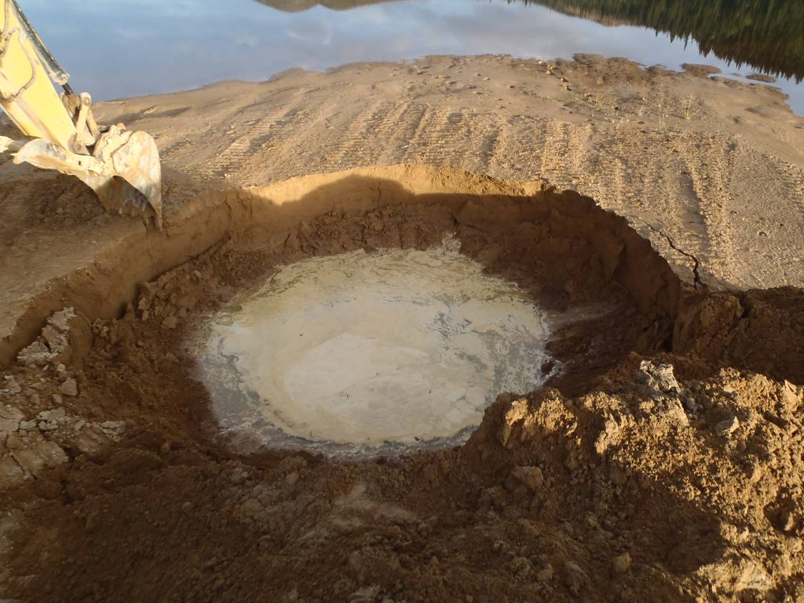
Photograph 1: TP-T-13-09 left open overnight.

Test pits completed on the west side of the tailings facility
- More slimes/fine grained material than on east
- They were completed to a shallow depth as the surface became very soft causing concerns about excavator stability safety
- Tension cracks and lots of sloughing occurred.
- Organics were found at shallow depth
- TP-T-13-01 found:
  - Tailings from 0 to 2.1 m, fine grained on surface, coarser sand grained at depth
  - Below the tailings, native open-graded sand, cobbles and gravel were found with free water, test pit filled with water,
  - Abandoned at 2.7 m for stability
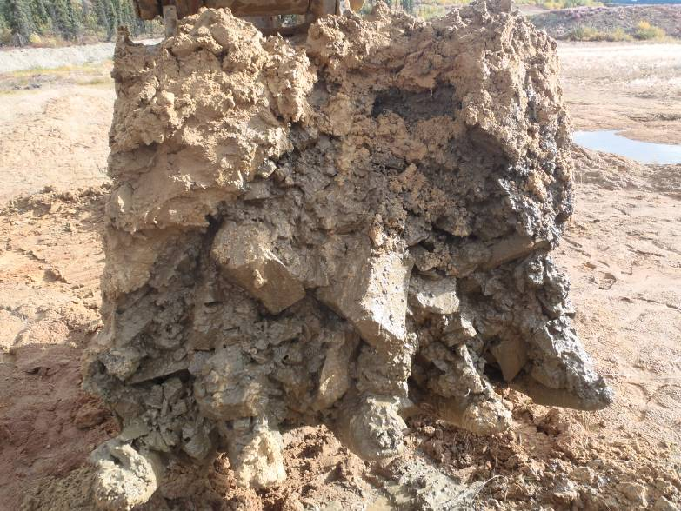
Photograph 2: TP-T-13-01 cobbles and boulders below tailings

- TP-T-13-02 found:
  - Sandy tailings at surface, and silty fine grained tailings below.
  - Organics/original ground was found at depth, then sand
  - Water flowing in to the bottom (seepage near top of native material)
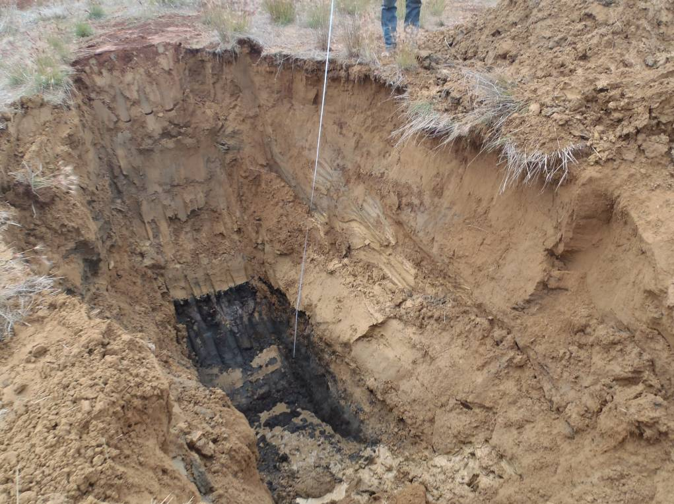
Photograph 3: TP-T-13-02

- TP-T-13-05
  - Unstable surface for access, only reached 2.6 m.
  - Tailings were coarser grained, but very wet.
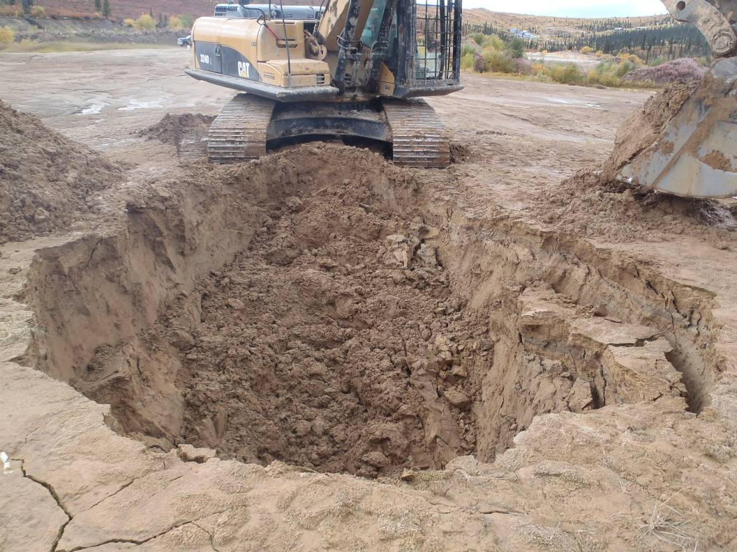
Photograph 4: TP-T-13-05 excavated, lots of sloughing, water entering

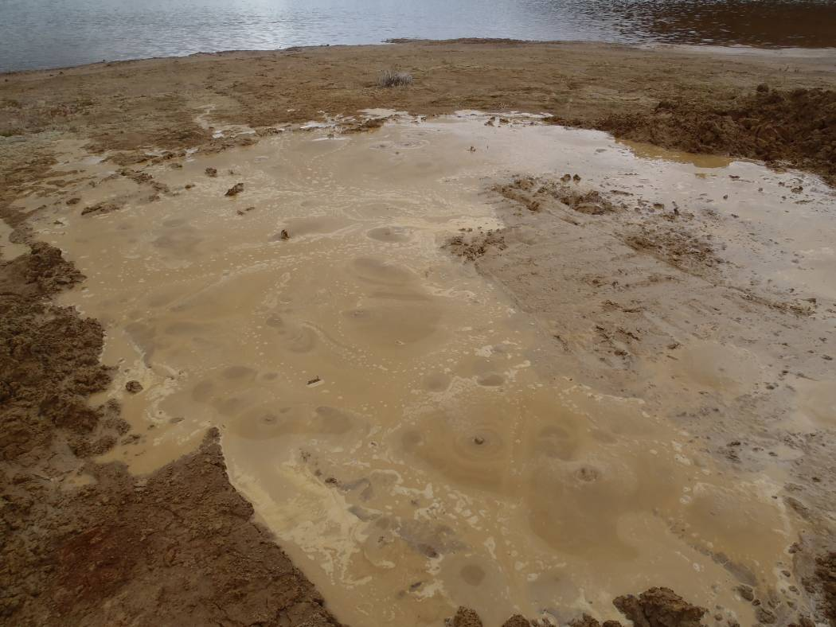
Photograph 5: Sand boils at TP-T-13-05 after backfilling
- After backfilling TP-T-13-05, the excavator tapped the surface with the excavator bucket about a dozen times to liquefy the backfill. Sand boils came up and it flooded with water. Visiting on Sept 15, the tailings were still very soft and difficult/unsafe to walk across the middle.
- TP-T-13-06
  - Tailings to 2 m depth
  - Sand with dark laminations from 2 to 4 m depth.
  - Left open overnight to assess stability
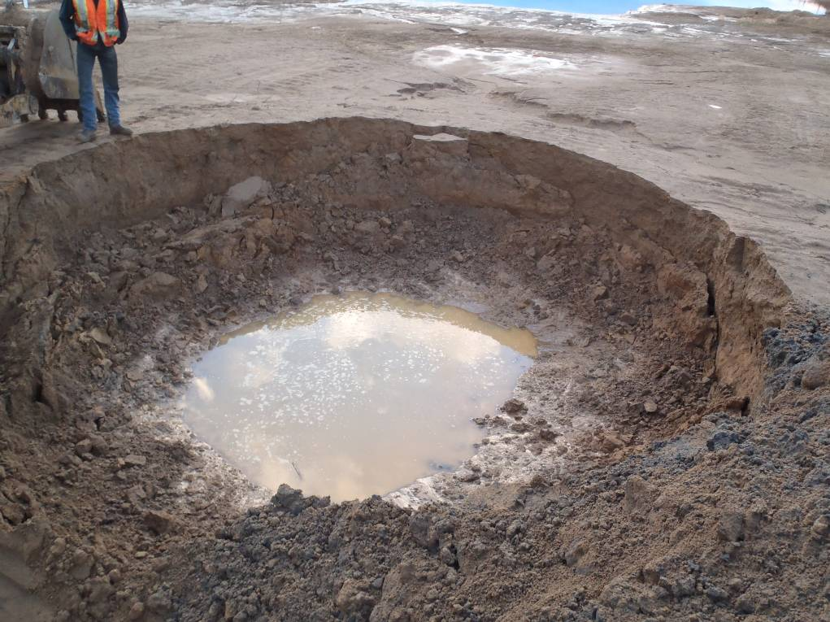
Photograph 6: TP-T-13-06 left overnight had 1.6 m depth to water, 1.3 m depth to top of seepage zone, 7 m diameter.

- TP-T-13-07
  - Tailings encountered in entire TP to 3.4 m
  - Groundwater level about 1.0 m
  - Left open overnight to assess stability. The next day the following was observed:
    - Depth of water from surface: 1.4 m,
    - Depth to saturated zone: 1.2 m,
    - Height of water from the bottom of the test pit: 0.5 m,
    - Depth of the tailings pond from the TP edge: 1.0 m.
    - Test pit diameter about the same, 7 m (i.e. no further sloughing of sides above water table)

A general summary of the observed response of the tailings to test pit excavation is:
- The top meter or so of tailings are above the ground water table. It is fairly dry and stands near vertical when excavated.
- The saturated depth of tailings is where the side walls tend to slump into the pit, and form a slope of approximately 2H:1V.
- Water will usually not immediately seep into the excavation if you are in the tailings unit (not sure of behaviour <8 m from the pond).
- Water will often seep into the excavation from the interface between the native soil and tailings (where encountered). Seepage was observed to be greater on the north side of the facility, probably because there appears to be less permafrost (south facing slope) and the diversion channel/hill slope may be contributing more water to the area.
- The steady state horizontal surface dimension of a test pit is about twice its depth
- When backfilling tailings with saturated material, excess pore pressures are generated and they liquefy. In the coarser beach sand near the tailings dam, usually the next day the surface is drained and stable enough to walk over. If they liquefy to depth in the fine grained tailings, it may take several days for pore pressures to dissipate to allow a machine or person to walk across it.
- The tailings are not very deep in the western portion of the facility, about 2 to 4 m depth.
- No frozen/permafrost tailings were encountered.

The underlying native material below the tailings:
- A dark coloured layer of sand with trace organics is present under much of the tailings facility. It is of variable thickness from 0.1 to over 1.0 m thick.
- Under the dark coloured layer is a layer of fine to medium grained sand, with thin dark laminations, no to little gravel, trace silt to silty, compact to dense, dark grey and wet. This appears to be similar to the sand that was observed in the borrow area – except the colour is brown/grey in the borrow area and dark grey/blue colour below the tailings.
- TP-T-13-01 encountered boulders and large cobbles with free water below the tailings. This was the only TP completed in the northwest corner of the TSF due to trafficability. These large rocks may be from shallow weathered bedrock. It is noted that the diversion channel is just upstream of this test pit location.
- Permafrost was usually encountered in the native unit, if at all. Frozen tailings were not encountered. Permafrost was encountered in locations on the south side of the facility only and typically near the top of the native sand layer, to a few meters below it. Per ASTM D4083 permafrost logging convention – this is an N_{bn} – as having no excess ice that occupies space in excess of the original voids of the soil. The soil is well bonded. The ice crystals are approximately 1 mm in size and are usually seen by crystalline reflections. The ice is usually visible in the organic layers, and not seen in the sand material. The material is well bonded and hard. A hammer and chisel/trowel is usually required to break open the core. When the sonic core comes out of the core barrel, the outer 5 mm is usually melted.
- This material could be considered thaw stable. Left overnight in the core box, it retains its shape. Getting trucked to the core storage area by the camp bunkhouse results in some liquefaction/falling apart, but the core is still intact usually.
- Some zones of ice were encountered with water contents up to 90%. They were encountered at depth 3-8 m below the top of permafrost.
- Core left in the corebox at the drill site for 2 days holds its shape as core. It can be broken by hand, as compact density (thawed).
- Little to no water pooling in the core box (except for the ice-lens pieces)
- Core transported to the core racks at the bunkhouse (a few kilometres along a gravel road) resulted in a few pieces liquefying. Generally ¼ of the core from BH-T-13-01 liquefied. These pieces were
  - Saturated tailings below the water table
  - Some pieces of thawed sand. These were generally saturated and had high amounts of water to begin with. The top of each Sonic drill run usually has a higher water content, and these pieces liquefied.

Tailings Area: Trafficability
Trafficability was assessed by observing the response of the tailings beach to a CAT 324D tracked excavator walking across the tailings surface. In addition observations were made during pickup truck traffic, drill rig traffic and foot traffic. Generally:
- The coarser grained the tailings, the better they performed.
- The higher the elevation above the tailings pond (even a decametre), the better they performed for walking on.
- Figure 2 below with the aerial image approximately reflects the size of the pond at the time of trafficability. Test pits around the pond perimeter were completed as close as possible to the pond as the excavator could safely walk around.
- The tailings beach close to the tailings dam performed the best for trafficability.
  - Pickup trucks were able to drive approximately half way from the edge of the facility to the edge of the pond.
  - After several passes on the upper beach areas with the excavator the tailings surface remained firm with minimal rutting.
- The northwest corner is very soft.
  - Higher areas (maybe 6” higher) with horsetail/fireweed vegetation were firmer, and that’s where the test pits occurred.
  - Tailings are finer-grained and saturated. The excavator had difficulty with stability at the rim of the test pits. The excavator sank until the bottom of the undercarriage hit the ground.
  - After one or two passes with the excavator, the ground was rutted and soft. Unsafe for additional equipment passes.
- The mid-area on the west side (marked as marshy on the map) is probably the most soft.
  - A small creek/trickle of water flows in this area, probably from the interceptor ditch and/or the Dome Creek diversion channel or possibly as result of shallow groundwater seepage.
  - The area has grasses on it, and areas of red coloured tailings/oxidation
  - No vehicles attempted to cross this area, even walking on foot was dangerous.
- The Southwest corner where the 2 drill holes were located was fairly firm on surface, however drilling did result in softening of the tailings and did limit the depth of the investigations.
  - Coarser-grained tailings were present here, and the area is raised
  - Pickup trucks could make it up to BH-T-13-01, but the soil was dry and loose, required 4WD, and that is probably as far as a pickup truck could make it.
- The peripheral edge of the Southwest corner (in yellow) was marginal for the excavator
  - Large, deep tracks were left in the sand, and the tailings surface was soft when walking on foot in the tracks
  - A few passes with the excavator is probably the maximum amount of traffic.
- Areas within about 5 m of the tailings pond (where it has recently lowered in water elevation) are very soft, and walking to the water edge is difficult.

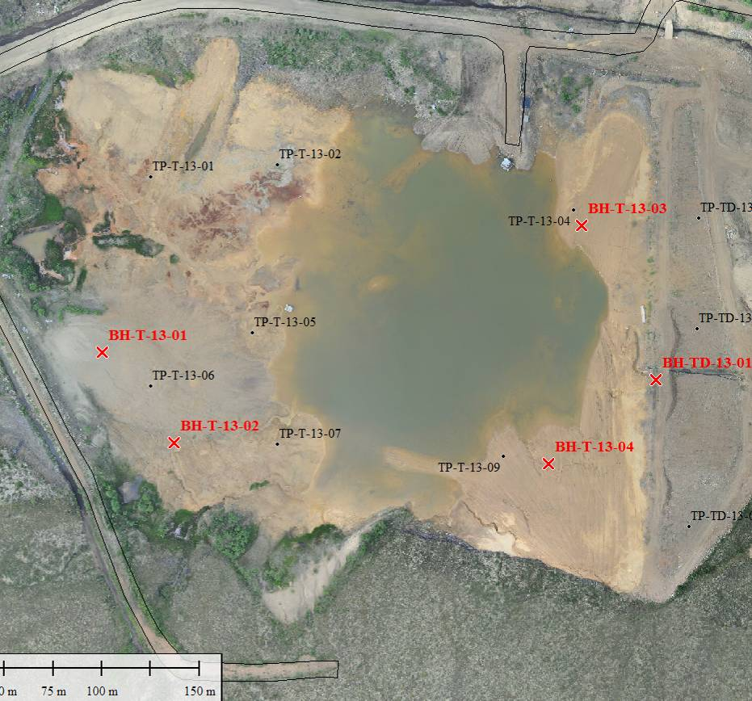
Very marshy here!
Figure 2: Summary of tailings beach trafficability observations

Note:
- Green outline indicates firm areas where the excavator and sonic drill could make it safely.
- Orange areas are marginal, where the excavator had difficulty accessing.
- Areas outside these green and orange areas are very soft, where walking on foot was deemed marginal, and machinery did not walk around.

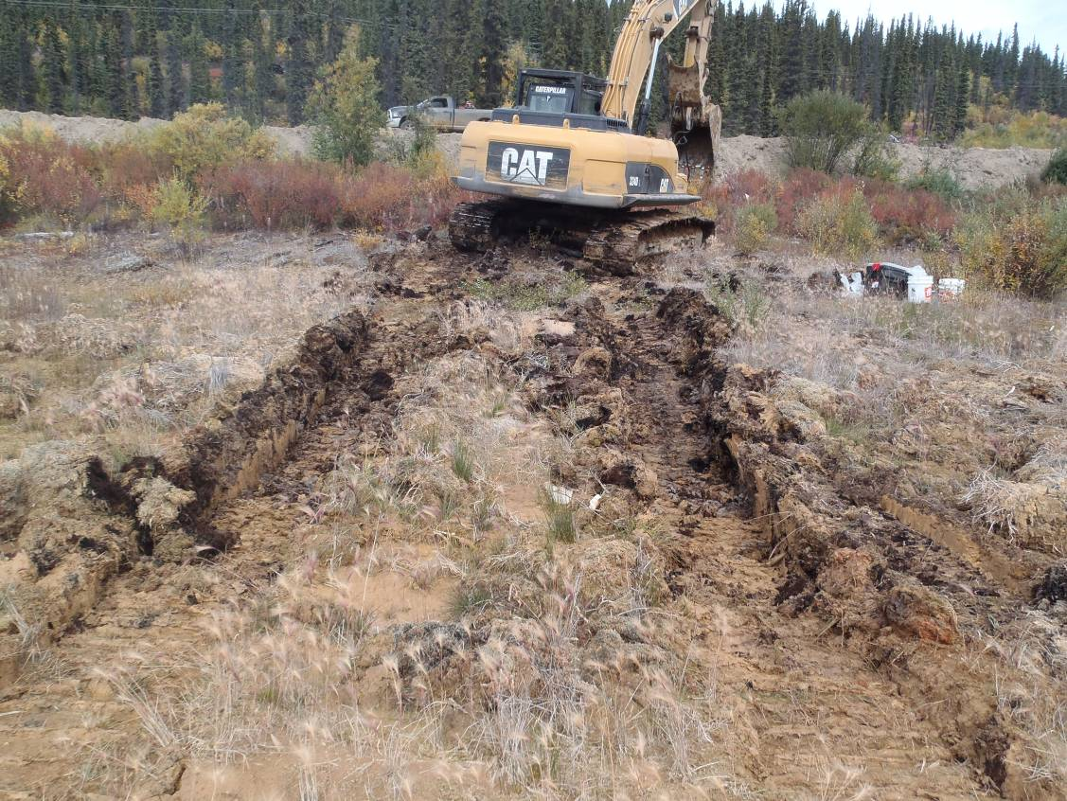
Photograph 7: Excavator walking from TP-T-13-02 northward to the access road.

Tailings DAm
Three test pits were completed on the downstream face of the dam, approximately 5 m vertically below the crest of the dam. One borehole was completed on the crest at the deepest part of the dam (see Figure 3).
- TP-TD-13-01 was completed on the northern portion of the tailings dam, at its lowest height.
  - About 1 foot of rock armouring was present
  - Immediately below the armouring, sand similar to that observed in the sand borrow was present. Thin laminations were present near surface too.
  - This portion of the dam appears to be native material, with little dam construction completed (or at least at the elevation of the test pit). The elevation matches the neighbouring borrow area. Part of the downstream face of the dam appears to have been formed by excavation and the material was probably used for other parts of the dam, resulting in the 2.5H:1V face.
- No permafrost encountered in the test pits in the mid to northern portion of the dam. This is the south facing portion of the dam, receiving more sunlight compared to the south end of the dam.
- TP-TD-13-02 hit native sand at 2 m depth, and did not hit permafrost. No organics noted.
- TP-TD-13-03 hit organics at 4.5 m depth for 0.3 m. Then native sand to depth. Potential permafrost at 6 m depth. No groundwater intersected.
- BH-TD-13-01 was located on the tailings dam crest, at the maximum height of the dam.
  - Sand fill to 17 m depth.
  - Groundwater table at 12 m
  - 17 to 25 m is sand with organic laminations. No thick layer of organic root mat from OG
  - Permafrost at 22 m depth
  - Drilled to 25 m, no well/ instrument install.
- The test pit observations are consistent with the understood tailings dam construction; the organics were stripped on the north side of the dam, until somewhere between BH-TD-13-01 and TP-TD-13-03 (see Figure 3).
- Permafrost was observed in the southern part of the dam below the tailings dam, a few meters below the original ground surface (see Figure 3). Classification is Nbn. No permafrost noted in the test pits on the northern part of the dam. This appears consistent with the geophysics survey results.
- The groundwater table is at a low elevation through the dam. Only the borehole in the middle of the dam intersected groundwater at a depth of 12 m (approximately 5 m above original ground).

Approx extent of permafrost encountered
Approx area of organics not stripped
Figure 3: Summary of observations in tailings dam investigations

Sand Borrow
Test pits were completed in the sand borrow to the east (downstream) of the tailings facility. Over the depth and spatial extent observed, the sand is consistent in characteristics.
- The sand is characterized as being fine to medium grained, with trace silt, grey to brown, damp.
- Permafrost was encountered at approximately 4 to 5 m depth in TP-BA-13-03 and 04 excavated in the sand borrow area downstream of the tailings dam. Permafrost was not encountered in TP-BA-05 which was excavated to a depth of 5.3 m.
- Trace angular coarse gravel was noted throughout the sand. The gravel was about 25 to 75 mm and gap graded (no fine gravel to coarse sand sized particles observed). The gravel was typically oxidized on surface, and a meta-sedimentary rock.
- The ground water table is approximately at a depth of 4 m.
- Thin (1 to 5 mm thick) dark laminations are present throughout this deposit. Spacing varies from a few millimetres to a few centimetres.
  - Above the water table from test pit observations, these layers appear dark coloured with little to no chemical breakdown/alteration
- Test pit stability was a concern. With the low water table, the loose sand experienced a lot of sloughing. Test pits completed to 5 m generally had a surface diameter of 10 m and round shaped. The top half of the excavation was generally vertical or very steep, and the bottom half slumped in.
- Once the excavator hit permafrost, it was difficult digging (especially at depth). Bucket-tooth marks were visible on the walls. Permafrost was noted to be Nbn.
  - TP-BA-13-03 hit permafrost at 4.4 m depth
  - TP-BA-13-04 hit permafrost at 5.3 m depth
  - TP-BA-13-05 potentially hit permafrost at 5.3 m, no sample retrieved.
- The excavator was unable to access the planned locations for TP-BA-13-03 and 04 in the sand borrow area upstream of the tailings facility. These are scheduled to be completed with a hand auger or hand test pits with a shovel. Based on observations of the material on surface and past project documentation, it is expected that this west borrow area is similar to the east borrow area.

