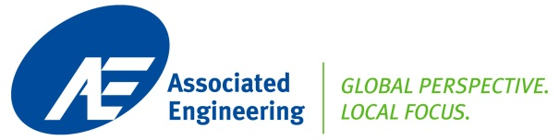
MEMO | Date: | October 18, 2013 | File: | 132333
 | To: | AMEC: Brian Geddes, PM,  AE: Steve Bartsch, PM & Ray Korpela, Lead
 | From: | George De Ridder, P.Eng.
 | Project: | MOUNT NANSEN REMEDIATION PROJECT
 | Subject: | SITE INSPECTION OCT 3-4 2013 REPORT
Date and Purpose of Inspections
Inspections were conducted on Thursday, October 3 and Friday, October 4 of the remaining buildings, to closely identify:
- structural configurations
- content of buildings
- materials and potential breakdown of deconstructed stream (recycle, salvage or disposed)
- potential hazardous materials

Team
George de Ridder of AE, accompanied by SUMAS Environmental team of three, lead by Alan Avery.

Work Plan
The pre-developed Work Plan by AE of September 2013 was followed; however, some smaller buildings were already demolished.

All buildings were accessible on foot, interior and exterior. No inspections were done on roofs requiring a ladder.

Preliminary conclusions
- Mill Complex & Workshop:
Structures were in good-to fair condition with high potential of re-use (salvage) of heavier steel components, expected 75+%. Advanced corrosion was present to a limited extent on columns and roof purlins in the zones between agitator tanks and ball mills. Steel cladding generally poor-fair, with corrosion near floors and on ceilings and ice damage on overhangs and gables. Expect 20-30% salvage/reuse, balance to recycle.

The primarily steel framing is of good design and general good condition, painted (possibly but unlikely lead & pcbs?) cladded with galvanized steel sheeting, including limited quantities of tin sheeting on walls and possibly also on roofs.

Interior of the complex is highly congested with residual process equipment: steel tanks, wood stave tanks, steel and PVC and HDPE pipes, mezzanine flooring, cable racks, electrical boards, instrumentation and cabling, racking, wood office cubicles and tool stores. Some cable racks were stripped of heavier gauge cabling.

Large steel agitator tanks were drained but not cleaned from residual sludge. These tanks appeared to be second-hand units with old scratch damage and worn coatings. Expect low potential for salvage; however, 100% recycling as scrap. Building shell will have to be removed before deconstructing the larger tanks.

Large wood stave bins for raw materials feeding the ball mills have potential of salvage or recycle of the wood. Some smaller wood stave mixing tanks are severely saturated with wet sludge and will probably be classified as hazardous disposed waste.

Base concrete floors are staggered in three mezzanine steps with retaining walls. Multiple machine bases and tank pedestals in concrete appears to be contaminated with oil and process spillage (arsenic?). Testing is planned by SUMAS to assess the hazardous potential of the sludge spillage on concrete base floors.

It is possible that ground is contaminated under the building footprint of the heavy process zones. Groundwater was seeping into the west tank zone of building.

The most feasible deconstruction method appears to be systematic dismantling for salvage and recycling of materials, largely steel and concrete. Roofs and wall cladding go first to open up for the retrieval of tanks and miscellaneous process equipment. Primary frames go after dismantling of secondary girts, purlins and flooring. Large tanks go after complete removal of the building shell, followed by demolition of the concrete floors, machine foundations and lastly retaining walls. We expect many of the concrete can crushed on site and be recycled for road building and rehabilitation of the site, depending on the hazardous substance assessment.

- Bunkhouse, Camp Shed and Cookhouse
The wood framed, wood sided and gypsum board interiors with steel cladded roofing will likely be deconstructed by removing steel roofing and interior fittings (doors, windows, bathroom and kitchen) for recycling and disposal (gypsum) before push-over demolition with a machine. Bunkhouse has salvageable laminated beams in the floor structure.

Woods will likely be recycled with low potential of disposed waste on site. Small quantities of concrete pad foundations are expected to be recycled as crushed fill on site. Potential hazardous substances are lead paint and creosote in the floor support structure, and pcbs in fluorescent light units. The buildings were energized with electric power.

- Small Pump Houses
Wooden constructions for the Victoria Creek wellhouse, the seepage pond pump and the electrical transfer station will be pushed over after removal of electrical and mechanical fittings for recycling. Small amount of concrete and steel components could be recycled, with low potential of hazardous substances involved.

Further work for Phase 1
The available drawings of the mill building and sketches of the wood buildings are not sufficiently detailed and lack dimensions and, therefore, cannot be used to develop reliable material or quantity estimates. A follow-up Stage 2 inspection and survey is recommended, as per our Work Plan. This inspection will include a detail inventory of materials.

The hazard material assessment from SUMAS should include identification of paints and sludge waste on the floors and in tanks of the mill complex. This information should enable realistic estimates of hazardous waste and classifications for recyclable steel, wood and concrete.

PHOTOS

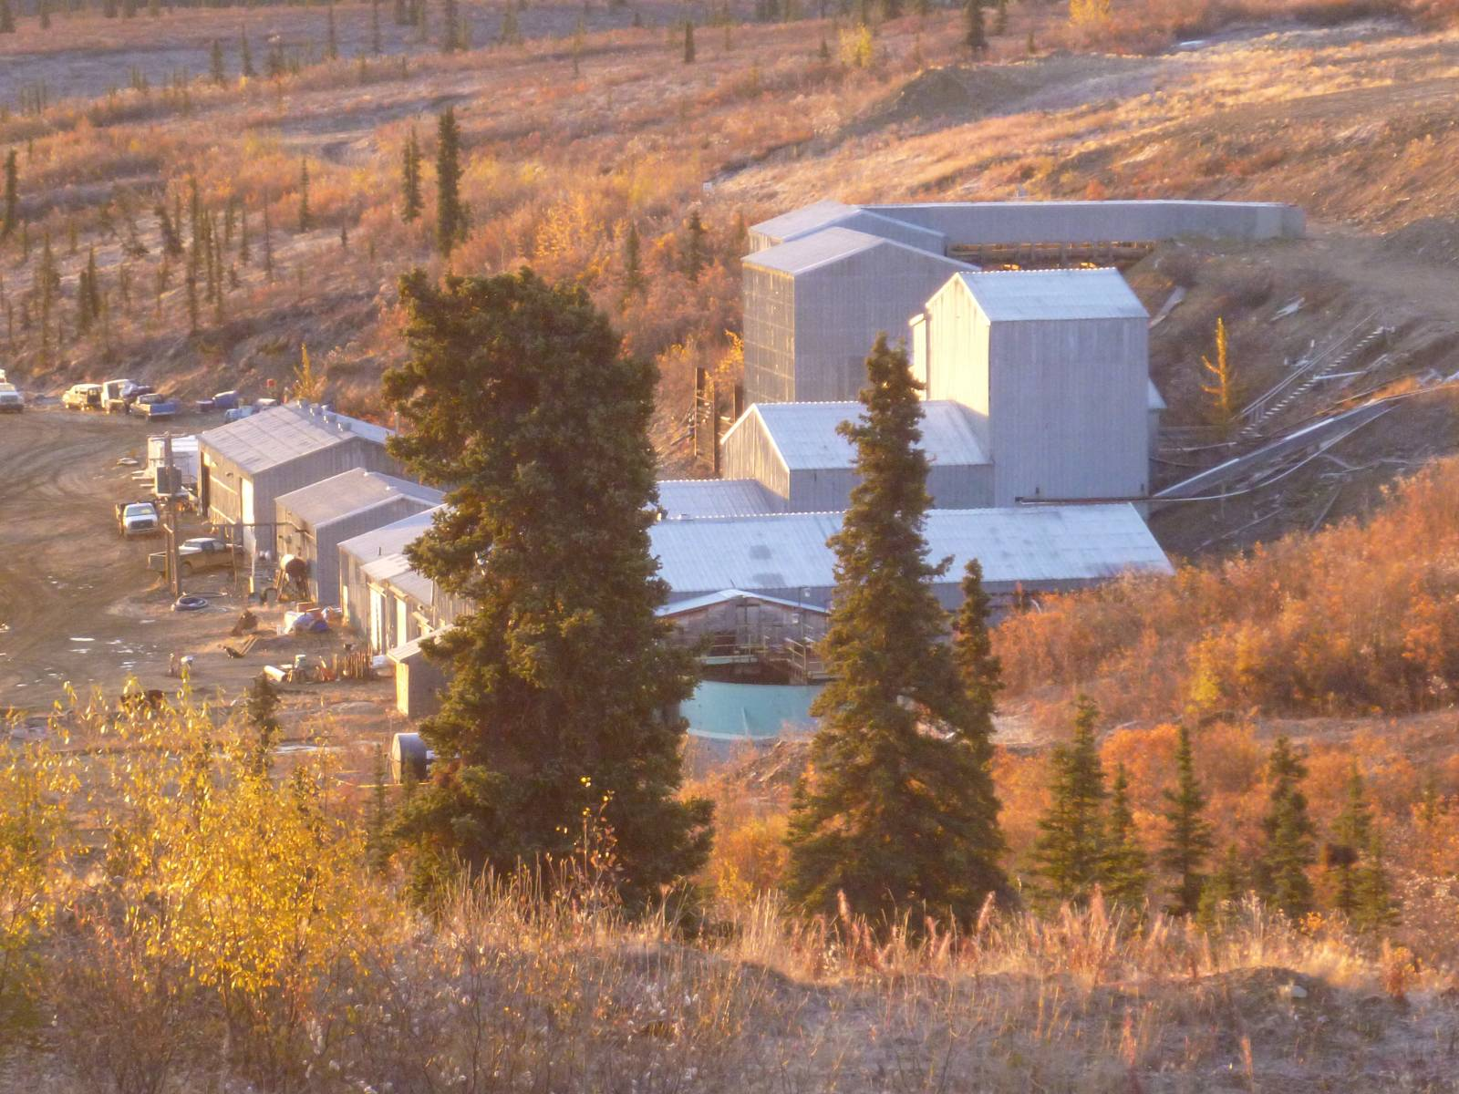
Photograph 1: Mill Complex

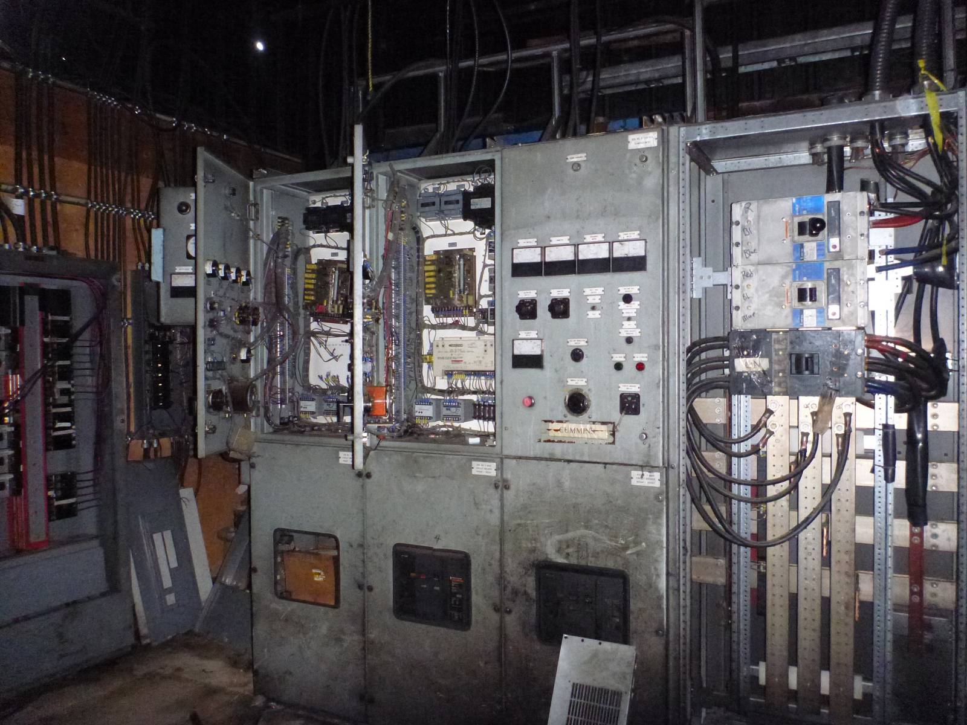
Photograph 2: Electrical Equipment
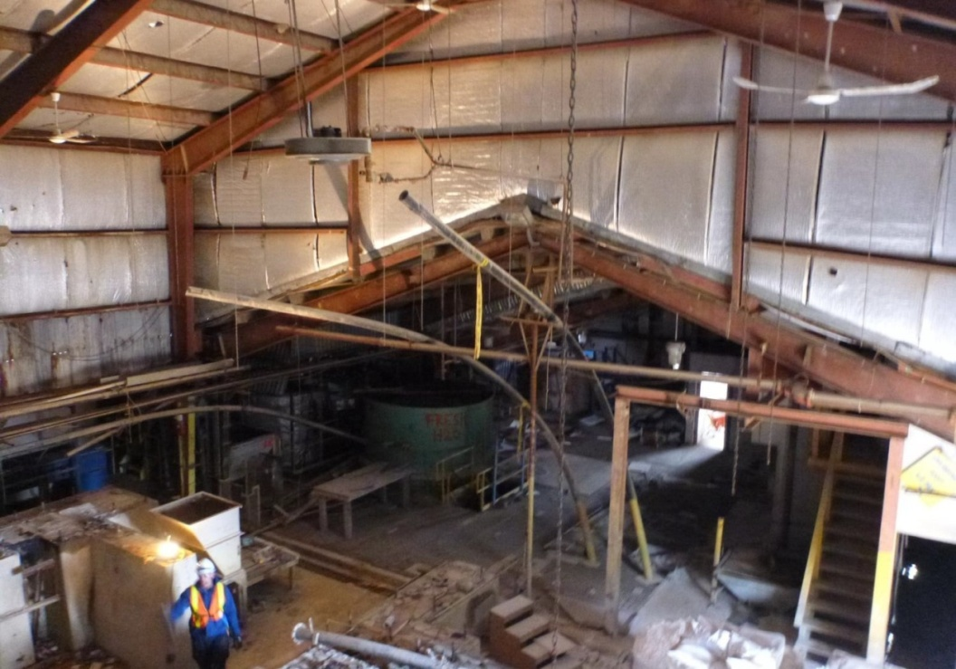
Photograph 3: Ball Mill Zone

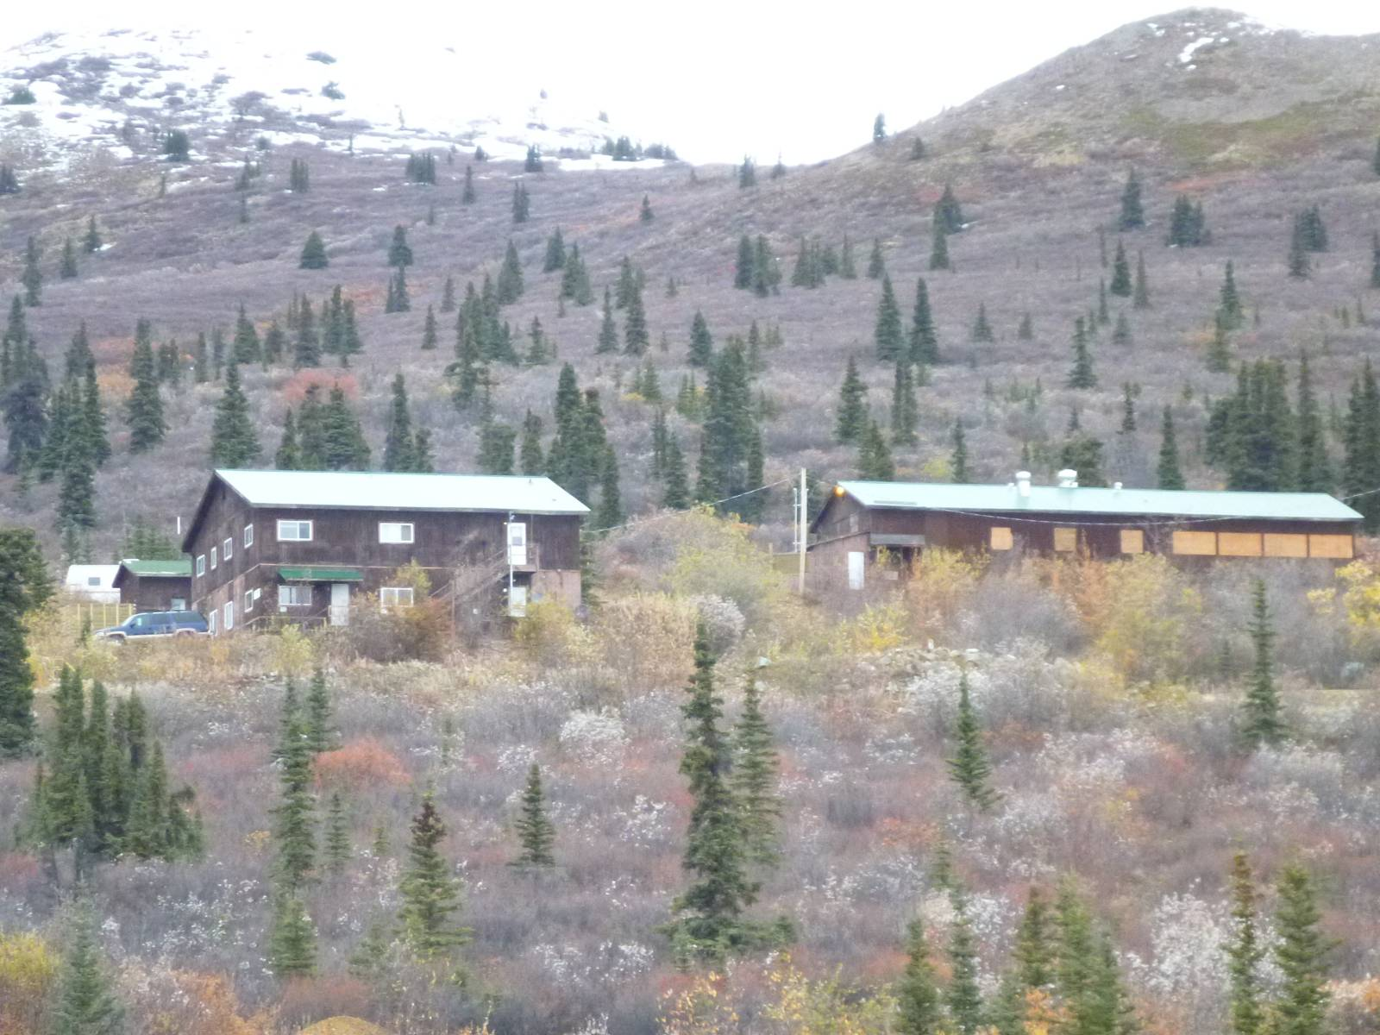
Bunkhouse
Camp Shed
Cookhouse
Photograph 4: Camp Area
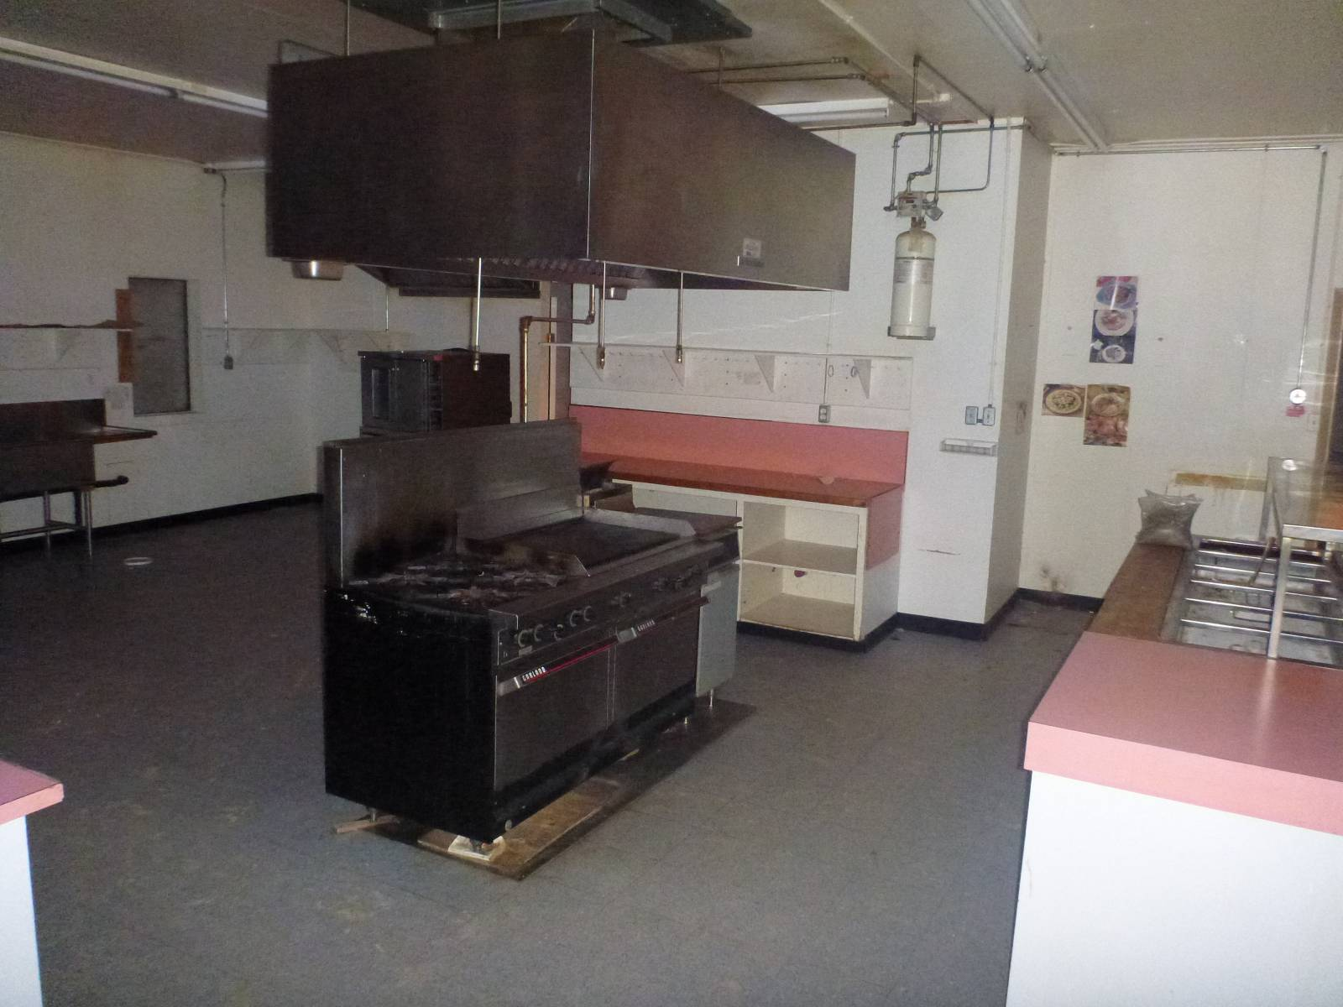
Photograph 5: Cookhouse

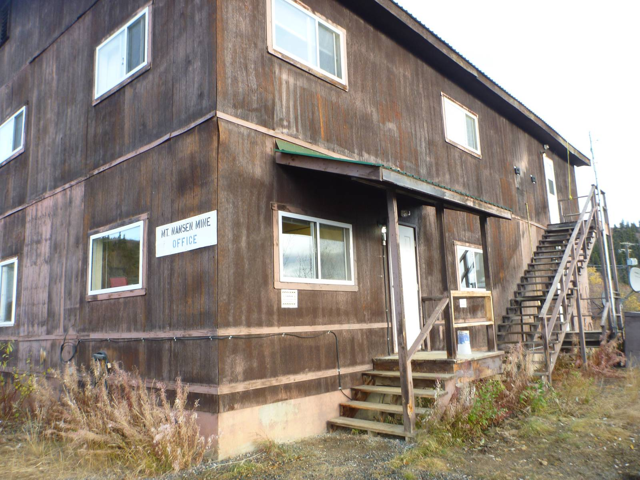
Photograph 6: Bunkhouse
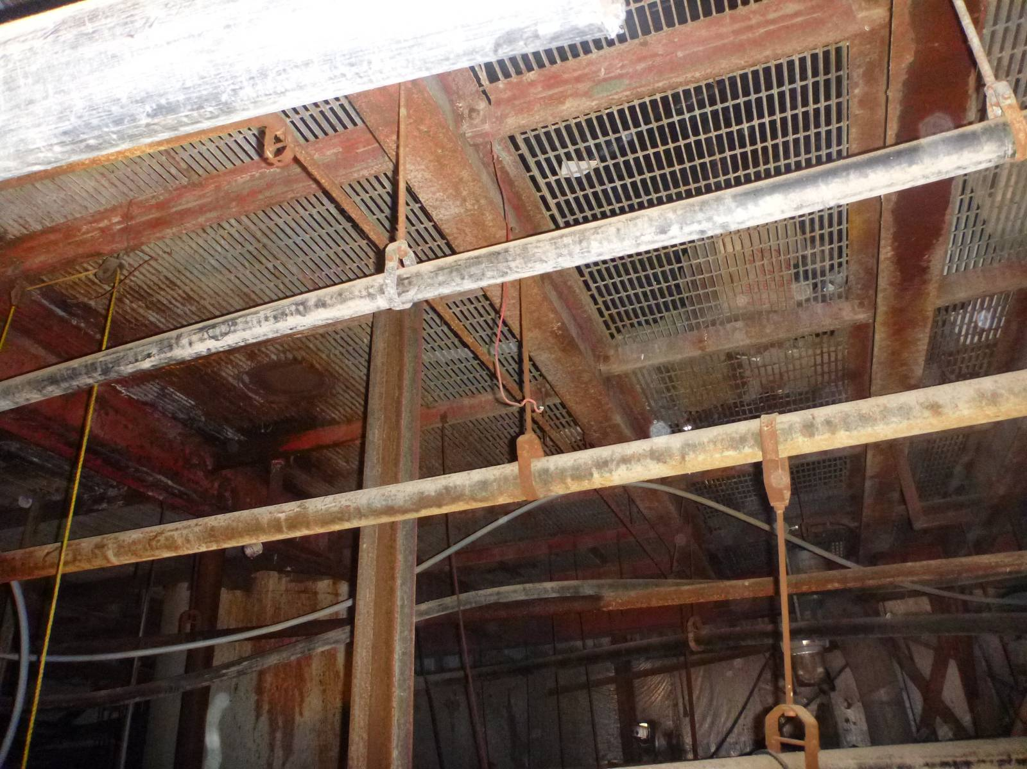
Photograph 7: Steel Mezzanine, Mill

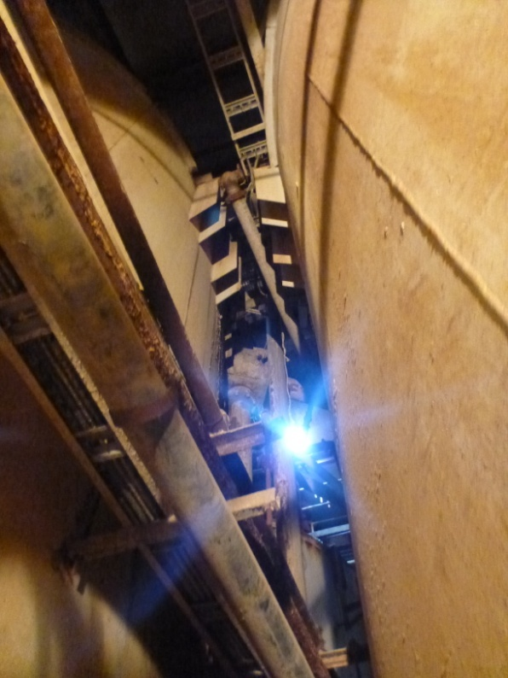
Photograph 8: Agitator Tanks, Mill

