Mount Nansen 2013 Site Investigation

list of photos
Page
Photos of Equipment Used 1
PHOTO 1: Excavator at TP-T-13-01. 1
PHOTO 2: Watching Test Pit Trafficability at TP-T-13-09. 1
PHOTO 3: Sonic Drill at BH-T-13-01. 2
PHOTO 4: Sonic Drill at BH-WA-13-01. 2
PHOTO 5: Slotted Section of PVC Pipe for TSF Standpipes, BH-T-13-04. 3
PHOTO 6: Installed Standpipe for BH-T-13-03. 3
PHOTO 7: Geoprobe Samples with Casing Still Intact. 4
PHOTO 8: CPT Cone Set Up. 4
PHOTO 9: Tracked Rig Set Up for Geoprobe/CPT Drilling. 5
PHOTO 10: Barge Set Up for Geoprobe/CPT Drilling. 5
PHOTO 11: Tripping Out Geoprobe Drill Rods on Barge. 6
PHOTO 12: Staff Gauges on Tailings Pond. 6
Site Overview Photos 7
PHOTO 13: Sand Borrow Area Northeast of TSF, September 4, 2013. 7
PHOTO 14: TSF Surface Looking East, September 5, 2013. 7
PHOTO 15: TSF Surface Looking West from Dam, September 6, 2013. 8
PHOTO 16: Sand Borrow Area West of TSF, September 8, 2013. 8
PHOTO 17: TSF Looking Southeast, September 8, 2013. 9
PHOTO 18: Excavator in Shale Borrow Area, September 8, 2013. 9
PHOTO 19: Excavator in Waste Area TP-WA-13-06, September 9, 2013. 10
PHOTO 20: Open Pit Looking South, September 10, 2013. 10
PHOTO 21: Open Pit Looking North, September 10, 2013. 11
PHOTO 22: Waste Area, Looking North, September 4, 2013. 11
PHOTO 23: Victoria Creek Wellhouse, September 4, 2013. 12
PHOTO 24: Mill Area, Looking Northwest, September 17, 2013. 12
PHOTO 25: Lined Sediment Pond, September 17, 2013. 13
PHOTO 26: Mill Area Looking Southeast, September 17, 2013. 13
PHOTO 27: Sampling Wells on TSF, September 17, 2013. 14
PHOTO 28: Sedimentation Ponds 1 and 2, September 4, 2013. 14
PHOTO 29: Pony Creek Adit Entrance, September 4, 2013. 15
PHOTO 30: Shale Borrow Area for TP-BA-13-08 and Burn Pile, September 4, 2013. 15
PHOTO 31: TSF Diversion Channel and Bridge, September 4, 2013. 16
PHOTO 32: Confluence of Dome Creek and TSF Diversion Channel West of TSF, September 4, 2013. 16
PHOTO 33: Mill Area. 17
PHOTO 34: Tailings Storage Facility. 17

Photos of Equipment Used

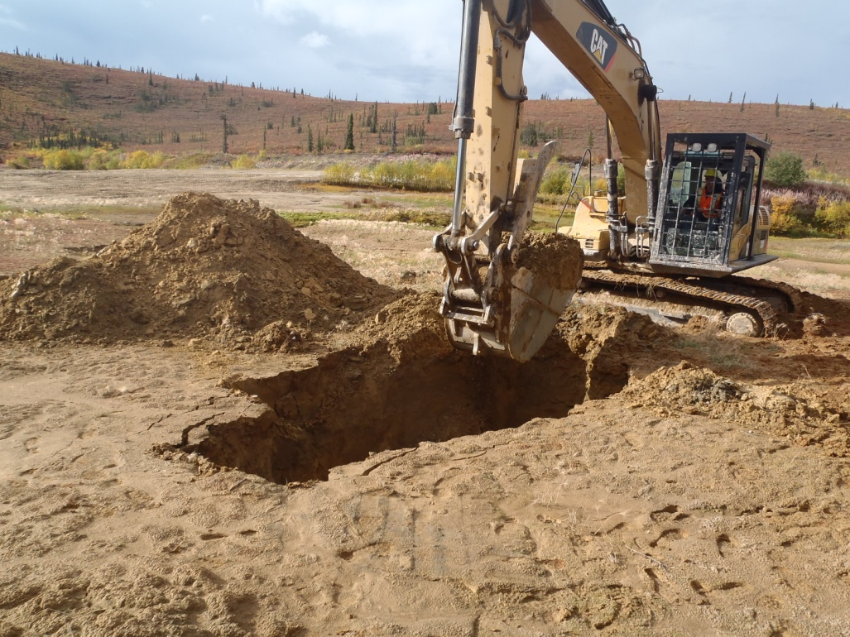

PHOTO 1: Excavator at TP-T-13-01.

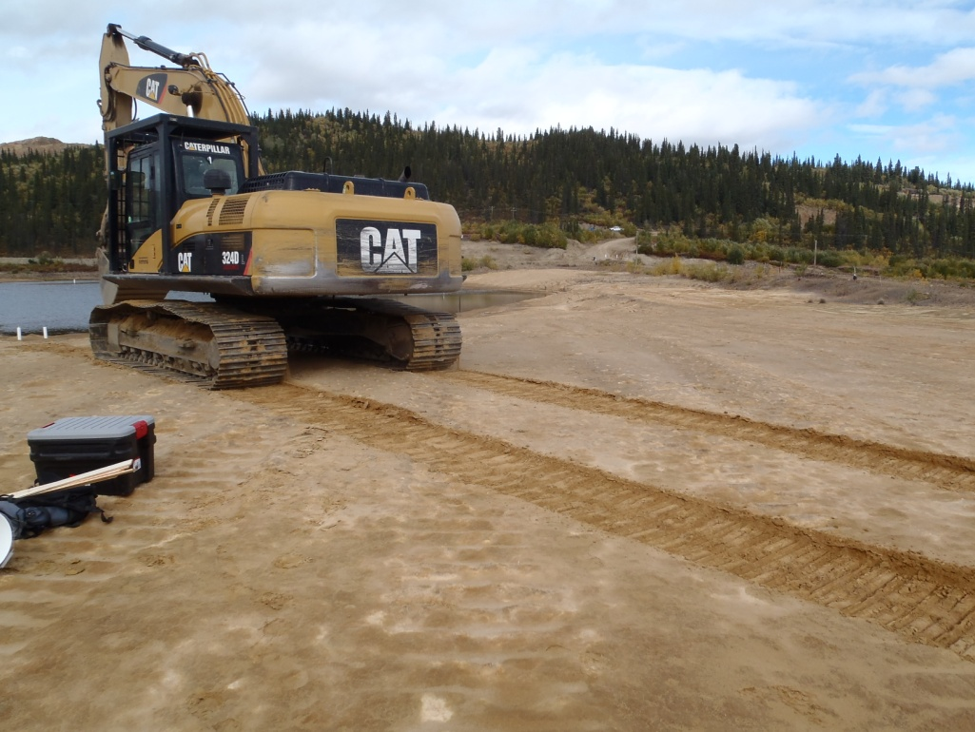

PHOTO 2: Watching Test Pit Trafficability at TP-T-13-09.
Government of Yukon - AAM
Mount Nansen 2013 Site Investigation
Photographs
Logged by: SM | Scale: NTS | Date: Oct 2013 | Project: VM00605E | Page 1

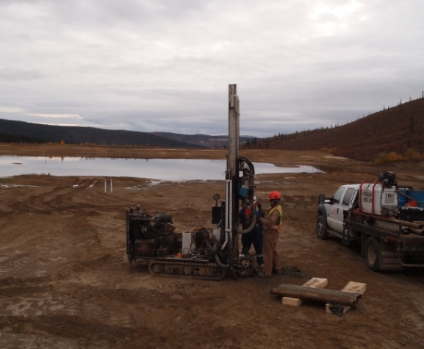

PHOTO 3: Sonic Drill at BH-T-13-01.

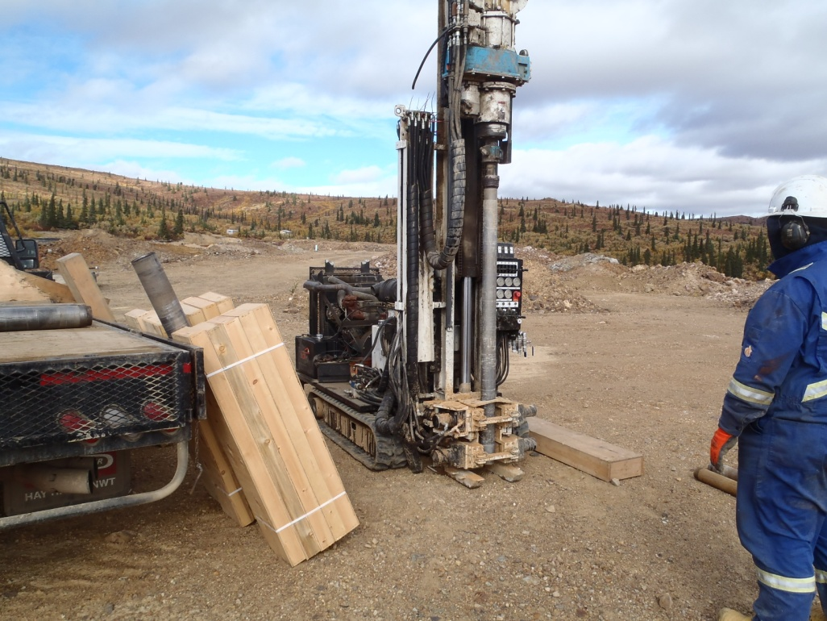

PHOTO 4: Sonic Drill at BH-WA-13-01.
AMEC Environment & Infrastructure |  | Government of Yukon - AAM  Mount Nansen 2013 Site Investigation  Photographs
Logged by: SM | Scale: NTS | Date: Nov 2013 | Project: VM00605E | Page 2

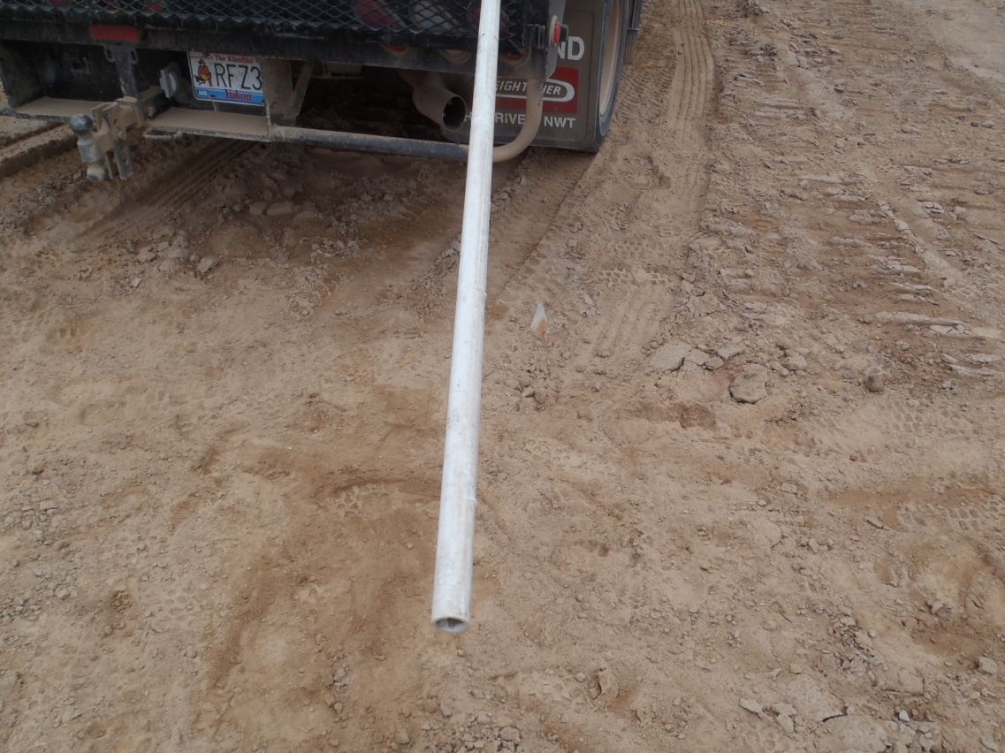

PHOTO 5: Slotted Section of PVC Pipe for TSF Standpipes, BH-T-13-04.

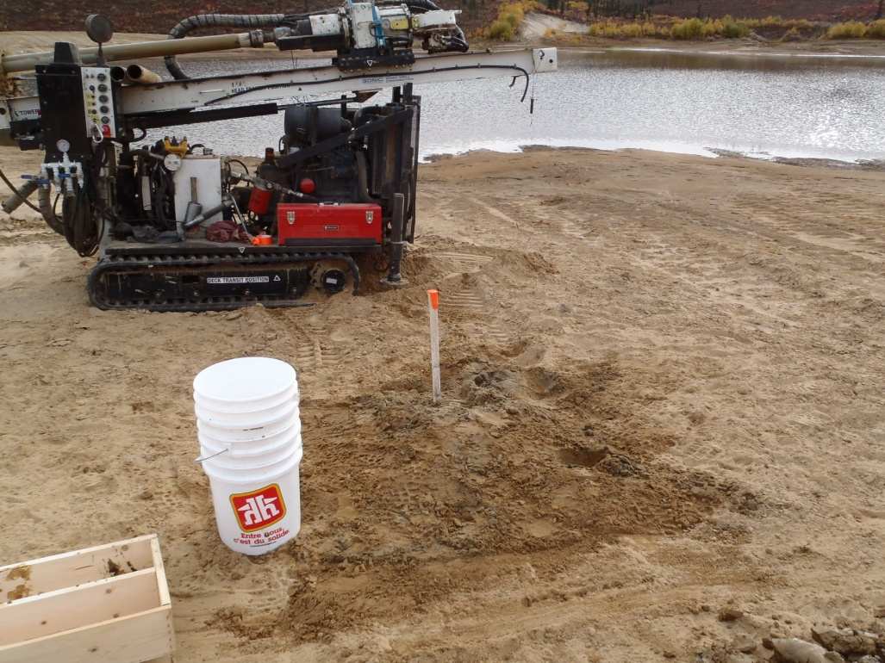

PHOTO 6: Installed Standpipe for BH-T-13-03.
AMEC Environment & Infrastructure |  | Government of Yukon - AAM  Mount Nansen 2013 Site Investigation  Photographs
Logged by: SM | Scale: NTS | Date: Nov 2013 | Project: VM00605E | Page 3

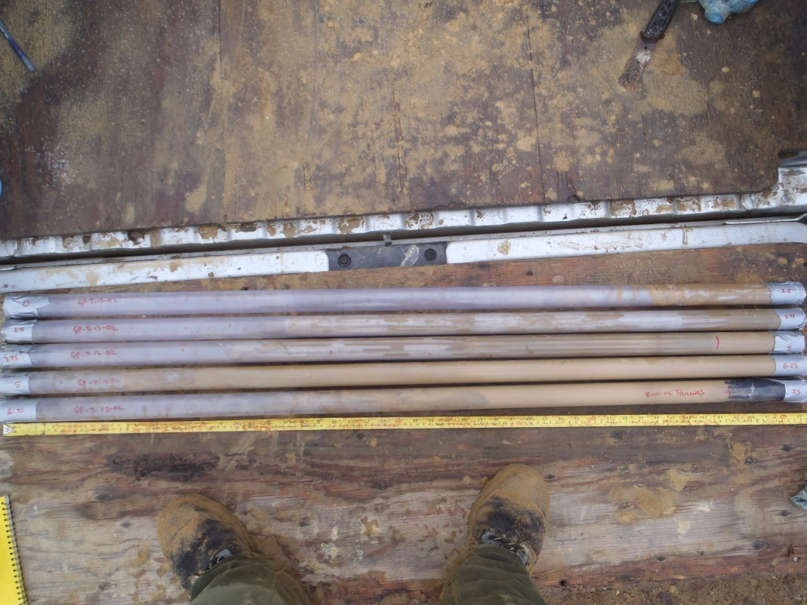

PHOTO 7: Geoprobe Samples with Casing Still Intact.

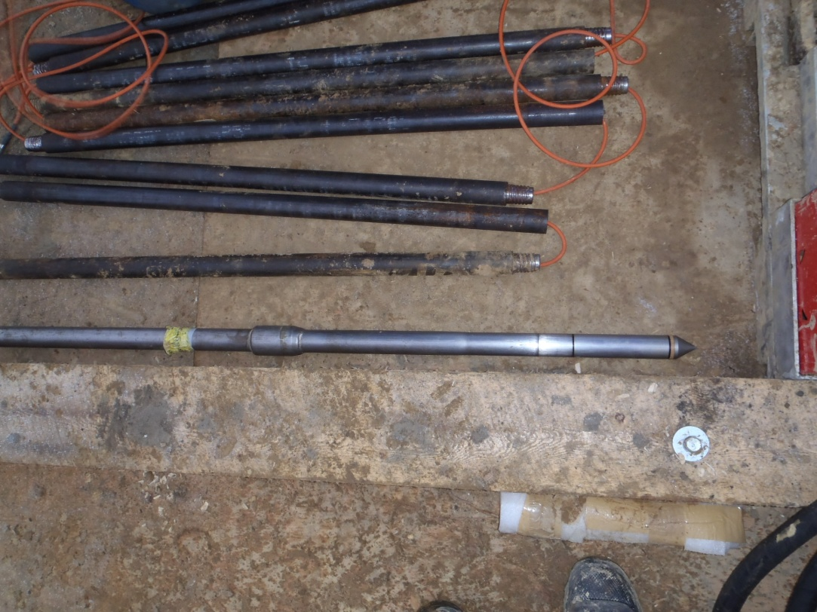

PHOTO 8: CPT Cone Set Up.
AMEC Environment & Infrastructure |  | Government of Yukon - AAM  Mount Nansen 2013 Site Investigation  Photographs
Logged by: DP | Scale: NTS | Date: Nov 2013 | Project: VM00605E | Page 4

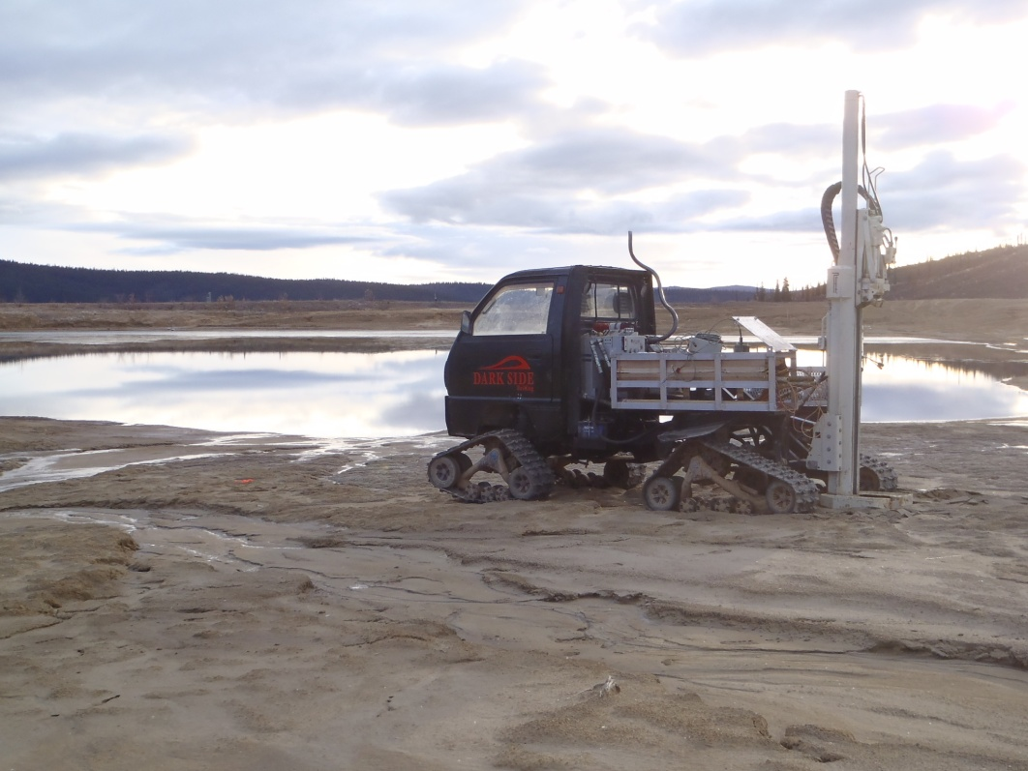

PHOTO 9: Tracked Rig Set Up for Geoprobe/CPT Drilling.

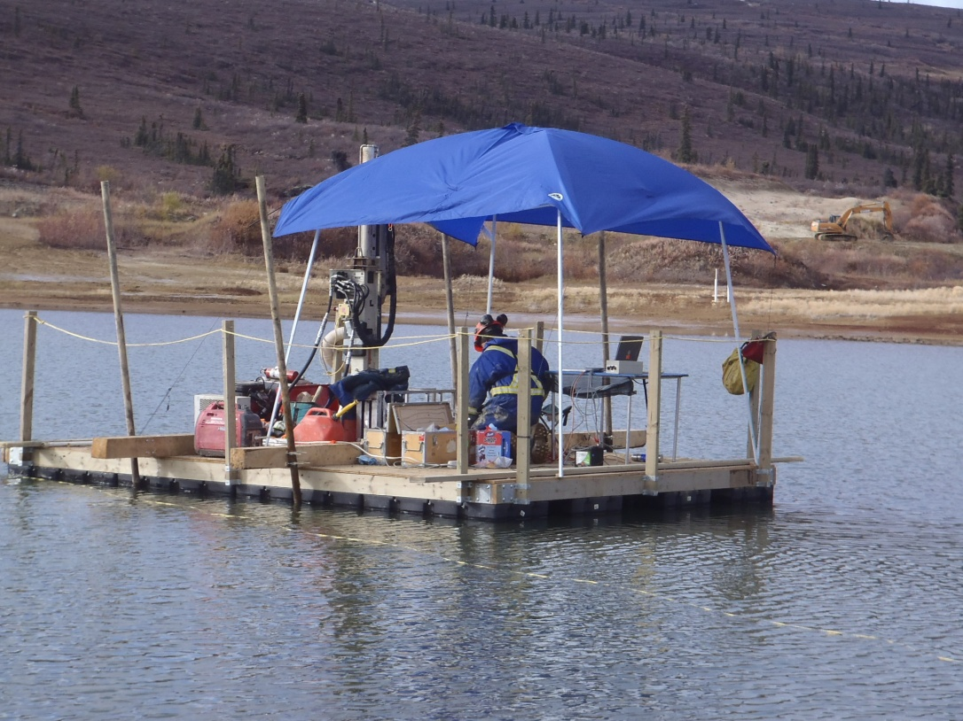

PHOTO 10: Barge Set Up for Geoprobe/CPT Drilling.
AMEC Environment & Infrastructure |  | Government of Yukon - AAM  Mount Nansen 2013 Site Investigation  Photographs
Logged by: DP | Scale: NTS | Date: Nov 2013 | Project: VM00605E | Page 5

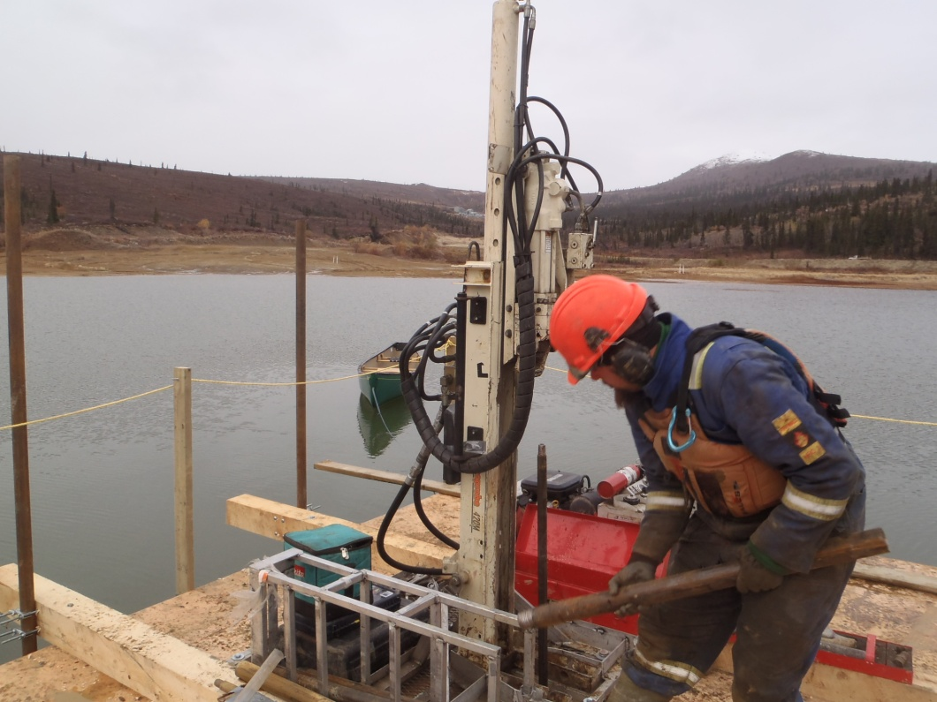

PHOTO 11: Tripping Out Geoprobe Drill Rods on Barge.

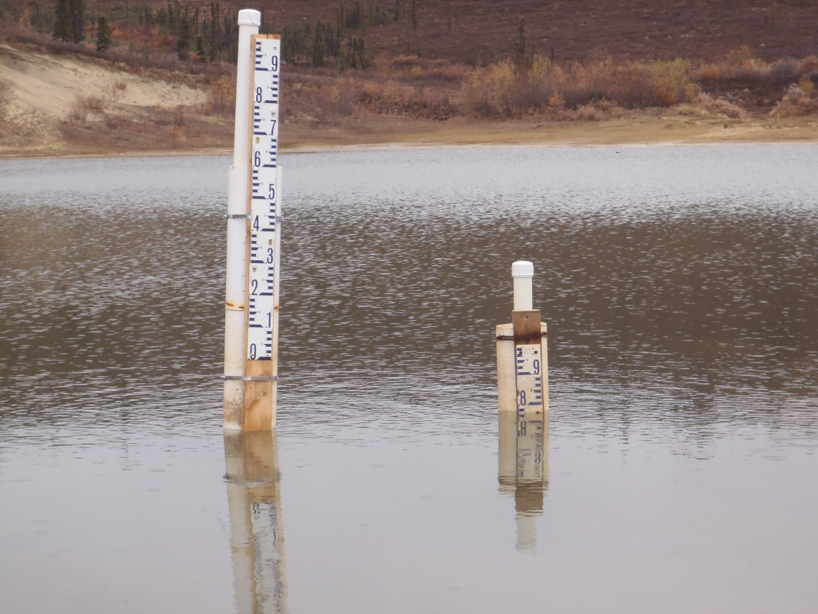

PHOTO 12: Staff Gauges on Tailings Pond.
AMEC Environment & Infrastructure |  | Government of Yukon - AAM  Mount Nansen 2013 Site Investigation  Photographs
Logged by: DP | Scale: NTS | Date: Nov 2013 | Project: VM00605E | Page 6

Site Overview Photos

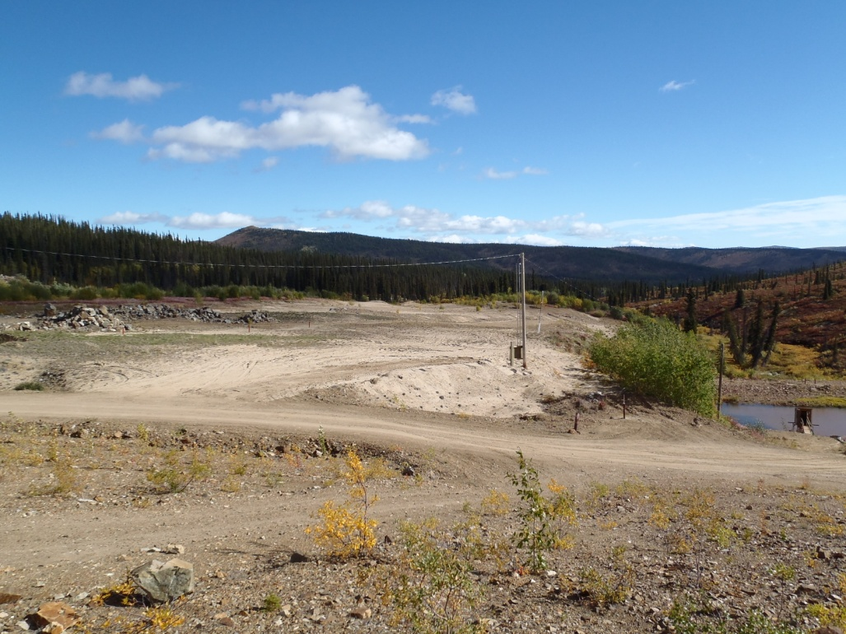

PHOTO 13: Sand Borrow Area Northeast of TSF, September 4, 2013.

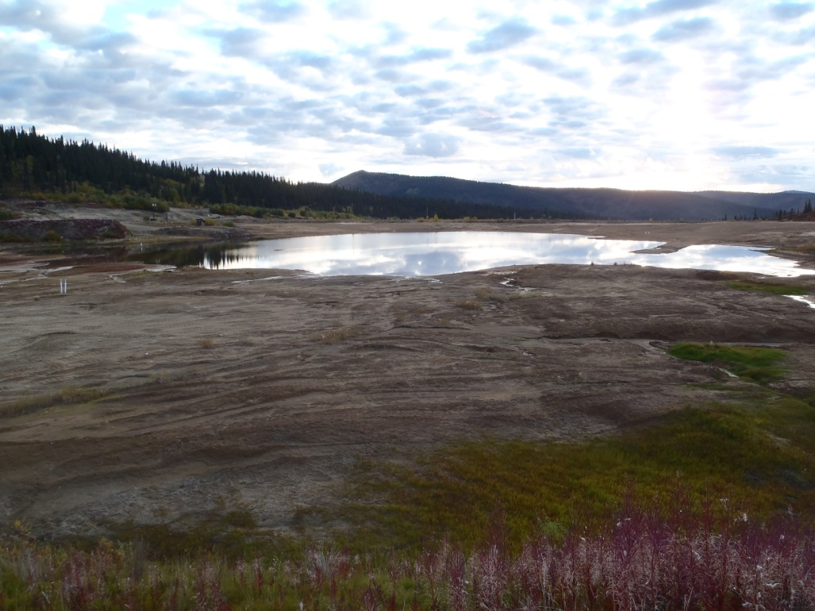

PHOTO 14: TSF Surface Looking East, September 5, 2013.
AMEC Environment & Infrastructure |  | Government of Yukon - AAM  Mount Nansen 2013 Site Investigation  Photographs
Logged by: SM | Scale: NTS | Date: Nov 2013 | Project: VM00605E | Page 7

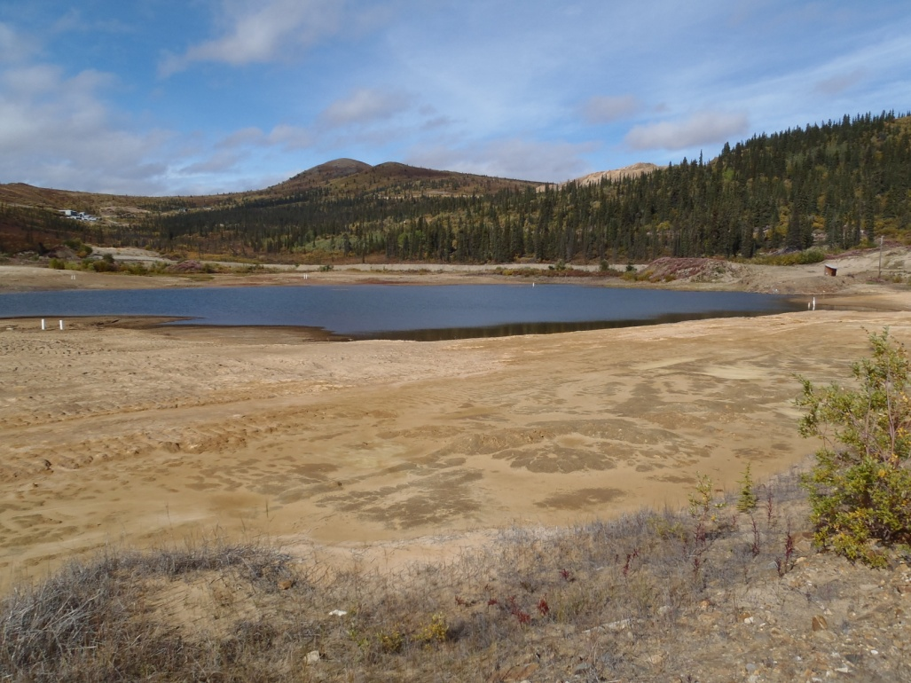

PHOTO 15: TSF Surface Looking West from Dam, September 6, 2013.

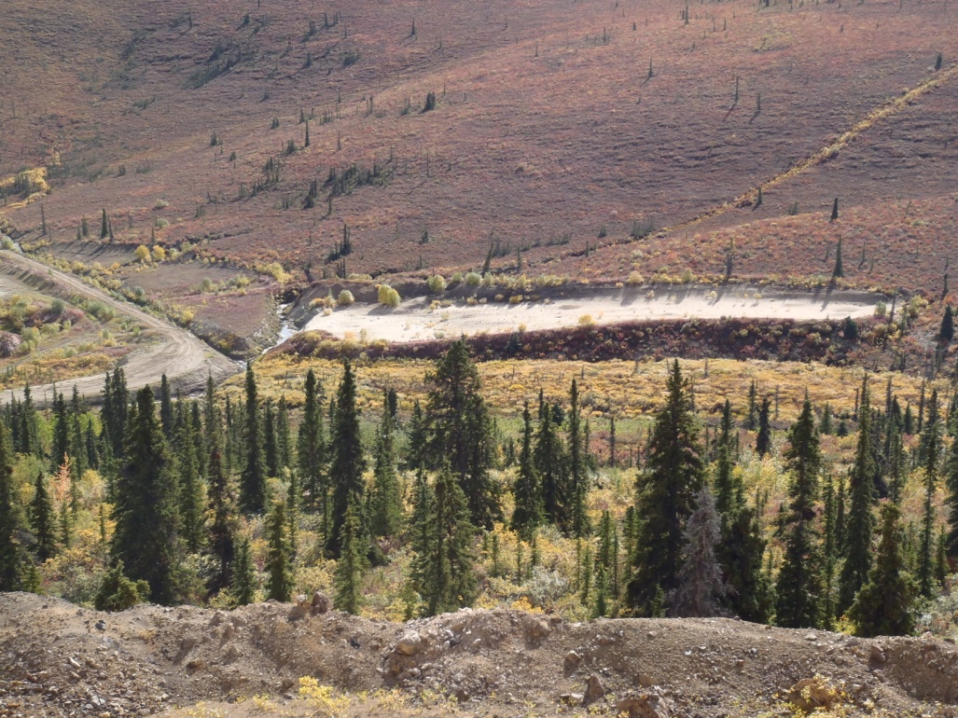

PHOTO 16: Sand Borrow Area West of TSF, September 8, 2013.
AMEC Environment & Infrastructure |  | Government of Yukon - AAM  Mount Nansen 2013 Site Investigation  Photographs
Logged by: SM | Scale: NTS | Date: Nov 2013 | Project: VM00605E | Page 8

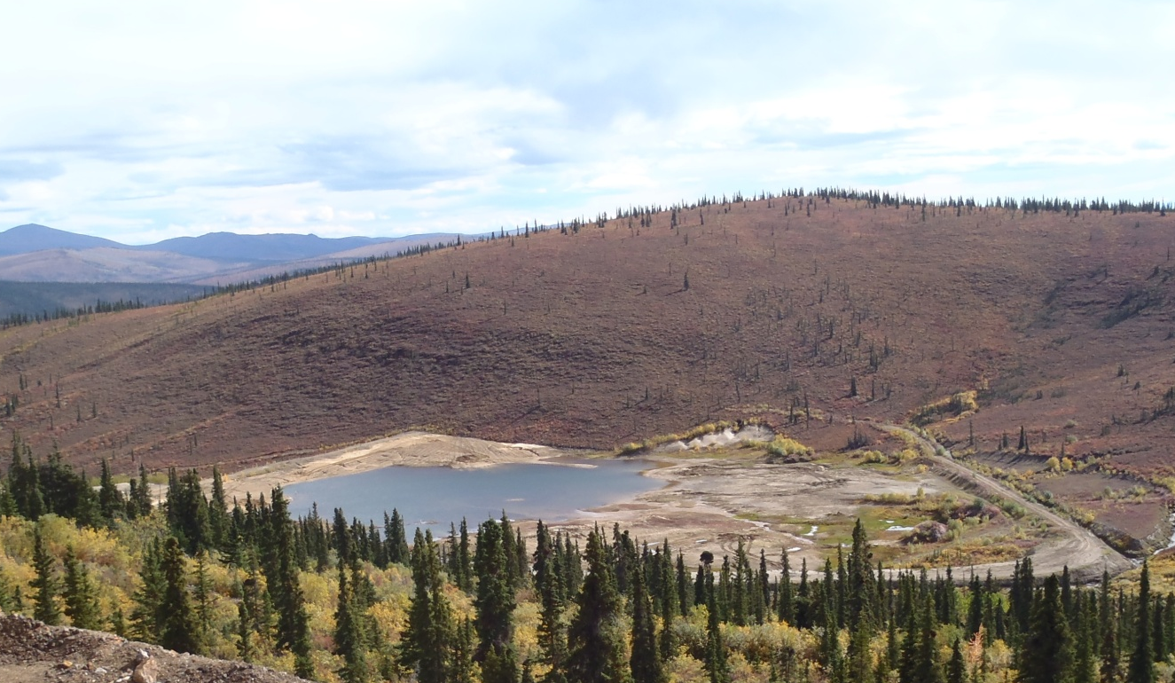

PHOTO 17: TSF Looking Southeast, September 8, 2013.

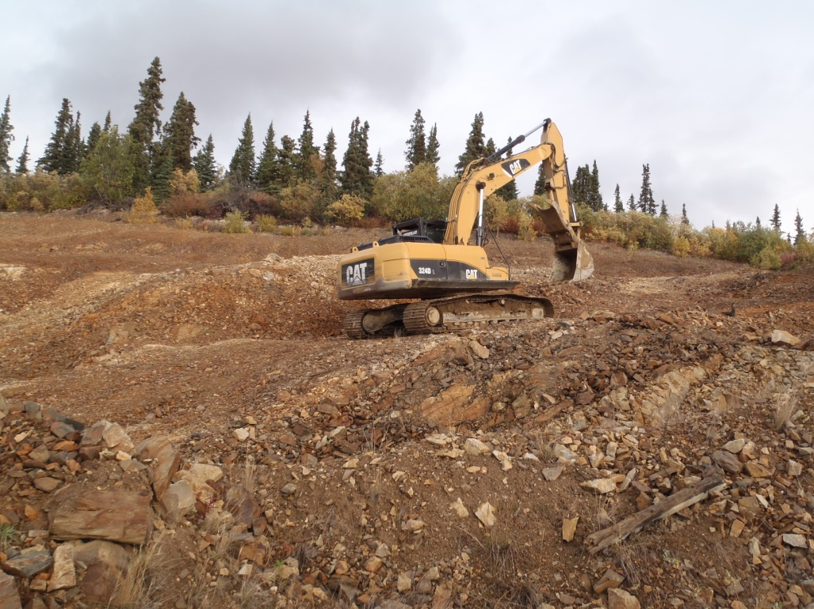

PHOTO 18: Excavator in Shale Borrow Area, September 8, 2013.
AMEC Environment & Infrastructure |  | Government of Yukon - AAM  Mount Nansen 2013 Site Investigation  Photographs
Logged by: SM | Scale: NTS | Date: Nov 2013 | Project: VM00605E | Page 9

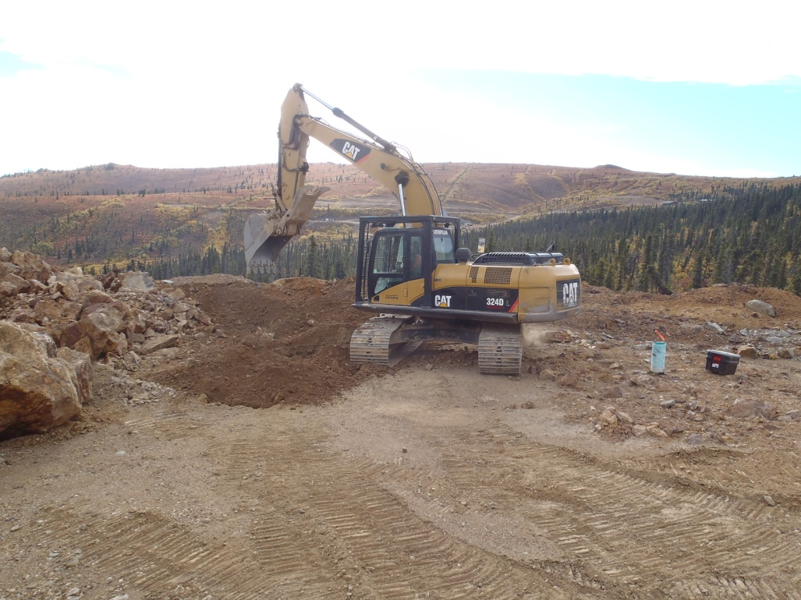

PHOTO 19: Excavator in Waste Area TP-WA-13-06, September 9, 2013.

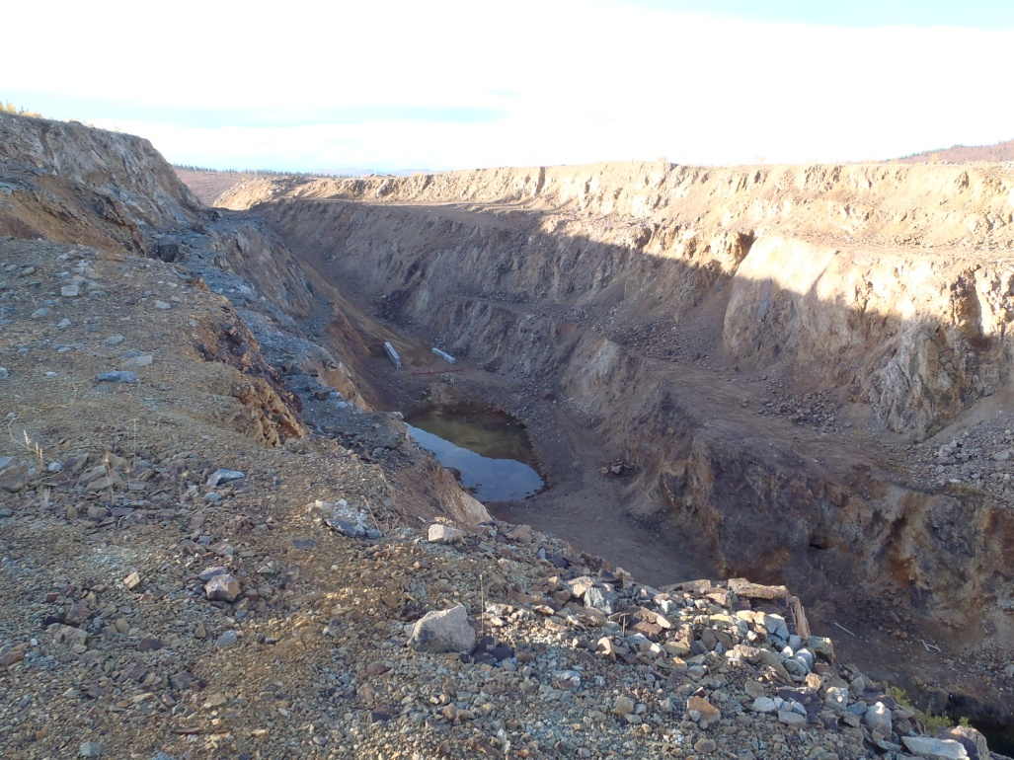

PHOTO 20: Open Pit Looking South, September 10, 2013.
AMEC Environment & Infrastructure |  | Government of Yukon - AAM  Mount Nansen 2013 Site Investigation  Photographs
Logged by: SM | Scale: NTS | Date: Nov 2013 | Project: VM00605E | Page 10

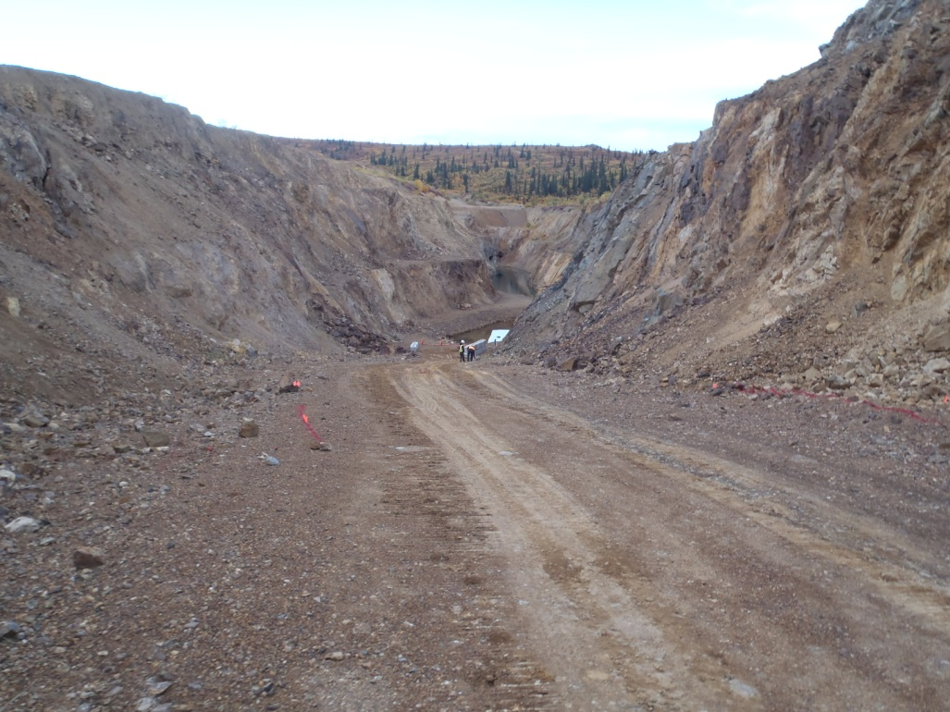

PHOTO 21: Open Pit Looking North, September 10, 2013.

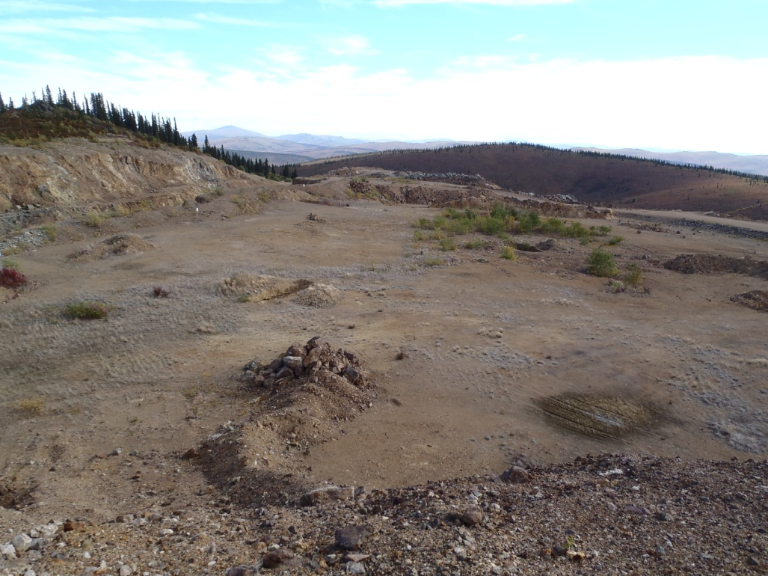

PHOTO 22: Waste Area, Looking North, September 4, 2013.
AMEC Environment & Infrastructure |  | Government of Yukon - AAM  Mount Nansen 2013 Site Investigation  Photographs
Logged by: SM | Scale: NTS | Date: Nov 2013 | Project: VM00605E | Page 11

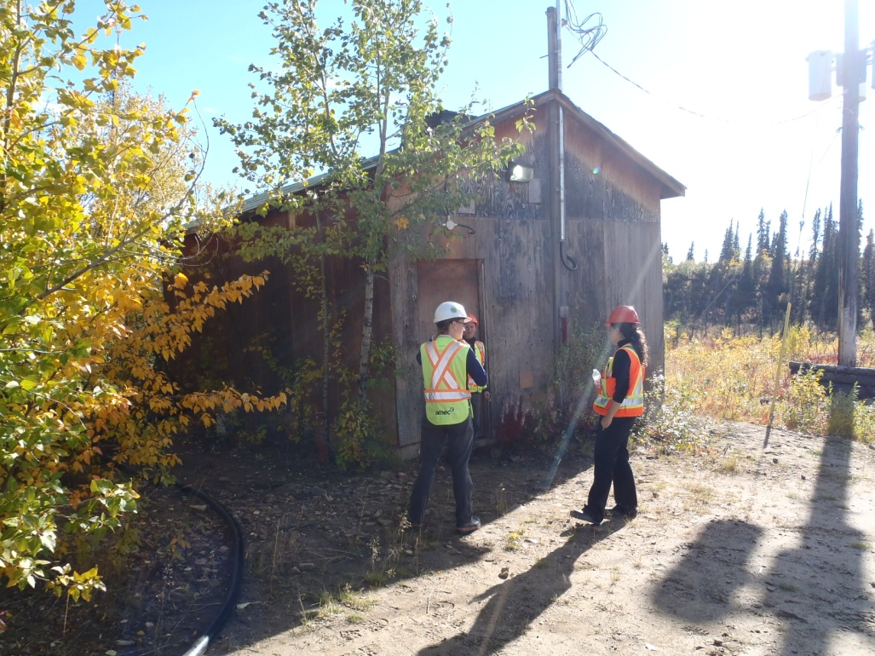

PHOTO 23: Victoria Creek Wellhouse, September 4, 2013.

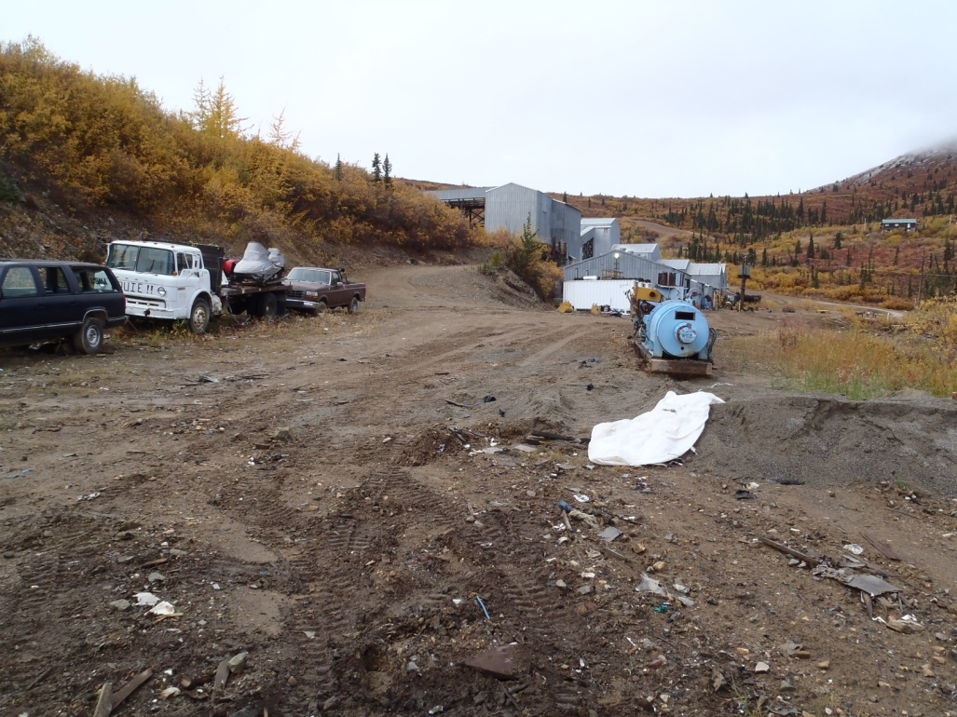

PHOTO 24: Mill Area, Looking Northwest, September 17, 2013.
AMEC Environment & Infrastructure |  | Government of Yukon - AAM  Mount Nansen 2013 Site Investigation  Photographs
Logged by: SM | Scale: NTS | Date: Nov 2013 | Project: VM00605E | Page 12

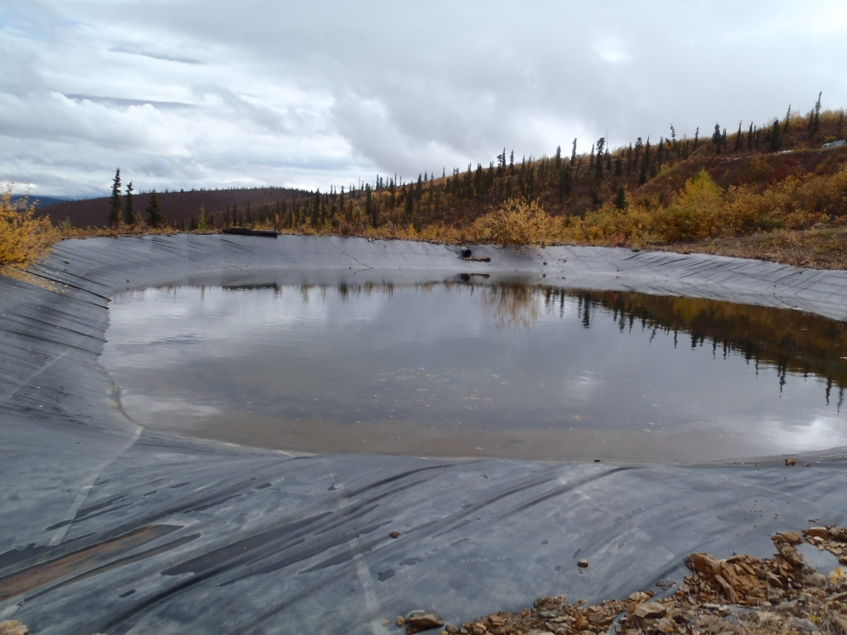

PHOTO 25: Lined Sediment Pond, September 17, 2013.

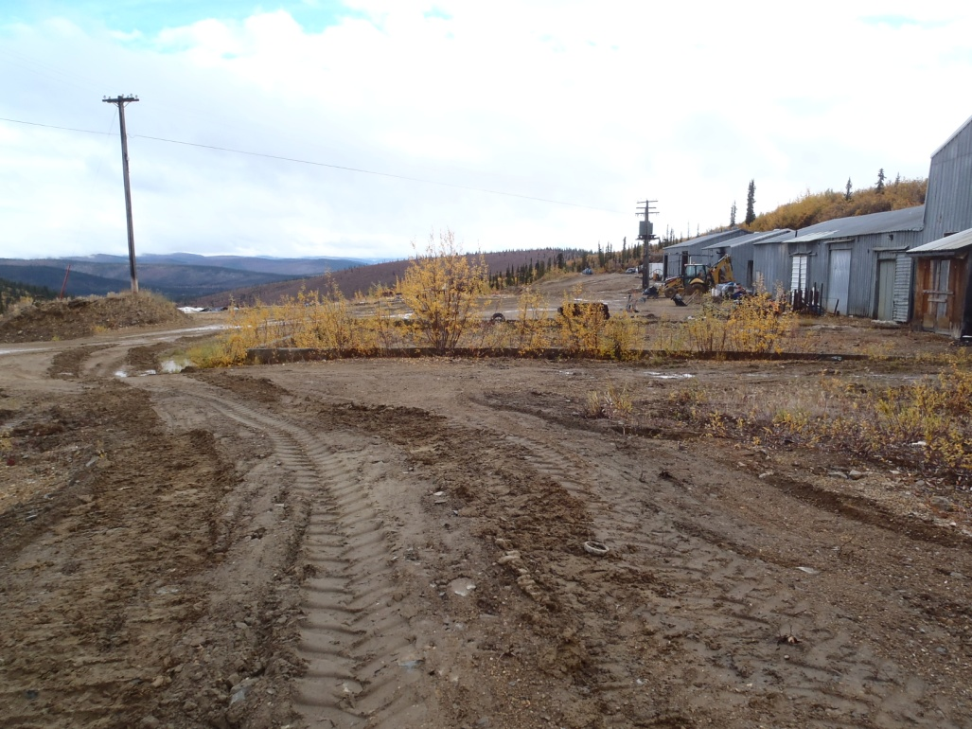

PHOTO 26: Mill Area Looking Southeast, September 17, 2013.
AMEC Environment & Infrastructure |  | Government of Yukon - AAM  Mount Nansen 2013 Site Investigation  Photographs
Logged by: SM | Scale: NTS | Date: Nov 2013 | Project: VM00605E | Page 13

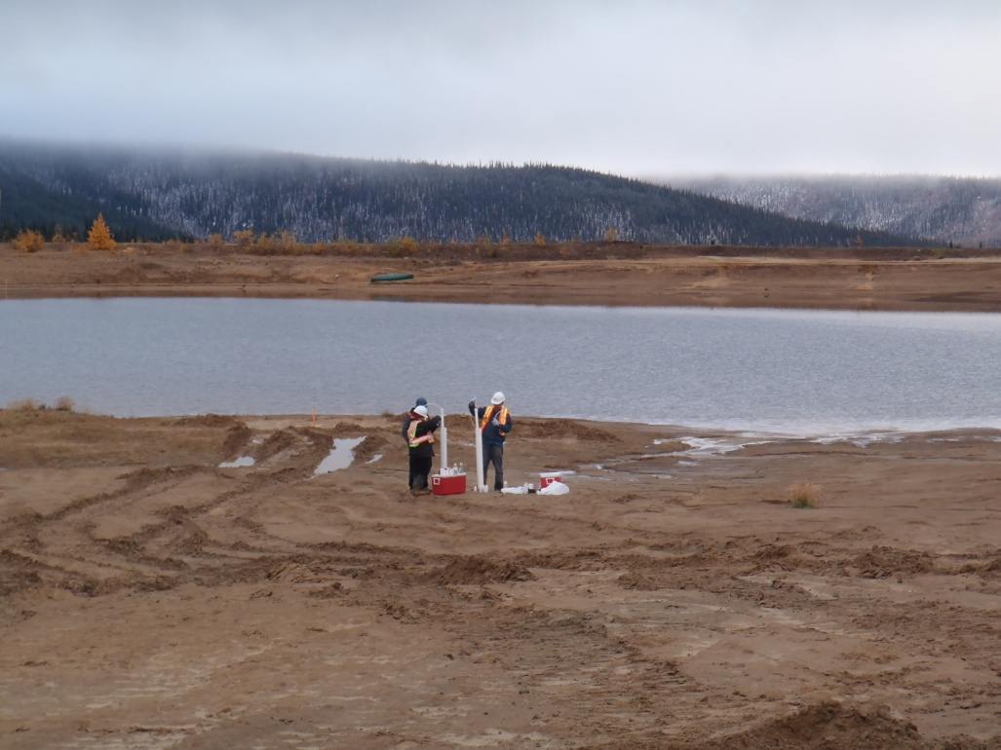

PHOTO 27: Sampling Wells on TSF, September 17, 2013.

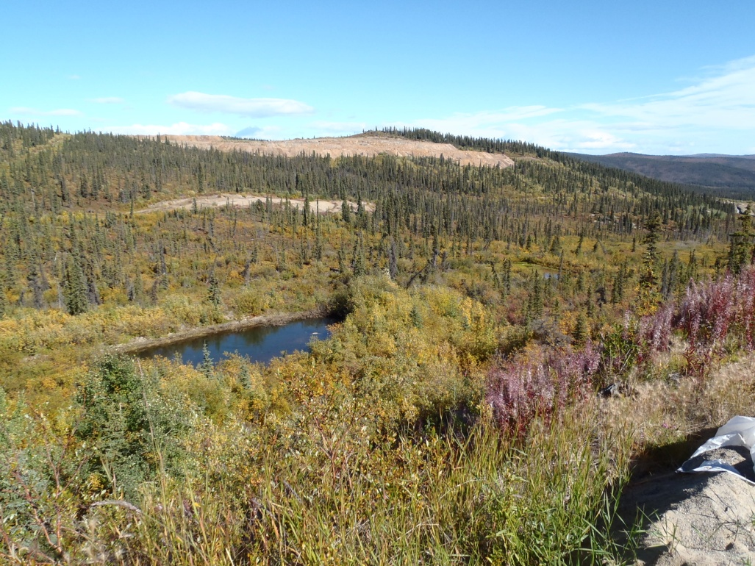

PHOTO 28: Sedimentation Ponds 1 and 2, September 4, 2013.
AMEC Environment & Infrastructure |  | Government of Yukon - AAM  Mount Nansen 2013 Site Investigation  Photographs
Logged by: SM | Scale: NTS | Date: Nov 2013 | Project: VM00605E | Page 14

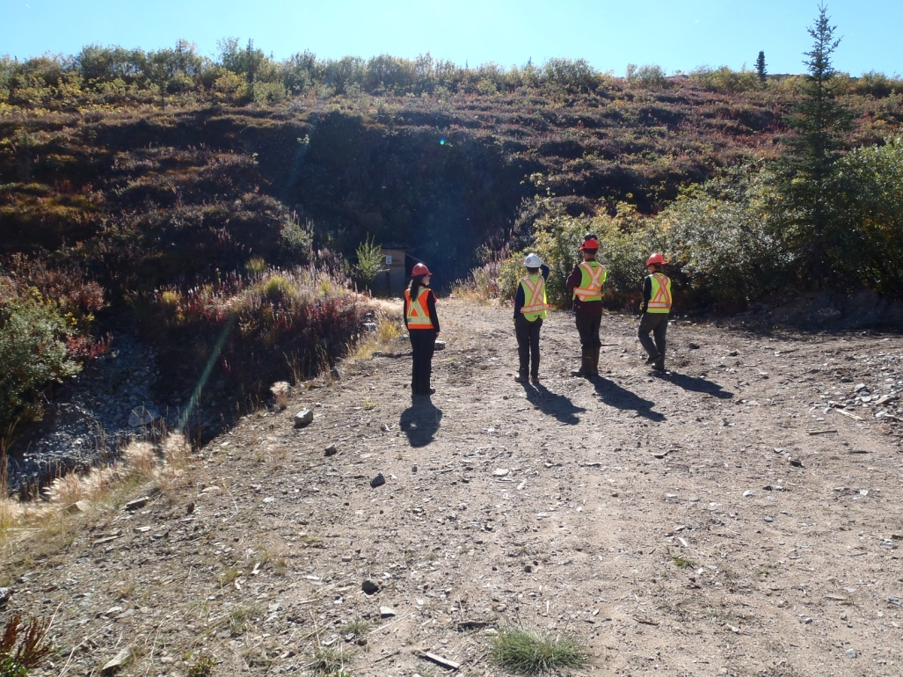

PHOTO 29: Pony Creek Adit Entrance, September 4, 2013.

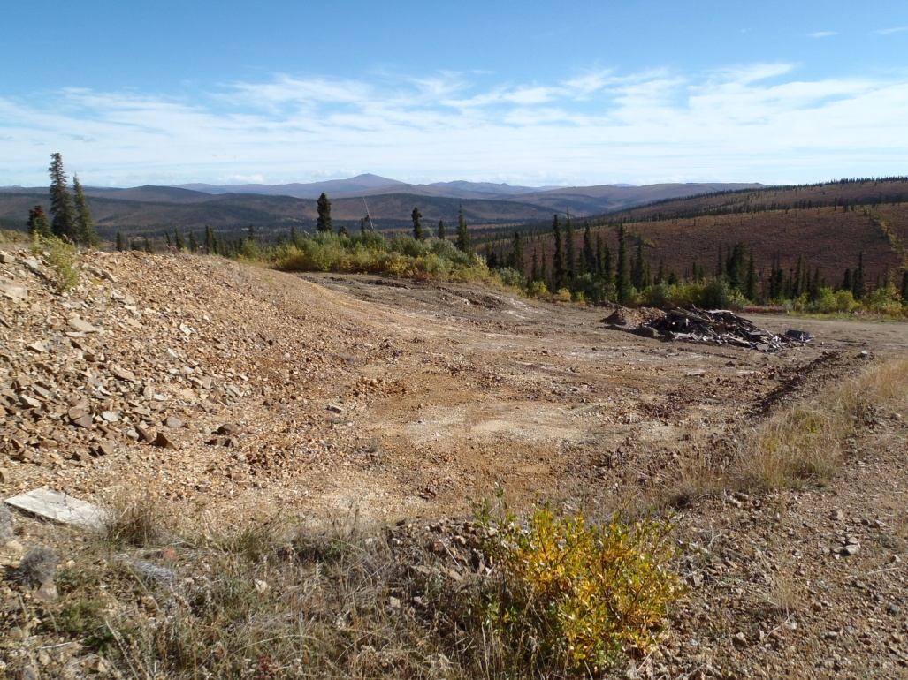

PHOTO 30: Shale Borrow Area for TP-BA-13-08 and Burn Pile, September 4, 2013.
AMEC Environment & Infrastructure |  | Government of Yukon - AAM  Mount Nansen 2013 Site Investigation  Photographs
Logged by: SM | Scale: NTS | Date: Nov 2013 | Project: VM00605E | Page 15

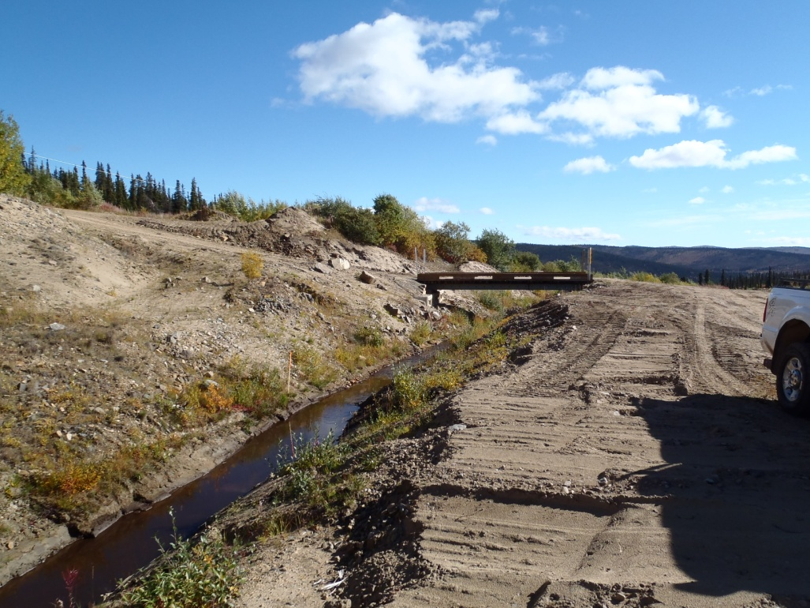

PHOTO 31: TSF Diversion Channel and Bridge, September 4, 2013.

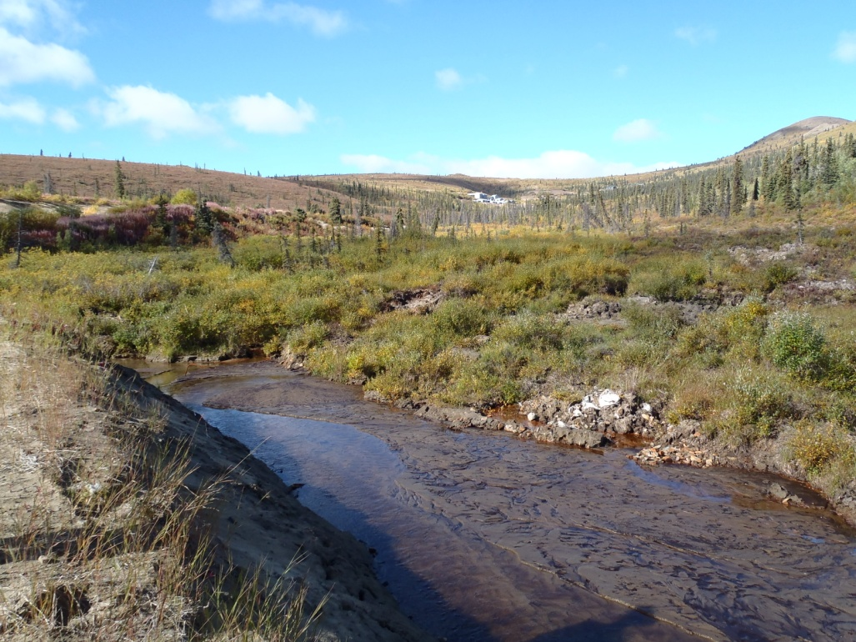

PHOTO 32: Confluence of Dome Creek and TSF Diversion Channel West of TSF, September 4, 2013.
AMEC Environment & Infrastructure |  | Government of Yukon - AAM  Mount Nansen 2013 Site Investigation  Photographs
Logged by: SM | Scale: NTS | Date: Nov 2013 | Project: VM00605E | Page 16

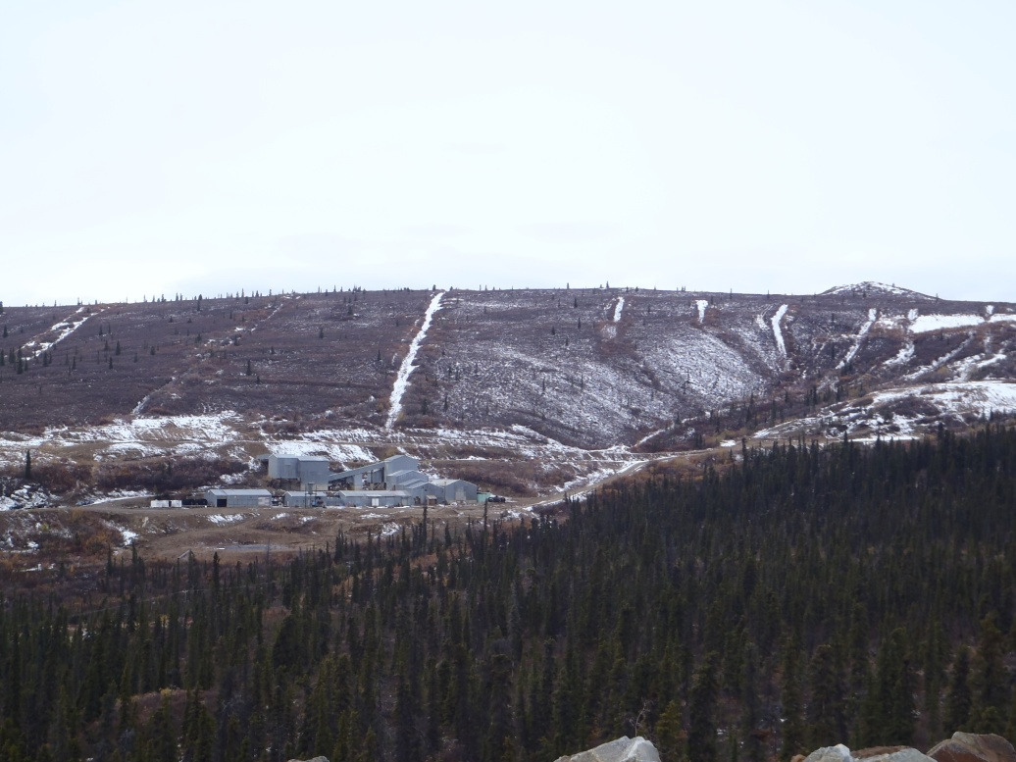

PHOTO 33: Mill Area.

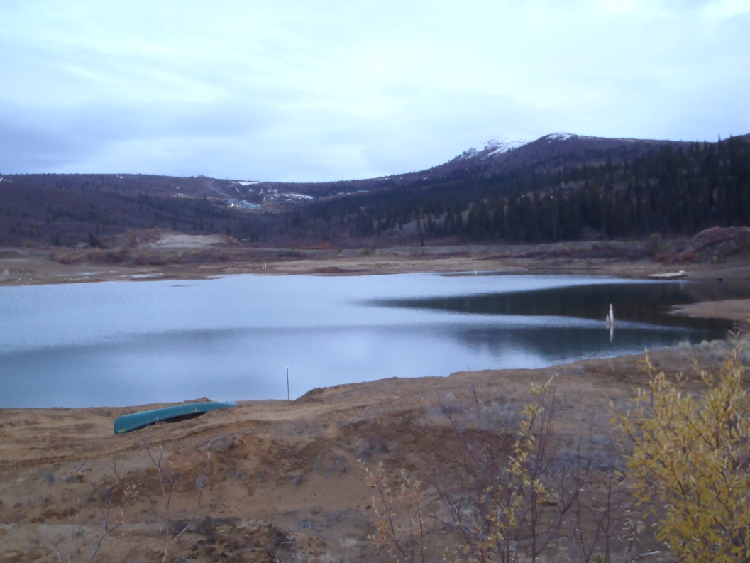

PHOTO 34: Tailings Storage Facility.
AMEC Environment & Infrastructure |  | Government of Yukon - AAM  Mount Nansen 2013 Site Investigation  Photographs
Logged by: DP | Scale: NTS | Date: Nov 2013 | Project: VM00605E | Page 17

