Mount Nansen 2013 Site Investigation

list of photos
Page
Photos of Sonic Core 1
PHOTO 1: BH-WA-13-01, 0.0 to 10.0 m. 1
PHOTO 2: BH-WA-13-01, 10.0 to 12.5 m. End of Hole. 2
PHOTO 3: BH-T-13-01, 0.0-7.5 m. 3
PHOTO 4: BH-T-13-01, 6.0-7.5 m, left at the drill site overnight. 4
PHOTO 5: BH-T-13-01, 6.0-7.5 m, transported to the core racks in a pickup truck shortly after the previous photo was taken. 4
PHOTO 6: BH-T-13-01, 7.5 to 13.5 m, EOH. 5
PHOTO 7: BH-T-13-01, 10.5 to 12.0 m, after transported to core racks in a pickup truck. 6
PHOTO 8: BH-T-13-01, 12.0 to 13.5 m, after transported to core racks in a pickup truck. 6
PHOTO 9: BH-T-13-02, 0.0 to 6.0 m. 7
PHOTO 10: BH-T-13-02, 3.0 to 4.5 m after being transported to core racks in a pickup truck. 8
PHOTO 11: BH-T-13-02, 6.0-12.0 m, EOH. 8
PHOTO 12: BH-T-13-03, 0.0-6.0 m. 9
PHOTO 13: BH-T-13-03, 6.0-12.0 m. 10
PHOTO 14: BH-T-13-03, 12.0-16.5 m, EOH. 11
PHOTO 15: BH-T-13-04, 0.0 to 8.5 m. 12
PHOTO 16: BH-T-13-04, 6.0 to 8.5 m after being transported to the core racks in a pickup truck. 13
PHOTO 17: BH-T-13-04, 8.5-15 m. 14
PHOTO 18: BH-T-13-04, 15.0-18.5 m, EOH. 15
PHOTO 19: BH-T-13-04, 15.0-16.0 m, after being transported to core racks in a pickup truck. 15
PHOTO 20: BH-TD-13-01, 0.0-5.0 m. 16
PHOTO 21: BH-TD-13-01, 5.0-10.1 m. 17
PHOTO 22: BH-TD-13-01, 10.1-16.5 m. 18
PHOTO 23: BH-TD-13-01,16.5-22.5 m. 19
PHOTO 24: BH-TD-13-01, 22.5-25.0 m, EOH. 20
PHOTO 25: BH-T-13-01, 12.8 to 12.86 m, ice lens behaviour when thawed, left in place at the drill site. 21

Photos of Sonic Core

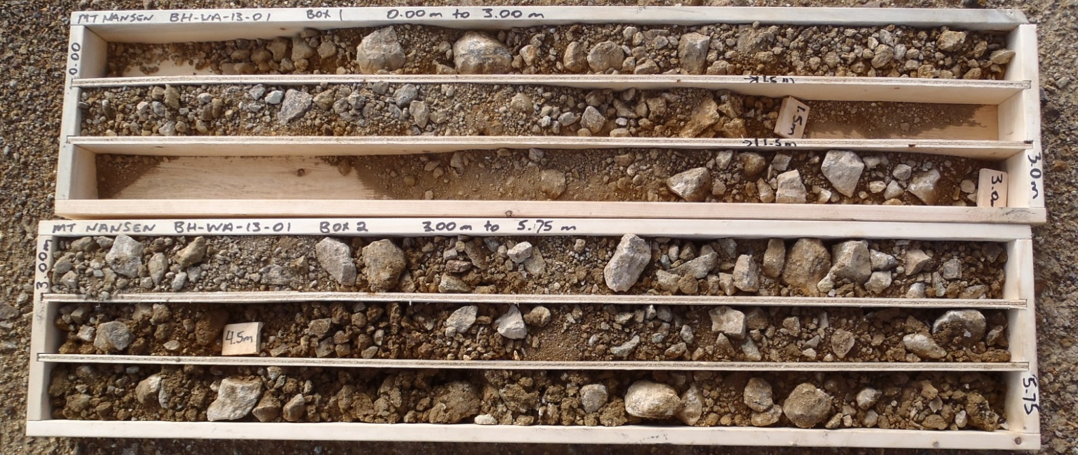

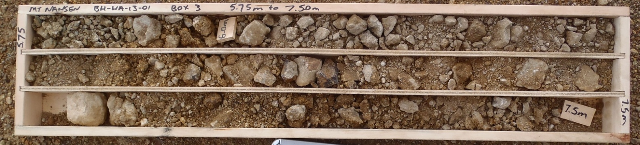

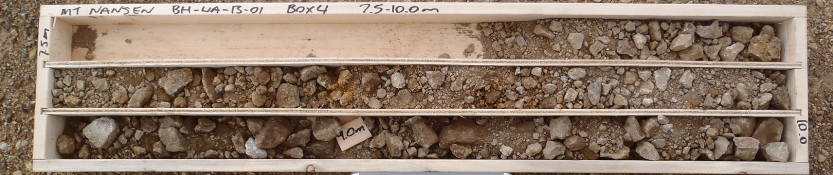

PHOTO 1: BH-WA-13-01, 0.0 to 10.0 m.
Government of Yukon - AAM
Mount Nansen 2013 Site Investigation
Photographs
Logged by: SM | Scale: NTS | Date: Oct 2013 | Project: VM00605E | Page 1

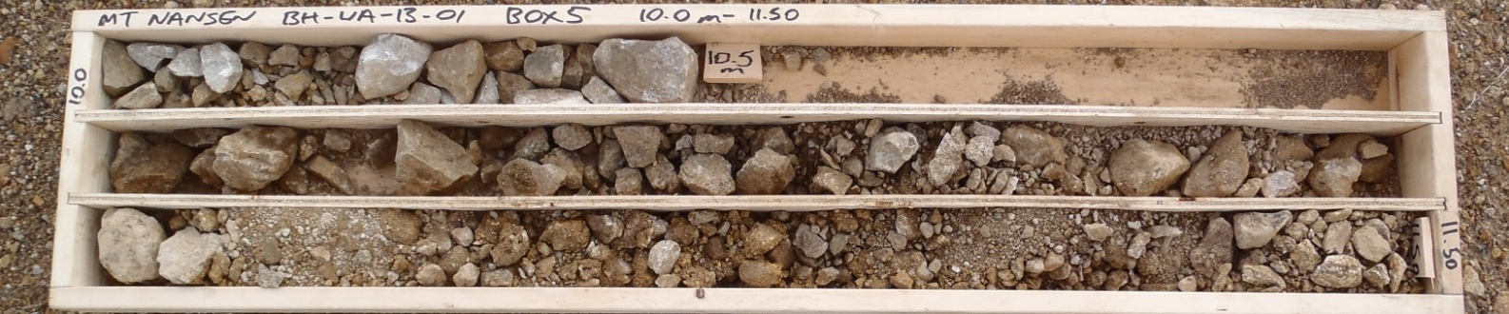
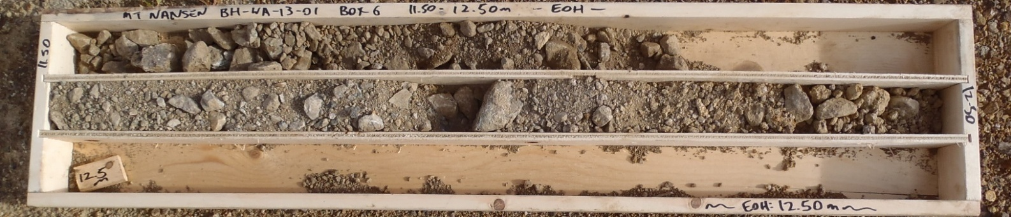

PHOTO 2: BH-WA-13-01, 10.0 to 12.5 m. End of Hole.
Government of Yukon - AAM
Mount Nansen 2013 Site Investigation
Photographs
Logged by: SM | Scale: NTS | Date: Oct 2013 | Project: VM00605E | Page 2

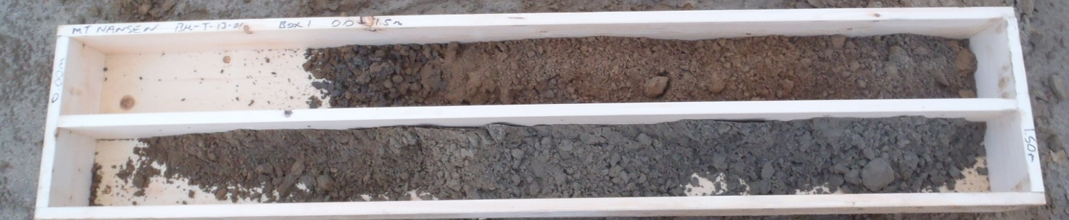
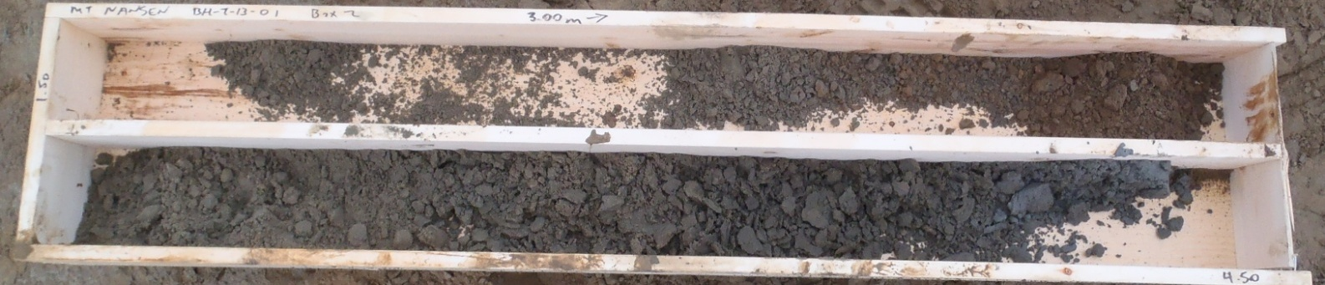
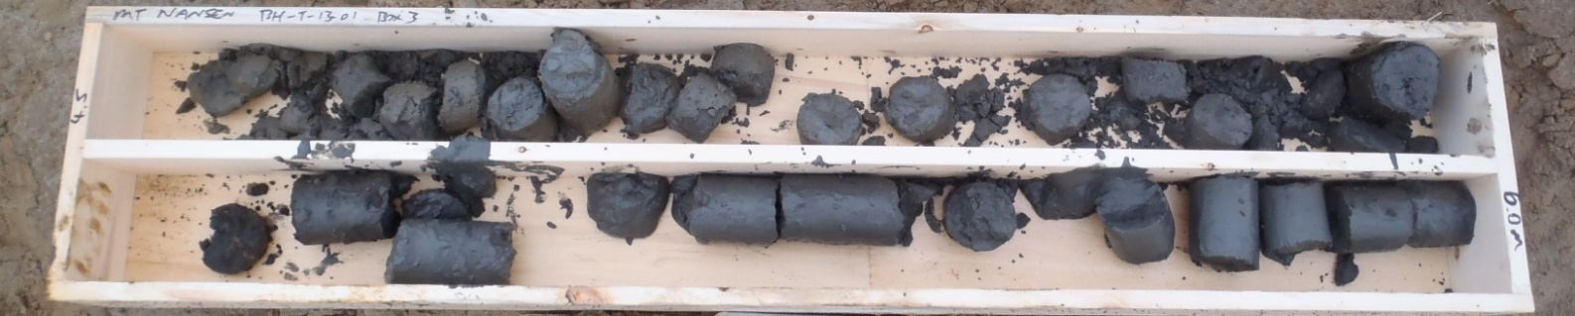
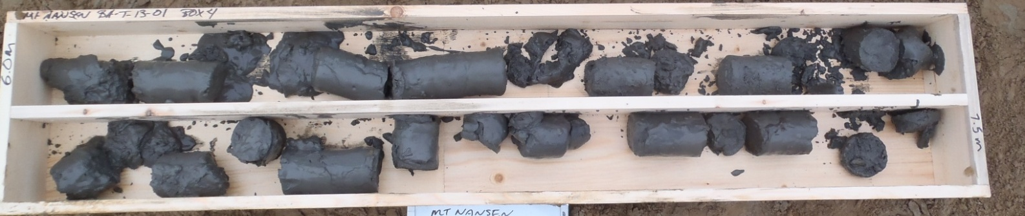

PHOTO 3: BH-T-13-01, 0.0-7.5 m.
Government of Yukon - AAM
Mount Nansen 2013 Site Investigation
Photographs
Logged by: SM | Scale: NTS | Date: Oct 2013 | Project: VM00605E | Page 3

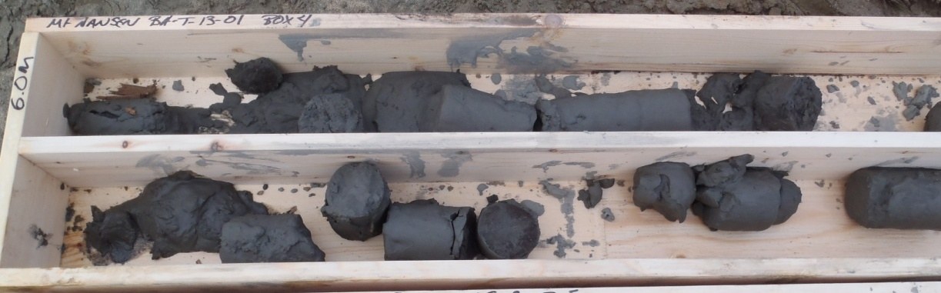

PHOTO 4: BH-T-13-01, 6.0-7.5 m, left at the drill site overnight.

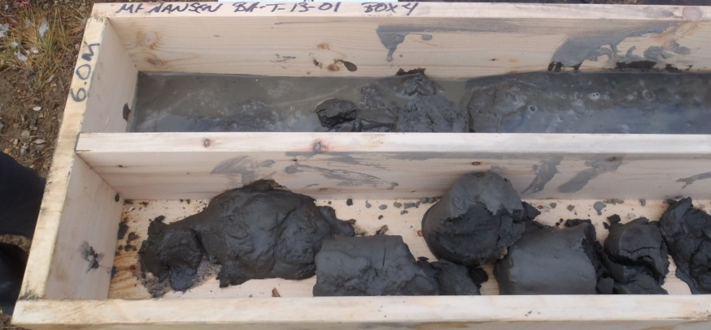

PHOTO 5: BH-T-13-01, 6.0-7.5 m, transported to the core racks in a pickup truck shortly after the previous photo was taken.
Government of Yukon - AAM
Mount Nansen 2013 Site Investigation
Photographs
Logged by: SM | Scale: NTS | Date: Oct 2013 | Project: VM00605E | Page 4

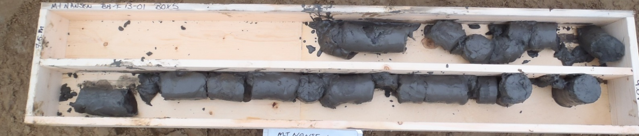
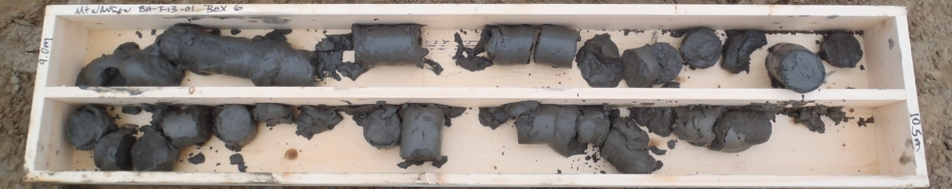
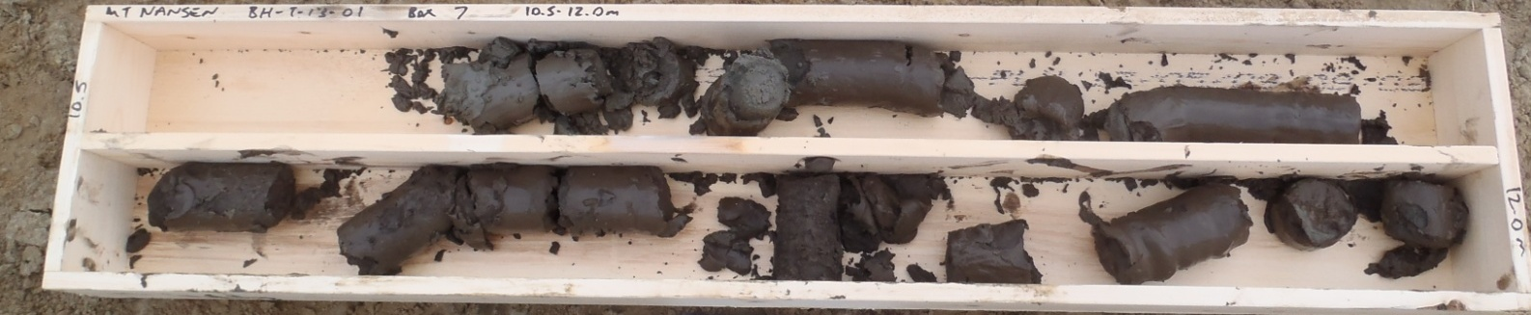
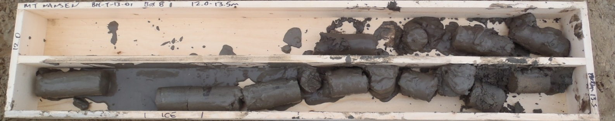

PHOTO 6: BH-T-13-01, 7.5 to 13.5 m, EOH.
Government of Yukon - AAM
Mount Nansen 2013 Site Investigation
Photographs
Logged by: SM | Scale: NTS | Date: Oct 2013 | Project: VM00605E | Page 5

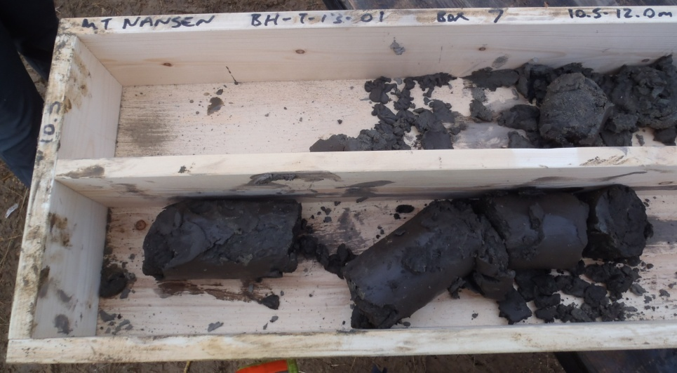

PHOTO 7: BH-T-13-01, 10.5 to 12.0 m, after transported to core racks in a pickup truck.

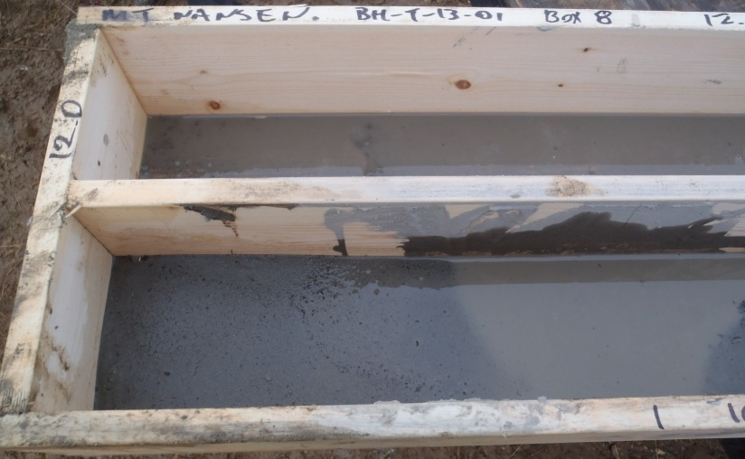

PHOTO 8: BH-T-13-01, 12.0 to 13.5 m, after transported to core racks in a pickup truck.
Government of Yukon - AAM
Mount Nansen 2013 Site Investigation
Photographs
Logged by: SM | Scale: NTS | Date: Oct 2013 | Project: VM00605E | Page 6

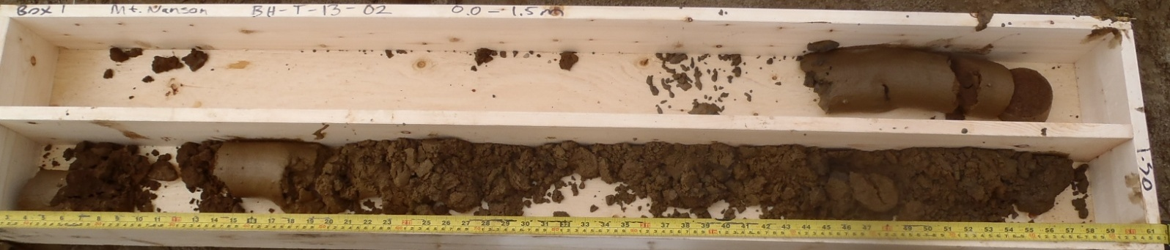
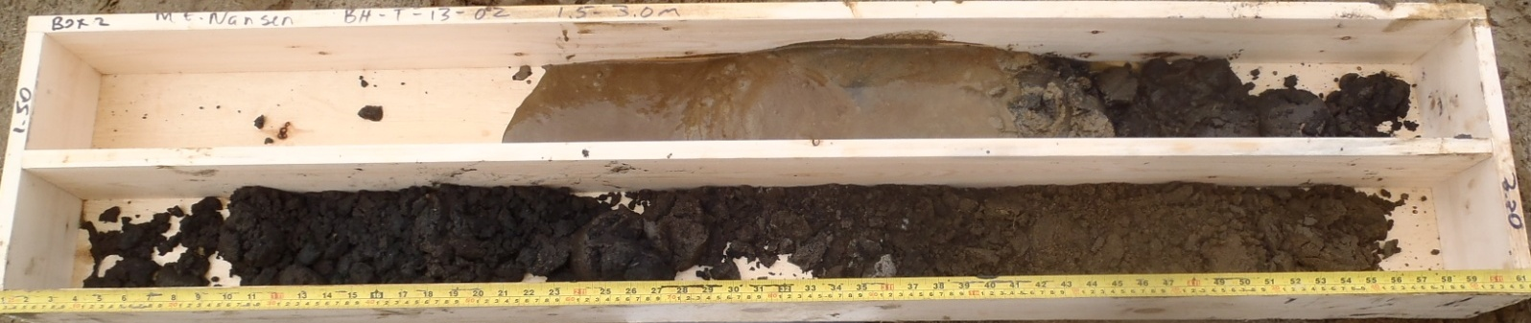
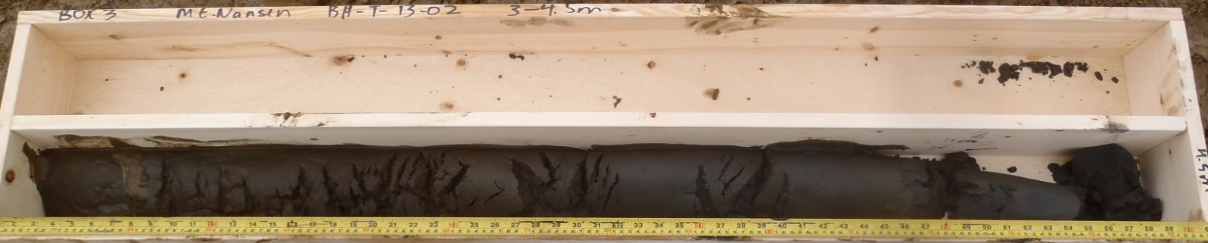
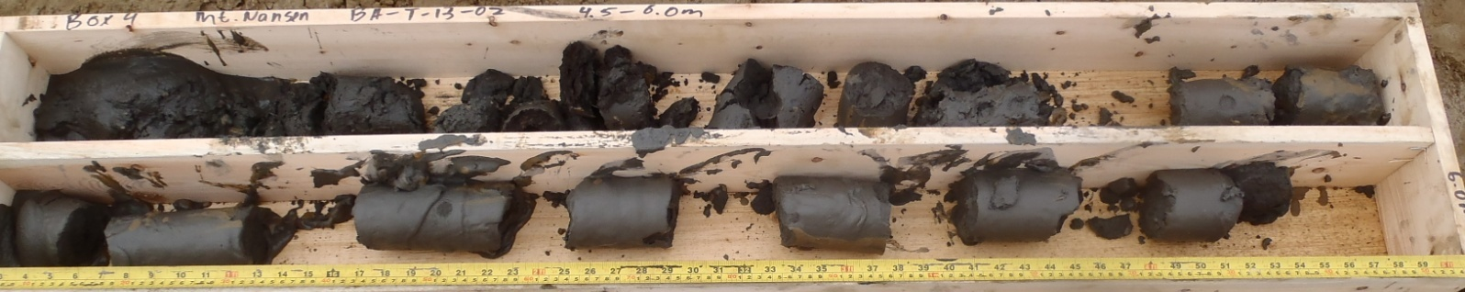

PHOTO 9: BH-T-13-02, 0.0 to 6.0 m.
Government of Yukon - AAM
Mount Nansen 2013 Site Investigation
Photographs
Logged by: SM | Scale: NTS | Date: Oct 2013 | Project: VM00605E | Page 7

PHOTO 10: BH-T-13-02, 3.0 to 4.5 m after being transported to core racks in a pickup truck.

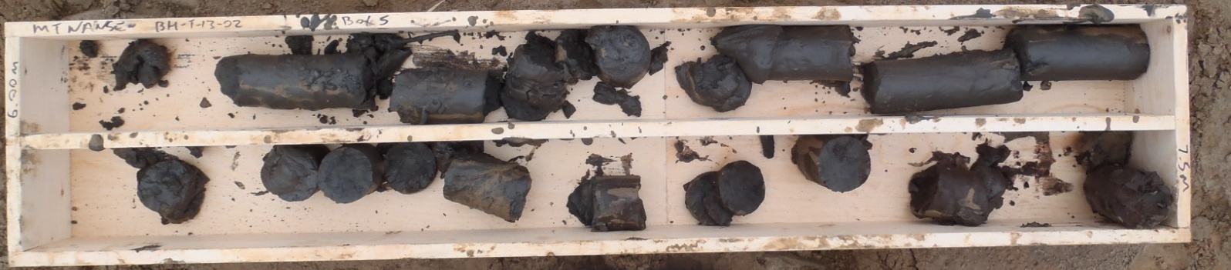
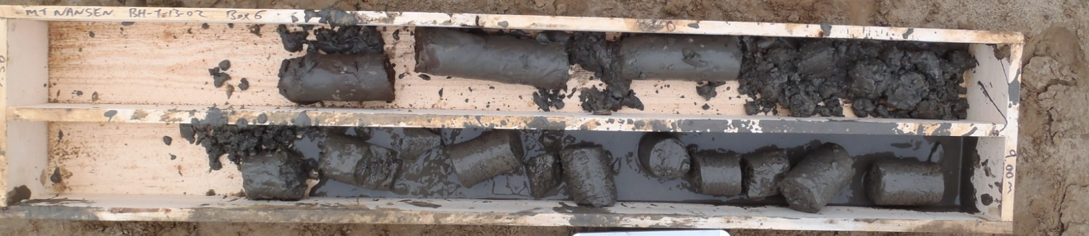
Missing photo of Box 7.
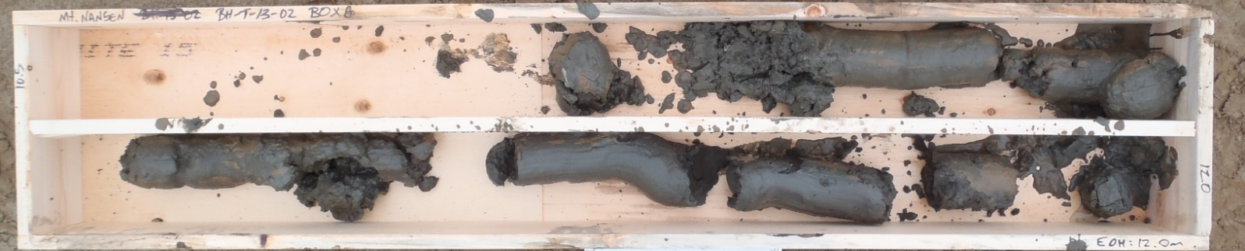

PHOTO 11: BH-T-13-02, 6.0-12.0 m, EOH.
Government of Yukon - AAM
Mount Nansen 2013 Site Investigation
Photographs
Logged by: SM | Scale: NTS | Date: Oct 2013 | Project: VM00605E | Page 8

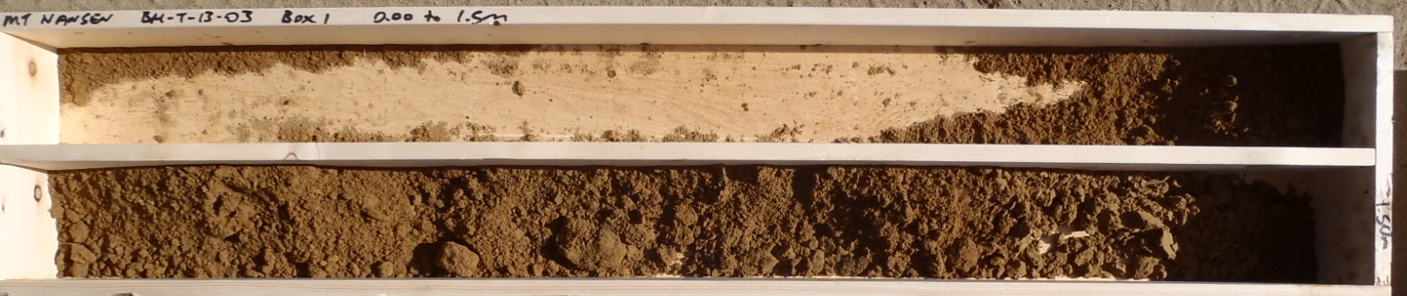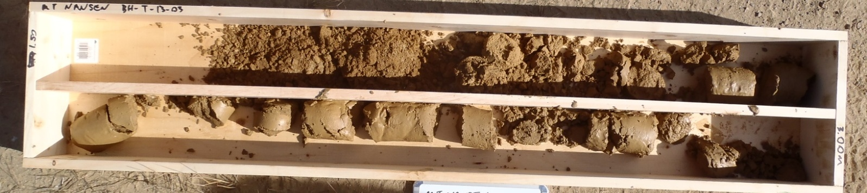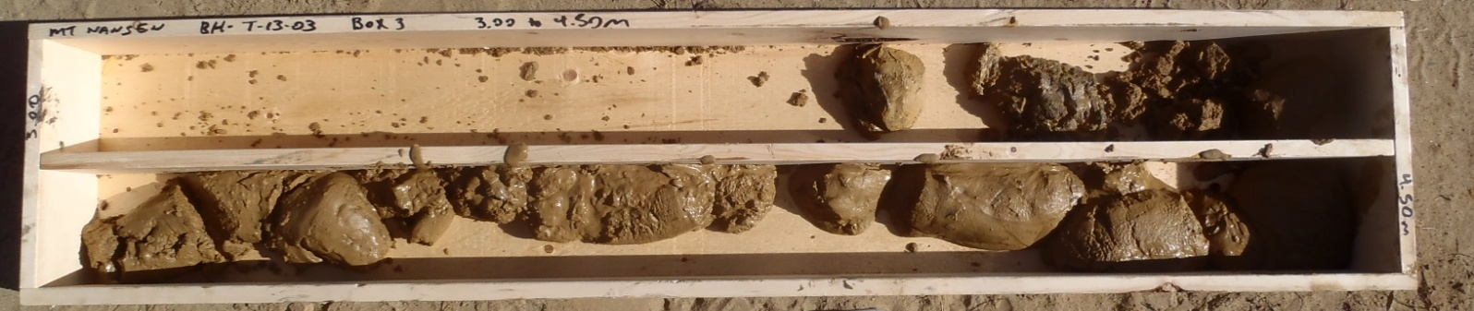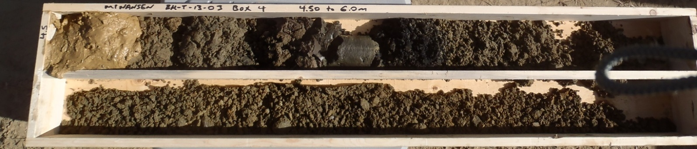

PHOTO 12: BH-T-13-03, 0.0-6.0 m.
Government of Yukon - AAM
Mount Nansen 2013 Site Investigation
Photographs
Logged by: SM | Scale: NTS | Date: Oct 2013 | Project: VM00605E | Page 9

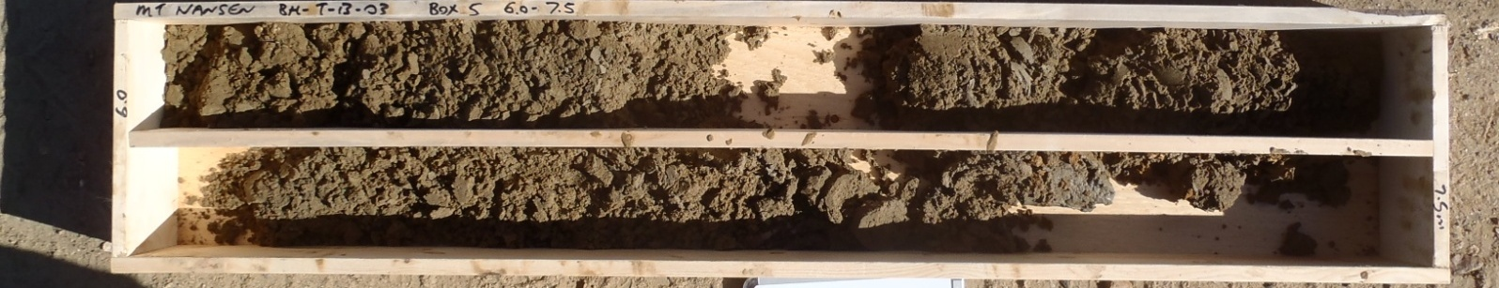
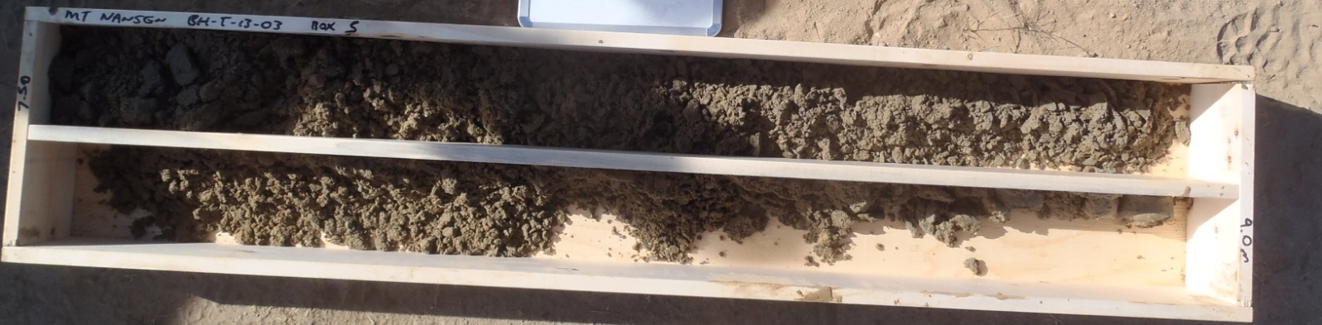
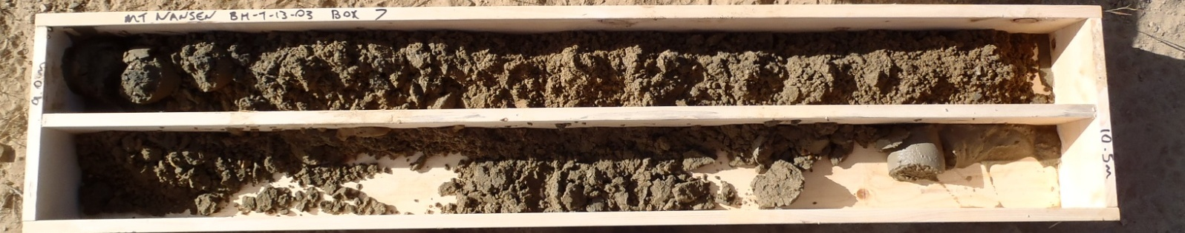
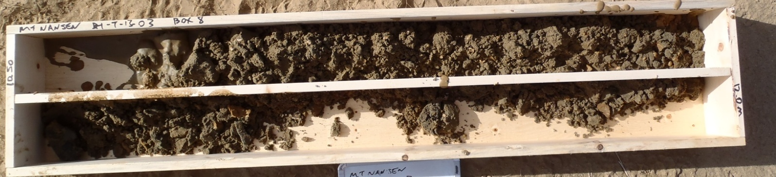

PHOTO 13: BH-T-13-03, 6.0-12.0 m.
Government of Yukon - AAM
Mount Nansen 2013 Site Investigation
Photographs
Logged by: SM | Scale: NTS | Date: Oct 2013 | Project: VM00605E | Page 10

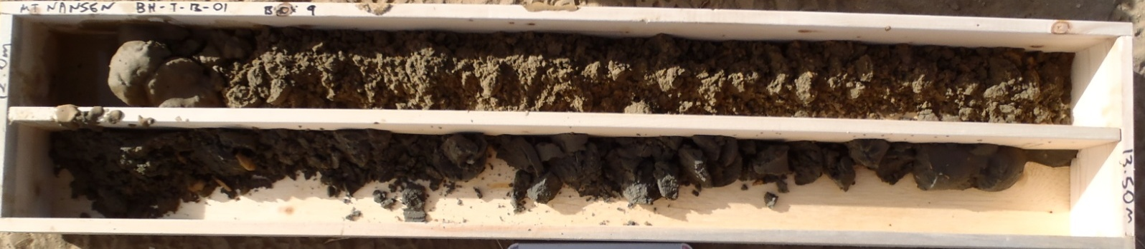
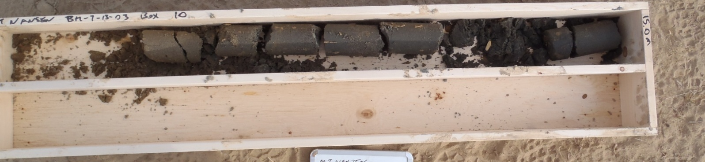
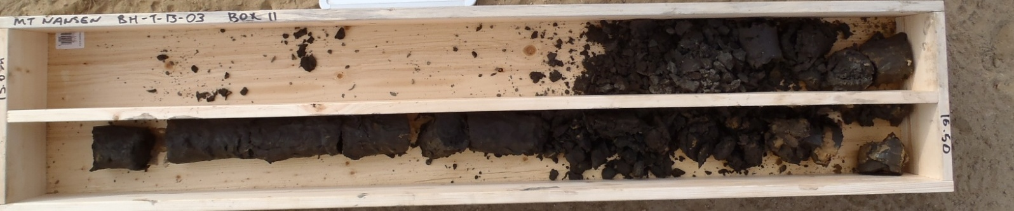

PHOTO 14: BH-T-13-03, 12.0-16.5 m, EOH.
Government of Yukon - AAM
Mount Nansen 2013 Site Investigation
Photographs
Logged by: SM | Scale: NTS | Date: Oct 2013 | Project: VM00605E | Page 11

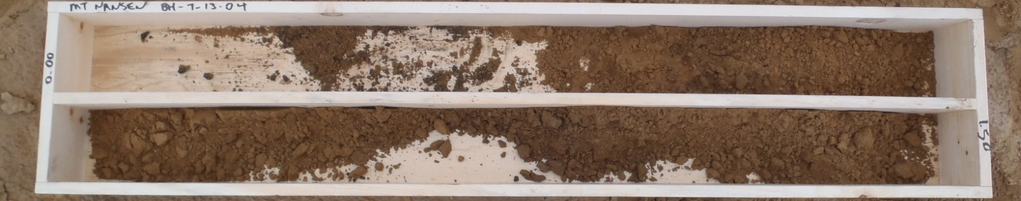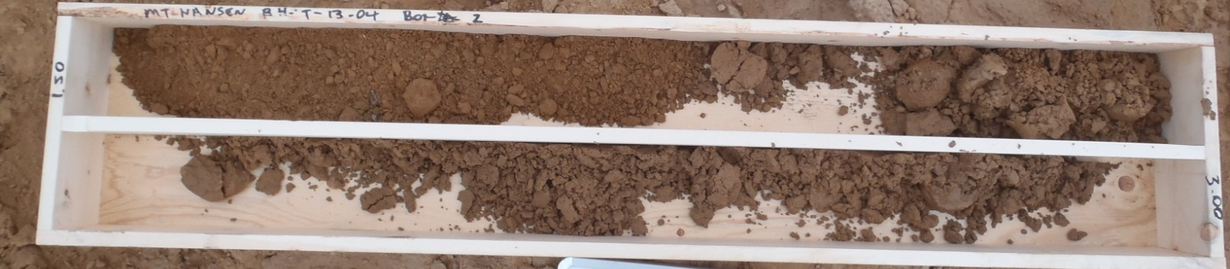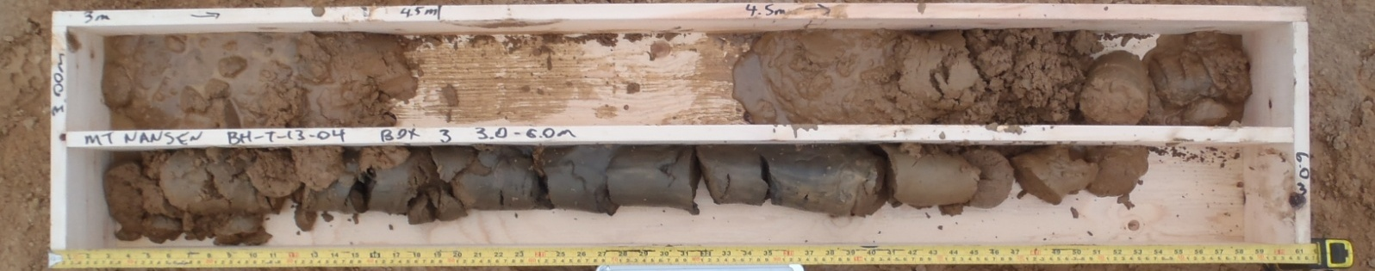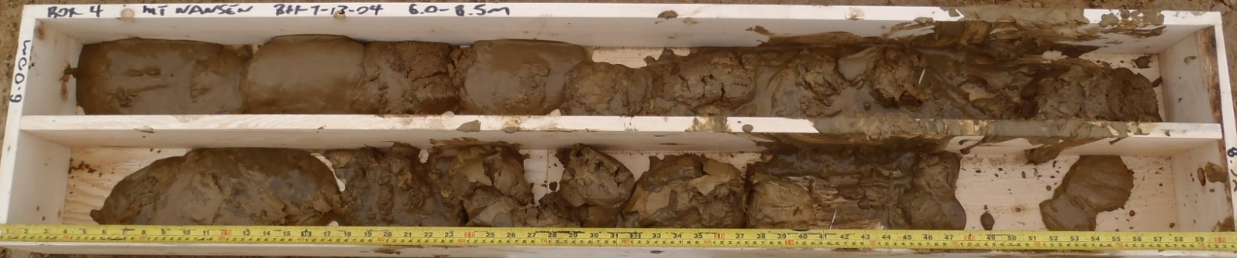

PHOTO 15: BH-T-13-04, 0.0 to 8.5 m.
Government of Yukon - AAM
Mount Nansen 2013 Site Investigation
Photographs
Logged by: SM | Scale: NTS | Date: Oct 2013 | Project: VM00605E | Page 12

PHOTO 16: BH-T-13-04, 6.0 to 8.5 m after being transported to the core racks in a pickup truck.
Government of Yukon - AAM
Mount Nansen 2013 Site Investigation
Photographs
Logged by: SM | Scale: NTS | Date: Oct 2013 | Project: VM00605E | Page 13

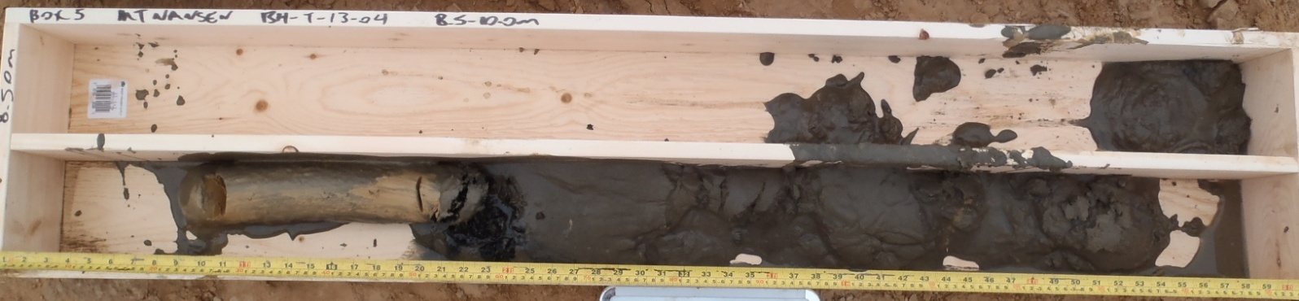
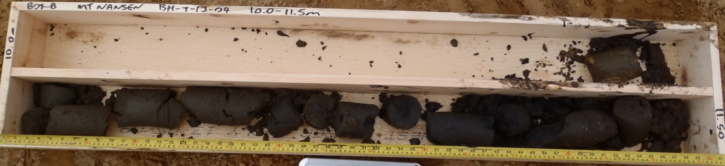
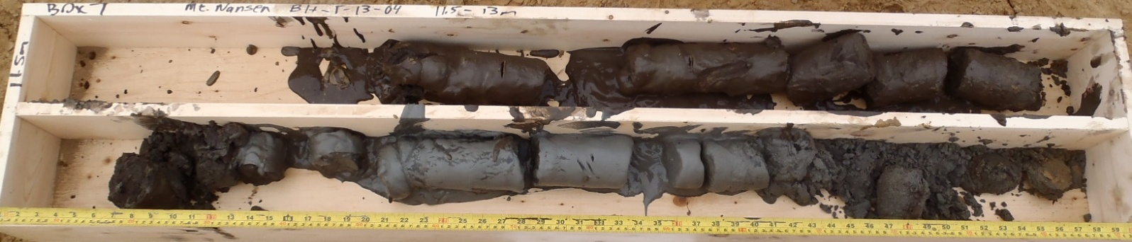
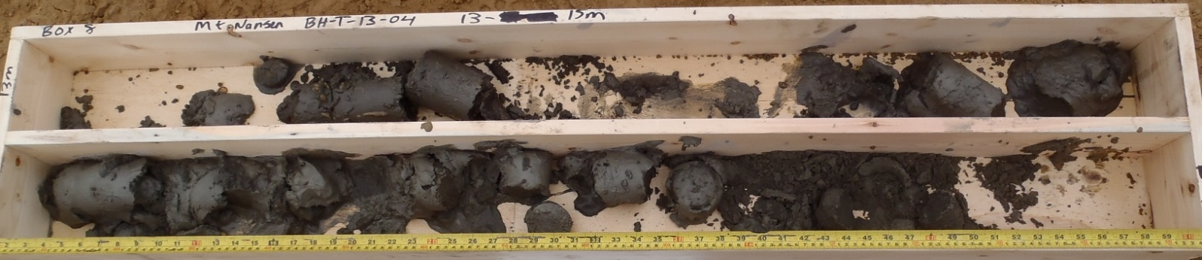

PHOTO 17: BH-T-13-04, 8.5-15 m.
Government of Yukon - AAM
Mount Nansen 2013 Site Investigation
Photographs
Logged by: SM | Scale: NTS | Date: Oct 2013 | Project: VM00605E | Page 14

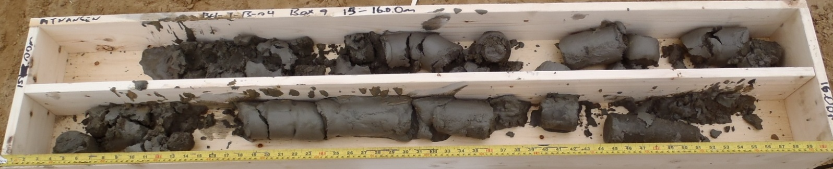
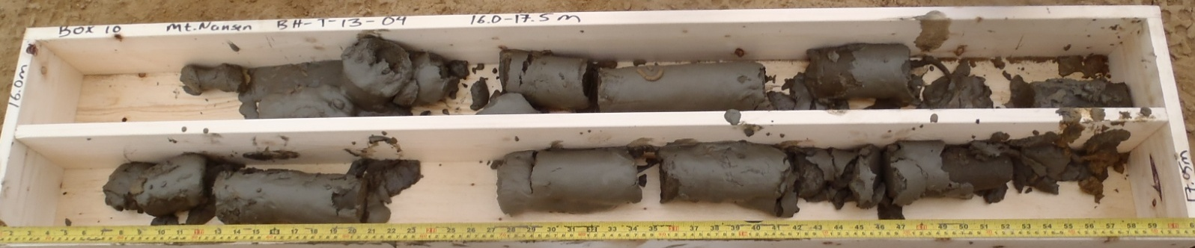
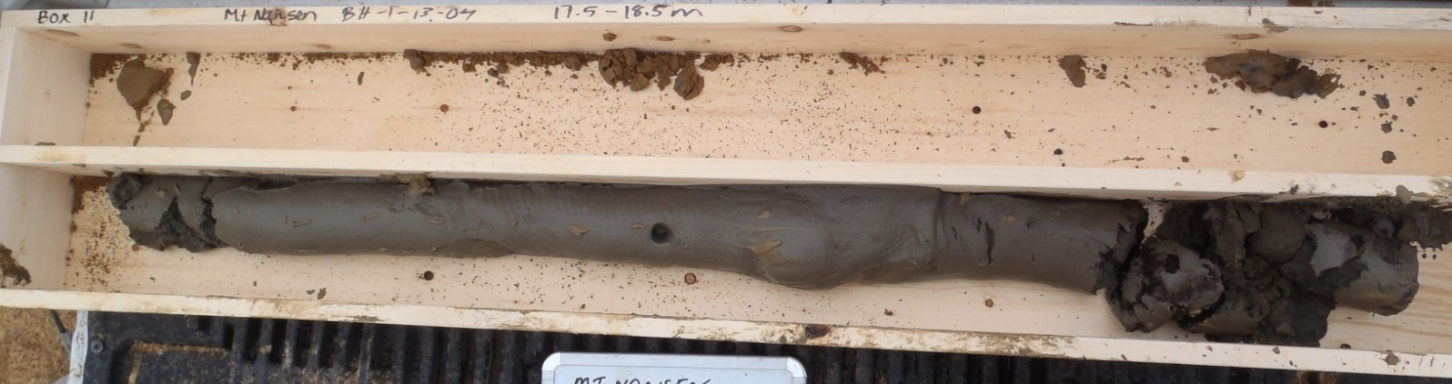

PHOTO 18: BH-T-13-04, 15.0-18.5 m, EOH.

PHOTO 19: BH-T-13-04, 15.0-16.0 m, after being transported to core racks in a pickup truck.
Government of Yukon - AAM
Mount Nansen 2013 Site Investigation
Photographs
Logged by: SM | Scale: NTS | Date: Oct 2013 | Project: VM00605E | Page 15

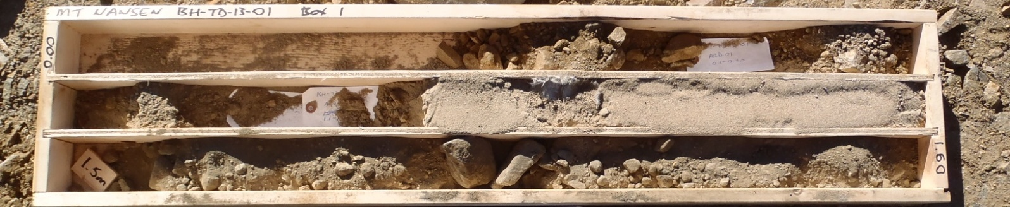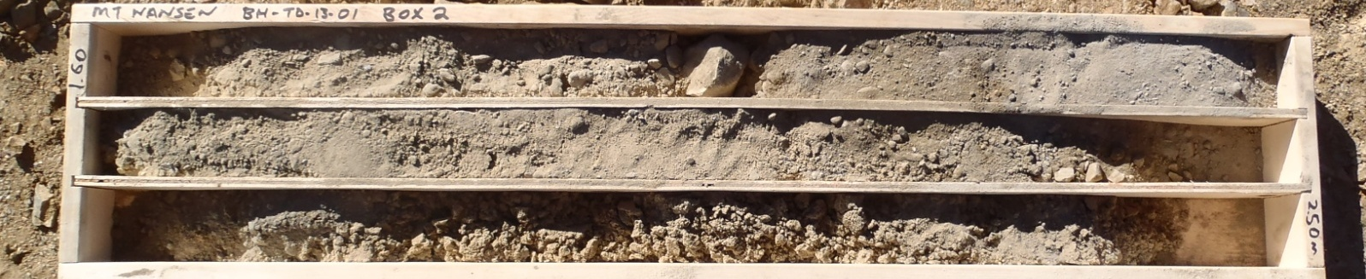
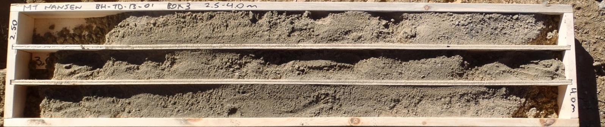
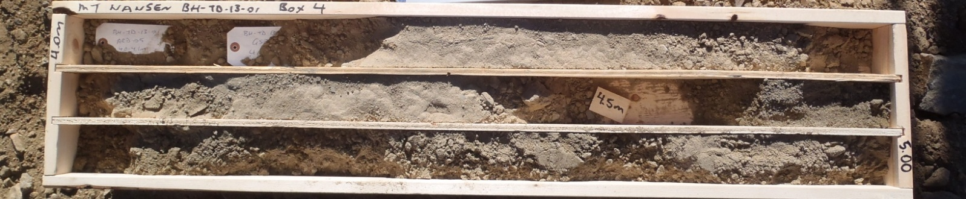

PHOTO 20: BH-TD-13-01, 0.0-5.0 m.
Government of Yukon - AAM
Mount Nansen 2013 Site Investigation
Photographs
Logged by: SM | Scale: NTS | Date: Oct 2013 | Project: VM00605E | Page 16

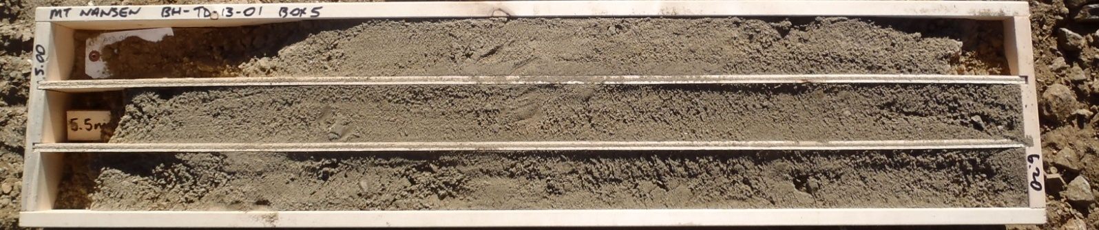
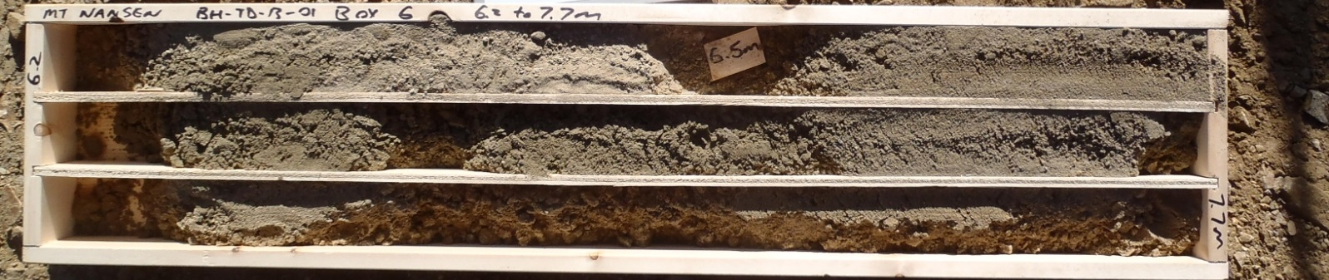
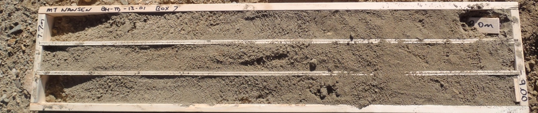
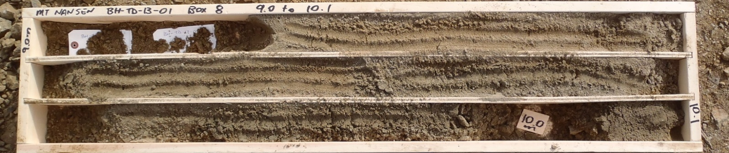

PHOTO 21: BH-TD-13-01, 5.0-10.1 m.
Government of Yukon - AAM
Mount Nansen 2013 Site Investigation
Photographs
Logged by: SM | Scale: NTS | Date: Oct 2013 | Project: VM00605E | Page 17

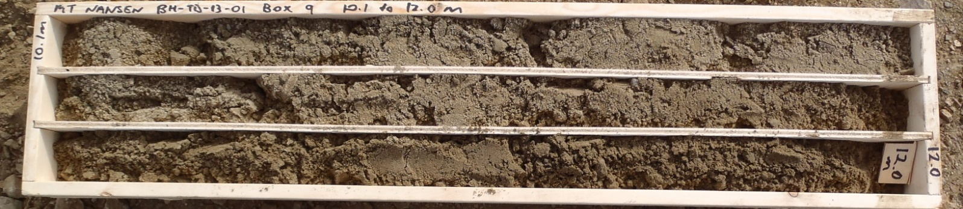
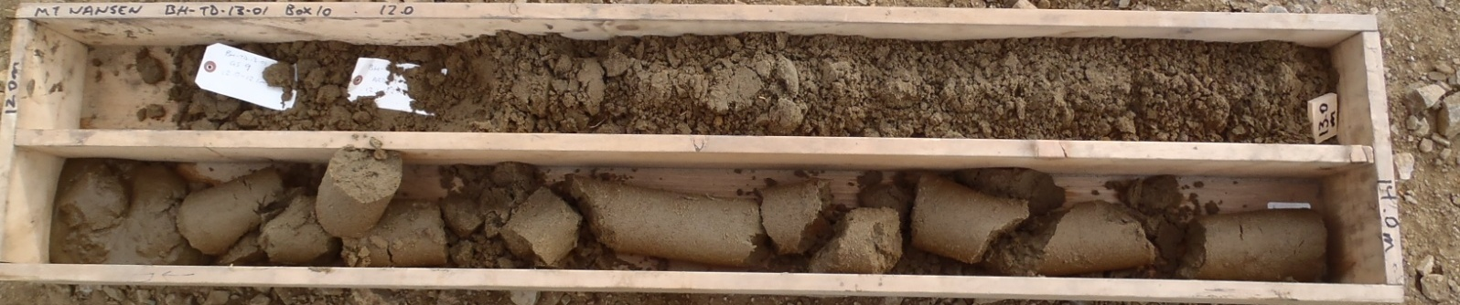
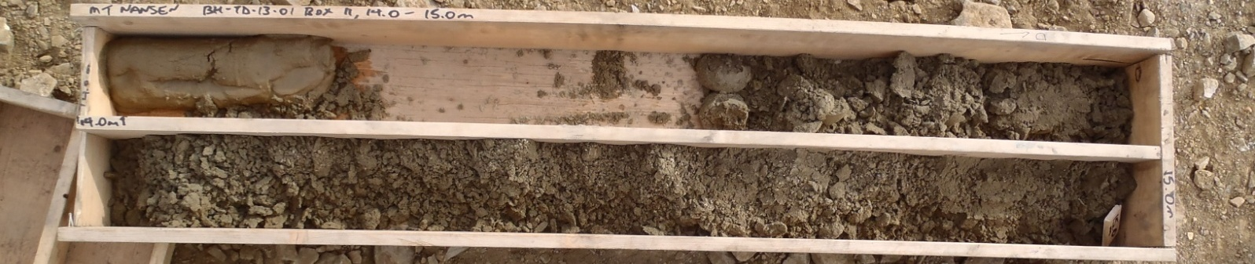
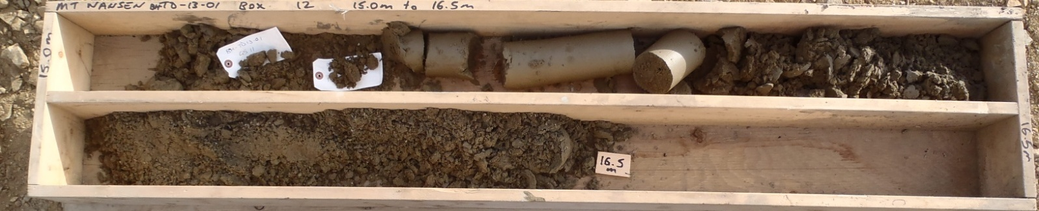

PHOTO 22: BH-TD-13-01, 10.1-16.5 m.
Government of Yukon - AAM
Mount Nansen 2013 Site Investigation
Photographs
Logged by: SM | Scale: NTS | Date: Oct 2013 | Project: VM00605E | Page 18

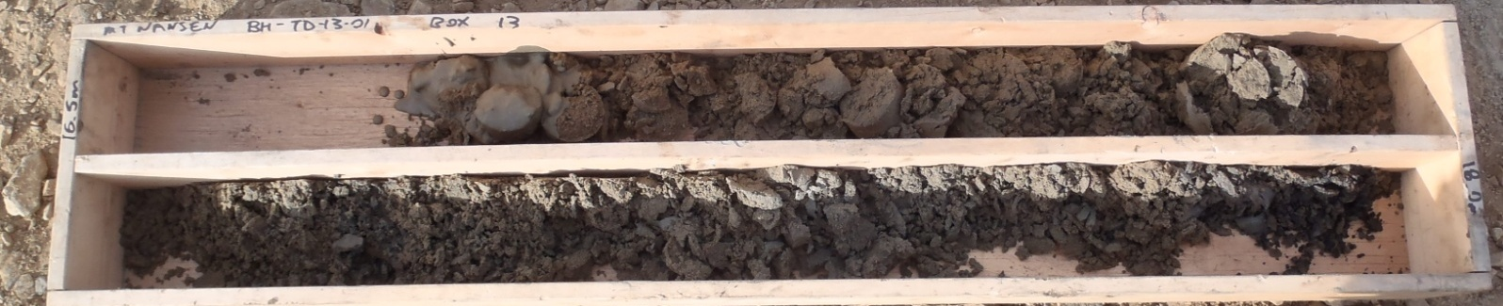
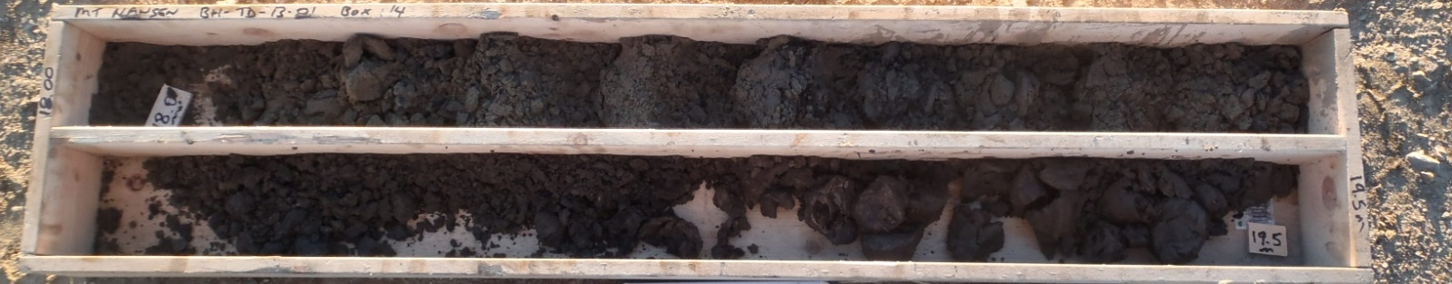
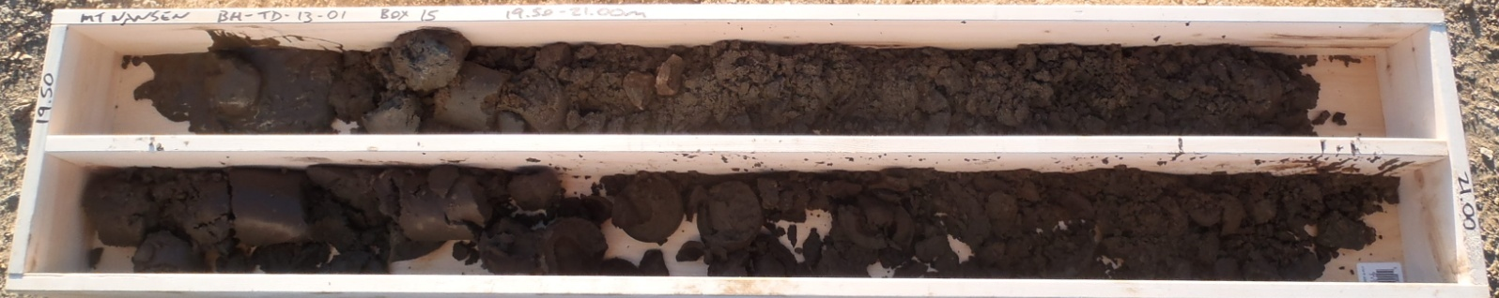
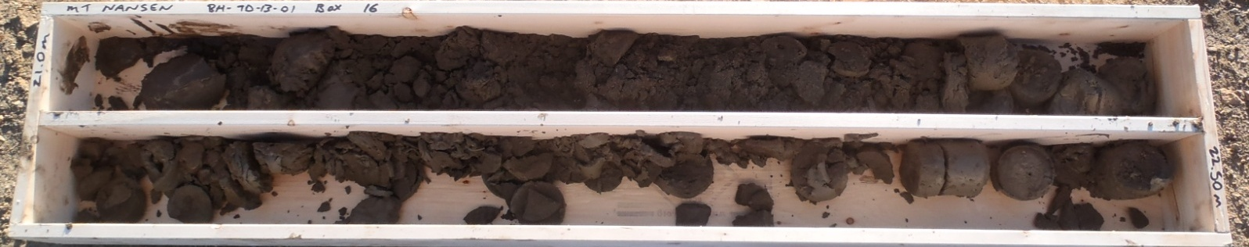

PHOTO 23: BH-TD-13-01,16.5-22.5 m.
Government of Yukon - AAM
Mount Nansen 2013 Site Investigation
Photographs
Logged by: SM | Scale: NTS | Date: Oct 2013 | Project: VM00605E | Page 19

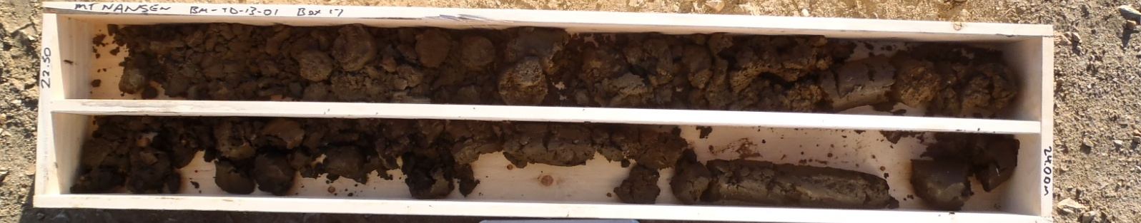
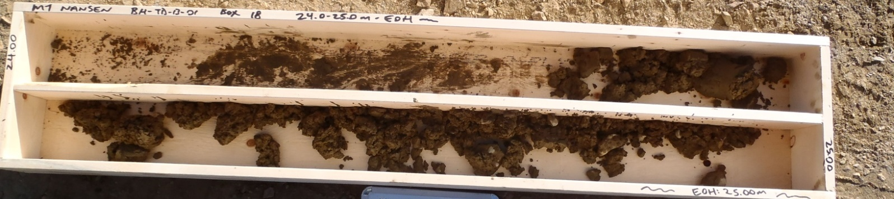

PHOTO 24: BH-TD-13-01, 22.5-25.0 m, EOH.

Government of Yukon - AAM
Mount Nansen 2013 Site Investigation
Photographs
Logged by: SM | Scale: NTS | Date: Oct 2013 | Project: VM00605E | Page 20

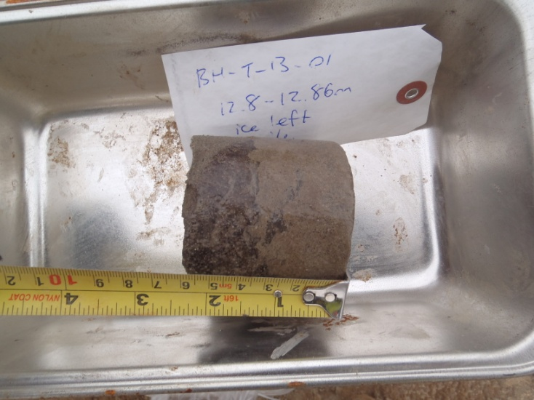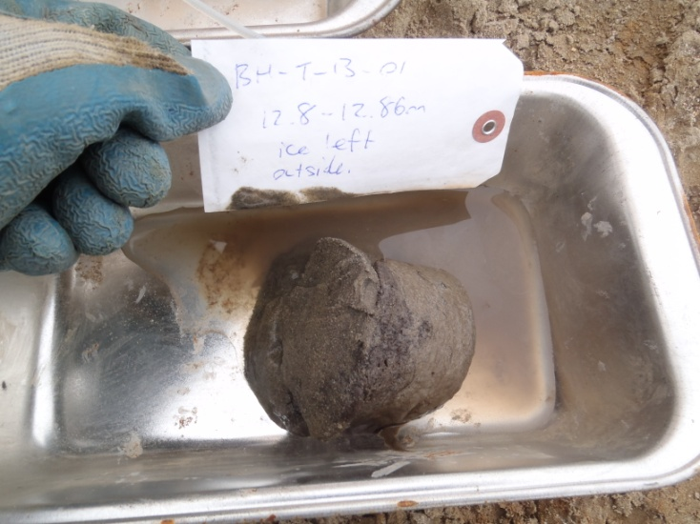
Time Zero 2 Hours Later

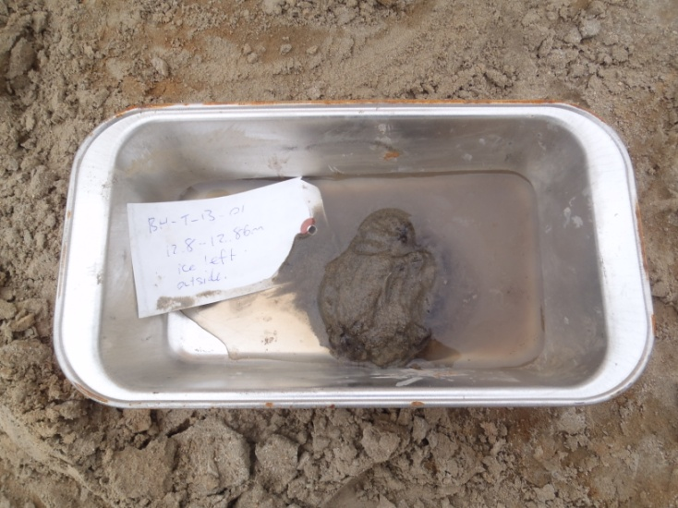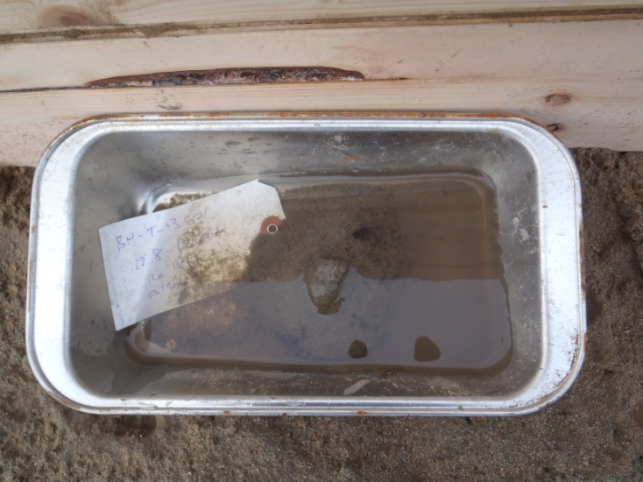
5 Hours Later 2 Days Later

PHOTO 25: BH-T-13-01, 12.8 to 12.86 m, ice lens behaviour when thawed, left in place at the drill site.
Government of Yukon - AAM
Mount Nansen 2013 Site Investigation
Photographs
Logged by: SM | Scale: NTS | Date: Oct 2013 | Project: VM00605E | Page 21

