Mount Nansen 2013 Site Investigation

list of photos
Page
Photos of Geoprobe Core 1
PHOTO 1: GP-T-13-01, 0-7m End of Hole; GP-T-13-02, 0-7.5m End of Hole. 1
PHOTO 2: GP-T-13-03, 0-9m End of Hole; GP-T-13-04, 0 to 11.5 m. End of Hole. 2
PHOTO 3: GP-T-13-10, 0 to 9.5 m End of Hole; GP-T-13-18, 0-6.25, End of Hole. 3
PHOTO 4: GP-T-13-22, 0 to 5.1 m. End of Hole. 4

Photos of Geoprobe Core

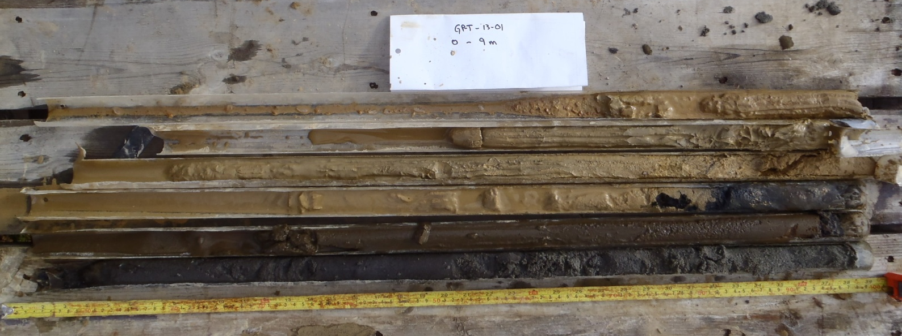
GP-T-13-01
0-7m
0
2
3
4
5
6
2
3
4
5
6
7
0
3.5
4.5
5.5
6.5
GP-T-13-02
0-7.5m
2.5

PHOTO 1: GP-T-13-01, 0-7m End of Hole; GP-T-13-02, 0-7.5m End of Hole.
Government of Yukon - AAM
Mount Nansen 2013 Site Investigation
Photographs
Logged by: DP | Scale: NTS | Date: Oct 2013 | Project: VM00605E | Page 1

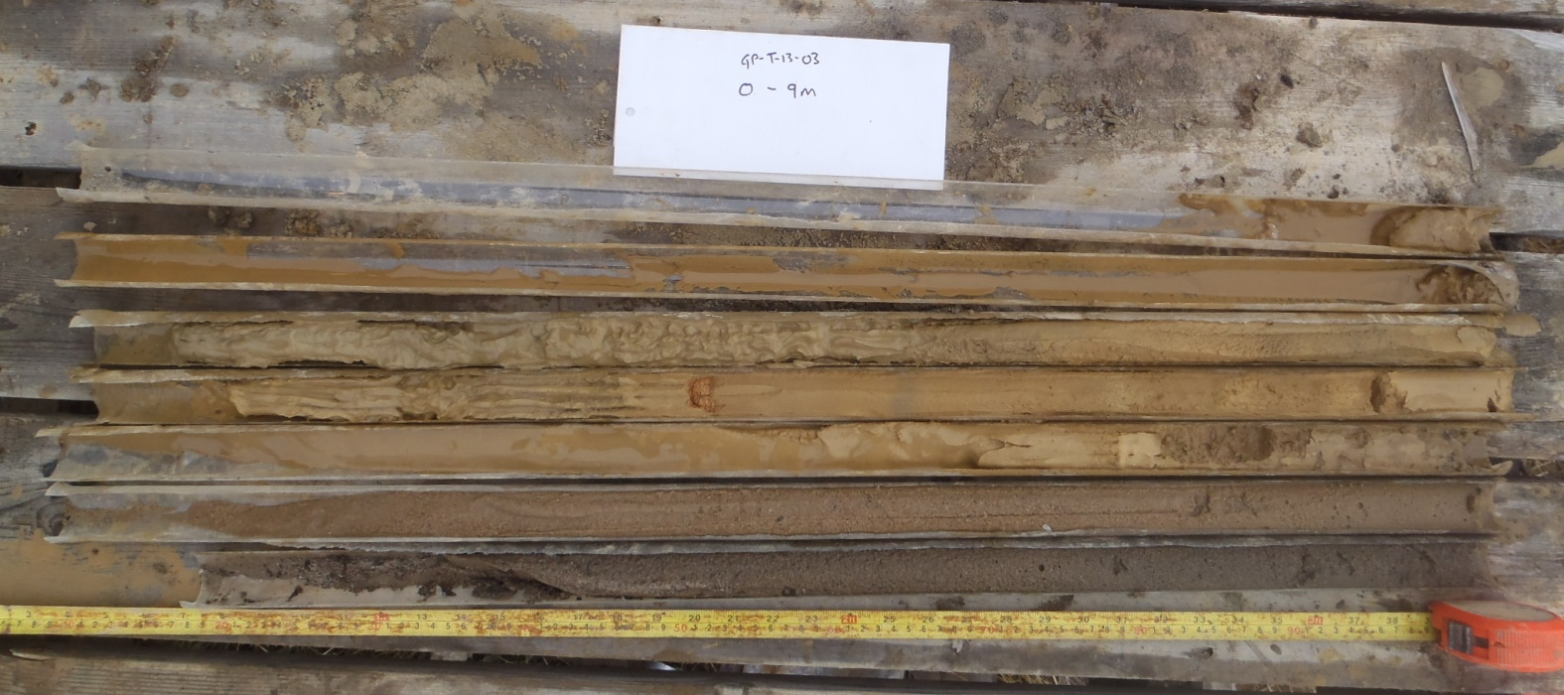
3
GP-T-13-03
0-9m
0
4
5
6
7
8
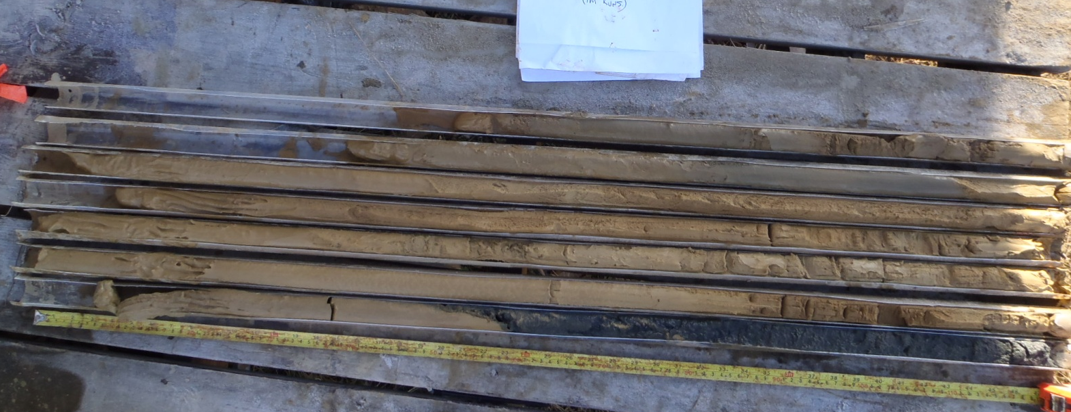
GP-T-13-04
0-11.5m
5.5
0
6.5
7.5
8.5
9.5
10.5

PHOTO 2: GP-T-13-03, 0-9m End of Hole; GP-T-13-04, 0 to 11.5 m. End of Hole.
AMEC Environment & Infrastructure |  | Government of Yukon - AAM  Mount Nansen 2013 Site Investigation  Photographs
Logged by: DP | Scale: NTS | Date: Oct 2013 | Project: VM00605E | Page 2

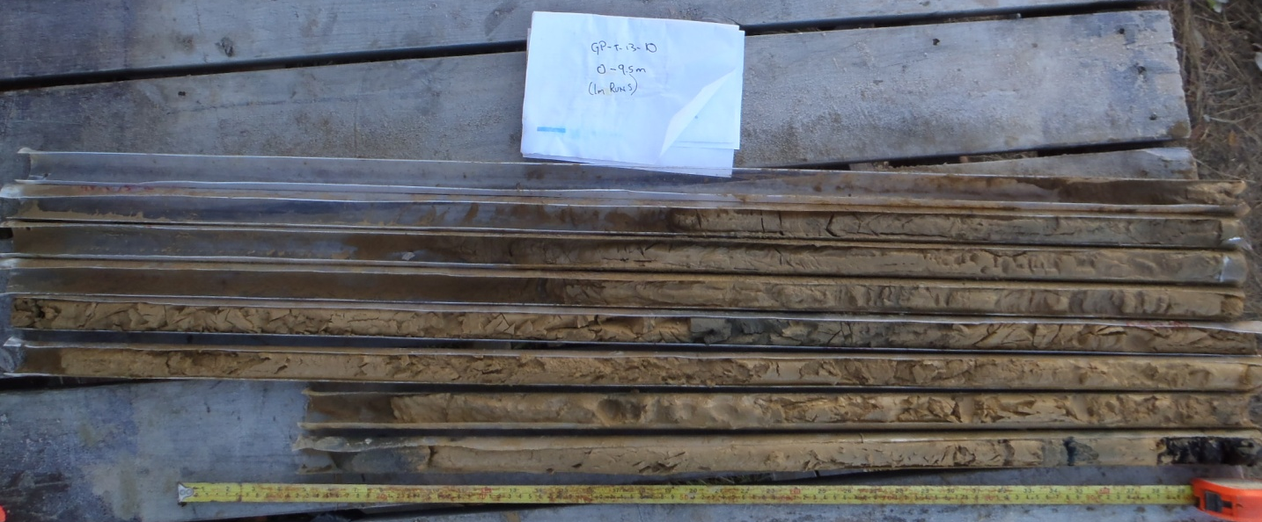
2.5
GP-T-13-10
0-9.5m
0
3.5
4.5
5.5
6.5
7.5
8.5
GP-T-13-18
0-6.25m
1.25
0
2.5
3.75
5

PHOTO 3: GP-T-13-10, 0 to 9.5 m End of Hole; GP-T-13-18, 0-6.25, End of Hole.
AMEC Environment & Infrastructure |  | Government of Yukon - AAM  Mount Nansen 2013 Site Investigation  Photographs
Logged by: DP | Scale: NTS | Date: Oct 2013 | Project: VM00605E | Page 3

1.25
GP-T-13-22
0-5.1m
0
2.5
3.75
5
5.0.1

PHOTO 4: GP-T-13-22, 0 to 5.1 m. End of Hole.

NOTE: No photos available for GP-T-13-21 and GP-T-13-23.
AMEC Environment & Infrastructure |  | Government of Yukon - AAM  Mount Nansen 2013 Site Investigation  Photographs
Logged by: DP | Scale: NTS | Date: Oct 2013 | Project: VM00605E | Page 4

