Mount Nansen 2013 Site Investigation

list of photos
Page
Photos of Dome Creek Watershed and Channel 1
PHOTO 1: Dome Creek Watershed – From the Mill Area Facing D/S to the Tailings Area. 1
PHOTO 2: Dome Creek – From the Tailings Area Facing U/S to the Mill Area. 1
PHOTO 3: Dome Creek – D/S of the TSF Looking U/S. 2
PHOTO 4: Dome Creek Watershed – Looking Up Valley Walls. 2
PHOTO 5: Dome Creek Watershed Valley Bottom – Moss. 3
PHOTO 6: Dome Creek – Moss Depth - 25 cm. 3
PHOTO 7: Dome Creek – U/S of the Mill & Bunkhouse Road. 4
PHOTO 8: Dome Creek – U/S of the Mill & Bunkhouse Road. 4
PHOTO 9: Dome Creek – Flow Measurement Location Near Bunkhouse (Bucket and Stopwatch). 5
PHOTO 10: Dome Creek – Channel at GSI-DC-2. 5
PHOTO 11: Dome Creek – Flow Measurement Location (Bucket and Stopwatch). 6
PHOTO 12: Dome Creek – Channel Dried Up U/S of TSF. 6
PHOTO 13: Dome Creek – TSF Diversion Channel. 7
PHOTO 14: Dome Creek – Flow Measurement Location Diversion Channel. 7
PHOTO 15: Dome Creek – Flow Measuring Location D/S of TSF. 8
PHOTO 16: Dome Creek – Flow Measuring U/S of TSF. 8
PHOTO 17: Dome Creek – Flow Measuring Station Culvert Near Bunkhouse. 9
Photos of Dome Creek Sediment Sampling 10
PHOTO 18: Dome Creek – SED-DC-1. 10
PHOTO 19: Dome Creek – SED-DC-1. 11
PHOTO 20: Dome Creek – SED-DC-2. 11
PHOTO 21: Dome Creek – SED-DC-3. 12
PHOTO 22: Dome Creek – SED-DC-4. 12
PHOTO 23: Dome Creek – SED-DC-4. 13
PHOTO 24: Dome Creek – SED-DC-5. 13
PHOTO 25: Dome Creek – SED-DC-6. 14
PHOTO 26: Dome Creek – SED-DC-12. 14
PHOTO 27: Dome Creek – SED-DC-13. 15
PHOTO 28: Dome Creek – SED-DC-14. 15
PHOTO 29: Dome Creek – SED-DC-15. 16
PHOTO 30: Dome Creek – SED-DC-16. 16
PHOTO 31: Dome Creek – SED-DC-17. 17
PHOTO 32: Dome Creek – SED-DC-18. 17
PHOTO 33: Dome Creek – SED-DC-19. 18
PHOTO 34: Dome Creek – SED-DC-20. 18
PHOTO 35: Dome Creek – SED-DC-11. 19
PHOTO 36: Dome Creek – SED-DC-7. 19
PHOTO 37: Dome Creek – SED-DC-8. 20
PHOTO 38: Dome Creek – SED-DC-9. 20
PHOTO 39: Dome Creek – SED-DC-10. 21
Photos of Pony Creek Watershed and Channel 22
PHOTO 40: Pony Creek Watershed – Facing D/S Near the Open Pit. 22
PHOTO 41: Pony Creek – Flow Measuring Station. 22
PHOTO 42: Pony Creek – Flow Measuring Station. 23
PHOTO 43: Pony Creek – Facing U/S Near the Open Pit. 23
PHOTO 44: Pony Creek – Flow Measuring Station. 24
PHOTO 45: Pony Creek – Facing D/S. 24
PHOTO 46: Pony Creek – Vegetation on the Valley Walls. 25
PHOTO 47: Pony Creek – Upper Watershed. 25

Photos of Dome Creek Watershed and Channel

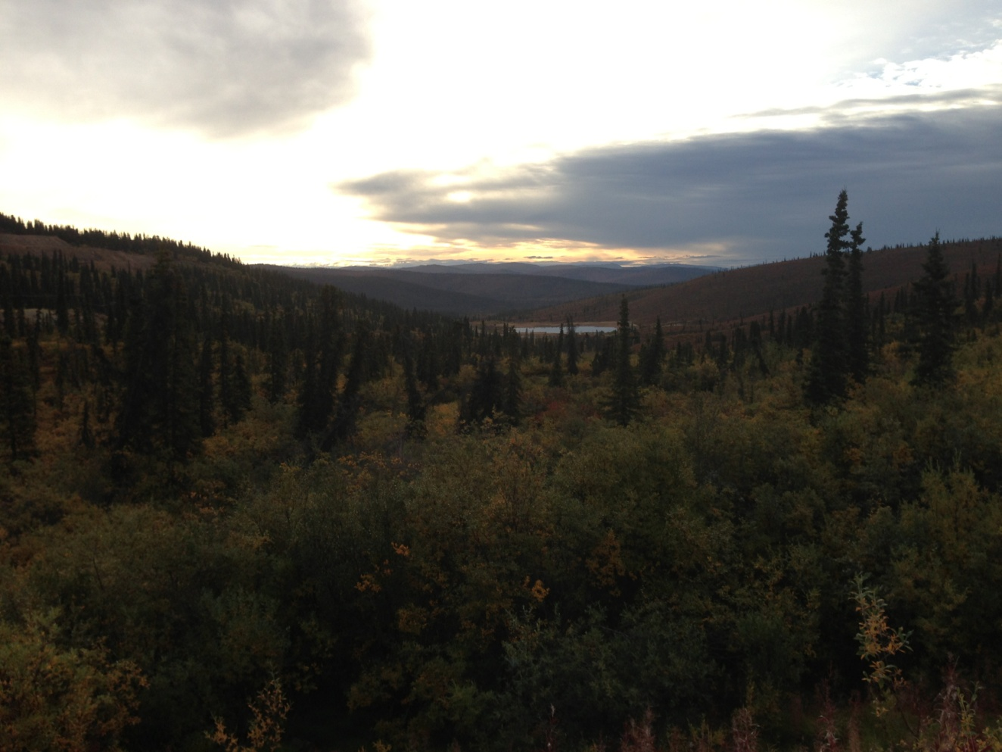

PHOTO 1: Dome Creek Watershed – From the Mill Area Facing D/S to the Tailings Area.

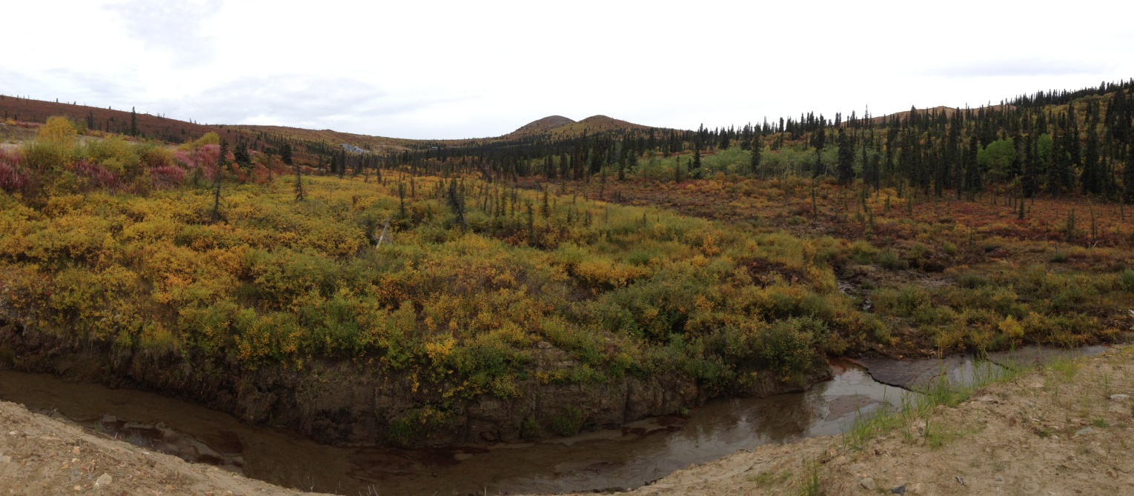

PHOTO 2: Dome Creek – From the Tailings Area Facing U/S to the Mill Area.
Government of Yukon - AAM
Mount Nansen 2013 Site Investigation
Photographs
Logged by: CM | Scale: NTS | Date: Oct 2013 | Project: VM00605E | Page 1

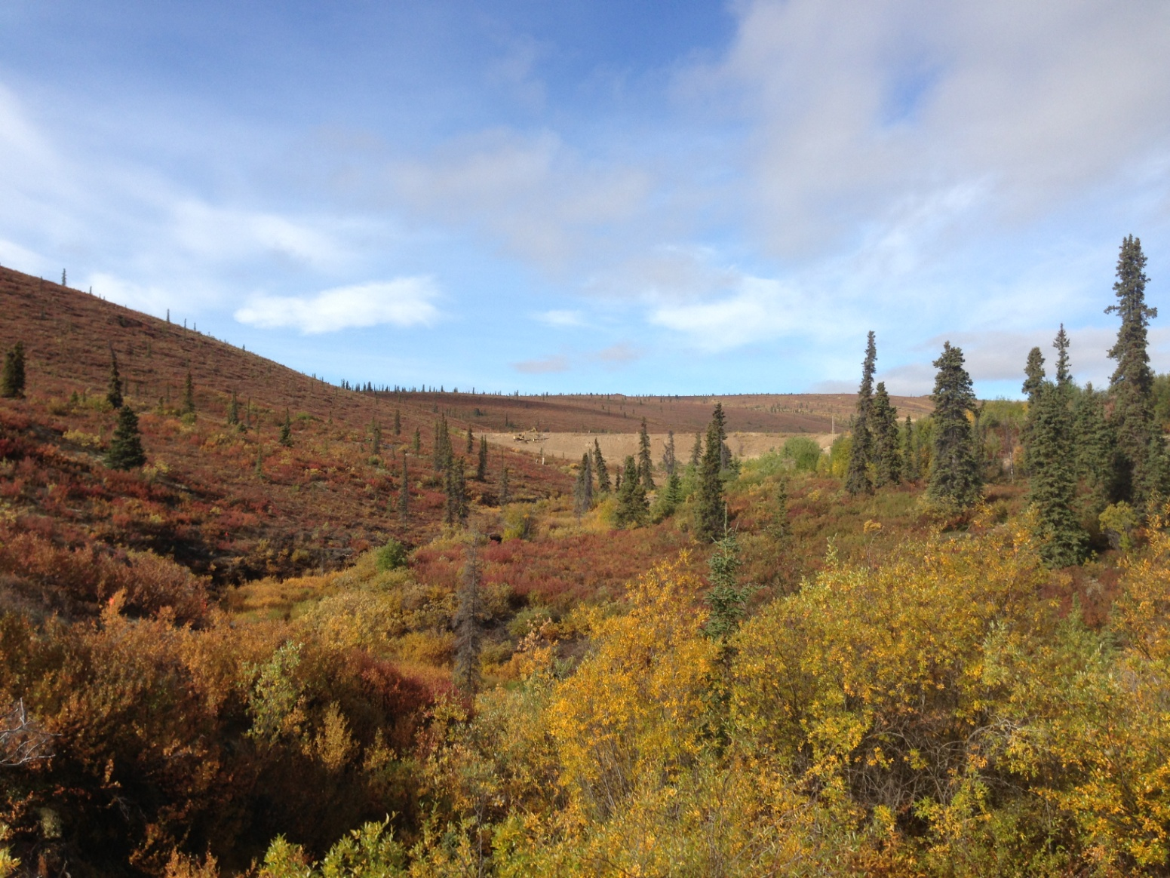

PHOTO 3: Dome Creek – D/S of the TSF Looking U/S.

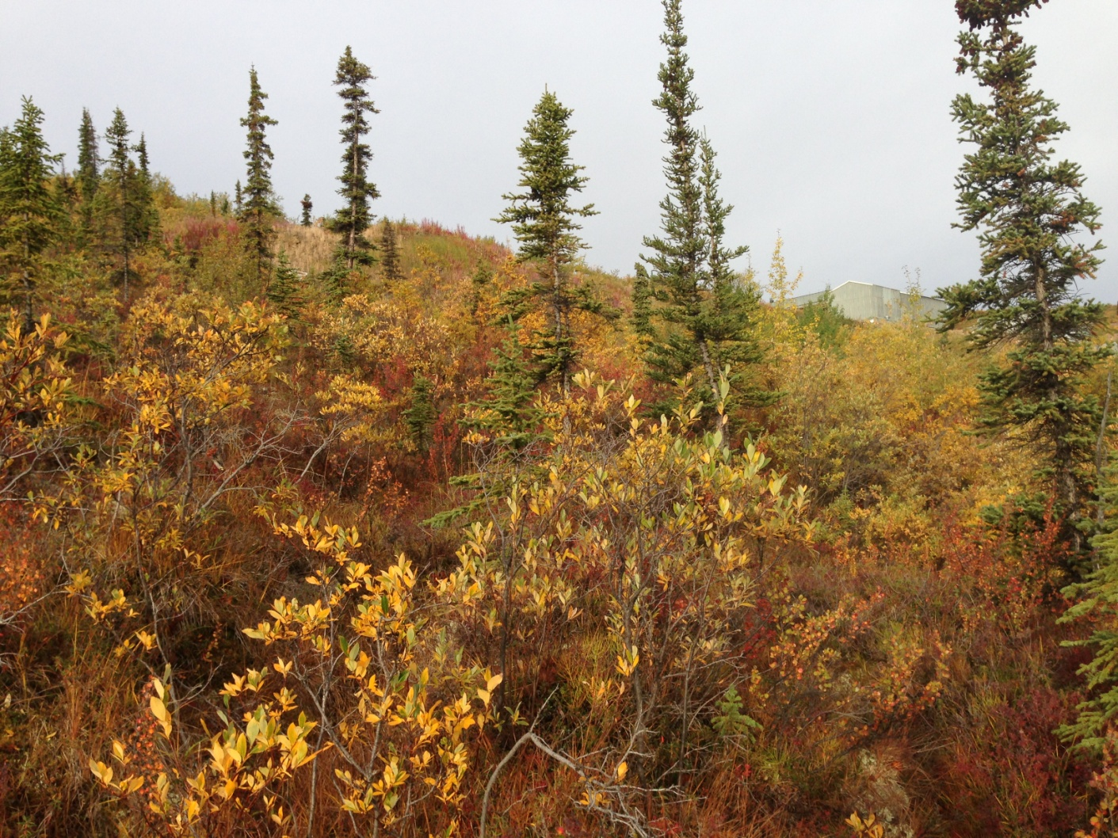

PHOTO 4: Dome Creek Watershed – Looking Up Valley Walls.
AMEC Environment & Infrastructure |  | Government of Yukon - AAM  Mount Nansen 2013 Site Investigation  Photographs
Logged by: CM | Scale: NTS | Date: Oct 2013 | Project: VM00605E | Page 2

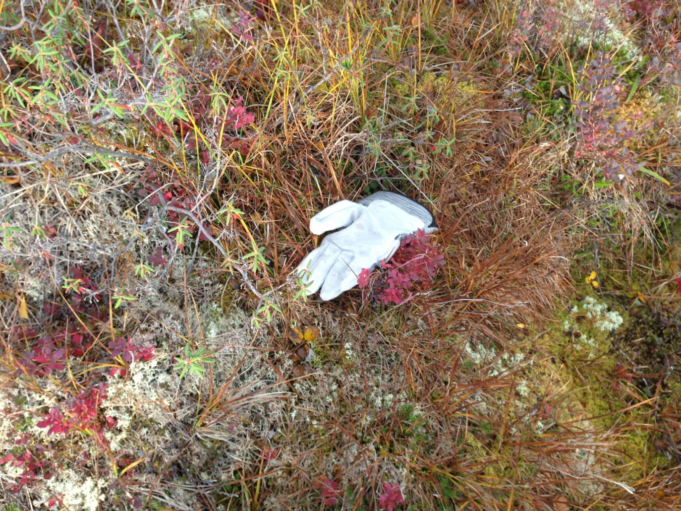

PHOTO 5: Dome Creek Watershed Valley Bottom – Moss.

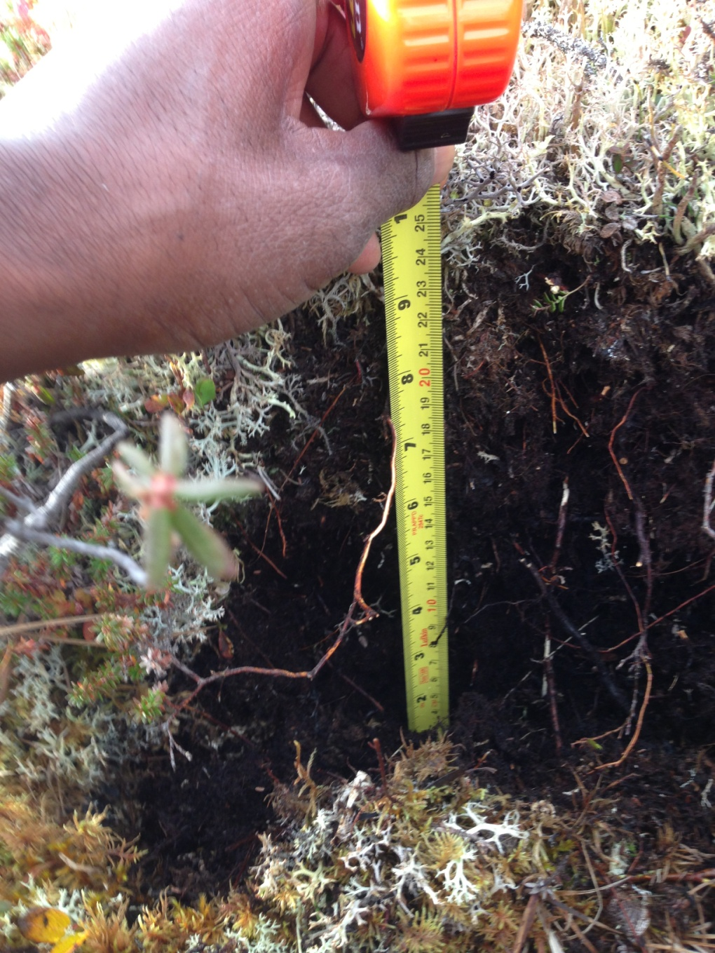

PHOTO 6: Dome Creek – Moss Depth - 25 cm.
AMEC Environment & Infrastructure |  | Government of Yukon - AAM  Mount Nansen 2013 Site Investigation  Photographs
Logged by: CM | Scale: NTS | Date: Oct 2013 | Project: VM00605E | Page 3

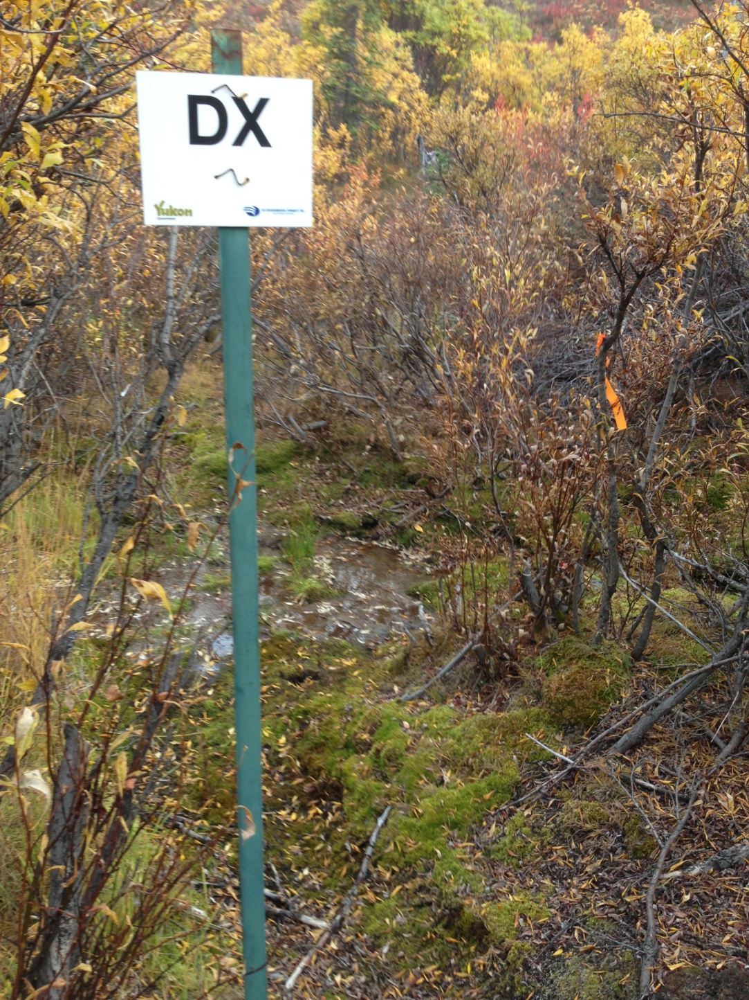

PHOTO 7: Dome Creek – U/S of the Mill & Bunkhouse Road.

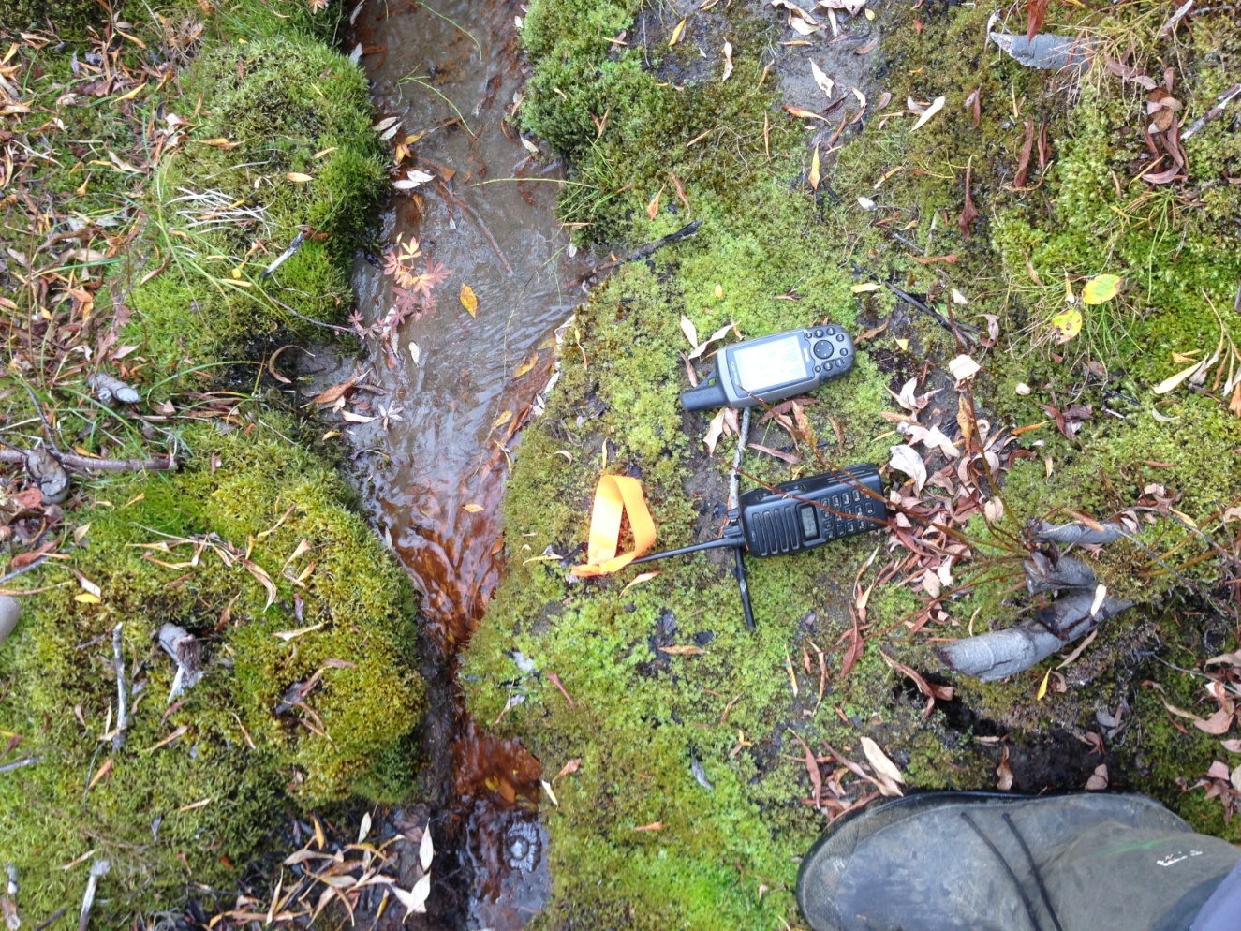

PHOTO 8: Dome Creek – U/S of the Mill & Bunkhouse Road.
AMEC Environment & Infrastructure |  | Government of Yukon - AAM  Mount Nansen 2013 Site Investigation  Photographs
Logged by: CM | Scale: NTS | Date: Oct 2013 | Project: VM00605E | Page 4

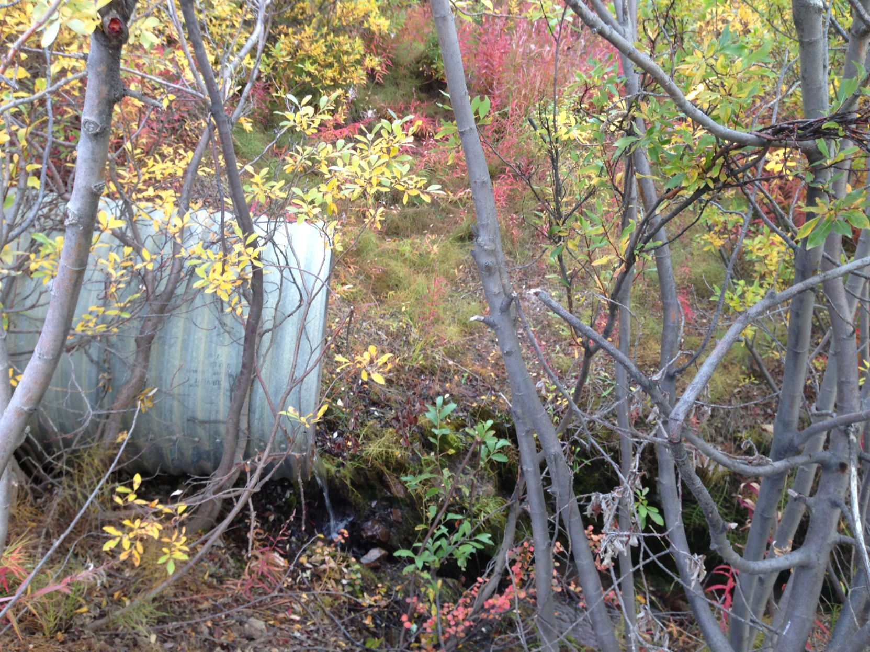

PHOTO 9: Dome Creek – Flow Measurement Location Near Bunkhouse (Bucket and Stopwatch).

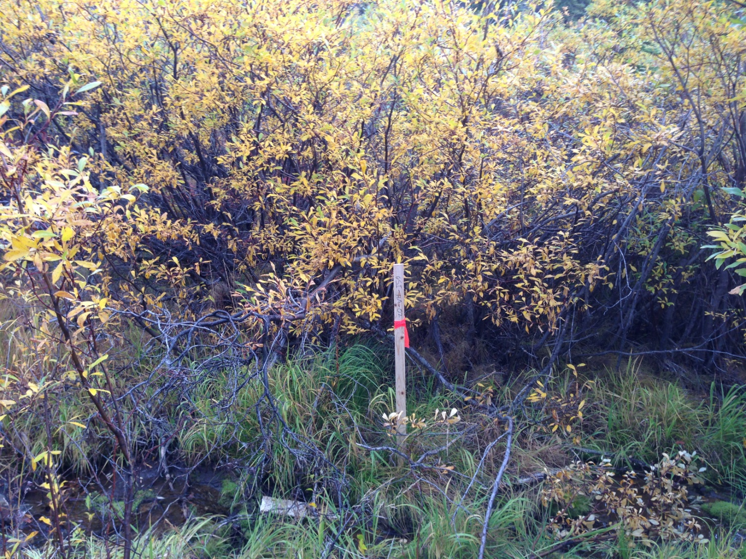

PHOTO 10: Dome Creek – Channel at GSI-DC-2.
AMEC Environment & Infrastructure |  | Government of Yukon - AAM  Mount Nansen 2013 Site Investigation  Photographs
Logged by: CM | Scale: NTS | Date: Oct 2013 | Project: VM00605E | Page 5

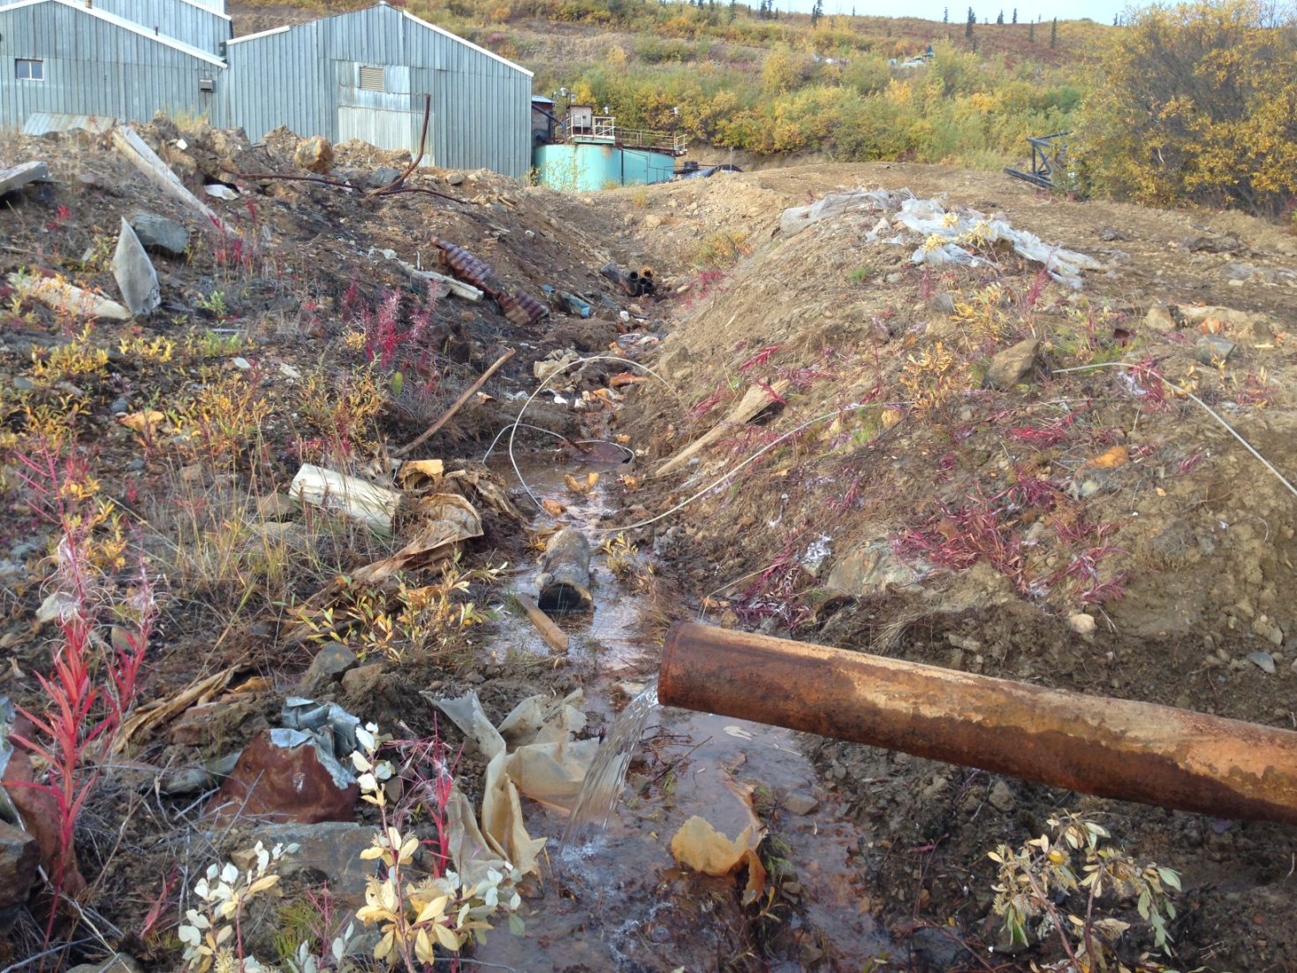

PHOTO 11: Dome Creek – Flow Measurement Location (Bucket and Stopwatch).

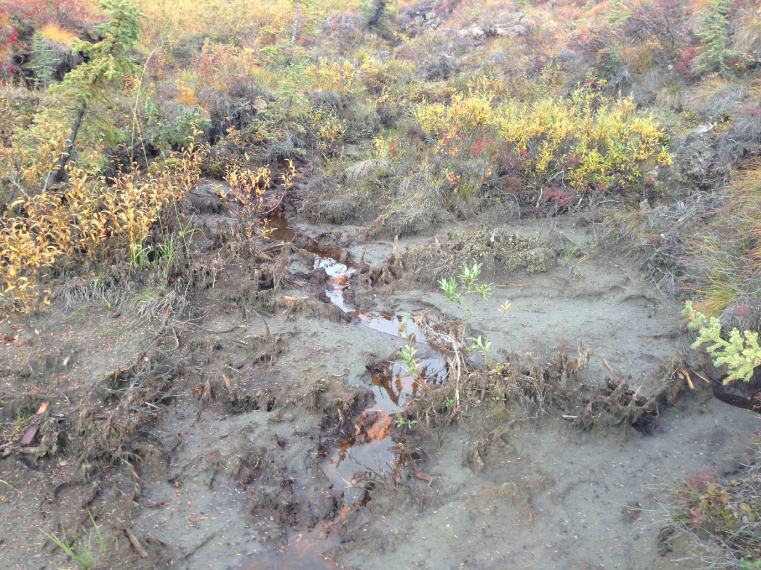

PHOTO 12: Dome Creek – Channel Dried Up U/S of TSF.
AMEC Environment & Infrastructure |  | Government of Yukon - AAM  Mount Nansen 2013 Site Investigation  Photographs
Logged by: CM | Scale: NTS | Date: Oct 2013 | Project: VM00605E | Page 6

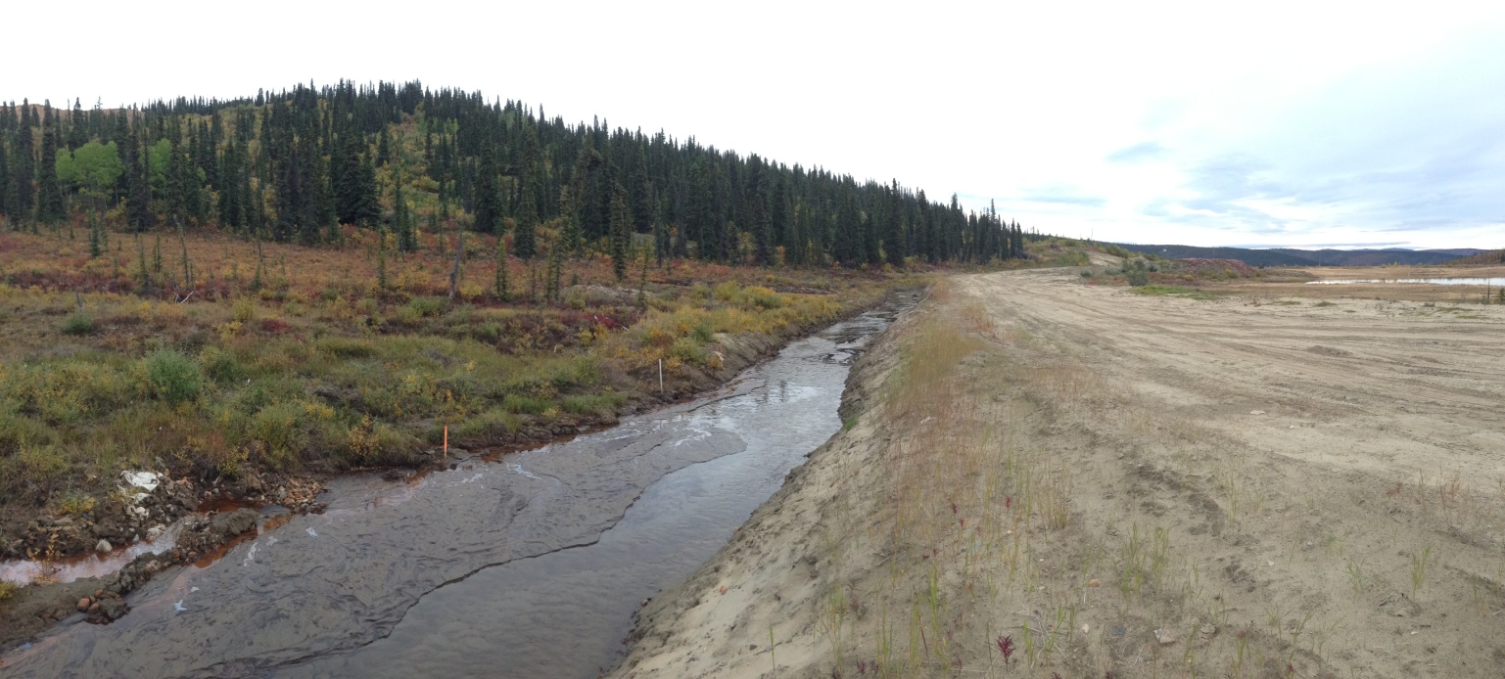

PHOTO 13: Dome Creek – TSF Diversion Channel.

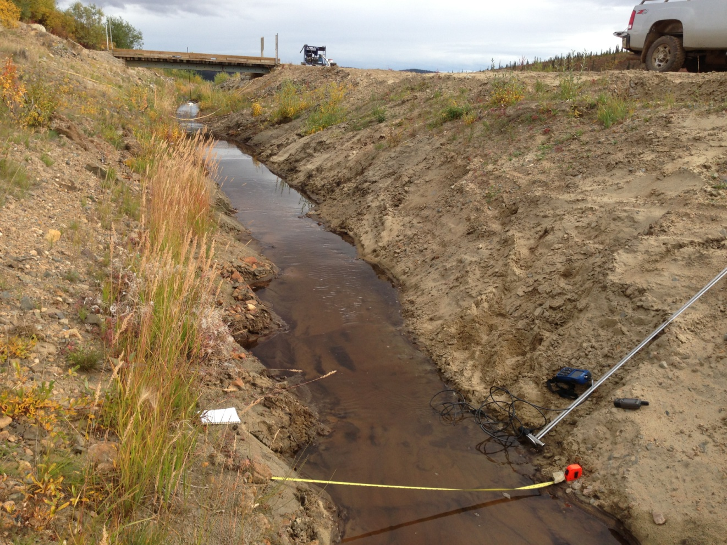

PHOTO 14: Dome Creek – Flow Measurement Location Diversion Channel.
AMEC Environment & Infrastructure |  | Government of Yukon - AAM  Mount Nansen 2013 Site Investigation  Photographs
Logged by: CM | Scale: NTS | Date: Oct 2013 | Project: VM00605E | Page 7

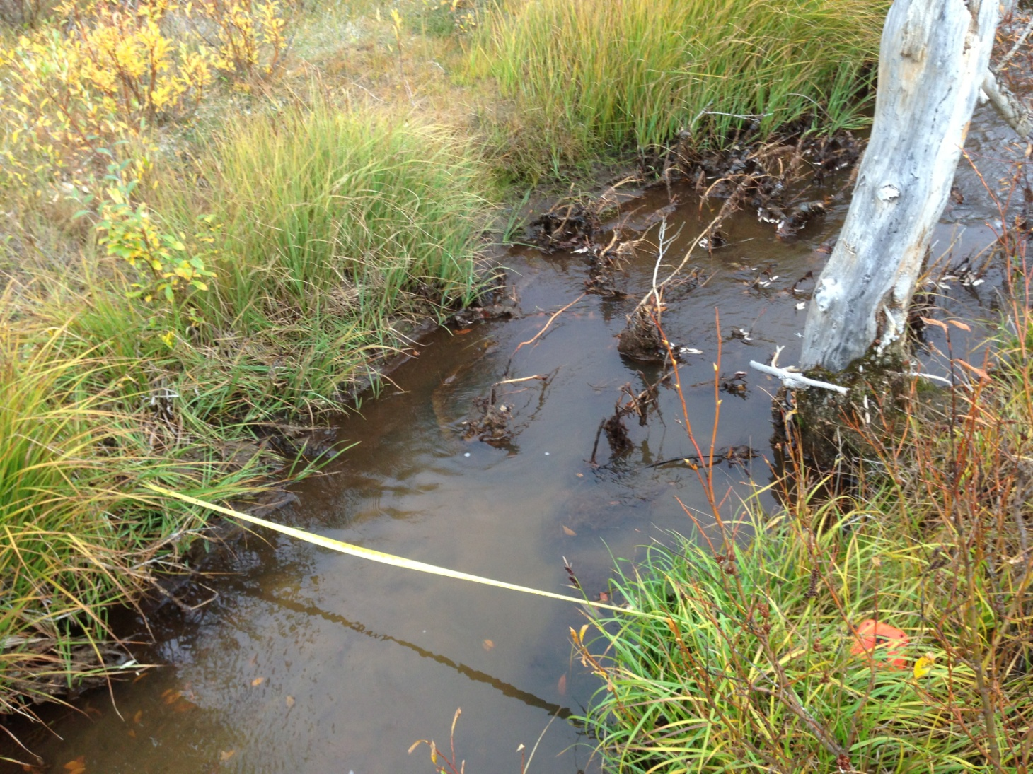

PHOTO 15: Dome Creek – Flow Measuring Location D/S of TSF.

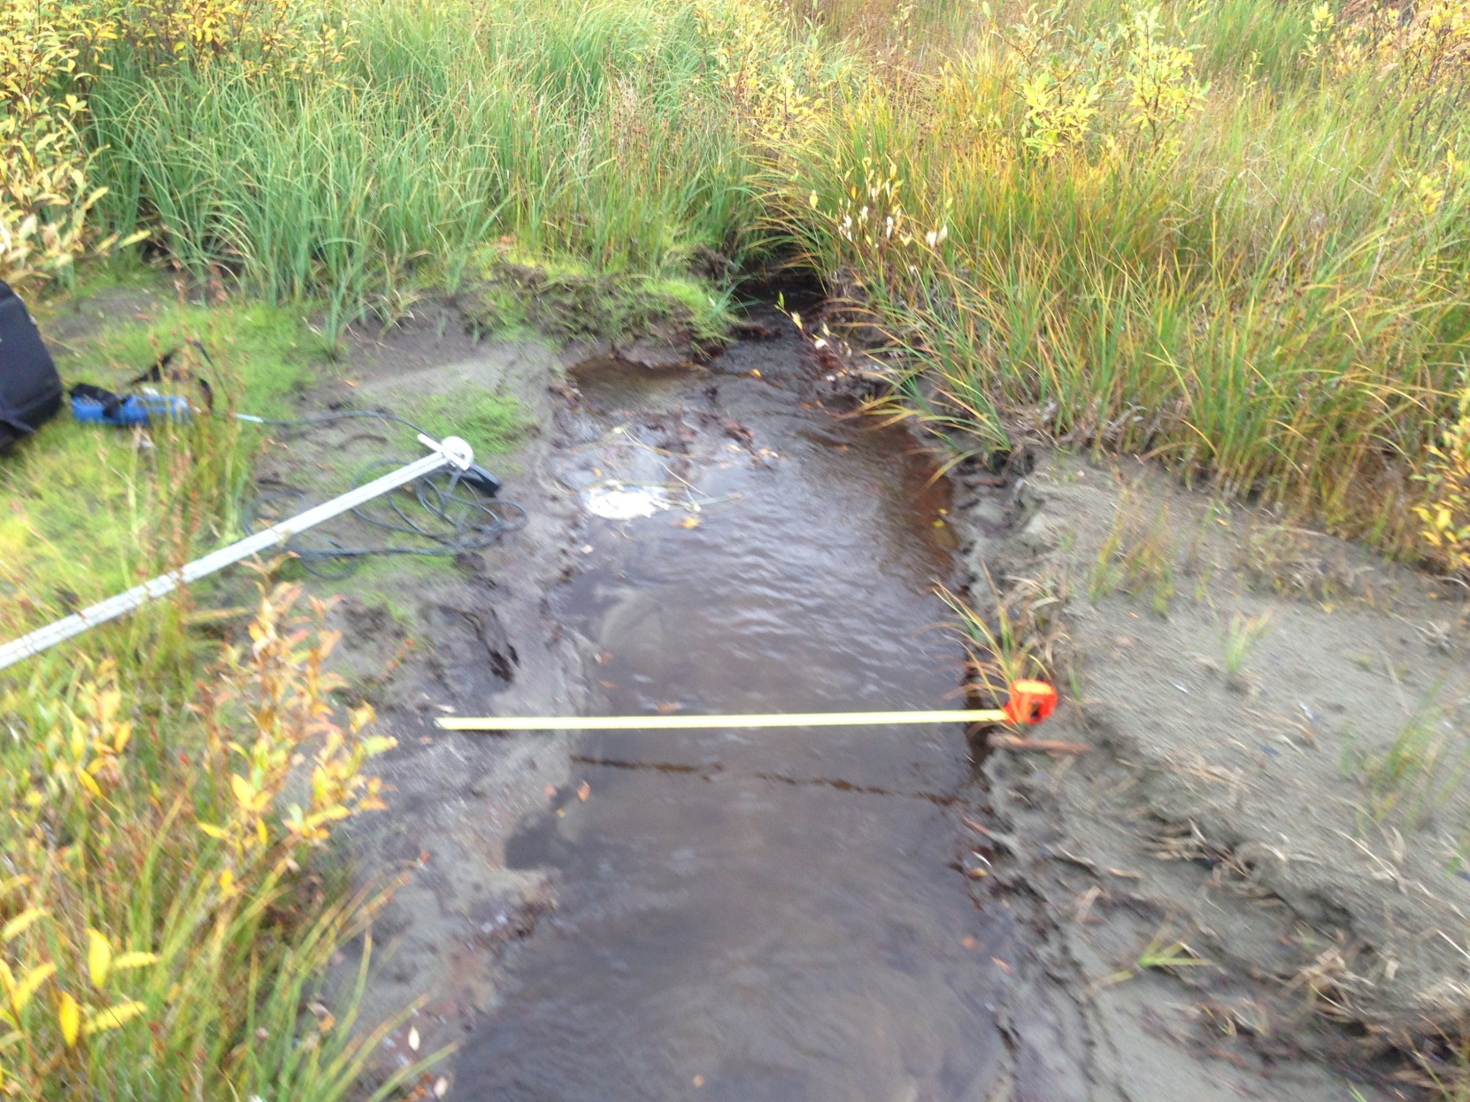

PHOTO 16: Dome Creek – Flow Measuring U/S of TSF.
AMEC Environment & Infrastructure |  | Government of Yukon - AAM  Mount Nansen 2013 Site Investigation  Photographs
Logged by: CM | Scale: NTS | Date: Oct 2013 | Project: VM00605E | Page 8

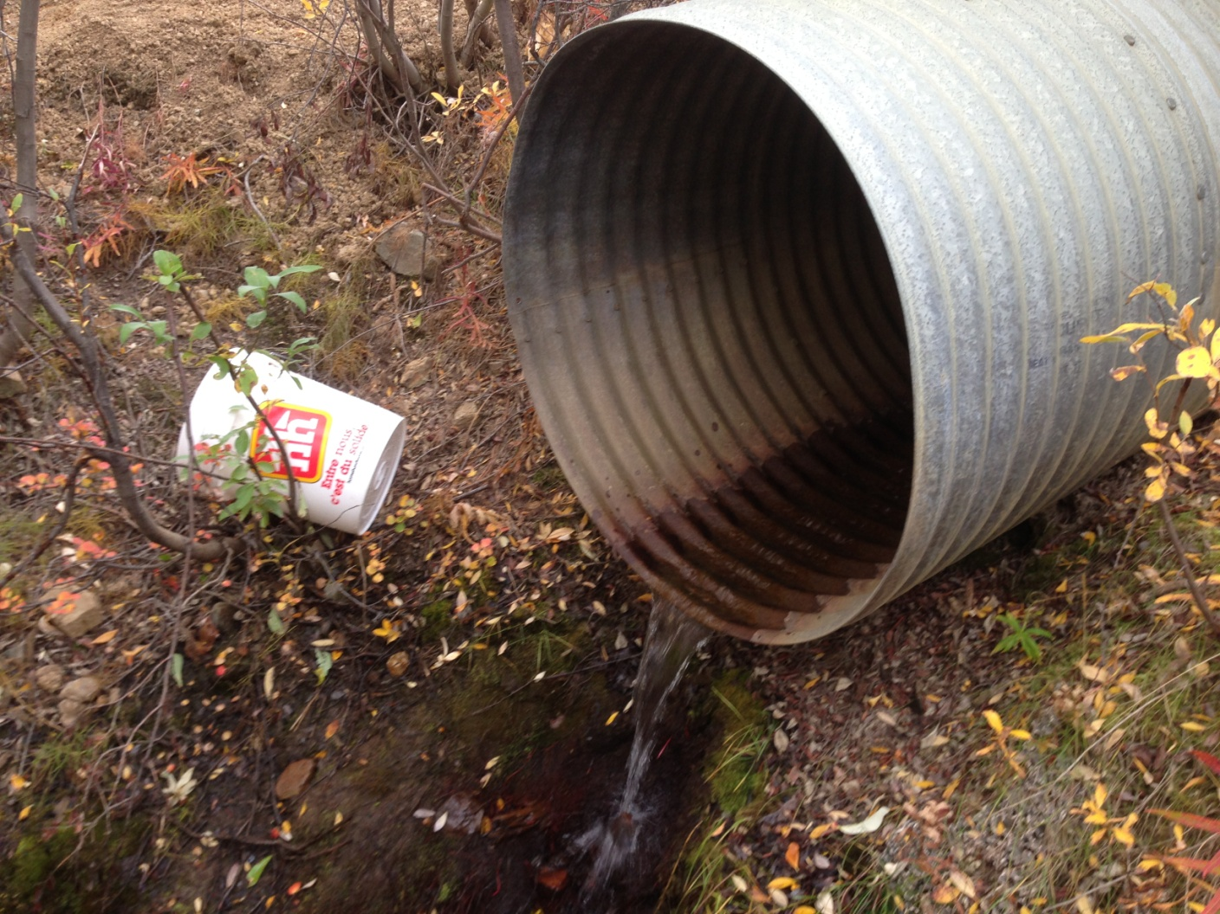

PHOTO 17: Dome Creek – Flow Measuring Station Culvert Near Bunkhouse.
AMEC Environment & Infrastructure |  | Government of Yukon - AAM  Mount Nansen 2013 Site Investigation  Photographs
Logged by: CM | Scale: NTS | Date: Oct 2013 | Project: VM00605E | Page 9

Photos of Dome Creek Sediment Sampling

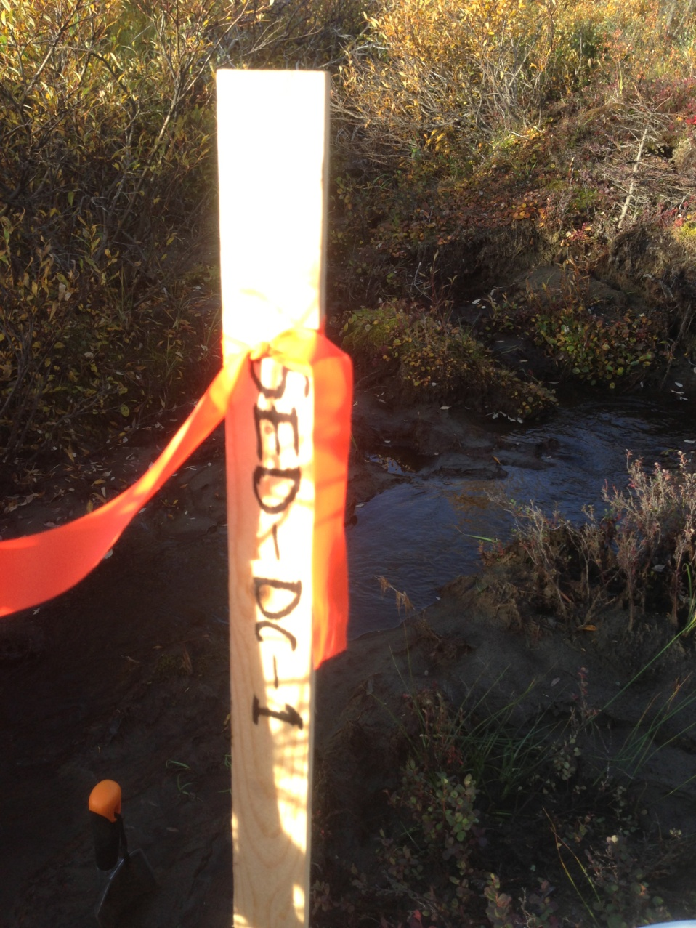

PHOTO 18: Dome Creek – SED-DC-1.
AMEC Environment & Infrastructure |  | Government of Yukon - AAM  Mount Nansen 2013 Site Investigation  Photographs
Logged by: CM | Scale: NTS | Date: Oct 2013 | Project: VM00605E | Page 10

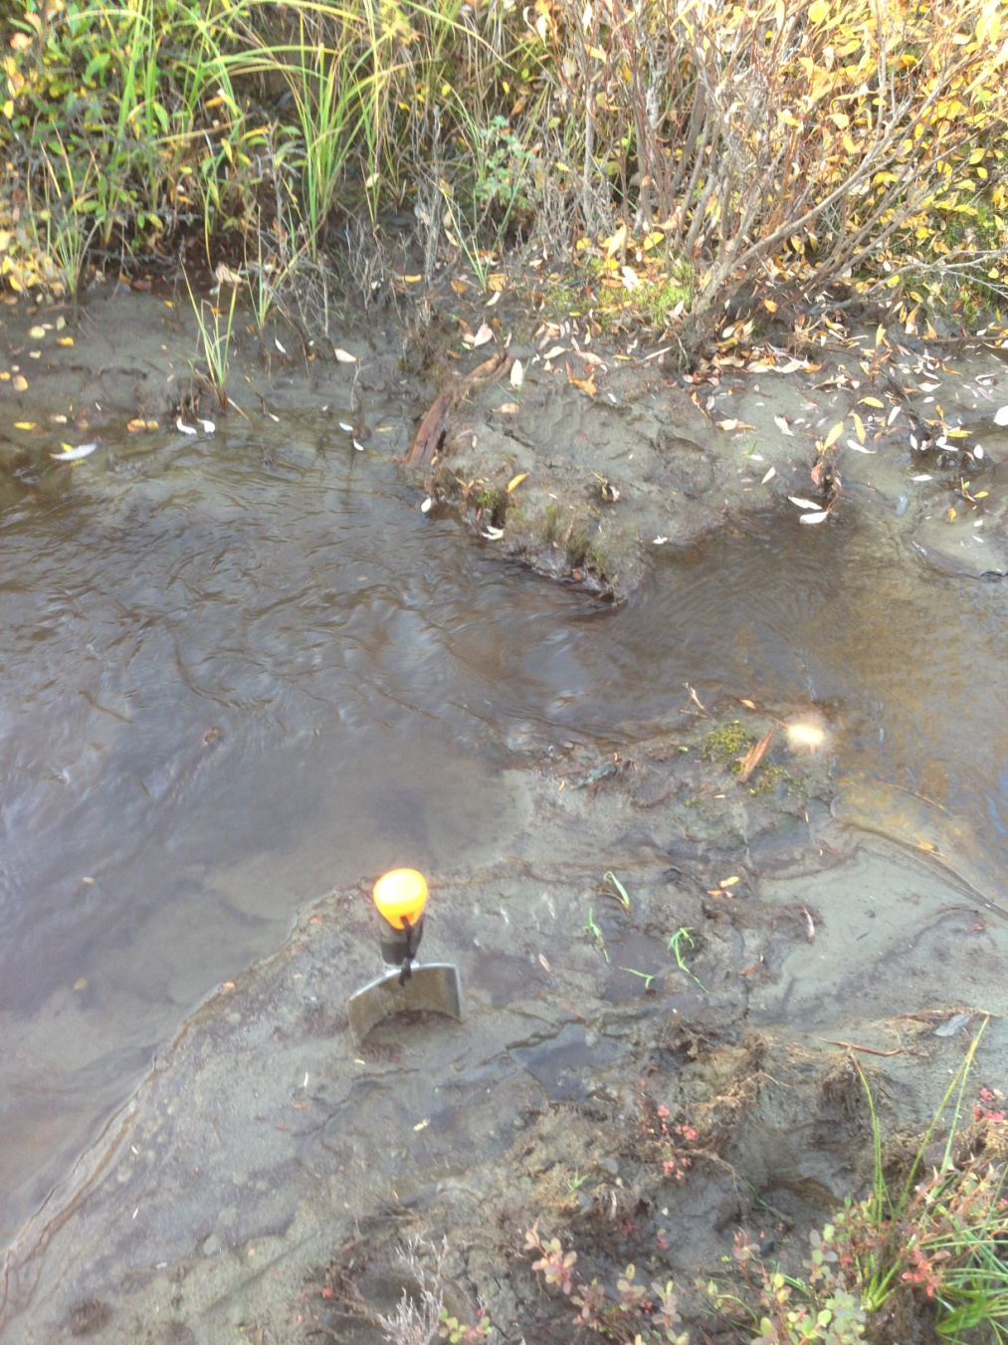

PHOTO 19: Dome Creek – SED-DC-1.

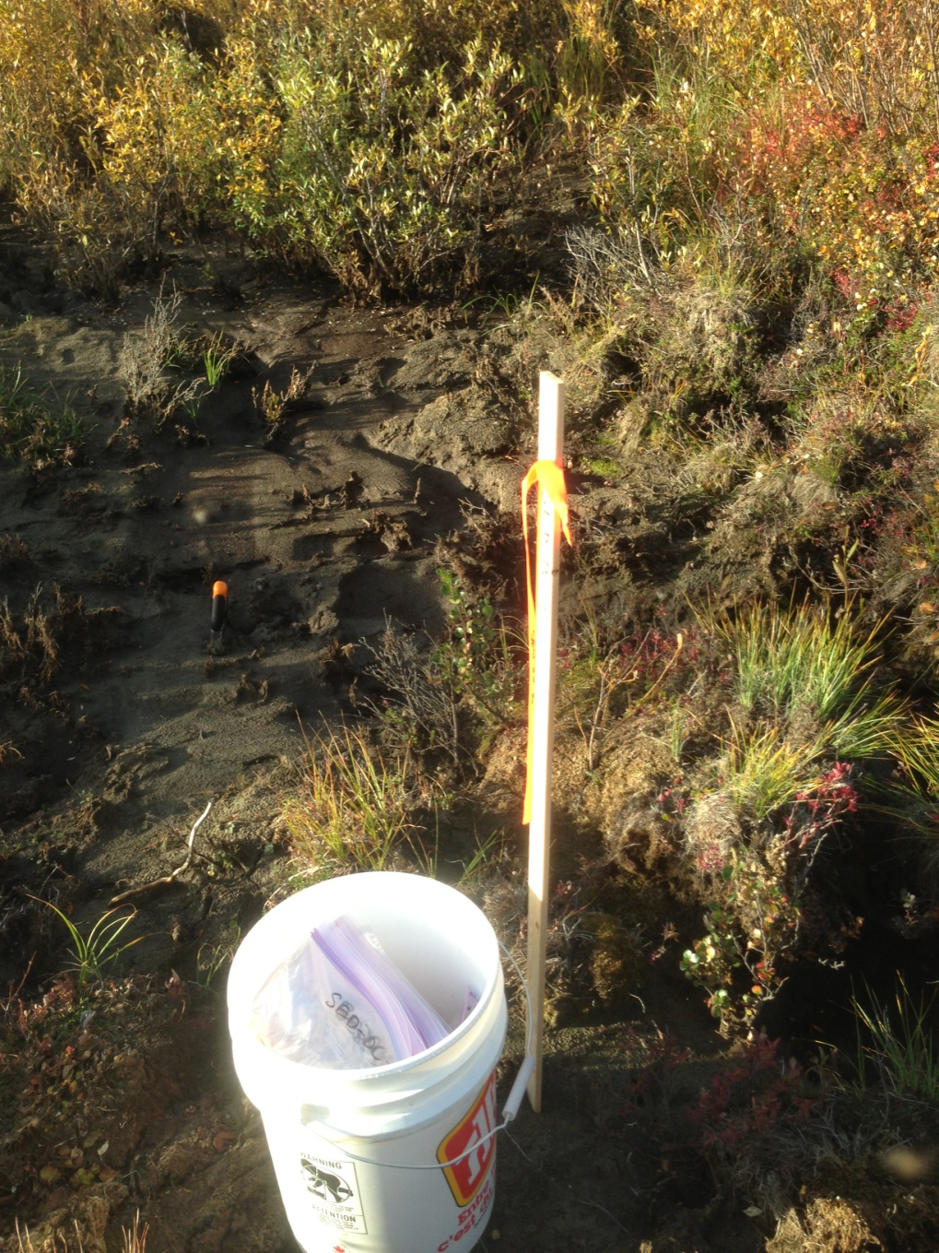

PHOTO 20: Dome Creek – SED-DC-2.
AMEC Environment & Infrastructure |  | Government of Yukon - AAM  Mount Nansen 2013 Site Investigation  Photographs
Logged by: CM | Scale: NTS | Date: Oct 2013 | Project: VM00605E | Page 11

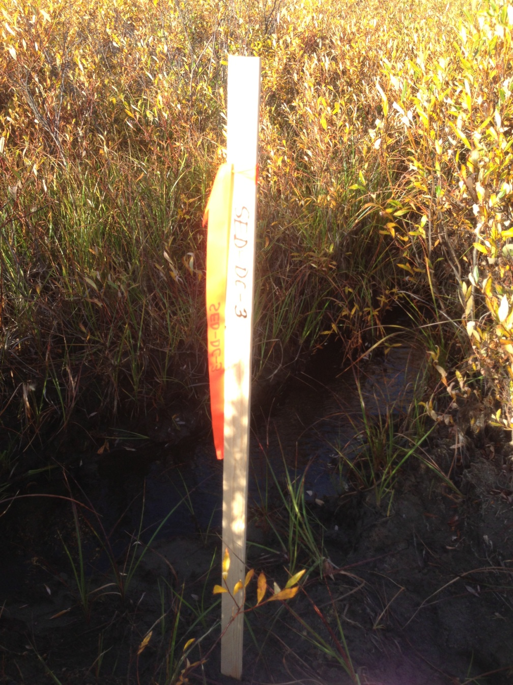

PHOTO 21: Dome Creek – SED-DC-3.

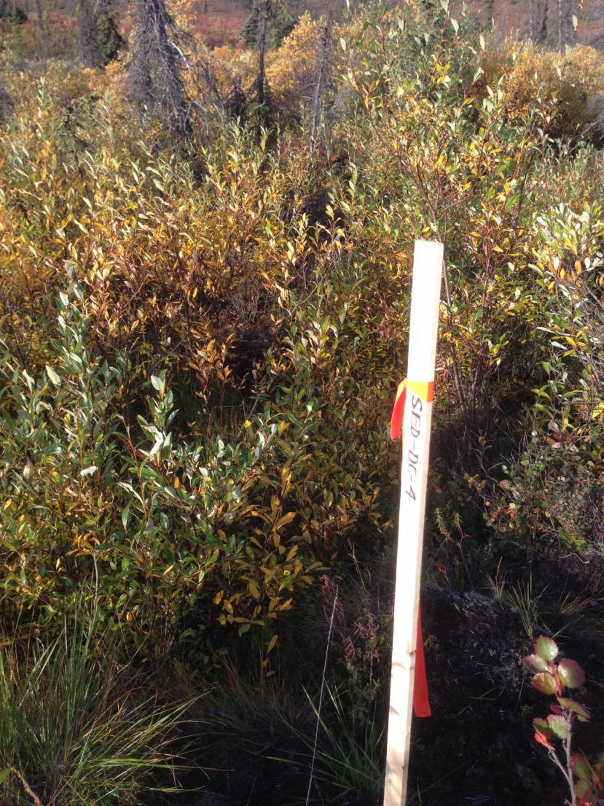

PHOTO 22: Dome Creek – SED-DC-4.
AMEC Environment & Infrastructure |  | Government of Yukon - AAM  Mount Nansen 2013 Site Investigation  Photographs
Logged by: CM | Scale: NTS | Date: Oct 2013 | Project: VM00605E | Page 12

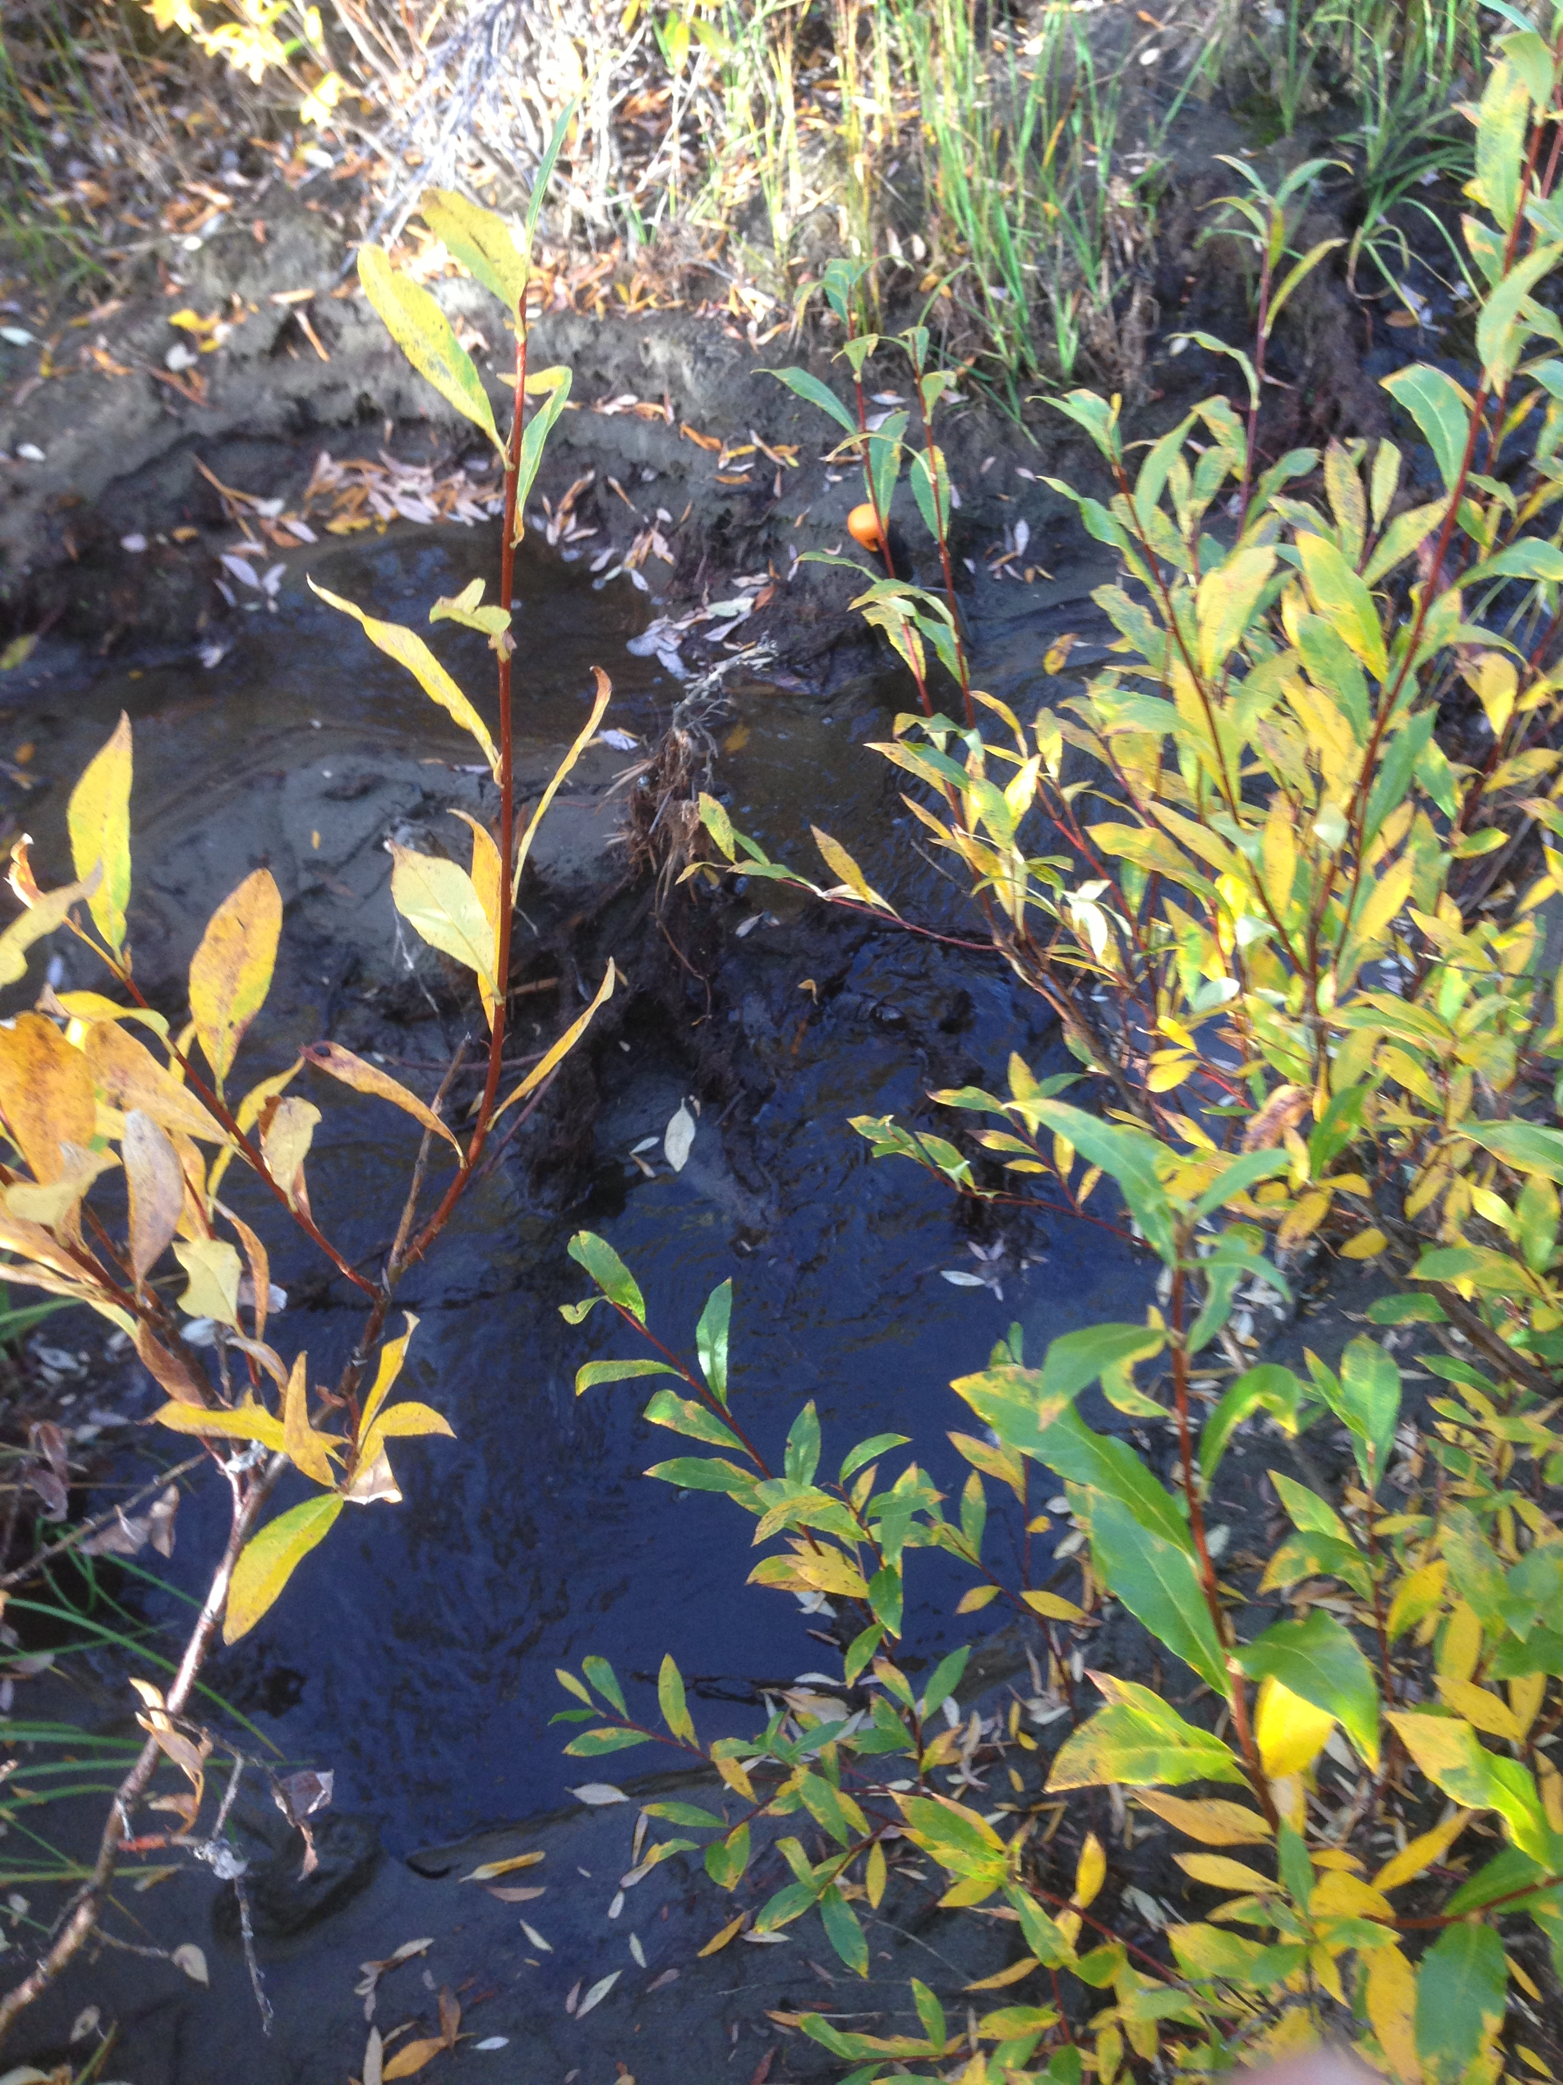

PHOTO 23: Dome Creek – SED-DC-4.

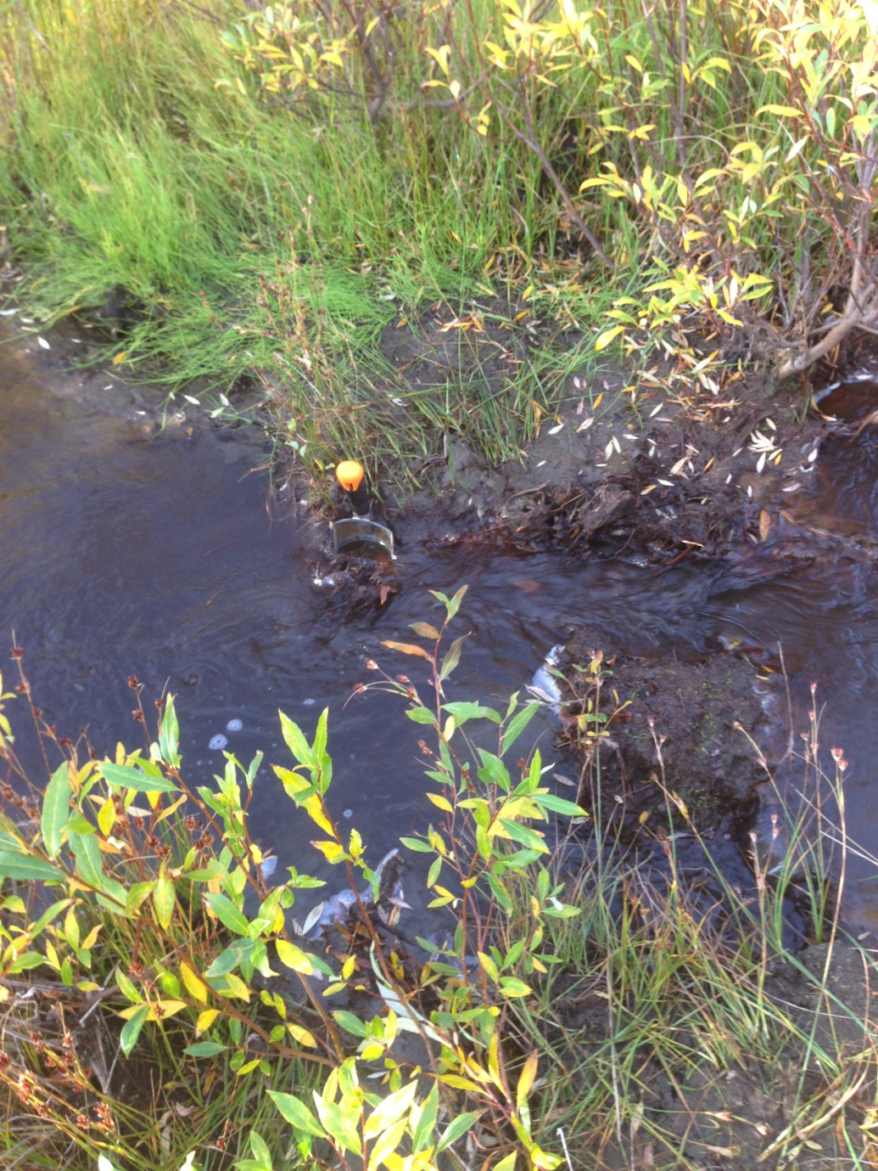

PHOTO 24: Dome Creek – SED-DC-5.
AMEC Environment & Infrastructure |  | Government of Yukon - AAM  Mount Nansen 2013 Site Investigation  Photographs
Logged by: CM | Scale: NTS | Date: Oct 2013 | Project: VM00605E | Page 13

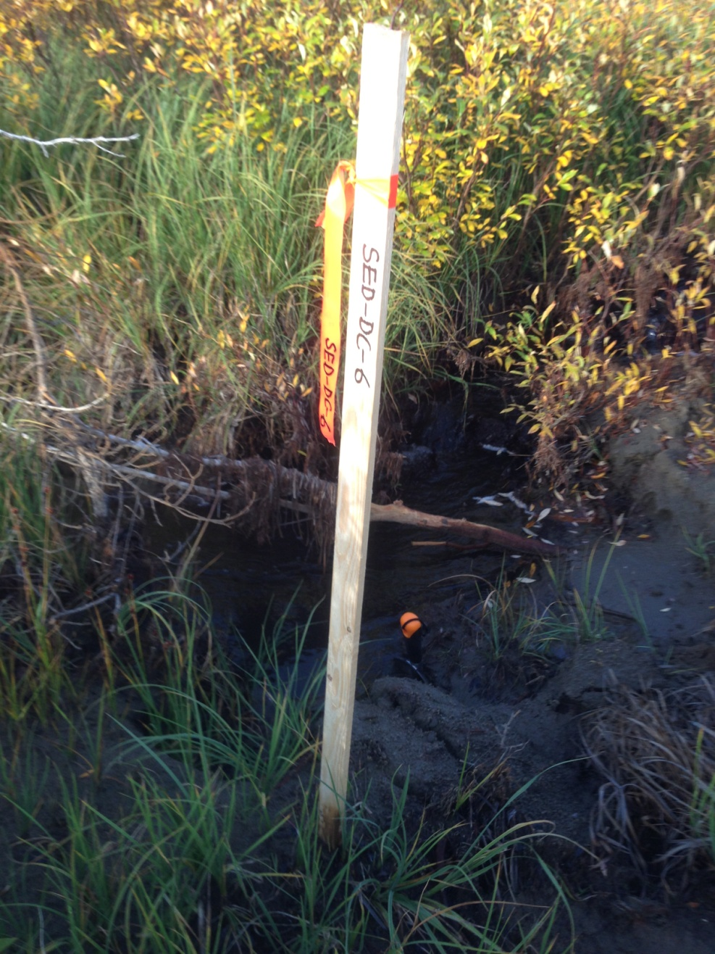

PHOTO 25: Dome Creek – SED-DC-6.

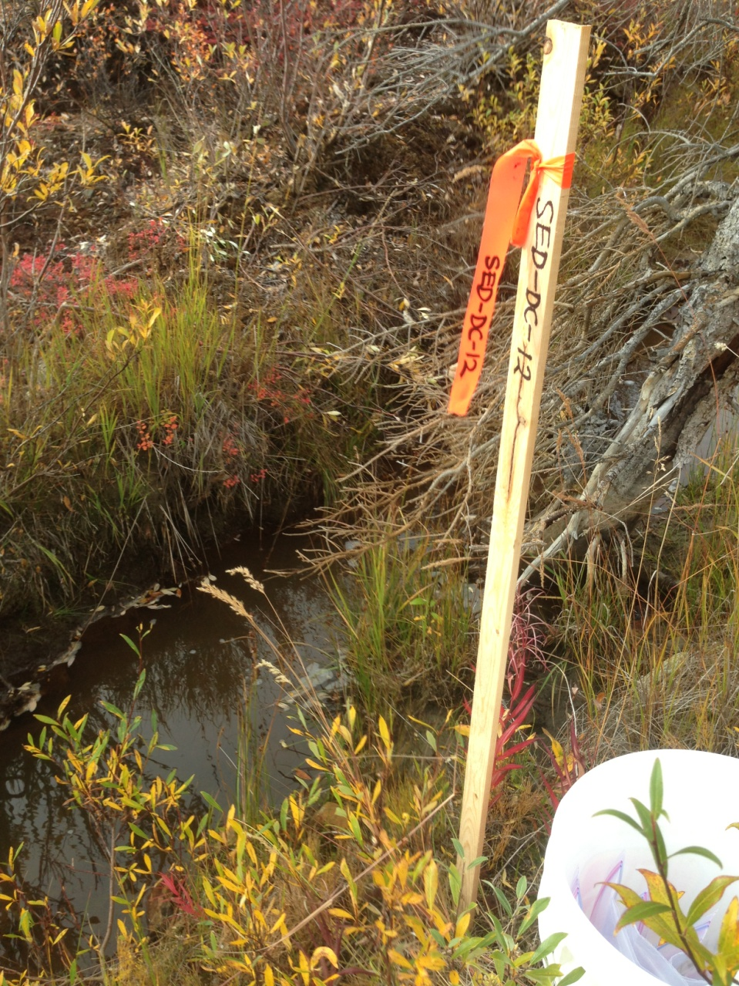

PHOTO 26: Dome Creek – SED-DC-12.
AMEC Environment & Infrastructure |  | Government of Yukon - AAM  Mount Nansen 2013 Site Investigation  Photographs
Logged by: CM | Scale: NTS | Date: Oct 2013 | Project: VM00605E | Page 14

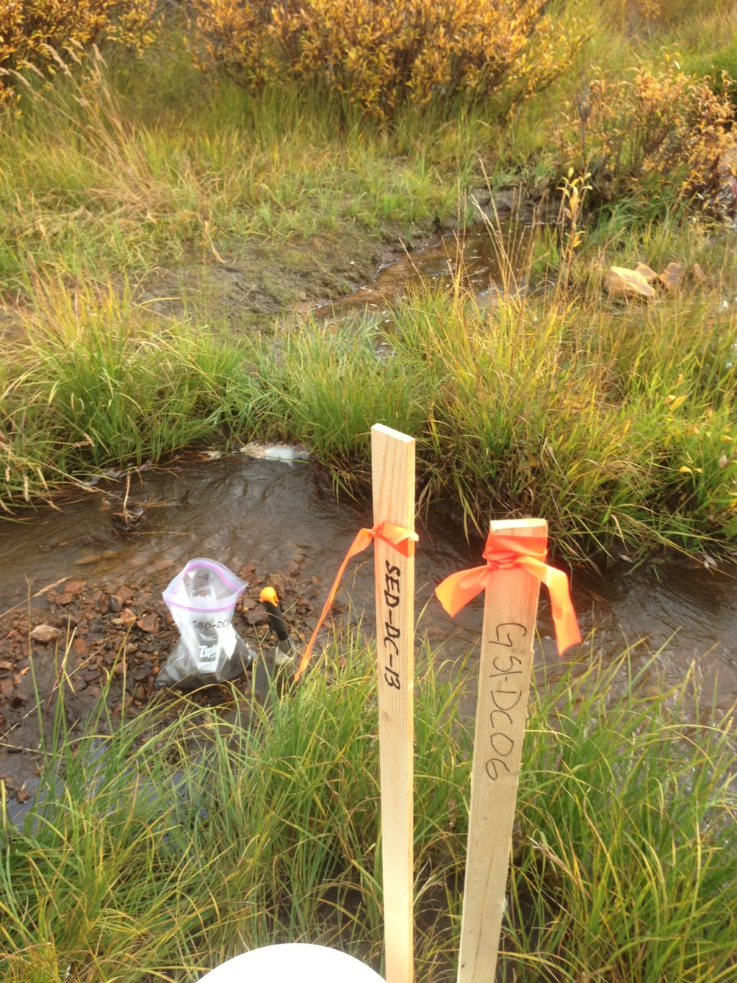

PHOTO 27: Dome Creek – SED-DC-13.

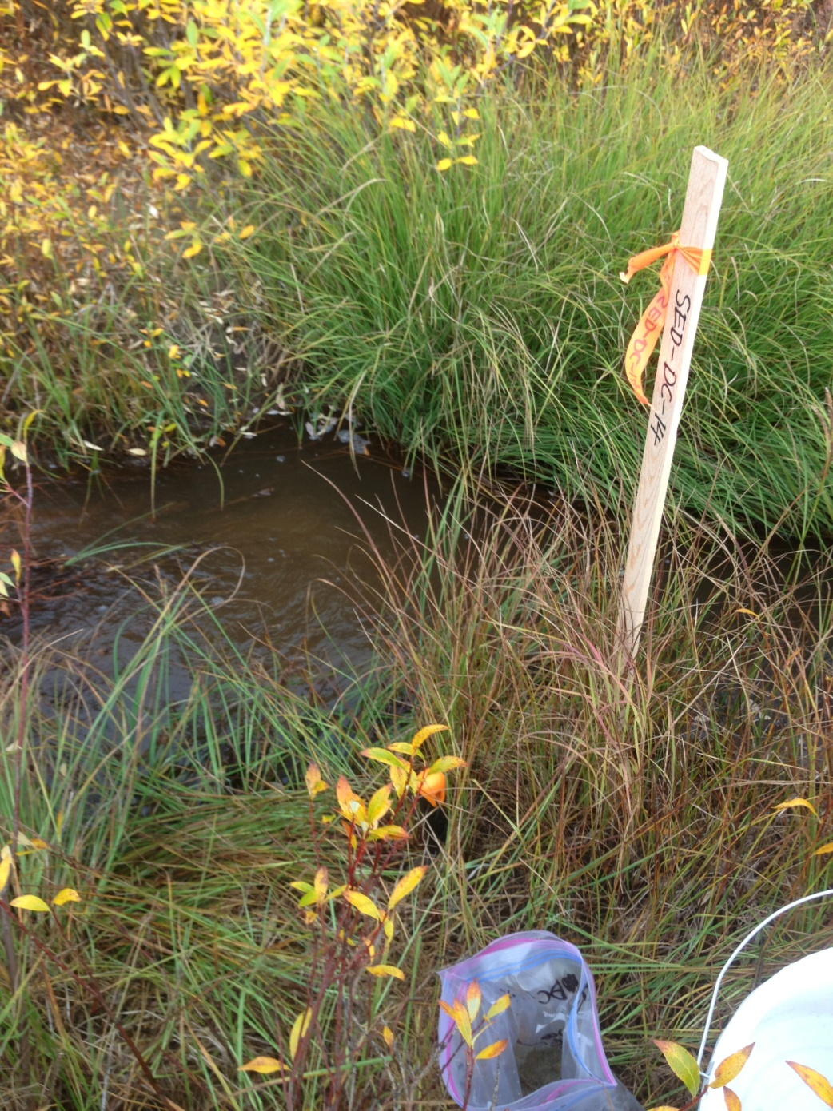

PHOTO 28: Dome Creek – SED-DC-14.
AMEC Environment & Infrastructure |  | Government of Yukon - AAM  Mount Nansen 2013 Site Investigation  Photographs
Logged by: CM | Scale: NTS | Date: Oct 2013 | Project: VM00605E | Page 15

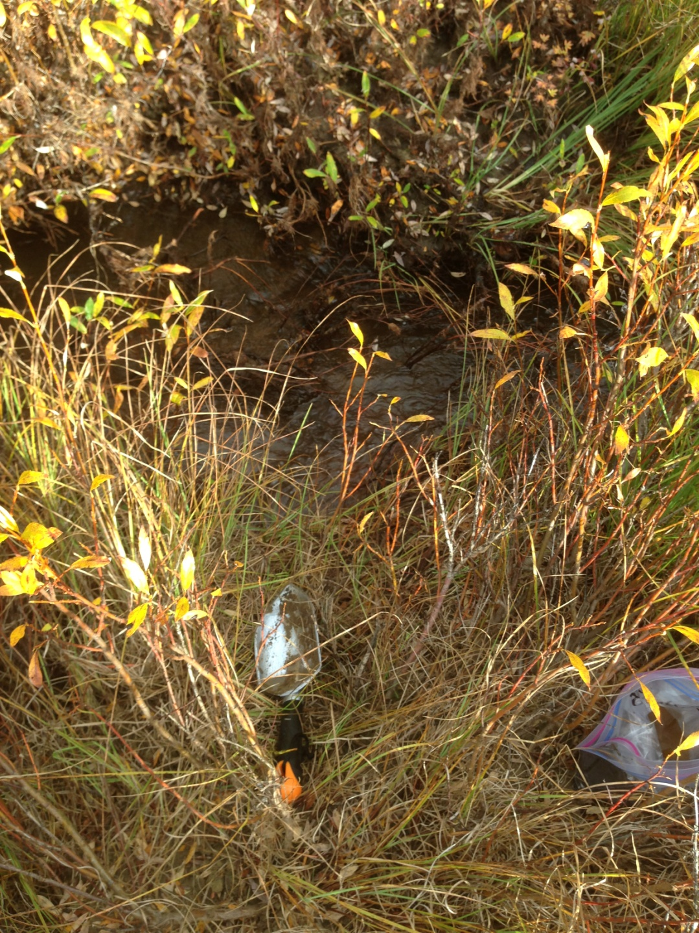

PHOTO 29: Dome Creek – SED-DC-15.

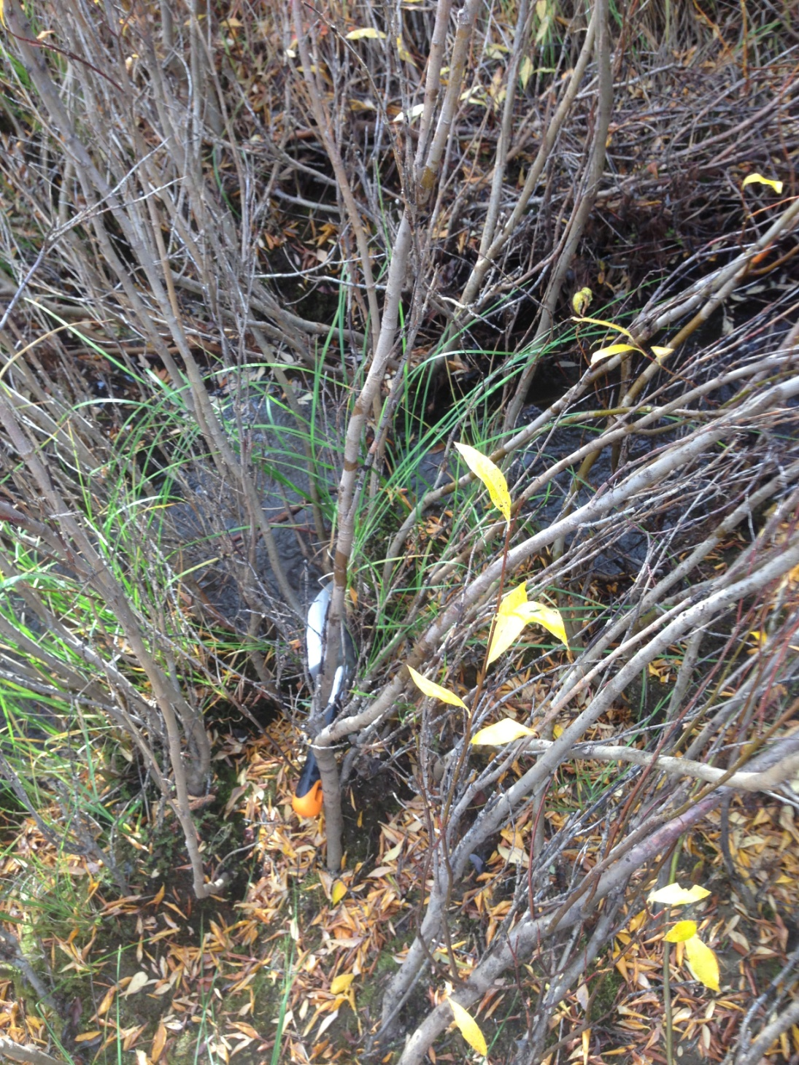

PHOTO 30: Dome Creek – SED-DC-16.
AMEC Environment & Infrastructure |  | Government of Yukon - AAM  Mount Nansen 2013 Site Investigation  Photographs
Logged by: CM | Scale: NTS | Date: Oct 2013 | Project: VM00605E | Page 16

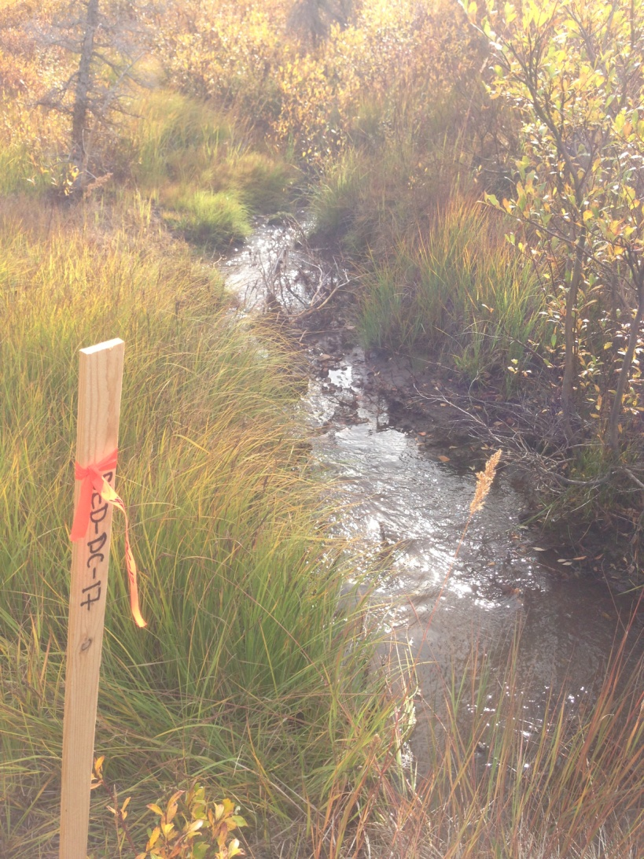

PHOTO 31: Dome Creek – SED-DC-17.

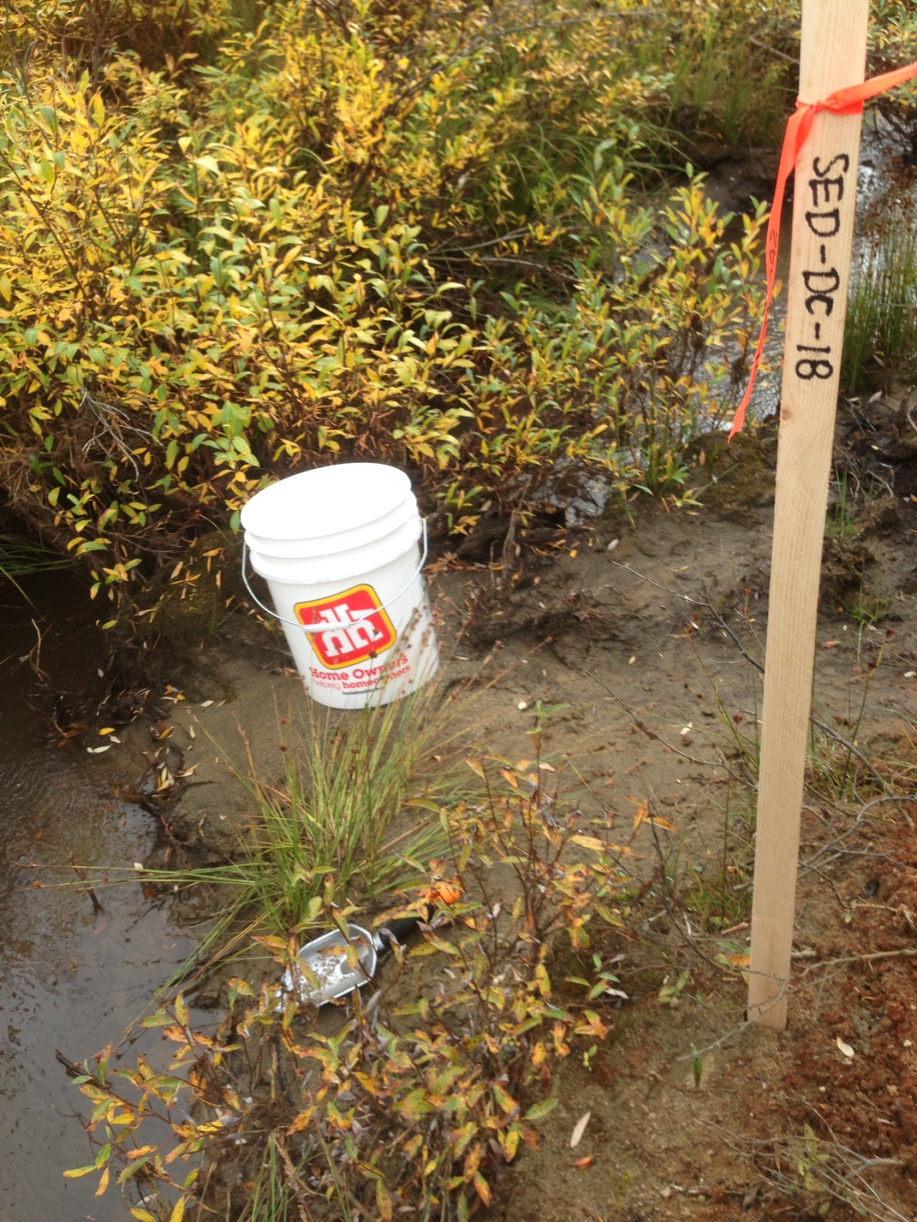

PHOTO 32: Dome Creek – SED-DC-18.
AMEC Environment & Infrastructure |  | Government of Yukon - AAM  Mount Nansen 2013 Site Investigation  Photographs
Logged by: CM | Scale: NTS | Date: Oct 2013 | Project: VM00605E | Page 17

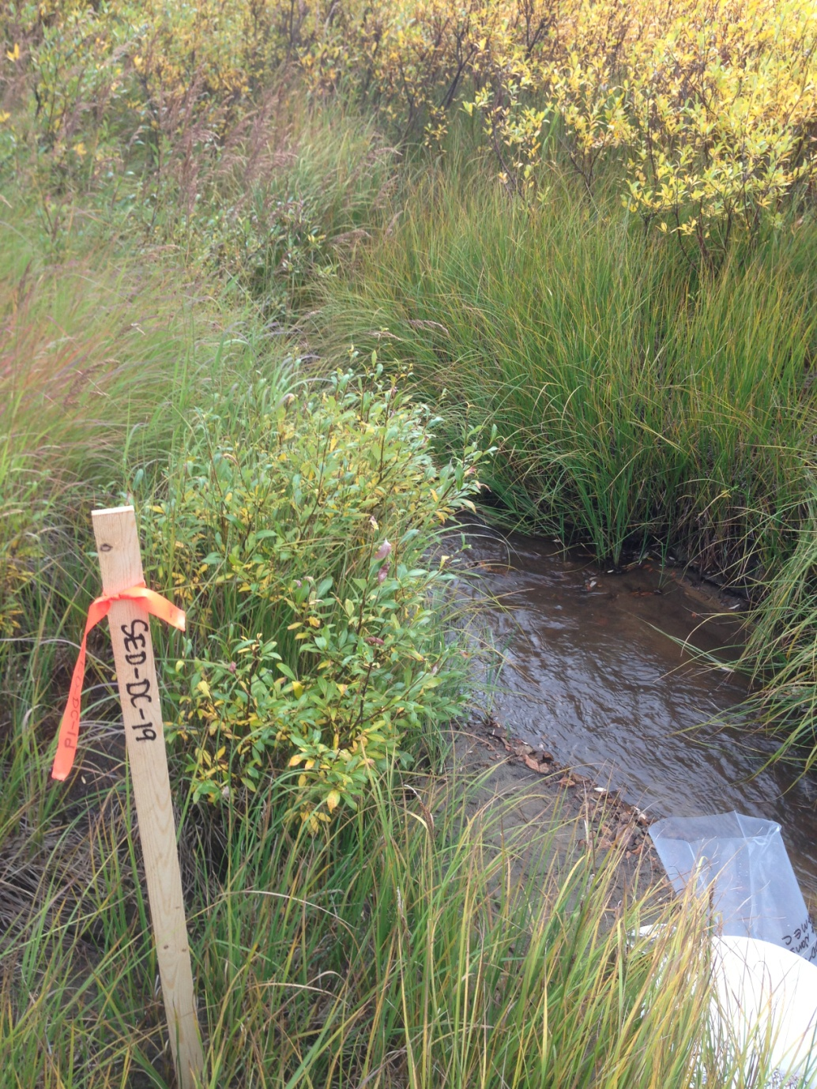

PHOTO 33: Dome Creek – SED-DC-19.

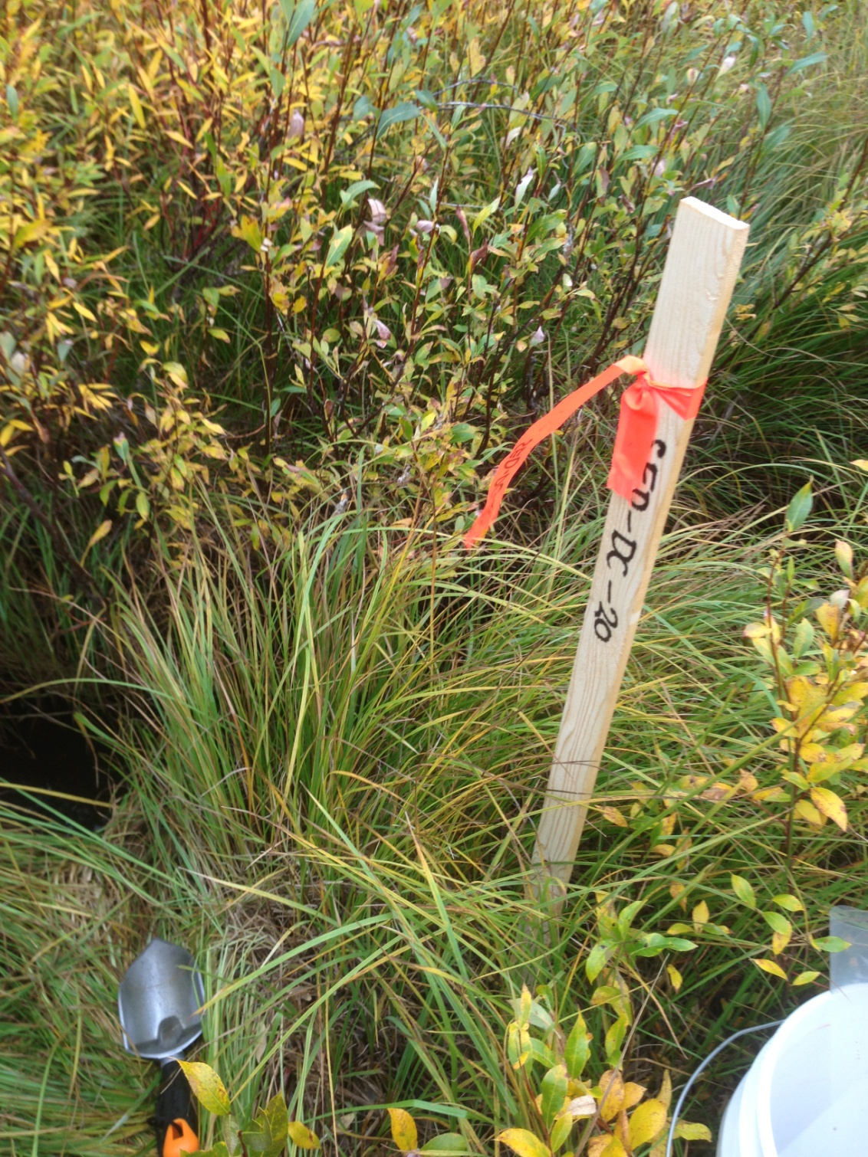

PHOTO 34: Dome Creek – SED-DC-20.
AMEC Environment & Infrastructure |  | Government of Yukon - AAM  Mount Nansen 2013 Site Investigation  Photographs
Logged by: CM | Scale: NTS | Date: Oct 2013 | Project: VM00605E | Page 18

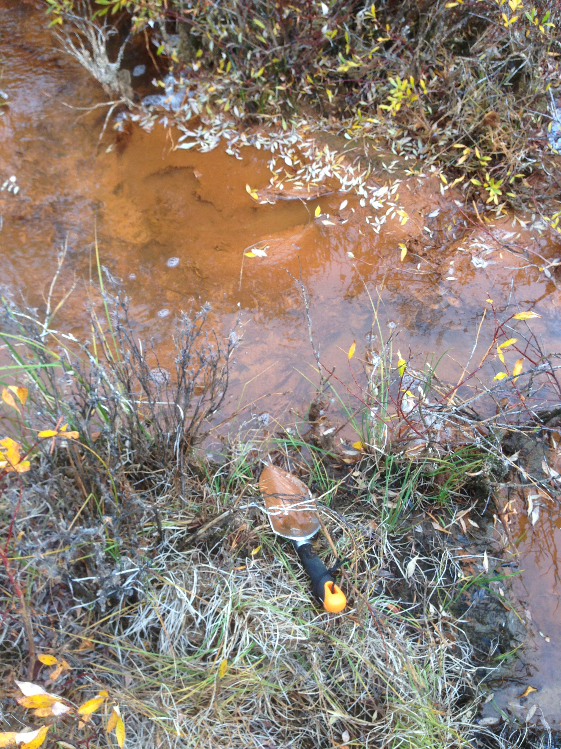

PHOTO 35: Dome Creek – SED-DC-11.

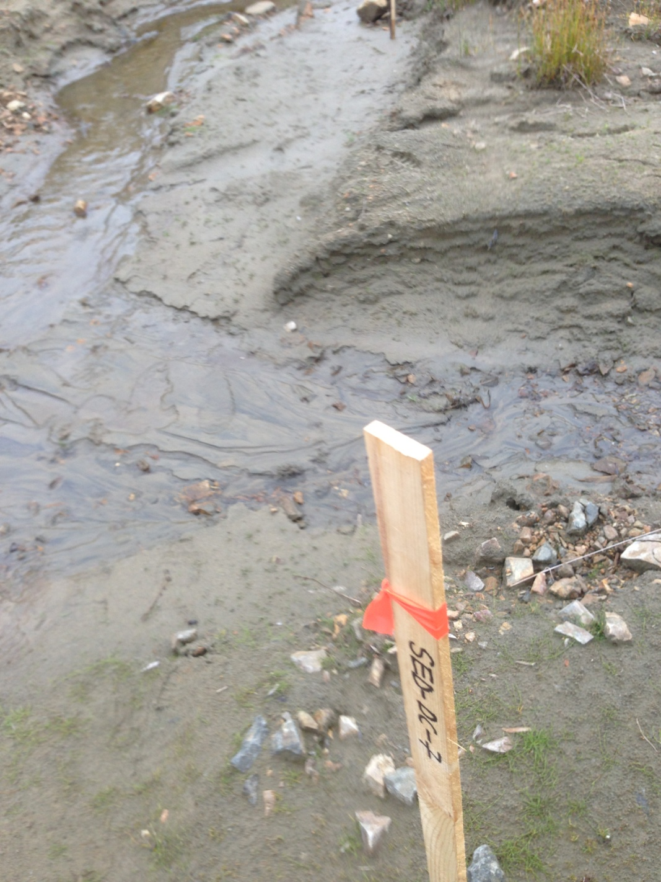

PHOTO 36: Dome Creek – SED-DC-7.
AMEC Environment & Infrastructure |  | Government of Yukon - AAM  Mount Nansen 2013 Site Investigation  Photographs
Logged by: CM | Scale: NTS | Date: Oct 2013 | Project: VM00605E | Page 19

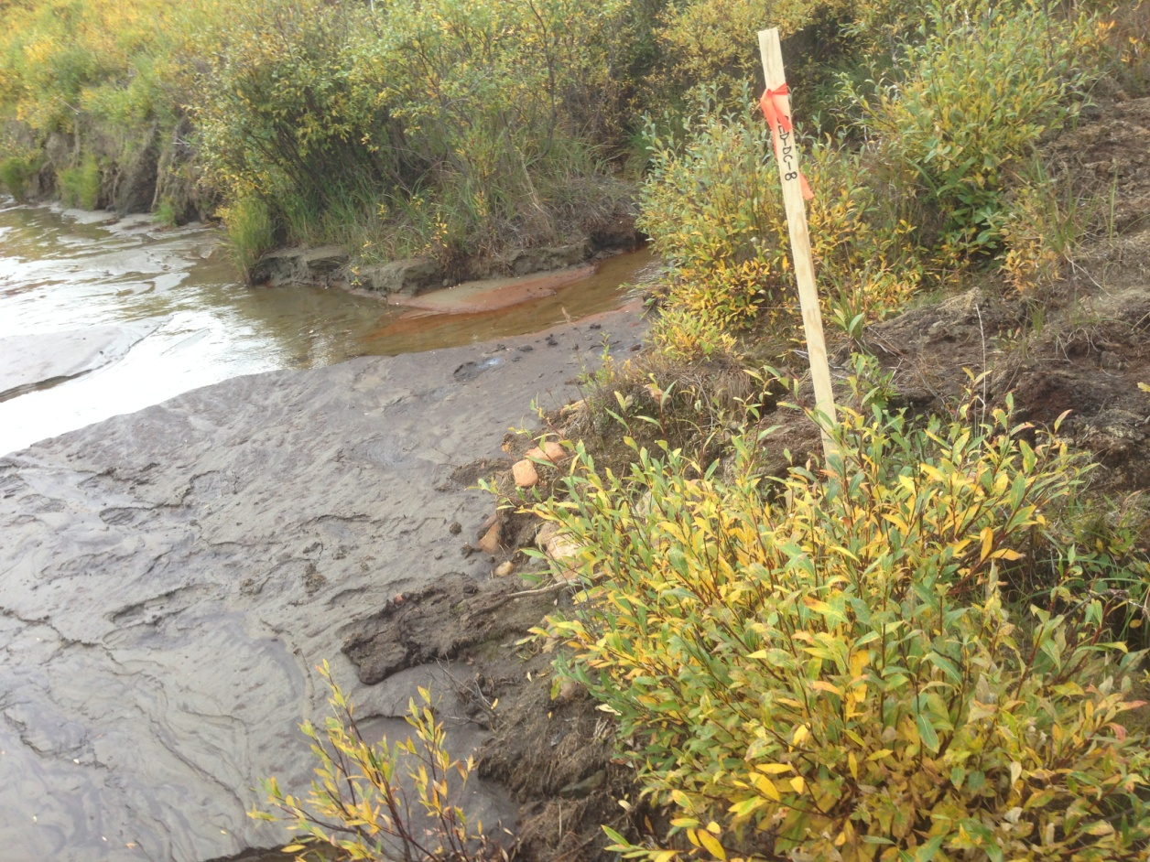

PHOTO 37: Dome Creek – SED-DC-8.

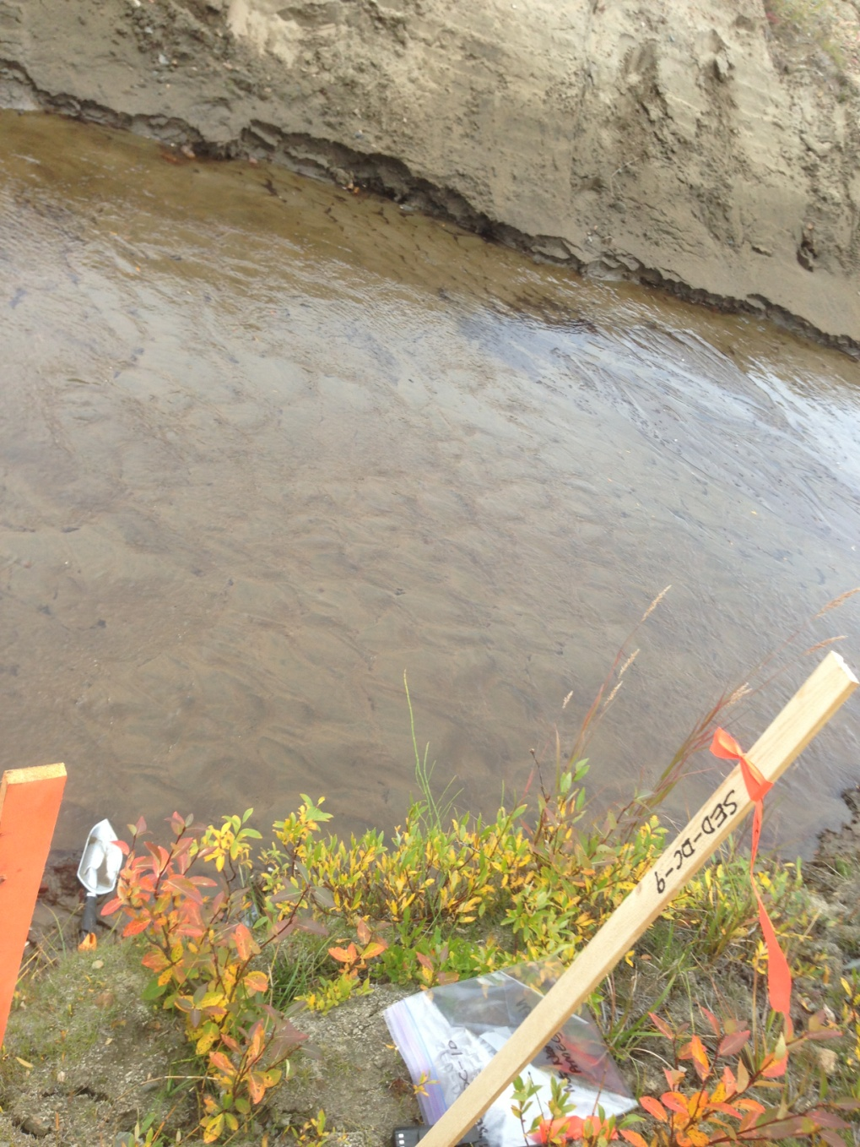

PHOTO 38: Dome Creek – SED-DC-9.
AMEC Environment & Infrastructure |  | Government of Yukon - AAM  Mount Nansen 2013 Site Investigation  Photographs
Logged by: CM | Scale: NTS | Date: Oct 2013 | Project: VM00605E | Page 20

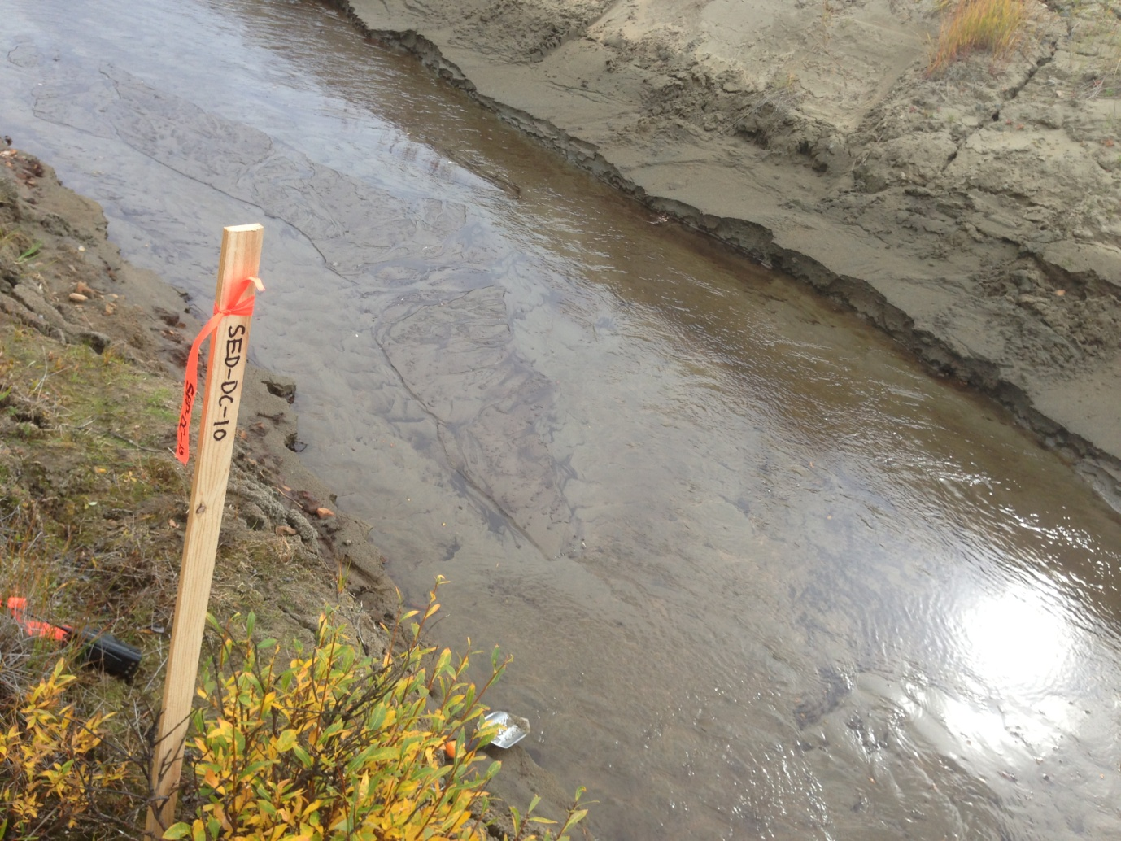

PHOTO 39: Dome Creek – SED-DC-10.
AMEC Environment & Infrastructure |  | Government of Yukon - AAM  Mount Nansen 2013 Site Investigation  Photographs
Logged by: CM | Scale: NTS | Date: Oct 2013 | Project: VM00605E | Page 21

Photos of Pony Creek Watershed and Channel

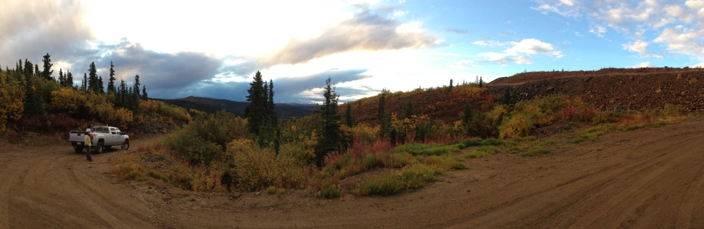

PHOTO 40: Pony Creek Watershed – Facing D/S Near the Open Pit.

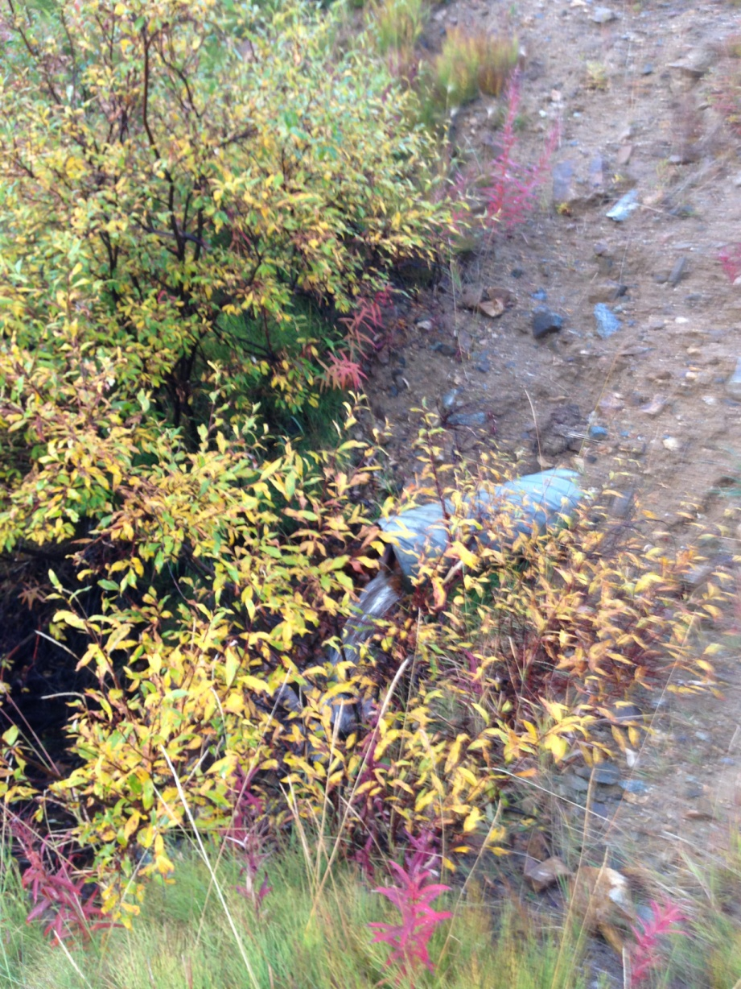

PHOTO 41: Pony Creek – Flow Measuring Station.
AMEC Environment & Infrastructure |  | Government of Yukon - AAM  Mount Nansen 2013 Site Investigation  Photographs
Logged by: CM | Scale: NTS | Date: Oct 2013 | Project: VM00605E | Page 22

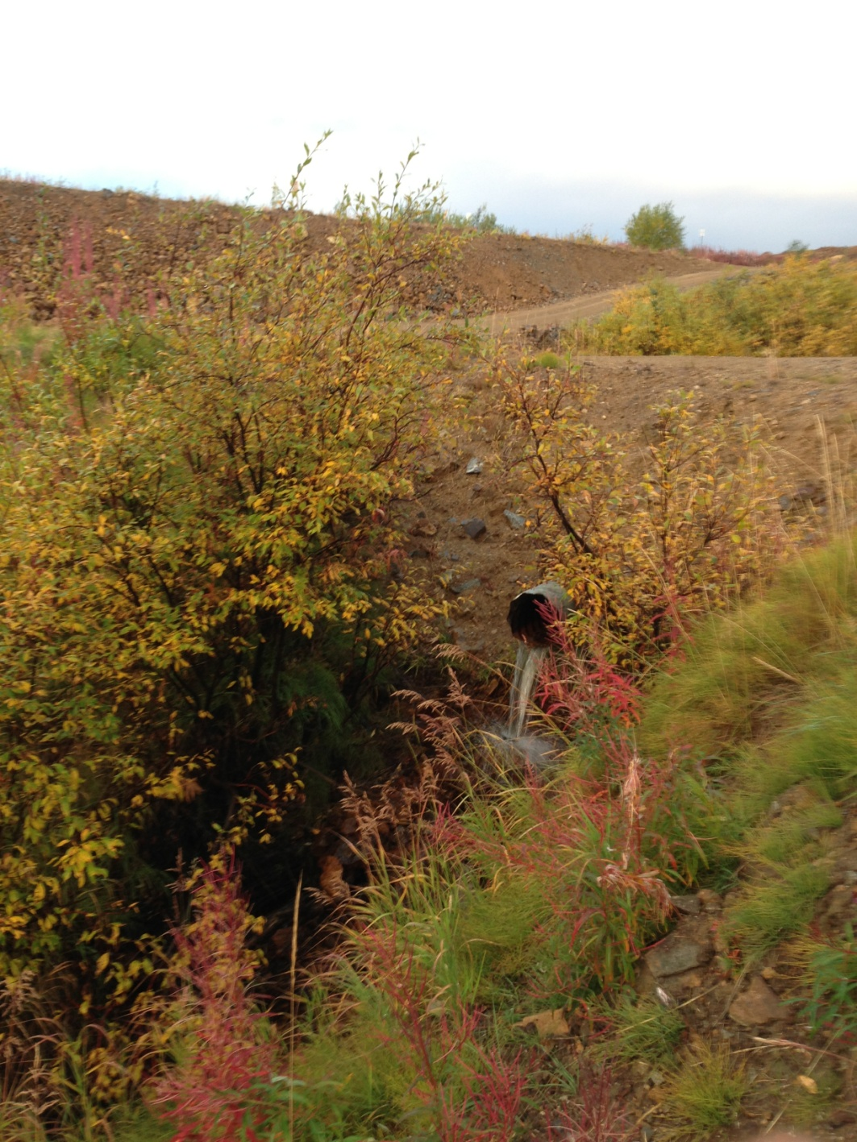

PHOTO 42: Pony Creek – Flow Measuring Station.

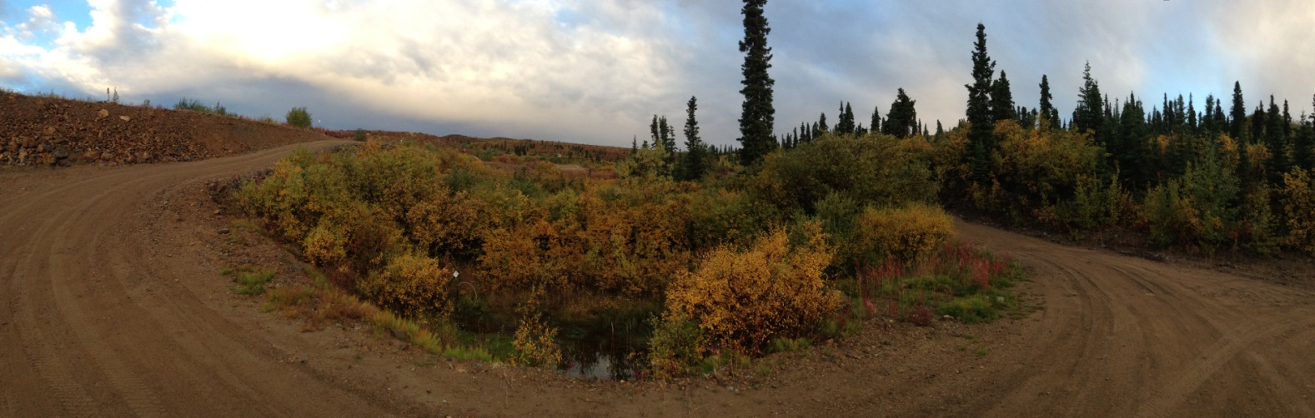

PHOTO 43: Pony Creek – Facing U/S Near the Open Pit.
AMEC Environment & Infrastructure |  | Government of Yukon - AAM  Mount Nansen 2013 Site Investigation  Photographs
Logged by: CM | Scale: NTS | Date: Oct 2013 | Project: VM00605E | Page 23

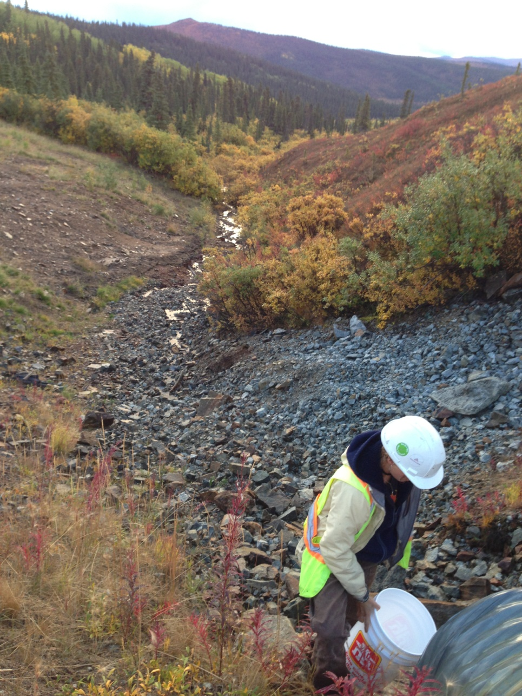

PHOTO 44: Pony Creek – Flow Measuring Station.

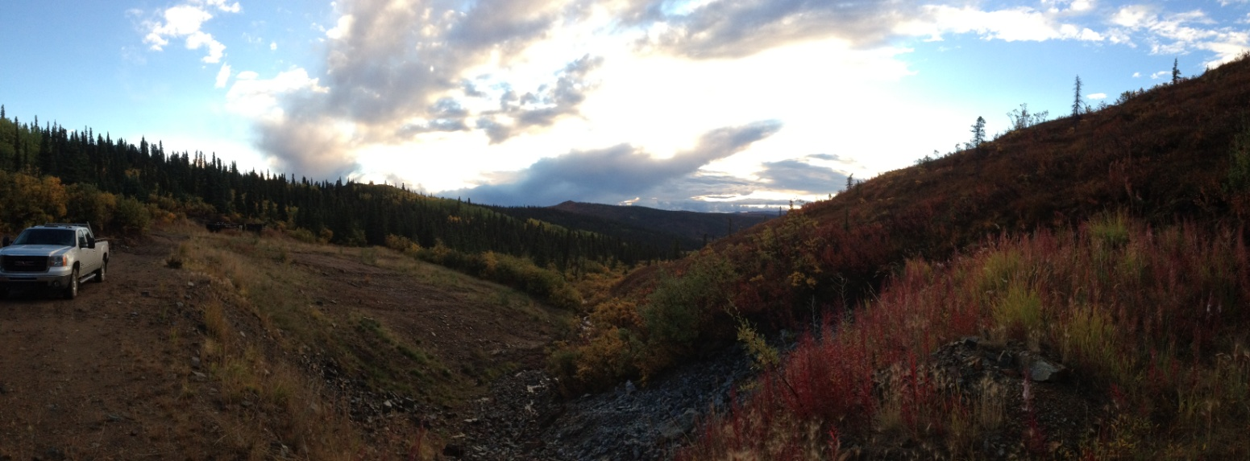

PHOTO 45: Pony Creek – Facing D/S.
AMEC Environment & Infrastructure |  | Government of Yukon - AAM  Mount Nansen 2013 Site Investigation  Photographs
Logged by: CM | Scale: NTS | Date: Oct 2013 | Project: VM00605E | Page 24

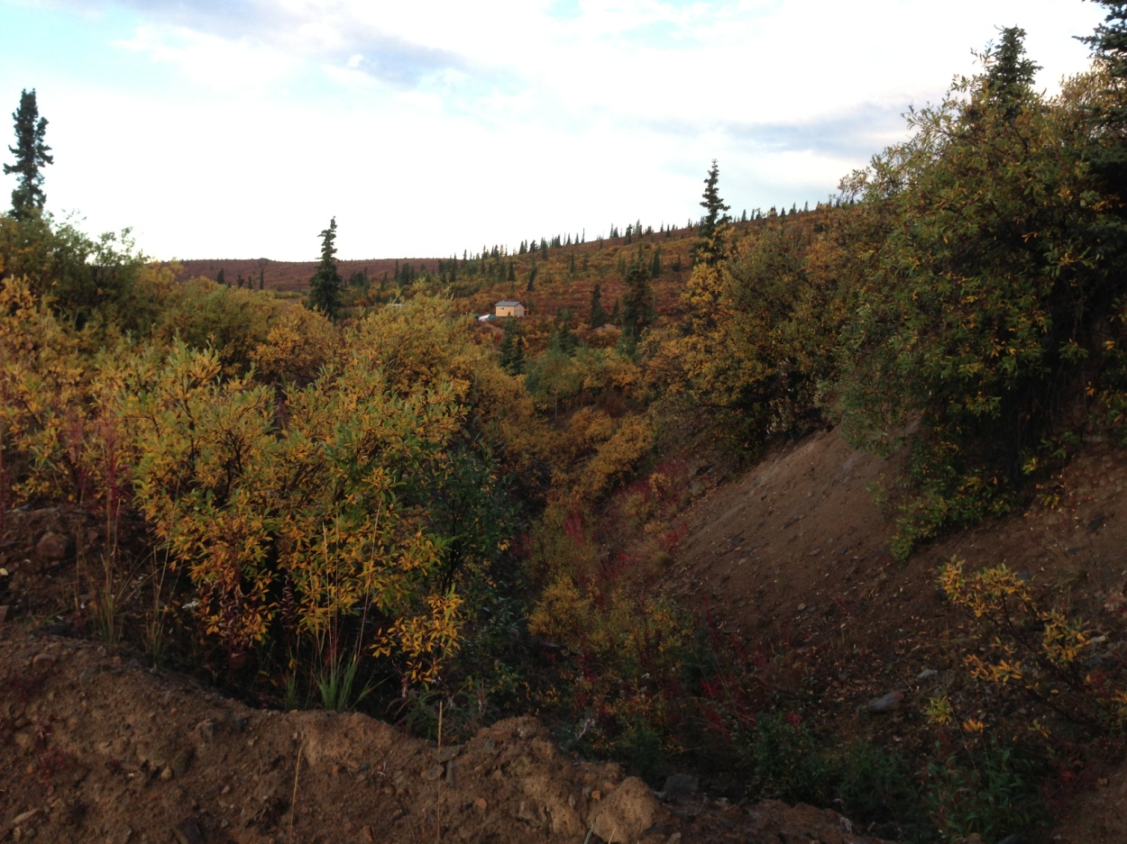

PHOTO 46: Pony Creek – Vegetation on the Valley Walls.

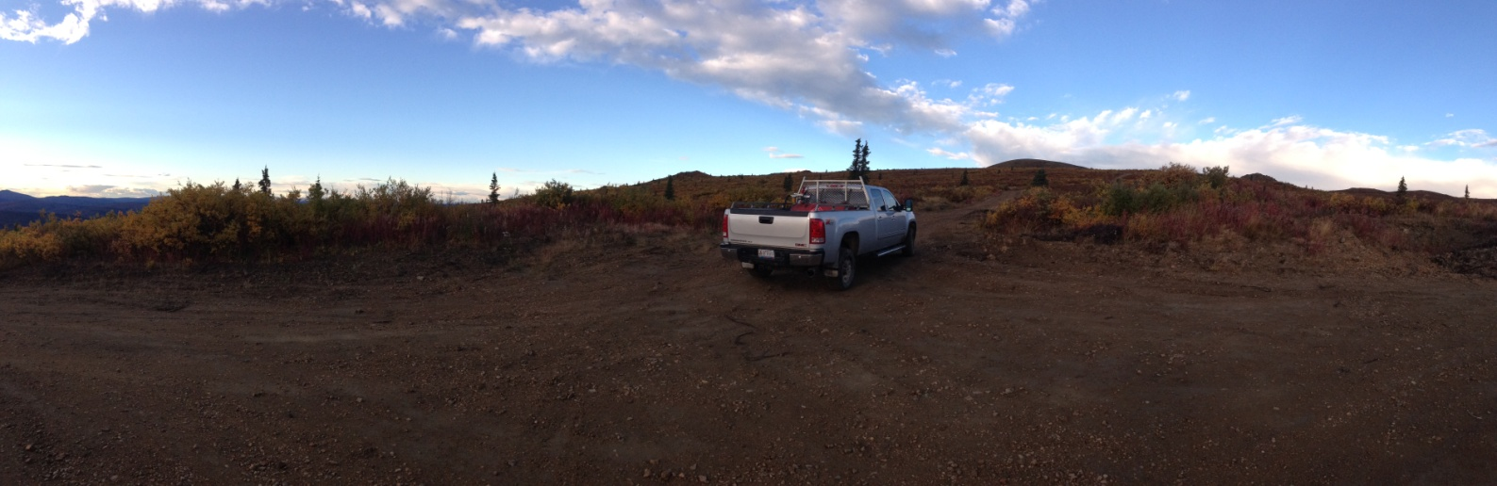

PHOTO 47: Pony Creek – Upper Watershed.
AMEC Environment & Infrastructure |  | Government of Yukon - AAM  Mount Nansen 2013 Site Investigation  Photographs
Logged by: CM | Scale: NTS | Date: Oct 2013 | Project: VM00605E | Page 25

