Mount Nansen 2013 Site Investigation

list of photos
Page
Photos of Reclamation Plots 1
PHOTO 1: Site 1 - View of Waste Rock Dump. 1
PHOTO 2: Site 1 – Test Pit 1. 1
PHOTO 3: Site 2 – View Looking Northeast. 2
PHOTO 4: Site 2 – Test Pit 2. 2
PHOTO 5: Site 3 – View Looking Northwest. 3
PHOTO 6: Site 4 – Looking North Upslope. 3
PHOTO 7: Site 4 – Test Pit Profile. 4
PHOTO 8: Site 5 – View Looking North. 4
PHOTO 9: Site 6 – View of Eolian Sand. 5
PHOTO 10: Site 7 – View Looking Northwest Upslope. 5

Photos of Reclamation Plots

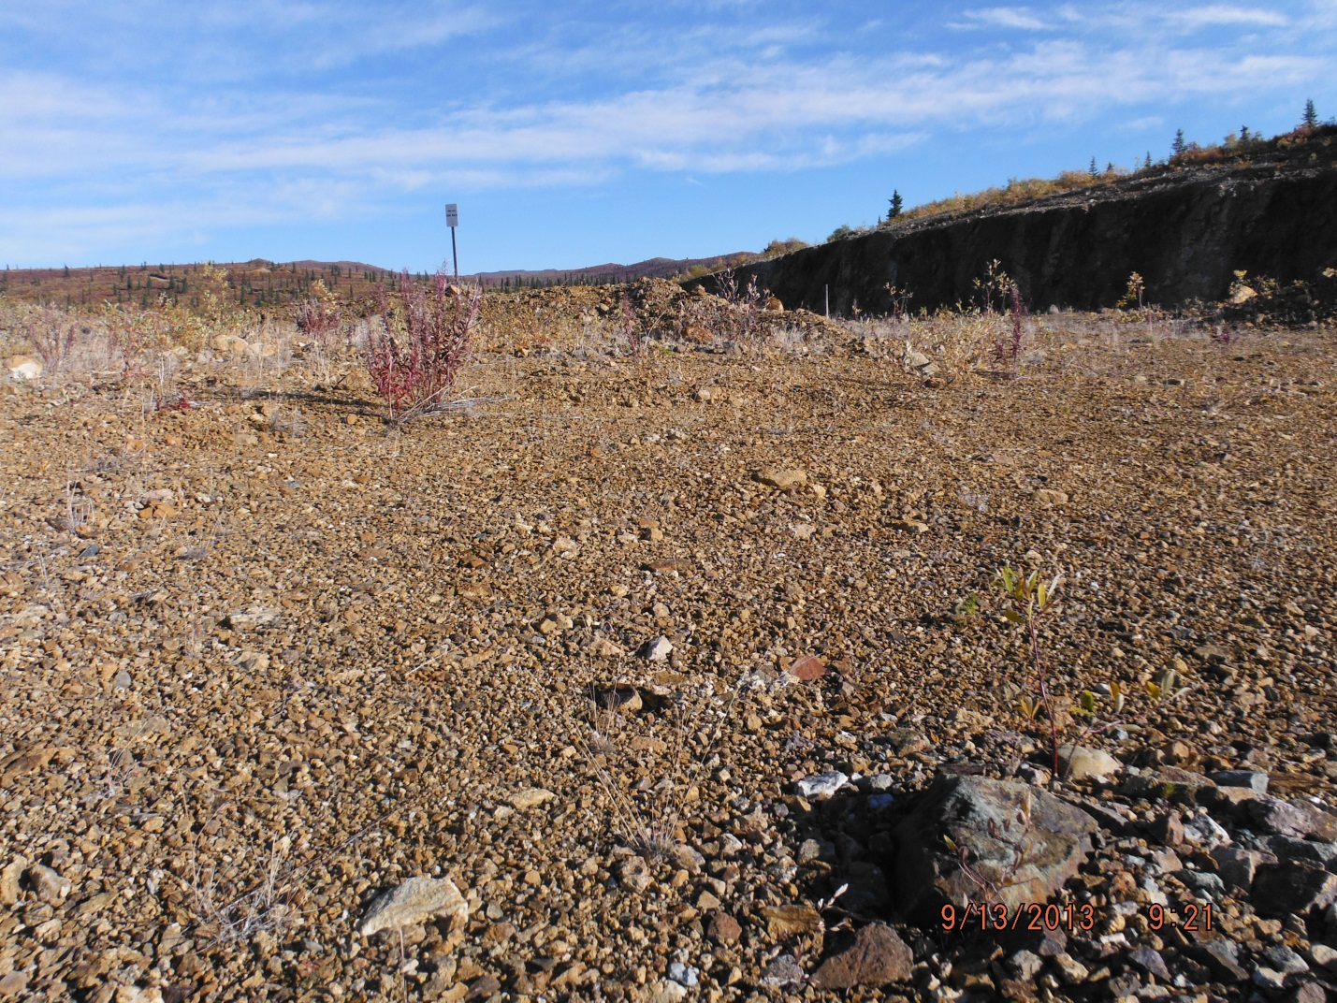

PHOTO 1: Site 1 - View of Waste Rock Dump.

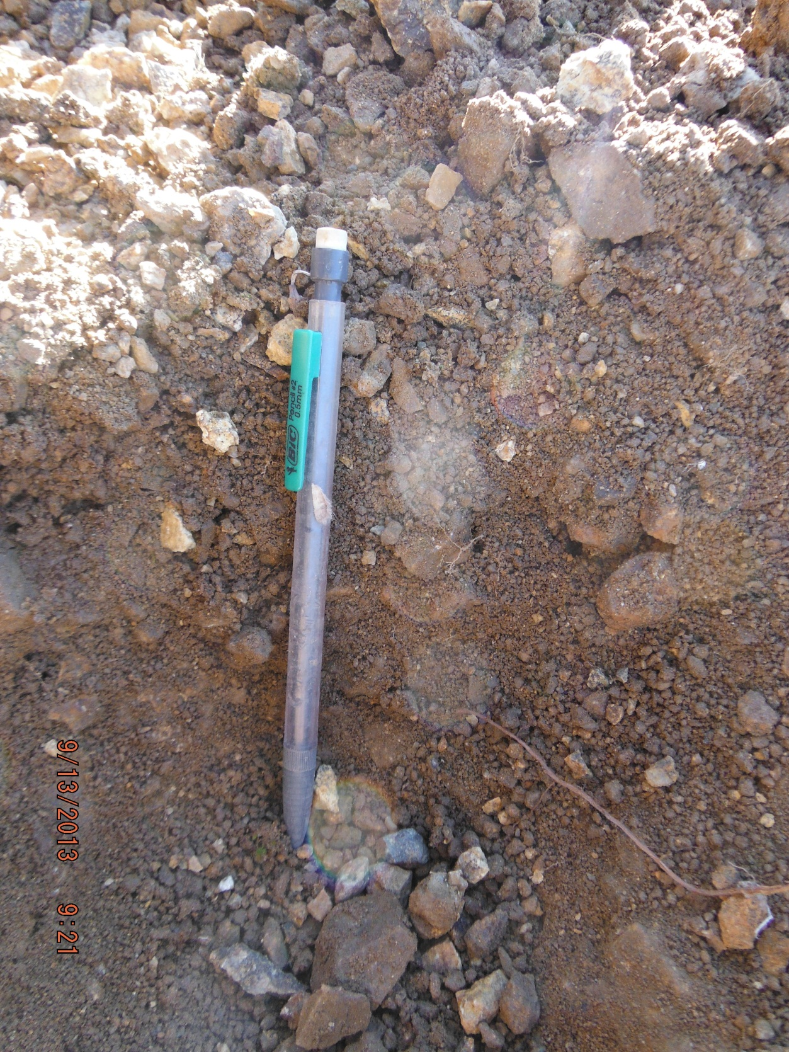

PHOTO 2: Site 1 – Test Pit 1.
Government of Yukon - AAM
Mount Nansen 2013 Site Investigation
Photographs
Logged by: MP | Scale: NTS | Date: Oct 2013 | Project: VM00605E | Page 1

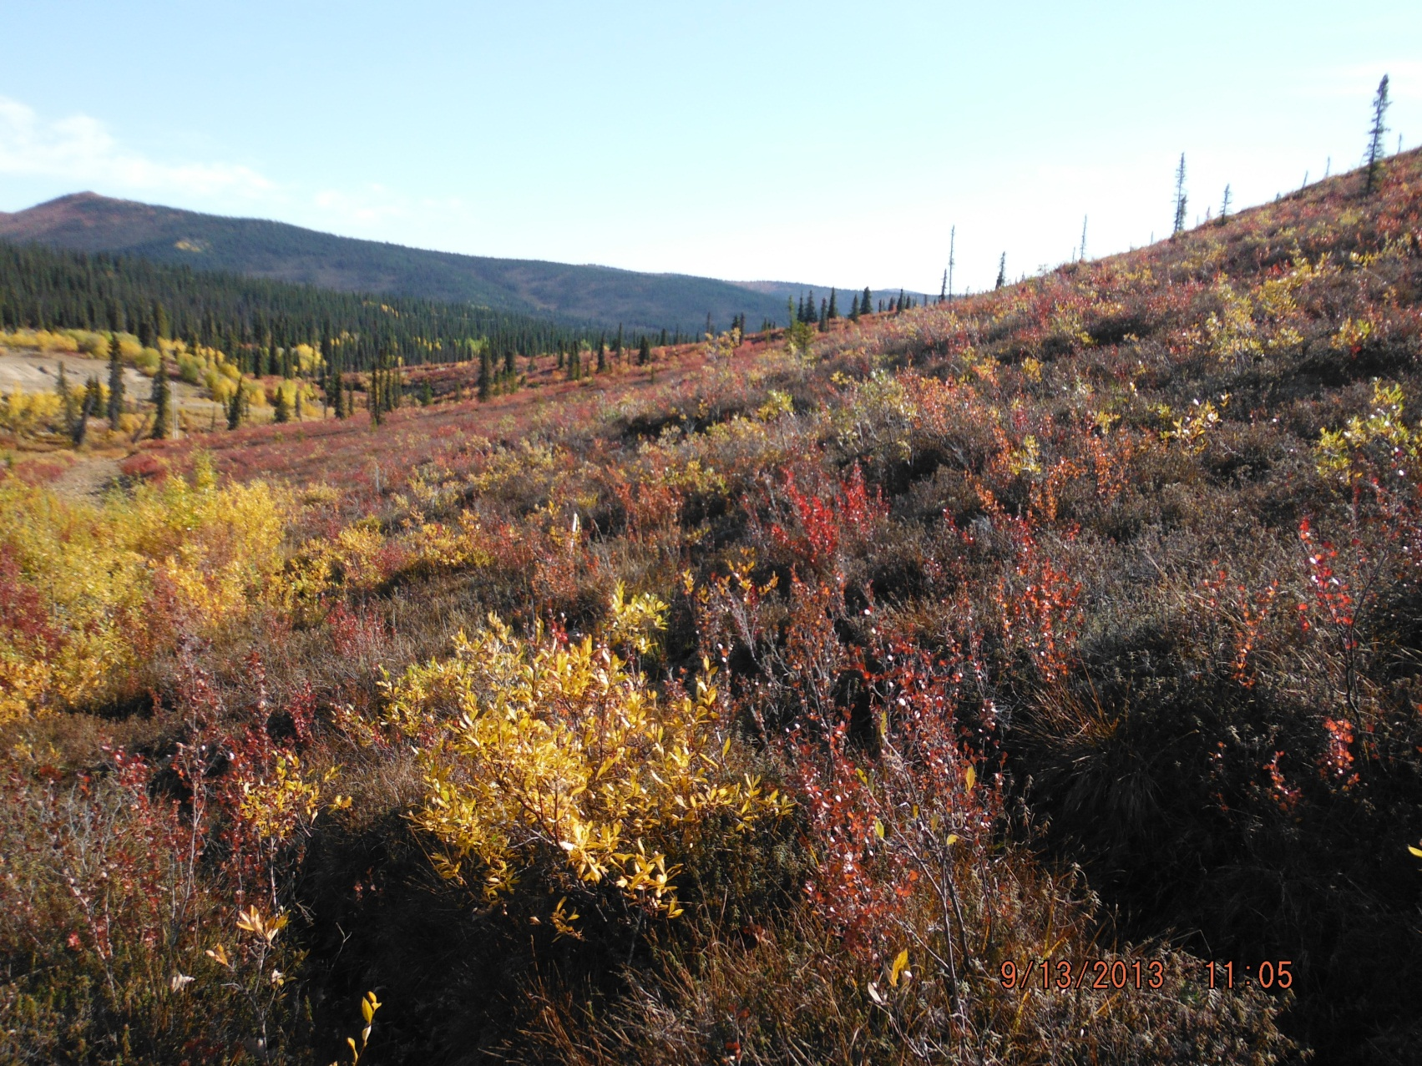

PHOTO 3: Site 2 – View Looking Northeast.

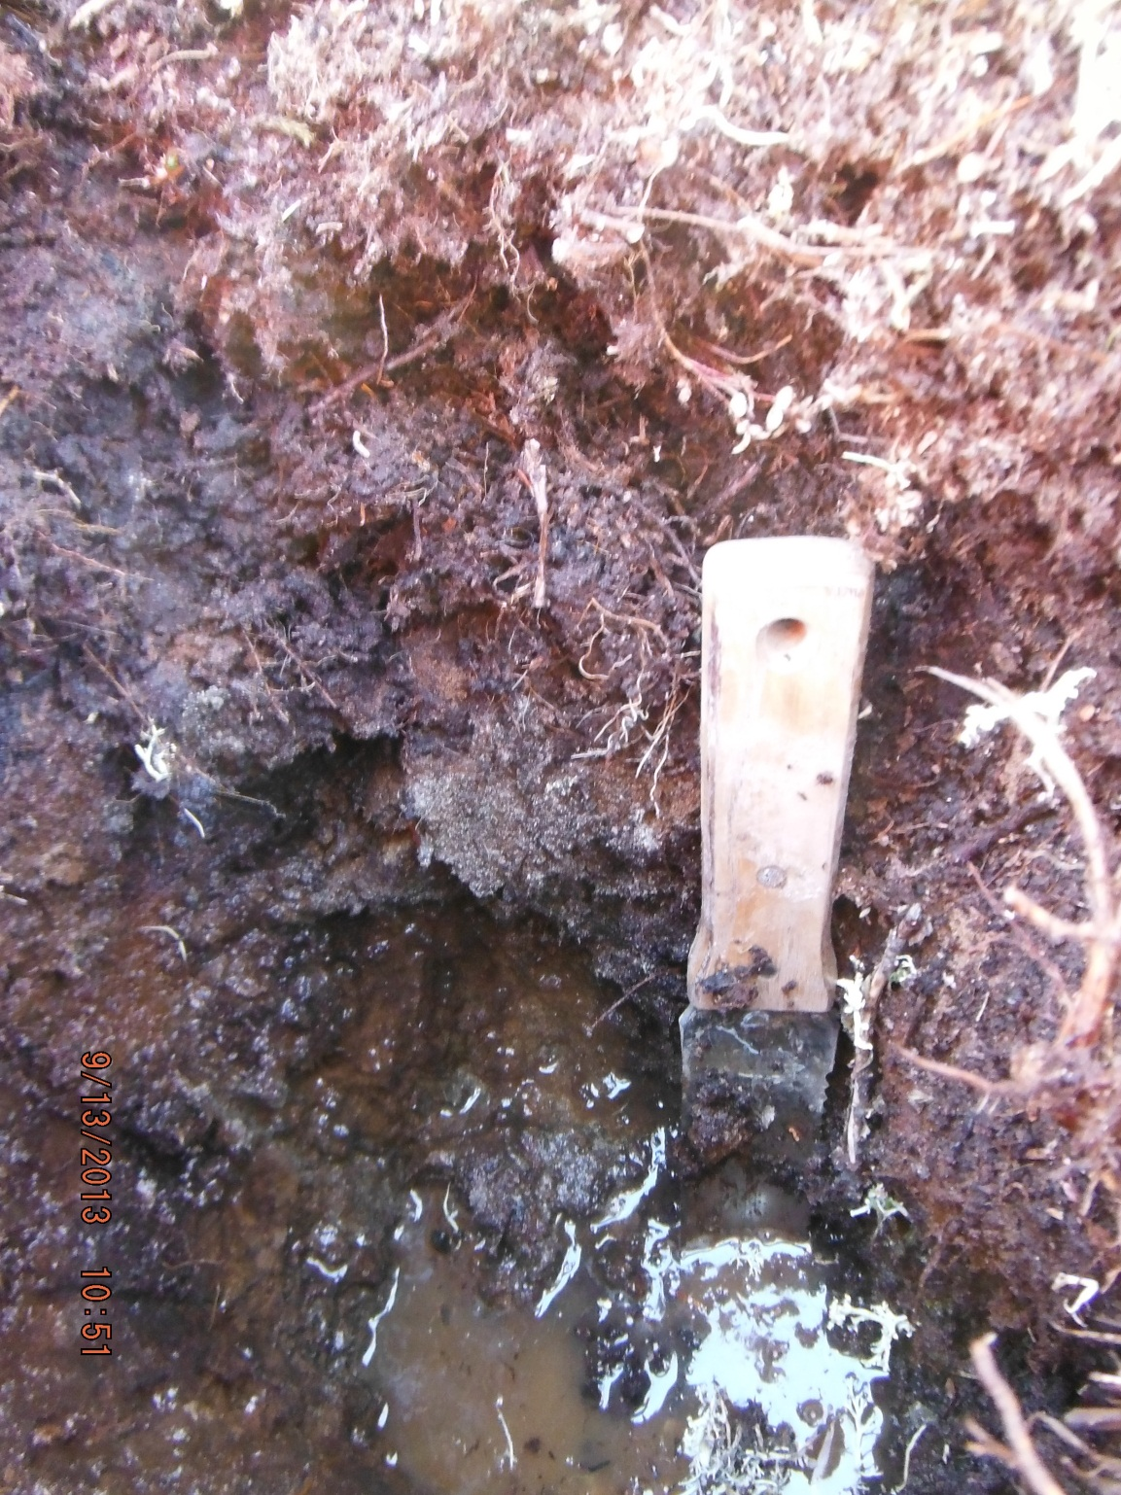

PHOTO 4: Site 2 – Test Pit 2.
AMEC Environment & Infrastructure |  | Government of Yukon - AAM  Mount Nansen 2013 Site Investigation  Photographs
Logged by: MP | Scale: NTS | Date: Oct 2013 | Project: VM00605E | Page 2

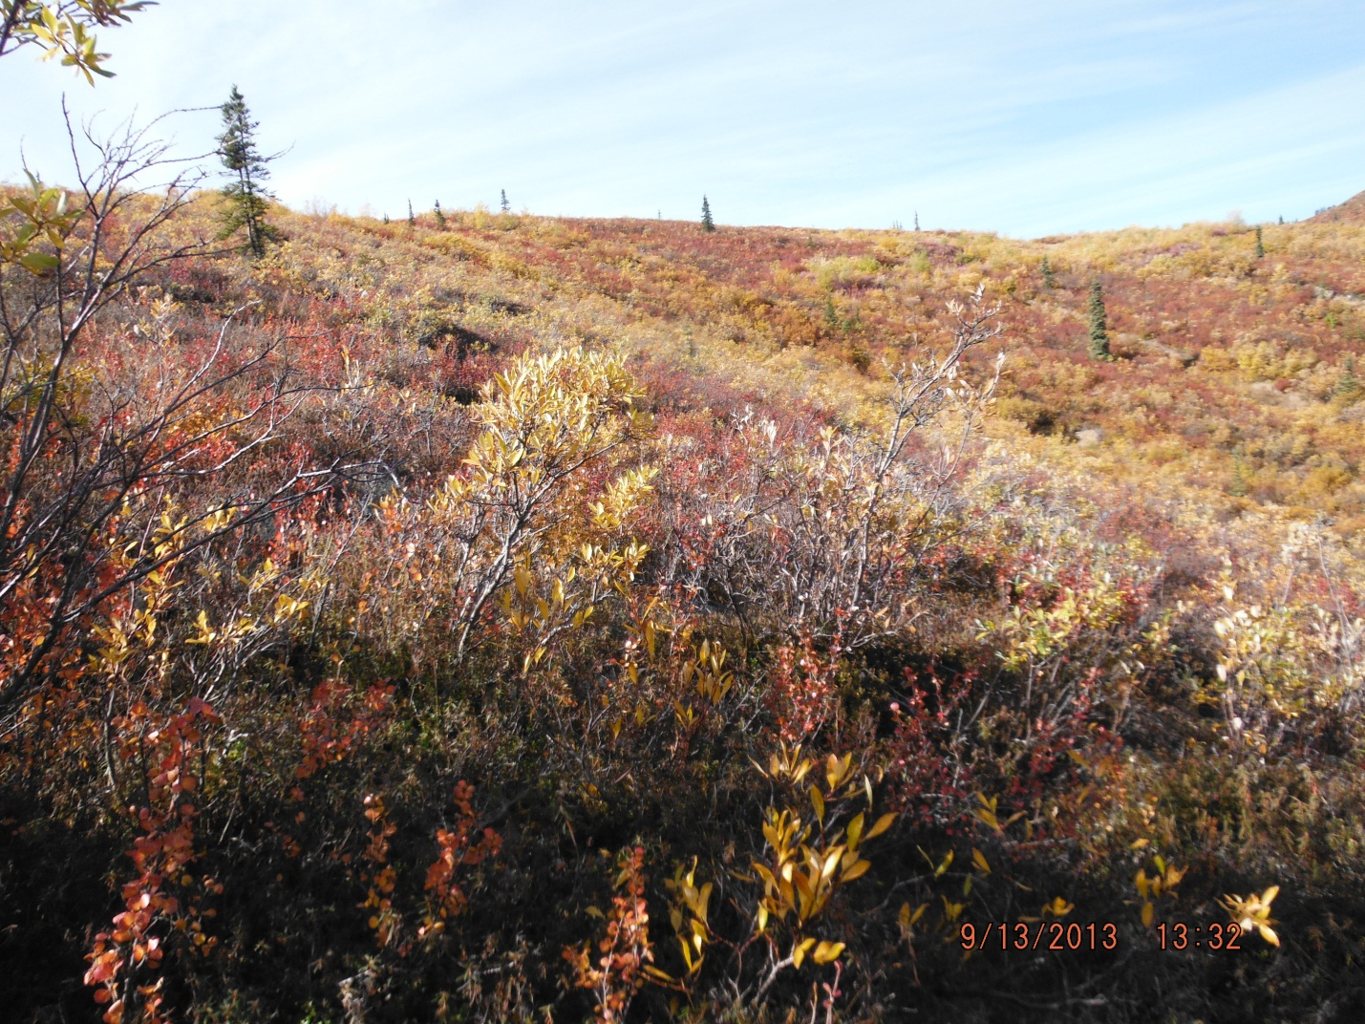

PHOTO 5: Site 3 – View Looking Northwest.

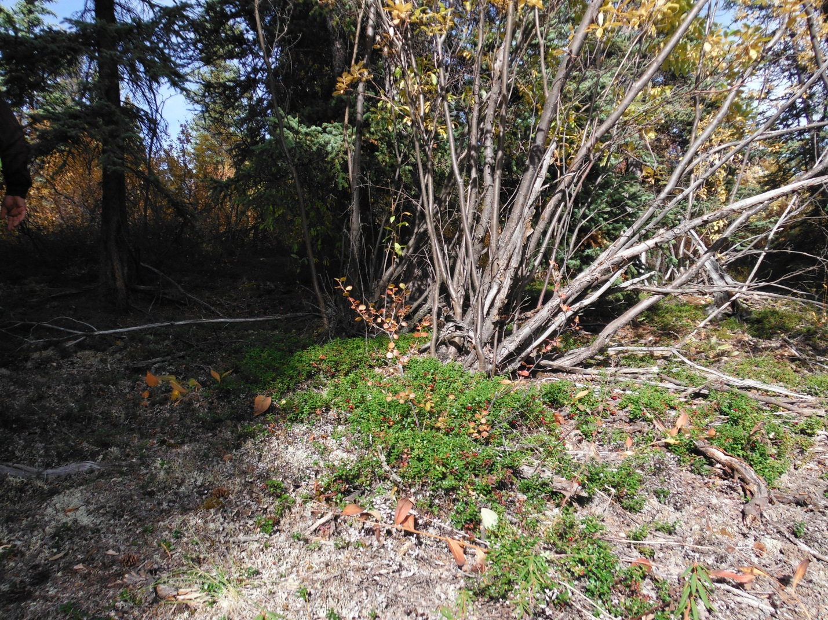

PHOTO 6: Site 4 – Looking North Upslope.
AMEC Environment & Infrastructure |  | Government of Yukon - AAM  Mount Nansen 2013 Site Investigation  Photographs
Logged by: MP | Scale: NTS | Date: Oct 2013 | Project: VM00605E | Page 3

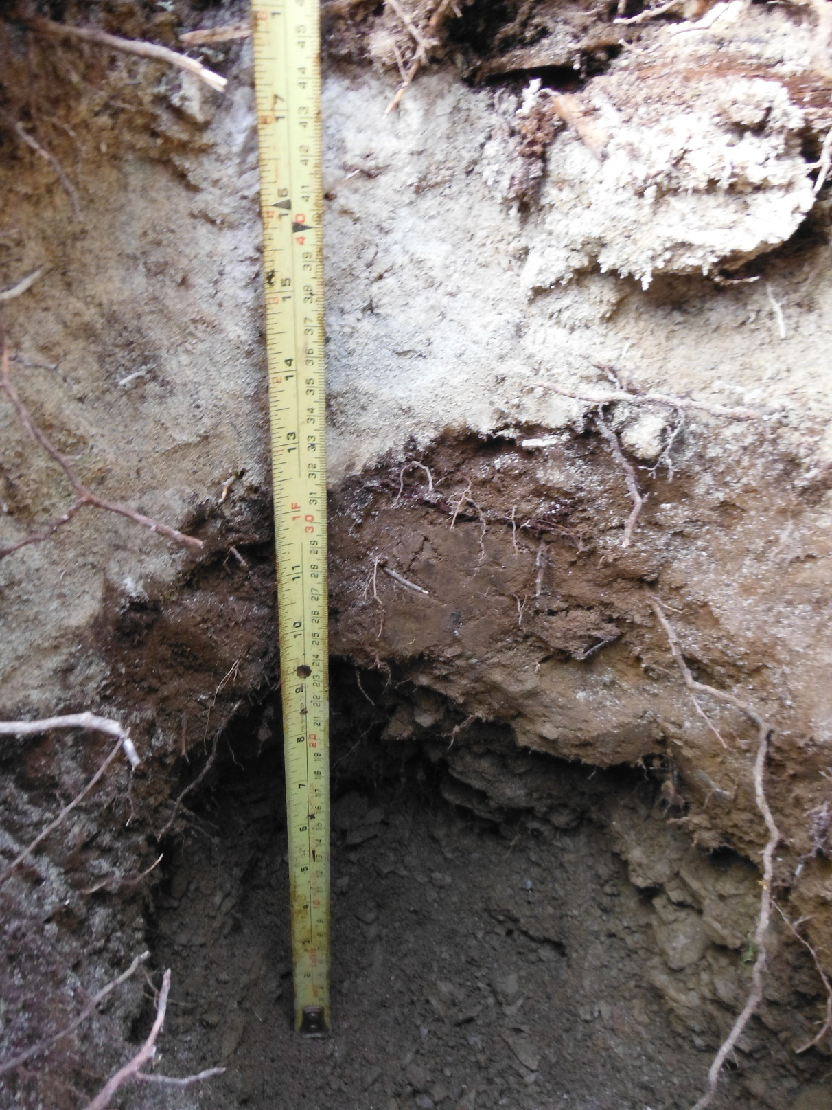

PHOTO 7: Site 4 – Test Pit Profile.

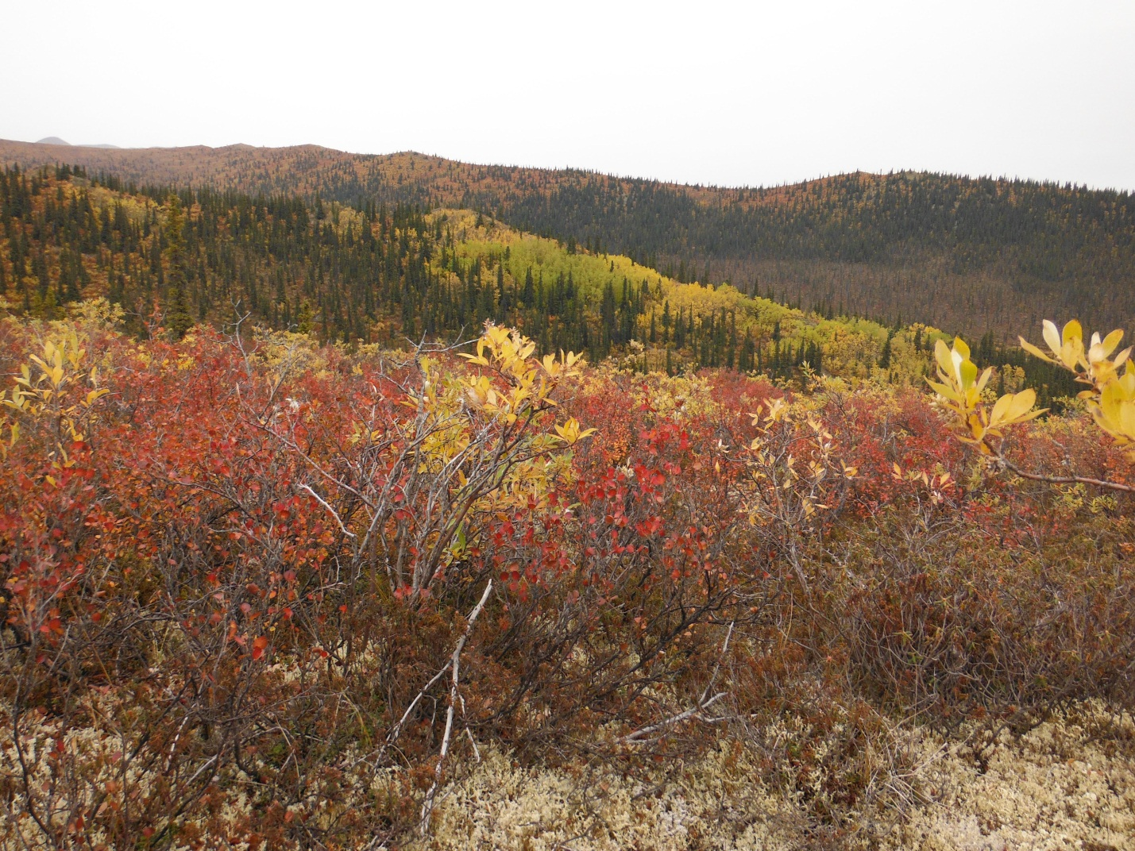

PHOTO 8: Site 5 – View Looking North.
AMEC Environment & Infrastructure |  | Government of Yukon - AAM  Mount Nansen 2013 Site Investigation  Photographs
Logged by: MP | Scale: NTS | Date: Oct 2013 | Project: VM00605E | Page 4

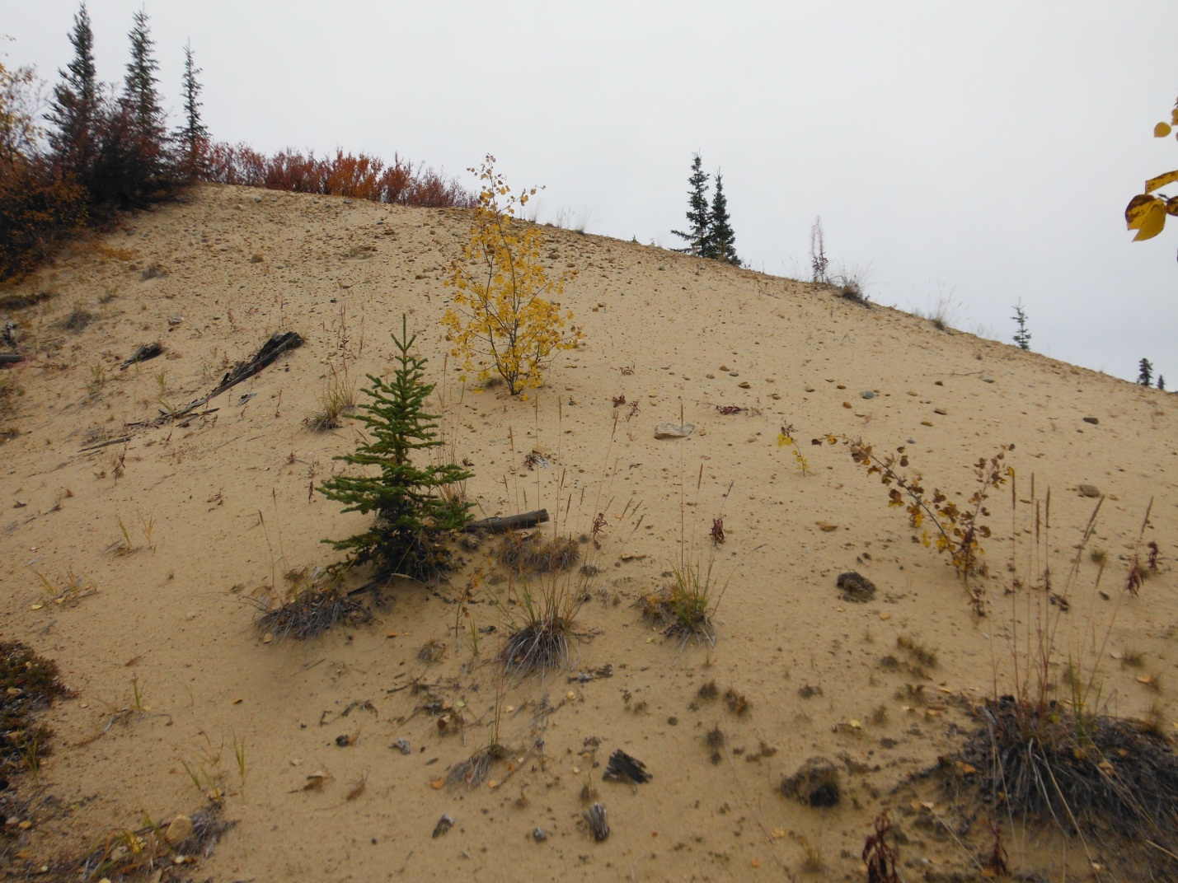

PHOTO 9: Site 6 – View of Eolian Sand.

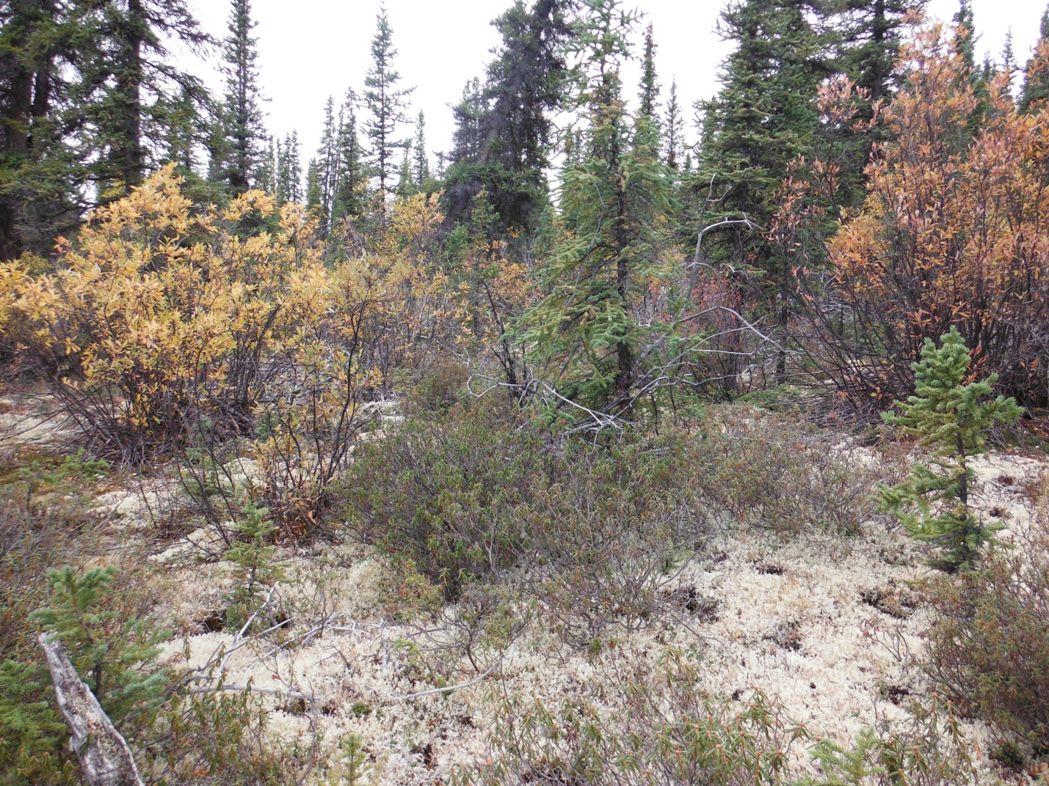

PHOTO 10: Site 7 – View Looking Northwest Upslope.
AMEC Environment & Infrastructure |  | Government of Yukon - AAM  Mount Nansen 2013 Site Investigation  Photographs
Logged by: MP | Scale: NTS | Date: Oct 2013 | Project: VM00605E | Page 5

