Mount Nansen 2013 Site Investigation

list of photos
Page
Photos of Creek Study Piezometer and Seepage Meter Installations 1
PHOTO 1: GSI-DC-01. 1
PHOTO 2: GSI-DC-02. 1
PHOTO 3: GSI-DC-03. 2
PHOTO 4: GSI-DC-04. 2
PHOTO 5: GSI-DC-05. 3
PHOTO 6: GSI-DC-06. 3
PHOTO 7: GSI-DC-07. 4
PHOTO 8: GSI-DC-08. 4
PHOTO 9: GSI-DC-09. 5
PHOTO 10: GSI-DC-10. 5
PHOTO 11: GSI-PC-01. 6
PHOTO 12: GSI-PC-02. 6
PHOTO 13: GSI-PC-03. 7
PHOTO 14: GSI-PC-04. 7
PHOTO 15: GSI-PC-05. 8
PHOTO 16: Drive Point Piezometer Set Up. 8
PHOTO 17: Using Slide Hammer to Install Drive Point Piezometer. 9
PHOTO 18: Set Up of Seepage Meter. 9
PHOTO 19: Typical Installation of Seepage Meter at GSI-PC-02. 10
PHOTO 20: Seepage Meter Installed at GSI-DC-02. 10
PHOTO 21: Installation Process of a Seepage Meter. 11
PHOTO 22: Weighing Water Bladder for Water Volume at End of Seepage Test. 11
PHOTO 23: GSI-HA-01-A. 12
PHOTO 24: GSI-HA-02-A. 12
PHOTO 25: GSI-HA-03-A. 13
PHOTO 26: GSI-HA-04-A. 13
PHOTO 27: GSI-HA-05-A. 14

Photos of Creek Study Piezometer and Seepage Meter Installations

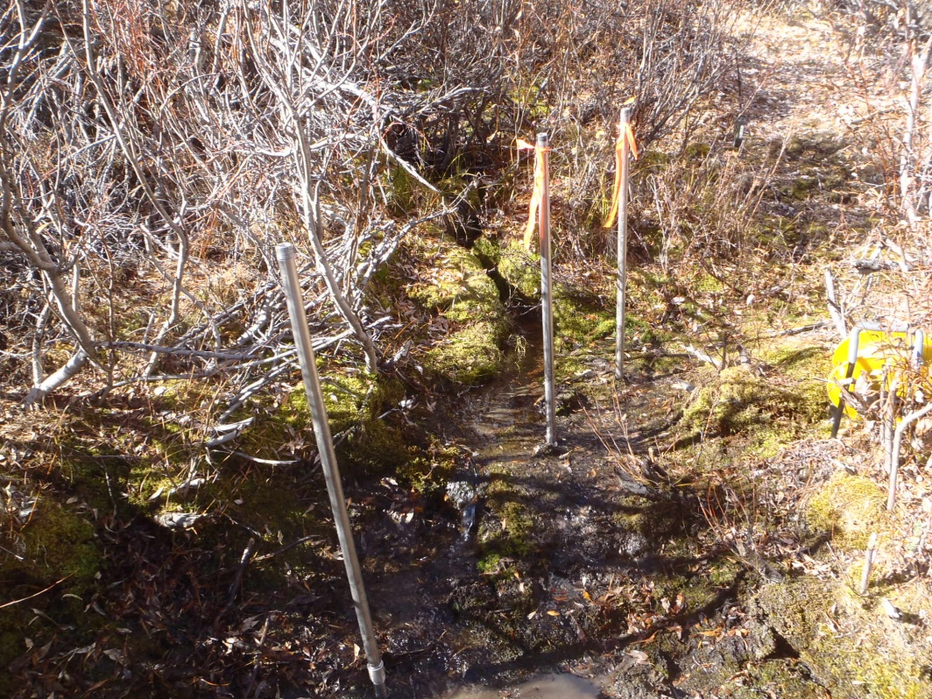

PHOTO 1: GSI-DC-01.

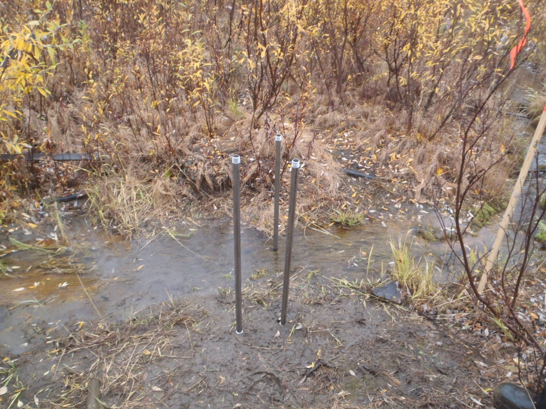

PHOTO 2: GSI-DC-02.
Government of Yukon - AAM
Mount Nansen 2013 Site Investigation
Photographs
Photos by: DP | Scale: NTS | Date: Oct 2013 | Project: VM00605E | Page 1

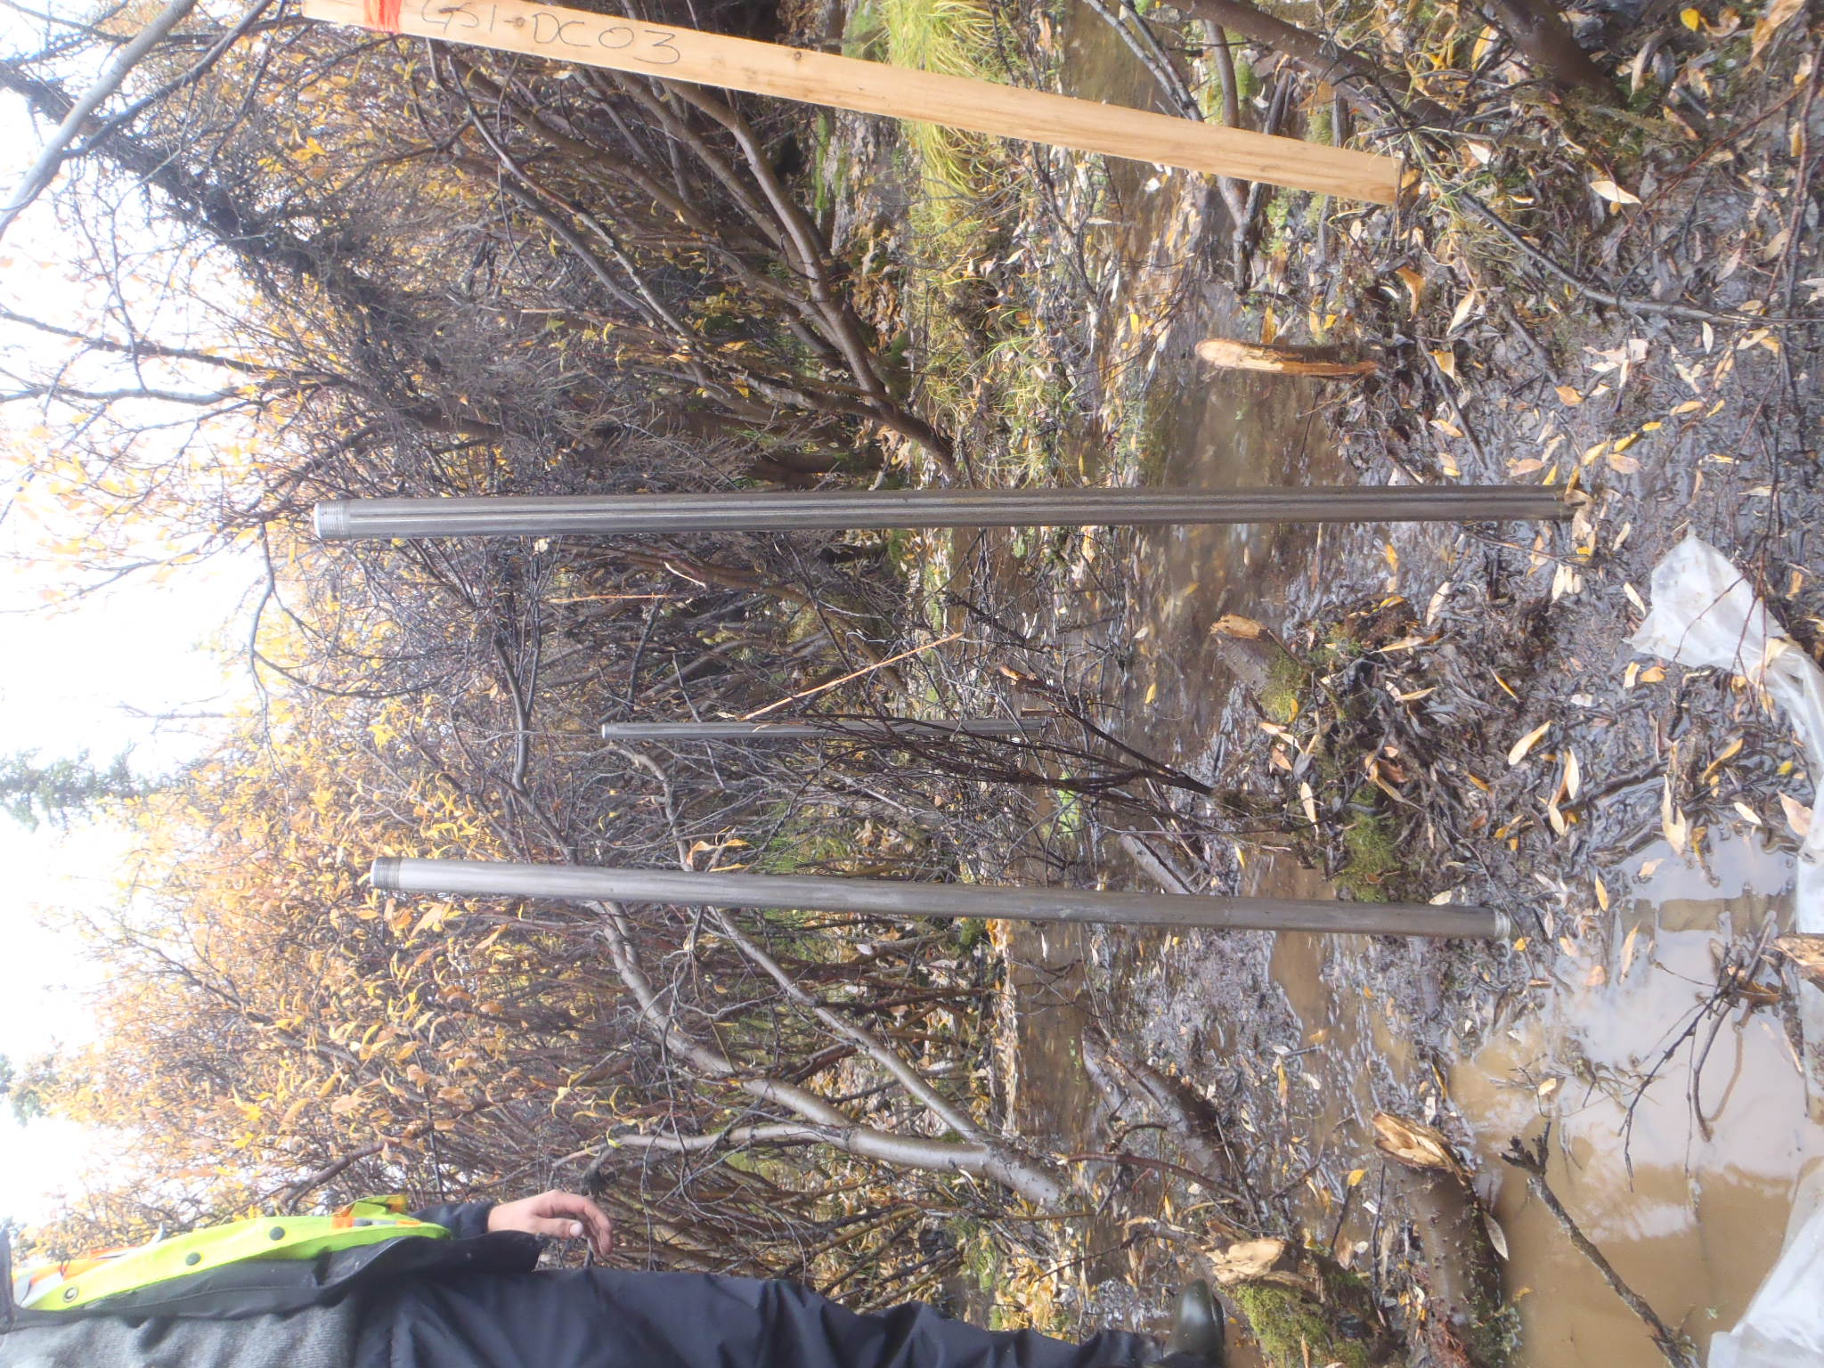

PHOTO 3: GSI-DC-03.

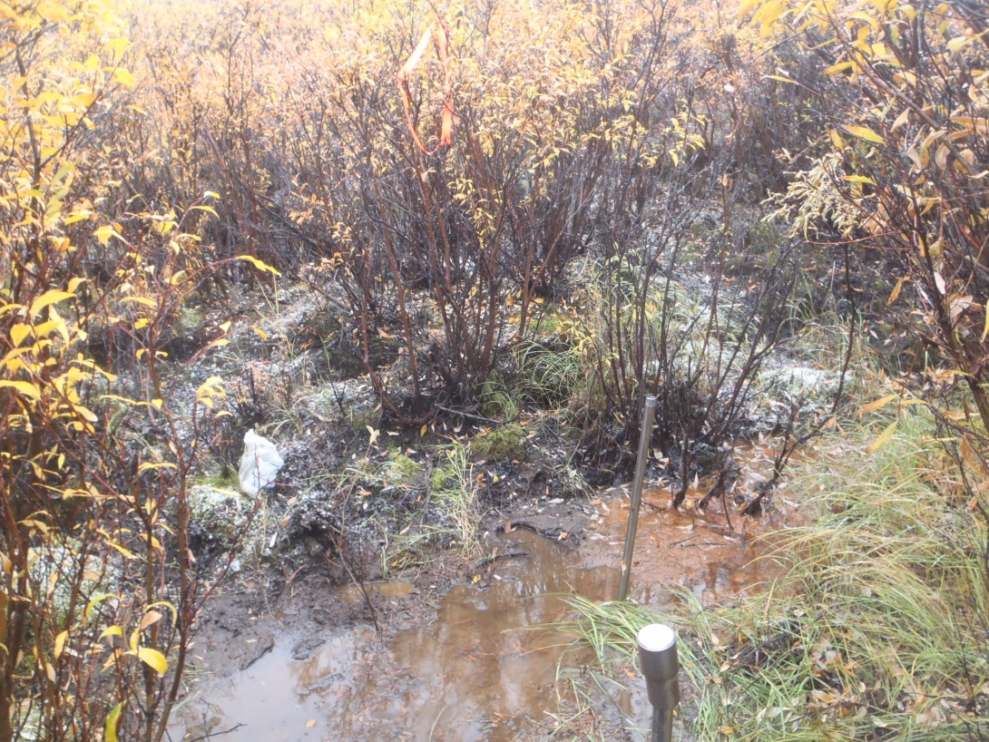

PHOTO 4: GSI-DC-04.
AMEC Environment & Infrastructure |  | Government of Yukon - AAM  Mount Nansen 2013 Site Investigation  Photographs
Photos by: DP | Scale: NTS | Date: Oct 2013 | Project: VM00605E | Page 2

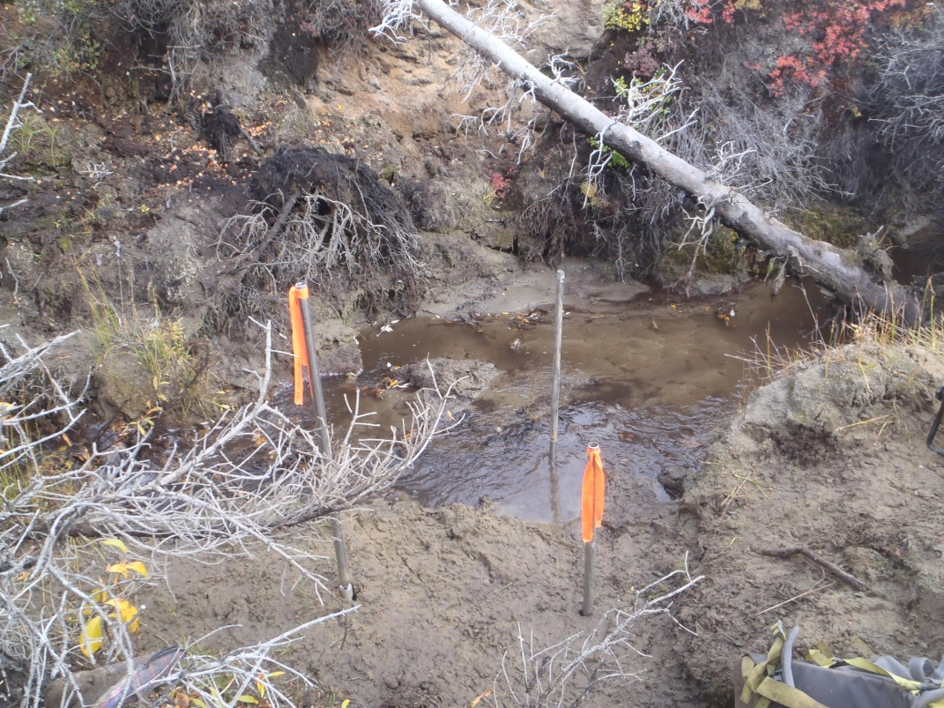

PHOTO 5: GSI-DC-05.

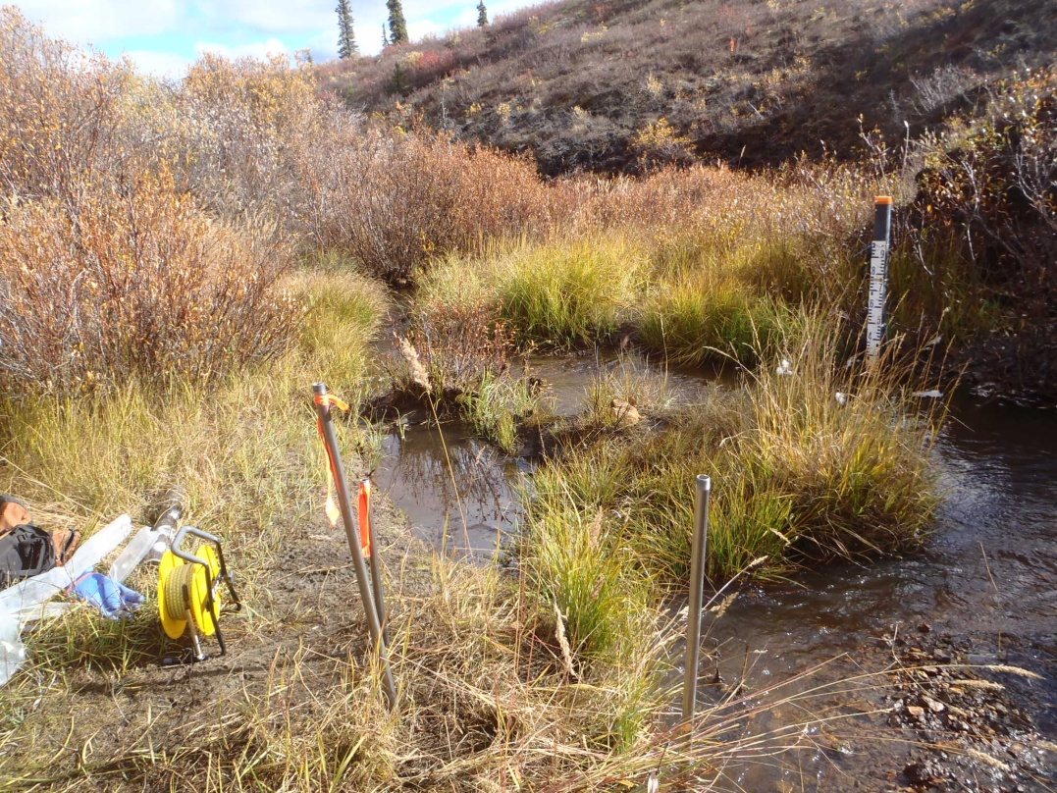

PHOTO 6: GSI-DC-06.
AMEC Environment & Infrastructure |  | Government of Yukon - AAM  Mount Nansen 2013 Site Investigation  Photographs
Logged by: DP | Scale: NTS | Date: Oct 2013 | Project: VM00605E | Page 3

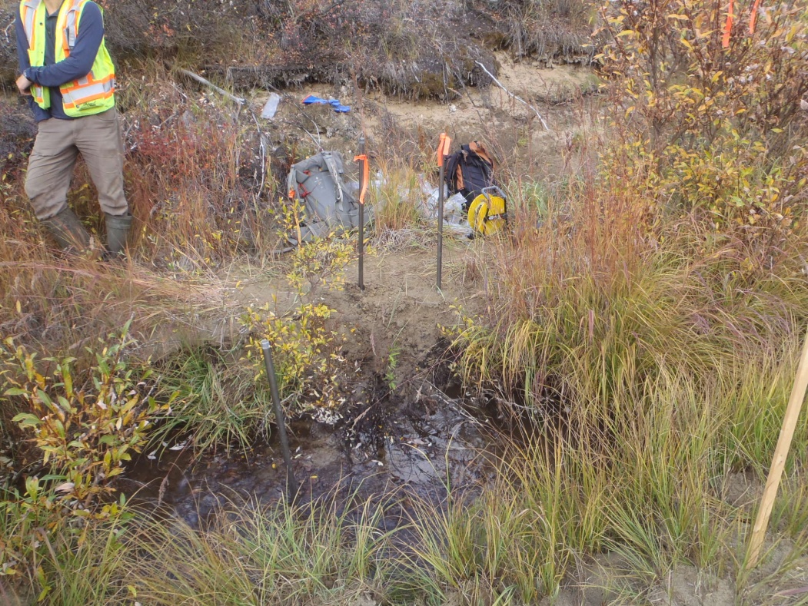

PHOTO 7: GSI-DC-07.

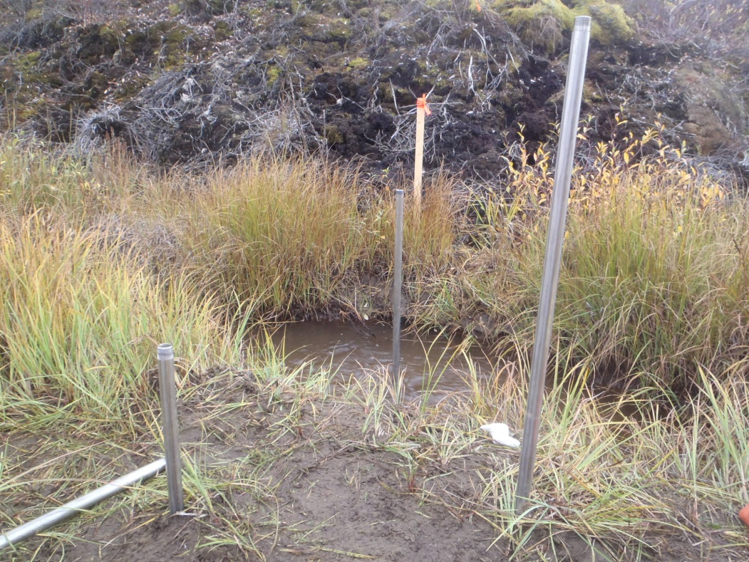

PHOTO 8: GSI-DC-08.
AMEC Environment & Infrastructure |  | Government of Yukon - AAM  Mount Nansen 2013 Site Investigation  Photographs
Logged by: DP | Scale: NTS | Date: Oct 2013 | Project: VM00605E | Page 4

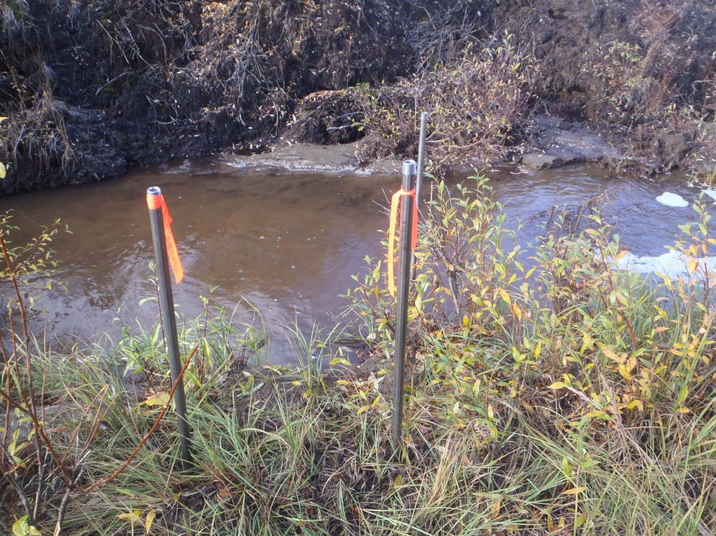

PHOTO 9: GSI-DC-09.

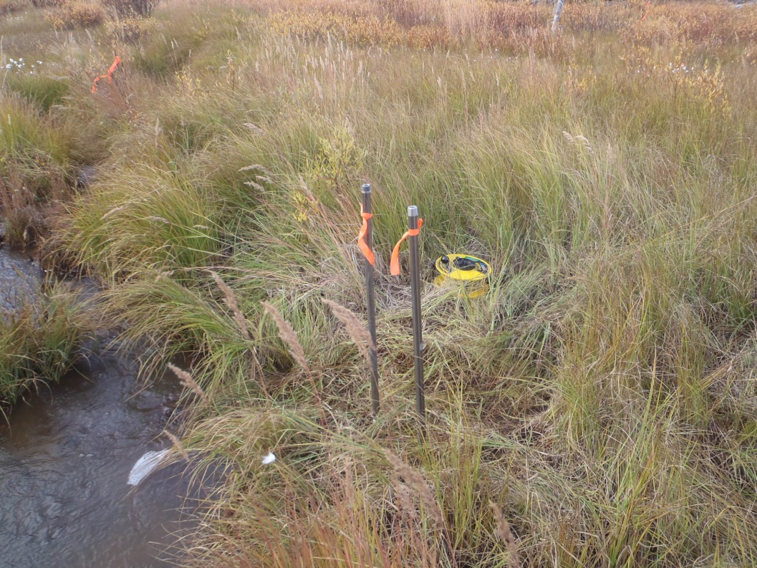

PHOTO 10: GSI-DC-10.
AMEC Environment & Infrastructure |  | Government of Yukon - AAM  Mount Nansen 2013 Site Investigation  Photographs
Logged by: DP | Scale: NTS | Date: Oct 2013 | Project: VM00605E | Page 5

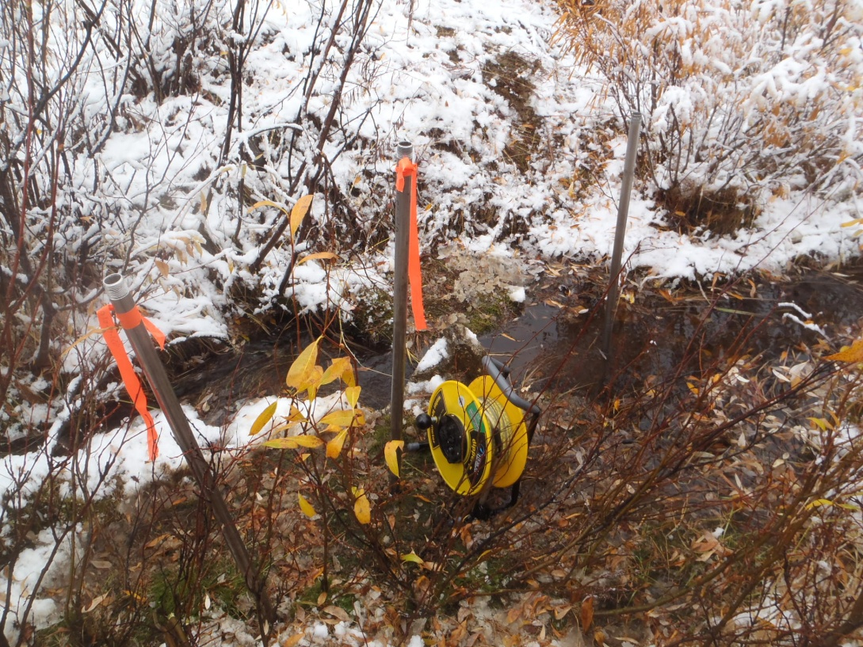

PHOTO 11: GSI-PC-01.

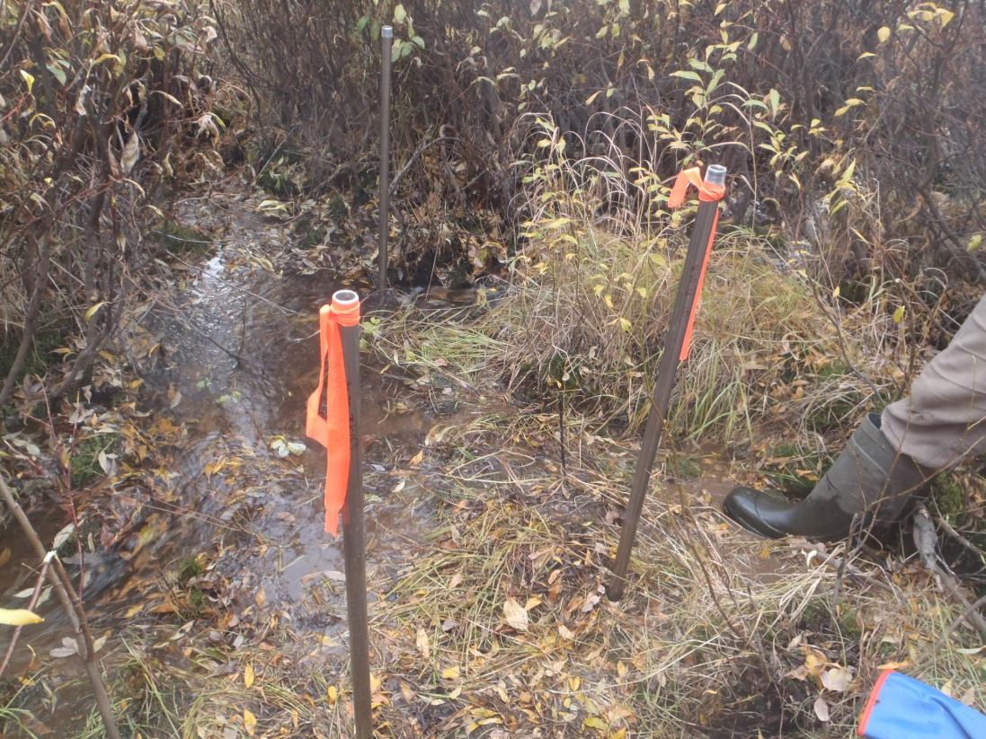

PHOTO 12: GSI-PC-02.
AMEC Environment & Infrastructure |  | Government of Yukon - AAM  Mount Nansen 2013 Site Investigation  Photographs
Logged by: DP | Scale: NTS | Date: Oct 2013 | Project: VM00605E | Page 6

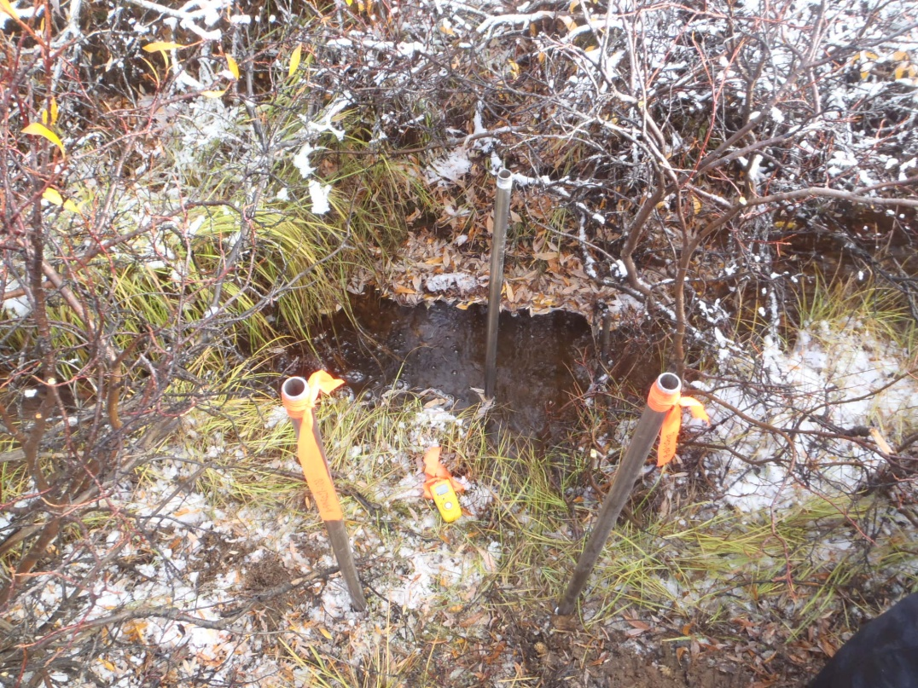

PHOTO 13: GSI-PC-03.

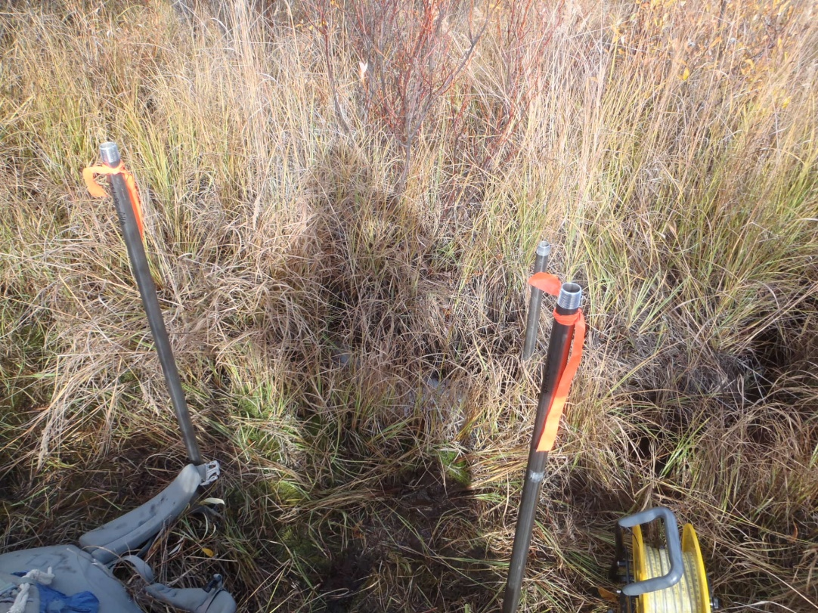

PHOTO 14: GSI-PC-04.
AMEC Environment & Infrastructure |  | Government of Yukon - AAM  Mount Nansen 2013 Site Investigation  Photographs
Logged by: DP | Scale: NTS | Date: Oct 2013 | Project: VM00605E | Page 7

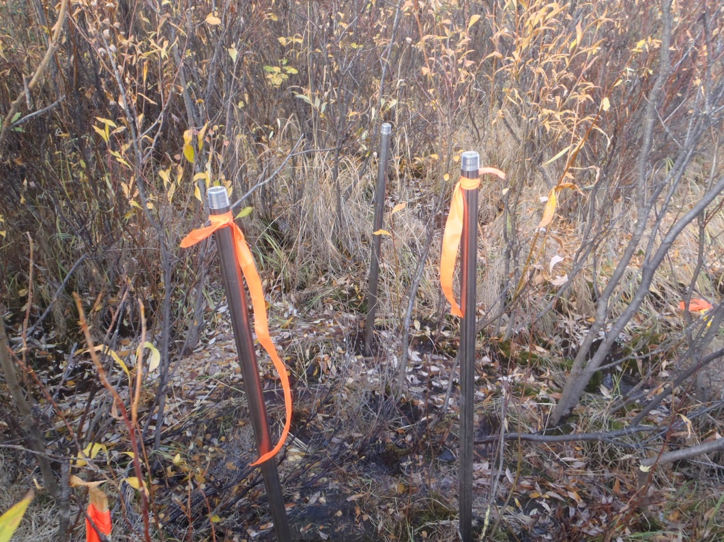

PHOTO 15: GSI-PC-05.

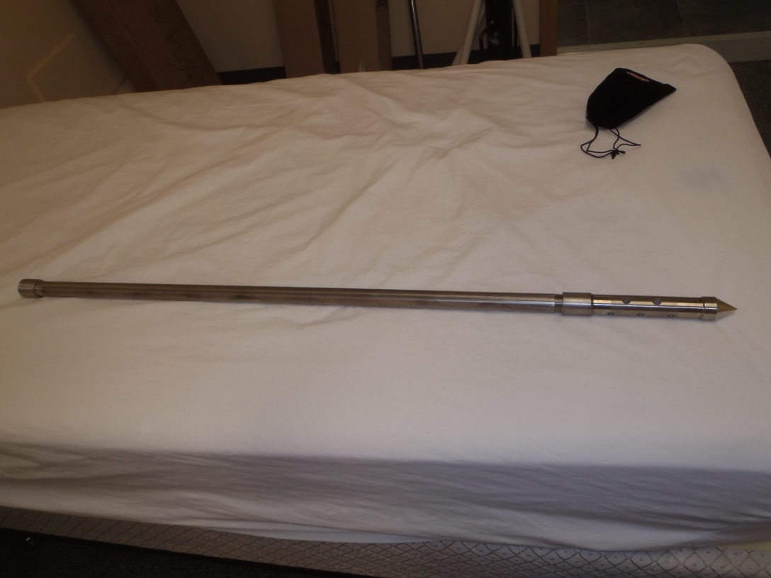

PHOTO 16: Drive Point Piezometer Set Up.
AMEC Environment & Infrastructure |  | Government of Yukon - AAM  Mount Nansen 2013 Site Investigation  Photographs
Logged by: DP | Scale: NTS | Date: Oct 2013 | Project: VM00605E | Page 8

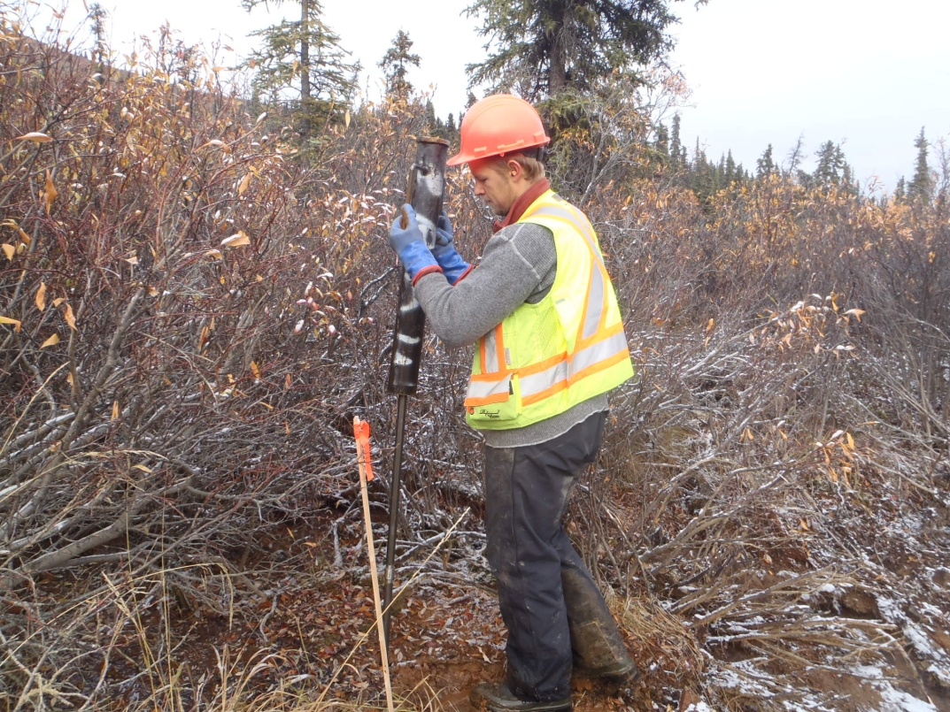

PHOTO 17: Using Slide Hammer to Install Drive Point Piezometer.

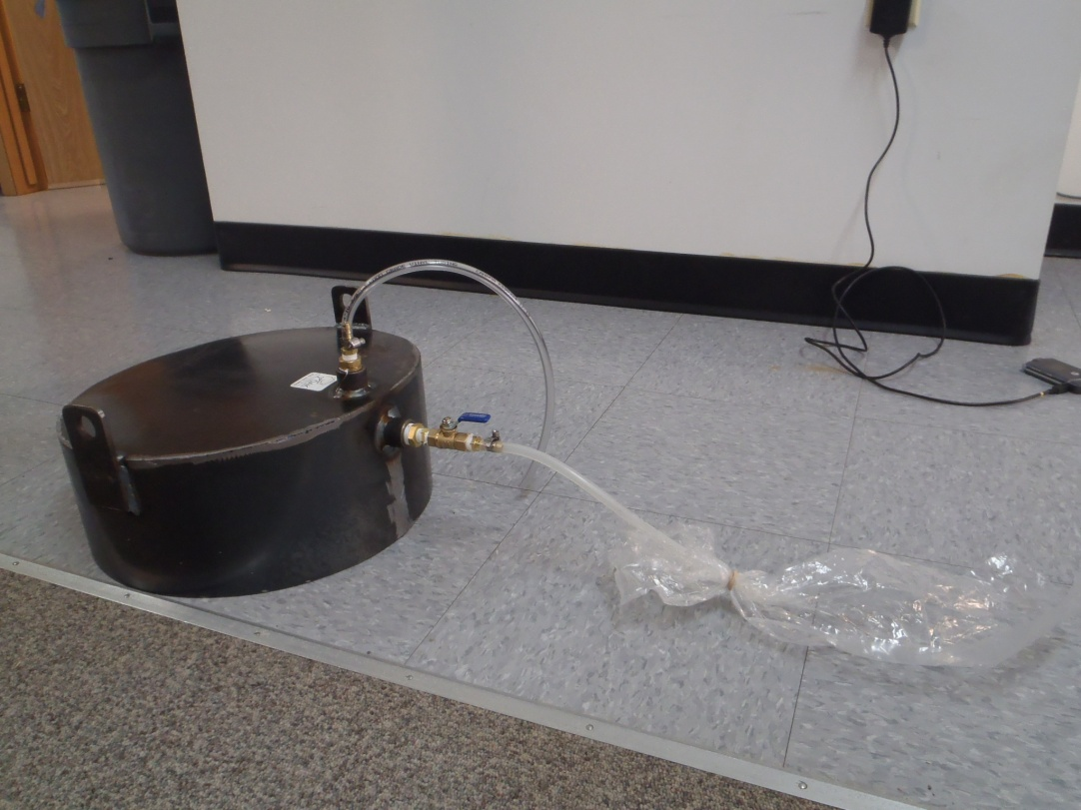

PHOTO 18: Set Up of Seepage Meter.
AMEC Environment & Infrastructure |  | Government of Yukon - AAM  Mount Nansen 2013 Site Investigation  Photographs
Logged by: DP | Scale: NTS | Date: Oct 2013 | Project: VM00605E | Page 9

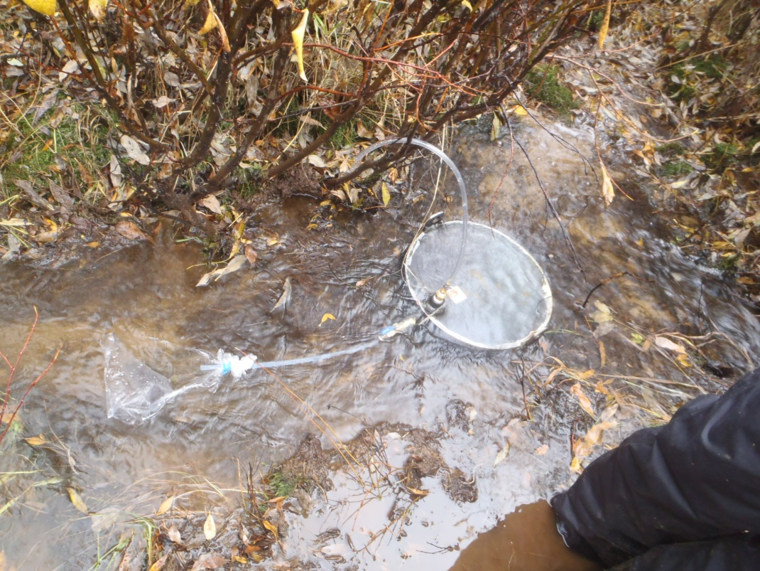

PHOTO 19: Typical Installation of Seepage Meter at GSI-PC-02.

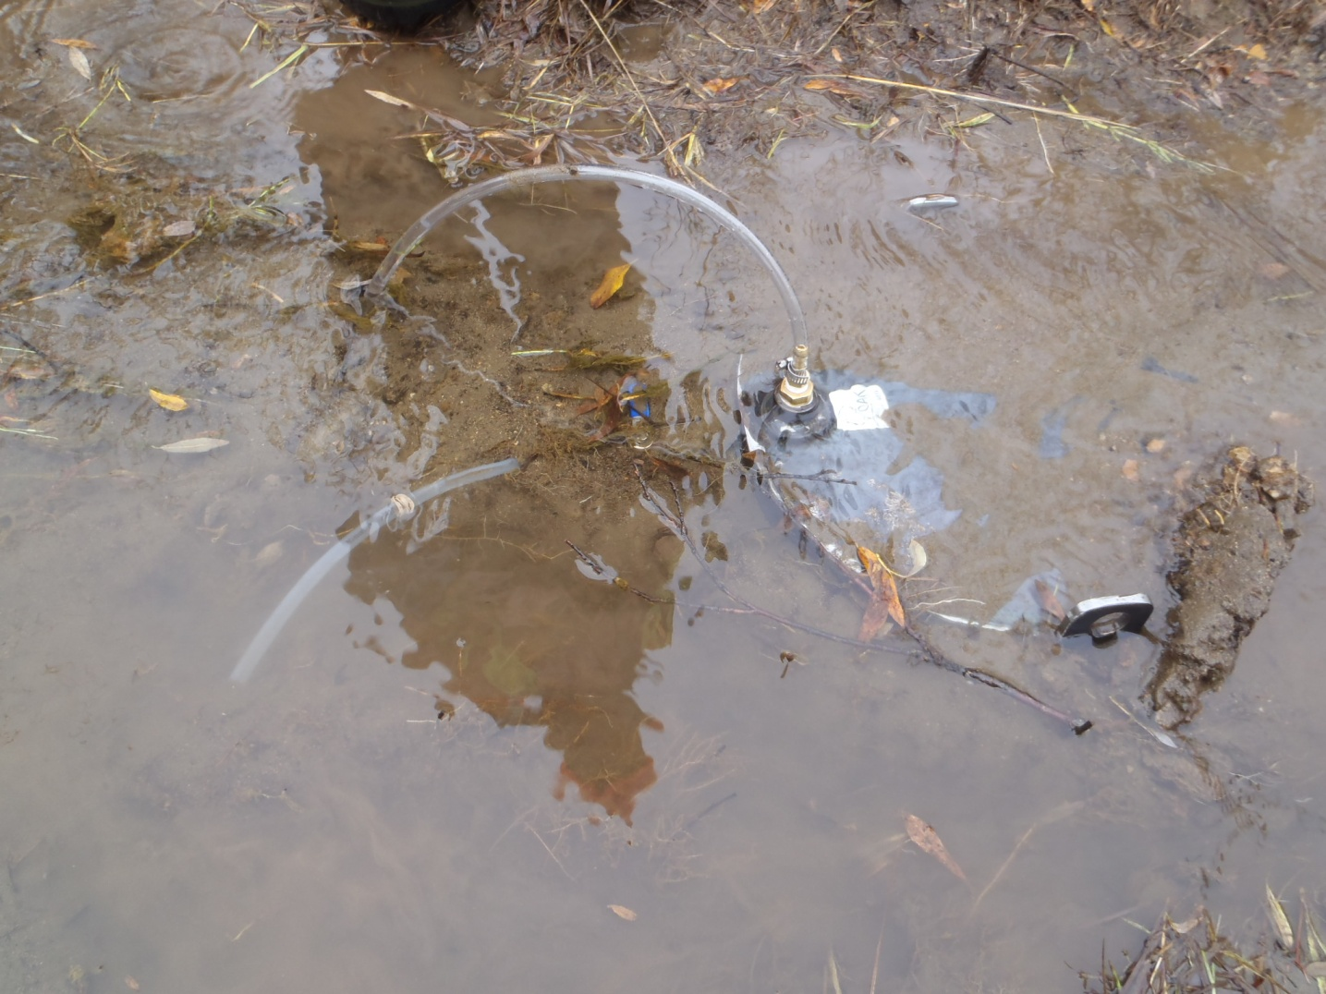

PHOTO 20: Seepage Meter Installed at GSI-DC-02.
AMEC Environment & Infrastructure |  | Government of Yukon - AAM  Mount Nansen 2013 Site Investigation  Photographs
Logged by: DP | Scale: NTS | Date: Oct 2013 | Project: VM00605E | Page 10

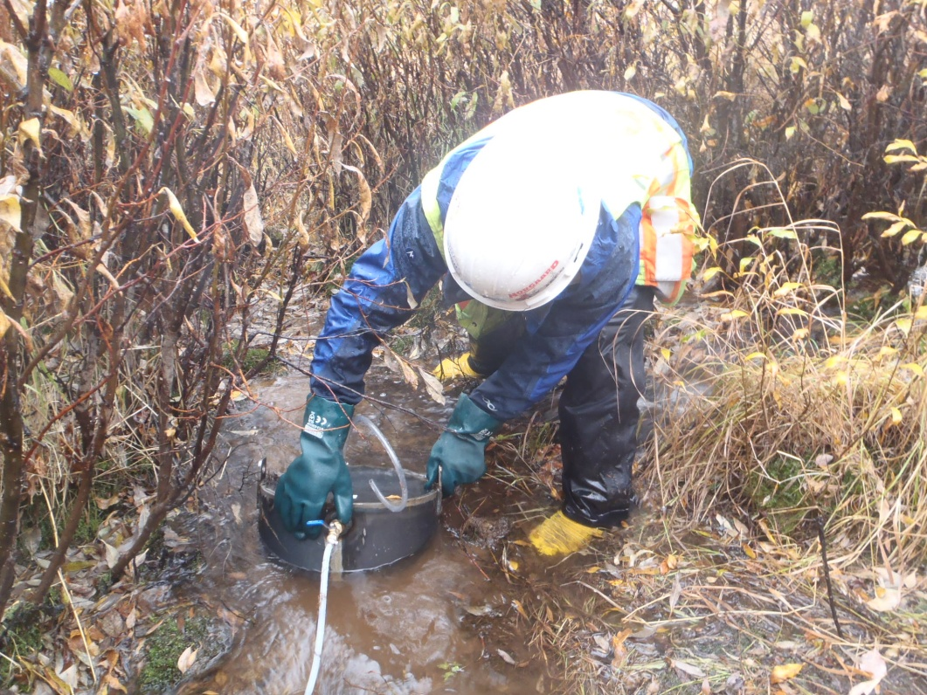

PHOTO 21: Installation Process of a Seepage Meter.

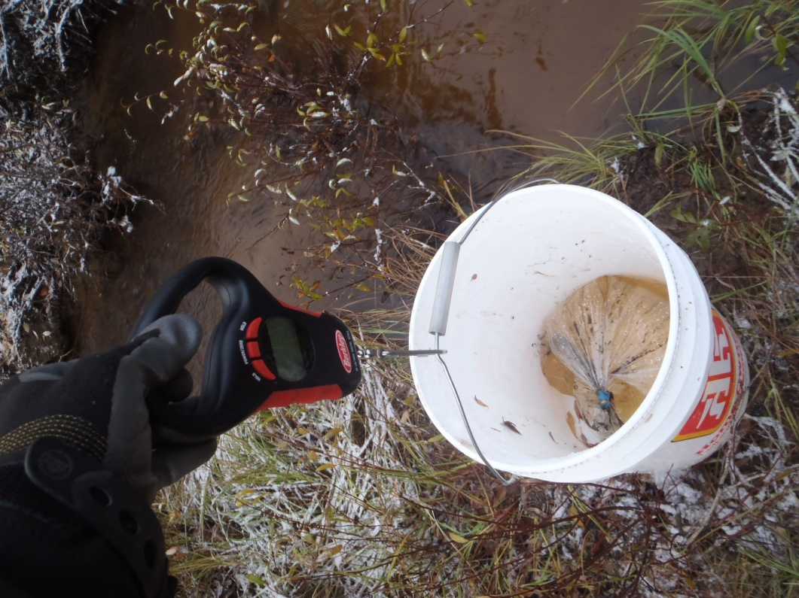

PHOTO 22: Weighing Water Bladder for Water Volume at End of Seepage Test.
AMEC Environment & Infrastructure |  | Government of Yuko Government of Yukon - AAM  Mount Nansen 2013 Site Investigation  Photographs
Logged by: DP | Scale: NTS | Date: Oct 2013 | Project: VM00605E | Page 11

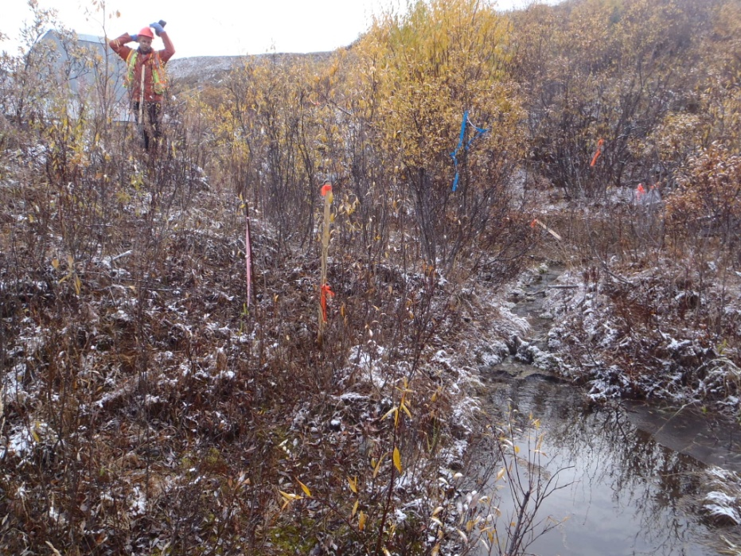

PHOTO 23: GSI-HA-01-A.

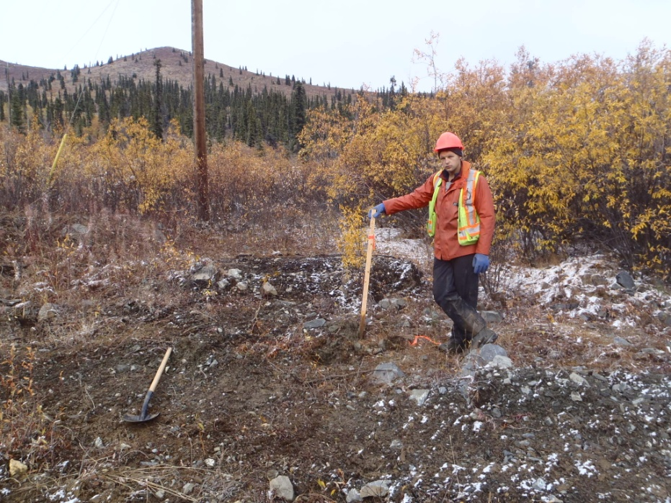

PHOTO 24: GSI-HA-02-A.

NOTE: Photos of the completed equipment installs of GSI-HA-01-A to GSI-HA-05-A were not taken. The photos included are of the appropriate locations during field reconnaissance.
AMEC Environment & Infrastructure |  | Government of Yukon - AAM  Mount Nansen 2013 Site Investigation  Photographs
Logged by: DP | Scale: NTS | Date: Oct 2013 | Project: VM00605E | Page 12

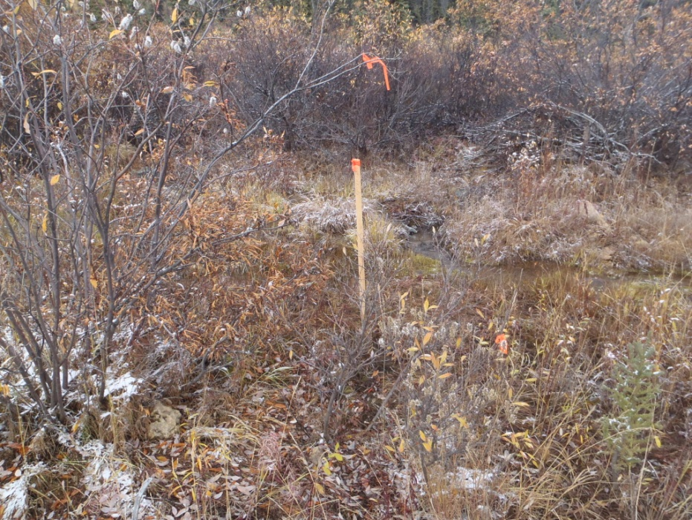

PHOTO 25: GSI-HA-03-A.

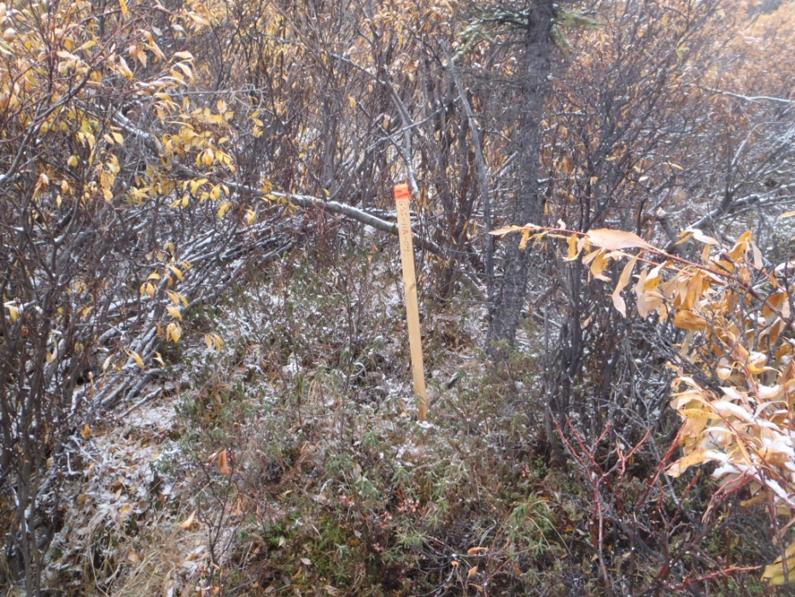

PHOTO 26: GSI-HA-04-A.
AMEC Environment & Infrastructure |  | Government of Yukon - AAM  Mount Nansen 2013 Site Investigation  Photographs
Logged by: DP | Scale: NTS | Date: Oct 2013 | Project: VM00605E | Page 13

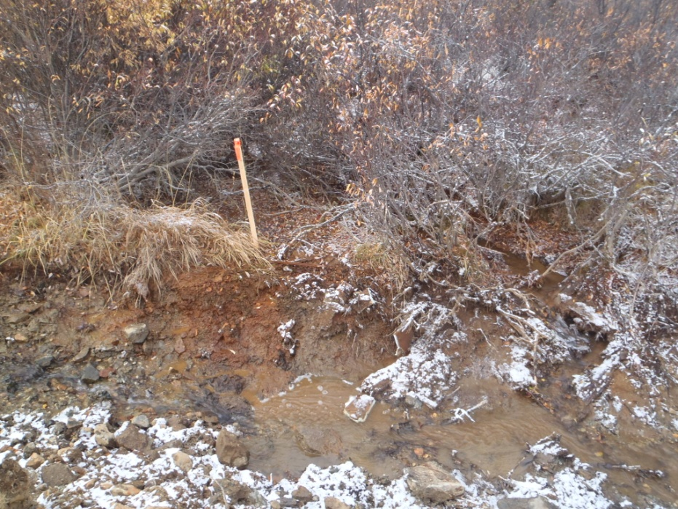

PHOTO 27: GSI-HA-05-A.

AMEC Environment & Infrastructure |  | Government of Yukon - AAM  Mount Nansen 2013 Site Investigation  Photographs
Logged by: DP | Scale: NTS | Date: Oct 2013 | Project: VM00605E | Page 14

