Mount Nansen 2013 Site Investigation

list of Geophysics Plans and Sections
Page
Geophysics Plans 1
FIGURE 1: Mill Area Plan 1
FIGURE 2: Tailings Storage Facility Geophysics Plan 2
FIGURE 3: Heustis Adit Area Plan 3
Geophysics Plans and Sections 4
FIGURE 4: NA 1 Section 4
FIGURE 5: NA 2 Section 5
FIGURE 6: NA 3 Section 6
FIGURE 7: NA 4 Section 7
FIGURE 8: NA 5 Section 8
FIGURE 9: NA 6 Section 9
FIGURE 10: NA 7 Section 10
FIGURE 11: NA 8 Section 11
FIGURE 12: NA 9 Section 12
FIGURE 13: NA 10 Section 13
FIGURE 14: NA 11 Section 14
FIGURE 15: NA 12 Section 15

Geophysics Plans

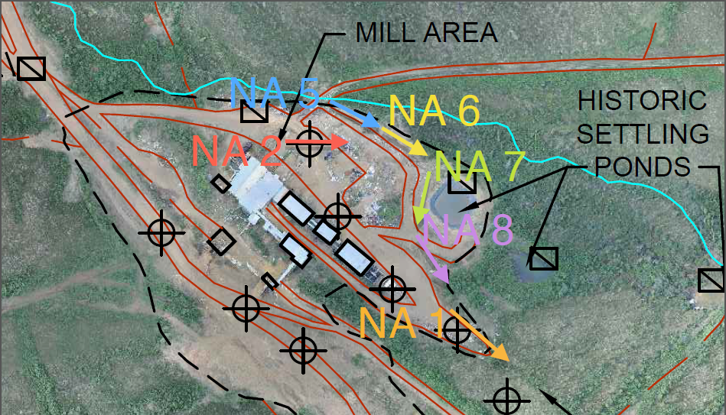

FIGURE 1: Mill Area Plan
Geophysics performed and interpretted by Kryotec Arctic Innovation Inc. |  |  | Government of Yukon - AAM  Mount Nansen 2013 Site Investigation  Geophysics Plans and Sections
 | Scale: NTS | Date: Oct 2013 |  | Page 1

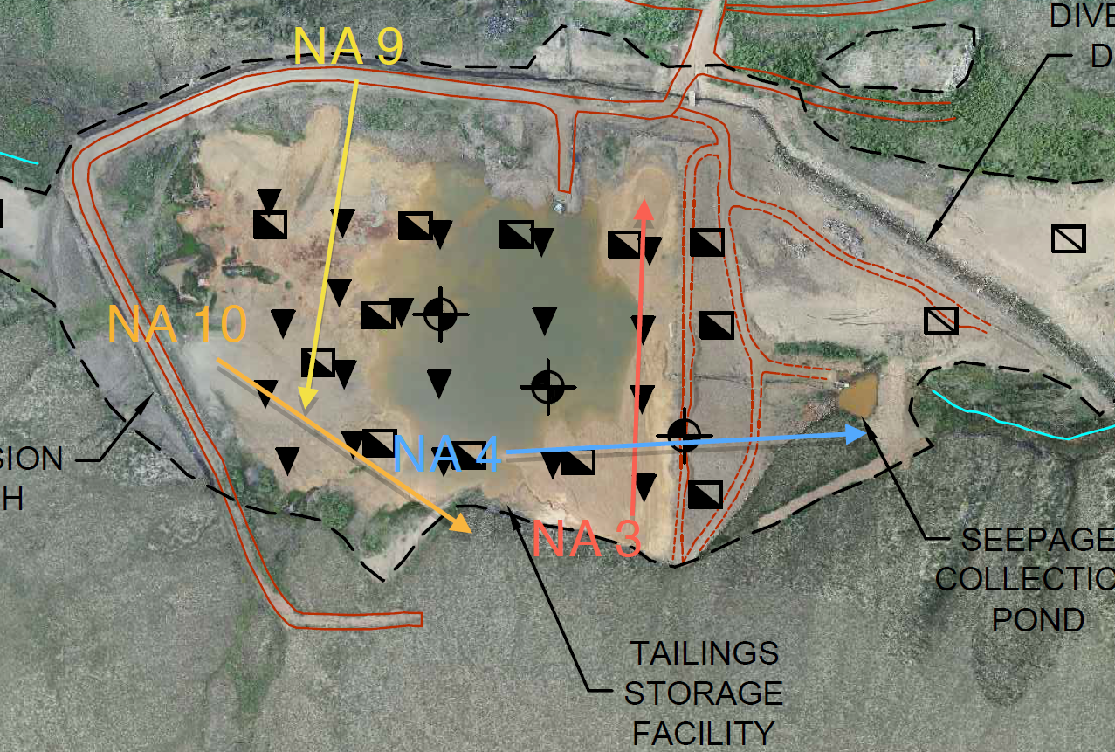

FIGURE 2: Tailings Storage Facility Geophysics Plan
Geophysics performed and interpretted by Kryotec Arctic Innovation Inc. |  |  | Government of Yukon - AAM  Mount Nansen 2013 Site Investigation  Geophysics Plans and Sections
 | Scale: NTS | Date: Oct 2013 |  | Page 2

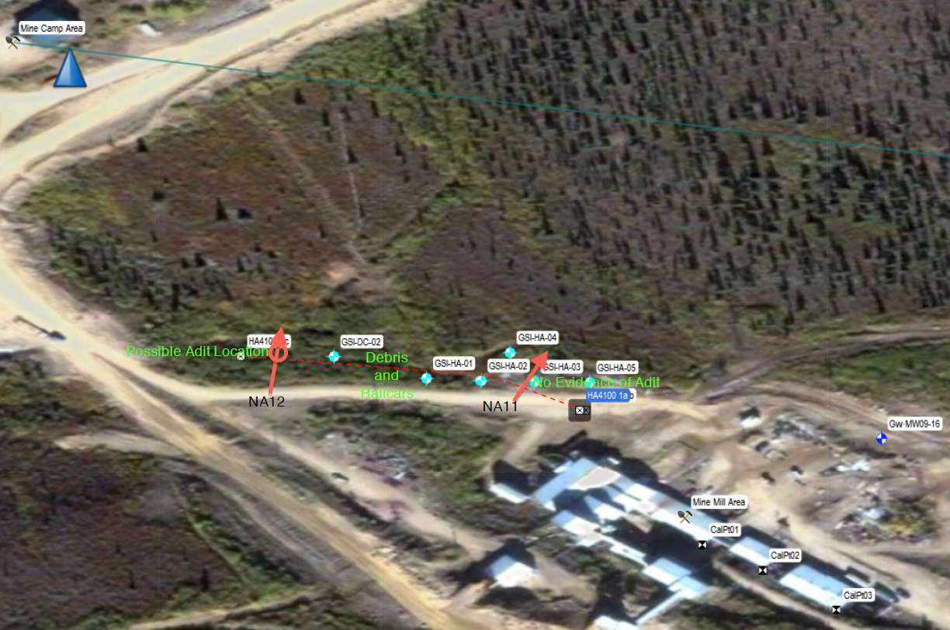

FIGURE 3: Heustis Adit Area Plan
Geophysics performed and interpretted by Kryotec Arctic Innovation Inc. |  |  | Government of Yukon - AAM  Mount Nansen 2013 Site Investigation  Geophysics Plans and Sections
 | Scale: NTS | Date: Oct 2013 |  | Page 3

Geophysics Plans and Sections

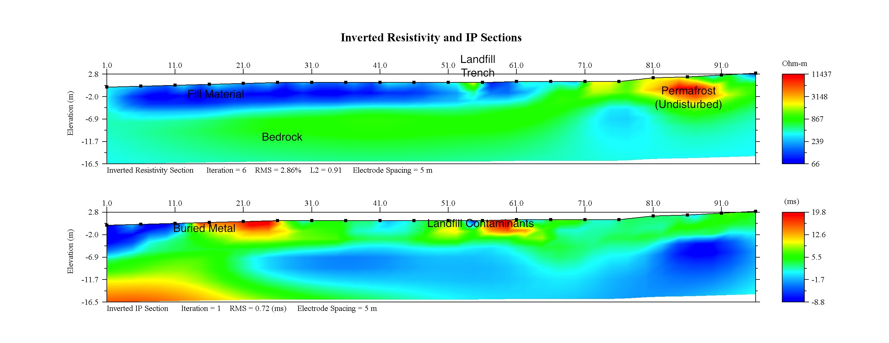

FIGURE 4: NA 1 Section
Geophysics performed and interpretted by Kryotec Arctic Innovation Inc. |  |  | Government of Yukon - AAM  Mount Nansen 2013 Site Investigation  Geophysics Plans and Sections
 | Scale: NTS | Date: Oct 2013 |  | Page 4

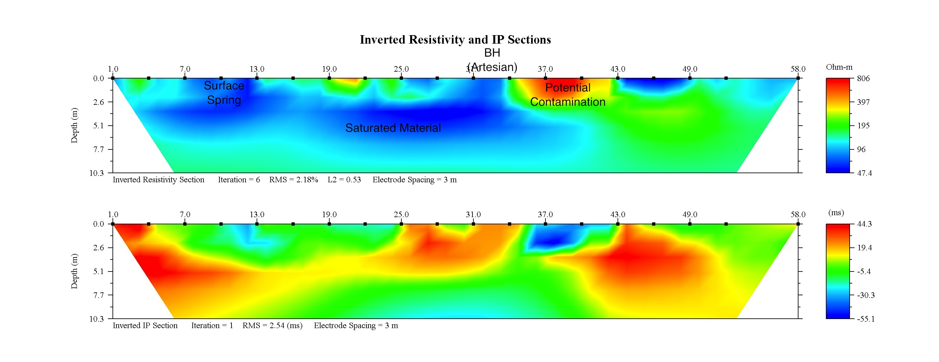

FIGURE 5: NA 2 Section
Geophysics performed and interpretted by Kryotec Arctic Innovation Inc. |  |  | Government of Yukon - AAM  Mount Nansen 2013 Site Investigation  Geophysics Plans and Sections
 | Scale: NTS | Date: Oct 2013 |  | Page 5

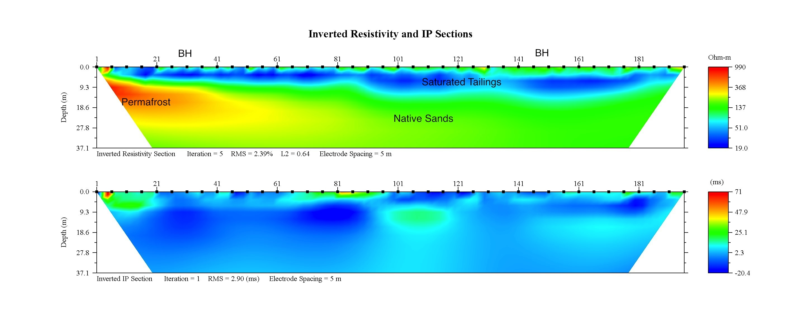

FIGURE 6: NA 3 Section
Geophysics performed and interpretted by Kryotec Arctic Innovation Inc. |  |  | Government of Yukon - AAM  Mount Nansen 2013 Site Investigation  Geophysics Plans and Sections
 | Scale: NTS | Date: Oct 2013 |  | Page 6

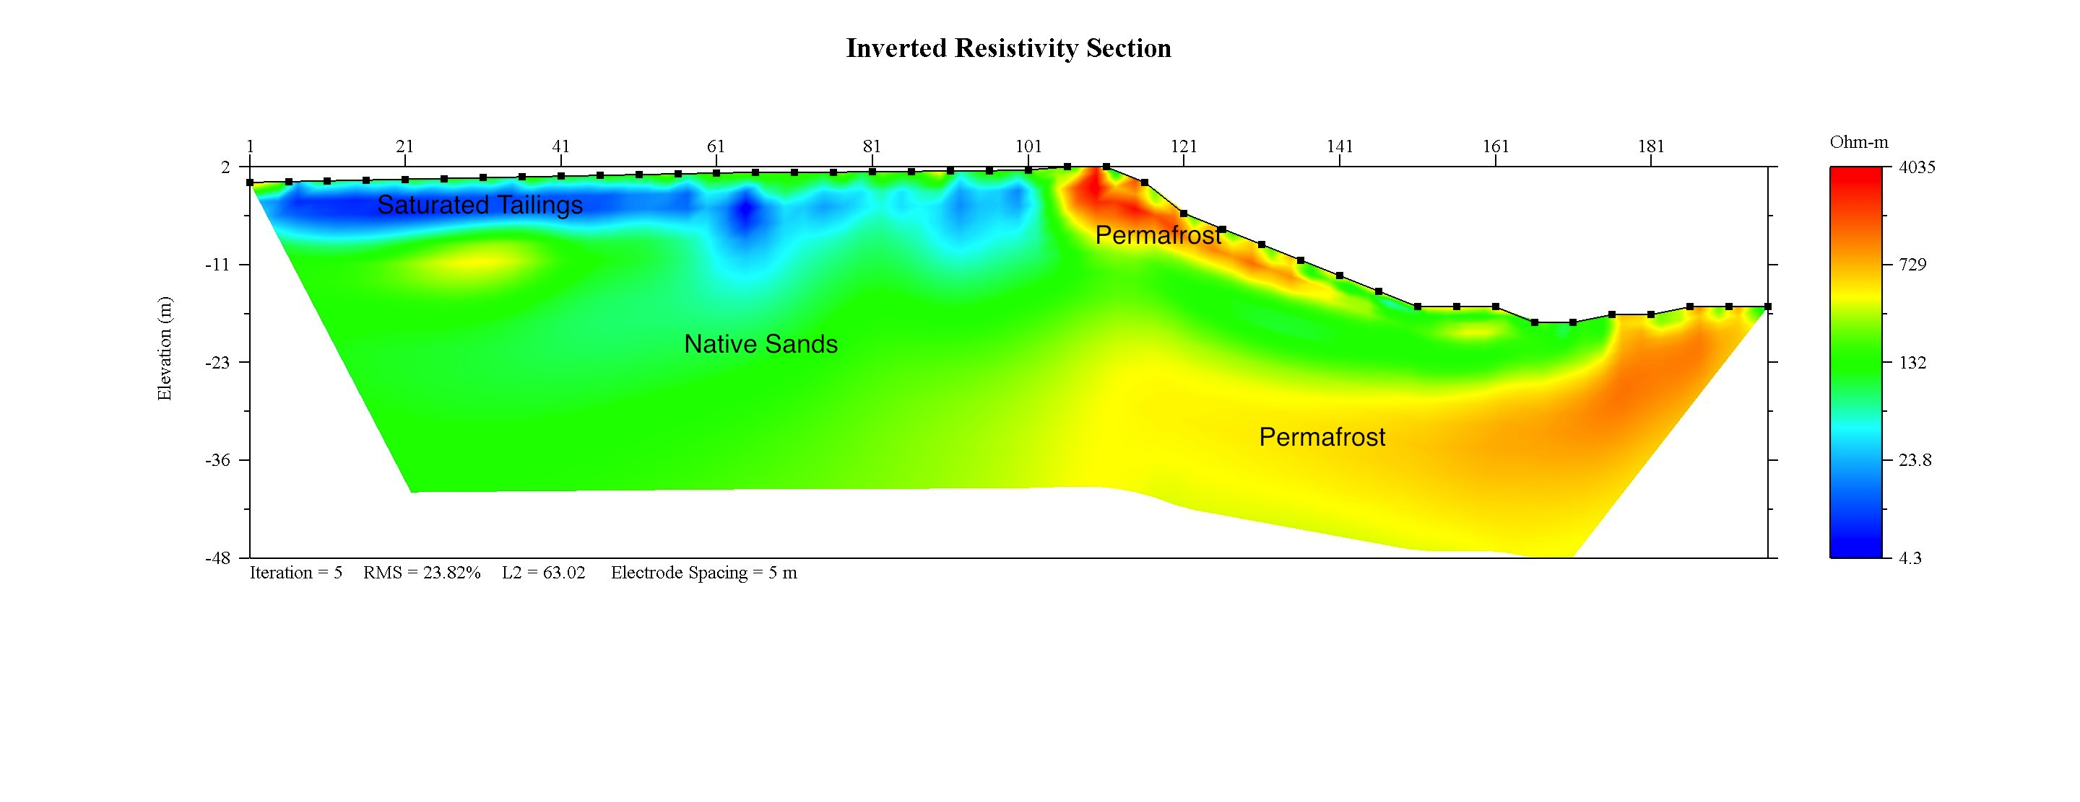

FIGURE 7: NA 4 Section
Geophysics performed and interpretted by Kryotec Arctic Innovation Inc. |  |  | Government of Yukon - AAM  Mount Nansen 2013 Site Investigation  Geophysics Plans and Sections
 | Scale: NTS | Date: Oct 2013 |  | Page 7

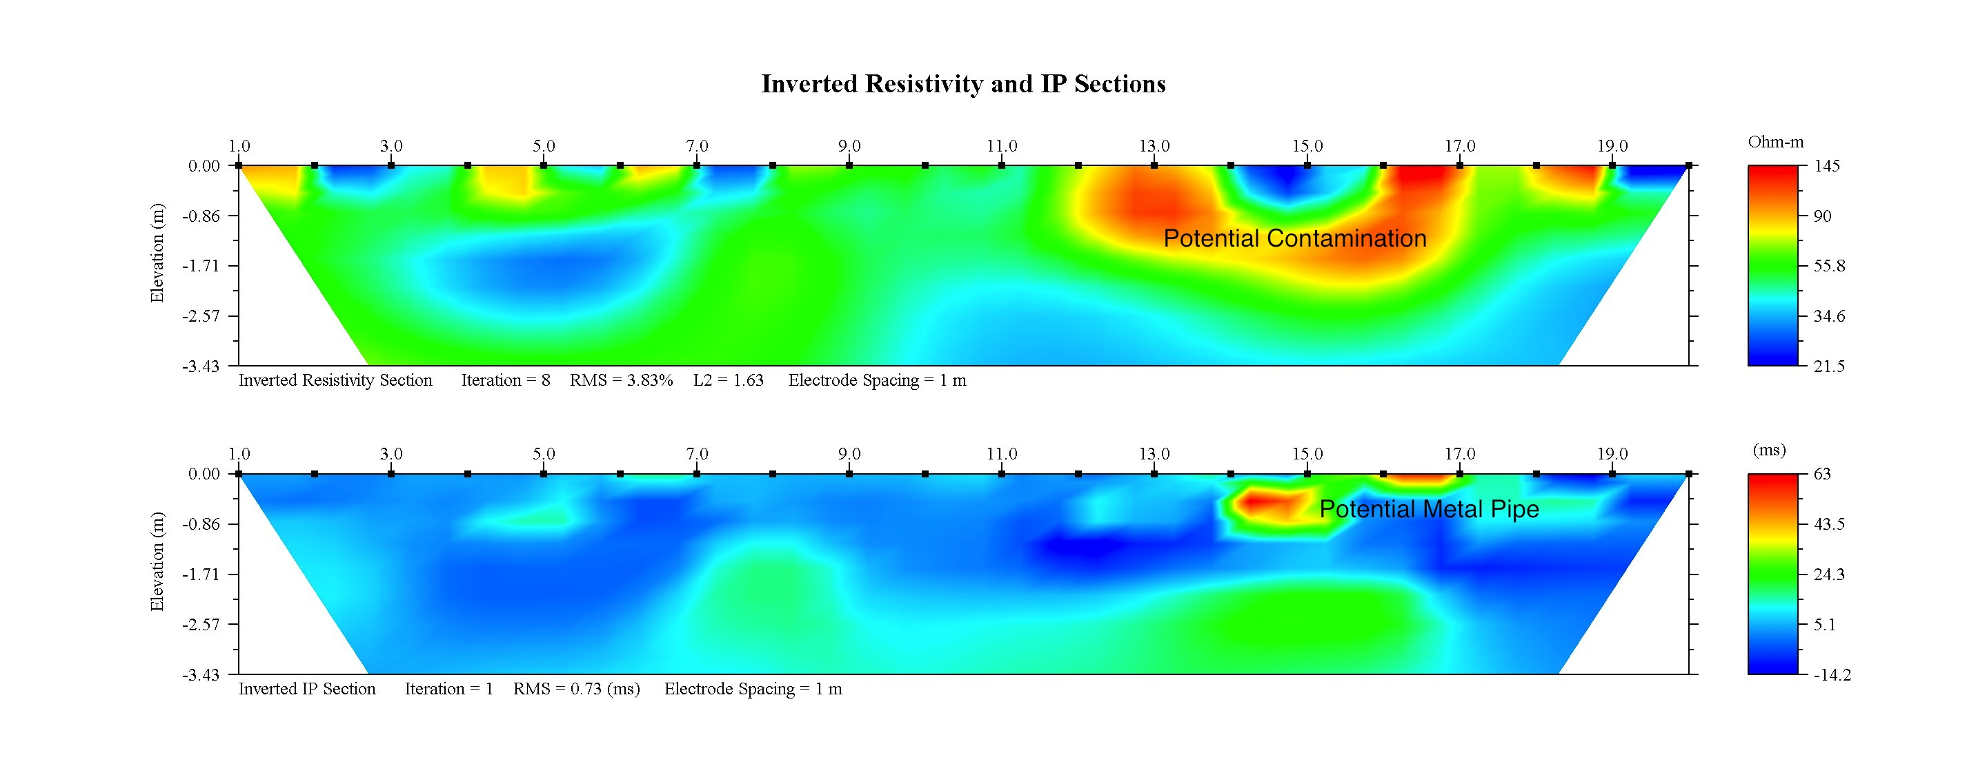

FIGURE 8: NA 5 Section
Geophysics performed and interpretted by Kryotec Arctic Innovation Inc. |  |  | Government of Yukon - AAM  Mount Nansen 2013 Site Investigation  Geophysics Plans and Sections
 | Scale: NTS | Date: Oct 2013 |  | Page 8

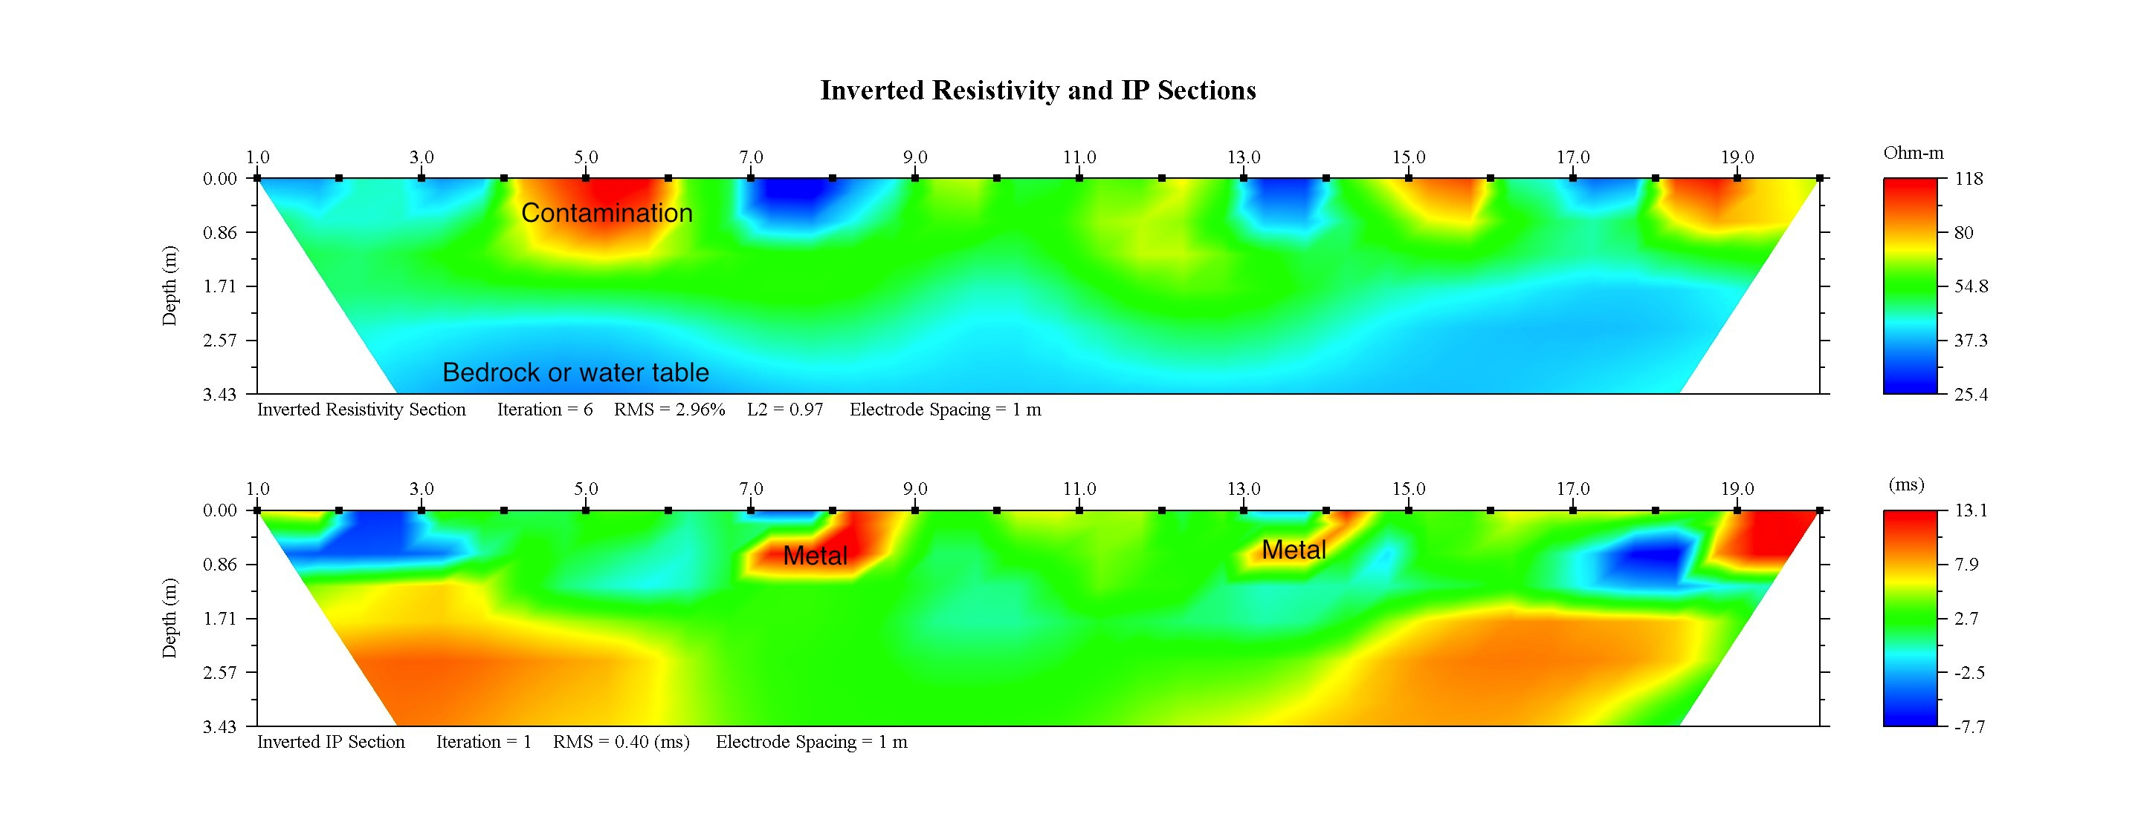

FIGURE 9: NA 6 Section
Geophysics performed and interpretted by Kryotec Arctic Innovation Inc. |  |  | Government of Yukon - AAM  Mount Nansen 2013 Site Investigation  Geophysics Plans and Sections
 | Scale: NTS | Date: Oct 2013 |  | Page 9

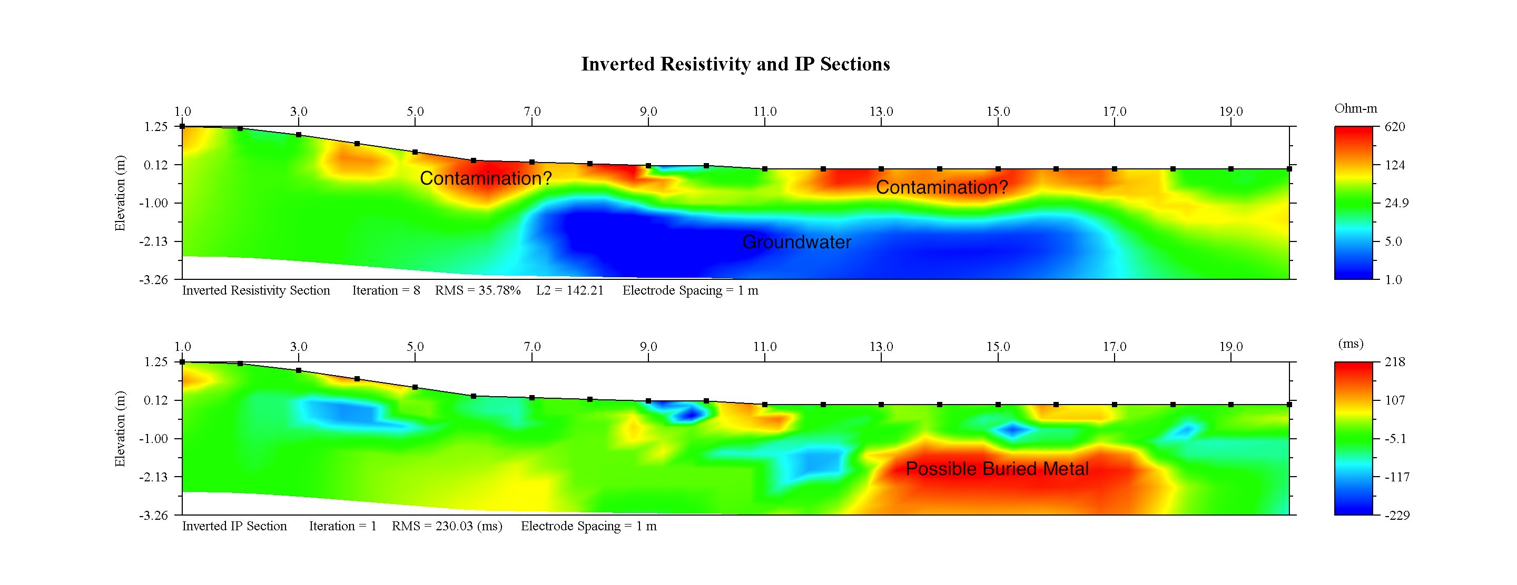

FIGURE 10: NA 7 Section
Geophysics performed and interpretted by Kryotec Arctic Innovation Inc. |  |  | Government of Yukon - AAM  Mount Nansen 2013 Site Investigation  Geophysics Plans and Sections
 | Scale: NTS | Date: Oct 2013 |  | Page 10

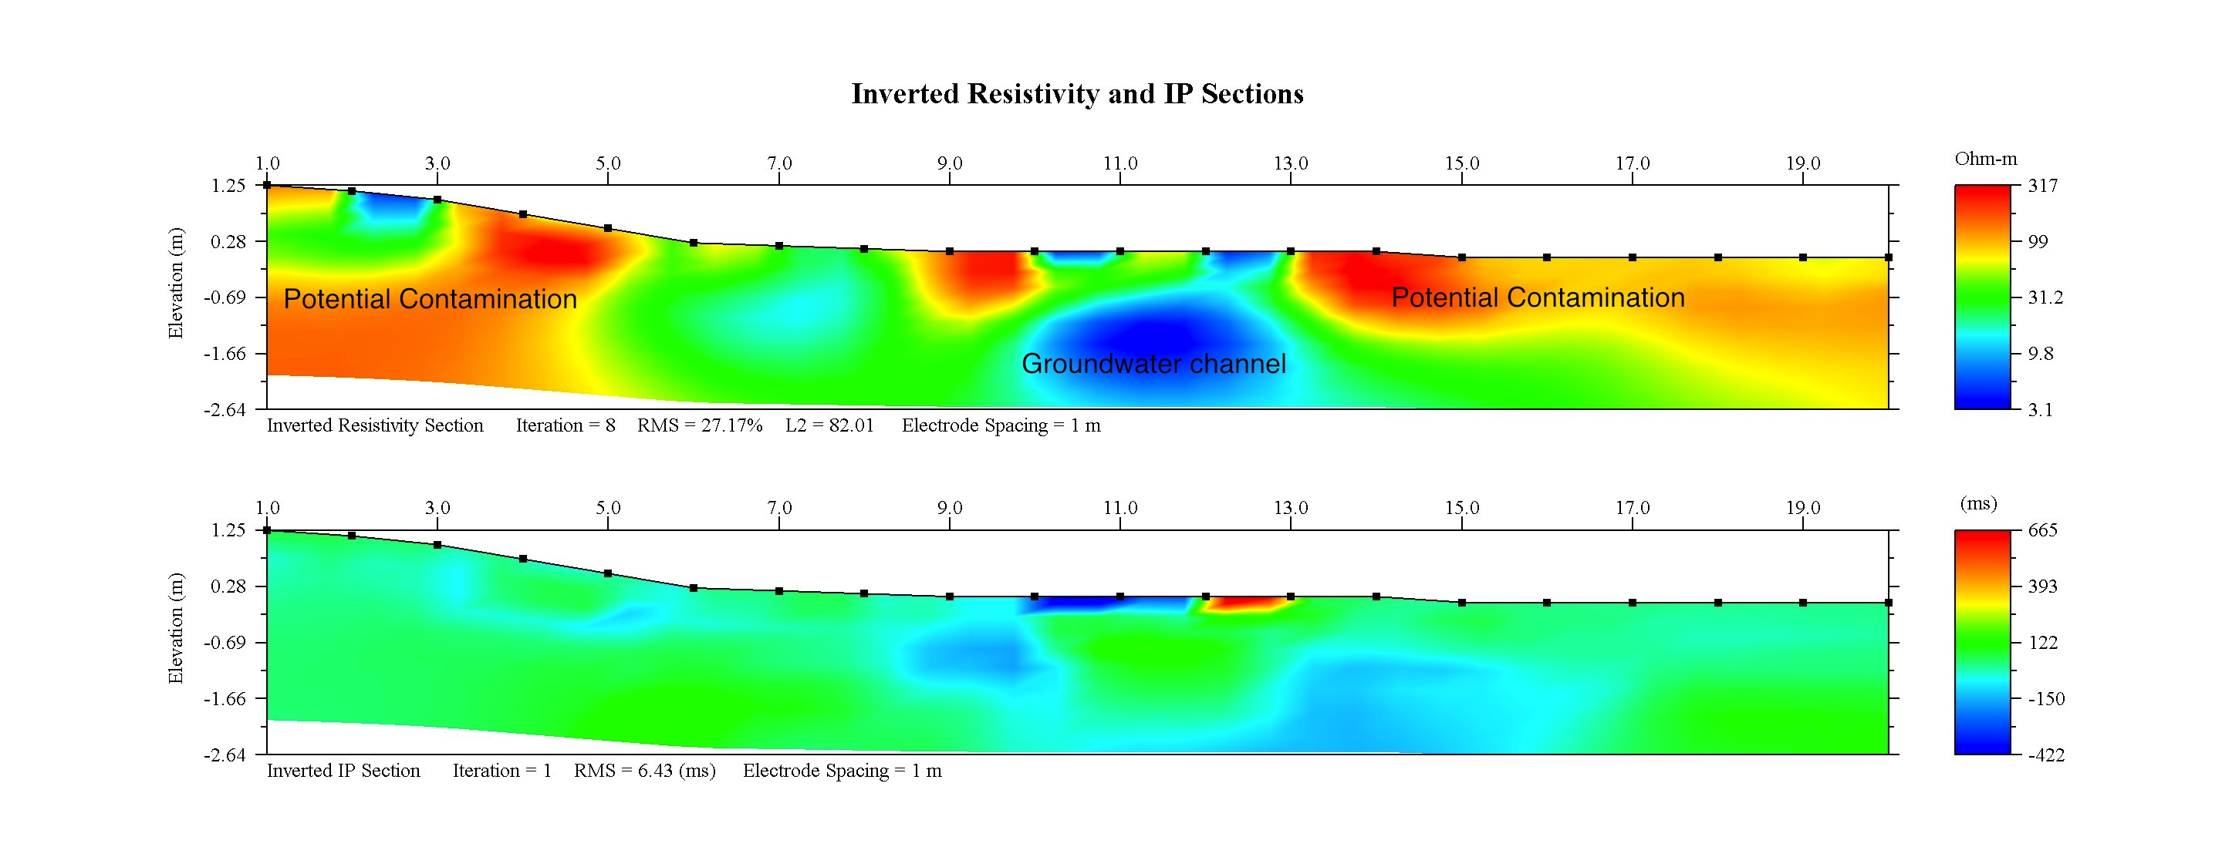

FIGURE 11: NA 8 Section
Geophysics performed and interpretted by Kryotec Arctic Innovation Inc. |  |  | Government of Yukon - AAM  Mount Nansen 2013 Site Investigation  Geophysics Plans and Sections
 | Scale: NTS | Date: Oct 2013 |  | Page 11

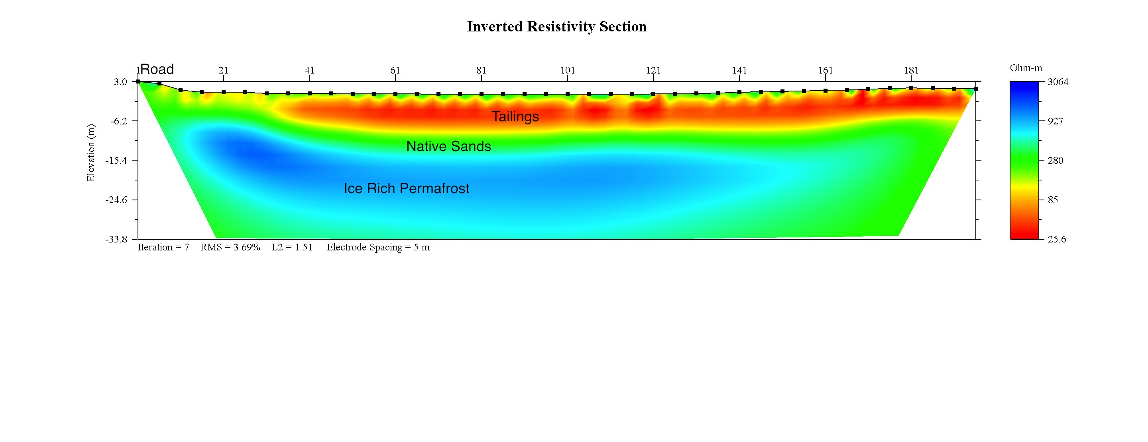

FIGURE 12: NA 9 Section
Geophysics performed and interpretted by Kryotec Arctic Innovation Inc. |  |  | Government of Yukon - AAM  Mount Nansen 2013 Site Investigation  Geophysics Plans and Sections
 | Scale: NTS | Date: Oct 2013 |  | Page 12

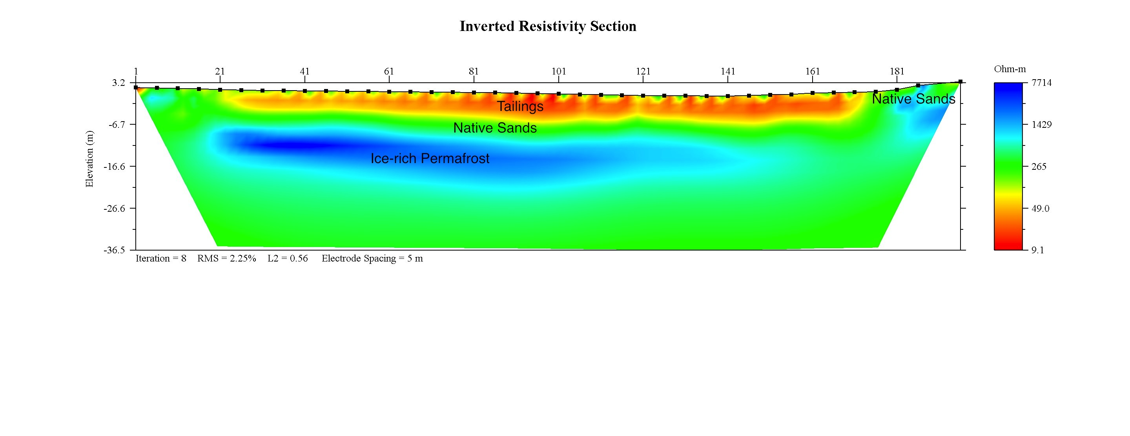

FIGURE 13: NA 10 Section
Geophysics performed and interpretted by Kryotec Arctic Innovation Inc. |  |  | Government of Yukon - AAM  Mount Nansen 2013 Site Investigation  Geophysics Plans and Sections
 | Scale: NTS | Date: Oct 2013 |  | Page 13

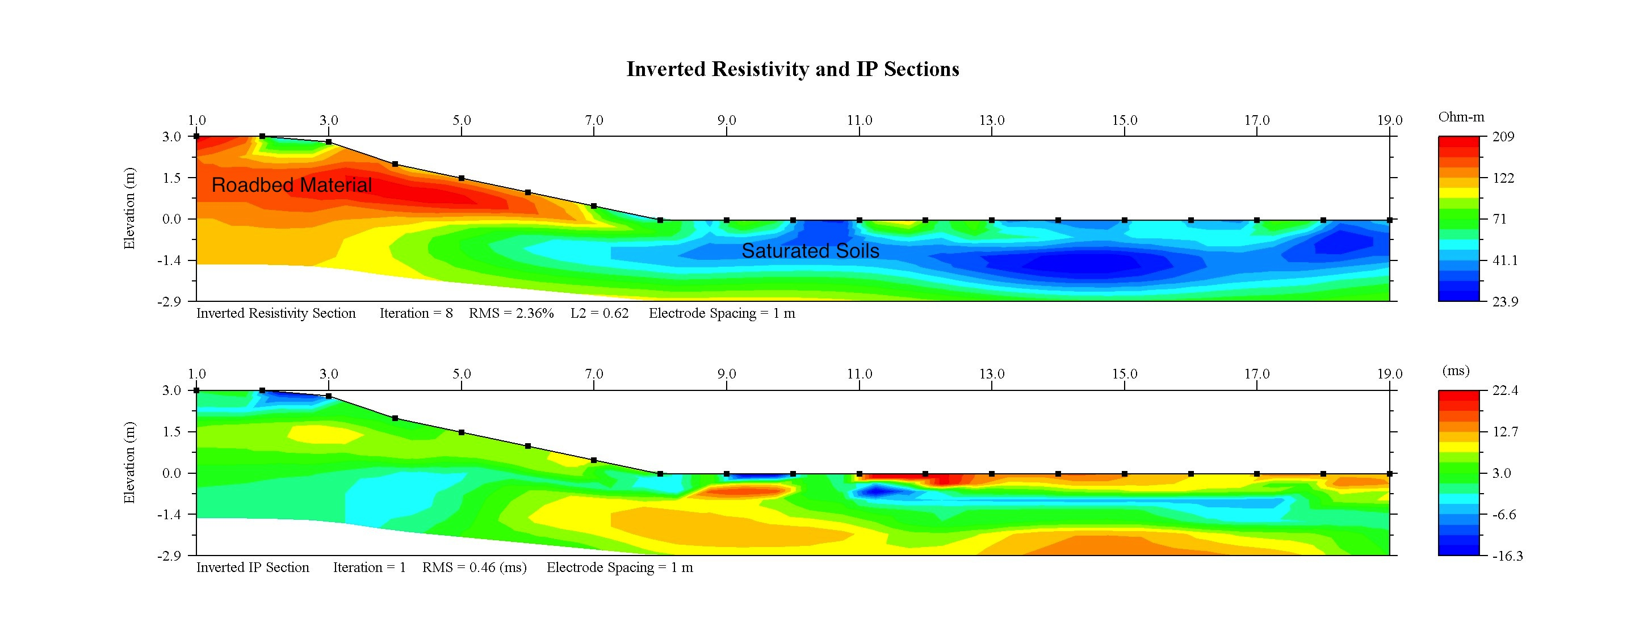

FIGURE 14: NA 11 Section
Geophysics performed and interpretted by Kryotec Arctic Innovation Inc. |  |  | Government of Yukon - AAM  Mount Nansen 2013 Site Investigation  Geophysics Plans and Sections
 | Scale: NTS | Date: Oct 2013 |  | Page 14

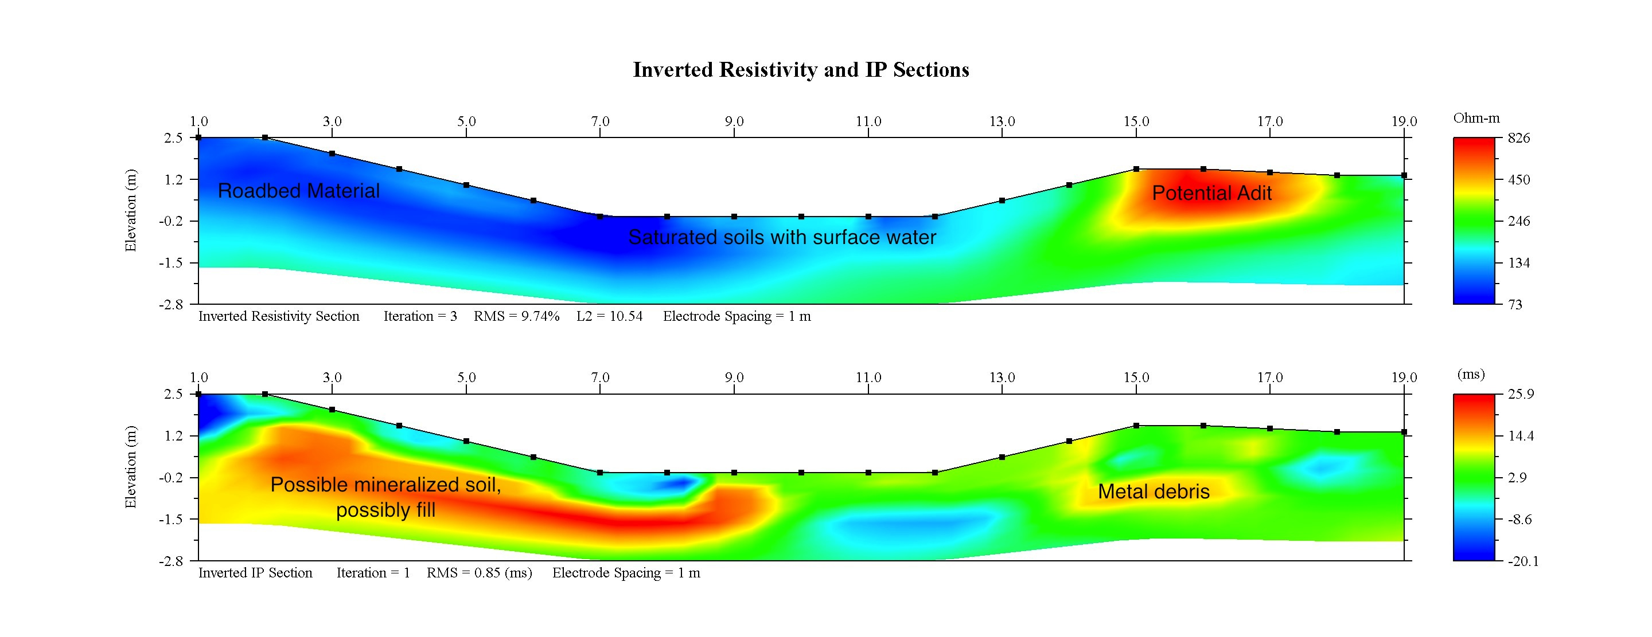

FIGURE 15: NA 12 Section
Geophysics performed and interpretted by Kryotec Arctic Innovation Inc. |  |  | Government of Yukon - AAM  Mount Nansen 2013 Site Investigation  Geophysics Plans and Sections
 | Scale: NTS | Date: Oct 2013 |  | Page 15

