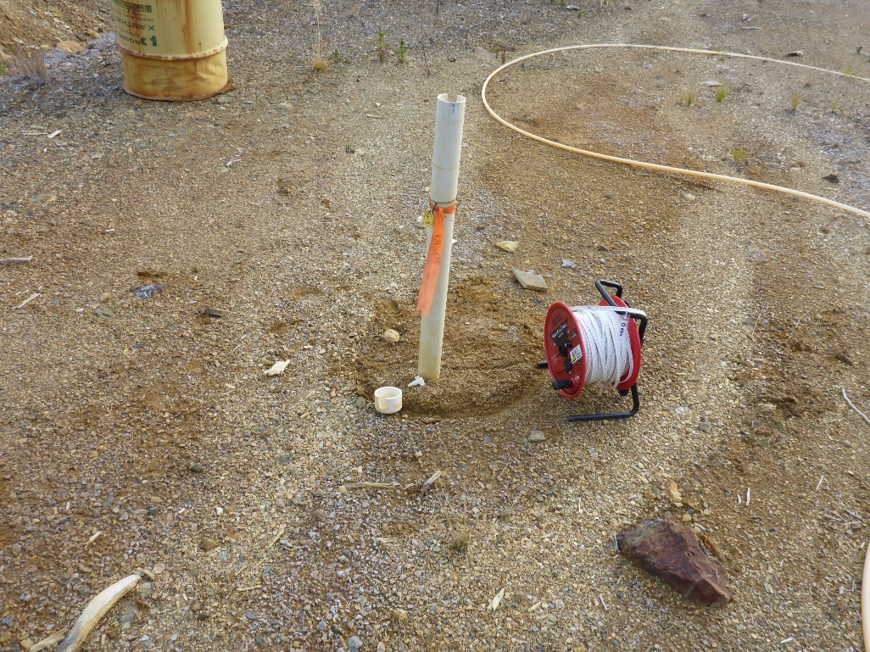
Photo 1: View of well BH8. Photo taken on September 24th, 2016.
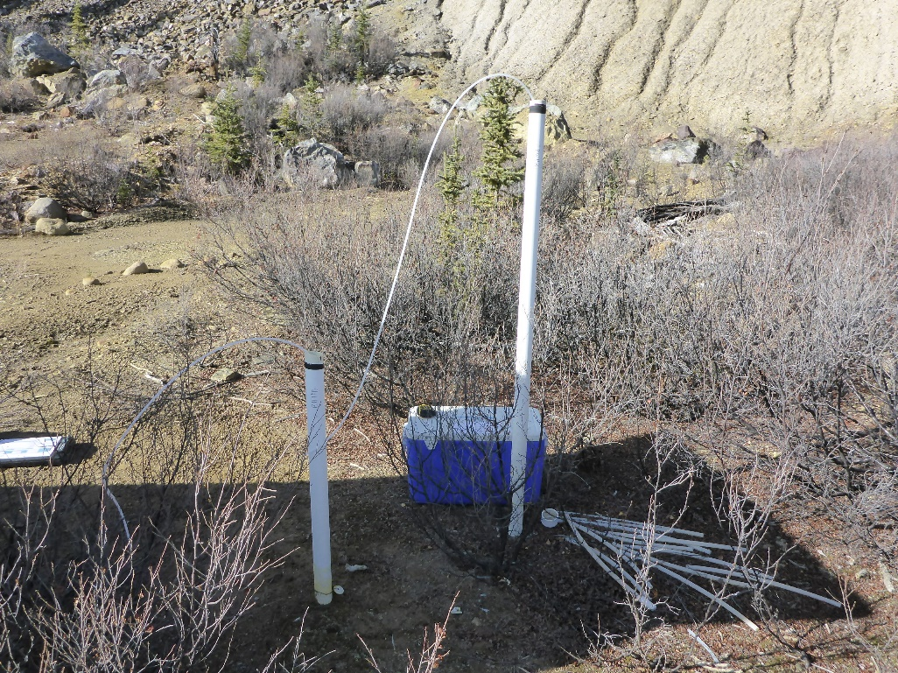
Photo 2: View of wells BH10A and BH10B. Photo taken on September 24th, 2016.
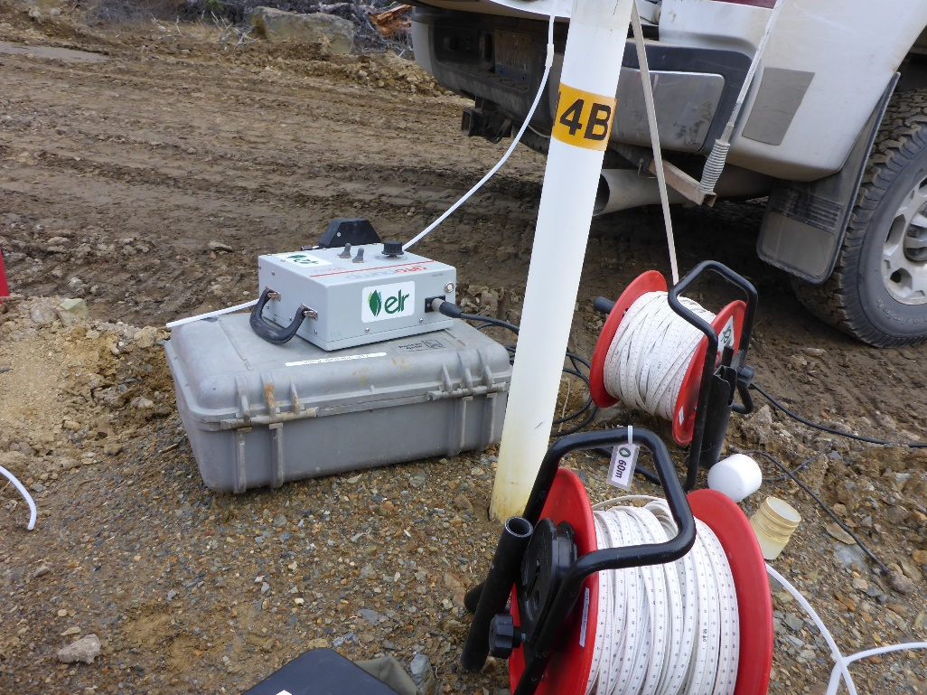
Photo 3: View of wells BH14A and BH14B. Photo taken on September 24th, 2016.
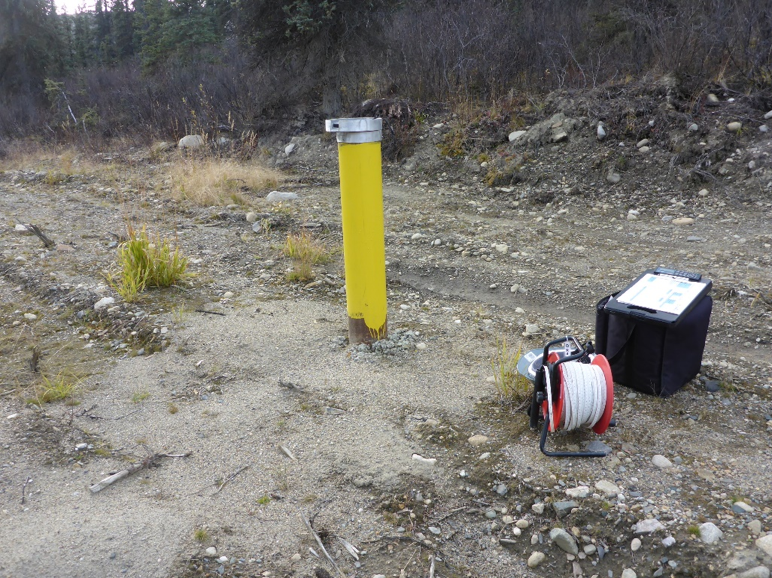
Photo 4: View of well CH14-107-MW001. Photo taken on September 24th, 2016.
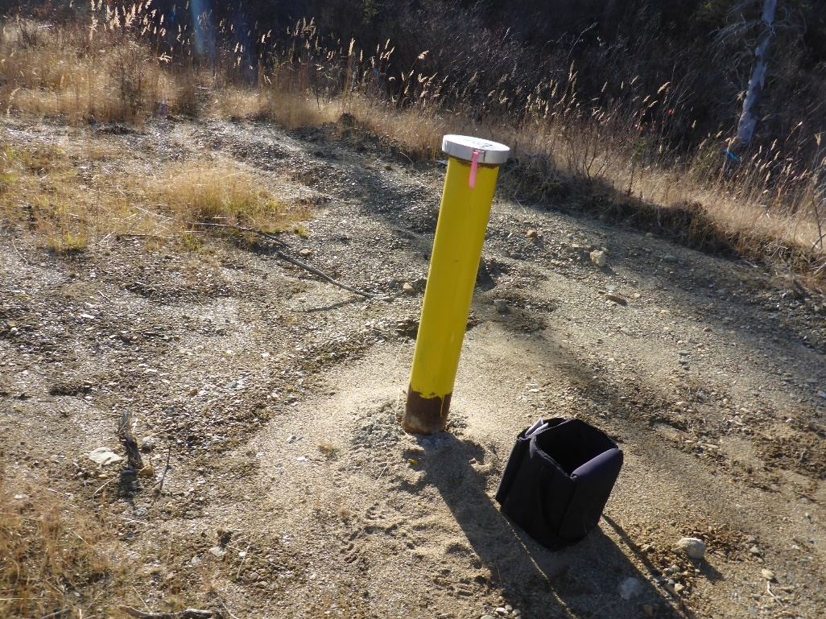
Photo 5: View of well CH14-107-MW002. Photo taken on September 24th, 2016.
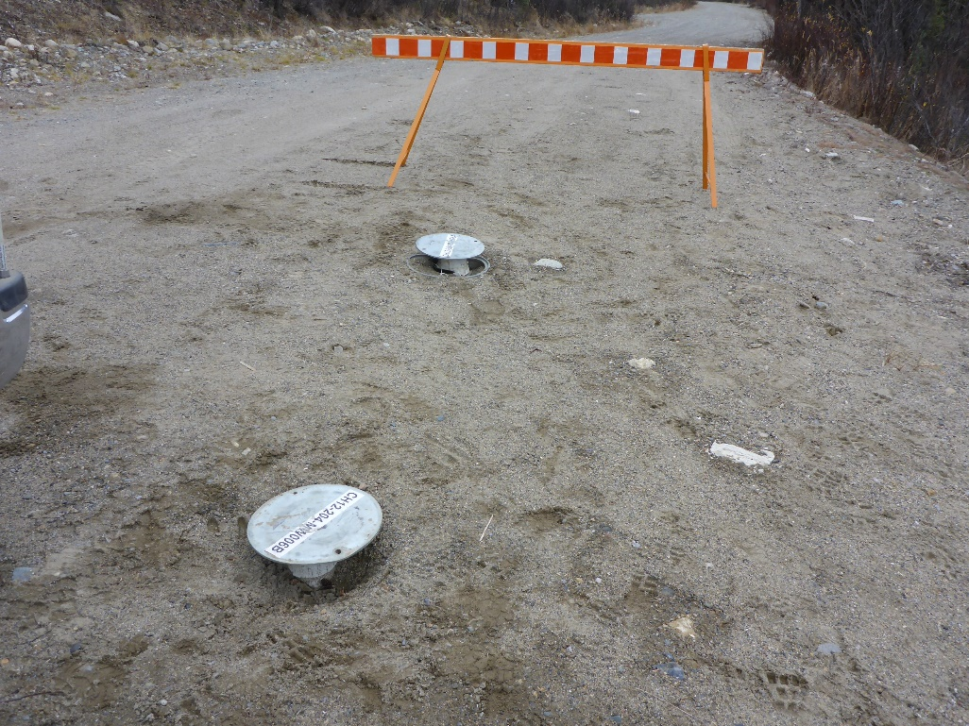
Photo 6: View of wells CH14-107-MW006A and CH14-107-MW006B. Photo taken on September 22nd, 2016.
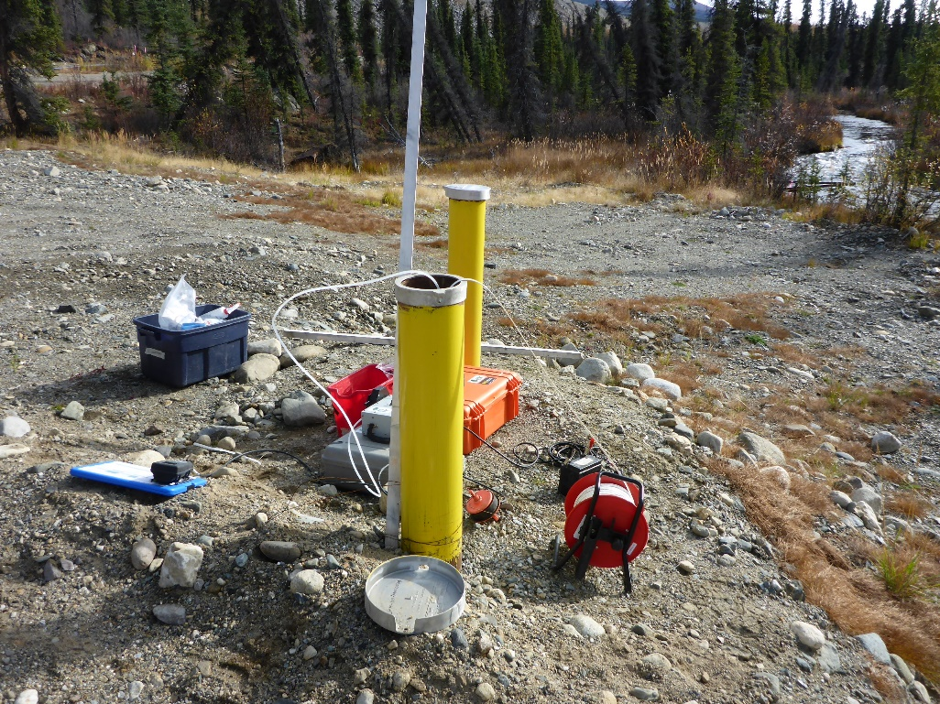
Photo 7: View of wells CH14-107-MW007A and CH14-107-MW007B. Photo taken on September 20th, 2016.
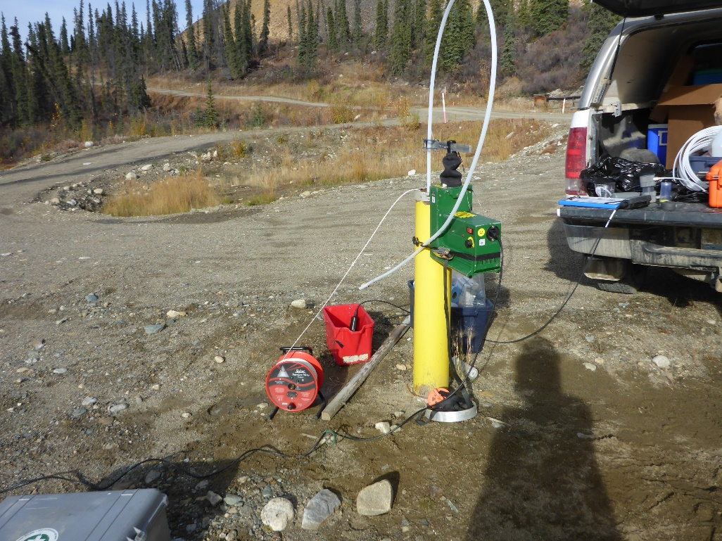
Photo 8: View of well CH14-107-MW009. Photo taken on September 20th, 2016.
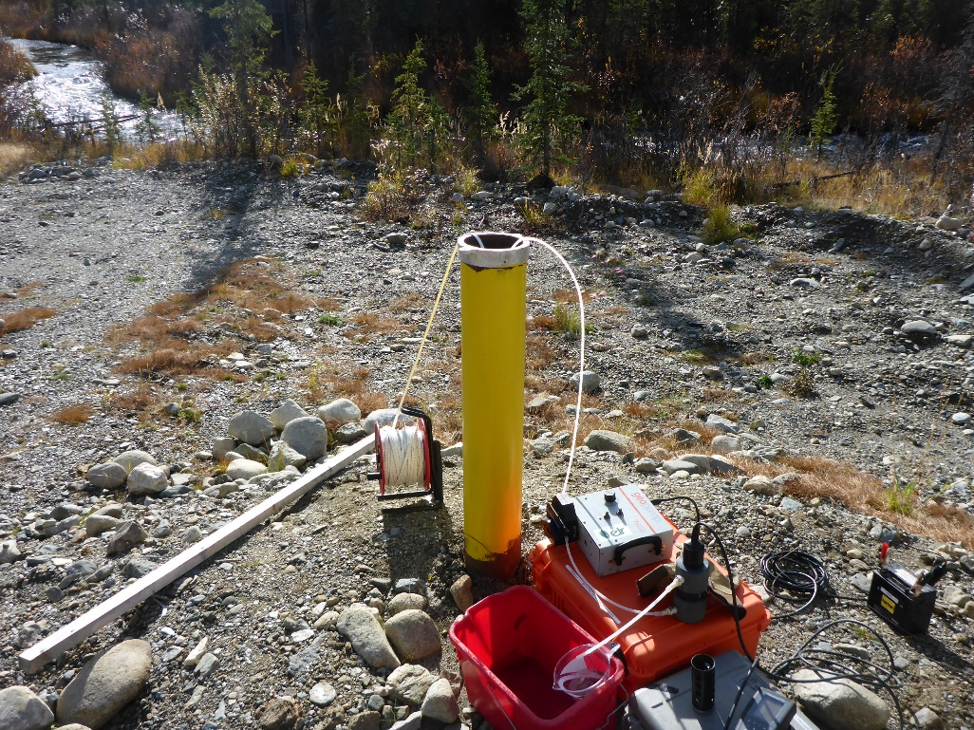
Photo 9: View of well CH14-107-MW010. Photo taken on September 20th, 2016.
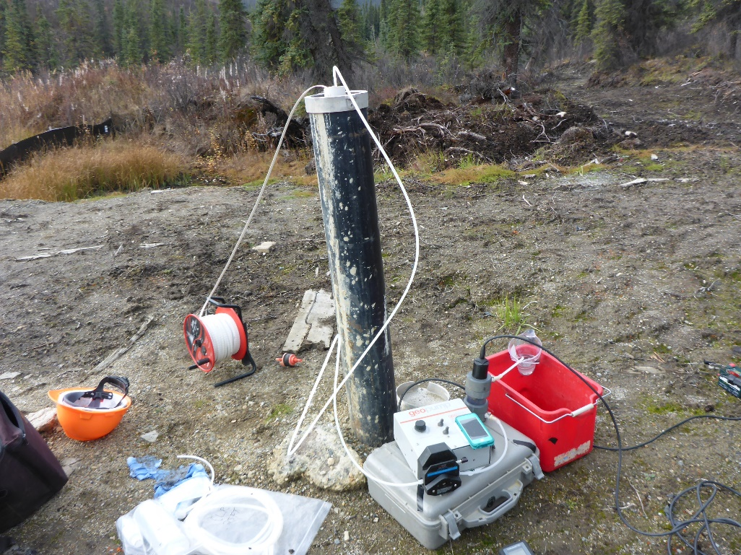
Photo 10: View of well CH15-107-MW019. Photo taken on September 21th, 2016.
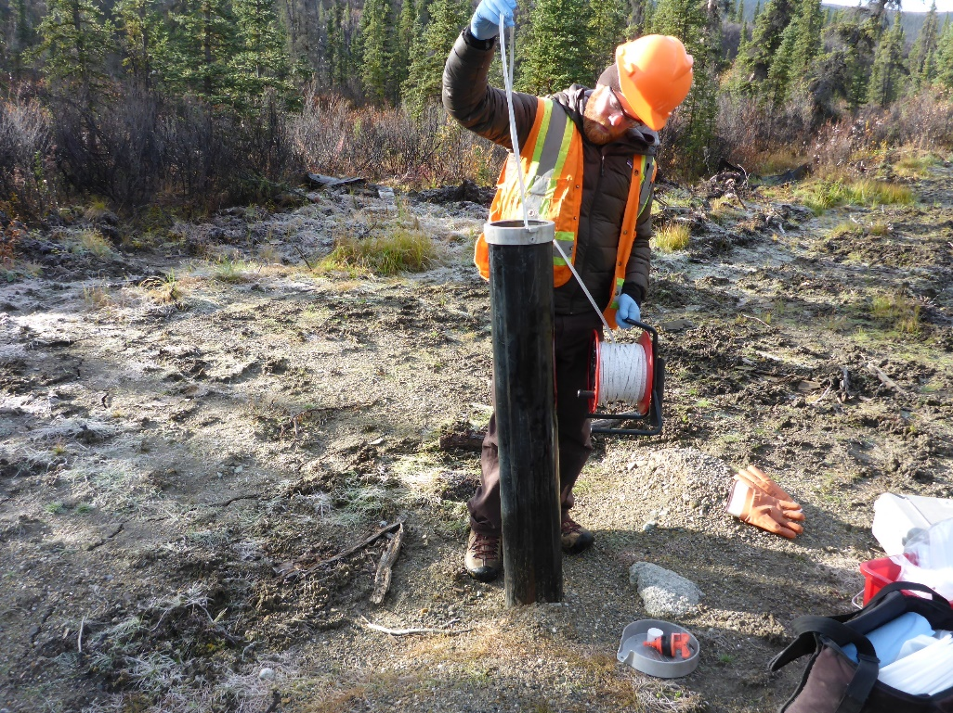
Photo 11: View of well CH15-107-MW022. Photo taken on September 21th, 2016.
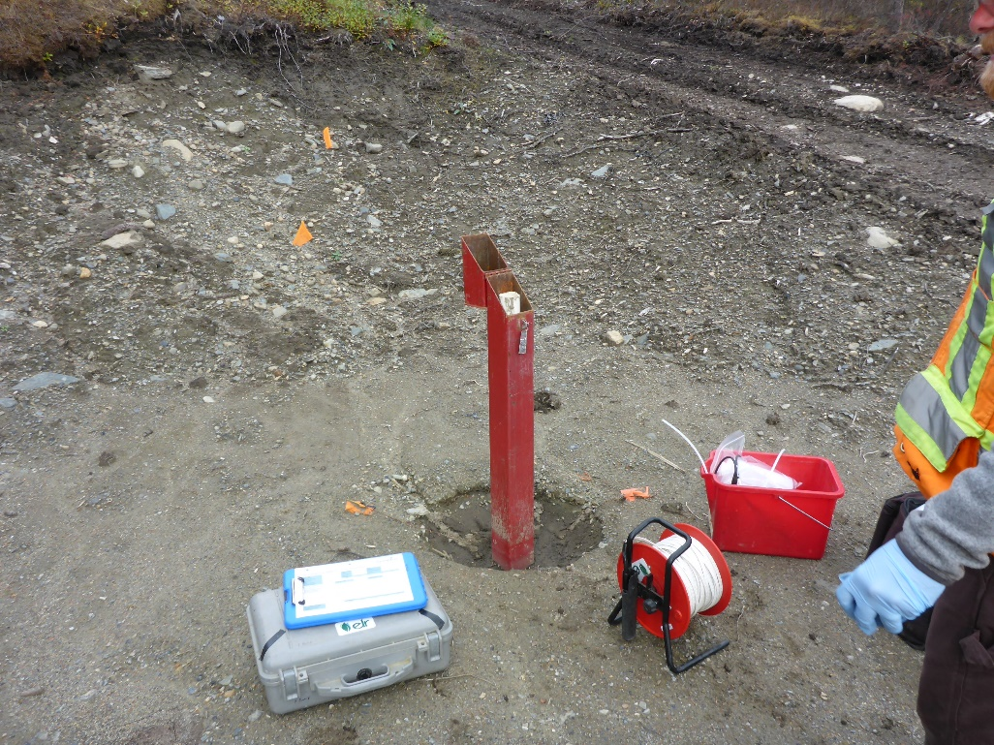
Photo 12: View of well CH15-107-MW023. Photo taken on September 21th, 2016.

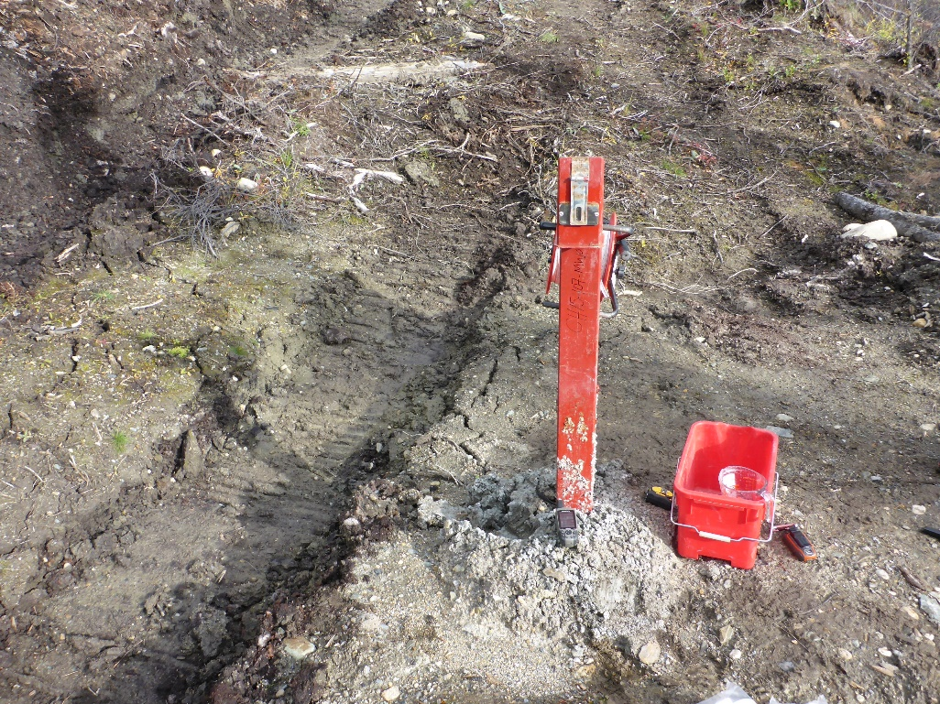
Photo 13: View of well CH15-107-MW025. Photo taken on September 21th, 2016.
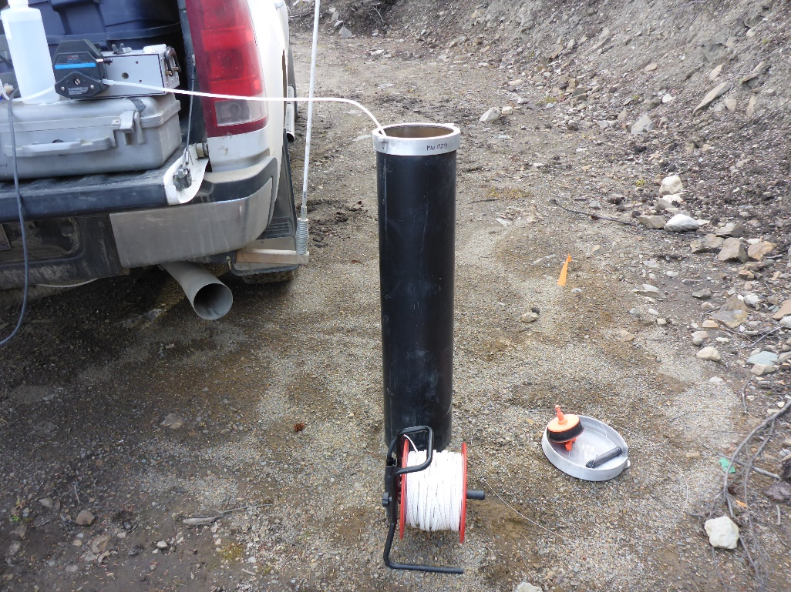
Photo 14: View of well CH15-107-MW029. Photo taken on September 24th, 2016.

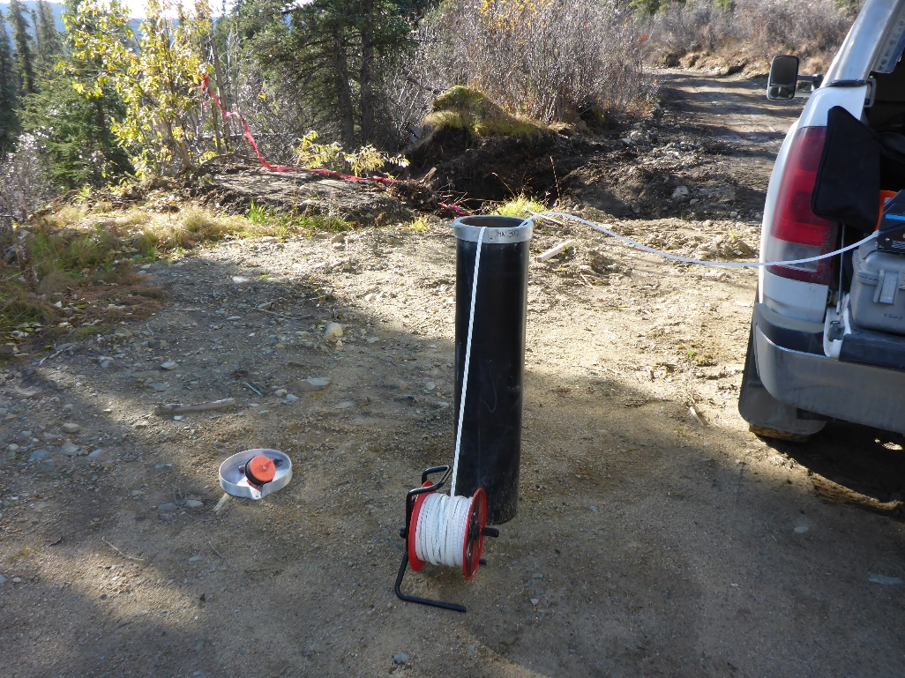
Photo 15: View of well CH15-107-MW030. Photo taken on September 24th, 2016.
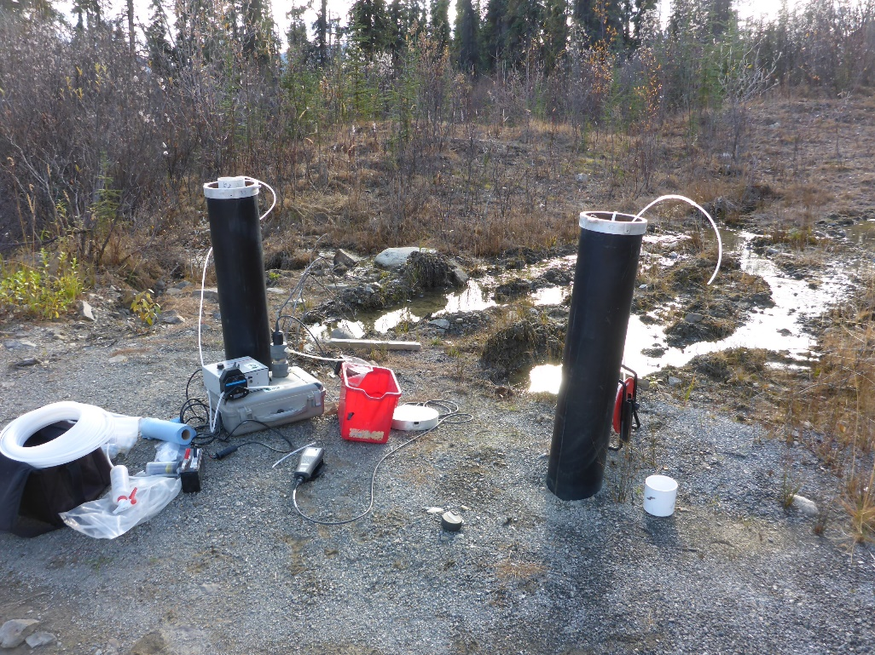
Photo 16: View of wells CH15-107-MW032 and CH15-107-MW033. Photo taken on September 24th, 2016.

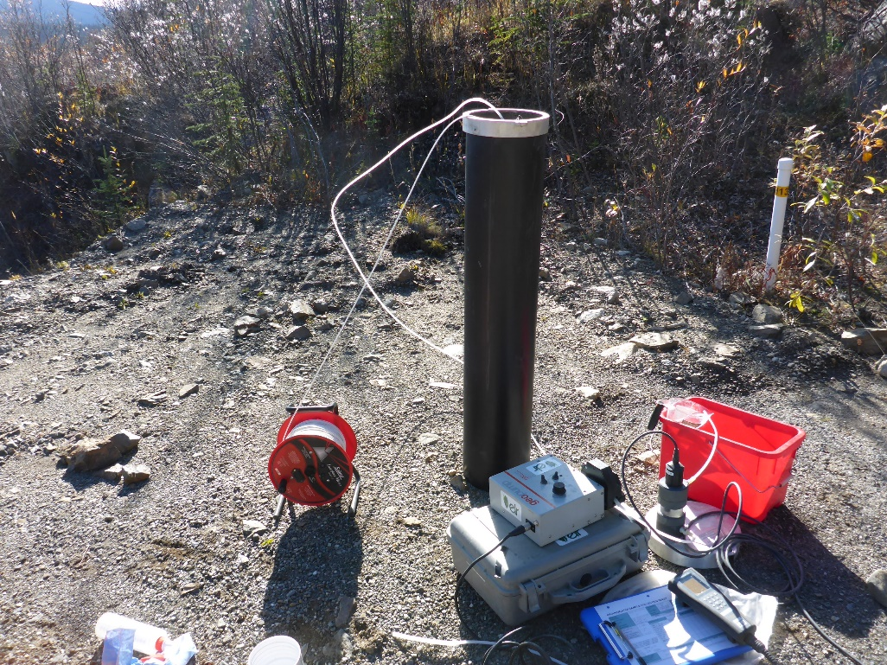
Photo 17: View of well CH15-107-MW034. Photo taken on September 24th, 2016.
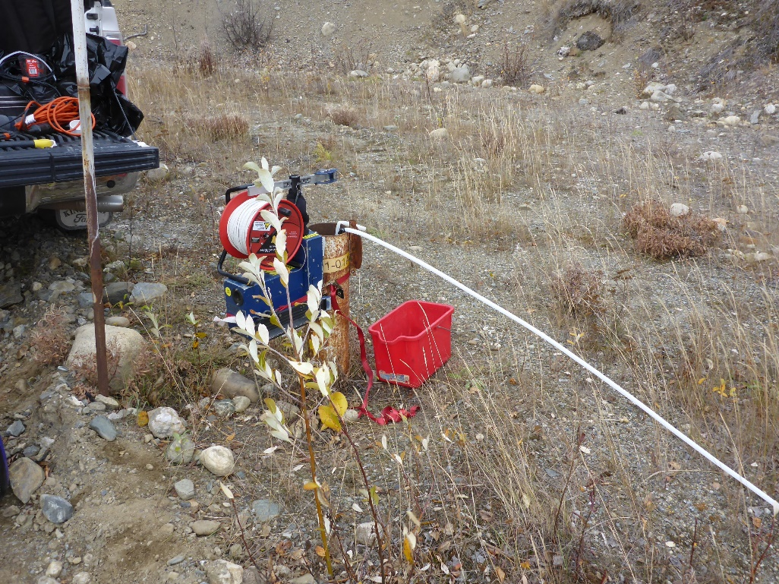
Photo 18: View of wells P01-01A and P01-01B. Photo taken on September 22nd, 2016.

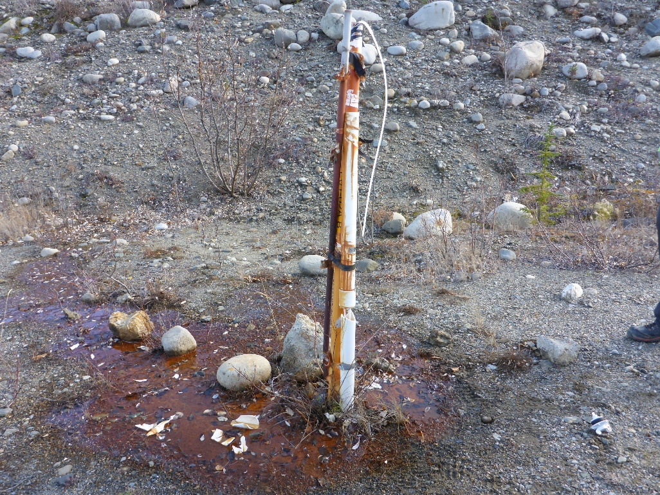
Photo 19: View of wells P01-02A and P01-02B. Photo taken on September 23rd, 2016.
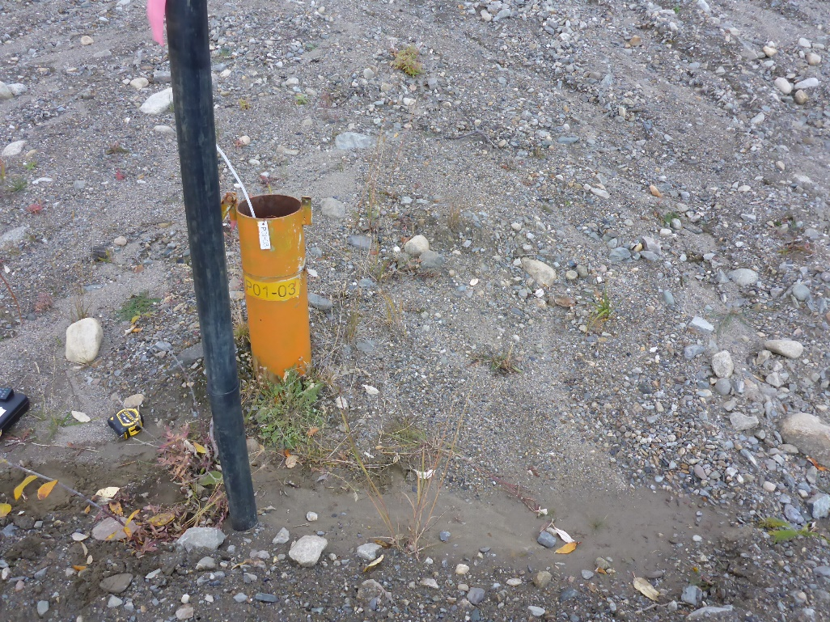
Photo 20: View of well P01-03. Photo taken on September 22nd, 2016.

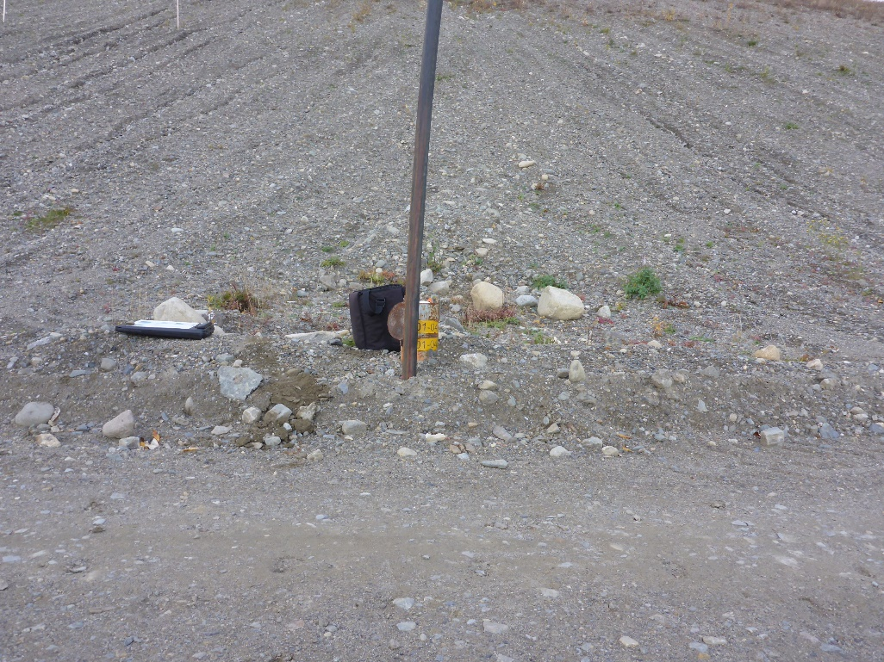
Photo 21: View of wells P01-04A and P01-04B. Photo taken on September 22nd, 2016.
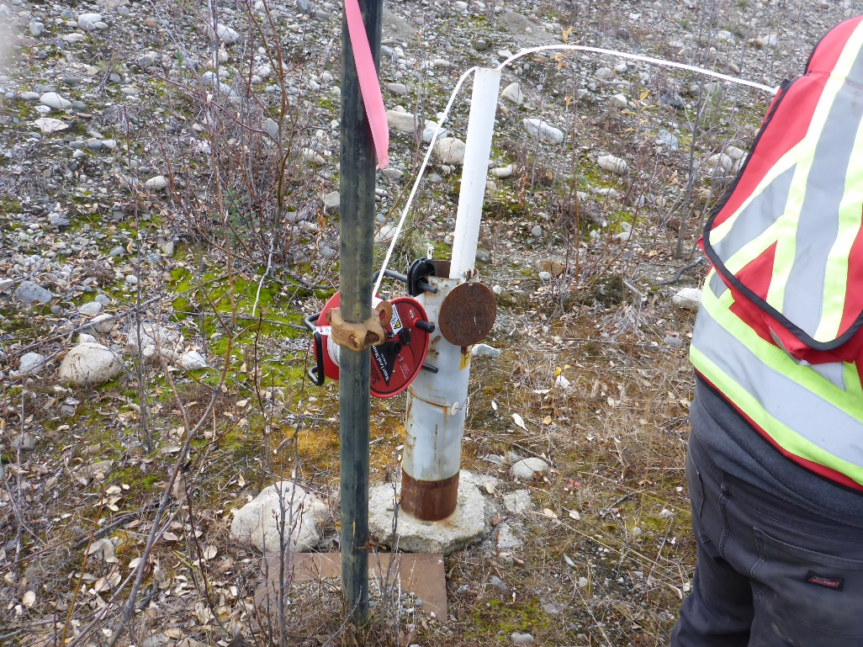
Photo 22: View of well P01-11. Photo taken on September 23rd, 2016.

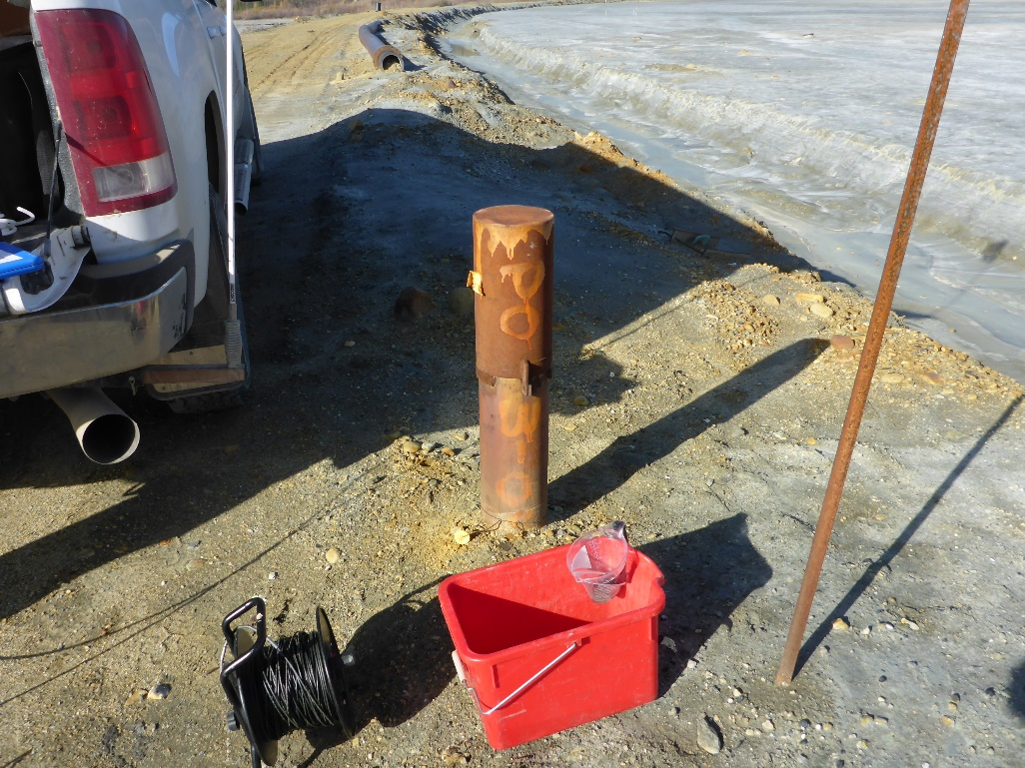
Photo 23: View of well P03-04, includes depths 02, 04, and 06. Photo taken on September 24th, 2016.
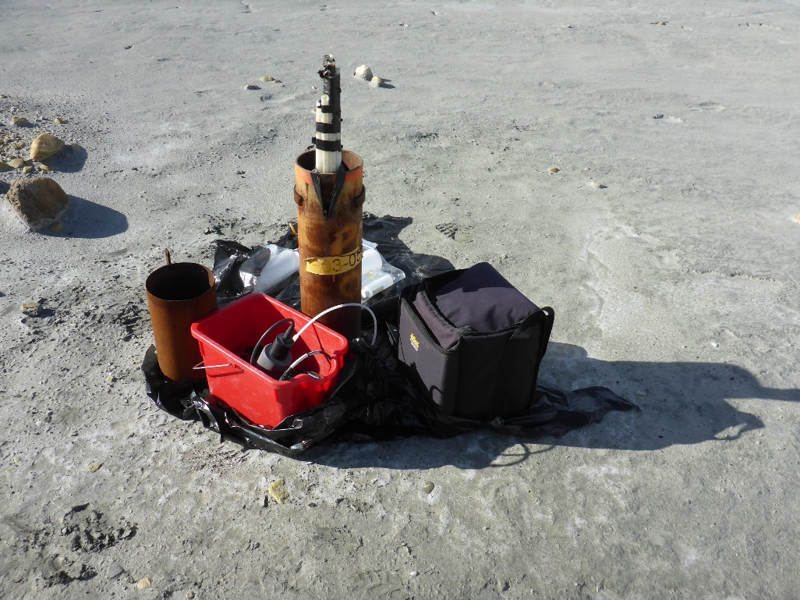
Photo 24: View of well P03-05, includes depths 02, 04, and 05. Photo taken on September 21st, 2016.

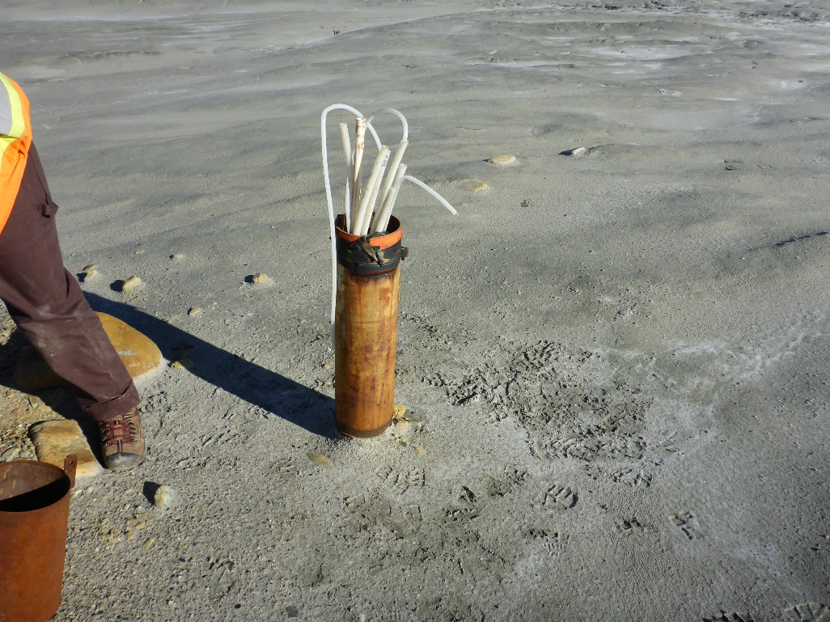
Photo 25: View of well P03-06, includes depths 1, 2, 03, 04, and 05. Photo taken on September 21st, 2016.
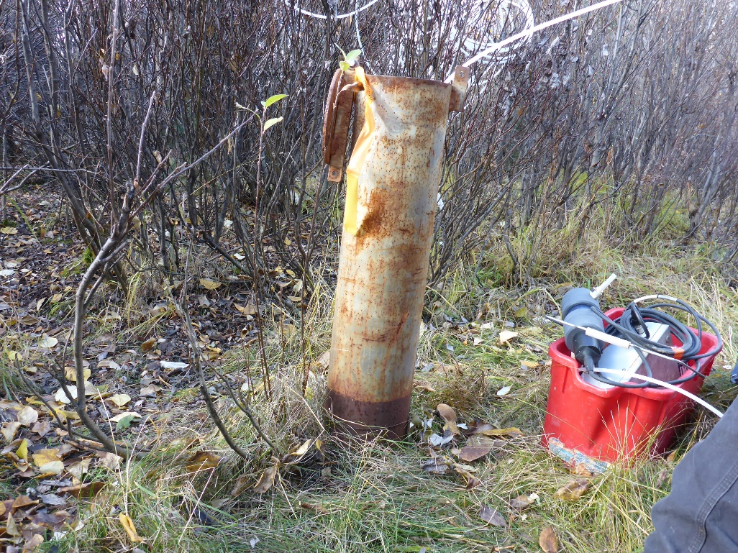
Photo 26: View of well P03-09, includes depths 02, 04, 6, 08, and 9. Photo taken on September 23rd, 2016.
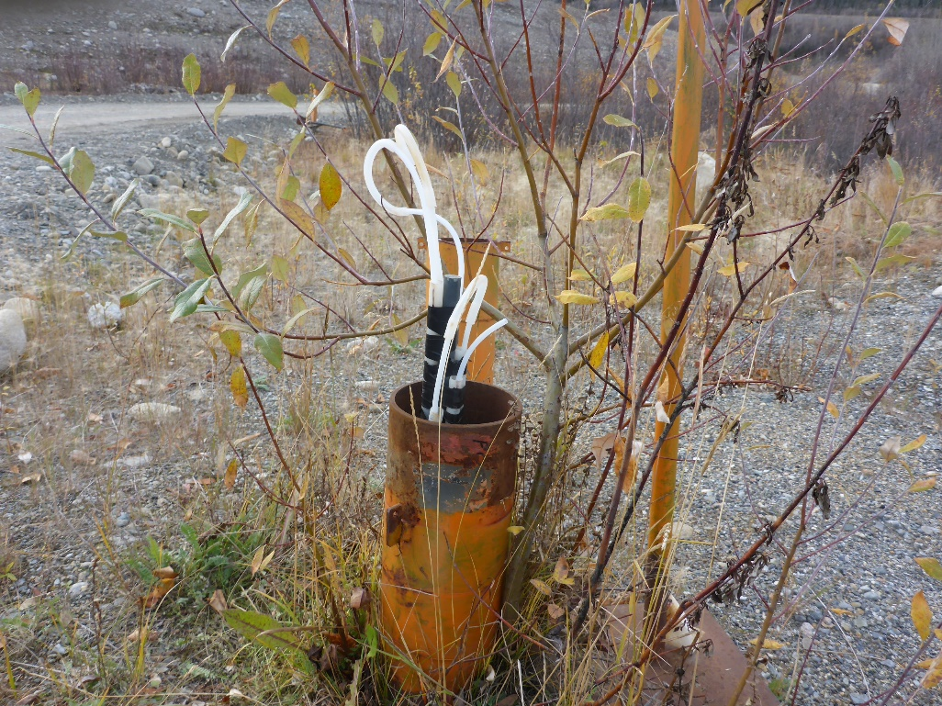
Photo 27: View of well P05-01, includes depths 01, 02, 03, 04, and 05. Photo taken on September 23rd, 2016.
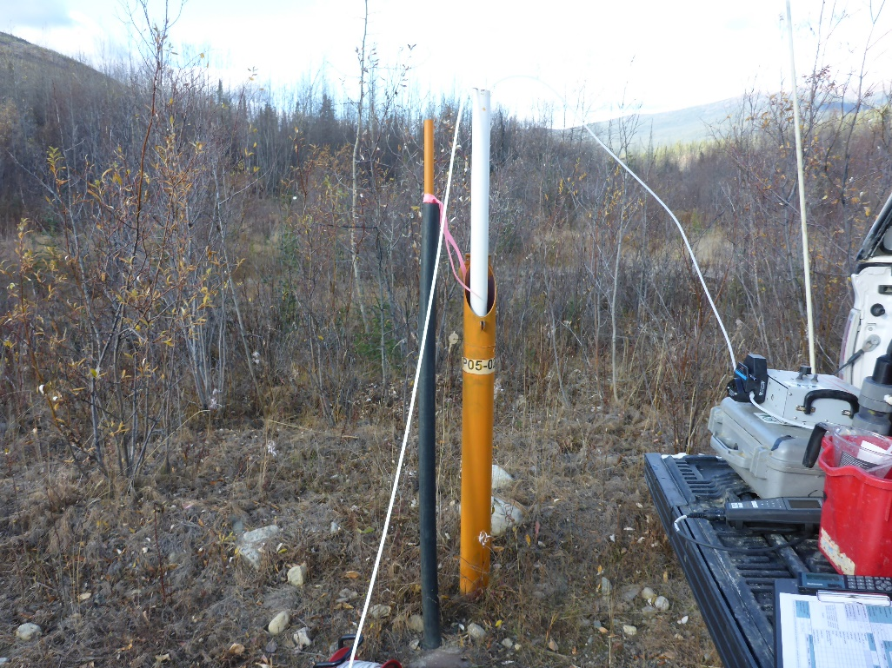
Photo 28: View of well P05-02. Photo taken on September 23rd, 2016.

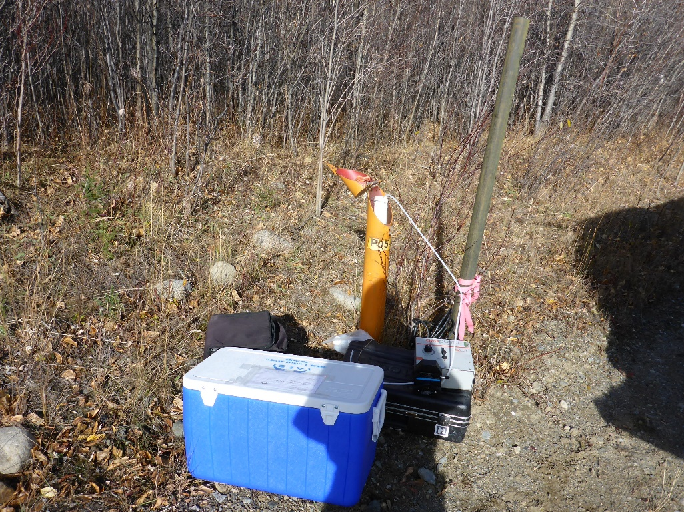
Photo 29: View of well P05-03. Photo taken on September 23rd, 2016.
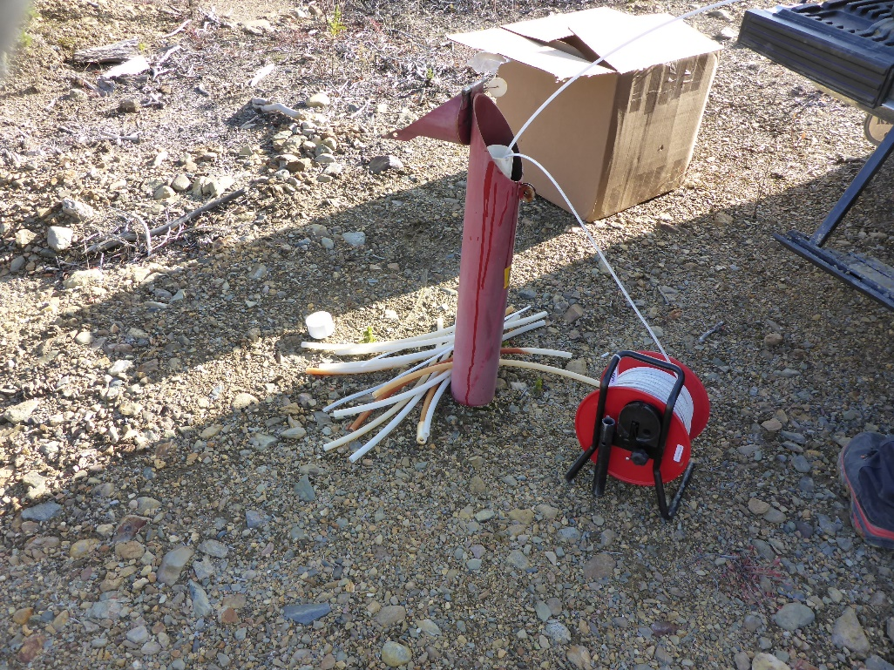
Photo 30: View of well P05-04. Photo taken on September 24th, 2016.

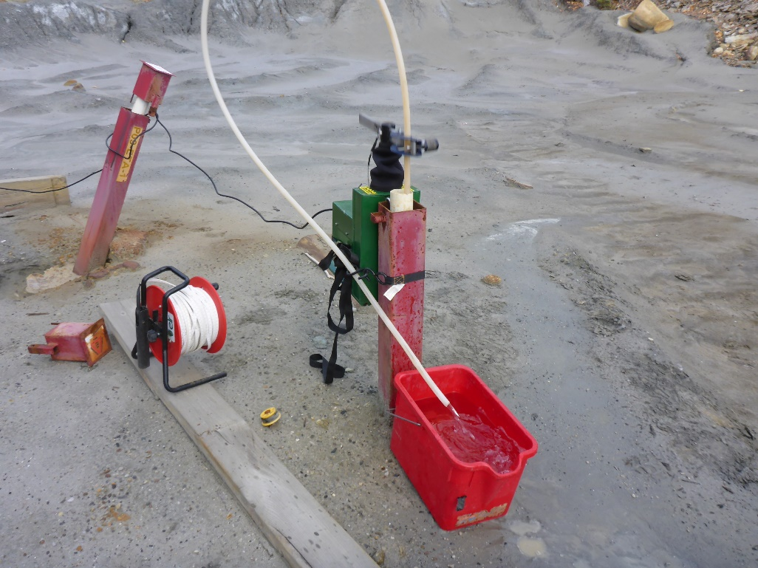
Photo 31: View of well P09-ETA-2. Photo taken on September 25th, 2016.
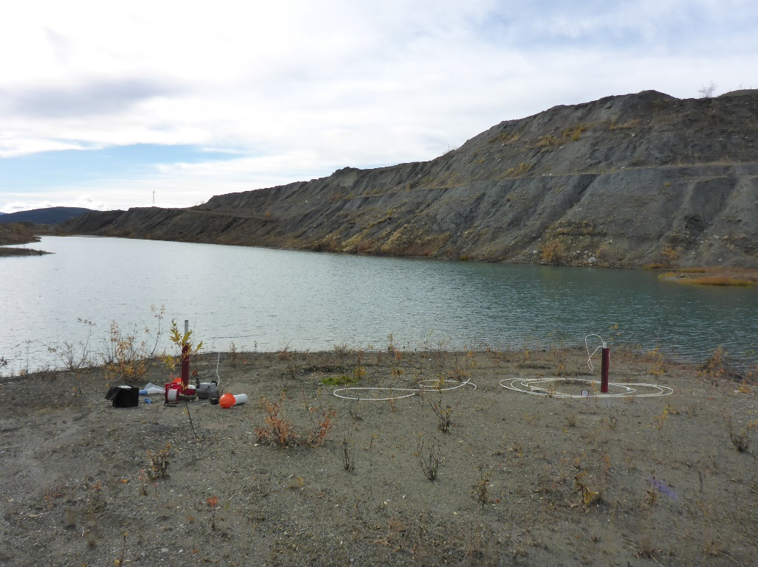
Photo 32: View of wells P09-GS1A and P09-GS1B. Photo taken on September 24th, 2016.

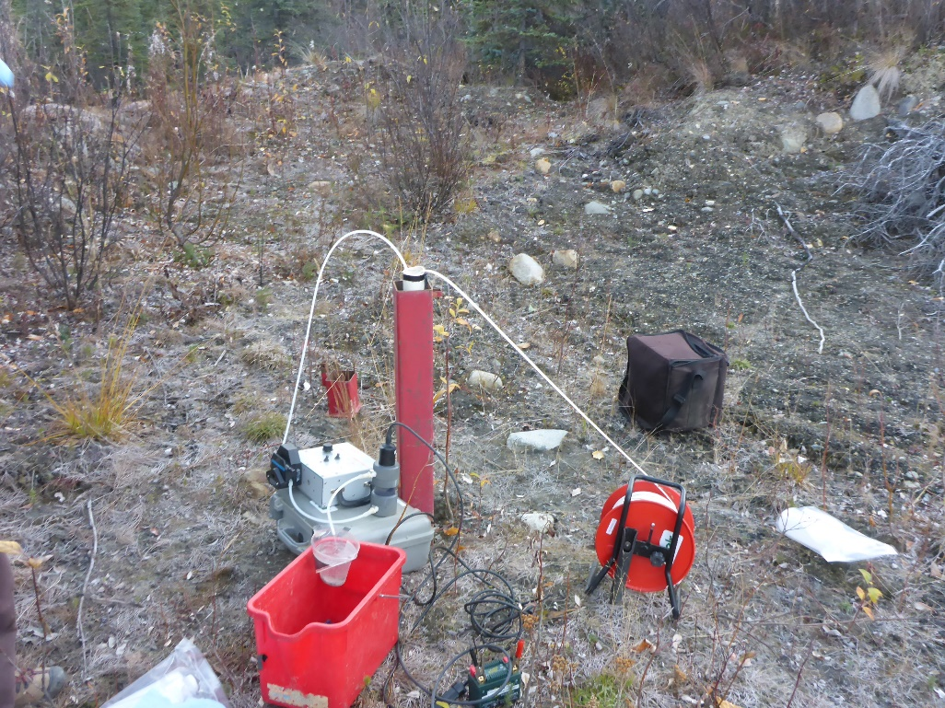
Photo 33: View of well P09-LCD1. Photo taken on September 24th, 2016.
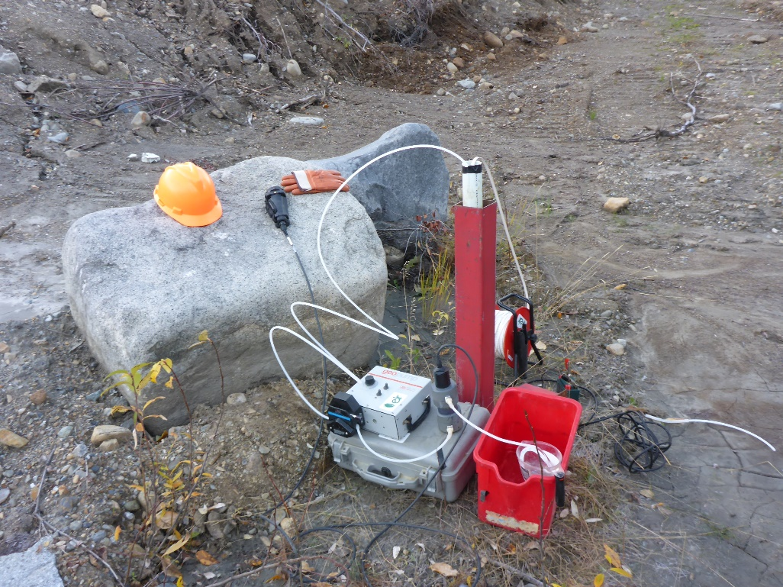
Photo 34: View of well P09-LCD4. Photo taken on September 25th, 2016.

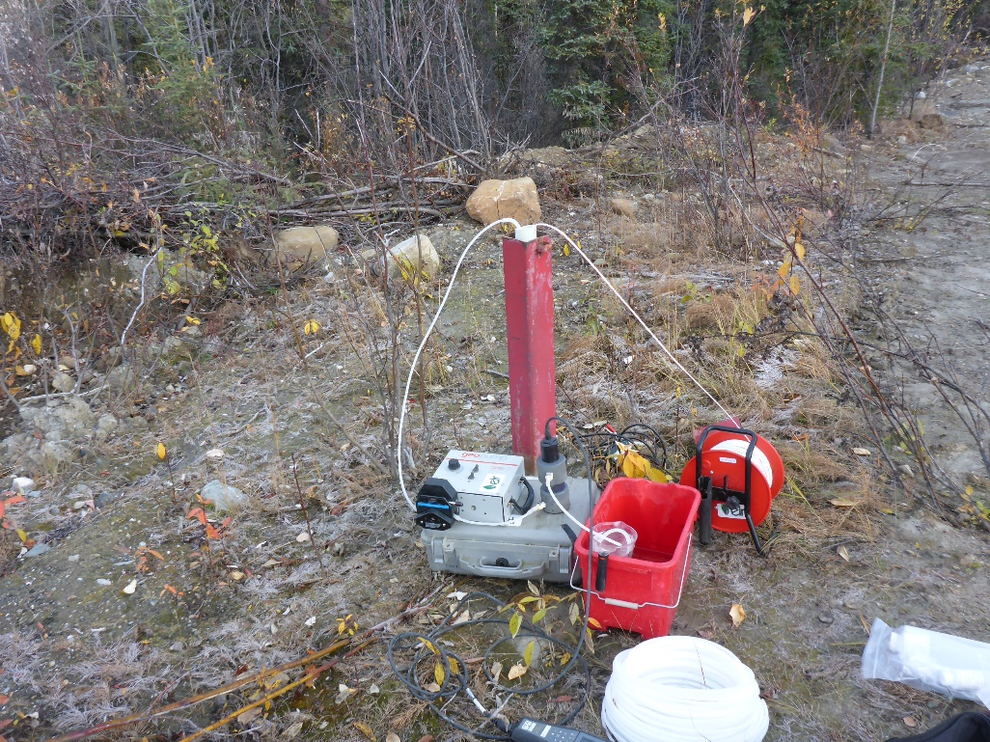
Photo 35: View of well P09-LCD6. Photo taken on September 24th, 2016.
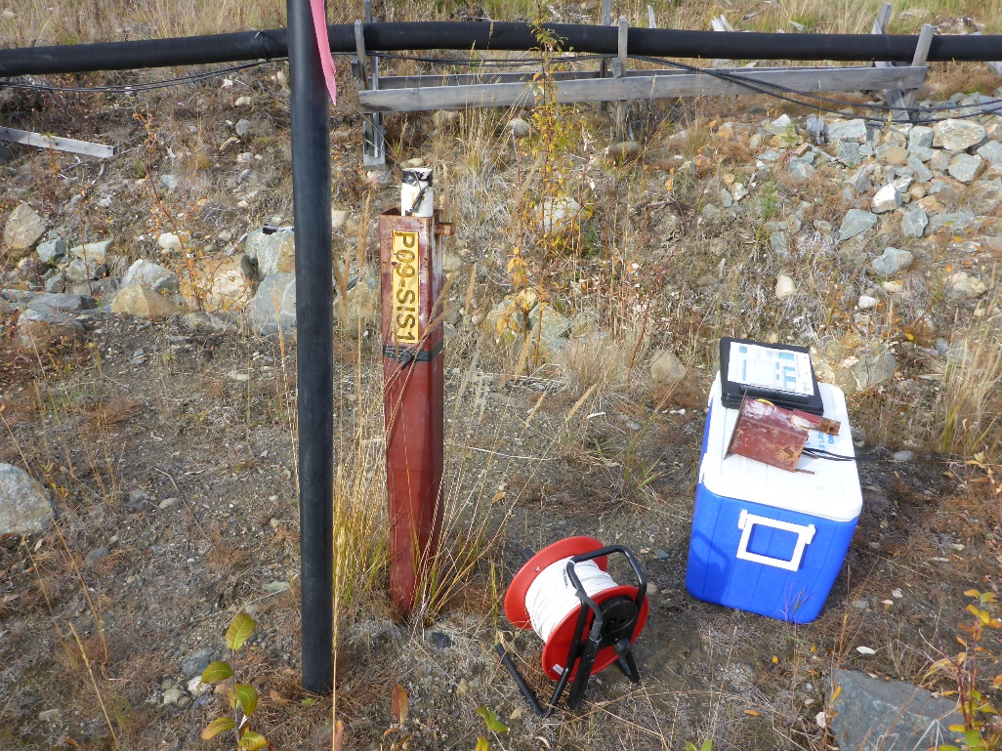
Photo 36: View of well P09-SIS1. Photo taken on September 20th, 2016.

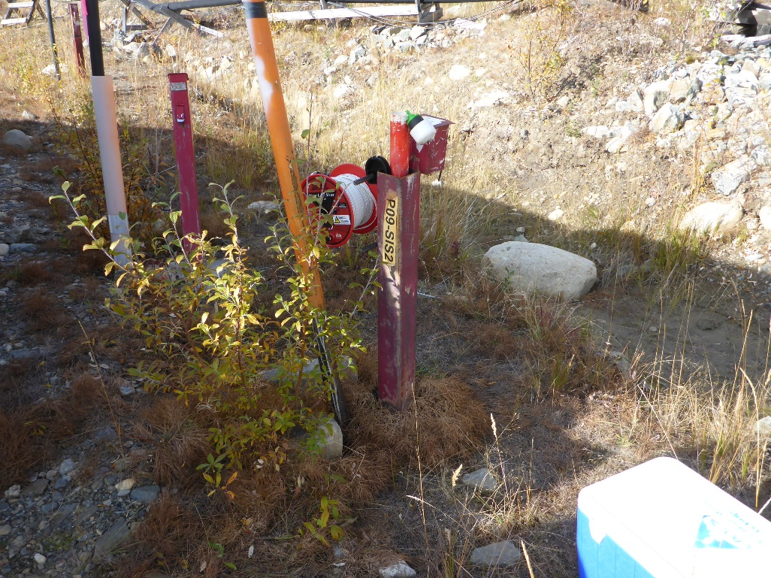
Photo 37: View of well P09-SIS2. Photo taken on September 20th, 2016.
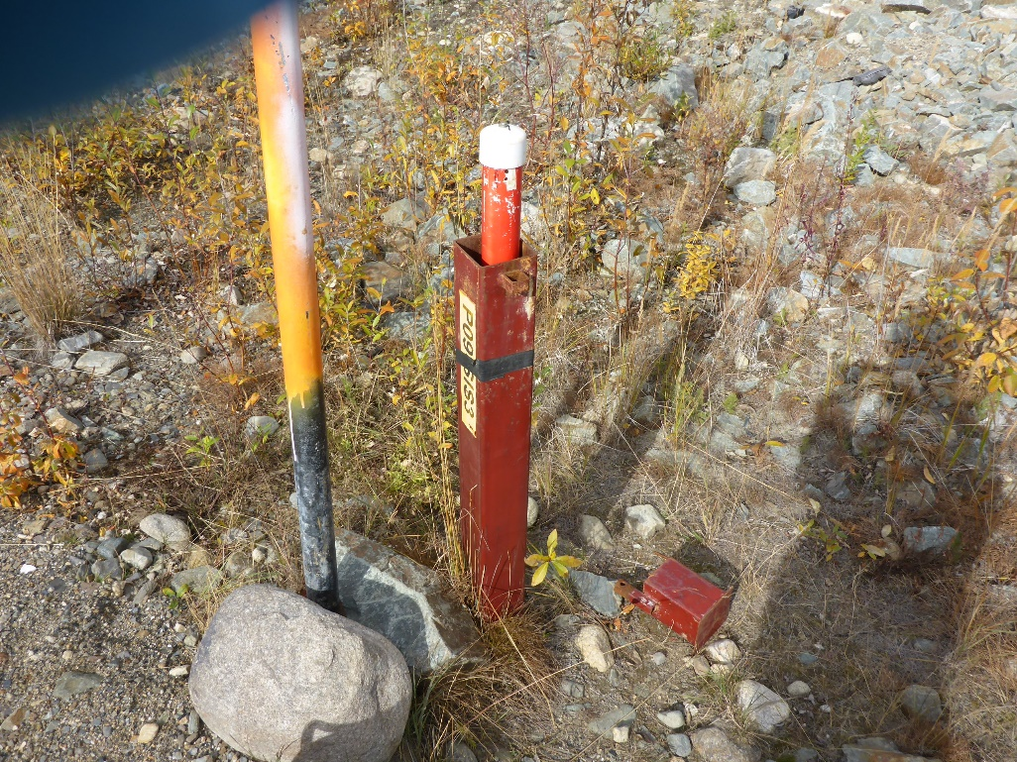
Photo 38: View of well P09-SIS3. Photo taken on September 20th, 2016.

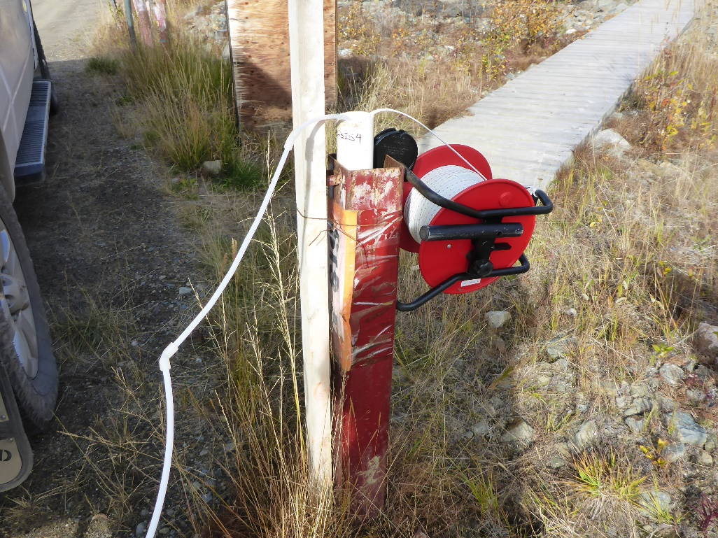
Photo 39: View of well P09-SIS4. Photo taken on September 20th, 2016.
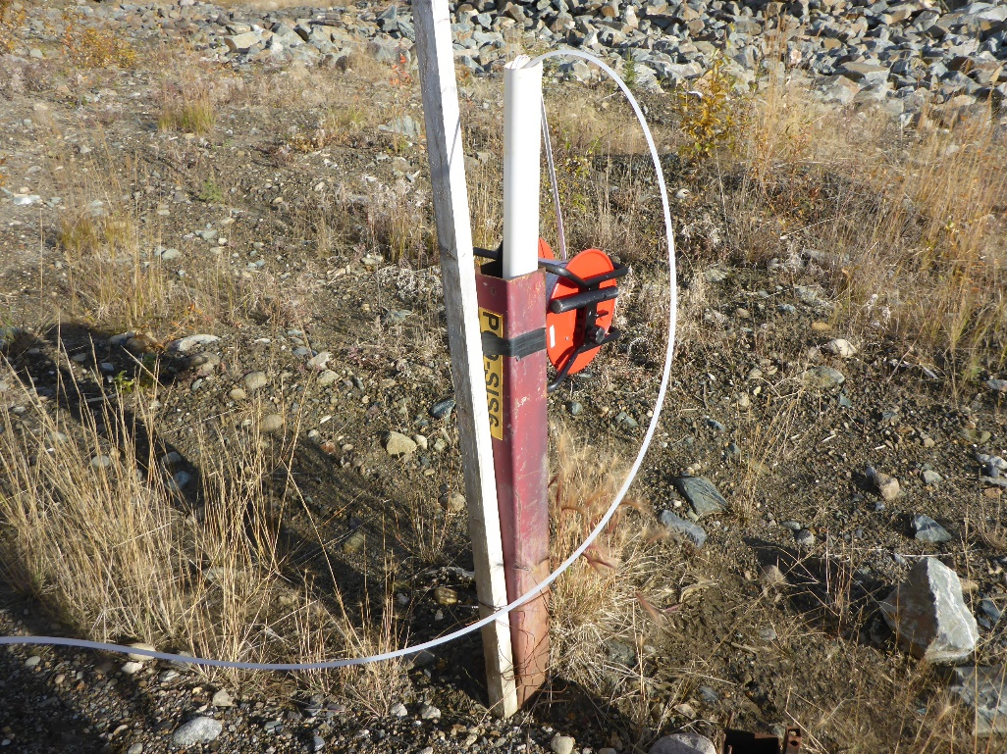
Photo 40: View of well P09-SIS6. Photo taken on September 20th, 2016.

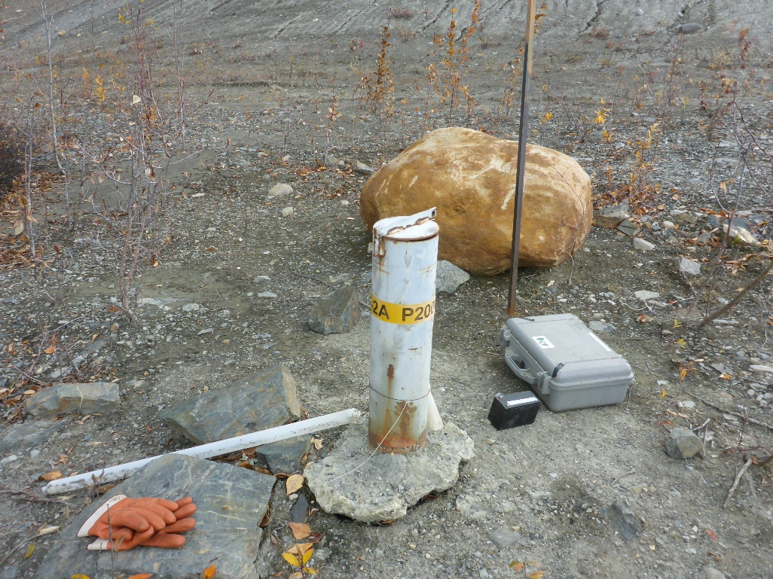
Photo 41: View of wells P2001-2A and P2001-2B. Photo taken on September 22nd, 2016.
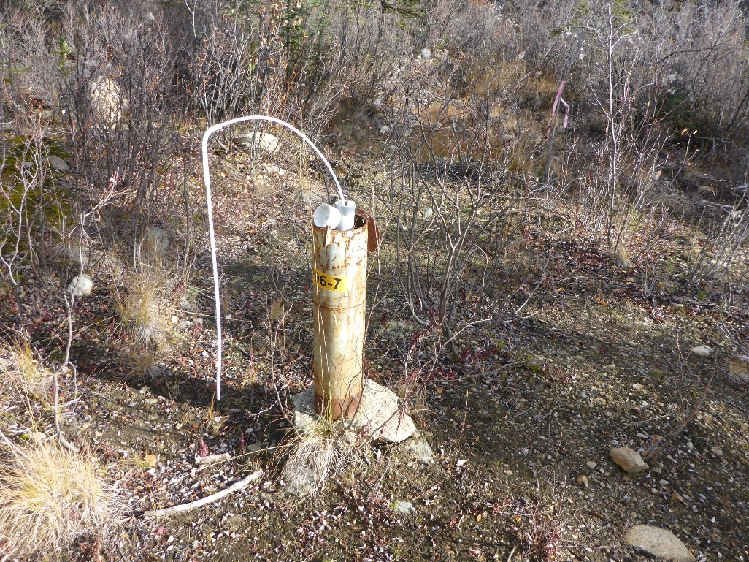
Photo 42: View of well P96-7. Photo taken on September 21st, 2016.

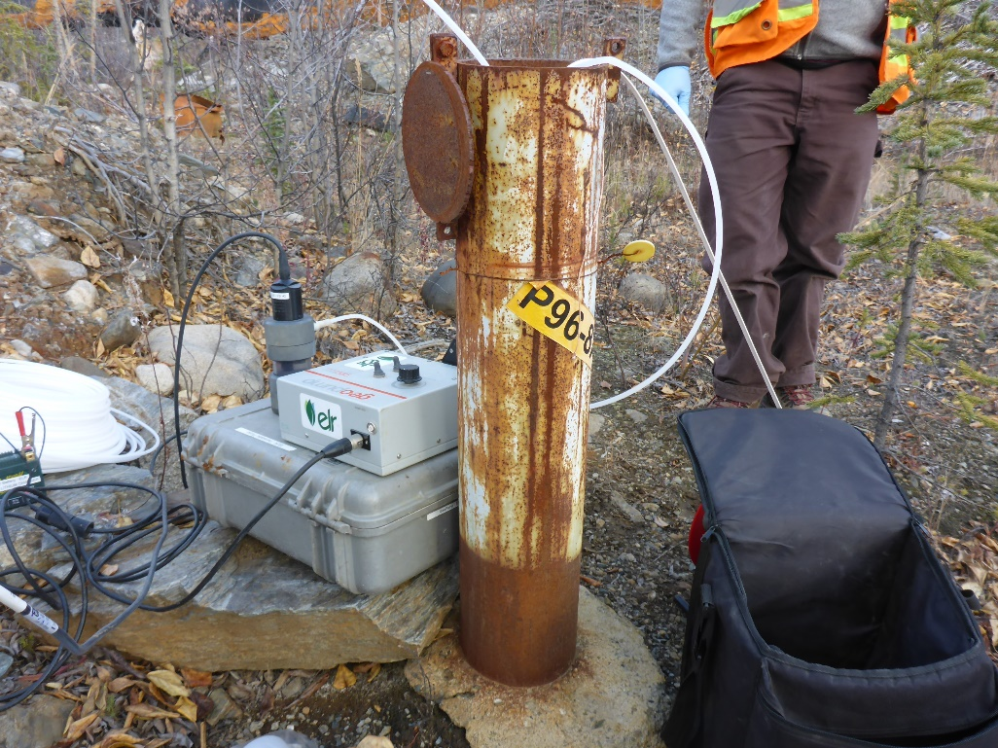
Photo 43: View of wells P96-8A and P96-8B. Photo taken on September 23rd, 2016.
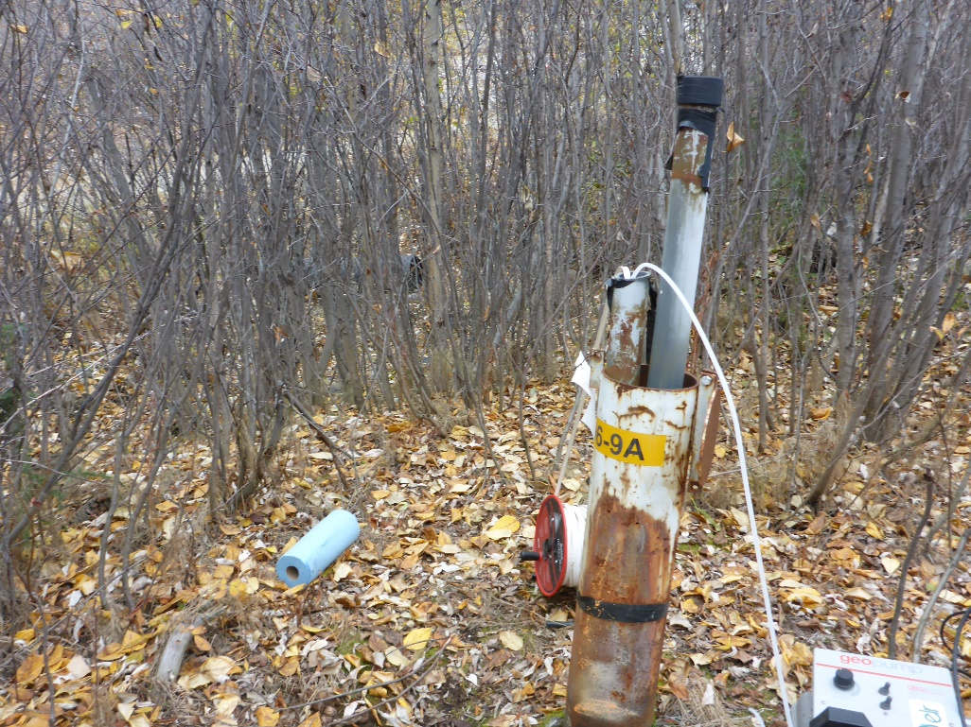
Photo 44: View of well P96-9A. Photo taken on September 22nd, 2016.

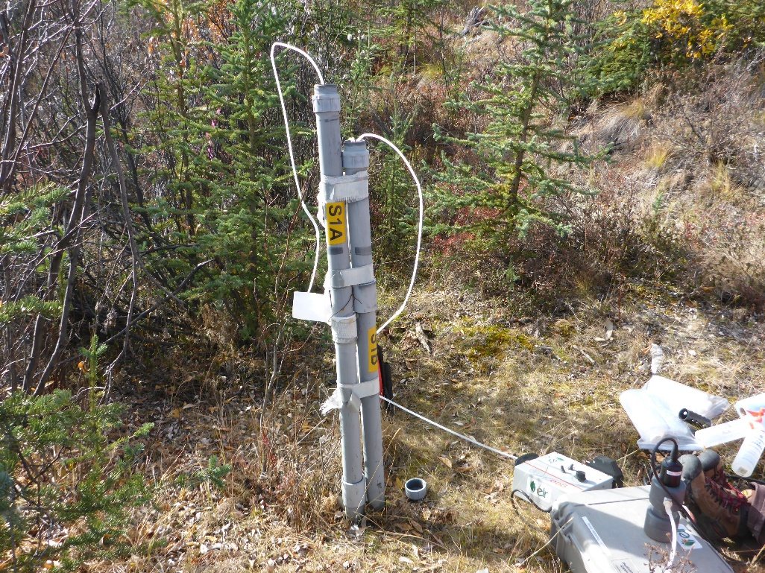
Photo 45: View of wells S1A and S1B. Photo taken on September 20th, 2016.
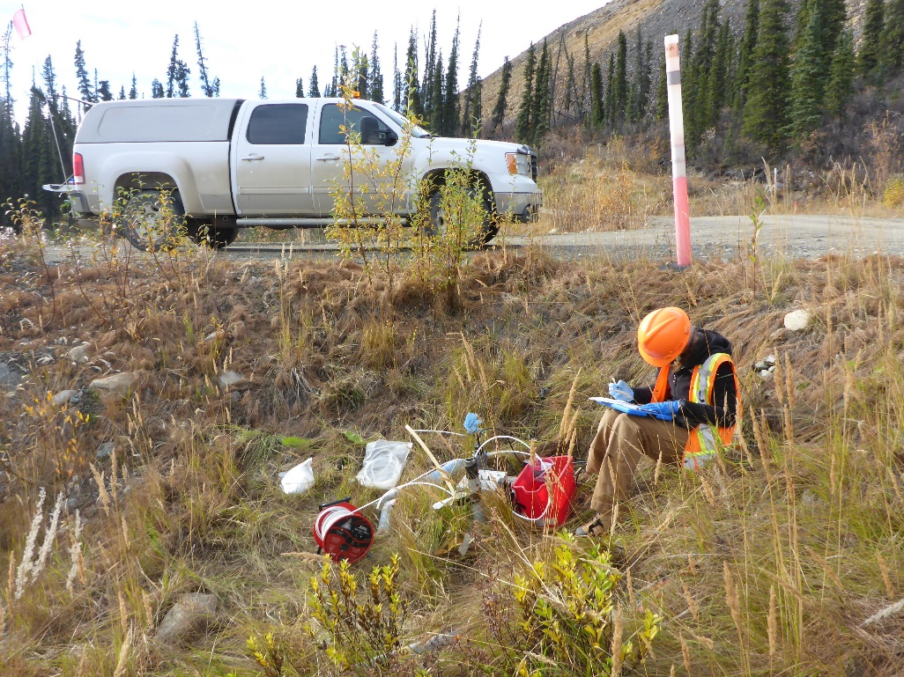
Photo 46: View of wells S2A and S2B. Photo taken on September 21st, 2016.

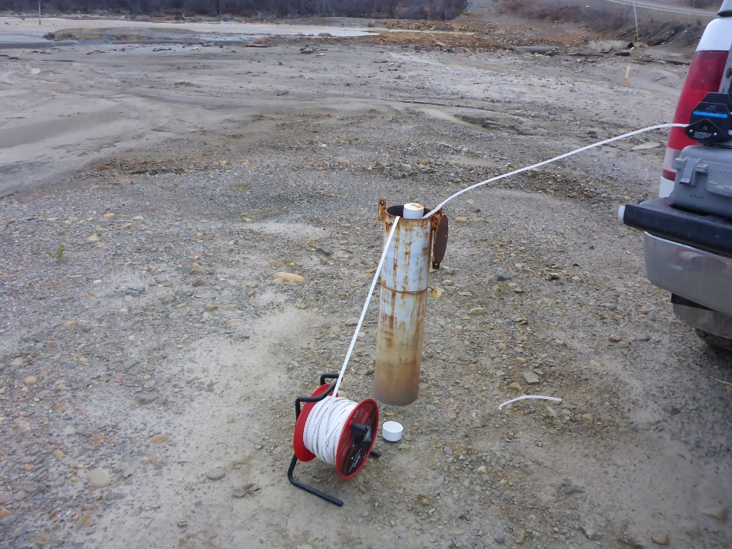
Photo 47: View of well SRK04-3A. Photo taken on September 23rd, 2016.
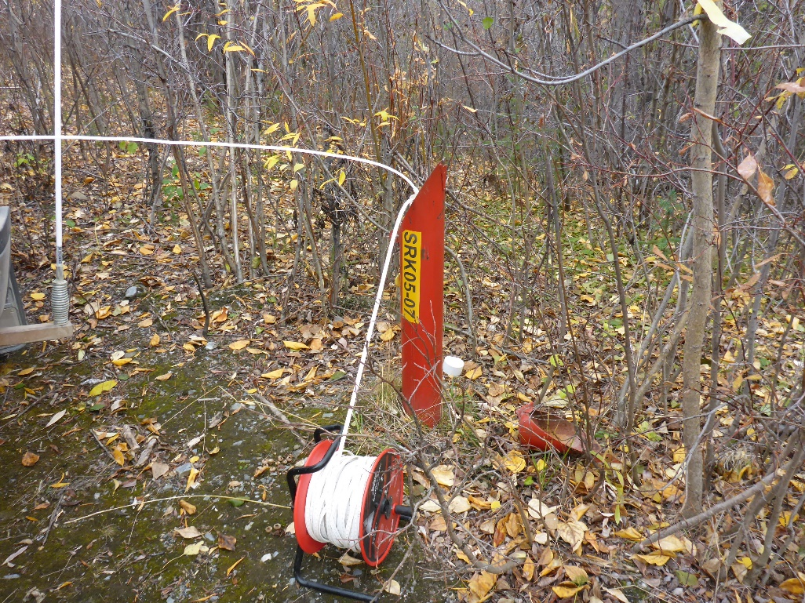
Photo 48: View of well SRK05-07. Photo taken on September 22nd, 2016.

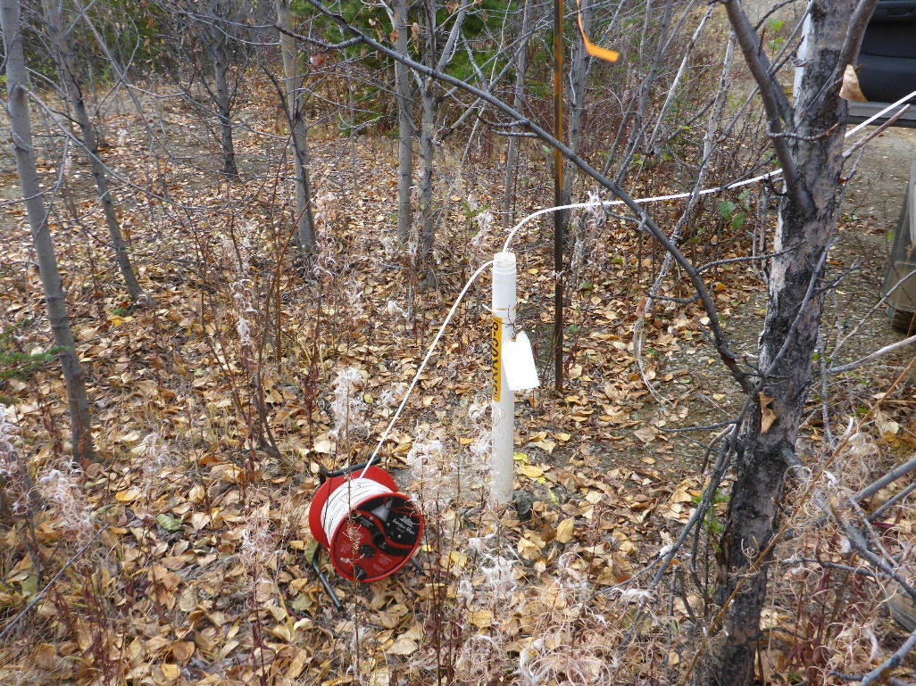
Photo 49: View of well SRK05-08. Photo taken on September 22nd, 2016.
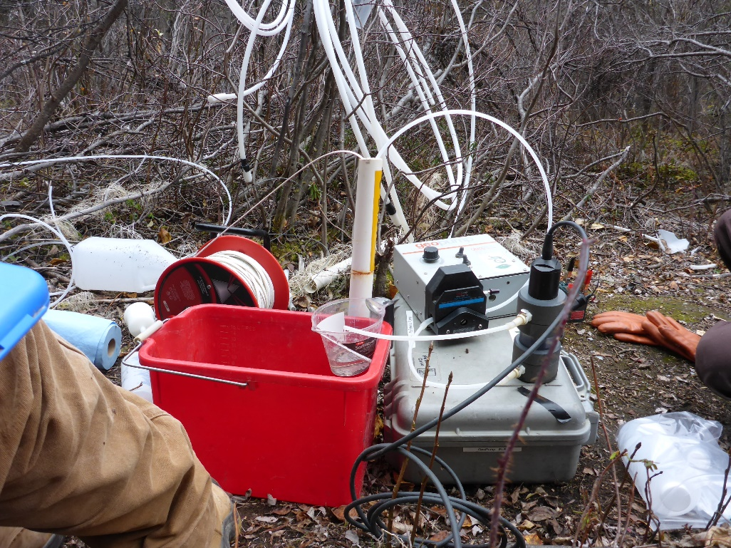
Photo 50: View of well SRK05-9. Photo taken on September 22nd, 2016.

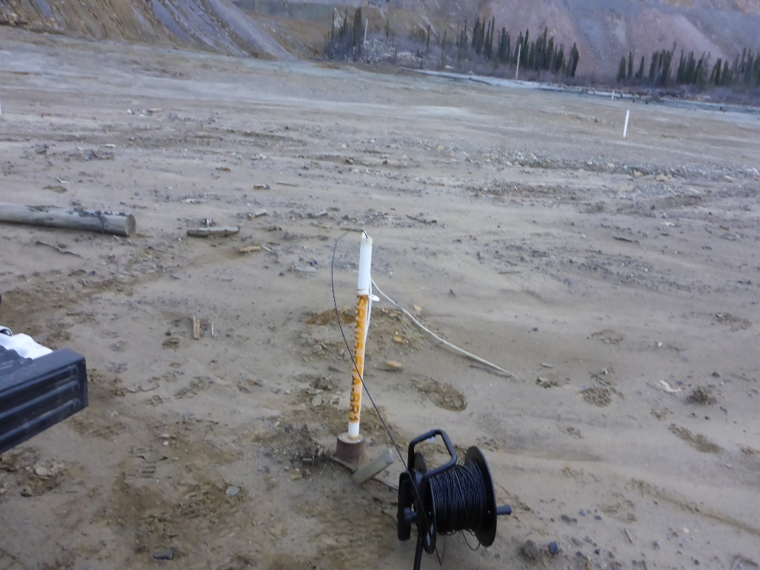
Photo 51: View of well SRK05-ETA-BR1. Photo taken on September 23rd, 2016.
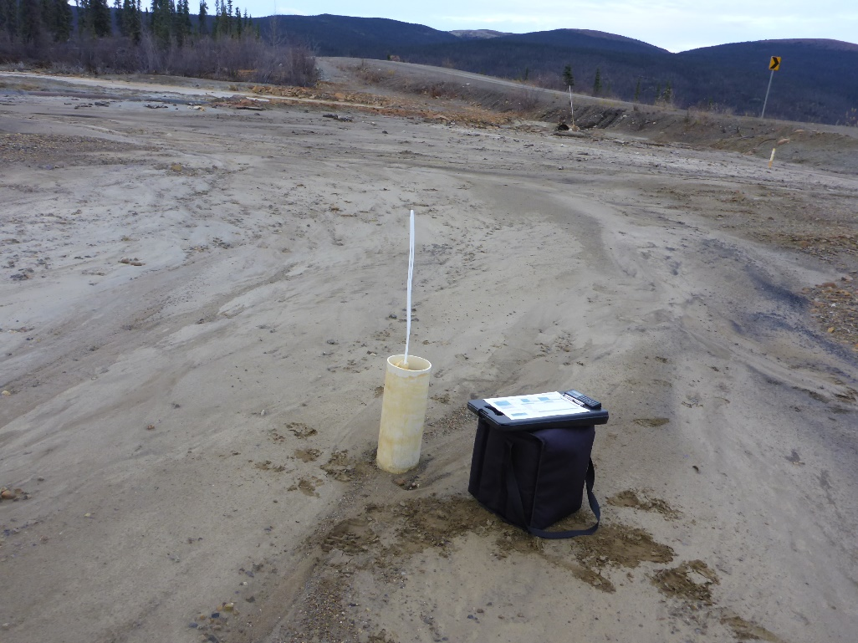
Photo 52: View of well SRK05-ETA-BR2. Photo taken on September 22nd, 2016.

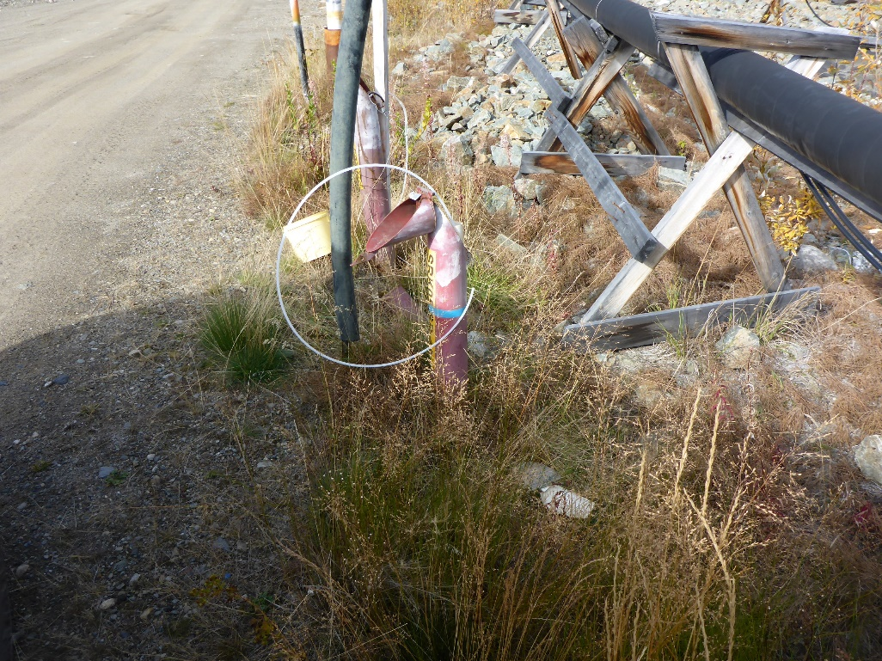
Photo 53: View of well SRK05-SP-4A. Photo taken on September 20th, 2016.
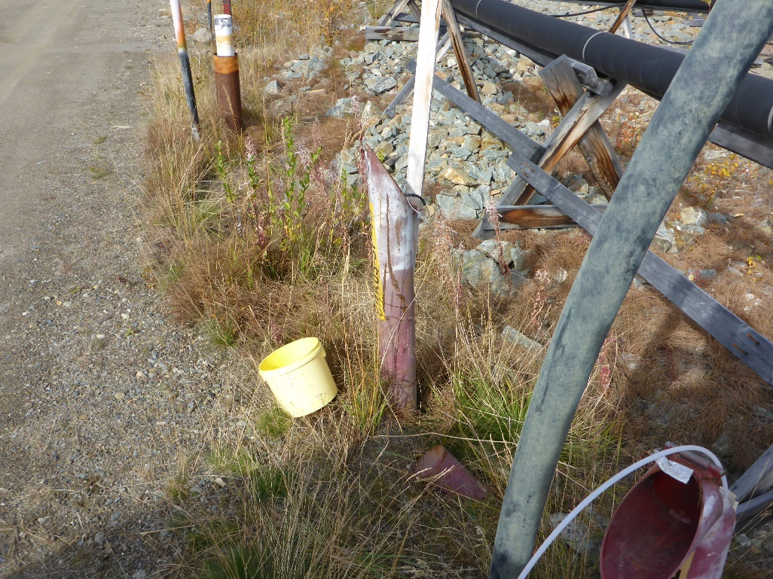
Photo 54: View of well SRK05-SP-4B. Photo taken on September 20th, 2016.

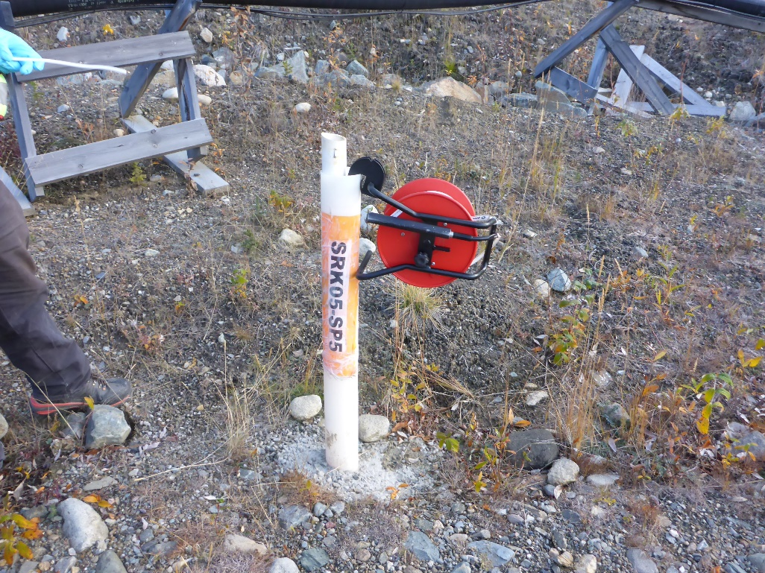
Photo 55: View of well SRK05-SP-5. Photo taken on September 21st, 2016.
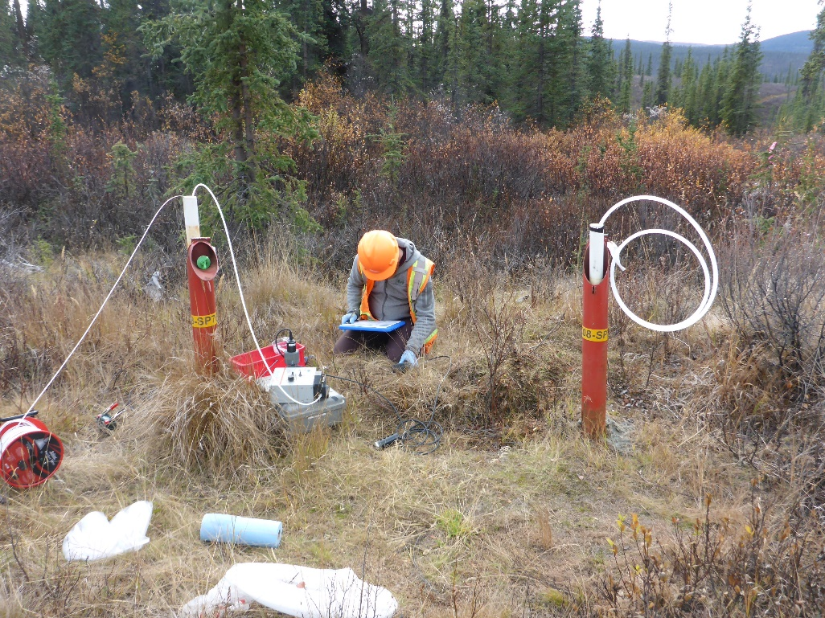
Photo 56: View of wells SRK08-SP-7A and SRK08-SP-7B. Photo taken on September 20th, 2016.

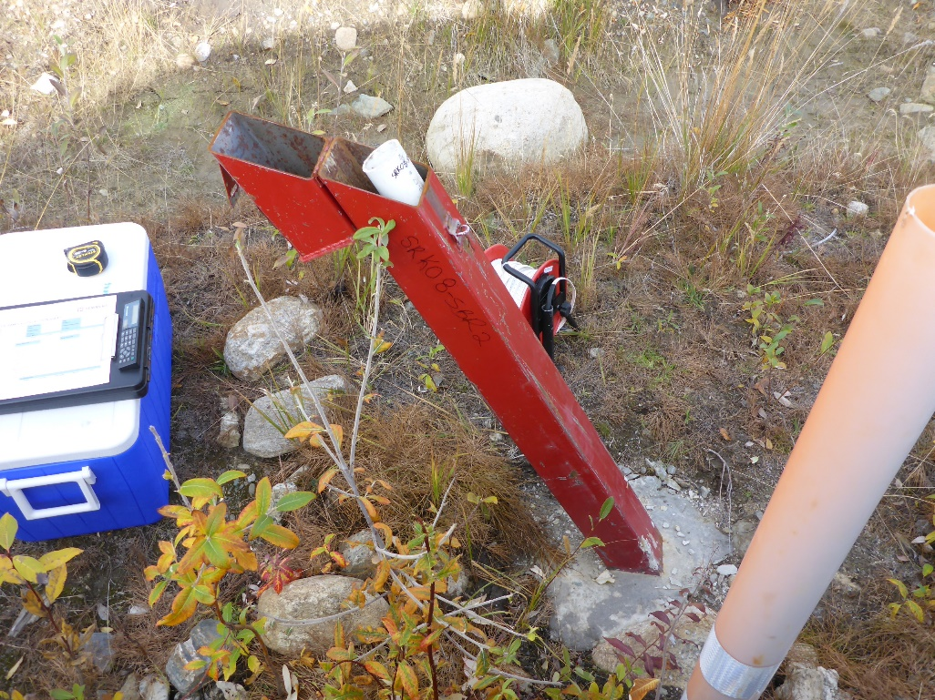
Photo 57: View of well SRK08-SBR2. Photo taken on September 20th, 2016.
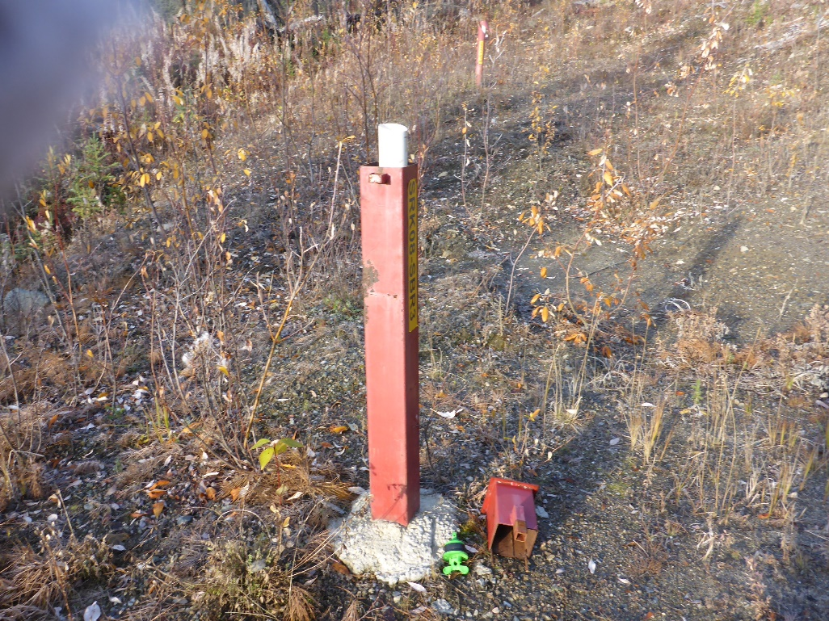
Photo 58: View of well SRK08-SBR3. Photo taken on September 21st, 2016.

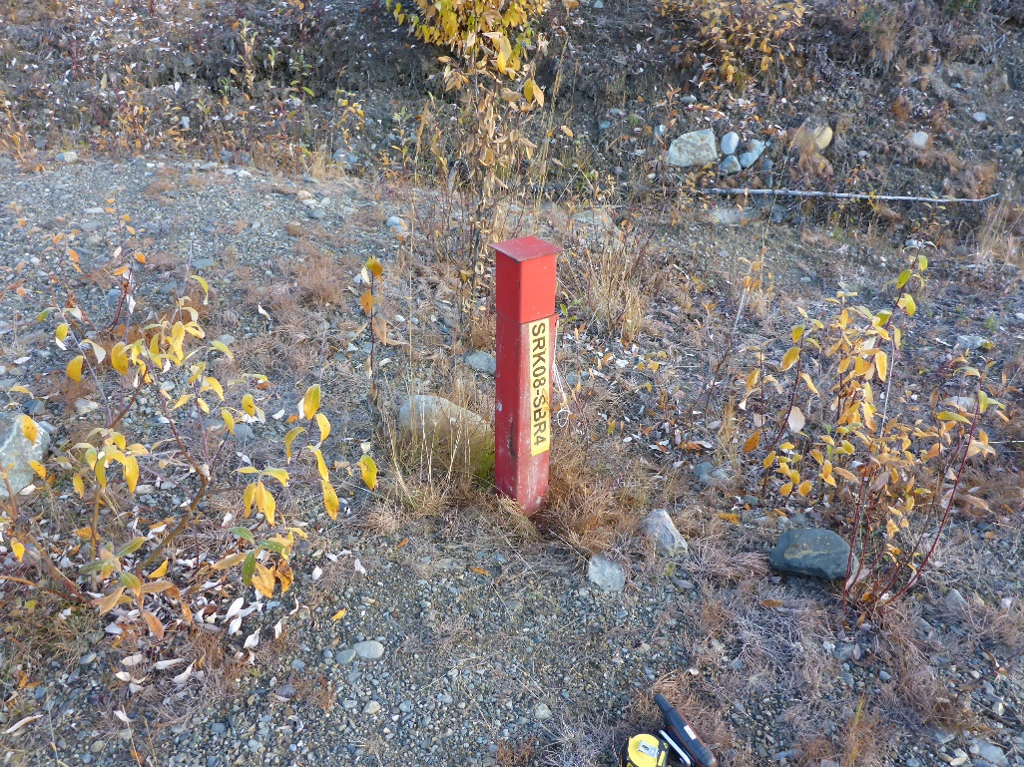
Photo 59: View of well SRK08-SBR4. Photo taken on September 21st, 2016.
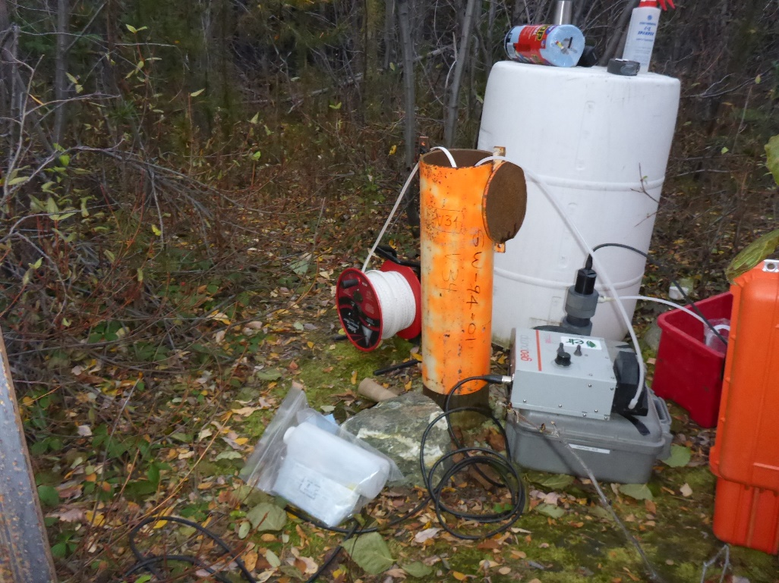
Photo 60: View of well V34. Photo taken on September 22nd, 2016.

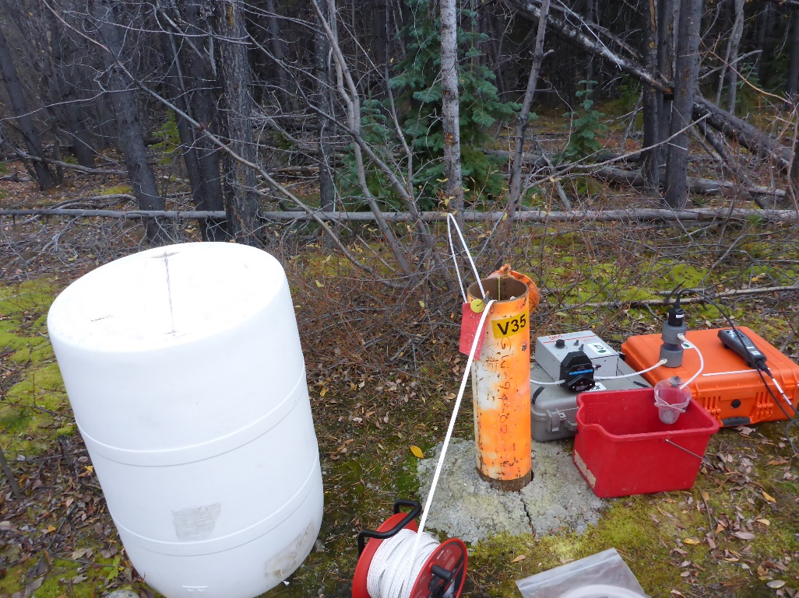
Photo 61: View of well V35. Photo taken on September 22nd, 2016.
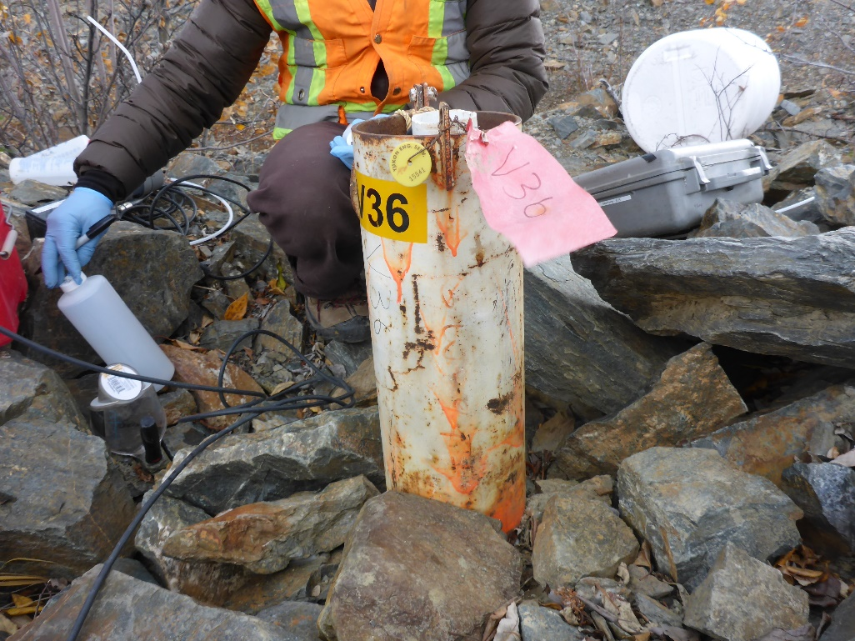
Photo 62: View of well V36. Photo taken on September 22nd, 2016.

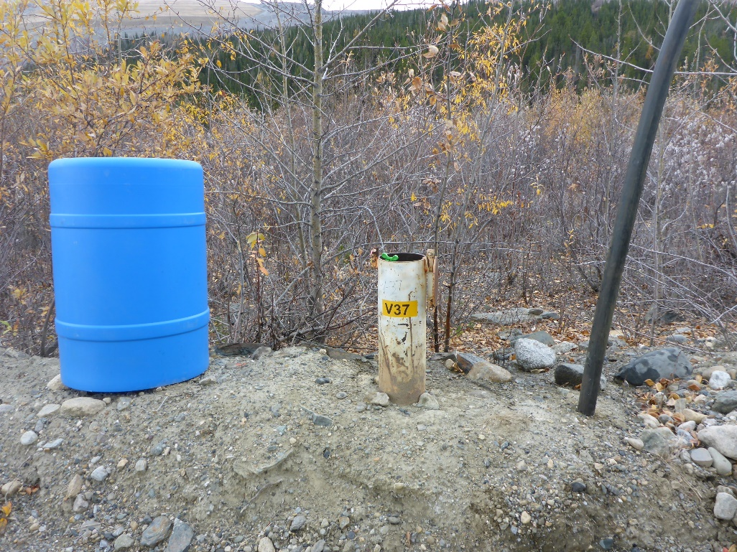
Photo 63: View of well V37. Photo taken on September 22nd, 2016.
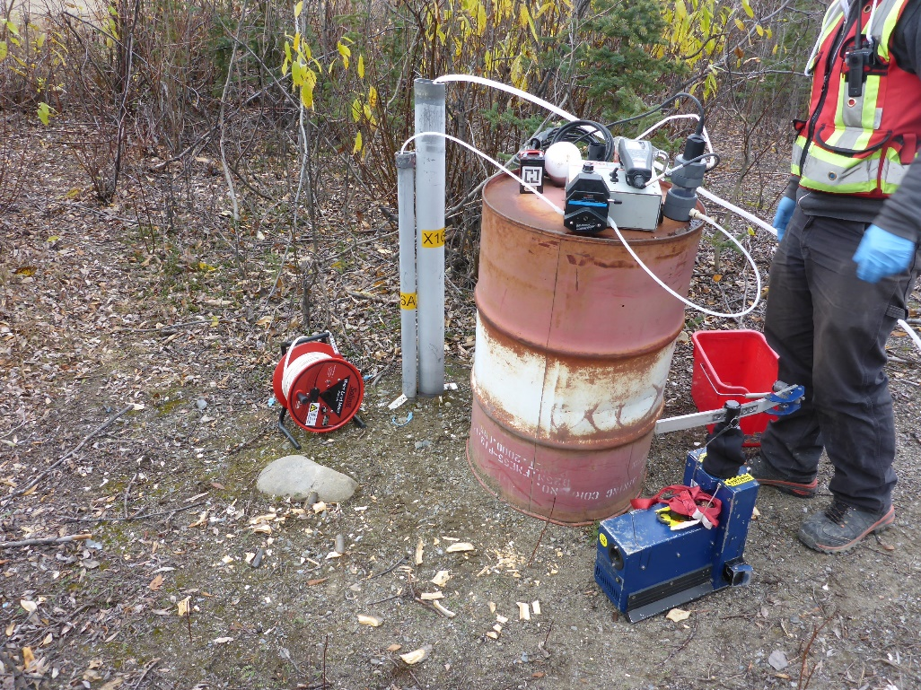
Photo 64: View of wells X16A and X16B. Photo taken on September 22nd, 2016.

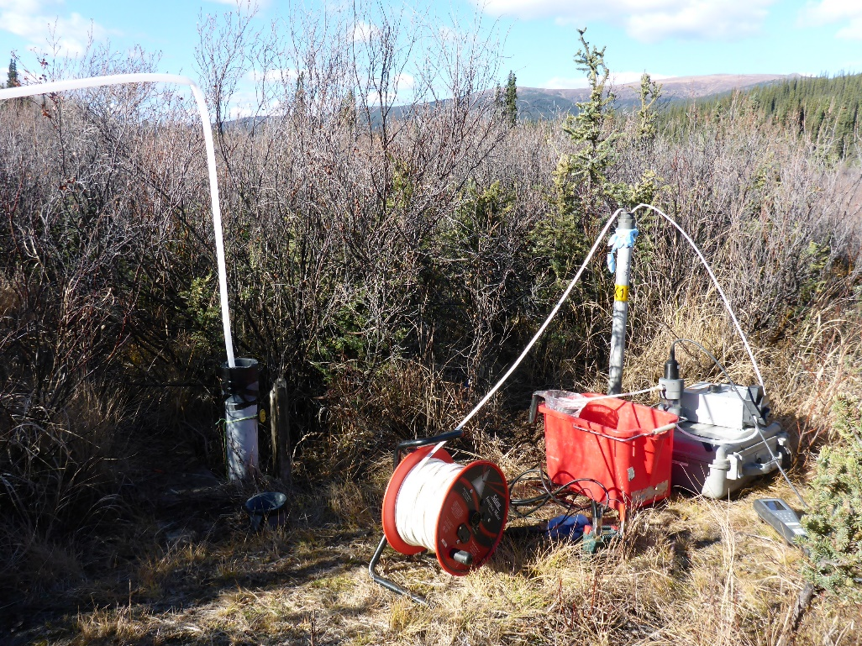
Photo 65: View of wells X17A and X17B. Photo taken on September 23rd, 2016.
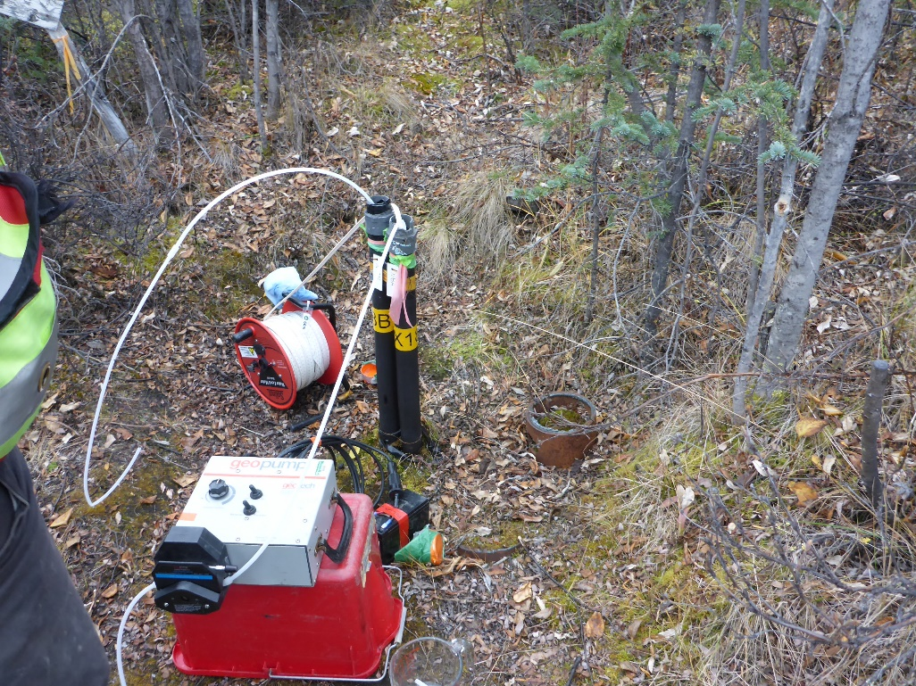
Photo 66: View of wells X18A and X18B. Photo taken on September 22nd, 2016.

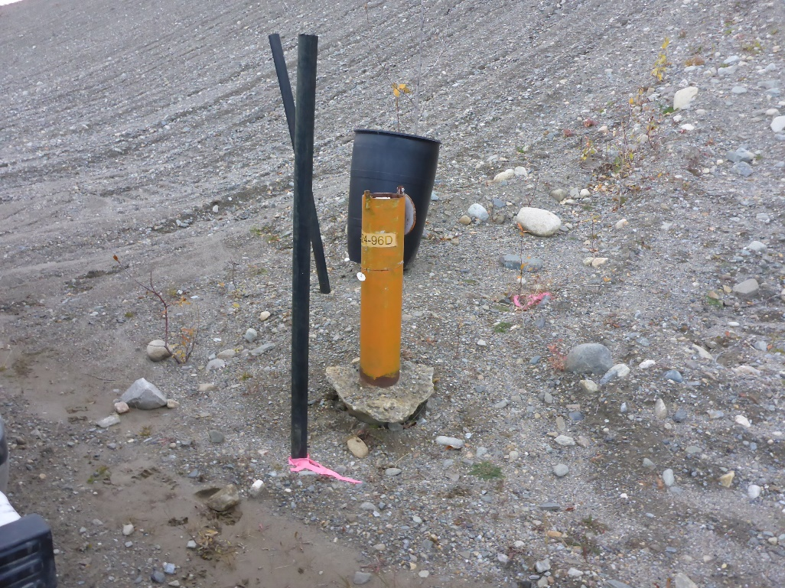
Photo 67: View of well X24-96D. Photo taken on September 23rd, 2016.
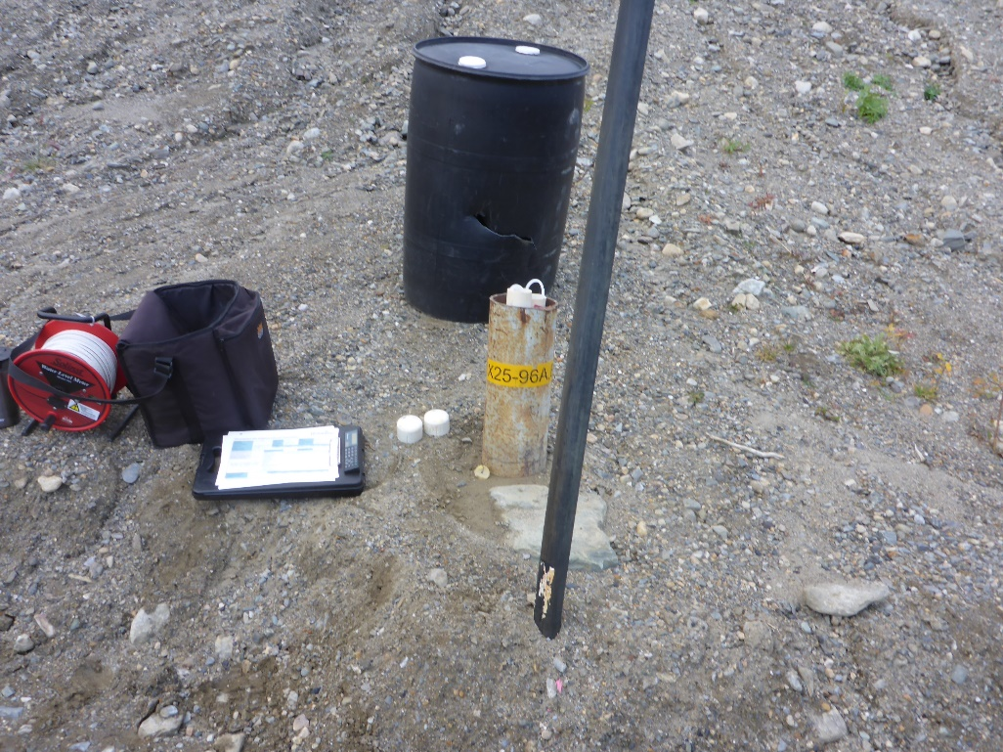
Photo 68: View of wells X25-96A and X25-96B. Photo taken on September 22nd, 2016.

