Mount Nansen 2013 Site Investigation

list of photos
Page
Photos of Test Pits in Sand Borrow Area 1
PHOTO 1: TP-BA-13-03: Example of rock fragment with surface oxidation. 1
PHOTO 2: TP-BA-13-03: Example of fine laminations from surface to about 1.5 m depth. 1
PHOTO 3: TP-BA-13-03 Below 4.4 m: Dense permafrost soil below. 2
PHOTO 4: TP-BA-13-05: Fine laminations in the top 0.5 m of test pit. 2
PHOTO 5: TP-BA-13-05: Test pit at final depth, and sloughing to approximately 10 m diameter. 3
PHOTO 6: TP-BA-13-04: Excavator at approximately 4 m depth. 3
PHOTO 7: TP-BA-13-04: Excavator backfilling test pit. 4
Photos of Test Pits on Tailings Dam 5
PHOTO 8: TP-TD-13-01: Approximately 2 m depth. 5
PHOTO 9: TP-TD-13-01: Backfilling in approximately 0.5 m lift. 5
PHOTO 10: TP-TD-13-02: Test pit at approximately 6 m depth. 6
PHOTO 11: TP-TD-13-02: Sample at 6 m depth. 6
PHOTO 12: TP-TD-13-03: Sample at 2 m, showing layers of dam fill. 7
PHOTO 13: TP-TD-13-03: Organic sample at 4.5 m depth. 7
PHOTO 14: TP-TD-13-03: Native sand at 5.8 m depth. 8
PHOTO 15: TP-TD-13-03: Organics and native sand at base of test pit. 8
Photos of Test Pits in Shale Borrow Area 9
PHOTO 16: TP-BA-13-06: At 1 m depth. 9
PHOTO 17: TP-BA-13-06: Sample at 1 m depth. 9
PHOTO 18: TP-BA-13-07: Example of oxidized ARD sample at 0.5 m. 10
PHOTO 19: TP-BA-13-07: Example of schist/phyillite alteration at 0.5 m. 10
PHOTO 20: TP-BA-13-07: Test pit at about 0.8 m depth. 11
PHOTO 21: TP-BA-13-08: Test pit at about 1.2 m depth. 11
Photos of Test Pits on Tailings Surface 12
PHOTO 22: TP-T-13-01: Tailings sample (sand, some silt) at 1.0 m. 12
PHOTO 23: TP-T-13-01: Sand to cobbles and wet native material at 2.6 m depth. 12
PHOTO 24: TP-T-13-01: Test pit at completion, sloughed in, water seeping in. 13
PHOTO 25: TP-T-13-01: Excavator sinking into tailings at completion of hole. 13
PHOTO 26: TP-T-13-02: Damp sand tailings at 0.8 m depth. 14
PHOTO 27: TP-T-13-02: Fine grained tailings at 1.0 m depth. 14
PHOTO 28: TP-T-13-02: Test pit to approximately 1.5 m depth. 15
PHOTO 29: TP-T-13-01: Organics at 2.6 m depth. 15
PHOTO 30: TP-T-13-02: Fine tailings at about 2.5 m depth. 16
PHOTO 31: TP-T-13-02: Native sand at 3.3 m depth. 16
PHOTO 32: TP-T-13-02: Test pit standing up at about 3 m depth. 17
PHOTO 33: TP-T-13-02: Test pit filling with water and sloughing in at completion. 17
PHOTO 34: TP-T-13-02: Seepage at 0.9 m depth, on north side of test pit. 18
PHOTO 35: TP-T-13-02: Excavator leaving site to the north. 18
PHOTO 36: TP-T-13-04: Sand tailings at 1 m depth. 19
PHOTO 37: TP-T-13-04: Fine grained tailings at 2 m depth. 19
PHOTO 38: TP-T-13-04: Wet sand tailings at 2.1 m depth. 20
PHOTO 39: TP-T-13-04: Organics at 3.5 m depth. 20
PHOTO 40: TP-T-13-04: Native sand at 5 m depth. 21
PHOTO 41: TP-T-13-04: Sand tailings over fine tailings over organics in test pit. 21
PHOTO 42: TP-T-13-04: Filled with water after being left open overnight. 22
PHOTO 43: TP-T-13-05: Sand tailings at 1 m depth. 22
PHOTO 44: TP-T-13-05: Test pit at about 1.2 m depth. 23
PHOTO 45: TP-T-13-05: Sloughing at completion. 23
PHOTO 46: TP-T-13-05: Excavator sinking at completion of test pit. 24
PHOTO 47: TP-T-13-05: Sand boils developing when liquefied the backfill. 24
PHOTO 48: TP-T-13-05: Ruts on the tailings surface after 2 passes with the excavator. 25
PHOTO 49: TP-T-13-05: Ruts on the tailings surface after completing test pit. 25
PHOTO 50: TP-T-13-06: Sand tailings overlying native sand at 2 m depth. 26
PHOTO 51: TP-T-13-06: Native sand at 4 m depth. 26
PHOTO 52: TP-T-13-06: Test pit sloughed at completion. 27
PHOTO 53: TP-T-13-06: Test pit filled with water and circular after being left open overnight. 27
PHOTO 54: TP-T-13-07: One pass with the excavator to the test pit. 28
PHOTO 55: TP-T-13-07: Test pit at about 1 m depth. 28
PHOTO 56: TP-T-13-07: Test pit at completion. 29
PHOTO 57: TP-T-13-07: Test pit filled with water after being left open overnight. 29
PHOTO 58: TP-T-13-09: Five passes with the excavator on the tailings surface. 30
PHOTO 59: TP-T-13-09: Test pit at about 1.5 m depth. 30
PHOTO 60: TP-T-13-09: Tailings sample at 4 m depth. 31
PHOTO 61: TP-T-13-09: Test pit at completion. 31
PHOTO 62: TP-T-13-09: Sloughed and filled with water after being left open overnight. 32
Photos of Test Pits in Waste Rock Area 33
PHOTO 63: TP-WA-13-01: Highly oxidized waste rock at 1 m depth. 33
PHOTO 64: TP-WA-13-01: Low oxidized waste rock at 4 m depth. 33
PHOTO 65: TP-WA-13-01: Test pit at completion. 34
PHOTO 66: TP-WA-13-02: Moist waste rock sample at 1 m depth. 34
PHOTO 67: TP-WA-13-02: Thin layer of organics at 1.9 m separating 2 layers of waste rock. 35
PHOTO 68: TP-WA-13-02: Native sand at 4.2 m depth. 35
PHOTO 69: TP-WA-13-02: Weathered bedrock at 5.2 m depth. 36
PHOTO 70: TP-WA-13-02: Test pit at completion. 36
PHOTO 71: TP-WA-13-02: Weathered bedrock and native sand at bottom of test pit. 37
PHOTO 72: TP-WA-13-03: Waste rock sample at 2 m depth. 37
PHOTO 73: TP-WA-13-03: Layer of organics between waste rock at 2.6 m depth. 38
PHOTO 74: TP-WA-13-03: Low level oxidation waste rock, lots of oversize particles at 2.9 m depth. 38
PHOTO 75: TP-WA-13-03: Test pit at completion. 39
PHOTO 76: TP-WA-13-04: Moderate level of oxidation waste rock at 2 m depth. 39
PHOTO 77: TP-WA-13-04: Example of a highly weathered piece of granitic rock, can crumble in hand, about 1 m depth. 40
PHOTO 78: TP-WA-13-04: Test pit at completion. 40
PHOTO 79: TP-WA-13-05: Waste rock sample with about 70% oversize 25 mm, at 3 m depth. 41
PHOTO 80: TP-WA-13-05: Test pit at completion, sloughing in. 41
PHOTO 81: TP-WA-13-06: Moderately weathered waste rock sample with about 45 % oversize 25 mm at 1 m depth. 42
PHOTO 82: TP-WA-13-06: 300 mm thick waste rock stratified layers in upper meter. 42
PHOTO 83: TP-WA-13-06: Oxidized waste rock sample at 4 m depth, about 60% oversize 25 mm. 43
PHOTO 84: TP-WA-13-06: Test pit at completion. 43
PHOTO 85: TP-WA-13-07: Moist waste rock at 1 m depth, about 40% oversize 25 mm. 44
PHOTO 86: TP-WA-13-07: Test pit at about 2 m depth. 44
PHOTO 87: TP-WA-13-07: Test pit at completion. 45
PHOTO 88: TP-WA-13-08: Waste rock sample at 2 m depth. 45
PHOTO 89: TP-WA-13-08: Test pit at completion. 46
PHOTO 90: TP-WA-13-08: Weathered bedrock at 4 m depth. 46
PHOTO 91: TP-WA-13-09: Excavator building access to test pit site. 47
PHOTO 92: TP-WA-13-09: Test pit at 2 m depth. 47
PHOTO 93: TP-WA-13-09: Waste rock sample at 4 m depth, about 80% oversize 25 mm. 48
PHOTO 94: TP-WA-13-09: Test pit at completion. 48
PHOTO 95: TP-WA-13-10: Spoil pile at completion, over 70% oversize 25 mm. 49
PHOTO 96: TP-WA-13-10: Waste rock sample at 3 m depth. 49
PHOTO 97: TP-WA-13-10: Test pit at completion. 50
PHOTO 98: TP-WA-13-11: Test pit to about 2 m depth, lots of boulders and cobbles. 50
PHOTO 99: TP-WA-13-11: Waste rock sample at 4 m depth, with high level of weathering. 51
PHOTO 100: TP-WA-13-11: Test pit at completion. 51

Photos of Test Pits in Sand Borrow Area

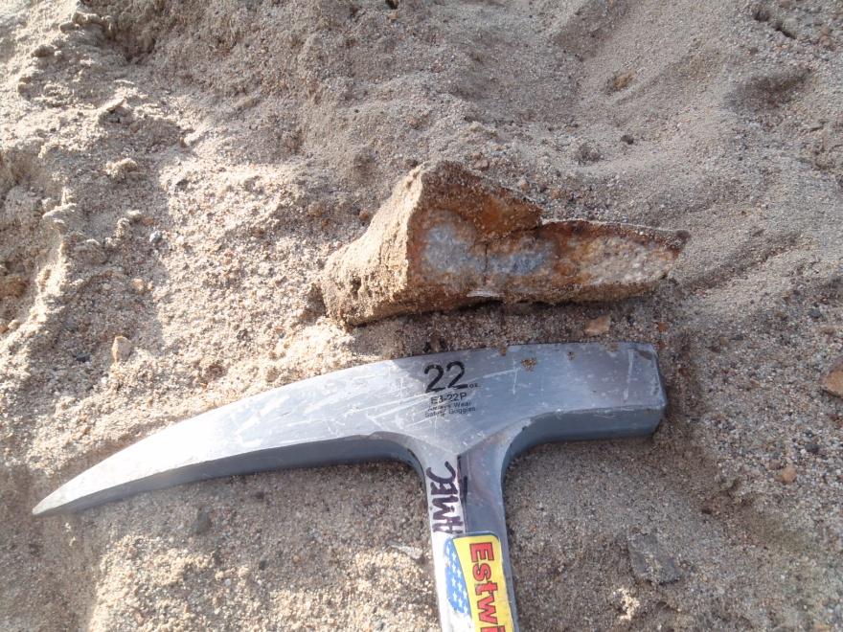

PHOTO 1: TP-BA-13-03: Example of rock fragment with surface oxidation.

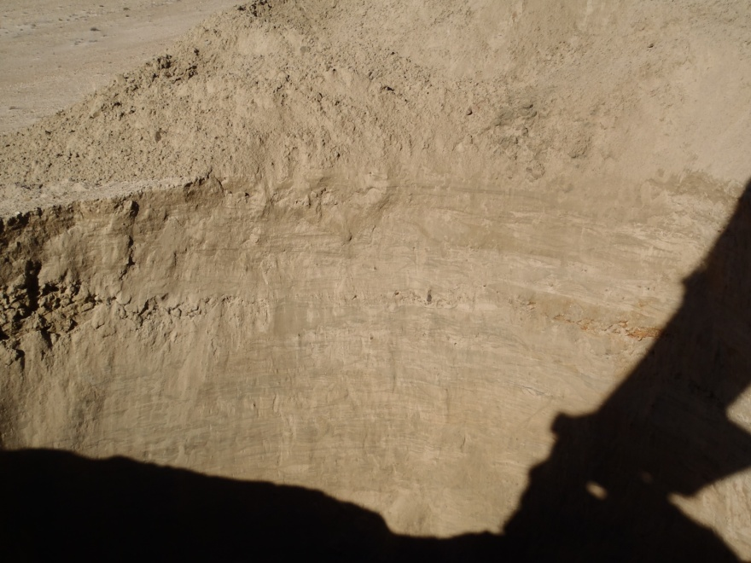

PHOTO 2: TP-BA-13-03: Example of fine laminations from surface to about 1.5 m depth.
   |  | Government of Yukon - AAM  Mount Nansen 2013 Site Investigation  Photographs
Logged by: SM | Scale: NTS | Date: Oct 2013 | Project: VM00605E | Page 1

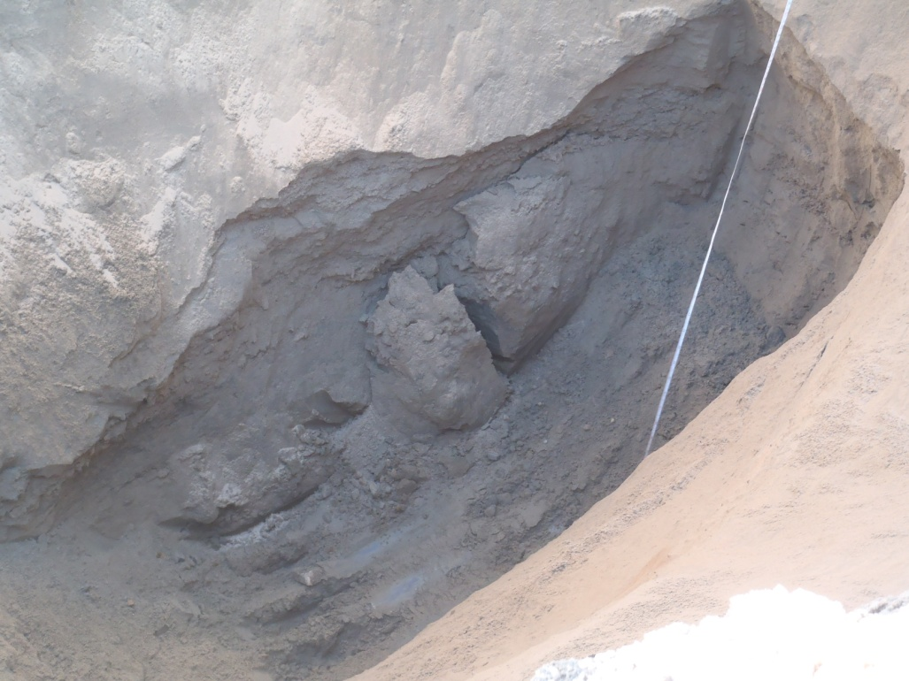

PHOTO 3: TP-BA-13-03 Below 4.4 m: Dense permafrost soil below.

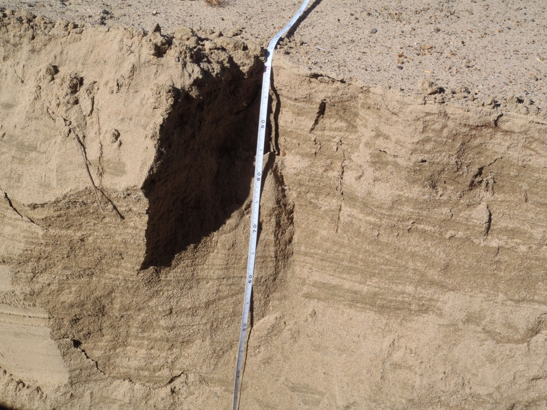

PHOTO 4: TP-BA-13-05: Fine laminations in the top 0.5 m of test pit.
Government of Yukon - AAM
Mount Nansen 2013 Site Investigation
Photographs
Logged by: SM | Scale: NTS | Date: Oct 2013 | Project: VM00605E | Page 2

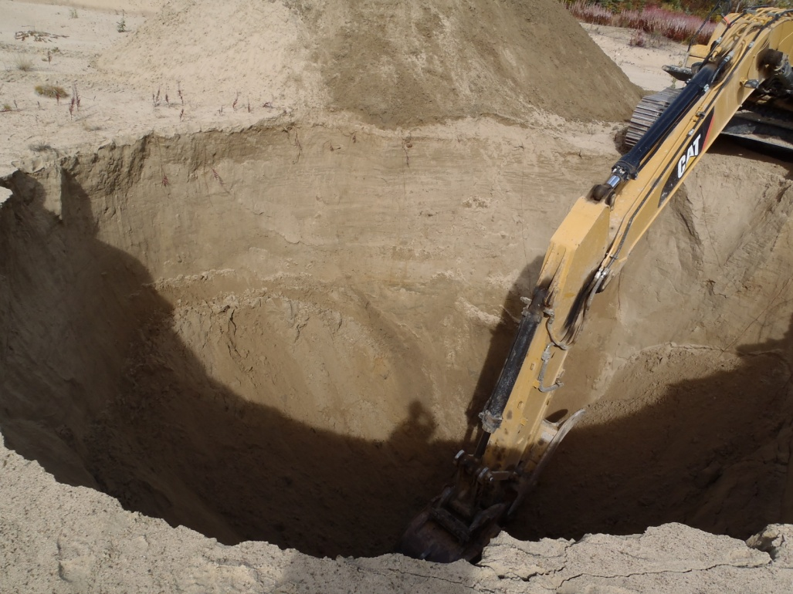

PHOTO 5: TP-BA-13-05: Test pit at final depth, and sloughing to approximately 10 m diameter.

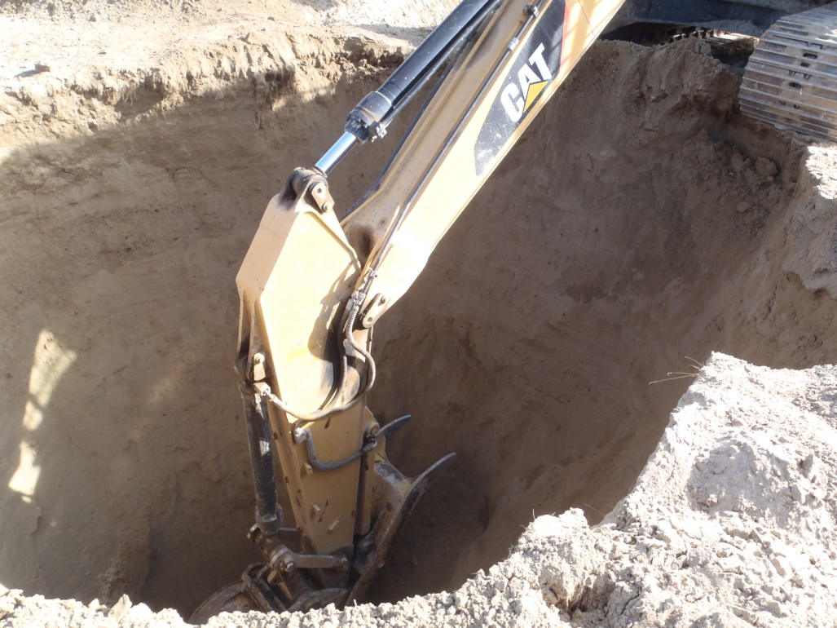

PHOTO 6: TP-BA-13-04: Excavator at approximately 4 m depth.
Government of Yukon - AAM
Mount Nansen 2013 Site Investigation
Photographs
Logged by: SM | Scale: NTS | Date: Oct 2013 | Project: VM00605E | Page 3

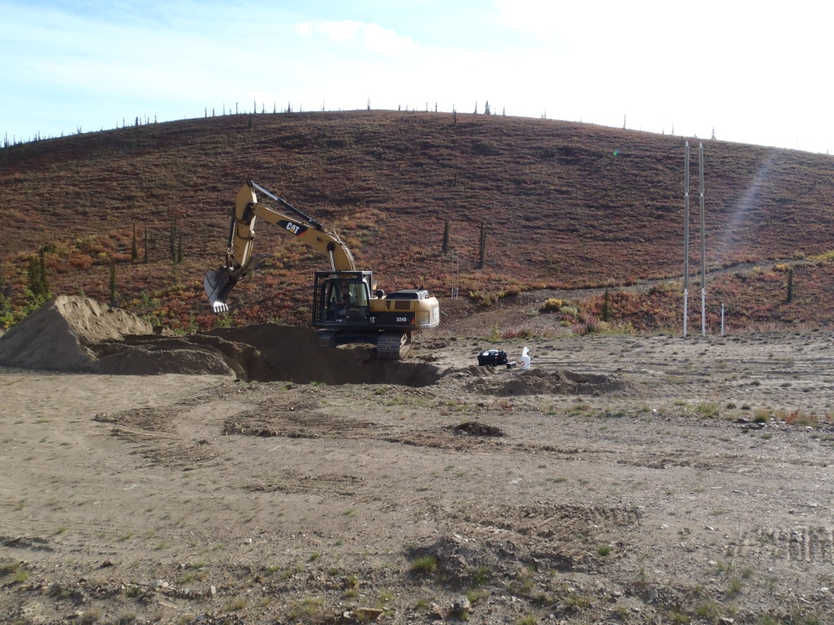

PHOTO 7: TP-BA-13-04: Excavator backfilling test pit.
Government of Yukon - AAM
Mount Nansen 2013 Site Investigation
Photographs
Logged by: SM | Scale: NTS | Date: Oct 2013 | Project: VM00605E | Page 4

Photos of Test Pits on Tailings Dam

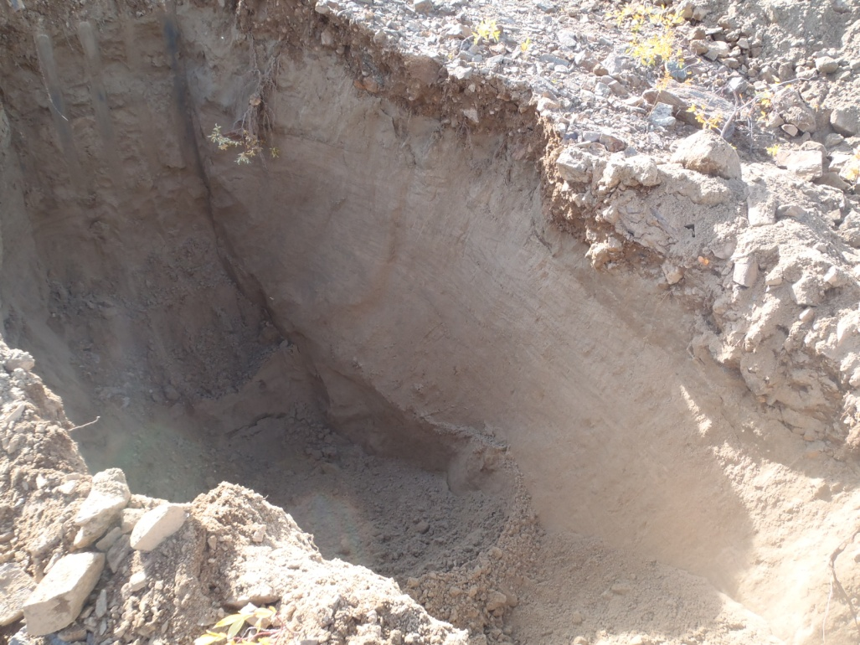

PHOTO 8: TP-TD-13-01: Approximately 2 m depth.

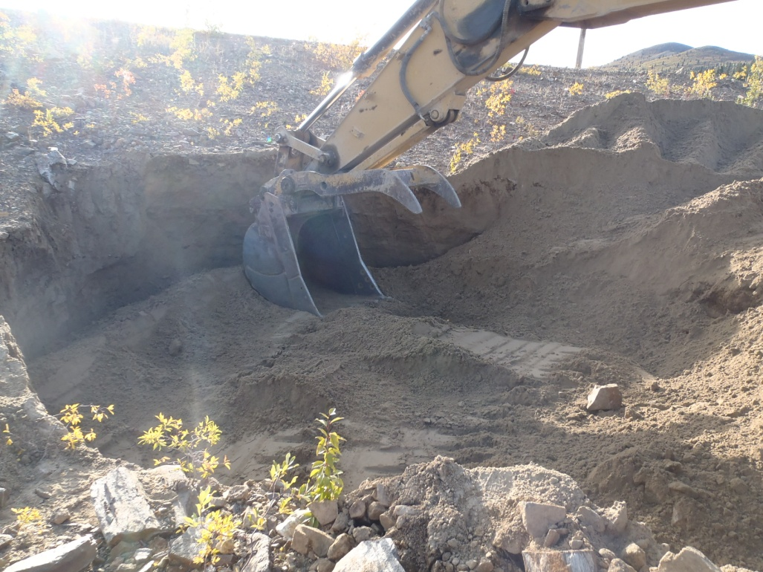

PHOTO 9: TP-TD-13-01: Backfilling in approximately 0.5 m lift.
Government of Yukon - AAM
Mount Nansen 2013 Site Investigation
Photographs
Logged by: SM | Scale: NTS | Date: Oct 2013 | Project: VM00605E | Page 5

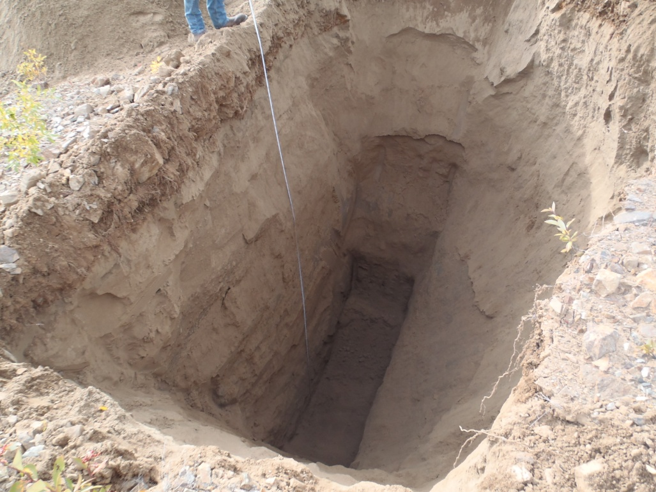

PHOTO 10: TP-TD-13-02: Test pit at approximately 6 m depth.

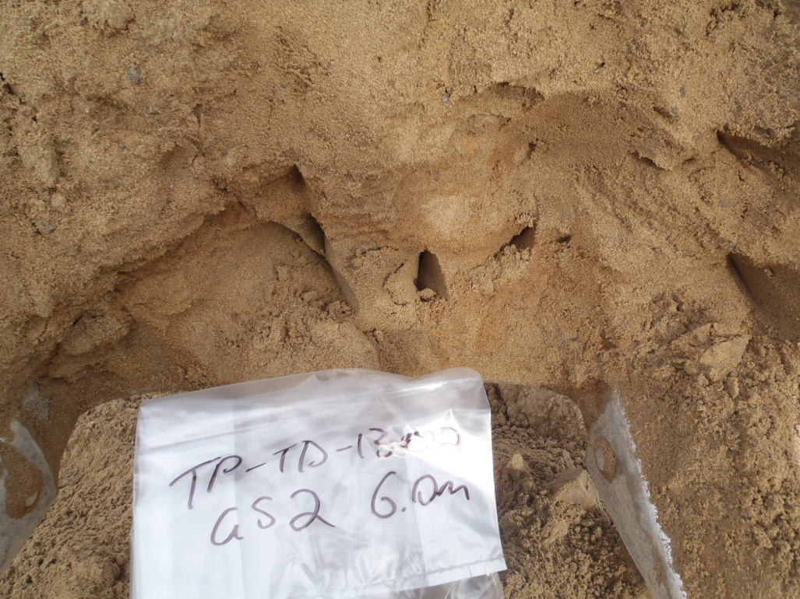

PHOTO 11: TP-TD-13-02: Sample at 6 m depth.
Government of Yukon - AAM
Mount Nansen 2013 Site Investigation
Photographs
Logged by: SM | Scale: NTS | Date: Oct 2013 | Project: VM00605E | Page 6

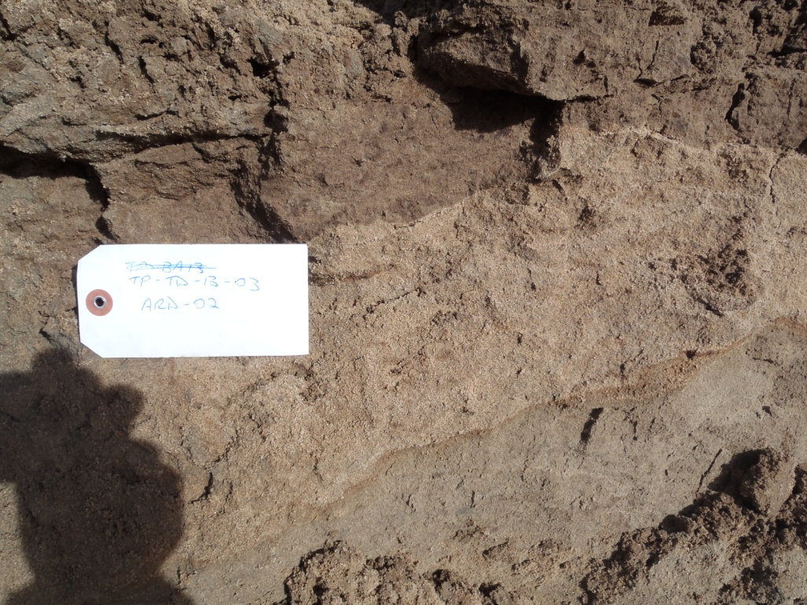

PHOTO 12: TP-TD-13-03: Sample at 2 m, showing layers of dam fill.

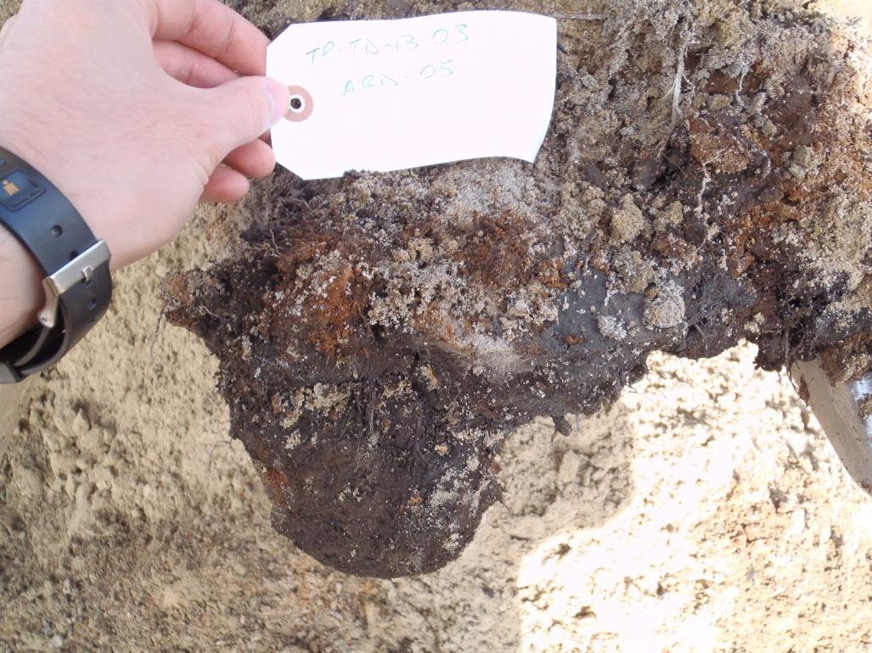

PHOTO 13: TP-TD-13-03: Organic sample at 4.5 m depth.
Government of Yukon - AAM
Mount Nansen 2013 Site Investigation
Photographs
Logged by: SM | Scale: NTS | Date: Oct 2013 | Project: VM00605E | Page 7

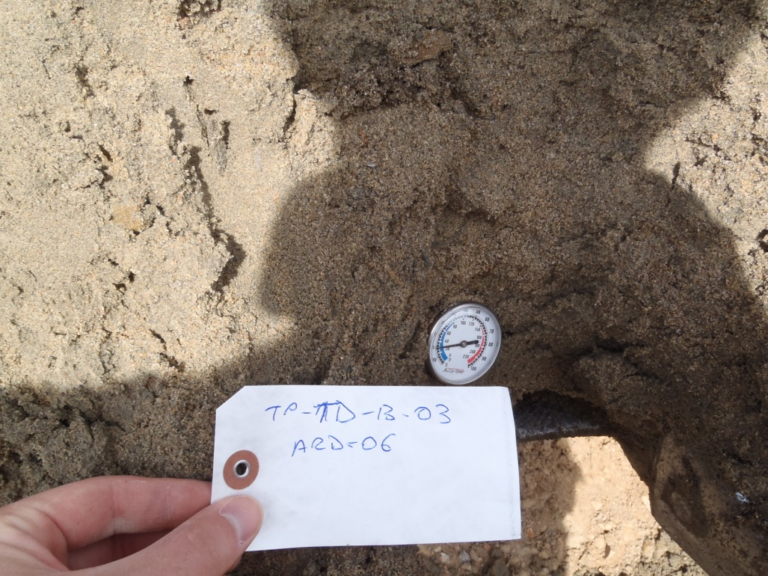

PHOTO 14: TP-TD-13-03: Native sand at 5.8 m depth.

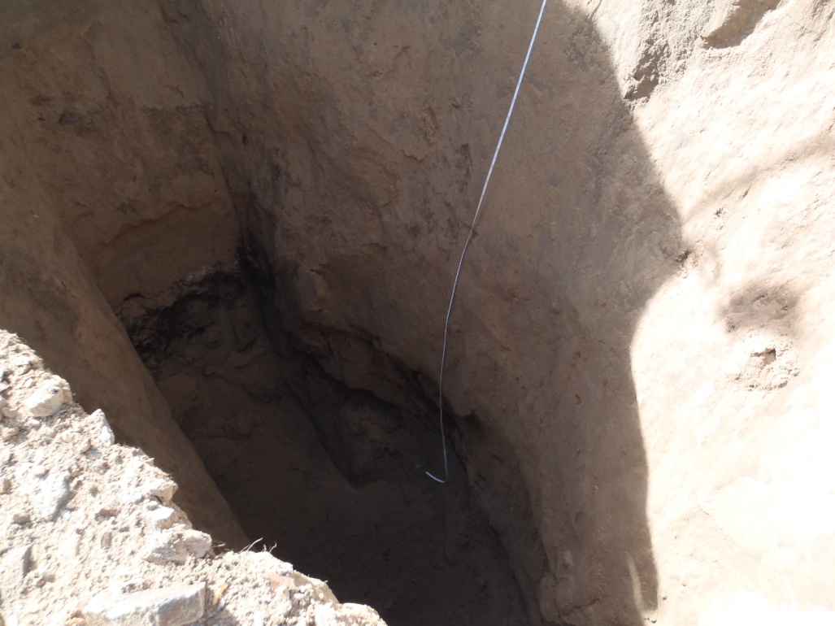

PHOTO 15: TP-TD-13-03: Organics and native sand at base of test pit.
Government of Yukon - AAM
Mount Nansen 2013 Site Investigation
Photographs
Logged by: SM | Scale: NTS | Date: Oct 2013 | Project: VM00605E | Page 8

Photos of Test Pits in Shale Borrow Area

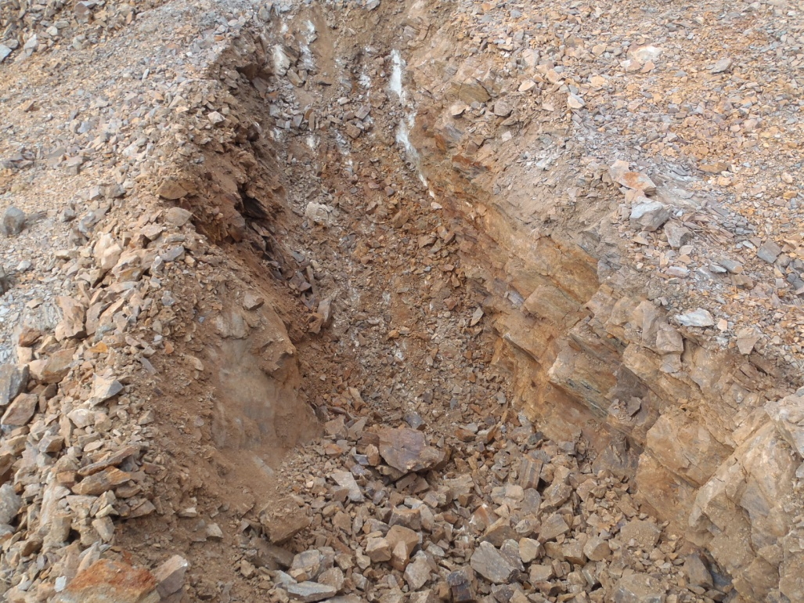

PHOTO 16: TP-BA-13-06: At 1 m depth.

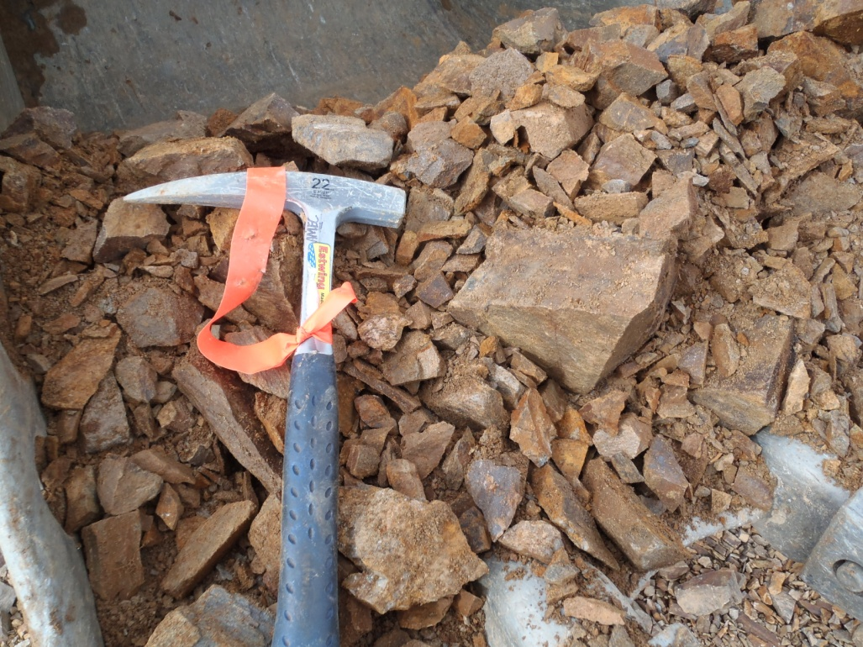

PHOTO 17: TP-BA-13-06: Sample at 1 m depth.
Government of Yukon - AAM
Mount Nansen 2013 Site Investigation
Photographs
Logged by: SM | Scale: NTS | Date: Oct 2013 | Project: VM00605E | Page 9

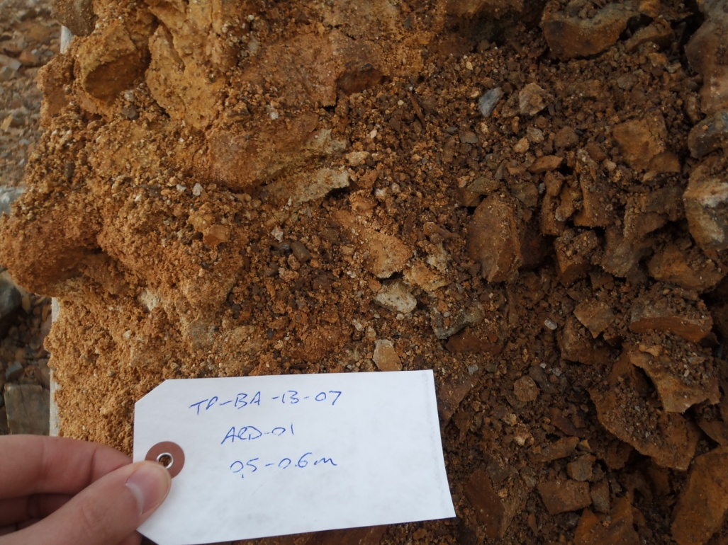

PHOTO 18: TP-BA-13-07: Example of oxidized ARD sample at 0.5 m.

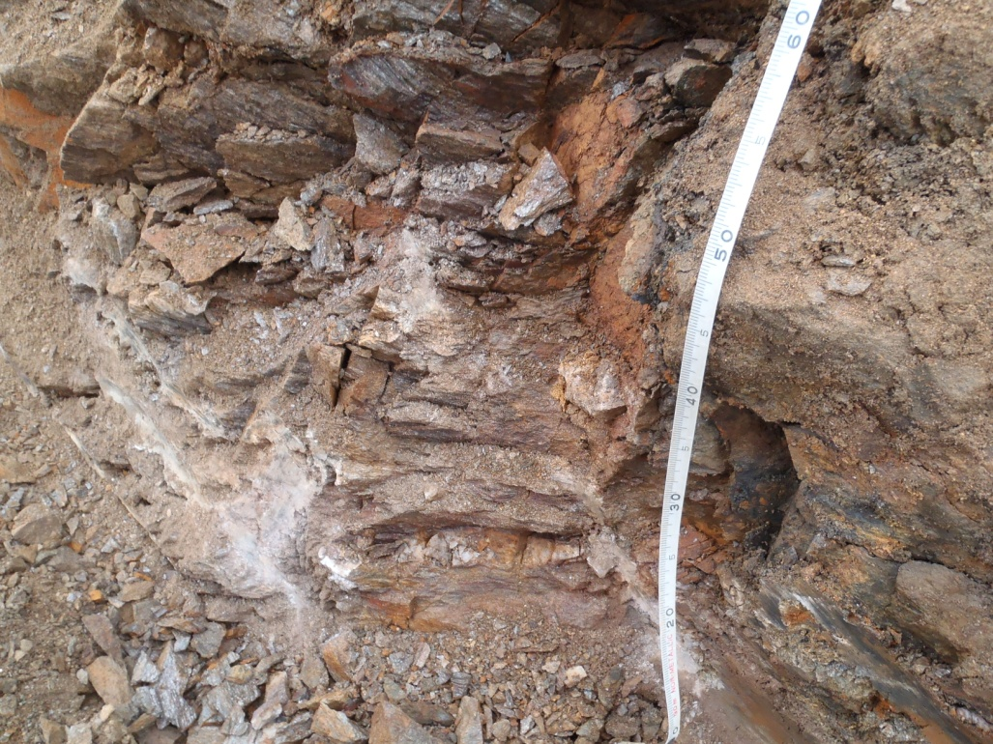

PHOTO 19: TP-BA-13-07: Example of schist/phyillite alteration at 0.5 m.
Government of Yukon - AAM
Mount Nansen 2013 Site Investigation
Photographs
Logged by: SM | Scale: NTS | Date: Oct 2013 | Project: VM00605E | Page 10

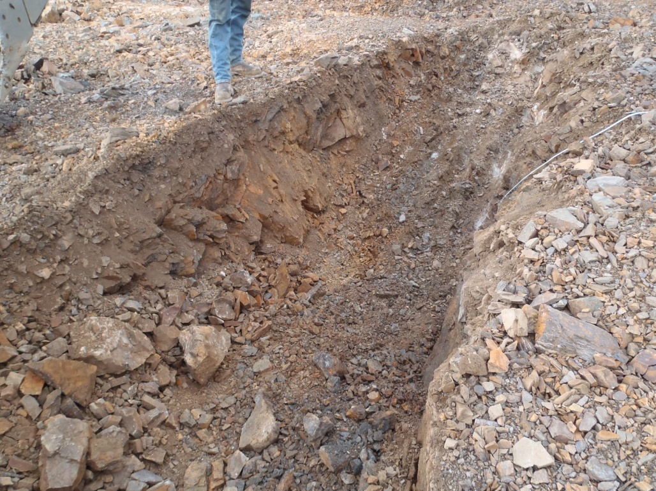

PHOTO 20: TP-BA-13-07: Test pit at about 0.8 m depth.

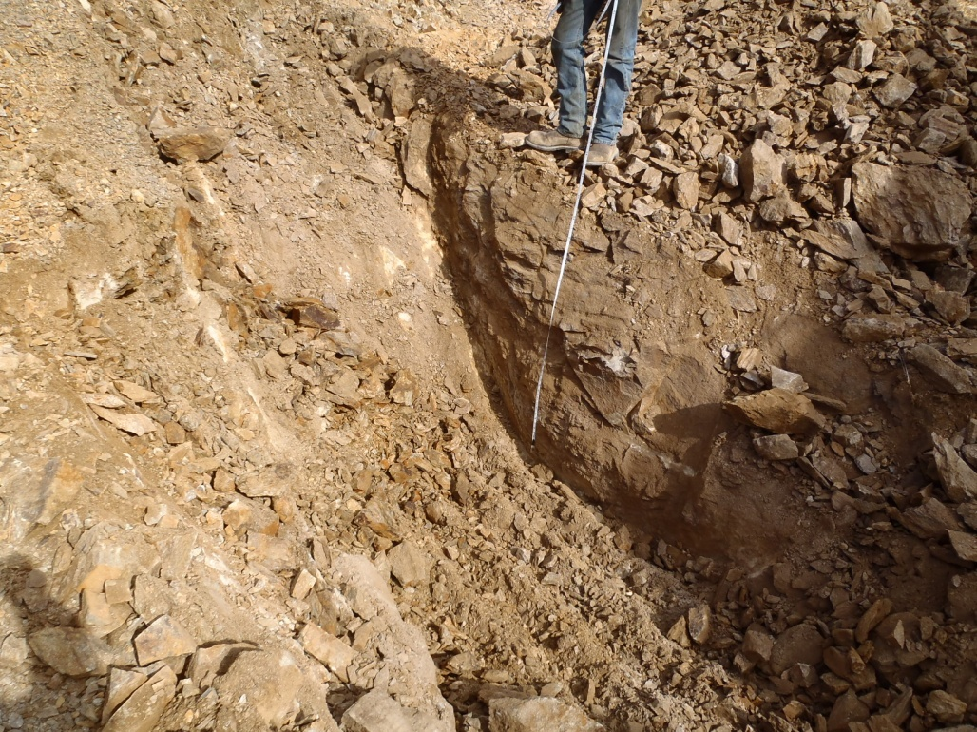

PHOTO 21: TP-BA-13-08: Test pit at about 1.2 m depth.
Government of Yukon - AAM
Mount Nansen 2013 Site Investigation
Photographs
Logged by: SM | Scale: NTS | Date: Oct 2013 | Project: VM00605E | Page 11

Photos of Test Pits on Tailings Surface

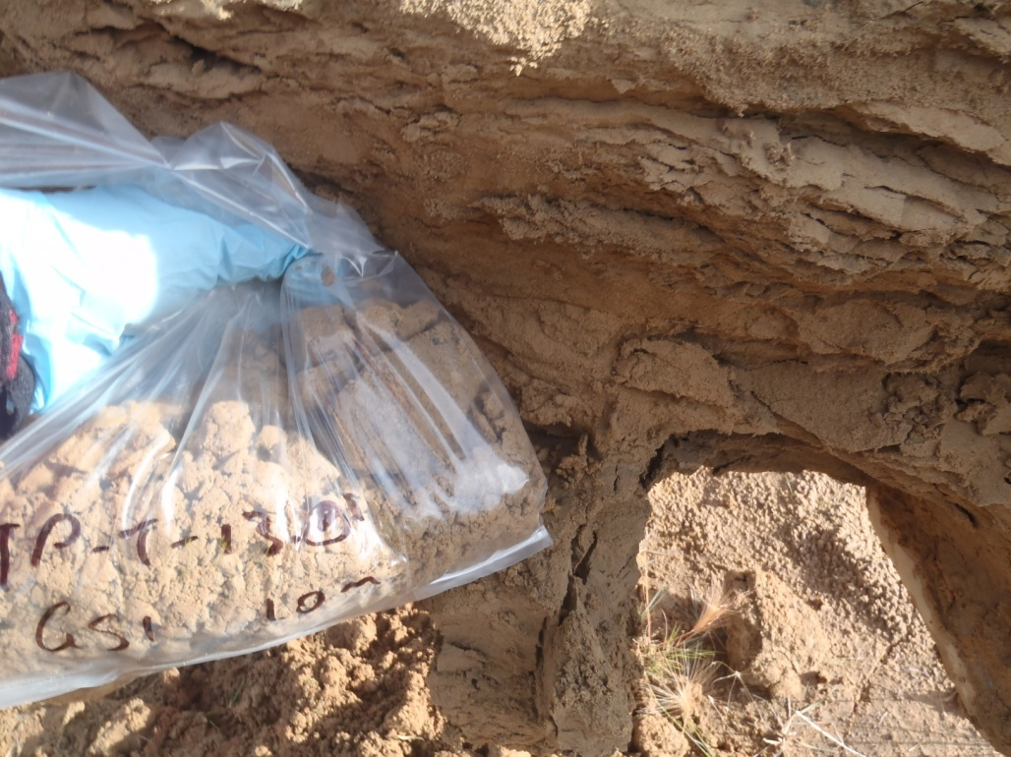

PHOTO 22: TP-T-13-01: Tailings sample (sand, some silt) at 1.0 m.

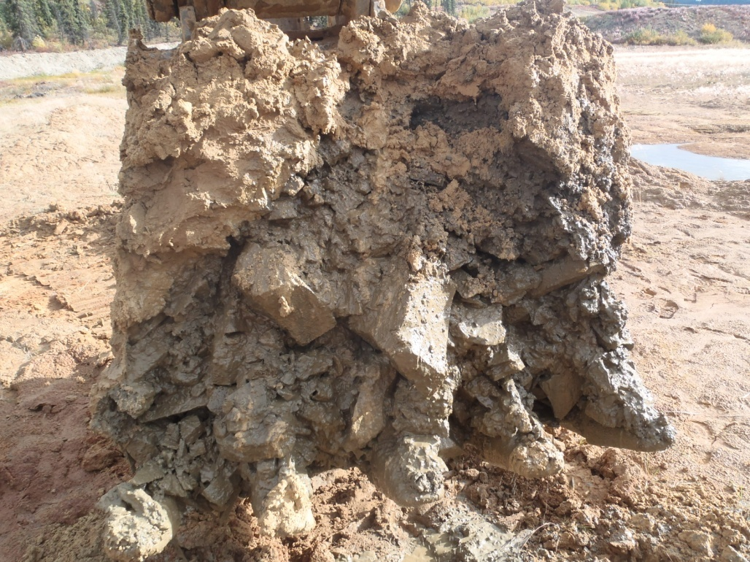

PHOTO 23: TP-T-13-01: Sand to cobbles and wet native material at 2.6 m depth.
Government of Yukon - AAM
Mount Nansen 2013 Site Investigation
Photographs
Logged by: SM | Scale: NTS | Date: Oct 2013 | Project: VM00605E | Page 12

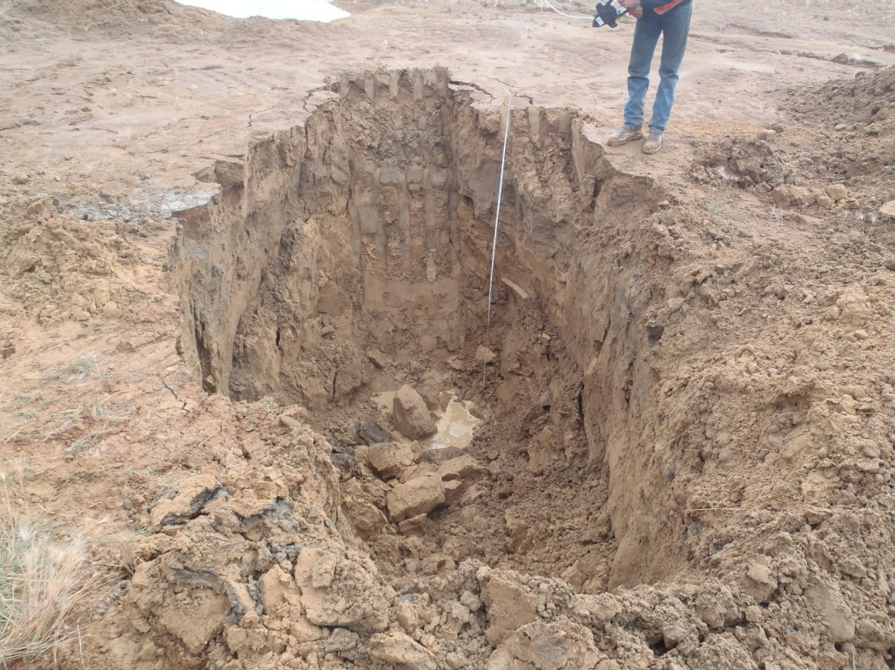

PHOTO 24: TP-T-13-01: Test pit at completion, sloughed in, water seeping in.

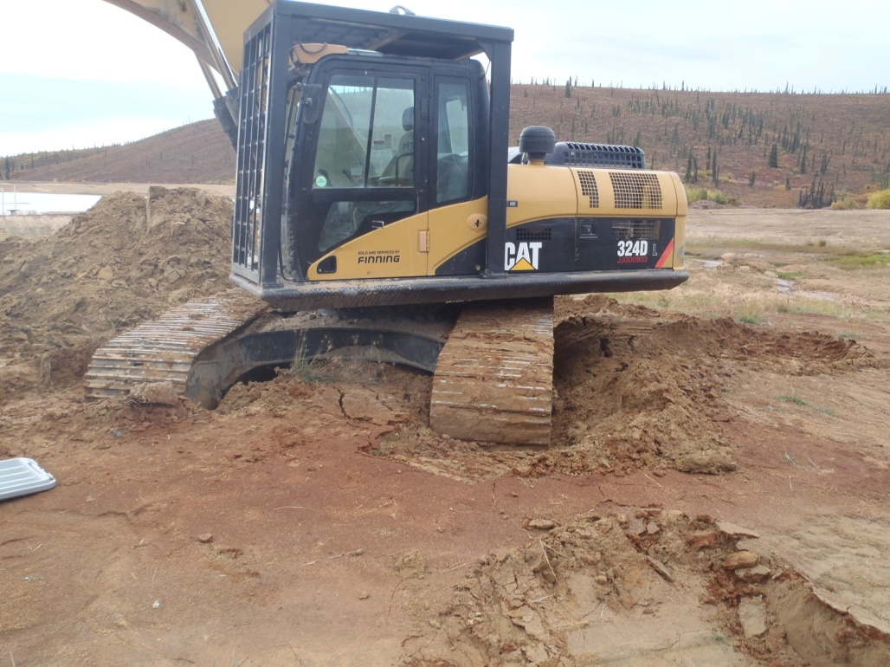

PHOTO 25: TP-T-13-01: Excavator sinking into tailings at completion of hole.
Government of Yukon - AAM
Mount Nansen 2013 Site Investigation
Photographs
Logged by: SM | Scale: NTS | Date: Oct 2013 | Project: VM00605E | Page 13

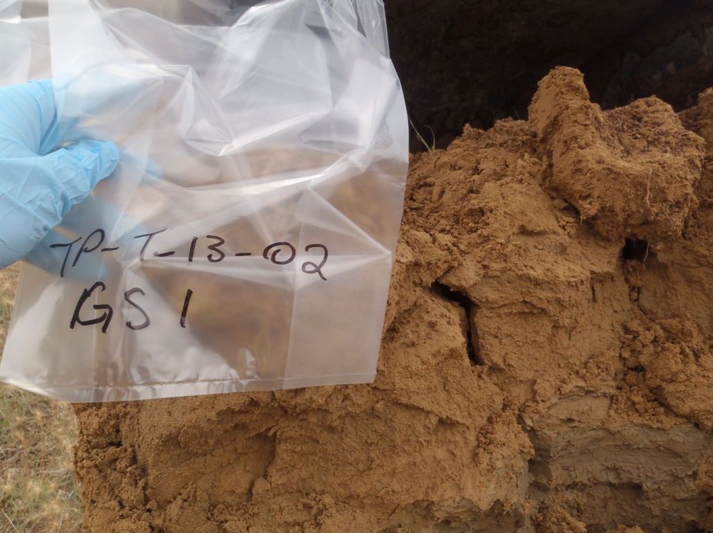

PHOTO 26: TP-T-13-02: Damp sand tailings at 0.8 m depth.

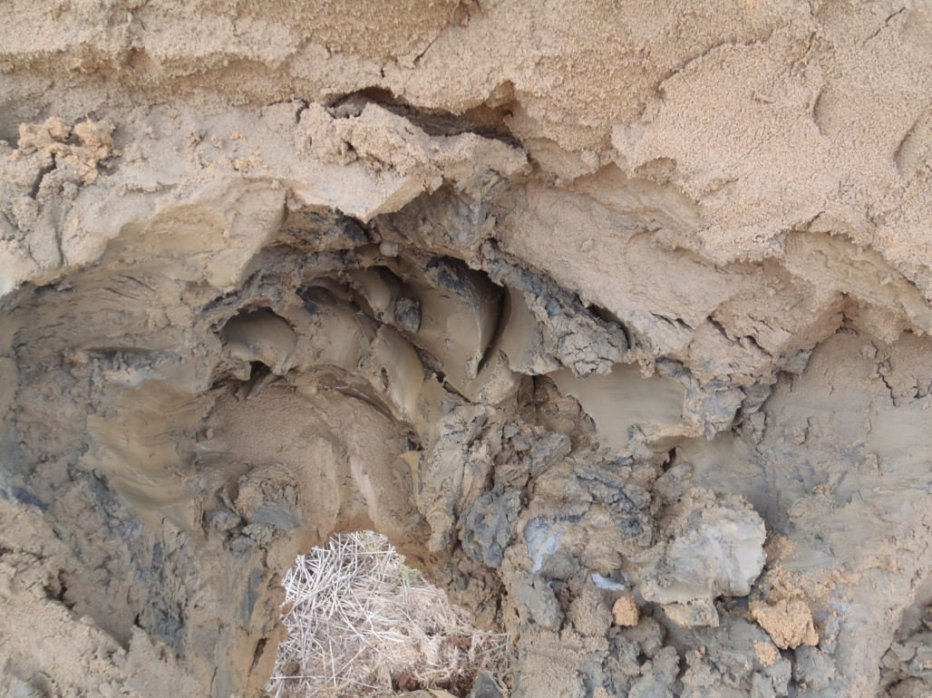

PHOTO 27: TP-T-13-02: Fine grained tailings at 1.0 m depth.
Government of Yukon - AAM
Mount Nansen 2013 Site Investigation
Photographs
Logged by: SM | Scale: NTS | Date: Oct 2013 | Project: VM00605E | Page 14

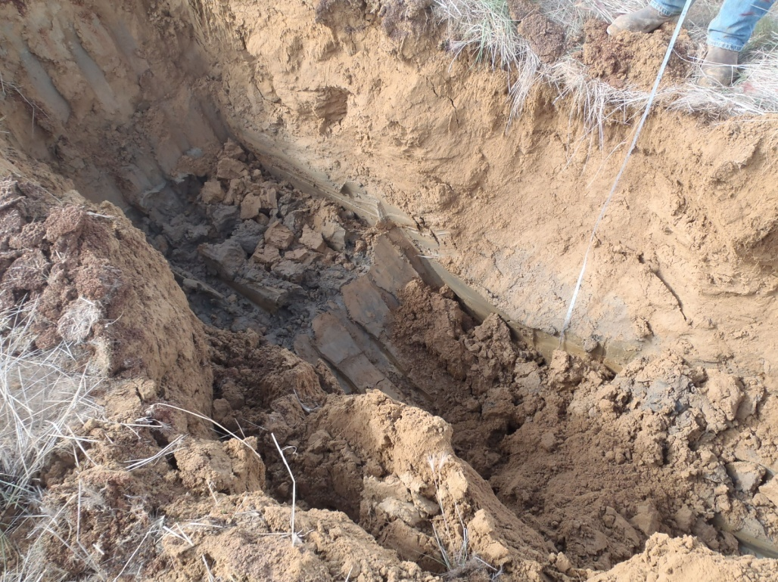

PHOTO 28: TP-T-13-02: Test pit to approximately 1.5 m depth.

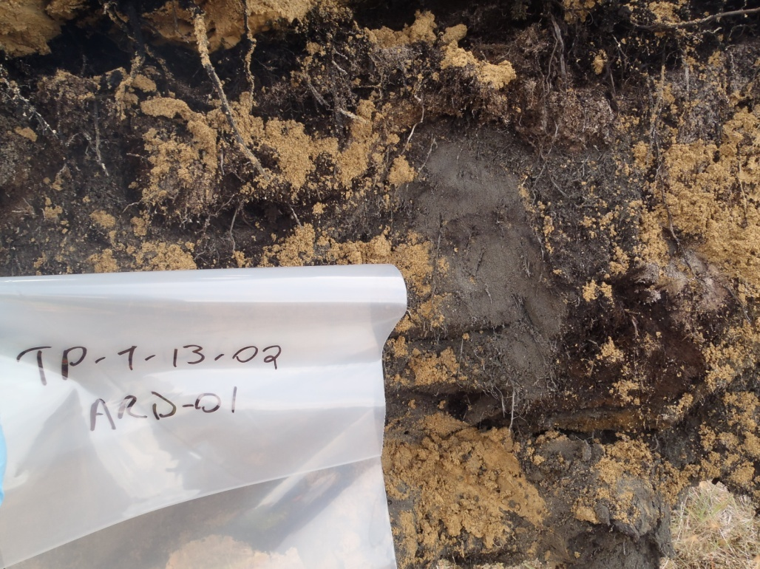

PHOTO 29: TP-T-13-01: Organics at 2.6 m depth.
Government of Yukon - AAM
Mount Nansen 2013 Site Investigation
Photographs
Logged by: SM | Scale: NTS | Date: Oct 2013 | Project: VM00605E | Page 15

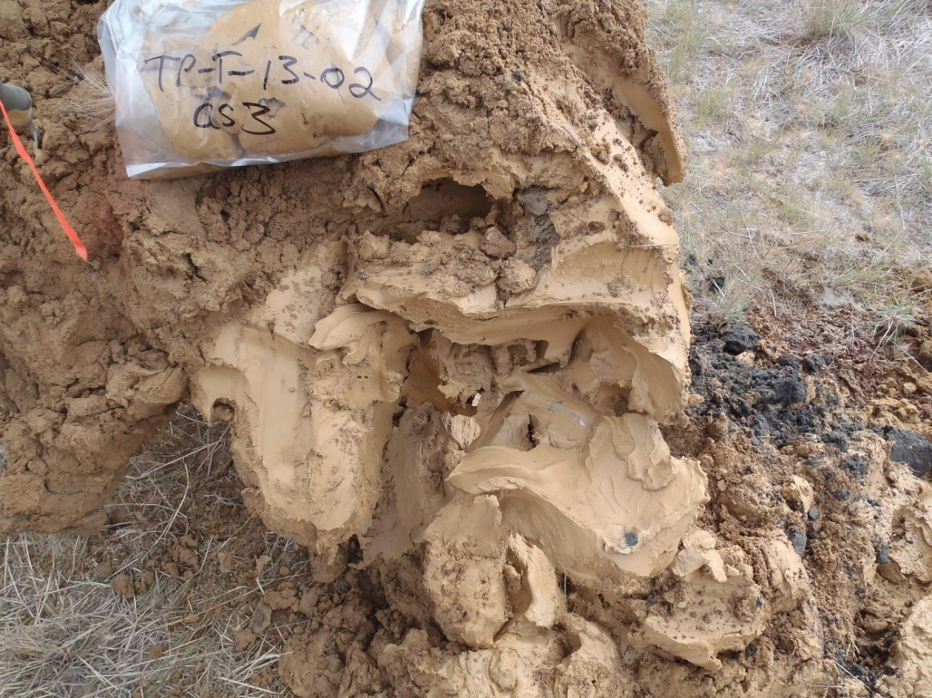

PHOTO 30: TP-T-13-02: Fine tailings at about 2.5 m depth.

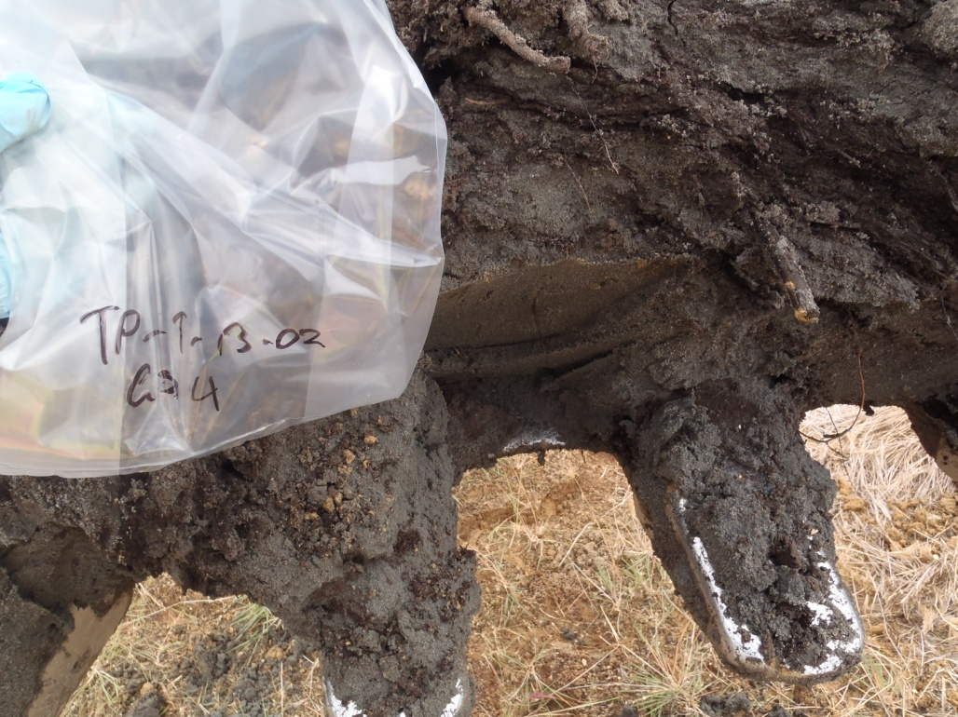

PHOTO 31: TP-T-13-02: Native sand at 3.3 m depth.
Government of Yukon - AAM
Mount Nansen 2013 Site Investigation
Photographs
Logged by: SM | Scale: NTS | Date: Oct 2013 | Project: VM00605E | Page 16

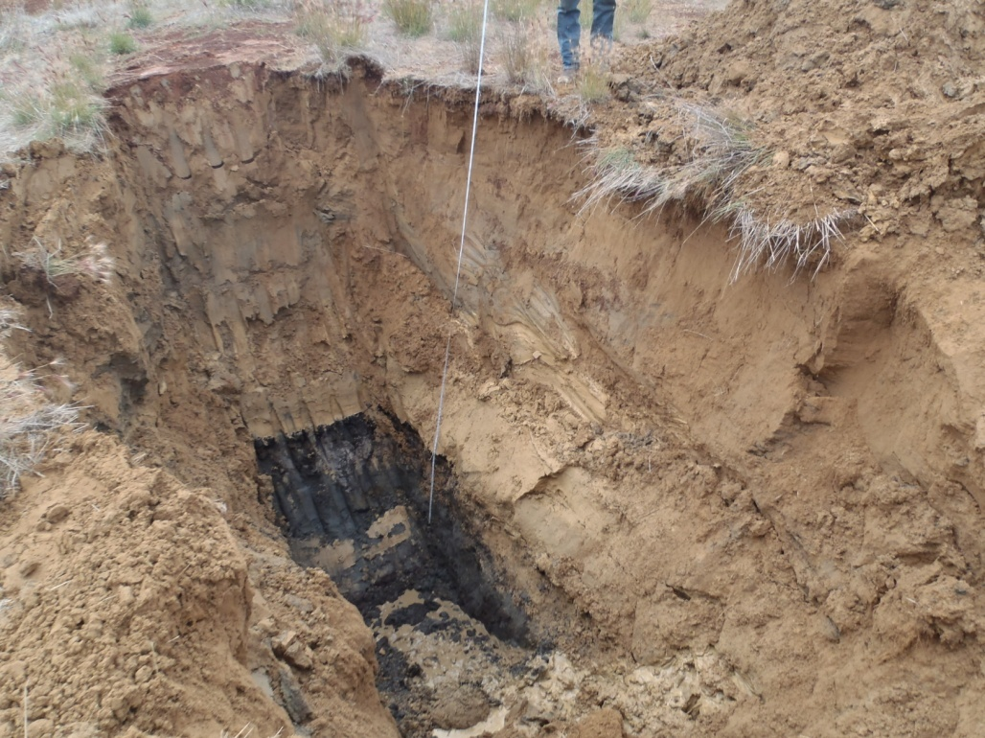

PHOTO 32: TP-T-13-02: Test pit standing up at about 3 m depth.

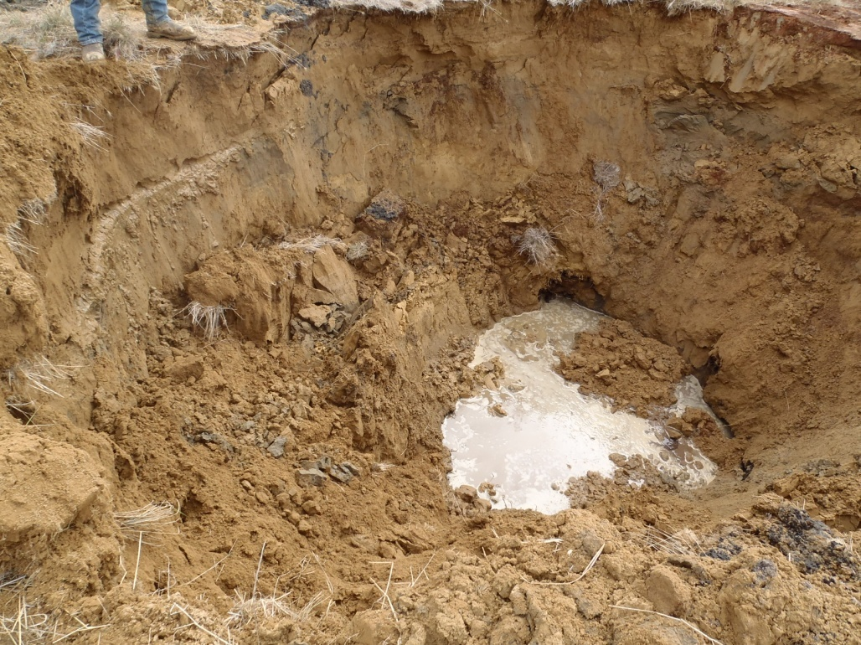

PHOTO 33: TP-T-13-02: Test pit filling with water and sloughing in at completion.
Government of Yukon - AAM
Mount Nansen 2013 Site Investigation
Photographs
Logged by: SM | Scale: NTS | Date: Oct 2013 | Project: VM00605E | Page 17

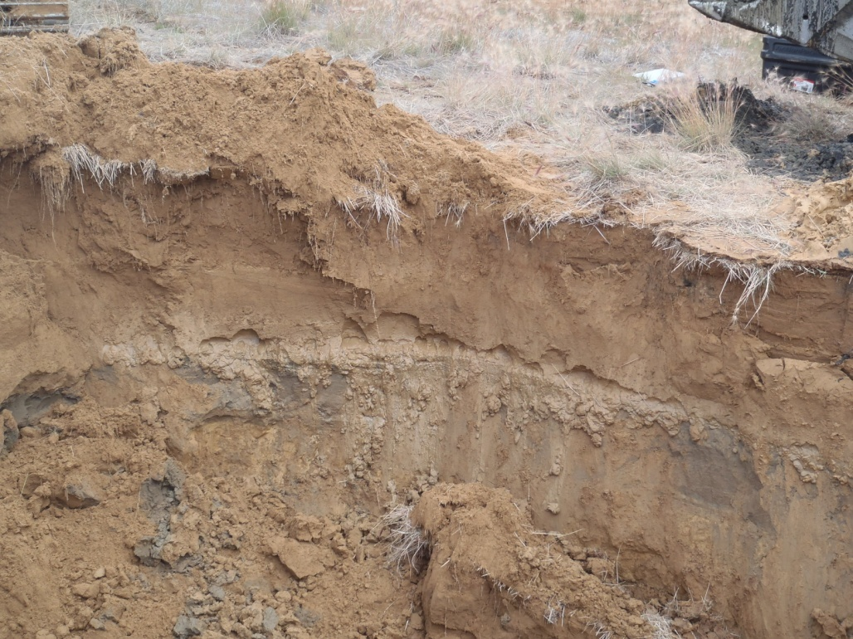

PHOTO 34: TP-T-13-02: Seepage at 0.9 m depth, on north side of test pit.

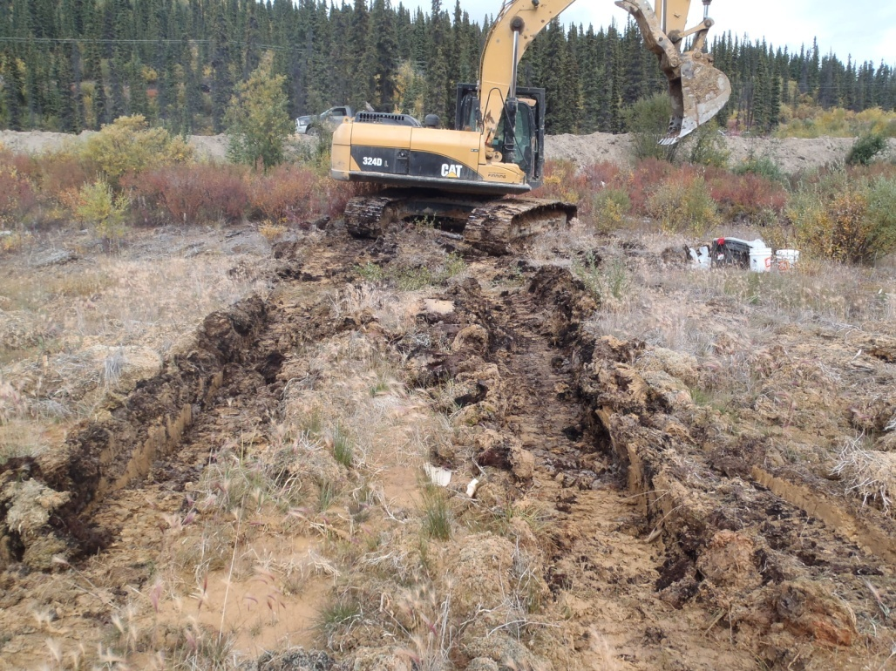

PHOTO 35: TP-T-13-02: Excavator leaving site to the north.
Government of Yukon - AAM
Mount Nansen 2013 Site Investigation
Photographs
Logged by: SM | Scale: NTS | Date: Oct 2013 | Project: VM00605E | Page 18

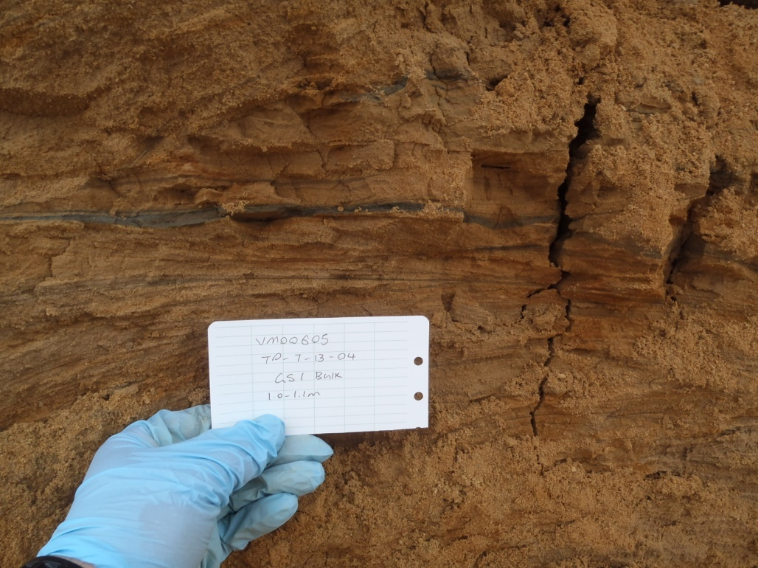

PHOTO 36: TP-T-13-04: Sand tailings at 1 m depth.

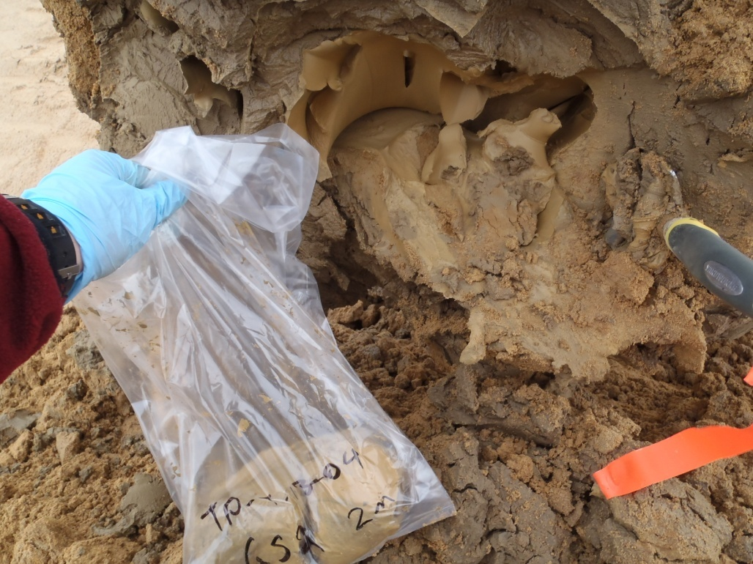

PHOTO 37: TP-T-13-04: Fine grained tailings at 2 m depth.
Government of Yukon - AAM
Mount Nansen 2013 Site Investigation
Photographs
Logged by: SM | Scale: NTS | Date: Oct 2013 | Project: VM00605E | Page 19

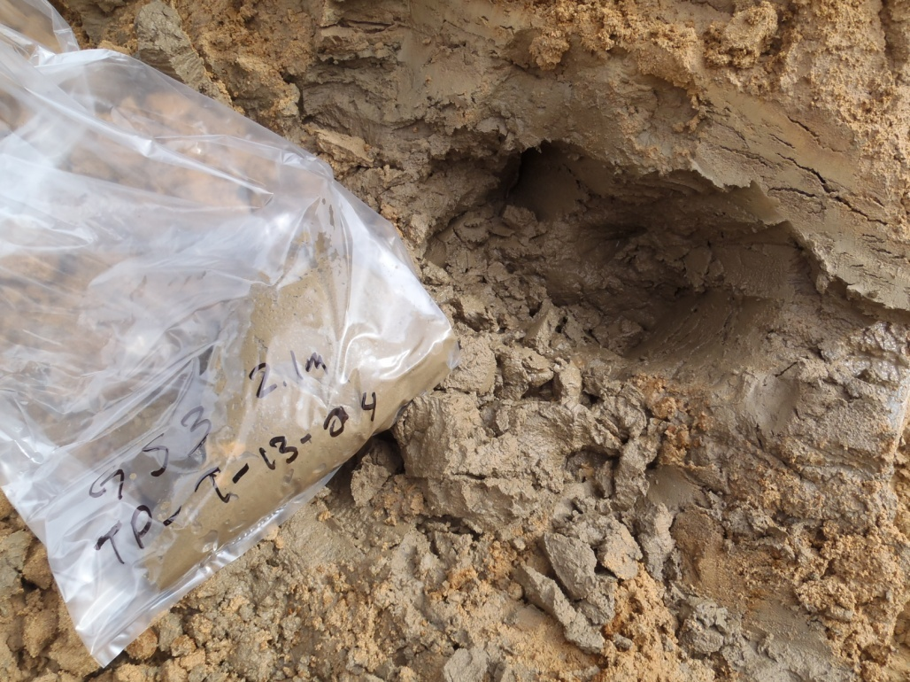

PHOTO 38: TP-T-13-04: Wet sand tailings at 2.1 m depth.

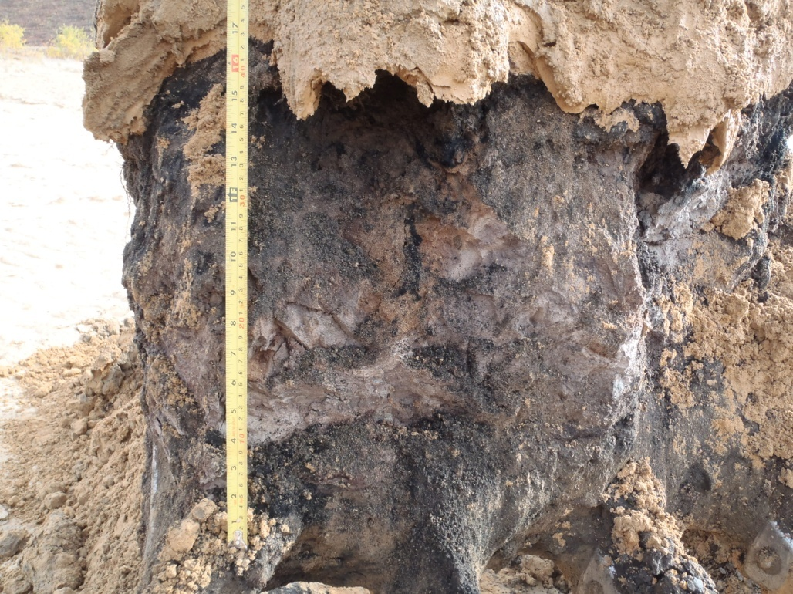

PHOTO 39: TP-T-13-04: Organics at 3.5 m depth.
Government of Yukon - AAM
Mount Nansen 2013 Site Investigation
Photographs
Logged by: SM | Scale: NTS | Date: Oct 2013 | Project: VM00605E | Page 20

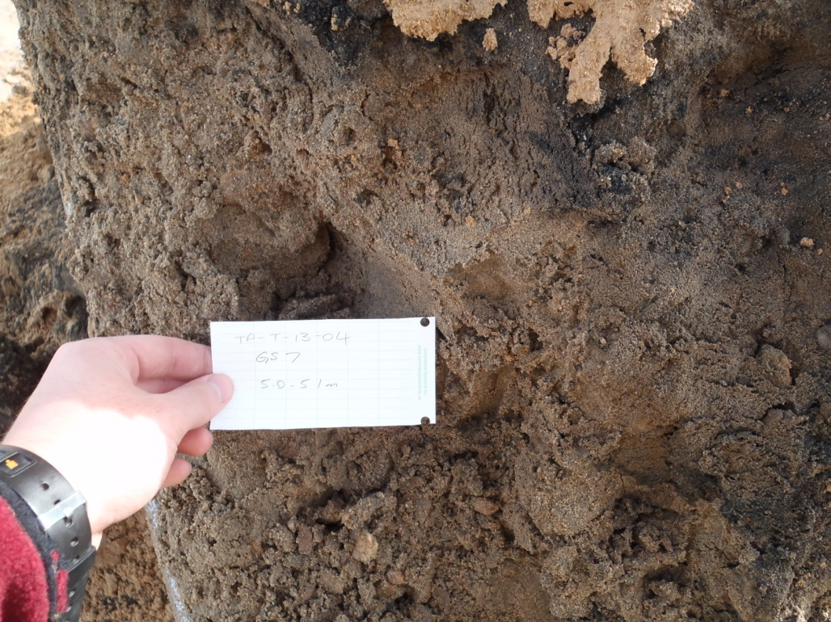

PHOTO 40: TP-T-13-04: Native sand at 5 m depth.

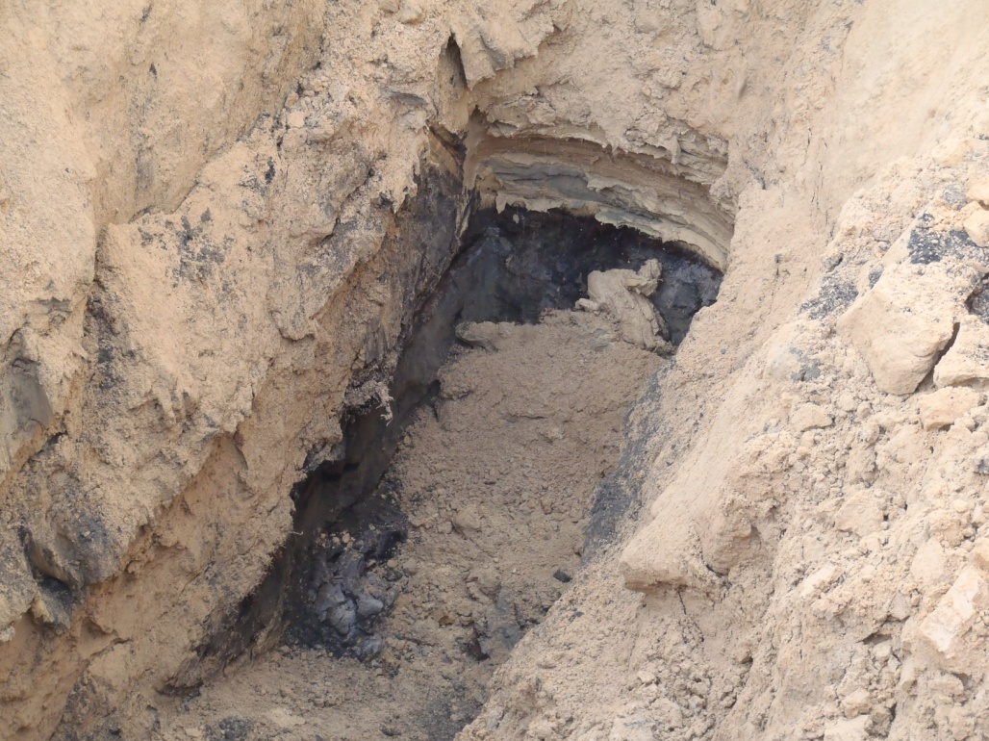

PHOTO 41: TP-T-13-04: Sand tailings over fine tailings over organics in test pit.
Government of Yukon - AAM
Mount Nansen 2013 Site Investigation
Photographs
Logged by: SM | Scale: NTS | Date: Oct 2013 | Project: VM00605E | Page 21

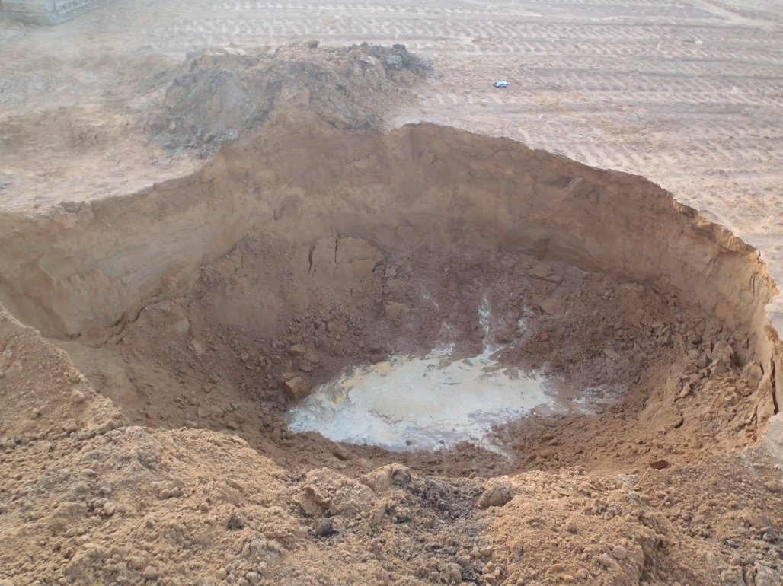

PHOTO 42: TP-T-13-04: Filled with water after being left open overnight.

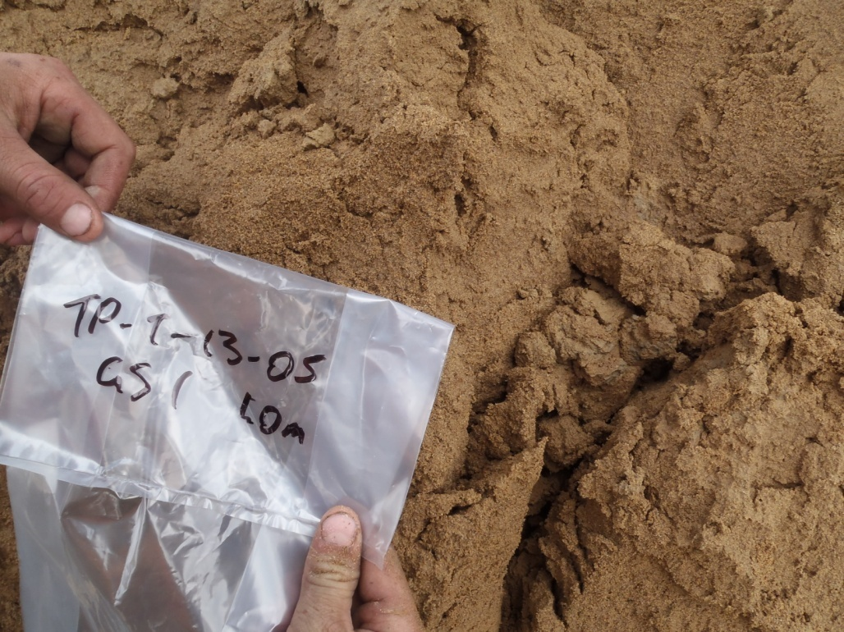

PHOTO 43: TP-T-13-05: Sand tailings at 1 m depth.
Government of Yukon - AAM
Mount Nansen 2013 Site Investigation
Photographs
Logged by: SM | Scale: NTS | Date: Oct 2013 | Project: VM00605E | Page 22

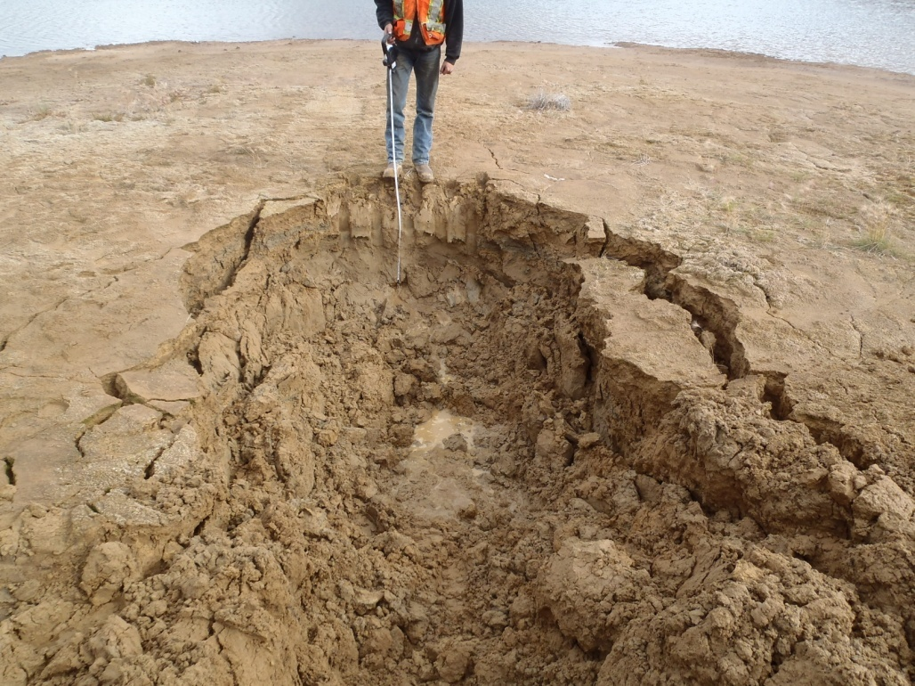

PHOTO 44: TP-T-13-05: Test pit at about 1.2 m depth.

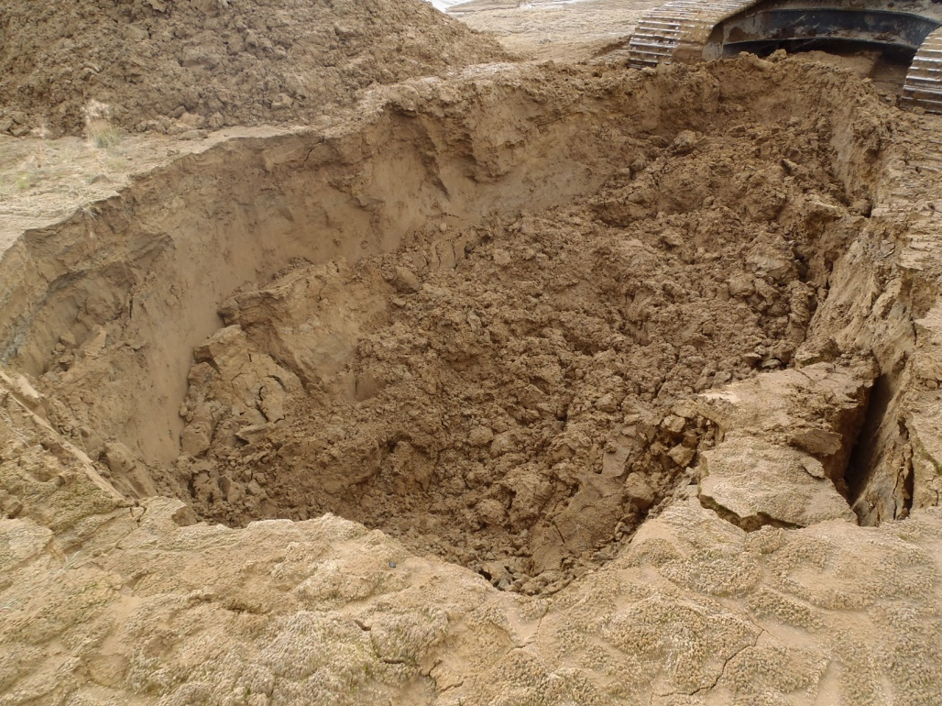

PHOTO 45: TP-T-13-05: Sloughing at completion.
Government of Yukon - AAM
Mount Nansen 2013 Site Investigation
Photographs
Logged by: SM | Scale: NTS | Date: Oct 2013 | Project: VM00605E | Page 23

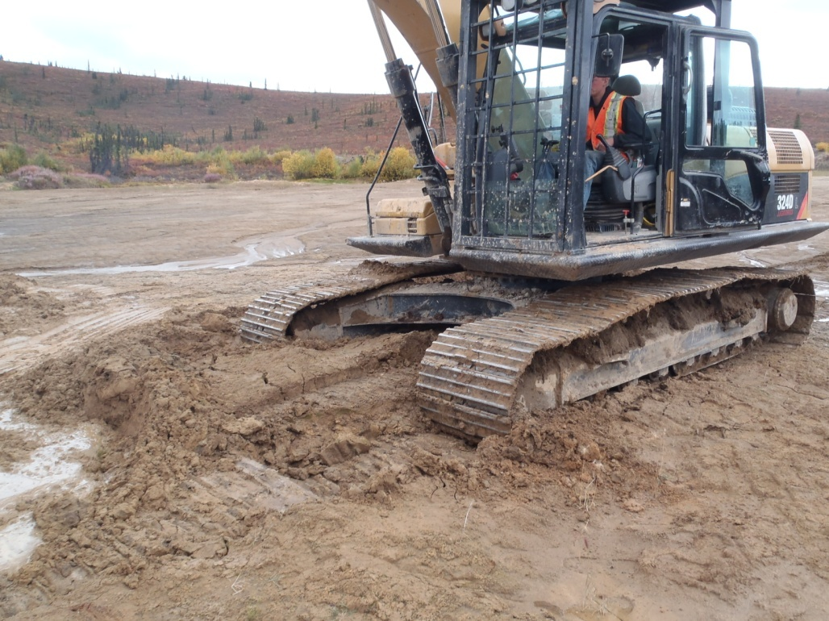

PHOTO 46: TP-T-13-05: Excavator sinking at completion of test pit.

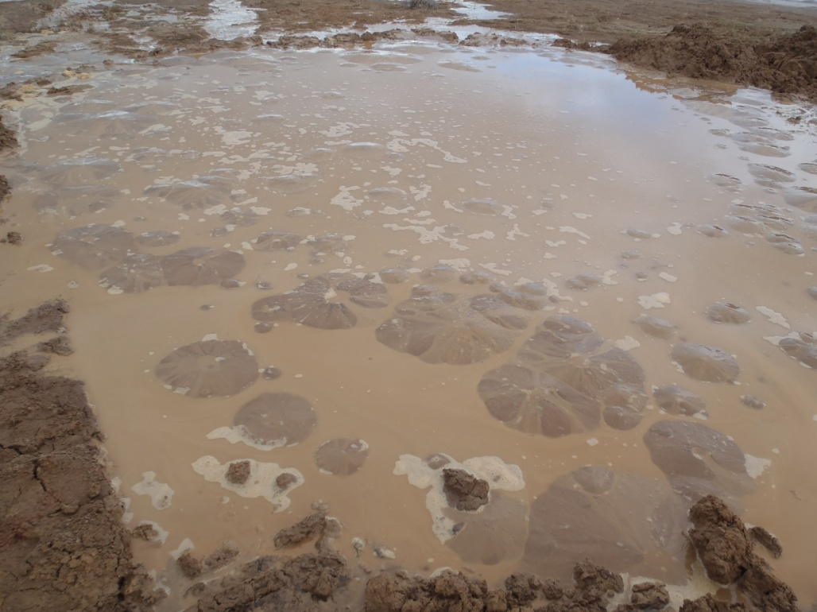

PHOTO 47: TP-T-13-05: Sand boils developing when liquefied the backfill.
Government of Yukon - AAM
Mount Nansen 2013 Site Investigation
Photographs
Logged by: SM | Scale: NTS | Date: Oct 2013 | Project: VM00605E | Page 24

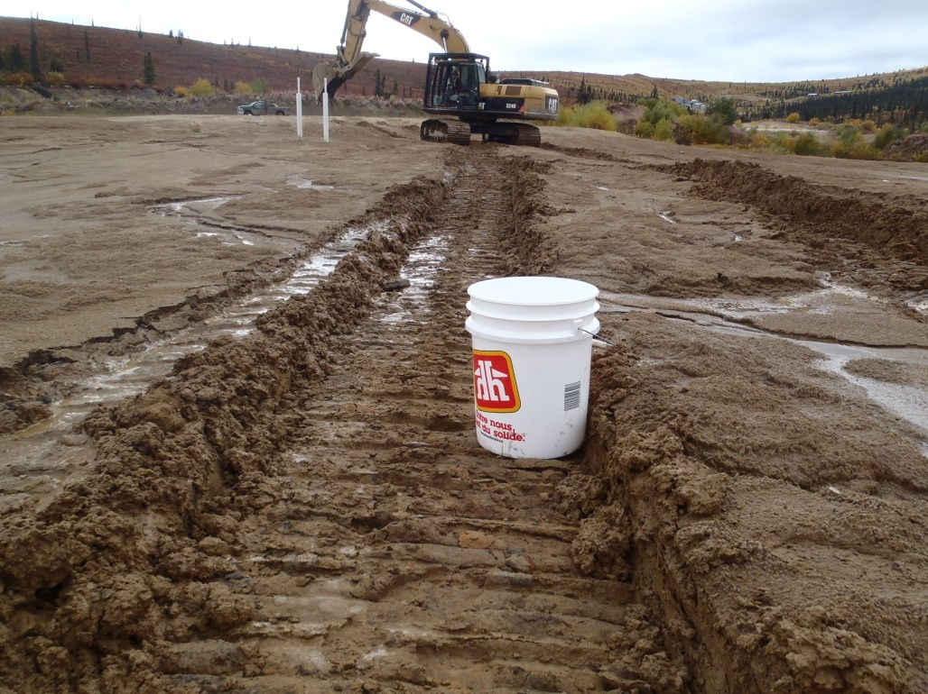

PHOTO 48: TP-T-13-05: Ruts on the tailings surface after 2 passes with the excavator.

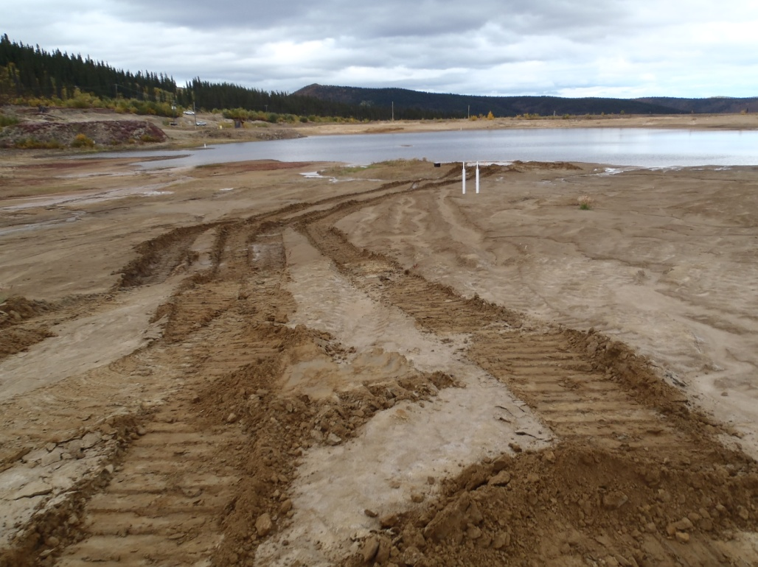

PHOTO 49: TP-T-13-05: Ruts on the tailings surface after completing test pit.
Government of Yukon - AAM
Mount Nansen 2013 Site Investigation
Photographs
Logged by: SM | Scale: NTS | Date: Oct 2013 | Project: VM00605E | Page 25

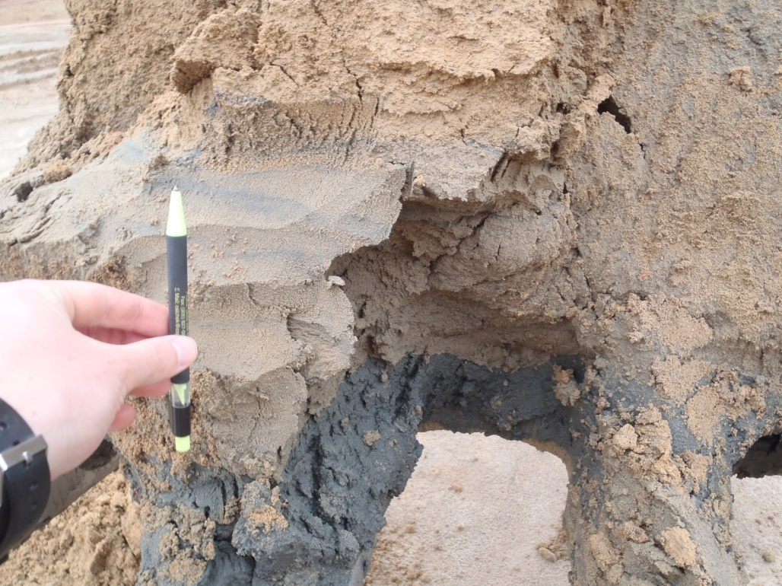

PHOTO 50: TP-T-13-06: Sand tailings overlying native sand at 2 m depth.

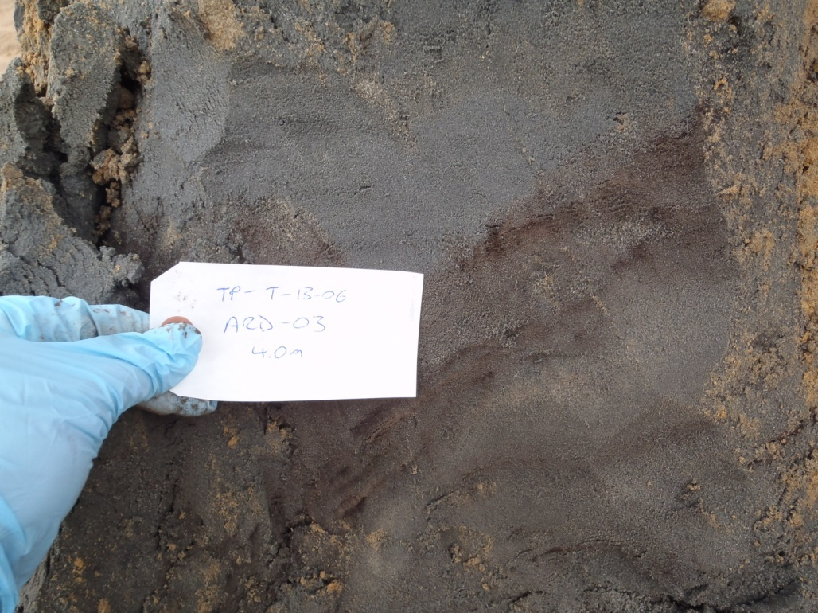

PHOTO 51: TP-T-13-06: Native sand at 4 m depth.
Government of Yukon - AAM
Mount Nansen 2013 Site Investigation
Photographs
Logged by: SM | Scale: NTS | Date: Oct 2013 | Project: VM00605E | Page 26

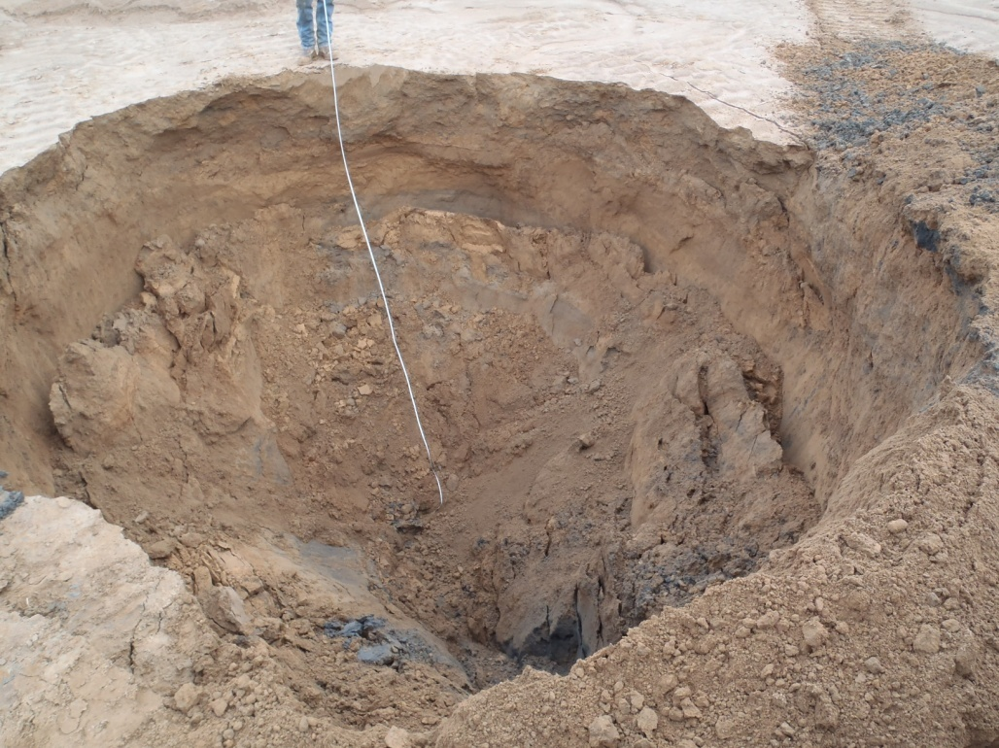

PHOTO 52: TP-T-13-06: Test pit sloughed at completion.

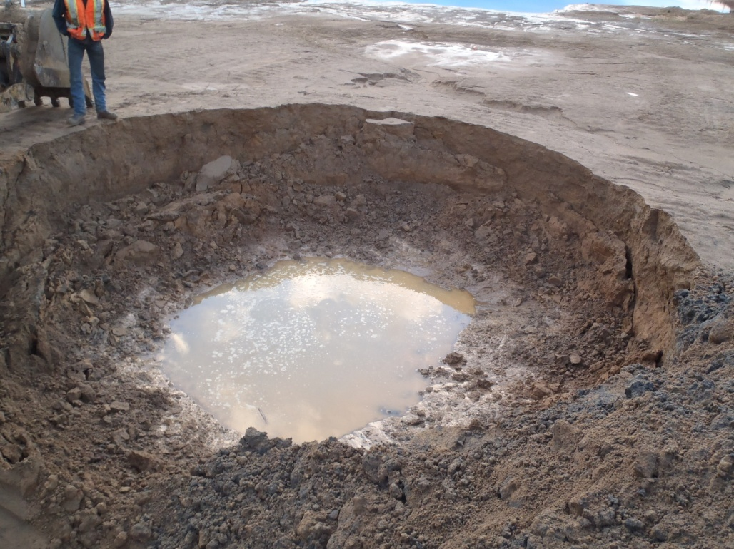

PHOTO 53: TP-T-13-06: Test pit filled with water and circular after being left open overnight.
Government of Yukon - AAM
Mount Nansen 2013 Site Investigation
Photographs
Logged by: SM | Scale: NTS | Date: Oct 2013 | Project: VM00605E | Page 27

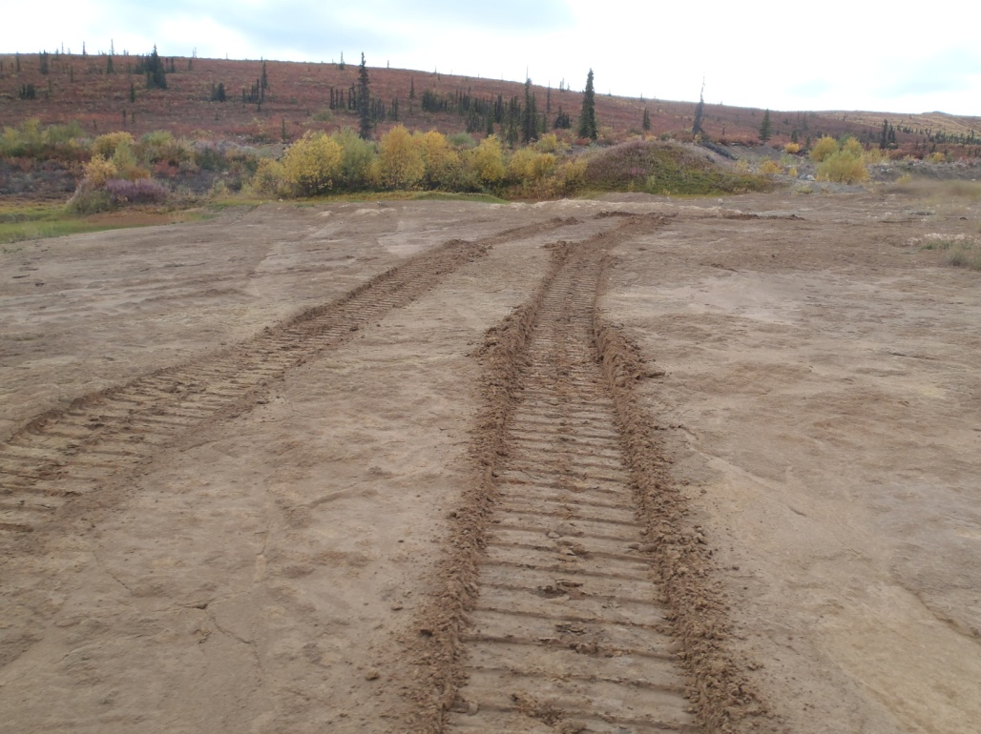

PHOTO 54: TP-T-13-07: One pass with the excavator to the test pit.

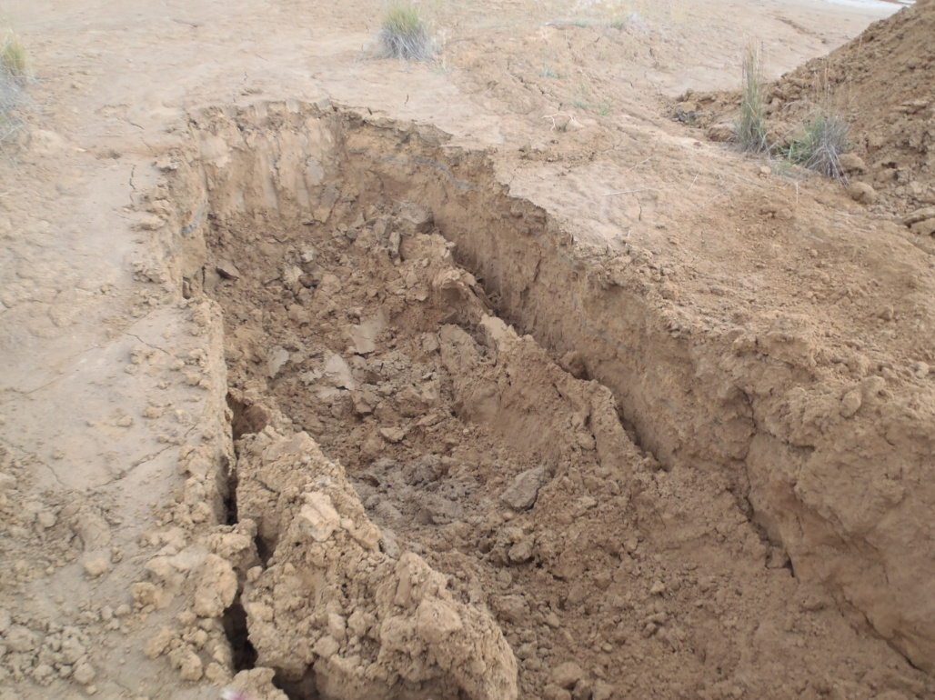

PHOTO 55: TP-T-13-07: Test pit at about 1 m depth.
Government of Yukon - AAM
Mount Nansen 2013 Site Investigation
Photographs
Logged by: SM | Scale: NTS | Date: Oct 2013 | Project: VM00605E | Page 28

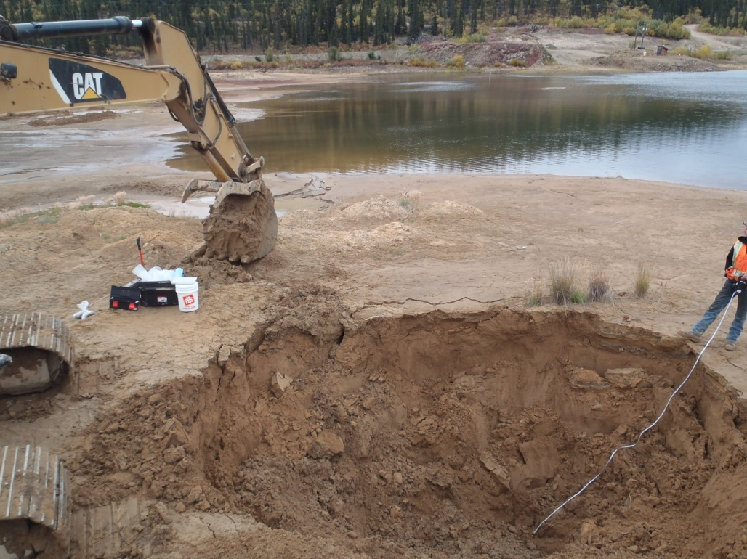

PHOTO 56: TP-T-13-07: Test pit at completion.

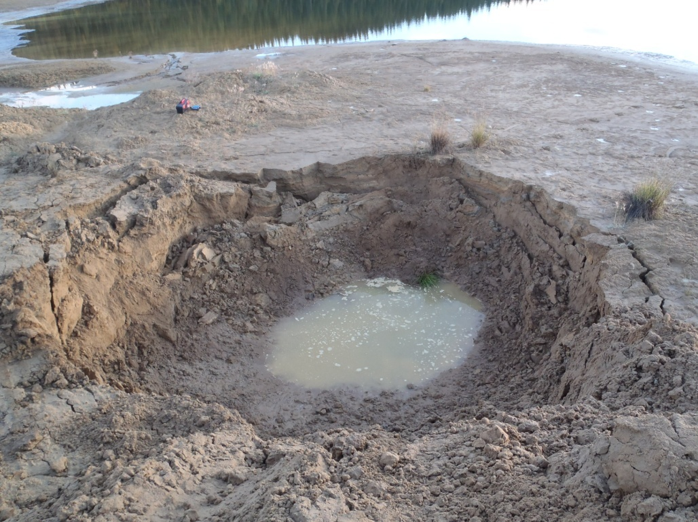

PHOTO 57: TP-T-13-07: Test pit filled with water after being left open overnight.
Government of Yukon - AAM
Mount Nansen 2013 Site Investigation
Photographs
Logged by: SM | Scale: NTS | Date: Oct 2013 | Project: VM00605E | Page 29

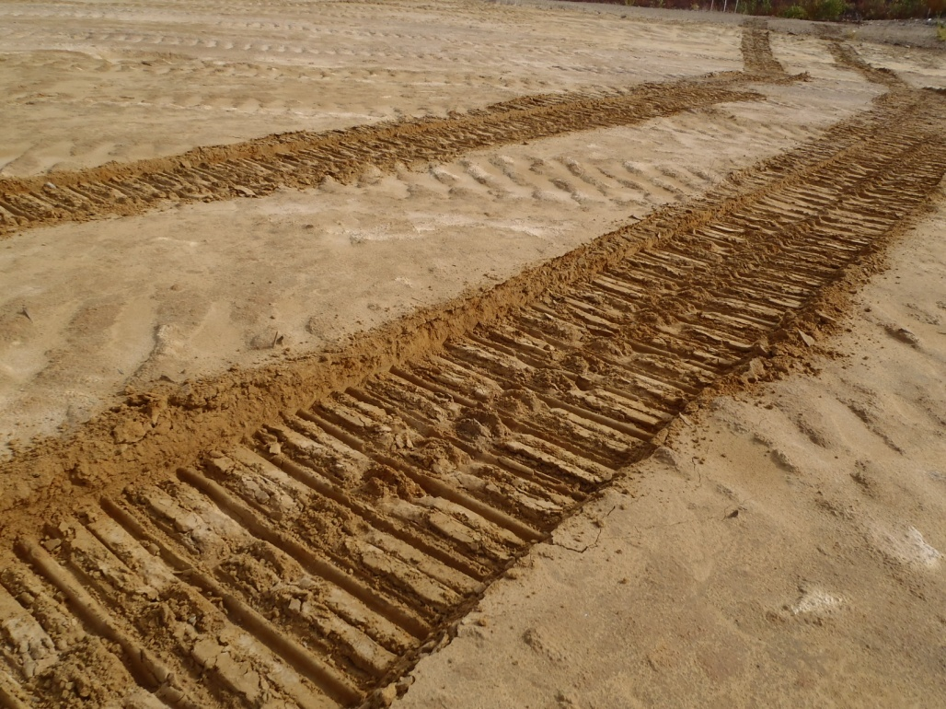

PHOTO 58: TP-T-13-09: Five passes with the excavator on the tailings surface.

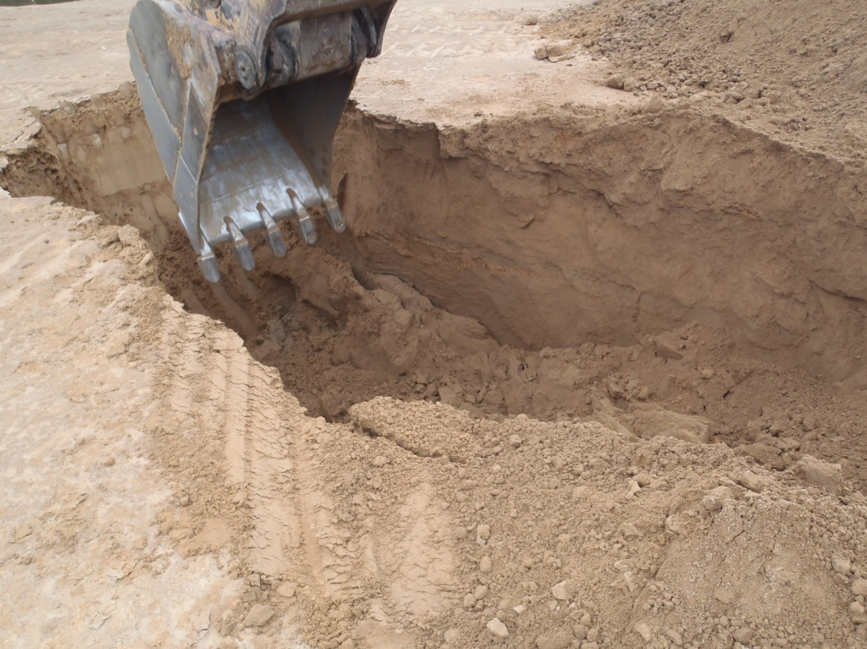

PHOTO 59: TP-T-13-09: Test pit at about 1.5 m depth.
Government of Yukon - AAM
Mount Nansen 2013 Site Investigation
Photographs
Logged by: SM | Scale: NTS | Date: Oct 2013 | Project: VM00605E | Page 30

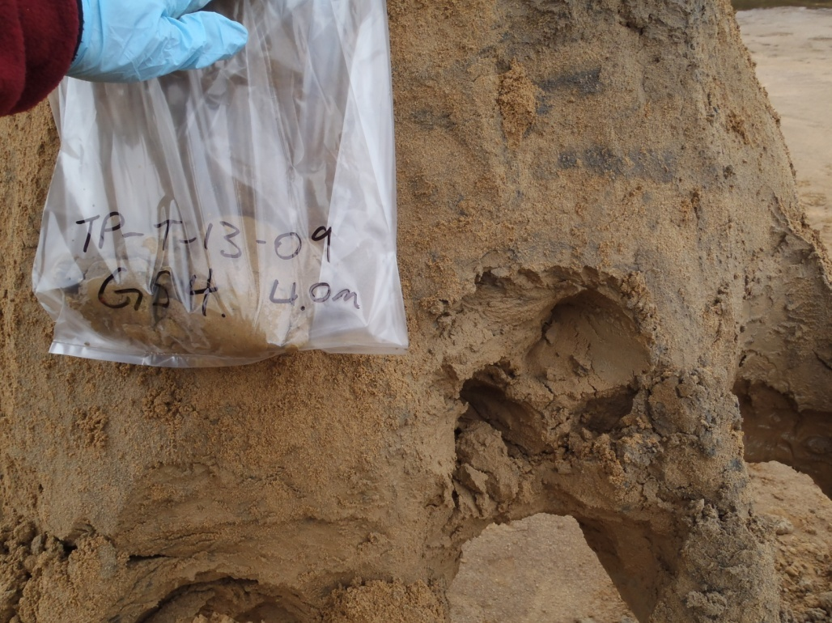

PHOTO 60: TP-T-13-09: Tailings sample at 4 m depth.

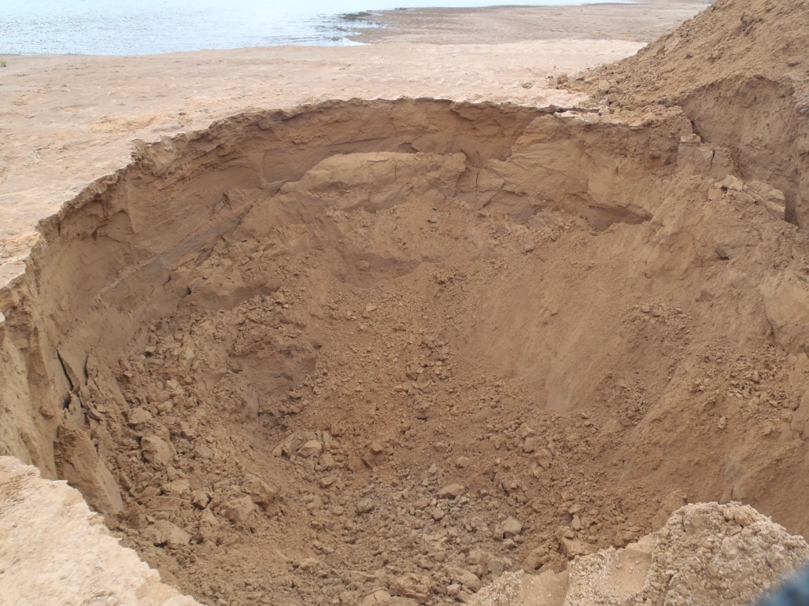

PHOTO 61: TP-T-13-09: Test pit at completion.
Government of Yukon - AAM
Mount Nansen 2013 Site Investigation
Photographs
Logged by: SM | Scale: NTS | Date: Oct 2013 | Project: VM00605E | Page 31

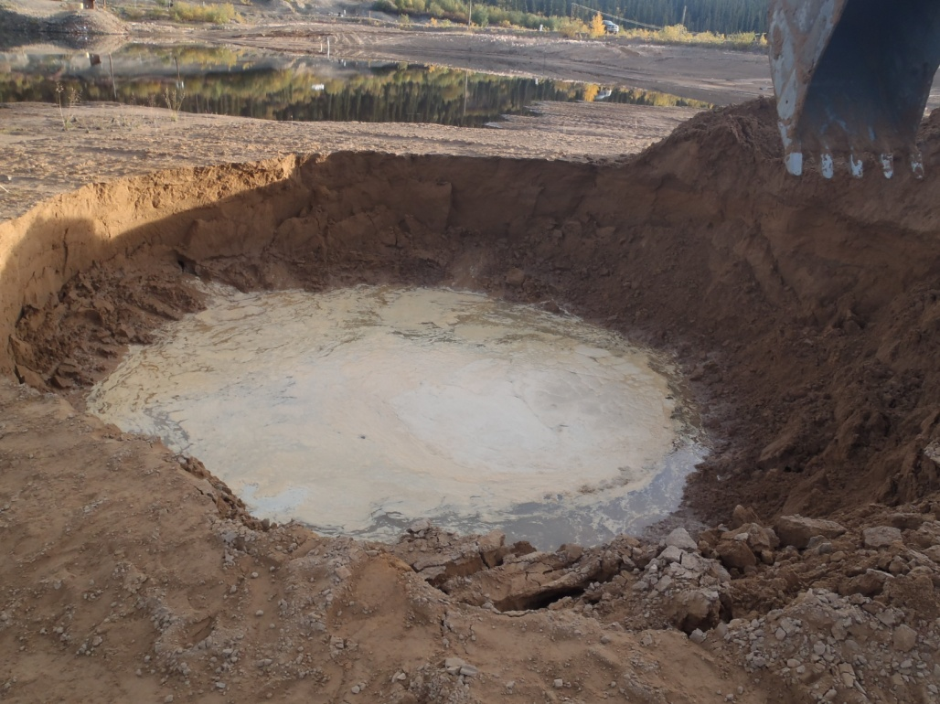

PHOTO 62: TP-T-13-09: Sloughed and filled with water after being left open overnight.
Government of Yukon - AAM
Mount Nansen 2013 Site Investigation
Photographs
Logged by: SM | Scale: NTS | Date: Oct 2013 | Project: VM00605E | Page 32

Photos of Test Pits in Waste Rock Area

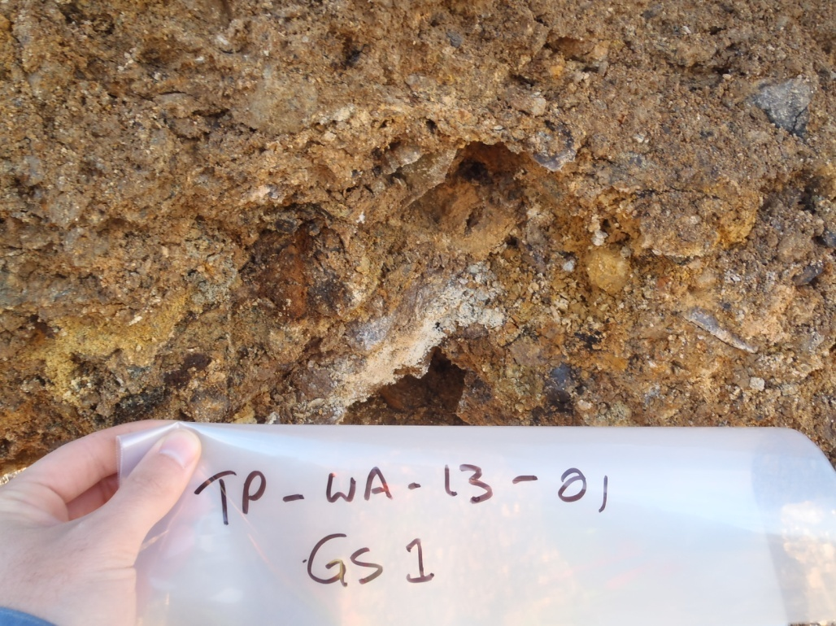

PHOTO 63: TP-WA-13-01: Highly oxidized waste rock at 1 m depth.

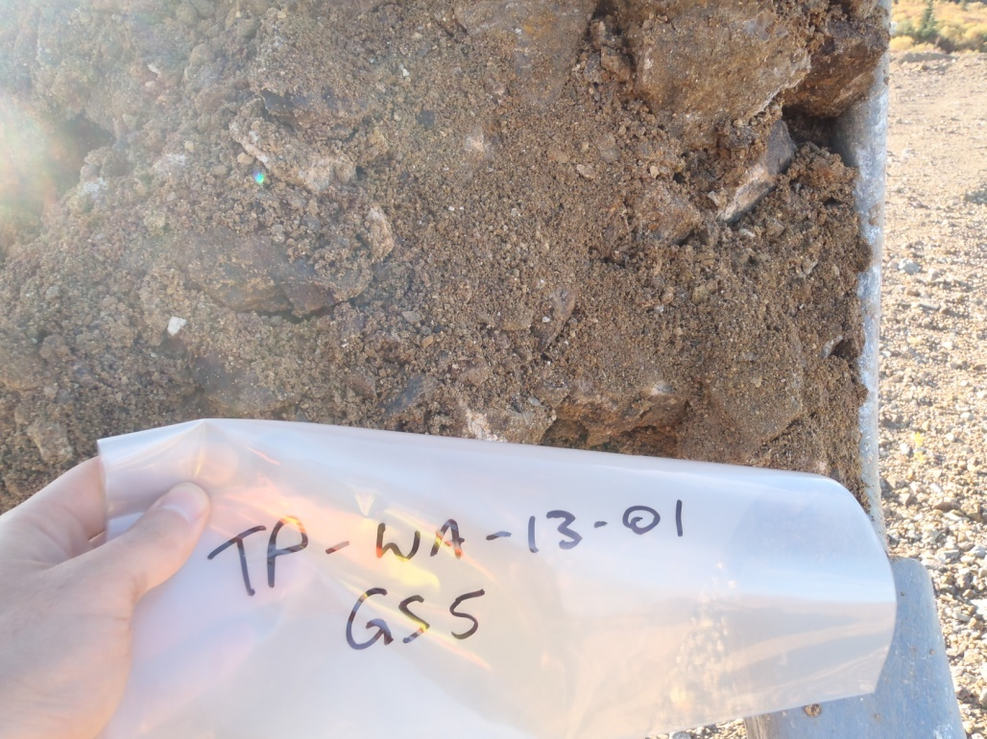

PHOTO 64: TP-WA-13-01: Low oxidized waste rock at 4 m depth.
Government of Yukon - AAM
Mount Nansen 2013 Site Investigation
Photographs
Logged by: SM | Scale: NTS | Date: Oct 2013 | Project: VM00605E | Page 33

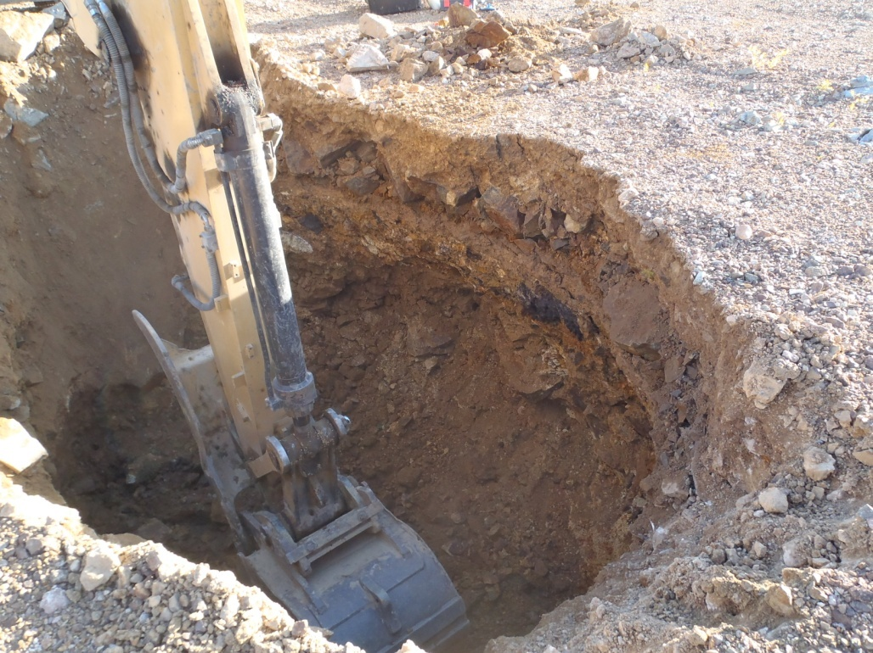

PHOTO 65: TP-WA-13-01: Test pit at completion.

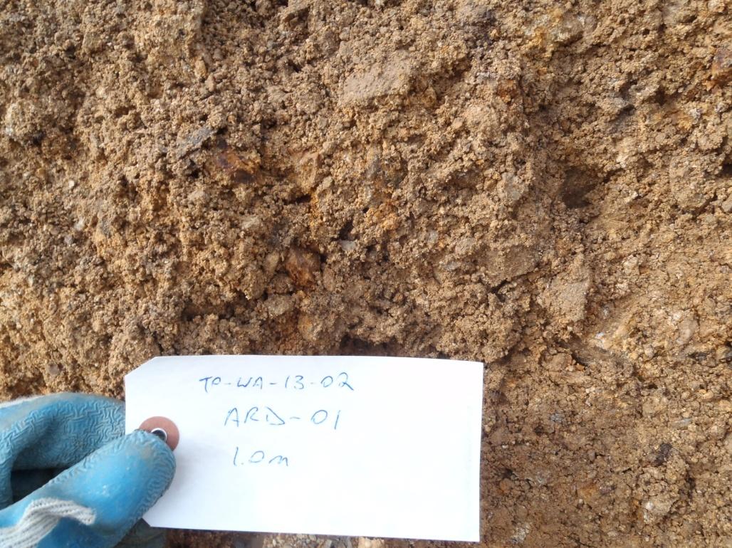

PHOTO 66: TP-WA-13-02: Moist waste rock sample at 1 m depth.
Government of Yukon - AAM
Mount Nansen 2013 Site Investigation
Photographs
Logged by: SM | Scale: NTS | Date: Oct 2013 | Project: VM00605E | Page 34

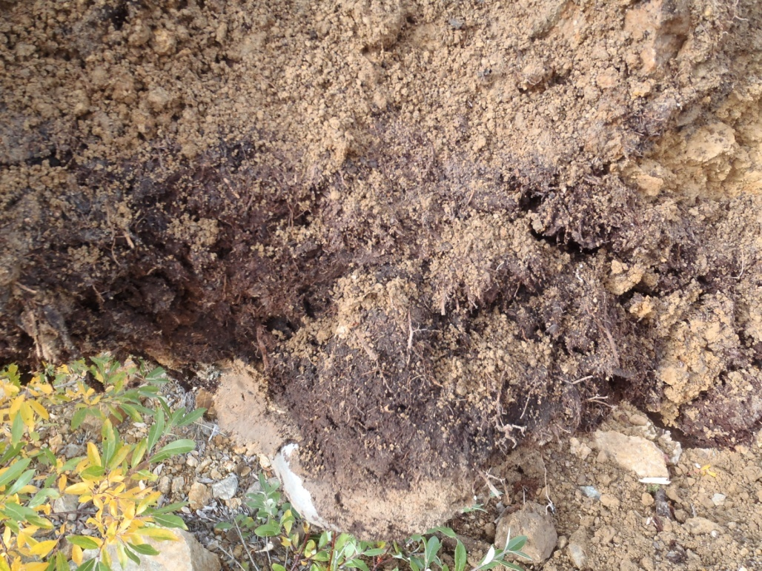

PHOTO 67: TP-WA-13-02: Thin layer of organics at 1.9 m separating 2 layers of waste rock.

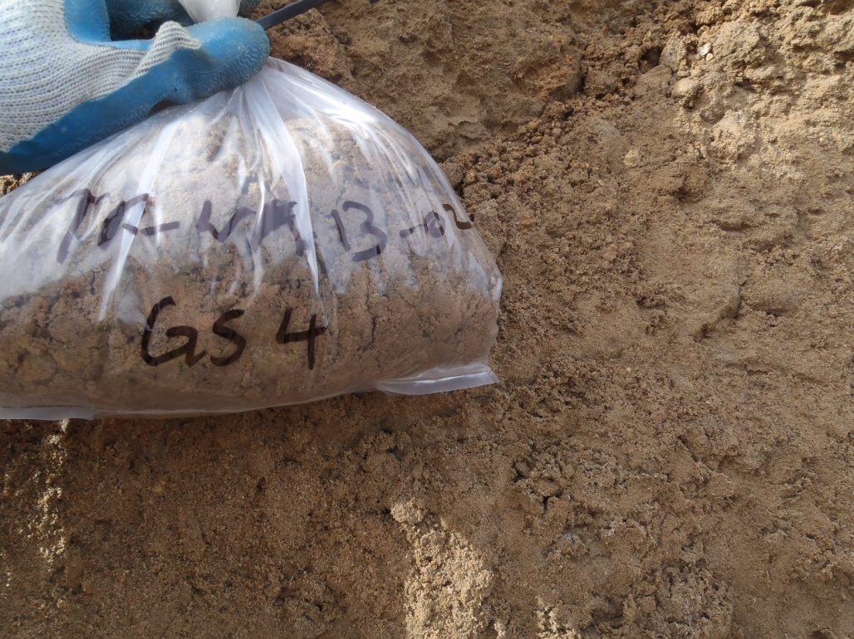

PHOTO 68: TP-WA-13-02: Native sand at 4.2 m depth.
Government of Yukon - AAM
Mount Nansen 2013 Site Investigation
Photographs
Logged by: SM | Scale: NTS | Date: Oct 2013 | Project: VM00605E | Page 35

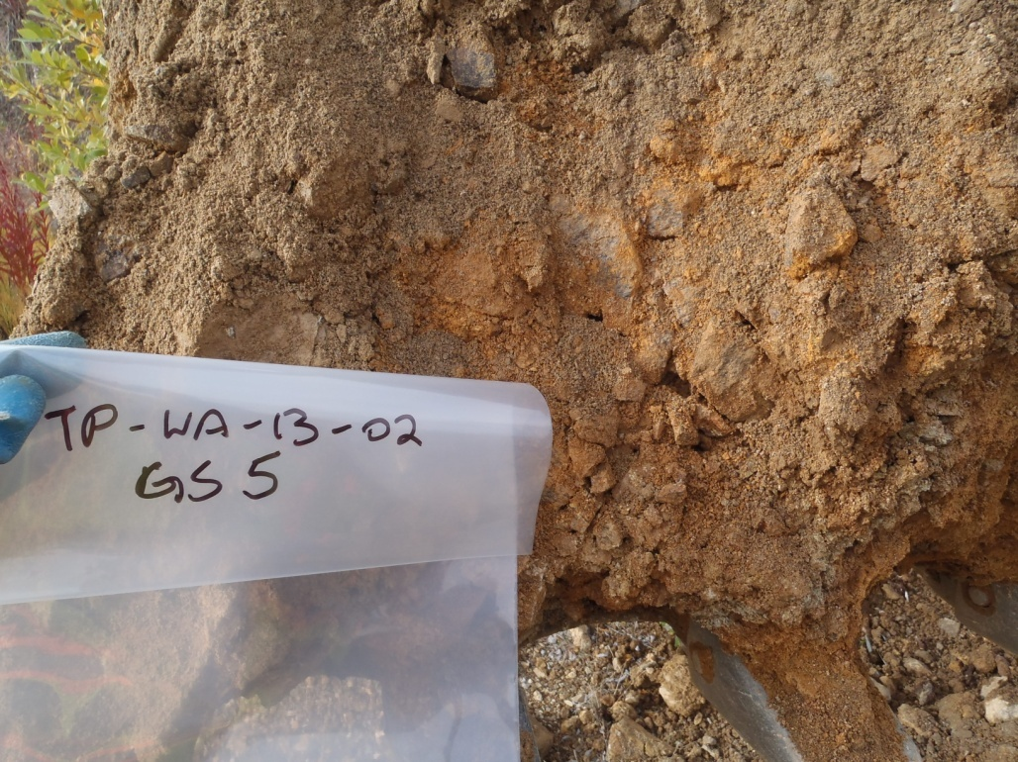

PHOTO 69: TP-WA-13-02: Weathered bedrock at 5.2 m depth.

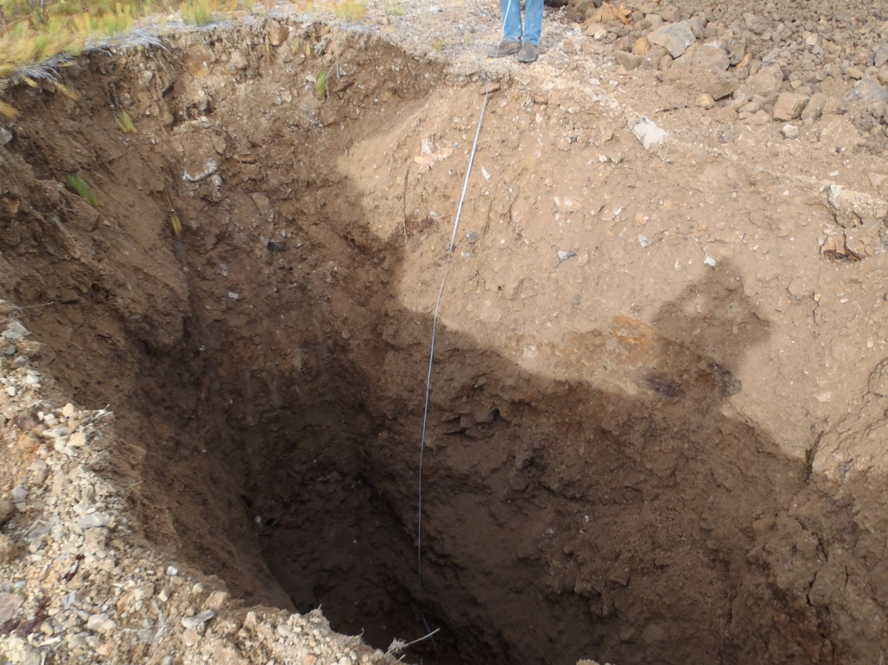

PHOTO 70: TP-WA-13-02: Test pit at completion.
Government of Yukon - AAM
Mount Nansen 2013 Site Investigation
Photographs
Logged by: SM | Scale: NTS | Date: Oct 2013 | Project: VM00605E | Page 36

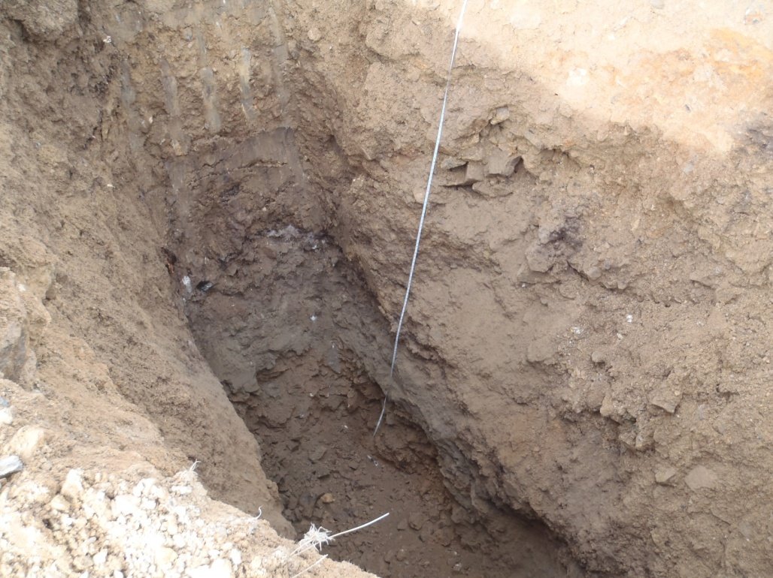

PHOTO 71: TP-WA-13-02: Weathered bedrock and native sand at bottom of test pit.

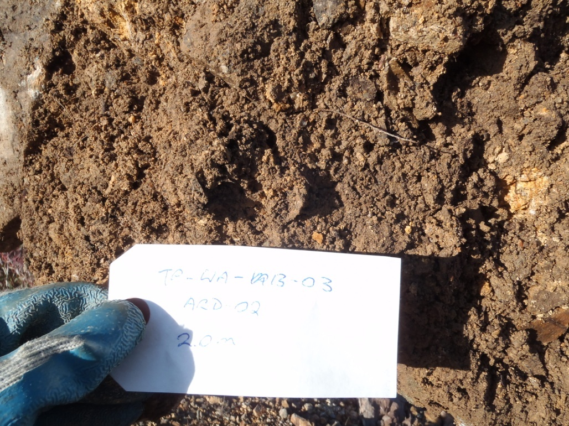

PHOTO 72: TP-WA-13-03: Waste rock sample at 2 m depth.
Government of Yukon - AAM
Mount Nansen 2013 Site Investigation
Photographs
Logged by: SM | Scale: NTS | Date: Oct 2013 | Project: VM00605E | Page 37

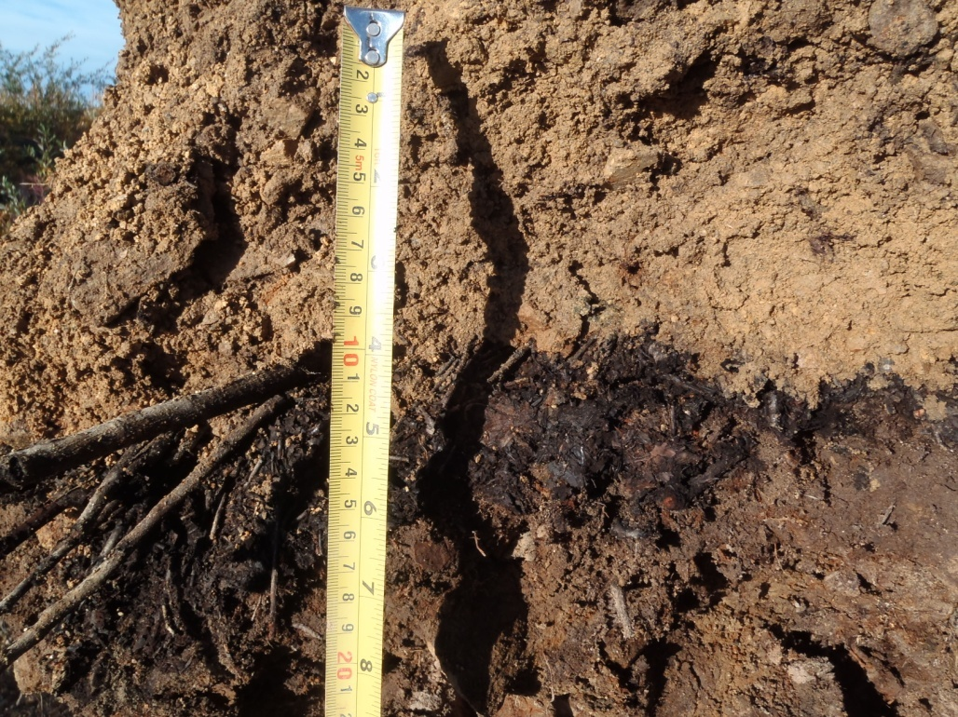

PHOTO 73: TP-WA-13-03: Layer of organics between waste rock at 2.6 m depth.

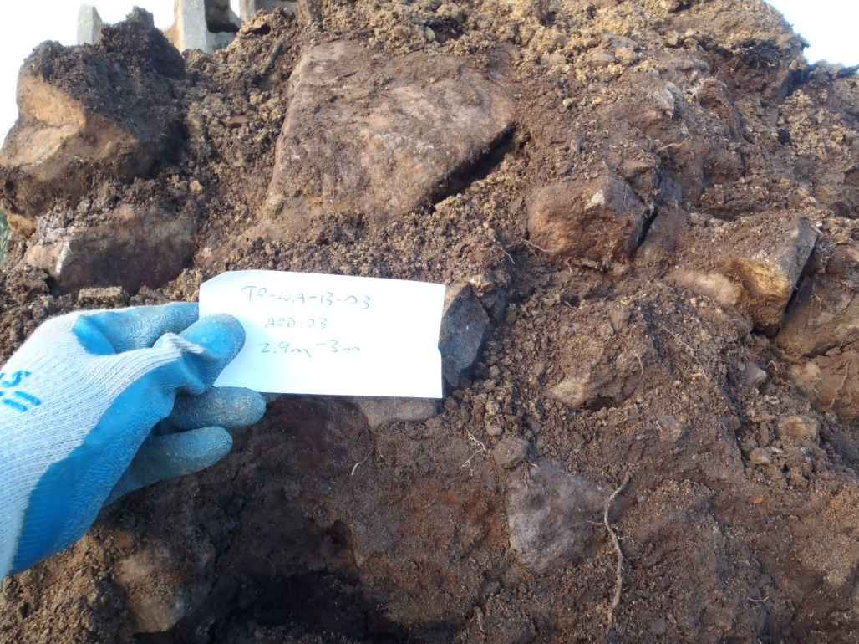

PHOTO 74: TP-WA-13-03: Low level oxidation waste rock, lots of oversize particles at 2.9 m depth.
Government of Yukon - AAM
Mount Nansen 2013 Site Investigation
Photographs
Logged by: SM | Scale: NTS | Date: Oct 2013 | Project: VM00605E | Page 38

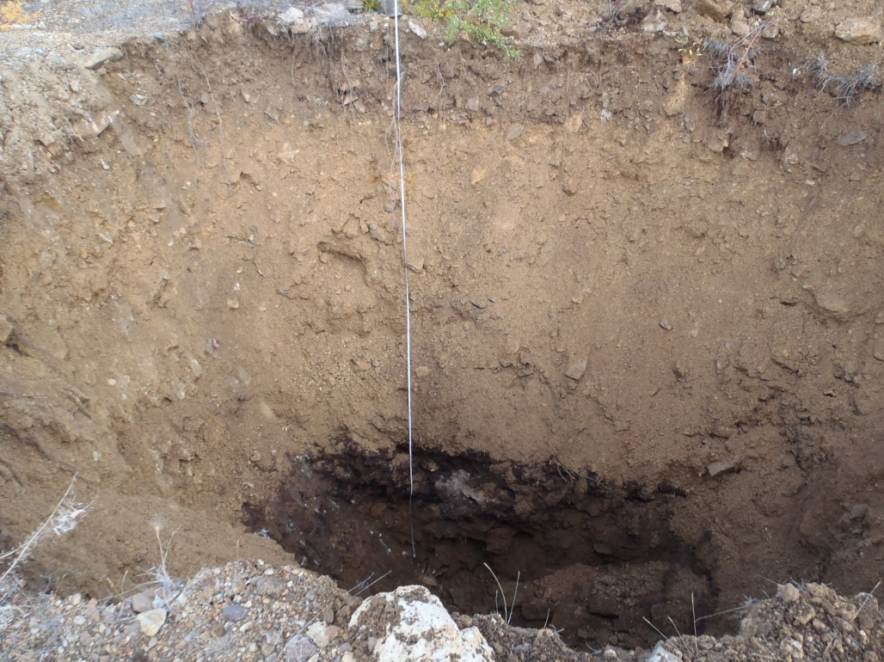

PHOTO 75: TP-WA-13-03: Test pit at completion.

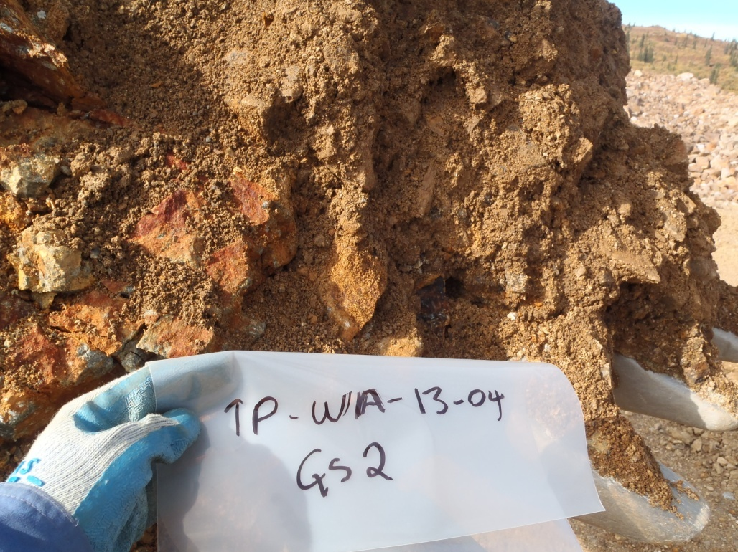

PHOTO 76: TP-WA-13-04: Moderate level of oxidation waste rock at 2 m depth.
Government of Yukon - AAM
Mount Nansen 2013 Site Investigation
Photographs
Logged by: SM | Scale: NTS | Date: Oct 2013 | Project: VM00605E | Page 39

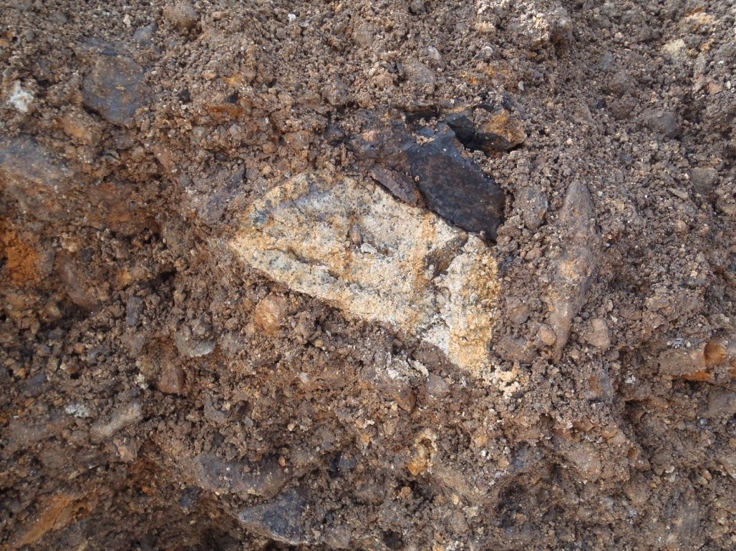

PHOTO 77: TP-WA-13-04: Example of a highly weathered piece of granitic rock, can crumble in hand, about 1 m depth.

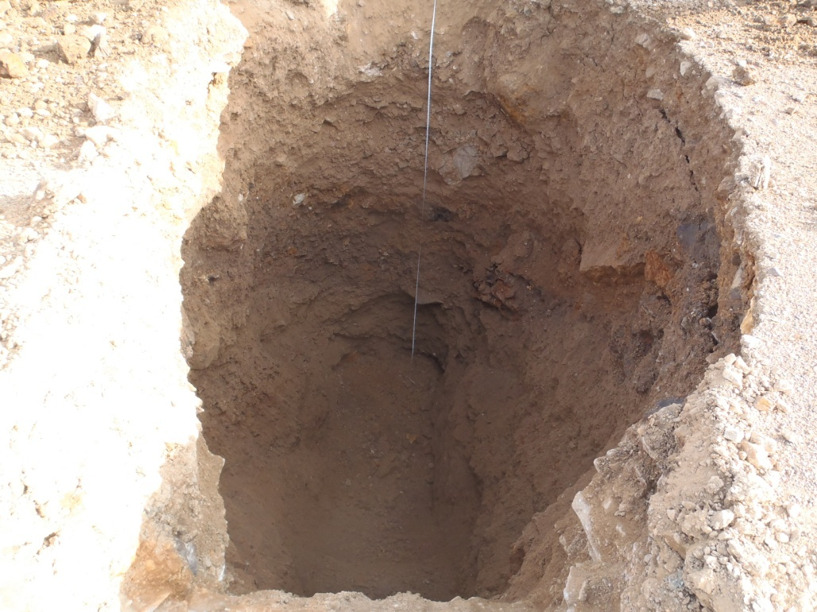

PHOTO 78: TP-WA-13-04: Test pit at completion.
Government of Yukon - AAM
Mount Nansen 2013 Site Investigation
Photographs
Logged by: SM | Scale: NTS | Date: Oct 2013 | Project: VM00605E | Page 40

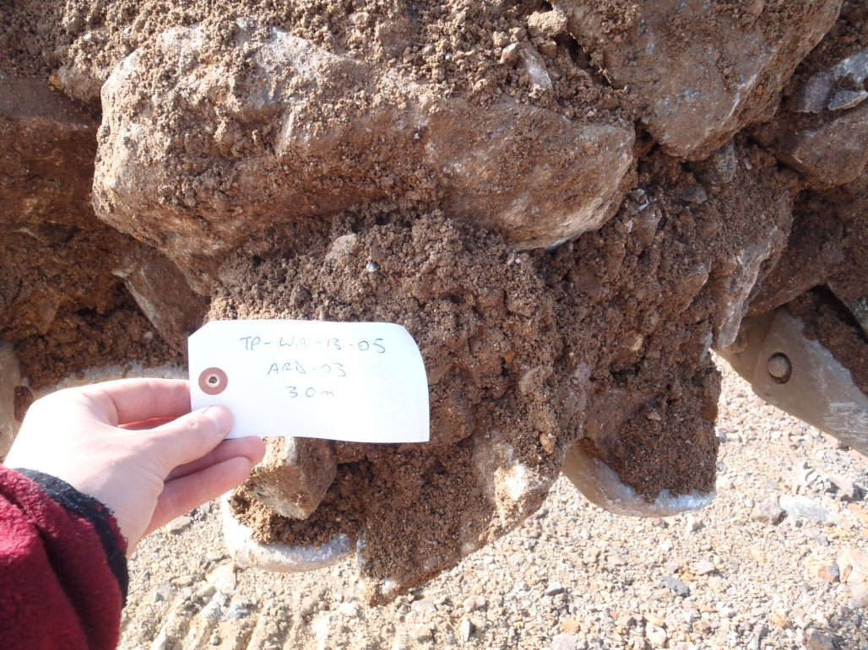

PHOTO 79: TP-WA-13-05: Waste rock sample with about 70% oversize 25 mm, at 3 m depth.

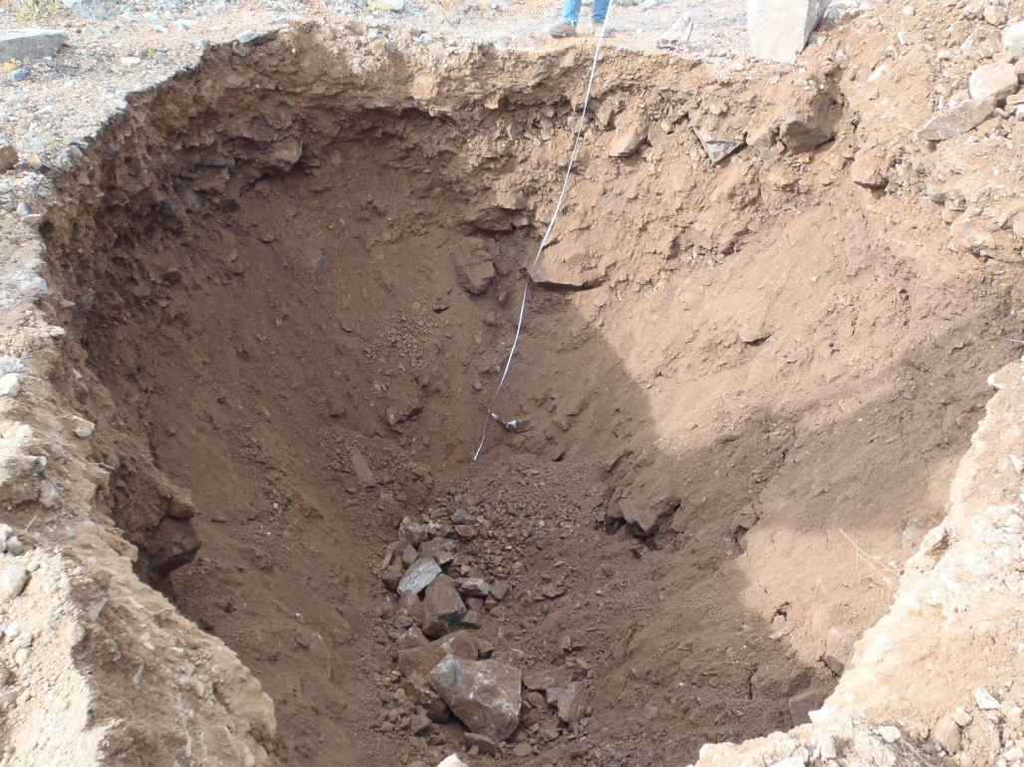

PHOTO 80: TP-WA-13-05: Test pit at completion, sloughing in.
Government of Yukon - AAM
Mount Nansen 2013 Site Investigation
Photographs
Logged by: SM | Scale: NTS | Date: Oct 2013 | Project: VM00605E | Page 41

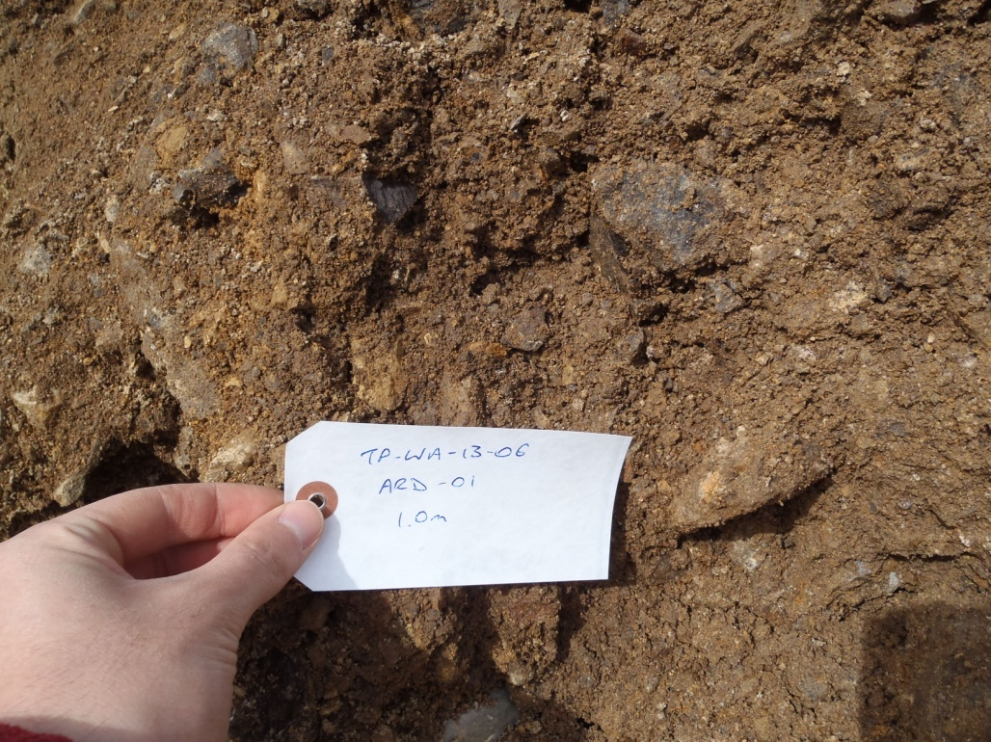

PHOTO 81: TP-WA-13-06: Moderately weathered waste rock sample with about 45 % oversize 25 mm at 1 m depth.

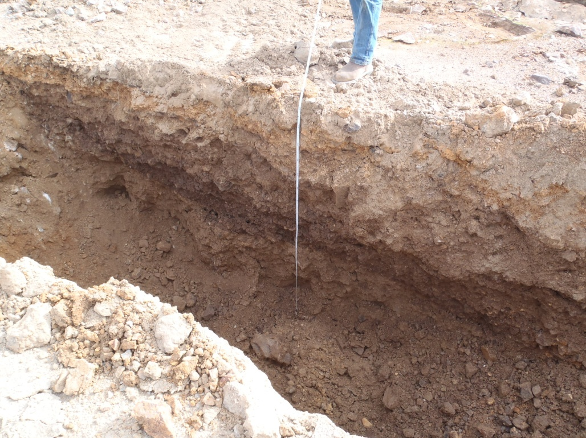

PHOTO 82: TP-WA-13-06: 300 mm thick waste rock stratified layers in upper meter.
Government of Yukon - AAM
Mount Nansen 2013 Site Investigation
Photographs
Logged by: SM | Scale: NTS | Date: Oct 2013 | Project: VM00605E | Page 42

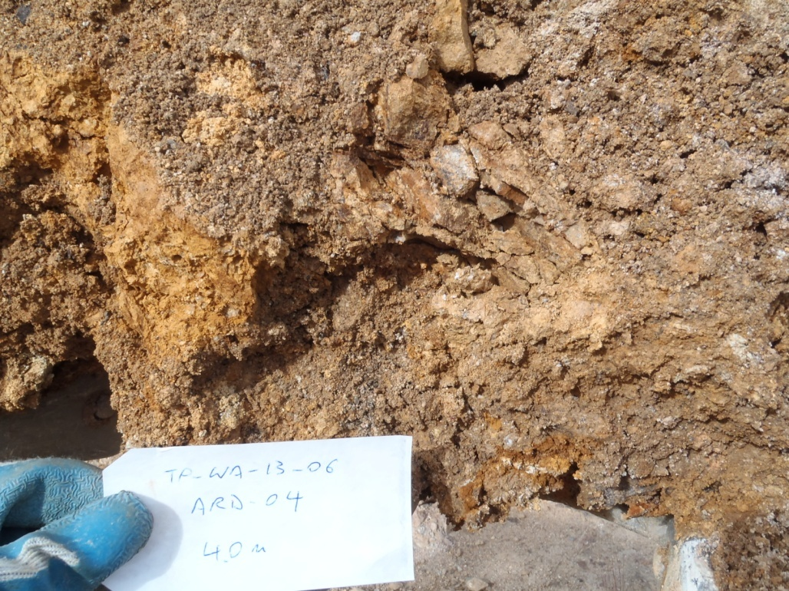

PHOTO 83: TP-WA-13-06: Oxidized waste rock sample at 4 m depth, about 60% oversize 25 mm.

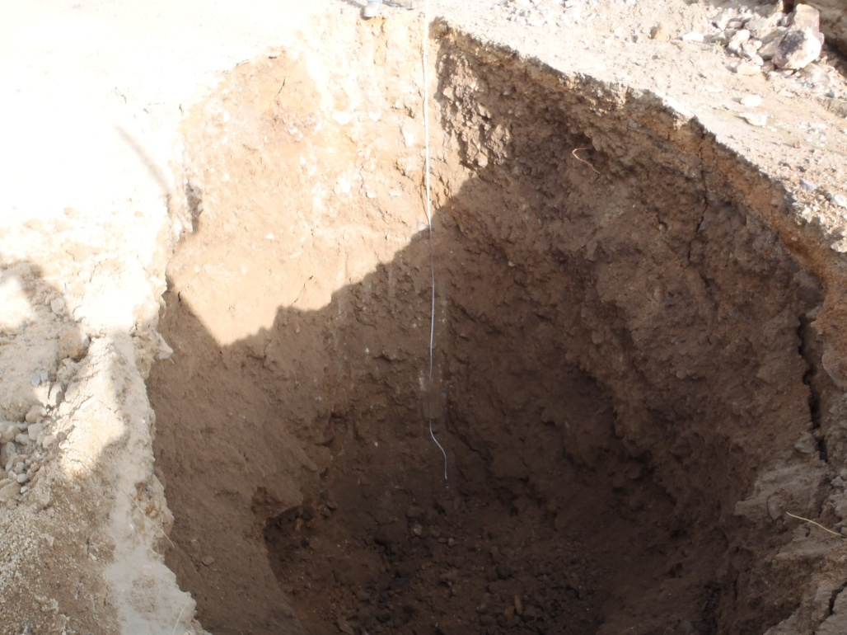

PHOTO 84: TP-WA-13-06: Test pit at completion.
Government of Yukon - AAM
Mount Nansen 2013 Site Investigation
Photographs
Logged by: SM | Scale: NTS | Date: Oct 2013 | Project: VM00605E | Page 43

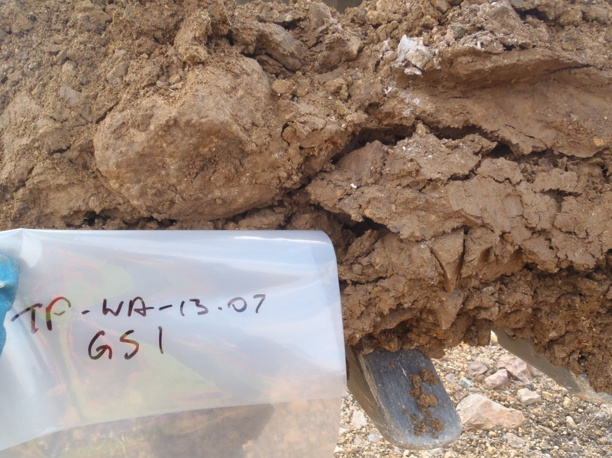

PHOTO 85: TP-WA-13-07: Moist waste rock at 1 m depth, about 40% oversize 25 mm.

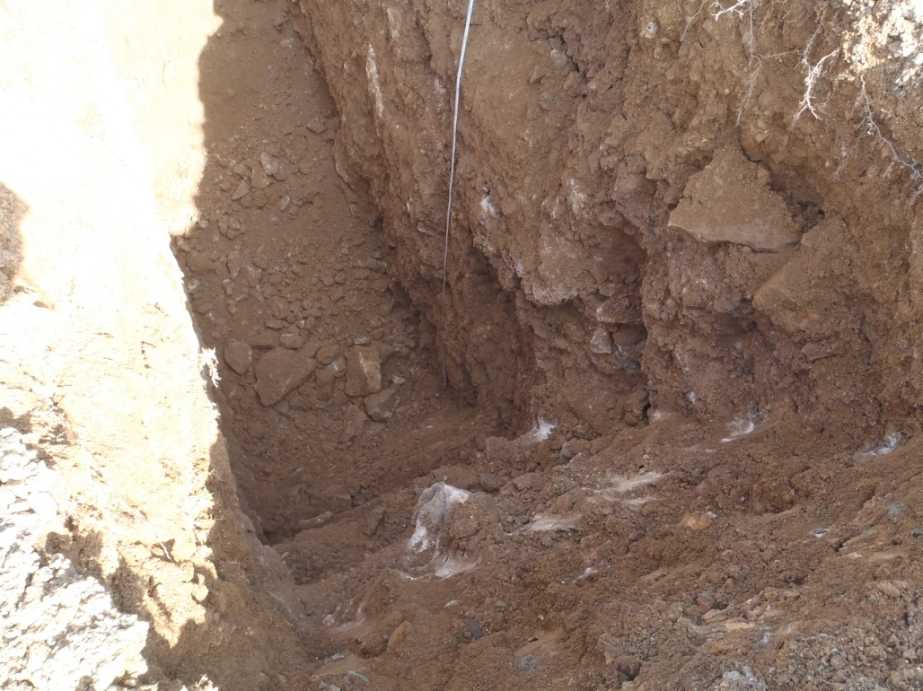

PHOTO 86: TP-WA-13-07: Test pit at about 2 m depth.
Government of Yukon - AAM
Mount Nansen 2013 Site Investigation
Photographs
Logged by: SM | Scale: NTS | Date: Oct 2013 | Project: VM00605E | Page 44

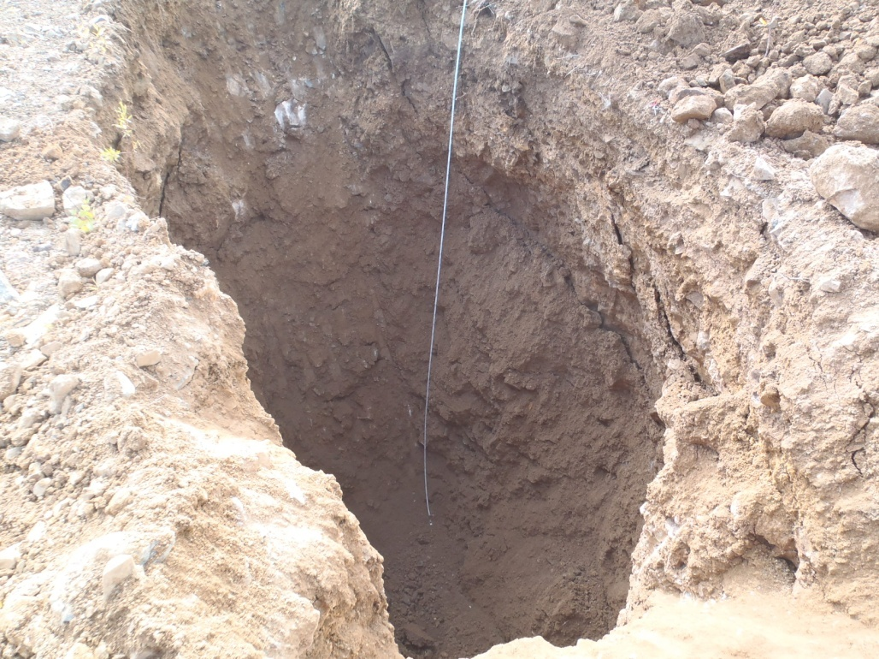

PHOTO 87: TP-WA-13-07: Test pit at completion.

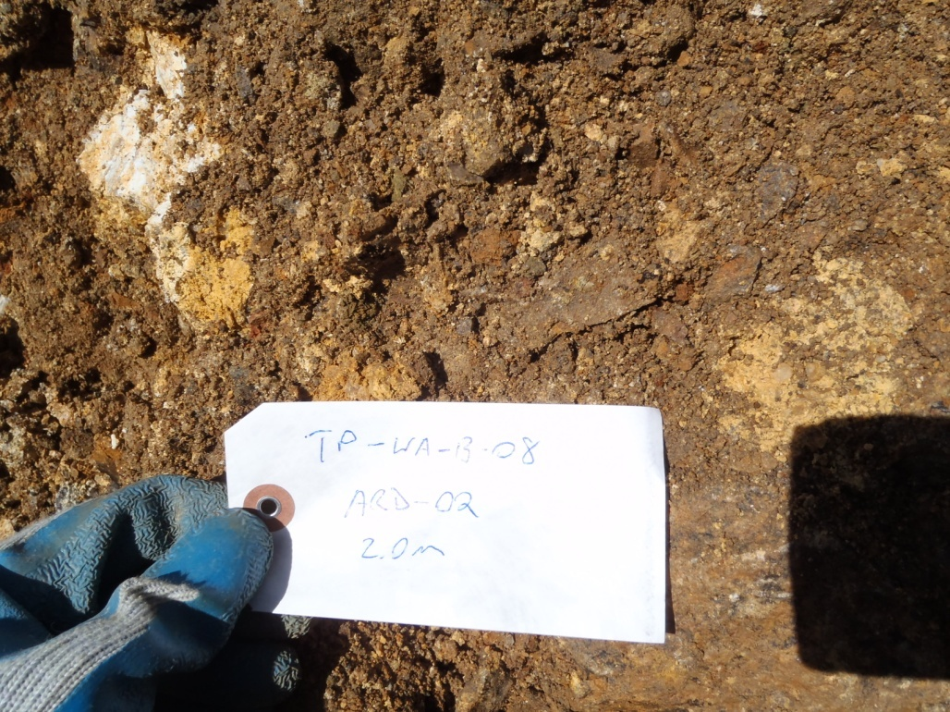

PHOTO 88: TP-WA-13-08: Waste rock sample at 2 m depth.
Government of Yukon - AAM
Mount Nansen 2013 Site Investigation
Photographs
Logged by: SM | Scale: NTS | Date: Oct 2013 | Project: VM00605E | Page 45

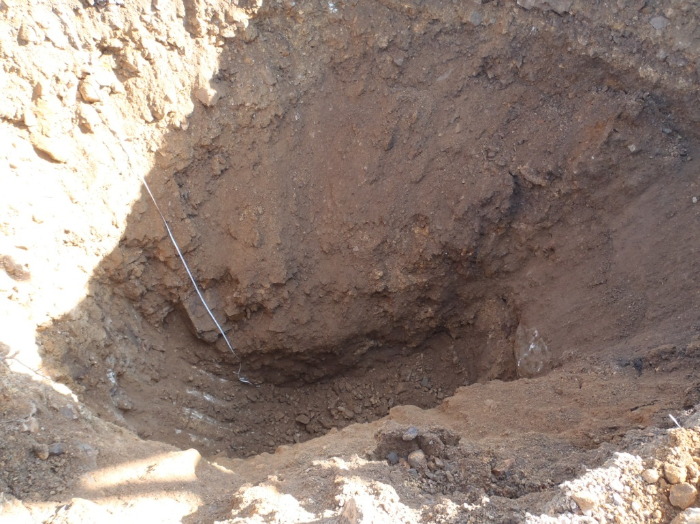

PHOTO 89: TP-WA-13-08: Test pit at completion.

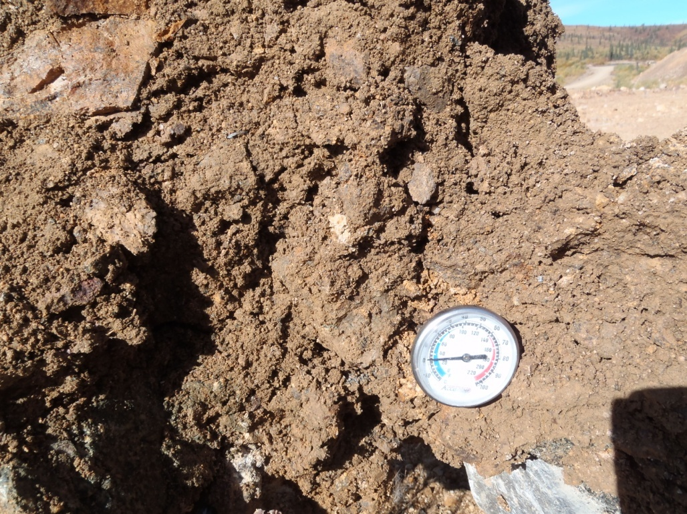

PHOTO 90: TP-WA-13-08: Weathered bedrock at 4 m depth.
Government of Yukon - AAM
Mount Nansen 2013 Site Investigation
Photographs
Logged by: SM | Scale: NTS | Date: Oct 2013 | Project: VM00605E | Page 46

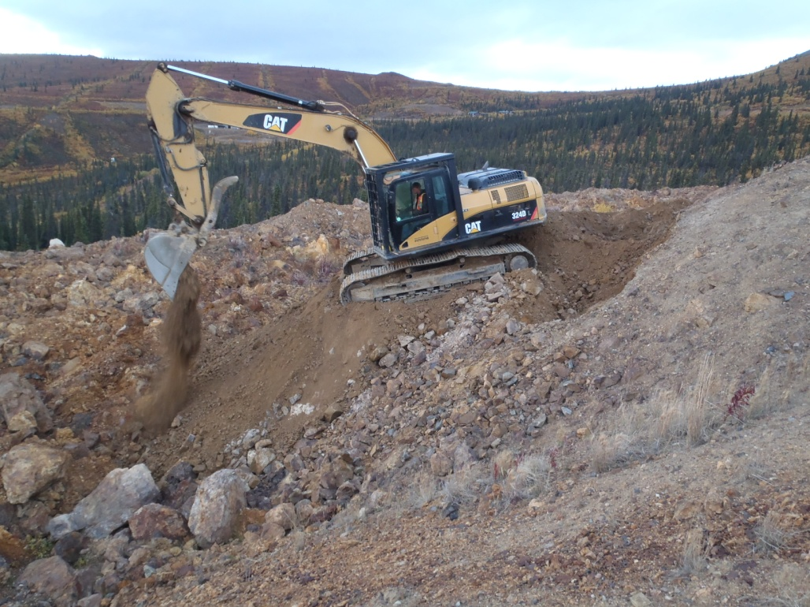

PHOTO 91: TP-WA-13-09: Excavator building access to test pit site.

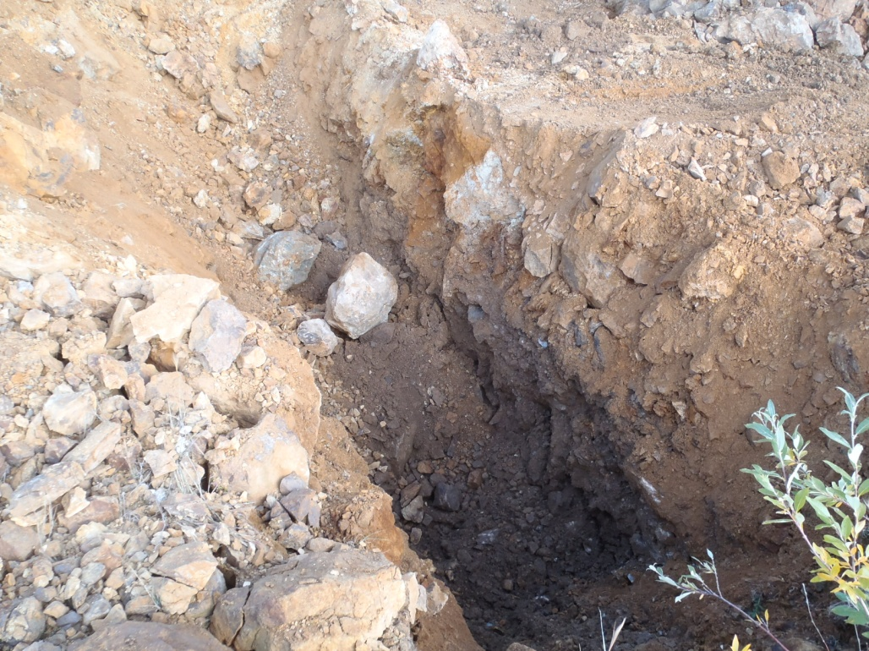

PHOTO 92: TP-WA-13-09: Test pit at 2 m depth.
Government of Yukon - AAM
Mount Nansen 2013 Site Investigation
Photographs
Logged by: SM | Scale: NTS | Date: Oct 2013 | Project: VM00605E | Page 47

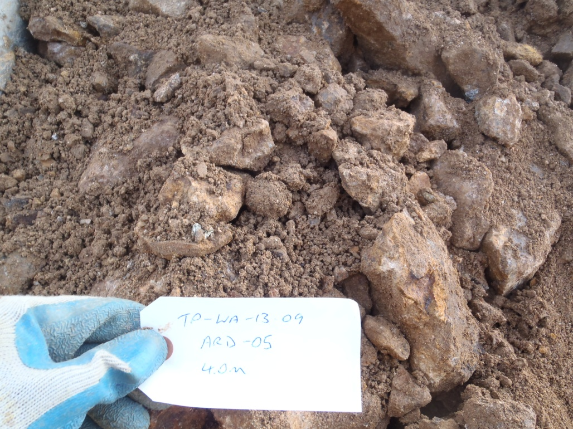

PHOTO 93: TP-WA-13-09: Waste rock sample at 4 m depth, about 80% oversize 25 mm.

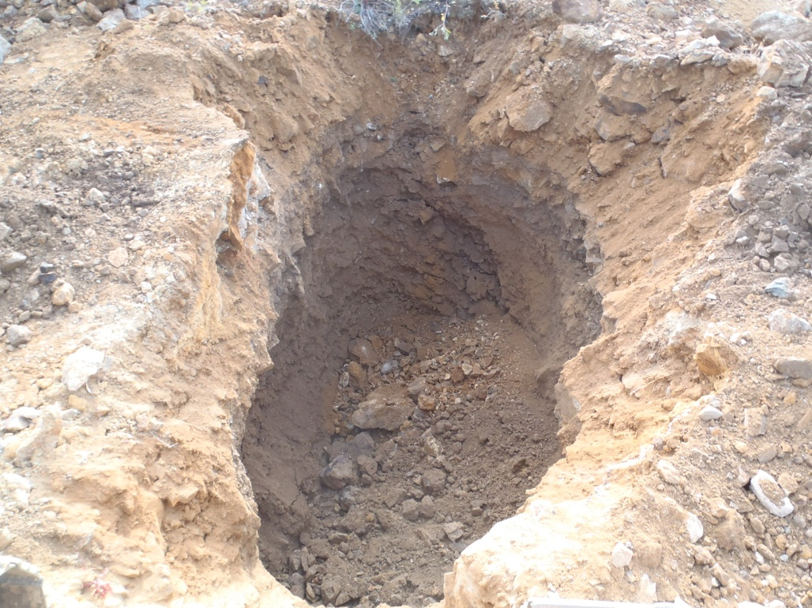

PHOTO 94: TP-WA-13-09: Test pit at completion.
Government of Yukon - AAM
Mount Nansen 2013 Site Investigation
Photographs
Logged by: SM | Scale: NTS | Date: Oct 2013 | Project: VM00605E | Page 48

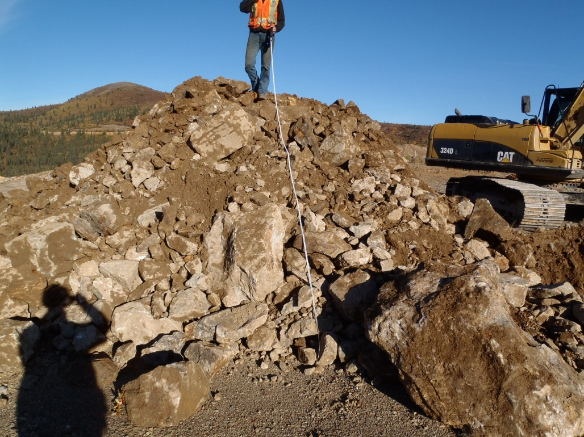

PHOTO 95: TP-WA-13-10: Spoil pile at completion, over 70% oversize 25 mm.

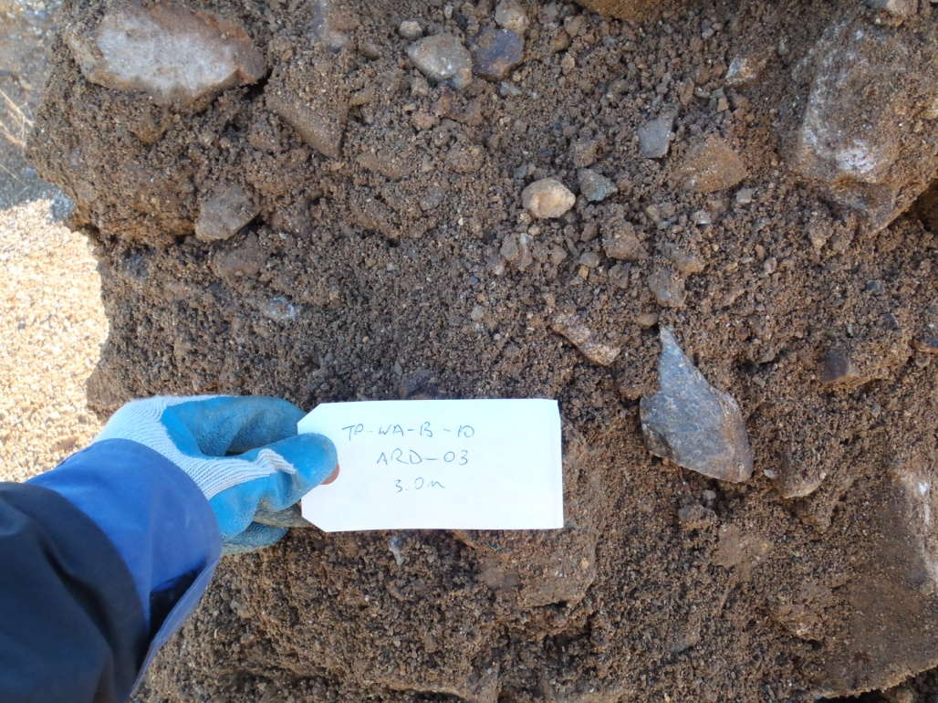

PHOTO 96: TP-WA-13-10: Waste rock sample at 3 m depth.
Government of Yukon - AAM
Mount Nansen 2013 Site Investigation
Photographs
Logged by: SM | Scale: NTS | Date: Oct 2013 | Project: VM00605E | Page 49

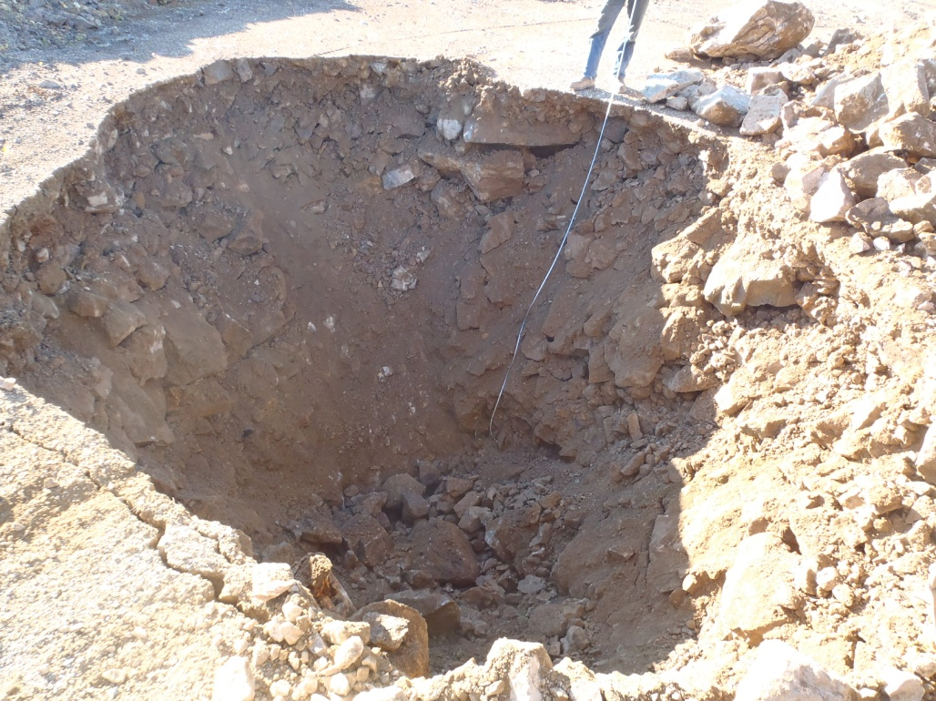

PHOTO 97: TP-WA-13-10: Test pit at completion.

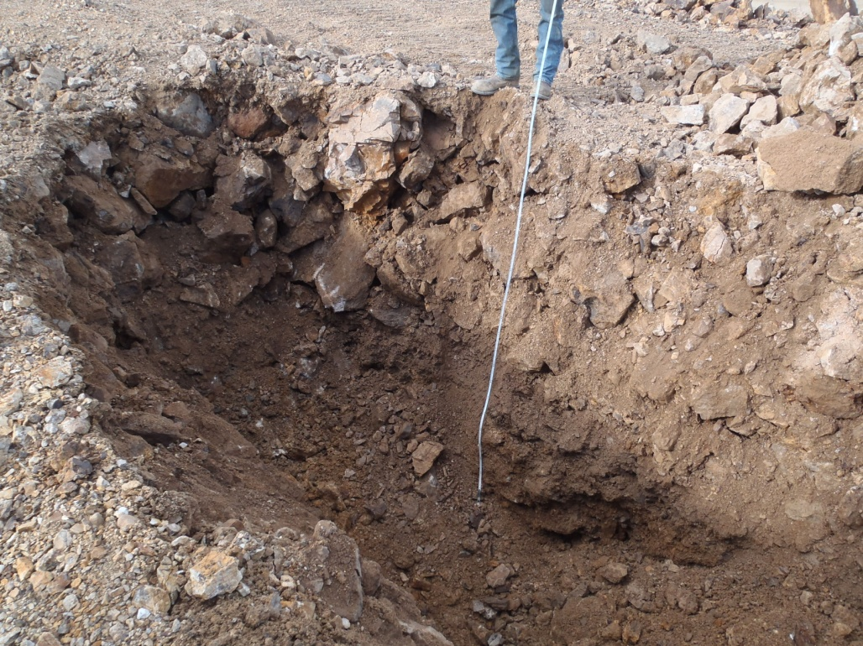

PHOTO 98: TP-WA-13-11: Test pit to about 2 m depth, lots of boulders and cobbles.
Government of Yukon - AAM
Mount Nansen 2013 Site Investigation
Photographs
Logged by: SM | Scale: NTS | Date: Oct 2013 | Project: VM00605E | Page 50

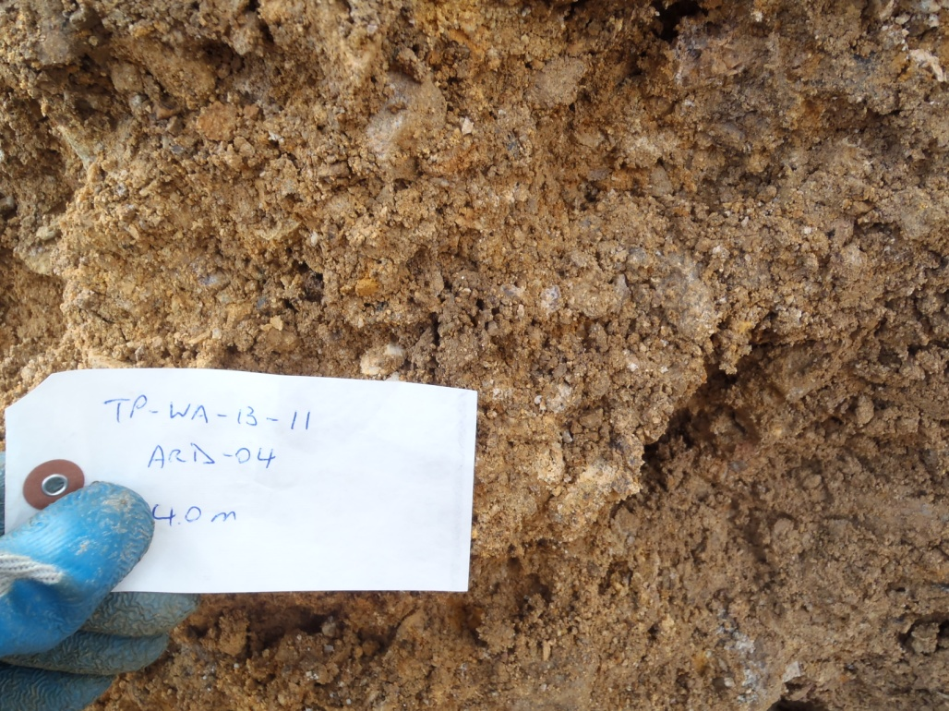

PHOTO 99: TP-WA-13-11: Waste rock sample at 4 m depth, with high level of weathering.

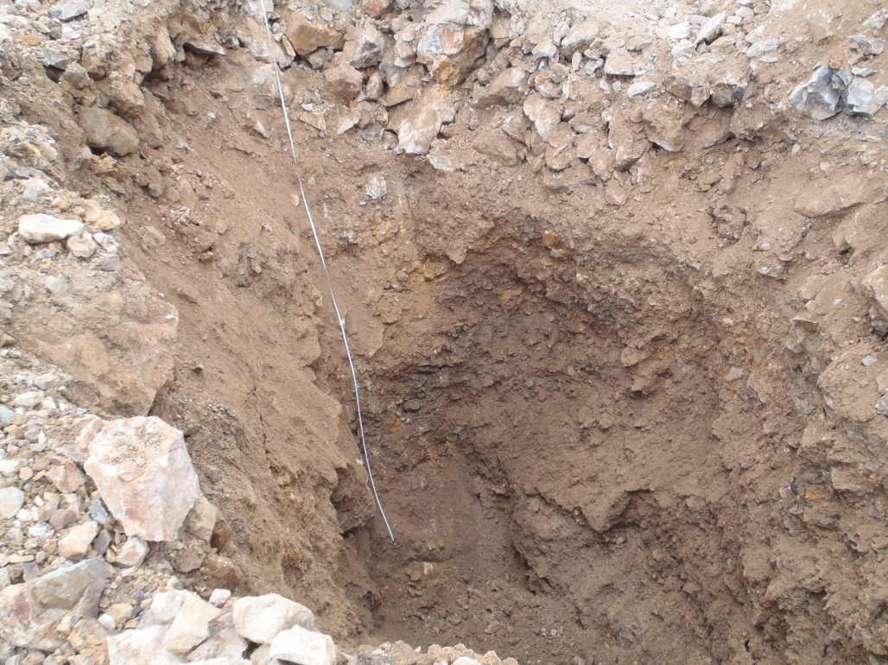

PHOTO 100: TP-WA-13-11: Test pit at completion.
Government of Yukon - AAM
Mount Nansen 2013 Site Investigation
Photographs
Logged by: SM | Scale: NTS | Date: Oct 2013 | Project: VM00605E | Page 51

