Mount Nansen 2013 Site Investigation

list of Diamond Drill Core photos
Page
Photos of CH-P-13-01 1
PHOTO 1: 1_CH-P-13-01_Box 1_0-9m_Sept 6, 2013. 1
PHOTO 2: 4_CH-P-13-01_Box 2_9-13m_Sept 6, 2013. 1
PHOTO 3: 7_CH-P-13-01_Box 3_13-16m_Sept 6, 2013. 1
PHOTO 4: 10_CH-P-13-01_Box 4_16-20m_Sept 7, 2013. 2
PHOTO 5: 13_CH-P-13-01_Box 5_20-24m_Sept 7, 2013. 2
PHOTO 6: 16_CH-P-13-01_Box 6_24-28m_Sept 7, 2013. 2
PHOTO 7: 19_CH-P-13-01_Box 7_28-32m_Sept 7, 2013. 3
PHOTO 8: 22_CH-P-13-01_Box 8_32-37m_Sept 7, 2013. 3
PHOTO 9: 25_CH-P-13-01_Box 9_37-40m_Sept 7, 2013. 3
Photos of CH-P-13-02 4
PHOTO 10: 1_CH-P-13-02 (Box 1 and 2) 8 to 12.8 mbgs_Oct 5, 2013. 4
PHOTO 11: 2_CH-P-13-02 (Box 3 and 4) 12.8 to 18.7 mbgs_Oct 5, 2013. 4
PHOTO 12: 3_CH-P-13-02 (Box 5 and 6) 18.7 to 27.7 mbgs_Oct 5, 2013. 5
PHOTO 13: 4_CH-P-13-02 (Box 7 and 8) 27.7 to 34 mbgs_Oct 5, 2013. 5
PHOTO 14: 5_CH-P-13-02 (Box 9 and 10) 34 to 40mbgs_Oct 5, 2013. 6
PHOTO 15: 6_CH-P-13-02 (Box 11 and 12) 40 to 50mbgs_Oct 5, 2013. 6
Photos of CH-P-13-03 7
PHOTO 16: 1_CH-P-13-03_Box 1_0-8m_Sept 11, 2013. 7
PHOTO 17: 4_CH-P-13-03_Box 2_8-12m_Sept 11, 2013. 7
PHOTO 18: 7_CH-P-13-03_Box 1 and 2_0-12m_Sept 11, 2013. 8
PHOTO 19: 8_CH-P-13-03_Box 3_12-16m_Sept 12, 2013. 8
PHOTO 20: 11_CH-P-13-03_Box 4_16-20m_Sept 12, 2013. 9
PHOTO 21: 14_CH-P-13-03_Box 3 and 4_12-20m_Sept 12, 2013. 9
PHOTO 22: 15_CH-P-13-03_Box 5_20-24m_Sept 12, 2013. 10
PHOTO 23: 18_CH-P-13-03_Box 6_24-28m_Sept 12, 2013. 10
PHOTO 24: 21_CH-P-13-03_Box 5 and 6_20-28m_Sept 12, 2013. 11
PHOTO 25: 22_CH-P-13-03_Box 7 and 8_28-36m_Sept 12, 2013. 11
PHOTO 26: 25_CH-P-13-03_Box 9 and 10_36-44m_Sept 13, 2013. 12
PHOTO 27: 28_CH-P-13-03_Box 11 and 12_44-50m_Sept 13, 2013. 12
Photos of CH-P-13-04 13
PHOTO 28: 1_CH-P-13-04_Box 1_0-7m_Sept 15, 2013. 13
PHOTO 29: 4_CH-P-13-04_Box 2_7-10m_Sept 15, 2013. 13
PHOTO 30: 7_CH-P-13-04_Box 3_10-15m_Sept 15, 2013. 13
PHOTO 31: 10_CH-P-13-04_Box 4_15-19m_Sept 15, 2013. 14
PHOTO 32: 13_CH-P-13-04_Box 5_19-23m_Sept 15, 2013. 14
PHOTO 33: 16_CH-P-13-04_Box 6_23-27m_Sept 15, 2013. 14
PHOTO 34: 19_CH-P-13-04_Box 7_27-31m_Sept 15, 2013. 15
PHOTO 35: 22_CH-P-13-04_Box 8_31-35m_Sept 16, 2013. 15
PHOTO 36: 25_CH-P-13-04_Box 9_35-39m_Sept 16, 2013. 15
PHOTO 37: 28_CH-P-13-04_Box 10_39-43m_Sept 16, 2013. 16
PHOTO 38: 31_CH-P-13-04_Box 11_43-47m_Sept 16, 2013. 16
PHOTO 39: 34_CH-P-13-04_Box 12_47-50m_Sept 16, 2013. 16

Photos of CH-P-13-05 17
PHOTO 40: 1_CH-P-13-05_Box 1 and 2_0-12m_Sept 21, 2013. 17
PHOTO 41: 4_CH-P-13-05_Box 3 and 4_12-19m_Sept 22, 2013. 17
PHOTO 42: 7_CH-P-13-05_Box 5 and 6_19-26m_Sept 22, 2013. 18
PHOTO 43: 10_CH-P-13-05_Box 7 and 8_26-33m_Sept 22, 2013. 18
PHOTO 44: 13_CH-P-13-05_Box 9 and 10_33-40m_Sept 22, 2013. 19
PHOTO 45: 16_CH-P-13-05_Box 11 and 12_40-47m_Sept 23, 2013. 19
PHOTO 46: 19_CH-P-13-05_Box 13_47-50m_Sept 23, 2013. 20
Photos of CH-P-13-06 21
PHOTO 47: 1_CH-P-13-06_Box 1 and 2_0-12m_Sept 23, 2013. 21
PHOTO 48: 4_CH-P-13-06_Box 3 and 4_12-20m_Sept 24, 2013. 21
PHOTO 49: 7_CH-P-13-06_Box 5 and 6_20-27m_Sept 24, 2013. 22
PHOTO 50: 10_CH-P-13-06_Box 7 and 8_27-34m_Sept 26, 2013. 22
PHOTO 51: 13_CH-P-13-06_Box 9 and 10_34-42m_Sept 26, 2013. 23
PHOTO 52: 16_CH-P-13-06 (Box 10 and 11) 37 to 46 mbgs_Sept 27, 2013. 23
PHOTO 53: 17_CH-P-13-06 (Box 12 and 13) 46 to 52 mbgs_Sept 27, 2013. 24
PHOTO 54: 18_CH-P-13-06 (Box 14 and 15) 52 to 60 mbgs_Sept 27, 2013. 24

Photos of CH-P-13-01

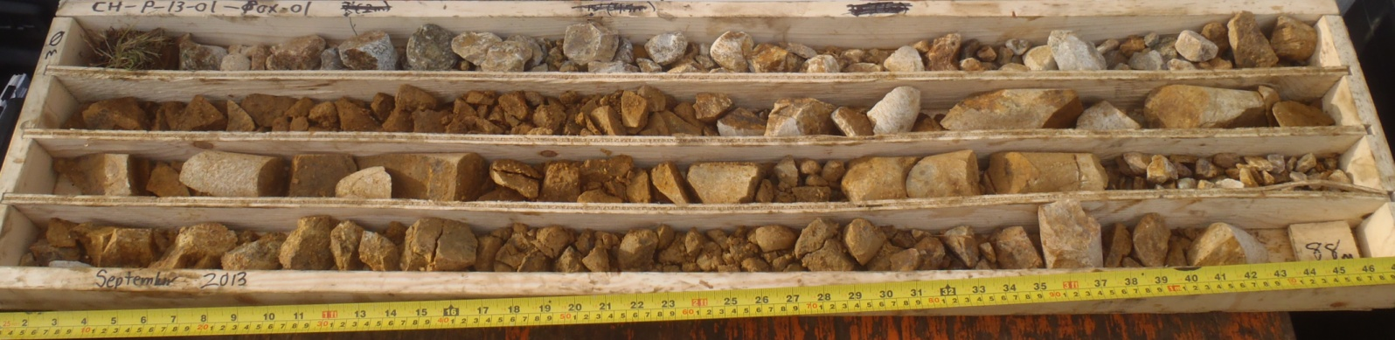

PHOTO 1: 1_CH-P-13-01_Box 1_0-9m_Sept 6, 2013.

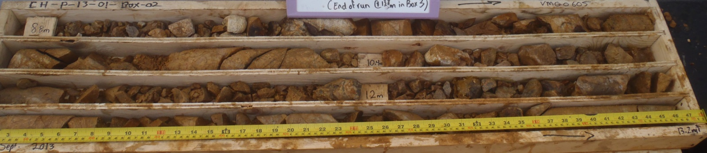

PHOTO 2: 4_CH-P-13-01_Box 2_9-13m_Sept 6, 2013.

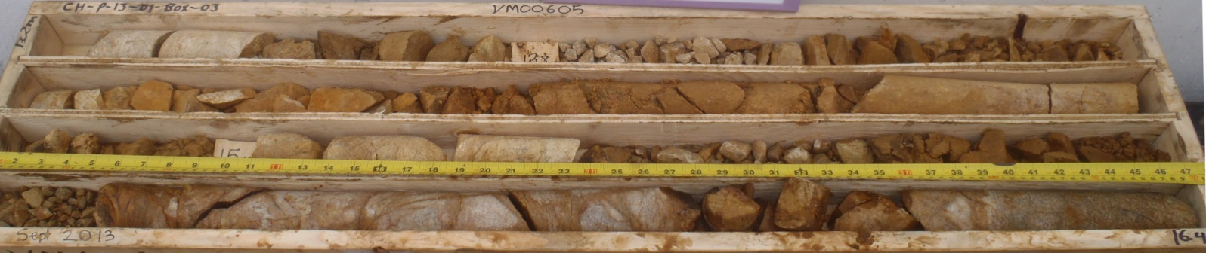

PHOTO 3: 7_CH-P-13-01_Box 3_13-16m_Sept 6, 2013.
   |  | Government of Yukon - AAM  Mount Nansen 2013 Site Investigation  Photographs
Logged by: TK | Scale: NTS | Date: Nov 2013 | Project: VM00605 | Page 1

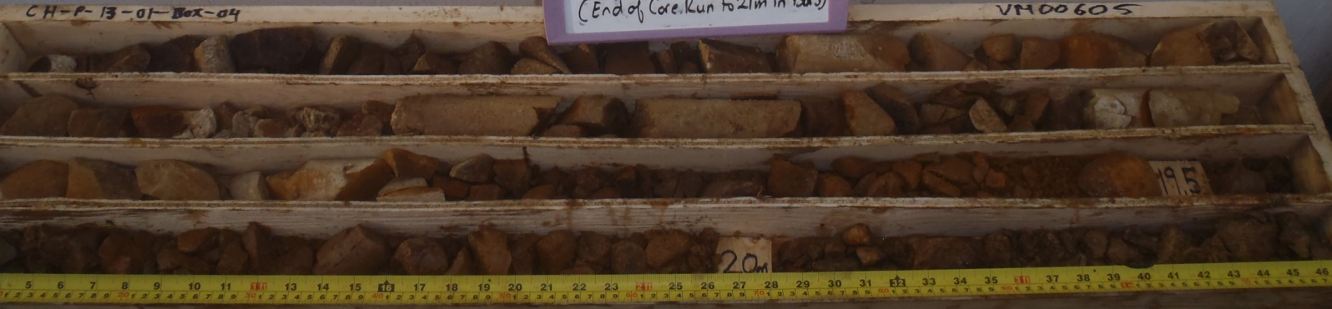

PHOTO 4: 10_CH-P-13-01_Box 4_16-20m_Sept 7, 2013.

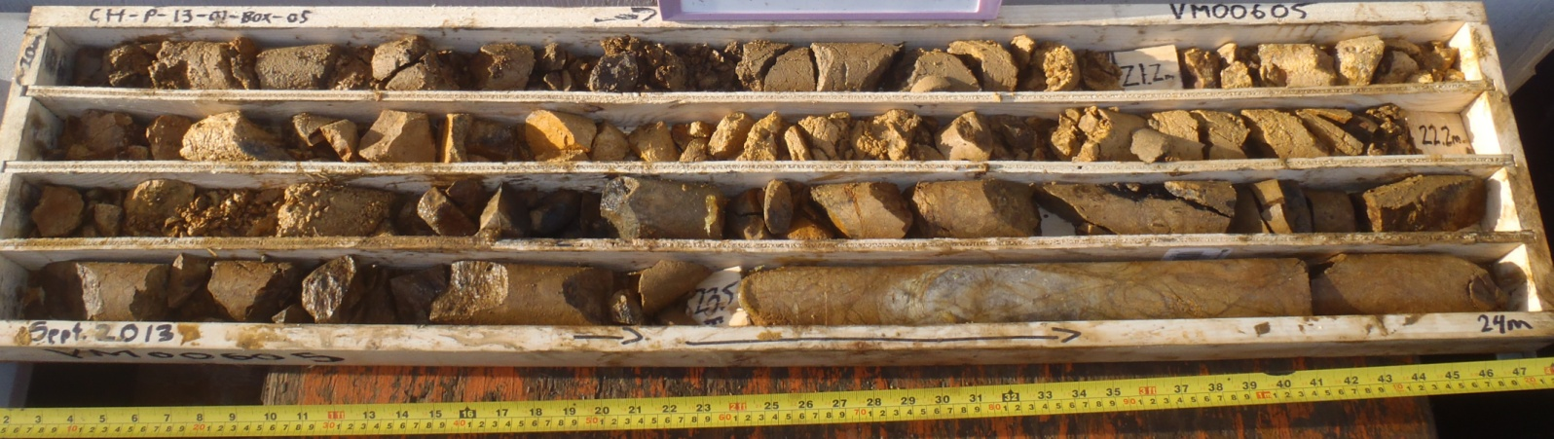

PHOTO 5: 13_CH-P-13-01_Box 5_20-24m_Sept 7, 2013.

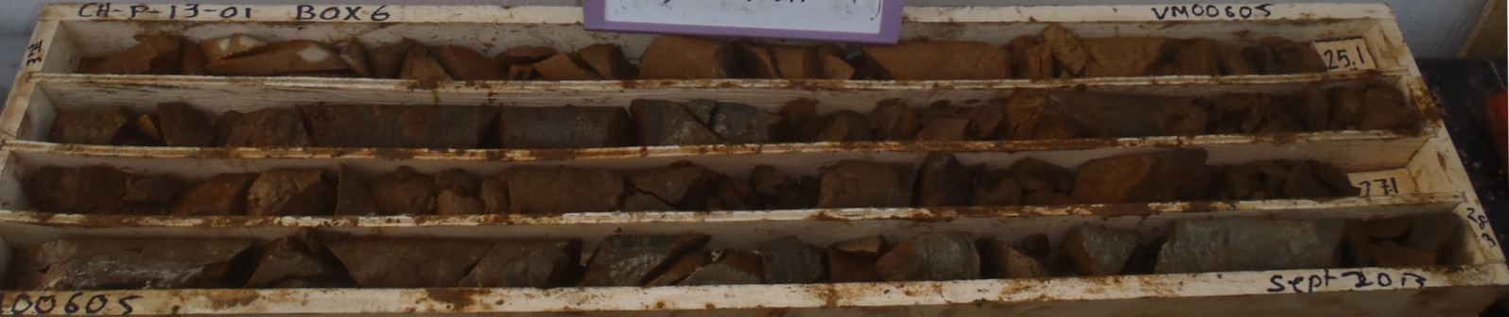

PHOTO 6: 16_CH-P-13-01_Box 6_24-28m_Sept 7, 2013.
AMEC Environment & Infrastructure |  | Government of Yukon - AAM  Mount Nansen 2013 Site Investigation  Photographs
Logged by: TK | Scale: NTS | Date: Nov 2013 | Project: VM00605 | Page 2

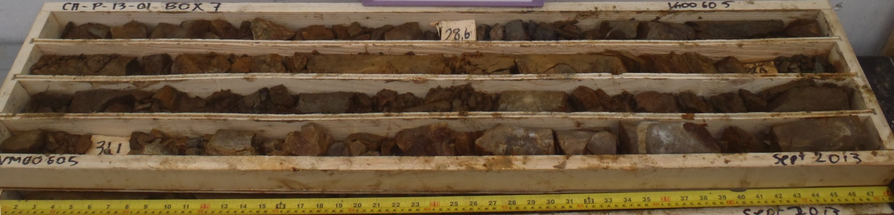

PHOTO 7: 19_CH-P-13-01_Box 7_28-32m_Sept 7, 2013.

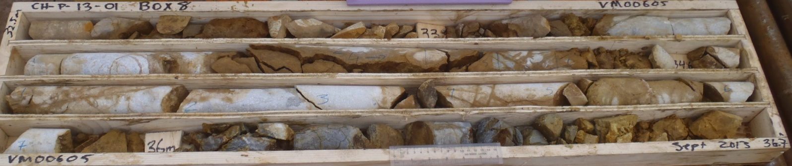

PHOTO 8: 22_CH-P-13-01_Box 8_32-37m_Sept 7, 2013.

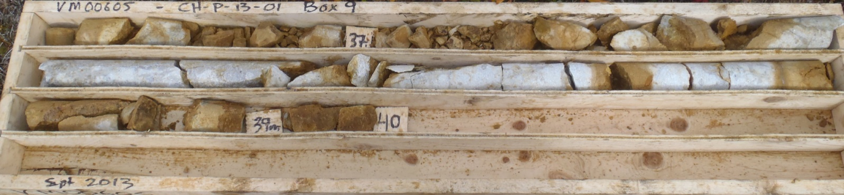

PHOTO 9: 25_CH-P-13-01_Box 9_37-40m_Sept 7, 2013.
AMEC Environment & Infrastructure |  | Government of Yukon - AAM  Mount Nansen 2013 Site Investigation  Photographs
Logged by: TK | Scale: NTS | Date: Nov 2013 | Project: VM00605 | Page 3

Photos of CH-P-13-02

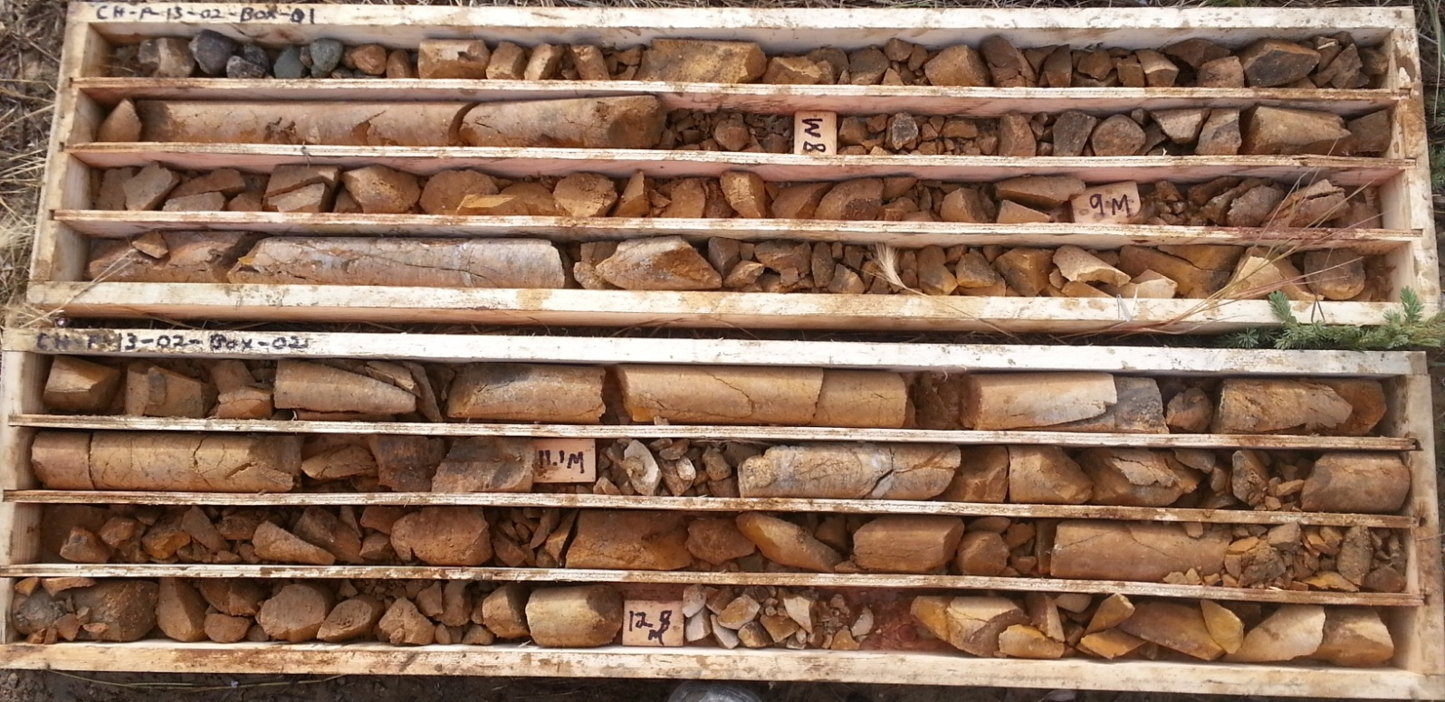

PHOTO 10: 1_CH-P-13-02 (Box 1 and 2) 8 to 12.8 mbgs_Oct 5, 2013.

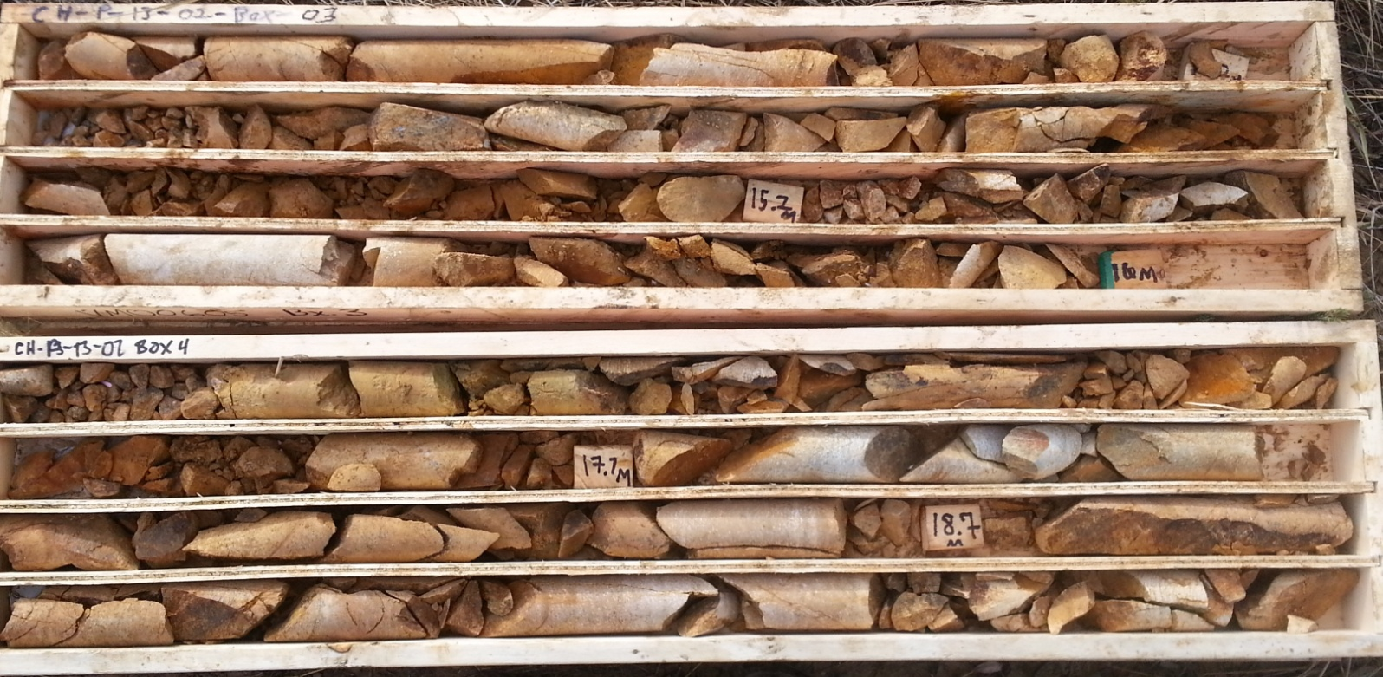

PHOTO 11: 2_CH-P-13-02 (Box 3 and 4) 12.8 to 18.7 mbgs_Oct 5, 2013.
AMEC Environment & Infrastructure |  | Government of Yukon - AAM  Mount Nansen 2013 Site Investigation  Photographs
Logged by: TK | Scale: NTS | Date: Nov 2013 | Project: VM00605 | Page 4

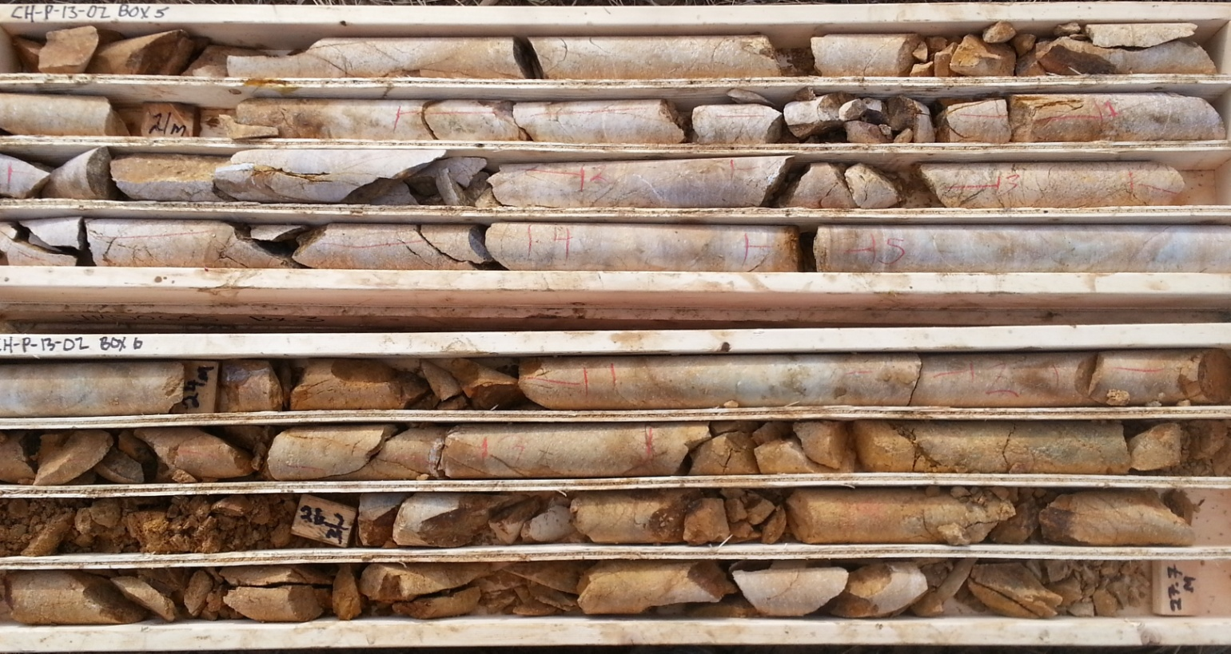

PHOTO 12: 3_CH-P-13-02 (Box 5 and 6) 18.7 to 27.7 mbgs_Oct 5, 2013.

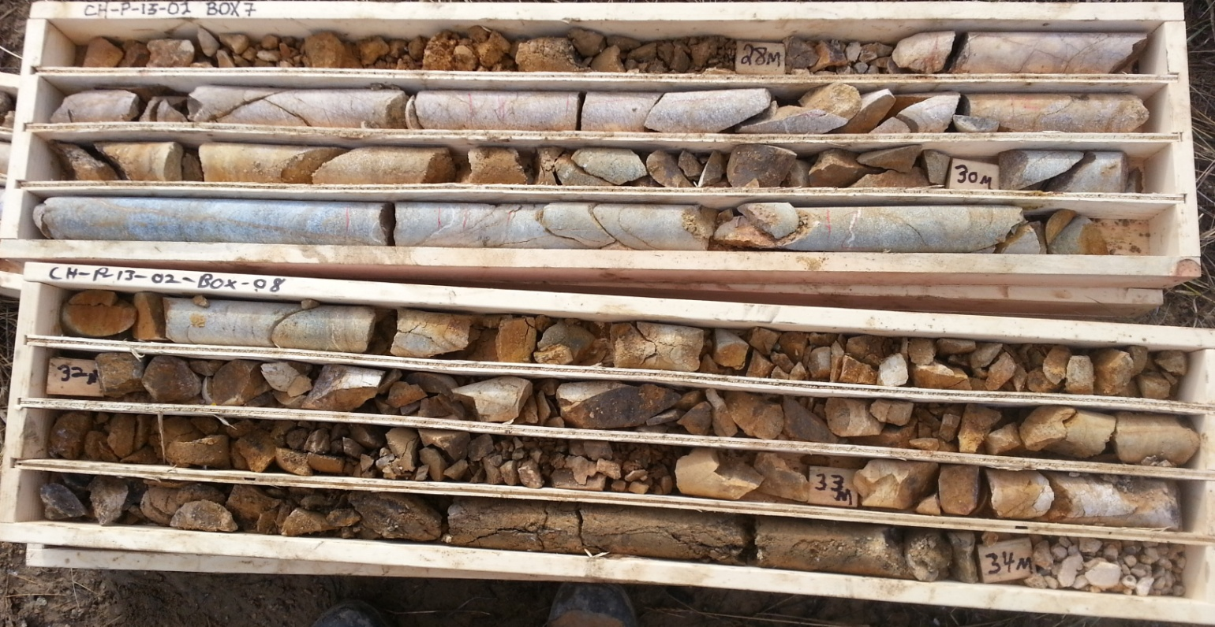

PHOTO 13: 4_CH-P-13-02 (Box 7 and 8) 27.7 to 34 mbgs_Oct 5, 2013.
AMEC Environment & Infrastructure |  | Government of Yukon - AAM  Mount Nansen 2013 Site Investigation  Photographs
Logged by: TK | Scale: NTS | Date: Nov 2013 | Project: VM00605 | Page 5

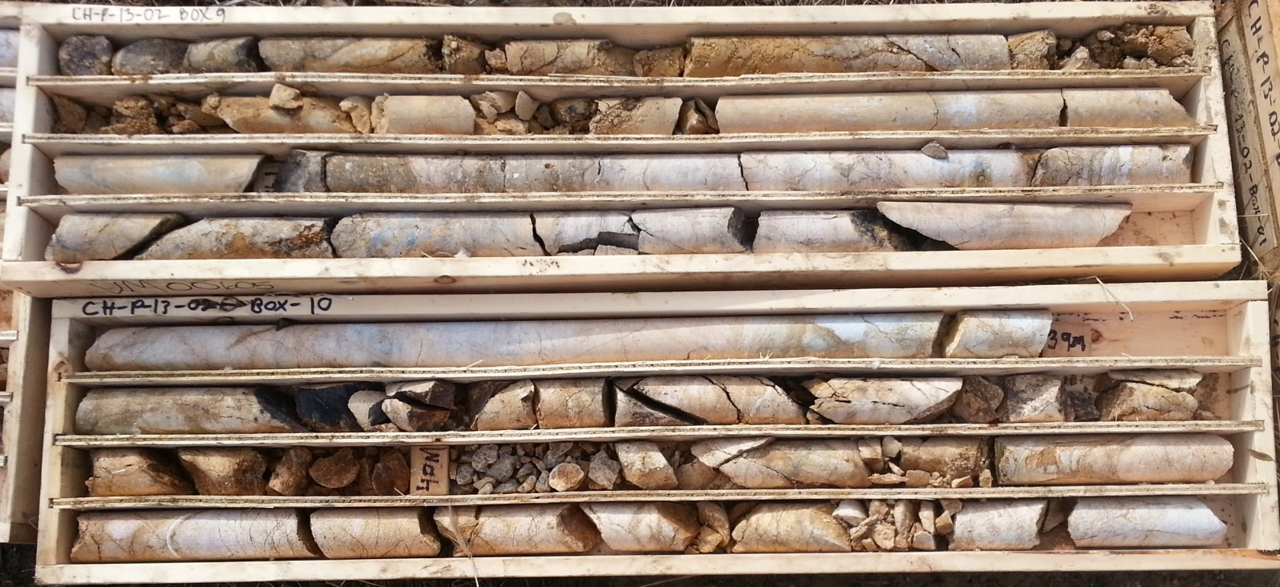

PHOTO 14: 5_CH-P-13-02 (Box 9 and 10) 34 to 40mbgs_Oct 5, 2013.

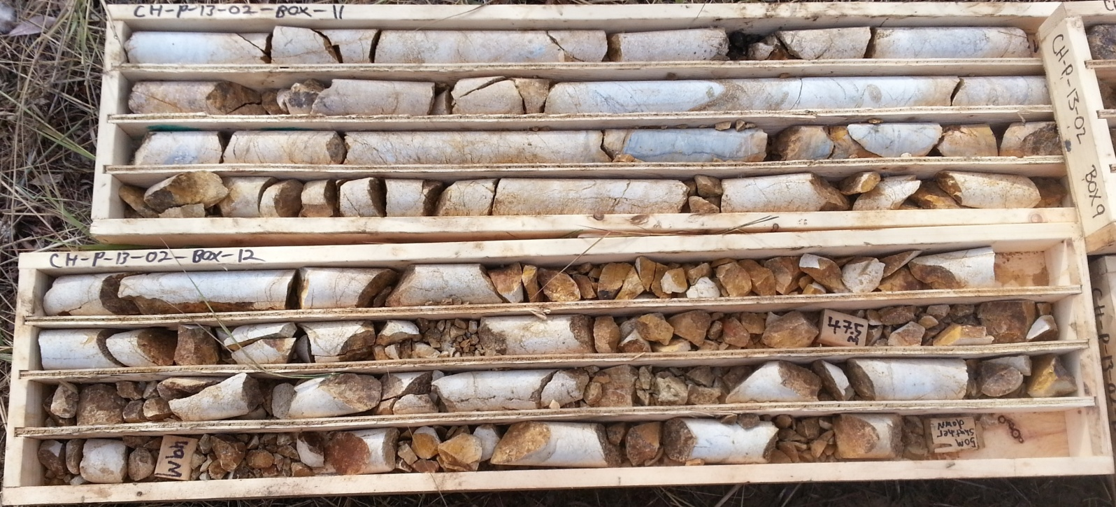

PHOTO 15: 6_CH-P-13-02 (Box 11 and 12) 40 to 50mbgs_Oct 5, 2013.
AMEC Environment & Infrastructure |  | Government of Yukon - AAM  Mount Nansen 2013 Site Investigation  Photographs
Logged by: TK | Scale: NTS | Date: Nov 2013 | Project: VM00605 | Page 6

Photos of CH-P-13-03

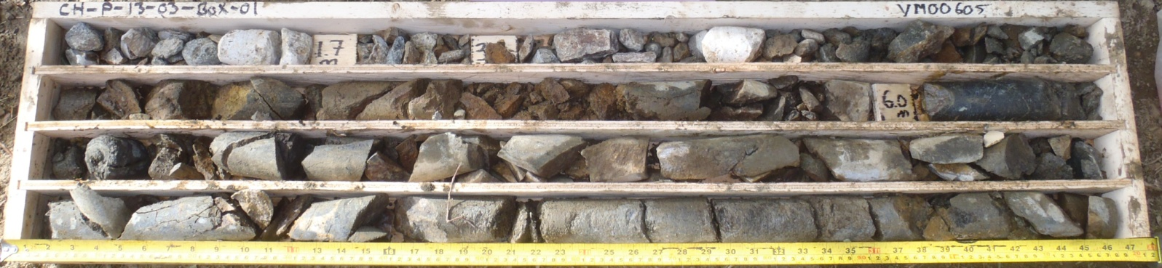

PHOTO 16: 1_CH-P-13-03_Box 1_0-8m_Sept 11, 2013.

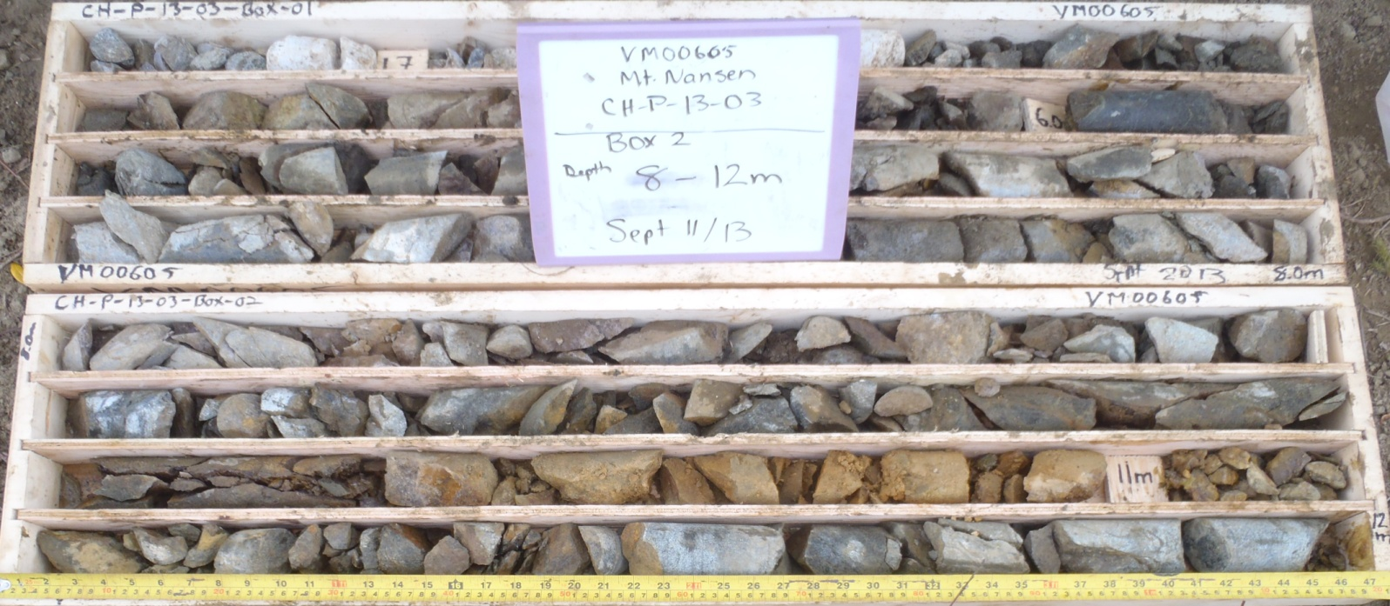

PHOTO 17: 4_CH-P-13-03_Box 2_8-12m_Sept 11, 2013.

Government of Yukon - AAM
Mount Nansen 2013 Site Investigation
Photographs
Logged by: TK | Scale: NTS | Date: Nov 2013 | Project: VM00605 | Page 7

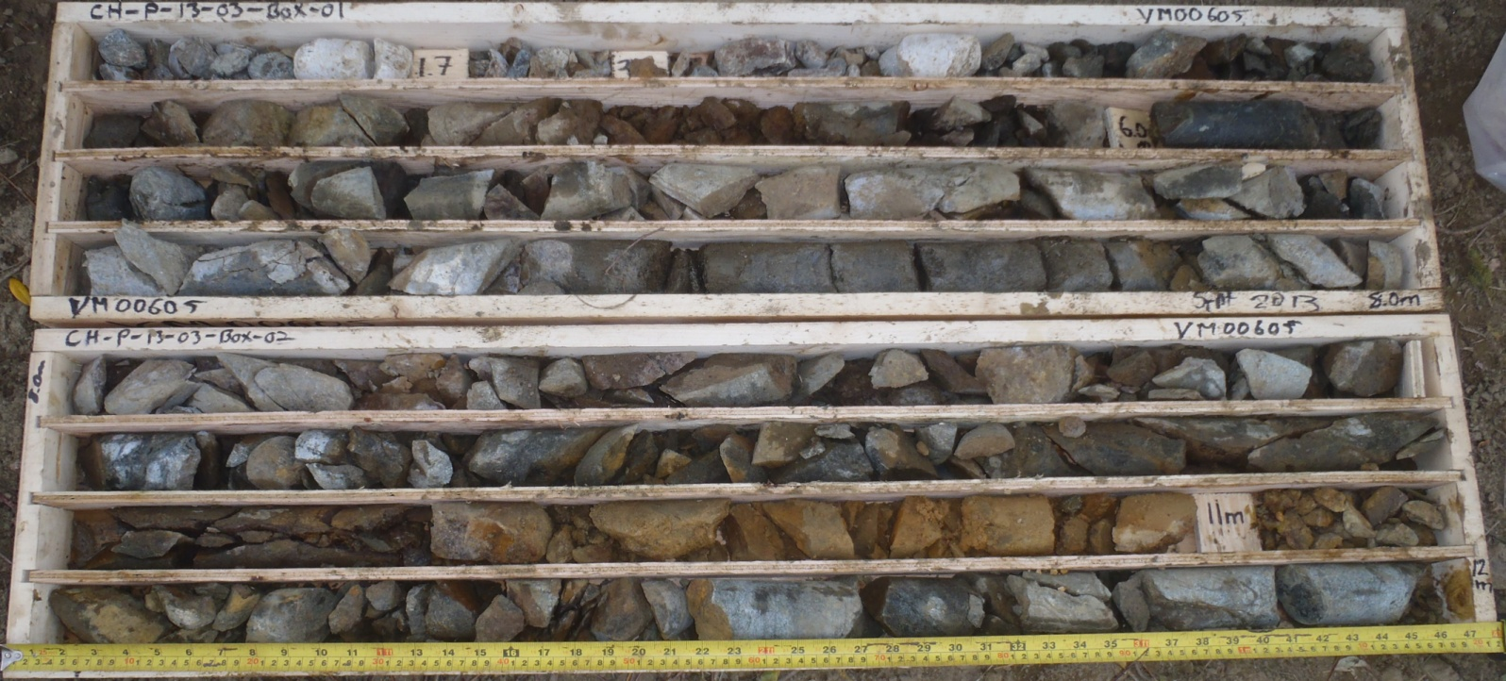

PHOTO 18: 7_CH-P-13-03_Box 1 and 2_0-12m_Sept 11, 2013.

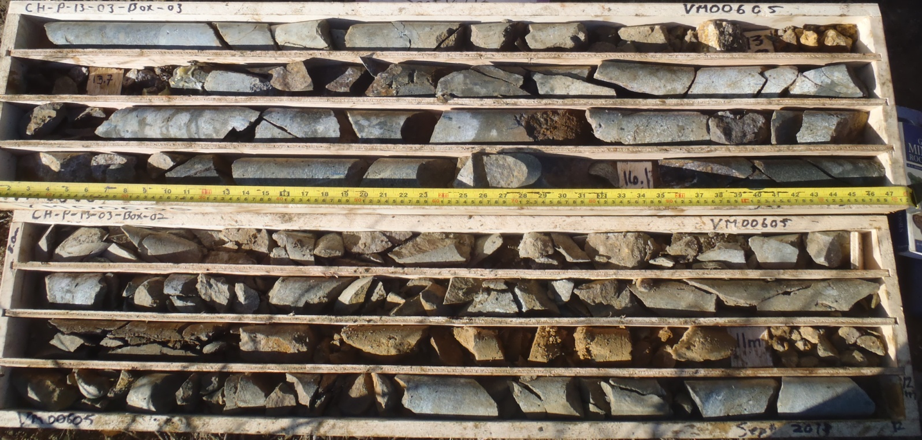

PHOTO 19: 8_CH-P-13-03_Box 3_12-16m_Sept 12, 2013.
AMEC Environment & Infrastructure |  | Government of Yukon - AAM  Mount Nansen 2013 Site Investigation  Photographs
Logged by: TK | Scale: NTS | Date: Nov 2013 | Project: VM00605 | Page 8

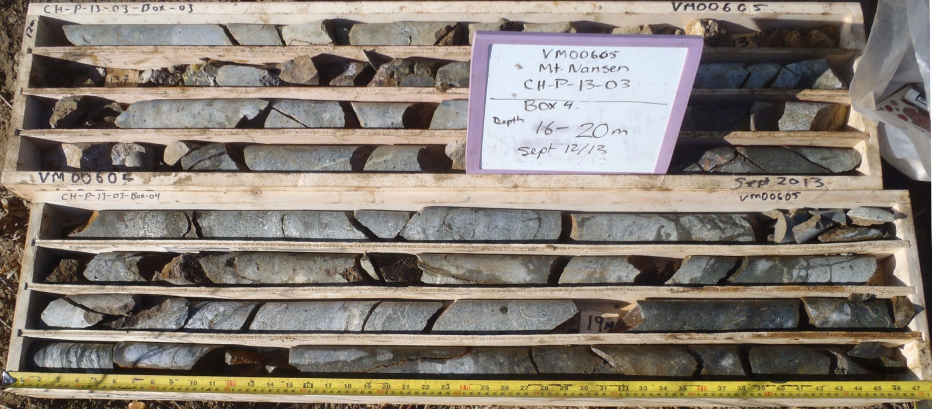

PHOTO 20: 11_CH-P-13-03_Box 4_16-20m_Sept 12, 2013.

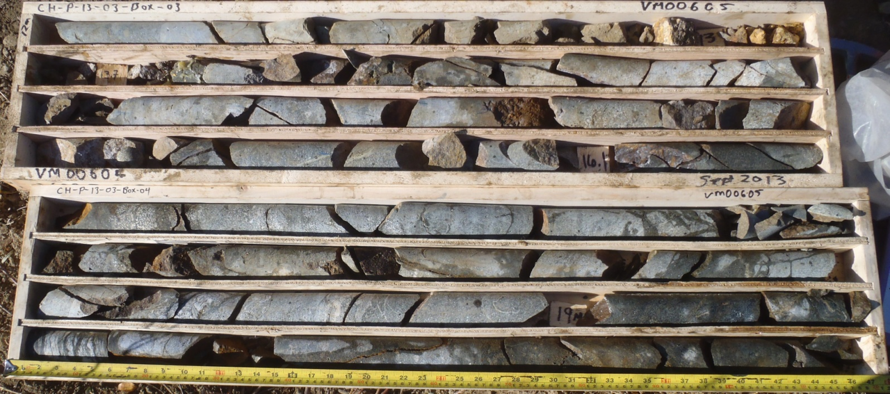

PHOTO 21: 14_CH-P-13-03_Box 3 and 4_12-20m_Sept 12, 2013.
AMEC Environment & Infrastructure |  | Government of Yukon - AAM  Mount Nansen 2013 Site Investigation  Photographs
Logged by: TK | Scale: NTS | Date: Nov 2013 | Project: VM00605 | Page 9

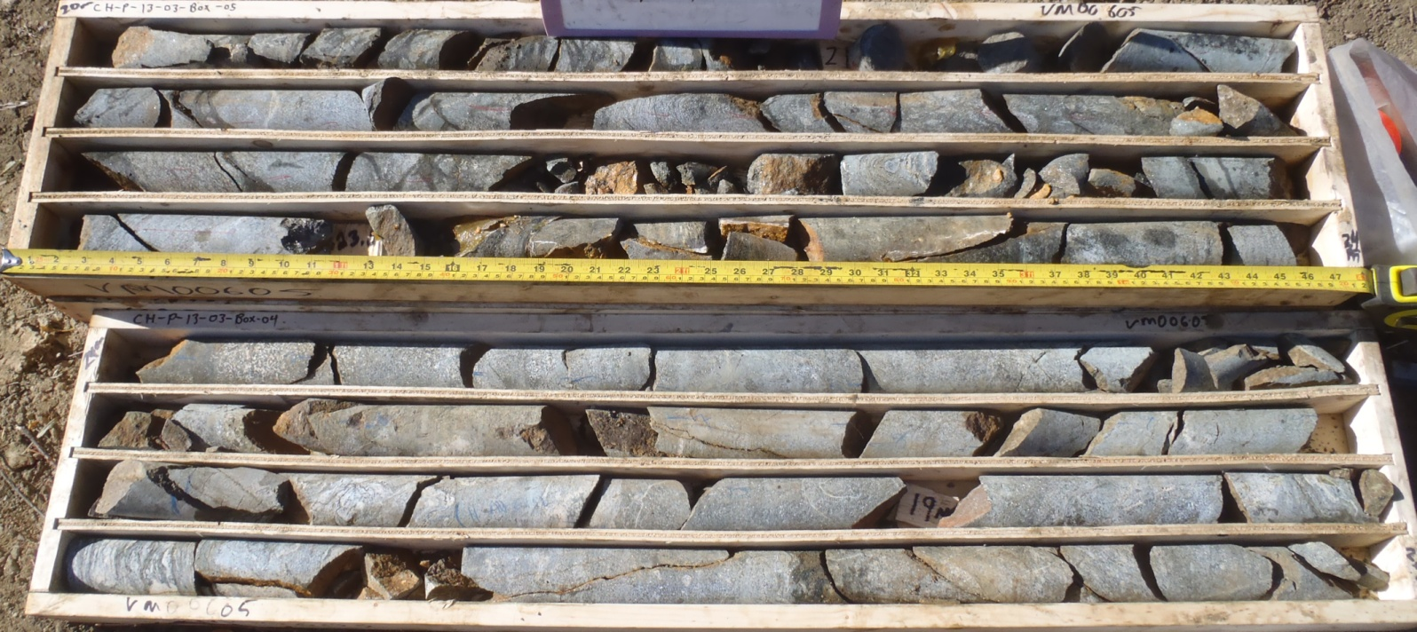

PHOTO 22: 15_CH-P-13-03_Box 5_20-24m_Sept 12, 2013.

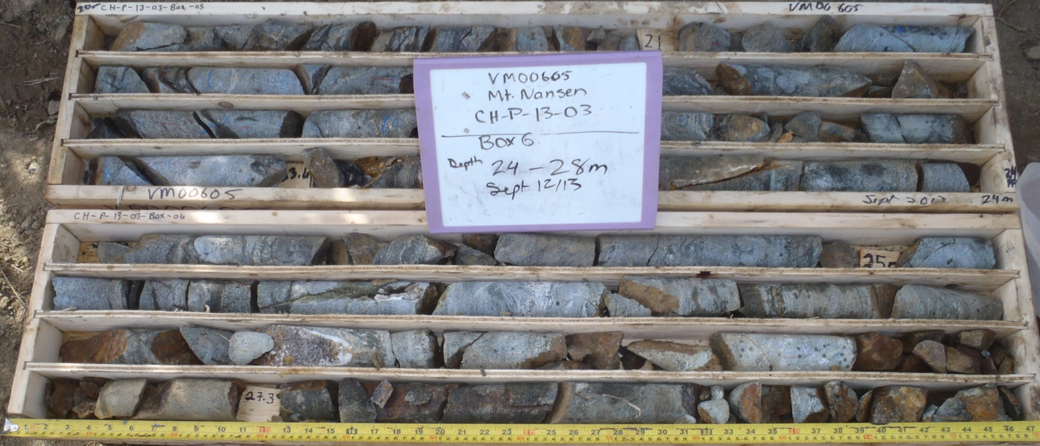

PHOTO 23: 18_CH-P-13-03_Box 6_24-28m_Sept 12, 2013.

AMEC Environment & Infrastructure |  | Government of Yukon - AAM  Mount Nansen 2013 Site Investigation  Photographs
Logged by: TK | Scale: NTS | Date: Nov 2013 | Project: VM00605 | Page 10

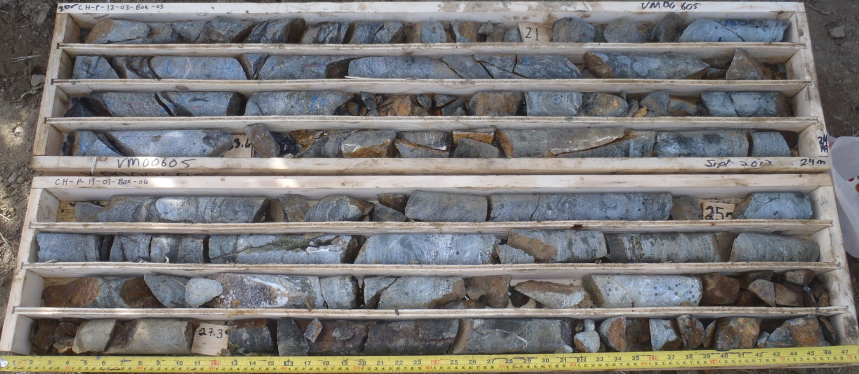

PHOTO 24: 21_CH-P-13-03_Box 5 and 6_20-28m_Sept 12, 2013.

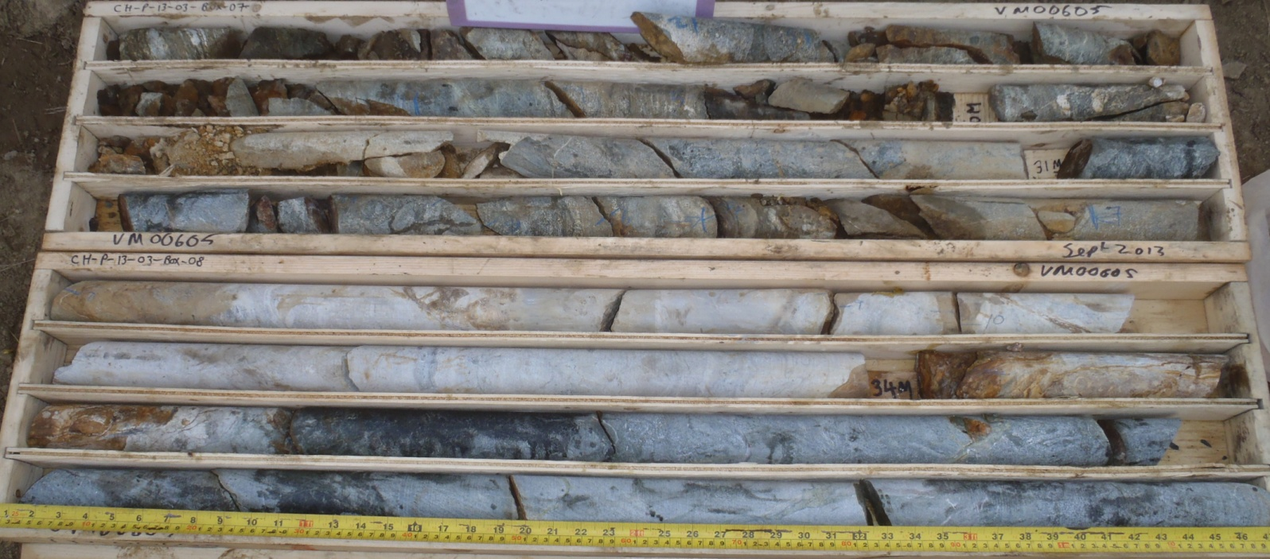

PHOTO 25: 22_CH-P-13-03_Box 7 and 8_28-36m_Sept 12, 2013.
AMEC Environment & Infrastructure |  | Government of Yukon - AAM  Mount Nansen 2013 Site Investigation  Photographs
Logged by: TK | Scale: NTS | Date: Nov 2013 | Project: VM00605 | Page 11

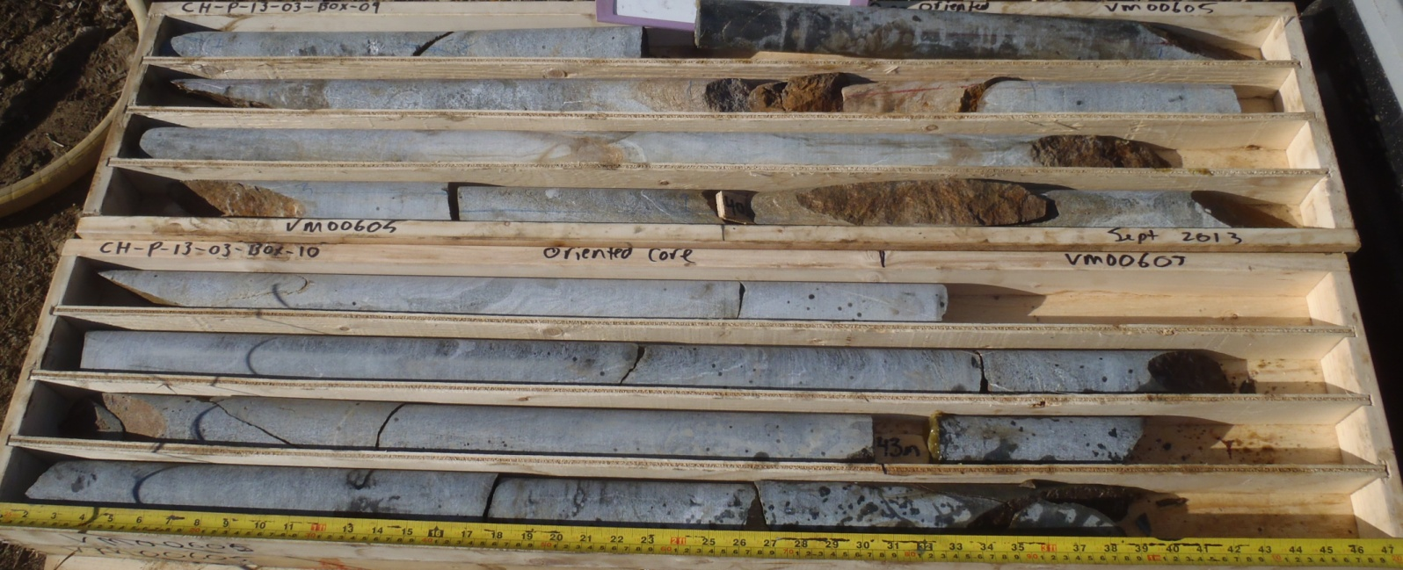

PHOTO 26: 25_CH-P-13-03_Box 9 and 10_36-44m_Sept 13, 2013.

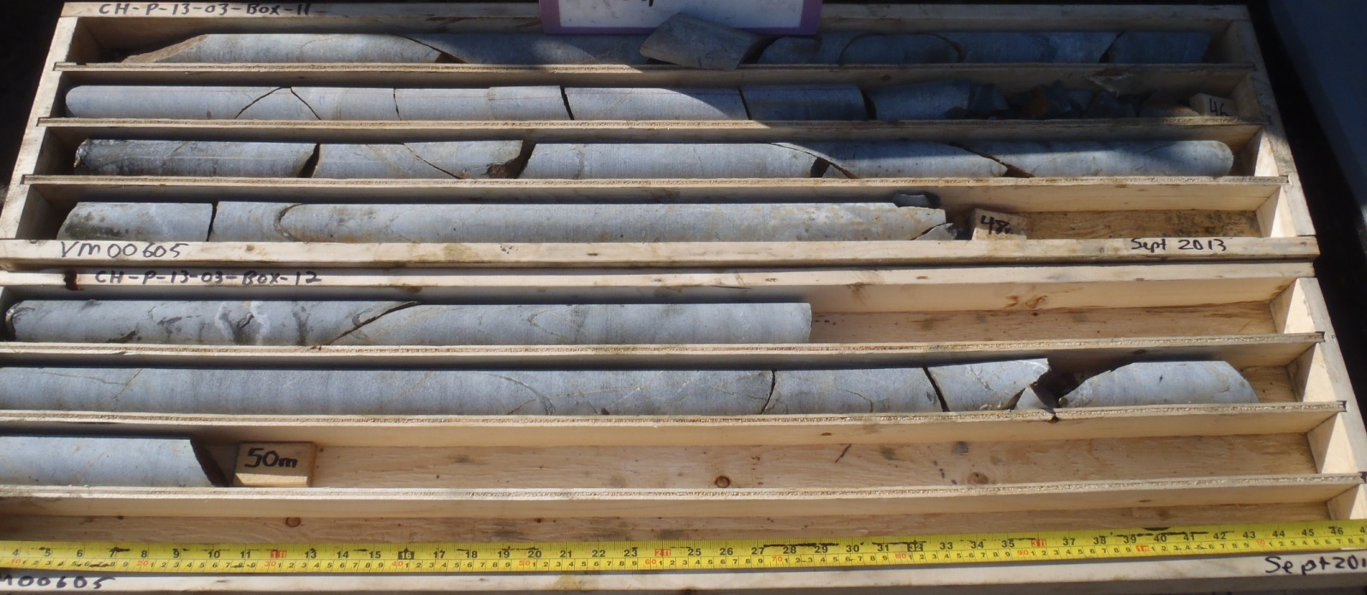

PHOTO 27: 28_CH-P-13-03_Box 11 and 12_44-50m_Sept 13, 2013.

AMEC Environment & Infrastructure |  | Government of Yukon - AAM  Mount Nansen 2013 Site Investigation  Photographs
Logged by: TK | Scale: NTS | Date: Nov 2013 | Project: VM00605 | Page 12

Photos of CH-P-13-04

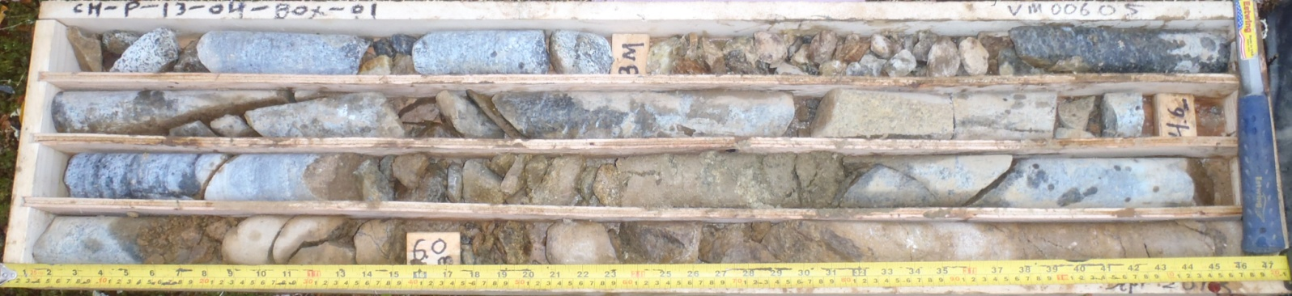

PHOTO 28: 1_CH-P-13-04_Box 1_0-7m_Sept 15, 2013.

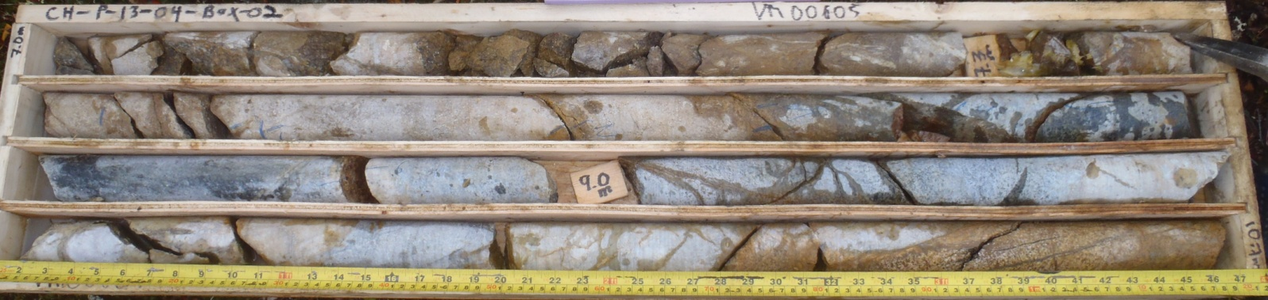

PHOTO 29: 4_CH-P-13-04_Box 2_7-10m_Sept 15, 2013.

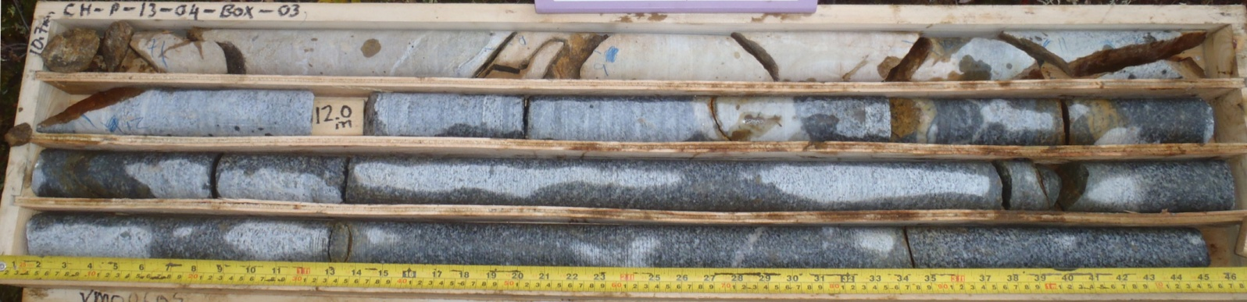

PHOTO 30: 7_CH-P-13-04_Box 3_10-15m_Sept 15, 2013.
Government of Yukon - AAM
Mount Nansen 2013 Site Investigation
Photographs
Logged by: TK | Scale: NTS | Date: Nov 2013 | Project: VM00605 | Page 13

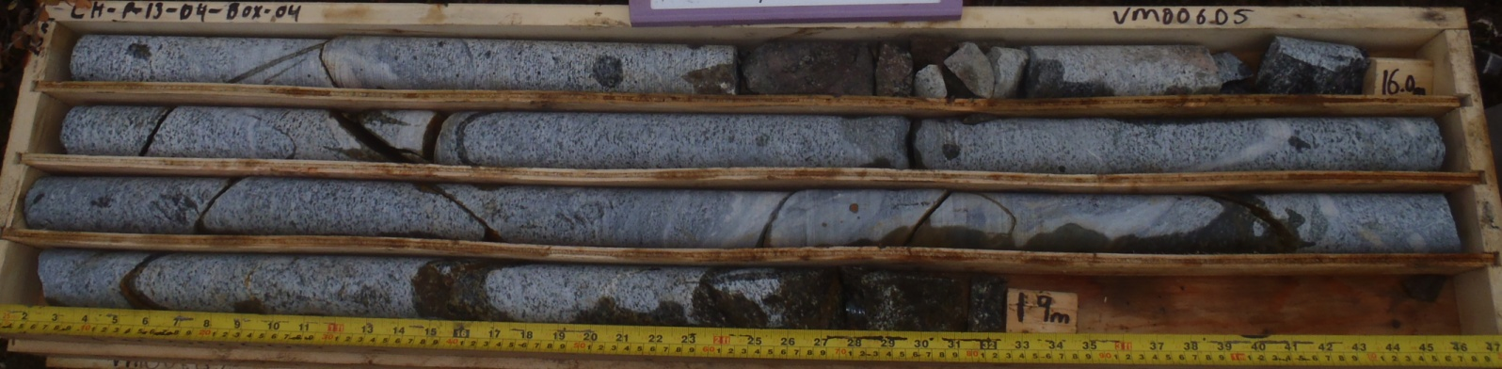

PHOTO 31: 10_CH-P-13-04_Box 4_15-19m_Sept 15, 2013.

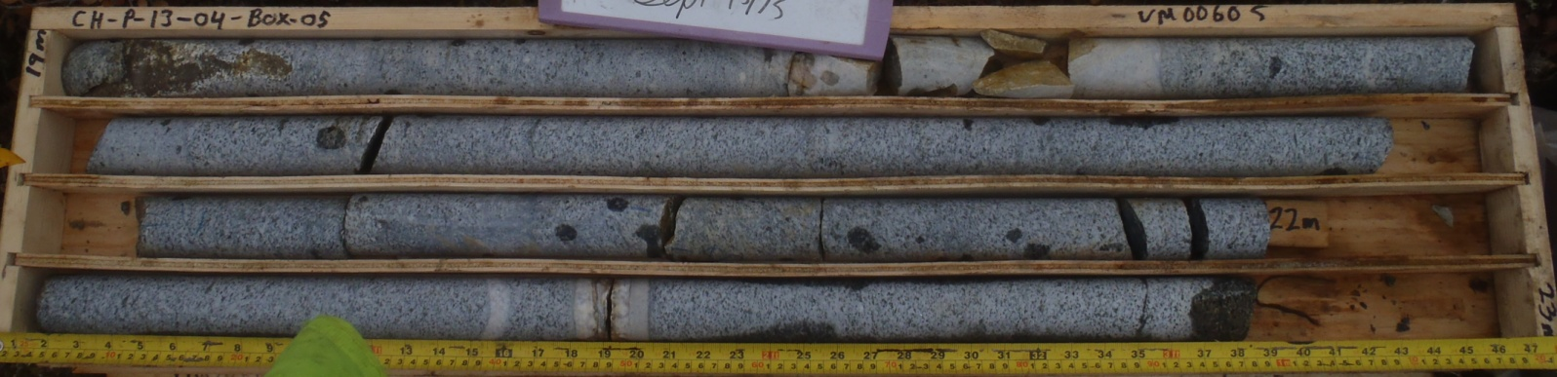

PHOTO 32: 13_CH-P-13-04_Box 5_19-23m_Sept 15, 2013.

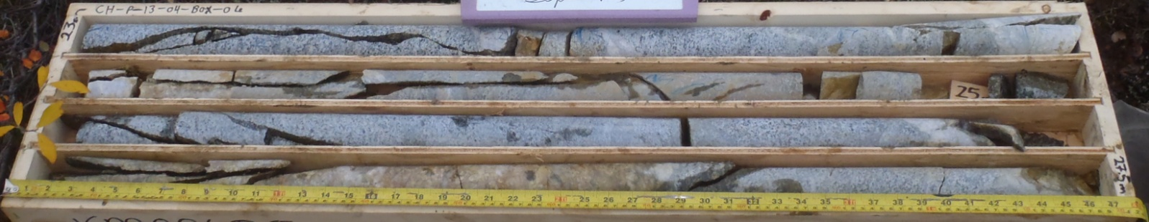

PHOTO 33: 16_CH-P-13-04_Box 6_23-27m_Sept 15, 2013.
AMEC Environment & Infrastructure |  | Government of Yukon - AAM  Mount Nansen 2013 Site Investigation  Photographs
Logged by: TK | Scale: NTS | Date: Nov 2013 | Project: VM00605 | Page 14

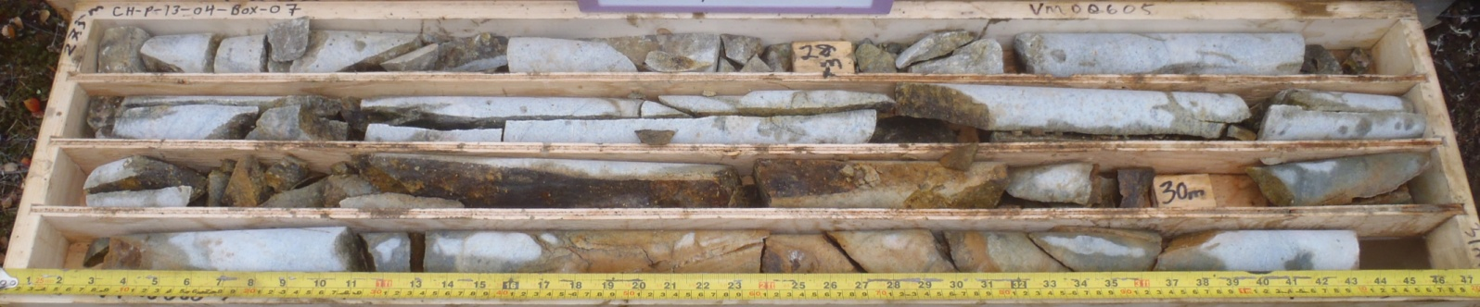

PHOTO 34: 19_CH-P-13-04_Box 7_27-31m_Sept 15, 2013.

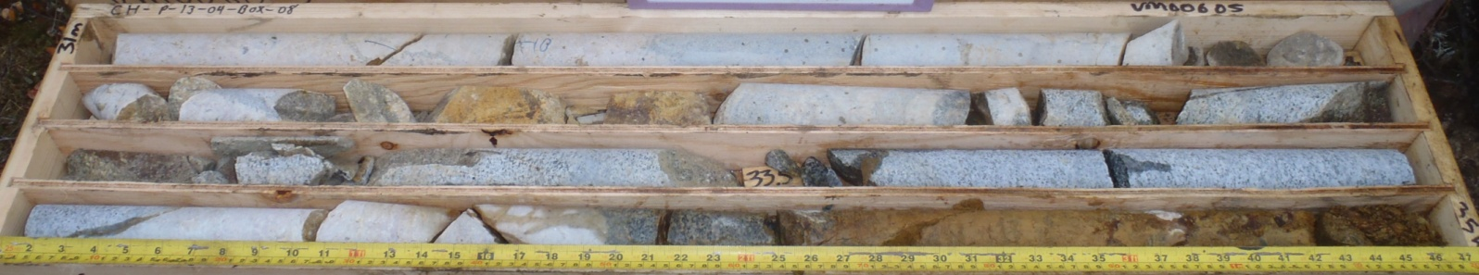

PHOTO 35: 22_CH-P-13-04_Box 8_31-35m_Sept 16, 2013.

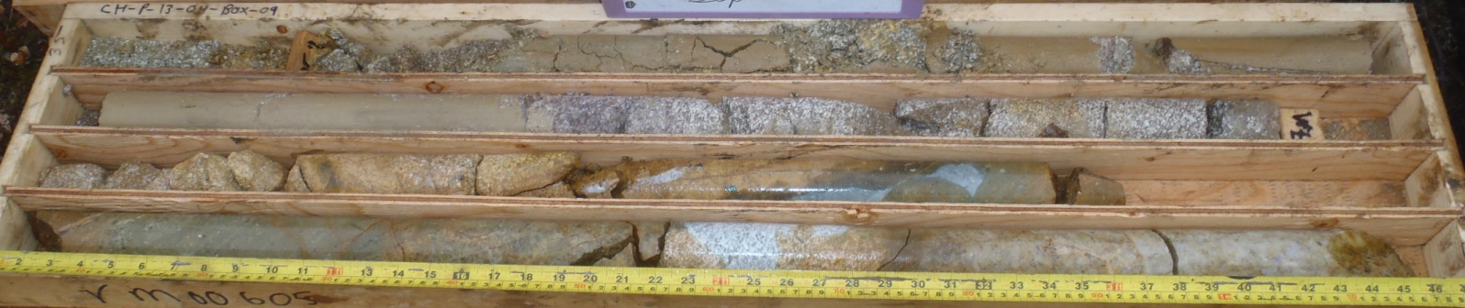

PHOTO 36: 25_CH-P-13-04_Box 9_35-39m_Sept 16, 2013.
AMEC Environment & Infrastructure |  | Government of Yukon - AAM  Mount Nansen 2013 Site Investigation  Photographs
Logged by: TK | Scale: NTS | Date: Nov 2013 | Project: VM00605 | Page 15

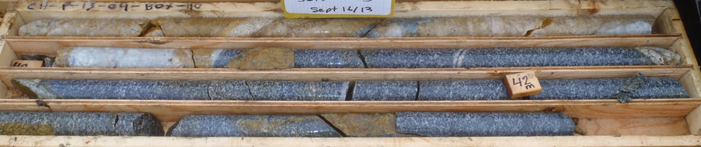

PHOTO 37: 28_CH-P-13-04_Box 10_39-43m_Sept 16, 2013.

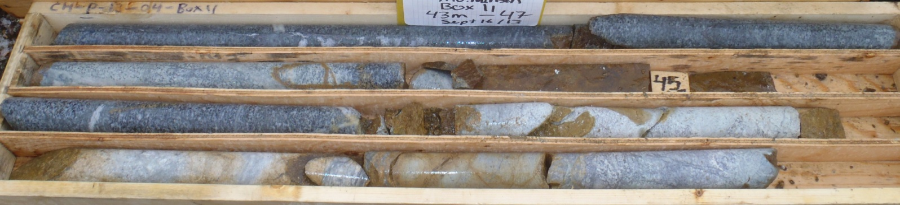

PHOTO 38: 31_CH-P-13-04_Box 11_43-47m_Sept 16, 2013.

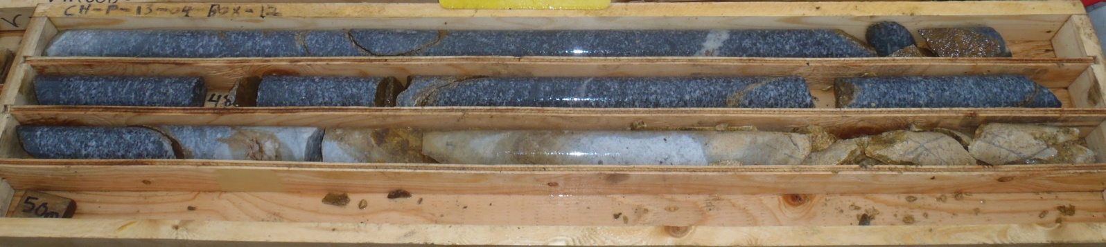

PHOTO 39: 34_CH-P-13-04_Box 12_47-50m_Sept 16, 2013.
AMEC Environment & Infrastructure |  | Government of Yukon - AAM  Mount Nansen 2013 Site Investigation  Photographs
Logged by: TK | Scale: NTS | Date: Nov 2013 | Project: VM00605 | Page 16

Photos of CH-P-13-05

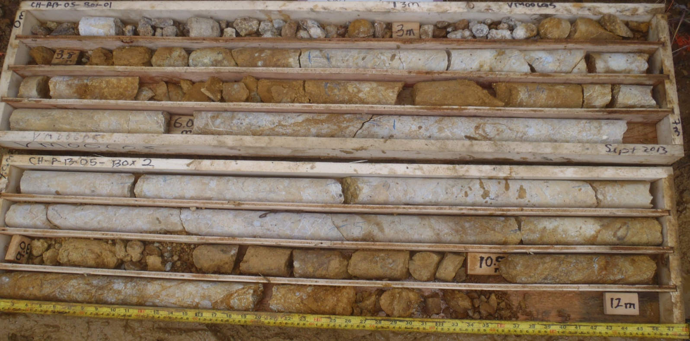

PHOTO 40: 1_CH-P-13-05_Box 1 and 2_0-12m_Sept 21, 2013.

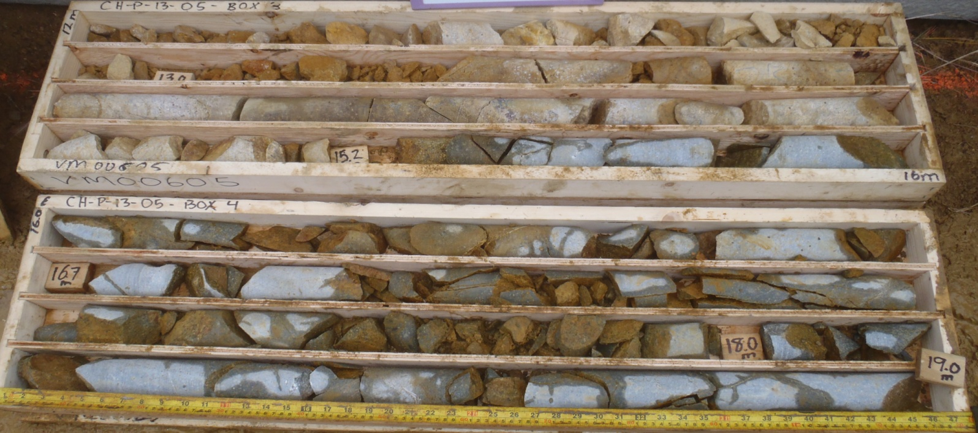

PHOTO 41: 4_CH-P-13-05_Box 3 and 4_12-19m_Sept 22, 2013.
Government of Yukon - AAM
Mount Nansen 2013 Site Investigation
Photographs
Logged by: TK | Scale: NTS | Date: Nov 2013 | Project: VM00605 | Page 17

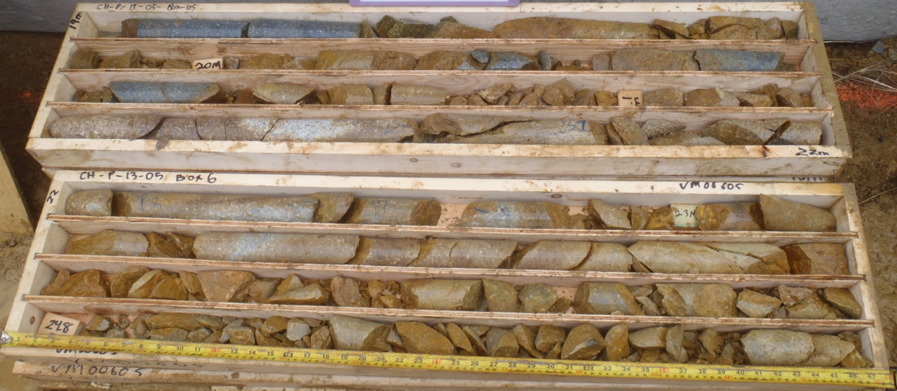

PHOTO 42: 7_CH-P-13-05_Box 5 and 6_19-26m_Sept 22, 2013.

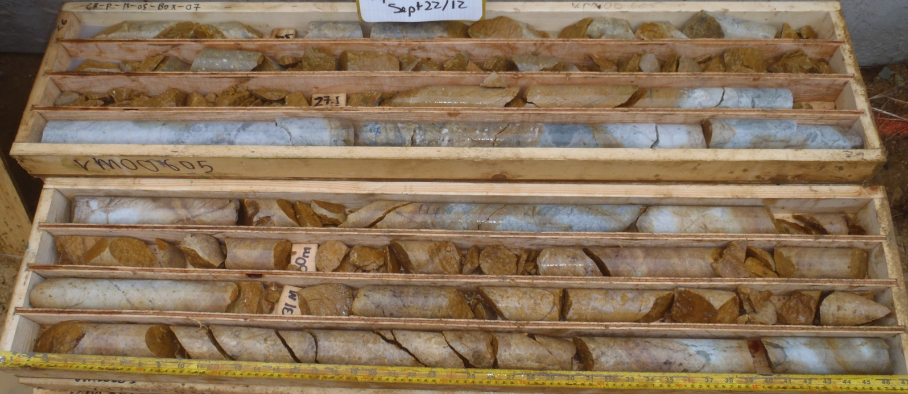

PHOTO 43: 10_CH-P-13-05_Box 7 and 8_26-33m_Sept 22, 2013.
AMEC Environment & Infrastructure |  | Government of Yukon - AAM  Mount Nansen 2013 Site Investigation  Photographs
Logged by: TK | Scale: NTS | Date: Nov 2013 | Project: VM00605 | Page 18

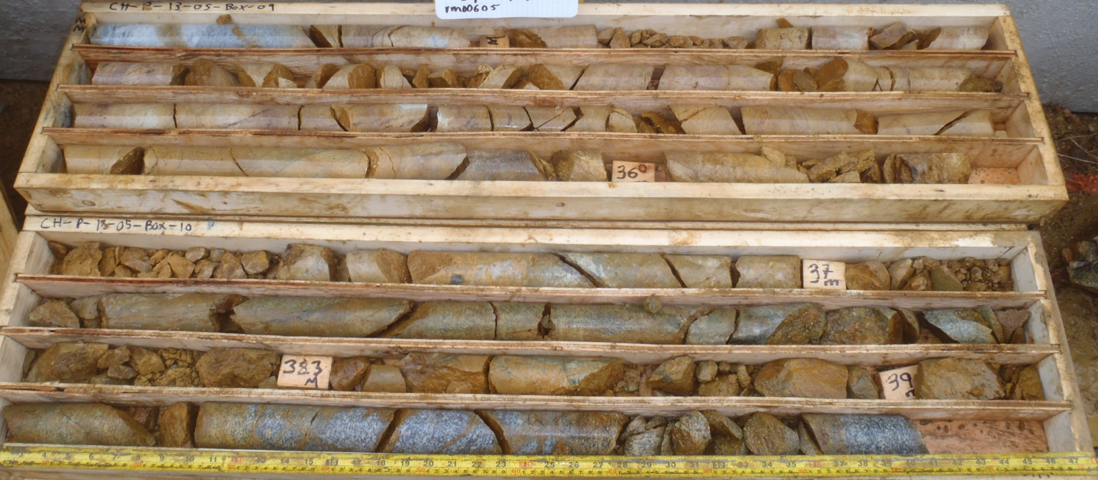

PHOTO 44: 13_CH-P-13-05_Box 9 and 10_33-40m_Sept 22, 2013.

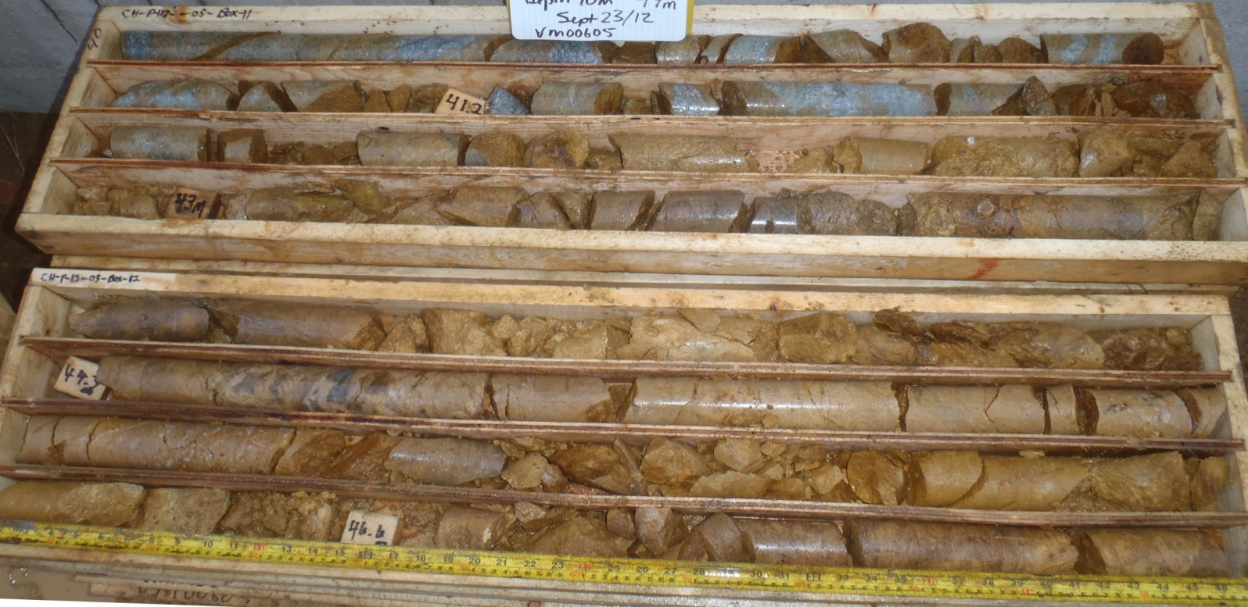

PHOTO 45: 16_CH-P-13-05_Box 11 and 12_40-47m_Sept 23, 2013.
AMEC Environment & Infrastructure |  | Government of Yukon - AAM  Mount Nansen 2013 Site Investigation  Photographs
Logged by: TK | Scale: NTS | Date: Nov 2013 | Project: VM00605 | Page 19

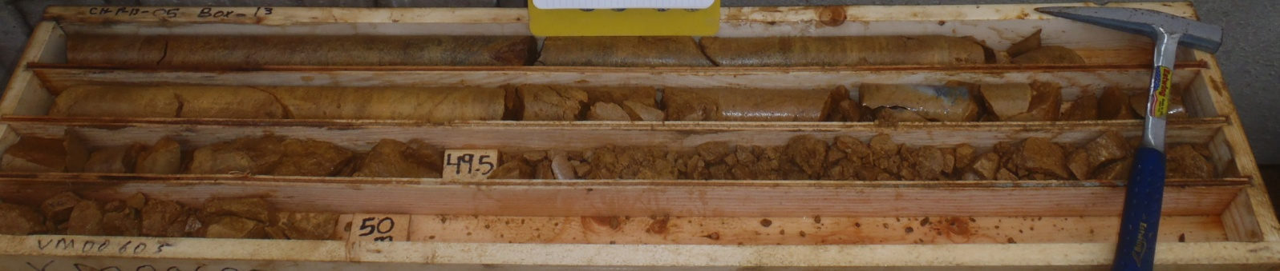

PHOTO 46: 19_CH-P-13-05_Box 13_47-50m_Sept 23, 2013.

AMEC Environment & Infrastructure |  | Government of Yukon - AAM  Mount Nansen 2013 Site Investigation  Photographs
Logged by: TK | Scale: NTS | Date: Nov 2013 | Project: VM00605 | Page 20

Photos of CH-P-13-06

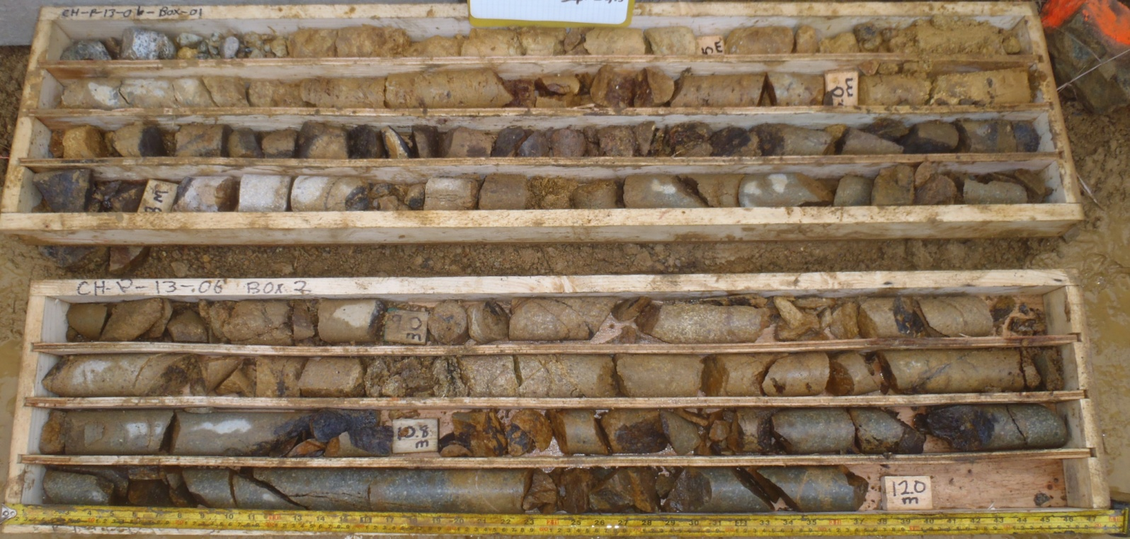

PHOTO 47: 1_CH-P-13-06_Box 1 and 2_0-12m_Sept 23, 2013.

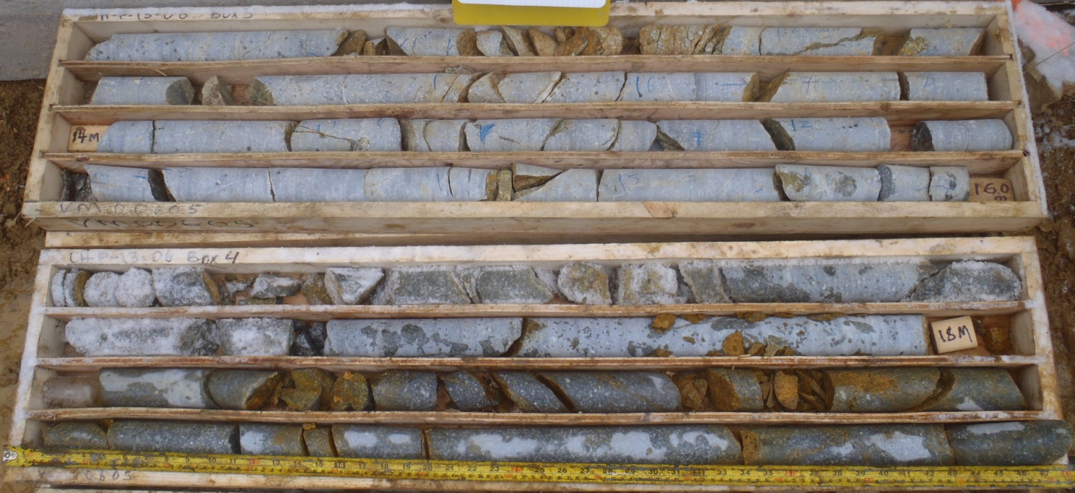

PHOTO 48: 4_CH-P-13-06_Box 3 and 4_12-20m_Sept 24, 2013.
Government of Yukon - AAM
Mount Nansen 2013 Site Investigation
Photographs
Logged by: TK | Scale: NTS | Date: Nov 2013 | Project: VM00605 | Page 21

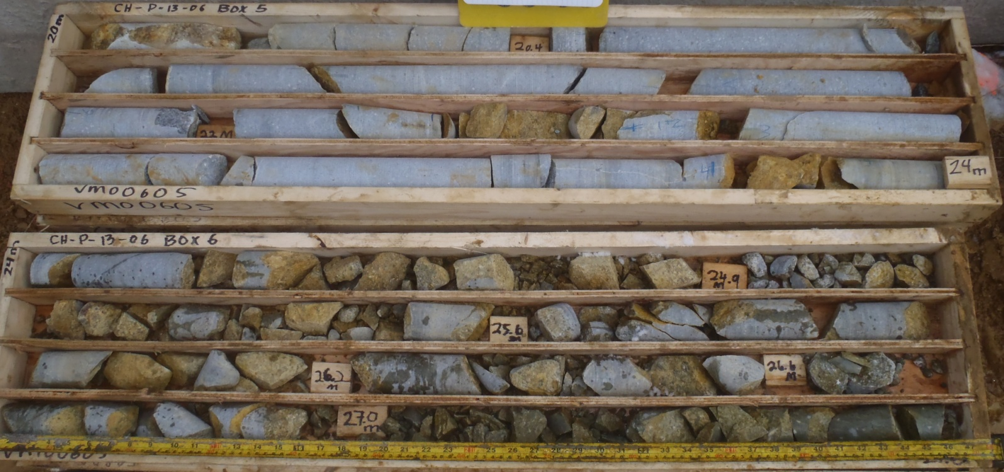

PHOTO 49: 7_CH-P-13-06_Box 5 and 6_20-27m_Sept 24, 2013.

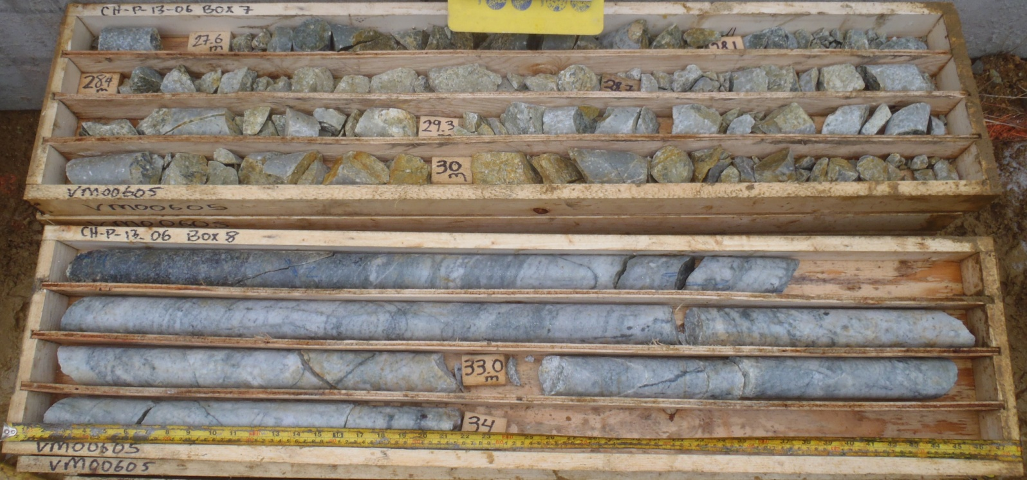

PHOTO 50: 10_CH-P-13-06_Box 7 and 8_27-34m_Sept 26, 2013.
AMEC Environment & Infrastructure |  | Government of Yukon - AAM  Mount Nansen 2013 Site Investigation  Photographs
Logged by: TK | Scale: NTS | Date: Nov 2013 | Project: VM00605 | Page 22

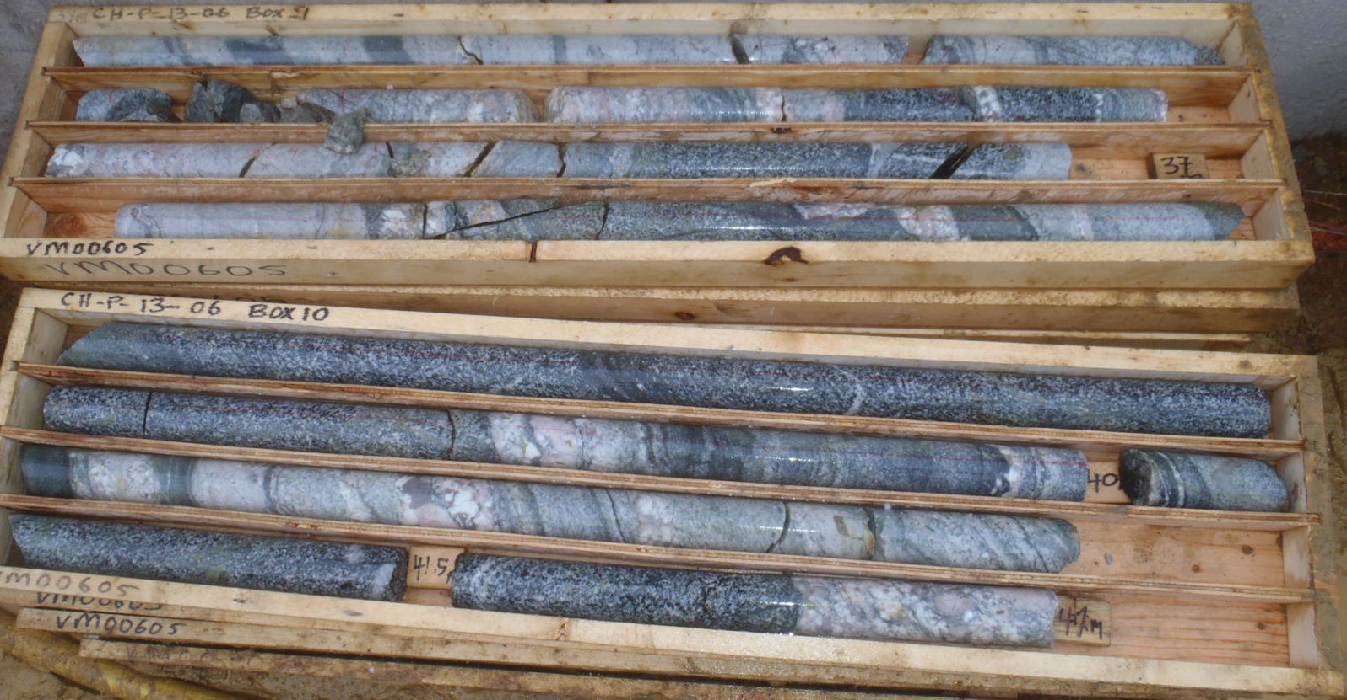

PHOTO 51: 13_CH-P-13-06_Box 9 and 10_34-42m_Sept 26, 2013.

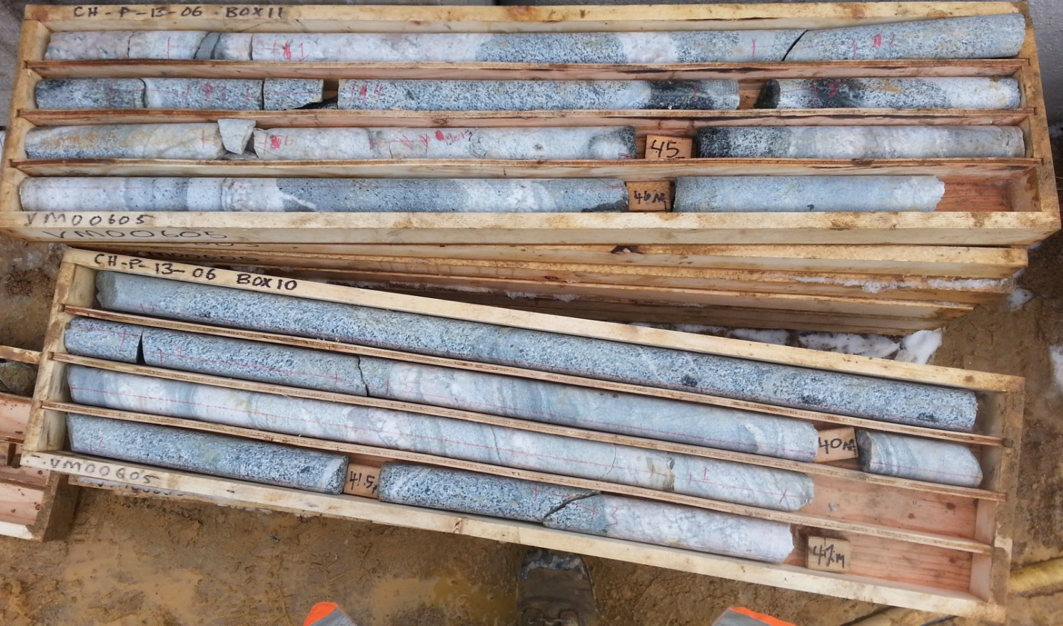

PHOTO 52: 16_CH-P-13-06 (Box 10 and 11) 37 to 46 mbgs_Sept 27, 2013.

AMEC Environment & Infrastructure |  | Government of Yukon - AAM  Mount Nansen 2013 Site Investigation  Photographs
Logged by: TK | Scale: NTS | Date: Nov 2013 | Project: VM00605 | Page 23

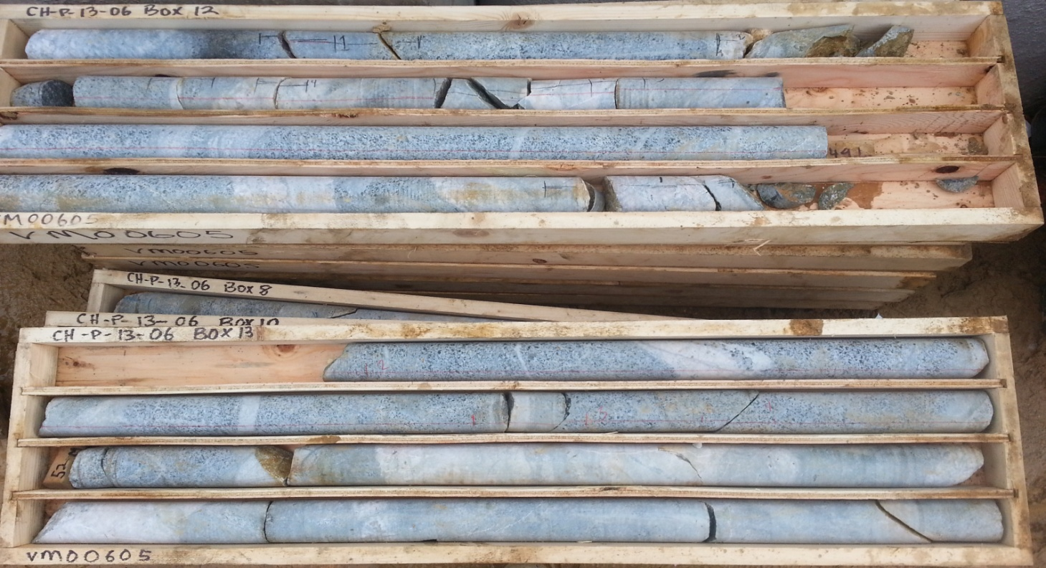

PHOTO 53: 17_CH-P-13-06 (Box 12 and 13) 46 to 52 mbgs_Sept 27, 2013.

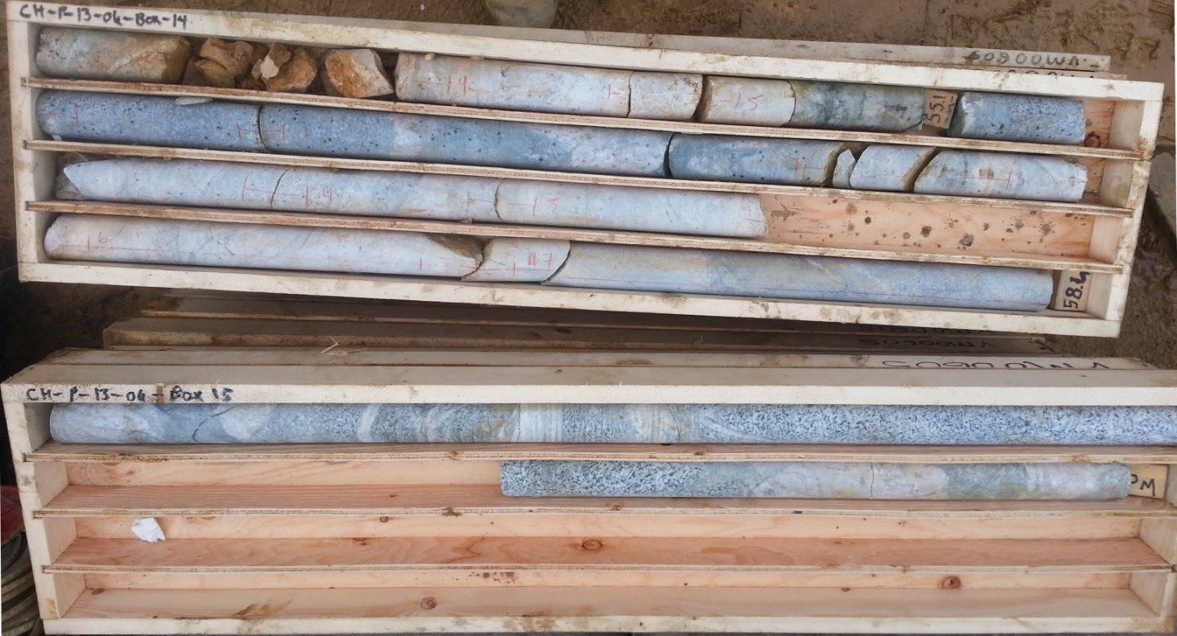

PHOTO 54: 18_CH-P-13-06 (Box 14 and 15) 52 to 60 mbgs_Sept 27, 2013.
AMEC Environment & Infrastructure |  | Government of Yukon - AAM  Mount Nansen 2013 Site Investigation  Photographs
Logged by: TK | Scale: NTS | Date: Nov 2013 | Project: VM00605 | Page 24

