Mount Nansen 2013 Site Investigation

list of photos
Page
Photos of Site Characteristic Test Pits and Sonic Drilling Photos 1
PHOTO 1: Staining observed near BH-KZ-13-01 (8 Sep. 2013). 1
PHOTO 2: Drilling at BH-KZ-01 (8 Sep. 2013). 2
PHOTO 3: Borehole BH-M-13-03 (9 Sep. 2013). 4
PHOTO 4: Drilling at Borehole BH-KZ-13-01 (9 Sep. 2013). 6
PHOTO 5: Soil from 2.6-3.0 m in Borehole BH-M-13-08 (10 Sep. 2013). 8
PHOTO 6: Drilling at Borehole BH-M-13-01 (10 Sep. 2013). 10
PHOTO 7: Groundwater surfacing at BH-M-13-04 (10 Sep. 2013). 12
PHOTO 8: Excavation of Testpit TP-R-13-05 (11 Sep. 2013). 14
PHOTO 9: Excavation of Testpit TP-R-13-04 (11 Sep. 2013). 16
PHOTO 10: Completed Testpit TP-R-13-04 (11 Sep. 2013). 18

Photos of Site Characteristic Test Pits and Sonic Drilling Photos

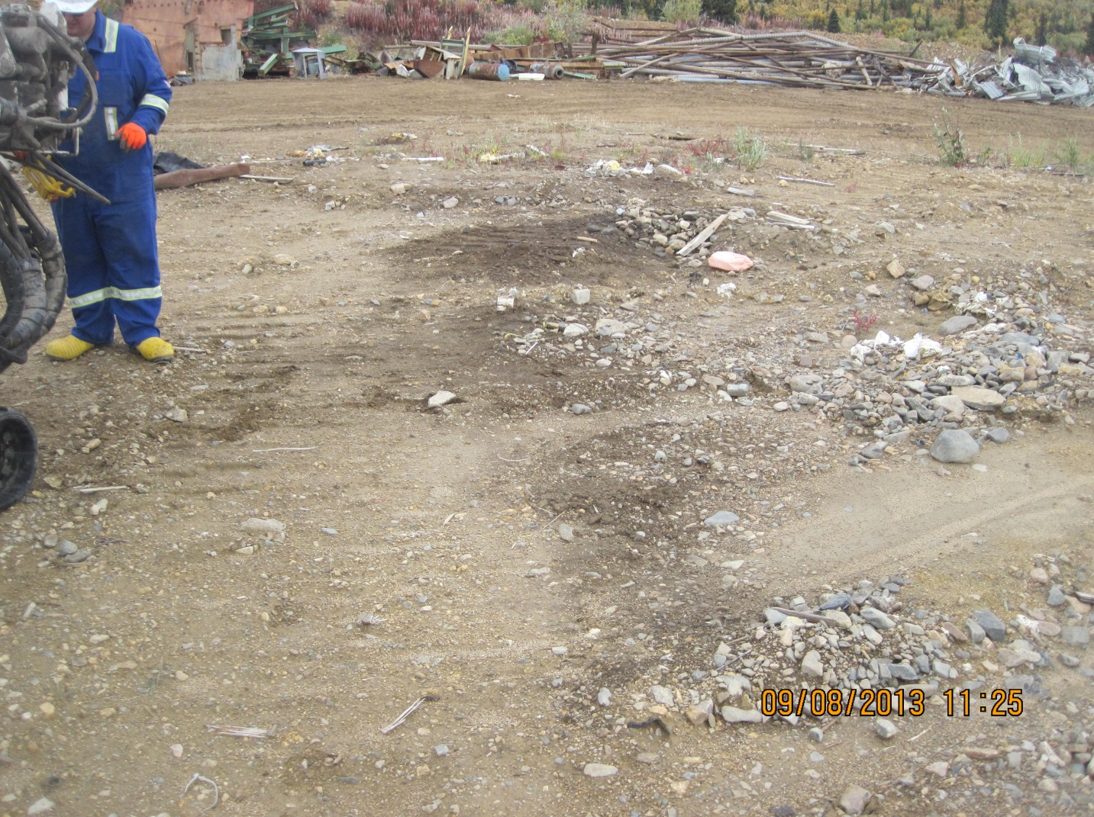

PHOTO 1: Staining observed near BH-KZ-13-01 (8 Sep. 2013).
   |  | Government of Yukon - AAM  Mount Nansen 2013 Site Investigation  Photographs
Logged by: NJ | Scale: NTS | Date: Oct 2013 | Project: VM00605E | Page 1

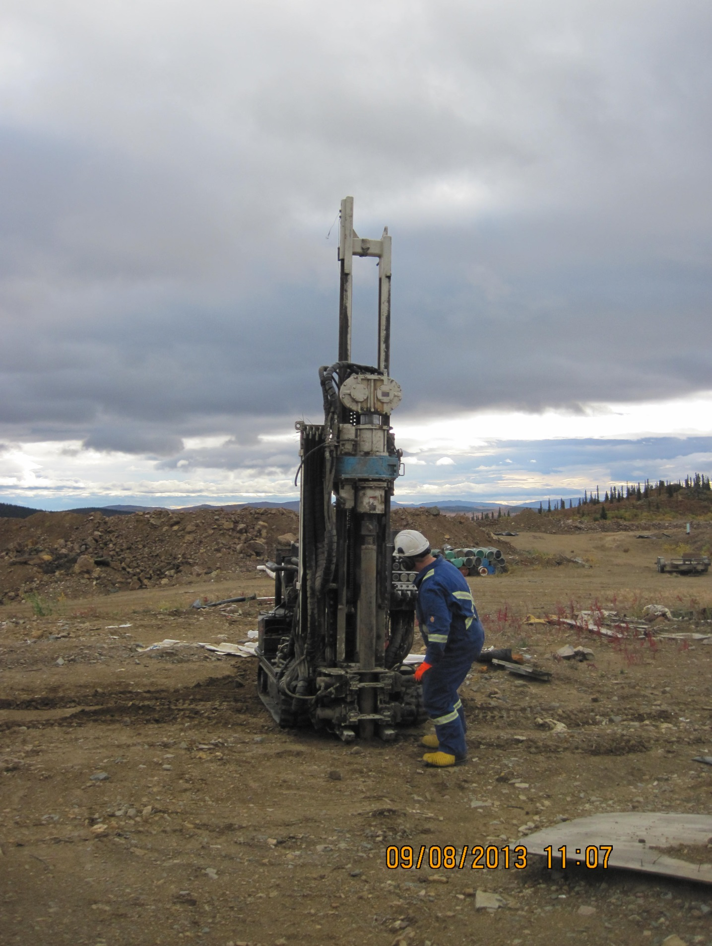

PHOTO 2: Drilling at BH-KZ-01 (8 Sep. 2013).
AMEC Environment & Infrastructure |  | Government of Yukon - AAM  Mount Nansen 2013 Site Investigation  Photographs
Logged by: NJ | Scale: NTS | Date: Oct 2013 | Project: VM00605E | Page 2

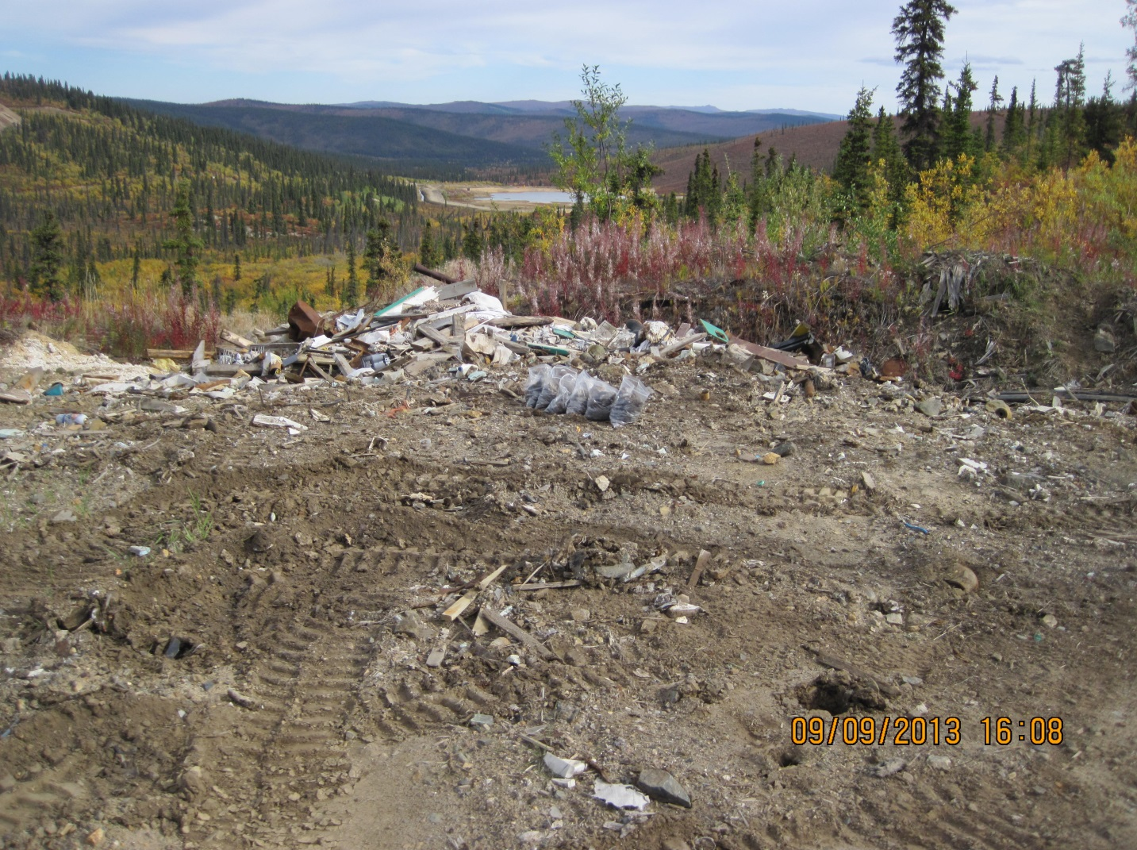

PHOTO 3: Borehole BH-M-13-03 (9 Sep. 2013).
AMEC Environment & Infrastructure |  | Government of Yukon - AAM  Mount Nansen 2013 Site Investigation  Photographs
Logged by: NJ | Scale: NTS | Date: Oct 2013 | Project: VM00605E | Page 3

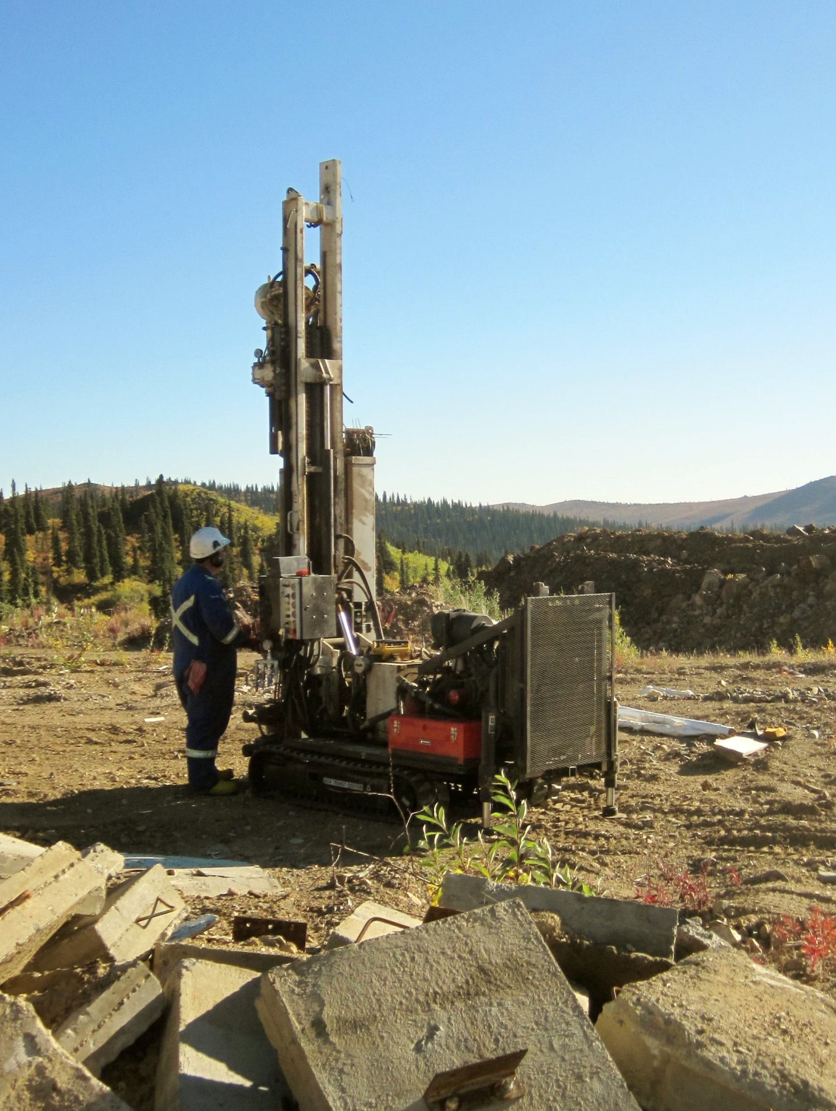

PHOTO 4: Drilling at Borehole BH-KZ-13-01 (9 Sep. 2013).
AMEC Environment & Infrastructure |  | Government of Yukon - AAM  Mount Nansen 2013 Site Investigation  Photographs
Logged by: NJ | Scale: NTS | Date: Oct 2013 | Project: VM00605E | Page 4

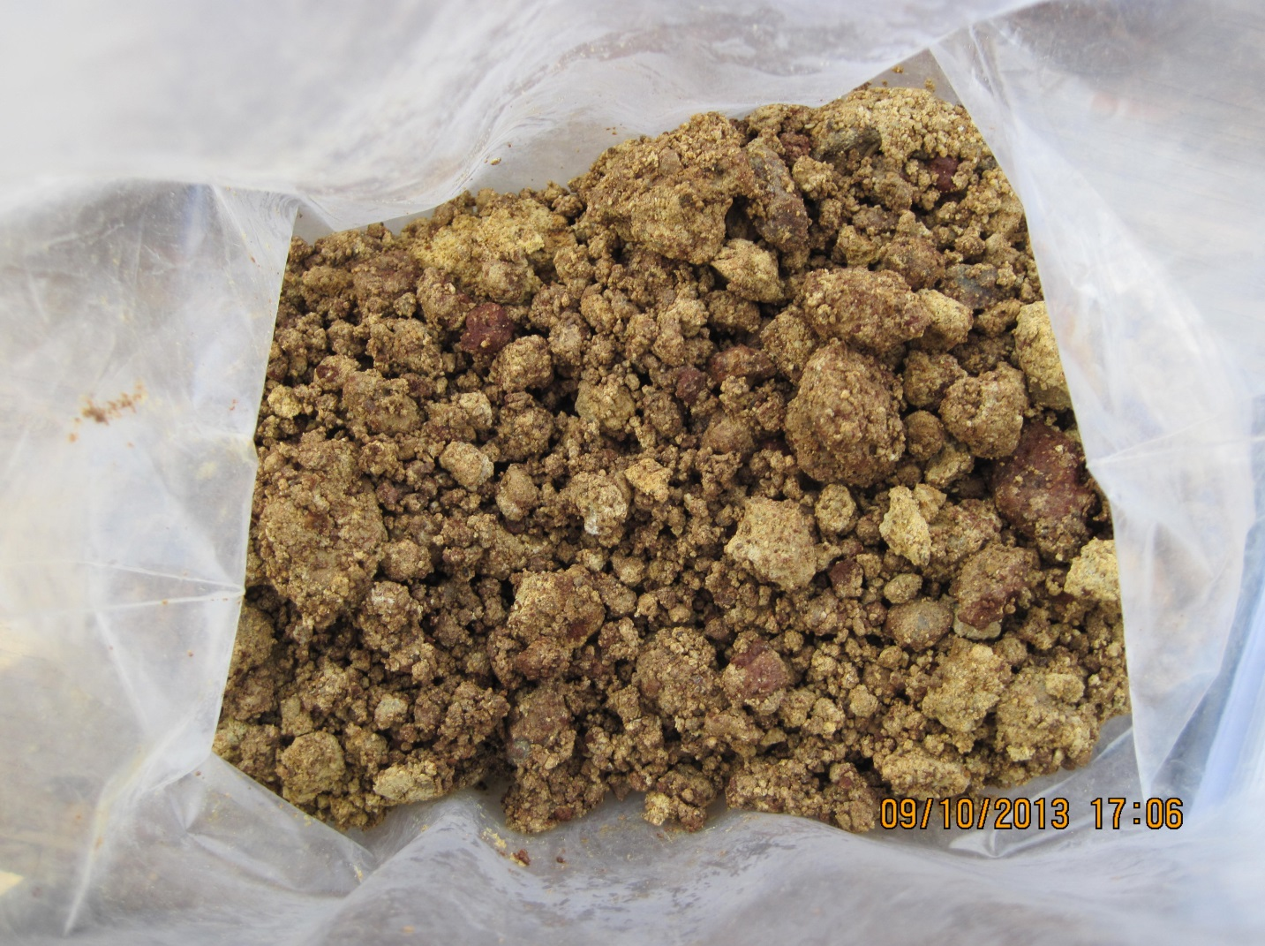

PHOTO 5: Soil from 2.6-3.0 m in Borehole BH-M-13-08 (10 Sep. 2013).
AMEC Environment & Infrastructure |  | Government of Yukon - AAM  Mount Nansen 2013 Site Investigation  Photographs
Logged by: NJ | Scale: NTS | Date: Oct 2013 | Project: VM00605E | Page 5

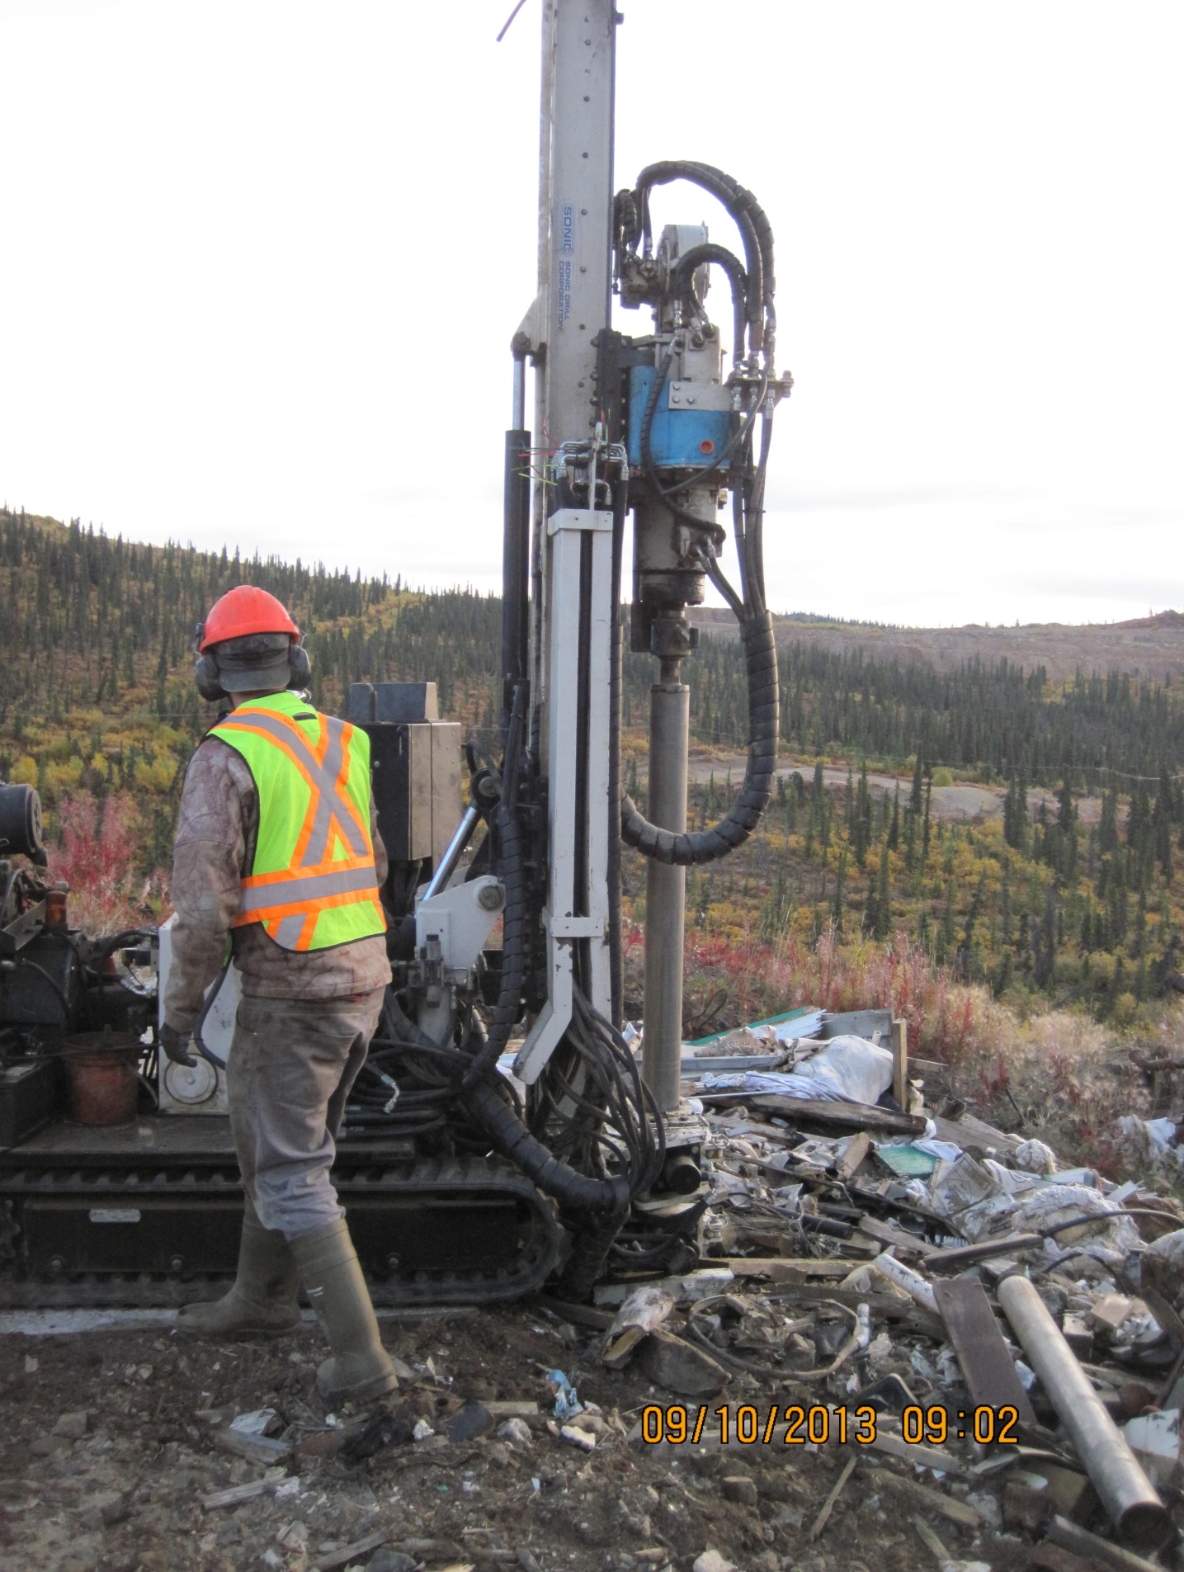

PHOTO 6: Drilling at Borehole BH-M-13-01 (10 Sep. 2013).
AMEC Environment & Infrastructure |  | Government of Yukon - AAM  Mount Nansen 2013 Site Investigation  Photographs
Logged by: NJ | Scale: NTS | Date: Oct 2013 | Project: VM00605E | Page 6

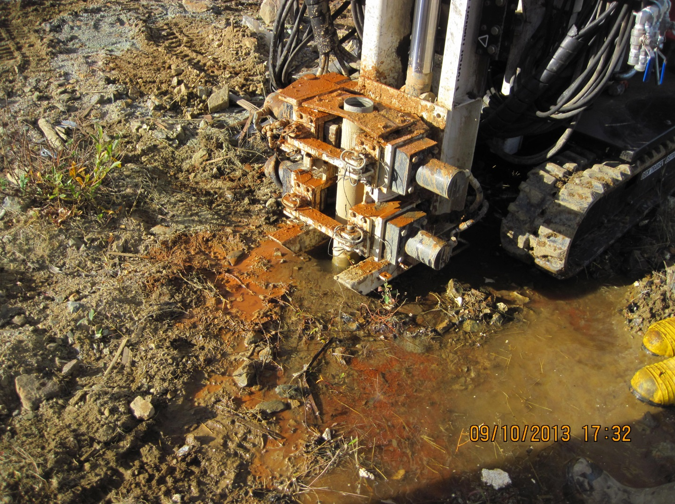

PHOTO 7: Groundwater surfacing at BH-M-13-04 (10 Sep. 2013).
AMEC Environment & Infrastructure |  | Government of Yukon - AAM  Mount Nansen 2013 Site Investigation  Photographs
Logged by: NJ | Scale: NTS | Date: Oct 2013 | Project: VM00605E | Page 7

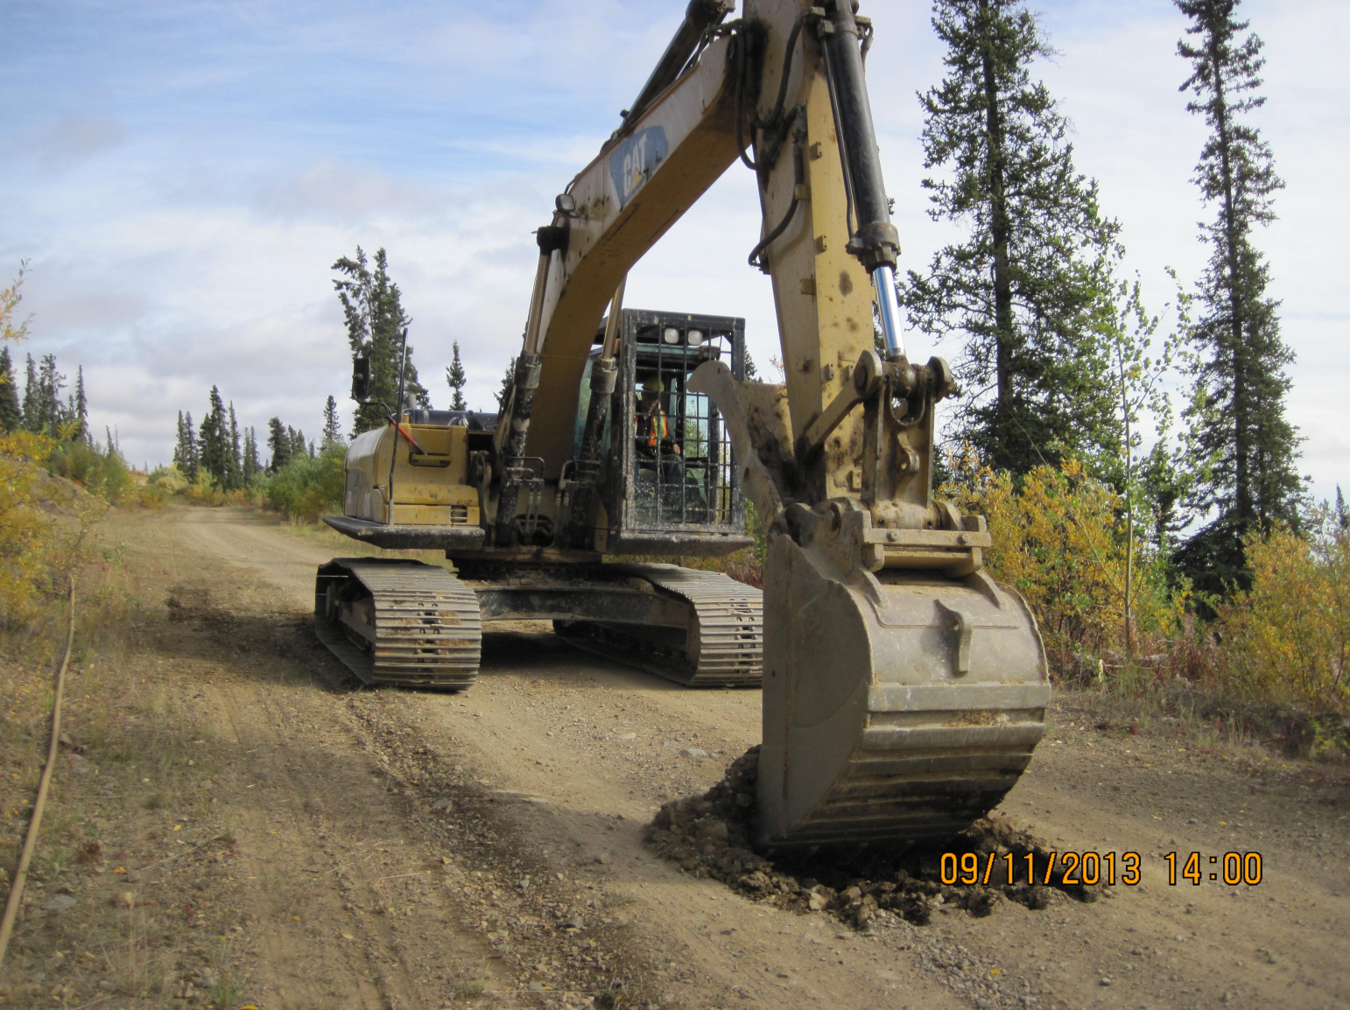

PHOTO 8: Excavation of Testpit TP-R-13-05 (11 Sep. 2013).
AMEC Environment & Infrastructure |  | Government of Yukon - AAM  Mount Nansen 2013 Site Investigation  Photographs
Logged by: NJ | Scale: NTS | Date: Oct 2013 | Project: VM00605E | Page 8

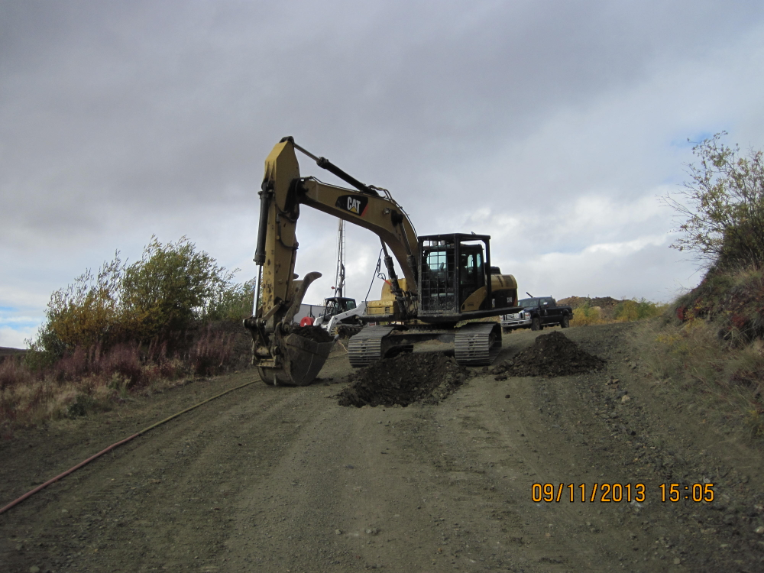

PHOTO 9: Excavation of Testpit TP-R-13-04 (11 Sep. 2013).
AMEC Environment & Infrastructure |  | Government of Yukon - AAM  Mount Nansen 2013 Site Investigation  Photographs
Logged by: NJ | Scale: NTS | Date: Oct 2013 | Project: VM00605E | Page 9

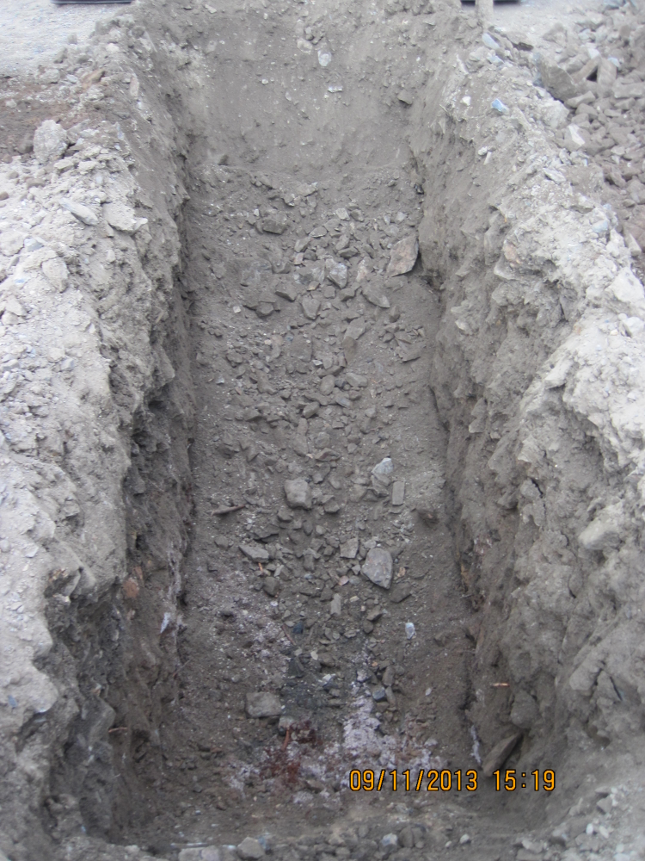

PHOTO 10: Completed Testpit TP-R-13-04 (11 Sep. 2013).
AMEC Environment & Infrastructure |  | Government of Yukon - AAM  Mount Nansen 2013 Site Investigation  Photographs
Logged by: NJ | Scale: NTS | Date: Oct 2013 | Project: VM00605E | Page 10

