Mount Nansen Tailings Dam

Dam Safety Review

Department of Energy, Mines and Resources
Assessment and Abandoned Mines
307071-00856-00-SS-REP-0001
13 November 2013

WorleyParsons Canada
Suite 600, 4321 Still Creek Drive
Burnaby, BC V5C 6S7 CANADA
Phone: +1 604 298 1616
Facsimile: +1 604 298 1625
www.worleyparsons.com
© Copyright 2013 WorleyParsons

Disclaimer
This Document [is conceptual in nature and] represents the work of WorleyParsons Canada Services Ltd. (WorleyParsons) performed to recognized engineering principles and practices appropriate for [conceptual engineering work and] the terms of reference provided by WorleyParsons’ contractual Customer, Government of Yukon (the “Customer”). This Document may not be relied upon for detailed implementation or any other purpose not specifically identified within this Document. This Document is confidential and prepared solely for the use of the Customer. The contents of this Document may not be relied upon by any party other than the Customer, and neither WorleyParsons its sub-consultants nor their respective employees assume any liability for any reason, including, but not limited to, negligence, to any other party for any information or representation herein. The extent of any warranty or guarantee of this Document or the information contained therein in favor of the Customer is limited to the warranty or guarantee, if any, contained in the contract between the Customer and WorleyParsons.

Contents
1. Introduction 1
1.1 General 1
1.2 Site Description 1
2. SCOPE OF WORK 2
3. Data and records 3
3.1 Geology 3
3.2 Hydrogeology 3
3.3 Hydrology 3
3.3.1 Rainfall Data 4
3.3.2 Runoff 4
3.4 Soil Conditions 5
3.5 Soil Parameters 6
3.6 Seismicity 7
3.7 Design and Construction 7
3.8 As-Built Documents 9
3.9 Updated Drawings 9
3.10 Dam Safety Review Reports 9
3.11 Inspection Reports 10
4. Site inspection and staff interviews 11
4.1 Site Inspections 11
4.1.1 Tailings Dam 11
4.1.2 Seepage Pond and Dyke 13
4.1.3 Dome Creek Diversion Channel 14
4.1.4 Interception Ditch 16
4.1.5 Pond Emergency Spillway 17
4.1.6 Combined Spillway 18
4.2 Staff Interviews 18
5. dam failure CONSEQUENCe 20
6. Dam Safety Analysis 21
6.1 Geotechnical Assessment 21
6.1.1 Seepage 21
6.1.2 Liquefaction 22
6.1.3 Potential for Piping 22
6.1.4 Slope Stability of Embankment 23
6.2 Hydrotechnical Assessment 25
6.2.1 Statistical Flood Analysis 25
6.2.2 Inflow Design Flood 25
6.2.3 Spillway and Other Flow Control Structures 26
6.2.4 Freeboard 29
6.2.5 Reservoir (Pond) Operating Rules 31
6.2.6 Ice and Debris 31
6.2.7 Seepage Collection Pond 31
7. OM&S, Emergency Preparedness, AND Public Safety 32
7.1 Operation, Maintenance, and Surveillance 32
7.2 Emergency Preparedness 33
7.3 Public Safety and Security 33
8. Dam Safety Management System 34
9. CONCLUSIONS 35
10. RECOMMENDATIONS 36
10.1 Geotechnical 36
10.2 Hydrotechnical 36
10.3 Operations and Maintenance 37
11. Closure 38
12. REFERENCES 39

Tables within Text
Table A Short Duration Rainfall Data (Klohn-Crippen 1995) 4
Table B Estimated Peak Instantaneous Flow (m³/s) 5
Table C Soil Parameters 6
Table D Reference (Class C) design PGA and Sa(T) for 1/1,000 AEP 7
Table E Factor of Safety for Slope Stability - Static Assessment 23
Table F Factor of Safety for Slope Stability - Seismic Assessment 23
Table G Factor of Safety for Slope Stability Assessment Mount Nansen Tailings Dam 24
Table H Instantaneous Peak Flow Estimates 25
Table I Criteria Applications 34

Photographs within Text
Photo A Upstream Face of Tailings Pond Dam 11
Photo B Crest of Tailings Pond Dam 12
Photo C Downstream Face of Tailings Pond Dam 13
Photo D Seepage from toe of dam into seepage pond 14
Photo E Dome Creek Diversion Channel 15
Photo F Bridge at Downstream End of Diversion Channel 16
Photo G Interception Ditch 17
Photo H Tailing Dam Spillway 17
Photo I Combined Spillway D/S of Tailings Pond 18
Photo J Bridge across Diversion Channel 27
Photo K Emergency Spillway Channel at Access Road Crossing 28
Photo L Slope Failure on Combined Spillway 30

Appendices
Appendix 1 Figures
Appendix 2 Inspection Check Sheets

Introduction

General
WorleyParsons Canada Services Ltd. (WorleyParsons) has been engaged by the Government of Yukon Energy, Mines and Resources (EMR) Assessment and Abandoned Mines (AAM) to undertake a Dam Safety Review (DSR) of the Mount Nansen tailings dam (the Site).
The DSR was undertaken in general accordance with the requirements of the Dam Safety Guidelines published by the Canadian Dam Association (CDA 2007) and covers the aspects required to assess that (i) the dam is safe, operated safely, and maintained in a safe condition; (ii) surveillance is adequate to detect any developing safety concerns; and (iii) emergency procedure are complete and appropriate.
The tailings dam is scheduled for removal in the next five years. As the previous DSR was undertaken at the site 10 years ago, AAM has determined that a review following the CDA Guidelines is required in the 2013 / 2014 fiscal year. As discussed with AAM, it is proposed that the DSR be conducted as though no previous assessments have been undertaken; hence, this review was conducted as if it was the first formal review completed of the tailings dam.

Site Description
Mount Nansen is a former gold and silver mine located in the Yukon (YT), approximately 45 km west of Carmacks, YT and 180 km north of Whitehorse, YT. The property is located within the traditional territory of Little Salmon / Carmacks first nations. Mount Nansen road connects the Site to the North Klondike Highway in Carmacks and is maintained by the Government of Yukon - Highways and Public Works. The Site is also located within the Dome Creek drainage area, a part of the watershed that flows into the Yukon River. The Site is powered by diesel-fuel and has both telephone and internet access. All infrastructure is maintained by full-time on-site operators. Since this site is located remotely, site personnel are also the first responders when it comes to emergencies and emergency procedures. Approximately 1.6 km downstream of the seepage pond, there is an access road (Mount Nansen Road) - which is open to the public that crosses Dome Creek.
The tailings dam, seepage pond dam, diversion channel and spillway are the four major structures at the site associated with the tailings facility. The facility was designed by Klohn-Crippen Consultants Ltd.
(Klohn-Crippen) in 1995 with construction management assistance from Ketza Construction Pacific Ltd. (Ketza) in 1996. Based on our review of the construction documents, the stability of the dam foundation has been suspect due to poor construction practices. This has caused the structure to be more prone to degradation due to the presence of permafrost within the area.
The diversion channel intercepts Dome Creek upstream of the tailings pond and directs water around the tailings and seepage ponds and back into Dome Creek further downstream. On site, the tailings pond seeps into the seepage pond. Flow pumped from the seepage pond is monitored using a flow meter and is discharged down gradient of the tailings dam provided that it satisfies the release criteria. Otherwise, the seepage pond water would be pumped back to the tailings pond. Since 2004, the pond seepage has been suitable for direct release to the environment. The flow rate of water out of the seepage pond provides an indication of increased or excess seepage from the tailings pond. This increased flow rate can be an indicator of possible impending failure of the tailings dam subgrade through permafrost melt. The ground generally has a low hydraulic conductivity if in permafrost, but with melting, the conductivity increases, along with seepage rate.

SCOPE OF WORK
WorleyParsons’ scope of work for the DSR was outlined in its proposal, dated May 6, 2013. In summary, the study includes the following tasks:
- Compilation and review of design information, previous reports, recorded data, and records along with an associated gap analysis;
- Site inspection and staff interviews;
- Determination of the inflow design flood, and seismic loading consistent with consequence classification of dam;
- Dam safety analysis;
- Operations, maintenance, and surveillance review;
- Emergency preparedness review;
- Public safety and security review;
- Dam safety management system review, including review of monitoring and instrumentation program, and action plans in case of exceedance; and
- DSR report preparation.

Data and records

Geology
In general, the surficial geology consists mainly of colluvial, residual, and granular glacial outwash overlying bedrock with a thickness of 1 m overlying upland bedrock outcrops to 20 m in the middle of the Dome Creek valley. In the valley, the till is overlain by silty sand up to 15 m thick and up to about 1 m of moss and peat (AECOM 2008).
The Site is located within the region associated with the Nansen glacial drift. At least 2,000 years ago, volcanic ash fell onto the area up to 30 cm in depth. Remnants of this ash are visible at many locations on the property. The ash occurs at surface or just below the organic soils. In general, the soil varies from sandy gravel to fine sandy silt and is medium density with some loose pockets (Klohn-Crippen 1995).
The site is located in the Dawson Range of the Yukon Tanana Terrane (YTT). The Dawson Range is underlain by Early Mississippian metamorphic rocks intruded by several plutonic suites. At the site location, bedrock consists of meta-sedimentary and meta-igneous rock types. The meta-sedimentary rock sub-group is made up of Nasina assemblage including micaceous quartz-feldspar gneiss, schist, and quartzite. Biotite-hornblende feldspar gneiss and course-grained granodiorite orthogneiss with lesser amphibolite make up the meta-igneous package (Protore Geological Service 2006). The Mount Nansen formation consists of a Porphyry system containing a multi-phased complex of porphyritic rocks that occur as dykes, small plugs, and breccia bodies located in a 3 km-long by 1.5 km-wide area between upper Nansen and Victoria Creeks.

Hydrogeology
A review of the site hydrogeology indicates that the seepage from the open pit flows to the bedrock aquifer system, which discharges downstream to talik under the tailings pond and/or the valley bottom aquifer system, located most likely in the Dome Creek drainage basin (AECOM 2008). It is possible that part of the flow into the seepage pond downstream of the main dam is associated with groundwater from the open pit; therefore, this needs to be considered when planning closure, determining environmental impact, and completing risk assessments.

Hydrology
The site is located in the Dome Creek catchment. Dome Creek is a tributary of Victoria Creek which flows into Nisling River and ultimately on to the Yukon River north of Carmacks, YT. The Dome Creek catchment area upstream of the tailings pond (Figure 1, Appendix 1) is approximately 281 ha. The main Dome Creek channel is diverted around the dam in a channel that runs to the north of the dam structure. Some surface flows are also diverted in an interception ditch from along the west side of the tailings pond (42 ha.) connecting with the west end of the Dome Creek diversion channel. Flow from the catchment along the south side of the tailings pond is not diverted and runoff from approximately 7 ha. flows directly into the tailing pond.

Rainfall Data
The Site hydrology was first studied by Klohn-Crippen in 1995. A frequency analysis was conducted using daily rainfall data collected at Carmacks, YT, located approximately 45 km from the Site and at an elevation approximately 500 m lower than the Site. The Atmospheric Environment Service (AES) Intensity Duration Frequency curve for Carmacks, for the period 1964 to 1984 was adjusted using various data manipulation techniques to increase the period of record to 1998; however, the validity of these adjustments is uncertain as limited information was provided in the reports. The spillway and diversion channel designs were based on the Inflow Design Flood (IDF) estimated from rainfall data presented in Table A.
Table A Short Duration Rainfall Data (Klohn-Crippen 1995)
Duration | Rainfall (mm)
Duration | 20-year | 200-year | Probable Maximum Precipitation (PMP)
5 min | 8.8 | 12.9 | 22.1
10 min | 12.0 | 17.8 | 41.2
15 min | 14.3 | 21.2 | 48.1
30 min | 16.8 | 24.1 | 57.8
1 h | 18.8 | 26.9 | 86.1
2 h | 21.7 | 30.0 | 101
6 h | 26.0 | 35.5 | 124
12 h | 31.9 | 44.0 | 146
24 h | 35.7 | 49.2 | 170

Runoff
The estimated instantaneous peak runoff from the site was assessed by Klohn-Crippen in 1995 and again by EBA Engineering Consultants Ltd. (EBA) in 2001, as detailed below.

Klohn-Crippen (1995)
Klohn-Crippen used an OTTHYMO model to estimate peak flow events in the diversion channel and over the tailings pond emergency spillway based on the six-hour storm event. The diversion channel was designed to convey the 20-year storm event (6.4 m³/s) with flow in the diversion channel in excess of the design capacity being discharged into the tailings pond. The pond emergency spillway was designed for the 200-year peak outflow (3.7 m³/s) after routing the IDF through the tailings pond. Klohn-Crippen estimated the 200-year flow over the emergency spillway to be less than the 20-year flow in the diversion channel because significant flow attenuation was predicted to occur within the tailings pond.
Klohn-Crippen compared the estimated 20-year flow in the diversion channel flow to the 200-year flow over the pond emergency spillway, and used the larger of the two as the design flow for the combined spillway (i.e., 6.4 m³/s).This estimate appears incorrect as, during the 200-year event, it is possible the diversion channel could be conveying the 20-year flow (6.4 m³/s) while also receiving flow out of tailings pond via the emergency spillway. Under these circumstances, it would seem likely that the flow downstream of the combined spillway could be greater than 6.4 m³/s.

EBA (2001)
The hydrology was reviewed in 2001 by EBA as part of the spillway and diversion channel modifications design work. This assessment utilized the same rainfall data as Klohn-Crippen (presented in Table B) and a Storm Water Management Model (SWMM) computer model. For the modelling, EBA used a two-hour duration storm event rather than the six-hour event used by Klohn-Crippen, on the basis that the 5.5 mm of additional rainfall that occurs during a six-hour vs. a two-hour event would be spread out over an additional four-hour period, and thus would not have a significant impact on peak flow estimates.
Preliminary analysis by WorleyParsons indicates that for the 200-year return period storm, the six-hour event may actually produce slightly higher peak flows than the two-hour event; however, this slight difference in peak flows was not considered significant for the purpose of this DSR. Based on a total catchment area of 3.07 km², EBA’s estimated instantaneous peak flows were 1.2 m³/s for the 20-year event and 3.0 m³/s for the 200-year event. EBA did not distinguish between peak flow in the diversion channel and peak flow into the tailings pond, which is appropriate.
Table B Estimated Peak Instantaneous Flow (m³/s)
Location | 20-year return period |  | 200-year return period
Location | Klohn-Crippen | EBA | Klohn-Crippen | EBA
Diversion Channel upstream (U/S) of Tailings Pond Spillway | 6.4 | --- | Not Provided | ---
Tailings Pond Spillway | --- | 1.2 | 3.7 | 3.0
Diversion Channel / Spillway downstream (D/S) of Tailing Pond Spillway | 6.4 | 1.2 | 6.4* | 3.0
WorleyParsons completed preliminary hydrological modeling using the Klohn-Crippen rainfall data, and the results were comparable to those presented by EBA; therefore, for the purposes of this DSR, the 200-year return period storm events as calculated by EBA was carried forward in the analysis.
The peak flow data (Table B) includes an estimate of the PMP; however, no estimate of the associated Probable Maximum Flood (PMF) was provided by Klohn-Crippen or by EBA. Based on preliminary calculations by WorleyParsons using the two-hour PMP event (101 mm), the peak instantaneous PMF is likely to be in the range of 20 m³/s to 30 m³/s without consideration of any flow attenuation that may occur within the tailings pond.

Soil Conditions
The main stratigraphic units across the Dome Creek Valley consist primarily of fine-to-medium sands with varying silt content. Surficial organic materials overlie the sand soils at the ground surface, with coarse gravel and sand layers occurring at depth underlying the main sand strata. Moisture contents varied in the different soil strata (5% to 20%), but showed a consistent trend. Though gravel layers were encountered intermittently throughout the upper sand strata, the frequency and coarseness of gravel appeared to increase significantly below a depth of approximately 9 m to 10 m below ground surface (bgs).
Bedrock was encountered in close proximity underlying the deep gravel layers in some holes drilled in 1994 and 1995 (Klohn-Crippen 1995), and two holes (where auger refusal was achieved) during the most recent geotechnical drilling program in the upper portion of the tailings pond (EBA 2012e). The bedrock depth is variable and is assumed to be between 13 m bgs and 20 m bgs.
The site lies within the discontinuous permafrost zone, close to the southern boundary of the widespread areas of Permafrost Island. The site investigation carried out before the 1995 indicated the entire area is underlain by permafrost. Natural depths to permafrost range from ground surface to 11 m bgs. The original designers predicted that the zone of foundation thawing (permafrost degradation) would be limited to an area underneath the tailings pond (up to 5 m) and the upstream embankment toe where the depth of thaw would be limited to 2 m (EBA 2002a). The permafrost table was then expected in the long term to rise into the dam by about 3 m at the centreline and return to natural permafrost levels (1.5 m) about 15 m beyond the downstream toe. Since 1998, thermistors installed in and downstream of the dam crest have been monitored. Data up until 2013 (EBA 2013b) has confirmed that the thawing of the permafrost beneath the tailings facilities has exceeded the design predictions and there is no evidence that significant freeze-back is occurring. The data, in fact, generally shows that the ground temperatures are warming (stable at some locations). This is not unexpected, given the convective heat transferred from seepage beneath the dam. There is no information with respect to the depth of thaw upstream of the dam because more readings from the single cable installed in 2012 at the east end of the tailings pond, are required to verify permafrost and identify any trend.

Soil Parameters
The definition of the soil parameters was based on limited available data and no additional data have been collected since 2000 (EBA 2002b). Three soil types were assumed and their estimated parameters are presented in Table C.
Table C Soil Parameters
Soil Unit | Unit Weight  γ (kN/m³) | Friction Angle  φ (°) | Cohesion  c (kPa)
Tailings | 18.6 | 28 | 0
Compacted Dam Fill | 19.5 | 34 | 0
Native Foundation Soil | 19.0 | 28 to 30 | 0
The bulk unit weight of the fill sand was estimated based on the limited compaction testing and two Standard Proctor tests completed during the dam construction.
For the tailings material, there was no site specific database of materials testing to assist in selecting a bulk unit weight; therefore, it was estimated by assuming values for the void ratio, specific gravity, and water content. Bulk densities were measured in the various strata underlying the tailings dam and an average bulk unit weight was assumed.
For the strength parameters, all three materials above were considered cohesionless and it was recognized that a definitive value for the friction angle could not be developed without laboratory test results (empirical correlations with the Cone Penetration Test [CPT] results were considered); therefore, either conservative values, or a ranges of values were assumed.

Seismicity
With reference to the National Building Code of Canada (NBCC) and considering the depth at which bedrock was encountered in some holes (13 m bgs to 18 m bgs), a seismic site classification of Class C “Very Dense Soil and Soft Rock” is considered reasonable for the Mount Nansen Tailings Dam site.
CDA Guidelines (2007) state that the level of Earthquake Design Ground Motion (EDGM) for which the dam or other structure shall be designed or evaluated should be selected on the basis of the consequence level in the event of a dam failure. Since the consequence associated with the failure of the Mount Nansen Tailings Dam is considered “SIGNIFICANT” (see Section 5), the EDGM should be taken as equal to the earthquake having an Annual Exceedance Probability (AEP) of 1/1,000.
Reference Peak Ground Accelerations (PGA) and Spectral Accelerations (S_{a}[T]) as obtained from the Earthquakes Canada website (Natural Resources Canada 2010) for a Class C site and a 1/1,000-year earthquake return period at the site are provided in Table D.
Table D Reference (Class C) design PGA and Sa(T) for 1/1,000 AEP
PGA | S_{a}(0.2) | S_{a}(0.5) | S_{a}(1.0) | S_{a}(2.0)
0.078 | 0.146 | 0.101 | 0.069 | 0.042
Reference PGA and S_{a}(T) for other earthquake return periods are provided on Figure 2, Appendix 1.

Design and Construction
The final design of the tailings impoundment was documented in a report dated August 1995 issued by Klohn-Crippen (1995). The tailing facilities were constructed by Ketza for B.Y.G. Natural Resources Inc. in 1996.
The geometric design of the dam included a crest width of 6 m at an elevation of 1,151.5 m (1,099.6 m in Universal Transverse Mercator [UTM] coordinates and a geodetic datum - adopted from 2008), an upstream slope of 2.5:1 (H:V), and downstream slope of 3.5:1 (H:V). The maximum tailings elevation within the impoundment was to be 1,149.2 m (1,097.3 m in UTM coordinates and a geodetic datum) at the end of the three-year mine plan.
The tailings dam and the seepage control dyke were built using fine- to medium-grained fluvial sand borrowed from sources within the impoundment and from the spillway excavation. The dam foundation consists of permafrost soils that, excluding an upper organic rich zone, are also a sand material.
A Geosynthetic Clay Liner (GCL) was incorporated into the upstream slope to provide secondary seepage control. The primary seepage control was to be provided by the tailings deposited within the impoundment. A minimum tailings beach width of 50 m was called for in the design. Exposed slopes and crest of the dam were protected from erosion by placing a layer of gravel and cobble-sized angular rock fragments from weathered bedrock borrowed from slopes above the north side of the dam.
Construction of the facility was completed between May 1996 and September 1996. The construction process was monitored by, and fully-documented in a report issued by, Klohn-Crippen (1996). Significant observations from the construction include that the foundation stripping was not completed to the extent proposed in the design and that compaction of sand fill was not well-documented and could be suspect in some areas, including the downstream buttress berm, whose construction in 1997 was carried out as an emergency repair operation to improve the slope stability. Furthermore, the work was not monitored in its entirety by an independent engineering firm.
The insufficient foundation stripping indicates that organic materials are likely present underneath some areas of the dam. The suspect compaction suggests that zones of loose sand could be present within the dam fill. Another observation from the construction period was that seepage through the north dam abutment was observed as early as August 1996, at which time there was impoundment due to runoff during construction.
At an early stage of the Dam Safety Assessment undertaken by EBA in 2000 (see Section 3.10), it was determined that urgent upgrading of both the seepage control dyke and spillway system was required. A fast-track design to upgrade the dyke and spillway was developed based on available data from existing reports (Klohn-Crippen 1995, EBA 2002) and documented in a construction report by EBA (2003). Upgrade / reconstruction of the dyke and spillway system were completed by November 2000 and August 2001, respectively. Pelly Construction Ltd. was the general contractor for the reconstruction work.
The upgraded seepage dyke was designed only to reduce the amount of seepage; it was not intended to be a zero-discharge structure. The remediation plan included incorporating a remnant of the existing dyke and raising the crest of the existing dyke. The liner was tied into a key trench in permafrost. A layer of sand-bentonite was placed on the base of the key trench to minimize the amount of seepage through the key trench. Horizontal thermosyphon loops were placed in the key trench to freeze the unfrozen key trench backfill and ensure that the geomembrane liner was tied into the natural permafrost soils below the original ground surface. The design relied on the geomembrane liner and nearly-saturated permafrost soils as containment barriers. The erosion channel on the south abutment was filled to protect the dyke from further erosion damage.
The upgraded spillway was designed to handle a 200-year storm event. This was to be achieved by re-grading the gravel layer on the bed of the spillway channel, placing a layer of riprap over the gravel, and adding a series of drop structures along the spillway, with the intent of reducing flow velocities in the spillway channel; however, because of limited on-site availability of acceptable riprap materials, the thickness and the areal coverage of the placed riprap was less than recommended (50% to 80% of the channel bed versus recommended 100%).Correspondingly, it was determined that the reconstructed spillway would only be able to handle flows from a 20-year storm event. In order to achieve the design 200-year storm event flow capacity, the riprap cover would have to be doubled in thickness and extended in areal coverage.
EBA’s observation during reconstruction suggested that the spillway was not constructed in a consistent manner (geotextile coverage, filter gravel thickness, and riprap thickness likely varied considerably along the spillway); therefore, the reliability of the spillway was considered suspect unless it had been fully reconstructed.

As-Built Documents
No proper as-built drawings are included in the construction reports related to the tailings dam. The only as-built drawing available for the main structure is, in fact, a site plan that includes rudimentary sections of the dam and channel (Drawing No. 5314-08-02 [Klohn-Crippen 1996]).
Construction drawings for the seepage dyke and spillway system improvement works are available and reported in the corresponding construction report (EBA 2003).

Updated Drawings
The only updated drawings are the plans of the tailings impoundment after the conclusion of the upgrade / reconstruction work for the seepage dyke and spillway accomplished in 2000 and 2001 (Figure 2 [EBA 2002a]).

Dam Safety Review Reports
A preliminary review of the dam was undertaken by EBA and Klohn-Crippen in 1999 (Klohn-Crippen 2000). This assessment was based on a site visit, followed by the evaluation of all available construction and instrumentation data. The results indicated that the tailings dam appeared to have an adequate static safety factor against slope instability, but the long-term performance of the structure was still unknown. In order to overcome the threats against the tailings dam safety related to the risk of seepage-induced internal erosion and dam overtopping, some investigation and monitoring measures were recommended during the interim period before the long-term strategy for closing or decommissioning the dam was to be developed.
A more complete assessment of the tailings facilities was undertaken by EBA in 2000 (EBA 2002a). This assessment identified significant safety deficiencies associated with both the normal operating conditions and with the extreme events that could have occurred. The deficiencies identified in the EBA report are summarized as follows.
- Tailings dam: inadequate seismic stability, a lower-than-acceptable static stability, excessive seepage rates, an un-quantifiable potential for piping, and higher than predicted permafrost degradation.
- Combined spillway system: inadequate capacity even for normal operation, inadequate safety for any event greater than a 20-year return storm.
- Seepage control dyke: inadequate performance in consideration of the excessive contaminated seepage passing beyond the facility at that time.
The deficiencies concerning the combined spillway system and the seepage control dyke were identified at an early stage in the assessment process and upgrading measures were enacted in the fall of 2000 and in the summer of 2001 to improve these elements. Objectives comprised mitigating hazards associated with the normal operating conditions in the short-term period (2000 to 2005) (see also Section 3.7).

The EBA assessment encompassed most-but-not-all of the elements of a more comprehensive DSR as defined by the updated CDA Guidelines (2007). Additional effort would have been necessary to evaluate:
- The assigned classification of the dam;
- The operational procedures utilized at the dam site;
- The maintenance procedures utilized at the site; and
- The emergency preparedness plans and procedures developed for the site.

Inspection Reports
As part of the on-going care and maintenance program recommended in the CDA Guidelines (2007), geotechnical inspections of the tailings dam and associated structures were undertaken over the last five years by AECOM (2008) and EBA (2012b and 2013a). Each report contains recommendations for the actions to be included for the improvement of the annual maintenance program.
The overall condition of the structures at the time of each of the inspections was considered to be satisfactory, with stable conditions. The main concern was related to the observed seepage that has been noted intermittently in different locations over the years on the downstream of both the tailings dam and seepage control dyke. Even if there were no signs of significant erosion or permafrost thaw features that could affect the stability, internal erosion of the earth fill associated with the toe seepage cannot be ruled out and the seepage should continue to be monitored, as also recommended by previous Dam Safety reviewers.
In particular, the last geotechnical inspections completed by EBA, as well as recent seepage observations, had led to the conclusion that surface water from Dome Creek may be reporting to the seepage collection pond. Another indication of possible hydraulic connection was the recent increase in reported pumping rates from the seepage collection pond, as compared to historical data. A geotechnical drill and instrumentation program was conducted during the fall of 2012 (EBA 2012e) to investigate the hypothesis that surface water from Dome Creek was going to the seepage pond.
In the 2012 investigation, four boreholes were drilled (indicated as W14103038-01 BH-01 to BH-04 in Figure 4, Appendix 1), which supported the suspicion that surface water was travelling from the unlined Dome Creek diversion spillway underground along the top of permafrost through the unfrozen sand terrace below the tailings dam; however, due to the relatively shallow depth of permafrost (~3 m bgs) in the vicinity of the borehole located at the upper (west) end of the tailings impoundment where the Dome Creek diversion begins, it was considered unlikely that the original Dome Creek channel is hydraulically connected to the seepage collection pond by a subsurface flow path into or under the tailings impoundment.
Several instruments were installed in the 2012 boreholes, including piezometers. The intent of these piezometers was to record water pressure once the ground has thawed; however, thermistor cables have indicated that permafrost remains in place at these locations (EBA 2013b).

Site inspection and staff interviews
On July 17, 2013, Mr. Lee Martin, Mr. Alex Timmis, and Mr. Fred Claridge of WorleyParsons, accompanied by Ms. Josée Perron of Yukon Energy, Mines and Resources Assessment and Abandoned Mines, conducted a site visit of the Mount Nansen site to inspect the tailings dam and associated water management infrastructure.

Site Inspections
A summary of the site observations is provided below.

Tailings Dam

Upstream Face
The upstream face of the dam appeared to be in good condition during the inspection, with no signs of erosion or slumping. A depression near the centreline of the dam was noted; however, AAM personnel indicated that the depression is a remnant from the removal of the tailings reclaim pump shack and inlet. The upstream slope was largely free of vegetation other than some spare grass and low shrubs.
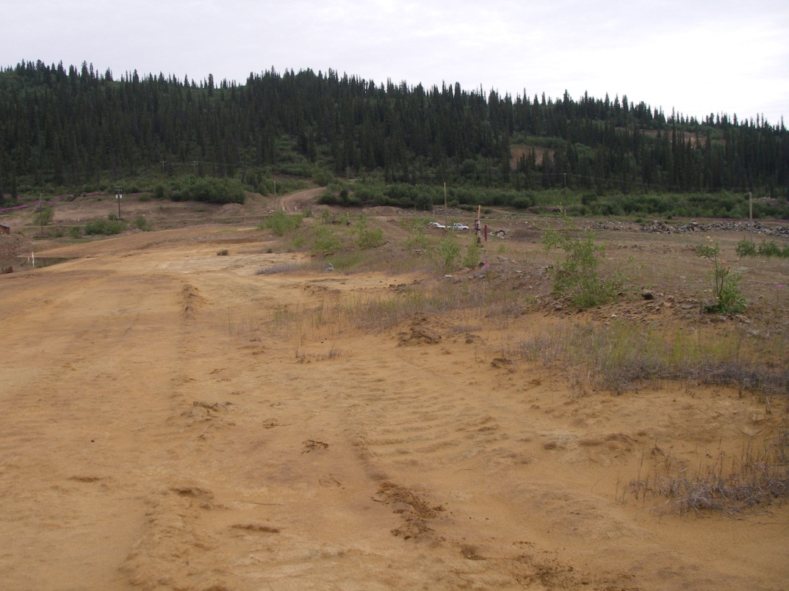
Photo A Upstream Face of Tailings Pond Dam

Crest
The crest of the dam also appears to be in good condition, with no signs of large scale rutting, settlement, or slumping; however, the grade of the crest is irregular and in several places, the creation of drill pads has reduced the elevation of the crest. The irregularity in the crest makes identifying settlement, potentially due to internal erosion of the dam from piping, difficult to detect. The crest of the dam is also largely free of vegetation, other than some spare grass and low shrubs.
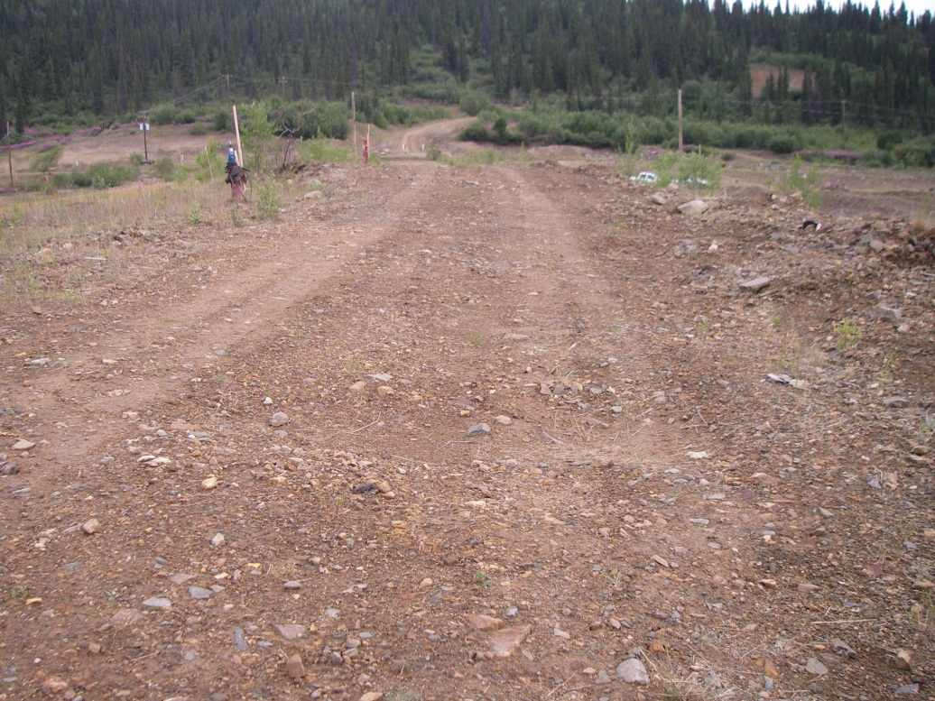
Photo B Crest of Tailings Pond Dam

Downstream Face
The downstream face of the dam also appears to be in good condition, with no signs of large scale slumping erosion visible at the time of inspection. No seepage, other than the regular seepage from the toe of the dam into the seepage control pond, was noted. Site staff noted that seepage is occasionally observed on the face of the dam, near the toe; none was visible during the WorleyParsons’ inspection.
One issue noted during the inspection is that uncontrolled vehicle access down the downstream face is allowed and some rutting was noted. Vehicle access down the middle of the dam face should be closed off and restricted to emergency situations. Access down to the seepage pond on either side of the dam face is acceptable.
The downstream face is largely free of vegetation, other than some spare grass and low shrubs.
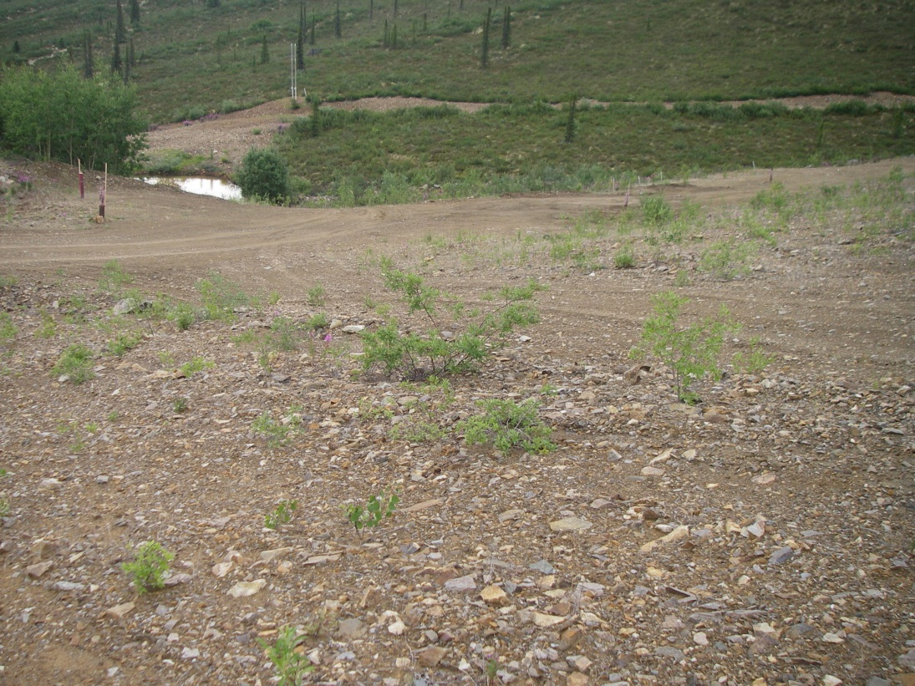
Photo C Downstream Face of Tailings Pond Dam

Seepage Pond and Dyke
The seepage pond and dyke appear to be in good shape. Some seepage was noted issuing from the toe of the dam during the inspection; however, site personnel noted that the quantity of seepage was not unusual. The seeps were observed to be clear and did not appear to contain sediment. Suspended sediment was noted in the seepage pond, as well as rust discoloration on the rocks and boulders at the toe of the dam; site personnel noted that the suspended sediment in the seepage pond is typical. Based on the clear nature of the seeps observed, and the location of the suspended sediment in the seepage pond (near the far end, away from the active seeps, see Photo D), it is likely due to the presence of colloidal sized particles which will not settle out.
No signs of slumping or erosion were noted on the dyke.
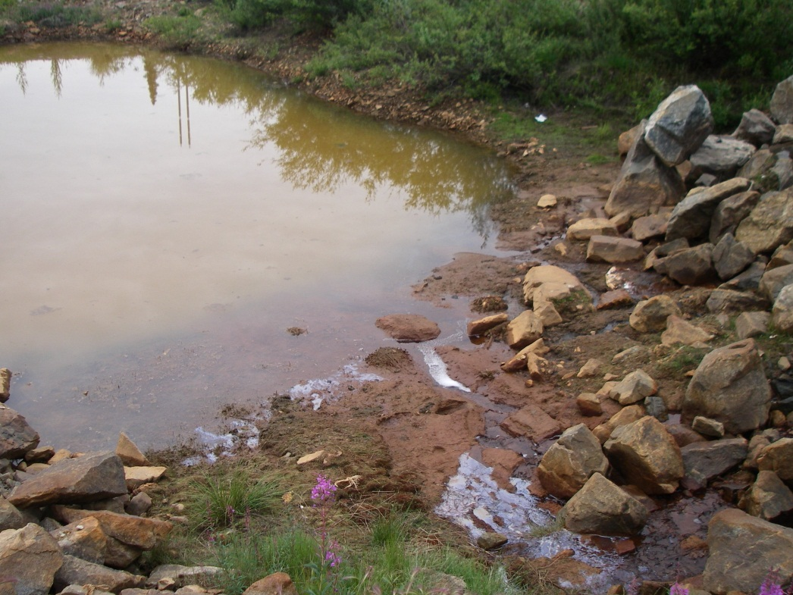
Photo D Seepage from toe of dam into seepage pond
The water level in the seepage pond is controlled by pumping and a syphon system. No spillway was incorporated into the design for emergency flow situations, so pumping is always required; it is possible that during a large snow melt or rainfall event, the dyke could be overtopped and damaged. In this case, the potential for dyke overtopping could also be mitigated in emergency cases through deployment of additional pumps; generally, however, the requirement for continuous operation of a pumping system to maintain safe operations of water management infrastructure is not recommended.

Dome Creek Diversion Channel
The diversion channel (Photo E) is located along the north side of the tailings pond and diverts water from the interception ditch and Dome Creek and conveys flow downstream of the tailing dam. The channel base width is approximately 1 m to 2 m with a depth of approximately 2 m. The channel has an average longitudinal slope of less than -0.5%. The channel’s south bank is generally steeper than the north bank with slopes around 2H to 1V but with some steeper sections up to 1H to 1V.
A small flow was observed in the channel at the time of inspection. Sediment has accumulated in the channel and no ditch armouring was observed. The channel appears to have sufficient cross sectional area and slope to pass the 200-year instantaneous peak flow (3 m³/s); however, localized erosion may occur during freshet and other high-flow events.
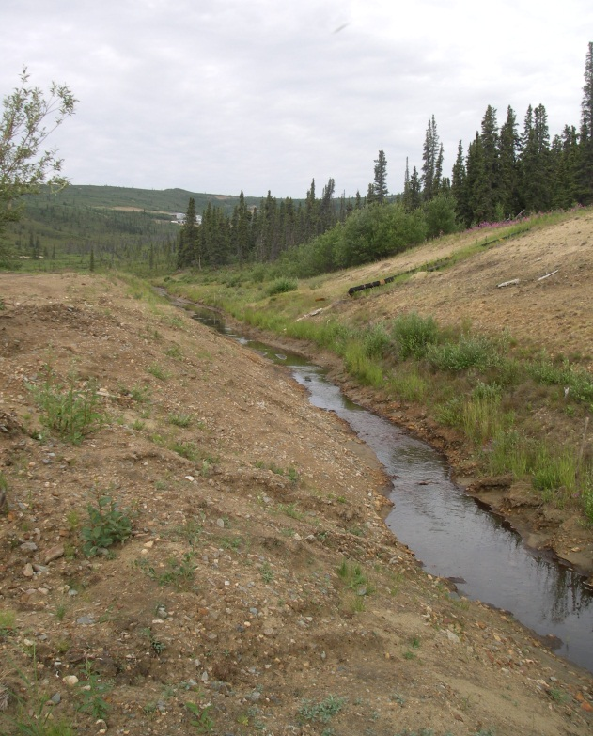
Photo E Dome Creek Diversion Channel
A bridge (Photo F) is located at the downstream end of diversion channel and consists of a wood deck over steel beams that rest on cement lock blocks. In its observed state, the bridge would not restrict the passage of the flood flow.
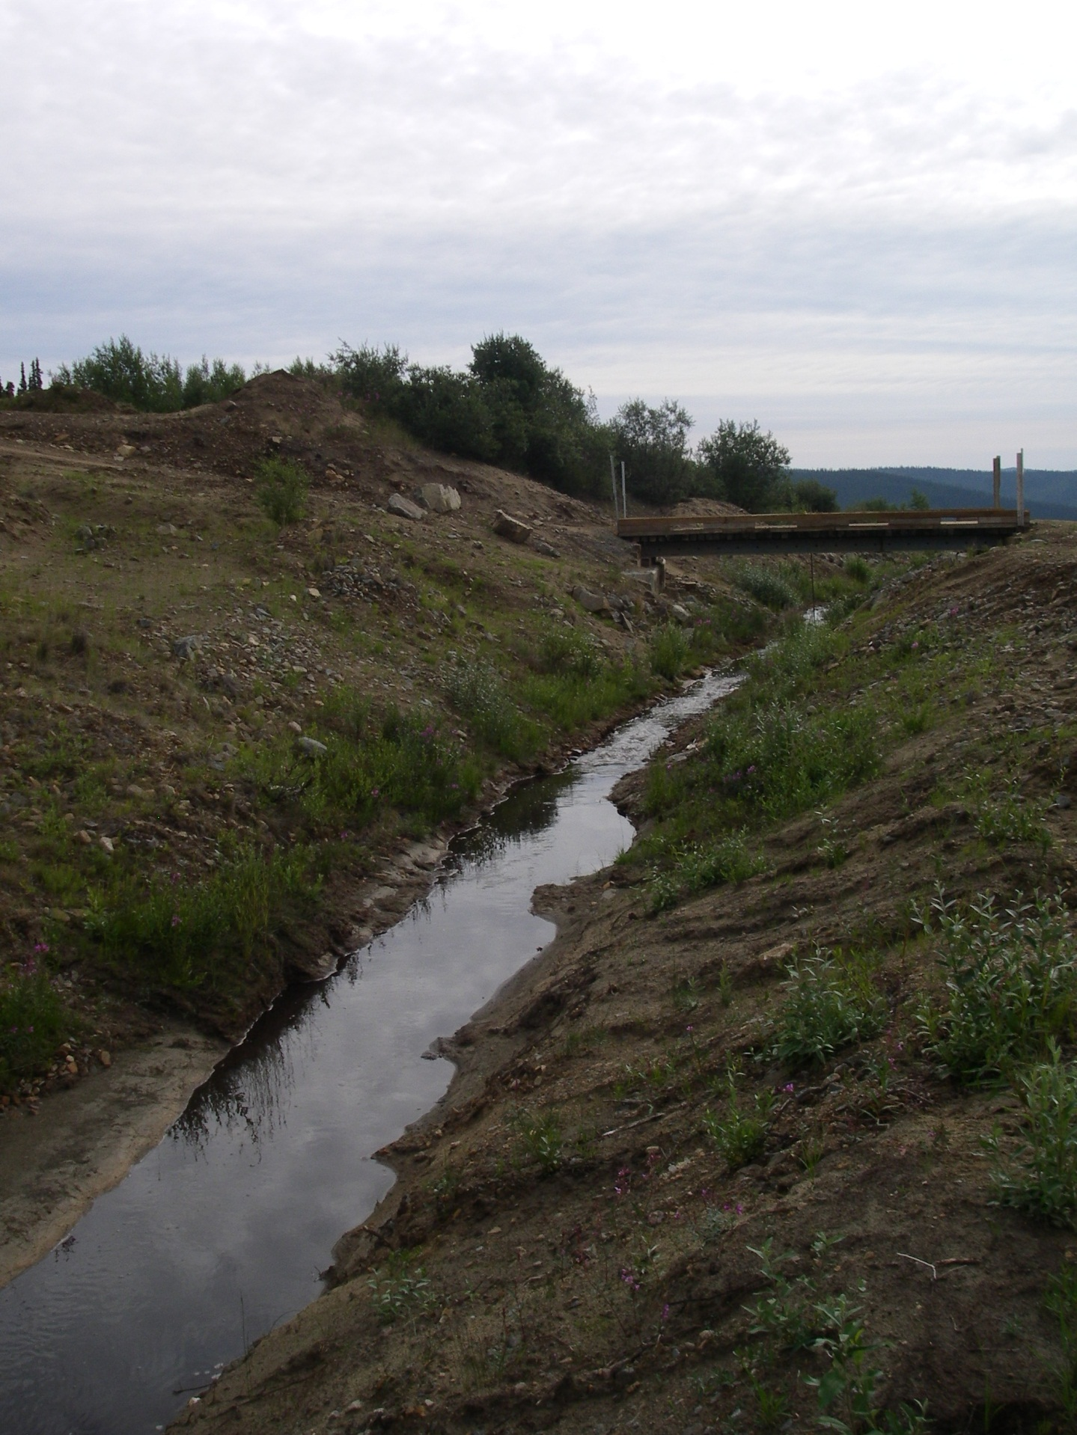
Photo F Bridge at Downstream End of Diversion Channel

Interception Ditch
The interception ditch (Photo G) picks up flow from a small portion of the catchment to the south of the tailings pond. The ditch was not flowing at the time of inspection. The extensive vegetation growth on the downslope side of the interception ditch suggests there is significant seepage loss out of the channel or groundwater flow bypassing the channel.
The capacity of the channel has been reduced by deposited sediment. The reduced capacity of the ditch still appears sufficient to convey the relatively small peak flows expected in the interception ditch. The east bank of the ditch is over-steepened in some locations with tension cracks visible, indicating areas where future slope failure is likely to occur. Sediment was also observed entering the ditch from upslope along the west side of the channel. Ongoing maintenance will be required remove accumulated sediment and to repair areas infilled by slope failures.
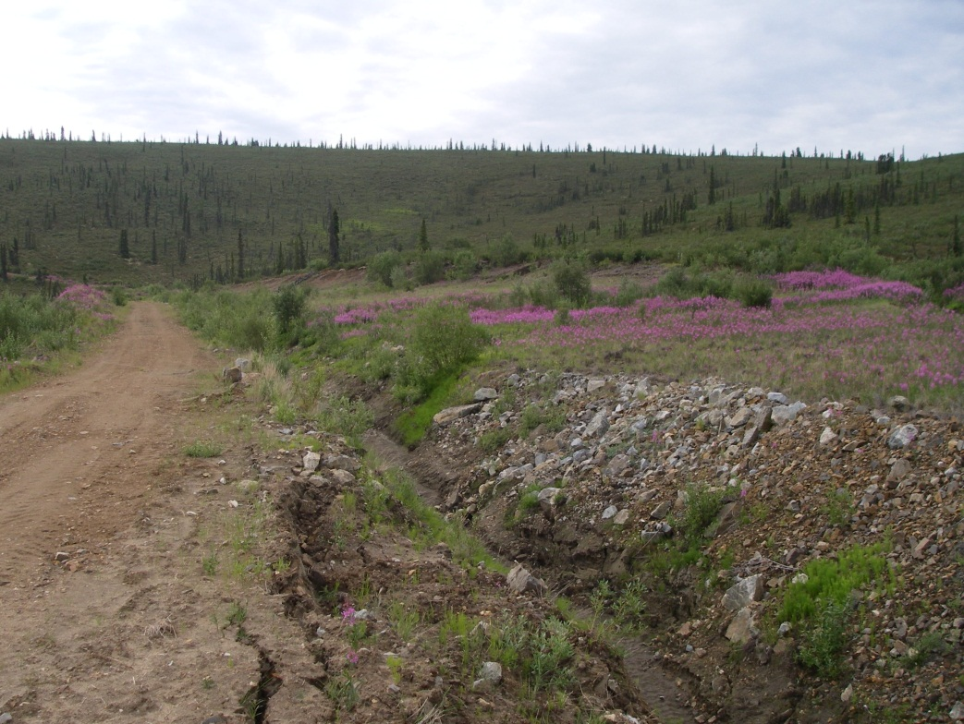
Photo G Interception Ditch

Pond Emergency Spillway
The emergency spillway (Photo H) consists of a channel (approximately 5 m to 6 m wide x 1 m to 2 m deep) located at the northeast corner of the tailings pond.
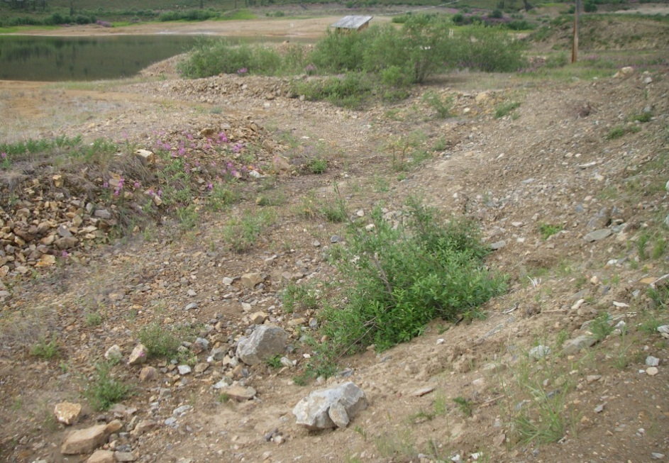
Photo H Tailing Dam Spillway

The emergency spillway channel is crossed by an access road approximately mid-way along the channel length. Visually, it was not apparent where the crest of the spillway was located. The emergency spillway is a relatively poorly-defined channel that curves around the access road. The emergency spillway channel had some, but insufficient, armouring. The dimensions of the emergency spillway appear sufficient to convey the attenuated flood flow. To date, no flow has been observed over the pond emergency spillway.

Combined Spillway
The combined spillway is a relatively steep channel (approximately -10% slope) with riprap armouring and drop structures. Some vegetation growth was observed, as well as a small volume of flow in the channel. During freshet 2013, a small length of the north channel bank had been eroded away; no geosynthetic filter layer was seen, confirming EBA’s assertion that construction of the spillway channel was not consistent along its length. The spillway has sufficient cross section area and slope to convey the IDF (3 m³/s); however, areas with inadequate armouring may be eroded during high flow events.
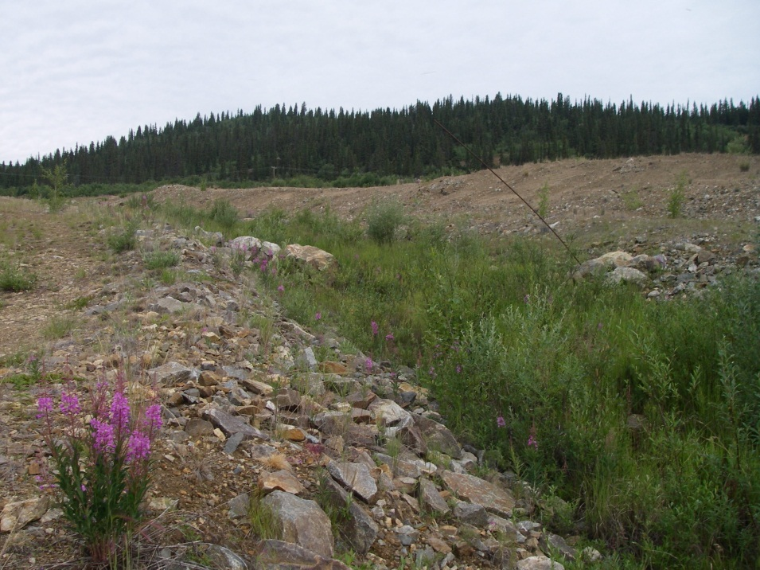
Photo I Combined Spillway D/S of Tailings Pond

Staff Interviews
During the site visit, WorleyParsons staff interviewed Mr. Richard Wilkinson of Denison Environmental Services, who is one of the two full-time site operators. The operators alternate on a two-week-on / two-week-off rotation. Mr. Wilkinson provided input on the current operations, maintenance, and surveillance of the site.
Access to the site is controlled by the site operator, with a safety orientation required for new personnel on-site. Radios are provided to visitors.
Inspections are conducted two or three times daily covering the entire site; these inspections include monitoring the water level in the seepage and tailings pond, and looking for signs of erosion in the channels, as well as potential stability concerns with the dam structure.
The seepage pond pumping rate is adjusted on a regular basis to maintain a relatively constant water level in the pond. A syphon structure also provides some flow out of the pond, providing some capacity to drain the seepage pond in the event of failure of the pumping system.
Regular maintenance is also conducted to clear silt, ice and snow obstructions from the diversion channel to prevent blockages; however, it is our understanding that snow or ice is not cleared from the emergency spillway. The emergency spillway should also be inspected prior to the spring freshet and snow or ice cleared to ensure that it is open and functional in case of a large scale spring flood.
The site personnel make regular reports to AAM on the state of the dam; however, the form currently submitted to AAM does not track the state of the dam and only notes that an inspection was completed and leaves room for comments. A comprehensive inspection form should be created for site staff to fill out and submit regularly to AAM.

dam failure CONSEQUENCe
As part of the safety assessment of the tailings dam, a consequence classification is required. The consequence classification represents the potential impacts associated with the failure of a dam or of its various components. Consequence of dam failure may include loss of life, injury, property and environmental damage, and general disruption of the lives of the population in the inundated area. For a given classification, extreme events, primarily floods and earthquakes, which could trigger a failure, are selected based on the CDA Guidelines (2007).
Following the shutdown of the mine in February 1999 and due to environmental concerns, the Federal Department of Indian and Northern Affairs (DIAND), which was the Responsible Authority (RA) for this undertaking, assumed management of the facility in the summer of 1999. The RA considered the facility and its spillway to be high-to-very-high consequences structures due to the potential for environmental damage that could result from a failure.
The present DSR included a qualitative risk assessment focused on the issues and consequences associated with a potential failure of a component of the tailings facilities, resulting in the release of untreated water and/or tailings to the downstream environment. The CDA Guidelines (2007) contain a classification scheme where estimates of potential consequences of dam failure are categorized to distinguish dams where the risk is much higher than others. Based on the current conditions of the facilities and the description of the incremental losses for each contemplated “Dam Class”, the dam and its facilities can be placed in the “SIGNIFICANT” class of the CDA Guidelines (2007), based on the following:
Loss of life: there is no identifiable population permanently living or working downstream of the dam at risk, so there is no possibility of loss of life other than through unforeseeable misadventure.
Environmental and cultural values: there is possible impairment to the wetlands and aquatic life downstream of the dam in the event of a dam breach and loss of tailings containment; however, this potential loss is not considered significant and restoration is highly possible. Further, if a breech were to result in the escape of contaminants from the tailings facility into the downstream watersheds, the dilution factor would reduce the human health risk to negligible levels. The exception to this is the groundwater wells on Victoria Creek which supply the Mt. Nansen site itself. These could be shut off in the event of a dam emergency.
Infrastructure and economics: aside from the main access road, no infrastructure or services are present downstream of the facility within the anticipated zone of inundation in the event of a loss of containment.
This class is the second-lowest rating out of five, and was given this level because of possible impairment to the wetlands and aquatic life downstream of the dam in the event of a dam breach and loss of tailings containment.

Dam Safety Analysis
The safety analysis of the dam system should include the internal and external hazards, failure modes and effects, operation reliability, dam response, and emergency scenarios (CDA 2007). The analysis includes both geotechnical and hydrotechnical assessments as detailed below.

Geotechnical Assessment
The scope of work for the DSR in WorleyParsons’ proposal did not include an intrusive geotechnical assessment (e.g., drilling, sampling, testing) to confirm the nature of the existing embankment materials. This assessment is based on observations during the site reconnaissance, available data on the existing tailings dam, and WorleyParsons’ engineering judgement.

Seepage
The design of the tailings dam (Klohn-Crippen 1995) was intended to minimize the seepage of the pond water downstream of the dam into Dome Creek and to ensure that piping and loss of material does not occur at the downstream toe of the dam due to uncontrolled seepage.
The primary seepage control was to be provided by the tailings deposited within the impoundment, with a minimum tailings beach width of 50 m as called for in the design. The reliability of the primary barrier was evaluated by means of Finite Element Method (FEM) seepage analyses that indicated a maximum seepage rate of 0.2 L/s and 2.4 L/s for the case of frozen foundation and with approximately 16 m of thawed foundation respectively.
A secondary (temporary) barrier was provided by a GCL on the upstream slope which was intended to function only for seepage control during the initial pond start-up when water would have been ponded against the upstream slope prior to tailings deposition, and also in the event of foundation thawing with likely differential settlement and cracking of the dam.
Since the early stage of the mine operations, it was noticed that seepage quality and quantity had not met design expectations: excessive seepage of contaminated fluid had exceeded the original design estimates by approximately an order of magnitude (Klohn-Crippen 2000). The excess seepage was attributed to the practice of maintaining high pond levels during the operational life of the tailings impoundment, which was not the intent of the original design which required maintaining a significant width of tailings beach as the primary seepage barrier. The lack of a wide beach exacerbated the seepage through the dam foundations due to the shorter seepage path than originally intended, and the dam itself had to rely more on the performance of the GCL, which was intended as a temporary barrier.
Water quality concerns required seepage to be pumped back to the tailings pond. A downstream toe-buttress berm was constructed in 1997 to control the seepage quantity, as well as to improve the downstream slope stability, and an upgrading of the seepage control dike was implemented in 2000 (Section 3.7).
Seepage in different locations on the downstream of both the tailings dam and seepage control dyke still constituted the main concern due to potential piping, resulting in the installation of additional instruments in 2012 to investigate a potential subsurface flow path from Dome Creek into or under the tailings impoundment as described in Section 3.11.

Liquefaction
Liquefaction of the dam or foundation soils can lead to internal erosion and piping leading to slope failure and potential dam overtopping.
The liquefaction potential was assessed by EBA (2002) based on Annual Exceedance Probability (AEP) level for Earthquake Design Ground Motion (EDGM) of 1/10,000 and the Cone Penetration Resistance data obtained from the two CPT programs completed at the site (18 CPT tests in total). From the results of liquefaction analysis, soil was considered susceptible to liquefaction at the following locations:
- Within the foundation soils underneath the dam crest at CPT-10 and CPT-11, and underneath the downstream buttress berm at CPT-3, CPT-7, and CPT-15;
- At the north side native ground near CPT-9; and
- Within some sporadic zones (0.5 m to 0.8 m in thickness) in the dam fills at CPT-03 and CPT-11.
Based on a failure consequence of “SIGNIFICANT”, the EDGM drops from 1:10,000 to 1:1,000. (CDA 2007) In addition, the ground motions for the area were revised as part of the 2010 National Building Code of Canada (NBCC), with the result that the input ground motion acceleration for the EDGM drops to 0.078g [NBCC] versus 0.27g used by EBA. An assessment of the liquefaction potential was undertaken for those locations where soil liquefaction was considered likely to occur (CPT locations mentioned above), using these new values.
The liquefaction analysis was conducted using the software NovoCPT (Novo Tech Software Ltd. 2012). The procedure followed is based on the recommendations proposed by Robertson and Cabal (2009). Given the results in terms of Liquefaction Safety Factor shown in Figure 3, Appendix 1, the foundation soils and the dam fill are considered to not be susceptible to liquefaction during the design seismic event.

Potential for Piping
As described in Section 6.1.1, the performance of the tailings facilities in terms of seepage has been poor, resulting in a potential for piping of dam-fill materials.
In 1997, piping was observed at the site during the failure of the Dome Creek Diversion spillway and along the north abutment slope that resulted in slumps and small failures above the seepage pond, with high contents of suspended solids in the pond itself (Klohn-Crippen 2000, EBA 2002).

The construction of the emergency toe-buttress berm in 1997, as described in Section 3.7, together with the north abutment slope armouring, were intended to prevent further seepage related failure; however, they were designed without the benefit of detailed engineering studies, constructed rapidly without full supervision, and not thought to be long-term solutions for potential piping problems. While there has been no signs of significant erosion over the past few years which could affect the stability of the dam (i.e., water seeping into the collection pond is reported to have been clear and free of silt and fine grained sand), future internal erosion of the earth fill associated with the toe seepage cannot be ruled out. There is an unquantifiable hazard of piping conditions; it is therefore recommended that the seepage conditions should continue to be monitored regularly.

Slope Stability of Embankment
The CDA Guidelines (2007) provide accepted minimum slope stability Factors of Safety (FOS) for various static and seismic loading conditions as shown in Table E and Table F.
Table E Factor of Safety for Slope Stability - Static Assessment
Loading Condition | Minimum Factor of Safety | Slope
End of Construction before Reservoir Filling | 1.3 | Upstream and Downstream
Long-term (steady-state seepage, normal reservoir level) | 1.5 | Downstream
Full or Partial Rapid Drawdown | 1.2 to 1.3 | Upstream
Table F Factor of Safety for Slope Stability - Seismic Assessment
Loading Condition | Minimum Factor of Safety | Slope
Pseudo-static | 1 | Upstream and Downstream
Post-earthquake | 1.2 to 1.3 | Upstream and Downstream
For the Mount Nansen tailings dam, only the downstream slope stability requires assessment (upstream stability is maintained by the weight of the tailings). Both the long-term (static) and pseudo-static (seismic) loading conditions have been analyzed in this study. The post-earthquake residual shear strength soil case was not assessed as the dam is not considered susceptible to liquefaction as previously discussed in Section 6.1.2.
Static and pseudo-static seismic global stability factors of safety were calculated using the Morgenstern-Price method of limit equilibrium analyses by means of the software SLOPE/W (GEO-SLOPE International Ltd. 2012).

The stability analyses were carried out for the downstream slope of the dam section with maximum height that, based on the available information from former stability analyses (Klohn-Crippen 1995, Klohn-Crippen 2000, EBA 2002), is the section in the proximity of borehole BH-12861-02 as shown in Figure 4, Appendix 1. The cross-section adopted is shown in Figure 5, Appendix 1. This topographic surface agrees with the LiDAR surface (BGC 2013), and the upstream slope profile (including the upstream berm) and the thickness of the native foundation soil (conservatively modelled as homogeneous sand, despite the presence of gravel layers) are consistent with the available information and previous assumptions (Klohn-Crippen 1995, Klohn-Crippen 2000, EBA 2002).
The geotechnical parameters adopted for the analyses are the same as presented in Table C of
Section 3.5, and in particular for the foundation soil, the lowest friction angle value indicated in the table has been adopted. Moreover, the foundation soil has been assumed to be completely thawed and there are no excess of pore pressures above the hydrostatic level (see phreatic surface shown on Figure 5, Appendix 1).
In terms of phreatic level, the two following scenarios have been considered.
- Scenario 1: current operating condition, where the assumed phreatic surface within the dam complies with the data collected in 2012 (EBA 2013b) with a straight line connection between the water levels in the tailings and seepage collection ponds. This is consistent with the available piezometer data from the boreholes adjacent to the cross section (and projected on it) as shown in Figure 5, Appendix 1.
- Scenario 2: maximum allowable water level in the tailings pond, preserving the stability of the downstream slope. This scenario should have considered the water level at the elevation of the spillway invert (1,097.94 m); however, because of the uphill spillway profile in the upstream portion (YES 2012), surface water will be spilled over the emergency spillway once the water level rises up to 1,098.56 m. Thus, the phreatic level within the dam complies with this level in the tailings pond and is the same as for Scenario 1 for the seepage collection pond.
The results of the analysis indicate that the dam exceeds the CDA Guidelines (2007) minimum factors of safety criteria for both static and seismic loading conditions and for both seepage scenarios. The results of the analyses are summarized in Table G and presented in Figure 6, Appendix 1.
Table G Factor of Safety for Slope Stability Assessment Mount Nansen Tailings Dam
 | Loading Condition | Factor of Safety
Scenario 1 | Static long-term | 1.80
Scenario 1 | Seismic pseudo-static | 1.32
Scenario 2 | Static long-term | 1.52
Scenario 2 | Seismic pseudo-static | 1.11

Hydrotechnical Assessment

Statistical Flood Analysis
Based on a risk classification of the dam as “SIGNIFICANT”, the required IDF is between the 100-year and 1,000-year return period event. Previous consultants (Klohn-Crippen and EBA) have estimated the 20-year and 200-year peak flows only. Typically, the selected IDF would be in the range of the 500-year return period flow event and it is estimated that the 500-year flow would be in the range of 10% to 20% higher than the 200-year event; however, the 500-year peak flow was not estimated by previous consultants. For the purposes of this assessment, due to the relatively small catchment area and low runoff flow estimate, it was determined that using the 200-year flow estimate for the IDF would be sufficient for the DSR.

Inflow Design Flood
The IDF was used in the design of the dam spillway and other surface water management infrastructure. The IDF was assessed by Klohn-Crippen in 1995 for the original design and in 2001 by EBA as part of the recommended upgrades to the spillway, with EBA estimating lower runoff rates than Klohn-Crippen (Section 3.3.2). The instantaneous peak flow rates for various return periods are present in Table H.
Table H Instantaneous Peak Flow Estimates
Return Period | Instantaneous Peak Flow (m³/s) | Source / Comment
20* | 1.2 | EBA 2002
200 (IDF) | 3.0 m³/s | EBA 2002
500* | 3.3 m³/s to 3.6 m³/s | Est. 10% to 20% higher than 200-year flows
PMF* | 30 m³/s to 40 m³/s | Approximation based on the PMP
Note (*) 20-year, 500-year, and PMF estimates provided for information only and were not used in assessment; additional hydrological analysis would be required to estimate the 500-year and PMP flow.
For the purposes of this DSR, it is required that all the structures are designed to convey the 200-year IDF. Klohn-Crippen’s concept to design the interception ditch and diversion channels for a lower return period event than the IDF (i.e., 20-year) does not seem appropriate as this could result in a release of untreated water, with associated environmental impacts, from the spillway during flow events less than the IDF. The water quality in the tailings pond does not currently meet regulatory criteria for discharge and would require treatment prior to discharge over the spillway. The diversion channel should therefore be capable of conveying the 1 in 200 year peak instantaneous flow.

Spillway and Other Flow Control Structures
The site surface water management infrastructure (Figure 1, Appendix 1) for the safe operation of the dam includes:
- Dome Creek Diversion;
- Pond Emergency Spillway; and
- Combined Spillway.
The water management infrastructure also includes a 200 m-long interceptor ditch located along the southwest side of the tailings pond. During the rainfall events, the majority of flow bypassing the dam will be via the Dome Creek channel, with only a minor contribution from the interception ditch. The functioning of the interception ditch is not seen as a critical component of the surface water management infrastructure. While this ditch should be maintained, blockage and/or failure of this ditch will likely not impact the safe operation of the dam.

Dome Creek Diversion
The Dome Creek diversion channel is approximately 780 m in length and is located along the north side of the tailings pond, passing to the north of the pond embankment and is sloped at approximately -0.5% to -0.3% (Photo E). Downstream of the pond, the channel steepens to approximately 5% before connecting with the dam spillway located approximately 50 m downstream of the centreline of the dam.
In 2002, EBA concluded that the Dome Creek diversion was capable of conveying the 200-year flow while maintaining sufficient freeboard but maintaining the gravel layer as shown on the original design drawings (300 mm-thick layer of <75 mm gravel) was required to reduce erosion. During the DSR site inspection, the cross sectional area and slope of the diversion ditch appeared sufficient to convey the IDF; however, ongoing maintenance is required to keep the channel clear of debris and accumulated sediment. As some sections of the channel bank appeared to be overly steep, it is recommended that where possible, the side slopes are cut back to a minimum 2.5H to 1V, to reduce the potential for future slope failure, potentially blocking the channel.
There is currently little evidence of the originally designed gravel layer along the channel. During a storm event, the flow velocity may be in the range of 0.75 to 1 m/s, so some erosion of accumulated sediment and bank material may occur. Installation of a gravel layer or other erosion control product is recommended as a long term solution to ditch erosion; however, in the short term, targeted channel maintenance to repair areas where erosion has occurred following a storm event can be considered.
A small bridge is located on the diversion channel upstream of the dam (Photo J). As is, the bridge is unlikely to impede flow; however, blockage of the diversion channel at the bridge would likely result in the diversion channel being overtopped and flow migrating into the emergency spillway and either into the tailings pond or down the combined spillway channel. Neither scenario is likely to result in failure of the dam structure; however, uncontrolled flow should be avoided to reduce the likelihood of unanticipated damage to critical infrastructure.
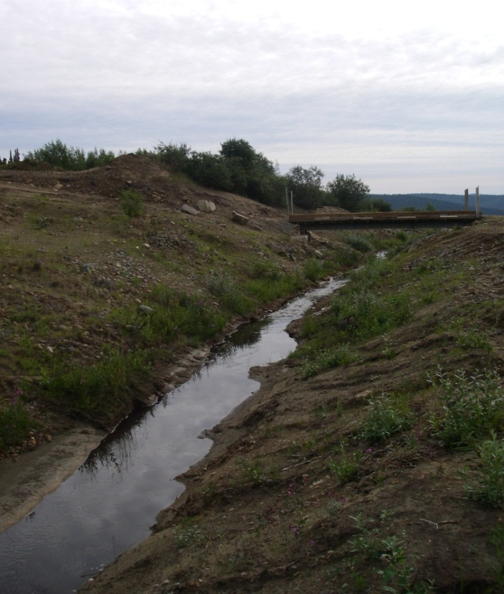
Photo J Bridge across Diversion Channel
Currently, daily monitoring and frequent channel maintenance, reduces the potential for blockage of the diversion channel. In the long term, it is recommended that AAM consider constructing one or possibly two high-flow diversion spillways on the diversion channel, upstream of the bridge, to safely and controllably convey high flows from the diversion ditch into the tailings pond. The crest elevation of these diversion spillways should be set such that they only convey flow should the diversion channel become blocked or a flow event greater than the IDF occurs. Construction of a diversion structure will not reduce the potential for the diversion becoming blocked, but it provides a controlled location, or locations, for the ditch to spill without causing significant damage. The diversion(s) would consist of a weir on the south bank of the diversion channel with a crest elevation above the anticipated 200-year flow level; an armoured spillway should be constructed between the weir structure and the tailings pond.

Dam Emergency Spillway
The emergency spillway structure is located in the northeast corner of the tailings impoundment and is designed to convey water from the tailings pond into Dome Creek via the combined spillway channel. The spillway width varies but is approximately 5 m wide with a crest invert elevation at approximately 1,098.6 m.
In the event that the Dome Creek diversion channel becomes blocked or the channel is overtopped, flow will likely end up in the tailings pond. In this situation, it is important that the pond emergency spillway be capable of conveying the resulting attenuated peak flow. Preliminary modeling indicates that it is unlikely that the tailings pond water level will reach the emergency spillway crest during a major rainfall event as over the past several years the pond water level has remained relatively constant at approximately 2.5 m below the emergency spillway crest, providing a large storage volume in the pond. In the event that the pond does fill, it is recommended that the emergency spillway is capable of passing the attenuated IDF flow. EBA estimated that the attenuated peak flow out of the tailings pond is 0.6 m³/s and can be handled by the emergency spillway; preliminary modelling by WorleyParsons estimated a peak flow rate over the emergency spillway of approximately 1.3 m³/s. For the DSR, the higher value was used in the assessment of the emergency spillway capacity.
The emergency spillway currently has a poorly defined channel and due to the access road across the channel, the flow path is not straight to the combined spillway as it curves slightly around the access road (Photo K). Within the emergency spillway channel, it is recommended that a trapezoidal shape channel be constructed and that the flow path be realigned to provide a relatively straight course, in order to reduce the potential for bank erosion. The realigned and reshaped emergency spillway can still allow for vehicle access to the dam crest and seepage pond, by reducing the side slopes of the spillway channel in the vicinity of the access road.
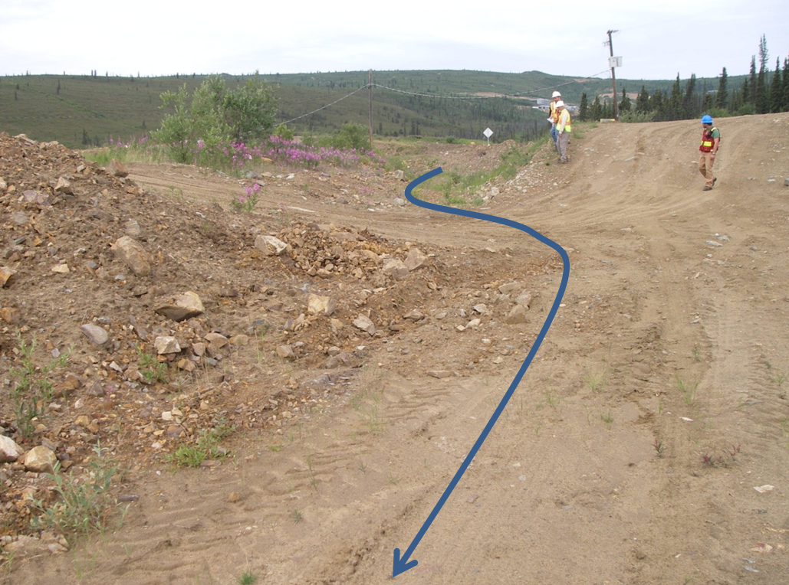
Photo K Emergency Spillway Channel at Access Road Crossing
The dam emergency spillway has sufficient capacity for the IDF flow; however, the sparse vegetation should be removed and the armouring in some section of the emergency spillway channel requires improvement (Photo K). With the shallow gradient of the spillway, even the sparse vegetation growth slightly reduces the flow capacity. To reduce erosion during a major storm event, either a suitably designed gravel / riprap armour layer should be placed along the length of the channel, or an alternative erosion control product can be installed.

Freeboard
As per the CDA requirements, the spillway should be capable of passing the IDF taking into account the routing effect of the reservoir without infringing on the minimum freeboard requirements of the tailings pond. The recommended freeboard requirement for the dam is a minimum of 1 m above the maximum level during an IDF event.
The CDA requirement is the establishment of freeboard that minimizes the probability of dam overtopping by waves. However, because of the small surface area of the ponded water above the dam and the short fetch, the probability of dam overtopping the spillway was not estimated and the minimum 1 m freeboard is deemed sufficient for control of wave overtopping.
EBA concluded that the emergency spillway is capable of conveying the attenuated 200-year flow while maintaining sufficient freeboard. Based on the higher attenuated IDF flow rate estimated by WorleyParsons (1.3 m³/s), the spillway is capable of passing the peak flow; however, there is insufficient freeboard. The elevation difference between the spillway crest (1,098.6 m) and the embankment crest elevation (1,099.6 m) is 1 m. The flow depth during the IDF event, over the spillway is approximately 0.3 m, providing 0.7 m of freeboard, 0.3 m less than required. It is therefore recommended that the crest of the spillway be lowered by 0.3 m, while maintaining a slope of approximately -0.5% down to the combined spillway channel.

Combined Spillway
The CDA guidelines (CDA 2007) state that the water conveyance structures downstream of the spillway, including energy dissipation structures, are integral parts of the flow control system. The structures should be designed to perform their function without being damaged, at least up to the IDF capacity.
The combined spillway starts where the Dome Creek diversion channel and the tailings pond emergency spillway connect, approximately 50 m downstream of the centreline of the dam. The combined spillway conveys flow at an average slope of approximately -9%, and connects to the natural Dome Creek channel approximately 290 m downstream of the emergency spillway.
In 2002, EBA concluded that the combined spillway could handle a peak flow of about 0.6 m³/s, well below the 3 m³/s IDF (note, this assumes the IDF flow is conveyed by the diversion channel and not attenuated within the tailings pond). EBA recommended upgrades to the spillway including widening the channel base, adding drop structures to reduce the velocity; adding a 300 mm-thick gravel filter layer and installing a Class 1 riprap layer along the length of the channel.
EBA’s recommended upgrades were partially completed; however, EBA observed that the spillway restoration was not completed in a consistent manner, with the geotextile coverage, filter gravel thickness and riprap thickness varying along the spillway. During the 2013 DSR inspection, the combined spillway appears to have sufficient cross-sectional area and energy dissipation (drop structures) to convey the IDF flow; however, an inadequate or poorly-installed filter layer and riprap has resulted in a recent ditch slope failure, and these failures will likely continue to occur in the future.
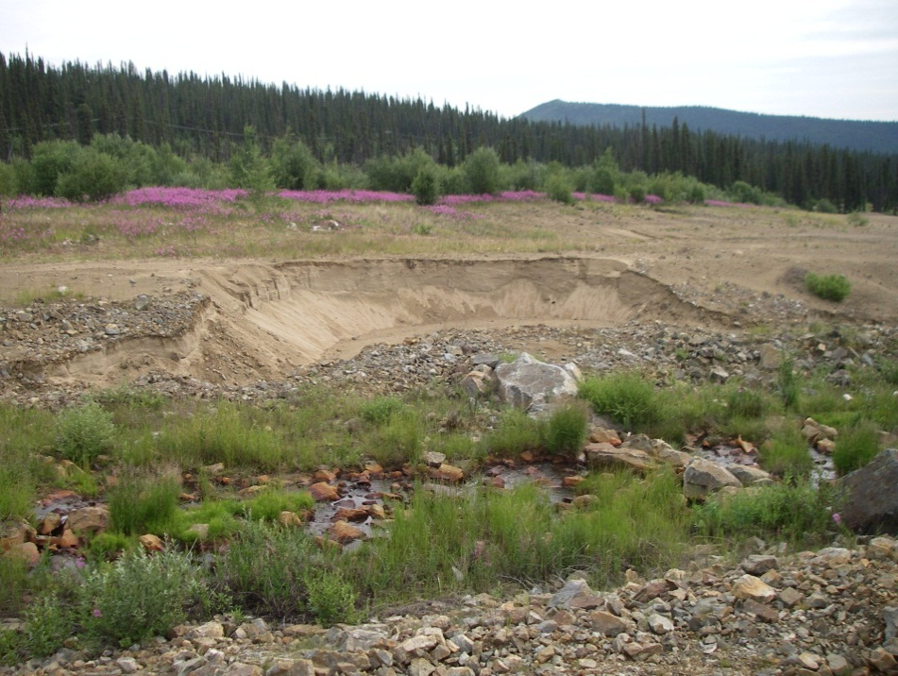
Photo L Slope Failure on Combined Spillway
This failure, or similar failures in the future, are unlikely to impact the safety of the dam structure, but may contribute to a short-term increase in sediment loading to Dome Creek. These isolated failures should be repaired as they occur, or alternatively, a uniformly constructed filter layer with riprap armouring should be installed, including a suitable anchor trench for any geotextile liner, along the entire length of the combined spillway.
Some vegetation was observed in the channel, but the capacity of the channel is not yet adversely affected. Should this vegetation growth continue, ‘mowing’ may be required to maintain sufficient capacity within the channel.
Blockage by snow and ice of the combined spillway channel, immediately downstream of the diversion channel and emergency spillway junction, could potentially cause flow to spill over the south channel bank, and down the north abutment to the Dome Creek channel. While flow down the abutment may cause some erosion and increased TSS concentrations in Dome Creek, a short-term temporary flow event down the north abutment is not expected to cause instability of the main dam structure. The channel should be maintained with snow and ice cleared as required, to reduce the potential for the combined spillway channel to be overtopped.

Reservoir (Pond) Operating Rules
There is no outlet from the tailings pond with the exception of the emergency spillway. There is also no mechanism to control the water level in the pond other than setting up a temporary pumping and treatment system. Over the past few years the water level has been observed to fluctuate only slightly during the year (estimated at 0.5 m), with seepage and evaporation losses maintaining water levels well below the spillway elevation. As such, there are no pond operating rules. Effort is made by site personnel to maintain the interception and collection ditches so that the majority of flood flow bypasses the tailings pond. During a flood event, it is possible that the diversion channel could become blocked either by failure of the channel banks or ice buildup and the diversion channel would spill into the tailings pond. It is considered unlikely that this would result in the pond water level reaching the emergency spillway crest level; however, the spillway is designed to accommodate the entire IDF, should the pond fill completely.

Ice and Debris
Accumulation of ice and debris in the diversion channel is likely the primary mechanism for failure of the Dome Creek diversion channel. This is recognized by site staff, and a rigorous winter inspection and maintenance program appears to be in place. In the event of ditch blockage by ice or debris upstream of the bridge, flow would likely spill out of the diversion channel and into the tailings pond. A blockage occurring downstream of the bridge would likely result in flow into the pond emergency spillway. As discussed in Section 6.2.4, blockage at the upstream end of the combined spillway could potentially result in temporary uncontrolled flow down the north abutment. While it is not considered that this scenario would result in failure of the main dam structure, blockage by ice, snow or debris of the water management structures should be avoided. With full-time site operators, the channel can be inspected and maintained to reduce the likelihood of the channel becoming blocked.

Seepage Collection Pond
There is the potential for the seepage pond dyke to be overtopped in the event of a pumping system breakdown; however, failure this dyke is not expected to impact the stability of the main tailings dam structure. The seepage pond does play an important role in management of water quality discharged from the site. In the event that water quality within the pond is deemed unsuitable for release, seepage water would be pumped back into the tailings pond rather than discharged. Also, failure of the tailings pond dyke could result in the uncontrolled release of high sediment laden water, potentially containing other contaminants, to the downstream environment.

OM&S, Emergency Preparedness, AND Public Safety
The site is currently under full-time care and maintenance, managed by AAM and site operations have been contracted out to DES. DES is responsible for the day to day operation, maintenance and surveillance of the site, implementation of the emergency response plan and ensuring public safety and security.

Operation, Maintenance, and Surveillance
The assessment of the site Operation, Maintenance, and Surveillance (OM&S) was based on a review of the draft Operations Maintenance and Surveillance Manual (AAM 2013a) and an interview with Mr. Wilkinson conducted on July 17, 2013. The following is a summary of the assessment.
- Safe operating procedures at the site include two or three site wide inspections daily. These inspections are documented with a check sheet (Appendix 2). Unusual conditions identified during these inspections are reported to AAM. A weekly inspection report is provided to AAM.
- Any new or previously unnoticed depressions on the surface of the dam or other structures are recorded, photographed, and measured. Fresh erosion channels are identified.
- The tailings pond and seepage pond water levels are monitored twice per day with adjustments made to the seepage pond pump as required maintaining a relatively constant water level.
- Data is collected from eight piezometers and 19 thermistors locations monthly. This data is reported to AAM monthly. This data is provided to a geotechnical engineer once per year for review and analysis.
- The frequency of monitoring and analysis are generally considered adequate to detect unsafe conditions in a timely manner; however, an annual analysis of the piezometer and thermistor readings is inadequate to detect any sudden changes in the internal status of the dam. Piezometer readings should be converted to head pressure immediately on data acquisition, as sudden rises in piezometric pressure in the dam would be cause for concern. In addition, trigger events, such as high creek levels or rainstorms, should be established, after which additional instrument readings are taken.
- Debris and sediment that accumulate in the diversion channel are removed. Potential obstructions to flow on the spillway channel have previously been removed (old pipeline).
- Ice is removed from the diversion ditch prior to freshet. Ice does not accumulate in the pond spillway; however, the spillway should be inspected prior to the annual freshet and cleared of any possible obstructions to ensure it is in good working condition and ready to cope with a spring flood.
- The seepage pond pump is maintained in good working order. Power to the pump is provided by a generator and a backup generator is on standby.
The OM&S plan recently prepared for the site is comprehensive and includes:
- A description of the site;
- Operational information includes roles and responsibilities, water management, and flow control gauging and emergency systems;
- Maintenance information for all major facilities and infrastructure on the site; and
- Surveillance information including inspections, instrumentation, response to unusual conditions and documentation, and follow-up.
Regular maintenance is also conducted to clear ice and snow obstructions from the diversion channel to prevent blockages; however, it is WorleyParsons’ understanding that snow or ice is not cleared from the emergency spillway. The emergency spillway should also be inspected prior to the spring freshet and snow or ice cleared to ensure that it is open and functional in case of a large scale spring flood.
The site personnel make regular reports to AAM on the state of the dam; however, the form currently submitted to AAM does not track the state of the dam and only notes that an inspection was completed and leaves room for comments. The draft OM&S manual includes a more comprehensive inspection form for site staff to fill out and submit regularly to AAM.
It is recommended that the draft OM&S manual is finalized and issued to the site operators. Drawings representing the as-built condition should be included with the OM&S manual. It is also recommended that the comprehensive inspection sheet is provided to the site operations. Weather conditions, recent precipitation amounts and instrument readings should also be recorded on the form when taken.

Emergency Preparedness
The assessment of the Emergency Preparedness was based on a review of the draft Emergency Response and Preparedness Plan (ERPP) (AAM 2013) and an interview with Richard Wilkinson conducted on July 17, 2013.
A compressive ERPP has been prepared for the site and includes:
- A description of the site;
- Identification of a requirement for action;
- Roles and responsibilities;
- Plan activation;
- Notification procedures and contacts; and
- Actions to prevent structure failure.
It is recommended that the draft ERPP is finalized and issued to the site operators, local government, First Nations in area, downstream residents.

Public Safety and Security
Access to the site is restricted by the full-time site operators. All visitors are required to sign in and complete a safety orientation. Unauthorized visitors are asked to leave the site immediately. Signs are posted indicating authorized personnel only are permitted to enter the site.

Dam Safety Management System
The effectiveness of the Dam Safety Management System at the Mount Nansen site was evaluated using the criteria provided in the CDA guidelines (CDA 2007). Table I summarizes how each of the criteria is applied at the site. Overall, the Dam Safety Management System in place at the site is considered appropriate for a dam with a “SIGNIFICANT” classification.
Table I Criteria Applications
Effective Dam Safety Management System Criteria | Mount Nansen Application
Roles, responsibilities, and authorities are clearly assigned. | These are clearly defined in the draft ERRP.
Key activities are clearly assigned. | The draft OM&S plan clearly assigns key activities (monitoring, maintenance, reporting).
Personnel understand their roles and responsibilities. | Interview with on-site staff indicated that personnel understand this.
OM&S activities are carried out and documented. | Site inspections, monitoring and maintenance are carried out and documented by the full-time on-site operators. Daily, weekly and monthly reports are provided to AAM. A more comprehensive checklist is recommended for site operators’ daily inspection.
Incidents are reported and addressed. | All incidents are reported to AAM and other parties as necessary.
Safety measures recommended in previous DSR reports have been carried out | Recommendations from the annual geotechnical inspections have been carried out.

CONCLUSIONS
The following conclusions have been reached with respect to Dam Safety Review of the Mount Nansen Tailings Dam. These conclusions are based on a site inspection conducted on July 17, 2013, and the background documentation cited in Section 12.
- The dam is stable with a minimum safety factor of 1.52 against a potential failure surface for static loading conditions and 1.11 for dynamic loading conditions associated with a 1 in 1000-year design earthquake (see Section 3.6). Given the results of the liquefaction analysis, the foundation soil and the dam fill are considered not susceptible to liquefaction during the design seismic event.
- In view of the absence of a permanent population immediately downstream of the dam, a dam failure consequence rating, as classified by the CDA, has been determined as “SIGNIFICANT”. This is the second-lowest rating out of five, and the dam was given this level because of possible impairment to the wetlands and aquatic life downstream of the dam in the event of a dam breach and loss of tailings containment.
- The seepage pond dam downstream of the tailings facility is also considered to be stable; however, in the unlikely failure of this dam, no detrimental impact on the integrity of the tailings dam is envisaged; however, water quality in the receiving environment could be adversely affected with an uncontrolled release of seepage water containing high concentrations of TSS, and potentially other contaminants.
- The diversion channel, tailings pond emergency spillway and combined spillway, have sufficient cross sectional areas and slope to convey the IDF flows (30 m³/s for the diversion channel and combined spillway; 1.2 m³/s for the emergency spillway); however, the current emergency spillway crest elevation provides insufficient freeboard within the tailings pond (<1 m).
- Comments on the draft Operations and Maintenance manual prepared by AAM are provided in Section 7 of this report. In summary, the plans as described in the draft manual are satisfactory.
- Comments on the Emergency Preparedness Plan prepared by AAM are provided in Section 7 of this report. In summary, the plans as described in the draft report are satisfactory.

RECOMMENDATIONS

Geotechnical
Seepage in different locations on the downstream slopes of both the tailings dam and seepage control dyke constitutes an ongoing concern. The volume and clarity of the seepage should continue to be monitored. Even if over the last years there have been no signs of significant erosion, it is deemed that there remains some unquantifiable hazard. Well-documented seepage monitoring would result in preventing or reducing the probability of a piping failure developing. Re-grading the crest of the dam to ensure that any settlements can be observed and reported would also aid in early detection of an internal erosion problem. After re-grading, survey monuments should be established on the crest to aid in settlement monitoring.
Though the Dam Safety Review has determined that the tailings dam is stable and no mechanism is apparent that would lead to a failure of the dam, it is recommended that the tailings facility be permanently closed within a reasonable timeframe, which is suggested to be no more than five years.
In view of the evident stability of the tailings dam, placement of a layer of waste rock over the downstream slope should be considered as a component of a closure plan to ensure long-term stability of the structure, if it is decided to leave the tailings facility permanently in its present location.

Hydrotechnical
Where possible, cutting back of the over-steepened bank sections along the Dome Creek diversion channel is recommended. In addition, placement of a gravel layer or erosion control product to reduce erosion is recommended. Alternatively, repairing sections of the diversion channel as failures occur can be considered as a short term measure instead of the installation of ditch armouring.
To provide the minimum freeboard in the tailings pond it is recommended that the crest of the emergency spillway is lowered by 0.3 m while maintaining a minimum slope of -0.5% down to the combined spillway. The spillway channel should also be straightened to reduce the potential for erosion of the channel banks during a high flow event. The spillway channel armouring should be improved with riprap or other erosion control product. A more defined channel structure should be constructed and the vegetation removed.
The combined spillway has sufficient cross-section and longitudinal slope to convey the required flows during an IDF event; however, the bank protection against erosion and scour is inadequate. Areas of bank erosion along the combined spillway should be repaired as soon as practically possible to limit the extent of the erosion. Removal of vegetation in the channel should be considered, if the capacity of the channel is restricted by this growth.

Operations and Maintenance
The regular inspection form / checklist within the draft OM&S manual should be used to thoroughly record and document all observations during each inspection. AAM personnel should also be provided with the means to determine piezometric pressures in the dam, instead of reporting the raw instrument readings for analysis on a semi-annual basis. A significant increase in observed piezometric level (greater than 100 mm), without an associated increase in pond water level, is an indication of problems developing in the dam and should be discussed with a suitable qualified geotechnical engineer as soon as practically possible.
The downstream face, crest and upstream face of the tailings dam are in generally good repair; however, the crest should be levelled and re-graded to the proper design elevation along its whole length. This will ensure proper functioning of the spillway in an emergency and will also allow for detection of dam settlement due to internal erosion. Vehicle access onto the crest of the dam and down the downstream face should be restricted, with access to the seepage pond limited to either side of the dam face.
Ongoing maintenance is required to keep the diversion channel free of obstructions and to repair areas where erosion has occurred. Blockage of the diversion channel is unlikely to result in failure of the dam structure as flow would either spill into the tailings pond and partially fill the pond, or spill into the emergency spillway which has sufficient capacity to convey the IDF flow. Blockage of the upstream end of the combined spillway could result in temporary uncontrolled flow down the north abutment and should be avoided through proactive clearing of snow, ice, and other debris.

Closure
We trust that this report satisfies your current requirements and provides suitable documentation for your records. If you have any questions or require further details, please contact the undersigned at any time.
Report Prepared by

Giuseppe Cammarata, Ph.D. Alex Timmis, P. Eng. (BC)
Geotechnical Specialist Senior Water Resource Engineer

Senior Review by

Lee Martin, P. Eng. Fred Claridge, P. Eng. (BC)
Geotechnical Engineering Manager Senior Technical Director

BC Business Unit
Infrastructure & Environment
WorleyParsons Canada Services Ltd.

REFERENCES
AECOM 2008, “Mount Nansen Tailings Dam 2008 Geotechnical Inspection”, November.
BGC 2013, LiDAR 2012 Data
Canadian Dam Association 2007. “Dam Safety Guidelines”.
EBA 1999, “Geotechnical Data Review Report”
EBA 2002a, “Dam Safety Assessment: Mount Nansen Tailings Facility near Carmacks, YT”, May.
EBA 2002b, “Mount Nansen Summary Data Report, Department of Indian Affairs & Northern Development Whitehorse Yukon”, September.
EBA 2003, “Construction Report Mount Nansen Seepage Control Dyke and Spillway Upgrading Department of Indian Affairs & Northern Development”, March.
EBA 2004, “Dam Instrumentation Data and Assessment, Mount Nansen Tailings Dam”, February.
EBA 2006, “Instrumentation Data Review: Tailings and Seepage Collection Dams, Mount Nansen Mine, Carmacks, YT” June.
EBA 2012a, “Summary of Geotechnical Services at Mount Nansen Abandoned Mine Site”, January 13.
EBA 2012b, “2011 Geotechnical Inspection of Earth Structure, Mount Nansen Mine, YT”, March 13.
EBA 2012c, “Groundwater Sampling methods and Results Report - Mount Nansen, Yukon”, November.
EBA 2012d, “Mount Nansen Instrumentation Inspections and Installation”, November.
EBA 2012e, “Final Report - Fall 2012 Geotechnical Drilling and Instrumentation Installation Program Mount Nansen, Yukon”, December.
EBA 2013a, “2012 Geotechnical Inspection of Earth Structures – Mount Nansen Site, YT”, January 11.
EBA 2013b, “Revised Summary of Piezometer and Ground Temperature Data to March 4, 2013”, March 31.
Environmental Dynamics Inc. (EDI) 2012, “Mount Nansen Snow Survey Program - 2011/2012”, July.
EDI 2013, “Mount Nansen Site Data Report: Surface Water and Meteorological Monitoring”, March.
Gartner Lee Limited, 2006, “2005 Water Balance for the Mount Nansen Mine Tailing Pond, Yukon”, May.
GEO-SLOPE International Ltd. 2012, “Stability Modeling with SLOPE/W”, March.
Government of Yukon Energy, Mines and Resources Assessment and Abandoned Mines 2011, “Glaciation Assessment and Remediation of the Dome Creek Diversion Channel at the Mount Nansen Site”, December.
Government of Yukon Energy, Mines and Resources Assessment and Abandoned Mines 2012, “Tailing Facility and Associated Structures: Operation Maintenance and Surveillance Manual”, May 22.
Government of Yukon Energy, Mines and Resources Assessment and Abandoned Mines 2013, “Tailing Facility and Associated Structures: Emergency Response and Preparedness Plan”, May 22.
Klohn-Crippen Consultants Ltd. 1995, “Tailings Impoundment Final Design Report”, August.
Klohn-Crippen Consultants Ltd. 1996, “Mount Nansen Tailings Facility: Mount Nansen Tailling Facility Construction Report May to October 1996” December.
Klohn-Crippen Consultants Ltd. 2000, “Dam Safety Assessment of Tailings Dam, Mount Nansen, YT”, January.
Leslie Investment Ltd. 2005, “Mineralogy of Tailings from the Mount Nansen Site, Yukon”, November.
Natural Resources Canada 2010, http://earthquakescanada.nrcan.gc.ca (Seismic Hazard).
Norwest Corporation 2012, “Field Notes - Visit to Mount Nansen Mine, Yukon”, February.
Novo Tech Software Ltd. 2012, “NovoCPT User’s Manual”, April.
Protore Geological Service 2006, “Geological Exploration Summary Mount Nansen Project (Peripheral Claims)” February 16.
Robertson P.K. and Cabal K.L. 2009, “Guide to Cone Penetration Testing for Geotechnical Engineering”, Gregg Drilling & Testing Inc., January.
Vista Engineering 1998, “Mt. Nansen Gold Mine, Tailings Impoundment Drainage Control Evaluation”, February 24.
YES 2012, Site survey plan and section of the emergency spillway.

Appendix 1 Figures

Appendix 2 Inspection Check Sheets

Note that there is no updated data collected from piezometers at BH-12861-02 because they were abandoned (EBA 2012d) - labelling on each cable was not legible and a reading from at least one of the cables did not stabilize when tested.

