YUKON MINERAL EXPLORATION PROGRAM FINAL REPORT

YMEP: 21-025

AUGER AND SONIC DRILL EXPLORATION TO ASSESS POTENTIAL PLACER MINING ZONES FOR 2022 SEASON
DOMINION CREEK, YUKON

Centralized point - UTM: Zone 7, 617505m E, 7061880m N
Dawson Mining District

NTS 115O/10

Grant Numbers: 42844
42838, 42837, 42836, 42835
42845, 42844
P 09162, P 09161, P 09160, P 09159, P09158, P 07995, P 28106

Prepared By:

NBC Contracting
Box 561
Terrace BC, V8G 4B5

Report by Dion Main GIT

February 16, 2021

Table of Contents

- Introduction and project overview
- Property and target locations
- Bedrock and surficial Geology
- Auger Exploration Zone 1 – Dominion creek, Gimlex Enterprises Inc. claims
- Auger Exploration Zone 2 – Dominion creek, Gimlex Enterprises Inc. and Dominion Gold Resources Inc. claims
- Auger Exploration Zone 3 – Dominion creek, Granville, Alton Ramsay claims
- Auger Exploration Zone 4 – Sulphur creek, Paydirt Holdings (1982) Ltd. Claims
- Sonic drill Exploration Zone 5 – Dominion creek dredge tailings, Gimlex Enterprises Inc. claims
- Statement of Expenses
- References

1.0 Introduction and project overview

This report details the target assessment drilling and additional exploratory drilling performed during the 2021 mining season by NBC Contracting under the YMEP. Drill exploration took place from May 30 to June 29th for auger drill testing and October 5th for Sonic drill testing. Auger drilling was all performed by Sylvain Fleurant and the sonic drilling was done by Metro Drilling.
The Auger drill Project consisted of the testing of five separate locations, beginning with the proposed location in the YMEP application. Based on the initial results and simultaneous mining of the area other prospects were sought out due to low gold grades found there. Four other nearby promising areas were drilled to determine potential mineability for the 2022 season as continued exploration of the initially proposed target area was no longer an option.
The exploration areas are referred to as Exploration Zones 1-5. Zone 1 auger drilling was done just North-east of the area mined by NBC in 2021 in a Gimlex Ent. Inc. claim block on Dominion creek. The auger testing done in zone 2 is partially in Dominion gold resources Inc. claims and the northeast extent of the claim block containing zone 1. Auger zone 3 is directly across valley from zone 1 in adjacent claims to the Gimlex block under Alton Ramsay. Zone 4 auger testing was done roughly 750m from the Gimlex claim block (zone1) following the dominion -Sulphur Road down the Sulphur creek valley. Sonic drill testing was done in zone 5 due to the nature of the dredge tailings being thawed. This zone is located between zones 1 and 2 in center valley within the Gimlex claim block leased by NBC (2020-2021)

2.0 Property and target locations

The 5 zones of exploration are located approximately 60 Km south of Dawson city, accessed via Dominion/Sulphur loop road from Bonanza or Hunker road (Figure 1).

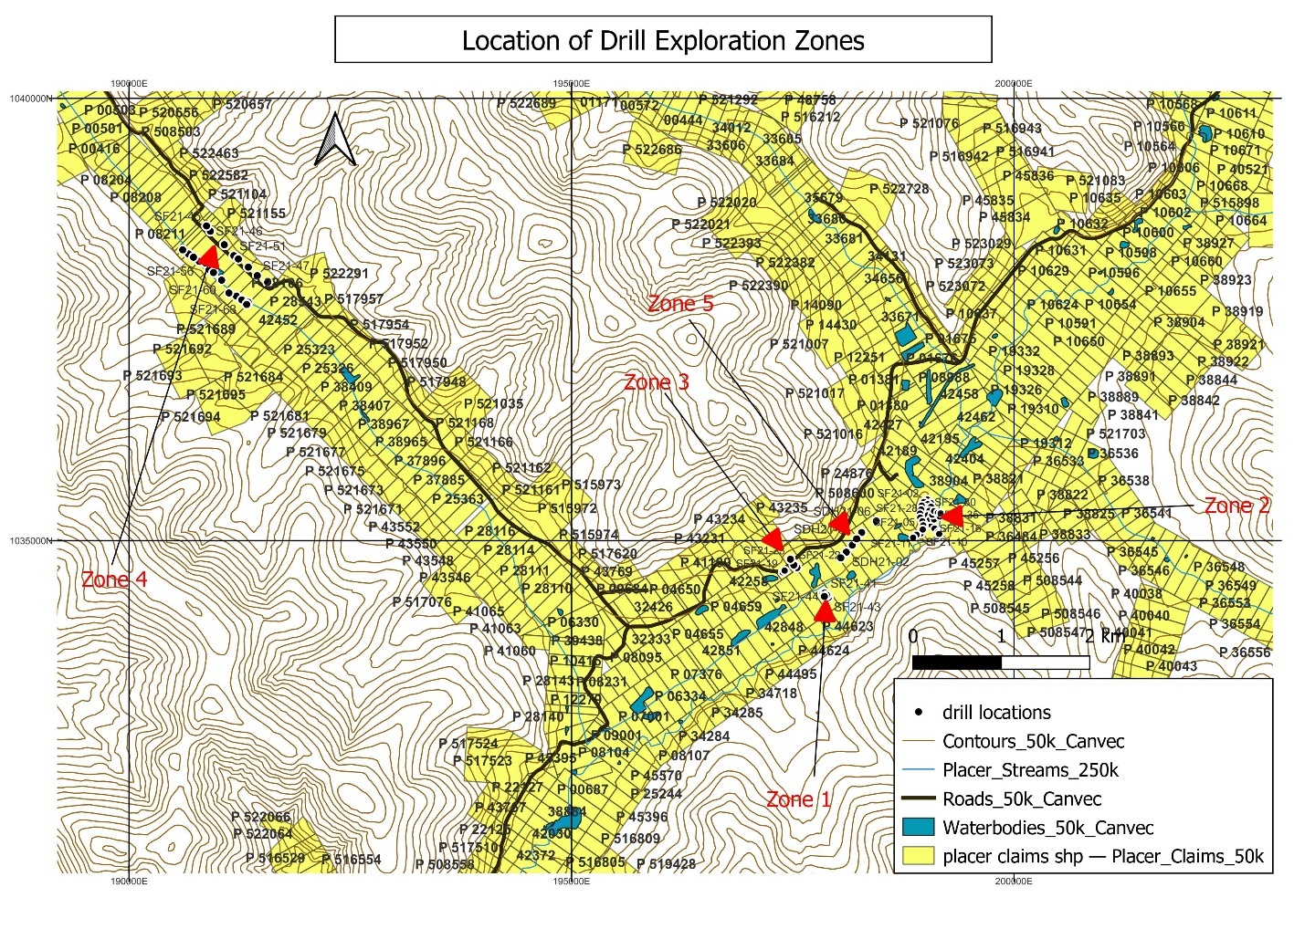
Figure 1. Drill exploration zone locations

Zone 1
The first exploration zone 1 auger drilling was done just North-east of the area mined by NBC in 2021. Five drill holes centralized around UTM Zone 7N, 617813.63 m E, 7062088.40m N on Tenure 42844 of Gimlex Enterprises Ltd. NBC has been leasing this claim block since 2020.

Zone 2
The second auger drilled zone was targeted due to its nearby proximity to NBC’s current operations and that its largely contained within the Gimlex claim block package (Tenures 42837, 42838) currently being leased. This area is directly northeast of zone 1 in un-mined ground between current Dominion creek and the miner’s ditch. Auger drilling was partially in Dominion gold resources Inc. claims (Tenures 42836, 42835). Thirty-three auger tests were done in this zone.

Zone 3
The third zone was picked due to its close proximity and being that it’s virgin ground. It located directly across valley (roughly 450m) from zone 1 in a claim block belonging to Alton Ramsay (Tenures 42260, 42261). Five auger test holes were done here.

Zone 4
The fourth exploration zone is the furthest from NBC’s current staging area, it is located roughly 750m from the Gimlex claim block (zone1) following the dominion -Sulphur loop Road down the Sulphur creek valley. The claim block tested includes Tenures P09158 -P01962, P07995, P28106 of Paydirt Holdings (1982) Ltd. Virgin ground at the limit of dredging extent was auger drilled to determine mining potential. Twenty-one holes were drilled in this location.

Zone 5
The fifth area explored was back on the Gimlex claim block package leased by NBC. Waste gravel over 1920’s dredge tailings were tested by sonic drilling to determine if gold rich pay gravels were missed by the dredges. Six sonic drill tests were done spaced along the mapped dredge extent to determine this. Tenures tested include: 42632, 42842, 42841, 42840.

3.0 Bedrock and Surficial Geology

Regional Bedrock Geology
The Klondike goldfield is underlain by highly deformed, greenschist-facies, Paleozoic metasedimentary and meta-igneous rocks of the Klondike Schist and Finlayson assemblage that form part of the Yukon-Tanana terrane, and by slices of ultramafic rocks of the Slide Mountain terrane (Figure 5). Regional-scale thrust faulting in the Early Jurassic stacked these rocks into a series of thrust slices that are locally separated by lenses of sheared ultramafic rocks (Mackenzie et al. 2007). The thrust slices were then uplifted through the brittle-ductile transition in the crust during the Jurassic and unconformably overlain by locally derived sedimentary and volcanogenic rocks in the Late Cretaceous (Mortensen, 1996). The Klondike goldfield was then offset approximately 450 km along the Tintina fault (Gabrielse et al., 2006). Erosion and minor regional uplift continued in the late Tertiary and resulted in the deposition of the Pliocene White Channel Gravels and their contained placer gold deposits (Lowey, 2005). Figure 5 highlights the fact bedrock covered by the Dominion placer claims in this report consist of mafic Klondike schist and Sulphur Creek orthogneiss. Mining in the adjacent areas has exposed mafic schist and granodioritic gneiss.

Surficial Geology

The Granville map area lies within the unglaciated region of the Klondike Plateau. It includes placer-gold-producing basins of lower Dominion, Gold Run, Sulphur, Wounded Moose and Eureka creeks and the upper Indian River. Surface geology consists largely of colluvial cover of varying thickness on the uplands and valley margins, with alluvium preserved on terraces and in valley bottoms with aeolian and colluvial covers.

Dominion creek fluvial deposits are divided into: 1). Pliocene terraces (equivalent to White Channel gravel); 2). Pleistocene terraces; 3). incised-valley-fill gravel (Ross gravel; >0.785 Ma); 4). Dominion Creek gravel (<0.785 Ma); and 5). gulch and stream deposits (<0.125 Ma). Ross gravel is volumetrically the most significant source for placer deposits on Dominion Creek (Froese et al. 2001).

Surficial geological mapping and stratigraphic sections by Froese and Jackson (2005) indicate that the ground covered by the Dominion Placer claims is composed of a 2m to 16m section of silt (organic rich), peat, fine sand, and organic detritus (collectively called muck), a 3m to 4m section of Dominion Creek Gravel, and a >5m section of Ross gravel.
Ross gravel underlies the contemporary flood plain gravels of Dominion, Sulphur, and Gold Run creeks and overlies bedrock. Ross gravel is a light-grey to white, quartz rich gravel that occurs below the modern creek level. Pebble counts of Ross gravel on Dominion creek are approximately 80% quartz with remaining lithologies derived from local metamorphic and volcanic rocks. The Ross gravel was deposited during an early Pleistocene interglacial period.

Dominion Creek gravel immediately overlies Ross gravel and also occurs in contact with bedrock upstream of Jensen Creek and along valley margins. The gravels are strongly iron stained. Pebble counts from the Dominion creek gravel are dominated by locally-derived schist and meta-volcanic clasts with quartz pebbles representing only 20-30%.

4.0 2021 Auger and sonic drilling

Procedure for Auger drilling and gold recovery performed by Sylvain Fleurant was done as follows:

Before drilling NBC’s CAT D10T2 Dozer and CAT 336 F Excavator were used to construct sufficient paths and pads in zones 1, 2 and 5. Zones 3 and 4 had access to drill sites that didn’t require earlier preparation.
Drilling was then performed by a tracked Bombardier muskeg carrier with a mounted 6” auger drill by Sylvain Fleurant and an assistant. Auger steel was kept at standard of 6” with daily welding. Samples were collected from the augers on 4x4 foot steel tray and shoveled into buckets that were numbered consecutively and kept in numerical order. After the hole was completed and the augers and bits cleaned the Sylvain retained the last 8’ of sample, representing 6’ of gravel on bedrock contact and 2’ of sample into bedrock for sluicing. At the end of each day of drilling collected samples were processed through a longtom processing site for concentration of heavy minerals and then further processing by sieving and meticulous hand panning. Raw gold recovered from each auger hole was finally dried then weighed using a mechanical balance calibrated to within 2mg accuracy.

Procedure for sonic drilling performed by Metro drilling was performed as follows:

Prior to drilling NBC’s CAT D10T2 Dozer prepared drill pads to accommodate Metro drillings 3” compact sonic drill rig. The goal of this small sonic drill test was mainly to determine if there was missed gravel beneath the 1920’s dredge tailings, thus sample size varied greatly. If there was virgin gravel found a 2’ sample was retained, 1 foot above bedrock contact and 1 foot into the bedrock. This gravel was specifically selected from the plastic sleeve encased samples and hand meticulously hand panned to determine gold content. Raw gold recovered from each sample was then dried and weighed using a digital scale accurate to 2mg.

DRILL RESULTS

Zone 1

Reason for targeting
The area of zone 1 testing was massively reduced from what was detailed in the YMEP application as NBC mining made the decision to extend their planned 2022 mine cut further southeast, towards the Dominion creek. This went beyond the extent of drill testing done by Gimlex et al., and the mining cleanup results that from this area was used in deciding where to place zone 1 targets. Since the gold grades diminished to near zero and the bedrock was continuing to rise at the south-east extent of the mine cut it was no longer viable to test. This prompted a specific target area (zone 1) to drill a previously undrilled gap in the expansive auger drill testing done by Gimlex et al. This was previously undrilled as it was a large standing pond that could not be accessed by a tracked auger drill in the summer when testing was performed. NBC decided to drill this small gap to determine if the south-eastward trend of diminishing gold grades was present.

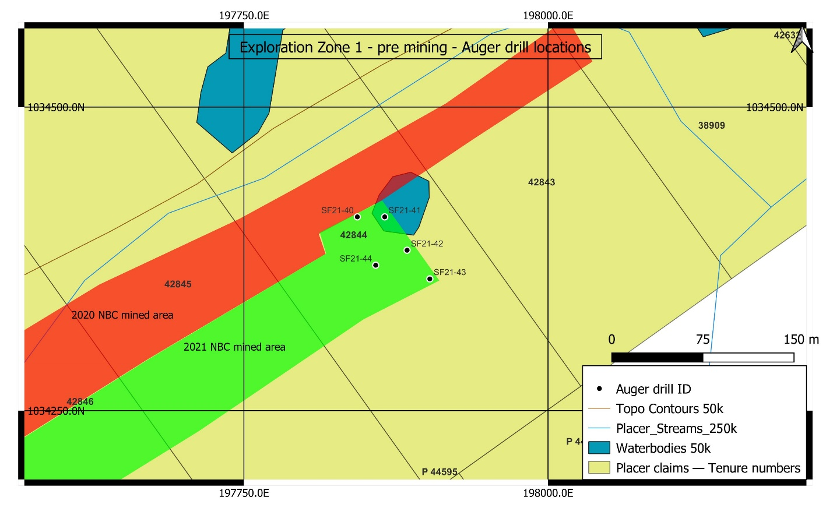
Figure 2. Exploration zone 1 auger drill locations.
Red and green areas denote the areas completed mining in 2020 and 2021 respectively.

Findings
Of the five auger test holes drilled in this zone only two were in frozen ground required to return a quality sample for determining gold grades. Drill holes SF21-43 and SF21-44 produced 2mg and 12mg respectively. Their depths of 8’ and 12’ clearly demonstrated the shallowing bedrock was consistent moving south-east. Directly adjacent to SF21-40 was the cut wall of the NBC 2020 mine cut. This wall was 50’ deep, thus the auger tests showed a rapid shallowing of bedrock over 80m, cross valley. These tests were sufficient evidence to rule out a possible deeper channel that would warrant further drill testing to the southeast.
After the findings of this investigation alternative exploration zones were sought out to find a viable mining option for NBC to continue in 2021.
Drill ID | Easting (m) | Northing (m) | Depth drilled to bedrock (ft) | raw gold produced (mg)
SF21-40 | 617852 | 7062066 | thawed failed sample
SF21-41 | 617809 | 7062111 | thawed failed sample
SF21-42 | 617831 | 7062087 | thawed failed sample
SF21-43 | 617852 | 7062065 | 8 | trace
SF21-44 | 617806 | 7062070 | 12 | 12
Table 1. Auger drill results of zone 1.

Conclusions and Recommendations
The poor auger drill recovery due to thawed gravel in this area is a probable effect of the previously overlying pond. This body of water could have facilitated more efficient thermal transfer during summertime gradually melting permafrost below. This area was the only thawed gravel encountered in the 2020-2021 cuts of NBC. Poor sampling return could reflect the suboptimal auger drilling conditions, but the rate of bedrock shallowing heading perpendicular to topo contours is consistent with findings of the NBC 2021 mine cut. Bedrock depth coupled with the gold grades recovered suggest mining would be dismal.

Zone 2

Reason for targeting
The second exploration target, zone 2, was selected for its nearby proximity to NBC’s current staging area and because the area has similar qualities to the proven mined area by NBC in 2020.This zone on the same side of the valley, immediately adjacent to the Dominion creek miners ditch in a section of virgin ground between workings done by Gimlex to the southwest and Ross to the north. In theory, the ground nearest to the miners ditch could contain economic gold grades that will likely decrease to the southeast as seen in zone1 and the NBC mined areas (2020-2021). An initial auger drill line was with pads was installed closest to the miners ditch to test the potentially richest ground and later drill targets were added southeastward of this to establish a potentially mineable area (Figure 3.)
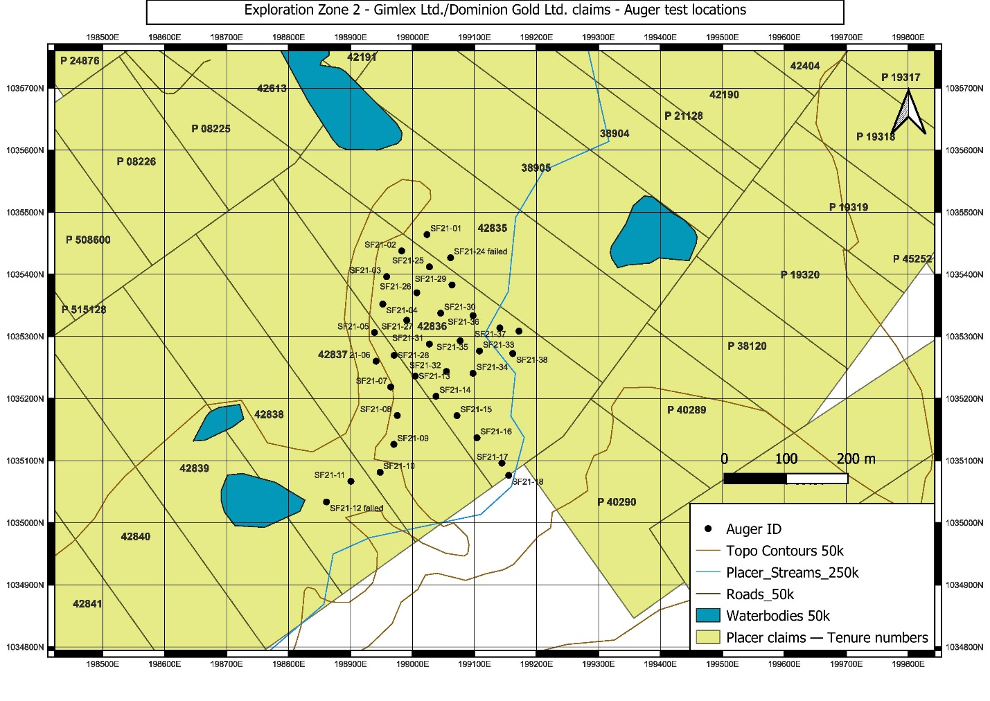
Figure 3. Exploration Zone 2

Findings

Thirty-three auger tests were done in this area and the holes with the highest gold values were situated closest to the valley center along the miners ditch. These high gold values were also associated with the deepest bedrock, as to be expected. Moving towards Dominion creek the bedrock shallowed to roughly 20 feet depth and gold grades dropped off (Table 2).
A minimum gold value in mg was determined based on the standard 8’ of 6” auger sampling sluiced from each test hole. The cut off grade was decided to be 1 tOz/100yrd^3 this determined a cut off value of 25mg or greater per * feet of sampled material. In zone 2 only 4/32 auger samples met this. Figure 4 demonstrates the distribution of the highest gold values in zone 2.

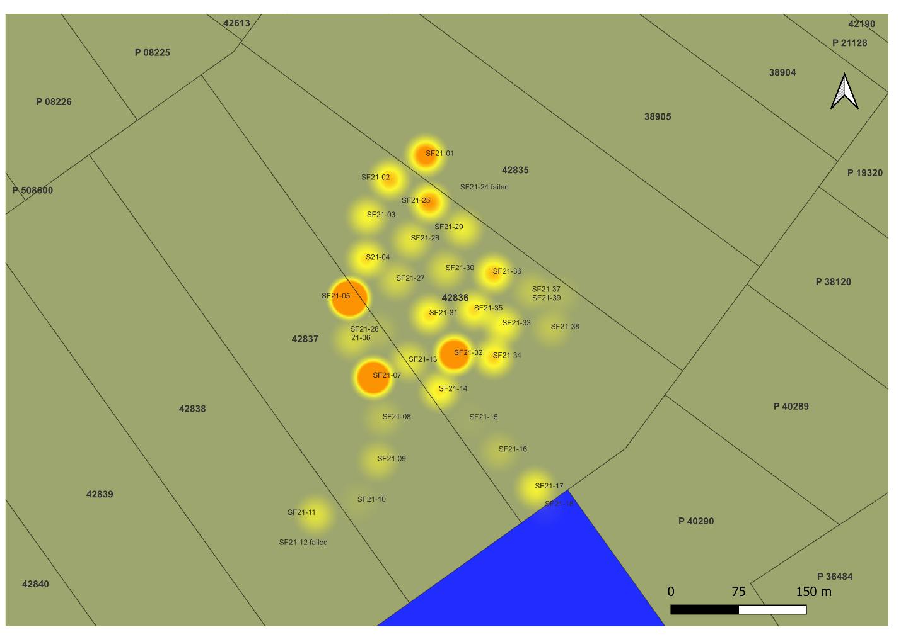
Figure 4. Gold value threshold map of zone 2.
Gold values of auger test sites are represented by an orange to yellow gradient where the largest solid orange areas reach the threshold of 25mg.

Drill hole ID | Easting (m) | Northing (m) | Depth drilled to bedrock (ft) | raw gold produced (mg)
SF21-1 | 618816 | 7063310 | 35 | 30
SF21-2 | 618779 | 7063278 | 36 | 21
SF21-3 | 618760 | 7063234 | 41 | 15
SF21-4 | 618760 | 7063189 | 38 | 18
SF21-5 | 618753 | 7063142 | 37 | 77
SF21-6 | 618761 | 7063097 | 37 | 9
SF21-7 | 618790 | 7063059 | 34 | 55
SF21-8 | 618807 | 7063015 | 24 | 5
SF21-9 | 618808 | 7062968 | 29 | 8
SF21-10 | 618792 | 7062921 | 27 | 2
SF21-11 | 618747 | 7062900 | 25 | 11
SF21-13 | 618827 | 7063081 | 33 | 12
SF21-14 | 618865 | 7063054 | 28 | 17
SF21-15 | 618903 | 7063027 | 20 | <2mg
SF21-16 | 618939 | 7062996 | 19 | 5
SF21-17 | 618985 | 7062961 | 18 | 14
SF21-18 | 618998 | 7062943 | 18 | <2mg
SF21-24 | 618858 | 7063278 | thawed failed sample | failed
SF21-25 | 618827 | 7063259 | 38 | 25
SF21-26 | 618812 | 7063215 | 36 | 12
SF21-27 | 618802 | 7063168 | 36 | 9
SF21-28 | 618789 | 7063110 | 36 | 4
SF21-29 | 618867 | 7063234 | 35 | 13
SF21-30 | 618854 | 7063187 | 42 | 10
SF21-31 | 618843 | 7063135 | 49 | 18
SF21-32 | 618876 | 7063095 | 30 | 46
SF21-33 | 618925 | 7063135 | 20 | 16
SF21-34 | 618919 | 7063098 | 22 | 19
SF21-35 | 618892 | 7063147 | 22 | 18
SF21-36 | 618907 | 7063190 | 30 | 21
SF21-37 | 618952 | 7063176 | 18 | 6
SF21-38 | 618979 | 7063138 | 16 | 6
SF21-39 | 618984 | 7063175 | 16 | 3
Table 2. Auger drill results of zone 2

Conclusions and Recommendations
The small fraction of auger test holes that met the threshold of 25mg or greater is very low and the spacial distribution shown in Figure 4 does not clearly delineate an area that could be opened as a cut for mining. Further infill drilling with a larger auger diameter could be used to increase a potentially economic deposit.
The areas containing the auger tests that meet the 25mg threshold were found to be too small to be economic for NBC mining thus further exploration elsewhere was needed.

Zone 3

Reason for targeting
The third target exploration area was targeted for its potential for similar depositional settings directly across the Dominion valley from the NBC mining cut 2020-2021. Theoretically it could be in “side pay” adjacent to 1920’s dredge workings. Five exploratory auger test holes were done in the Alton Ramsay claim block to assess its potential (Figure 5.). The initial target zone covered by the first three drill holes was directly adjacent to the 1920’s dredge workings (SF21-19 to SF21-21). The last two target holes sampled the cross valley heading up slope to determine the nature of the bedrock slope in this area.
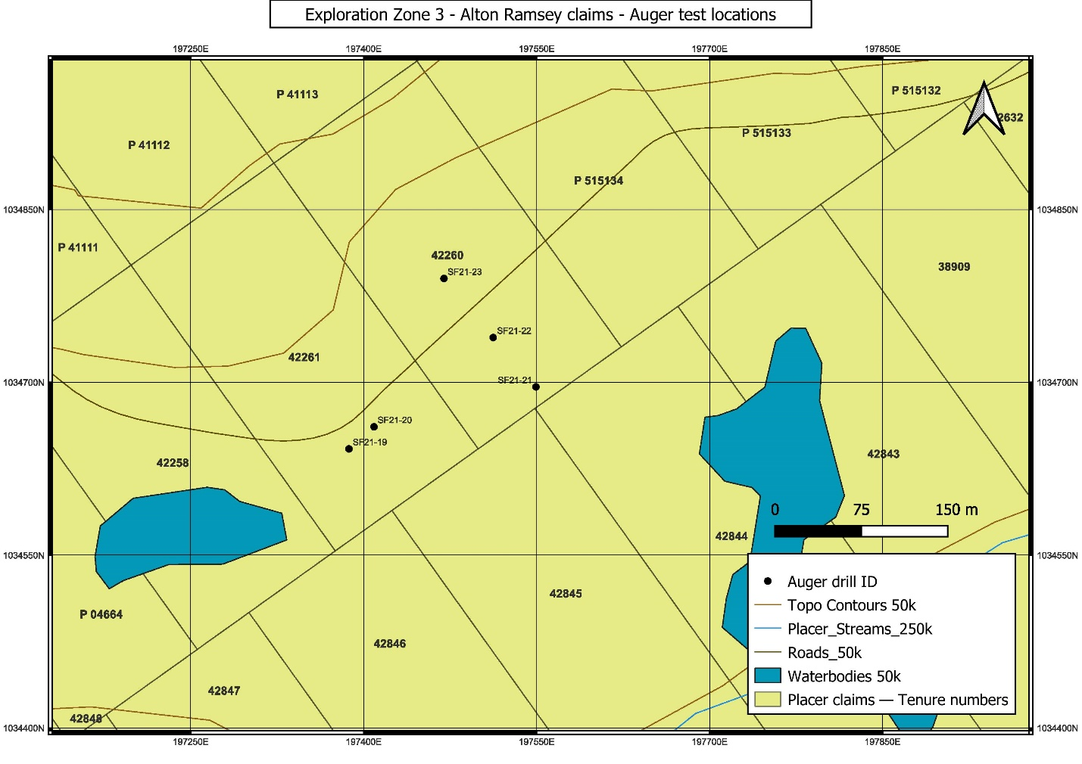
Figure 5. Auger exploration zone 3

Findings
The auger drill results in all five locations produced very little gravel and all gold values were below the 25mg threshold set. The auger tests sampling the more center valley gravel, that in theory could represent the highest gold values did not prove to be economic (Table 3). The final two auger tests moving northward, cross valley showed increasing depths of organic muck overburden with significantly lower gold grades at bedrock.

Table 3. Auger drill results of zone 3.

Conclusions and Recommendations
This small claim block produced very poor drill results in areas tested that held the greatest likelihood of being economic. The poor results of SF21-22 and SF21-23 indicated that there was aa significant increase in overburden heading north so the potential economic target was further decreased. Overall, this exploration prospect was shown to be low grade and the area was too small to be viable economically for NBC.

Zone 4

Reason for targeting
The Paydirt Holdings (1982) Ltd. Claim block is a thoroughly dredged section of the Sulphur creek valley, but it has relatively wide, potential “sidepay” margins that remain. This property is reasonably close to NBC’s base of operations on Dominion creek which made this a viable exploration option.
The dredge workings extent was easily visible and auger drill test sites were planned to test as close as possible to the center valley on the remaining virgin ground in order to assess the potential maximum gold grades that may be present here. Twenty-one auger drill sites spread evenly over the dredge-virgin ground boundary were planned to sample this in preliminary exploration drilling.

Findings

Table 4. Auger drill results zone 4

Twenty successful auger test holes were completed along the boundary of the dredge workings (Table 4, Figure 6.). Only one auger test produced gold values above the cut-off threshold of 25mg. The remaining test holes averaged 8.8 mg, suggesting the remaining “sidepay” is not economic. Further infill drilling focused around SF21-49 could expand on a potentially enriched area missed by earlier dredging. Based on these preliminary drill results this zone is currently not an economic mining option for NBC Contracting. Further testing is required.

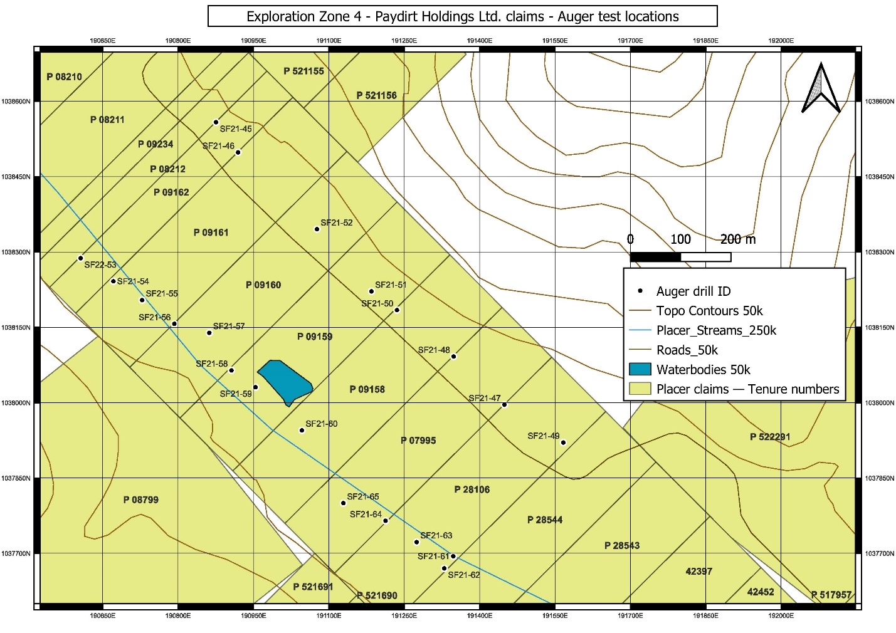
Figure 6. Auger exploration zone 4

Zone 5
Reason for targeting
The last zone explored was again selected for its proximity to NBC’s staging area. I lies between zones 1 and 2 in the center of Dominion creek valley in 1920’s dredge tailings. The goal of this test was to determine whether the dredge had fully excavated to bedrock. If any of the gravel remained unmined beneath the tailings it would represent the richest gold grade gravels known to be found directly on the bedrock contact in this area (from NBC findings 2020). A sonic drill was required to successfully drill and sample in the thawed, ground water laden, dredge tailings. Six drill holes were planned, spread over feasibly mineable extent of the Gimlex claim block (Figure 7.). These holes were also placed closest to center valley along the mapped dredge limits from Yukon historic placer data.

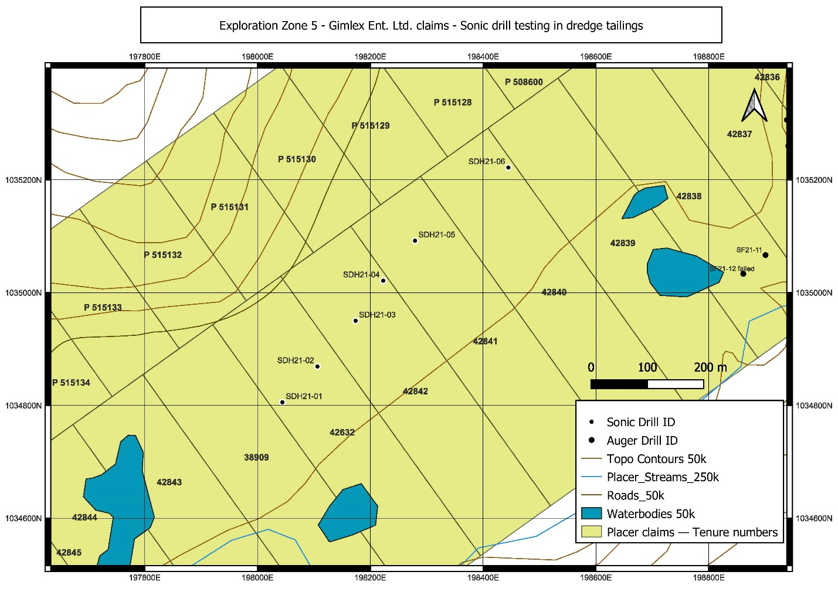
Figure 7. Zone 5 - Sonic drill test locations

Findings
Sonic drilling performed by Metro drilling revealed two generations of waste materials stacked over the 1920’s dredge tailings. The total overburdens ranged from 45-60ft and massive amounts of water flowing through this thawed overburden made for some difficulties in drilling. Of the six drill holes (detailed in Table 5.) five successfully sampled to bedrock. Drill holes SD21-02, SD21-04 and SD21-06 revealed up to one and a half feet of remaining undisturbed gravels.

Drill ID | Easting (m) | Northing (m) | Depth drilled to bedrock (ft) | raw gold produced (mg) | depth of gravel under tailings (ft)
SD21-01 | 617938 | 7062525 | 50 | trace | 0
SD21-02 | 617988 | 7062596 | 55 | 3 | 1
SD21-03 | 618044 | 7062686 | 45 | 4 | 0
SD21-04 | 618083 | 7062762 | 55 | trace | 1
SD21-05 | 618131 | 7062840 | 45 | failed | failed
SD21-06 | 618276 | 7062991 | 60 | 4 | 1.5

Table 5. Sonic drill test results, zone 5

Unfortunately, due to the small diameter of the sonic drill the sampling sizes of the bedrock contact material was relatively small and is not likely a reliable indicator of true gold grades. This coupled with the high ground water content compromises the sampling quality further. The gold weight found for each drill hole is more safely used as an indicator of the presence of gold only.
One interesting finding of the sonic drilling is that the deepest hole SD21-06 may suggest that deeper depressions in the bedrock likely harbor large reserves of undisturbed gravels missed by the dredges. This preliminary assessment of the dredge tailings shows potential for unmined gravel, but significantly more drill sampling would be ideal to estimate its economic worth.

5.0 Statement of Expenses

8.0 References

Froese, D.G., Enkin, R.J., and Smith, D.G. Placer depositional settings and their ages along Dominion Creek, Klondike area, Yukon in Yukon Exploration and Geology 2000.

Froese, D.G., and Jackson, Jr., L.E. Surficial Geology Granville, Yukon Territory GSC Open File 4587, 2005

Gabrielse, H. & Murphy, Donald & Mortensen, James. (2006). Cretaceous and Cenozoic dextral orogen-parallel displacements, magmatism, and paleogeography, north-central Canadian Cordillera. Paleogeography of the North American Cordillera: Evidence For and Against Large-Scale Displacements. 46. 255-276.

Grant W. Lowey, The origin and evolution of the Klondike goldfields, Yukon, Canada, Ore Geology Reviews, Volume 28, Issue 4, 2006, Pages 431-450, ISSN 0169-1368

MacKenzie, D.J., Craw, D., Mortensen, J.K. and Liverton, T., 2006. Structure of schist in the vicinity of the Klondike goldfield, Yukon. In: Yukon Exploration and Geology 2006, D.S. Emond, L.L. Lewis and L.H. Weston (eds.), Yukon Geological Survey, p. 197-212.

Mortensen, J.K., 1996. Geological Compilation Maps of the Northern Stewart River Area, Klondike and Sixtymile Districts (115N/15, 16, 115O/13, 14 and Parts of 115O/15, 16). Indian & Northern Affairs Canada/Department of Indian & Northern Development: Exploration & Geological Services Division, Open File 1996-1(G).

Dredge Summary Various 1931 E Davidson

Yukon Energy, Mines and Resources/YGS Website –
http://www.emr.gov.yk.ca/mining/mapsdatapubs.html

