Yukon Mineral Exploration Program

Bedrock Creek and Sixty Mile Placer Evaluation
Sonic Drill Program

Final Report
YMEP – 23-050

Dawson Mining District
NTS 115N15
Latitude 63 58’ 11” Longitude 140 51’ 47”

Claim Names: Claim 200 – Claim 209, Claim 1 – Claim 10, Jado, Claim 23, Claim 22
Grant Numbers: P 06235 – P06244, 42707 – 42716, P 519344, P 35042, P 35041

Prepared by:
Neil Loveless
PO Box 832, Dawson City, YT, Y0B 1G0

For:
Favron Enterprises Ltd, PO Box 529, Dawson City, YT
Northern Envy Industries Ltd, PO Box 832, Dawson City, YT

January 25, 2023
Table of Contents

Introduction …..…………………………………………………………………………. 3
Claims Location and Ownership ……….……………………………………….. 4
History …..………………………………………………………………………………….. 7
Project Summary ………………………………………………………………………. 8
Drilling Program Details …..……………………………………………………….. 9
Results ….…………………………………………………………………………………. 10
Conclusion ………………………………………………………………………………. 18

Introduction
The following report is the final report for the Bedrock Creek and Sixty Mile Placer Evaluation, YMEP 23-050. This project was designed to assess two potential placer deposits located in a historic placer district known as the Sixty-Mile region, on a historically worked creek that has sat mostly inactive for thirty years. Its focus was to follow up on some initial findings showing a potential pay streak in the Bedrock Creek valley bottom outflowing into the Sixty-Mile River valley, and look for an economical left limit bench of Bedrock Creek.
Favron Enterprises, Northern Envy Industries and Paushe Industries Inc. purchased the main Bedrock Creek property in 2016 which consisted of forty-three claims. The first bunch of these claims were staked in 1974 with more claims being staked and added to the package in 1978 and 1988, they were held by two different owners prior to this purchase. Since purchasing the claims Favron Enterprises and Northern Envy Industries have staked an additional forty-six claims that are attached to the grouping. There is now a valid water and class four licence on the original property, +twenty-five of the additionally staked claims until October of 2030.
In 2018 while completing assessment work, we dug a few trenches and panned the left limit of Bedrock Creek and found promising results that showed good potential. The following year we hired Sylvain Fluerant to do some auger drilling on the left limit. Due to wet conditions, difficult frost and thawed layers, difficulty determining between bedrock and slide rock as well as a limited timeframe, we decided to end the project after twelve holes until a better solution could be found. Although we did not get as much info as we had hoped, we did get two good drill holes that showed a potentially rich pay streak on the left limit.
In 2020 a neighbouring miner began exploration and mining on Bedrock Creek upstream of our property, this was the first large scale testing and mining that had been done on the creek in thirty years. His operation has found an elevated left limit bench directly upstream of our property which was approximately 5,000 ft upstream of the auger drill holes.
As we are hoping to begin mining in the Sixty Mile area in 2025 and with the recent exciting activity occurring on Bedrock Creek, we decided it was time to for a larger exploration program. By using the YMEP program it gave us the ability to pursue a higher cost technique that would give us the certainty in our results that we need to make a good decision on whether to commence mining on this creek.

Claims Location and Ownership
The Bedrock Creek placer project is in the Dawson Mining District and is located 70km directly west of Dawson City, in the area historically referred to as the Sixty-Mile region. Bedrock Creek is a left limit tributary to the Sixty-Mile River, and is upstream from the more well-known Glacier Creek and Miller Creek. It is easily accessible using the top of the world highway, Upper Sixty-Mile access road, and a new access road we constructed to the bottom of our property in 2021.

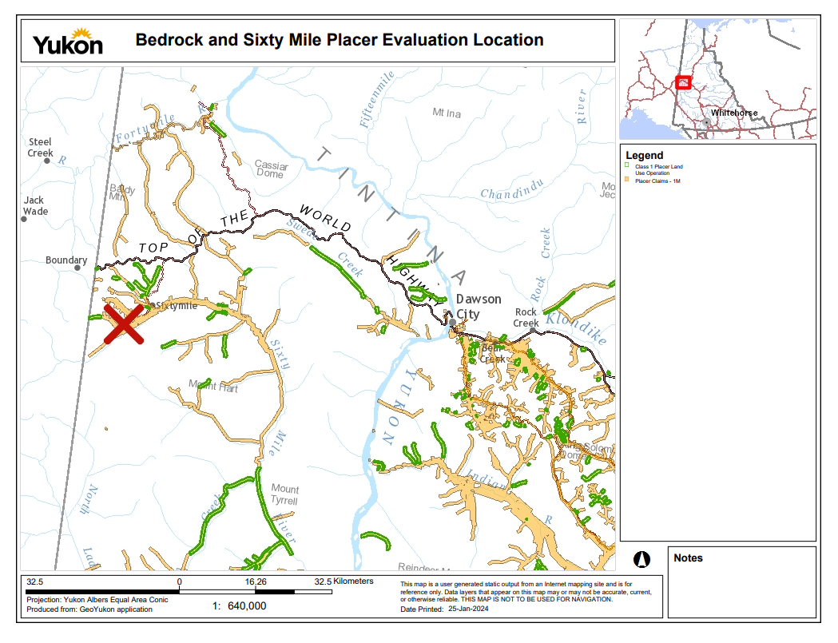
Figure 1. Project located 70 km directly west of Dawson City.
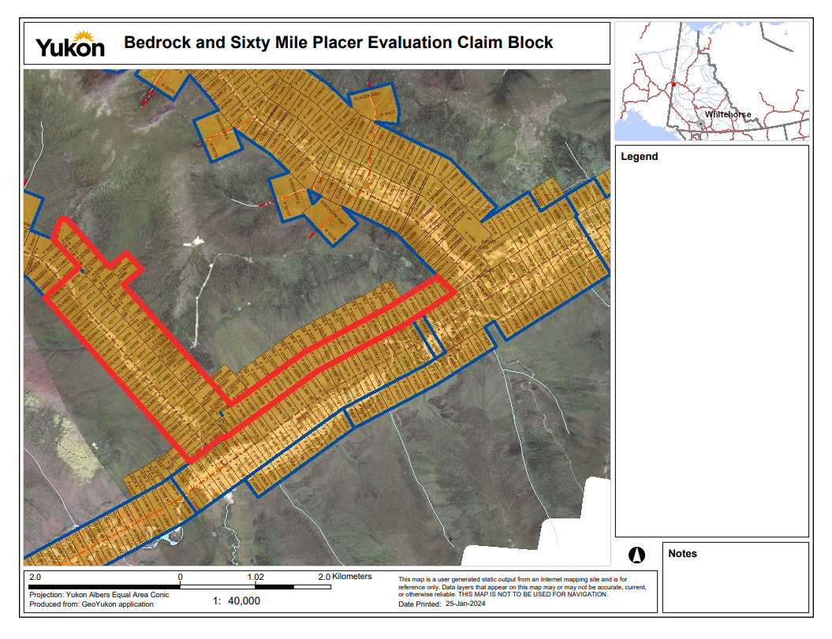
Figure 2. Placer claims listed on Class 4 licence highlighted in red above

The tables below are broken into two parts, the claims covered under the class four license where drilling and exploration activities occurred and the claims remaining in the class four license that allows for these activities to occur. These claims are owned by Favron Enterprises Ltd. (Favron), Northern Envy Industries Ltd. (Envy), and Paushe Industries Inc. (Paushe).

Table 1. Claims where activity occurred.
Grant # | Claim Name | Claim Owner | Expiry Date
P 06235 | Claim 200 | Favron33.33%, Envy33.33%,Paushe 33.34% | 01-Jan-25
P 06236 | Claim 201 | Favron33.33%, Envy33.33%,Paushe 33.34% | 01-Jan-25
P 06237 | Claim 202 | Favron33.33%, Envy33.33%,Paushe 33.34% | 01-Jan-25
P 06238 | Claim 203 | Favron33.33%, Envy33.33%,Paushe 33.34% | 01-Jan-25

Grant # | Claim Name | Claim Owner | Expiry Date
P 06239 | Claim 204 | Favron 33.33%, Envy 33.33%, Paushe 33.34% | 01-Jan-25
P 06240 | Claim 205 | Favron 33.33%, Envy 33.33%, Paushe 33.34% | 01-Jan-25
P 06241 | Claim 206 | Favron 33.33%, Envy 33.33%, Paushe 33.34% | 01-Jan-25
P 06242 | Claim 207 | Favron 33.33%, Envy 33.33%, Paushe 33.34% | 01-Jan-25
P 06243 | Claim 208 | Favron 33.33%, Envy 33.33%, Paushe 33.34% | 01-Jan-25
P 06244 | Claim 209 | Favron 33.33%, Envy 33.33%, Paushe 33.34% | 01-Jan-25
42707 | Claim 1 | Favron 33.33%, Envy 33.33%, Paushe 33.34% | 01-Jan-25
42708 | Claim 2 | Favron 33.33%, Envy 33.33%, Paushe 33.34% | 01-Jan-25
42709 | Claim 3 | Favron 33.33%, Envy 33.33%, Paushe 33.34% | 01-Jan-25
42710 | Claim 4 | Favron 33.33%, Envy 33.33%, Paushe 33.34% | 01-Jan-25
42711 | Claim 5 | Favron 33.33%, Envy 33.33%, Paushe 33.34% | 01-Jan-25
42712 | Claim 6 | Favron 33.33%, Envy 33.33%, Paushe 33.34% | 01-Jan-25
42713 | Claim 7 | Favron 33.33%, Envy 33.33%, Paushe 33.34% | 01-Jan-25
42714 | Claim 8 | Favron 33.33%, Envy 33.33%, Paushe 33.34% | 01-Jan-25
42715 | Claim 9 | Favron 33.33%, Envy 33.33%, Paushe 33.34% | 01-Jan-25
42716 | Claim 10 | Favron 33.33%, Envy 33.33%, Paushe 33.34% | 01-Jan-25
P 35041 | Claim 22 | Favron 33.33%, Envy 33.33%, Paushe 33.34% | 01-Jan-25
P35042 | Claim 23 | Favron 33.33%, Envy 33.33%, Paushe 33.34% | 01-Jan-25
P 519344 | Jado | Favron 50%, Envy 50% | 01-Jan-25

Table 2. Remaining claims that are included in Class four Water Licence
Grant # | Claim Name | Claim Owner | Expiry Date
P35020-5040 | Claim 1 - 21 | Favron33.33%, Envy33.33%, Paushe33.34% | 01-Jan-25
P 519345 | Crunch | Favron 50%, Envy 50% | 01-Jan-25
P 519346 | Argo | Favron 50%, Envy 50% | 01-Jan-25
P 519347 | Dutchbean | Favron 50%, Envy 50% | 01-Jan-25
P 519348 | Chinook | Favron 50%, Envy 50% | 01-Jan-25
P 521045 | Burgan | Favron 50%, Envy 50% | 01-Jan-25
P 521046 | Cat Burgalor | Favron 50%, Envy 50% | 01-Jan-25
P 521047 | 28000 | Favron 50%, Envy 50% | 01-Jan-25
P 521048 | Zoozeum | Favron 50%, Envy 50% | 01-Jan-25
P 519847 | Victoria | Favron 50%, Envy 50% | 01-Jan-25
P 519848 | Bailey | Favron 50%, Envy 50% | 01-Jan-25
P 519849 | Nicole | Favron 50%, Envy 50% | 01-Jan-25
P 519850 | Lisa | Favron 50%, Envy 50% | 01-Jan-25
P 521040 | MRB | Favron 50%, Envy 50% | 01-Jan-25
P521041 | Mega | Favron 50%, Envy 50% | 01-Jan-25
P519804-9809 | BB1 - BB6 | Favron 50%, Envy 50% | 01-Jan-25
P521036-1039 | BB7 - BB10 | Favron 50%, Envy 50% | 01-Jan-25
History
Bedrock Creek has been a historic placer creek and was prospected and hand mined from before the gold rush as gold was discovered on Miller Creek in 1892. In the Sixty-Mile region, Glacier and Miller creeks were the focus of this activity but other creeks such as Big Gold, Little Gold and Bedrock Creek are all mentioned as primary creeks that were being worked.
The location where our claims are now was once owned and prospected by the Dole Pineapple company in the late 1930’s and 1940’s. A churn drill was used for prospecting, but this project was stopped when World War 2 broke out and Dole Pineapple company never returned to the project.
The claims upstream of our property had been worked by a single operator using one cable dozer. He was believed to have been working in the area starting in the 1950’s. The old tailings piles, and his old cuts were still visible until last season when the current claim owner began to work the area. The valley bottom had been mined heavily with his workings ending at the border between our claims.
The first set of claims were staked in 1974 and were then mined periodically by three different operators over the next 20 years with the last operation finishing their work in the fall of 1992. They were lined up to return in 1993 but a disagreement with the claim owner led them to move. Since then, only testing and assessment work has been completed.
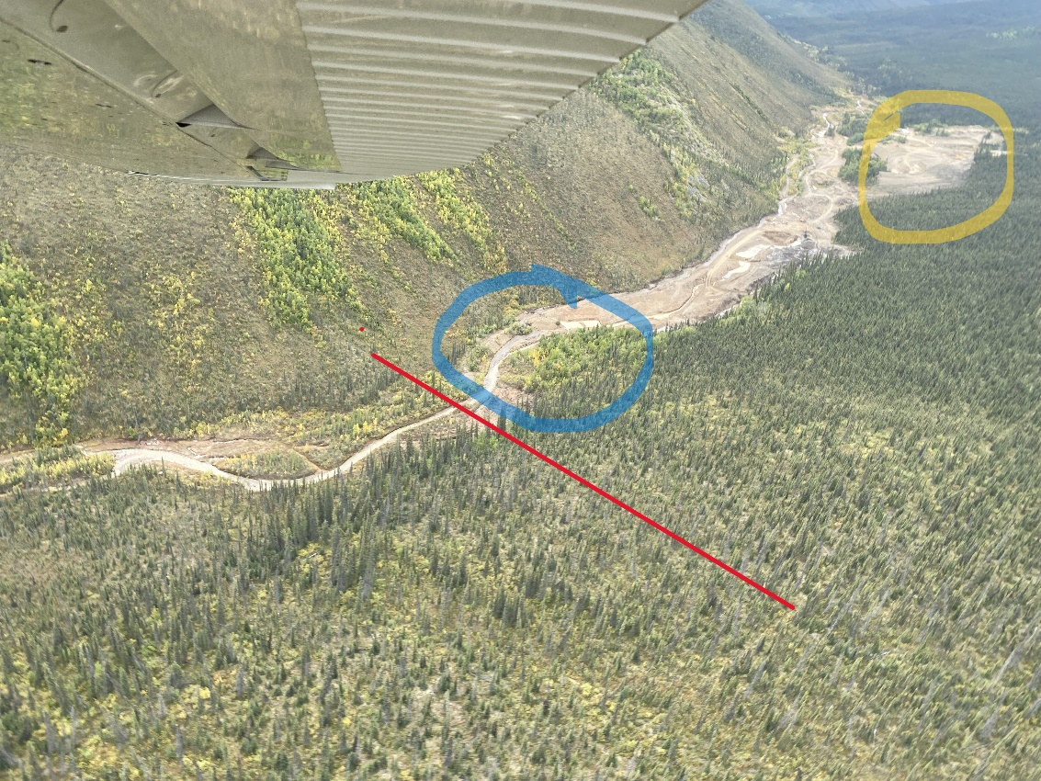
Picture 1. Picture of Bedrock Creek activity Upstream of border (red line), including area mined in the 1950s (highlighted in blue) and Current Bench being mined (highlighted in yellow)
Project Summary
We had 77 holes drilled on this project. We drilled 75 holes on Bedrock Creek, 64 were in the valley looking for the limits of the valley bottom, 11 were looking for a left limit bench, and 2 holes were in the Sixty-Mile valley directly downstream of Bedrock Creek.
The drilling was completed by Liam Ferguson with Northern Sonic Drilling and Consulting. They were on location for nineteen days and drilled/ worked on this project for twelve of those days. Northern Sonics drill is a Terrasonic drill head mounted on a IHI IC-75-2 low ground pressure unit, and the support unit is a Terramac RT9 low ground pressure unit. Northern Sonic can offer either 6” or 8” holes, we opted to go with the 8” hole as the Sixty-Mile area is known for its spottiness. Our hope was that by increasing the square inches of each hole by a factor of 1.78 when compared to 6” it would help us in gathering more accurate results.
On the ground Neil Loveless and one employee were periodically on-site spending nine of the twelve days at site with the drill crew. We had a Komatsu D375 dozer, Hitachi ZX450 and a Komatsu PC128 excavator on site. We used the dozer and 45-ton excavator to improve roads in order to allow the drill crew vehicle access around the site. These machines were also used to build access to the none accessible parts of the bench as steep grades were overcome using old tailings and waste piles. We used the PC128 to build drill trails by removing minimal brush and trees, this excavator also allowed for minimal disturbance to the floor covering.
When drilling, the driller records the location, depths, type, and consistency of materials drilled, once they have hit and confirmed bedrock, they bag the samples in 2ft increments. The sample recovered was typically 2’ of bedrock and 4 to 6’ of the pay gravels lying on bedrock. Each hole is flagged and tagged with the hole number and depths of material. Corresponding samples are given the same flagging and tags then taken back to the sampling shack at end of day.
Drill hole sampling is typically completed the day after drilling. Information collected by the driller is entered into a drill log for each hole, then sample bags are cut open, photos and more detailed notes are taken describing types of gravels and bedrock. After all relevant information has been collected and recorded the sample is washed and put through a small trommel and longtom configuration. Samples are panned out and weighed, the gold from each sample is put into a small baggie and stapled to the drill logs.
In the end each sample has a tag and flagging tape at the drill hole location that corresponds with the individual drill log as well as photos for that hole. Then all of the information is recorded and digitized on mapping software showing the results for each hole.

Drilling Program Details
This drilling program as laid out in the application had two targets. We were looking for the main pay channel in the valley as well as look for the source which we believed to be coming from an elevated left limit bench as discovered by a neighbouring miner.
In search for the main pay channel in the Bedrock Creek valley bottom, we started the drill program at the bottom end of our claims just upstream from where the creek enters the Sixty-Mile River. We had some previous evidence from mining completed in the late 80’s and early 90’s to believe that the pay channel had hugged the left limit on Bedrock Creek. The drill plan was laid out to focus on the left limit of the current creek, the lines were perpendicular to the baseline. Each line was located approximately 1,000 ft upstream of the previous line, some lines varied due to landscape issues. Each drill line had a varying number of holes per line depending on where the first hole was located. The first hole was usually located 50’ from the creek or edge of previous mining, the holes were then 100 ft apart moving towards the left limit bench and stopped when bedrock significantly rose, or the grade became too steep to level off the drill. This portion of the drilling consisted of 66 holes + 2 holes in the Sixty-Mile River Valley itself.
We tested the 2 holes in the Sixty-Mile valley early on. After seeing the results from these holes we decided to focus primarily upstream as we had better access and better results. If things had tapered off upstream, we had the option to continue further downstream if needed.
While drilling the valley bottom, we decided to extend our lines up the slope on a few of the drill lines that provided easier access to the bench. This was decided as a good first step to begin seeing where the limits of the bench might be. There were 3 lines that provided this access, these lines were lines five, six and seven. Each of these lines we drilled up the slope until we began to see a levelling off of bedrock, or a tapering off of the gravels.
For lines eight and nine we built a trail up to access the more visible bench sections. We drilled 3 more holes on line eight with the last hole ending at 83ft deep. Then on line nine we drilled one hole to 77ft deep. After drilling 2 deep holes consecutively on lines eight and nine it was agreed that the 8” drill stem was not the correct tool to explore the bench and we opted to see if the bench downstream was shallower.
We drilled one hole on the bench at the mouth of Bedrock Creek and it was to a depth of 66ft, which again was difficult to drill with 8” drill stem. At this point we decided to spend the remaining time and funds on completing the main pay channel feasibility and mapping.
In total we completed 66 holes in the Bedrock Creek Valley, 2 holes in the Sixty-Mile Valley and 11 holes on the Bedrock Creek Bench. These drill holes were spread out over ten drill lines in the Bedrock Valley and one drill line in the Sixty-Mile Valley. In total we drilled 1,657ft in the Bedrock Valley, 78ft in the Sixty-Mile Valley, and 571ft on the Bedrock Bench.
Results
When we initially started the project we had set out with a plan to find/confirm a left limit pay streak in the Bedrock Creek Valley, and search for the source of this paystreak which we believed to be up on an elevated left limit bench.
Our results in the valley bottom showed there to be a consistent left limit pay streak from the bottom of our property up to or within 1,000 ft from the upstream claim border. This pay streak appears to be narrow and hugging the bench at the upstream end of the claim block. It is at most 150-200 ft wide and continues downstream like this for 4,000 ft, where it is intercepted by the mining done in the early 90’s.
Downstream of this mined section (BPC3, Bedrock Potential Cut 3) the pay streak appears to be getting wider ranging between 300ft to 700ft in width. It is leaner but has economic grades worth mining and portions of this section have already been mined. The first line we drilled at the bottom of the property has sporadic results and indicates that potentially the pay streak has braided into two different pay streaks as it enters the Sixty-Mile Valley, one near the current creek channel and one continuing to hug the left limit.
Results from the bench were weak. Of the 11 holes drilled, none of them indicate the ground is economical to mine at this time. However, the drill holes did show that there is a prominent gravel bench on the top 2,500ft of our claims, a potentially tiered bench for the next 4,000 ft downstream, then the bench visually reappears, and the lone drill hole showed a deep gravel bench. Although the drill results were weak, we believe more effort needs to be put into researching this bench to determine its extent and potential.
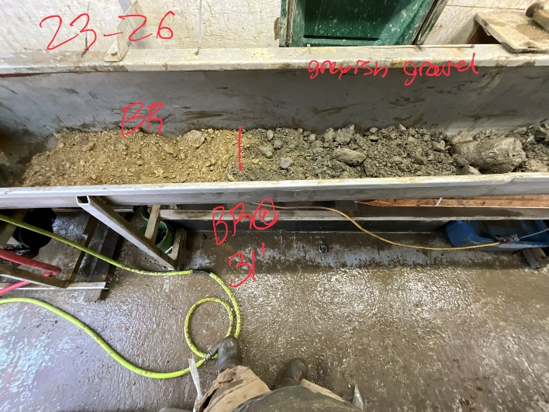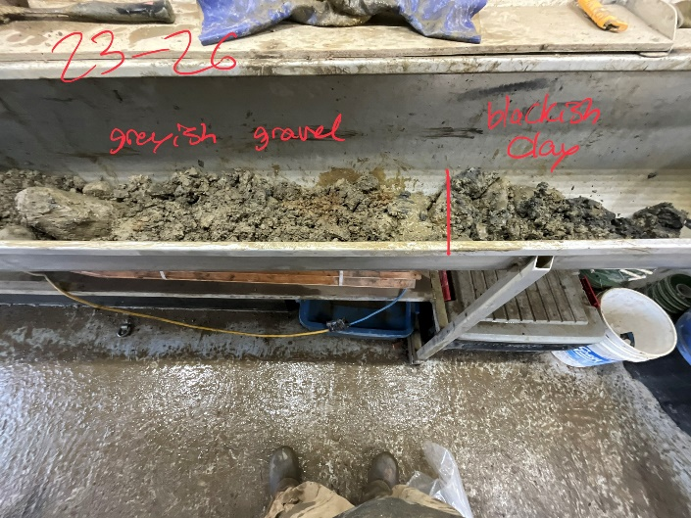
Photo 2 and 3. Core shack wash station photos showing Bedrock, Gravel, Clay for Hole 23-26
The following tables have the compiled drill results that will correlate with the maps below, the tables are broken up into 3 sections, Bedrock Creek Valley, Sixty-Mile Valley and Bedrock Creek Bench.
Table 3, below. Bedrock Creek Valley drill results, showing depth of mud and depths of gravel individually then the accumulated depth to bedrock, followed by total depth of each drill hole.
Bedrock Creek Valley
Drill Hole # | Gold | Mud Depth | Gravel Depth | Depth To BR | Total Depth
23-18 | 36 mg | 15 ft | 6 ft | 21 ft | 26 ft
23-19 | 34 mg | 10 ft | 11 ft | 21 ft | 24 ft
23-20 | 10 mg | 10 ft | 9 ft | 19 ft | 22 ft
23-21 | 60 mg | 15 ft | 8 ft | 23 ft | 26 ft
23-22 | 0 mg | 10 ft | 20 ft | 30 ft | 34 ft
23-23 | 0 mg | 10 ft | 12 ft | 22 ft | 27 ft
23-24 | 0 mg | 10 ft | 20 ft | 30 ft | 34 ft
23-25 | 22 mg | 11 ft | 21 ft | 32 ft | 35 ft
23-26 | 169mg | 6 ft | 24 ft | 30 ft | 34 ft
23-27 | trace | 25 ft | 6 ft | 31 ft | 36 ft
23-28 | 37mg | 10 ft | 5 ft | 15 ft | 17 ft
23-29 | 4 mg | 9 ft | 6 ft | 15 ft | 20 ft
23-30 | 3 mg | 14 ft | 4 ft | 18 ft | 24 ft
23-31 | 3 mg | 20 ft | 4 ft | 24 ft | 27 ft
23-32 | 2 mg | 18 ft | 15 ft | 33 ft | 37 ft
23-33 | 74 mg | 10 ft | 9 ft | 19 ft | 21 ft
23-34 | 29 mg | 8 ft | 6 ft | 14 ft | 19 ft
23-35 | 83 mg | 10 ft | 11 ft | 21 ft | 25 ft
23-36 | trace | 19 ft | 5 ft | 24 ft | 27 ft
23-37 | 6 mg | 19 ft | 8 ft | 27 ft | 30 ft
23-38 | trace | 15 ft | 8 ft | 23 ft | 26 ft
23-39 | 2 mg | 23 ft | 7 ft | 30 ft | 33 ft
23-46 | trace | 34 ft | 11 ft | 45 ft | 49 ft
23-47 | trace | 26 ft | 4 ft | 30 ft | 36 ft
23-48 | 14 mg | 18 ft | 3 ft | 21 ft | 26 ft
23-49 | 55 mg | 8 ft | 4 ft | 12 ft | 13 ft
23-50 | 15 mg | 19 ft | 9 ft | 28 ft | 30 ft
23-51 | 1 mg | 3 ft | 3 ft | 6 ft | 13 ft
23-52 | 3 mg | 15 ft | 6 ft | 21 ft | 26 ft
23-54 | 139 mg | 15 ft | 5 ft | 20 ft | 22 ft
23-55 | 14 mg | 25 ft | 2 ft | 27 ft | 30 ft
23-56 | trace | 14 ft | 5 ft | 19 ft | 26 ft
23-57 | 13 mg | 27 ft | 4 ft | 31 ft | 35 ft
23-58 | 6 mg | 36 ft | 7 ft | 43 ft | 45 ft
23-60 | 0 mg | 12 ft | 2 ft | 14 ft | 18 ft
23-61 | 12 mg | 20 ft | 6 ft | 26 ft | 31 ft

Bedrock Creek Valley
Drill Hole # | Gold | Mud Depth | Gravel Depth | Depth To BR | Total Depth
23-62 | 194 mg | 33 ft | 2 ft | 35 ft | 45 ft
23-63 | 21 mg | 24 ft | 2 ft | 26 ft | 31 ft
23-67 | 8 mg | 2 ft | 10 ft | 12 ft | 14 ft
23-68 | 16 mg | 0 ft | 8 ft | 8 ft | 10 ft
23-69 | 86 mg | 1 ft | 11 ft | 12 ft | 15 ft
23-70 | trace | 10 ft | 6 ft | 16 ft | 19 ft
23-71 | 12 mg | 12 ft | 6 ft | 18 ft | 23 ft
23-72 | 196 mg | 14 ft | 6 ft | 20 ft | 23 ft
23-73 | 16 mg | 6 ft | 12 ft | 18 ft | 23 ft
23-74 | trace | 11 ft | 10 ft | 21 ft | 25 ft
23-75 | 3 mg | 24 ft | 3 ft | 27 ft | 28 ft
23-76 | trace | 26 ft | 5 ft | 31 ft | 33 ft
23-78 | 8 mg | 9 ft | 16 ft | 25 ft | 27 ft
23-79 | 67 mg | 6 ft | 16 ft | 22 ft | 24 ft
23-80 | 37 mg | 10 ft | 12 ft | 22 ft | 27 ft
23-81 | 129 mg | 12 ft | 11 ft | 23 ft | 25 ft
23-82 | 9 mg | 13 ft | 14 ft | 27 ft | 29 ft
23-83 | 72 mg | 11 ft | 15 ft | 26 ft | 28 ft
23-85 | 9 mg | 14 ft | 10 ft | 24 ft | 26 ft
23-86 | 4 mg | 10 ft | 8 ft | 18 ft | 22 ft
23-87 | 9 mg | 11 ft | 8 ft | 19 ft | 23 ft
23-88 | 1 mg | 12 ft | 5 ft | 17 ft | 19 ft
23-89 | 2 mg | 24 ft | 6 ft | 30 ft | 33 ft
23-90 | trace | 20 ft | 3 ft | 23 ft | 29 ft
23-91 | 0 mg | 0 ft | 5 ft | 5 ft | 9 ft
23-92 | trace | 0 ft | 13 ft | 13 ft | 15 ft
23-93 | 13 mg | 0 ft | 10 ft | 10 ft | 11 ft
23-94 | 8 mg | 2 ft | 13 ft | 15 ft | 17 ft

Table 4, below. Sixty Mile Valley drill results, showing depth of mud and depths of gravel individually then the accumulated depth to bedrock, followed by total depth of each drill hole.
Sixty Mile Valley
Drill Hole # | Gold | Mud Depth | Gravel Depth | Depth To BR | Total Depth
23-40 | 22 mg | 18 ft | 13 ft | 31 ft | 34 ft
23-41 | trace | 28 ft | 12 ft | 40 ft | 44 ft

Table 5, below. Bedrock Creek Bench drill results, showing depth of mud and depths of gravel individually then the accumulated depth to bedrock, followed by total depth of each drill hole.
Bedrock Creek Bench
Drill Hole # | Gold | Mud Depth | Gravel Depth | Depth To BR | Total Depth
23-42 | 3 mg | 38 ft | 13 ft | 51 ft | 54 ft
23-43 | 4 mg | 24 ft | 17 ft | 41 ft | 45 ft
23-44 | trace | 20 ft | 17 ft | 37 ft | 40 ft
23-45 | trace | 4 ft | 29 ft | 33 ft | 36 ft
23-53 | trace | 40 ft | 3 ft | 43 ft | 55 ft
23-59 | trace | 6 ft | 14 ft | 20 ft | 23 ft
23-64 | 2 mg | 1 ft | 28 ft | 29 ft | 31 ft
23-65 | 3 mg | 0 ft | 45 ft | 45 ft | 49 ft
23-66 | 0 mg | 0 ft | 83 ft | 83 ft | 85 ft
23-77 | 16 mg | 0 ft | 77 ft | 77 ft | 80 ft
23-84 | trace | 6 ft | 60 ft | 66 ft | 73 ft

The results from the tables above correlate with the following maps. The first map is an overview of the project showing claim borders, drill holes and cuts. The maps 2 - 6 will be a zoomed in version starting at the lower end of our property where the Bedrock Creek Valley is joining the Sixty Mile Valley. It also includes the most downstream drill holes in the Sixty-Mile Valley (holes 40 and 41). The rest of the maps in order will be moving upstream on Bedrock Creek to our upstream claim border.
These maps will include drill hole locations (centre of gold circle), drill hole number (small numbers) and the values of each hole indicated by the size of the gold circle. For more detail on each hole use the tables above. They will also included the cuts we plan on mining based on the information gathered from this YMEP. Areas in red have confirmed economic grades worth mining, areas in blue are potential areas worth mining but require some larger bulk sampling, each polygon is labelled BC (Bedrock Cut) or BPC (Bedrock Potential Cut) and a number indicating each individual cut. All other areas not covered with a polygon are either uneconomical or in some cases in need of further testing such as the Bedrock Creek Bench.

Figure 3. Overview of Project including claim borders
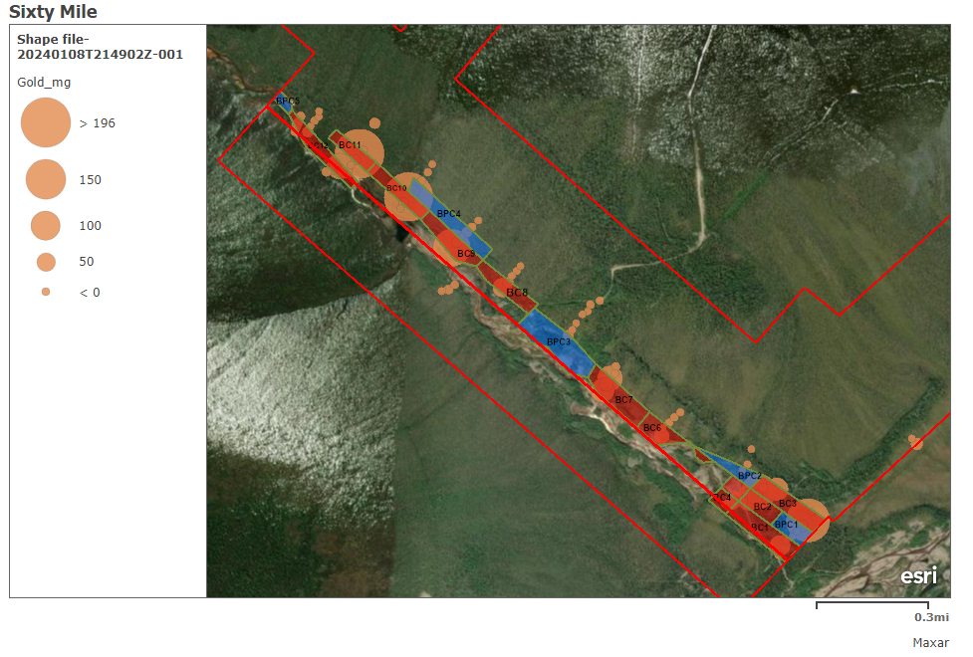
Figure 4. Mouth of Bedrock Creek where Bedrock Valley is joining Sixty-Mile Valley
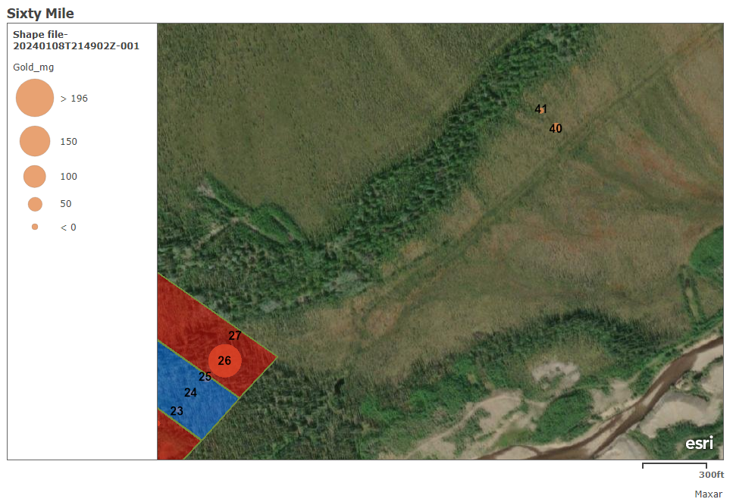
Figure 5. Downstream end of Bedrock Creek Valley
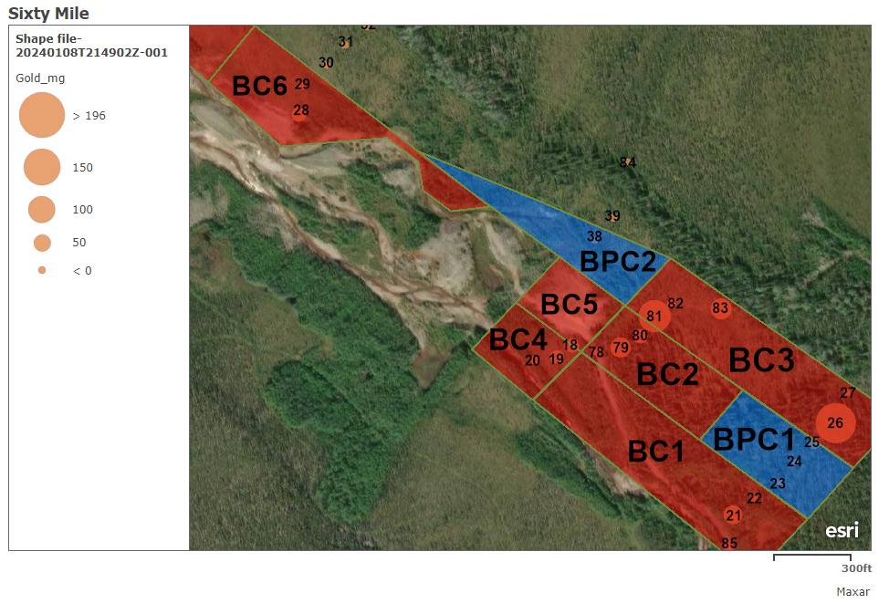
Figure 6. Middle Valley Bedrock Creek, including previously mined 1992 left limit (BPC3)
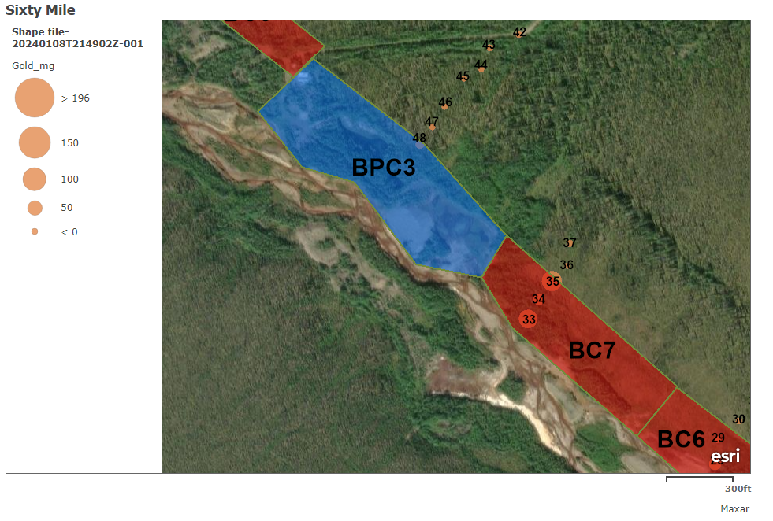
Figure 7. Mid Bedrock Creek Valley, Upstream of 1990s mining
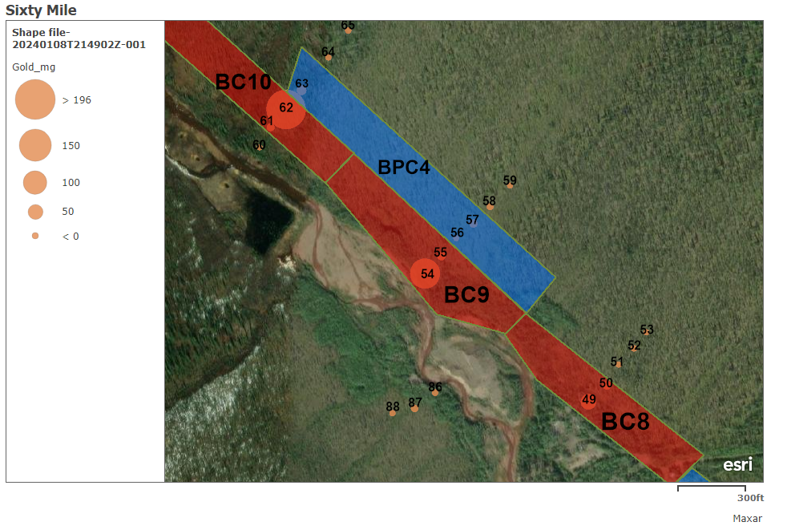
Figure 8. Top of our Bedrock Creek Property, Border is at the top end of BPC5
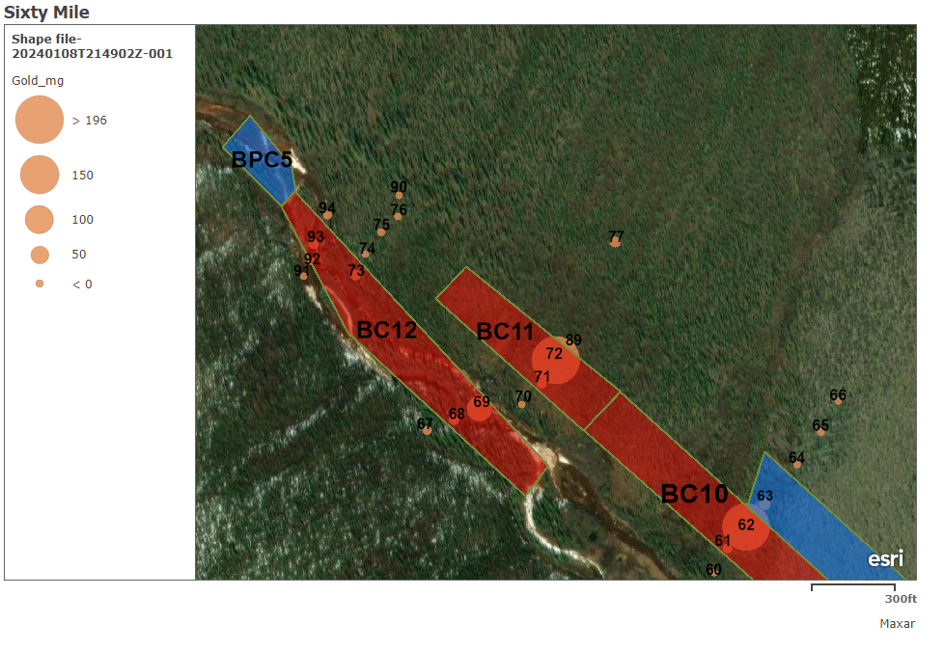
These polygons are our best estimate as to where the pay streak is. We mapped these polygons using the drill results recovered. The mapped cuts in red were chosen by including all drill holes that had a value above 30 mg, then included drill holes neighbouring those holes with a value of more than 10 mg. Where there was not a neighbouring drill hole value of 10 mg we made the border of the cut no less than 75 ft from a good drill hole (above 30 mg). The maximum size of a cut was set at 1,000 ft x 250 ft. We then took the drill holes included in the polygon as well as drill holes within 25 ft of the polygons width and within 250 ft either end of its length, and produced an average drill result.
In one instance on cut BC6 due to shallow ground and the evidence of a wide pay streak downstream, we included a section that did not meet this criteria. We also mapped BPC3 as one large cut measuring 400,000 sq ft but this is the area that had past mining and also where we recovered our good pans from test pits. Therefore we believe there is at least 200,000 sq ft of virgin left under waste/tailings piles and old service yard.
To calculate the grade per cut we take the (average drill result x 2.87) = mg per sq ft, then (mg per sq ft/31,104) = raw oz per sq ft, then (raw oz per sq ft x square footage of cut) = Total raw oz per cut.
The following is a spreadsheet indicating the expected value out of each cut (red and blue polygon)
Cut Name | Avg Drillhole | Mg per sq ft | Raw oz per sq ft | Cut Sq ft | Total raw oz
BC1 | 25 mg | 71.8 mg | 0.0023 | 250,000 | 577
BC2 | 37 mg | 106.2 mg | 0.0034 | 125,000 | 427
BC3 | 57 mg | 163.6 mg | 0.0053 | 250,000 | 1,325
BC4 | 27 mg | 76.5 mg | 0.0025 | 75,000 | 185
BC5 | 37 mg | 106.2 mg | 0.0034 | 75,000 | 255
BC6 | 24 mg | 68.9 mg | 0.0022 | 180,000 | 399
BC7 | 45 mg | 130.3 mg | 0.0042 | 250,000 | 1,047
BC8 | 35 mg | 100.4 mg | 0.0032 | 180,000 | 581
BC9 | 51 mg | 146.4 mg | 0.0047 | 210,000 | 988
BC10 | 73 mg | 209.0 mg | 0.0067 | 180,000 | 1,210
BC11 | 70 mg | 200.9 mg | 0.0065 | 125,000 | 813
BC12 | 23 mg | 66.0 mg | 0.0021 | 210,000 | 446
 |  | Bedrock Cuts Totals |  | 2,110,000 | 8,253 raw oz
BPC1 | 7 mg | 21 mg | 0.0006 | 125,000 | 75
BPC2 | 17 mg | 48.8 mg | 0.0016 | 150,000 | 240
BPC3 | 14 mg | 40.2 mg | 0.0013 | 200,000 | 260
BPC4 | 10 mg | 28.7 mg | 0.0009 | 250,000 | 231
BPC5 | 11 mg | 31.6 mg | 0.001 | 45,000 | 45
 |  | Bedrock Potential Cuts Totals |  | 770,000 | 851 raw oz
Conclusion
In conclusion we have mapped out and proven an area of 2,110,000 square feet worth mining (red polygons) and an additional area of 770,000 square feet that has potential and needs further bulk sampling (blue polygons). An additional 1,200,000 sq ft that from the surface looked conducive to placer mining was ruled out due to low economic values saving us time and money.
This drill program has also given us the confidence to enter and begin mining on this creek in a large scale and has proven there to be good gold grades in the area. Being able to enter this drainage with confidence will allow us to further our exploration of the Bedrock Creek Bench and Sixty-Mile left limit bench, while commencing mining in the Bedrock Valley bottom. We plan to begin stripping and preparation for mining on Bedrock Creek starting the fall of 2024.
Going into the future we plan on continuing our exploration of this property and during the 2024 season we are hoping to get an aerial drone survey and some ground sensing resistivity done to better define land features and future potential targets. After receiving and collecting this data we will begin planning our next Sonic Drill program which will be planned out to maximize efficiency by having two or three target areas picked ahead of time and using 6” sonic bits to allow for deeper drilling with quicker results.
In the end this drill program proved up approximately 8,253 raw oz of gold, at 84% pure will be 6,933 fine oz and will provide our mining operation (8–10 person crew) approximately three to four years of mining if values hold true. It has also laid the groundwork for us to continue exploration and potentially add additional years of mining to this mine plan.

