2023 Work Summary for YMEP #23-056
Prepared by Kane Morgan
Work commenced on YMEP #23-056 in April of 2023 and stopped at the end of February, 2024, with 3 days of report writing and 1 demobilizing in March 2024. The work was done by Kane Morgan and Jessi Birnie. Another man, Peter Greenland, helped for 3 days at the end of February. The start of the program involved tidying up from last seasons activities from YMEP #22-015, then processing sample dump piles from that season. The second stage was building an exploration trail across 8 claims to access the middle portion of the creek, shafting and assaying heavies for PGE’s and any other anomalies. The majority of the program was digging shafts with hand-tools, electric jackhammers, and steam-point from a wood boiler, for a total of 69ft over 4 shafts, one having a bedrock drift with a depth of 11ft. All shafts had length and width dimensions of 3ft x 3ft. Gravels encountered were sampled every 3ft or significant layer change before the 3ft mark. All samples were processed by gold panning, the average increment being 40L of volume, which is roughly 5% of a yard. At each shaft site there are larger, bulk sample dumps from which smaller values were panned, that are awaiting sluicing once spring thaw happens. A diagram was composed of the crosscut view of the valley stratigraphy and bedrock depths that the series of shafts over the past 2 years have revealed on claim Larry #3.
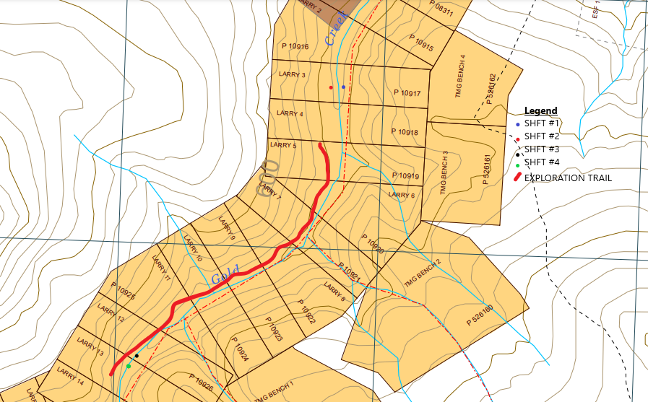

In April, 4 days were done to cover shafts from the previous season’s diggings, sample some bedrock from one shaft, secure and cover the sample dump piles for springtime thawing, and demobilize gear. The bedrock sampled from shaft SHFT #5-TMG23 yielded no gold. Only the top 1/2ft, below gravel, was sampled, volume 15L.
In May 2023 and June 1st, all the sample dump piles from last seasons YMEP #22-015, were sluiced and panned down. The gravel samples were separated in 3ft intervals as they were encountered digging down. Due to the previous years findings of a gold bearing upper gravel layer right under mud/gravel contact, 3ft intervals of gravels were sampled from the top to bedrock contact. The same method was repeated this season and there are several piles awaiting sluicing to acquire valid results, instead of panning a smaller value and formulating an estimated yard value from the gold recovered and volume processed, which is done in the meantime until conditions allow the samples to be sluiced for an accurate result.
The first piles to be sluiced were from SHFT #3-TMG23, with bedrock at 10ft deep, and just under 4ft of brown gravels from 6-10ft. At this location 26ft away there is a drill hole with a depth of 21ft that sampled 5ft of bedrock, but drilling was most likely inconclusive as far as a valid interpretation of the stratigraphy. There is either a drop in the bedrock that is closer to being under the creek, as there are two shafts on either side of the creek with the same depth of 10ft to bedrock, or the drillers interpretation of the material that they encountered was wrong. Drill hole TMG15-05 was drilled in 2015 by previous property owner Martin Knutson. Due to the result obtained by Martin in 2015, and the amount of bedrock he recorded taking in the drill log, it had to be confirmed whether or not the gold came from the gravels or went down into the bedrock. Only 6ft of bedrock was dug out of SHFT #3-TMG23, from 10-16ft, before becoming too hard and blocky to pursue by hand. Sample intervals were as follows; 6-8ft gravel, 9-10.5ft gravel with top 6 inches of bedrock, 10.5-13ft bedrock, and 14-16ft bedrock. Top gravels here had 15 fine colors in one yard from sample interval 6-8ft, then 0.33g of gold recovered from 2/3 of a yard from sample interval 9-10.5ft. All bedrock past 11ft had no gold recovered.
The next sample piles processed were from SHFT #5-TMG23, with a bedrock depth of 14.5-15ft and 5ft of brown gravels from 10-14.5ft. This shaft is located 25ft away on the left limit side of SHFT #3-TMG23. Two gravel intervals were sampled here, one from 10-12ft and another from 13-14.5ft. The top gravels sampled from 10-12ft, for 1 yard processed, yielded an estimated 100mg of gold. The second interval sampled from 13-14.5ft, for a volume of ½ a yard processed, there was 0.4g of gold recovered. No bedrock past 15ft was sampled here.
The last piles sluiced were from SHFT #4-TMG23, on the left limit side of the valley, located 650ft upstream from claim Larry #3 where the two previous sluicing location were. Sample intervals at this location were as follows; 17-19ft quartz/graphitic rock gravel with a brown sandy clast, green gravels from 21-25ft, a drift with a depth of 3ft running towards the creek on the right limit side of the valley, 1ft of green bedrock, and 1ft of green gravels from drifting towards the left limit side of the valley. Gold content was minor here but increased in both size and quantity when following the bedrock decline towards the creek. Bedrock might follow this trend and level out and gravel thickness and gold quantity would assumably increase towards the center and right limit of the valley. The 1.3 yards of green gravels yielded an estimated 50mg, then the drift running towards the right limit side of the valley where the creek is located yielded an estimated 90mg from 1 yard. A petrified mammoth tooth was recovered from this drift as well. The bedrock was beginning to drop significantly with large boulders appearing and the size of the gold flakes found was increasing. All other sample intervals had no gold. A measurement was taken to the adjacent hillside, 40ft to the right limit of the creek. This is assumed to be the edge of the channel, giving a width of approximately 125ft.
At the end of September, along with 2 days in October, activity was resumed to begin preparations for the upcoming winters prospecting activities. First a trail was built with chainsaw, pickaxe and shovel, from claim Larry #5, 0.8 of a mile upstream to the start of claim Larry #13. Then locations were scouted off of this trail and prepared for wintertime digging. In areas where the steepness of the hillside was too much to prevent machine rollover, the topside of the trail was dug out and folded on to the downhill side to create a more level trail. Sometimes cleared brush was interwoven in between the trees on the downhill side of the trail to act as a retaining wall for debris to build the trail up. Come snowfall that is sufficient for snowmobile use, the trail is packed by snow snowshoes and groomed with a snow shovel to fill in steep parts and holes.
Two shaft site locations were found, cleared and prospected, one on claim Larry #13 and another at the top end of Larry #12. On Larry #13 the site is located at UTM: zone 7, V 0611151, 7092627. The site on claim Larry #12 is located at UTM: zone 7, V 0611184, 7092658. They were determined to be good locations to pursue in the winter. On claim Larry #12, one shaft was started on the right limit creek bank and dug to a depth of 5ft, going 1.5ft into brown gravels. Four gold pans were taken here of the brown gravels. Two larger fines and 2 fine pieces of gold were recovered, along with magnetite nuggets up to 1 inch wide and large garnets. Given that the gravel would be considered top material, there were several good indicators here to pursue activity. Water from the creek started to come into the hole, so it was left until winter temperatures can freeze it off to continue depth. The second hole was dug on the right limit creek bank, 150ft upstream from the shaft started on Larry #12. While working here a cabin from the gold rush era was found up on the left limit hillside. This shaft was dug down to 6ft, with 2ft into brown gravels. There was the beginning of an interlocked boulder layer 2ft below gravel/mud contact, from which 3 gold pans were taken. They yielded 1 gold color and large magnetite nuggets up to 1 inch wide, along with large garnets up to 1cm in width. Water from the creek came in here as well, so the hole was left to freeze of for wintertime digging.
On October 6th, the two shafts that had good gold results on claim Larry #3, SHFT #5-TMG23 and SHFT #3-TMG23, were pumped out to allow freezing of the walls to potentially resume some diggings on, such as drifting or taking a bedrock sample from SHFT #5-TMG23. Two more shafts were started here on claim Larry #3 to allow the groundwater and top thawed material above permafrost to freeze off. One was against the right limit hillside, across the creek and the other on the left limit hillside, 25ft away from SHFT #5-TMG23. These two new shafts are running perpendicular to the creek, in line with shafts; SHFT #5-TMG23 and SHFT #3-TMG23, to create a cross cut of the valley bedrock and gravels. What gear that wasn’t useable in wintertime was demobilized at this time, such as the ATV and trailer.
A conversation in October with a local miner, Alex Sealy revealed some very interesting information. He had stated that his father was an antique dealer who did business in the Dawson City area and had a family mail him an old dairy that they had found of a past family member who had hand mined on Too Much Gold creek in the 70s or 80s. He had said the man had kept mail correspondence with his family during this time and wrote in the dairy as well. Some of the main points were that he had to hike up around 2 miles from the mouth, he was able to make enough to survive while also stockpiling gold, he was working by hand, and he made enough after so many years to return home to do something with the gold money that he had been saving up for. The miner also made reference to ‘Gold Rush’ like finds. In the authors opinion he must have been finding half ounce a yard material or better then. This information was confirmed by finding the man’s cabin with items that were from the late 1970’s and early 1980’s, such as metal Chevron fuel and oil pails, food cans with labels intact, fine liquor glass bottles and plastic remnants. It is located on claim TMG #1, close to the mouth of the main fork on Too Much Gold Creek.
In November the shaft started on the right limit of claim Larry #3 was continued. SHFT#1-TMG24 is located at UTM: zone 7, V 0611844, 7093609. Bedrock was encountered at 10ft deep with 4ft of gravels on top. These gravels were a tightly interlocked assembly of large boulders from under mud/gravel contact all the way down to a green mafic bedrock, some serpentinization. A 40L sample of gravels and 20L of bedrock were taken. The gravels yielded one color of gold and there was almost no magnetite or garnets in the heavies concentration, in comparison to the other shaft samples. More material was also processed at a later date, from the dump pile of gravel and no gold was recovered.
The second shaft, SHFT#2-TMG24, dug on the left limit of claim Larry #3, was continued down to bedrock, from mid-November to December 8th. It is located at UTM: zone 7, V 0611820, 7093605. Bedrock was struck at 17ft deep, with brown gravels overlying, starting at 10ft deep and 7ft in thickness. An old windlass frame from last seasons work was moved over 50ft to this new site and reused instead of cutting more timbers required to construct a new frame. Gravels were sampled in the amounts of 10, 20 and 40L as depth was pursued, these samples were panned down to see where the gold began. The first gravel depth interval to contain gold was from 3-4ft below mud/gravel contact. From 10L sampled from the 3-4ft interval, a significant amount of heavies were collected, along with 1 fine gold color and 1 finer piece. The next interval sampled from 5-6ft, in the amount of 20L and processed to recover gold in the amount of 2 colors, 2 smaller colors, and 6 fines. The magnetite content also increased dramatically and the most hematite found yet was recovered from any sample. The last interval sampled at this time were gravels from 7ft, and the top 1/2ft of bedrock, in the amount of 20L; 5L of gravel and 15L of bedrock. Gold was recovered in the amount of 3 colors and 9 fines.
Work on Too Much Gold creek resumed December 19th, by setting up a wall-tent camp and finishing packing down the trail so that it could be used to haul the generator and digging equipment up to claims Larry #12 and #13. Towards the end of the month and until January 28th, digging resumed on the shafts on these 2 claims that were started in the fall time. Gear had to leap frogged back and forth, 150ft between sites, as thawed materials that were encountered were left to freeze off to prevent water coming in. When one hole would become wet, we would move to the opposing hole that would be frozen off by then. The shaft on Larry #12, SHFT#3-TMG24, had to be abandoned after getting 5ft into gravels, where a water leak came in that couldn’t be frozen off. The top gravels here had gold appearing a few feet in and the largest magnetite chunks found yet on TMG, up to 2 inches wide. A total of 40L was sampled from 3-4ft into gravels, with gold recovered in the form of 4 small colors and 3 fines.
Upstream on claim Larry #13 the second shaft, SHFT#4-TMG24, was continued down to bedrock/ gravel contact at 13.5ft. Gravels were 9ft thick, brown in appearance, and tightly interlocked large boulders for all 9ft. Some of the boulders were over 2ft wide and had to broken into smaller pieces to be removed. This gravel had the most boulders encountered so far on TMG. Depth was pursued into bedrock down to 17ft where a water table was encountered. At this point diggings were halted and moved back downstream to claim Larry #3. Sampling of the gravels indicated some gold appearing from 9 to 11ft but couldn’t find anymore afterwards. In total 70L of material was processed, 30L of that being bedrock and the remaining 40L being gravels. Two small gold colors were recovered and when viewed under a magnifying lens they appear to have course, sharp edges and black staining in the crevices on the surface. Bedrock was struck at 14ft. It was an extremely hard, blue/grey igneous rock with veins and speckles of magnetite throughout that were eroded into angular chunks mixed in with the local gravels. There was also quartz veining within the bedrock up to 3” wide. From 12ft to 15ft the clast became mixed with a sticky dense clay.
On January 29^{th,} activity resumed on claim Larry #3 on SHFT#2-TMG24. Based on the bedrock decline trending towards a low point on the left limit side of the valley, a drift was decided to be dug on the 17ft to bedrock shaft to see if the bedrock drops off or rose with the hillside on surface. First 3.5ft of bedrock was dug out for a total of 4ft taken out, creating a sump for material to fall into while setting the drift. Bedrock was a green mafic rock with biotite throughout, some serpentinization. It hardened up significantly at 4ft. There appeared to be talc or calcite bodies or a similar rock within the bedrock as well. Then a drift was established on the left limit wall of the shaft, running perpendicular to the creek valley. We set up a home-made wood fired boiler and steam-point to thaw the material prior to digging horizontal along bedrock. The was the first time incorporating steam into my shafting operation. It allowed for more footage to be achieved. By the end of the program the drift was dug in a depth of 11.5ft. Sample intervals were every 4ft running in over the total depth, 0-4ft, 5-8ft, and 9-11.5ft. The material encountered was the same brown gravel as the other 3 shafts to the right limit of this hole, but the quartz content was increasing in both the bedrock and the gravels as the bedrock dropped to the left limit of the valley.
A chip sample running the length of 4ft in (0-4) from the start of the drift, was collected out of the drift wall, on the downstream side. The volume and material were 20L of 1ft gravels and 6” of top bedrock that meets the gravel. Only 1 fine color of gold was recovered from this sample, along with a large magnetite nugget almost 2” wide. The next sample of 5-8ft in was collected from a chip sample, this time running on the floor of the drift, following the a more pronounced decline starting in the bedrock. The material collected was a mix of bedrock and gravels, a few inches below the visible, distinguishable contact of bedrock and gravels. The same volume of 20L was collected of this described material. Gold recovered was in the amount of 1 small nugget, weighing 0.11g, 2 colors, and 5 fines. If this value is consistent to the volume, this section of material could be up to 4.4g of gold per yard. The last sample was 80L of various material collected in columns from 9-11.5ft into the drift. The bedrock started to drop significantly here from 8ft in and then from 9ft in, to the end at 11.5ft, the bedrock drops almost 3ft over 4ft. Gold recovered was in the amount of 1 course color, 1 large color, 4 colors, 2 fines, and 1 ultrafine. The majority of the gold was on the edge of the slope before it became steeper. Almost no gold was found past 10ft in, as the bedrock drop dramatically from here to the end. It appeared to keep going, but no further depth was dug to explore that possibility. This was the last of the prospecting activity on the claims for YMEP #23-056.
This YMEP grant yielded several results and new findings that can be used to guide the mining that will start in summer of 2024. The various information accumulated from this program, from the gold found, to the conversation with Alex Sealy, give some new possibilities for future exploration targets. A water licence and land use permit were approved at the end of September 2023 (PM23-014) for a period of ten years on Too Much Gold Creek. The values found last year, along with the consistent values discovered through gold panning this season, have revealed a wider and richer channel then previously thought. The drift dug towards the left limit of claim Larry #3 starts to show what appears to be potential paystreak with the nugget that was panned on the edge of a steep bedrock decline. The next stage of events would involve sluicing the dump piles with a high banker style sluice-box and shovel on claims Larry #3, #12, and #13, to acquire accurate gold to yard values throughout the various separate layers. After documenting the gold findings in these dump piles, the gold found could be combined with the previous exploration seasons discoveries to have a 2-gram button smelted to acquire the gold purity percentage. The gold found on TMG creek does appear to be far brighter than most gold found in the Klondike area. This particular information has been lost in time since the last period when TMG was producing, was during the Klondike Gold Rush. The gold purity percentage would prove to be useful for economic calculations, along with being essential information added to the placer data for TMG.
The bench claims should be explored on foot and hand-tools to find, if any signs of placer deposits located on the right limit hillside and if found, followed up on with pits dug by an excavator. The gold and large amount of heavies in the top gravels of claims Larry #12 and #13 is of interest. It has to be confirmed whether or not this is coming off the right limit bench or from richer gravels located further upstream that have washed down over time and events, or even a combination of both possibilities. The exploration trail going up the left limit of TMG should be completed from its current end on Larry #13, to claim TMG #4, located 1.1 miles upstream. This would allow quick foot access in the summertime and snowmobile access for wintertime shafting. The other important reason for this, is it allows access to explore the area where the more modern camp was found (1970’s-80’s), that coincides with the information that Alex Sealy provided in October 2023, regarding values that were rich enough to work by hand and make a substantial profit. Exploration should now be primarily focused in this area at the forks, running up to the top end of the creek.
The magnetic (ST032555) and non-magnetic (ST032554) heavies materials sent away for assay by ALS laboratories didn’t reveal any anomalies, but it did show trace amounts of certain rare earth elements within the magnetic heavies, being in order of largest ratio by ppm, to smallest; Ru (0.05), Ir (0.035), Pt (0.03), Os (0.02), and Rh (0.008). From 0.63kg of non-magnetic material only 0.02kg was assayed and from 0.41kg of magnetic material the same amount of 0.02kg was assayed as well. If another round of assays is to be done the different types and amount of magnetic material should be more organized and downsized, as there were several kinds of magnetic materials, some clearly something different then magnetite and some of the magnetite having a blue metallic lustre to it, not just a metallic black. The magnetite itself should have an iron ore assay done on it to figure out its general composition. Given the amount of magnetite and magnetics found from sampling the gravels by hand, there will be an abundance as a secondary product from gold mining with heavy machinery and it should be known whether or not it has any more value than just an iron ore.

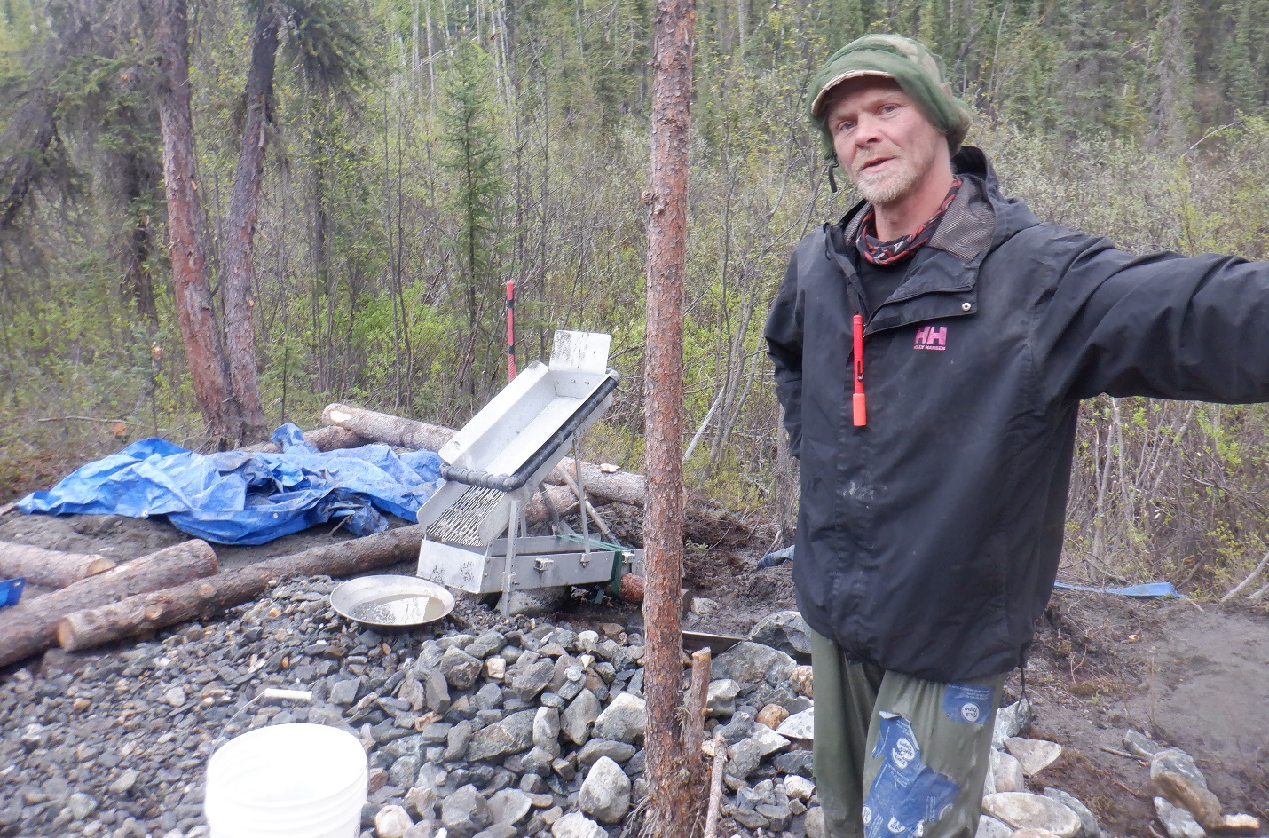(Above: Jessi Birnie at SHFT#4-TMG23, sluicing piles.)

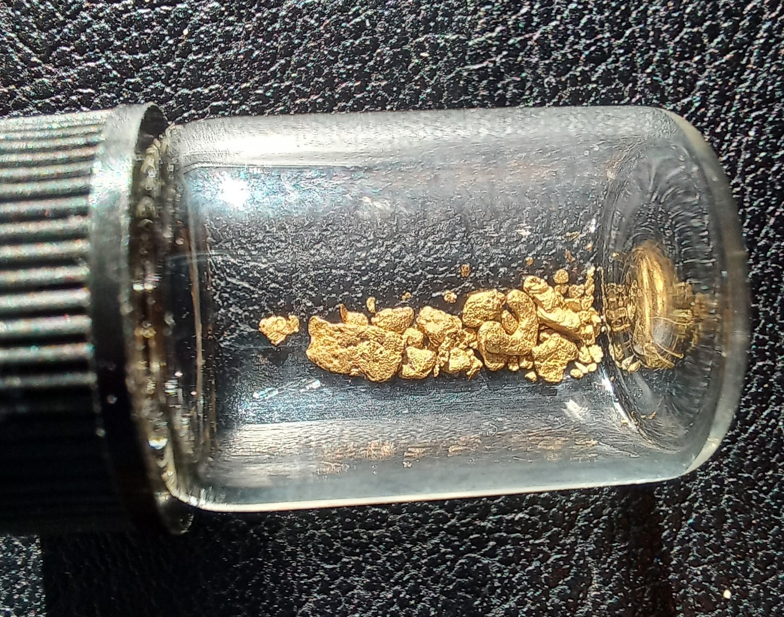(Above: Result from SHFT#3-TMG23, 0.33g/0.6y.)

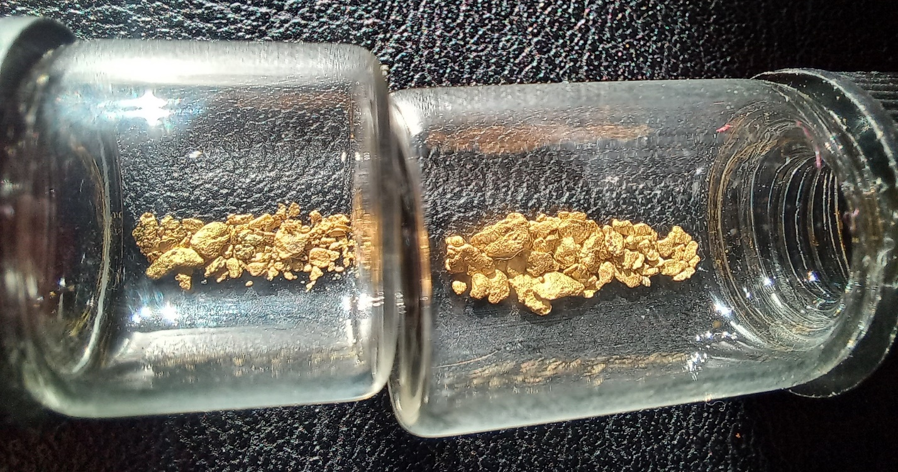
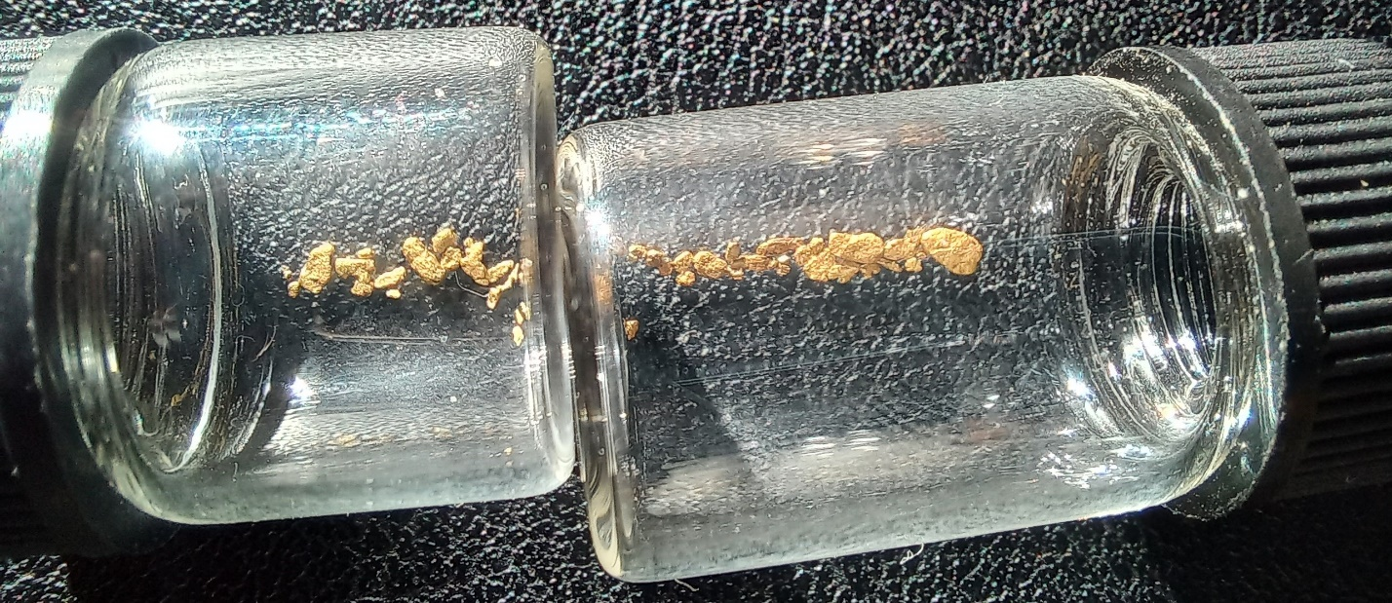
(Above: Results from SHFT#5-TMG23, 0.4g/0.5y in large vial and small vial est. 100mg from 1 yard of top gravels, in a 3ft x 3ft column, starting at mud contact going down to 1ft above bedrock. Second photo is of left limit channel edge on Larry #5. Shows edge of channel contains gold and gold size and quantity was increasing with bedrock decline towards the right limit.)

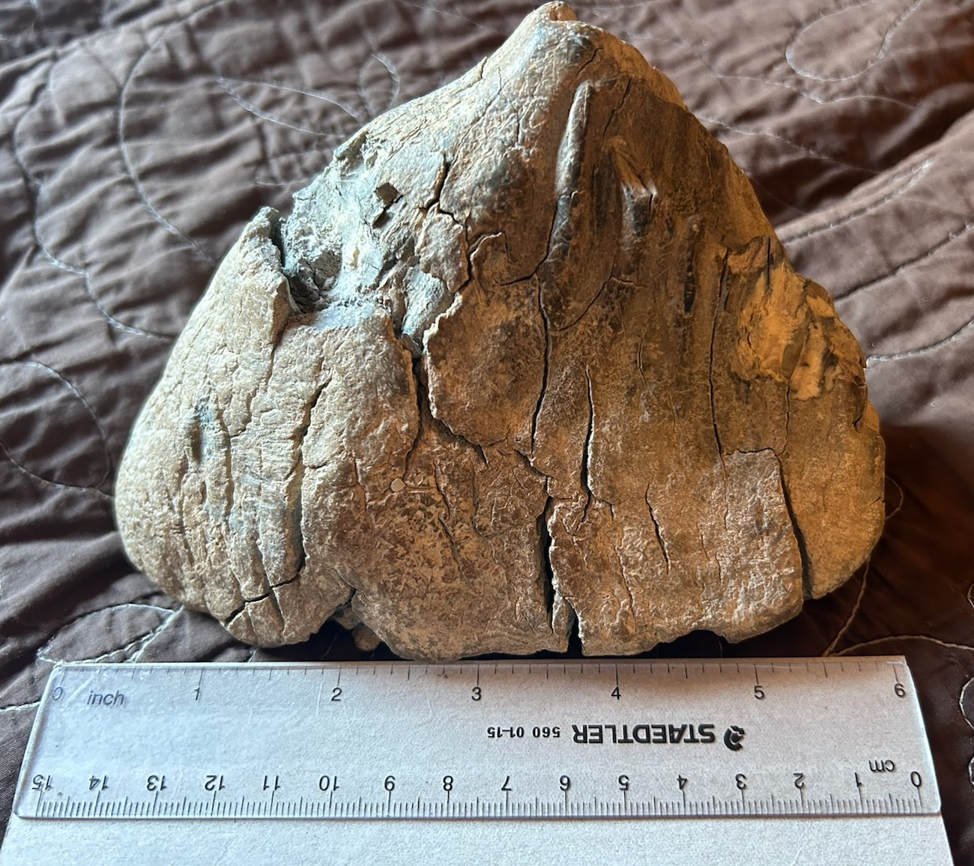(Above: Mammoth tooth found on Larry #5.)

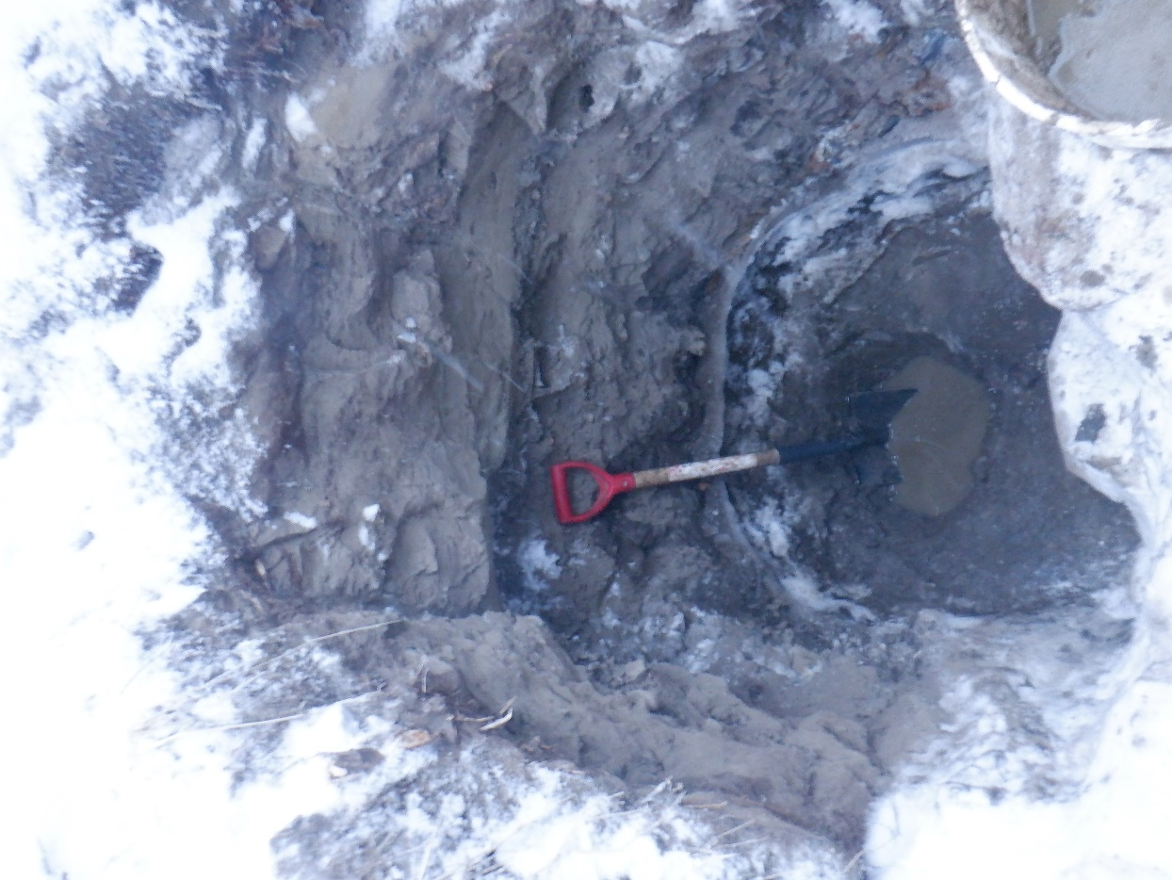 (Above: Shaft on claim Larry #12 that was flooded out, photo is of hole after bailing to acquire a sample.)
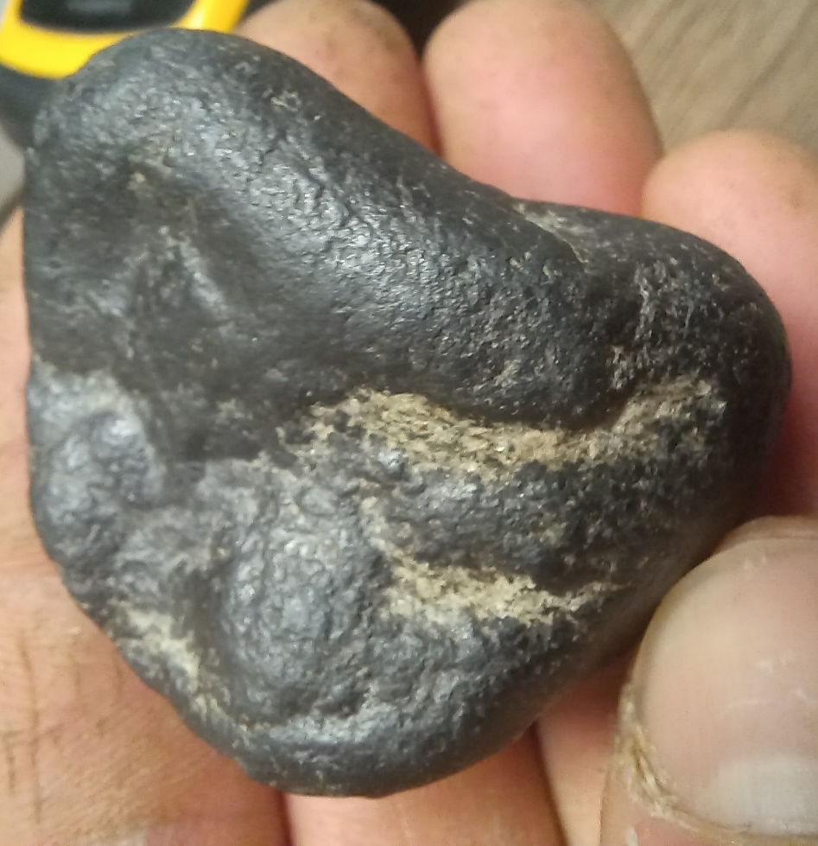
(Above: Magnetite nugget found in upper gravels on Larry #12.)
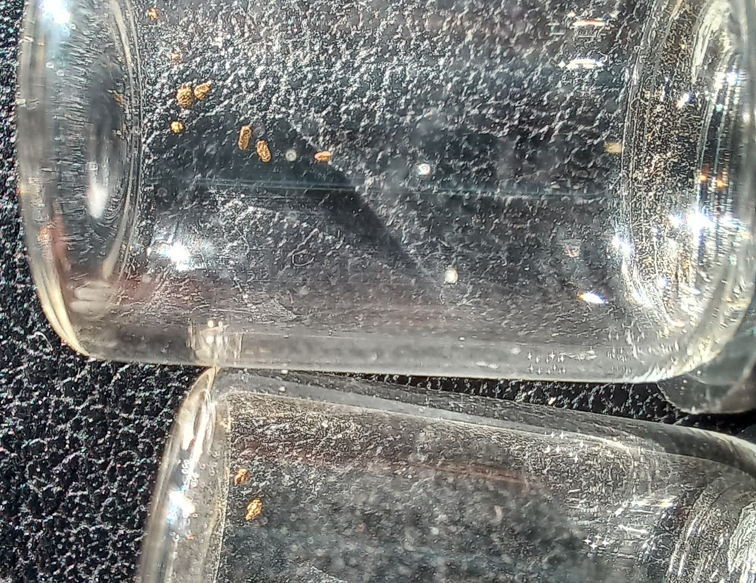(Above: Top vial, gold from 40L of top gravels from shaft on Larry #12, bottom vial is gold from Larry #13.)

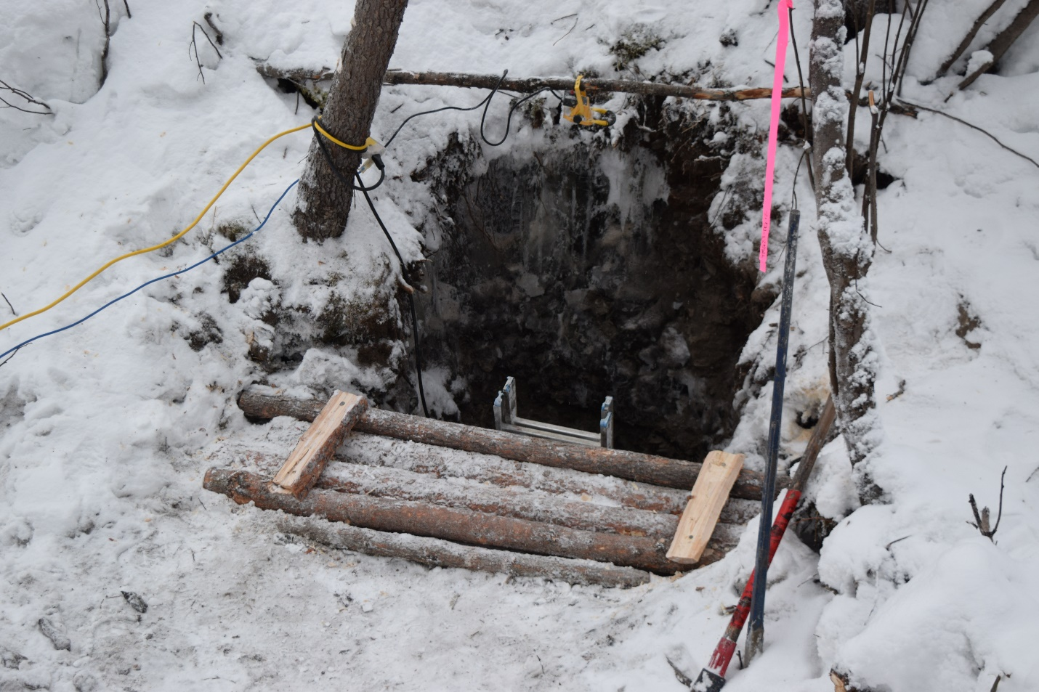
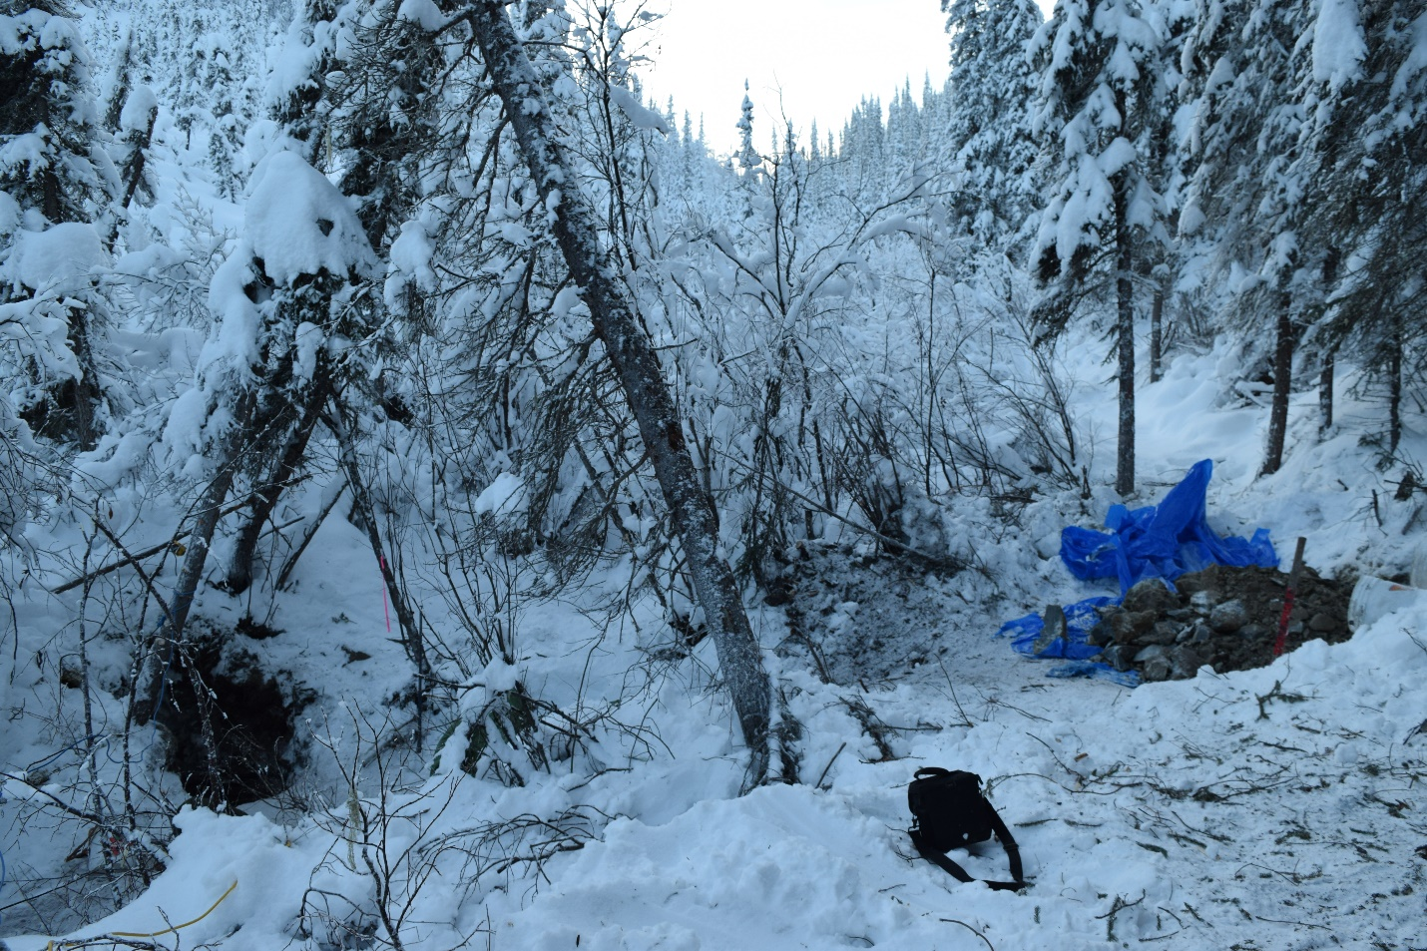
(Above: Shaft and sample dumps on claim Larry #13, looking upstream.)
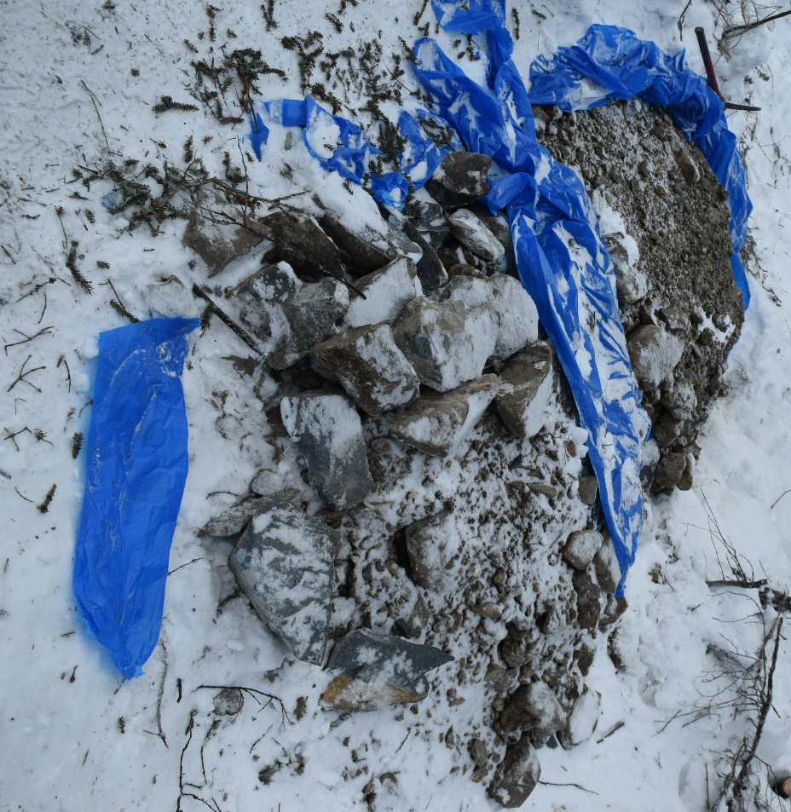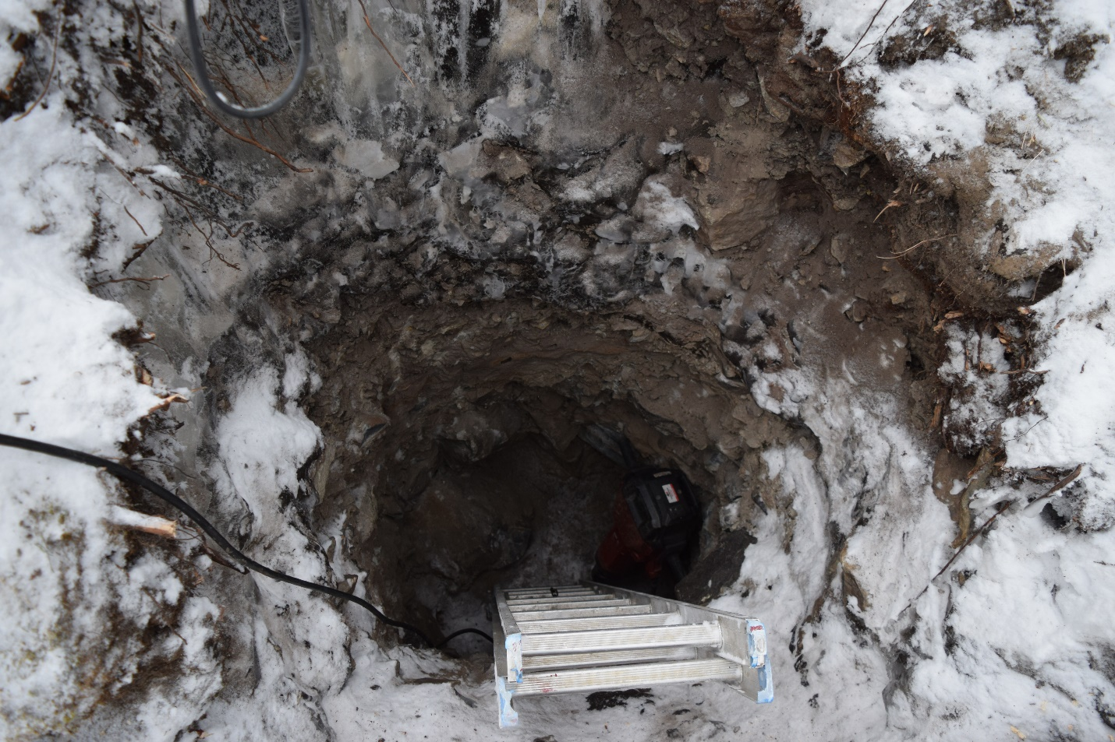
(Above: Sample dumps and shaft on Larry #13, showing large boulders.)
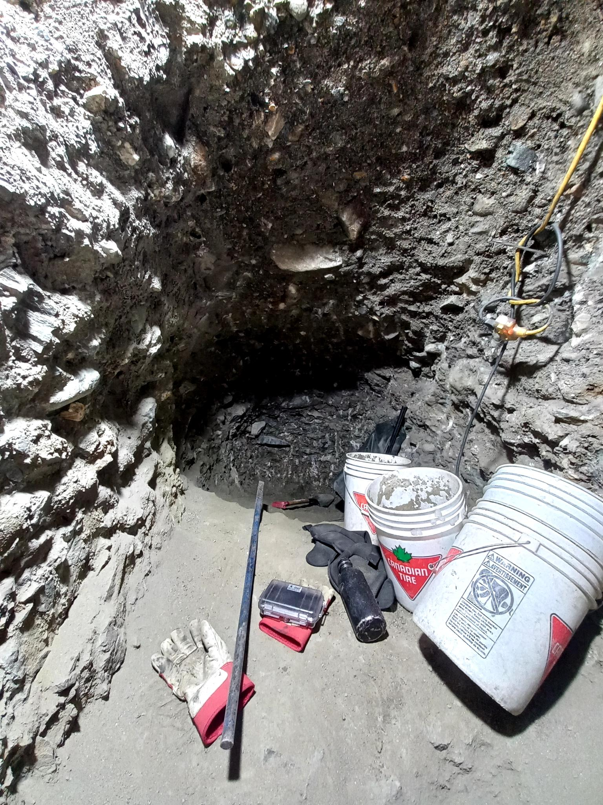(Above: Drift on SHFT#2-TMG24. Below: Top area on SHFT#2-TMG24 and bedrock decline.)
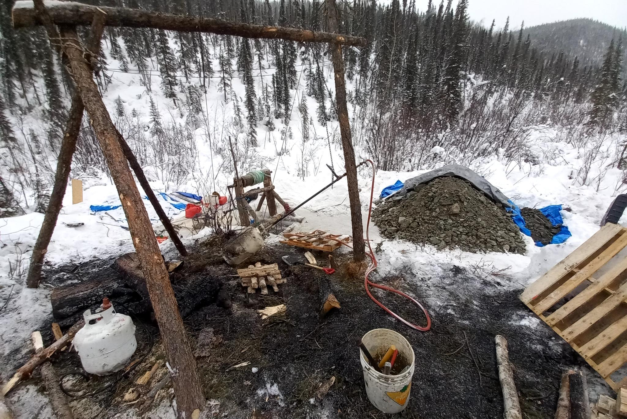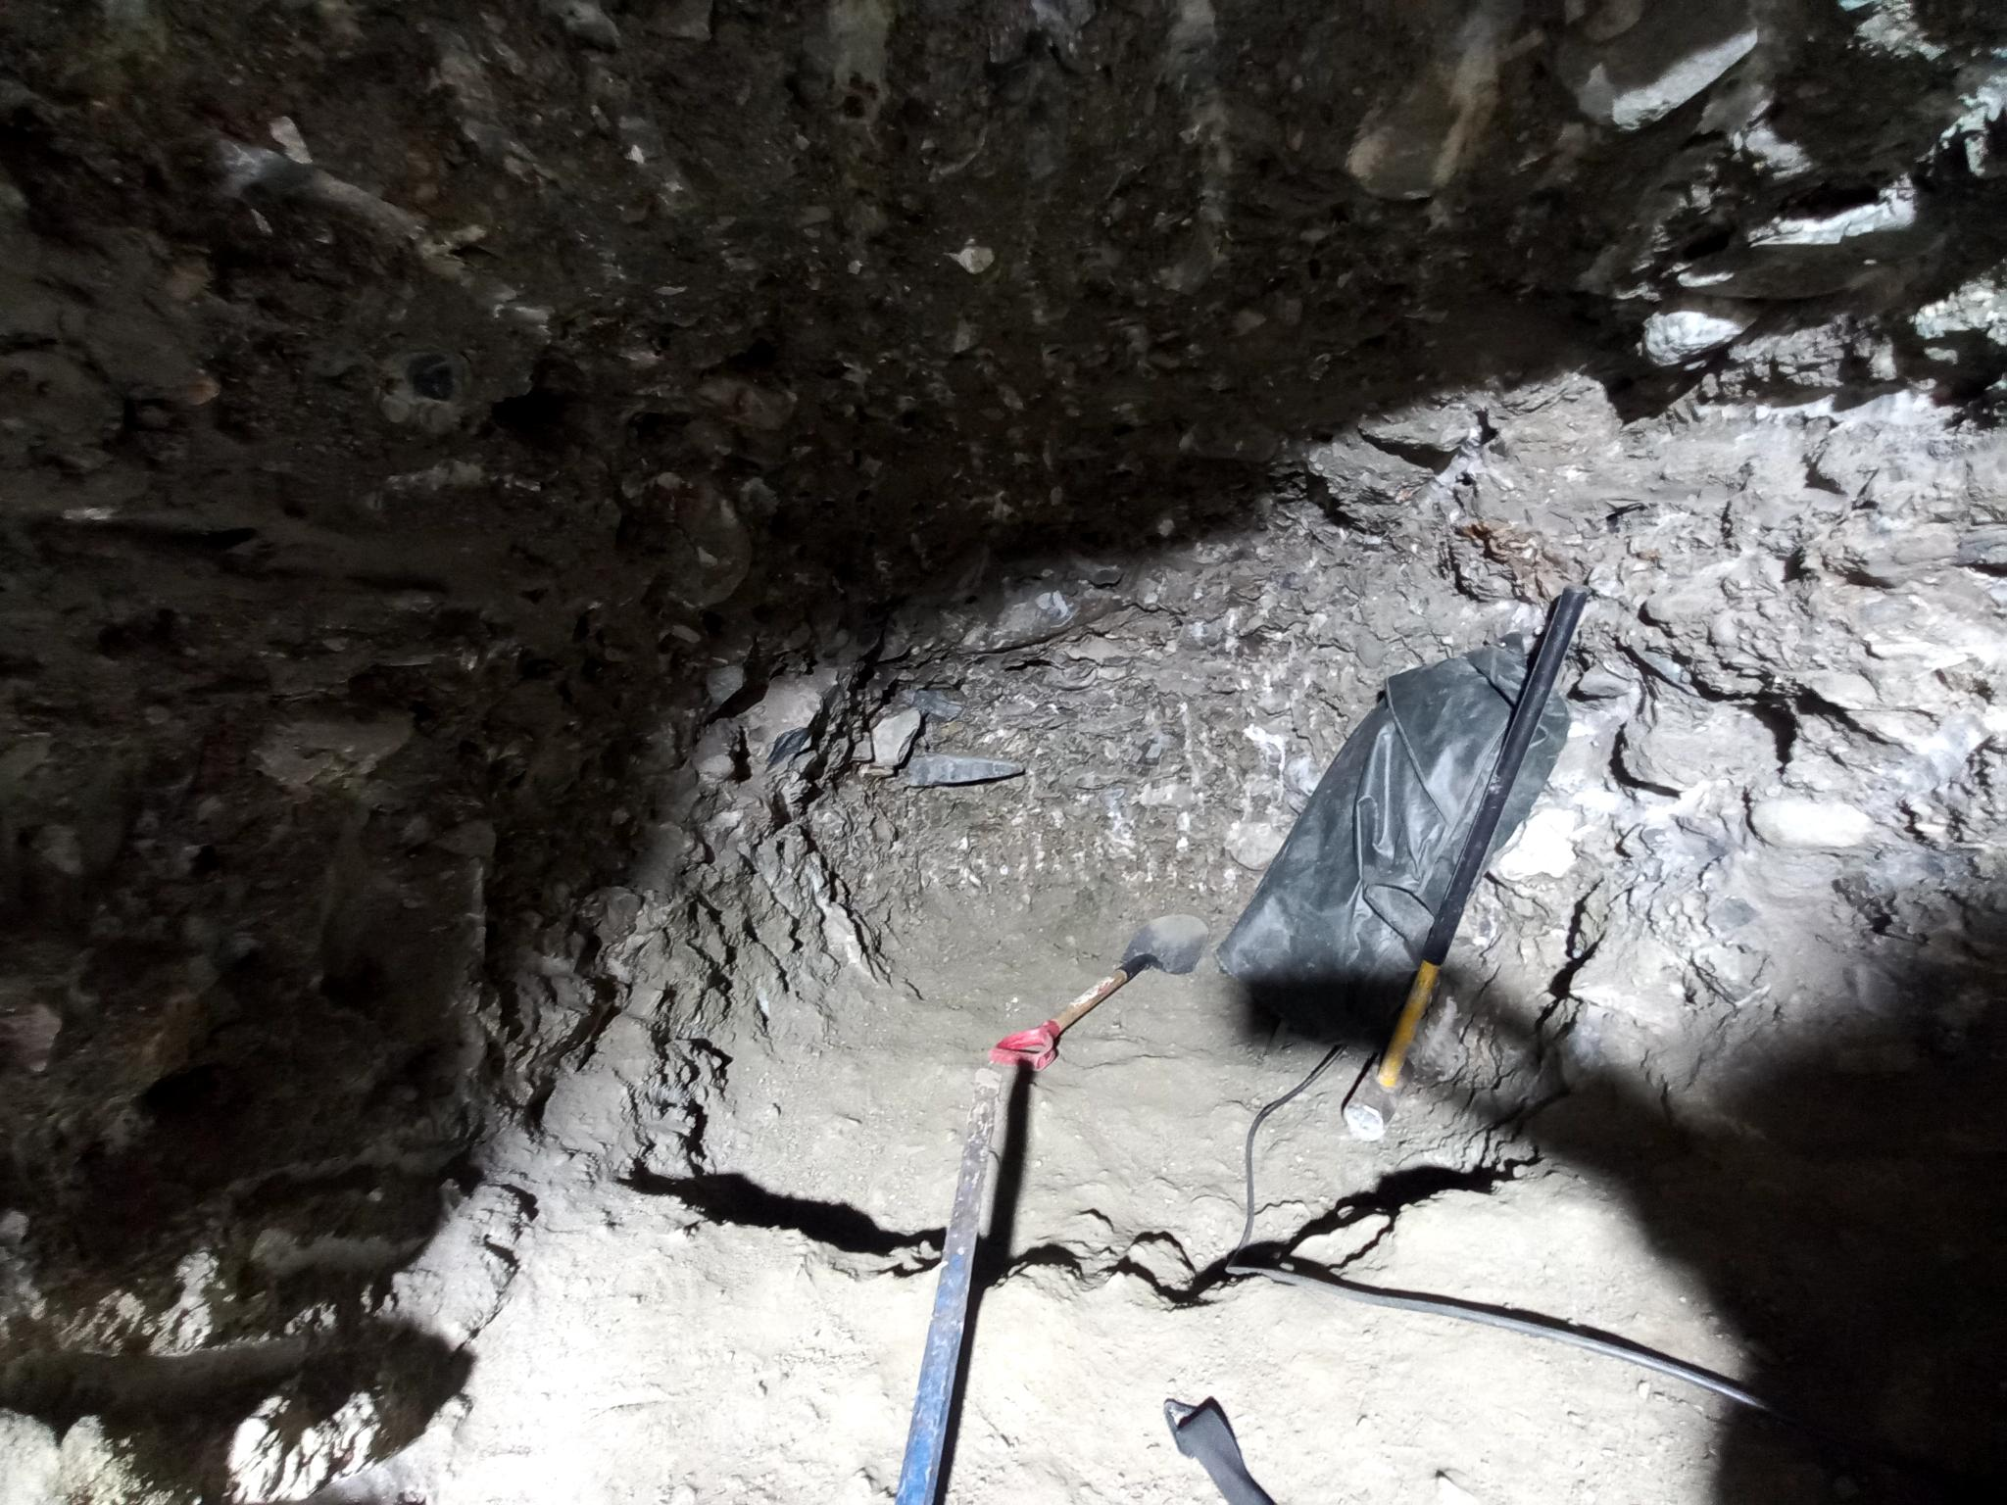
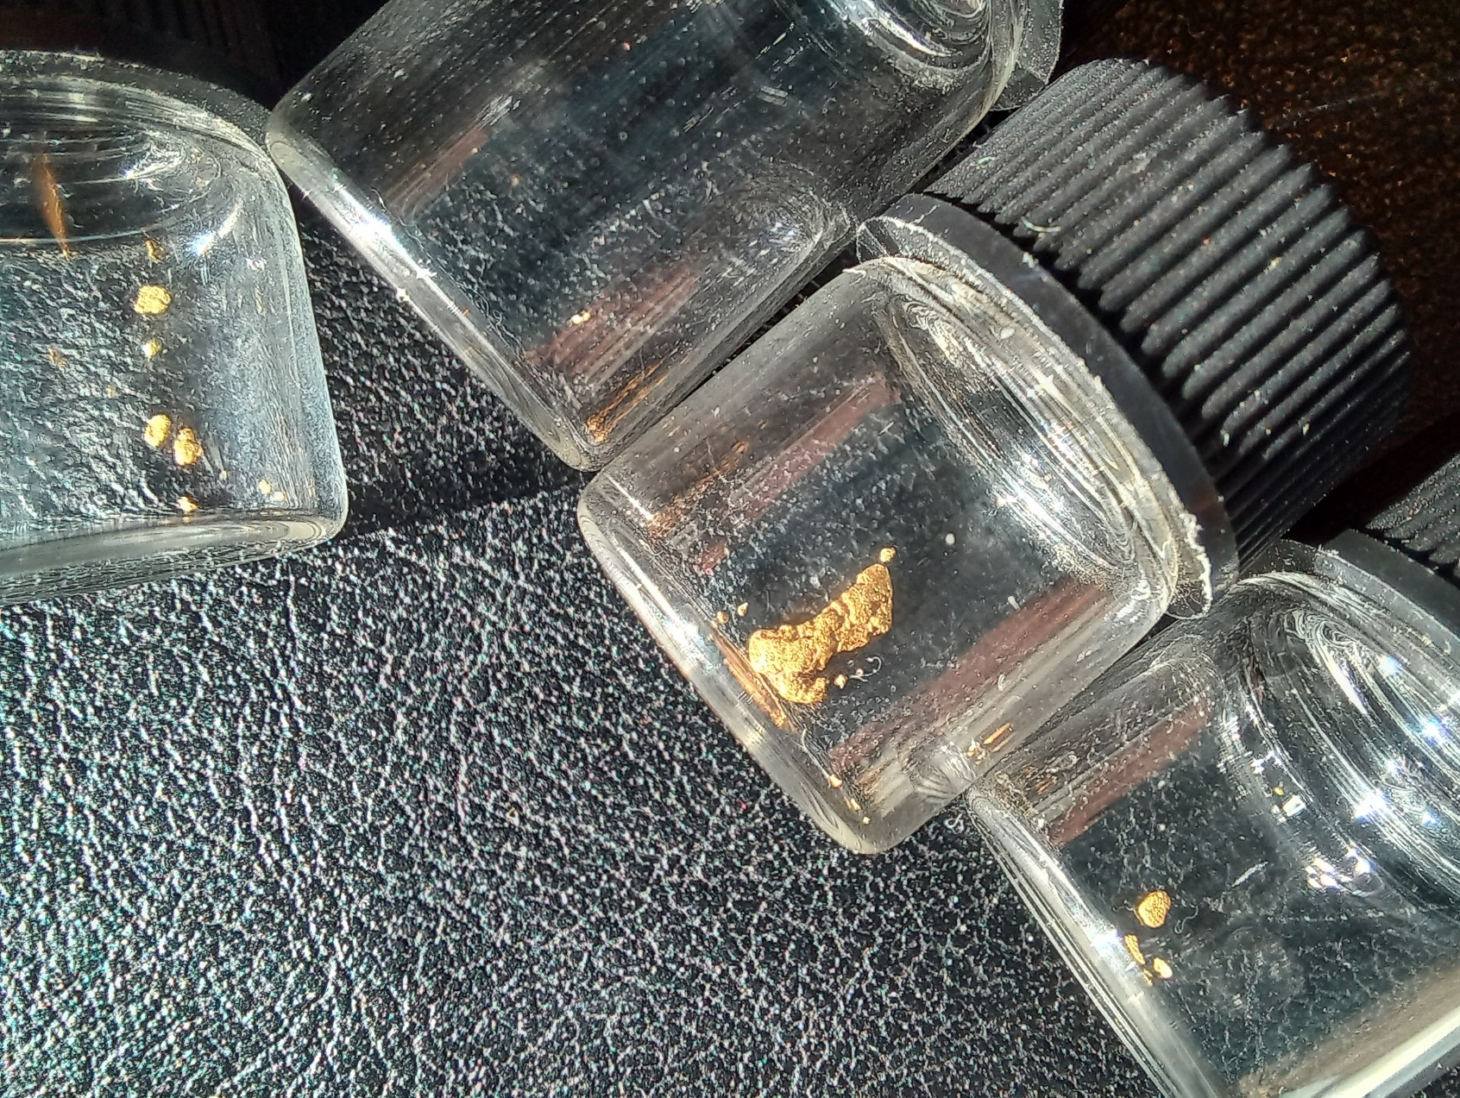
(Above: Gold results from SHFT#4-TMG24. Top vial is column of gravels in the main shaft, and then running down to bottom left corner, gold found from the 3 sample intervals in the drift. (0-11.5ft, split into 0-4ft, 5-8ft, & 9-11.5ft) Below: Kane Morgan in the drift, assay certificate from 2 heavies concentration samples; magnetic heavies and non-magnetic, and a diagram showing the paygrades encountered, along with absolute (shafts) and assumed (drillholes) bedrock depths and trends.)
