GEOPHYSICAL REPORT
GROUND MAGNETIC SURVEY

Field Report - Basic data Processing

Bob and Nug Project
YT, Canada

NTS: 115O/11

Work Performed On: April. 9-12, 2021

FOR:
Bernie Kreft

Report# BK-BNG-GMAG21- Rev. 01

Prepared By:
GroundTruth Exploration Inc.
BOX 70, Dawson City, YT

Author: Amir H. Radjaee, Ph.D., P.Geo

April 20, 2021

Table of Contents
1.0 Introduction 2
2.0 Purpose and Scope 2
3.0 Survey Description 2
4.0 Survey Theory 3
5.0 Results and recommendations 4
6.0 Deliverables 5

List of Figures
Figure 1: Location map of ground magnetic survey 2021 on the Bob and Nug areas. 3
Figure 2: Earth’s magnetic field, declination (D) and inclination angles 4
Figure 3: Total Magnetic Intensity RTP from ground magnetic survey 2021. 6
Figure 4: Total Magnetic Intensity 1VD from ground magnetic survey 2021. 7
Figure 5: Total Magnetic Intensity Tilt Derivative from ground magnetic survey 2021. 8

List of Tables
Table 1: Kreft 2021 ground mag survey grids. 3

Introduction
This report describes data acquisition and preliminary data processing results of the 2021 ground magnetic survey. GroundTruth Exploration was commissioned by Bernie Kreft to conduct the survey and process the data.
Between April 9-12, 2021, ground magnetic surveys were completed over the Bob and Nug claim areas located in the Yukon Territory. This survey is a part of a comprehensive survey completed in order to target future exploration on the property.

Purpose and Scope
The primary purpose of completing ground magnetic geophysical surveys is to determine the spatial distribution of subsurface magnetic properties of rocks. This, in turn, will allow the characterization of geophysical signatures for zones of mineralization and support geological models and structural mapping.

Survey Description
Data were acquired using two GEM-19 portable VLF systems supplemented by a high-sensitivity Overhauser magnetometer. The Overhauser magnetometers have the advantages of low power consumption (lighter or longer lifetime battery), faster sampling as the electron-proton coupling can happen even as measurements are being taken. The magnetometer has an absolute accuracy of about +/- 0.01nT. Along with basic GPS tracking, GEM provides a navigation feature with the real-time coordinate transformation to UTM and the local grid. Operators can define a complete survey on PC and download points to the magnetometer via RS-232 serial port. During the survey, a GEM-19 magnetometer was set up as the base station to collect data for correction and removing of unwanted noise arising from solar and atmospheric activity.
Total coverage of the survey block amounted to 61.1 line-km in two individual grids. The survey lines are in azimuthal directions of S-N (N0E) for all grids. Table-1 presents survey parameters and total line-km for separate grids. The outline of survey areas and layout of lines is shown in Figure-1.

Table 1: Kreft 2021 ground mag survey grids.
Grid name | Line spacing (m) | Line Azimuth | Line index | Total surveyed line-km | # of Lines | # of Tie-lines
Grid-1 | 25 | S-N (N000E) | 1000-2200 | 46.89 | 49 | 1
Grid-2 | 25 | S-N (N000E) | 1000-1600 | 14.18 | 25 | 1

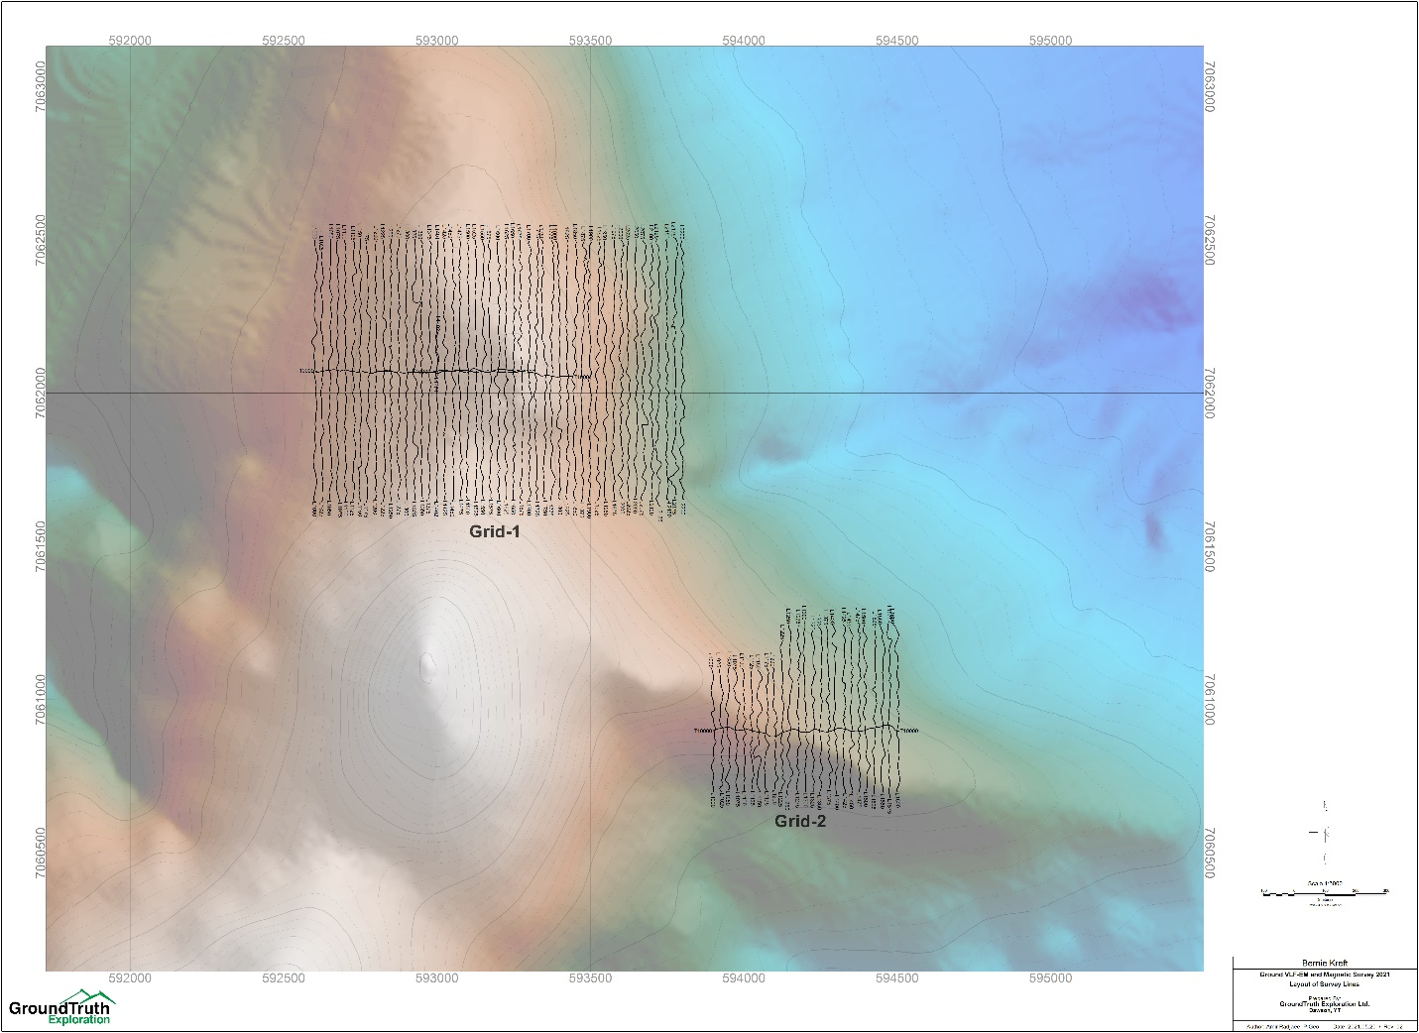
Figure 1: Location map of ground magnetic survey 2021 on the Bob and Nug claim areas, YT.

Survey Theory
  - Magnetic surveys
Magnetics is the most commonly used geophysical method for gold, diamond, platinum group metals and base metal exploration. Measurements of the magnetic field contain information about subsurface variations in magnetic susceptibility. Data can be acquired in the air (planes, satellites), on the ground (stationary, moving platforms, marine) and underground (boreholes, tunnels). The measurements record the sum of Earth’s field and fields induced in magnetic materials. More magnetic (i.e. susceptible) materials have stronger induced fields. Removing Earth’s field from the observations yields anomalous fields that can be interpreted in terms of where magnetic material lies and also its susceptibility and shape. Processed data are presented as maps or profiles, and advanced processing, involving inversion, yields parametric structures or 3D models of the subsurface susceptibility distribution.
Magnetic surveying is extremely versatile and can be applied in many areas in the geosciences including geologic mapping and mineral exploration. In gold exploration, magnetics helps in direct detection of associated mineralization and for mapping large- and local-scale structure (faults, dikes, and shear zones).
To a first approximation, the Earth’s magnetic field resembles a large dipolar source with a negative pole in the northern hemisphere and a positive pole in the southern hemisphere. The dipole is offset from the center of the earth and is also tilted. The north magnetic pole at the surface of the earth is approximately at Melville Island, Nunavut. The field at any location on the Earth is generally described in terms described of magnitude |B|, declination D and inclination I as illustrated in Figure 3.
When the magnetic source field is applied to earth materials it causes the material to become magnetized. Magnetization is dipole moment per unit volume. This is a vector quantity because a dipole has a strength and a direction. Because Earth's field is different at different locations on the earth, then the same object gets magnetized differently depending on where it is situated. As a consequence, magnetic data from a steel drum buried at the north pole will be very different from that from a drum buried at the equator.
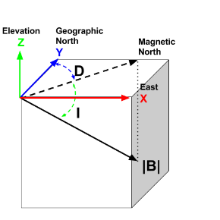
Figure 2: Earth’s magnetic field, declination (D) and inclination angles (2018, GeoSci Developers).

Results and recommendations
The total magnetic intensity map and derivatives are presented in Figures 3-5. The combination of geophysical models and geological information allows some general correlations to be made. The objective of the magnetic survey is to attempt to measure concentrations of magnetite.
The data can be processed in advanced levels using 3D inversion codes for mag data to create susceptibility model for detail analysis and visualization. This will ensure that 3D geological models respect a consistent structural, stratigraphic, and topological framework in addition to ensuring consistency between different geophysical models.

Deliverables
Report in pdf format
Ground magnetic survey 2021; Field Report - Basic data Processing; Minneapolis Creek Project, YT; April 2021
Database in Geosoft .dbf and .xyz formats
Kreft_Gmag21_Grid1.gdb
Kreft_Gmag21_Grid2.gdb
Kreft_Gmag21_Grid1.xyz
Kreft_Gmag21_Grid2.xyz

Geosoft grids in .grd and tiff format
Kreft_Gmag21_TMI_RTP_lvl_G1.grd Residual Magnetic Intensity - RTP (Grid 1)
Kreft_Gmag21_TMI_RTP_lvl_G1_1VD.grd 1st Vertical Derivative of RTP (Grid 1)
Kreft_Gmag21_TMI_RTP_lvl_G1_TDR.grd Tilt Derivative of RTP (Grid 1)
Kreft_Gmag21_TMI_RTP_lvl_G2.grd Residual Magnetic Intensity - RTP (Grid 2)
Kreft_Gmag21_TMI_RTP_lvl_G2_1VD.grd 1st Vertical Derivative of RTP (Grid 2)
Kreft_Gmag21_TMI_RTP_lvl_G2_TDR.grd Tilt Derivative of RTP (Grid 2)

Maps in .jpg format
Kreft_Gmag21_latout.jpg
Kreft_Gmag21_RTP.jpg
Kreft_Gmag21_RTP_1VD.jpg
Kreft_Gmag21_RTP_TDR.jpg

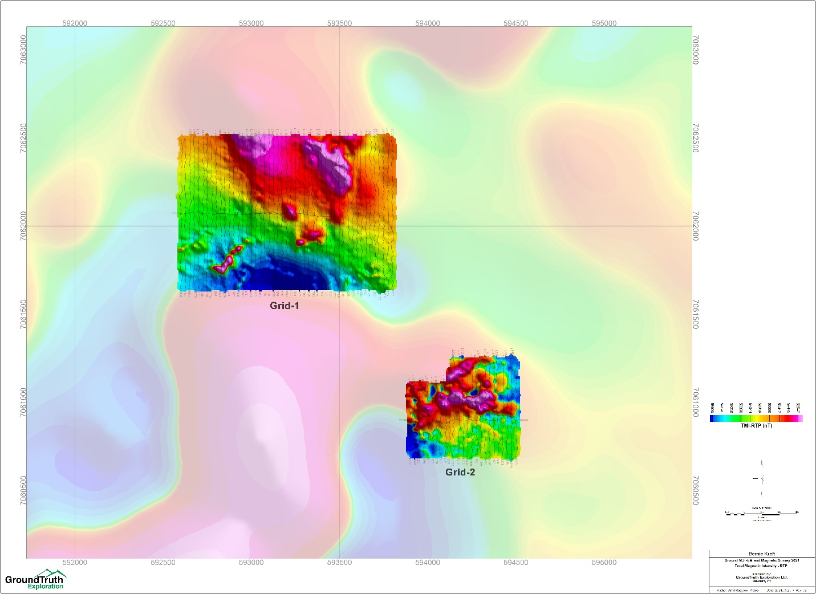
Figure 3: Total Magnetic Intensity RTP from ground magnetic survey 2021.

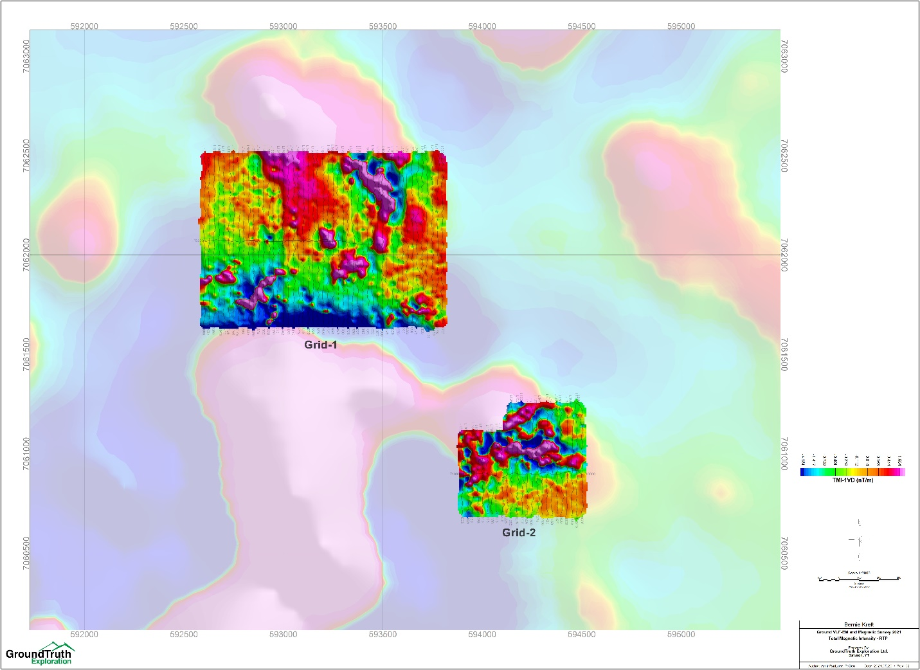
Figure 4: Total Magnetic Intensity RTP-1VD from ground magnetic survey 2021.

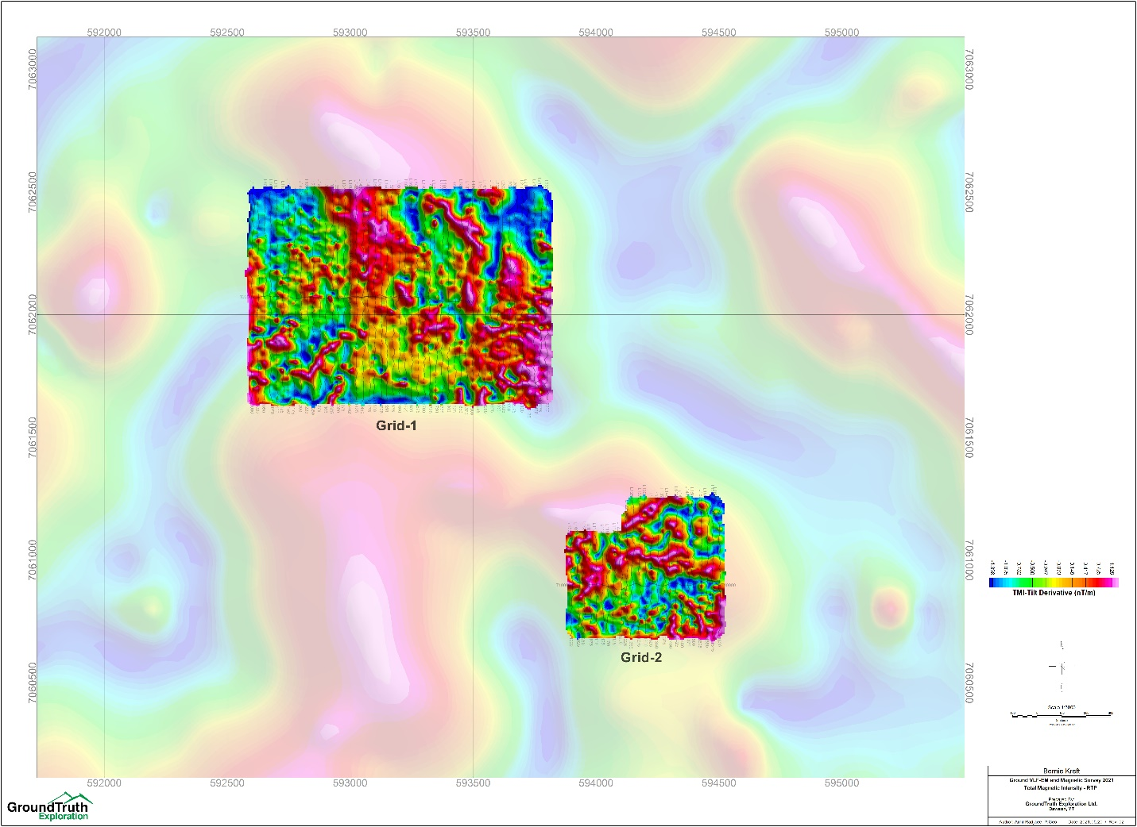
Figure 5: Total Magnetic Intensity RTP-Tilt Derivative from ground magnetic survey 2021.

